Formative assessment when co-teaching
970 | 42 | 51
STUDENTS | LEARNING SPACES (including 8 collaborative spaces) | TEACHERS (including 12 specialists)

Randwick Public School
Randwick Public School (RPS) has a well-established and dynamic culture of learning for students and teachers alike, achieving very strong academic results. The focus of instructional leadership and professional learning at RPS has been on high impact, evidence-informed practices. Two key practices are formative assessment and co-teaching, both of which enable teachers to collaboratively gather and apply evidence to improve student outcomes.
Why? | What?
The learning culture at RPS is one of continuous improvement in an environment that nurtures and appropriately challenges students. In the context of implementing co-teaching and a range of high-impact strategies from Hattie’s (2008) Visible Learning, the focus is on offering students differentiated, quality learning activities with ongoing feedback.  Seeking evidence of student understanding and capacity through formative assessment is a key part of the teaching and learning cycle, as well as the co-teaching cycle. The feedback loop enables RPS teachers to appropriately design the next series of lessons that are flexible enough to be further targeted on a daily basis, if needed. | The most important aspect of formative assessment at RPS is how it provides feedback to learners about personalising their learning and teachers on next steps to develop each student’s skills.  For co-teachers, formative assessment enables targeted and increased accuracy in differentiation. RPS co-teachers use pre-assessment data to co-create differentiated activities and plan student groupings. Formative assessment is used to make adaptations to ensure that each student:  - is progressing in their learning via the activity or group;  - can demonstrate understanding or mastery of a skill or process; and  - is receiving feedback to inform their progress.

Formative assessment (or assessment for learning) involves “making very clear what the learning is for and how to know when it has been successfully achieved... [and is] about ensuring that the assessment is sensitive to individual strengths and weaknesses so as to adapt activities and materials to the current needs of students.”
OECD, Innovative Learning Environments, 2013, p. 173

How? | ability to apply understanding, particularly in lessons which rely on previously taught skills or concepts.  RPS teachers draw on effective formative assessment strategies, including polls and quizzes. One teacher can lead the activity while the other observes student performance and analyses data as it is gathered digitally. In applications such as Kahoot, patterns of student performance can be quickly identified – answering with ease, rushing answers, consistently incorrect, lacking quick recall, etc.  Drawing on the six approaches in the evidence-based model by Friend, Reising and Cook (1993) RPS teachers use the one teach, one assist approach to gather formative assessment data and interpret it to guide decisions about the remainder of the lesson. They then use the alternate and/or parallel approaches to offer more nuanced groupings or exploration of concepts as appropriate.
The supportive and adaptive teaching environment at RPS has been significantly enriched with the introduction of formalised co-teaching relationships and processes. Co-teaching enables more frequent, targeted and actionable formative assessment to be conducted.
RPS co-teachers have found there are increased opportunities and efficiencies in being able to action information they collect about student performance. With two adults present there is enhanced capacity to edit, adjust or rework planned activities and lessons within the session.
One outcome has been an improved ability to group students to target their learning needs and develop tasks differentiated to those needs. This has resulted in students demonstrating improved knowledge retention and
“While outstanding teachers produce excellent learning for their students regardless of their methods, the value of teachers not only teaching the 21st century skills of communication, collaboration critical thinking and creativity, but modelling it in their work, not only embeds these practices for students but supports all teachers to be outstanding.”
Susan Allen, Principal, Randwick Public School

Improved student progress tracking
Technology plays an important part in gathering formative assessment data at RPS. As a one-to-one device school, the collection, storage and analysis of data is easier and faster for co-teachers. One method used includes spreadsheets to track student progress towards outcomes and capabilities, and a colour-coded system for student feedback. This means co-teachers gain a snapshot of student achievement across the cohort.
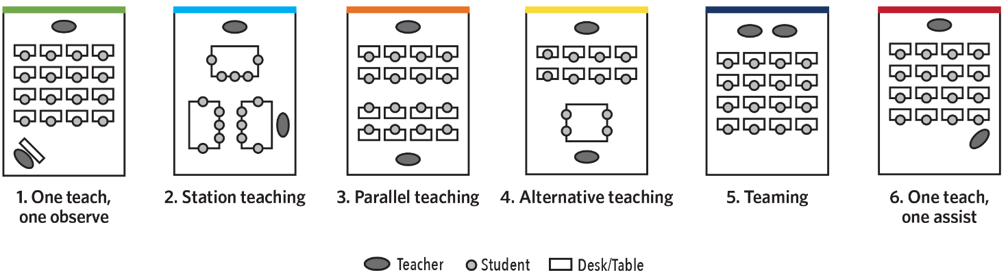
Model for co-teaching with six approaches, Friend, Reising, & Cook (1993)
Other tools used by teachers and students include Apple Classroom and Nearpod Collaborate to facilitate ‘at a glance’ observation of student work. This allows teachers to quickly gather data about the way students are working. For example, teachers using the app’s to observe student pace and methodology of solving Mathematics problems or process in Science diagrams as students work through the task on their device. Teachers also store PDFs of student work samples and results.
The use of technology has augmented existing observational and pedagogical practices. Teachers can be more unobtrusive in their feedback as learning and target that feedback faster.
Support and enrichment | or enrichment opportunities. One co-teacher will lead a session with higher levels of explicit instruction, guided processes and feedback as learning is occurring; while the other teacher may operate in similar modes, or facilitate students collaborating, reflecting or working independently.  Co-planning and check-in discussions during the session maintain responsivity to whole group needs, ensure co-teachers are supporting each other and keep timing consistent.  This combination of alternate teaching and regular check-ins gives co-teachers high levels of confidence about catering to the needs of all students without inadvertently putting a ceiling on achievement or cognitively overloading other students due to group instruction.
Co-teaching has offered increased opportunities for student support and enrichment. Much closer and sustained focus from one teacher can be easily provided without jeopardising the progress of the remainder of the group.
In some instances, RPS co-teachers coordinate the development of student resources, particularly when designing two versions of each unit – one for enrichment and a differentiated core unit. This allows each teacher to gather and interpret the data for their target group of students and take the lead in creating responsive innovative activities.
The alternate co-teaching model enables small group direct instruction for students who may need remedial support

“… the discussions between the co-teachers is so crucially important. It’s being able to talk out loud about a specific child’s needs and progress with a colleague who knows that individual just as well as you do that makes it so rich in detail. You both notice things and so come to a deeper understanding.”
Quetzal Himmelreich-Bell, Assistant Principal, Randwick Public School

Teacher reflection | according to Hattie’s meta-analysis. CTE increased teachers’ awareness and critical reflection on what they do, how they do it and why they do it. There are frequent discussions about the impact of teaching and the amount of student progress being made.  Enhancing CTE has boosted teacher confidence to try new approaches and motivation have higher expectations of themselves. This has directly correlated with having high expectations of their students and enhancing the learner-centred classroom with increased student autonomy. This has led to better learning outcomes as students have developed higher intrinsic motivation, curiosity and a desire for challenge.
At RPS the ability to reflect on student performance has been improved due to co-teaching, in comparison to their experience of teaching alone. The depth of knowledge of each student’s progress means the insights are richer compared with discussions with a stage colleague, which are more often on a surface level. A co-teacher adds their own observations and knowledge so that interpretations or decisions are much more informed.
The formalising of co-teaching relationships has enhanced the climate of trust, sense of togetherness and mutual belief in each other as professionals. This is collective teacher efficacy (CTE), the factor with the highest effect size

Adaptation of instruction
Co-teachers at RPS can employ a much wider variety of options to respond to formative assessment, especially when the data shows they need to return to a concept or skill. In co-reflecting on a lesson, they examine the impact on student outcomes. At RPS, co-teachers do this in a ‘huddle’ during a lesson and at the end of the day; when planning the upcoming week and when preparing the next learning sequence. Co-teachers draw on their strengths and perspective of the lesson to ask themselves questions like:
- How can we ensure learning intentions are clear and appropriate for all students?
- What would it look like if one co-teacher or another leads the design or instruction of a revised lesson?
- Were the student group sizes effective? Was whole group instruction best, were student groups too large or small, etc?
- How might a different approach increase student engagement or success?
- How might we re-sequence the learning? Was there too much explicit instruction or independent work; do students need more guidance prior to collaborating, etc?
- How can we ensure there is the right amount of student choice and voice?
- Were there enough real-world connections?
In reflecting on information about student performance, co-teachers co-plan next steps for student learning. The high levels of trust between them enables honest reflection and analysis. They move smoothly and flexibly between the six co-teaching approaches to offer high quality learning based on evaluation of gathered data.

Friend, M., Reising, M., & Cook, L. (1993). Co-teaching: An overview of the past, a glimpse at the present, and considerations for the future. Preventing School Failure: Alternative Education for Children and Youth, 37(4), 6–10. NB. All future references to co-teaching models are from this source.
Hattie, J. & Zierer, K. (2019). Visible Learning Insights, p. 49

