Kirrawee High School – Portrait of a Graduate
1200 | 63 | 82
STUDENTS | LEARNING SPACES | TEACHERS

Signature Strengths
The Signature Strengths are seen as a gateway to a number of positive outcomes. They are more than just a set of characteristics for students to work towards. They are also a focal point for engaging in a case for change for new practices to invigorate learning and teaching. Contemporary pedagogy, Jefferson and Anderson’s 4Cs, and active learning are being drawn on to build characteristics to enhance success for a rapidly changing world.

Why?
The Signature Strengths of Kirrawee High School’s (KHS) nine month journey began with the realisation that the existing decades-old core values and mission statements did not reflect the rapidly changing world of today.  The school wanted a way to clearly articulate what Kirrawee students could become, look like and sound like. Leadership believed it was important for all to understand the values that students | would possess as a result of six years of schooling at Kirrawee High School.  The school was functioning on a ‘passed down’ set of expectations. A stable teaching staff and community meant that common values were present. However, school leaders were convinced that there was a way to empower students to deepen their understanding of those common values in order to be even more fulfilled members of a global community.

Who?
To begin, teachers and executive staff had informal discussions about the changing needs of students to become successful graduates. This became the starting point for a strategically driven approach.  It was crucial that all members of the whole school community were involved. This meant the process was a multi-faceted one. The choice of desirable characteristics was informed by exploring | the nature of the world young people would be entering when they graduated.  Student leaders, teacher leaders, the whole staff and the P&C were involved in formulating the Signature Strengths. Drawing on all of these perspectives enabled the statements to function as expectations in the classroom, community core values, mission statements for the school and motivators for individuals.
“With all our knowledge, skill and drive we must be respectful, responsible and resilient to ourselves and each other. The rules we live by need not be based on negatives, but aspirations to be better.”
Greg Munsie, Principal, Kirrawee High School
Teacher Workshops |  | Student Workshops
A combination of teacher leaders and executive attended SLEC’s ‘Introduction to Teaching and Learning in Innovative Learning Environments’ course. Afterwards, collegial discussions led to the decision to engage the whole staff in the portrait of a graduate activity.  Teachers worked in faculty groups to create a concept map of the characteristics crucial for Kirrawee High graduates. Responses focused on cognitive, personal and interpersonal competencies. A gallery walk of the posters and a whole staff discussion saw the creation of a core set of characteristics that were valued by staff.  The work of supporting the growth of these characteristics has been supported in an ongoing way spaced over a year. Teachers have engaged with SLEC’s PL materials to explore contemporary pedagogy and learn from other school’s journeys. |  | At the annual KHS student leadership conference day, 120 students ranging from the prefects, SRC, Social Justice Council, White Ribbon Ambassadors, and the Sustainability & Environmental Committee were mixed into 10 groups.  The groups co-created concept maps on the desired qualities or personal traits. They included characteristics they saw as already existing or wanting to exist in themselves as result of attending and graduating from KHS. Each group then presented their top three, pictured below. This led to a shortlist of ideals - respect, resilience, responsibility, school pride, personal best, engagement, global citizenship and a common humanity. This short list was then workshopped by the two Year 10 GAT English classes. They created a first draft of the Signature Strengths.
“As the name suggests, the Signature Strengths of the Kirrawee High School Community are for our entire community. All major stakeholders had a role in their formulation, promoting wonderful philosophical and pedagogical discussions surrounding what sort of young people we wanted our graduates to grow up to become.”  Mark Mitchell, relieving Deputy Principal |  |  | 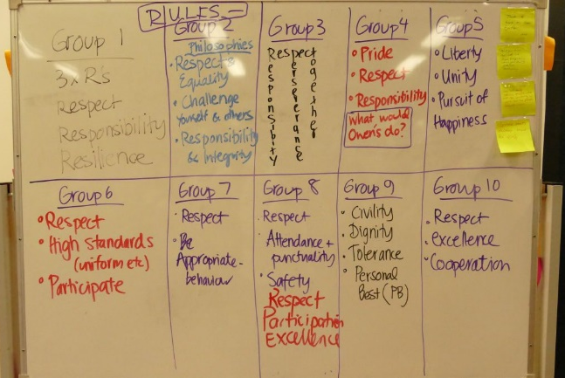
P&C Involvement |  |  | Launch Event
The P&C had an important role to play in refining the wording, and ultimately approving, the Signature Strengths. Parents and carers contributing to the process was so important to getting a full understanding of the values and beliefs across the whole school community.  The P&C had a clear picture in their minds of what they wanted for their children, and prospective KHS students of the future. Many drew on the benefits they had seen for graduated siblings as well as what they would have liked looking back with hindsight. In bringing parents’ life experiences and knowledge of the world today, the Signature Strengths closely aligns with community need. |  |  | The whole-school launch assembly was extremely successful. The various speeches and visuals used made it clear to teachers and students how the Signature Strengths came about (the process), what they mean and how they will be expressed in the everyday business of learning and teaching at the school. The assembly was entirely student-led, addressing the big ideas of respect, global citizenship, resilience, responsibility, and school pride.  Each student gave a very personal reflection on how they understood one aspect of the Signature Strengths. Being unpacked by student voice had a far more powerful effect on the student audience than could have occurred with an adult keynote speaker.
“… as a result of being resilient, determined and changing my approach towards maths and learning in general ... I am now more confident and always ask questions when I am confused … I have realised that it is fine to fail as long as you have given it your best effort. All you need to do is to pick yourself back up and try again. Most importantly, I can now proudly refer to myself as a resilient learner who works towards my personal best and strives to achieve their goals.”
Georgia Graham, Year 8 student – a resilient learner (pictured right)

Student action
Student leaders regularly write website articles to continue to communicate the message of the Signature Strengths. They explore what one of the signature strengths means to them in their life. They discuss how that characteristic is being fostered at the school and how it will assist them as graduates and global citizens. The use of authentic student voice is crucial in having an impact on the student body – student leaders are building the momentum to effect change in school culture.
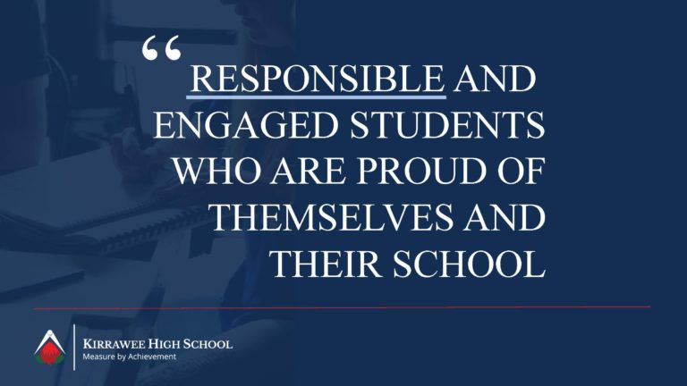
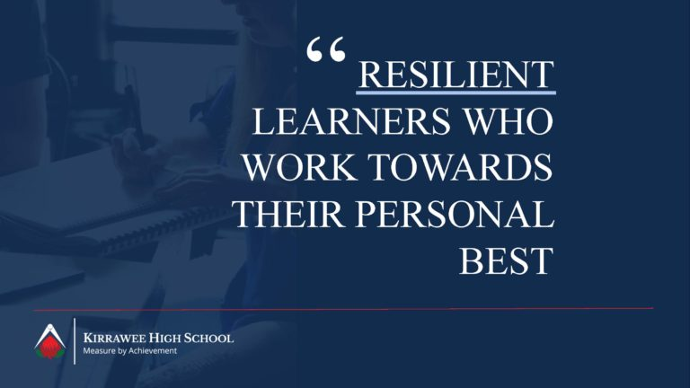
Challenges faced  Establishing a new vision for a school community and breaking with past successful practices was challenging. Creating a case for change amongst teachers, students and the community required careful planning so the change wasn’t just new but actually better. Sharing the right kind of information and participation in activities to create buy-in was strategically managed over a 9 month process.  With teachers it centered around exploring research on the impact of AI on global practices, the future of jobs and how young people could be better supported to be resilient in the face of rapid change. This incorporated professional readings and learning opportunities with SLEC to deepen the understanding of contemporary pedagogy.  This pedagogy is one way teachers are developing the desired characteristics for students that were identified in the portrait of a graduate activity. Building teacher confidence to trial strategies with students was a challenge that saw colleagues and school leaders support one another. This has enabled teachers to shift away from | some traditional strategies to more effective learning opportunities that involve increased active learning and student voice.  Outcomes  The Signature Strengths of the Kirrawee High School Community have become the over-arching “ethos” of the school that have promoted positive change and re-focus on:  - a common language by teachers in the classroom when defining expectations in learning  - calling all KHS students, staff and parents/carers to embrace and embody the Signature Strengths for themselves.  - academic reports, recently reviewed and a new format implemented in line with the Signature Strengths focused on current capacities and future steps to build skills  - discipline and welfare flows, currently under review.  The impact of the Signature Strengths on aspects of school culture such as frequency of positive and negative behavior incidents, students’ perceptions of themselves as students, and impact on academic results is an area for future data analysis.

