Brainwriting
Brainwriting was first developed by Bernd Rohrbach, who published the idea in a German magazine in 1969. The technique is similar to brainstorming – they're both methods for generating ideas and solutions to a problem.
Brainwriting, however, gives everyone equal opportunity to participate, and it enables all group members to think without any "blocking."
- Seat group members at a table, with a sheet of paper in front of each person. At the top of the page, ask them to write down the problem that everyone is trying to solve. (Note: they should not write their names.) Appoint someone to be moderator, and time each round.
- Give the group three minutes to write down three ideas for how to solve the problem. They should not edit the ideas, or try to perfect them. Allow them to write in "free form." Do not permit any discussion.
- After three minutes, move on to round two. Gather in the papers, shuffle them, and then pass them out. You may need to sort out cases where someone gets back a paper they have already written on. Ask everyone to generate three more ideas on the new paper they have just received. They can build on the first three ideas that are already written, or think of three new solutions.
- The moderator decides how many rounds there are.
- When all rounds are finished, collect the papers, and write all of the ideas on a whiteboard for everyone to see. Then begin discussing which ideas would work best for solving the current problem.

Blended learning brainwriting
- Using Google Jamboard, create a digital collaborative whiteboard with a page for each student group.
- Post the following information onto each whiteboard by adding a sticky note:
- The problem to be solved
- Activity instructions
- Time instructions
- Send all students the following information:
- A link to the Jamboard.
- A list of student groups and their designated pages in the Jamboard.
- Students access their designated page in the Jamboard and spend allocated time (eg. 5 min) brainstorming and recording solutions to the problem.
- Then students move to a new page and add new ideas or comment on ideas already posted.
- When all rounds are finished, students return to their original page in the Jamboard and rank the solutions in order of preference (assigning a rank of 1 to their favourite).
- Students add the scores for each solution and move the one with the lowest score (i.e. highest average ranking) to the top of the whiteboard – this is the final solution for the group.
Alternative digital tool
This activity could also be facilitated using padlet (read the learning tool card on padlet on the DLS). Teachers create a separate Padlet for each student group and share the unique links to each Padlet with students – each rotation here will require students to access a new link.

Socratic Seminars
Socratic seminars are a student-driven discussion method. Students are given a topic, text or driving question to consider before the session. They drive and reflect on this discussion of the topic with minimal teacher guidance.
- Arrange students into two circles – inner and outer.
- Ensure students all have resources that enable them to take notes during the discussion.
- Teacher poses a question/topic and the inner circle discusses it. They can only pose questions/comments to each other, not the teacher. The teacher only speaks if the discussion needs to be redirected.
- The outer circle listens to the discussion and takes notes.
- At the end of the discussion, outer circle comment on the discussion, give feedback or pose further questions.
- Can repeat for another round with the inner circle basing their new discussion on the comments and questions of the outer circle.
Socratic circles are great for building skills needed for respectful discussion and ensure student voices are heard in the classroom. They enable social and cooperative learning because students bounce off one another rather than relying on teacher guidance.
A detailed overview of the technique is in this ACSA reading and this We Are Teachers blog.

Blended learning Socratic seminars
This strategy can be facilitated synchronously or asynchronously using online tools. Teachers should access the department’s pdf on guidelines for the use of live video with students prior to using this strategy.
- Before the activity, send all students the following information:
- Their assigned group. Students should be divided into two groups:
  - Group 1 will discuss the question (the ‘inner circle’).
  - Group 2 will observe and comment on the discussion (the ‘outer circle’).
- Activity instructions for each group.
- Instructions for effective, safe and ethical use of video conferencing tools (or video recording tools if asynchronous).
- Question that will drive discussion.
- Instruction for all students in Group 1 to prepare discussion points.
- Once all students have accessed the video conference, explain the following:
  - The tasks for each group and the question to be discussed.
  - The correct use of microphones.
    - Group 1 should have microphones and video on during the discussion and muted during the feedback phase.
    - Group 2 should have microphones muted during the discussion and switched on during the feedback phase.
  - Discussion protocols including virtual hand-raising when ready to speak.
- Students in Group 2 could use the chat or Q&A feature in the video conferencing room to take notes while listening to the discussion.
Suggested digital tools
- Zoom or MS Teams
- Asynchronous tools include apps like Flipgrid or shared files such as OneNote or Keynote.

Microhack
A hackathon is a sprint-like design event where programmers and designers collaborate to solve a problem and create new products.
A microhack is just a short version of this that can work in a classroom. The focus here is on speed and creative, collaborative design thinking and problem-solving.
- Preparation: Select/nominate learners to act as team leaders. Present teams with a problem to hack: a product to create, a problem to solve, a design challenge. Team leaders are given five minutes to develop a plan for how to solve the problem.
- The Pitch Session: Team leaders pitch their plans to the class in 1 minute, then class members choose a team to join.
- The Hack-It Session: Teams have 45 minutes to develop or design their solution. The team leader should spend some time explaining the plan in more detail and the team should give feedback and collaborate on the design process.
- The Showcase: Teams present their hacked solutions to the class. The teacher may opt to select a winning team.
Some classroom hackathon topic ideas at this The Edvocate blog.

Blended learning microhacks
A microhack is a short version of a hackathon that that can be implemented in a virtual classroom. Teachers can vary the time frame for this activity according to the needs of learners, but keep it short so the activity remains a design sprint.
- Preparation: This stage of the microhack can be facilitated by the school LMS. Teachers post an activity overview and pose the driving question to team leaders.
- The Pitch Session: This stage of the microhack can be facilitated using student video. Team leaders could film themselves making their one-minute pitch then share it with peers using a platform like Microsoft Stream. Invite students to contact you with team membership requests or post their team requests in a collaborative digital document or virtual classroom.
- The Hack-it Session: This stage of the microhack can be facilitated using a collaborative virtual whiteboard such as Google Jamboard (read about this learning tool card on the DLS card). Teams can be assigned one page of a Jamboard and use it to design their solutions.
- The Showcase: Teams summarise their solutions or designs on their Jamboard. They could use digital sticky notes, images or photos. They could consider filming themselves explaining their solution and posting it on Microsoft Stream, then placing a link to the video on their Jamboard. A reflection template could also be provided for each student to complete.
Alternative digital tools
- Padlet or a Google doc could be used in place of Jamboard.
- To add an element of demonstration, teams could create a presentation using Microsoft Sway to present their solutions to the class.

Gallery Walk
A gallery walk is a strategy that enables peer reflection on student work. Learners are taught how to give constructive, direct feedback to their peers and each learner uses this to reflect on and improve their own work.
- Teacher presents a task to students (something to be created – works best with tasks that don’t have too much dense writing – a product, an artwork, a piece of writing, a digital presentation) and class works in collaboration with teacher to develop a set of success criteria. Can be useful to run through some strategies for positive feedback here, too.
- Learners produce a first draft of their piece of work.
- Learners’ work is displayed gallery-style. This could be a digital display; it could make use or writable surfaces, or work could be posted around the classroom.
- Learners circulate, view, and comment on their peers’ work. They can use post-it-notes; write on the writable surfaces or post digital comments. All comments should be constructive and relate directly to the success criteria.
- Learners review the comments on their own work and ask necessary questions.
- Learners revise their work using their peer feedback.
Tip:
This can be great to use in the PBL process, towards the end of the create phase, as part of the product refining process.

Blended learning gallery walk
A gallery walk is a useful strategy for ensure learners diversify the ways they connect and collaborate digitally.
- Learners and teachers can collaborate to develop success criteria and a list of phrases, words and strategies for offering constructive feedback to peers using online word processors such as Google Docs or Microsoft Word Online. Teachers can post a draft version of success criteria and suggested phrases. Learners can use the Comments function to suggest alterations and additions.
- Learners can display their work for the gallery walk on a collaborative virtual whiteboard such as Google Jamboard. Learners can take a screen shot or copy digital work, then paste it into their own page of a collaborative Jamboard.
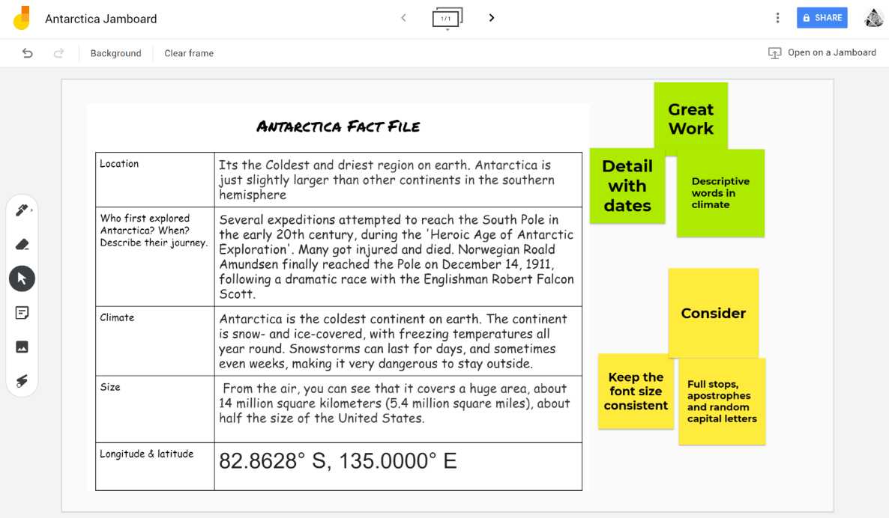
- Peers can post comments or suggestions on the Jamboard using digital sticky notes.
Figure 1 Work presented on Jamboard for feedback.
Alternative digital tools
Learners could share their work on their own slides within a collaborative Microsoft PowerPoint Online presentation.

Conscience Alley
Conscience alley is an adaptation of the classic class debate that engages students in argument development, persuasive communication and critical thinking.
- Teacher gives learners a topic to debate.
- Teacher selects one learner to serve as debate adjudicator – this student will hear each side of the debate and select the most compelling argument.
- Remaining learners are divided into equal groups, and one side of the debate assigned to each group.
- Having learners to choose a ‘side’ engages student voice and build purpose.
- Alternatively, designating ‘sides’ for each learner can encourage the consideration of different perspectives and the control of biases.
- Teams prepare an argument that can be communicated verbally. Learners develop one point to support their team’s argument. Learners carefully consider what and how they will deliver to grab the adjudicator’s attention. Consideration is given to the order in which points will be presented.
- Learners form an alley with one team lined up on each side, facing one another. This step is best facilitated outside.
- The adjudicator walks down the alley while learners from both teams present their arguments. As the adjudicator walks past each learner, they should present their point. Encourage the adjudicator to move slowly to enable each learner to present their point.
- As the adjudicator reaches the end of the alley, they consider both sides of the argument and select the more compelling side.
- The adjudicator presents their decision to their peers and justifies their choice.
- Teacher debriefs with both teams, discussing strengths and weaknesses of their arguments and techniques.

Blended learning conscience alley
Learners can be engaged in the same collaborative development and delivery of compelling arguments using an online word processor.
- Set up an online document and share with all learners. In this debate document, record the topic and the roles of each learner.
- Set up separate online word processor documents for each team. Share links to these working documents with all team members.
- Learners use their working documents to develop an overall argument, three strong points to support it and three potential rebuttals for the opposing team (this simplifies the argument development process for an online environment).
- Each team presents their arguments and three points in the debate document. They could use a table or create a collaborative piece of writing.
- Once both teams have presented their points in the debate document, their rebuttal points can be added to the opposing team’s argument.
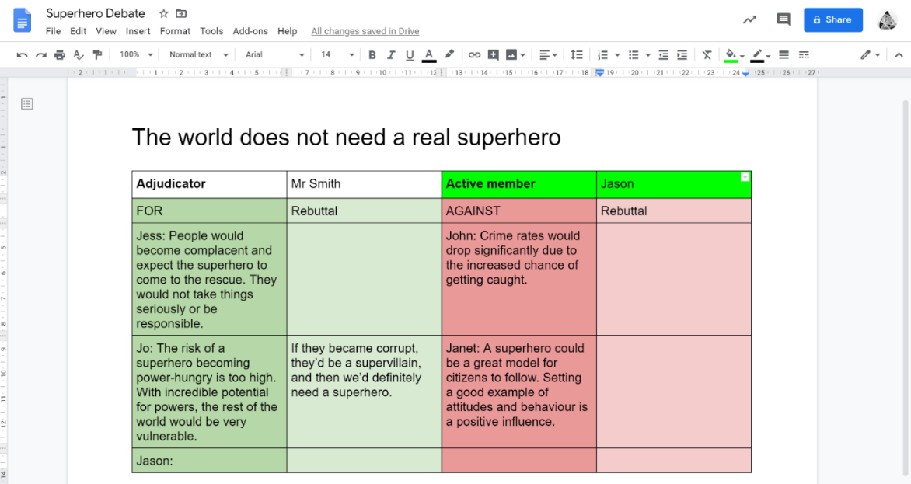
- The adjudicator reviews each argument in the online document and selects the most compelling.
Figure 2 Online conscience alley example using Google Docs
Alternative digital tools
- Learners could film themselves presenting their points verbally using Flipgrid and the adjudicator could review videos rather than a written document.

One-pager
A strategy where students present key information on one page using words, images, colour, acronyms/mnemonics and graphic organisers.
Allan Paivio’s research (1986) suggests that humans’ ability to recall or recognise is enhanced when they present information in both visual and written form (see types of feedback for more information). When combining the use of two ways to share what they’ve learnt, students draw on both ways to process. For this reason the information students choose to include on the one page becomes more memorable.
- Teachers decide on which elements they want students to include on the one-pager – important people and dates or connections to other disciplines or links to present issues/real world etc.
- Teachers create a layout to guide completion of the task and connect the instructions with the layout. Lists/templates for what students need could include quotations, a diagram, two images, a key theme etc depending on the material students are working with and the learning intention.
- Students engage in some kind of learning to build knowledge and understanding – it may be from a poem, a Ted Talk, a reading, an historical source, research on an important individual, an experiment etc.
- Students use critical thinking to determine important takeaways from the activity, explain a process or evaluate the significance of a person/event etc.
- Students work creatively to interpret information and images to produce a colourful one-pager including symbols, icons, different types of lettering etc.
Tips:
- Templates support students who are wary of creative tasks or those daunted by a blank page; for example, quotations in a border, themes centred, image top right etc
- Shows students a sample or exemplar one-pager.
- This strategy can be used effectively as a formative assessment task, as a ‘getting to know you’ activity, analysing text, or as a focus point while viewing multi-media.

Blended learning one-pager
One-pagers are a simple strategy for structured independent learning. They offer learners a new way to make meaning from information that is taught explicitly or accessed independently.
- Teachers can develop a one-pager template using Microsoft Sway (this DLS tool information card may be useful for those new to this process).
- Teachers share this template with learners. Learners make their own copy of the template and use it to create a digital one-pager. Learners can use all the design tools built into Microsoft Sway to make meaning, and include images or symbols sourced online.
Alternative digital tools
- Learners could use Google Jamboard to create a less structured one-pager.
- Learners could use a Google Slides or Microsoft PowerPoint Online presentation to make a one-pager to be shared with peers. Each learner could be assigned a slide and record key points focused on a different aspect of the source information. This transforms the activity into a collaborative task very similar to a jigsaw activity.
- Learners could use Microsoft Office Lens to digitise their one-pager and share the digital copy with their class/teacher.

Bus Stop
Bus Stop enables student voice that allows students to reflect on what they have learned. It is a scaffold for sharing ideas and for gauging student understanding. It can be used at the beginning or the end of an inquiry/lesson/unit of work, and can be linked with any learning area, topic and PBL (Project Based Learning) or STEAM (Science, Technology, Engineering, Art, and Mathematics).
Bus Stop is great for developing focus and active listening skills. It enables students to be aware of others and to share their knowledge and understanding in a considered and polite manner.
It can also be beneficial to explicitly teach this strategy to students, if you are working towards a No-Hands-Up Classroom (an environment where students don’t need to put their hands up to answer and ask questions, nor to have discussions with their peers).
Students need to be aware of verbal and non-verbal cues, gestures, body language, energy, silence and the expression of others. These skills need to be taught explicitly to students to ensure that they have a deep understanding of these concepts.
- Students stand up, in a line, as though waiting for the bus. Without discussion or using hands, they decide when to respond to an open question. Once they have contributed a response, they sit down (get on the bus).
- Each response must be a new idea or build on another student’s idea. Students must listen carefully and respectfully to others so that they don’t repeat a response.
- You may like to tell the students “You are on the Bus”, after they offer their response. As they become familiar with this strategy you should no longer need to prompt. Alternatively, peers could provide the confirmation, creating a student-centred environment that enables the teacher to focus on recording responses.
Extension: Bus Stop in a Bus Stop
- Divide the class in half. One half observes the first Bus Stop, then participates in the second Bus Stop reflecting on the original responses (first Bus Stop).
- Bus Stop can also be used in adult learning or during meetings to enable voices, and to build/enhance a positive school culture, where all voices are heard and valued.
Reference: Transforming Schools: Creativity, Critical Reflection, Communication, Collaboration, Miranda Jefferson and Michael Anderson, Bloomsbury 2017 (p.120 and p.142)

Blended Learning bus stop

Snowball
Snowball activities help learners build understanding of a topic. Learners build upon one another’s ideas/perspectives to develop thoughts collectively.

Snowball discussions
- Learners pairs up to discuss the topic, reading, artwork, controversial interpretation etc., sharing their ideas or solutions. A variation – they must come to a consensus.
- Two pairs join up, creating a group of four share their ideas.
- Two groups of four connect, creating a group of eight to continue the discussion.
- This process of group doubling and discussion continues until all learners are combined in a single group.
- The final collection of ideas or solutions is presented and recorded. If appropriate, the teacher can scaffold a process of reaching a final consensus.

Snowball writing
- Small groups of 3 to 6 members form and sit in a circle to facilitate eye contact and sharing of ideas equitably.
- The teacher assigns a theme/topic/stimulus to the group. Then each member of the group writes down their first thoughts, expressed in a few words or phrases.
- When everyone has written their thoughts on the topic, each student passes their paper to the student on the right. They then read the paper and write down their thoughts filling in information, developing ideas, challenging or questioning things that were written by the previous student/s.
- The papers continue to be rotated until all members of the group have contributed to all papers, continuing to develop the ideas. The teacher can stop the rotations at any point before the paper has gone full circle if the groups are different sizes or if they feel that the goal has been reached.

Blended learning snowball
- Teachers set up a Google Doc or Microsoft Word Online document with a page designated for each learner. Consider using a scaffold like that displayed in Figure 3 to guide learners through the activity.
- Teachers share the problem, challenge or question, along with the document link, with learners.
- Learners record their initial ideas or solutions in their page of the document.
- When signalled learners move through the pages assigned to their peers to add comments or suggestions.
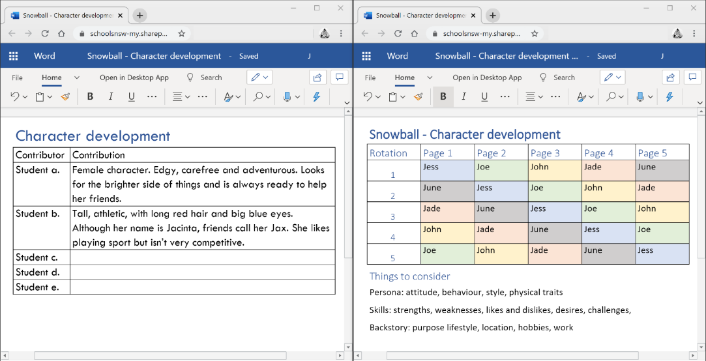
Figure 3 Examples of Snowball scaffolds
Alternative digital tools
- Learners could use a Google Slides or Microsoft PowerPoint Online presentation to record their ideas and review the ideas of their peers.

Fishbowl
A fishbowl activity is a structure for discussions where some students in the class are active participants while others are observing the discussion and listening to the ideas being presented. Students take turns in these roles so they are both contributors and listeners.
- Teacher constructs a topic or stimulus, more effective ones are controversial, are dilemmas or do not have one simple answer.
- Set up the room with a circle of 6-12 chairs (the ‘fishbowl’) and enough room around the circle for the remaining students to observe.
- Present learners with the topic or stimulus and offer a short period of time (eg. 5 min) to prepare ideas and questions for the discussion.
- Students need to be aware of the rules and guidelines for respectful discussion before they start. Variations include – having the speakers and the observers switch at 10-15mins, allow individual observers to tap speakers on the shoulder to switch roles, observers recording specific elements of the discussion.
- The inner circle of students discusses the topic while the outer circle observes the discussion and takes notes if appropriate.
- After the discussion, facilitate a reflection session where learners consider what they learned and evaluate their performance as listeners and participants.
Tips:
- Can be an effective pre-writing strategy, supporting students to develop an understanding of ideas they can then develop more deeply independently.
- Students could be assigned various specific perspectives or viewpoints, eg of historical figures, social class, political/philosophical points of view, or characters in a novel. This set up enables students to explore how perspective shapes the construction of meaning.
- For smaller groups, place two students in the fishbowl with students on the outside acting as coaches.
- Observing students may use rubrics to provide feedback to the students involved in the discussion.

Blended learning fishbowl
The following modifications enable fishbowl activities can succeed in a blended learning environment. If using video conferencing tools, it is advised that teachers access the department’s guidelines for the use of live video with students before leading this activity.
- Send group placements (discussion or observation group) and discussion stimulus to learners via the school LMS.
- Use a video conferencing tool such as Zoom to facilitate discussion.
  - Instruct all learners to mute their microphones.
  - Learners in the Discussion group can use Zoom’s hand-raising function to indicate when they want to speak, then unmute their microphones only while speaking.
- Learners in the observation group can use Zoom’s chat function to comment on the discussion as it progresses, or pose questions to the discussion group.
- Teachers can use Zoom’s poll function to create a self-reflection form for all learners to complete at the end of the activity.
Alternative digital tools
- Microsoft Teams video meetings could be used in place of Zoom.
- A text-based Fishbowl discussion could be facilitated using the chat function in a digital classroom such as Google Classroom.

Rapid-fire writing
Rapid-fire writing is a simple, structured strategy to support students reviewing and revising written work using a highly structured way to alternate between writing about a topic and thinking.
- Teacher selects stimulus on a topic that will elicit varied, complex responses from students.
- Students have writing materials out before engaging with the stimulus.
- Teacher outlines the protocol structure so students aren’t surprised when they are guided through the process.
- Students read/view the chosen content.
- Using a timer, the teacher leads the students through a series of steps:
  - 1 minute – quiet thought, no writing
  - 3 minutes – write continuously, or at least try not to stop writing at all
  - 1 minute - read and circle three main ideas (words or phrases) from what was already written; no writing, students only read and reflect.
  - 2 minutes – students continue writing
  - 30 seconds – read and put a square around one word or phrase that is the final focus of the writing
  - 1 minute – write to finalise the focus idea
- Students reflect on the ideas generated in small groups or as a whole class.
Tips:
- This strategy is helpful for brainstorming and narrowing the focus for the piece of writing, it can be used as a pre-writing task, for formulating the thesis for a formal essay, use drafts to build skills in editing.
- Depending on the students’ ability and writing experience, the durations may be shortened or lengthened as needed, eg. expand the writing times to 5-10 mins each to have students produce paragraphs for a formal essay.
- Post topic-related vocabulary to assist students with learning needs.
- Depending on need, teachers could provide students with a scaffold to guide writing; have students highlight key points in a reading or take notes from a visual stimulus.
- Rather than providing a new stimulus, provide a topic that students already know well and use the writing as formative assessment.

Blended learning rapid-fire writing
As a structured independent task, rapid-fire writing is a useful strategy for enabling learners to reflect upon and crystallise their understanding. Slightly increase the times for each phase of the strategy to allow for learner navigation through slides.
- Create a new Google Slides presentation with 8 slides. You could consider using this template. Populate the slides with the instructions and time for each step on a new slide. Include the stimulus material or the web link if it is a digital stimulus.
- To add a video displaying a timer (for example for two-minutes) to the top left corner of the slide, use the instructions below:
    - Select Insert à Video.
    - Search YouTube for a two-minute timer video then ‘Select’.
    - Resize and move the video to suit your slide design.
    - In the Playback menu at the right, select ‘Autoplay when presenting’ so the timer automatically starts when learners access the slide.
    - In the Playback menu at the right, select ‘Mute audio’.
    - Repeat this process for each slide.
- To share the Google slide with learners:
- Select ‘Share’ and name the Google Slides presentation.
- Select ‘Get shareable link’ then ‘Anyone at NSW Dept of Education with the link can view’. Select ‘Copy link’.
- Delete all characters in the link after the final “/” and replace them with ‘copy’. This will force learners to make a copy of your presentation rather than allowing them to edit your original. Share your new link with learners.
- Learners communicate their final ideas in a digital classroom.

