Lesson Plan
Fill out the cells in the table ensuring that you tailor the use of the learning modes and your chosen strategy as appropriate to your context. Also consider what adjustments are needed for students with additional needs. Match your selected learning modes to each step of the lesson plan. You may use a learning mode more than once and you don’t need to use all eight learning modes in one lesson.
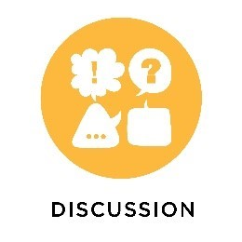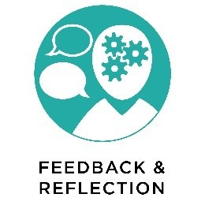
Class: | Unit of work: | Topic:
Targeted outcome/s: | Targeted general capability or cross-curricula priority:

Chosen Strategy:

Learning intentions:

Success criteria:

Lesson introduction: (including connection to prior learning)

Steps for the lesson |  | Learning modes
Lesson Conclusion:

Reflection and evaluation of lesson:

