Learning Modes
The department’s eight learning modes are a set of organising principles that account for different ways in which learning occurs. Each mode requires students and teachers to be interacting differently with content, resources and each other.
When we are aware of, and can identify the intention of learning, it can guide our decision-making on how to design learning experiences that match these intentions.
The learning modes provide a framework for learning and, while presented individually, they are connected and fluid. For example, a student working on an independent task may require collaboration with their peers to increase understanding or develop ideas then seek feedback after reflecting on the work they produced.
This process requires students to understand the purpose of their task and make responsible decisions on how to best engage with their learning.
The recent work of Professor John Hattie (2019) features in the literature review of our learning modes, which can be found on our website. This synthesis encompasses: the characteristics of, the theory behind; the strategies for and success factors of each learning mode.

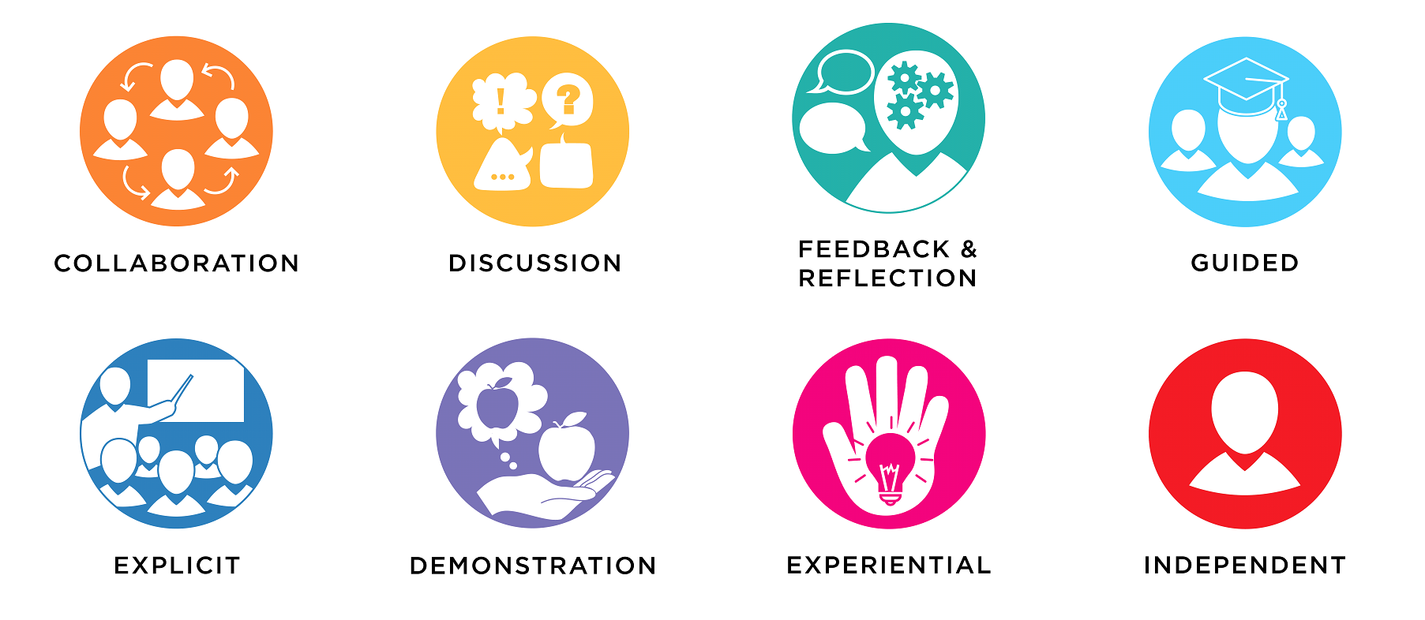

Collaboration

Learning with others
When students collaborate, they work together towards a common goal or purpose. Planning activities that give students the opportunity to collaborate enables them to learn and grow with and from each other. Authentic collaboration crystalises the ideas and efforts of a group of learners.
In contemporary classrooms, collaboration plays a vital role in ideation, solving complex problems, developing collective intelligence, increasing confidence, and fostering positive interpersonal skills and dispositions. Teachers explicitly teach their students the skills of collaboration.
Flexible spaces and furniture should ensure groups of learners are in close proximity to one another and provide good eye contact, a collaborative workspace and ideation platform.
Hattie (2019) identifies high-impact strategies and factors for effective collaboration, including:
- Co-operative learning - developing positive interdependence, belonging, and wellbeing through peer learning, shared problem-solving, and cooperative classroom structures.
- Peer tutoring - teaching self-regulation and control over learning, teaching students to become their own teachers; peer tutors understanding material at a deeper level.
- Small group learning - assigning tasks to small groups, teaching group work skills, employing cooperative learning strategies, and adapting content to ability groupings when they are used.
- Teacher-student relationships - building positive relationships with students by developing their agency, efficacy, and respectfully recognising what each child brings to the class; practising the skills of active listening, empathy, caring, and having a positive regard for others.
- Strong classroom cohesion - fostering a classroom culture where learners work towards positive learning gains by employing goal directedness, positive interpersonal relations, and social support. Online learning tools and platforms such as Google Jamboard can enable collaboration for students learning from home or in a blended learning environment.
Purposeful strategies enable students to: collaborate, effectively co-create and co-construct products, discuss and challenge ideas and concepts and find solutions to complex problems.

Discussion

Talking about learning
When working in this mode, students communicate their ideas in an environment built on trust and mutual respect, where all voices are heard and valued.
Students are encouraged to confidently share their ideas to enhance and develop critical thinking, creativity, reasoning and resilience. Discussion allows students to effectively communicate by sharing ideas, enabling perspective, and having agency and choice in their learning. As such, discussion strategies should encourage equitable and respectful student participation.
Teachers can facilitate discussion by posing questions that provoke a response, reaction or deep thought. Teachers of Aboriginal students could consider the Eight Ways of Learning when activating this Learning Mode, including story sharing.
Furniture settings should ensure learners are in close proximity to one another with good eye contact.
Hattie references these high impact discussion strategies in his most recent research (2019):
      - Questioning - the posing of factual or conceptual questions to students.
      - Elaborative interrogation – asking students to generate explanations for explicitly stated facts by asking a range of “why” questions.
      - Philosophy in schools - teaching students reasoning and argumentative skills.
      - Teaching communication skills - explicit teaching of communication skills.
      - Classroom cohesion - developing a sense that teachers and students are working together towards positive learning goals.
      - Positive peer influences - building an awareness of positive influences peers can have on others’ learning.
Students learning from home or in a blended learning environment can discuss concepts live using digital learning tools such as Google Classroom or Microsoft Teams.
When using video conferencing tools for discussion, consider setting up protocols for respectful turn-taking, appropriate questioning and active listening to support student learning and model success.

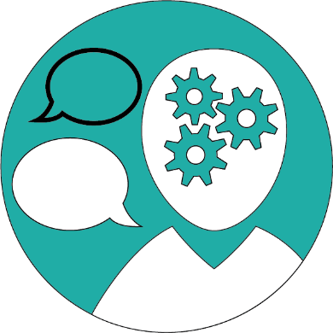
Feedback and Reflection

Learning about learning
Timely and consistent feedback contextualises and grounds the relevance of learning and allows students and teachers to engage with reflective processes. Enabling this mode ensures learning is relevant, differentiated and aimed at improving outcomes.
Learners consider the method of collecting and presenting information and mastery of a skill. The aim is to seek feedback on the work they produce using learning targets, scaffolds and rubrics, with the purpose of iterative improvement.
When activated successfully, accountability is built into this process, as work can be reviewed and suggestions actioned in a timely and efficient manner. By activating the reflection mode, we build students’ capacity to critically evaluate their own work and develop their critical metacognitive skills.
This mode allows students and teachers to engage with reflective processes to ensure learning is personalised and aimed at improving outcomes. It can also help learners master the process of unlearning and relearning. It involves students being actively engaged in assessment for learning, setting personal learning goals and tracking their progress towards achieving them.
Reflection on learning and feedback can be independent, collaborative, or part of a teacher-student or student-student consultation.
Hattie’s research features strategies that enable feedback and reflection, including:
- Clear goal intentions - linking goal intentions to plans to overcome expected obstacles.
- Self-reported grades - students assessing the quality of their own work or their level of mastery over a given subject domain.
- Self-judgement and reflection - cultivating the ability to apply established standards to their own work; developing the ability to reflect on their learning and make self-judgements.
- Positive self-concept - fostering a sense of confidence and the development of a positive sense of self through cognitive appraisals, acceptance of feedback, benchmarking to difficult goals, and comparison to subject criteria.
- Self-efficacy - developing students’ confidence and positive self-perceptions through regular feedback and/or reflection.
Feedback from teachers or peers using learning management systems, collaborative Google Docs or digital communication tools such as Microsoft Teams can keep students connected while learning from home or in a blended learning environment.

Guided

Learning with an expert
Learners follow along with an expert as they model a process or skill until they reach mastery. Success is achieved when the learner demonstrates understanding of a new skill or ability.
Guided learning provides opportunity for differentiated instruction and can be delivered to large group, small group or individual learners. It should lead learners to increasing independence.
Guided learning also allows students to practice new knowledge with assistance from the expert. Experts are classified as ‘someone more knowledgeable’ and may be a teacher or other adult, student peer or content expert.
Teachers scaffold guided learning through assessment and differentiation determine the appropriate access point of learners. They lead practise and consolidation tasks, question and demonstrate to bridge gaps in student learning.
Hattie’s research identifies a range of practices that are linked to guided learning, including:
- Scaffolding - establishing, and gradually removing, forms of outside assistance that enable students to complete tasks.
- Teacher-learner relationships - developing strong relationships that encourage students to view teachers as a guide able to assist them in their learning.
- Explicitly choosing materials and designing tasks in accordance with cognitive development.
- Conceptual change programs - uncovering students’ preconceptions about a particular topic and using various techniques to help students change their conceptual framework.
- Cognitive task analysis - explicitly targeting key cognitive drivers of the behaviour of people engaged in particular tasks; shaping instructional approaches for inexpert students who require guidance through the learning process.
- Intelligent tutoring systems - using systems that aim to provide instructional advice on a one-on-one basis, and to develop and test models about the cognitive processes involved in instruction.
- Parental involvement - active participation by parents in the child’s schooling.
When students are learning from home or in a blended learning environment, experts (teacher or student) can guide learning through a live online platform such as Adobe Connect to enable synchronous guided learning for groups of students.

Explicit

Learning from an expert
Learners access expert knowledge in order to reach an understanding of new information and concepts. They synthesise and use that knowledge for another purpose or in another context.
This mode enables all students to engage with new concepts, processes or information in groups or individually
Explicit learning provides clear learning goals and intentions; a central focus point to direct learners and new content that can be delivered in a virtual or physical manner. It should be provided in short, sharp sessions. Teachers may have a more direct role where they are the expert and model new learning or provide new information.
Hattie’s meta-analyses point to several high-impact strategies related to explicit instruction. Key examples include:
- Clear goal intentions - linking goal intentions to plans to overcome expected obstacles.
- Comprehensive instructional approaches for teachers - programs that are detailed, well-designed and resource-rich for explicitly supporting instructional approaches such as teaching complex discipline content, improving literacy and numeracy, or improving comprehension.
- explicit teaching strategies - employing a series of supports or scaffolds, whereby students are guided through the learning process with clear statements about the purpose and rationale for learning the new skill, clear explanations and demonstrations of the instructional target, and supported practice with feedback until independent mastery has been achieved.
- Teacher clarity - instruction that demonstrates effective organisation, explanation, examples, and guided practice; clearly communicating the intentions of the lessons (including skills, knowledge, attitudes, and values students need to learn) and success criteria.
- Teacher credibility - students regarding their teacher as a credible authority based on their perceptions of competence, trustworthiness, and perceived caring.
Use of consistently formatted ePub text-based filesExternal link, flipped learningExternal link videos, learning management systemsExternal link or self-paced online learning platforms like Google Classroom are useful tools that activate explicit learning to occur while students are learning from home or in a blended learning environment.

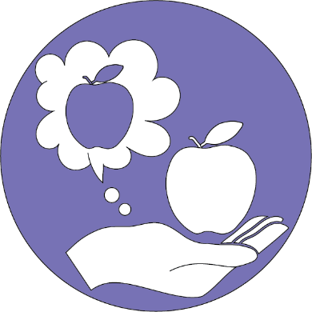
Demonstration

Students presenting learning
Learners share new understanding or skills with an appropriate audience. This may involve student presentations of learning, sharing products they have made or teaching their peers.
Students should have opportunity and experience in demonstrating their learning in different styles and platforms, and to a variety of audiences.
When used successfully, this mode builds students’ confidence and their communication skills using a range of tools.
Teachers can use demonstration as an assessment opportunity, or to provide feedback and guidance for further learning.
According to Hattie, high-impact strategies associated with demonstration include:
- Reciprocal teaching - enabling students to learn and use cognitive strategies such as summarising, questioning, clarifying, and predicting; each student takes a turn at being “the teacher”, leading a dialogue, and checking their understanding of content through questioning and summarising.
- Inductive teaching - encouraging students to reason from observation, or to move logically from observing, testing, and comparing to articulating broad principles
- Concept mapping - creating graphic representations of course content.
- Teacher clarity - instruction that demonstrates effective organisation, explanation, examples, and guided practice; clearly communicating the intentions of the lessons (including skills, knowledge, attitudes, and values students need to learn) and success criteria.
Asynchronous platforms for students to share and interact with each other include podcasts made with Adobe Audition, digital presentations created using Google Slides, videos shared using Microsoft Stream, or live demonstrations on digital platforms like Microsoft Teams.

Experiential

Making, exploring and investigating
Experiential learning provides opportunity for students to explore, apply and acquire knowledge in a practical context. Students can do, make, explore and create using materials available to them.
This applied approach should enable students to think critically and creatively about theories, put into practice their design thinking skills, and apply problem-solving skills.
Students engage in hands-on activities to explore, challenge and test concepts. These activities can involve embodied learning, include a variety of resources and materials and encourage interdisciplinary learning.
Art, music, science experiments and drama activate this mode of learning, and enhance students’ creative and critical thinking skills.
Hattie’s meta-analyses suggest several high-impact strategies that can activate experiential learning, including:
- Inquiry-based teaching - students generating questions and seeking to develop answers through the accumulation of evidence.
- Asking questions or problems; small-scale investigations, or projects.
- Transfer strategies - students being able to make a spontaneous, unprompted, and appropriate transfer of a learning or problem-solving strategy from one context to another.
- Tactile stimulation - providing students with tactile stimulation and environment manipulation aimed to increase focus and time-on-task and attention.

Online coding, video editing (using Adobe Presenter) and virtual reality (using Google Expeditions) can be explored digitally while design and make or upcycling projects can provide kinaesthetic opportunities.
These strategies can be useful when students are learning from home or in a blended learning environment.

Independent

Students learning by themselves
Independent learning fosters student self-regulation and affords students the opportunity to develop the skills of lifelong learning. Students have agency in making decisions about their learning through self-organisation, time management and selecting appropriate learning approaches and tools.
Teachers provide clear learning intentions and success criteria. They empower learners to take risks and meet challenges and responsibilities.
Successful independent learners review intended outcomes, set personal goals, monitor their progress, have regular teacher or peer check-ins and evaluate and reflect on their work.
Hattie’s meta-analyses reveal a number of strategies that support independent learning:
- Elaboration and organisation - committing information and skills to memory.
- Help seeking - adaptively seeking external support for an academic or mental health problem.
- Deliberate practice - extensively engaging in relevant practice activities in order to improve particular aspects of performance.
- Field independence - fostering a learner’s interest in abstract subject matter, learns individualistically, and thinks through problems impersonally.
- Positive self-concept - fostering a sense of confidence and the development of a positive sense of self through cognitive appraisals, acceptance of feedback, benchmarking to difficult goals, and comparison to subject criteria (and not other students).
- Self-efficacy - developing students’ confidence and positive self-perceptions through regular feedback and/or reflection.
- Prior achievement - developing reflection tasks that encourage students to integrate prior knowledge with present learning activities.
- Deep motivation and approach - encouraging students to desire mastery, deeper understanding, or high degree of investment to have a fuller understanding overall of the topic.
Teachers can scaffold this progress by setting clear success criteria and learning goals for students learning from home or in a blended learning environment. This can be achieved by engaging in regular check-ins on progress by using digital communication tools like Google Classroom.

