Collaborative Professionalism

Activity: Read the Collaborative Professionalism article excerpt and discuss briefly in groups. Then, using post-it notes, brainstorm collaborative teaching practices you have seen in your school. Write each one on its own post-it note (e.g. one might read “pilot marking of Year 12 essays”). Stick your post-it notes on this A3 poster in the appropriate quadrant, using the article excerpt to guide you. Then discuss how each practice could be modified or extended or improved to make it better resemble collaborative professionalism. Outline the updated version of each practice on its post-it note and move the post-it note to the new appropriate quadrant (with the aim that most/all post-it notes move top right).
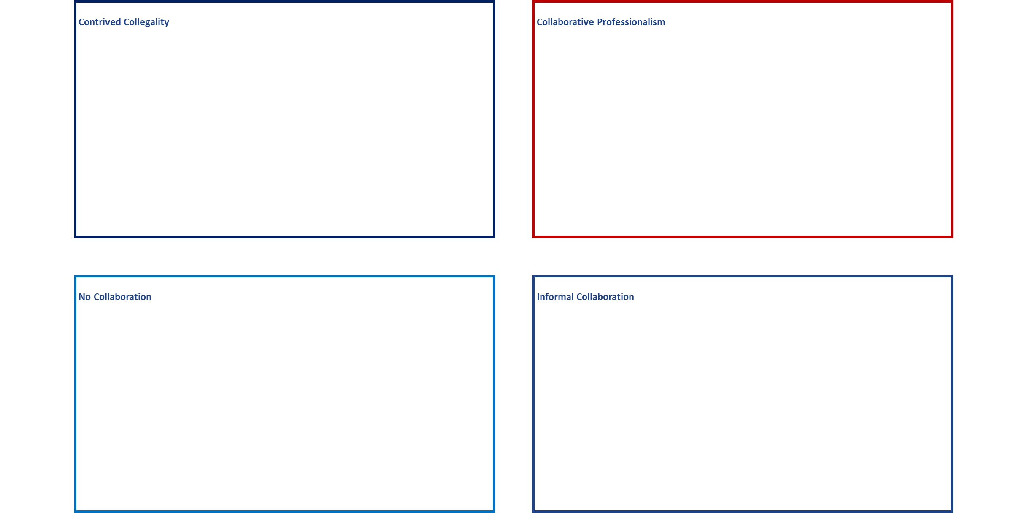
High
Low TRUST High
Low
PRECISION

