Co-teaching model
The common approaches in the co-teaching model:
- One teach, one observe – one teacher delivers all instruction while the other gathers observational data on students – whole group or 1:1. Prior to the lesson, co-teachers need to decide on the roles (instructor/observer), what types of data they are seeking to collect and informs future instruction and adjustments for specific students. However, both teachers don’t contribute equally so it doesn’t fully utilise all the skills of both teachers.
- Station teaching – each teacher is responsible for a different aspect of the lesson where students are divided into 2 or 3 groups (with 2 groups teacher-led and one independent) where either students travel from station to station or the work rotates around. Strengths are this is an efficient way to coordinate responsibility for producing and delivering learning materials, draw on teacher strengths, can differentiate the groups/work offered; but requires efficient time management, needs more floor space and management of students working independently.
- Parallel teaching – class is divided into 2 groups, each teacher teaches their group at same time as the other on same content/skill, enabling increased differentiation. Strengths are that students may get more individual attention, increased student participation and can allow for student groupings to be determined more consciously by the teacher; on the down side it requires good time management, may be harder to invisibly differentiate the work offered and both teachers have to be equally strong in delivering the same skill/activity.
- Alternate teaching – one teacher works with the bulk of the students on one aspect of the lesson/skill etc while the other works with a smaller group on a totally different lesson. Therefore 2 fundamentally different lessons are happening at same time in same space. The pro’s are that differentiation is facilitated, remedial work can be offered and a higher control of behaviour in the smaller group; the are con’s it may ‘pigeon hole’ certain students if consistently taught separately thus reducing the impact of inclusion.
- Teaming – both teachers actively share leadership of the whole class, this is a more common image of co-teaching; requires a very high functioning relationship with high levels of trust in order to work together to plan and deliver the same lesson to the same group of students with equal responsibility for the lesson. This is of benefit as 2 teachers provide perspective on issues/activities and can allow for teaching 2 strategies simultaneously, but this kind of rapport can’t be faked or rushed.
- One teach, one assist – one delivers the lesson to the whole class while the other manages behaviour or assists individual student as needed eg. of SLSOs.

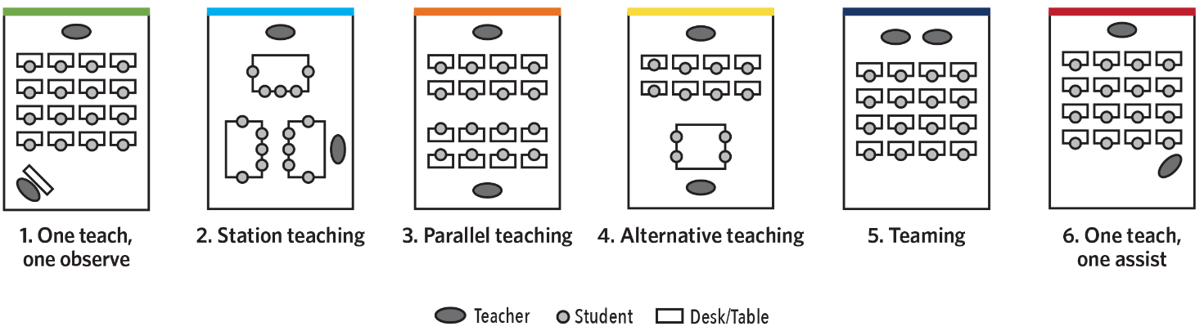
Diagram based on Dr Marilyn Friend and Dr Lynne Cook’s (2010). Interactions: Collaboration skills for school professionals (6th ed.). Boston: Pearson.

