2. Building our Understanding

Focus questions:
- What is our belief about the importance of the case for change?
- What could we do better and differently in our teaching practice to support students to thrive in this future world?

Pre-activity recap
Reflect on last session – revisit the ideas that you collated on the compass.
- North – need to know. What else do you need to learn about this topic?
- East – excited. What excites you about the possibilities for change explored in the text?
- West – worries. What concerns you about the vision for learning and teaching explored in the text?
- South – steps. What steps will your team take next?

Activity 2: Taking our school’s temperature - where are we now?
You should now have come to a deeper understanding of the changing future of jobs, the impact of AI on the world and specifically education, along with desirable skill sets for graduates to thrive throughout their lives. Now make closer links between the research and what changes may be appropriate for your school community.
Complete the optional reading - CESE “5 Essentials for Effective Evaluation” https://www.cese.nsw.gov.au/publications-filter/5-essentials-for-effective-evaluation You may like to use the appendix to plan your objectives.
Make a list of relevant data that will enable you to tell the story of your school community, understand school performance and culture. You may like to use Tell Them From Me, SCOUT, Nationally Consistent Collection of Data (NCCD), the Family-Schools Partnership Framework and/or a school-designed survey (of teachers, students, parents/community).
Interpret and analyse your data to make some judgments.
What themes have emerged? This will ensure that you can target your efforts around an action plan. You may like to use the below modified SWOT concept map to bring order to your findings.

Activity 3: Communicating your findings with the school community
AITSL’s the “Australian Professional Standard for Principals” outlines the steps to accomplish behaviour change. It begins with gaining an awareness of the benefits of change as the “vital first step” and then building understanding of the nature of the change “increases the likelihood of the change occurring” (AITSL “Australian Professional Standards for Principals and the Leadership Profiles”, 2015 and updated 2019, p. 9).
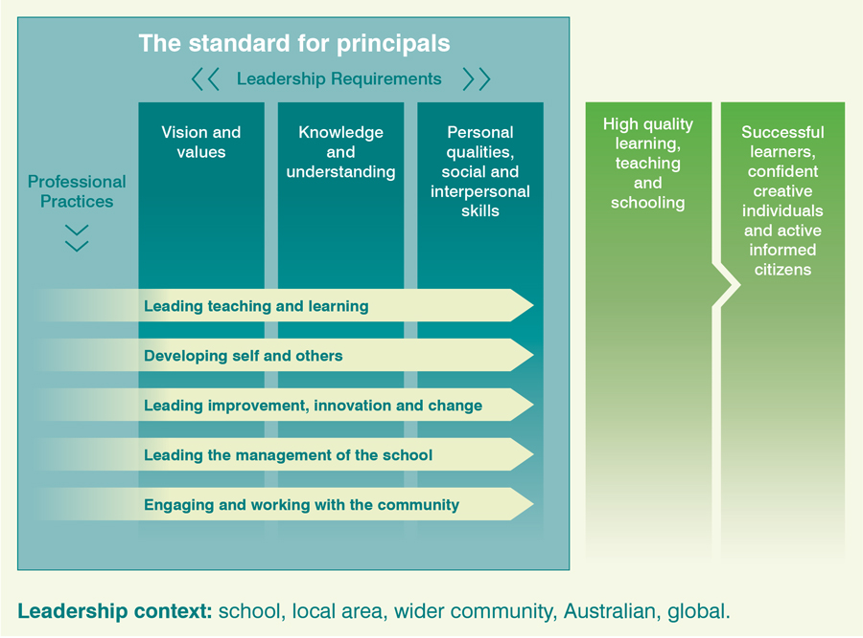
In drawing on the three leadership requirements, the purpose of the change is clear, understandable and related directly to the core business of the school – focusing on student needs and positively impacting outcomes.
1. Concept map, from https://www.aitsl.edu.au/tools-resources/resource/australian-professional-standard-for-principals
As a team, you might share research/data findings with teachers at staff meetings and the school community via presentations, newsletter, school website and/or forums.
In some cases it may require a clearer idea of what the school wants as a final outcome for their graduates is needed in order to make a case for change.
SLEC’s ‘Graduate Profile’ activity enables a focus on the skills and characteristics desired in graduates. Complete this activity with groups of teachers, students and parents/carers. In this way all voices will be heard in determining the beliefs and aspirations of the whole community so that the values are authentic and meaningful. Ensure that each group understands why their input is important – the final set of values will guide decisions about school life.
School leaders may find it helpful to complete the following optional reading - “Education Plus - a white paper” Fullan & Scott on 6Cs to support completion of ‘Graduate Profile’ https://michaelfullan.ca/wp-content/uploads/2014/09/Education-Plus-A-Whitepaper-July-2014-1.pdf

Instructions for the Graduate Profile activity
- In groups, discuss a list of qualities, characteristics and capabilities that the ideal graduate of your school will have:
- What cognitive competencies will they have?
- What intrapersonal competencies will they have?
- What interpersonal competencies will they have?
- Divide the participants into groups of 6-8 people.
- Discuss the three categories of qualities with the whole group. If needed provide some suggestions to start the discussion, such as creativity and innovation for cognitive; adaptability and grit for intrapersonal; and entrepreneurship and social skills for interpersonal.
- Once working in groups, each member writes their ideas on post-it notes.
- The group reads over all the ideas, gathering them into the three categories and deleting any duplicates. Put the selected post-it notes on the poster on the next page. The group may like to further annotate the poster with drawings and symbols.
- Use a gallery walk to share and build upon ideas of other groups (for guidance using the gallery walk protocol, access the Digital Learning Selector: https://app.education.nsw.gov.au/digital-learning-selector/LearningActivity/Card/555#.YO-672Xw_TI.link). Display all the posters around the room, the whole group walks around reading all the posters.
- Either hold a whole group discussion to decide which qualities to include on one final poster or have each group decide on which three of its own post-its to contribute to the whole group poster.
- Use the final poster to create a cohesive graduate profile.

Optional additional activity for Portrait of a Graduate:
Select one characteristic identified in the activity:
- To what extent is this currently evidence in your school? How do you know?
- What are the key requirements to enable this to be present?
- What can your team do the enable all of these characteristics/capabilities to be more fully present in order to maximise impact?

Graduate Profile
What are the characteristics, qualities and skills that our graduates will need to be successful? Identify key cognitive capacities, personal and interpersonal characteristics. Annotate this scaffold with key words and phrases, symbols and drawings to build a graduate profile.

Activity 4: Creating momentum for change
Schools need to work creatively to effectively support young people to meet the challenges of a global community where the pace of change increases constantly. Employer’s desired skills for graduates have never been greater or more diverse. According to Muhammad and Cruz, school leaders need to find new ways to effectively work in their system and face “hardened expectations of educators and parents …. [by] changing school culture” (Muhammad and Cruz “Time for Change – 4 essential skills for transformational school and district leaders”, Solution Tree Press, 2019, pp.13-14).

Creating a set of core attributes
As school leaders leverage the understanding built by exploring the nature of work and the future, reflection on their school community and their hopes for graduates to create a focal point for action.
One way to do this is to create a set of core attributes built on the findings from the ‘Graduate Profile’ activity. Form a team of students, teachers and parents to design and publish new core attributes. Ensure that the whole community is included in building the portrait:
- The team can design a series of signs or posters, a school song or pledge for student leaders and hold a public vote. Support broad parent involvement by showcasing samples or voting on designs by having students collect votes at school events like assemblies, education week events or subject selection nights.
- Student leaders can write articles for the school newsletter or website.
- Hold a launch event involving breaking down the components of the core attributes via student speeches and/or have past graduates return to talk about the skills they currently need in their jobs and how these were developed.
Having a clear set of values for the school community and outcomes for students provides clarity. It supports making difficult decisions about school directions.

