School Assessment Tool
Reflection matrix

Purpose of the School Assessment Tool
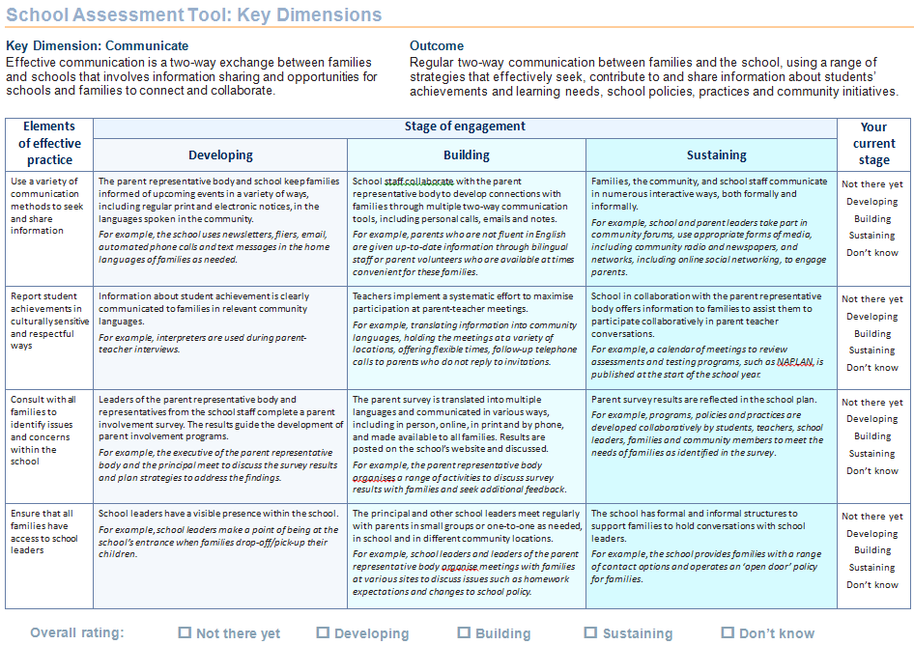
The School Assessment Tool has been developed to assist members of the school community (students, parents, staff and community members) to assess current family and community engagement practices and evaluate their progress when implementing strategies to strengthen engagement.
This Tool has been developed to align with the seven Key Dimensions of effective practice identified by the Family-School Partnerships Framework.
Schools can use the School Assessment Tool to identify where they are placed on a continuum of engagement.

Elements of the School Assessment Tool

1. The seven Key Dimensions
The Family-School Partnerships Framework classifies activities into seven Key Dimensions. Each dimension includes a statement about the importance of the activity’s contribution to strengthening engagement with families and the community to improve student learning outcomes. The example below shows the “Communicate” Key Dimension.

2. Outcome statement
Outlines what a school could achieve when it reaches a sustainable stage of development. The outcomes can be measured or evaluated through the collection of data or observation.

3. Elements of effective practice
Includes examples of effective practice to achieve the intended outcome for the dimension.

4. Stages of engagement
Represents the three stages, Developing, Building, Sustaining, within each dimension as a continuum of engagement.

5. The matrix
Combines the descriptions for each element of effective practice, with examples, across the three stages of engagement.

6. Overall rating for dimension
On completion of the matrix schools can clearly identify and rate their current stage of engagement for the Key Dimension.

Getting started
Effective use of this tool requires participation by the whole school community—students, families, school staff and members of the community.
The Individual Assessment can be completed by a range of members of the school community. The responses to the Individual Assessment are then combined to achieve a group consensus using the Group Assessment sheet.
It is important to gain an understanding of how the school is operating across the seven Key Dimensions before taking action.

Individual assessment
Step 1: Start with the first element of effective practice, then read the descriptions for the three stages (developing, building or sustaining) to get a sense of what school practice might be at the different stages.
When reading the statements, ask: Is this statement true of my school?
- If you do not have enough information or knowledge to properly answer, select Don’t know at the end of the row.
- If you think the statement is not true or there is little evidence of this practice, select Not there yet.
- If you think the statement is true, read on to the next stage of engagement.
Step 2: Again ask the question again: Is this statement true of my school?
- If you answer No, then go back to the previous stage and select Developing at the end of the row. Move down to the next element of effective practice.
- If you answer Yes, read on to the next stage of engagement.
- If you answer No, then go back to the previous stage and select Building at the end of the row. Move down to the next element of effective practice.
- If you answer Yes, select Sustaining at the end of the row and them move down to the next element of effective practice.
Step 3: Repeat steps 1 and 2 for each of the elements of effective practice.
Step 4: Decide the overall rating for the dimension. Look to see which stage (Developing, Building or Sustaining) has the most selections, or whether Not there yet or Don’t know reflects your thinking. Then select the appropriate box in the Overall rating at the bottom of the page.
Note: in the event that two stages have the same number of selections, draw on your knowledge of other practices in the school related to this dimension to help determine the most appropriate stage.

Step 5: Reread the statement in the Key Dimension and use the Analysing current practice proforma
Record any effective practices that are already evident at your school; note those that are working well and those that need more work. This information will be useful when determining priorities for further action.
Analysing current practice proforma (page 12)
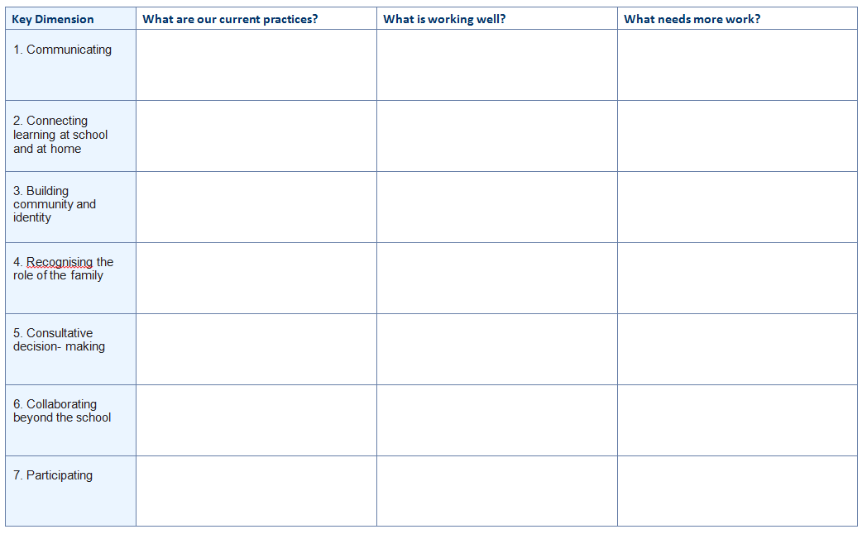
Step 6: Use the Individual assessment sheet proforma
Shade the column of the selected dimension to indicate the stage you think your school community has reached. You can shade all or part of the column, for example, a quarter, half or two thirds to give a clearer idea of where you think your school community is now.
Individual assessment sheet proforma (page 13)

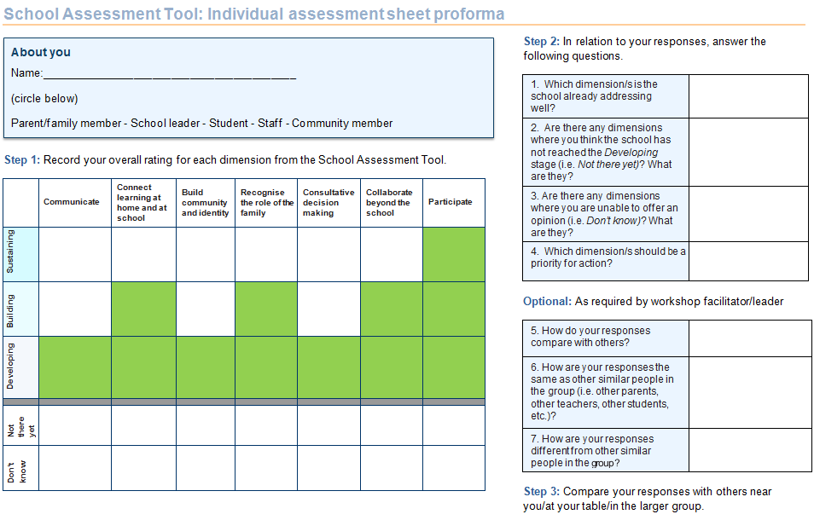

Step 7: Repeat Steps 1 to 6 for the other Key Dimensions.
Step 8: Complete questions 1 to 4 on the individual assessment sheet.
Step 9: Be prepared to share your responses with the larger group.
Step 10: (Optional task) Complete questions 5 to 7.
Note: throughout this tool, the stages of engagement build on each other, assuming that good practices at the Developing and Building stage will progress to the Sustaining stage.

Group consensus (for facilitators/workshop leaders)
Group assessment proforma (page 14)

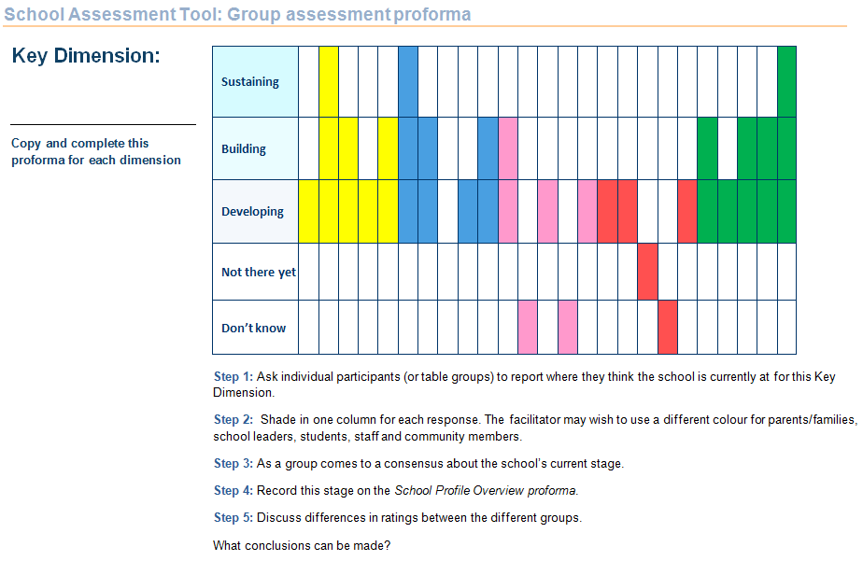

School profile overview proforma (page 15)

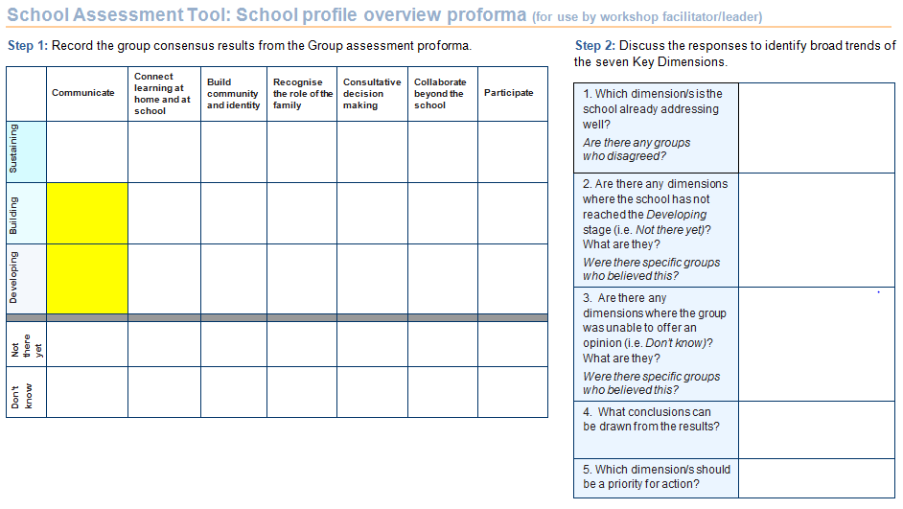

Step 1: Collate the responses onto the Group assessment proforma (page 14). The facilitator may wish to use a different colour for each group.
Step 2: Discuss the range of perceptions and come to a consensus about the school’s current stage for the dimension: Not there yet, Developing, Building, Sustaining or Don’t know.
Step 3: Record this stage on the School profile overview proforma (page 15).
Step 4: Discuss differences in ratings between the different groups. What conclusions can be made?
Step 5: Repeat Steps 1 to 4 for the remaining six dimensions.
Step 6: As a group respond to questions 1 to 5.
Alternative process: Depending on the size of the group and time available, facilitators may prefer to set up a continuum along the floor with markers to indicate Don’t know, Not there yet, Developing, Building and Sustaining.
Step 1: For each Key Dimension, invite participants to take a position along the continuum. If time permits, participants could be invited to share the reason for their position and given the opportunity to change their position.
Step 2: Discuss the range of perceptions and come to a consensus about the school’s current stage for the Key Dimension: Not here yet, Developing, Building, Sustaining or Don’t know.
Step 3 to Step 6: as above.

Key Dimension: Communicate
Effective communication is a two-way exchange between families and schools that involves information sharing and opportunities for schools and families to connect and collaborate.

Outcome
Regular two-way communication between families and the school, using a range of strategies that effectively seek, contribute to and share information about students’ achievements and learning needs, school policies, practices and community initiatives.

Elements of effective practice | Stage of engagement: Developing | Stage of engagement: Building | Stage of engagement: Sustaining | Your  current stage
Use a variety of communication methods to seek and share information | The parent representative body and school keep families informed of upcoming events in a variety of ways, including regular print and electronic notices, in the languages spoken in the community.  For example, the school uses newsletters, fliers, email, automated phone calls and text messages in the home languages of families as needed. | School staff collaborate with the parent representative body to develop connections with families through multiple two-way communication tools, including personal calls, emails and notes.  For example, parents who are not fluent in English are given up-to-date information through bilingual staff or parent volunteers who are available at times convenient for these families. | Families, the community, and school staff communicate in numerous interactive ways, both formally and informally.  For example, school and parent leaders take part in community forums, use appropriate forms of media, including community radio and newspapers, and networks, including online social networking, to engage parents. | Not there yet Developing Building Sustaining Don’t know
Report student achievements in culturally sensitive and respectful ways | Information about student achievement is clearly communicated to families in relevant community languages.  For example, interpreters are used during parent-teacher interviews. | Teachers implement a systematic effort to maximise participation at parent-teacher meetings.  For example, translating information into community languages, holding the meetings at a variety of locations, offering flexible times, follow-up telephone calls to parents who do not reply to invitations. | School in collaboration with the parent representative body offers information to families to assist them to participate collaboratively in parent teacher conversations.  For example, a calendar of meetings to review assessments and testing programs, such as NAPLAN, is published at the start of the school year. | Not there yet Developing Building Sustaining Don’t know
Consult with all families to identify issues and concerns within the school | Leaders of the parent representative body and representatives from the school staff complete a parent involvement survey. The results guide the development of parent involvement programs.  For example, the executive of the parent representative body and the principal meet to discuss the survey results and plan strategies to address the findings. | The parent survey is translated into relevant community languages and communicated in various ways, including in person, online, in print and by phone, and made available to all families. Results are posted on the school’s website and discussed.  For example, the parent representative body organises a range of activities to discuss survey results with families and seek additional feedback. | Parent survey results are reflected in the school plan.  For example, programs, policies and practices are developed collaboratively by students, teachers, school leaders, families and community members to meet the needs of families as identified in the survey. | Not there yet Developing Building Sustaining Don’t know
Ensure that all families have access to school leaders | School leaders have a visible presence within the school.  For example, school leaders make a point of being at the school’s entrance when families drop-off/pick-up their children. | The principal and other school leaders meet regularly with parents in small groups or one-to-one as needed, in school and in different community locations.  For example, school leaders and leaders of the parent representative body organise meetings with families at various sites to discuss issues such as homework expectations and changes to school policy. | The school has formal and informal structures to support families to hold conversations with school leaders.  For example, the school provides families with a range of contact options and operates an ‘open door’ policy for families. | Not there yet Developing Building Sustaining Don’t know

Key Dimension: Connect learning at home and at school
Connections between families and school that promote student learning and high expectations from both teachers and family contribute to students’ success at school.

Outcome
Families and the school share responsibility for student learning and wellbeing. They work together to create positive attitudes to learning, develop shared understandings of how children learn and learning programs, and build on families’ capacity to support learning at home.

Elements of effective practice | Stage of engagement: Developing | Stage of engagement: Building | Stage of engagement: Sustaining | Your  current stage
Provide multiple opportunities for all families and teachers to discuss students social and academic progress | Families can contact teachers in person or through email, notes or phone and receive a timely response. Teachers make personal contact with all parents at the beginning of the year to establish positive relationships.  For example, teachers send home a welcome note to all families inviting their comments and providing an email address or phone number. | Teachers and school leaders regularly contact families with positive news as well as concerns about their children. Families have an easy way to communicate with teachers on a regular basis.  For example, the school communicates online, posting information about student work and school wide events. Parents can ask general questions or organise meetings with teachers as needed. | Teachers and families discuss students’ individual learning styles, family cultural experiences, strengths, and academic and personal needs, then develop learning goals to support academic success at school and at home.  For example, families, students and teachers are involved in the development of individual learning plans for students. | Not there yet Developing Building Sustaining Don’t know
Support families to participate in their child’s learning | The school offers programs to parents that will help promote learning in the home.  For example, the school offers a series of year-based workshops to help parents better understand what is taught in mathematics. | The school provides families with tools to support student learning in a variety of settings.  For example, information packages for families of students participating in community based programs include strategies to support their child’s learning. | Teachers and parent representative body leaders plan regular family learning events at school and community locations.  For example, workshops on a variety of topics that help parents support learning are held in a community centre during lunchtime or at a childcare centre late in the afternoon. | Not there yet Developing Building Sustaining Don’t know
Develop families’ understanding of learning programs and expected learning outcomes | Student work is displayed throughout the school in a way that shows how it meets academic standards.  For example, teachers display students’ writing tasks to demonstrate how students used skills such as clear and concise language, proper spelling and grammar. | Teachers explain to families what students are learning throughout the year and what good work looks like for the student’s stage of learning.  For example, teachers maintain portfolios of student’s work for parents to view at key times during the year. | Teachers and families have regular, scheduled discussions about how each school program or activity links to student learning.  For example, teachers and families discuss the various curriculum outcomes addressed by student participation in the annual school concert. | Not there yet Developing Building Sustaining Don’t know
Smooth transitions for students and families at key points in the education continuum | Programs are conducted to help prepare students and families for the next step in schooling.  For example, a primary school collaborates with the local high school to implement a transition program for families and students. | School staff, students and parent leaders reach out to new students and their families, offering an orientation to the school, opportunities to participate in school activities and to meet other students and families.  For example, student leaders assign ‘buddies’ to new students and the parent representative body connects families to parent mentors. | A transition program developed by the parent representative body leaders and school staff helps families feel connected and remain involved as their children progress through school.  For example, information sessions explain how expectations, teaching approaches and learning skills change from primary to junior secondary to senior secondary and to tertiary study. | Not there yet Developing Building Sustaining Don’t know

Key Dimension: Build community and identity
Inclusive school policies, practices and programs build a welcoming culture of inclusion and belonging for all families that reflects and respects diversity within the school’s community.

Outcome
School policies and practices, learning activities and community building initiatives have built a welcoming culture of inclusion and belonging that reflects and respects the diversity within the school community.

Elements of effective practice | Stage of engagement: Developing | Stage of engagement: Building | Stage of engagement: Sustaining | Your  current stage
Develop strong relationships with all families | Families are made feel welcome when they enter the school.  For example, a staff member, using the family’s home language, gives new families information about the school and a tour of the school. | Family volunteers work in the front office to provide information and support to families and schools.  For example, a help desk is established and staffed by family volunteers, fluent in various community languages. | The school employs a liaison officer to help families and community members become more engaged in school.  For example, the liaison officer calls new families to invite them to attend school activities, offering to pick them up or meet them at the front of the school. | Not there yet Developing Building Sustaining Don’t know
Create a family-friendly atmosphere | The school is easy for visitors to navigate, and the community knows what is going on at the school.  For example, signs clearly direct visitors to the front office and an outside noticeboard keeps the community informed of upcoming events. | The school is welcoming to families and community members.  For example, morning tea playgroups and other activities scheduled for families to meet staff, learn what is happening at school and celebrate children’s learning. | The school is a welcoming place where all families can drop in and connect with school staff and other families.  For example, the school’s parent representative body and staff together create a family resource centre, with information in various languages about the school and community, and staffed with family volunteers or school staff. | Not there yet Developing Building Sustaining Don’t know
Facilitate connections between families | The school takes steps to help families get to know other families in the school.  For example, the school organises welcome social events throughout the year and maintains a school blog for parents to stay connected. | The parent representative body provides opportunities for families to get to know each other.  For example, the parent representative body’s newsletters provide information about its activities and strategies to help families build networks. | The parent representative body and school staff jointly develop programs to help parents connect with each other.  For example, the parent representative body collaborates with school staff to jointly plan an orientation program at the beginning of the year and distributes a calendar and school-wide directory with staff and parent listings. | Not there yet Developing Building Sustaining Don’t know
Respect and celebrate the diversity within the school community | Teachers ensure that resources, classroom lessons and activities are inclusive of the diversity within the school community.  For example, Aboriginal Education committees are involved in planning and implementing Aboriginal studies and education programs. | School, families and community members work together to celebrate the diversity within the school.  For example, the school community coordinates a whole school approach to a specific day for celebrating the diversity within the school, such as on Harmony Day. | School collaborates with families and community agencies representing all backgrounds to improve cultural understandings.  For example, the school and community jointly deliver cultural awareness training for staff. | Not there yet Developing Building Sustaining Don’t know

Key Dimension: Recognise the role of the family
School staff, parents and families recognise and appreciate their complementary roles in educating children and support and encourage collaborative learning in and out of school.

Outcome
School policies, practices and programs acknowledge and encourage families to be partners in their children’s education. The school recognises and builds on the capacity of families to assist and encourage their children’s learning in and out of school, and to support school goals, directions and ethos.

Elements of effective practice | Stage of engagement: Developing | Stage of engagement: Building | Stage of engagement: Sustaining | Your  current stage
Value and build on families’ knowledge of their children | Teachers consult with families at the beginning of the year about their child’s goals, strengths and talents.  For example, teachers send a written survey in relevant community languages home with the child. | The school uses information provided by families to develop individual learning plans and school activities.  For example, a teacher and local community member organise an after-school chess club for students and interested families. | Schools and families work together to develop strategies to use in the home to build on students’ strengths.  For example, successful programs are written up as a resource for other families and schools. | Not there yet Developing Building Sustaining Don’t know
Recognise and support the needs of families | Teachers consult with families to find out what would help them to support their child’s learning at home.  For example, teachers send a written survey in relevant community languages home with the child. | Schools provide culturally appropriate resources in relevant community languages to support families with their child’s learning.  For example, bilingual numeracy and literacy resources are developed and made available to families. | School, families and community agencies collaborate to develop a program of activities to support families.  For example, a series of information sessions and workshops on parenting related topics is delivered by professionals in the field of child development. | Not there yet Developing Building Sustaining Don’t know
Remove barriers to family involvement | School consults with families to find out what would help them to support their child’s learning at school or at home.  For example, the school uses staff and members of the parent representative body with multi-lingual skills to conduct a telephone survey of families. | The school uses the results of the consultation to develop strategies to remove barriers to family and community engagement in school activities.  For example, interpreter services, transport and childcare are made available. | The school collaborates with the parent representative body to review school and representative body policies and programs to ensure that barriers to family involvement are reduced.  For example, students are given choice of technology options, depending on availability, to complete learning tasks at home. | Not there yet Developing Building Sustaining Don’t know
Acknowledge the critical role families play in their child’s learning | Teachers find out what they can do to help parents support their children’s learning at home.  For example, homework sheets contain a brief outline of the expected outcomes of the tasks, and include opportunities for feedback from families and students. | Families have input into the school’s homework and assessment policy.  For example, homework and assessment tasks include interactive activities that show parents and families how they can use everyday activities to support learning. | The school makes its facilities and resources available outside school hours for homework and study.  For example, the school opens the library or computer room for afternoon or evening homework sessions where families can assist their children and gain support from teachers. | Not there yet Developing Building Sustaining Don’t know

Key Dimension: Consult on decision making
Families are represented in the school decision making processes through parent bodies, committees and other forums.

Outcome
School policies, practices and programs support families to be partners in their children’s education. Families are active and equal participants in decisions affecting their children in and out of school.

Elements of effective practice | Stage of engagement: Developing | Stage of engagement: Building | Stage of engagement: Sustaining | Your  current stage
Ensure that all families have a voice in decisions that affect their children | The school informs families about issues or proposed changes, and gives them an opportunity to respond.  For example, the school informs families in advance about changes in school activities, and offers contact information in case families have questions. | Family and community networks are used by the school to involve families in relevant decision making.  For example, the school has strong links with local community groups who provide advice about Aboriginal education or resources for culturally and linguistically diverse communities, and uses these links to reach out to families. | The school develops a policy to ensure that parents have an equal voice in all relevant decisions that affect children.  For example, the policy establishes a mechanism for parent initiated suggestions to change policy and review programs. | Not there yet Developing Building Sustaining Don’t know
Involve families and community members in whole-school planning and evaluation processes | The school uses a variety of strategies to seek input and involvement from families and community members.  For example, the school holds focus groups and community discussions throughout the community to identify issues. | The school and parent representative body hosts meetings with families and school personnel about programs and policies to gain their ideas and feedback.  For example, meetings are held at the school and community settings during the day and evening with interpreters as needed, to evaluate the school’s literacy program. | The school develops a policy to ensure that families and community members contribute to whole-school planning and evaluation processes.  For example, the diversity within the school community is reflected in the composition of all school committees. | Not there yet Developing Building Sustaining Don’t know
Develop an effective parent representative body that represents all families | The school encourages and supports the development of a parent representative body. School and parent leaders reach out to families who are not involved at the school to identify interests, concerns and priorities.  For example, parent leaders and school staff meet with families at community gathering spots and activities to build membership of the representative body. | Families from different cultural groups are supported to become involved in the activities of the school representative body.  For example, services such as interpreters during meetings, transportation and childcare are consistently provided for school-based events and school events held in community locations. | Parent committee leaders participate in a leadership induction program and attend ongoing leadership training.  For example, all parents interested in leadership roles in the school are invited to participate in a leadership induction program. | Not there yet Developing Building Sustaining Don’t know
Develop parent leadership capacity | Parent representative body leaders reach out to parents from diverse backgrounds and invite them to become involved in the school.  For example, leaders greet families as they bring their children to school events, and get their ideas for family learning activities. | Principal and parent representative body leaders recruit interested families from all backgrounds to volunteer, sit on committees and run for office.  For example, leaders survey families to find out their interests and skills, and follow up with opportunities where they might be able to help. | Parents are trained to co-facilitate parent workshops.  For example, parent leaders are trained in facilitation skills such as brainstorming, role-plays, and small group activities that encourage everyone to speak out. | Not there yet Developing Building Sustaining Don’t know

Key Dimension: Collaborate beyond the school
Develop partnerships with outside community agencies to help strengthen the ability of schools and families to support their children’s learning and development outcomes through shared and sustainable pathways.

Outcome
The school has strategically developed ongoing relationships with government and non-government agencies, community groups, businesses and other educational providers, which enhance learning opportunities and outcomes for students and families.

Elements of effective practice | Stage of engagement: Developing | Stage of engagement: Building | Stage of engagement: Sustaining | Your  current stage
Connect families and students with community resources | School leaders and teachers work with community agencies to identify resources and programs that support student learning.  For example, local officials and community leaders are invited to staff meetings to raise staff awareness of resources in the community. | Schools work with the parent representative body to identify families who may not know how to access community resources.  For example, a multi-lingual school handbook of community resources is developed and made available to families in the school’s resource centre and in community locations such as doctor’s surgeries, shopping centres, real estate agents and libraries. | School and community agencies help families better understand student options for additional resources to support their learning needs.  For example, a register of the groups and resources available in the community is developed and made available to families through the school and on the school’s website. | Not there yet Developing Building Sustaining Don’t know
Provide families with access to community resources | School staff members collect information for families about community resources.  For example, the school office and community room has a notice board and resource table with brochures about local training colleges, health services, sports teams, and service-learning opportunities. | The school distributes information in multiple languages on local services about available programs and resources.  For example, the school provides information about after-school tutorial programs provided at the local youth centre. | The school is an active member of regular inter-agency meetings where information is shared and strategies to promote services are developed.  For example, a community resource expo is held every year to provide information for families about their services. | Not there yet Developing Building Sustaining Don’t know
Create a community hub within the school | School staff and the parent representative body create a family-friendly space within the school where staff and parent volunteers inform families about services and programs and plan activities.  For example, the space is available to the community to provide on-site services. | Outreach courses for families and community members are conducted in school facilities at various times.  For example, the local TAFE uses the school’s computer room to conduct evening computer related courses for families and community members. | Government and non-government agencies locate on school grounds.  For example, the local council uses the school community room to conduct play groups for parents and pre-school age children. | Not there yet Developing Building Sustaining Don’t know
Build capacity in community organisations to engage with schools and support families | School staff reach out to community organisations and businesses seeking support for school activities.  For example, workers in local businesses support the school’s literacy program by volunteering an hour a week to listen to children read. | The school invites community leaders to be involved in school based programs.  For example, the school establishes a mentoring program with local businesses to work with students and families to help students achieve their goals. | School and parent leaders work with community and business representatives to develop programs to support student learning.  For example, the school community jointly develops submissions for funding for grants to enhance community engagement. | Not there yet Developing Building Sustaining Don’t know

Key Dimension: Participate
Participation by every member of the school community is valued and the time, energy and expertise families contribute supports their children’s learning and development.

Outcome
Families and community members contribute to the life of the school in ways that reflect their interests, skills, experience and capacity.

Elements of effective practice | Stage of engagement: Developing | Stage of engagement: Building | Stage of engagement: Sustaining | Your  current stage
Provide opportunities for families and community to participate in the life of the school | The school identifies opportunities for families and other community members to participate at all levels of the school’s operation.  For example, school staff surveys at the beginning of the year identify opportunities for family and community participation. | The parent representative body works with the school to organise formal participation programs.  For example, the parent organisation helps develop a volunteer program, sends invitation forms to all families in their home language, and coordinates the response. | The school participation program reaches out to all families and offers opportunities for volunteering and paid employment.  For example, leaders of the parent representative body make personal phone calls to parents from diverse backgrounds to connect them to volunteering and employment opportunities. | Not there yet Developing Building Sustaining Don’t know
Support families to engage in student learning activities | Teachers and families work together to develop resources to support teaching and learning programs.  For example, families and community members help to produce numeracy resource kits that can be used to support learning in the classroom or at home. | The school and parent organisation implement strategies to overcome barriers to family and community engagement in teaching programs.  For example, interpreter services, transportation and childcare facilities are made available. | The school organises a database of family and community skills, expertise and backgrounds, though which teachers can find resources.  For example, a parent who is writer is invited to be a Writer-in-residence during Literacy/Numeracy Week to work with students to improve writing skills. | Not there yet Developing Building Sustaining Don’t know
Train parents and community members as classroom helpers | Individual teachers train parents to work with students in their classroom.  For example, a Year 2 teacher trains a small group of parents to work one-on-one with students during reading lessons. | Families and community members are invited to participate in school-wide training programs to support teaching and learning programs.  For example, workshops on specific aspects of literacy and numeracy are offered throughout the year to build the capacity of families and community members to assist in classrooms. | The school partners with training providers to deliver accredited courses for families and community members.  For example, the school and local TAFE jointly train parents from diverse backgrounds as tutors to support students’ literacy and numeracy learning. | Not there yet Developing Building Sustaining Don’t know
Build the capacity of family and community members to lead the learning of others | Family and community members with an interest and experience in conducting workshops for other families are identified.  For example, school and parent representative body survey parents and community members and develops a database of workshop leaders. | School staff and the parent representative body develop parent leaders who help meet other parent’s learning needs.  For example, parent leaders are trained in workshop facilitation skills and strategies for working in culturally diverse settings. | School and parent leaders work with parents on a regular basis to develop ways to improve parents’ capacity to support student learning.  For example, the annual school plan includes strategies to build the capacity of family and community members to support the learning of others through ongoing parent leadership development. | Not there yet Developing Building Sustaining Don’t know

Key Dimension | What are our current practices? | What is working well? | What needs more work?
1. Communicate
2. Connect learning at school and at home
3. Build community and identity
4. Recognise the role of the family
5. Consult on decision making
6. Collaborate beyond the school
7. Participate

About you
Name:
(circle below)
Parent/family member - School leader - Student - Staff - Community member

Step 1: Record your overall rating for each dimension from the School Assessment Tool.
 | Communicate | Connect learning at home and at school | Build community and identity | Recognise the role of the family | Consult on decision making | Collaborate beyond the school | Participate
Sustaining
Building
Developing
Not
there
yet
Don’t
know
Step 2: In relation to your responses, answer the following questions.
1. Which dimension/s is the school already addressing well?
2. Are there any dimensions where you think the school has not reached the Developing stage (i.e. Not there yet)? What are they?
3. Are there any dimensions where you are unable to offer an opinion (i.e. Don’t know)? What are they?
4. Which dimension/s should be a priority for action?

Optional: As required by workshop facilitator/leader
5. How do your responses compare with others?
6. How are your responses the same as other similar people in the group (i.e. other parents, other teachers, other students, etc.)?
7. How are your responses different from other similar people in the group?

group?

Step 3: Compare your responses with others near you/at your table/in the larger group.

Key Dimension:

Copy and complete this proforma for each dimension
Sustaining
Building
Developing
Not there yet
Don’t know

Step 1: Ask individual participants (or table groups) to report where they think the school is currently at for this Key Dimension.
Step 2: Shade in one column for each response. The facilitator may wish to use a different colour for parents/families, school leaders, students, staff and community members.
Step 3: As a group comes to a consensus about the school’s current stage.
Step 4: Record this stage on the School Profile Overview proforma.
Step 5: Discuss differences in ratings between the different groups.
What conclusions can be made?

Step 1: Record the group consensus results from the Group assessment proforma.
 | Communicate | Connect learning at home and at school | Build community and identity | Recognise the role of the family | Consult on decision making | Collaborate beyond the school | Participate
Sustaining
Building
Developing
Not
there
yet
Don’t
know

Step 2: Discuss the responses to identify broad trends of the seven Key Dimensions.
1. Which dimension/s is the school already addressing well?
Are there any groups who disagreed?
2. Are there any dimensions where the school has not reached the Developing stage (i.e. Not there yet)? What are they?
Were there specific groups who believed this?
3. Are there any dimensions where the group was unable to offer an opinion (i.e. Don’t know)? What are they?
Were there specific groups who believed this?
4. What conclusions can be drawn from the results?
5. Which dimension/s should be a priority for action?

