Tables 2 ways
This lesson follows directly on from the previous Venn diagrams lesson. 2-way tables are discovered, and data is interchanged between 2-way tables and Venn diagrams. Venn diagrams and 2-way tables are compared to determine where each would be used.

Visible learning
This learning episode incorporates Path content.

Learning intentions
- To understand how data is represented using 2-way tables and Venn diagrams.
- To know when data should be presented using 2-way tables or Venn diagrams.

Success criteria
- I can interpret information presented in 2-way tables and Venn diagrams
- I can calculate probabilities from 2-way tables and Venn diagrams.
- I can compare 2-way tables and Venn diagrams.

Syllabus outcomes
A student:
- develops understanding and fluency in mathematics through exploring and connecting mathematical concepts, choosing and applying mathematical techniques to solve problems, and communicating their thinking and reasoning coherently and clearly MAO-WM-01
- solves problems involving Venn diagrams, 2-way tables and conditional probability
MA5-PRO-P-01
Mathematics K–10 Syllabus © NSW Education Standards Authority (NESA) for and on behalf of the Crown in right of the State of New South Wales, 2022.

Activity structure
Please use the associated PowerPoint Tables 2 ways to display images in this lesson.

Warm up
- Display slide 2 of the associated PowerPoint Tables 2 ways or draw each Venn diagram from Figure 1 for students to see.
Figure 1 – which one doesn't belong?
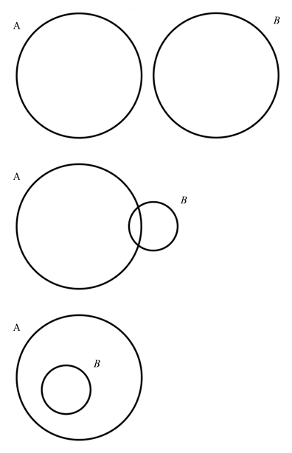
- In a Think-Pair-Share (bit.ly/thinkpairsharestrategy), students discuss which one doesn’t belong (bit.ly/wodb).
- Conduct a class discussion where students can share their thoughts.
There is no one correct answer for this. There are many different, correct ways of choosing which one doesn't belong.

Launch
- Facilitate a discussion about colds. Ask students:
- What do you do when you have a cold?
- Have you taken medicine for a cold?
- Have you heard of any ‘home remedies’?
- Explain to students that a common home remedy for a cold is thought to be vitamin C. Ask students if they’ve heard that you should drink orange juice when you have a cold.
Common sources of vitamin C include:
Citrus (oranges, kiwi, lemon, grapefruit), capsicum, strawberries, tomatoes, broccoli, brussels sprouts, cabbage, cauliflower, white potatoes.
A placebo is a ’dummy’ or ‘fake’ treatment. It's something that looks like real medicine but doesn't contain any active ingredients to treat a condition. It is commonly used in clinical trials to act as a control group.
- Draw Table 1 on the board or display slide 4 of the associated PowerPoint Table 2 ways.
Table 1 – incidence of common colds involving French skiers (Pauling 1971)
 | Cold | No Cold
Placebo | 31 | 109
Vitamin C | 17 | 123
- Explain to students that this is a 2-way table. The table shows data collected during a 2-week period on a sample of 280 French skiers. The study provided approximately half of the participants with Vitamin C supplements and the other half with placebo supplements and recorded if they contracted a cold or not.
- By referring to Table 1, in a Think-Pair-Share, students discuss:
- Why do you think this table is called a 2-way table?
- How can you confirm that 280 skiers were surveyed?
- How many people who were given vitamin C contracted a cold?
- How many skiers in total contracted a cold?
- Do you think vitamin C prevents you from getting a cold?
At this point students should be encouraged to discuss these prompts and compare answers across the class. No formulae or explicit teaching needs to happen yet.

Explore

2-way tables and Venn diagrams
- Students copy the 2-way table (Table 1) into their books and find each of the following probabilities:
- $P\left(Cold\right)$
- $P(\overline{Cold})$
- Ask students if there is anything they could add to the table to help them calculate probabilities.
We want students to identify that totals could make 2-way-tables easier to use.
- Show students slide 6 of the Tables 2 ways PowerPoint to formalise the setting out.
- Ask students to consider the Venn diagrams constructed in previous lessons. In a Think-Pair-Share have students discuss whether the data from the 2-way table could be presented in a Venn diagram.
- Challenge students to draw a Venn diagram to represent the information in the 2-way table. Students will need to consider:
- How many circles to draw.
- What to label each circle.
- Where to place each number.
- Are there numbers not included in the circles?
- Ask students to calculate the probabilities below, first using the 2-way table then the Venn diagram.
- $P(Cold∩Vitamin C)$
- $P(\overline{Cold}∩\overline{Vitamin C})$
- Randomly select students to explain how they reached each solution.
- Use a questioning strategy such as Pose-Pause-Pounce-Bounce (PDF 557 KB) (bit.ly/posepausepouncebounce) to ask students:
- If a Venn diagram and 2-way table can tell us the same information, why do we have both?
- If you were trying to share this information on colds and vitamin C on social media, would you choose a Venn diagram or 2-way table?
Venn diagrams are a visual representation of either categorical or quantitative data and can compare more than 2 data sets. 2-way tables only use quantitative data and focus on the relationship between two comparable data sets.

Summarise
- Present students with a driving question: ’Does having a bike make you more likely to ride to school?’
- Explain to students that we will create a 2-way table and Venn diagram to answer this driving question.
- Collect, by show of hands, the number of students who:
- have a bike?
- ride a bike to school?
- did not raise their hand to the previous 2 questions?
- Record the number of students in each category on the board.
- Present students with the 2-way table scaffold, Table 2, and ask them to put the data from the board, into the table.
Table 2 – have a bike and ride to school 2-way table
 | Have a bike | Don’t have a bike | Total
Ride to school
Don’t ride to school
Total
- In a Think-Pair-Share have students attempt to fill in the rest of the table. Teacher prompts will be dependent on the results of your class survey but could include:
- If the total number of students who have a bike and ride to school is greater than the number of students in the class – Where did the extra votes from come from? Where would they be in the table?
- What should the total in the bottom right corner add to?
- Are there any sections you expect to have zero students?
Data from a sample class has been included in the suggested solutions at the end of this document.
- Once students’ 2-way tables are completed, have students translate the information from the 2-way table into a Venn diagram. As students fill in a section of the Venn diagram, they should colour that section and its corresponding section in the 2-way table.
At the end of the activity students will have a 2-way table and Venn diagram that have the same colours representing corresponding table cells and regions, making it clear to students how the 2 representations are related.
- Have students answer the following questions in their books:
- What is the probability a student in this class has a bike?
- What is the probability a student in this class rides a bike to school?
- What is the probability a student doesn’t have a bike or ride to school?
- What is the probability a student has a bike or rides to school?
- Have students discuss in a Think-Pair-Share:
- Which representation was more helpful in answering the above probability questions?
- Does having a bike make you more likely to ride to school?

Apply
- Print and distribute Appendix A ‘If I know… then I know…’ to each student.
- Students work independently to complete each question. The questions require students to use what they know about Venn diagrams and 2-way tables to fill in missing values and calculate probabilities.

Assessment and differentiation

Suggested opportunities for differentiation
Warm up
- As this activity has no incorrect answers and is subject to opinion, all students should be able to contribute.
Launch
- If the context or numbers used pose difficulties for students, consider completing a class survey like the one found in the explore.
Explore
- There are 3 variations of notation for complementary probabilities used in the syllabus, $\overline{A}$, $A'$, and $A^{c}$. Expose students to all 3 and allow them to use the one they prefer.
- Within each activity students should be challenged to consider if there are any other permutations of probabilities that could be found. For example, $P\left(Cold∩\overline{Vitamin C}\right).$
- Venn diagram pieces could be cut out of paper so that students can physically construct the Venn diagram.
Summarise
- Conditional probability could be explored using both 2-way tables and Venn diagrams.
Apply
- Appendix A provides a sample of questions that challenge students to apply their knowledge of 2-way tables and Venn diagrams. Additional practice beyond this learning episode is recommended.
- Students could be presented with a probability and asked to write a question that produces the given probability.
- Conditional probability could be explored using both 2-way tables and Venn diagrams.

Suggested opportunities for assessment
Explore
- Review student’s Venn diagrams created from the 2-way table to check understanding of Venn diagrams.
- Monitor responses in class discussion to check student’s understanding of 2-way tables.
Summarise
- Collect the coloured in 2-way tables and Venn diagrams to check for understanding.
Apply
- Appendix A could be collected and used as summative assessment for this unit of learning.

Appendix A

If I know… then I know…
- 10 shapes are shown below but 2 shapes are missing.
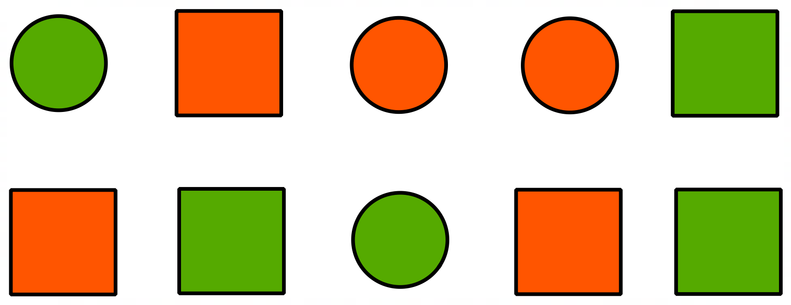
- Fill in the missing values in the 2-way table and use the table to determine what colour and shape the 2 missing shapes are.
 | Circle | Square | Total
Orange |  |  | 5
Green |  |  | 7
Total | 5 | 7 | 12
- Calculate each probability:
    - $P\left(Orange\right)$
    - $P(\overline{Orange})$
    - $P\left(Orange∩Circle\right)$
    - $P\left(Orange∪Circle\right)$
    - $P(\overline{Orange}∪\overline{Circle})$

- A science class conducted an experiment where they gave some sunflowers fertiliser to determine if it aided their growth. The results are recorded in the Venn diagram below; however, one section has not been filled in.
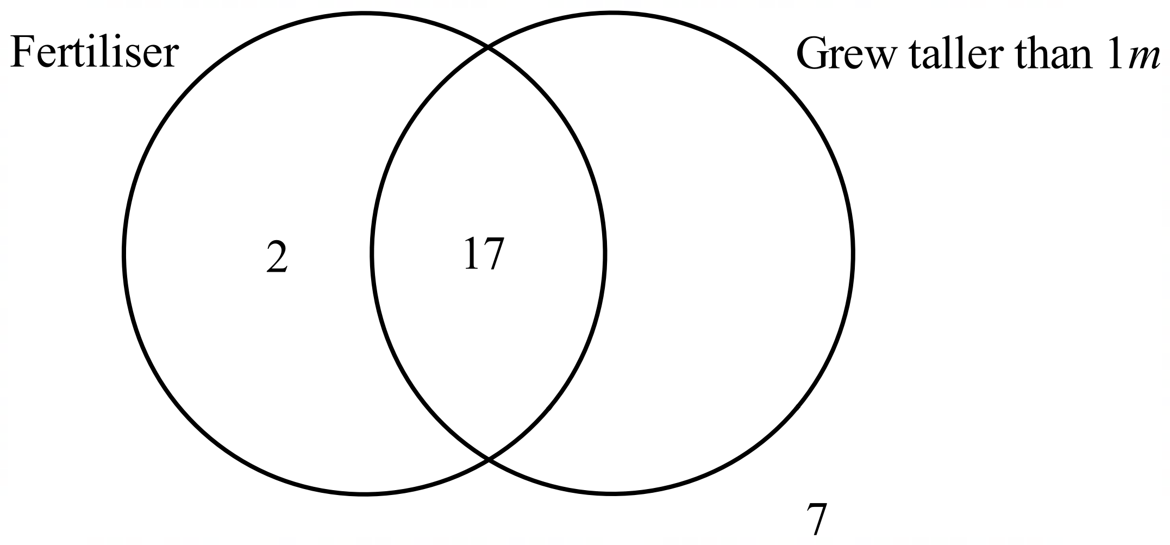
- Given that the class tested 30 sunflower plants, fill in the missing value in the Venn diagram.
- Calculate each probability:
    - $P\left(Grew taller than 1m ∩Fertiliser\right)$
    - $P$($\overline{Grew taller than 1m}$)
    - $P(Fertiliser∪Grew taller than 1m)$

- The Venn diagram below shows events A and B where $P\left(A\right)=0.3, P\left(A∪B\right)=0.6$ and $p\left(A∩B\right)=0.1$. The values $a, b, c$ are probabilities.
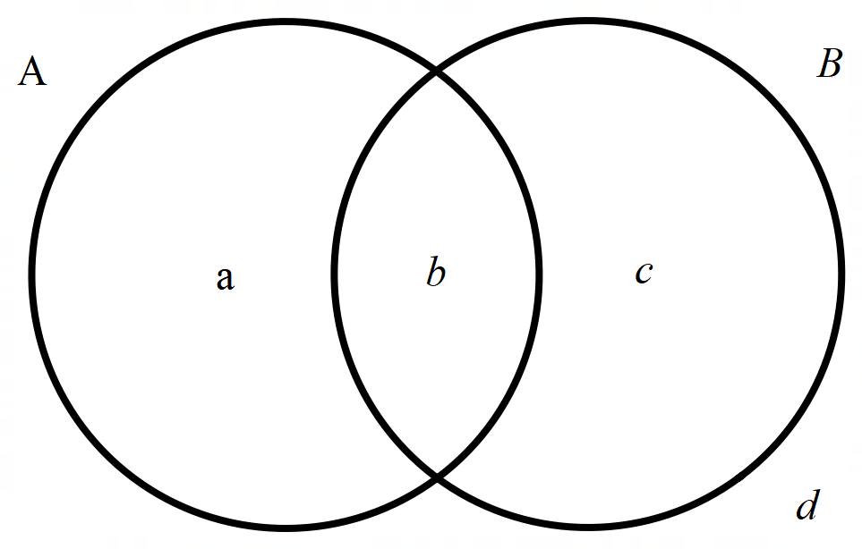
- Find the value of each pronumeral.
- Calculate $P(\overline{A∩B})$

Sample solutions

Driving question
- 28 have a bike
- 12 rides to school
- 3 didn’t raise their hand
- 32 students in the classroom.
 | Have a bike | Don’t have a bike | Total
Ride to school | 11 | 1 | 12
Don’t ride to school | 17 | 3 | 20
Total | 28 | 4 | 32

Appendix A – If I know… then I know…
- 10 shapes are shown below but 2 shapes are missing.

 | Circle | Square | Total
Orange | 2 | 3 | 5
Green | 3 | 4 | 7
Total | 5 | 7 | 12
- Calculate each probability:
    - $P\left(Orange\right)=\frac{5}{12}$
    - $P\left(\overline{Orange}\right)=\frac{7}{12}$
    - $P\left(Orange∩Circle\right)=\frac{2}{12}$
    - $P\left(Orange∪Circle\right)=\frac{8}{12}$
    - $P\left(\overline{Orange}∪\overline{Circle}\right)=\frac{7}{12}+\frac{7}{12}-\frac{4}{12}=\frac{10}{12}$ (Equivalent to adding $P(Green)+P(Square$) but in doing so $P(Green∩Square$) was counted twice)
- A science class conducted an experiment where they gave some sunflowers fertiliser to determine if it aided their growth. The results are recorded in the Venn diagram below; however, one section has not been filled in.
- Given that the class tested 30 sunflower plants, fill in the missing value in the Venn diagram.
Missing value is $30-26=4$
- Calculate each probability:
    - $P\left(Grew taller than 1m ∩Fertiliser\right)=\frac{17}{30}$
    - $P$($\overline{Grew taller than 1m})=\frac{9}{30}=\frac{3}{10}$
    - $P\left(Fertiliser∪Grew taller than 1m\right)=\frac{23}{30}$
- The Venn diagram below shows events A and B where $P\left(A\right)=0.3, P\left(A∪B\right)=0.6$ and $p\left(A∩B\right)=0.1$. The values $a, b, c$ are probabilities.
- Find the value of each pronumeral.
$$b=0.1$$
$$a=0.3-0.1=0.2$$
$$c=0.6-0.3=0.3$$
$$d=1-0.2-0.1-0.3=0.4$$
- Calculate $P\left(\overline{A∩B}\right)=1-0.1=0.9$

References
This resource contains NSW Curriculum and syllabus content. The NSW Curriculum is developed by the NSW Education Standards Authority. This content is prepared by NESA for and on behalf of the Crown in right of the State of New South Wales. The material is protected by Crown copyright.
Please refer to the NESA Copyright Disclaimer for more information https://educationstandards.nsw.edu.au/wps/portal/nesa/mini-footer/copyright.
NESA holds the only official and up-to-date versions of the NSW Curriculum and syllabus documents. Please visit the NSW Education Standards Authority (NESA) website https://educationstandards.nsw.edu.au and the NSW Curriculum website https://curriculum.nsw.edu.au.
Mathematics K–10 Syllabus © NSW Education Standards Authority (NESA) for and on behalf of the Crown in right of the State of New South Wales, 2022.
PennState Eberly College of Science (n.d.) ‘Notation & Structure’, PennState Eberly College of Science website, accessed 29 February 2024.

© State of New South Wales (Department of Education), 2024
The copyright material published in this resource is subject to the Copyright Act 1968 (Cth) and is owned by the NSW Department of Education or, where indicated, by a party other than the NSW Department of Education (third-party material).
Copyright material available in this resource and owned by the NSW Department of Education is licensed under a Creative Commons Attribution 4.0 International (CC BY 4.0) license.
This license allows you to share and adapt the material for any purpose, even commercially.
Attribution should be given to © State of New South Wales (Department of Education), 2024.
Material in this resource not available under a Creative Commons license:
- the NSW Department of Education logo, other logos and trademark-protected material
- material owned by a third party that has been reproduced with permission. You will need to obtain permission from the third party to reuse its material.
Links to third-party material and websites
Please note that the provided (reading/viewing material/list/links/texts) are a suggestion only and implies no endorsement, by the New South Wales Department of Education, of any author, publisher, or book title. School principals and teachers are best placed to assess the suitability of resources that would complement the curriculum and reflect the needs and interests of their students.
If you use the links provided in this document to access a third-party's website, you acknowledge that the terms of use, including licence terms set out on the third-party's website apply to the use which may be made of the materials on that third-party website or where permitted by the Copyright Act 1968 (Cth). The department accepts no responsibility for content on third-party websites.

