What’s on the packet is in the packet
Students interact with Venn diagrams in a range of contexts, from considering animals on packaging to grouping polygons based on geometrical properties. The tasks have a low floor and high ceiling approach, meaning all students should be able to engage in the activities while providing deep exploration for all students.
Students have the option to use at least one digital device per pair to interact with a Desmos activity during this lesson.

Visible learning
This learning episode incorporates Path content.

Learning intentions
- To be able to interpret Venn diagrams.
- To be able to construct Venn diagrams.

Success criteria
- I can describe what a Venn diagram represents.
- I can describe what each section of a Venn diagram represents.
- I can read and use set notation.

Syllabus outcomes
A student:
- develops understanding and fluency in mathematics through exploring and connecting mathematical concepts, choosing and applying mathematical techniques to solve problems, and communicating their thinking and reasoning coherently and clearly MAO-WM-01
- solves problems involving Venn diagrams, 2-way tables and conditional probability
MA5-PRO-P-01
Mathematics K–10 Syllabus © NSW Education Standards Authority (NESA) for and on behalf of the Crown in right of the State of New South Wales, 2022.

Activity structure
Please use the associated PowerPoint What’s on the packet is in the packet to display images in this lesson.

Launch
- Show students the video ‘Fun Maths Starter 14 Dave Gorman explains Venn Diagrams
(0:00–4:03)’ (bit.ly/vennvideo).
Alternatively, bring in several food products with an animal on the packet to introduce the activity without the video.
- Print Appendix A ‘Packet Venn’ on A3 paper. Place each sheet in a plastic pocket and place the pockets on walls around the room using adhesive putty, to act as vertical non-permanent surfaces (bit.ly/VNPSstrategy).
- Assign visibly random groups of 3 (bit.ly/visiblegroups) and position groups at a plastic pocket, with one whiteboard marker per group.
- Display Table 1, which is on slide 3 of the associated PowerPoint.
Table 1 – packet Venn
On the packet
Pig
Cow
Chicken
Dog
Duck
Cat
Bee
Human
Rabbit
Fish
Toucan
- Students attempt to assign each animal to a section of the Venn diagram. Allow between
5–10 minutes for this activity.
- Once groups are finished, have neighbouring groups compare answers.
- Initiate a sharing of ideas and reasoning using the Pose-Pause-Pounce-Bounce question strategy (PDF 557KB) (bit.ly/posepausepouncebounce) to have groups explain where they placed certain animals.

Explore
- Display Figure 1 which is on slide 5 of the associated PowerPoint.
Figure 1 – multiples Venn
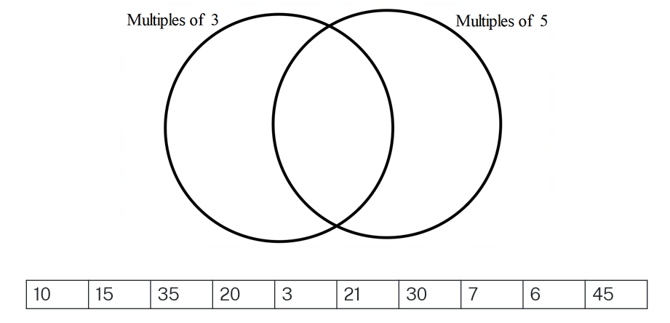
- Randomly select students to state where each number should be placed in the Venn diagram. Facilitate conversations as they arise, for example, when a student needs to place 15 in the intersection, or when a student needs to place 7 outside the 2 sets.
- Once the Venn diagram is filled, use a questioning strategy such as Pose-Pause-Pounce-Bounce to ask:
- What does the intersection of the 2 circles represent?
- Can we think of any other numbers that wouldn’t belong in either set?
- Display Figure 2 which is slide 6 of the associated PowerPoint.
Figure 2 – multiples Venn 2
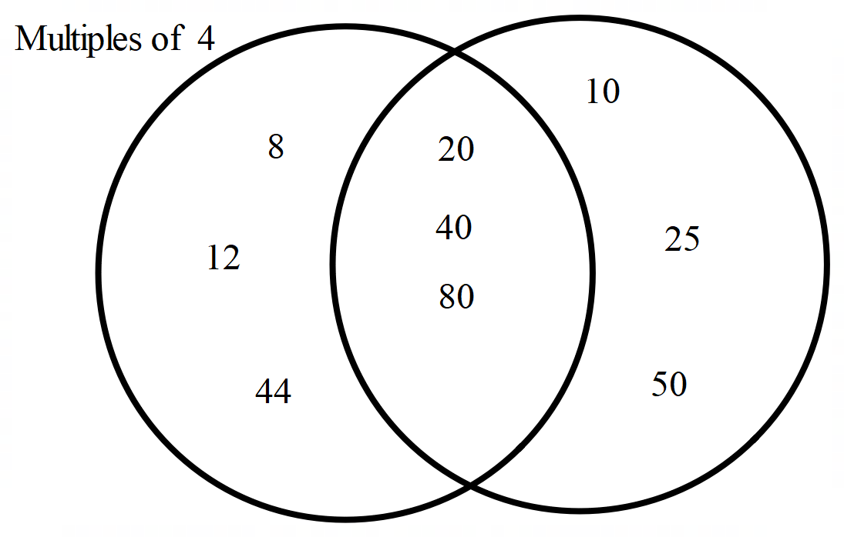
- In a Think-Pair-Share (bit.ly/thinkpairsharestrategy), students are to discuss:
- One set contains multiples of 4. What does the other set contain?
- What does the intersection of the 2 circles represent?
- Can we think of any numbers that wouldn’t belong in either set?
Students remain in their pairs for the next activity. Conversations should be encouraged. If students were to work independently, they are more likely to consolidate misconceptions.
- Distribute one copy of Appendix B ‘Exploring Venn diagrams’ to each pair.
- Pairs work through the 5 problems together.
- Have pairs combine with another pair to compare answers or display the sample solutions using slides 7–11 of the associated PowerPoint.

Summarise

Defining set notation
- Distribute one copy of Appendix C ‘Colour in Venn diagrams’ to each student.
- Display slides 13–25 of the associated PowerPoint to define each of the set notation examples below. For each example:
- Show the notation and have students predict what parts of the Venn diagram will be included.
- Show the answer.
- Students colour in the corresponding sections of their blank Venn diagram.
Examples:
- A
- $B$
- $A∩B$
- $A∪B$
- $\overline{A}$
- $\overline{A}∩B$
$∩$ means intersection – $A∩B$ means an elemnet belongs in both set A and set B.
$∪$ means union – $A∪B$ means an element belongs in either set A or set B or both.
$\overline{A}$ means the complement of A or not A.
- The last 2 are intentionally blank for students to create their own combinations.

Desmos card sort
- Before doing this activity, you will need to set up a Desmos classroom (bit.ly/desmosclassroomstrategy).
- With one device between pairs, direct students to the Desmos activity ‘Matching Venn diagrams’ (bit.ly/matchingvenn).
Appendix D ‘Cut and sort Venn diagrams’ can be printed and cut into individual cards to complete this activity without technology.

Apply
The following activity is from mathpickle.com. There is an accompanying YouTube video explaining the activity ‘Categorize Polygons (7:07)’ (bit.ly/categorizepolygons). The solution is shown at 5:00 in the video.
The letter codes (A, B1, B2 and so on) are there to make discussion and referring to regions of the Venn diagram easier. Students may choose to label shapes with the corresponding letter code, or they could draw the shapes on.
- Print Appendix E ‘Venn for polygons’ on A3 paper. Place each sheet in a plastic pocket and place the pockets on walls around the room using adhesive putty.
- Assign visibly random groups of 3 (https://bit.ly/visiblegroups) and direct groups to stand at a plastic pocket, with one whiteboard marker per group.
- Groups should be encouraged to check in with other groups and share ideas.
- Before concluding the activity, have nearby groups compare answers and discuss any shapes they had not agreed on.

Assessment and differentiation

Suggested opportunities for differentiation
Launch
- The purpose of the launch activity is to introduce Venn diagrams through a problem that does not have clearly correct answers. Instead, the focus is on students explaining their reasoning and deepening their understanding of the overlapping sections of the Venn diagram.
- As this activity is subject to opinion, all students should be able to make an attempt without fear of being incorrect.
- Students should be challenged to make connections with prior knowledge they have. If students have previously seen Venn diagrams they should be encouraged to share.
Explore
- If students require additional practice of divisibility tests, they are previously covered in Stage 4 Unit 5 – Multiplicative Thinking, Lesson 03 – Area models and divisibility tests.
- Challenge students to create their own Venn diagram similar to problem 4, that incorporates another topic they have explored in mathematics.
- Physical rings (string or hula hoops) can be laid out to create Venn diagrams on the floor. Students can then solve the problems by placing number cards in the Venn diagrams.
Summarise
- Students are interacting with 2 concrete representations, colouring in Venn diagrams and completing the card sort activity. These activities will provide opportunities for students to engage in discussions and play an active role in applying set notation.
Apply
- This learning episode aims to develop students’ understanding of the properties of Venn diagrams. Students should be exposed to further problems that consolidate set notation in practice.
- This learning episodes uses tasks with a low floor and high ceiling approach, meaning that students should be able to engage with Venn diagrams at their level. Whether that be discussing where an animal should be placed in the Launch activity or dealing with the complexities of Appendix E ‘Venn for polygons’.

Suggested opportunities for assessment
- Throughout each activity, student discussions are critical to students developing a strong understanding of Venn diagram properties and understanding set notation. Teachers can observe these conversations and prompt or challenge when necessary to assess students’ reasoning.
Summarise
- Teachers can use the Desmos teacher dashboard to assess the students’ card sort activity in real time or following the lesson. If there is a common incorrect answer, this could be used as a warm up to the following lesson.

Appendix A

Packet Venn
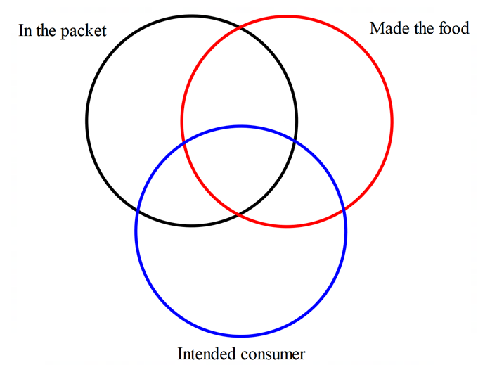

Appendix B

Exploring Venn diagrams
Problem 1
Write each number from the sample space in their corresponding sections of the Venn diagram.
Sample space {15, 10, 35, 20, 3, 21, 30, 7, 6, 45}

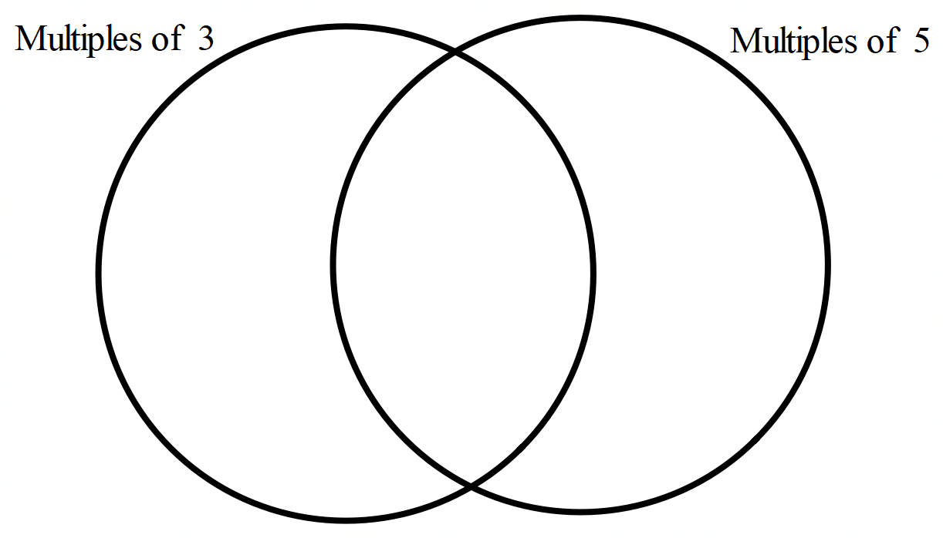
Problem 2
The Venn diagram below has been partially filled in. Write the remaining numbers from each set in their corresponding sections of the Venn diagram.
Set A = {1, 2, 3, 4, 5, 6, 7, 8}, Set B = {2, 4, 6, 8, 10, 12}
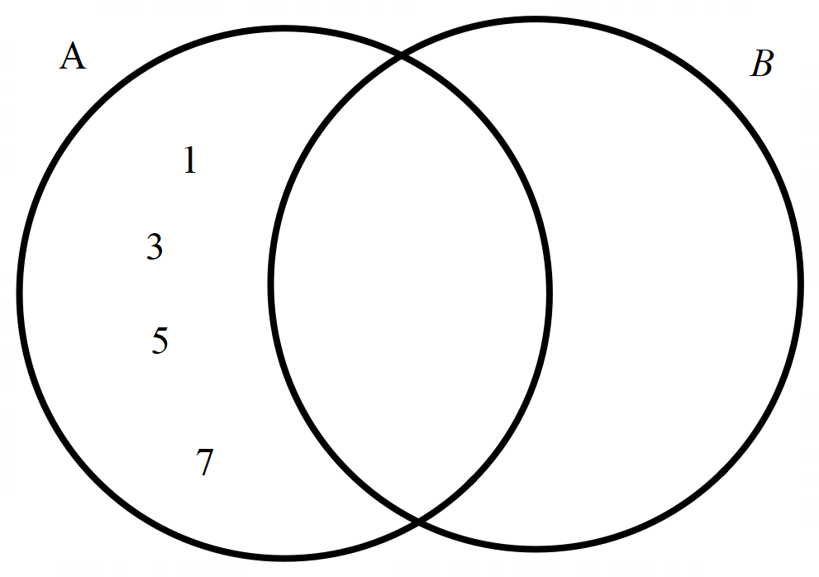
Problem 3
The Venn diagram below has been completed.
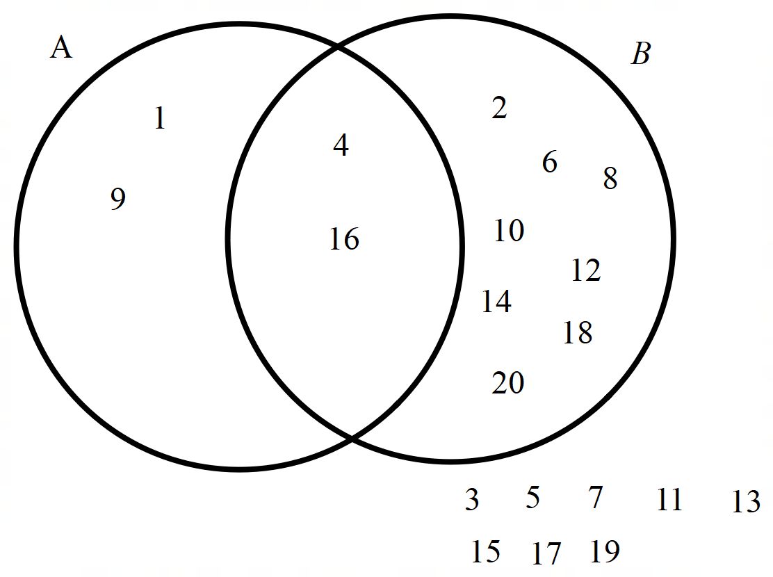
- List Set A.
- List Set B.
- Describe each set, in words.
- List the intersection of Set A and Set B?

Problem 4
Sort the shapes below into 2 sets, R and S, using a Venn diagram.
Set R contains shapes with a right angle.
Set S contains shapes with 4 sides.
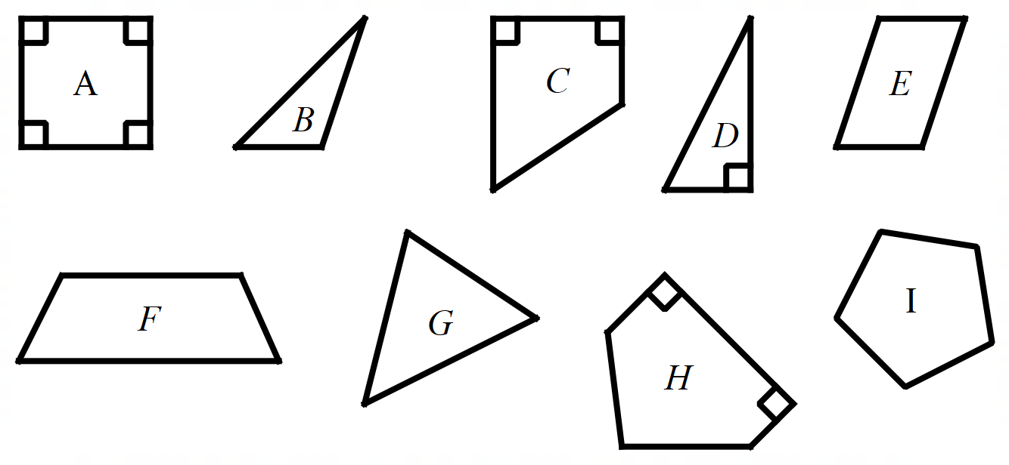

Problem 5
The Venn diagram below shows numbers sorted into 2 sets, Odd numbers and Even numbers.
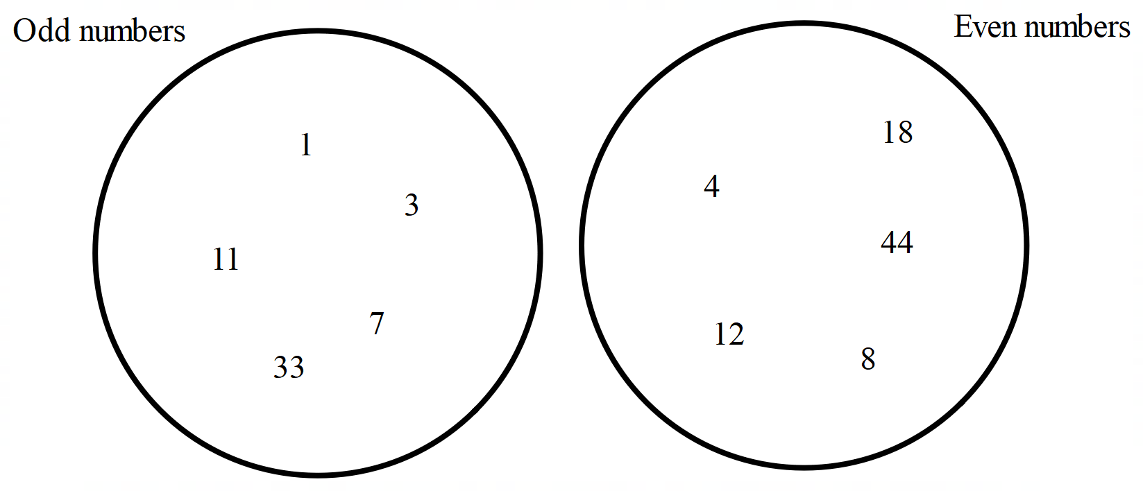
- Explain why there is no intersection between the 2 sets.
- These 2 sets are mutually exclusive. What do you think mutually exclusive means? Provide an example of mutually exclusive events.

Appendix C

Colour in Venn diagrams
$$A$$  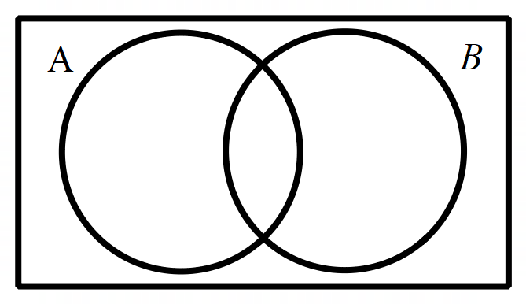 | $$B$$
$$A∩B$$ | $$A∪B$$
$$\overline{A}$$ | $${\overline{A}}^{}∩B$$

Appendix D

Cut and sort Venn diagrams
Venn diagrams
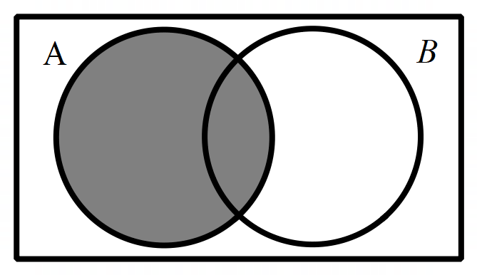 | 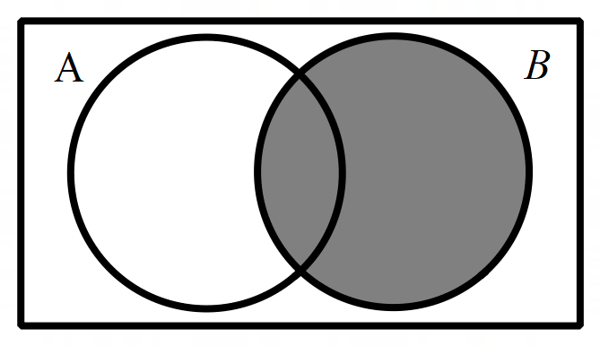
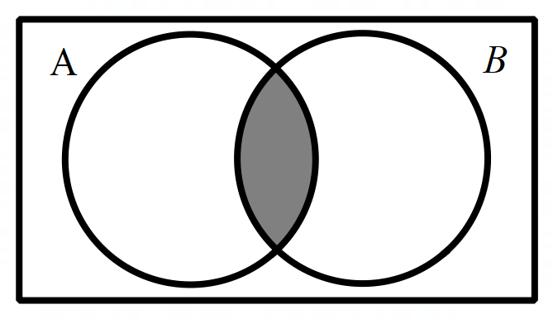 | 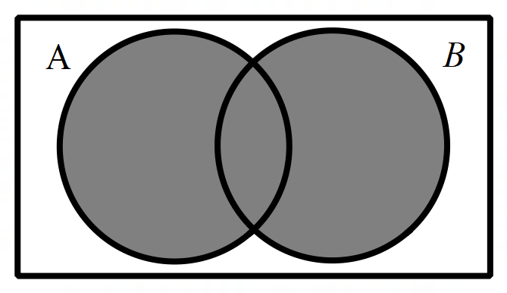
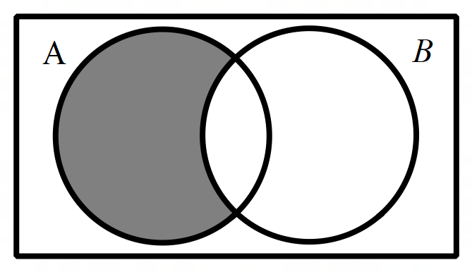 | 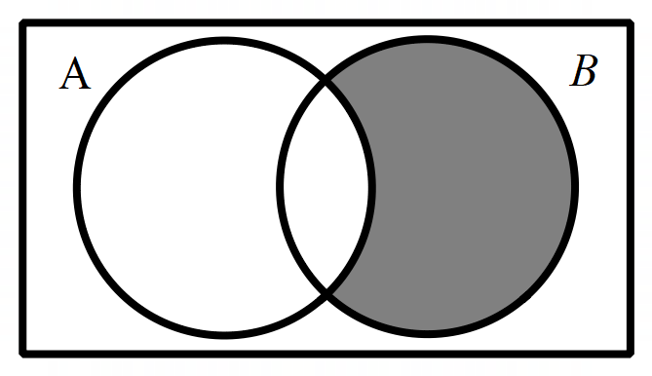
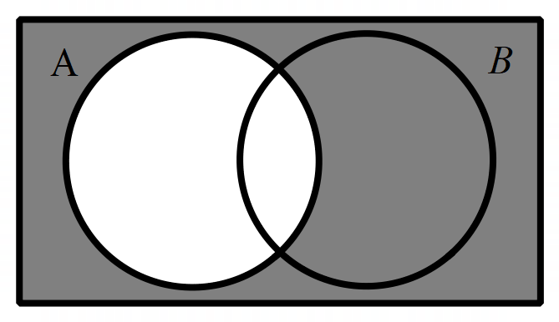 | 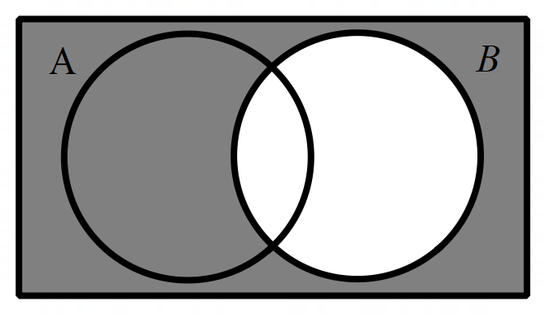
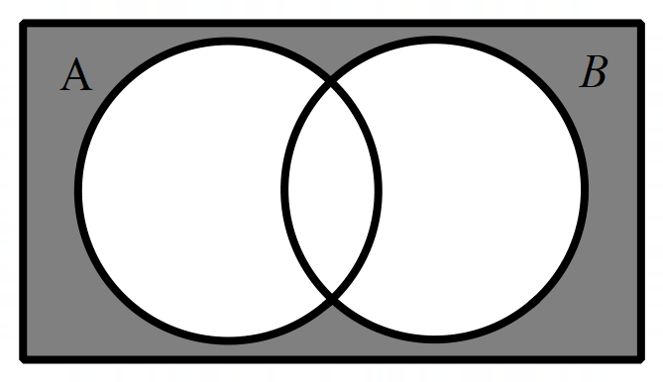 | 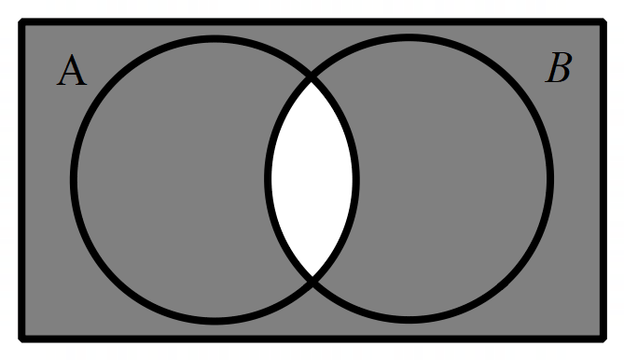
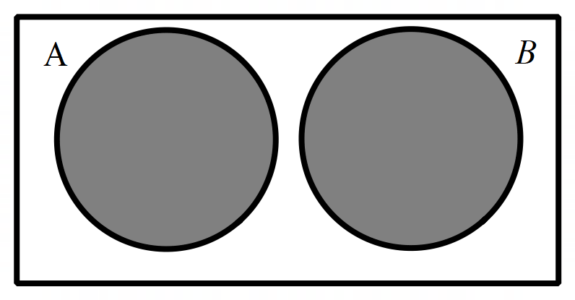

Set notation
$$A$$ | $$B$$
$$A∩B$$ | $$A∪B$$
$$A∩\overline{B}$$ | $$\overline{A}∩B$$
$$\overline{A}$$ | $$\overline{B}$$
$$\overline{A}∩\overline{B}$$ | $$(\overline{A∩B})$$
$$A∪B$$

Appendix E

Venn for polygons
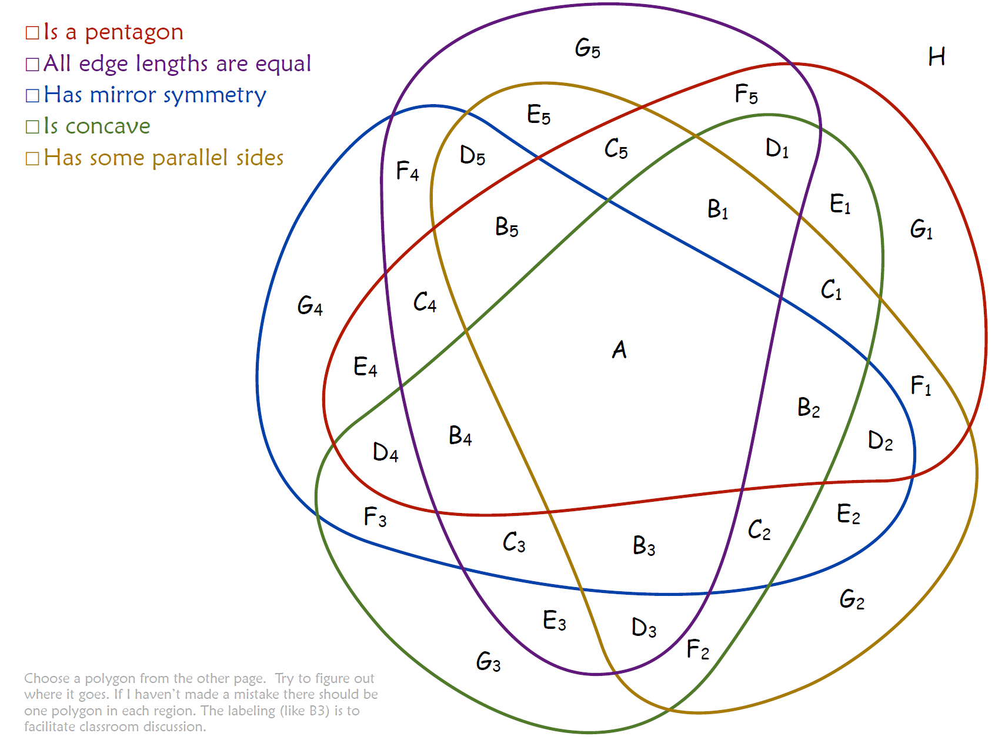
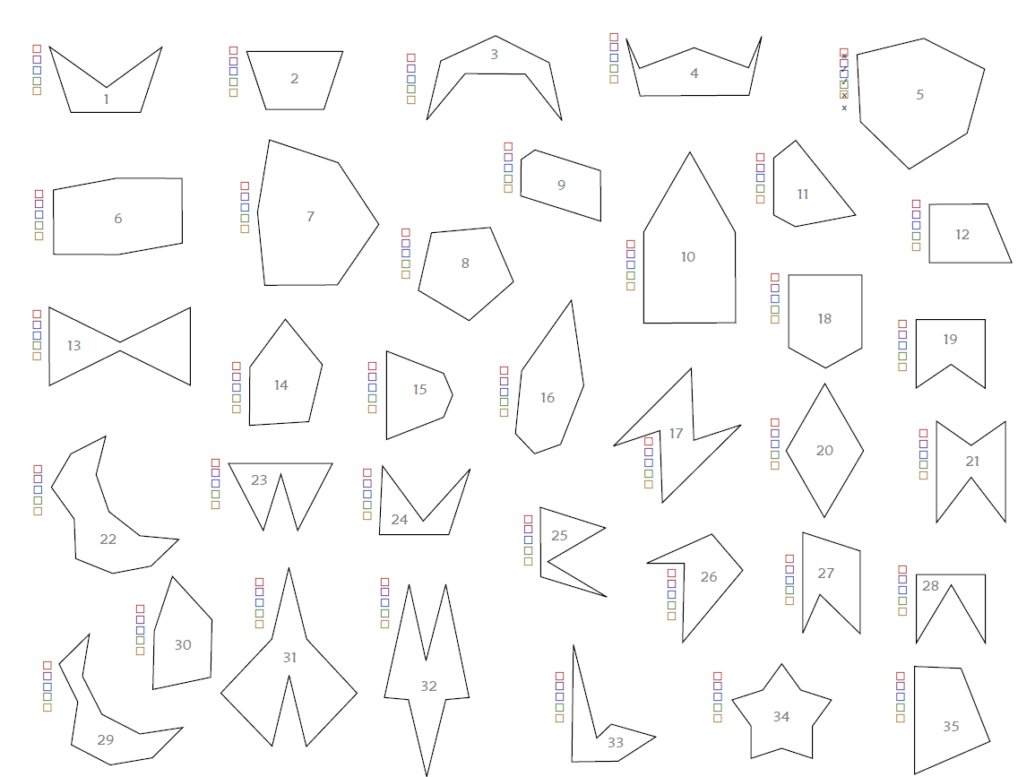

Sample solutions

Appendix A – packet Venn
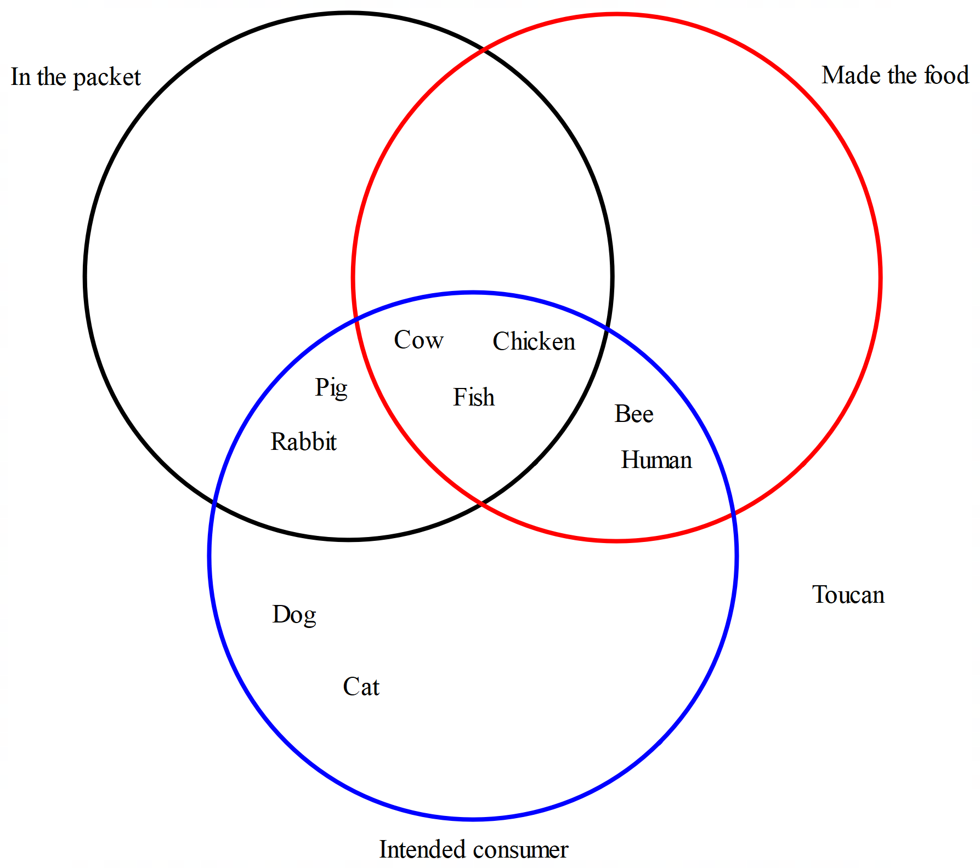
This is a sample solution, the point of this activity is that students are discussing what each section represents, not where they place each animal. Toucan is excluded as fruit loops is the only packet (at this point in time) with a toucan and doesn’t fit any category

Appendix B – exploring Venn diagrams
Problem 1
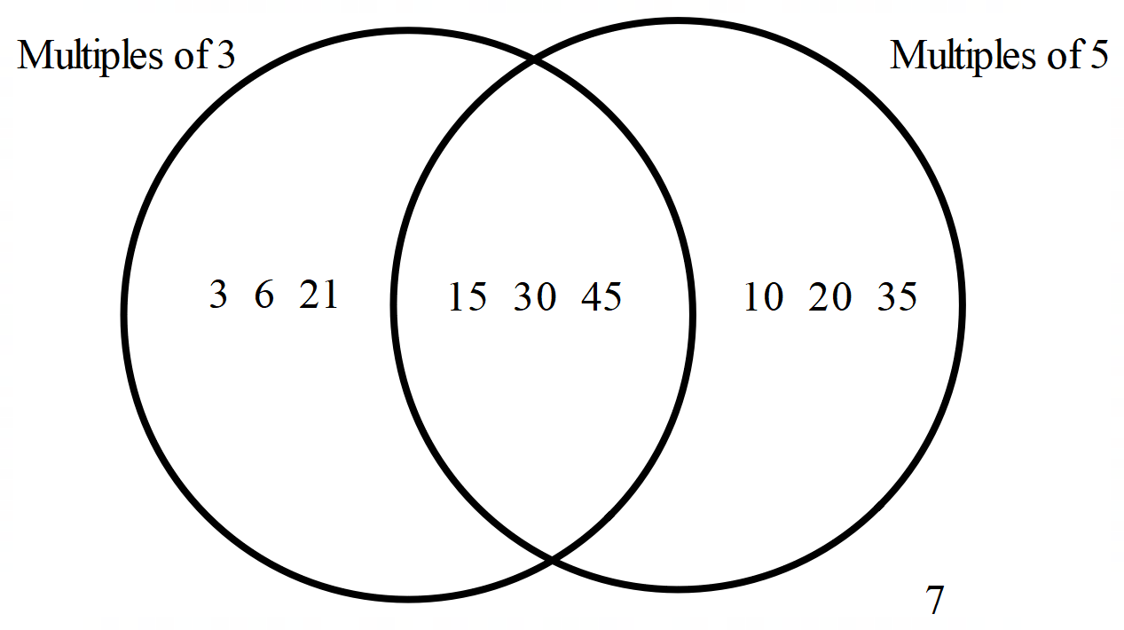
Problem 2
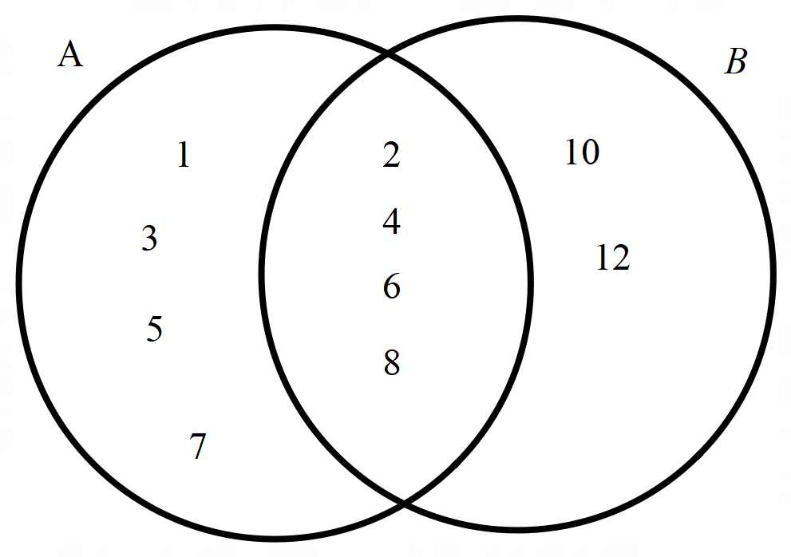
Problem 3
- Set A = {1, 4, 9, 16}
- Set B = {2, 4, 6, 8, 10, 12, 14, 16, 18, 20}
- Set A contains square numbers. Set B contains even numbers.
- Set A$∩$B (note students don’t know this notation yet) = {4, 16}
Problem 4
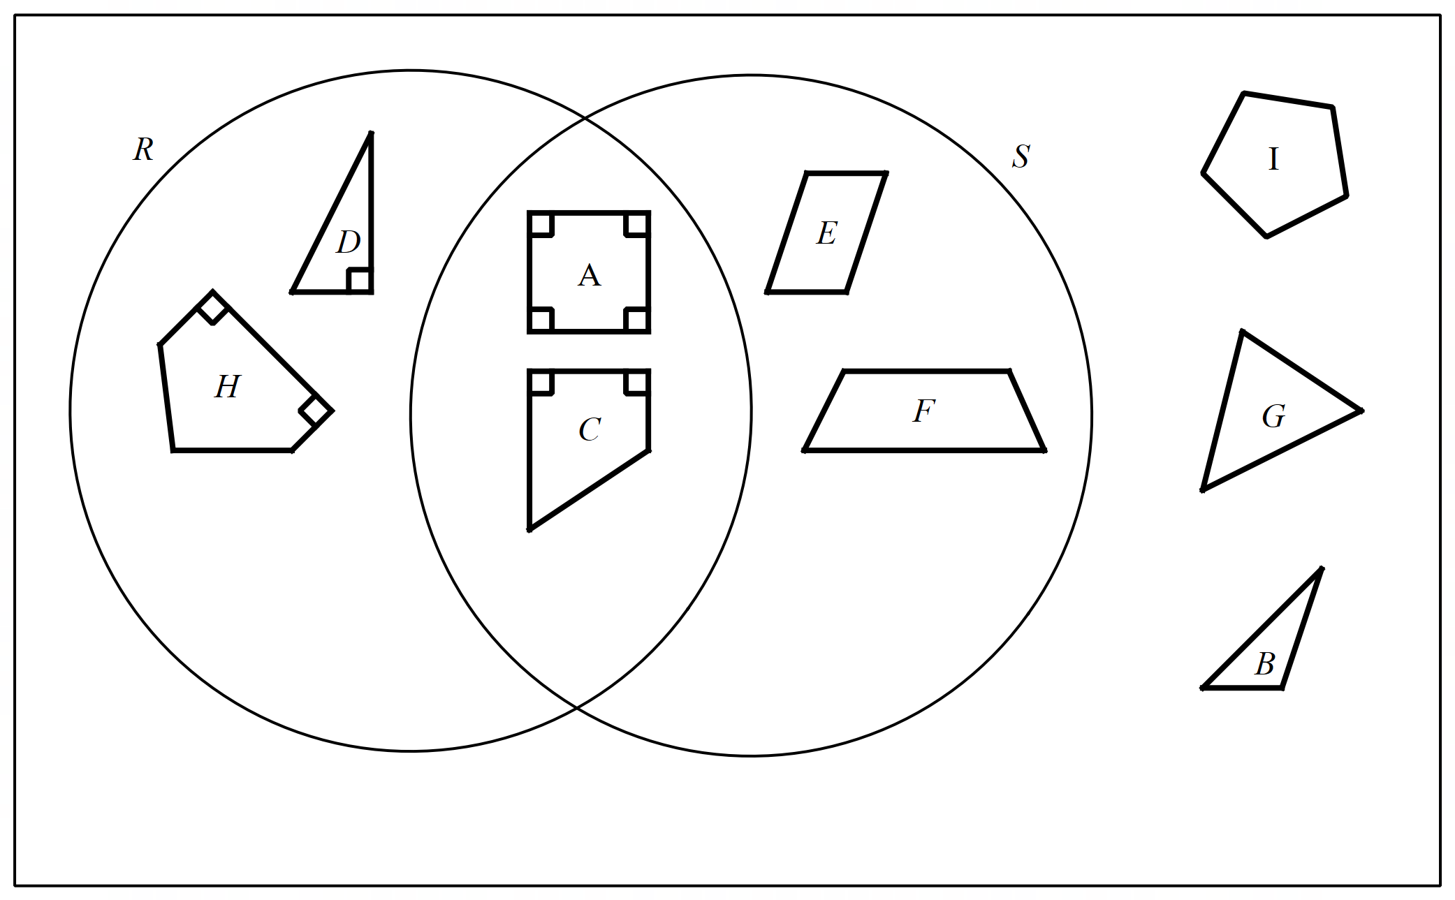

Appendix C – colour in Venn diagrams
Venn diagrams
$$A$$ | $$B$$
$$A∩B$$ | $$A∪B$$
$$\overline{A}$$ | $$\overline{A}∩B$$

Appendix D – cut and sort Venn diagrams
Students can view their results by selecting the Correctness button within the Desmos activity. Student correctness can also be viewed by the teacher using Desmos’ teacher Dashboard.
The printed version is in corresponding order.

Appendix E – Venn for polygons
The solution is shown at 5:00 in the video ‘Categorize Polygons (7:07)’ (bit.ly/categorizepolygons).

References
This resource contains NSW Curriculum and syllabus content. The NSW Curriculum is developed by the NSW Education Standards Authority. This content is prepared by NESA for and on behalf of the Crown in right of the State of New South Wales. The material is protected by Crown copyright.
Please refer to the NESA Copyright Disclaimer for more information https://educationstandards.nsw.edu.au/wps/portal/nesa/mini-footer/copyright.
NESA holds the only official and up-to-date versions of the NSW Curriculum and syllabus documents. Please visit the NSW Education Standards Authority (NESA) website https://educationstandards.nsw.edu.au/ and the NSW Curriculum website https://curriculum.nsw.edu.au/.
Mathematics K–10 Syllabus © NSW Education Standards Authority (NESA) for and on behalf of the Crown in right of the State of New South Wales, 2022.

© State of New South Wales (Department of Education), 2024
The copyright material published in this resource is subject to the Copyright Act 1968 (Cth) and is owned by the NSW Department of Education or, where indicated, by a party other than the NSW Department of Education (third-party material).
Copyright material available in this resource and owned by the NSW Department of Education is licensed under a Creative Commons Attribution 4.0 International (CC BY 4.0) license.
This license allows you to share and adapt the material for any purpose, even commercially.
Attribution should be given to © State of New South Wales (Department of Education), 2024.
Material in this resource not available under a Creative Commons license:
- the NSW Department of Education logo, other logos and trademark-protected material
- material owned by a third party that has been reproduced with permission. You will need to obtain permission from the third party to reuse its material.
Links to third-party material and websites
Please note that the provided (reading/viewing material/list/links/texts) are a suggestion only and implies no endorsement, by the New South Wales Department of Education, of any author, publisher, or book title. School principals and teachers are best placed to assess the suitability of resources that would complement the curriculum and reflect the needs and interests of their students.
If you use the links provided in this document to access a third-party's website, you acknowledge that the terms of use, including licence terms set out on the third-party's website apply to the use which may be made of the materials on that third-party website or where permitted by the Copyright Act 1968 (Cth). The department accepts no responsibility for content on third-party websites.

