Random relay
This learning episode introduces tree diagrams as a visual representation to recognise sample spaces and calculate probabilities. Students consider the impact replacement has on tree diagram probabilities.

Visible learning

Learning intentions
- To use tree diagrams to solve problems.

Success criteria
- I can draw a tree diagram.
- I can draw a multistage tree diagram.
- I can make predictions using tree diagrams.

Syllabus outcomes
A student:
- develops understanding and fluency in mathematics through exploring and connecting mathematical concepts, choosing and applying mathematical techniques to solve problems, and communicating their thinking and reasoning coherently and clearly MAO-WM-01
- solves problems involving probabilities in multistage chance experiments and simulations MA5-PRO-C-01
Mathematics K–10 Syllabus © NSW Education Standards Authority (NESA) for and on behalf of the Crown in right of the State of New South Wales, 2022.

Activity structure
Please use the associated PowerPoint Random relay to display images in this lesson.

Launch

Equipment:
- Coins (1 per group)
- Dice (1 per group)
- 15 red counters and 5 yellow counters (per group)

Method:
- Assign students into visibly random groups of 3 (bit.ly/visiblegroups).
- Explain to students that they will be participating in a relay. They get to choose which event they compete in. Regardless of which event your team chooses the first team in the class to finish their event wins.
- State the 3 events:
- Flip heads on a coin 3 times in a row.
- Roll an even number 3 times in a row.
- Draw 3 consecutive red counters from a bag with 15 red counters and 5 yellow counters, with replacement.
Use slide 3 of the Random Relay PowerPoint to display these visually for the students. It is important that not all groups choose the same option.
- Give groups one minute to discuss which event they would like to complete, then start a visible timer with all groups completing their chosen activity at the same time.
- Once a group has finished, stop the relay and facilitate a class discussion based on the following prompts:
- Were any other groups close to being finished?
- If we completed the relay again, would you change events?
- Have the students repeat the relay, with each group repeating the event they chose the first time.
- Once a group has finished, stop the relay and facilitate a class discussion based on the following prompts:
- Was the result the same as the last relay? Why or why not?
- If we completed the relay again, would you expect the same team to win? Why or why not?
- Have all groups change events and repeat the relay.

Explore
- Create new random groups of 3 and position groups at vertical non-permanent surfaces (VNPS) (bit.ly/VNPSstrategy) around the room.
- Pose the question ‘Was the relay fair?’ and allow students to work in their groups to discuss the answer.
- Ask students assessing and advancing questions to further student thinking. Question suggestions are included below.
Assessing questions draw out students’ thinking about a problem and what methods they have tried so far.
Advancing questions are intended to help move student’s thinking forward toward the lesson goals. We want to draw their attention to something they may not have noticed or considered yet.

Assessing questions | Advancing questions
Which event do you think is most likely to be completed first? | What is the probability of flipping one head? Rolling one even number? Drawing one red counter?
Describe the chances of each event occurring in words? | How can we visually represent each probability?
How do you know your probabilities are correct? Did the relay results happen as expected? | Could you make each event fair?
Encourage students to think about how they could visually represent each event’s probabilities.
- While the activity is happening, select 2–3 groups that have created visual representations of their probabilities. Let these groups know that they will be asked to share their ideas with the class.
Students may choose to draw several visual representations such as tables or tree diagrams if they have seen them before.
- Walk around as a class to different group’s work and give the preselected groups the opportunity to explain their thinking. Ask students from other groups to explain what they see.

Summarise
- Explain to students that various visual representations could be used to represent probabilities, but we tend to favour one visual representation for multistage events like those in the random relay, called a tree diagram.
- Model tree diagrams as a visual representation of multiple stage events. Below are the steps to introduce a 2-stage tree diagram using traffic lights. Slides 5–7 of the Random relay PowerPoint can be used to walk students through the process below.
- Slide 5 – ask students to consider driving up to a set of traffic lights. What could the traffic lights show?
- Slide 6 – show students how we would display this single event using a tree diagram.
- Ask students to consider a second set of traffic lights. Do the options change?
- Slide 7 – show students how we would display this using a tree diagram, drawing attention to the sample space and how it is found.
- Use slides 8–11 of the Random relay PowerPoint for the explicit teaching of constructing tree diagrams and calculating probabilities using tree diagrams with equally likely events.
The explicit teaching technique used in the PowerPoint is ‘Your turn’. The first slide is a worked example which should be displayed for the students before using the following steps.
- Reveal the question to students and its solution.
- Students read in silence.
- Students individually explain to themselves what is happening in each step.
- Students hold a thumbs up to the teacher when they have finished reading and have some sort of understanding.
- Think-Pair-Share. Students explain the solution to their partner.
- In pairs, students then answer the self-explanation questions.
- Finally, randomly select students to share their answers with the whole class.
- Use slides 12–15 for the explicit teaching of tree diagrams with events that are not equally likely.
- Students consider in a Think-Pair-Share (bit.ly/thinkpairsharestrategy):
- How would the tree diagrams from example 2 and ‘Your turn’ question 2 of the Random relay PowerPoint, change if the counters were drawn without replacement?
- Students could attempt to amend the tree diagram to show the probabilities if the counters were not replaced.

Apply
The following activity is adapted from Craig Barton’s website (bit.ly/variationtheory). Slides 17–19 of the Random relay PowerPoint can be displayed to assist in explaining the problem to students.
- Print and distribute Appendix A ‘Tree diagrams’ with one copy between pairs of students.
- Before writing on their sheet, in a Think-Pair-Share, students discuss:
- What is the same or different about questions 1–4?
- What might ‘Y / N’ represent?
- How are the probabilities in a tree diagram related?
- How could you determine if a tree diagram is correct?
- Pairs work through Appendix A.
- Randomly select students to explain their answer for a tree diagram of their choice. After a student has explained, randomly select another student to agree or disagree with their answer, giving reasons why.

Assessment and differentiation

Suggested opportunities for differentiation
Launch
- Increase or decrease the number of steps for each event to suit your students. If adding steps, tree diagrams will become exceptionally large which is a great opportunity to necessitate students only considering relevant parts of each tree diagram.
Explore
- Students may benefit from constructing tree diagrams using concrete manipulatives such as pencils.
- Students may need to order the events from most chance to least chance before calculating probabilities.
- Groups can be challenged to consider changing the nature of each event and the number of tasks to make the events as fair as possible.
- Further Path questions could be asked using the terms ‘at least’, ‘at most’, ‘not’ and ‘and’.
Summarise
- Students may benefit from seeing the teacher draw the tree diagrams rather than present them using the PowerPoint.
- More questions can be asked of the tree diagrams in ‘Your turn’ explicit teaching PowerPoint. For example, what’s the difference between seeing only one green light and the probability of seeing at least one green light?
- Students can draw tree diagrams with equally likely events or without probabilities to limit their focus to the sample space for each event.
Apply
- Have pairs create a set of 5 tree diagrams that are correct or incorrect, to be traded with another pair to complete. Challenge students to create tree diagrams with more than one step.
- Further practice with tree diagrams can be found on Craig Barton’s website bit.ly/bartontreediagrams.

Suggested opportunities for assessment
Explore
- Monitor student’s responses to the assessing and advancing questions.
- Students will demonstrate their working mathematically skills in discussions and justifications.
Apply
- The worksheet in Appendix A can be collected and used as a source of evidence. Alternatively, students’ explanations of solutions could be used to assess learning.

Appendix A

Tree diagrams
For the set of tree diagrams below:
- Indicate whether the tree diagram branch is correct or not.
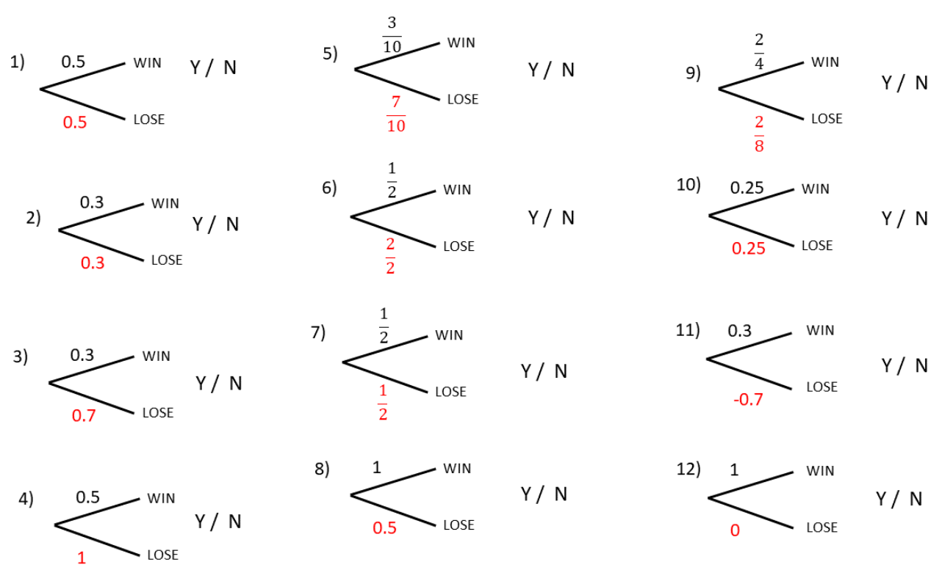
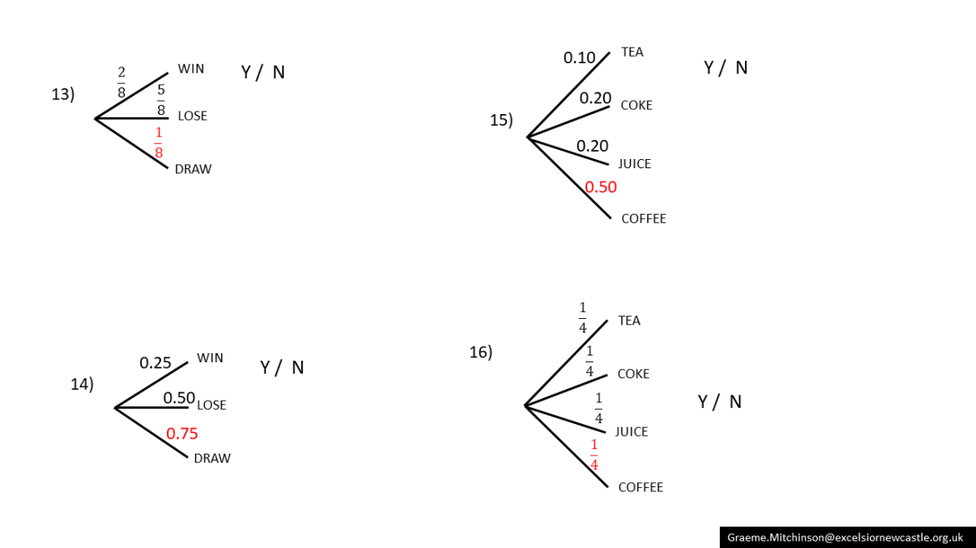
For the set of tree diagrams below:
- Find the missing probability.
- Indicate whether the tree diagram is correct or not.
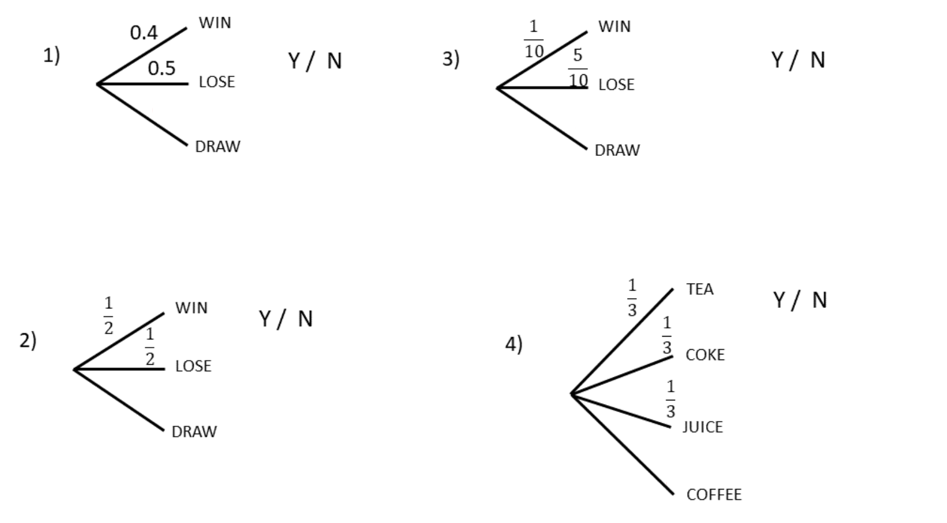

Sample solutions

Appendix A – tree diagrams
Solutions are available from Criag Barton’s website (bit.ly/variationtheory).

References
This resource contains NSW Curriculum and syllabus content. The NSW Curriculum is developed by the NSW Education Standards Authority. This content is prepared by NESA for and on behalf of the Crown in right of the State of New South Wales. The material is protected by Crown copyright.
Please refer to the NESA Copyright Disclaimer for more information https://educationstandards.nsw.edu.au/wps/portal/nesa/mini-footer/copyright.
NESA holds the only official and up-to-date versions of the NSW Curriculum and syllabus documents. Please visit the NSW Education Standards Authority (NESA) website https://educationstandards.nsw.edu.au/ and the NSW Curriculum website https://curriculum.nsw.edu.au/.
Mathematics K–10 Syllabus © NSW Education Standards Authority (NESA) for and on behalf of the Crown in right of the State of New South Wales, 2022.
Mr Barton Maths (2013) Probability & Tree Diagrams [PDF 158 KB], Mr Barton Maths, accessed 22 February 2024.

© State of New South Wales (Department of Education), 2024
The copyright material published in this resource is subject to the Copyright Act 1968 (Cth) and is owned by the NSW Department of Education or, where indicated, by a party other than the NSW Department of Education (third-party material).
Copyright material available in this resource and owned by the NSW Department of Education is licensed under a Creative Commons Attribution 4.0 International (CC BY 4.0) license.
This license allows you to share and adapt the material for any purpose, even commercially.
Attribution should be given to © State of New South Wales (Department of Education), 2024.
Material in this resource not available under a Creative Commons license:
- the NSW Department of Education logo, other logos and trademark-protected material
- material owned by a third party that has been reproduced with permission. You will need to obtain permission from the third party to reuse its material.
Links to third-party material and websites
Please note that the provided (reading/viewing material/list/links/texts) are a suggestion only and implies no endorsement, by the New South Wales Department of Education, of any author, publisher, or book title. School principals and teachers are best placed to assess the suitability of resources that would complement the curriculum and reflect the needs and interests of their students.
If you use the links provided in this document to access a third-party's website, you acknowledge that the terms of use, including licence terms set out on the third-party's website apply to the use which may be made of the materials on that third-party website or where permitted by the Copyright Act 1968 (Cth). The department accepts no responsibility for content on third-party websites.

