Why vampires don’t exist
Students explore a problem involving exponential growth to introduce the concept of logarithms.

Visible learning
This learning episode incorporates Path content and assumes students are confident with related Core content.

Learning intention
The learning intention and success criteria are to be revealed in the Explore section of this learning episode.
- To know how exponential equations and logarithms are related.

Success criteria
- I can convert between exponential equations and logarithms.
- I can explain why logarithms are useful.

Syllabus outcomes
A student:
- develops understanding and fluency in mathematics through exploring and connecting mathematical concepts, choosing and applying mathematical techniques to solve problems, and communicating their thinking and reasoning coherently and clearly MAO-WM-01
- establishes and applies the laws of logarithms to solve problems MA5-LOG-P-01
Mathematics K–10 Syllabus © NSW Education Standards Authority (NESA) for and on behalf of the Crown in right of the State of New South Wales, 2022.

Activity structure
Please use the associated PowerPoint Why vampires don’t exist to display images in this lesson.

Launch
- Use a questioning strategy such as Pose-Pause-Pounce-Bounce (PDF 200 KB) (bit.ly/pausepouncebounce) to ask the class:
- What do you know about vampires?
- Are vampires real? How do you know?
- Show the YouTube video ‘Are Vampires Real? | COLOSSAL QUESTIONS’ (0:00–2:56) (bit.ly/arevampiresreal).
- Explain to students that they are going to prove that vampires don’t exist.
- Provide each student with one A4 sheet of paper.
- Students fold the paper in half and then in half again, creating 4 sections, as shown in Figure 1.
Figure 1 – folded paper
- Students either draw a vampire or write the letter $V$ in the centre of the top section.
Figure 2 – V in top section
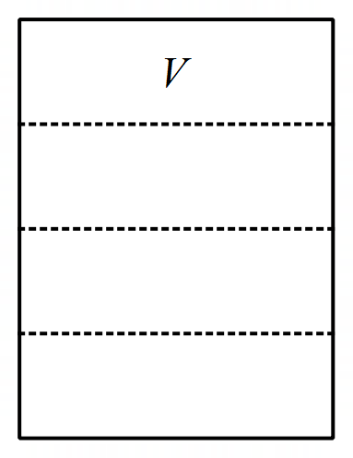
- Explain to students:
‘For the purposes of this activity, we are going to assume that a vampire needs to ‘feed’ only once a month.
When a vampire ‘feeds’, the human population decreases by one and the vampire population increases by one.’
- Students label the top section of their paper as Month 0. The next section as Month 1, then Months 2 and 3.
- Model what Month 1 would look like if one vampire ‘feeds’ on one human. That would mean for Month 1 there are 2 vampires in total (the original vampire and one more), as can be seen in Figure 3.
Figure 3 – Month 1
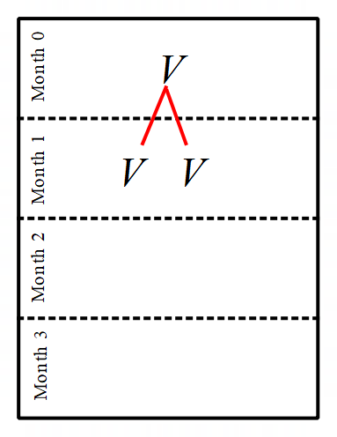
- Students continue this process for Months 2 and 3. Students should have 8 vampires for Month 3.
- Explain to students:
For the purposes of this activity, we’ll assume that the first vampire appeared on 1 January 1600. The global population at this time is estimated to have been 536,870,911.
So, on 1 February there would be 2 vampires and the population would be 536,870,910 and on 1 March there would be 4 vampires and a population of 536,870,908.
- By working in visibly random groups of 3 (bit.ly/visiblegroups) on vertical non-permanent surfaces (bit.ly/VNPSstrategy), challenge students to determine how many months it would take for there to be no humans left.
- Students write, draw or use technology to succinctly justify why vampires couldn’t have existed.
- Use a questioning strategy such as Pose-Pause-Pounce-Bounce to share student responses and highlight a range of strategies used by students.
- The Desmos graph ‘Vampires’ (bit.ly/vampiresdesmos) could be used to visually represent the problem and draw together students’ explanations. A table of values has also been provided in the sample solutions for this learning episode.

Explore
- With students still at vertical non-permanent surfaces, ask them to find how many months it would take to have 32 vampires, then how many months for 512 vampires, then 65,536 vampires.
- Ask students to share their strategies. Students should recognise the relationship $V=2^{m}$, where $V$ is the number of vampires and $m$ is the number of months after 1 January 1600.
It is likely students are reading off their working from the Launch activity. This is intended. The purpose of the following prompts is to necessitate a more efficient method.
- Explain to students, there is a more efficient way of recording ‘how many months’, using logarithms.
- Reveal the learning intention and success criteria to students.
- Write the following equation on the board for students to see: $\log_{2}{65536}=16$. In a Think-Pair-Share (bit.ly/thinkpairsharestrategy), students discuss the following prompts:
- What does each part of the equation represent?
- How does the equation relate to $V=2^{m}$?
- How would you write the logarithm to represent the number of months for the vampire population to have reached 8?
- How would the logarithm change if each vampire ‘feeds’ on 2 people each month instead of one?

Summarise
- Use slides 2–9 from the Why vampires don’t exist PowerPoint for explicit teaching of converting between exponential equations and logarithms.
The explicit teaching technique used in the PowerPoint is ‘Your turn.’ The first slide is a worked example which should be displayed for the students and then use the following steps.
- Reveal the question to students and its solution.
- Students read in silence.
- Students individually explain to themselves what is happening in each step.
- Students hold a thumbs up to the teacher when they have finished reading and have some sort of understanding.
- Think-Pair-Share. Students explain the solution to their partner.
- In pairs, students then answer the self-explanation questions.
- Finally, randomly select students to share their answers with the whole class.
- Print and distribute Appendix A ‘Thin slicing worksheet’ to each student. Students are to independently fill in each missing cell in the table. Students create their own problems for the last 2 rows.
- Randomly select some students to share the problems they created with the class.

Apply
- Display Figure 4 ‘Open Middle problem’ on slide 10 of the associated PowerPoint or directly from the Open Middle website (openmiddle.com/logs).
Sample solutions and hints are available via the link.
Figure 4 – Open Middle problem
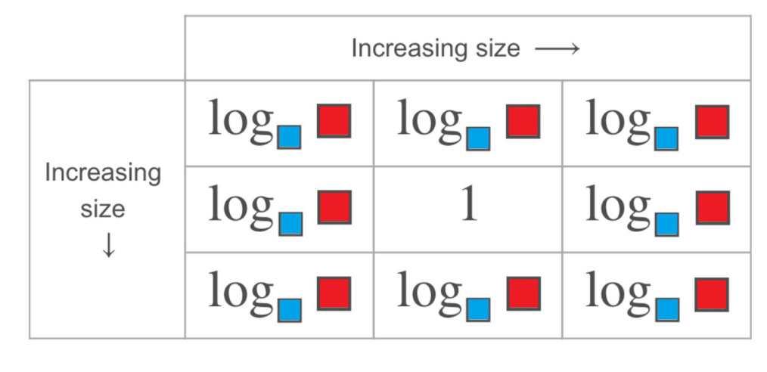
- Students use the integers 1–9, to fill in the red and blue boxes so that the table is accurate. You can only use a number once per red box and once per blue box.
- This task could be completed on vertical non-permanent surfaces, mini whiteboards, or printed A3 paper.
- Complete a gallery walk (bit.ly/DLSgallerywalk) for students to compare answers.

Assessment and differentiation

Suggested opportunities for differentiation
Launch
- There are lots of assumptions made in this model. For example, human mortality rate is ignored. Students could include these factors in their model to be more accurate.
Explore
- If students are not ready to calculate such large numbers, the time period could be significantly reduced. For example, propose the idea ‘If the first vampire existed 100 years ago, how many would there be now?’
- The context of vampires and growth may be too complex for some students. Consider using counters or small chocolates to represent repeated doubling.
- Students could be challenged to represent the problem graphically, encouraging them to use visual representations to help explain their reasoning.
- Students could be challenged to compare whether a linear or exponential model will grow faster, using visual representations to justify their arguments.
- Students could be extended to use the logarithm formula to calculate non-integer months. For example, how many vampires after 20.5 months.
Summarise
- The solutions to Appendix A could be printed and cut out individually to be completed as a matching activity.

Suggested opportunities for assessment
Explore
- Students will demonstrate their working mathematically skills in discussions and justifications.
Summarise
- Monitor student responses in the ‘Your turn’ section to check for understanding.

Appendix A

Thin slicing worksheet
Exponential form | Logarithmic form
$$3^{2}=9$$
$$3^{3}=27$$
 | $$\log_{3}{9=2}$$
 | $$\log_{7}{16807=5}$$
$$9^{\frac{1}{2}}=$$
 | $$\log_{8}2{=\frac{1}{3}}$$
 | $$\log_{4}{4=1}$$

Sample solutions

Vampire population
Month | Vampire population | Human population
1 | 1 | 536,870,911
2 | 2 | 536,870,910
3 | 4 | 536,870,908
4 | 8 | 536,870,904
5 | 16 | 536,870,896
6 | 32 | 536,870,880
7 | 64 | 536,870,848
8 | 128 | 536,870,784
9 | 256 | 536,870,656
10 | 512 | 536,870,400
11 | 1024 | 536,869,888
… | … | …
29 | 536,870,912 | 0

Appendix A – thin slicing worksheet
Exponential form | Logarithmic form
$$3^{2}=9$$ | $$\log_{3}{9=2}$$
$$3^{3}=27$$ | $$\log_{3}{27=3}$$
$$3^{5}=243$$ | $$\log_{3}{243=5}$$
$$7^{5}=16807$$ | $$\log_{7}{16807=5}$$
$$9^{\frac{1}{2}}=3$$ | $$\log_{9}{3}=\frac{1}{2}$$
$$8^{\frac{1}{3}}=2$$ | $$\log_{8}2{=\frac{1}{3}}$$
$$4^{1}=4$$ | $$\log_{4}{4}=1$$
$$a^{0}=1$$ | $$\log_{a}{1}=0$$

References
This resource contains NSW Curriculum and syllabus content. The NSW Curriculum is developed by the NSW Education Standards Authority. This content is prepared by NESA for and on behalf of the Crown in right of the State of New South Wales. The material is protected by Crown copyright.
Please refer to the NESA Copyright Disclaimer for more information https://educationstandards.nsw.edu.au/wps/portal/nesa/mini-footer/copyright.
NESA holds the only official and up-to-date versions of the NSW Curriculum and syllabus documents. Please visit the NSW Education Standards Authority (NESA) website https://educationstandards.nsw.edu.au and the NSW Curriculum website https://curriculum.nsw.edu.au.
Mathematics K–10 Syllabus © NSW Education Standards Authority (NESA) for and on behalf of the Crown in right of the State of New South Wales, 2022.

© State of New South Wales (Department of Education), 2024
The copyright material published in this resource is subject to the Copyright Act 1968 (Cth) and is owned by the NSW Department of Education or, where indicated, by a party other than the NSW Department of Education (third-party material).
Copyright material available in this resource and owned by the NSW Department of Education is licensed under a Creative Commons Attribution 4.0 International (CC BY 4.0) license.
This license allows you to share and adapt the material for any purpose, even commercially.
Attribution should be given to © State of New South Wales (Department of Education), 2024.
Material in this resource not available under a Creative Commons license:
- the NSW Department of Education logo, other logos and trademark-protected material
- material owned by a third party that has been reproduced with permission. You will need to obtain permission from the third party to reuse its material.
Links to third-party material and websites
Please note that the provided (reading/viewing material/list/links/texts) are a suggestion only and implies no endorsement, by the New South Wales Department of Education, of any author, publisher, or book title. School principals and teachers are best placed to assess the suitability of resources that would complement the curriculum and reflect the needs and interests of their students.
If you use the links provided in this document to access a third-party's website, you acknowledge that the terms of use, including licence terms set out on the third-party's website apply to the use which may be made of the materials on that third-party website or where permitted by the Copyright Act 1968 (Cth). The department accepts no responsibility for content on third-party websites.

