Para-solar
Students explore the relationship between the equation of a parabola and its focus through an experiment with parabolic solar reflectors.
This lesson investigates properties of a parabola; however, the focus is on applying parabolas to a genuine field of STEM. This lesson assumes students have engaged with at least some of Non-linear relationships A, Non-linear relationships B and Non-linear relationships C (Path).
The properties of a parabola and its focus are explored beyond the scope of the Mathematics Stage 5 Syllabus.
Students will need at least one digital device per pair to interact with Desmos during this lesson.

Visible learning
This learning episode incorporates Path content and assumes students are confident with related Core content.

Learning intentions
- To be aware of an application of parabolas.
- To understand how the equation of a parabola affects its shape.

Success criteria
- I can use technology to explore how the value of $a$ changes the shape of $y=\frac{x^{2}}{4a}$.
- I can conduct an experiment to demonstrate the relationship between the shape of a parabola and its focus.

Syllabus outcomes
A student:
- develops understanding and fluency in mathematics through exploring and connecting mathematical concepts, choosing and applying mathematical techniques to solve problems, and communicating their thinking and reasoning coherently and clearly MAO-WM-01
- interprets and compares non-linear relationships and their transformations, both algebraically and graphically MA5-NLI-P-01
Mathematics K–10 Syllabus © NSW Education Standards Authority (NESA) for and on behalf of the Crown in right of the State of New South Wales, 2022.

Activity structure
Please use the associated PowerPoint Para-solar to display images in this lesson.

Launch
- Display Figures 1, 2 and 3 which are also available on slide 2 of the associated PowerPoint.
Figure 1 – flat solar panels
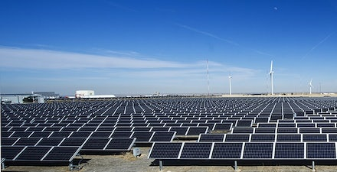
‘NREL'S newest PV array' by U.S. Department of Energy is licensed under CC0 1.0.
Figure 2 – parabolic solar reflectors
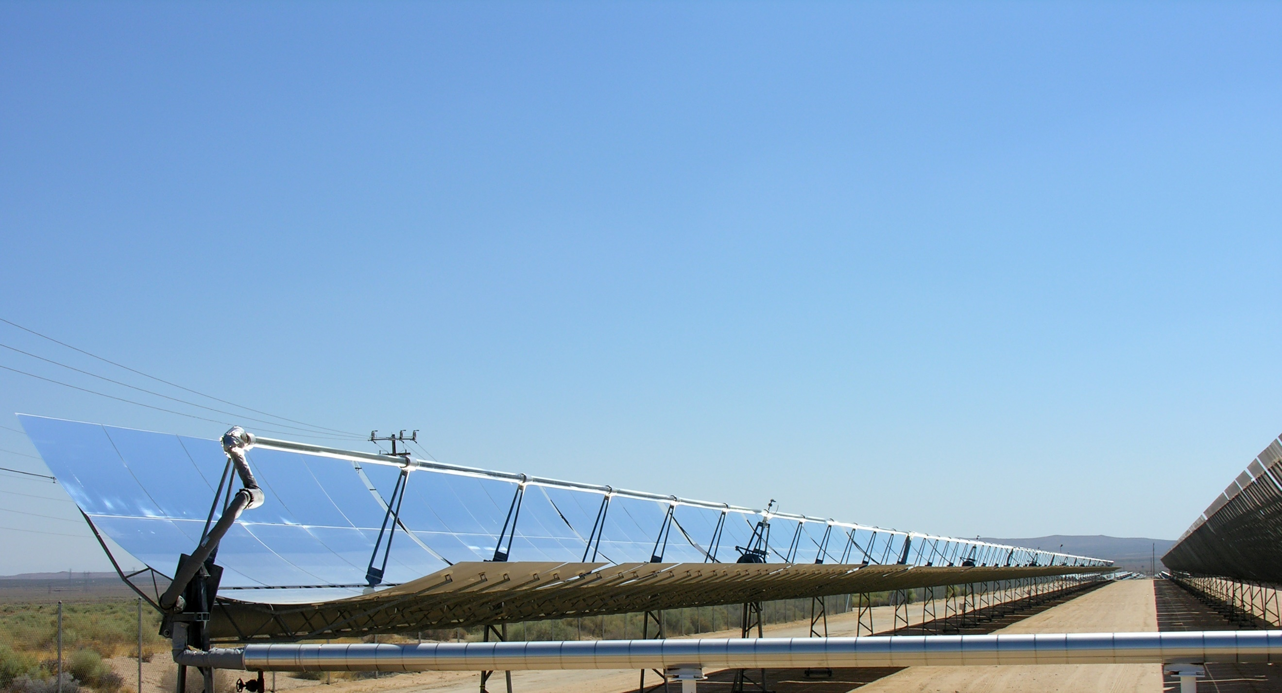
‘Parabolic trough solar thermal electric power plant 1’ by Kjkolb is licensed under CC BY-SA 3.0.
Figure 3 – round solar reflectors
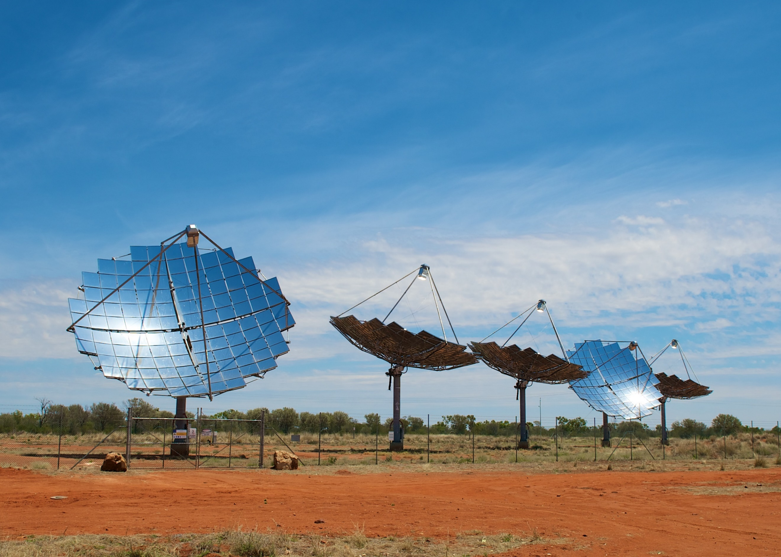
‘Windorah Solar Farm’ by Aaronazz is licensed under CC BY-SA 3.0 DEED.
- Initiate a sharing of ideas using the Pose-Pause-Pounce-Bounce question strategy (PDF 200 KB) (bit.ly/pausepouncebounce), to discuss:
- What does each system have in common?
- What is different about each system?
Facts about solar reflectors
Solar reflectors generally produce more power than flat panels, requiring fewer of them to produce the equivalent power.
Reflectors target energy on the focus, a short distance from the centre of the trough or dish.
There are 2 predominant options for solar reflectors – parabolic trough (Figure 2) and parabolic dish (Figure 3)
Parabolic reflectors have a focus that absorbs the sun’s rays reflected by the trough or dish.
- Show students the video ‘Solar cooker SOLARIO SAFE designed for developing countries by FOCALIS (2:22)’ (bit.ly/solarcookervideo).
- Tell students that they will be building their own solar cookers in this learning episode.

Explore
- With one digital device between pairs, direct students to the Desmos graph ‘Focus’ (bit.ly/solardesmos).
- Students should be given time to interact with the graph by selecting and dragging the red point (the focus) and noticing how the graph changes.
- By typing in each of the equations $y=\frac{x^{2}}{4}$, $y=\frac{x^{2}}{8}$, and $y=x^{2}$ into Desmos, students should then drag the focus so that the graphs align and students can record the focus for each graph. For example, $y=\frac{x^{2}}{4}$ has a focus at (0,1).
- Encourage students to discuss the relationship between the focus of a parabola and the equation.
Students may notice that for parabolas in the form $y=\frac{x^{2}}{4a}$, the focus will be at $\left(0,a\right)$. This is further explored in the Summarise section of this learning episode.
- If students haven’t already, have them drag the slider ‘Turn on sun rays’. Students should drag the focus to change the shape of the parabola. Students discuss with a partner:
- If you were to build a parabolic solar panel (or cooker) what shape of parabola would you choose to build and why?

Summarise
- Distribute Appendix A ‘Parabolas and their focuses’ to pairs.
- Students discuss the relationship between the focus of a parabola and the equation in a Think-Pair-Share (bit.ly/thinkpairsharestrategy).
- Students should generalise a rule relating the focus of a parabola to its equation and test their rule within the Desmos graph.
- Randomly select students to share their rule, then use the Pose-Pause-Pounce-Bounce question strategy to have students add to or agree with the rule suggested.
- Ask pairs to predict the focus and shape for the parabolas: $y=\frac{x^{2}}{12}$, $y=\frac{x^{2}}{20}$, $y=2x^{2},$ drawing an approximate sketch of each parabola.
For parabolas in the form $y=\frac{x^{2}}{4a}$, the focus will be at $\left(0,a\right)$.
$y=\frac{x^{2}}{12}$ has focus $\left(0, 3\right).$
$y=\frac{x^{2}}{20}$ has focus $\left(0, 5\right).$
$y=2x^{2}$ has focus$\left(0,\frac{1}{8}\right)$

Apply
Conduct the ‘Linear parabolic solar reflectors’ experiment from Liacos Educational Media. The accompanying activity sheet can be retrieved from liacoseducationalmedia.com/solar-reflectors. The equipment and method have been written out below which should be accompanied by a link to the video explanation ‘Linear Parabolic Solar Reflectors: A Practical Experiment for Students (10:07)’ (bit.ly/solarreflectorsvideo).

Equipment
Prepare equipment for groups of 3.
- ‘Linear parabolic solar reflectors’ (PDF 438 KB) activity sheet from Liacos Educational Media (https://bit.ly/solarreflectorsactivity)
- Cardboard
- A3 graph paper
- Scissors
- Glue
- Aluminium foil
- 8 triangular struts
- 2 cans
- 2 thermometers
- 3 retort stands
- 4 boss heads
- 4 clamps
- Sticky tape
- Rubber stopper (or an alternative to hold the rolled paper)
- Pencil
- Water
- Cling wrap

Method
Part A – making your parabolic reflector
- Fill in the table showing the values for the curve $y=\frac{1}{40}x^{2}$ (to one decimal place).
- Plot the points onto an A3 sheet of graph paper.
- Join the points with a smooth parabolic curve.
- Cut out the shape and use it to cut out 2 parabolic curves on 2 cardboard pieces.
- Cut out a large rectangular piece of cardboard measuring 15 cm × 46 cm.
- Curve the rectangular cardboard so that it rests on the 2 parabolic outlines.
- Using at least 8 triangular struts, paste the 15 cm × 46 cm piece of cardboard onto the other 2.
- Cut out a 48 cm × 15 cm sheet of aluminium foil and glue it onto the parabolic dish. The focus of the dish is now 10 cm from the bottom of the curve.
- Finally, place a 10 cm long, rolled-up piece of paper through the hole in a rubber stopper and glue the stopper onto the reflector at its vertex. This piece of paper will help you align the reflector and shows you where the reflector’s focus is.
Part B – testing your parabolic reflector
- Put exactly 30 mL of water into each can.
- Measure the temperature of the water in both cans.
- Use clamps to position the parabolic reflector so that the vertex of the parabola is facing directly towards the sun. You’ll know that the parabola is facing the sun if the rolled-up paper is not casting a shadow.
- Use a retort stand, a boss head and a clamp to hold the test can exactly 10 cm above the reflector’s vertex (since the focal length of the parabola is 10 cm).
- Clamp the other can at a similar height but away from the reflector. This can will be your ‘control’ can.
- Wrap cling wrap around the top of each can to stop any evaporation.
- If you have done it correctly, the can at the focus of the parabola will be bathed in sunlight from above and below, while the control can will only be getting direct sunlight.
- Record the temperature of both cans every minute for 20 minutes. Every 5 minutes or so, you may want to reposition the reflector slightly as the sun moves across the sky.

Assessment and differentiation

Suggested opportunities for differentiation
Explore
- Students should notice that the focus lies along the axis of symmetry. This is a great opportunity to introduce and formally define vocabulary.
- Students can explore the ‘Hints’ folder in the Desmos graph. For example, $S=\left[-9,7,…,9\right]$ is the sequence that determines the intervals of the vertical sun rays. Students could change these values and observe how the sequence is affected.
Apply
- If significant assistance is needed for students to complete the experiment, consider inviting senior students to work with each group.

Suggested opportunities for assessment
- Students could be asked to deliver a presentation explaining the results of their experiment. Snippets of these presentations could be shared by the school on social media.

Appendix A

Parabolas and their focuses
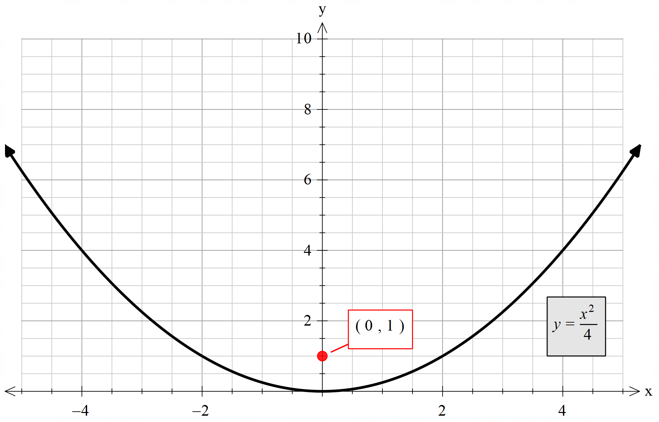
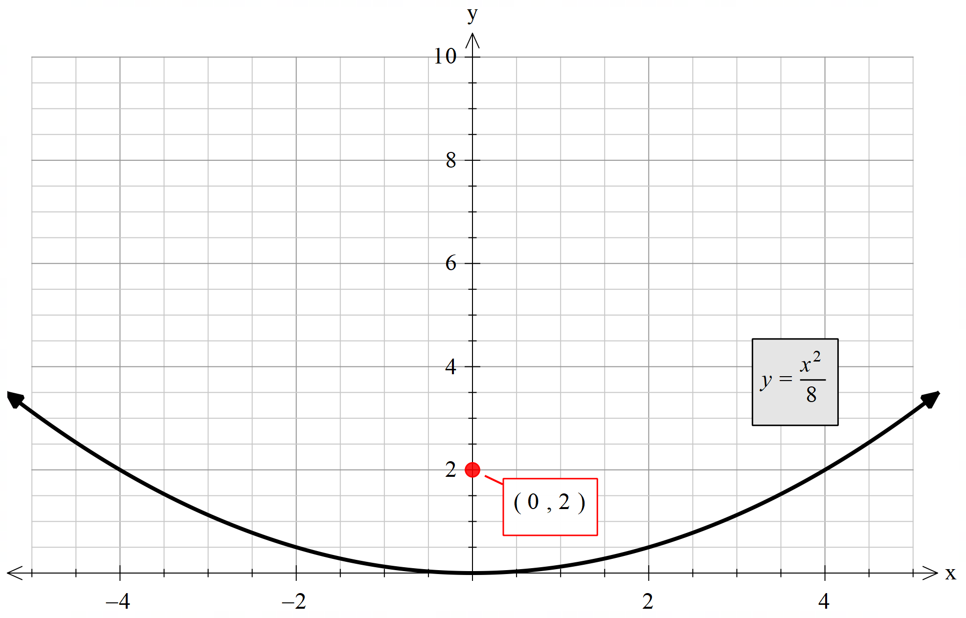
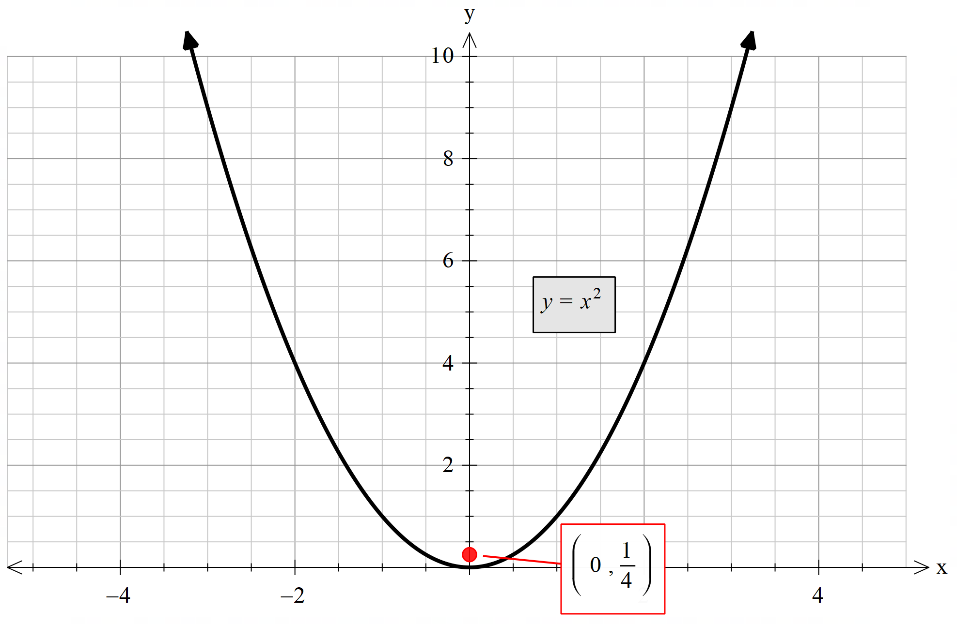

References
This resource contains NSW Curriculum and syllabus content. The NSW Curriculum is developed by the NSW Education Standards Authority. This content is prepared by NESA for and on behalf of the Crown in right of the State of New South Wales. The material is protected by Crown copyright.
Please refer to the NESA Copyright Disclaimer for more information https://educationstandards.nsw.edu.au/wps/portal/nesa/mini-footer/copyright.
NESA holds the only official and up-to-date versions of the NSW Curriculum and syllabus documents. Please visit the NSW Education Standards Authority (NESA) website https://educationstandards.nsw.edu.au and the NSW Curriculum website https://curriculum.nsw.edu.au.
Mathematics K–10 Syllabus © NSW Education Standards Authority (NESA) for and on behalf of the Crown in right of the State of New South Wales, 2022.

© State of New South Wales (Department of Education), 2024
The copyright material published in this resource is subject to the Copyright Act 1968 (Cth) and is owned by the NSW Department of Education or, where indicated, by a party other than the NSW Department of Education (third-party material).
Copyright material available in this resource and owned by the NSW Department of Education is licensed under a Creative Commons Attribution 4.0 International (CC BY 4.0) license.
This license allows you to share and adapt the material for any purpose, even commercially.
Attribution should be given to © State of New South Wales (Department of Education), 2024.
Material in this resource not available under a Creative Commons license:
- the NSW Department of Education logo, other logos and trademark-protected material
- material owned by a third party that has been reproduced with permission. You will need to obtain permission from the third party to reuse its material.
Links to third-party material and websites
Please note that the provided (reading/viewing material/list/links/texts) are a suggestion only and implies no endorsement, by the New South Wales Department of Education, of any author, publisher, or book title. School principals and teachers are best placed to assess the suitability of resources that would complement the curriculum and reflect the needs and interests of their students.
If you use the links provided in this document to access a third-party's website, you acknowledge that the terms of use, including licence terms set out on the third-party's website apply to the use which may be made of the materials on that third-party website or where permitted by the Copyright Act 1968 (Cth). The department accepts no responsibility for content on third-party websites.

