Direct variation
Students explore applications of direct variation such as electrical circuits and Charles’s Law to understand direct variation’s relevance in science. Students are explicitly taught how to construct equations and solve problems involving direct variation.
Students will need at least one digital device per pair to interact with the digital tools used in this lesson.

Visible learning
This lesson incorporates Path content and assumes students are confident with related Core content.

Learning intention
- To understand what makes 2 variables directly proportional.

Success criteria
- I can construct an equation for 2 variables that are directly proportional.
- I can graph equations representing direct variation.
- I can explain why a problem does or doesn’t represent direct variation.

Syllabus outcomes
A student:
- develops understanding and fluency in mathematics through exploring and connecting mathematical concepts, choosing and applying mathematical techniques to solve problems, and communicating their thinking and reasoning coherently and clearly MAO-WM-01
- develops understanding and fluency in mathematics through exploring and connecting mathematical concepts, choosing and applying mathematical techniques to solve problems, and communicating their thinking and reasoning coherently and clearly MA5-RAT-P-02
Mathematics K–10 Syllabus © NSW Education Standards Authority (NESA) for and on behalf of the Crown in right of the State of New South Wales, 2022.

Activity structure

Launch
- Show students the video ‘How To Make A Lemon Battery (1:30)’ (bit.ly/lemonvoltage) or conduct the lemon battery experiment (bit.ly/lemonbatteryexperiment).
- In a Think-Pair-Share (bit.ly/thinkpairsharestrategy), students discuss:
- What does voltage mean? Where have you heard of voltage previously?
- If each lemon has 0.85 V, how many lemons would be needed to power a TV that requires 240 V?
- What is the relationship between the number of lemons and the number of batteries they can power?
- Use a questioning strategy such as Pose-Pause-Pounce-Bounce (PDF 200 KB) (bit.ly/pausepouncebounce), to hear students’ responses to the prompts.
Explain to students that in this lesson they will be exploring the direct variation between voltage and current in a circuit.

Explore
In this activity students explore the relationship between voltage, current, and resistance in a circuit.
- If definitions weren’t organically provided in the Launch activity, define voltage, current, and resistance. Example definitions are provided below.

Voltage
Imagine you're at the top of a slide in a playground. From there, you have a lot of potential to slide down fast. Voltage is like that. It's like the electrical ‘height’ from which charges can ‘slide’ down.
In a battery or power source, voltage is the electric potential that it has. It's like the push that it gives to the charges or energy to move them along in a circuit, from one point to another, just like how the height of a slide determines how fast you might go.
So, voltage is a measure of the ‘push’ that moves electric charges around. Without it, the electricity wouldn't flow, just like without a high point to start from, a slide wouldn't be much fun.
Voltage is measured in Volts, we write the unit as V.
Current
Current is like the flow of a river but with electricity. It's the movement of electric charges or how many pass by in a certain time. More charges passing means a stronger current, just like a fast river is stronger than a slow one.
Current is measured in units of ampere or ‘amps’, we write the unit as A.
Resistance
Resistance is a measure of how much an electrical component or material opposes the flow of electric current.
Resistance arises due to various factors, such as the material's atomic structure, the length and cross-sectional area of the conducting path, and the temperature.
Resistance is measured in Ohms, we write the unit as Ω.
- In pairs, with one device between 2, direct students to the PhET simulation ‘Circuit construction kit: DC’ (bit.ly/phetcircuitconstruction).
- There are 2 large tiles to choose from, students should select the ‘Lab’ tile.
- Students follow the instructions below, to create a circuit:
- Select the Battery and drag it to the main area.
- Select the Resistor and drag it to the main area.
- Select and drag the Wire to connect the positive end of the Battery (the end with the bump) to one end of the Resistor.
- Select and drag a new Wire to connect the other end of the Resistor to the negative end of the Battery. You may need more than one wire, depending on how you set up your circuit.
- Select and drag the Voltmeter from the right side of the screen to the main area.
- Connect the Voltmeter to the Battery, black to the negative end and red to the positive end.
If students have followed the steps correctly, the Voltmeter should read 9.00 V and the electrons should be moving from the positive end of the battery to the negative end of the battery.
The teacher could model the steps or print the instructions for students.
Figure 1 – example circuit with Voltmeter attached
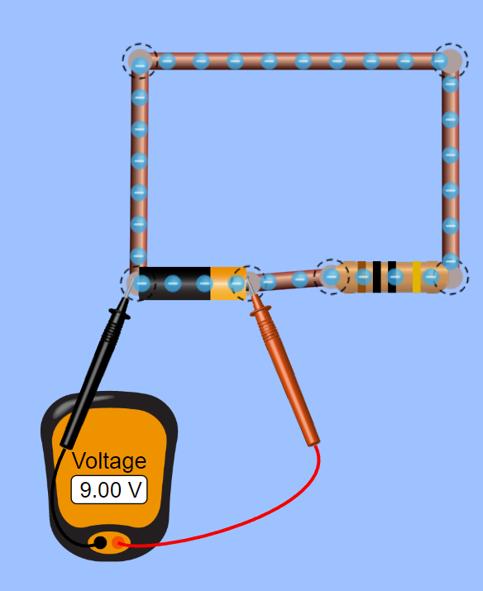
- Instruct students to follow the steps below to measure the current of the circuit:
- Select and drag the left Ammeter to the main area.
- Select and drag the round crosshair over any part of the circuit.
If students have followed the steps correctly, the Current should read 0.90 A.
Figure 2 – ammeter attached
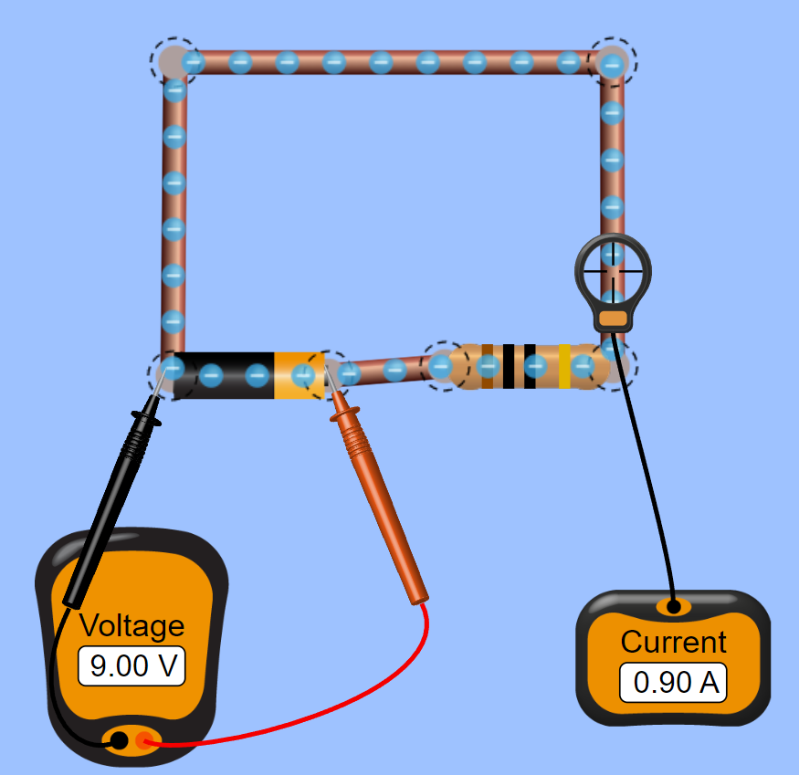
- Students record the Voltage (9.00 V), Current (0.90 A) and Resistance (10 Ohms – they can check this by clicking once on the Resistor), in a spreadsheet or at a vertical non-permanent surface (bit.ly/VNPSstrategy). Students could instead use Appendix A ‘Voltage, current, resistance table’ to record their results.
Figure 3 – resistance 10.0 ohms
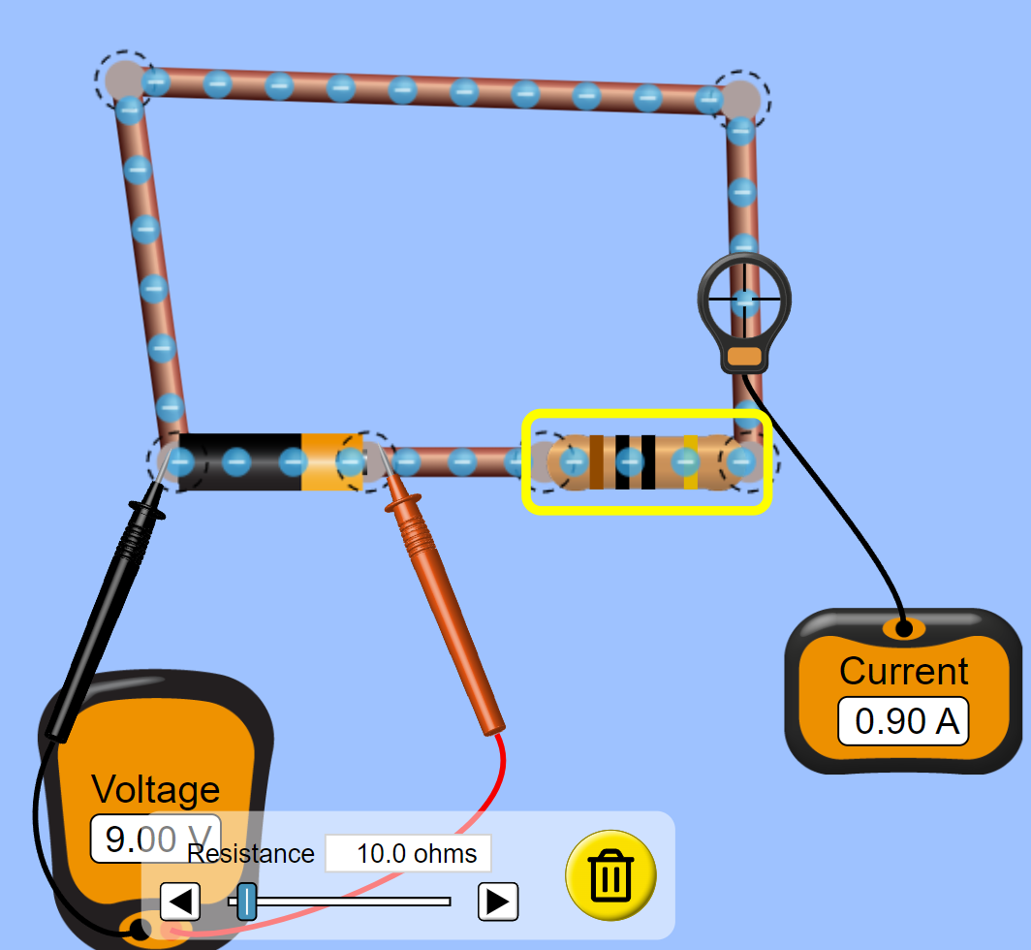
- Students select the Resistor so it appears at the bottom of the screen. Students should change the resistance at least 9 times, recording the Voltage, Current, and Resistance each time.
- Students should analyse the data for any relationships.
Students should recognise that the product of the current and resistance will always be approximately 9, which is the voltage. Facilitate conversation as to rounding answers and why the product is not always exactly 9.00 V.
- Introduce students to Ohm’s law, in which current is directly proportional to voltage across a resistor, given the resistance remains constant. Write the formula for Ohm’s law on the board: $V=IR$, where $V=$voltage, $I=$current, $R=$resistance.
- Have students verify the formula with values they obtained from the simulation.
- Conclude that if we set the resistance to 10 ohms, we would have the formula $V=10I$. In this example, we say that $V∝I$ ($V$ is directly proportional to $I$). Simply put, as one quantity increases or decreases, the other quantity changes by the same factor. For example, if the voltage doubles so does the current. Students can verify this using the PhET simulation.
- Print and distribute Appendix B ‘Missing values’. Students work independently to complete the table of missing values.

Summarise
- Explain to students that direct variation can always be written as a linear equation, $y=kx$. Explain $V=10I$ is written in the same form, where the resistance 10, is the constant.
- Ask students to discuss in a Think-Pair-Share why all direct variation can be described by the equation $y=kx$ where $k$ is a constant. Challenge students to use an example to explain their reasoning.
- Use slides 2–11 from the Direct variation PowerPoint for explicit teaching of solving problems with direct variation.
The explicit teaching technique used in the PowerPoint is ‘Your turn’. The first slide is a worked example which should be displayed for the students before using the following steps.
- Reveal the question to students and its solution.
- Students read in silence.
- Students individually explain to themselves what is happening in each step.
- Students hold a thumbs up to the teacher when they have finished reading and have some sort of understanding.
- Think-Pair-Share. Students explain the solution to their partner.
- In pairs, students then answer the self-explanation questions.
- Finally, randomly select students to share their answers with the whole class.
- Print and distribute Appendix C ‘Direct variation worksheet’ and a device to pairs.
- Explain how students are to interact with the task:
- For each question fill in each column of the table. (You might like to model the first question for the class).
- There is one ‘catch question’ which won’t work using the same process as the other questions. When students think they have discovered the catch question, they should attempt to solve the problem, filling in the table, and explaining why that question is different in the space provided.
- Students should use a graphing calculator such as Desmos (desmos.com/calculator) to graph the equations they construct then sketch the graph on Appendix C, labelling only the important features in the space provided.
- After the activity, discuss which question students thought was the catch question and why. Discuss with students why direct variation doesn’t apply to this question.
- Students write notes to their future forgetful selves (bit.ly/notesstrategy) on how to construct and use an equation for direct variation problems.

Apply
Below are 2 ways of demonstrating direct variation as described by Charles’s Law. You might choose to show the video and conduct the experiment or choose the option that best suits your students.

Video demonstration
- Describe Charles’s law to students and write the statement ‘temperature is proportional to volume’ on the board.
Charles’s Law is an example of direct variation. Charles’s Law states that the temperature and volume of an ideal gas are directly proportional so long as its pressure and mass remain constant. This means that as the temperature (x) increases, the volume (y) increases, and as the temperature decreases, the volume decreases.
- Show students MWSU Chemistry Department’s YouTube video ‘Charles's Law Demonstration (4:08)’ (bit.ly/charleslawdemo).

Experiment
- Assign visibly random groups of 3 (bit.ly/visiblegroups). Provide each group with a copy of Appendix D ‘Charles’s law experiment’ and required equipment.
- Have students predict what will happen to a balloon when it is placed into a very cold/very hot environment and write a hypothesis in the space provided.
- Students follow the steps as laid out in Appendix D.
This experiment is based on ‘The Sci Guys: Science at Home - SE2 - EP10: Charles's Law of Ideal Gases (5:12)’ by The Sci Guys (bit.ly/charlesidealgases). You could share the video with students to assist in explaining the method.
It would be preferable if this experiment was carried out in a kitchen or science laboratory for safety reasons. Students should stand when handling boiling water if possible.

Assessment and differentiation

Suggested opportunities for differentiation
Explore
- Let students explore the PhET simulation, adding elements to their circuit.
- Introduce students to the rearrangements of Ohm’s law and have them verify the results using the PhET simulation.
- Challenge students to justify their use of rounding in Appendix B ‘Missing values’.
- Students can explore circuit creation using Upper Story’s ‘Spintronics simulator’ (upperstory.com/spintronics/simulator/).
Apply
- Have students calculate the volume of the balloon using an approximate solid, for example a sphere or ellipsoid. Students can then graph the results which will yield a linear graph.

Suggested opportunities for assessment
Explore
- Monitor student progress and collect Appendix B ‘Missing values’ activities from students to ensure they are informally demonstrating understanding of direct variation.
Summarise
- Monitor student progress and collect Appendix C ‘Direct variation worksheet’ from students to assess their ability to represent and solve direct variation problems.
- For Appendix C’s catch question, challenge students to create a representation to explain why it is not an example of direct variation.

Appendix A

Voltage, current, resistance table
Voltage (Volts) | Current (Amps) | Resistance (Ohms)

Appendix B

Missing values
Voltage (Volts) | Current (Amps) | Resistance (Ohms)
9.00 V | 0.90 A | 10.0 $Ω$
9.00 V |  | 20.0 $Ω$
9.00 V |  | 30.0 $Ω$
9.00 V | 0.26 A
9.00 V | 0.18 A
 | 0.13 A | 70.0 $Ω$
 | 0.09 A | 100.0 $Ω$

Appendix C

Direct variation worksheet
- $y∝x$. When $x=10, y=10$. Find $y$ when $x=5$.
- $y∝x$. When $x=20, y=10$. Find $y$ when $x=5$.
- $y∝x$. When $x=20, y=10$. Find $x$ when $y=5$.
- $y$ is directly proportional to $x$. When $x=20$, $y=100$. Find $y$ when $x=2.5.$
- The cost of repairing a bicycle is directly proportional to the amount of time spent working on it. If it takes 20 hours to complete a repair job that costs $100, calculate the cost of a repair that takes 2 and a half hours.
- The number of workers on a job is directly proportional to the time taken to complete a job. If it takes 20 workers 100 hours to complete a job, calculate the time taken for 30 workers to complete the same job.
Catch question: _____
It’s a catch question because:
 | Construct an equation | Find the constant of variation | Find the value required | Verify graphically
a.
b.
c.
d.
e.
f.

Appendix D

Charles’s law experiment

Equipment
- A heat resistant beaker or glass (1 per group of 3).
- Pre-frozen balloon blown up and left in a freezer for 2–3 hours (1 per group of 3).
- Room temperature balloon (1 per group of 3).
- Boiling water
- A 30 cm ruler (1 per group of 3).
- Device
Safety: use fully enclosed leather shoes, temperature resistant gloves and an apron or lab coat when handling boiling water.

Method
Hypothesis:

Cold balloon
- Place the pre-frozen balloon down and measure its longest length from end to end and record this length.
- Continue to measure the same length of the balloon, recording the time of each measurement as its temperature approaches room temperature.
Hot balloon
- Blow up and tie off the room temperature balloon, only large enough that it will still fit inside the glass or beaker.
- Place the room temperature balloon down and measure its longest length from end-to-end and record this length.
- Fill the heat resistant beaker or glass with boiling water, to approximately $\frac{1}{3}$ volume.
- Place the balloon in the hot water and leave it in for 1–2 minutes.
Optional: place a lid on top to increase the effect.
- Take out the heated balloon. Place the heated balloon down and measure its longest length from end to end and record this length.
- Continue to measure the same length of the balloon, recording the time of each measurement as its temperature approaches room temperature.
Graph results:
- After the activity, plot your results on a graph with temperature on the $x$ axis and length on the $y$ axis.
- Write a conclusion for the experiment, reflecting on your hypothesis and what you can infer from the data collected.

Sample solutions

Appendix B – missing values
Voltage | Current | Resistance
9.00 V | 0.90 A | 10.0 $Ω$
9.00 V | 0.45 A | 20.0 $Ω$
9.00 V | 0.30 A | 30.0 $Ω$
9.00 V | 0.26 A | 34.62 $Ω$
9.00 V | 0.18 A | 50 $Ω$
9.00 V | 0.13 A | 70.0 $Ω$
9.00 V | 0.09 A | 100.0 $Ω$

Appendix C – direct variation worksheet
 | Construct an equation | Find the constant of variation | Find the value required | Verify graphically
a. | $$y=kx$$ | $$10=10k$$  $$k=1$$  $$y=x$$ | $$y=5$$ | 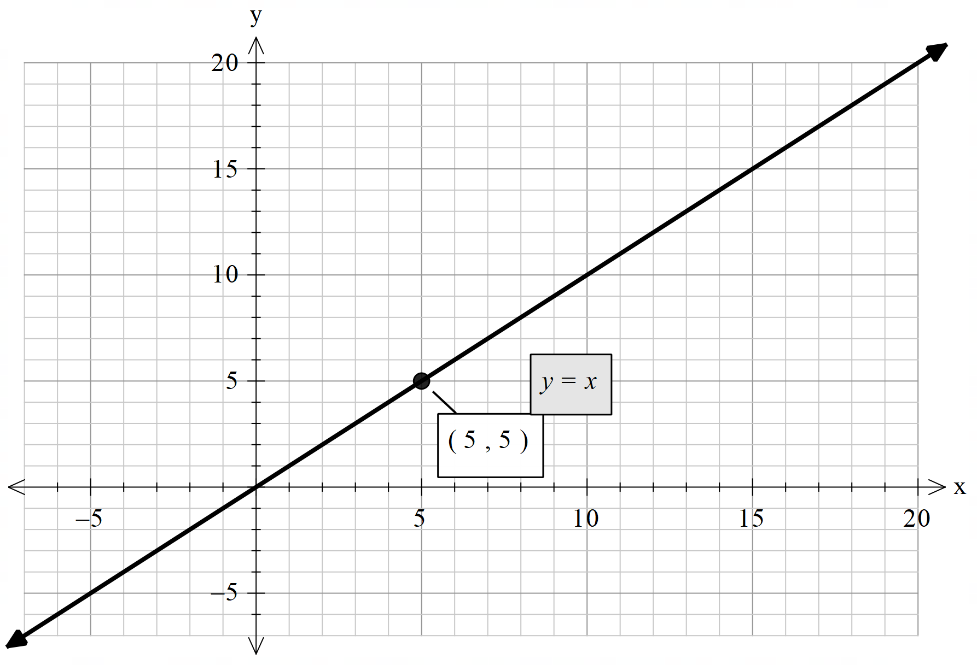
b. | $$y=kx$$ | $$10=20k$$  $$k=\frac{1}{2}$$  $$y=\frac{1}{2}x$$ | $$y=\frac{1}{2}\left(5\right)$$  $$y=\frac{5}{2}$$ | 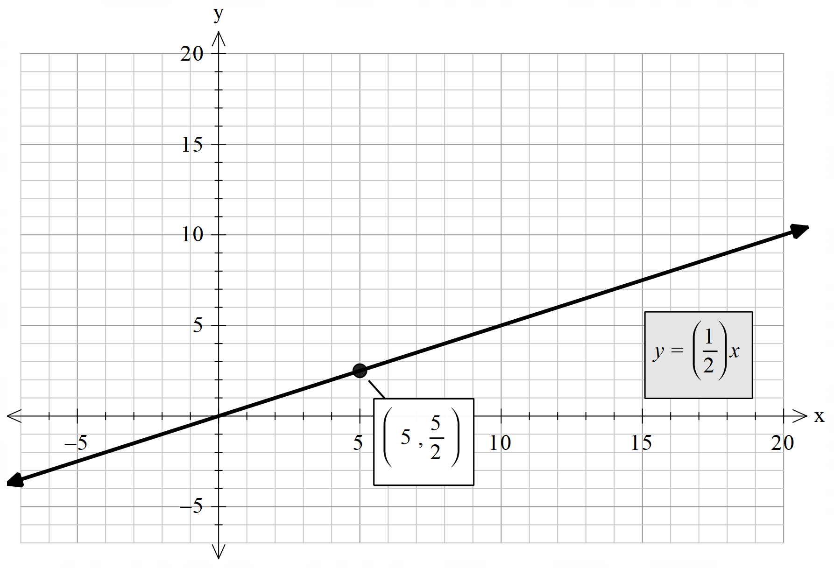
c. | $$y=kx$$ | $$10=20k$$  $$k=\frac{1}{2}$$  $$y=\frac{1}{2}x$$ | $$5=\frac{1}{2}x$$  $$x=5×\frac{2}{1}$$  $$x=10$$ | 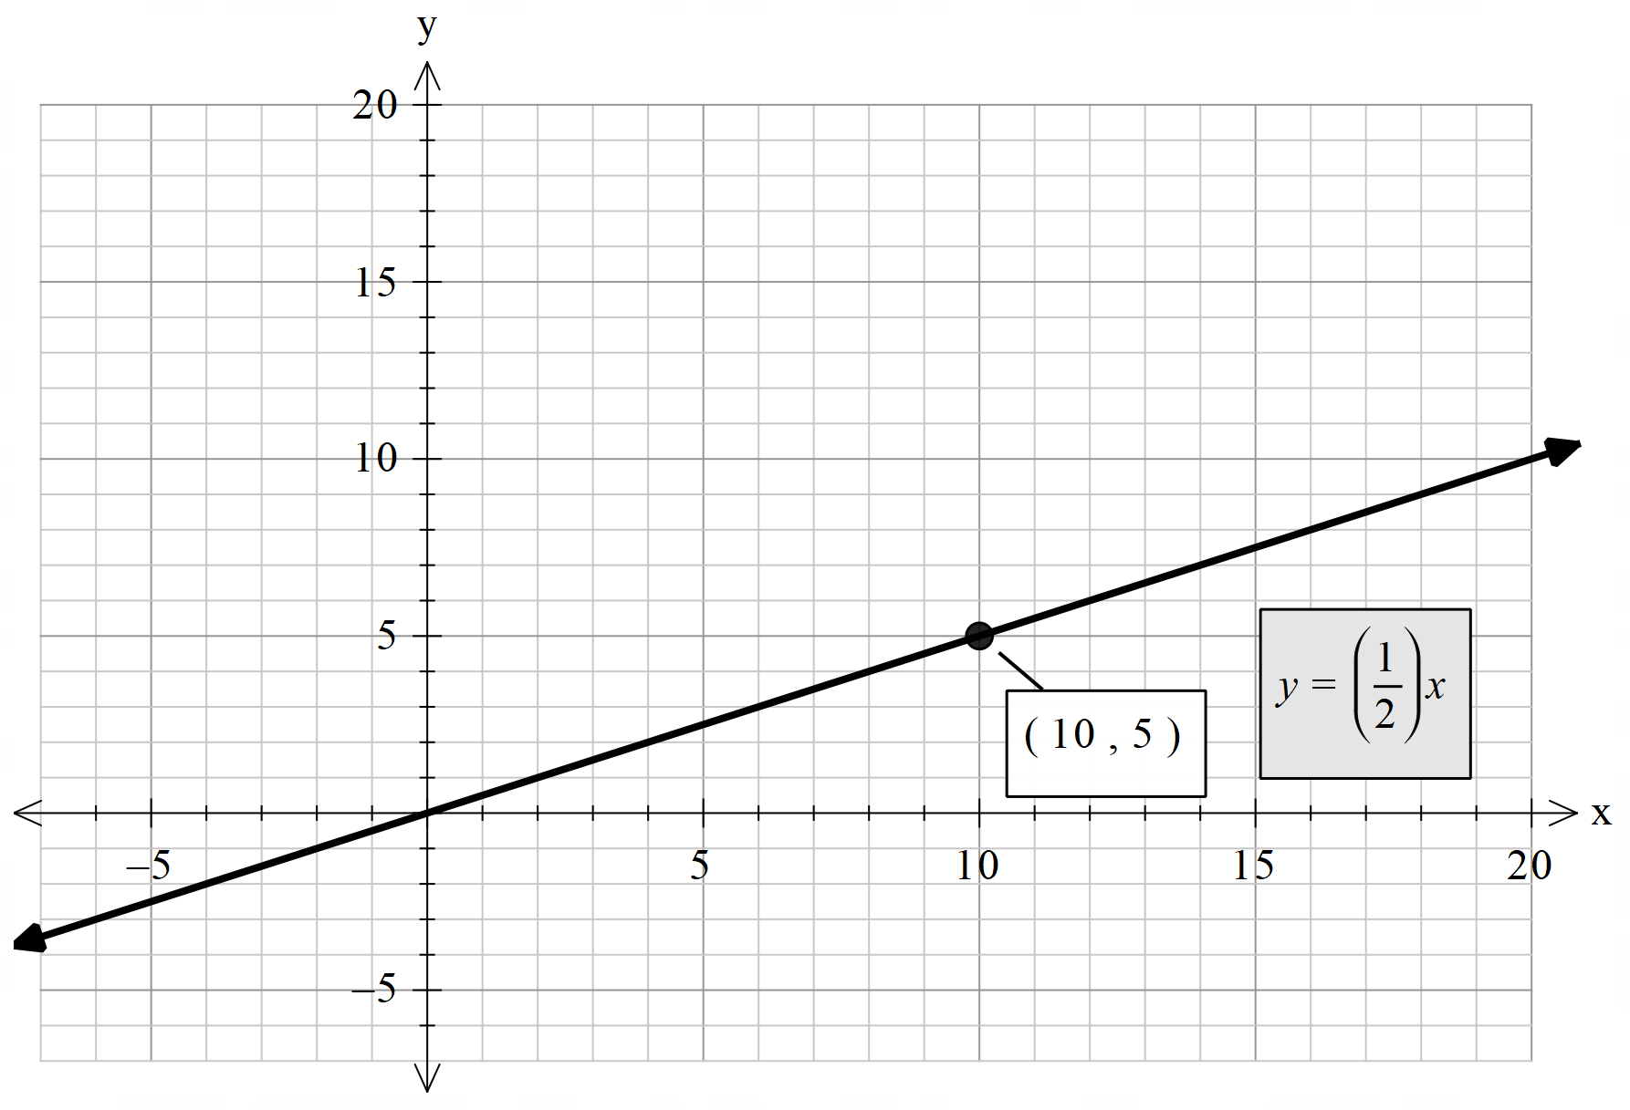
d. | $$y=kx$$ | $$100=20k$$  $$k=5$$  $$y=5x$$ | $$y=5\left(2.5\right)$$  $$y=12.5$$ | 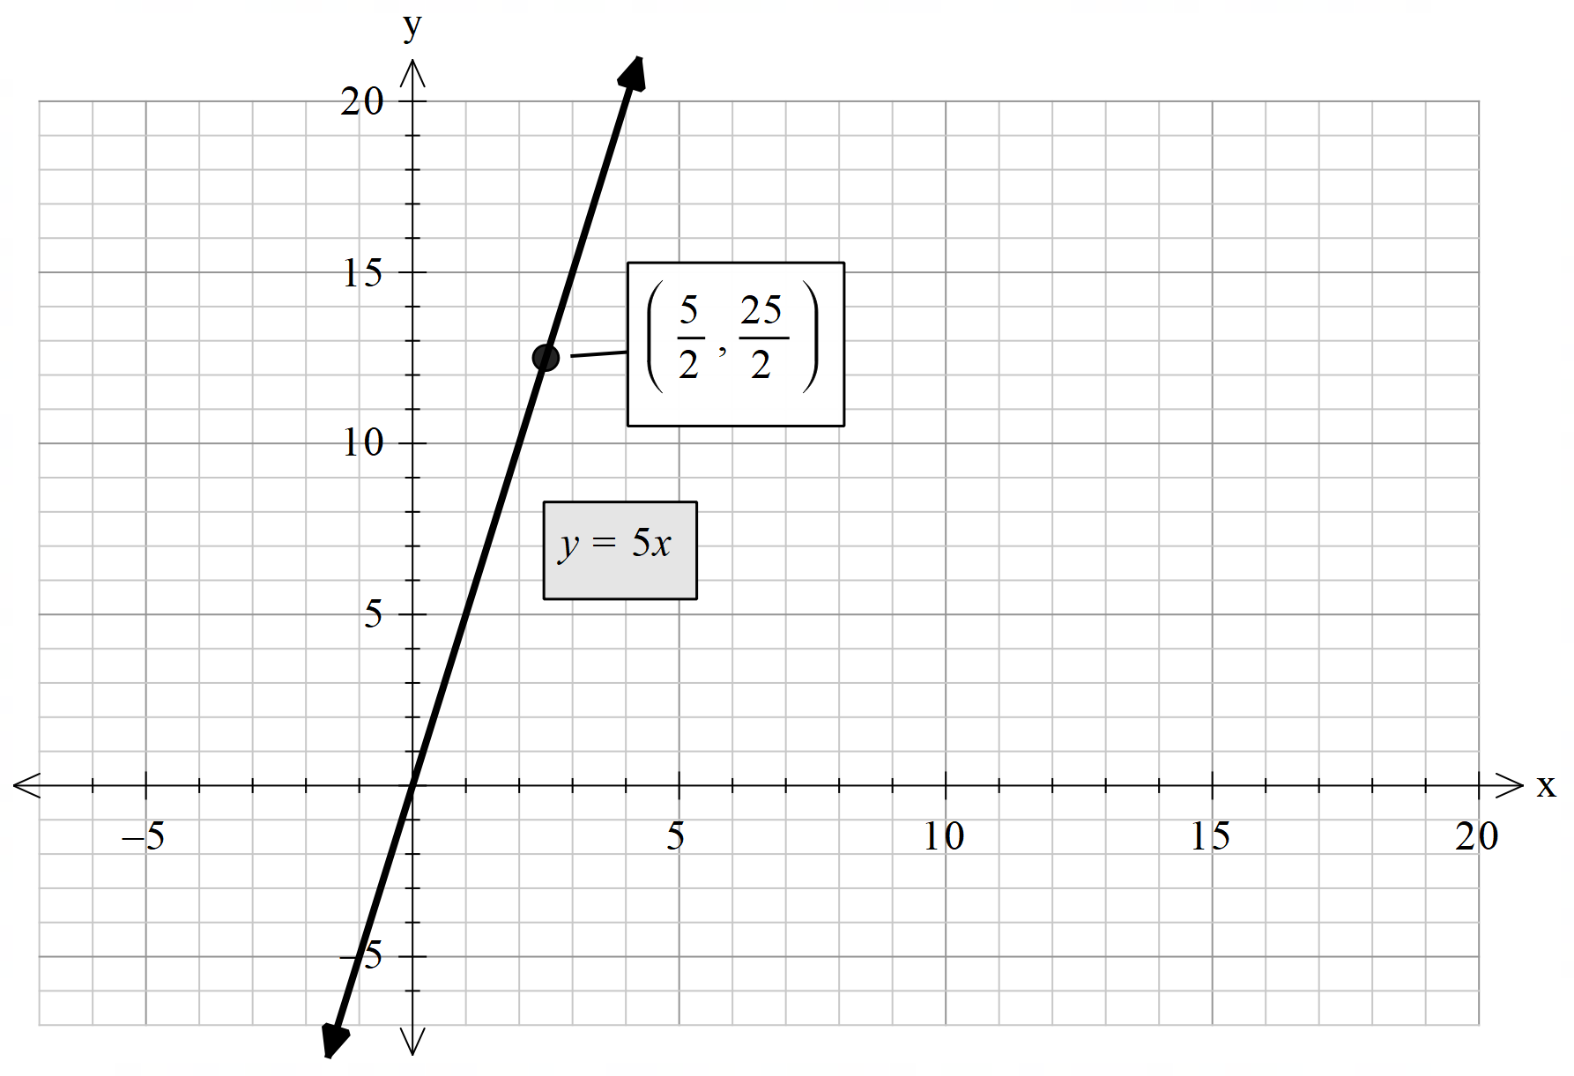
e. | $$C=kt$$ | $$100=20k$$  $$k=5$$  $$C=5t$$ | $$C=5\left(2.5\right)$$  $$C=12.5$$  $$\$12.50$$ | 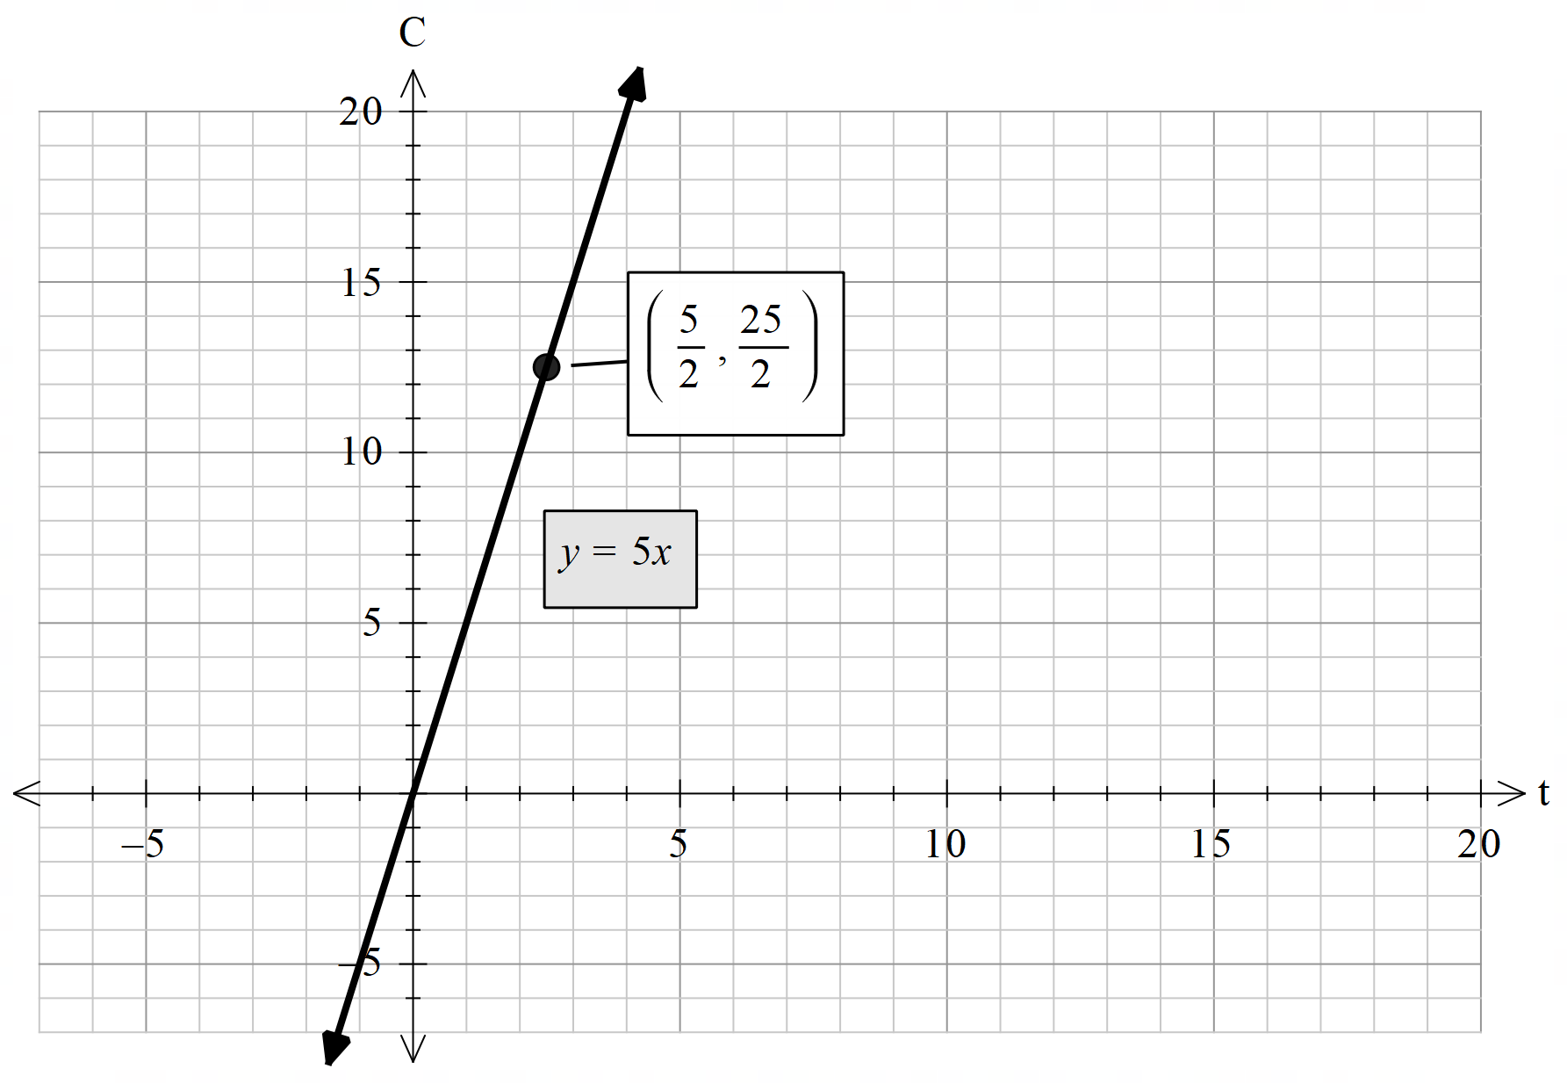
f. | This is the catch question. Workers and time taken is an inverse relationship and should instead be constructed as $t=\frac{k}{w}$.  Students could attempt this question as an inverse relationship. | $$100=\frac{k}{20}$$  $$k=2000$$  $$t=\frac{2000}{w}$$ | $$t=\frac{2000}{30}$$  $$t=66.666…$$  $$t=66.7 hours$$ | 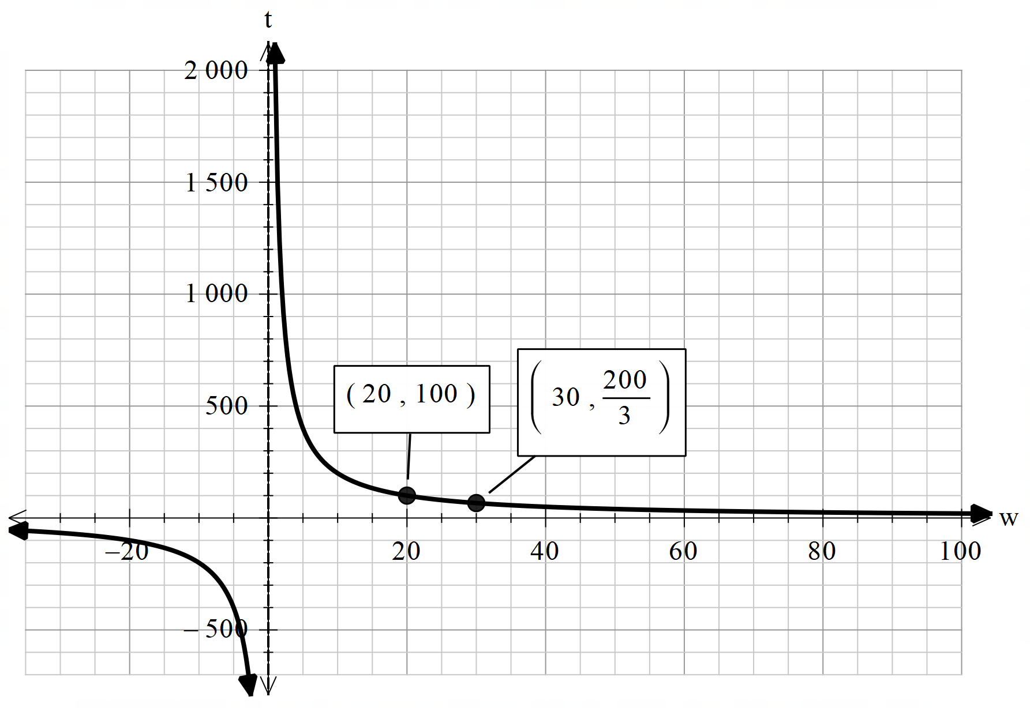

References
This resource contains NSW Curriculum and syllabus content. The NSW Curriculum is developed by the NSW Education Standards Authority. This content is prepared by NESA for and on behalf of the Crown in right of the State of New South Wales. The material is protected by Crown copyright.
Please refer to the NESA Copyright Disclaimer for more information https://educationstandards.nsw.edu.au/wps/portal/nesa/mini-footer/copyright.
NESA holds the only official and up-to-date versions of the NSW Curriculum and syllabus documents. Please visit the NSW Education Standards Authority (NESA) website https://educationstandards.nsw.edu.au/ and the NSW Curriculum website https://curriculum.nsw.edu.au/home.
Mathematics K–10 Syllabus © NSW Education Standards Authority (NESA) for and on behalf of the Crown in right of the State of New South Wales, 2022.
© State of New South Wales (Department of Education), 2024
The copyright material published in this resource is subject to the Copyright Act 1968 (Cth) and is owned by the NSW Department of Education or, where indicated, by a party other than the NSW Department of Education (third-party material).
Copyright material available in this resource and owned by the NSW Department of Education is licensed under a Creative Commons Attribution 4.0 International (CC BY 4.0) license.
This license allows you to share and adapt the material for any purpose, even commercially.
Attribution should be given to © State of New South Wales (Department of Education), 2024.
Material in this resource not available under a Creative Commons license:
- the NSW Department of Education logo, other logos and trademark-protected material
- material owned by a third party that has been reproduced with permission. You will need to obtain permission from the third party to reuse its material.
Links to third-party material and websites
Please note that the provided (reading/viewing material/list/links/texts) are a suggestion only and implies no endorsement, by the New South Wales Department of Education, of any author, publisher, or book title. School principals and teachers are best placed to assess the suitability of resources that would complement the curriculum and reflect the needs and interests of their students.
If you use the links provided in this document to access a third-party's website, you acknowledge that the terms of use, including licence terms set out on the third-party's website apply to the use which may be made of the materials on that third-party website or where permitted by the Copyright Act 1968 (Cth). The department accepts no responsibility for content on third-party websites.

