Graph-ity falls
This learning episode introduces students to distance-time graphs which are an important lead into motion graphs in physics. Students will match graphs to stories and describe the rate of change of distance-time graphs.
Students will need at least one digital device per pair to interact with online manipulatives during this lesson.

Visible learning
This lesson incorporates Path content and assumes students are confident with related Core content.

Learning intention
- To be able to analyse and construct graphs related to rates of change.

Success criteria
- I can match a distance-time graph to its description.
- I can draw a distance-time graph to match a given scenario.

Syllabus outcomes
A student:
- develops understanding and fluency in mathematics through exploring and connecting mathematical concepts, choosing and applying mathematical techniques to solve problems, and communicating their thinking and reasoning coherently and clearly MAO-WM-01
- identifies and solves problems involving direct and inverse variation and their graphical representations MA5-RAT-P-01
Mathematics K–10 Syllabus © NSW Education Standards Authority (NESA) for and on behalf of the Crown in right of the State of New South Wales, 2022.

Activity structure
Please use the associated PowerPoint Graph-ity falls to display images in this lesson.

Launch
- Display the PhET interactive ‘Graph Matching’ (bit.ly/phetgraphmatching) and have a wireless mouse connected that can be passed to students.
- Before interacting with the ‘Graph Matching’ activity, ask students to work in pairs to write a list of everything they notice and wonder (bit.ly/noticewonderstrategy) about what they can see of the interactive on the screen.
- Randomly select students to share what they noticed and wondered about the interactive.
Students might notice:
There is a pink dot where the axes meet, there are instructions on the graph, each section of the graph is linear.
Students might wonder:
What will happen when you drag the character? What does dragging the character have to do with the graph? What is the point of the game?
- Pick a random student, hand them the mouse and tell them they have one go at the game, which means select and hold the blue Drag Me! button.
- Repeat with a few more randomly chosen students.
- Use a questioning strategy such as Pose-Pause-Pounce-Bounce (PDF 200 KB) (bit.ly/pausepouncebouncestrategy), to ask students what the player should do for each section of the graph.
- Either randomly pick a few more students to try the game until they get close, or if students have devices, they could attempt the game in pairs.

Explore

Activity 1 – guided match the graph to the story
- Use slide 2 from the Graph-ity falls PowerPoint to display the graphs for this activity.
- Read or write up the following stories:
- A motorbike travels away from home at a constant speed.
- A car remains parked in a car park.
- A runner runs at a constant pace away from home then turns around and runs back.
- Students write the letters M (for motorbike), C (for car), and R (for runner) in the order they think the graphs are in. The correct answer is C, R, M.
- Before revealing the correct answer, students should share their answer and reasoning with a partner in a Think-Pair-Share structure (bit.ly/thinkpairsharestrategy).

Activity 2 – graphing motion

Equipment:
- Appendix A ‘Distance/time axes’, printed A3 (1 per group of 3).
- A3 plastic pockets (1 per group of 3).
- Adhesive putty
- Whiteboard markers (1 per group of 3).
- Ball for teacher to throw.

Method:
- Place a copy of Appendix A ‘Distance/time axes’ in A3 plastic pockets and use adhesive putty to stick the pockets to walls around the room.
- Assign visibly random groups of 3 (bit.ly/visiblegroups) and position students at A3 plastic pockets around the room (bit.ly/VNPSstrategy), with one whiteboard marker per group.
- Explain to students that their objective is to draw graphs showing the distance travelled over time for the ball.
- For each throw, groups discuss and attempt to draw the distance over time graph on one set of axes.
- For the first throw, roll the ball gently along the ground.
- Groups draw their graphs. Have groups compare graphs with an adjacent group and take note of any similarities and differences.
- Ask randomly selected students to share what they found the same/different about their graphs.
- Model the sample solution for graph 1, emphasising to students that the sample solution is also an estimate, as we don’t have specific values and are more focused on how the graphs are changing.
- Repeat steps 6–8 for the following throws:
- Roll the ball to a student then the student rolls it back.
- Drop the ball from shoulder height.
- Throw the ball vertically in the air and catch it.
Discussions should be facilitated about what a distance/time graph shows. Students may interpret dropping the ball to mean negative distance. You might choose to introduce displacement or simply explain that distance will always be positive.
- For the last 2 axes, students draw their own graphs telling a story about the ball. For example, throw the ball and let it fall to the ground.
- Groups then swap positions with an adjacent group and write a description of each graph’s stories on the plastic pockets.

Summarise
- Use slides 3–10 from the Graph-ity falls PowerPoint for explicit teaching of analysing distance-time graphs.
The explicit teaching technique used in the PowerPoint is ‘Your turn’. The first slide is a worked example which should be displayed for the students before using the following steps.
- Reveal the question to students and its solution.
- Students read in silence.
- Students individually explain to themselves what is happening in each step.
- Students hold a thumbs up to the teacher when they have finished reading and have some sort of understanding.
- Think-Pair-Share. Students explain the solution to their partner.
- In pairs, students then answer the self-explanation questions.
- Finally, randomly select students to share their answers with the whole class.
- Students write notes to their future forgetful selves (bit.ly/notesstrategy), describing the types of rates of change observed and how to calculate speed from a distance/time graph.

Apply
- Direct students to: https://davidwees.com/graphgame/
- There are 12 puzzles for students to attempt.
The objective of the game is to move the stickman to match the distance-time graph shown.
Instructions for students:
- Move the stickman by selecting it and dragging.
- You can restart a level by selecting the arched arrow.
- You can move to the next level by selecting the right arrow.
- Write down the highest score you get for each puzzle.
- Regroup students and use a questioning strategy such as the Pose-Pause-Pounce-Bounce question strategy (PDF 200 KB) (bit.ly/pausepouncebounce), to ask questions such as:
- Which puzzle was the easiest and why?
- Which puzzle was the most difficult and why?
- Did you improve as the puzzles went on?
- Was it easier to solve linear or curved puzzles?

Assessment and differentiation

Suggested opportunities for differentiation
Launch
- If students struggle understanding the connection between the character’s movement and the graph constructed, they may benefit from being provided with distance-time graphs and physically acting out the movements.
- Strategies could be modelled with students, such as completing a table of values to show how far away a car travelling $50 km/hr$is at intervals of time.
Explore
Activity 1
- Extension activity: draw a distance-time graph to show:
- A person takes their dog for a walk. Stops to buy a coffee. Returns home.
Then students create their own story to graph.
- Ask students, for each graph if the axes were swapped, would the story change?
Summarise
- If students require support identifying the gradient of a line, draw a right-angle triangle to emphasise the horizontal and vertical components.
Apply
- Students could be challenged to explore ‘The moving man’ simulation by PhET (bit.ly/themovingmanphet). This is an opportunity to explicitly teach students the difference between speed and velocity. You can use the PhET simulation to model velocity. By dragging the red arrow next to the Velocity chart to 5 and selecting the play button, the man will walk at a speed of 5 in the positive direction. By dragging the red arrow to -5 and clicking the play button, the man will walk at a speed of 5 in the negative direction.

Suggested opportunities for assessment
Launch
- Students could record their answers on mini whiteboards. Students then hold their whiteboards up all at once, so that the teacher can informally assess that students have understood the task.
- Take note of students’ vocabulary around distance/displacement, speed/velocity, and so on.
Explore
- Activity 1 is designed as a hinge point opportunity (bit.ly/hingepointstrategy). If students struggle answering this question, it might indicate a need for intervention and/or explicit teaching before commencing with the lesson.
- Assess students’ justifications and reasoning through observing group conversations.
- Challenge students to justify their responses with prompts such as ‘Would you bet $100 that you’re correct?’.

Appendix A

Distance/time axes
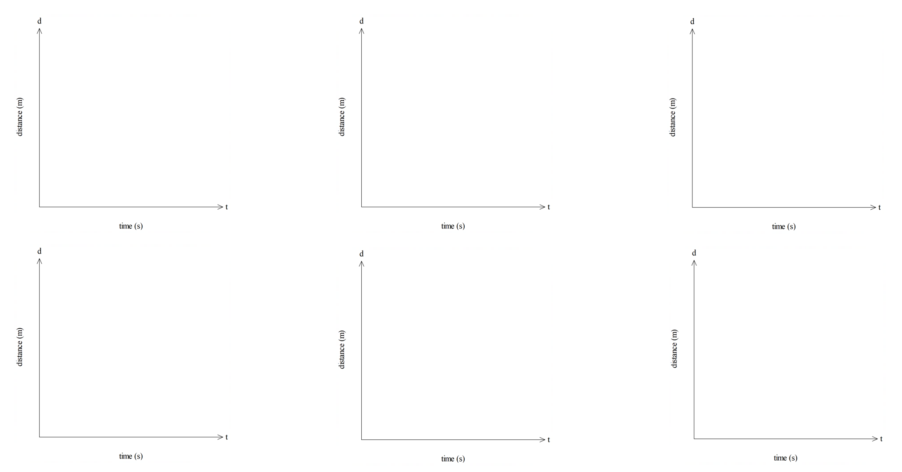

Sample solutions

Activity 2 – graphing motion
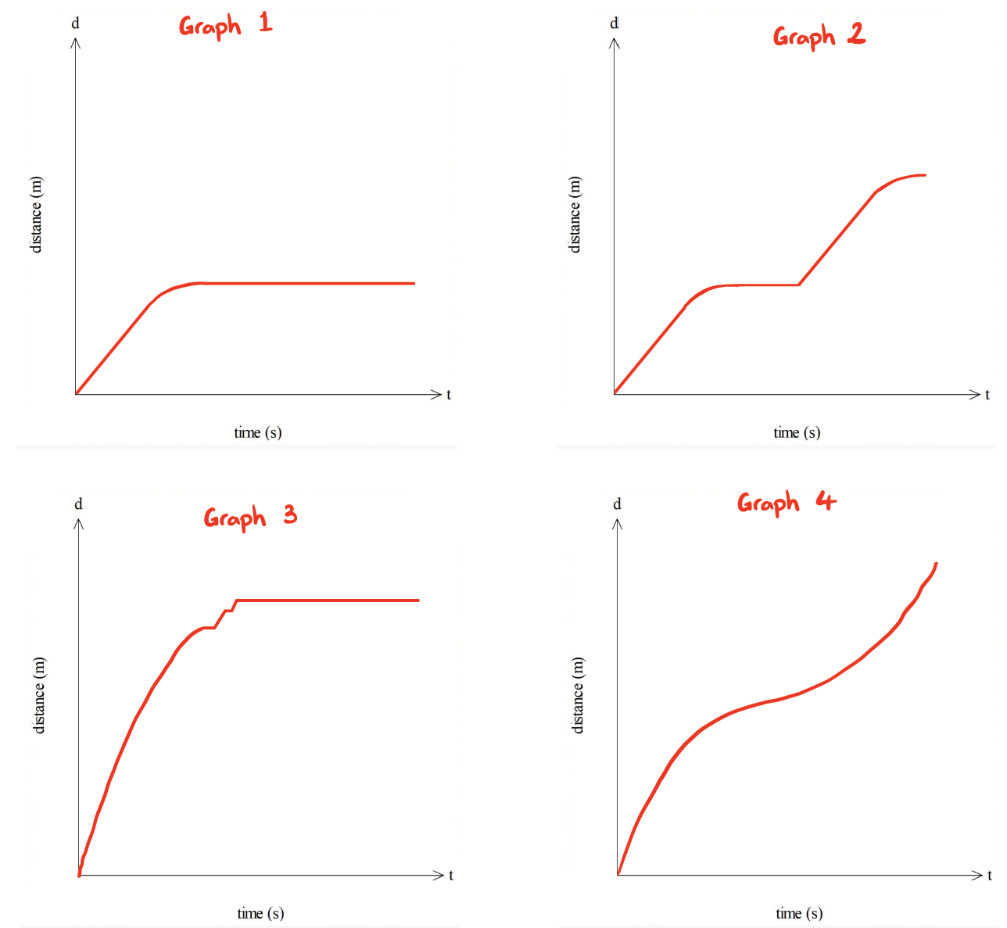

References
This resource contains NSW Curriculum and syllabus content. The NSW Curriculum is developed by the NSW Education Standards Authority. This content is prepared by NESA for and on behalf of the Crown in right of the State of New South Wales. The material is protected by Crown copyright.
Please refer to the NESA Copyright Disclaimer for more information https://educationstandards.nsw.edu.au/wps/portal/nesa/mini-footer/copyright.
NESA holds the only official and up-to-date versions of the NSW Curriculum and syllabus documents. Please visit the NSW Education Standards Authority (NESA) website https://educationstandards.nsw.edu.au/ and the NSW Curriculum website https://curriculum.nsw.edu.au/home.
Mathematics K–10 Syllabus © NSW Education Standards Authority (NESA) for and on behalf of the Crown in right of the State of New South Wales, 2022.

© State of New South Wales (Department of Education), 2024
The copyright material published in this resource is subject to the Copyright Act 1968 (Cth) and is owned by the NSW Department of Education or, where indicated, by a party other than the NSW Department of Education (third-party material).
Copyright material available in this resource and owned by the NSW Department of Education is licensed under a Creative Commons Attribution 4.0 International (CC BY 4.0) license.
This license allows you to share and adapt the material for any purpose, even commercially.
Attribution should be given to © State of New South Wales (Department of Education), 2024.
Material in this resource not available under a Creative Commons license:
- the NSW Department of Education logo, other logos and trademark-protected material
- material owned by a third party that has been reproduced with permission. You will need to obtain permission from the third party to reuse its material.
Links to third-party material and websites
Please note that the provided (reading/viewing material/list/links/texts) are a suggestion only and implies no endorsement, by the New South Wales Department of Education, of any author, publisher, or book title. School principals and teachers are best placed to assess the suitability of resources that would complement the curriculum and reflect the needs and interests of their students.
If you use the links provided in this document to access a third-party's website, you acknowledge that the terms of use, including licence terms set out on the third-party's website apply to the use which may be made of the materials on that third-party website or where permitted by the Copyright Act 1968 (Cth). The department accepts no responsibility for content on third-party websites.

