Graphing stories
Students represent rates of change using graphs, with an emphasis on linear graphs and gradient.
Students will need at least one digital device per pair to interact with online manipulatives during this lesson.

Visible learning
This lesson incorporates Path content and assumes students are confident with related Core content.

Learning intention
- To be able to represent a rate of change of one quantity over time.

Success criteria
- I can graph the change in a quantity over time.
- I can describe the rate of change in linear graphs.
- I can explain the connection between the rate of change and gradient.

Syllabus outcomes
A student:
- develops understanding and fluency in mathematics through exploring and connecting mathematical concepts, choosing and applying mathematical techniques to solve problems, and communicating their thinking and reasoning coherently and clearly MAO-WM-01
- identifies and solves problems involving direct and inverse variation and their graphical representations MA5-RAT-P-01
Mathematics K–10 Syllabus © NSW Education Standards Authority (NESA) for and on behalf of the Crown in right of the State of New South Wales, 2022.

Activity structure
Please use the associated PowerPoint Graphing stories to display images in this lesson.

Warm up
- Print Appendix A ‘Equations Venn’ on A3 paper. Place each sheet in a plastic pocket and place the pockets on walls around the room using adhesive putty.
If doing both the Warm up and Launch activities, Appendices A and B can be printed back-to-back on one A3 sheet of paper. Students can flip the plastic pocket when changing between activities.
- Assign visibly random groups of 3 (bit.ly/visiblegroups) and direct groups to stand at a plastic pocket, with one whiteboard marker per group.
- Groups attempt to write the equation of a line in each section of the Venn diagram. If they believe a section cannot be filled, they should write a justification explaining why.
- Before concluding the activity, have nearby groups compare answers and discuss.

Launch
- Print Appendix B ‘Filling containers’ on A3 paper. Place each sheet in a plastic pocket and place the pockets on walls around the room using adhesive putty.
- Display the GeoGebra applet ‘Depth Time Graphs of filling different containers’ (geogebra.org/m/S4Yc2fda).
- Select the Animate button and ask for suggestions of what the graph is showing and any noticeable features of the graph.
Figure 1 – 'Animate' button
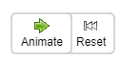
Image created using GeoGebra and is licensed under the GeoGebra License.
- Select the second container from the 6 options along the bottom of the applet. Ask students to suggest what will stay the same or change about the graph for this container. Select the Animate button.
- Explain the task to students:
You’ve seen the depth over time graphs for containers 1 and 2. Your job is to predict and draw what the graphs will look like for the remaining 4 containers.
- Assign students to visibly random groups of 3. Each group should collect one whiteboard marker and cloth before heading to a plastic pocket to complete the task.
Ask assessing questions to determine students’ prior knowledge of linear and non-linear graphs. For example:
- What did you notice about the first 2 containers?
- What makes these containers similar or different?
- What do each of the axes represent?
Advancing questions should be used to support groups that are struggling.
For example:
- Is there anything similar about containers 3 and 4?
- What makes a graph linear or non-linear?
- Have students conduct a gallery walk (bit.ly/DLSgallerywalk) to compare their graphs with those of other groups.
- Show students the graphs for the remaining containers, one at a time, having groups rate their graph on a scale out of 5, with 5 being exactly like the graph shown and 1 being nothing like the graph shown.

Explore

Activity 1 – charge!
- Assign students to pairs. Provide one laptop between each pair.
- Before doing this activity, you will need to set up a Desmos classroom (bit.ly/desmosclassroomstrategy).
- Set the Desmos classroom activity ‘Charge!’ (bit.ly/desmoschargeactivity) for students. One student from each group should log into the activity.
In this activity, students use linear modelling to predict how long it will take for a smartphone to reach full charge. Students will also interpret the parameters of their equation in context.
Use the pacing tool on the Desmos teacher dashboard if you wish to provide group instruction and restrict the slides students can access.
- After completing the activity, have students discuss with their partner something they noticed and something they wondered (bit.ly/noticewonderstrategy) about how phones charge.
- Ask non-volunteer students to share what they noticed and wondered.

Activity 2 – modern charging
Throughout the Desmos activity it’s likely that students will suggest that phone charging has changed significantly since 2017 when the activity was made. This activity is a chance to explore the charging speeds of current smartphones.
- Explain to students that the Desmos activity was made in 2017. How do they think battery charging speeds will have changed since 2017, if at all?
- Students return to their pairs with one laptop between 2.
- Direct students to Digital Trend’s article ‘Top 10 fastest-charging smartphones in the world, ranked’ (bit.ly/chargingpower).
- Each phone’s total battery and charging rate are given in mAh (milliampere-hours). Have students use the Desmos graphing calculator (desmos.com/calculator) to construct a graph for each phone, all on the same axis.
Have students assume the phones charge in a linear pattern, as the charging rate provided is an average.

Summarise
Equipment
- Print and individually cut out graphs from Appendix C ‘Matching graphs’.
- Print and individually cut out rates from Appendix D ‘Matching graphs – rates’.
- Adhesive putty.
Method
- Students return to their groups of 3. Provide each group with cut up copies of Appendices C and D, as well as some adhesive putty.
- Students match the graph to the rate and stick them up together on the wall using the adhesive putty.
- Once graphs and rates are matched, students find the equation for each line and verify that the equation works by testing a point on the graph.
- Once all graphs are matched have students compare with a nearby group.
- Have students discuss what made the activity easier or harder and any strategies they used. Then share as a class.
- If students don’t suggest that the gradient is the rate, explicitly highlight the connection between gradient and rate.
If students are not confident finding the gradient or equation of a line, this could be explicitly taught either as a whole class moment, or by working with smaller groups.

Apply
- Assign visibly random groups of 3 and position groups at blank plastic pockets around the room.
- Display Figures 2 and 3 using the associated PowerPoint Graphing stories. Displayed are 6 containers that are being filled with water at a constant rate, and 9 graphs that represent the height of the water in a container as a function of the volume of water in the container.
Figure 2 – 6 containers
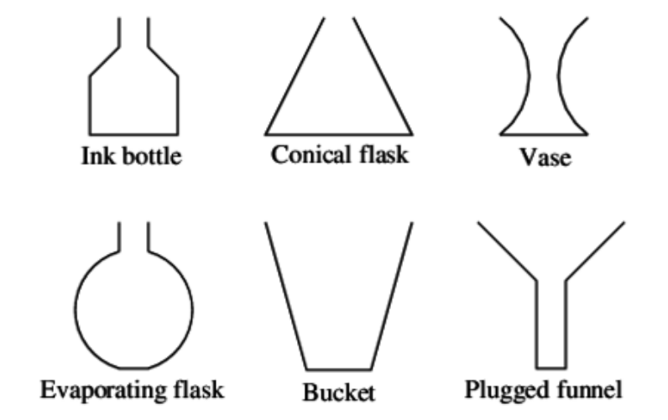
‘6 containers’ by Illustrative Mathematics is licensed under CC BY-NC-SA 4.0
Figure 3 – 9 graphs
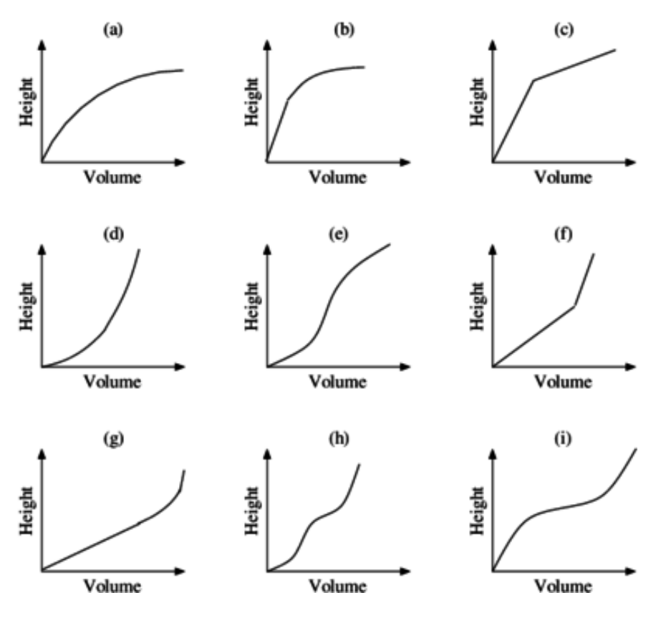
‘9 graphs’ by Illustrative Mathematics is licensed under CC BY-NC-SA 4.0.
- Students are to:
- choose the graph that corresponds to each container
- write a brief justification for each match, explaining how the rate is changing
- sketch what the containers could look like for the remaining 3 graphs.
If water is flowing at a constant rate into a part of the container whose cross-section is the same at all heights, like the bottom part of the ink bottle or the top part of the evaporating flask, then the height is increasing at a constant rate, and so the corresponding part of the graph is linear. Moreover, if the vessel is wide, the height increases at a slower rate than if it is narrow, so the corresponding part of the graph is steeper. If the cross section is changing in width, then the corresponding part of the graph is not linear.
Encourage and model for students how to describe the rate of change as increasing at a constant, increasing, or decreasing rate.
- Challenge students to assign numbers to the axes of each graph.
- Take note of the numbers students assign. Do they use the same numbers on each axis? Ask them to justify the numbers used.
- Ask students if they can find the gradient of any graphs? If so, what does that gradient mean? What would a gradient of 2 mean in this context? Which container would have the greatest gradient?

Assessment and differentiation

Suggested opportunities for differentiation
Warm up
- Students who aren’t confident with equations might benefit from using Desmos’ graphing calculator (desmos.com/calculator) to construct and test linear graphs.
Explore
- Student progress can be monitored using the Desmos teacher dashboard. If students are struggling, you could send them individualised feedback or possibly freeze the activity for the whole class to talk through a specific slide.
- If students finish the Desmos activity early, have them research the charge time for their phone (if they have one) or the top selling phones. This information can be used in the Apply section of the lesson.
- To extend students, have them look at the battery usage of their phones and attempt to draw and describe the graph. Usually this can be viewed in their phone settings.
Summarise
- If students are struggling to engage with the activity you could assign roles, such as ‘knowledge mobiliser’. This student’s role is to observe what another group is doing and report back.
- Students could be challenged to find the rate of change of a curve, and/or explain why this is not as accurate as finding the gradient of a linear graph.
Apply
- For struggling students, assign them just one graph. Have students write as much as they know about the graph. Then have them try to pick the container that would match or draw one if there is no match. If doing this strategy with a small group of students, they could each have their own graph to work on. Then they can share their solutions to match all graphs to their containers.
- Ask how the graphs would change if each container had a stem.
- Introduce the Pythagorean cup to students. Challenge them to draw a graph of filling the Pythagorean cup.
- Challenge students to explain how the graphs would change if the axes were swapped.

Suggested opportunities for assessment
Launch
- Ask assessing questions to assess students’ prior knowledge of linear and non-linear graphs.
Explore
- Students’ progress through the Desmos activity can be monitored in real time and following the lesson using the Desmos teacher dashboard.
Summarise
- Listen to student discussions. Are they using correct vocabulary? Do their arguments make sense?
- Ask assessing questions to assess for development in students’ descriptions of linear and non-linear graphs.
Summarise
- Listen to student discussions and observe work at vertical non-permanent surfaces. Challenge students to justify their answers.

Appendix A

Equations Venn
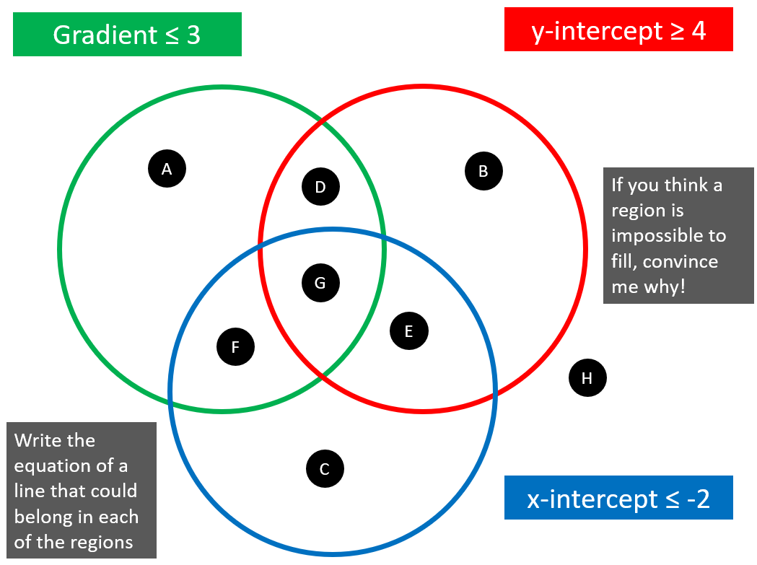
Activity available at Maths Venns (bit.ly/equationsvenn).

Appendix B

Filling containers

Appendix C

Matching graphs
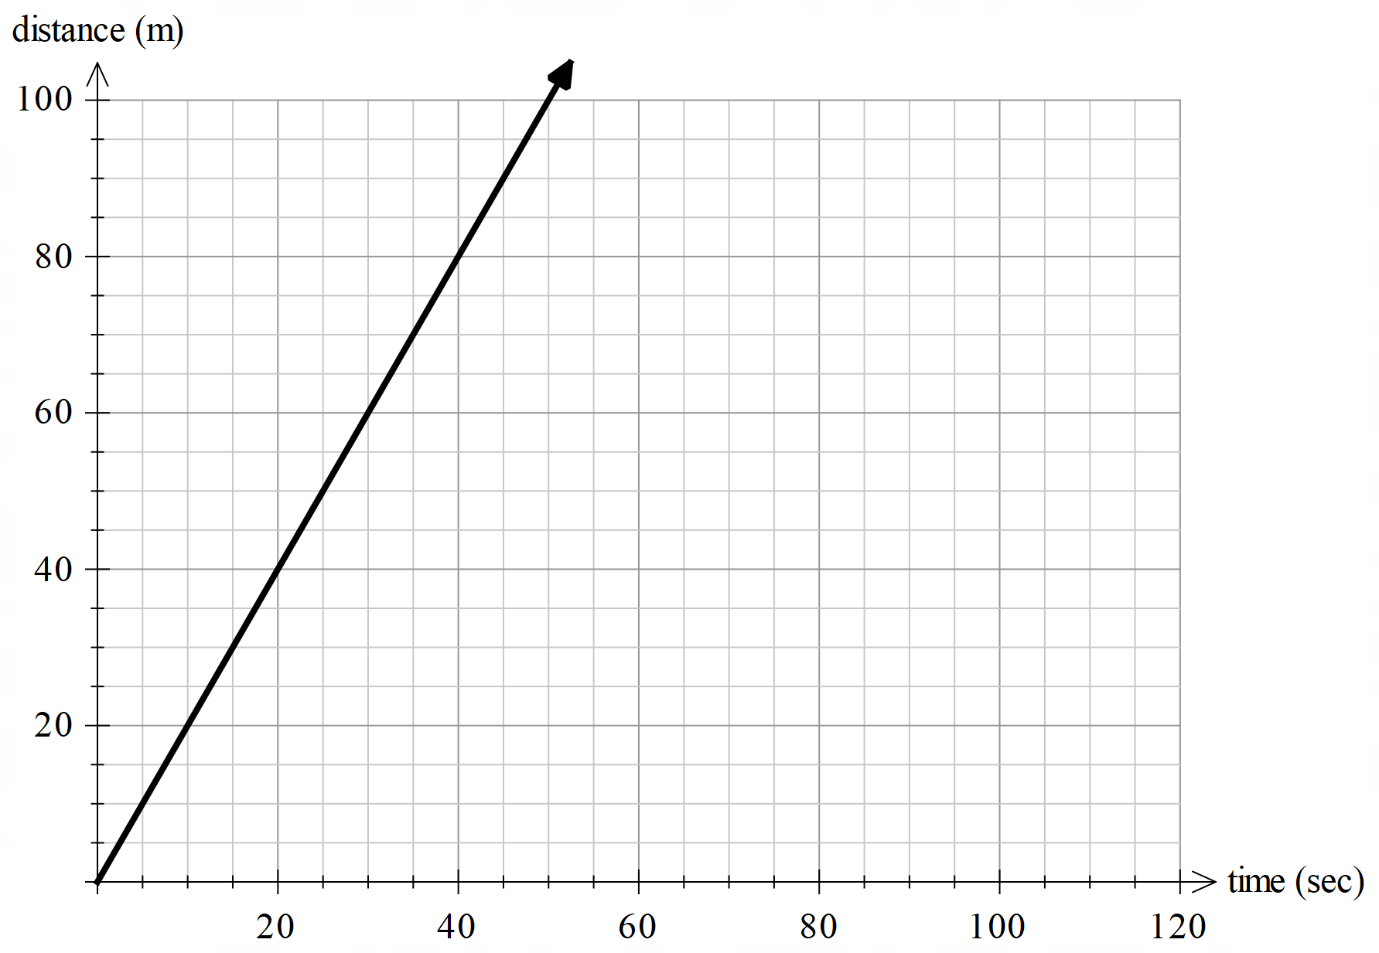
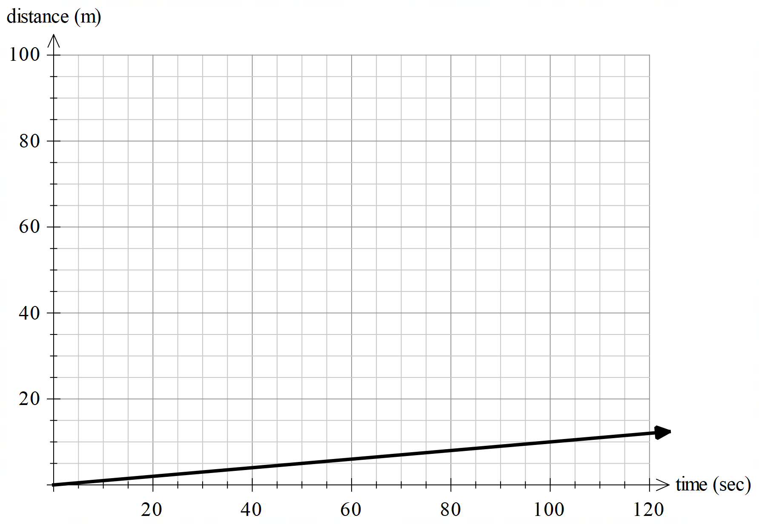
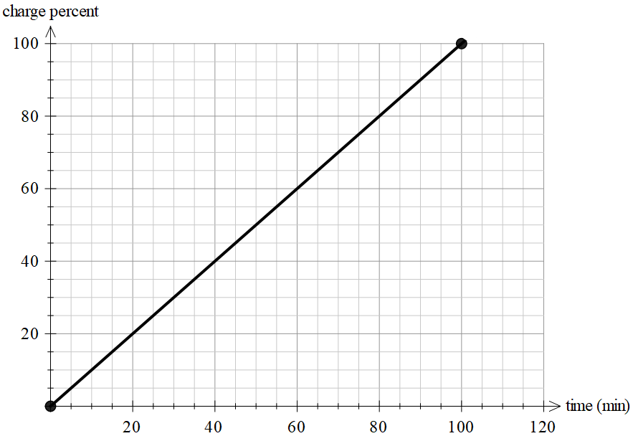
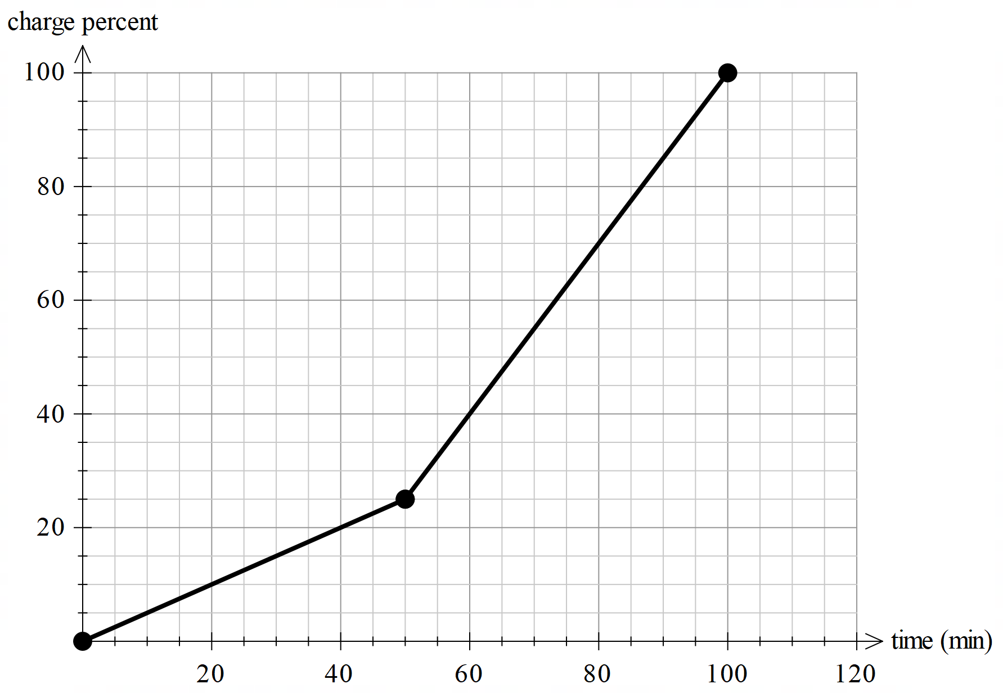
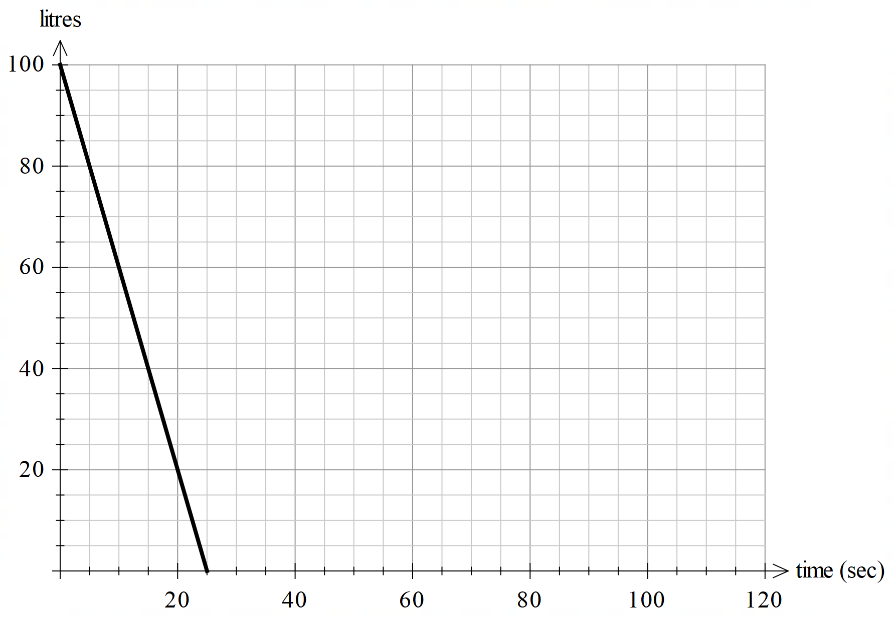
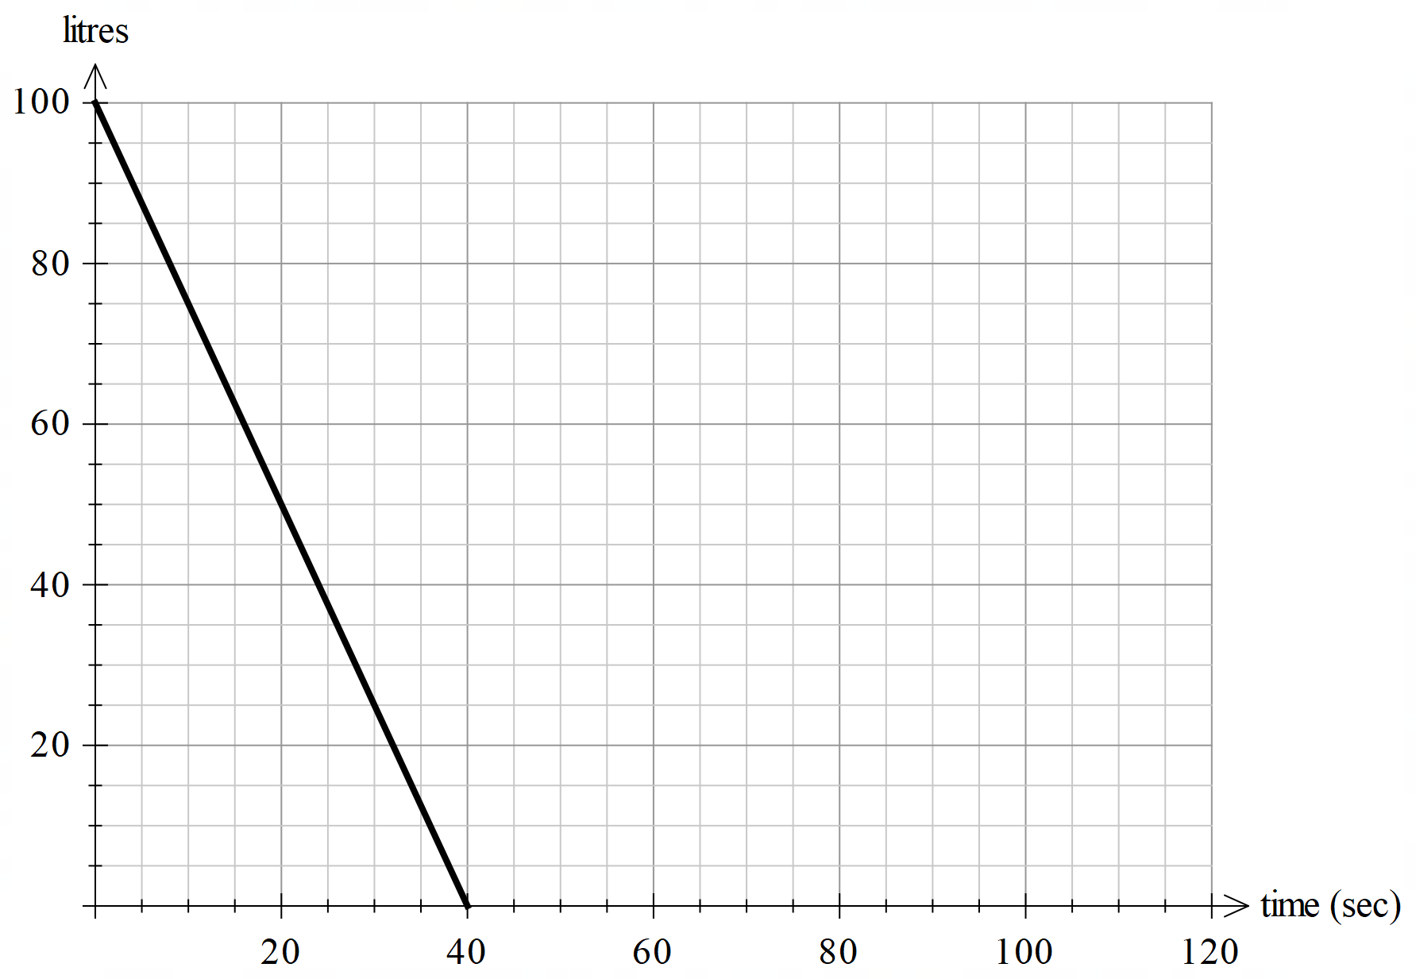

Appendix D

Matching graphs – rates
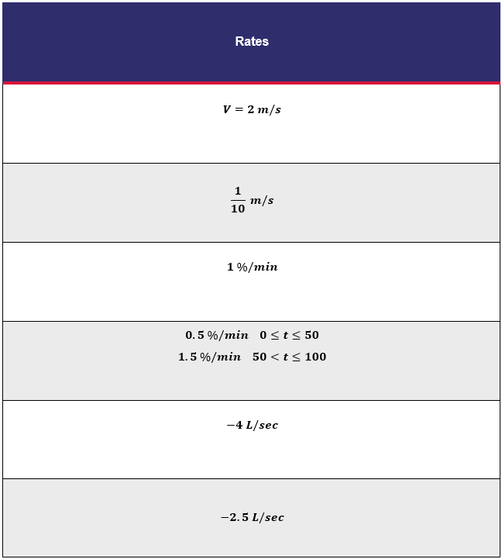

Sample solutions
Summarise
The graphs and rates are provided in matching order in Appendices C and D.
Apply
Bucket – a.
Conical flask – d.
Vase – e.
Plugged funnel – b.
Ink bottle – g.
Evaporating flask – i.

© State of New South Wales (Department of Education), 2024
The copyright material published in this resource is subject to the Copyright Act 1968 (Cth) and is owned by the NSW Department of Education or, where indicated, by a party other than the NSW Department of Education (third-party material).
Copyright material available in this resource and owned by the NSW Department of Education is licensed under a Creative Commons Attribution 4.0 International (CC BY 4.0) license.
This license allows you to share and adapt the material for any purpose, even commercially.
Attribution should be given to © State of New South Wales (Department of Education), 2024.
Material in this resource not available under a Creative Commons license:
- the NSW Department of Education logo, other logos and trademark-protected material
- material owned by a third party that has been reproduced with permission. You will need to obtain permission from the third party to reuse its material.
Links to third-party material and websites
Please note that the provided (reading/viewing material/list/links/texts) are a suggestion only and implies no endorsement, by the New South Wales Department of Education, of any author, publisher, or book title. School principals and teachers are best placed to assess the suitability of resources that would complement the curriculum and reflect the needs and interests of their students.
If you use the links provided in this document to access a third-party's website, you acknowledge that the terms of use, including licence terms set out on the third-party's website apply to the use which may be made of the materials on that third-party website or where permitted by the Copyright Act 1968 (Cth). The department accepts no responsibility for content on third-party websites.

