It’s a sign
Students use street signs to explore how to find the area of composite shapes involving special quadrilaterals and triangles.

Visible learning
Learning intentions and success criteria should be shared with students after the Launch activity.

Learning intention
- To be able to find the area of composite shapes.

Success criteria
- I can separate a figure into known quadrilaterals and triangles.
- I can explain how to calculate the area of a composite shape.
- I can pick the most effective method to find the area of a composite figure.

Syllabus outcomes
A student:
- develops understanding and fluency in mathematics through exploring and connecting mathematical concepts, choosing and applying mathematical techniques to solve problems, and communicating their thinking and reasoning coherently and clearly MAO-WM-01
- applies knowledge of area and composite area involving triangles, quadrilaterals and circles to solve problems MA4-ARE-C-01
Mathematics K–10 Syllabus © NSW Education Standards Authority (NESA) for and on behalf of the Crown in right of the State of New South Wales, 2022.

Activity structure
Use the PowerPoint It’s a sign to display images for this lesson.

Warm up
Students are to complete the activity Quad Areas (bit.ly/quadareas). In this activity students are to create as many quadrilaterals as possible in a 3 × 3 grid, and find their area, assuming the length between dots is equal to 1.
For those without access to devices there is an offline printable version found on the website or students could use geoboards and elastic bands.

Launch
- Display Figure 1 on slide 2 of the PowerPoint It’s a sign. This displays a street sign.
Figure 1 – street sign
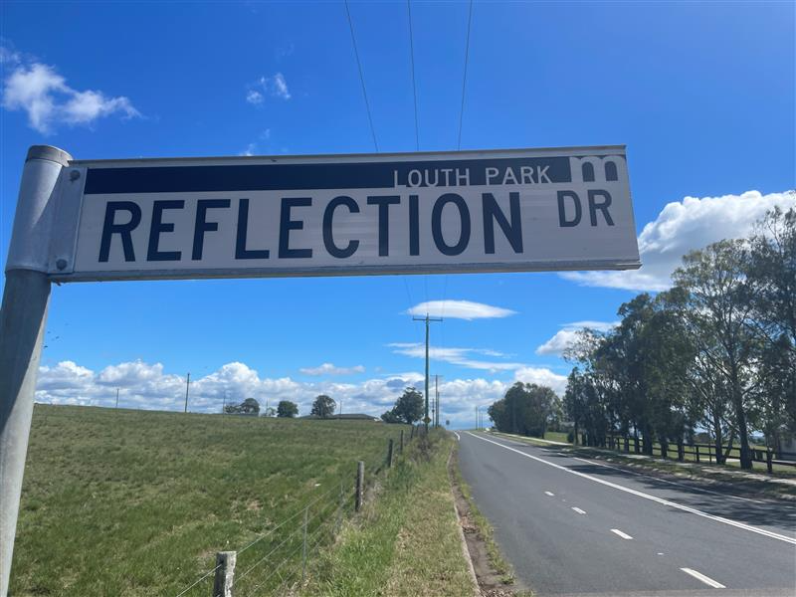
- Explain to students that the letters on a street sign are heavy duty stickers that are cut out of a template. When they are cut out of the sticker sheet there is a lot of waste
- Display Figure 2 on slide 3 of the PowerPoint It’s a sign. This displays the dimensions of letters on street signs.
Figure 2 – street sign dimensions
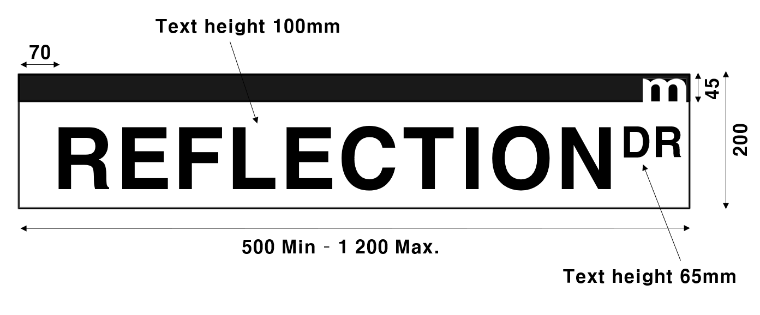
- In a Think-Pair-Share (bit.ly/thinkpairsharestrategy), ask students what area they think the letters take up and what percentage of the sticker is wasted.
The letter sizes on street signs are based on the dimensions for Maitland City Council Standard Drawings (5.7 MB) (bit.ly/maitlandstreetsigns).

Explore
- Reveal the learning intentions and success criteria for students.
- Remind students what composite shapes are.
A composite shape is a shape that is formed by combining other plane shapes. Composite shapes are often described as 'complex' when they are made up of many and different shapes.
- Assign students into visibly random groups of 3 (bit.ly/visiblegroups) on vertical non-permanent surfaces (bit.ly/VNPSstrategy).
- Distribute Appendix A ‘Letter A’ on A3 paper in plastic sleeves. Challenge students to find as many ways as possible to break up the letter A into shapes we know how to find the area of.
Figure 3 – letter A
- Give each student 2 stickers of 2 different colours.
Alternatively, you can use different coloured markers to mark on the board or sticky notes.
- Students are to do a gallery walk (bit.ly/DLSgallerywalk) of each group’s letters. Ask them to use one colour sticker to place on their favourite solution and the other colour sticker for the solution that is the most different to their own.
- Visit the boards that have the most stickers for ‘most different to their own’. Using a questioning strategy such as Pose-Pause-Pounce-Bounce (PDF 557KB) (bit.ly/posepausepouncebounce), challenge students to compare the 2 most effective strategies and why one is better than the other.
- Have students return to their groups of 3 at their boards.
- Distribute Appendix B ‘Letter A measurements’, which has the letter A with dimensions. Ask students to try and find the area of the letter.
- Walk around the room and look at student work. Join groups together that have produced different solutions to the same problem and state ‘At least one of you is incorrect.’
This activity can be continued by doing more letters of the alphabet.
- Display slide 4 from the PowerPoint It’s a sign to show the letter V with its measurements. Ask students to attempt to find the area of the letter.
- Distribute Appendix C ‘Letter V’ to each student. This appendix shows 2 approaches to finding the area of the letter V involving addition and subtraction. Ask students what they notice and wonder (bit.ly/noticewonderstrategy) about the solutions.
- Start a class discussion by asking students which method they think is most effective and why.
- Students are to return to their groups at their vertical non-permanent surface. Challenge students to find another solution method to finding the area of the letter A that involves subtraction.

Summarise
- Students are to create notes to their future forgetful selves (bit.ly/notesstrategy) on how to find the area of composite shapes. They should use a letter from their own name as an example.
- Students should swap notes with the person next to them and discuss with their partner any important notes they might have missed.

Apply

Create your own font
- Distribute at least one page of graph paper to each student.
A4 graph paper can be found on Math-Aids (https://www.math-aids.com/Graph_Paper/).
Most graph paper comes in square centimetres.
- Explain that students are to create their own word using letters made up of special quadrilaterals and triangles. They must find the area of each letter they create in square millimetres.
- Students are to find the area of their word and show all calculations.
- Students should then decide on the size of rectangular sticker sheet that their letters will be cut from.
- They will then determine the percentage of waste from the sticker sheet.

Assessment and differentiation

Suggested opportunities for differentiation
Warm up
- Students could use a geoboard and elastic bands to create quadrilaterals.
Explore
- Challenge students to cut the letter A using the least number of shapes. They should be able to find multiple possibilities.
- Students may need to be reminded of the formulas for different shapes to complete the task.
- Challenge students to find more strategies to calculate the area of the letter A.
Apply
- To support and challenge students, have them select words of varying length. For students building their confidence start with 3-letter words. For students wanting a challenge suggest words of 7 letters or more.
- Students could be challenged to consider how they might split a letter with curved sides into known shapes. For instance, the letter D.
- Students needing support could work in nearest whole centimetres instead of millimetres.
- Students could be challenged to convert the area of their word into other units. For example, converting into cm² or m².

Suggested opportunities for assessment
Explore
- Monitor responses in class discussions to check for student understanding of adding or subtracting areas to find the composite area of shapes.
- When placed in groups of 3, students provide and receive peer feedback on their understanding.
Summarise
- Review students’ notes to future forgetful selves.
Apply
- Collect students’ created words and area calculations as an exit ticket.

Appendix A

Letter A
Image created using Desmos and is licensed under the Desmos Terms of Service.

Appendix B

Letter A measurements
All measurements provided are in millimetres.
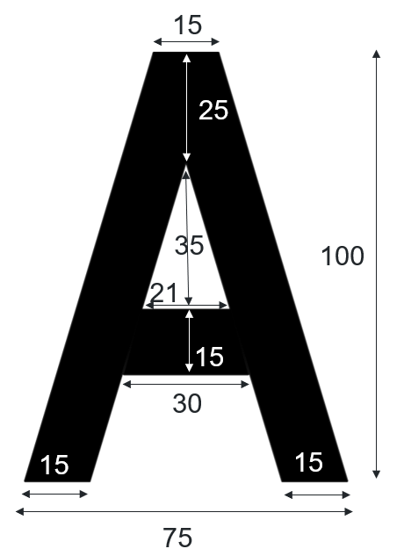

Appendix C

Letter V
Find the area of the letter V. The measurements are given below.
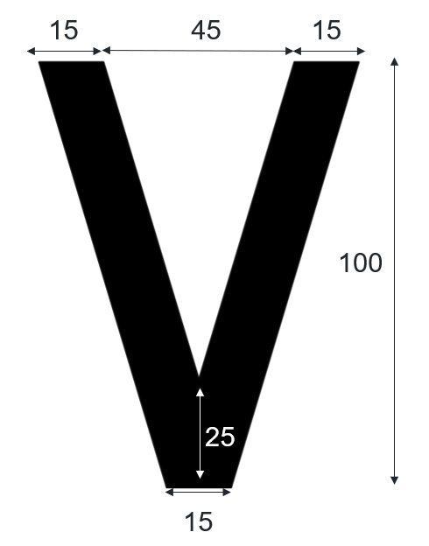
Image created using Desmos and is licensed under the Desmos Terms of Service.
James’ solution | Rayner’s solution
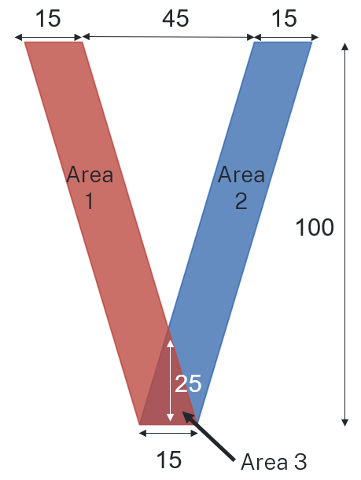 | 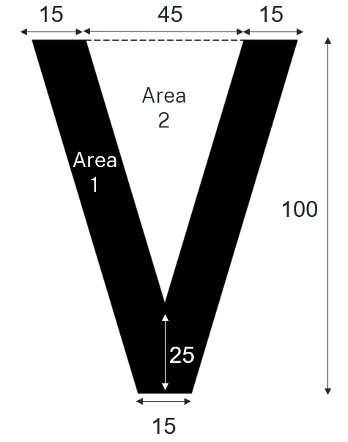
Area 1: Parallelogram  $$15×100=1500mm^{2}$$  Area 2: Parallelogram  $$15×100=1500mm^{2}$$  Area 3: Triangle  $$\frac{1}{2}×25×15=187.5mm^{2}$$  Total area  $$A= 1500+1500-187.5 \\ A=2812.5mm^{2}$$ | Area 1: Trapezium  $$15+45+15=75$$  $$\frac{100}{2}\left(15+75\right)=4500mm^{2}$$  Area 2: Triangle  $$100-25=75$$  $$\frac{1}{2}×45×75=1687.5mm^{2}$$  Total area  $$4500-1687.5=2812.5mm^{2}$$

Sample solutions

Appendix A – Letter A
There are many other solutions, these are just 2.
Solution 1 | Solution 2
Area 1: Parallelogram  $$15×100=1500mm^{2}$$  Area 2: Parallelogram  $$15×100=1500mm^{2}$$  Area 3: Triangle  $$\frac{1}{2}×15×25=187.5mm^{2}$$  Area 4: Trapezium  $$\frac{15}{2}\left(21+30\right)=382.5mm^{2}$$  Total area  $$A= 1500+1500-187.5+ 382.5 \\ A=3195mm^{2}$$ | Area 1: Trapezium  $$\frac{100}{2}\left(15+75\right)=4500mm^{2}$$  Area 2: Triangle  $$\frac{1}{2}×35×21=367.5mm^{2}$$  Area 3: Trapezium  $$100-25-35-15=25mm^{2}$$  $$75-15-15=45$$  $$\frac{25}{2}\left(30+45\right)=937.5mm^{2}$$  Total area  $$A=4500-367.5-937.5$$  $$A=3195mm^{2}$$

References
This resource contains NSW Curriculum and syllabus content. The NSW Curriculum is developed by the NSW Education Standards Authority. This content is prepared by NESA for and on behalf of the Crown in right of the State of New South Wales. The material is protected by Crown copyright.
Please refer to the NESA Copyright Disclaimer for more information https://educationstandards.nsw.edu.au/wps/portal/nesa/mini-footer/copyright.
NESA holds the only official and up-to-date versions of the NSW Curriculum and syllabus documents. Please visit the NSW Education Standards Authority (NESA) website https://educationstandards.nsw.edu.au and the NSW Curriculum website https://curriculum.nsw.edu.au.
Mathematics K–10 Syllabus © NSW Education Standards Authority (NESA) for and on behalf of the Crown in right of the State of New South Wales, 2022.
Maitland City Council Infrastructure & Works (2019) Maitland City Council Standard Drawings [5.7 MB], Maitland City Council, accessed 11 March 2024.
© State of New South Wales (Department of Education), 2024
The copyright material published in this resource is subject to the Copyright Act 1968 (Cth) and is owned by the NSW Department of Education or, where indicated, by a party other than the NSW Department of Education (third-party material).
Copyright material available in this resource and owned by the NSW Department of Education is licensed under a Creative Commons Attribution 4.0 International (CC BY 4.0) license.
This license allows you to share and adapt the material for any purpose, even commercially.
Attribution should be given to © State of New South Wales (Department of Education), 2024.
Material in this resource not available under a Creative Commons license:
- the NSW Department of Education logo, other logos and trademark-protected material
- material owned by a third party that has been reproduced with permission. You will need to obtain permission from the third party to reuse its material.
Links to third-party material and websites
Please note that the provided (reading/viewing material/list/links/texts) are a suggestion only and implies no endorsement, by the New South Wales Department of Education, of any author, publisher, or book title. School principals and teachers are best placed to assess the suitability of resources that would complement the curriculum and reflect the needs and interests of their students.
If you use the links provided in this document to access a third-party's website, you acknowledge that the terms of use, including licence terms set out on the third-party's website apply to the use which may be made of the materials on that third-party website or where permitted by the Copyright Act 1968 (Cth). The department accepts no responsibility for content on third-party websites.

