Growing pains
Students generate number patterns from exploring the change in area that results from an increase in the dimensions of a quadrilateral.

Visible learning

Learning intention
- To be able to generate a number pattern from a formula.

Success criteria
- I can substitute values into a formula and evaluate it.
- I can fill out a table of values.
- I can explain what happens to the area of shapes as their sides increase.

Syllabus outcomes
A student:
- develops understanding and fluency in mathematics through exploring and connecting mathematical concepts, choosing and applying mathematical techniques to solve problems, and communicating their thinking and reasoning coherently and clearly
MAO-WM-01
- generalises number properties to operate with algebraic expressions including expansion and factorisation MA4-ALG-C-01
- applies knowledge of area and composite area involving triangles, quadrilaterals and circles to solve problems MA4-ARE-C-01
Mathematics K–10 Syllabus © NSW Education Standards Authority (NESA) for and on behalf of the Crown in right of the State of New South Wales, 2022.

Activity structure
This lesson uses the PowerPoint Growing pains.

Warm up
- Display slide 2 from the PowerPoint Growing pains to display the following Open Middle problem.
- Students are to select from the numbers 1–9 to fill in the circles to create shapes with a maximum total area. You can only use each number once.
Figure 1 – Open Middle problem
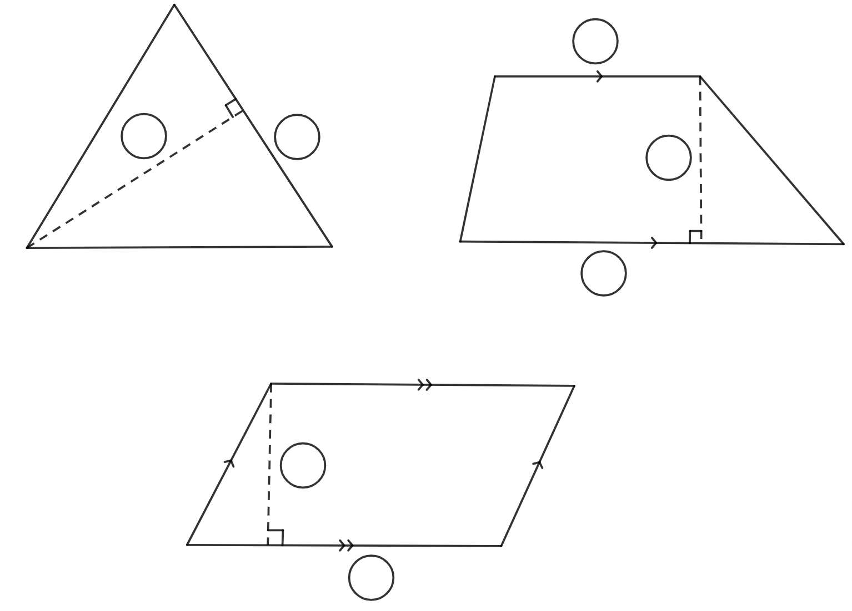

Launch
- Present to the students, the statement ‘When the length and height of a parallelogram doubles, its area doubles’. This can be found on slide 3 of the PowerPoint Growing pains.
- In a Think-Pair-Share (bit.ly/thinkpairsharestrategy), have students decide their position on the statement and why.
Teachers can set up areas in the room for students to move to for agree and disagree.
- Ask students what they think happens as the dimensions of other quadrilaterals increase. Do they follow the same trend as a parallelogram or are they different?
- Tell students, in this lesson we will be exploring how changes to a shape’s dimensions affect its area.

Explore
During this section, students will work in visibly random groups of 3 (bit.ly/visiblegroups) to complete a jigsaw activity (bit.ly/jigsawgroupstrategy).
- Set up a Jigsaw task with 6 stations. Each station will focus on a different shape from Appendix A ‘Growing shapes’.
- Explain to students that each person in their group is to visit 2 stations and complete the worksheet at that station. Students need to select stations, so that as a group they cover all the stations around the room. Each station will need enough worksheets for one per group. The worksheet will be completed at the station and students can discuss answers with other students working at that station.
- Once all stations are completed, students should return to their original group. They are to take turns explaining what they discovered from visiting the different stations.
- Revisit the launch question ‘When the length and height of a parallelogram doubles, its area doubles’. Conduct a class vote to determine whether students now agree or disagree with this statement. Randomly select students to explain their reasoning.
- Distribute Appendix B ‘Jigsaw questions’ to each group of students. Students should complete these in their groups.
- Initiate a sharing of ideas and reasoning using the Pose-Pause-Pounce-Bounce question strategy (PDF 557 KB) (bit.ly/posepausepouncebounce) for each question from Appendix B.

The group questions should highlight to students that:
- shapes that have similar dimensions and formulas grow in the same way, such as a rectangle and a parallelogram
- they can use number patterns to complete the remaining values in the table of values or the area formulas
- areas double when only one dimension is doubled.

Summarise
- Explain to students what a number pattern is, showing examples from the Explore section.
A number pattern is a list of numbers that follow a certain sequence or pattern. Examples could include: the area of the rectangle (5, 10, 15, …) as an arithmetic number pattern increasing by 5 each time, or the area of a square (1, 4, 9, …) showing the square numbers.
- Use slides 4–7 from the Growing pains PowerPoint for explicit teaching of completing tables of values.
The explicit teaching technique used in the PowerPoint is ‘Your turn’. The first slide is a worked example which should be displayed for the students before using the following steps.
- Reveal the question to students and its solution.
- Students read in silence.
- Students individually explain to themselves what is happening in each step.
- Students hold a thumbs up to the teacher when they have finished reading and have some sort of understanding.
- Think-Pair-Share. Students explain the solution to their partner.
- In pairs, students then answer the self-explanation questions.
- Finally, randomly select students to share their answers with the whole class.

Apply
In pairs, students are to explore the following questions using area formulae and tables of values:
- If both the diagonals in a kite double, how much does the area increase by?
- If one or both parallel side lengths of a trapezium each increase by one, how much does the area increase by?
Students should find that when both diagonals double, then the area of the shape quadruples.
Students should find that when one side increases by 1 cm, the area increases by half the height. When both parallel sides increase, the area increases by the value of the height.

Assessment and differentiation

Suggested opportunities for differentiation
Explore
- Students can choose the shapes they are most comfortable with to complete.
- Students may need to be reminded how to draw a line graph.
- Students talk through their answers with other students before sharing with the class to improve confidence in their answers and receive feedback.
Apply
- To challenge students, ask them to make their own statements to explore, such as '’What happens when the dimensions triple’.
- Students could use grid overlays and count squares to assist them in determining area and determining patterns.

Suggested opportunities for assessment
Explore
- Students will demonstrate their working mathematically skills in discussions and justifications.
- When placed in groups of 3, students provide and receive peer feedback on their understanding.
Summarise
- Monitor student responses in the ‘Your turn’ section to check for understanding.

Appendix A

Growing shapes

Rectangles
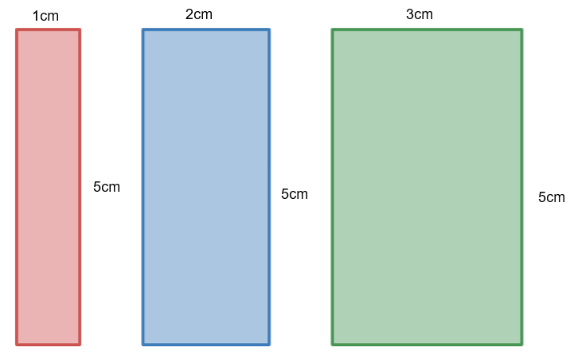
- Find the area for each of the rectangles.
- Find the area for a rectangle with dimensions 4 cm by 5 cm.
- Write the formula for any rectangle with length ($l$) and height of 5 cm.
- Complete the table below to show what happens to the area of the rectangle when the length increases by 1 cm, but the width remains at 5 cm.
$$l$$ | 1 cm | 2 cm | 3 cm | 4 cm | 5 cm | 6 cm | 7 cm | 8 cm
$$A$$
- Describe what happens to the area each time the length is increased by 1 cm.
- Describe what would happen if the width changed to 6 cm.

Squares
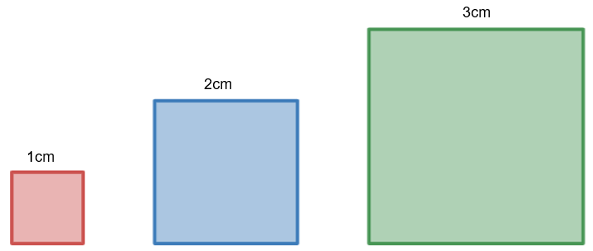
- Find the area for each of the squares.
- Find the area for a square with dimensions 4 cm by 4 cm.
- Write the formula for any square with the length ($l$).
- Complete the table below to show what happens to the area of the square when the length and width increase by 1 cm.
$$l$$ | 1 cm | 2 cm | 3 cm | 4 cm | 5 cm | 6 cm | 7 cm | 8 cm
$$A$$
- Describe what happens to the area each time the length and width is increased by 1 cm. Use visual representations to help explain the growth of the shape.

Triangles
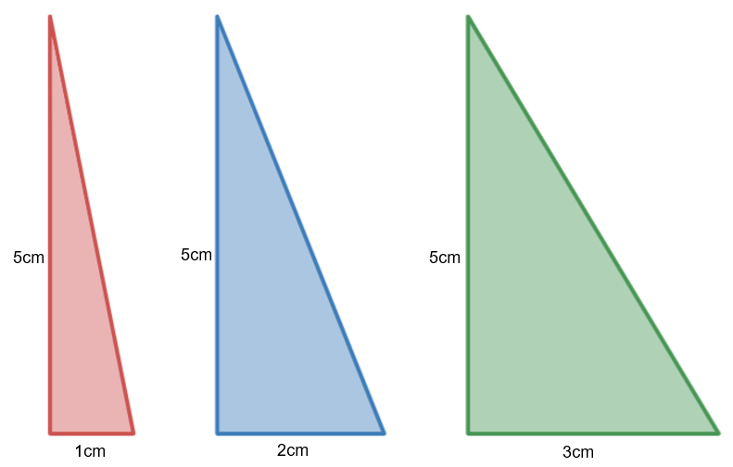
- Find the area for each of these right-angled triangles.
- Find the area for a triangle with dimensions of base 4 cm and perpendicular height of 5 cm.
- Write the formula for any triangle with base ($b$) and height of 5 cm.
- Complete the table below to show what happens to the area of the triangle when the base length increases by 1 cm, but the height remains at 5.
$$b$$ | 1 cm | 2 cm | 3 cm | 4 cm | 5 cm | 6 cm | 7 cm | 8 cm
$$A$$
- Describe what happens to the area each time the base length is increased by 1 cm.
- Given the area of a triangle is 45 $cm^{2}$, and it belongs in this number pattern. Find the base length of the triangle.

Kites
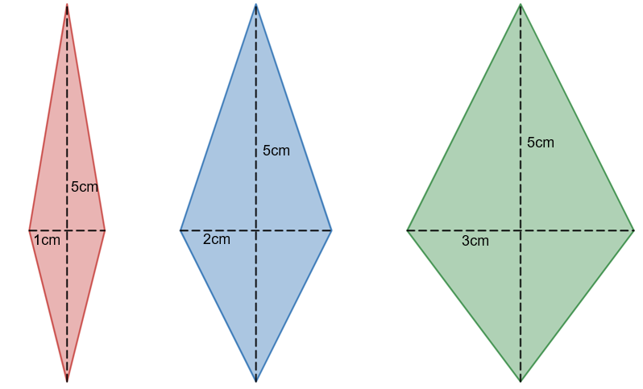
- Find the area for each of the kites.
- Find the area for a kite with diagonals of 4 cm and 5 cm.
- Write the formula for any kite with a diagonal ($x$) and other diagonal of 5 cm.
- Complete the table below to show what happens to the area of the kite when one diagonal increases by 1 cm, and the other diagonal remains at 5 cm.
$$x$$ | 1 cm | 2 cm | 3 cm | 4 cm | 5 cm | 6 cm | 7 cm | 8 cm
$$A$$
- Describe what happens to the area as the length of one of the diagonals increases by 1cm.
- Draw a line graph to represent this relationship. What do you notice?
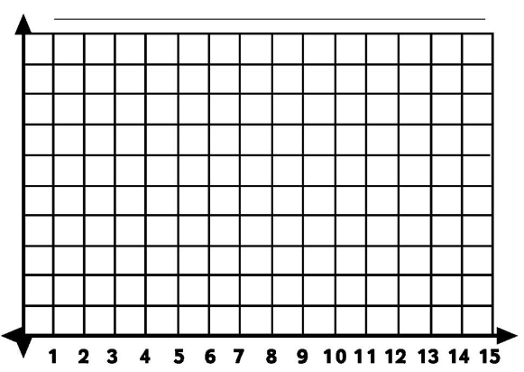

Parallelogram
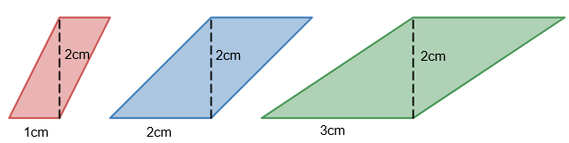
- Find the area for each of the parallelograms.
- Find the area for a parallelogram with base of 4 cm and perpendicular height of 5 cm.
- Write the formula for any parallelogram with base ($b$) and height of 5 cm.
- Complete the table below to show what happens to the area of the parallelogram when the base increases by 1 cm.
$$b$$ | 1 | 2 | 3 | 4 | 5 | 6 | 7 | 8
$$A$$
- Describe what happens to the area each time the base length is increased by 1 cm.
- Does the area double when the base length is doubled? Use examples to support your answer.

Trapezium
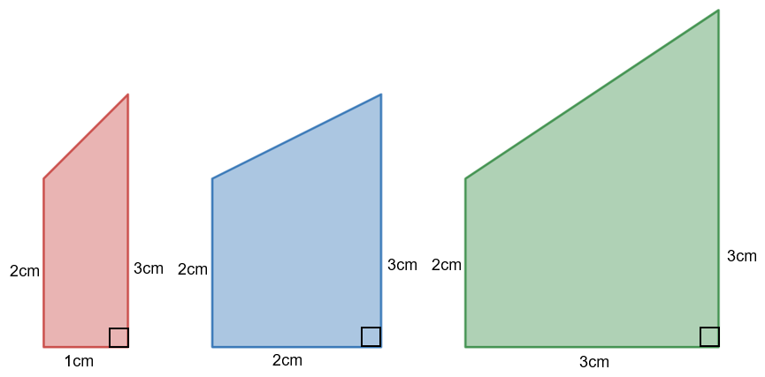
- Find the area for each of the trapeziums.
- Find the area for a trapezium with parallel sides of 2 cm and 3 cm and height 4 cm.
- Write the formula for any trapezium with perpendicular height ($h$) and parallel sides of 2 cm and 3 cm.
- Complete the table below to show what happens to the area of the trapezium when the height increases by 1 cm, but the parallel sides remain the same.
Height | 1 cm | 2 cm | 3 cm | 4 cm | 5 cm | 6 cm | 7 cm | 8 cm
Area
- Describe what happens to the area each time the height is increased by 1 cm.
- Examine the statement, ‘If the height of a trapezium doubles, the area doubles.’ Is this true? Use examples to support your answer.

Appendix B

Jigsaw questions
- Group together shapes that change in the same way when their dimensions increase. Describe their similarities and differences. Why do you think that is the case?
- Explain how you filled out the table to your group. Did you all use the same method? Which method was the easiest?
- ‘When the length and height of a parallelogram doubles, so does its area’. What is your group’s position on this statement? Explain why.

Sample solutions

Warm up
Triangle
$$A=\frac{1}{2}bh$$
$$A=\frac{1}{2}×8×3$$
$$A=12$$
Trapezium
$$A=\frac{h}{2}\left(a+b\right)$$
$$A= \frac{1}{2}\left(7+9\right)$$
$$A=9$$
Parallelogram
$$A=bh$$
$$A=6×2$$
$$A=12$$
Students may find a better solution than the one provided.

Appendix A – growing shapes

Rectangles
- 5$cm^{2}$, 10$cm^{2}$ and 15$cm^{2}$.
- $20cm^{2}$.
- $A=5l$

$$l$$ | 1 cm | 2 cm | 3 cm | 4 cm | 5 cm | 6 cm | 7 cm | 8 cm
$$A$$ | 5 | 10 | 15 | 20 | 25 | 30 | 35 | 40
- Each time the length increased by 1 the area increased by 5.
- Each time you increased by 1 the area would increase by 6.

Squares
- 1$cm^{2}$, 4$cm^{2}$ and 9$cm^{2}$.
- 16$cm^{2}$.
- $A=l^{2}$

$$l$$ | 1 cm | 2 cm | 3 cm | 4 cm | 5 cm | 6 cm | 7 cm | 8 cm
$$A$$ | 1 | 4 | 9 | 16 | 25 | 36 | 49 | 64
- Each time the length increased by 1 it added the next consecutive odd number.

Triangles
- $2.5cm^{2}, 5cm^{2}$ and $7.5cm^{2}$
- $10cm^{2}$
- $A=2.5b$

$$b$$ | 1 cm | 2 cm | 3 cm | 4 cm | 5 cm | 6 cm | 7 cm | 8 cm
$$A$$ | 2.5 | 5 | 7.5 | 10 | 12.5 | 15 | 17.5 | 20
- Each time the length increases by 1 the area increases by 2.5.
- $45=\frac{1}{2}×b×5$$$45=2.5h \\ b=18cm$$

Kites
- $2.5cm^{2}, 5cm^{2}$ and $7.5cm^{2}$
- $10cm^{2}$
- $A=\frac{5}{2}x$

$$x$$ | 1 cm | 2 cm | 3 cm | 4 cm | 5 cm | 6 cm | 7 cm | 8 cm
$$A$$ | 2.5 | 5 | 7.5 | 10 | 12.5 | 15 | 17.5 | 20
- Each time the length increases by 1 the area increases by 2.5.
- 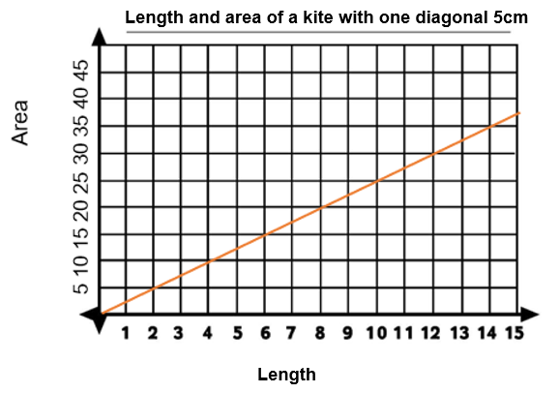

Parallelogram
- $2cm^{2}, 4cm^{2}$ and $6cm^{2}$.
- $8cm^{2}$.
- $A=2b$

$$b$$ | 1 | 2 | 3 | 4 | 5 | 6 | 7 | 8
$$A$$ | 2 | 4 | 6 | 8 | 10 | 12 | 14 | 16
- Each time the base length increased by 1 the area increased by 2.
- Yes, the area didn’t double, as you can see in the example.
$$2×2=4$$Double the dimensions.
$$4×2=8$$

Trapezium
- $2.5cm^{2}, 5cm^{2}$ and $7.5cm^{2}$.
- $10cm^{2}$
- $A=\frac{5h}{2}$

$$h$$ | 1 cm | 2 cm | 3 cm | 4 cm | 5 cm | 6 cm | 7 cm | 8 cm
$$A$$ | 2.5 | 5 | 7.5 | 10 | 12.5 | 15 | 17.5 | 20
- Each time the length increases by 1 the area increases by 2.5.
- If the height of a trapezium doubles, so does its area. This can be seen in the table when the height is 2 and 4.

References
This resource contains NSW Curriculum and syllabus content. The NSW Curriculum is developed by the NSW Education Standards Authority. This content is prepared by NESA for and on behalf of the Crown in right of the State of New South Wales. The material is protected by Crown copyright.
Please refer to the NESA Copyright Disclaimer for more information https://educationstandards.nsw.edu.au/wps/portal/nesa/mini-footer/copyright.
NESA holds the only official and up-to-date versions of the NSW Curriculum and syllabus documents. Please visit the NSW Education Standards Authority (NESA) website https://educationstandards.nsw.edu.au and the NSW Curriculum website https://curriculum.nsw.edu.au.
Mathematics K–10 Syllabus © NSW Education Standards Authority (NESA) for and on behalf of the Crown in right of the State of New South Wales, 2022.

© State of New South Wales (Department of Education), 2024
The copyright material published in this resource is subject to the Copyright Act 1968 (Cth) and is owned by the NSW Department of Education or, where indicated, by a party other than the NSW Department of Education (third-party material).
Copyright material available in this resource and owned by the NSW Department of Education is licensed under a Creative Commons Attribution 4.0 International (CC BY 4.0) license.
This license allows you to share and adapt the material for any purpose, even commercially.
Attribution should be given to © State of New South Wales (Department of Education), 2024.
Material in this resource not available under a Creative Commons license:
- the NSW Department of Education logo, other logos and trademark-protected material
- material owned by a third party that has been reproduced with permission. You will need to obtain permission from the third party to reuse its material.
Links to third-party material and websites
Please note that the provided (reading/viewing material/list/links/texts) are a suggestion only and implies no endorsement, by the New South Wales Department of Education, of any author, publisher, or book title. School principals and teachers are best placed to assess the suitability of resources that would complement the curriculum and reflect the needs and interests of their students.
If you use the links provided in this document to access a third-party's website, you acknowledge that the terms of use, including licence terms set out on the third-party's website apply to the use which may be made of the materials on that third-party website or where permitted by the Copyright Act 1968 (Cth). The department accepts no responsibility for content on third-party websites.

