Property trap
Students will investigate and use the formula for the area of a trapezium to estimate the size of a block of land.

Visible learning

Learning intention
- To be able to find the area of a trapezium.

Success criteria
- I can identify the parallel sides and the perpendicular height of a trapezium.
- I can explain how the formula for the area of a trapezium is developed.
- I can correctly substitute values into the area of a trapezium formula.

Syllabus outcomes
A student:
- develops understanding and fluency in mathematics through exploring and connecting mathematical concepts, choosing and applying mathematical techniques to solve problems, and communicating their thinking and reasoning coherently and clearly
MAO-WM-01
- applies knowledge of area and composite area involving triangles, quadrilaterals and circles to solve problems MA4-ARE-C-01
Mathematics K–10 Syllabus © NSW Education Standards Authority (NESA) for and on behalf of the Crown in right of the State of New South Wales, 2022.

Activity structure
The PowerPoint Property trap accompanies this lesson.

Warm up
On vertical non-permanent surfaces (bit.ly/VNPSstrategy) in visibly random groups of 3 (bit.ly/visiblegroups), ask students to draw the following:
- a trapezium, marking which sides are parallel and the perpendicular height
- another trapezium, different to the first, marking the parallel sides and perpendicular height
- a trapezium someone might think is correctly labelled but is not.
- list places where you might see trapeziums.

Launch
- Display slide 3 from the PowerPoint Property trap. This shows a diagram of a property and its boundaries.
Figure 1 – property boundary
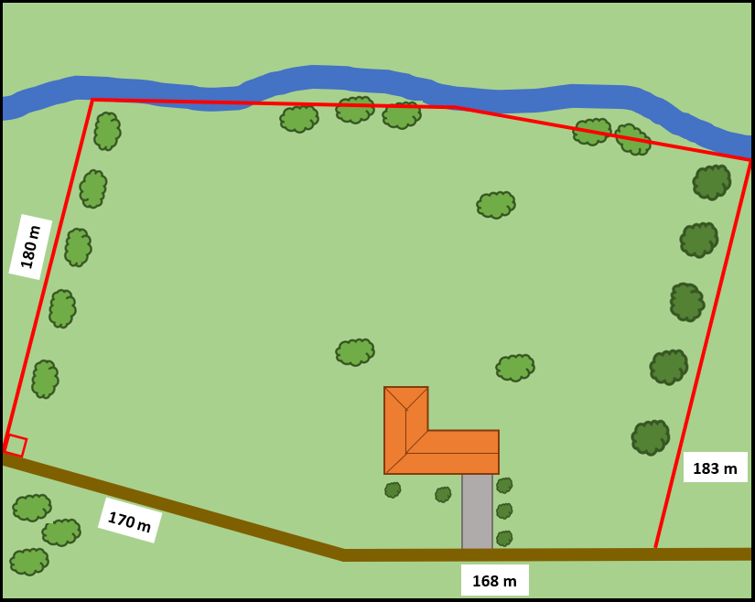
- Read the following scenario to students.
Jesse is thinking about buying a property. Some information has been provided about the area of the land, but Jesse would like to check if the information is accurate.
- In a Think-Pair-Share (bit.ly/thinkpairsharestrategy), students are to consider how Jesse might be able to accurately estimate the area of the property. Ensure discussion is focused on strategies that Jesse could use rather than what they believe the area of the property is.
- Randomly select students to share their strategies with the class and explain their reasoning.
Students will return to this scenario in the Apply section of the lesson.

Explore

Equipment
For each pair of students:
- scissors
- A4 blank paper
- ruler.

Method
- Distribute a blank piece of A4 paper to each student and ask them to fold it in half.
- Instruct students to draw a trapezium on the folded page and cut it out, while the paper is still folded, so they have 2 identical shapes.
- Ask students to measure the parallel sides and perpendicular height of their trapeziums and label them on their shapes.
Alternatively, you can ask students to label the shortest parallel side of the trapezium $a$, the longest parallel side$b$ and the perpendicular height $h$.
- Remind students which shapes they already know how to find the area of. This should include, but not be limited to, square, rectangle, triangle and parallelogram.
- Without cutting or folding, ask students to explore what shapes they can create with their 2 trapeziums.
Students should be able to identify that they can create a parallelogram. If students have created a pair of right-angled trapeziums, they will likely identify that the type of quadrilateral they can create is a rectangle. Remind students that a rectangle is a type of parallelogram.
- In a Think-Pair-Share, ask students to try and find the area of their new shape.
- Continuing in a Think-Pair-Share, ask the students how they might use the information about the area of their shape to find the area of the trapeziums they used to create it.
Students should be able to recognise that if 2 identical trapeziums were used to create the parallelogram, that the area of one of the trapeziums is half of the area of the parallelogram.
A useful visual prompt, for students who are having difficulty, is to ask them to trace and cut out the parallelogram and fold it in half to recreate 2 congruent trapeziums.
- Ask students to further investigate with other pairs of trapeziums. They can do so by swapping with other pairs or drawing a new trapezium.
Students should verify their solutions with a square centimetre grid overlay if available.
- Use a Pose-Pause-Pounce-Bounce (PDF 557 KB) (bit.ly/posepausepouncebounce) question strategy to generate a class discussion aimed at determining the formula for the area of a trapezium by posing the question ’How can we use what we know about the area of a parallelogram to write an equation for the area of a trapezium?’
During the discussion, students need to be encouraged to recognise that the base length of the parallelogram is the sum of the 2 parallel sides of the trapezium.

Summarise
Whilst students may use and should be encouraged to use various methods to find the area of the trapezium the syllabus specifically calls out for students to use the formula.
- In a Think-Pair-Share, ask students to respond to the working used on slides 5–6 of the PowerPoint Property trap. These slides formalise the process that students have just done numerically during the Explore.
- Use slides 7–10 from the PowerPoint Property trap for explicit teaching of the formula for the area of a trapezium.
The explicit teaching technique used in the PowerPoint is ‘Your turn’. The first slide is a worked example which should be displayed for the students before using the following steps.
- Reveal the question to students and its solution.
- Students read in silence.
- Students individually explain to themselves what is happening in each step.
- Students hold a thumbs up to the teacher when they have finished reading and have some sort of understanding.
- Think-Pair-Share. Students explain the solution to their partner.
- In pairs, students then answer the self-explanation questions.
- Finally, randomly select students to share their answers with the whole class.
- Challenge students individually to draw as many trapeziums as they can with an area of $56cm^{2}$. They are to prove they have an area of $56cm^{2}$ by showing all working.

Apply
- Assign students to visibly random groups of 3 (bit.ly/visiblegroups) on vertical non-permanent surfaces (bit.ly/VNPSstrategy).
- Distribute Appendix A ‘Land estimates’. This Appendix gives students the property map they explored in the Launch and asks them to find an estimate closer than Jesse’s, who used a parallelogram to estimate the area.
- Students are to do a gallery walk (bit.ly/DLSgallerywalk) of other students’ solutions looking for different ways students approached the problem.
- Bring students back together and ask random students to pick their favourite solution from another group and to explain the other group’s working.

Assessment and differentiation

Suggested opportunities for differentiation
Launch
- There are no correct answers during the launch and all students should be encouraged to participate and share their thoughts and reasoning.
- For vision impaired students, replicating the block of land on a geoboard would be beneficial.
Explore
- Visual representations are used to assist students with their understanding of finding area.
- Challenge students to name which quadrilateral they make and to justify how they know it is a parallelogram or rectangle and so on.
- Students talk through their answers with other students before sharing with the class to improve confidence in their answers and receive feedback.
Apply
- To challenge students, prompt them to use more shapes, or all the shapes they have learnt so far to estimate the area.
- Challenge students to explain why they will never get the exact area found by the real estate agency.

Suggested opportunities for assessment
Explore
- Students will demonstrate their working mathematically skills in discussions and justifications.
Summarise
- Students can submit a trapezium that has an area of 56$cm^{2}$ as an exit ticket.
Apply
- When placed in groups of 3, students provide and receive peer feedback on their understanding.
- Students understanding of mathematical communication can be assessed when explaining other students’ solutions to problems.

Appendix A

Land estimates
Jesse is thinking about buying a property. The real estate agent claims the land is 5.8 ha. Jesse would like to check this information is accurate.
Jesse drew a parallelogram over the property to make an estimate of the land size. He estimated the base length to be 320 m, with a perpendicular height of 170 m. This gave him an area of 5.44 ha.
Jesse thinks it’s possible to make a more accurate estimate by using trapeziums.
By estimating the lengths needed, can you get the total area closer to 5.8 ha?
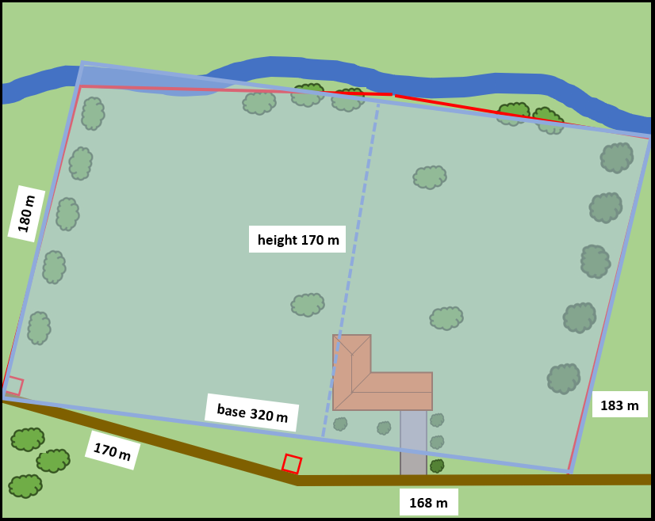
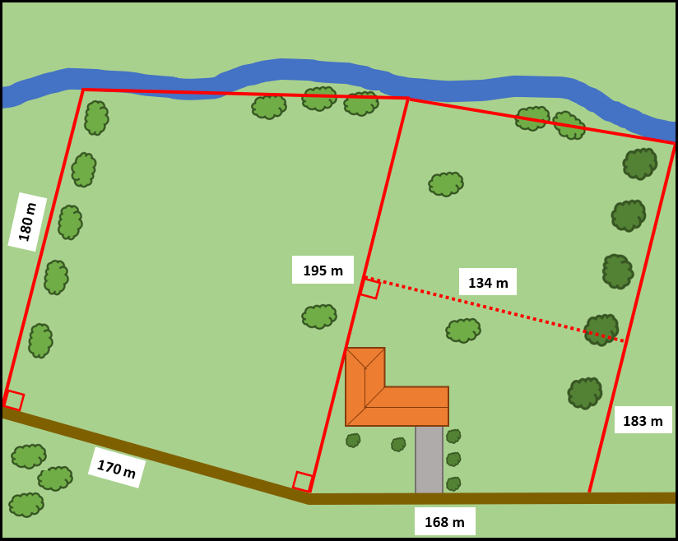

Sample solutions

Summarise – trapeziums with an area of $56cm^{2}$
h | a | b
4 | 4 | 24
8 | 2 | 12
16 | 5 | 2
112 | 0.5 | 0.5

Appendix A – land estimates
Left trapezium
Estimated lengths: $a=180$, $b=195$ and $h=170$.
$$A=\frac{170}{2} \left(180+195\right) \\ A=31 875 m^{2}$$
Right trapezium
Estimated lengths: $a=195$, $b=183$ and $h=134$.
$$A=\frac{134}{2}\left(195+183\right) \\ A=25 326 m^{2}$$
Total area
$$31 875+25 326=57201 m^{2}$$
$$57 201÷100^{2}≈5.7 ha$$

References
This resource contains NSW Curriculum and syllabus content. The NSW Curriculum is developed by the NSW Education Standards Authority. This content is prepared by NESA for and on behalf of the Crown in right of the State of New South Wales. The material is protected by Crown copyright.
Please refer to the NESA Copyright Disclaimer for more information https://educationstandards.nsw.edu.au/wps/portal/nesa/mini-footer/copyright.
NESA holds the only official and up-to-date versions of the NSW Curriculum and syllabus documents. Please visit the NSW Education Standards Authority (NESA) website https://educationstandards.nsw.edu.au and the NSW Curriculum website https://curriculum.nsw.edu.au.
Mathematics K–10 Syllabus © NSW Education Standards Authority (NESA) for and on behalf of the Crown in right of the State of New South Wales, 2022.

© State of New South Wales (Department of Education), 2024
The copyright material published in this resource is subject to the Copyright Act 1968 (Cth) and is owned by the NSW Department of Education or, where indicated, by a party other than the NSW Department of Education (third-party material).
Copyright material available in this resource and owned by the NSW Department of Education is licensed under a Creative Commons Attribution 4.0 International (CC BY 4.0) license.
This license allows you to share and adapt the material for any purpose, even commercially.
Attribution should be given to © State of New South Wales (Department of Education), 2024.
Material in this resource not available under a Creative Commons license:
- the NSW Department of Education logo, other logos and trademark-protected material
- material owned by a third party that has been reproduced with permission. You will need to obtain permission from the third party to reuse its material.
Links to third-party material and websites
Please note that the provided (reading/viewing material/list/links/texts) are a suggestion only and implies no endorsement, by the New South Wales Department of Education, of any author, publisher, or book title. School principals and teachers are best placed to assess the suitability of resources that would complement the curriculum and reflect the needs and interests of their students.
If you use the links provided in this document to access a third-party's website, you acknowledge that the terms of use, including licence terms set out on the third-party's website apply to the use which may be made of the materials on that third-party website or where permitted by the Copyright Act 1968 (Cth). The department accepts no responsibility for content on third-party websites.

