Quickly counting kites
Students examine how many kites would fit into a pattern on a rectangular wall as context for investigating and developing a formula for the area of a kite.

Visible learning
The learning intentions and success criteria for this lesson should be displayed after the Launch section of the lesson.

Learning intentions
- To understand the relationship between the area of a kite and related rectangles.
- To be able to calculate the area of a kite.

Success criteria
- I can identify the diagonals of a kite.
- I can use the formula for the area of a kite to solve problems.
- I can explain how the formula for the area of a kite can be found using a rectangle.

Syllabus outcomes
A student:
- develops understanding and fluency in mathematics through exploring and connecting mathematical concepts, choosing and applying mathematical techniques to solve problems, and communicating their thinking and reasoning coherently and clearly MAO-WM-01
- applies knowledge of area and composite area involving triangles, quadrilaterals and circles to solve problems MA4-ARE-C-01
Mathematics K–10 Syllabus © NSW Education Standards Authority (NESA) for and on behalf of the Crown in right of the State of New South Wales, 2022.

Activity structure
Please use the Quickly counting kites PowerPoint to display images from this lesson.

Launch
- Display Figure 1 for students and state that this image represents a tiling pattern in a wall. Figure 1 is also available on slide 3 of the Quickly counting kites PowerPoint.
Figure 1 – square tiling pattern
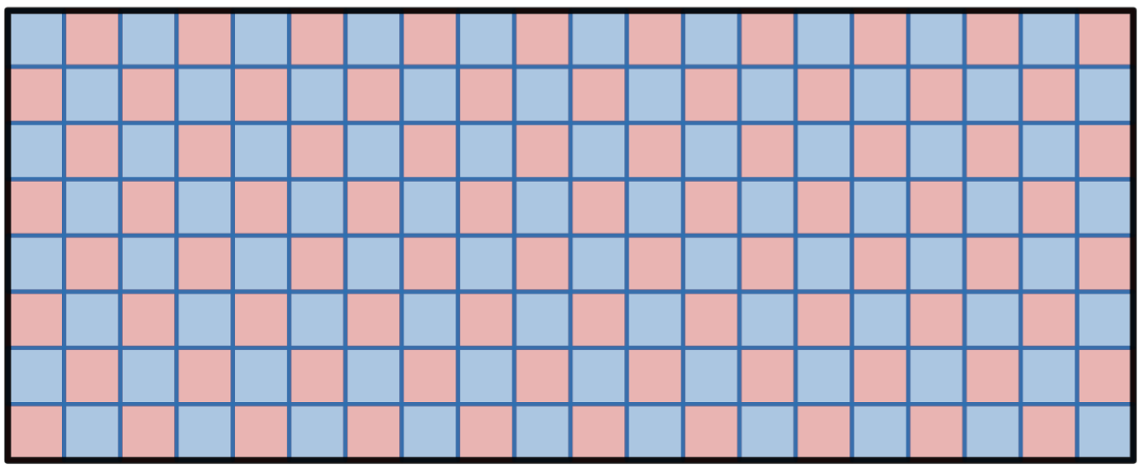
Image created using Desmos and is licensed under the Desmos Terms of Service.
- Pose the question below and have students use mini whiteboards (bit.ly/miniwhiteboards) to record an answer and hold this up to show the teacher.
If you were tiling this wall, how many tiles would you need to order?
- Select non-volunteer students to share their strategy for finding the number of tiles with the class.
Students will likely discuss that as the wall is 8 squares by 20 squares, we would need to order $8×20=160$ tiles. Teachers may choose to introduce the idea that we always order at least 10% more than we need to factor in wastage and to keep some spare for future repairs.
- Display Figure 2 to show the solution to students, also available on slide 4 of the Quickly counting kites PowerPoint.
Figure 2 – square tiling pattern, counted to 160
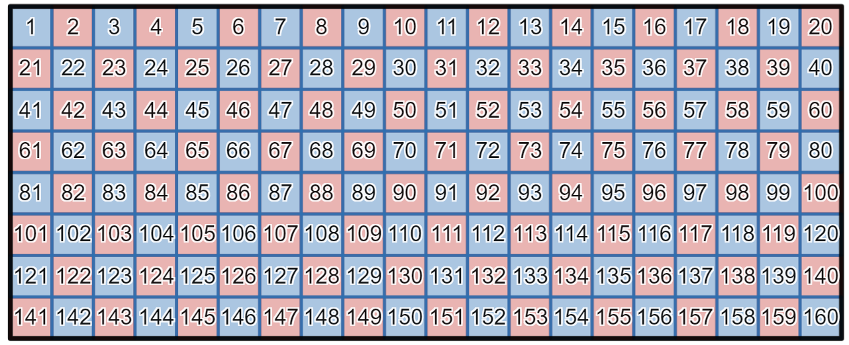
Image created using Desmos and is licensed under the Desmos Terms of Service.
- Open the Desmos graph ‘Kites wall’ (bit.ly/KitesWallDesmos) on the teacher screen.
- Ask students to estimate the number of kites they can see in the tiling pattern on the wall, sharing their estimate with the teacher via the mini whiteboards.
- Once students have had an opportunity to make an estimate, press the ‘play’ button on the left of the Desmos graph, as shown below.
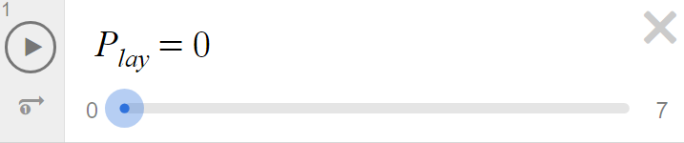
Image created using Desmos and is licensed under the Desmos Terms of Service.
Alternatively, teachers can display Figures 3 and 4 to students, showing the beginning and end of the Desmos animation. These images are available on slides 5 and 6 respectively of the Quickly counting kites PowerPoint.
Figure 3 – a wall of tessellating kite tiles
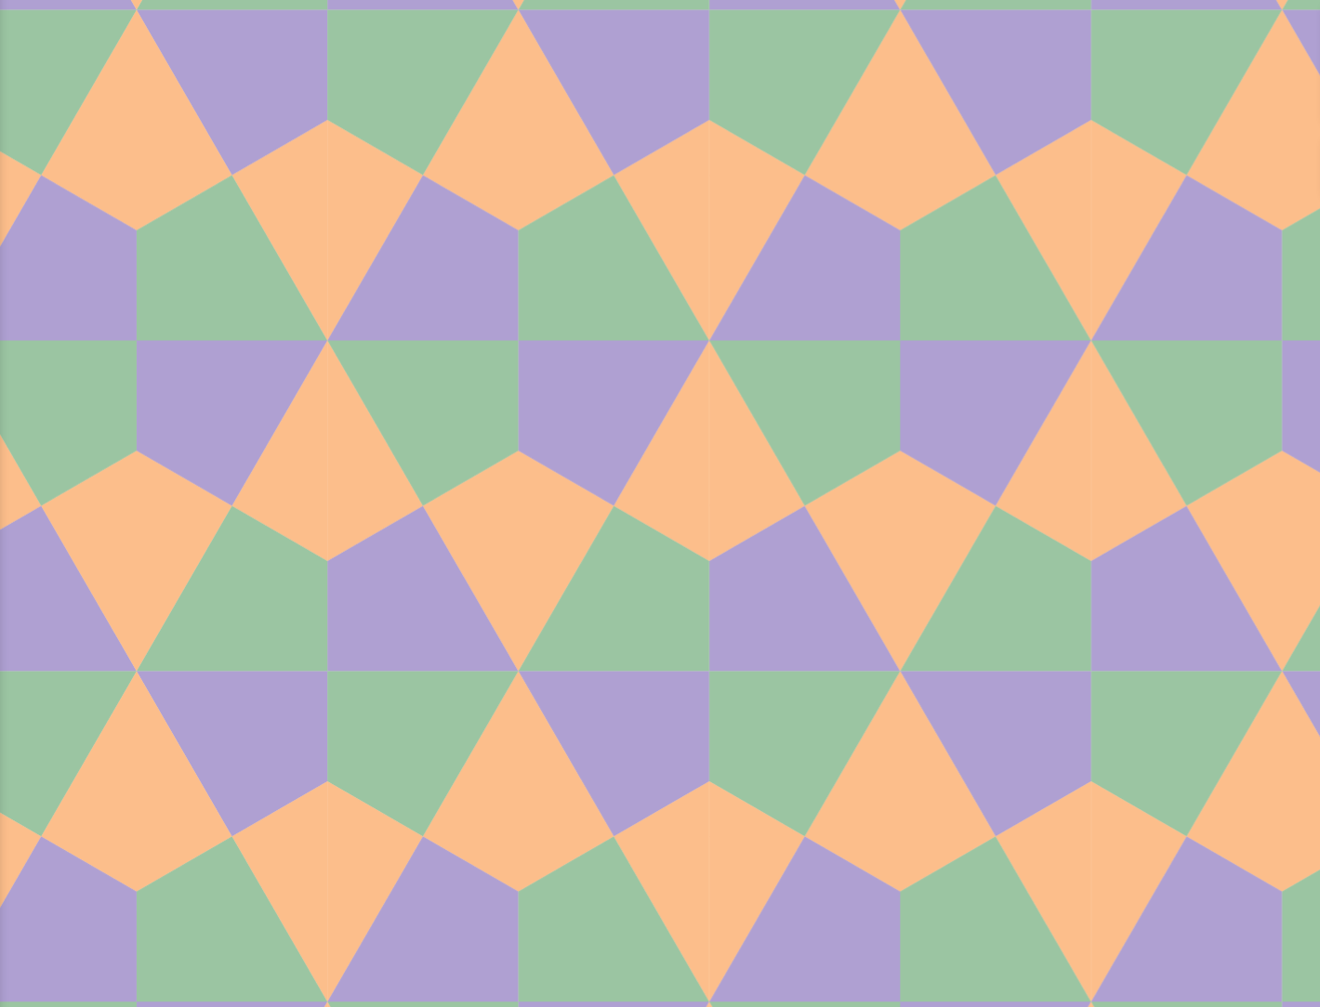
Image created using Desmos and is licensed under the Desmos Terms of Service.
Figure 4 – a zoomed out wall of tessellating kite tiles
Image created using Desmos and is licensed under the Desmos Terms of Service.
- Have students make a final estimate of the number of kites in the entire wall using their mini whiteboards.

Explore
- Have students engage in a Think-Pair-Share (bit.ly/thinkpairsharestrategy) to discuss the following questions.
- Is there a quicker way to find the number of tiles?
- What would we need to know about the situation?
Discussions could include counting the number of rows and multiplying by the number of kites we count in each row or counting the number of hexagons and multiplying by 6. In all these cases, teachers can consider applying algebraic techniques to express their method.
Our hope is for students to consider the area of the shapes and the number of kites that would fit, which would require us to know the area of the whole rectangle and the area of a single kite.
- Still working in their pairs, hand students a copy of Appendix A, ‘The area of a kite’ and challenge them to determine the area of a kite with and without a grid.
- Ask students assessing and advancing questions to further student thinking.
- Assessing questions draw out students’ thinking about a problem and what methods they have tried so far.
- Advancing questions are intended to help move students’ thinking forward toward the lesson goals. We want to draw their attention to something they may not have noticed or considered yet.
Question suggestions are included below. Students can be prompted using these assessing and advancing questions to help guide their thinking.
Table 1 – assessing and advancing questions
Assessing questions | Advancing questions
Can you explain to me what you’ve done so far? | How could you represent your working?
What shapes do you already know how to find the area of? | Is there another way to approach this problem?
- Lead a discussion with students to collect responses about how they have found the area of each shape.
Responses from students could include counting the whole squares before counting parts of squares, or cutting parts of the shape to rearrange and form a new shape that is easier to count.

Summarise
- Explain to students that we will be writing a formula for the area of a kite.
- Display the Desmos graph ‘Kite animation’ (bit.ly/DesmosKiteFormula) on the teacher screen.
- Select the Play button and press pause after the pronumerals $x$ and $y$ appear on the screen, representing the diagonals of the kite. This will occur after ‘Play’ is greater than 1.
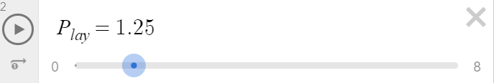
Image created using Desmos and is licensed under the Desmos Terms of Service.
- Instruct students to engage in a Think-Pair-Share about what they believe the formula should be based on their work in Appendix A. Instruct students to explain and justify their reasoning.
- Select the Play button again to show why the formula for the area of a kite is $A=\frac{1}{2}×x×y$, where $x$ and $y$ are the lengths of the diagonals.
This unit focuses on the use of rectangles to develop the formulas for the area of other quadrilaterals and triangles. The formula for the area of a kite can also be developed by cutting the shape in half using whichever diagonal is an axis of symmetry. Teachers may wish to lead a discussion with students about other methods for developing the formula or acknowledge if students have found these themselves.
- Display Figure 5 to students, also available on slide 8 of the Quickly counting kites PowerPoint.
Figure 5 – dimensions of kite tiles on the wall
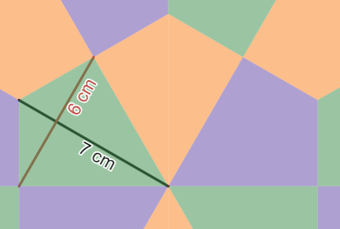
Image created using Desmos and is licensed under the Desmos Terms of Service.
- Inform students that the entire wall is 6 metres wide and 3 metres high.
- By working in visibly random groups of 3 (bit.ly/visiblegroups) on vertical non-permanent surfaces (bit.ly/VNPSstrategy), instruct students to attempt to calculate the number of kite tiles that will fit on the wall.
- Once adequate time has passed, stop students while they are still in their groups. Initiate a sharing of ideas and reasoning using the Pose-Pause-Pounce-Bounce question strategy (PDF 557 KB) (bit.ly/posepausepouncebounce) to highlight how students approached the problem.
- Display Figure 6, which is also available on slide 9 of the Quickly counting kites PowerPoint.
Figure 6 – rhombus tiles on a wall
Image created using Desmos and is licensed under the Desmos Terms of Service.
- Ask students to share what shapes they see.
Conclude with students that the shape in the pattern is a rhombus.
- Have students engage in a Think-Pair-Share to discuss the following questions.
- How have we previously found the area of a rhombus?
- What do a rhombus and a kite have in common?
- What is different about a kite and a rhombus?
In the sharing section of this discussion, it is important to conclude that:
- we have previously found the area of a rhombus by treating it as a parallelogram, using the formula $A=bh$, where $b$ is the length of the base and $h$ is the perpendicular height
- a rhombus and a kite both have equal adjacent sides and both have diagonals that are perpendicular
- a rhombus has all the features of a kite and also has all 4 sides equal, rather than just pairs of adjacent sides.
- Display the Desmos graph ‘Rhombus animation’ (bit.ly/DesmosRhombusFormula) on the teacher screen and press the Play button.
- Conclude with students that the area of a rhombus can be found using the lengths of the diagonals in the same way as a kite. Acknowledge the formula on the screen at the end of the animation, $A=\frac{1}{2}×x×y$, where $x$ and $y$ are the lengths of the diagonals of the rhombus.
- Display Figure 7, which is also available on slide 10 of the Quickly counting kites PowerPoint.
Figure 7 – dimension of rhombus tiles on the wall
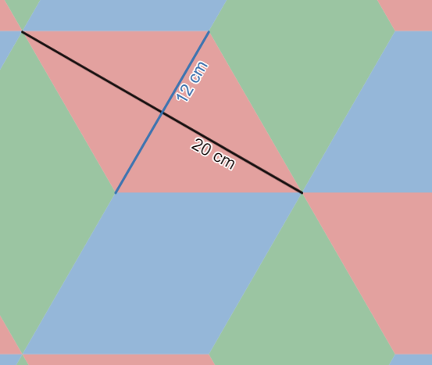
Image created using Desmos and is licensed under the Desmos Terms of Service.
- Challenge groups to again determine the number of tiles required for our original wall (6 metres wide and 3 metres high) if using these rhombus tiles in this pattern.
- For groups who finish, challenge them to try to explain why the same formula works for both kites and rhombuses, but not for a parallelogram.

Apply

Greatest area

Equipment
- Grid paper
- Ruler
- Markers
- Plastic sleeves

Method
- Place grid paper on the wall inside plastic sleeves for students to work from.
- Organise students into new visibly random groups 3. Send them to vertical non-permanent surfaces and inform them that they will be trying to find the kite with the maximum area.
- Instruct students to draw as many kites as they can so that the diagonals add to 10 units. They need to calculate the area of each kite.
If geoboards are available, students can construct their kites on geoboards first before recording them on their grid paper. Geoboards can also be accessed using the online interactive ‘Geoboard by The Maths Learning Center’ (bit.ly/MLCGeoboard).
- Once groups have had sufficient time to complete this task, have them answer the following questions.
- What kite do you believe will have the largest area if the diagonals add to equal 10 units?
- Does it matter which diagonal is longer?
- How many different kites can we make with the same length diagonals?

Teachers can use the Desmos graph ‘Kites: Maximum area’ (bit.ly/KitesMaxDesmos) to show the various kites with diagonals that sum to 10 units and summarise the solutions to the questions above.
The solution to the final question is that there are infinite different kites with the same length diagonals, as the proportions can be modified to make a new kite.
- For groups who finish, issue them the following challenge questions and ask them to find a solution and provide reasoning and justification.
- Do all kites with diagonals 4 cm and 6 cm have the same area?
- Do all kites with diagonals 4 cm and 6 cm have the same perimeter?
- Does a kite with both diagonals equal to 5 cm have the same area as a square with side length 5 cm?

Assessment and differentiation

Suggested opportunities for differentiation
Explore
- Students may benefit from further revision of approximating the area of rectangles or triangles by counting squares before extending this to kites. Geoboard is useful for constructing shapes and counting squares https://apps.mathlearningcenter.org/geoboard/.
- Students can be given kite-shaped tiles to construct their own wall patterns similar to those shown in Figure 3 to assist them in developing a method to count the kites in the wall. Polypad may be useful if physical tiles are not available https://mathigon.org/polypad.
- Students can be challenged to immediately move from counting squares to a generalised formula for the area of a kite if exhibiting a strong understanding of both area and algebra.
Summarise
- Students can be challenged to investigate which quadrilaterals the formula $A=\frac{1}{2}×x×y$ can be applied to and which it cannot, providing reasoning.
- Every time a tile needs to be cut it produces wastage. Students could be challenged to consider how many tiles are needed, accommodating for wastage.
- Centimetres have often been used in this lesson to keep calculations manageable. In real life, most trades work in millimetres and metres, rather than centimetres. Students could be challenged to complete the calculations in millimetres or metres.\
Apply
- The use of geoboards, particularly physical ones, allows students to feel shape changes and use this to guide their opinions of the dimensions of the shape.

Suggested opportunities for assessment
Summarise
- Teachers should carefully apply questioning and discussion strategies described in the lesson to ensure progress is based on the knowledge and understanding of all students. Observing and recording student responses during Think-Pair-Share activities can give evidence of students’ ability to use a formula to describe a repeated process.
Apply
- Teachers can collect the grid paper from groups of students from the ‘Greatest area’ activity as evidence of students’ ability to apply the formula for the area of a kite.

Appendix A

The area of a kite
Below is a kite on a grid.
- What is the area of the kite? How many squares fit inside the shape?
- How did you count the squares?
- The shape is 4 squares across and 6 squares in height. How do these numbers relate to your final area?
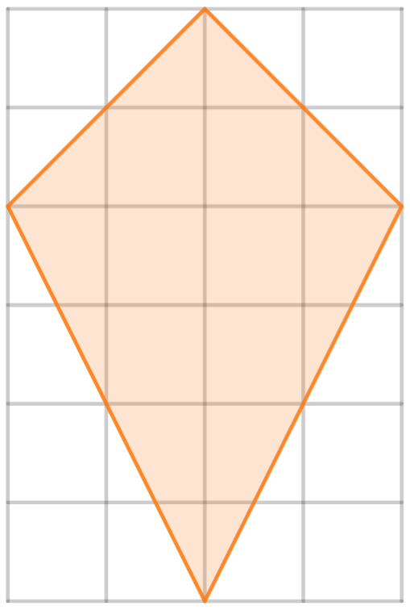

Use your method from above to find the area of each of the shapes in the table below.
Shape | Area
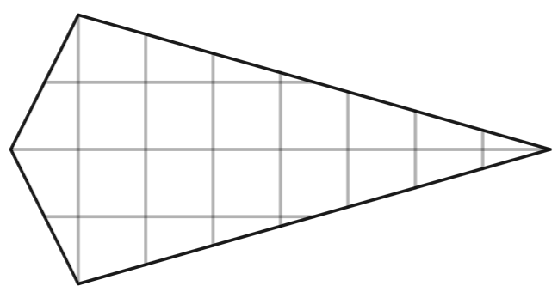
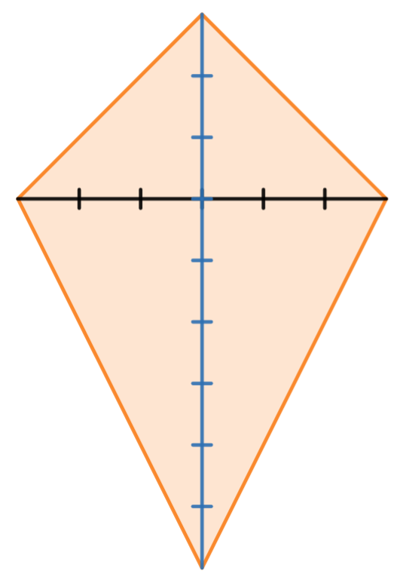
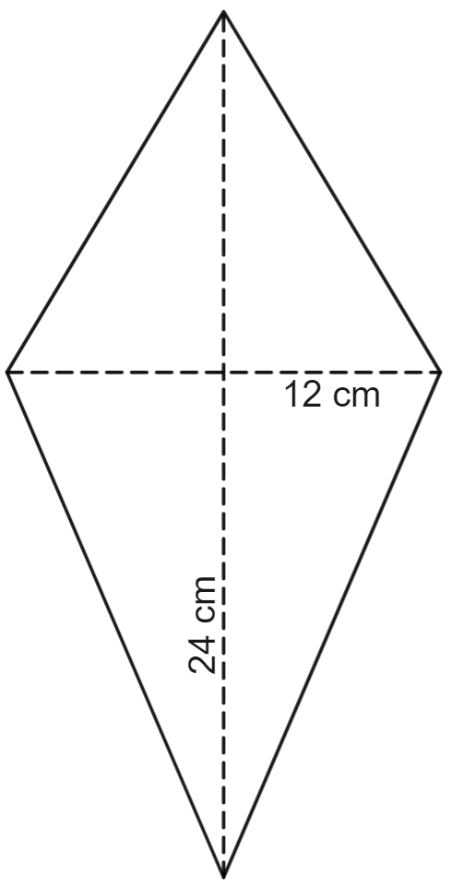
Image created using Desmos and is licensed under the Desmos Terms of Service.

Sample solutions

Appendix A – the area of a kite
Below is a kite on a grid.
- What is the area of the kite? How many squares fit inside the shape? 12 squares fit inside the shape.
- How did you count the squares? Combining parts of squares.
- The shape is 4 squares across and 6 squares in height. How do these numbers relate to your final area? The final area is 12 square units, which is half of $4×6=24$.
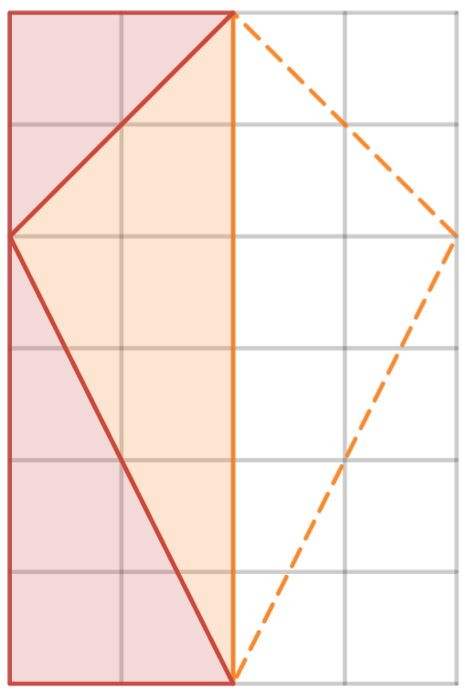
$$2×6=12units^{2}$$
Use your method from above to find the area of each of the shapes in the table below.
Shape | Area
 | $$A=\frac{1}{2}×8×4=16 units^{2}$$
 | $$A=\frac{1}{2}×6×9 \\ =27 units^{2}$$
 | $$A=\frac{1}{2}×12×24 \\ =144 {cm}^{2}$$
Image created using Desmos and is licensed under the Desmos Terms of Service.

Summarise

Kite tiles
The area of one kite tile is $A=\frac{1}{2}×6×7=21 cm^{2}$.
The area of the wall in square centimetres is $6000×3000=18 000 000 cm^{2}$.
Therefore, $18 000 000÷21=857 142.9$ tiles will fit in the wall.
If we choose to increase this by $10\%$ to allow for wastage, we should be purchasing $857 142.9×110\%=942 857$ tiles.

Rhombus tiles
The area of one rhombus tile is $A=\frac{1}{2}×12×20=120 cm^{2}$.
Therefore, $18 000 000÷120=150 000$ tiles will fit in the wall.
If we choose to increase this by 10% to allow for breakages, we should be purchasing $150 000×110\%=165 000$ tiles.

Rhombus and kite formula
The use of the formula $A=\frac{1}{2}×x×y$ where $x$ and $y$ are the diagonals applies for both rhombuses and kites because both shapes have perpendicular diagonals. This is why this formula will not work for every parallelogram or rectangle.

Apply

Greatest area
The images in the table below show 3 possible kites which could be drawn by students during this activity.
Kite 1 | Kite 2 | Kite 3
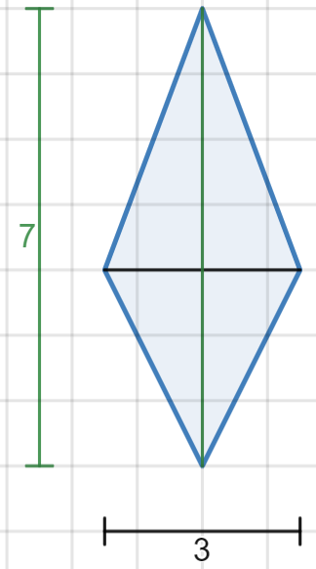 | 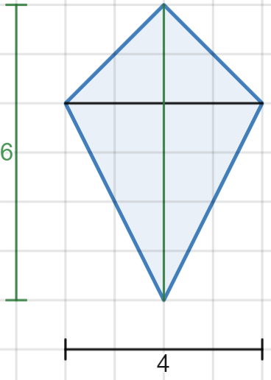 | 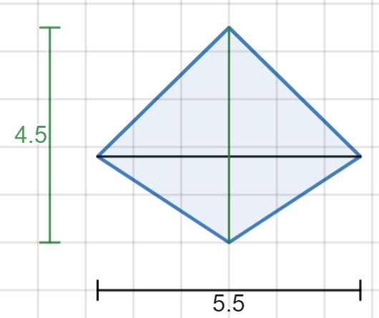
$$A=\frac{1}{2}×7×3 \\ =10.5 units^{2}$$ | $$A=\frac{1}{2}×6×4 \\ =12 units^{2}$$ | $$A=\frac{1}{2}×4.5×5.5 \\ =12.375 units^{2}$$
Images created using Desmos and is licensed under the Desmos Terms of Service.
The kite with the largest area whose diagonals add to 10 units will have diagonals of 5 units each. There are infinite different ways to construct this kite, with one example shown in Figure 8 below.
Figure 8 – the kite with the largest area
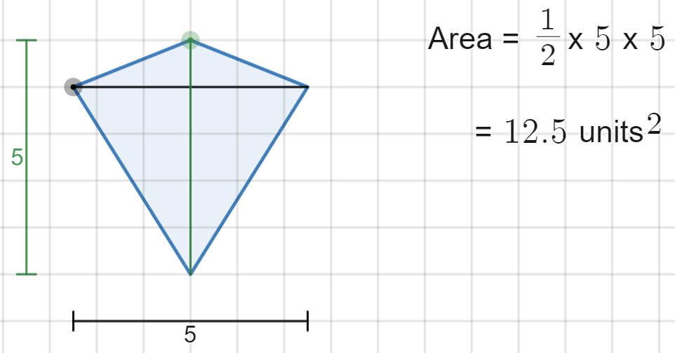
Image created using Desmos and is licensed under the Desmos Terms of Service.

References
This resource contains NSW Curriculum and syllabus content. The NSW Curriculum is developed by the NSW Education Standards Authority. This content is prepared by NESA for and on behalf of the Crown in right of the State of New South Wales. The material is protected by Crown copyright.
Please refer to the NESA Copyright Disclaimer for more information https://educationstandards.nsw.edu.au/wps/portal/nesa/mini-footer/copyright.
NESA holds the only official and up-to-date versions of the NSW Curriculum and syllabus documents. Please visit the NSW Education Standards Authority (NESA) website https://educationstandards.nsw.edu.au and the NSW Curriculum website https://curriculum.nsw.edu.au.
Mathematics K–10 Syllabus © NSW Education Standards Authority (NESA) for and on behalf of the Crown in right of the State of New South Wales, 2022.

© State of New South Wales (Department of Education), 2024
The copyright material published in this resource is subject to the Copyright Act 1968 (Cth) and is owned by the NSW Department of Education or, where indicated, by a party other than the NSW Department of Education (third-party material).
Copyright material available in this resource and owned by the NSW Department of Education is licensed under a Creative Commons Attribution 4.0 International (CC BY 4.0) license.
This license allows you to share and adapt the material for any purpose, even commercially.
Attribution should be given to © State of New South Wales (Department of Education), 2024.
Material in this resource not available under a Creative Commons license:
- the NSW Department of Education logo, other logos and trademark-protected material
- material owned by a third party that has been reproduced with permission. You will need to obtain permission from the third party to reuse its material.
Links to third-party material and websites
Please note that the provided (reading/viewing material/list/links/texts) are a suggestion only and implies no endorsement, by the New South Wales Department of Education, of any author, publisher, or book title. School principals and teachers are best placed to assess the suitability of resources that would complement the curriculum and reflect the needs and interests of their students.
If you use the links provided in this document to access a third-party's website, you acknowledge that the terms of use, including licence terms set out on the third-party's website apply to the use which may be made of the materials on that third-party website or where permitted by the Copyright Act 1968 (Cth). The department accepts no responsibility for content on third-party websites.

