Escher-llations
Students explore tessellations in artworks by MC Escher and create their own artworks by constructing images from rectangles. Students then reverse this process to consider how constructing rectangles from more complex shapes can simplify area calculations and comparisons.

Visible learning

Learning intentions
- To understand rectangles can be used to find the area of more complex shapes.
- To be able to deconstruct complex shapes into rectangles.

Success criteria
- I can use measuring tools to calculate the area of rectangles.
- I can identify where to cut complex shapes to rearrange into rectangles.

Syllabus outcomes
A student:
- develops understanding and fluency in mathematics through exploring and connecting mathematical concepts, choosing and applying mathematical techniques to solve problems, and communicating their thinking and reasoning coherently and clearly MAO-WM-01
- applies knowledge of area and composite area involving triangles, quadrilaterals and circles to solve problems MA4-ARE-C-01
Mathematics K–10 Syllabus © NSW Education Standards Authority (NESA) for and on behalf of the Crown in right of the State of New South Wales, 2022.

Activity structure

Warm up
- Hand pairs of students a copy of Appendix A ‘Fitting quadrilaterals on a page’.
- Display the Desmos graph ‘Shapes on a page’ (bit.ly/DesmosShapesPage) and inform students that they need to discuss with their partner how many of each shape, A, B, C, D, E and F, will fit in the rectangle in the Desmos graph.
- Either reveal the results for students on the screen by dragging the switches on the graph as shown below, or give students access to the graph on their own device after they have made an estimate.
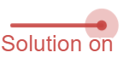
Image created using Desmos and is licensed under the Desmos Terms of Service.
- Still in pairs, have students discuss the following reflection questions in the style of a Think-Pair-Share (bit.ly/thinkpairsharestrategy).
- Did you have the same estimate for any 2 shapes? Why did you make the estimates you made?
- Did any of the shapes fit in the rectangle the same number of times? Can you explain why?
Teachers should consider guiding the sharing portion of this discussion to conclude that shapes that had a relationship in area then have a relationship in how many times they fit in the rectangle.

Launch
- Show students the video ‘The Mathematical Art of M.C. Escher (3:59)’ (bit.ly/YouTubeEscher).
- If digital devices are available, send students to the website ‘M. C. Escher Tessellation Art Gallery’ (https://mcescher.com/gallery/ . If devices are not available, the teacher can display a single image from this website.
- Ask students, in pairs, to consider what they notice and what they wonder (bit.ly/noticewonderstrategy) about these artworks.
Student responses may include that the artworks are formed by tessellations, or that the art uses both shapes and drawings of living creatures to fit together.
- Inform students that they will make their own artwork using a similar process.

Explore
The website ‘M. C. Escher Tessellation Art Gallery’ (https://mcescher.com/gallery/ contains an entire section with different strategies to make your own artwork. One method is described below. On the website this method is referred to as ‘Tracing paper: Translation (Slide)’.

Equipment
- 1 square of paper per student (cardboard would be preferable for ease of tracing)
- 1 larger piece of paper (or poster) per student (A3 suggested)
- 1 pair of scissors per student
- Adhesive tape per group of students
- Coloured pencils or markers

Method
- Hand students their square of paper and larger poster paper.
- Use a Pose-Pause-Pounce-Bounce question strategy (PDF 557 KB) (bit.ly/posepausepouncebounce) to ask students how many times they believe their small square will fit into the large paper or poster.
- Open the Desmos graph ‘Animal artwork instructions’ (bit.ly/DesmosArtTess) on the teacher screen.
- Use the slider on the Desmos graph to show the steps to make an animal that tessellates.
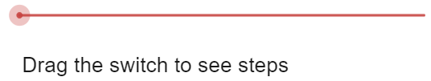
Image created using Desmos and is licensed under the Desmos Terms of Service.
- Have students create an animal by cutting pieces from their square of paper, as shown in Figure 1 below.
Figure 1 – tessellating animal
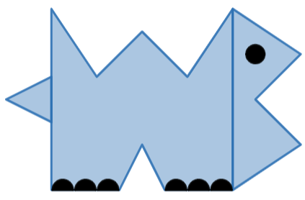
Image created using Desmos and is licensed under the Desmos Terms of Service.
- Instruct students to trace their animal onto their large piece of paper or poster, interlocking in a tessellating pattern, as shown in the Desmos instructions and in Figure 2 below.
Figure 2 – tessellation pattern
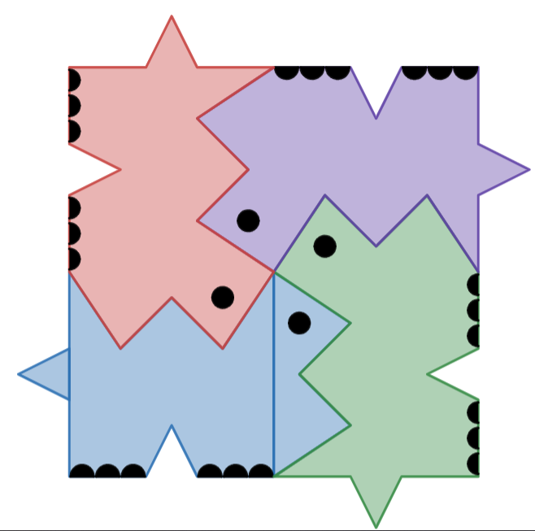
Image created using Desmos and is licensed under the Desmos Terms of Service.
- Have students engage in a Think-Pair-Share reflecting on the following questions:
- How many times did your animal fit on your poster?
- Why would everyone’s total number be the same?
Teachers should use the sharing portion of this activity to highlight to students that each person’s artwork fits in the poster the same number of times, because they all had the same area, having been created from the same size square of paper.
- Organise students into visibly random groups of 3 (bit.ly/visiblegroups) and have them work at vertical non-permanent surfaces (bit.ly/VNPSstrategy).
- Hand each group a copy of Appendix B ‘Untangling rectangles’. Each group will also need a ruler to measure basic lengths.
- Acknowledge that each of the 6 shapes on Appendix B tessellate. Inform students that in this task, we will reverse the process used when creating our artwork to revert these complex shapes back into rectangles.
In Lesson 5 – unravelling tessellations of Unit 6 – triangles and quadrilaterals (bit.ly/departmentresources), students explore why shapes tessellate based on their angles.
- Instruct students that they are to first estimate the order of the shapes by area from largest to smallest. Students should write a list of the order of the 6 shapes, naming them by letter.
- Students are then to cut out the shapes, and by performing at most 2 cuts, rearrange the shape into a rectangle.
- Students can then measure the length and breadth of the newly formed rectangle to check the actual order of the area of the shapes.

Summarise
- Still in groups of 3, have students consider the following reflection questions.
- How well did you order the shapes before cutting them to make rectangles?
- Which shape was the most difficult to cut into a rectangle?
- What helped you to find where to cut shapes and rearrange into rectangles?
- Ask non-volunteer students to share their responses to the questions above.
Students might suggest that looking for right angles that can be cut is a good strategy. It is important to also conclude that the area of these shapes was easier to calculate and compare when they were all arranged into rectangles.

Apply
The activity below is inspired by the Open middle problem, ‘Composite 2D shapes’ (bit.ly/2DShapesOM).
- Hand groups of 3 students Appendix C ‘Open middle problem’.
- Instruct students to determine the area of the shape. Inform them that they can use rulers to measure dimensions.
Teachers can choose to give students further instructions to cut the shape into rectangles and triangles if this is necessary.

Assessment and differentiation

Suggested opportunities for differentiation
Warm up
- As estimating in this activity has no incorrect answers and is subject to opinion, all students should be able to make an attempt.
- The online option for this activity eliminates measurement difficulties and errors as a barrier to students’ mathematical thinking.
- Students should be challenged to use the image of shapes tessellating to justify their decision around the number of times each shape fits into the overall rectangle.
Launch
- All students can make an attempt at estimating the number of times their square will fit onto a poster or A3 page and create an animal for their artwork. In doing so, all students should have access to consider the concept of area for their artwork.
Explore
- Teachers may choose to add dotted lines to some of the figures in Appendix B to help guide students to experience some success.
- Students can be challenged to consider how to cut more complex, known shapes into rectangles, such as trapeziums.

Suggested opportunities for assessment
Apply
- Appendix C can be collected as an exit ticket, demonstrating students’ ability to visualise triangles and rectangles within a more complex figure.

Appendix A

Fitting quadrilaterals on a page
Each of the shapes on the Desmos graph ‘Shapes on a page’ (bit.ly/DesmosShapesPage) tessellate. In the table below, make an estimate as to how many of each shape will fit in the rectangle in the Desmos graph. Record the actual number after an estimate is made.
Shape | Estimate | Actual
Square (A)
Rectangle (B)
Rhombus (C)
Kite (D)
Parallelogram (E)
Trapezium (F)
What relationships can you see between the shapes based on your results?

Appendix B

Untangling rectangles
Cut each shape in at most 2 places and rearrange to make a rectangle. Then measure the base length and height of each shape, calculate the area and determine the largest shape.
Shape A | Shape B
Shape C  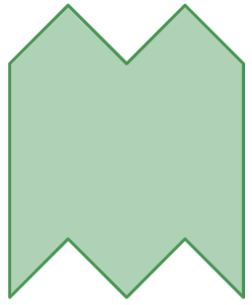 | Shape D
Shape E | Shape F  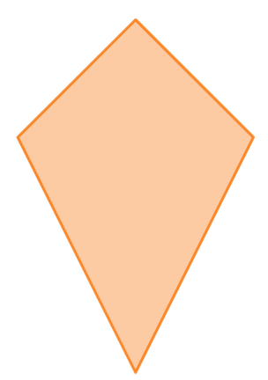
Images created using Desmos and is licensed under the Desmos Terms of Service.

Appendix C

Open Middle problem
Image created using Desmos and is licensed under the Desmos Terms of Service.

Sample solutions

Appendix A – fitting quadrilaterals on a page
Shape | Estimate | Actual
Square (A) | 40 | 42
Rectangle (B) | 20 | 21
Rhombus (C) | 40 | 36 whole, 42 when parts are combined.
Kite (D) | 40 | 46 whole, 59 when parts are combined.
Parallelogram (E) | 20 | 16 whole, approximately 21–22 when parts are combined.
Trapezium (F) | 20 | 24 whole, approximately 27–28 when parts are combined.
What relationships can you see between the shapes based on your results?
The rhombus (C) is approximately the same size as the square (A). The parallelogram (E) is approximately the same size as the rectangle (B), which is approximately double the size of the square and rhombus.

Appendix B – untangling rectangles
The shapes below are measured in Microsoft Word and ordered from largest to smallest. Depending how the document is printed or arranged, dimensions could differ from these sample solutions.
Shape A  Approximately $4 cm$ by $6 cm$.  Area = $24 cm^{2}$ | Shape B  Approximately $7 cm$ by $3 cm$.  Area = $21 cm^{2}$
Shape C  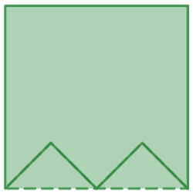  Approximately $4 cm$ by $4 cm$.  Area = $16 cm^{2}$ | Shape D  Approximately $4 cm$ by $5.5 cm$.  Area = $22 cm^{2}$

Shape E  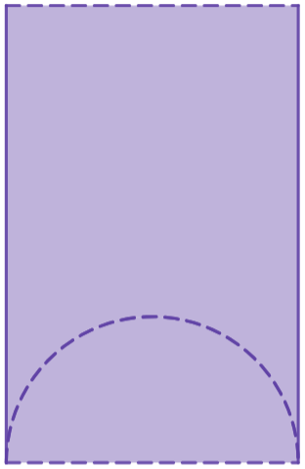  Approximately $5 cm$ by $3 cm$.  Area = $15 cm^{2}$ | Shape F  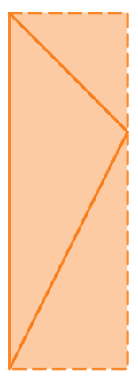  Approximately $6.5 cm$ by $2 cm$.  Area = $13 cm^{2}$
Images created using Desmos and is licensed under the Desmos Terms of Service.

Appendix C – Open Middle problem
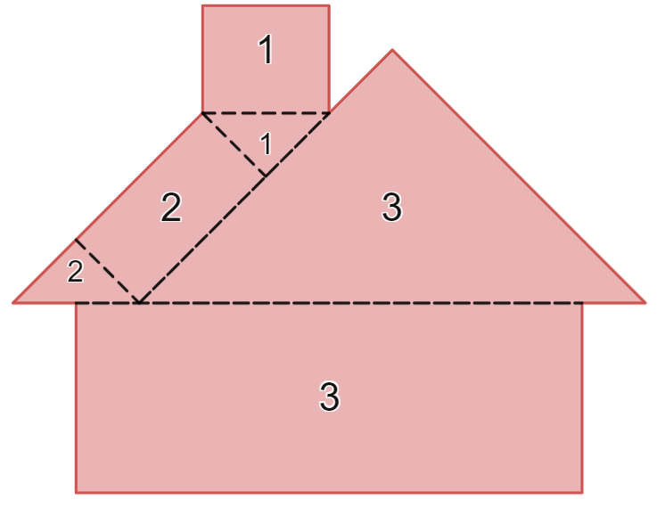
Image created using Desmos and is licensed under the Desmos Terms of Service.
Dimensions and total area will depend on printing. Approximate dimensions based on measurements in printing onto A4 paper are listed below.
Rectangle 1: $2.5 cm×2 cm=5 cm^{2}$
Triangle 1: $\frac{1}{2}×1.5 cm×1.5 cm=1.125 cm^{2}$
Rectangle 2: $3 cm×1.5 cm=4.5 cm^{2}$
Triangle 2: $\frac{1}{2}×1.5 cm×1.5 cm=1.125 cm^{2}$
Triangle 3: $\frac{1}{2}×9.5 cm×5 cm=23.75 cm^{2}$
Rectangle 3: $9.5 cm×3.5 cm=33.25 cm^{2}$
Total area: $A=5+1.125+4.5+1.125+23.75+33.25=68.75 cm^{2}$

References
This resource contains NSW Curriculum and syllabus content. The NSW Curriculum is developed by the NSW Education Standards Authority. This content is prepared by NESA for and on behalf of the Crown in right of the State of New South Wales. The material is protected by Crown copyright.
Please refer to the NESA Copyright Disclaimer for more information https://educationstandards.nsw.edu.au/wps/portal/nesa/mini-footer/copyright.
NESA holds the only official and up-to-date versions of the NSW Curriculum and syllabus documents. Please visit the NSW Education Standards Authority (NESA) website https://educationstandards.nsw.edu.au and the NSW Curriculum website https://curriculum.nsw.edu.au.
Mathematics K–10 Syllabus © NSW Education Standards Authority (NESA) for and on behalf of the Crown in right of the State of New South Wales, 2022.

© State of New South Wales (Department of Education), 2024
The copyright material published in this resource is subject to the Copyright Act 1968 (Cth) and is owned by the NSW Department of Education or, where indicated, by a party other than the NSW Department of Education (third-party material).
Copyright material available in this resource and owned by the NSW Department of Education is licensed under a Creative Commons Attribution 4.0 International (CC BY 4.0) license.
This license allows you to share and adapt the material for any purpose, even commercially.
Attribution should be given to © State of New South Wales (Department of Education), 2024.
Material in this resource not available under a Creative Commons license:
- the NSW Department of Education logo, other logos and trademark-protected material
- material owned by a third party that has been reproduced with permission. You will need to obtain permission from the third party to reuse its material.
Links to third-party material and websites
Please note that the provided (reading/viewing material/list/links/texts) are a suggestion only and implies no endorsement, by the New South Wales Department of Education, of any author, publisher, or book title. School principals and teachers are best placed to assess the suitability of resources that would complement the curriculum and reflect the needs and interests of their students.
If you use the links provided in this document to access a third-party's website, you acknowledge that the terms of use, including licence terms set out on the third-party's website apply to the use which may be made of the materials on that third-party website or where permitted by the Copyright Act 1968 (Cth). The department accepts no responsibility for content on third-party websites.

