Which quadrat?
A quadrat is a small area of a habitat, typically of one square metre, selected at random to act as samples for assessing the local distribution of plants or animals. Students explore identifying units of area and converting between them through the idea of using quadrats to sample population sizes.

Visible learning

Learning intentions
- To know and use appropriate units of area.
- To be able to convert between units of area.

Success criteria
- I can identify units of area.
- I can select appropriate units of area to measure different objects.
- I can convert between units of area.

Syllabus outcomes
A student:
- develops understanding and fluency in mathematics through exploring and connecting mathematical concepts, choosing and applying mathematical techniques to solve problems, and communicating their thinking and reasoning coherently and clearly MAO-WM-01
- applies knowledge of area and composite area involving triangles, quadrilaterals and circles to solve problems MA4-ARE-C-01
Mathematics K–10 Syllabus © NSW Education Standards Authority (NESA) for and on behalf of the Crown in right of the State of New South Wales, 2022.

Activity structure
Use the PowerPoint Which quadrat to display pictures from this lesson.

Launch
- Display slide 2 from the PowerPoint Which quadrat which shows a daisy field. Tell students they have 10 seconds to work out how many daisies there are.
Figure 1 – daisy field
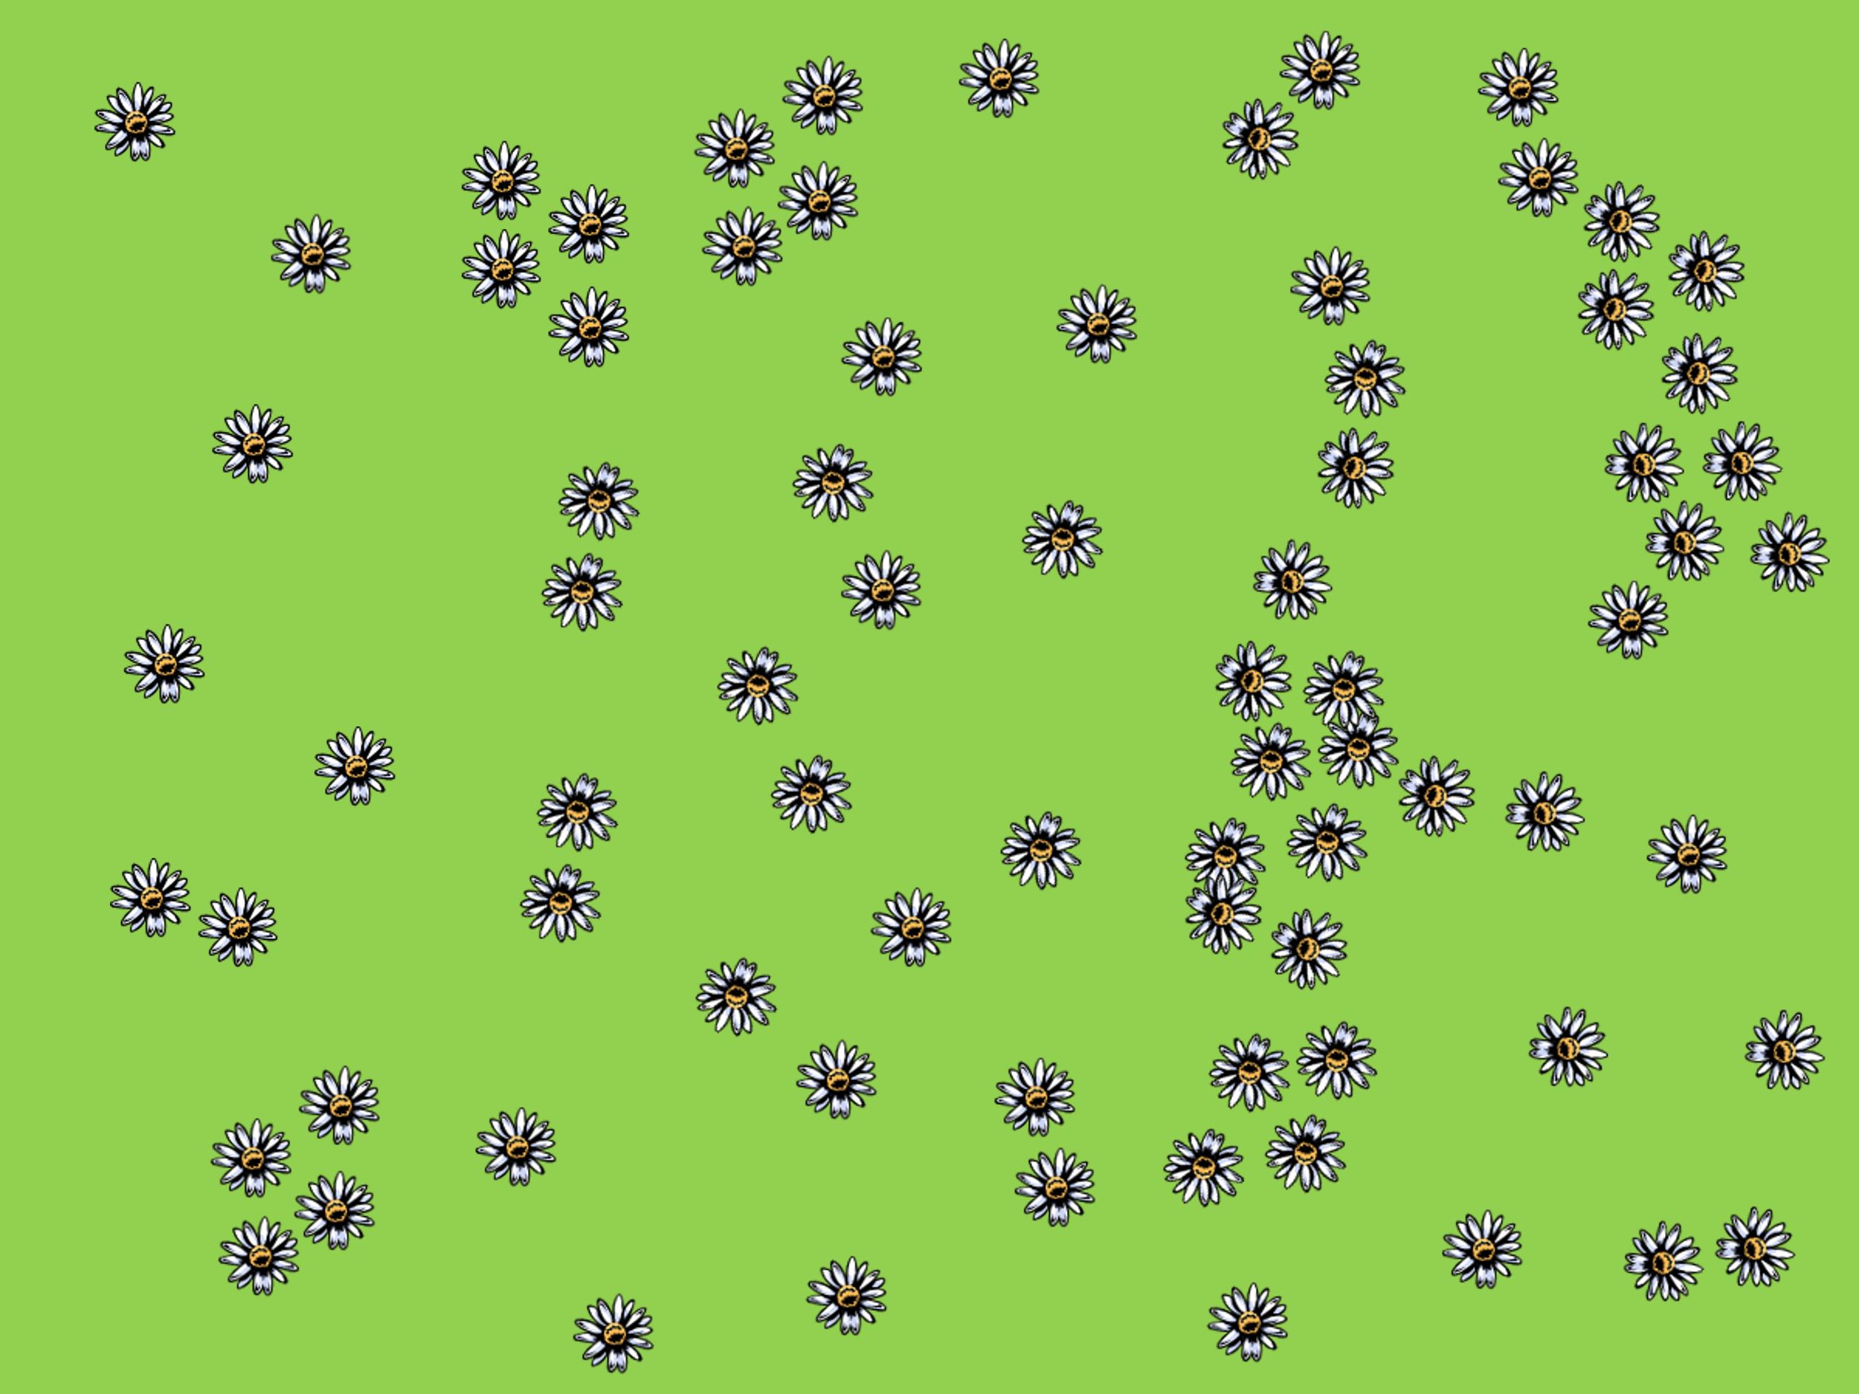
- Using a questioning strategy such as Pose-Pause-Pounce-Bounce (PDF 557 KB) (https://bit.ly/posepausepouncebounce) ask students, ‘How did you estimate the number of daisies?’
- Display slide 3 from the PowerPoint Which quadrat which shows a daisy field separated into squares. Once again ask students to tell you how many daisies there are.
Figure 2 – daisy field with quadrats
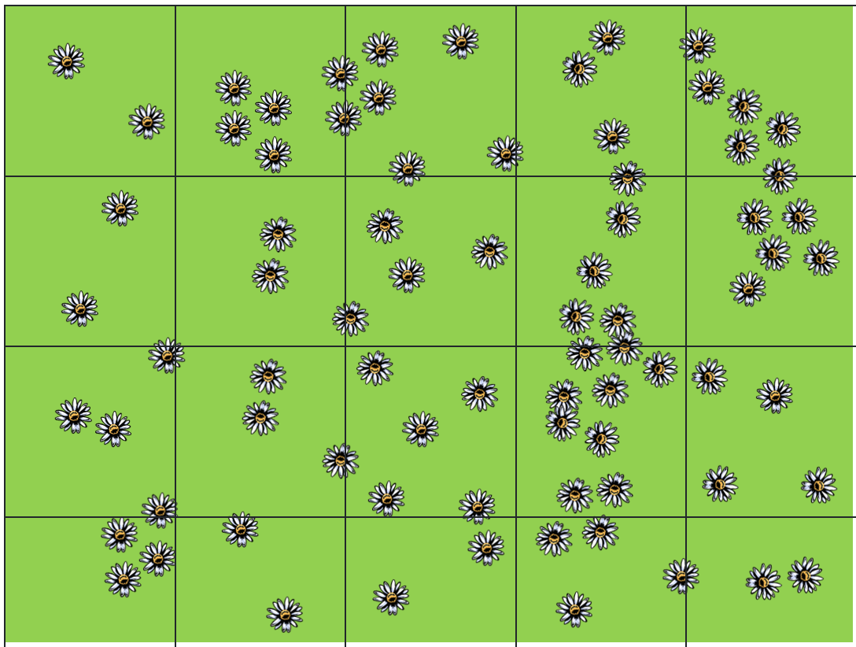
- Initiate a class discussion using the following prompts:
- How did your estimate change? Was it larger or smaller?
- Did you use the grid? If so, how did you use it?
- If this were a real daisy field, what sized squares would you use? Why?
The aim is for students to recognise the square size they would use to break up the space.
There are a total of 78 daisies in the field. If students are yet to master mean, median and mode, this activity can be extended to explore which measure of centre can be used to create the best estimate of another field.

Explore

Units of area
- Distribute Appendix A ‘Which quadrat’ to each student.
- Explain to students what a square unit is and state that certain quadrats are made from square units.
A square unit is a unit of measurement that has a side length of 1 unit. For example, a square metre is a square with sides lengths of one metre.
- Individually, ask students to match the best quadrat size for each scenario in the section ‘Match the quadrat’.
- Explain that each quadrat they matched is a unit of area. This is because each quadrat has side lengths of one unit and therefore created one square unit.
- Students are to return to the Appendix and complete ‘Select the unit of area’. This gives students scenarios in which they need to select the best unit of measure.
- In a Think-Pair-Share (bit.ly/thinkpairsharestrategy), ask the students the following questions:
- How did you pick what unit matched the scenario?
- What would happen if you picked a quadrat too small?
- What would happen if you picked a quadrat too big?
- What did everyone select for the size of a farm? Why?
When selecting a unit to measure area we do not want one that results in a very large number or a small fraction. When choosing the size of a quadrat, we do not want to choose an area that is too large or we make counting difficult, but if we choose an area that is too small, we do not give ourselves enough information to estimate a population.
If the size of a farm was measured in square metres it would result in a large number, but using square kilometres would result in a very small number. This is why hectares were introduced as an extra unit of area.
- Introduce students to another unit called a hectare. Explain that a hectare is a bit different to our other units of measure as it is a square with side lengths of 100 m, which is the best unit to measure the farm with.
- Distribute Appendix B ‘Flow chart template’ to each student. Ask students to order the units of measurement from smallest to largest in the rectangular boxes.

Area conversions
- Assign students into visibly random groups of 3 (bit.ly/visiblegroups) on vertical non-permanent surfaces (bit.ly/VNPSstrategy).
- Display the picture below or slide 4 of the PowerPoint Which quadrat and ask students to find, how many square millimetres fit in a square centimetre.
Figure 3 – square centimetre and square millimetre
Walk around the room and note the work you want to share with the class. Search for different strategies that may include drawing in a grid and counting or converting the length of the sides and multiplying.
- When groups are confident in their answer ask them the following questions:
- How many square centimetres are in a square metre?
- How many square metres are in a hectare?
- How many square metres are in a square kilometre?
- How many hectares are in a square kilometre?
- To help students with their thinking throughout this task you can use the following assessing and advancing questions.
Assessing questions | Advancing questions
How did you find the number of square units in the scenario? | Could you draw a diagram?
Can you explain why you converted the side lengths to that unit? | Can you see a pattern here?
Why didn’t you use the same approach in this situation? | Is there a quicker way you could find the answer for each scenario?
- Ask students the following questions:
- If we were to convert from a smaller unit to a larger, would we expect the number of squares to be larger or smaller? Why?
- If we were to convert from a larger unit to a smaller, would we expect the number of squares to be larger or smaller? Why?
- Display slide 5 that shows conversions of length next to conversion of area. Ask students what they notice/wonder (bit.ly/noticewonderstrategy).
Students should notice that the conversion for area is the square of the conversion for length. This can be connected to the conversion of the 2 side lengths to the smaller unit.
- Students are to fill in the flow chart from Appendix B showing how many of a smaller unit are contained in a larger unit.
- Have students return to their groups at their non-permanent surface and ask them how many square centimetres there are in a rectangle that is 0.5 m by 1.2 m. Ask students to use the numbers they discovered previously to see if there is a quicker way to find the solution.
- Students are to do a gallery walk (bit.ly/DLSgallerywalk) of the solutions. On this walk tell students they are to reflect on their own work and see if they can find the most efficient way to find the area in square centimetres.
- Initiate a sharing of ideas and reasoning using the Pose-Pause-Pounce-Bounce question strategy for students to share the most efficient strategy and why it works.
- Have students return to their groups at their vertical non-permanent surface and ask them how many square metres there are in a rectangle that is 140 cm by 90 cm. Encourage students to use the most efficient way to find the solution. They may choose to use a strategy they saw on their gallery walk.
- Initiate a sharing of ideas and reasoning using the Pose-Pause-Pounce-Bounce question strategy for students to share the most efficient strategy, how it differs to the previous situation and why it works.
Two methods of conversion should be compared here. The first is converting the area after it has been found and the other is converting the lengths and then finding the area. Depending on the information provided these are both efficient methods.

Summarise
- Students are to create notes to their future self (bit.ly/notesstrategy) on how to convert between units of area.
- Distribute Appendix C ‘Size order’ where students must order the measures of area from smallest to largest.
- Students should compare their solutions with the person next to them. If one answer differs, they are to explain to each other how they came to their solution.

Apply
- Distribute Appendix D ‘Property report’. This displays different options that some animal enthusiasts are looking to buy in the Moreton Bay region.
- Students are to open City of Moreton Bay’s website ‘Requirements for keeping animals’ (PDF 1260 KB) (bit.ly/moretonbayanimals).
- Students are to write a report for their clients in regard to how many animals they can house on each property.

Assessment and differentiation

Suggested opportunities for differentiation
Launch
- To connect with student interest, you can change the daisies to be a plant or slow-moving creature in your local environment, such as a snail or limpet.
Explore
- Students can be given a visual representation of a square centimetre and millimetre if struggling to draw one themselves.
- Students talk through their answers with other students before sharing with the class to improve confidence in their answers and receive feedback.
Summarise
- Students can be prompted to use their flowchart to help with the area conversion.
Apply
- Students can be directed to draw a scale model of a property and how it meets the requirements for housing animals.
- Teachers could provide a writing scaffold to assist students to write their report.

Suggested opportunities for assessment
Explore
- When placed in groups of 3, students provide and receive peer feedback on their understanding.
- Monitor responses in class discussions to check for student understanding of unit conversions.
- Students will demonstrate their working mathematically skills in discussions and justifications.
Summarise
- Review students’ notes to future selves.
- Appendix C could be collected and used as summative assessment for this unit of learning.

Appendix A – which quadrat?

Match the quadrats
Scenario | Type of quadrat
The number of starfish in a system of rock pools. | Square centimetre
The number of koalas in a forest. | Square metre
The number of bacteria cells on a petri dish. | Square kilometre

Selecting the unit of area
For each of the scenarios, select the unit of area you would use. Your options are square millimetre, square centimetre, square metre and square kilometre.
- The area taken up by trees in the Amazon Rainforest.
- The area taken up by your desk.
- The area taken up by a farm.
- The area taken up by your hand.
- The area taken up by a stop sign.
- The area taken up by the head of a nail.
- The area of sand in the Sahara Desert.
- The area taken up by a whiteboard.

Appendix B – flow chart template

Appendix C – size order
Order these areas from smallest to largest.
- 8.3 ha
- 0.00824 $km^{2}$
- 8 290,000 $cm^{2}$
- 831 000$m^{2}$
- 8 240 000 $mm^{2}$

Appendix D – property sizes
Property | Size
1 | 28,330 $m^{2}$
2 | 8,320 $m^{2}$
3 | 3 $ha$
4 | 40 $ha$
5 | 1 $km^{2}$

Sample solutions

Appendix A – which quadrat?

Match the quadrats
Scenario | Type of quadrat
The number of starfish in a system of rock pools. | Square metre
The number of koalas in a forest. | Square kilometre
The number of bacteria cells on a petri dish. | Square centimetre

Selecting the unit of area
- Square kilometre.
- Square centimetre or square metre (depending on size of desk).
- Square kilometre or square metre (introduced to hectares later).
- Square centimetres.
- Square centimetres.
- Square millimetres.
- Square kilometres.
- Square metres.

Appendix B – flow chart template
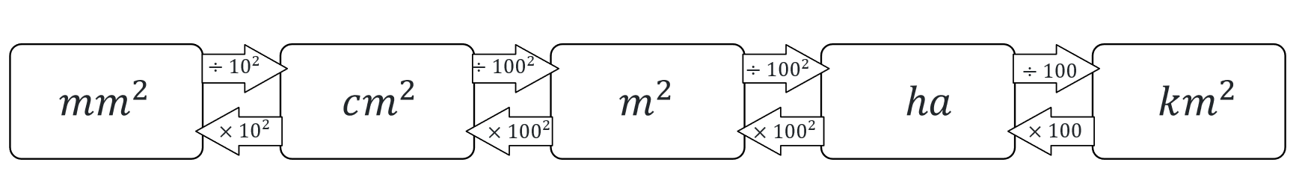

Appendix C – size order
Order these areas from smallest to largest.
- 8.3 ha $×{100}^{2}=83 000m^{2}$
- 0.00824 $km^{2}×{1000}^{2}=8240m^{2}$
- 8 290 000 $cm^{2}÷{100}^{2}=829m^{2}$
- 831 000$m^{2}$
- 8 240 000 $mm^{2}÷{10}^{2}÷{100}^{2}=8.24m^{2}$
Order: 8 240 000 $mm^{2}$, 8 290 000 $cm^{2}$, 0.00824 $km^{2}$, 8.3 ha, 831 000$m^{2}$

Appendix D – property sizes
This table summarises the number of animals you can house on each property. A sample report is not provided due to the large variety of formats and styles.
Property | Size | Sheep/Goat | Pig | Other animals
1 | 28,330 $m^{2}$ | 28 | 0 | 7
2 | 8,320 $m^{2}$ | 8 | 0 | 2
3 | 3 $ha$ = 30 000 $m^{2}$ | 30 | 1 | 7
4 | 40 $ha$ = 400 000$m^{2}$ | 400 | 1 | 100
5 | 1 $km^{2}$ = 1 000 000$m^{2}$ | 1000 | 1 | 250

References
This resource contains NSW Curriculum and syllabus content. The NSW Curriculum is developed by the NSW Education Standards Authority. This content is prepared by NESA for and on behalf of the Crown in right of the State of New South Wales. The material is protected by Crown copyright.
Please refer to the NESA Copyright Disclaimer for more information https://educationstandards.nsw.edu.au/wps/portal/nesa/mini-footer/copyright.
NESA holds the only official and up-to-date versions of the NSW Curriculum and syllabus documents. Please visit the NSW Education Standards Authority (NESA) website https://educationstandards.nsw.edu.au and the NSW Curriculum website https://curriculum.nsw.edu.au.
Mathematics K–10 Syllabus © NSW Education Standards Authority (NESA) for and on behalf of the Crown in right of the State of New South Wales, 2022.
RSPCA Australia (2024) How much space does a layer hen need?, RSPCA knowledge base website, accessed 27 February 2024.

© State of New South Wales (Department of Education), 2024
The copyright material published in this resource is subject to the Copyright Act 1968 (Cth) and is owned by the NSW Department of Education or, where indicated, by a party other than the NSW Department of Education (third-party material).
Copyright material available in this resource and owned by the NSW Department of Education is licensed under a Creative Commons Attribution 4.0 International (CC BY 4.0) license.
This license allows you to share and adapt the material for any purpose, even commercially.
Attribution should be given to © State of New South Wales (Department of Education), 2024.
Material in this resource not available under a Creative Commons license:
- the NSW Department of Education logo, other logos and trademark-protected material
- material owned by a third party that has been reproduced with permission. You will need to obtain permission from the third party to reuse its material.
Links to third-party material and websites
Please note that the provided (reading/viewing material/list/links/texts) are a suggestion only and implies no endorsement, by the New South Wales Department of Education, of any author, publisher, or book title. School principals and teachers are best placed to assess the suitability of resources that would complement the curriculum and reflect the needs and interests of their students.
If you use the links provided in this document to access a third-party's website, you acknowledge that the terms of use, including licence terms set out on the third-party's website apply to the use which may be made of the materials on that third-party website or where permitted by the Copyright Act 1968 (Cth). The department accepts no responsibility for content on third-party websites.

