Are all areas created equal?
Students design spaces for handball ‘squares’ and learn to differentiate between the concept of perimeter and area.

Visible learning
The learning intentions and success criteria for this learning episode should be revealed to students during the summarise activities.

Learning intentions
- To understand that the same perimeter can create many different shapes and areas.
- To know that the maximum area of a rectangle with a given perimeter is a square.

Success criteria
- I can explain how 2 shapes with the same perimeter can have different areas.
- I can solve problems that require a maximum area.

Syllabus outcomes
A student:
- develops understanding and fluency in mathematics through exploring and connecting mathematical concepts, choosing and applying mathematical techniques to solve problems, and communicating their thinking and reasoning coherently and clearly MAO-WM-01
- applies knowledge of area and composite area involving triangles, quadrilaterals and circles to solve problems MA4-ARE-C-01
- applies knowledge of the perimeter of plane shapes and the circumference of circles to solve problems MA4-LEN-C-01
Mathematics K–10 Syllabus © NSW Education Standards Authority (NESA) for and on behalf of the Crown in right of the State of New South Wales, 2022.

Activity structure
Please use the associated PowerPoint Are all areas created equal to display images in this lesson.

Launch
- Play the video ‘Downball (AKA handball, foursquare) is still the recess king | Everyday Home | ABC Australia’ (5:03) (bit.ly/ABCDownball).
- Have students engage in a Think-Pair-Share (bit.ly/thinkpairsharestrategy) to discuss the rules they use for handball, likely to be different in every school. Create a class list during the ‘share’ portion of this activity.
- Display Figure 1 on slide 3 of the Are all areas created equal PowerPoint file.
Figure 1 – handball ‘squares’
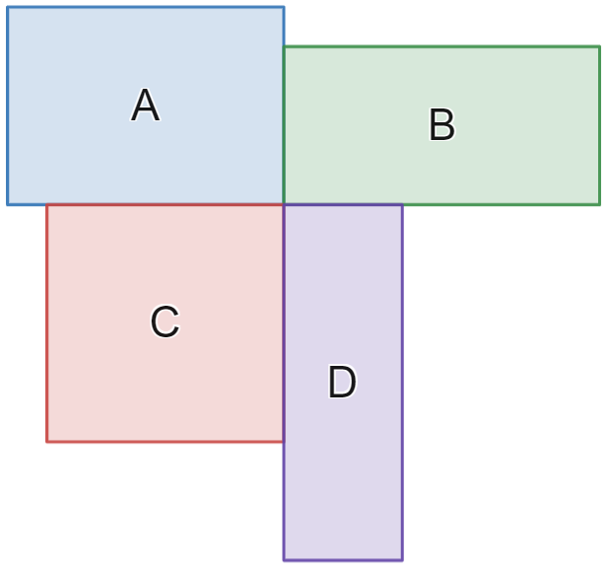
Image created using Desmos and is licensed under the Desmos Terms of Service.
- Explain that this image represents 4 handball ‘squares’ that are clearly not identical and clearly not all squares.
- Have students engage in a Think-Pair-Share to discuss which of the rectangles A, B, C or D would be the easiest to play from in a game of handball.
Ask questions to ensure that students justify why one rectangle would be easier to play in than another. Students may consider the area of the rectangle, its shape or the portion of its perimeter that is shared with another player’s space.

Explore

Equipment
- Grid paper, at least one per group
- Rulers, at least one per group
- Chalk
- Tennis balls
- Large ruler or tape measures
- Copies of Appendix A, ‘Who gets out the most’

Method
- Organise students into visibly random groups of 3 (bit.ly/visiblegroups) and hand each group a sheet of grid paper.
- Instruct students to create as many different rectangles as they can that have a perimeter of 14 units.
If geoboards are available, students can construct their rectangles on geoboards first before recording them on their grid paper. Geoboards can also be accessed using the online interactive ‘Geoboard by The Maths Learning Center’ (bit.ly/MLCGeoboard).
Students are likely to identify rectangles with dimensions 1 × 6 units, 2 × 5 units and 3 × 4 units. Teachers should encourage students to look beyond this list to non-integer possibilities to ensure we have 4 unique spaces. This is also an opportunity for teachers to remind students that a square is a type of rectangle.
- Agree upon a set of 4 rectangles to be the dimensions of our handball ‘squares’. An example is shown in Figure 2, available on slide 5 of the Are all areas created equal PowerPoint. Note to students that we will be using metres as our units.
Figure 2 – handball 'squares' with dimensions
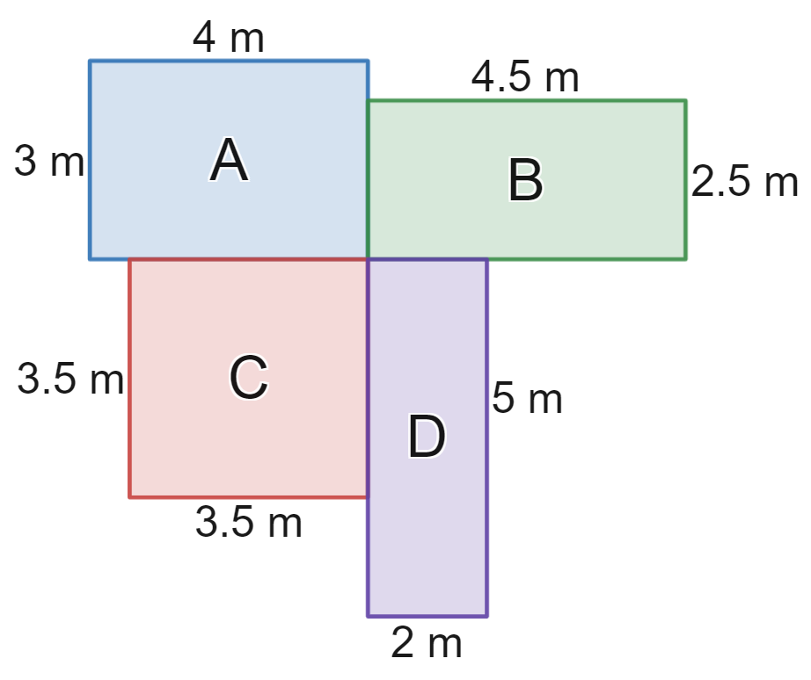
Image created using Desmos and is licensed under the Desmos Terms of Service.
- Take students out to a courtyard or concrete space and combine 2 groups of 3 together to make teams of 6.
- Have the groups of 6 use the large rulers or tape measures to mark out the 4 rectangles designed in Figure 2.
- Have each group play games of handball in their designed rectangles. Groups should play up to approximately 20 games.
- The 2 players not playing at any time should be recording the result of who was ‘out’ in each game on Appendix A. Players should rotate in and out as well as moving between squares depending on who gets out in each game.
- Bring everyone back to the classroom and have students construct a suitable graph to display their data.
Students could display their data using spreadsheet software to create a suitable graph. Teachers can show students the video Creating Charts (2:53) (bit.ly/Graphs_Excel365) to teach them how to graph in Microsoft Excel.
- Ask students to share what graph they chose to display their data and to justify why they made this choice.
- Collect the class data and enter the totals into a spreadsheet or the Desmos graph ‘Handball class graph’ (bit.ly/DesmosHBCGraphs), displaying on the teacher screen.
- Have students engage in a Think-Pair-Share to discuss why any one rectangle seemed to be easier to lose from than another.
- Have students calculate the area of the rectangles in their pairs and repeat the Think-Pair-Share process to consider how the area impacted the difficulty of playing in a square.
The intention of this investigation is that it would help the class to conclude that a larger area is more difficult to defend. Regardless of the result, students should be encouraged to form opinions of what makes the spaces easier or harder to defend in a game of handball to help motivate the next section.

Summarise
- Organise new, visibly random groups of 3 and have students work at vertical, non-permanent surfaces (bit.ly/VNPSstrategy). Challenge students to find the rectangle with a perimeter of 14 m and the largest possible area. Students should be challenged to justify how they know this is the correct shape.
- Hand groups copies of Appendix C ‘So many rectangles’ and have them complete the line graph by finding the area of each of the rectangles shown in the table and marking them on the graph.
- For groups who finish this task, extend them by having them consider the following, related further challenges.
- Find the rectangle with a perimeter of 14 m that has the smallest area.
- Find the rectangle with a perimeter of 20 m that has the largest area.
- Find the rectangle with a perimeter of $x$ m that has the largest area.
- Conclude with students that for any given perimeter, the rectangle with the largest area is when the length and the width are equal and hence is also a square.
- Reveal to students the learning intentions and success criteria for this lesson.
- Organise students into visibly random groups of 3 working at vertical non-permanent surfaces.
- Hand groups of students a copy of Appendix D ‘Practical problems’ to solve.
- Have students explore different rectangles to attempt to solve the 3 problems.
- Come together as a group to share group responses.

Apply

Equipment
- Grid paper, at least one per group
- Rulers, at least one per group
- String, cut to 12 cm in length.

Method
- Still in groups of 3, have students move to a desk and give groups the equipment listed above.
- Instruct students to hold the string at 3 points to form a triangle and trace a triangle with a 12 cm perimeter. They then need to use the ruler to find the base length and perpendicular height to calculate the area.
- Challenge students to repeat this with different sized triangles and attempt to find the triangle with the largest area.
If students are quick to jump to the conclusion that an equilateral triangle will hold the largest area, challenge them to use calculations of the area of other triangles to show this.

Assessment and differentiation

Suggested opportunities for differentiation
Launch
- As students are able to discuss any factors that would make playing from a particular rectangle difficult, all students should be able to engage in the discussion.
Explore
- Students can be given Appendix B ‘Handball graphs’ as a template to graph their results or be sent to the Desmos graph ‘Handball graph’ (bit.ly/DesmosHBGraphs) to enter their data and view possible graphs.
- Students can be challenged to calculate and compare factors that they believe influence the difficulty of playing in each handball square, such as the portion of the perimeter that is shared with other squares.
- Students can be challenged to explore if shapes other than rectangles could create a larger area from the given length.
Apply
- Students can be challenged to explore the area of other shapes that can be formed with a 12 cm length of string and look for the largest area. They can use shapes for which they know the area, or approximate area by laying the shape over the grid paper.

Suggested opportunities for assessment
Launch
- Teachers should listen to student discussions for specific language related to shapes and area. These Think-Pair-Share discussions are also an opportunity for students to demonstrate their skills in justifying their perspective with mathematical concepts.
Explore
- Teachers can observe students constructing handball spaces to evaluate their ability to use measuring tools.
- Teachers can observe students taking data during the handball activity and can also collect Appendix B as evidence of students’ ability to work with data and construct graphs.
Summarise
- Teachers can observe students during the group questions for evidence of students’ ability to use known facts about the areas of rectangles to help them solve the given problems.

Appendix A

Who gets out the most
Record the rectangle of the player who got out in each game in the table below.
Rectangle | Tally | Frequency
A
B
C
D

Appendix B

Handball graph

Column graph
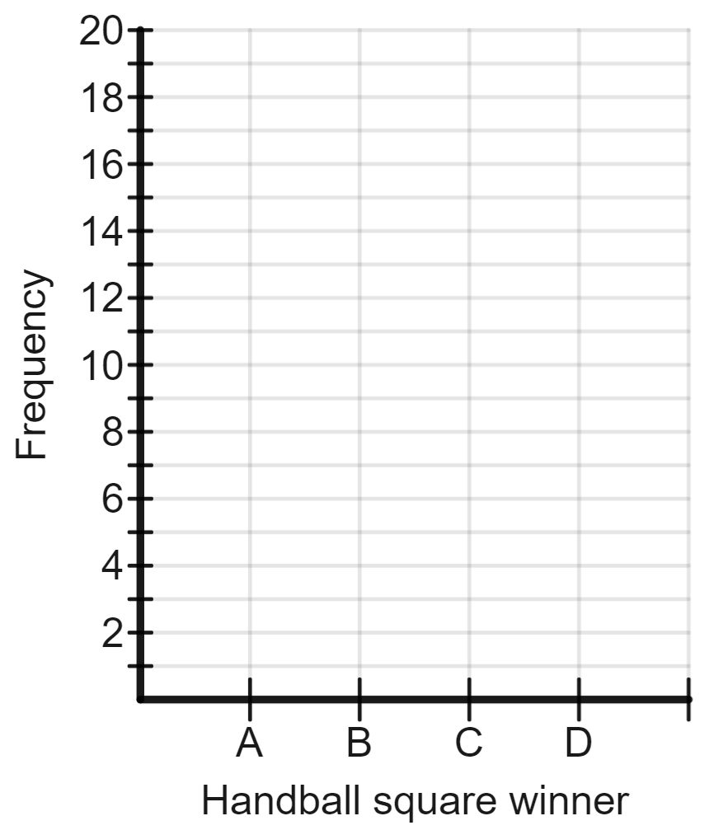
Image created using Desmos and is licensed under the Desmos Terms of Service.
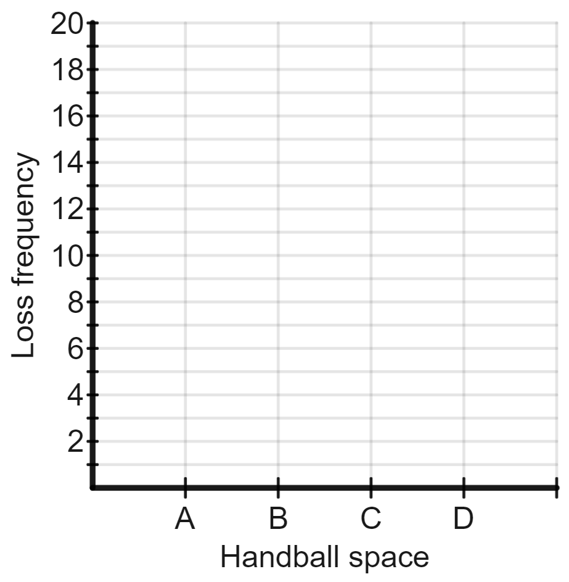
Image created using Desmos and is licensed under the Desmos Terms of Service.

Dot plot
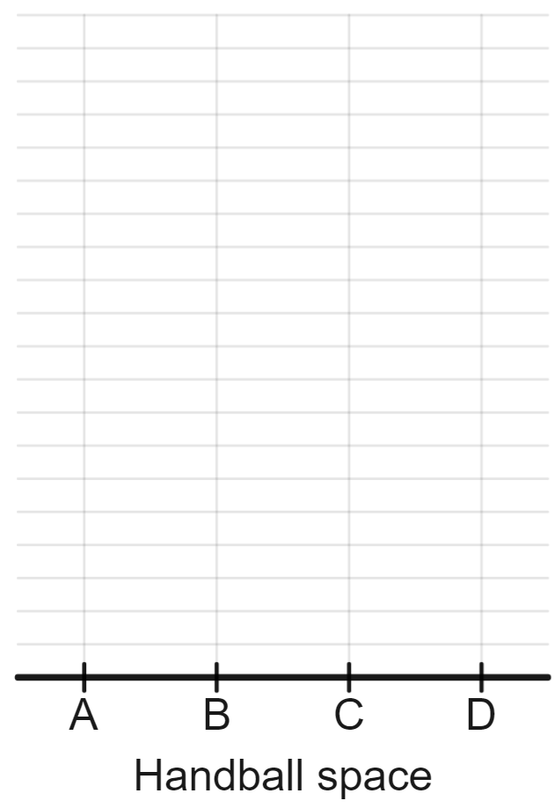
Image created using Desmos and is licensed under the Desmos Terms of Service.

Sector graph
The circle below has been divided into 24 parts to assist in creating a sector graph.
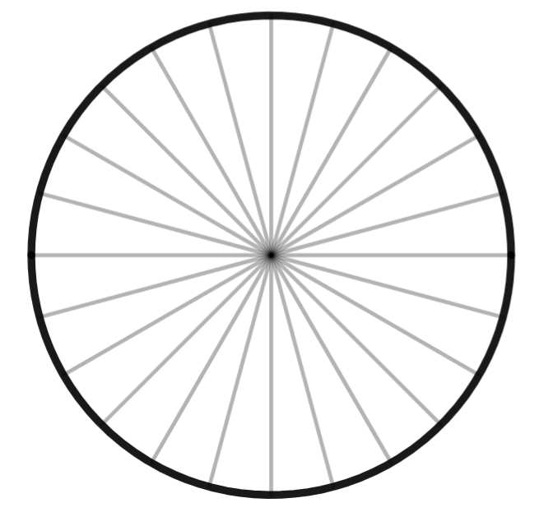
Image created using Desmos and is licensed under the Desmos Terms of Service.

Appendix C

So many rectangles
All of the rectangles in the table below have a perimeter of 14 metres. Find the area of each rectangle and plot it on the graph below. The first rectangle, with a base length of 0.5 metres, has been completed for you.
Rectangle | Area | Rectangle | Area
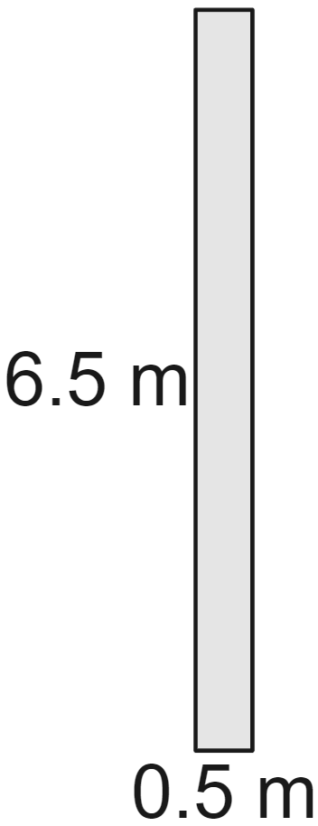 | $$A=0.5×6.5 \\ =3.25 m^{2}$$ | 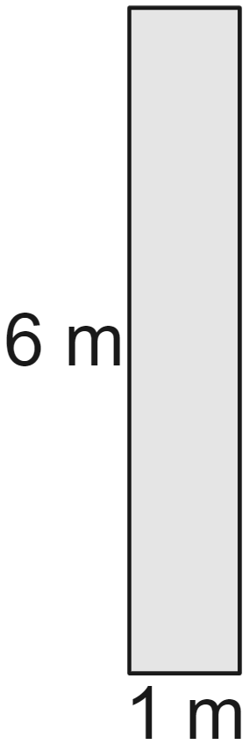
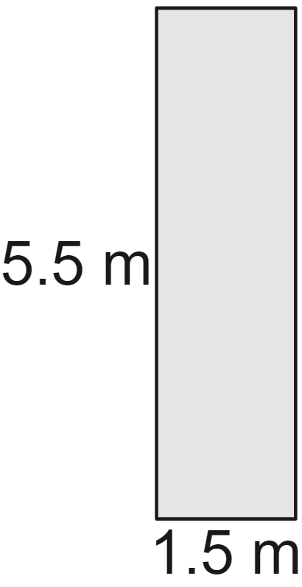 |  | 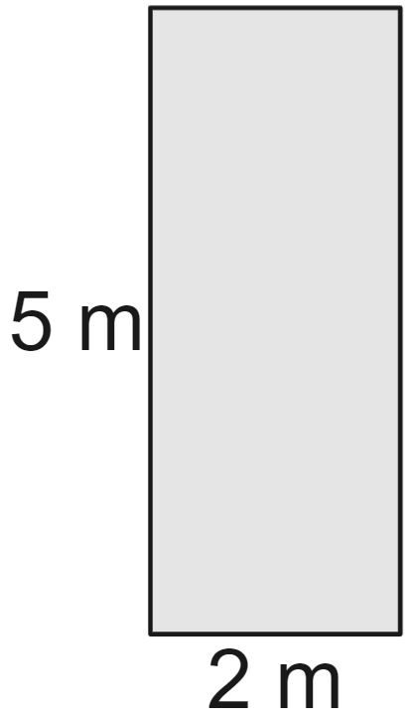
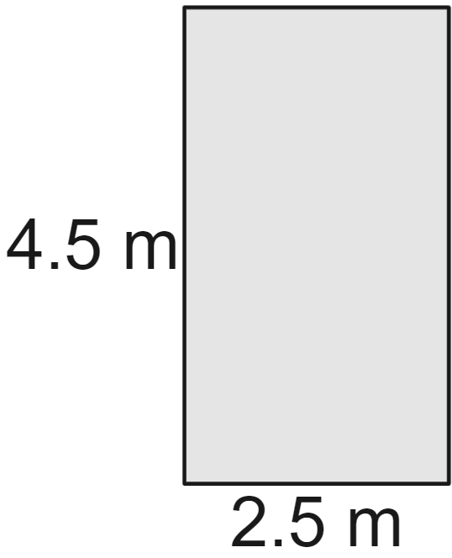 |  | 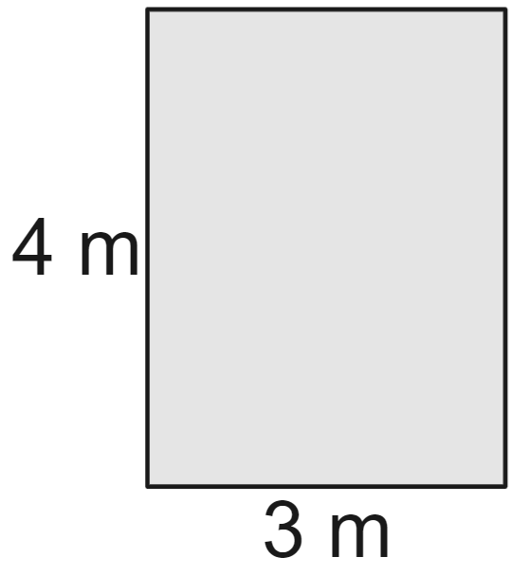
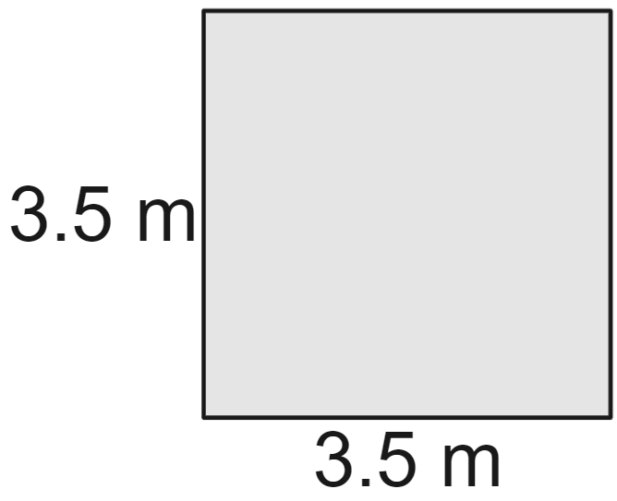 |  | 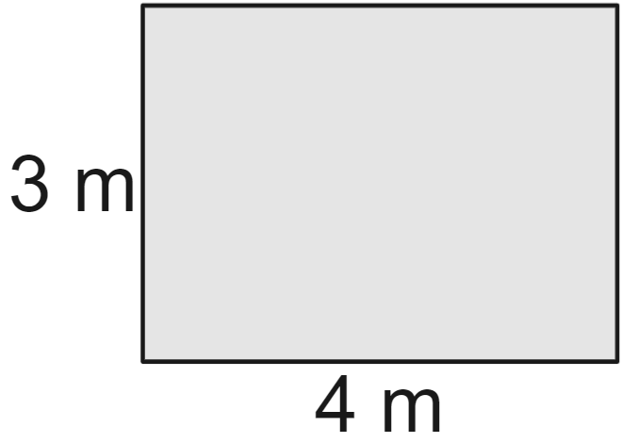
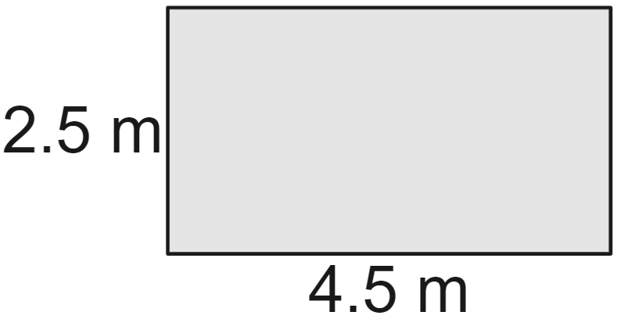 |  | 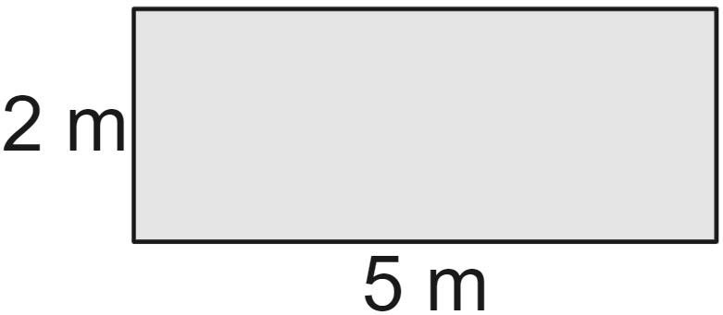
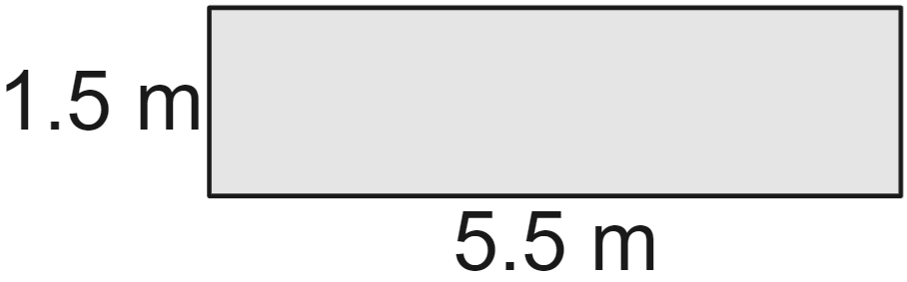 |  | 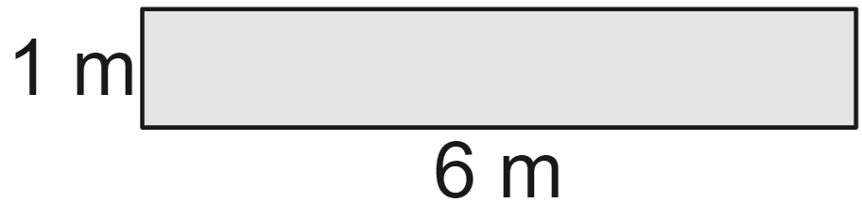
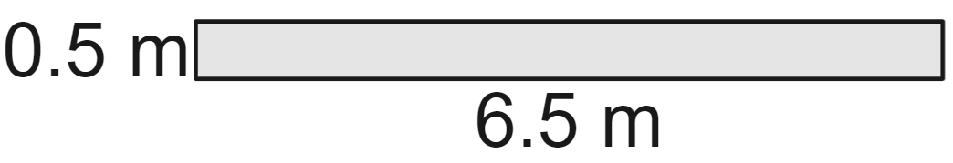
Images created using Desmos and is licensed under the Desmos Terms of Service.

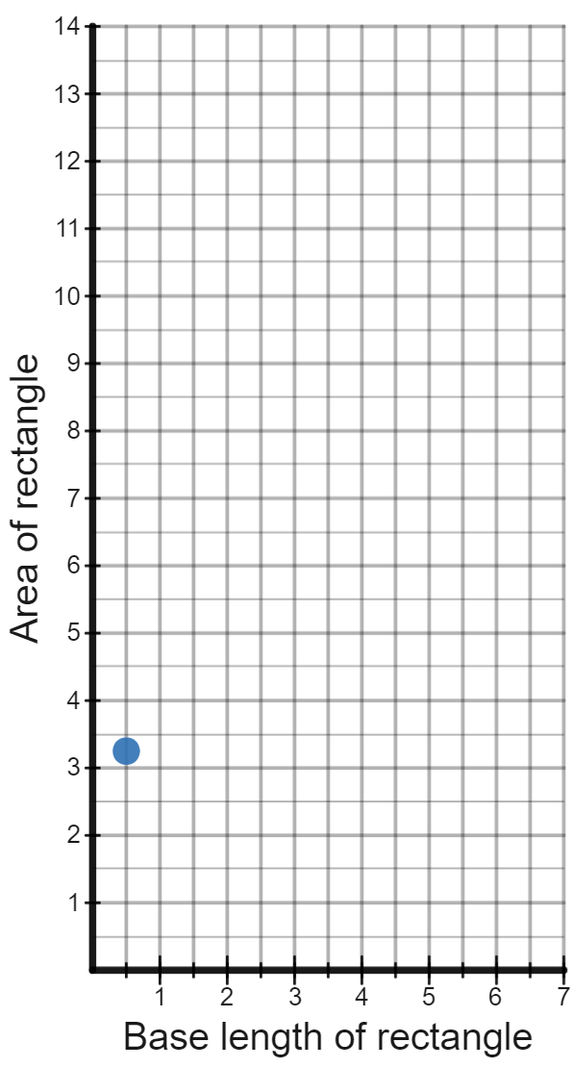
Image created using Desmos and is licensed under the Desmos Terms of Service.

Appendix D

Practical problems
By exploring possible rectangles, solve the following 3 problems.
Problem | Answer
- A farmer has 60 metres of fencing available. She wants to fence a rectangular area that gives as much space as possible to her sheep. What is the largest area she can create with this fencing?
- The farmer has now decided to create an area beside a building and use a brick wall as one of the sides of the rectangle. Therefore the 60 metres of fencing will be used for the other 3 sides. What is the largest area she can create with this fencing?
- A school will be keeping 4 sheep and needs to build a pen to house them to reduce the risk of injury or attack by predators. The pen needs to provide 10 square metres of area for the sheep. What is the minimum amount of fencing that the school can buy to create a pen for the 4 sheep.

Sample solutions

Appendix C – so many rectangles
Rectangle | Area | Rectangle | Area
 | $$A=0.5×6.5 \\ =3.25 m^{2}$$ |  | $$A=1×6 \\ =6 m^{2}$$
 | $$A=1.5×5.5 \\ =8.25 m^{2}$$ |  | $$A=2×5 \\ =10 m^{2}$$
 | $$A=2.5×4.5 \\ =11.25 m^{2}$$ |  | $$A=3×4 \\ =12 m^{2}$$
 | $$A=3.5×3.5 \\ =12.25 m^{2}$$ |  | $$A=4×3 \\ =12 m^{2}$$
 | $$A=4.5×2.5 \\ =11.25 m^{2}$$ |  | $$A=5×2 \\ =10 m^{2}$$
 | $$A=5.5×1.5 \\ =8.25 m^{2}$$ |  | $$A=6×1 \\ =6 m^{2}$$
 | $$A=6.5×0.5 \\ =3.25 m^{2}$$
Image created using Desmos and is licensed under the Desmos Terms of Service.

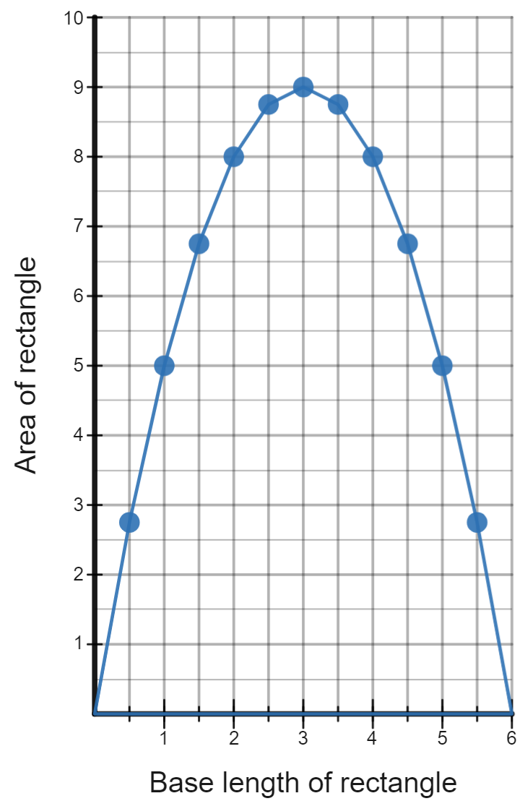
Image created using Desmos and is licensed under the Desmos Terms of Service.

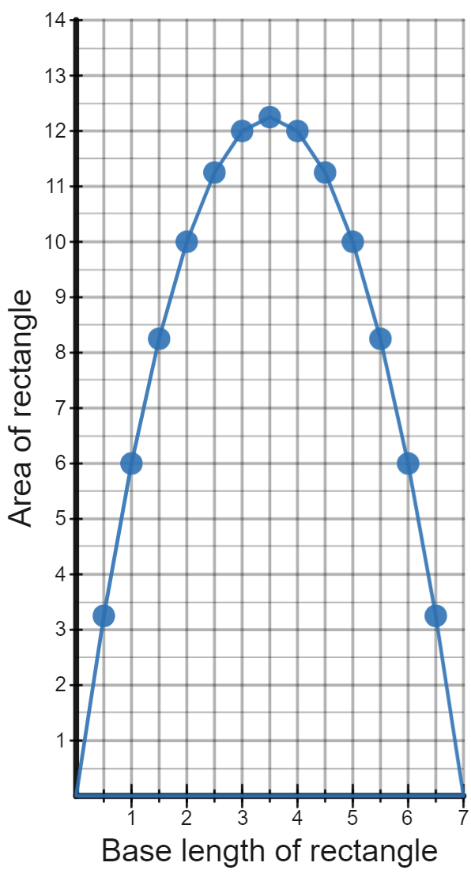
Image created using Desmos and is licensed under the Desmos Terms of Service.

Appendix D – practical problems
By exploring possible rectangles, solve the following 3 problems.
Problem | Answer
- A farmer has 60 metres of fencing available. She wants to fence a rectangular area that gives as much space as possible to her sheep. What is the largest area she can create with this fencing? | $$A=15×15 \\ =225 m^{2}$$
- The farmer has now decided to create an area beside a building and use a brick wall as one of the sides of the rectangle. Therefore the 60 metres of fencing will be used for the other 3 sides. What is the largest area she can create with this fencing? | $$A=30×15 \\ =450 m^{2}$$
- A school will be keeping 4 sheep and needs to build a pen to house them to reduce the risk of injury or attack by predators. The pen needs to provide 10 square metres of area for the sheep. What is the minimum amount of fencing that the school can buy to create a pen for the 4 sheep. | $$A=10 m^{2}$$  $$l=\sqrt{10} \\ =3.162 \\ =3.2 m$$  $$P=4×3.2=12.8 m$$

References
This resource contains NSW Curriculum and syllabus content. The NSW Curriculum is developed by the NSW Education Standards Authority. This content is prepared by NESA for and on behalf of the Crown in right of the State of New South Wales. The material is protected by Crown copyright.
Please refer to the NESA Copyright Disclaimer for more information https://educationstandards.nsw.edu.au/wps/portal/nesa/mini-footer/copyright.
NESA holds the only official and up-to-date versions of the NSW Curriculum and syllabus documents. Please visit the NSW Education Standards Authority (NESA) website https://educationstandards.nsw.edu.au/ and the NSW Curriculum website https://curriculum.nsw.edu.au/home.
Mathematics K–10 Syllabus © NSW Education Standards Authority (NESA) for and on behalf of the Crown in right of the State of New South Wales, 2022.

© State of New South Wales (Department of Education), 2024
The copyright material published in this resource is subject to the Copyright Act 1968 (Cth) and is owned by the NSW Department of Education or, where indicated, by a party other than the NSW Department of Education (third-party material).
Copyright material available in this resource and owned by the NSW Department of Education is licensed under a Creative Commons Attribution 4.0 International (CC BY 4.0) license.
This license allows you to share and adapt the material for any purpose, even commercially.
Attribution should be given to © State of New South Wales (Department of Education), 2024.
Material in this resource not available under a Creative Commons license:
- the NSW Department of Education logo, other logos and trademark-protected material
- material owned by a third party that has been reproduced with permission. You will need to obtain permission from the third party to reuse its material.
Links to third-party material and websites
Please note that the provided (reading/viewing material/list/links/texts) are a suggestion only and implies no endorsement, by the New South Wales Department of Education, of any author, publisher, or book title. School principals and teachers are best placed to assess the suitability of resources that would complement the curriculum and reflect the needs and interests of their students.
If you use the links provided in this document to access a third-party's website, you acknowledge that the terms of use, including licence terms set out on the third-party's website apply to the use which may be made of the materials on that third-party website or where permitted by the Copyright Act 1968 (Cth). The department accepts no responsibility for content on third-party websites.

