Enough room for all
Students will compare area and perimeter, considering the impact on one when the other is changed.

Visible learning

Learning intention
- To understand how perimeter and area are related.

Success criteria
- I can define perimeter and area.
- I can choose appropriate strategies for calculating perimeter.
- I can choose appropriate strategies for calculating area.
- I can explain which shapes will have the largest perimeter and which shapes will have the smallest perimeter.

Syllabus outcomes
A student:
- develops understanding and fluency in mathematics through exploring and connecting mathematical concepts, choosing and applying mathematical techniques to solve problems, and communicating their thinking and reasoning coherently and clearly MAO-WM-01
- applies knowledge of the perimeter of plane shapes and the circumference of circles to solve problems MA4-LEN-C-01
- applies knowledge of area and composite area involving triangles, quadrilaterals and circles to solve problems MA4-ARE-C-01
Mathematics K–10 Syllabus © NSW Education Standards Authority (NESA) for and on behalf of the Crown in right of the State of New South Wales, 2022.

Activity structure
Please use the associated PowerPoint Enough room for all to display images in this lesson.

Launch
This activity is based on a story book Spaghetti and Meatballs for All by Marilyn Burns.
A reading of the story can be accessed, ‘Spaghetti and Meatballs for All!’ (7:54) (bit.ly/chairsforall).
You may choose to read the book to students or show a video of the book being read by a narrator, however, this is not necessary. Before beginning, explain that the story is aimed at a younger audience, but it is useful to think about the mathematical concepts in the story.
- Display slide 3 of the Enough room for all PowerPoint. Read the information to the students. Explain that the diagram represents a table with 4 seats. Lead a discussion to determine that 8 tables and 32 chairs will need to be hired.
- Display slide 4 of the Enough room for all PowerPoint. Read the information and draw attention to the diagram of the seating plan.
- Explain that Mrs Comfort is worried about the amount of space that the tables take up. Challenge students, by working in visibly random groups of 3 (bit.ly/visiblegroups) on vertical non-permanent surfaces (bit.ly/VNPSstrategy), to come up with a different seating arrangement, using the same size tables, to seat the 32 people.
Students could also use the desmos classroom activity ‘Enough room for all’ to find different table combinations https://bit.ly/EnoughRoom.
- Ask students to go on a gallery walk (bit.ly/DLSgallerywalk) to observe the solutions from the other groups.
- As a class, discuss what was the same about the different solutions and what was different?
Consider which arrangement used the greatest number of tables (area) and which used the smallest.
- Challenge students to consider how they know we have found the best solution.

Explore
This activity has been modified from the Mathigon activity 'Pentomino Perimeters' (PDF 158 KB).
- Using the previous groups, issue each group with a copy of Appendix A ‘Pentominoes’ printed on A3 paper and placed in a plastic pocket attached to the wall.
- By working on the A3 plastic sleeve (bit.ly/VNPSstrategy), ask students to find the perimeter and area of each shape.
- Use the Pose-Pause-Pounce-Bounce question strategy (PDF 557KB) (bit.ly/posepausepouncebounce) for students to share what they discovered.
All pentominoes have the same area and most pentominoes have a perimeter of 12, but there is only one with a perimeter of 10.
- Introduce the idea of joining 2 or more pentominoes together. Explain that to join pentominoes they must share at least one side and not overlap. An example is available on slide 6 of the PowerPoint Enough room for all.
Figure 1 – two pentonimoes joined together
- Ask students to predict how joining the pentominoes together will change the area and the perimeter. Questions to provoke thinking include:
- Will the perimeter double?
- Will the area double?
- Will the changes follow a rule?
- Ask students to make several different shapes by joining together 2 different pentominoes. Have them find the perimeters of the shapes they make.
Students can either cut out the pentominoes in Appendix A or they can use the desmos classroom activity Enough room for all (https://bit.ly/EnoughRoom)
- Prompt students to answer the following questions:
- What is the smallest perimeter of a shape made by joining 2 pentominoes together?
- What is the largest perimeter of a shape made by joining 2 pentominoes together?
- Which perimeters in between can you make?
- Can you make a perimeter of 15?
Some questions to assess and advance student thinking could include:
- How do you know that you have found the smallest and largest possible perimeter?
- How did you work out the perimeters?
- Why are all the perimeters even numbers?
- How can you be certain that no other perimeters could be made?

Summarise
- Discuss with students what factors led to the largest perimeter and what factors led to the smallest perimeter.
Students should be able to identify that the more sides that overlap, the smaller the perimeter.
- Distribute a copy of Appendix B ‘Less, same, more’.
- Tell students that to complete the table, they need to draw rectangles in each cell of the table that match the given conditions for that cell. For instance, in the middle cell on the left, they will need to draw a rectangle that has the same perimeter and less area than the rectangle in the centre of the table.
- When students have completed the table, ask them to compare the results in their table with other students.
- Generate a class discussion about how they chose the dimensions of the rectangles and how they calculated the area and perimeter of each.
Appendix C ‘Less, same, more challenge’ is available to extend students.

Apply
- Working in visibly random groups of 3 at vertical non-permanent surfaces, students are to consider the largest and smallest perimeters that can be made with differing numbers of tables (assuming that tables are joined and not separated).
- They should record their results in the table in Appendix D ‘Enough for all’.
- Ask students to identify any patterns they see in the table and if they could predict what the largest and smallest perimeters would be for 10 tables or 20 tables.
- Students could be challenged to come up with general rules for the largest and smallest perimeters for a given number of tables.

Assessment and differentiation

Suggested opportunities for differentiation
Launch
- Students may find working on graph or dotted paper assists them to count the number of tables and people.
Explore
- All students will be able to count the squares on the edges of the pentominoes to find the perimeter.
- Students could be challenged to consider the largest and smallest perimeter if they joined 3 pentominoes together.
Summarise
- Students may begin with a trial-and-error approach by removing rows or columns in the rectangle and then assessing which cell their new shape belongs.
- Challenge students to fill the cells by making as minimal changes as possible to the rectangle. Students could also consider what would happen if the shape did not need to remain a rectangle, when filling the other cells.
- Appendix C has a more challenging problem for students to solve
Apply
- Using graph or dotted paper will help students to draw their shapes and calculate the perimeter.
- Students could be challenged to consider how many different hexominoes are possible.
- Students can be further challenged to consider a general rule for the perimeter given differing numbers of tables.

Suggested opportunities for assessment
Launch & Explore
The teacher should monitor student discussions throughout these activities. They should listen for correct terminology and any misconceptions that students may possess.
Summarise
Teachers could collect Appendix B and C as student work samples to check for understanding.
Apply
Students could write and submit a statement explaining how they created their smallest and largest perimeters. What factors were necessary to create a shape with a small perimeter? What factors were necessary to create a shape with a large perimeter?

Appendix A

Perimeter pentominoes
Each pentomino has 5 squares. Find the perimeter and area of each pentomino.
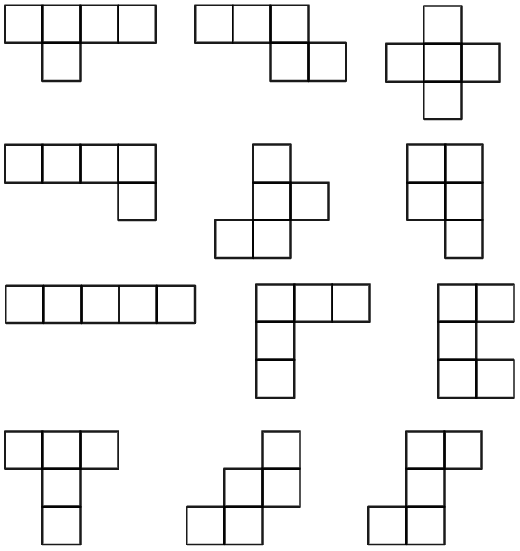

Appendix B

Less, same, more
Draw rectangles in each cell of the table that match the given conditions for that cell.
For example, in the top left cell, you need to draw a rectangle that has less area and less perimeter than the one given to you in the middle cell.
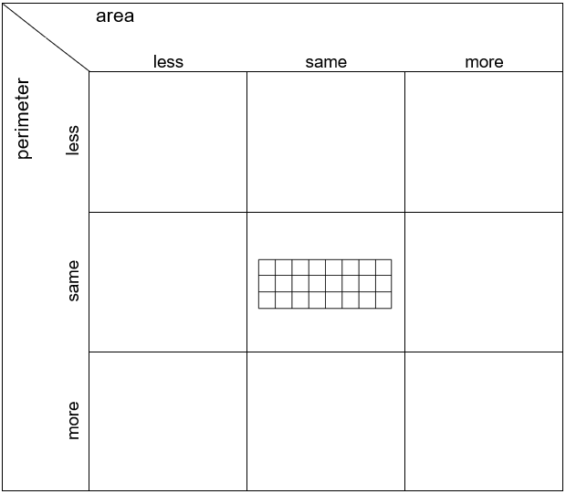

Appendix C

Less, same, more challenge
Draw rectangles in each cell of the table that match the given conditions for that cell.
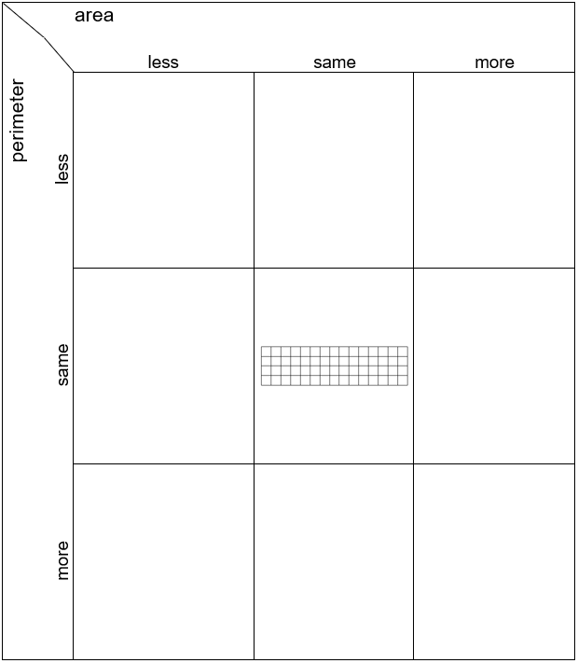

Appendix D

Enough room for all
Number of tables | Largest perimeter | Smallest perimeter
1 | 4 | 4
2 | 6 | 6

3

4
5 | 12 | 10

6

7

Sample solutions

Appendix B – less, same, more
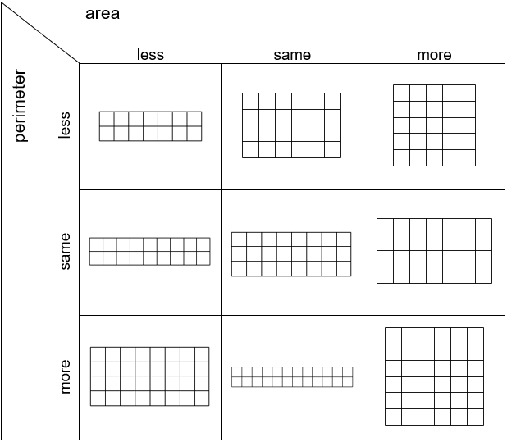

Appendix C – less, same, more challenge
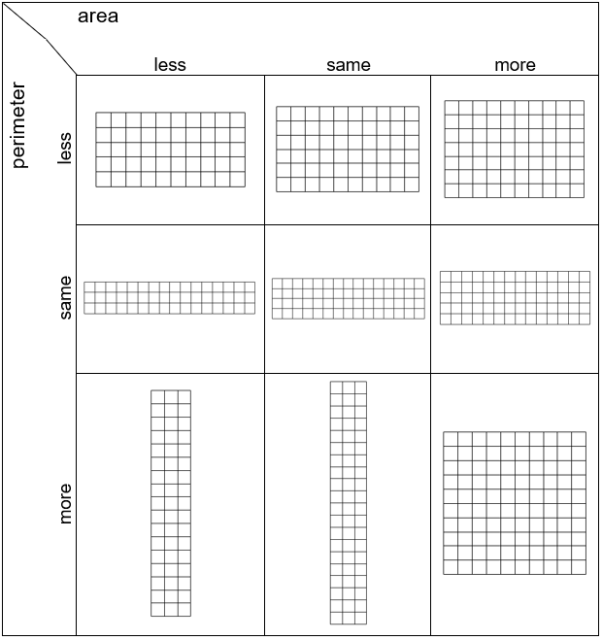

Appendix D – enough room for all
Number of tables | Largest perimeter | Smallest perimeter
1 | 4 | 4
2 | 6 | 6
3 | 8 | 8
4 | 10 | 8
5 | 12 | 10
6 | 14 | 10
7 | 16 | 12
n | $$2n+2$$

References
This resource contains NSW Curriculum and syllabus content. The NSW Curriculum is developed by the NSW Education Standards Authority. This content is prepared by NESA for and on behalf of the Crown in right of the State of New South Wales. The material is protected by Crown copyright.
Please refer to the NESA Copyright Disclaimer for more information https://educationstandards.nsw.edu.au/wps/portal/nesa/mini-footer/copyright.
NESA holds the only official and up-to-date versions of the NSW Curriculum and syllabus documents. Please visit the NSW Education Standards Authority (NESA) website https://educationstandards.nsw.edu.au/ and the NSW Curriculum website https://curriculum.nsw.edu.au/.
Mathematics K–10 Syllabus © NSW Education Standards Authority (NESA) for and on behalf of the Crown in right of the State of New South Wales, 2022.

© State of New South Wales (Department of Education), 2024
The copyright material published in this resource is subject to the Copyright Act 1968 (Cth) and is owned by the NSW Department of Education or, where indicated, by a party other than the NSW Department of Education (third-party material).
Copyright material available in this resource and owned by the NSW Department of Education is licensed under a Creative Commons Attribution 4.0 International (CC BY 4.0) license.
This license allows you to share and adapt the material for any purpose, even commercially.
Attribution should be given to © State of New South Wales (Department of Education), 2024.
Material in this resource not available under a Creative Commons license:
- the NSW Department of Education logo, other logos and trademark-protected material
- material owned by a third party that has been reproduced with permission. You will need to obtain permission from the third party to reuse its material.
Links to third-party material and websites
Please note that the provided (reading/viewing material/list/links/texts) are a suggestion only and implies no endorsement, by the New South Wales Department of Education, of any author, publisher, or book title. School principals and teachers are best placed to assess the suitability of resources that would complement the curriculum and reflect the needs and interests of their students.
If you use the links provided in this document to access a third-party's website, you acknowledge that the terms of use, including licence terms set out on the third-party's website apply to the use which may be made of the materials on that third-party website or where permitted by the Copyright Act 1968 (Cth). The department accepts no responsibility for content on third-party websites.

