Perimeter pals
Students use the concept of perimeter to delve into solving equations with pronumerals on both sides using bar models.

Visible learning

Learning intention
- To be able to solve equations with pronumerals on both sides.

Success criteria
- I can represent the perimeter of a shape as an equation.
- I can solve an equation with pronumerals on both sides.
- I can explain different ways to solve an equation with pronumerals on both sides.
- I can check my solutions to equations using substitution.

Syllabus outcomes
A student:
- develops understanding and fluency in mathematics through exploring and connecting mathematical concepts, choosing and applying mathematical techniques to solve problems, and communicating their thinking and reasoning coherently and clearly MAO-WM-01
- applies knowledge of the perimeter of plane shapes and the circumference of circles to solve problems MA4-LEN-C-01
- solves linear equations of up to 2 steps and quadratic equations of the form $ax^{2}=c$
MA4-EQU-C-01
Mathematics K–10 Syllabus © NSW Education Standards Authority (NESA) for and on behalf of the Crown in right of the State of New South Wales, 2022.

Activity structure
Please use the associated PowerPoint Perimeter pals to display images in this lesson.

Launch
- Place students in visibly random groups of 3 (bit.ly/visiblegroups) at vertical non-permanent surfaces (bit.ly/VNPSstrategy).
- Distribute Appendix A ‘Launch problem’ to each group of students and ask them to attempt the problem. The problem involves an isosceles triangle and a rectangle that share a side and the same perimeter. Students must find the length of the shared side.
Figure 1 – find the value of $x$ if the rectangle and triangle have the same perimeter
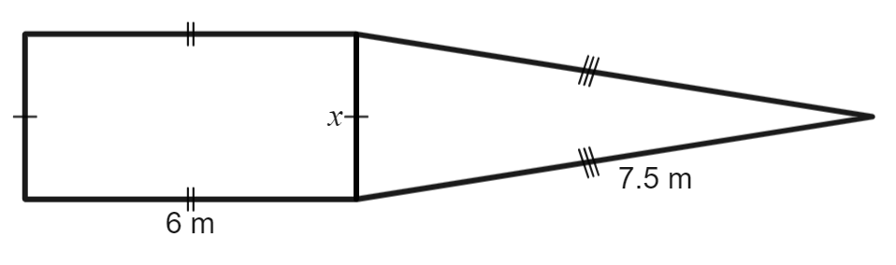
Image created using Desmos and is licensed under the Desmos Terms of Service.
- Walk around the room asking each group about their approach to the problem.
The aim of the activity is not to find the correct answer but to use it as a formative assessment opportunity to see what approaches students take to find the correct answer.

Explore
- Display slide 2 from the PowerPoint Perimeter pals. This displays an approach to the problem above using a bar model.
Figure 2 – bar model
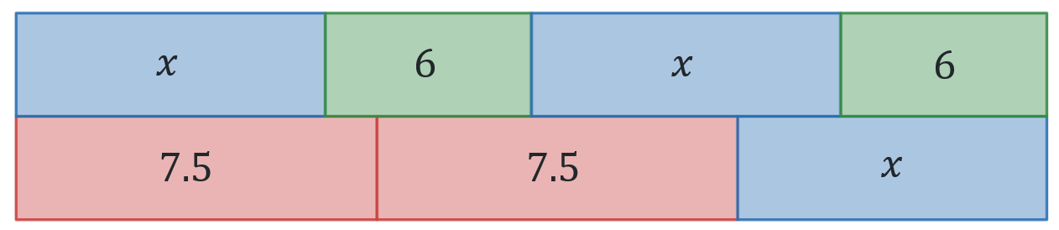
Image created using Desmos and is licensed under the Desmos Terms of Service.
- Ask students how they could redraw the bar model to make it simpler.
- In a Think-Pair-Share (bit.ly/thinkpairsharestrategy) ask students what their first step would be, if they were to solve this equation.
- Have students return to their vertical non-permanent surfaces in their groups of 3.
- Distribute Appendix B ‘Lengthy equations’ and ask students to try and find the values of the pronumerals in each question. Ask students to check their answers by substituting their answers into the initial equation.
- On a gallery walk (bit.ly/DLSgallerywalk), students are to think about if it matters if we remove constants first or the pronumerals.
- Display slide 3 from the PowerPoint Perimeter pals to show how to solve Derek’s equation from the launch both ways.
Figure 3 – solved bar models
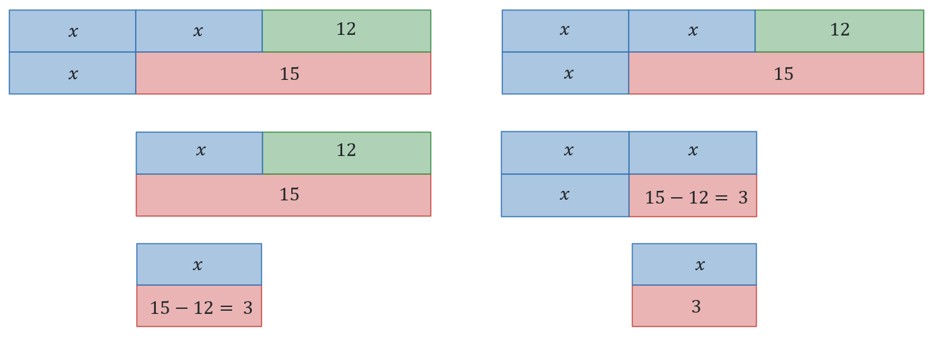
Image created using Desmos and is licensed under the Desmos Terms of Service.
- In a Think-Pair-Share, ask students why it does not matter if we deal with the constants or the pronumerals first.
This activity should show students that they can choose to simplify the constants or the terms with pronumerals first, as one step does not depend on the other.

Summarise
- Distribute Appendix C ‘Incorrect worked examples’ to individual students and have them complete.
- Individually, students are to attempt the Open Middle problem ‘Two-step equations 3’ (bit.ly/twostepequations3) to try and find the combination that gives a solution closest to zero using the numbers 1–9 to fill the boxes.
- By selecting random students, discuss the solution students found and the strategies they used to get to the solution they found.

Apply
- Issue each pair of students with a copy of Appendix D ‘Sharing sides’.
- By working in pairs, students are to try and explain each of the situations presented, justifying their responses mathematically.
- Using Pose-Pause-Pounce-Bounce (PDF 557KB) (bit.ly/posepausepouncebounce), share people reasoning and solutions to the problems.

Assessment and differentiation

Suggested opportunities for differentiation
Launch
- When discussing with students, teachers can encourage their students to think about their decisions.
Explore
- Using the same colours when changing representations can help students with how they are connected.
- Working in groups to solve problems help students with feedback from others before attempting on their own.
- Teachers can provide alternate questions that include fractions to challenge students.
Summarise
- Students can be prompted to use bar models to find the incorrect steps in Appendix C.
- Students can be grouped in twos or threes to complete the Open Middle problem.
- Extend students in the Open Middle problem by using the numbers -9 to 9.
Apply
- All students should be able to write the equation but may understand and be able to explain why they don’t work at different depths.

Suggested opportunities for assessment
Launch
- When placed in groups of 3, students provide and receive peer feedback on their understanding.
Explore
- Students will demonstrate their working mathematically skills in discussions and justifications.
Summarise
- Appendix C can be collected as evidence of learning.
- Create an exit ticket with one solution from the Open Middle problem.

Appendix A

Launch problem
An isosceles triangle and a rectangle share a side.
They also have the same perimeter.
Find the length of the shared side.

Appendix B

Lengthy equations
This activity has been modified from ‘Lengthy equations’ on the website ‘Median’ by Don Steward (bit.ly/lengthyequations).
Find the value of the pronumeral in each of the equations below.
Number | Equation
 | 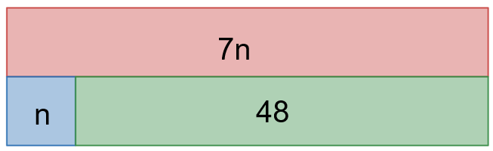
 | 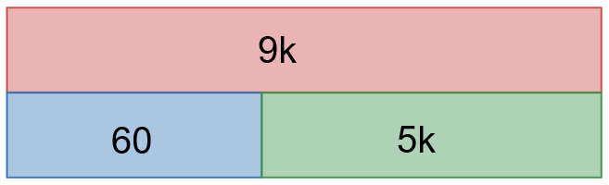
 | 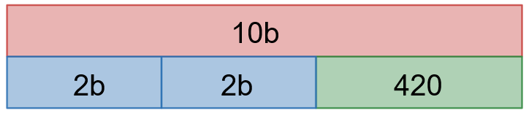
 | 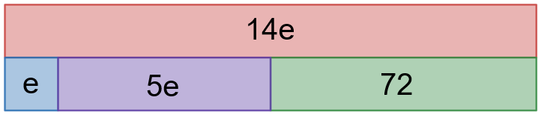
 | 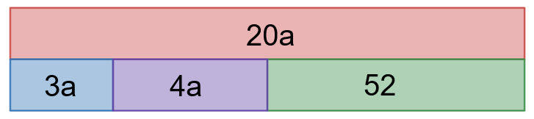
 | $$8t=3t+1005$$
 | $$4d+2.4=7d$$
 | $$5f-1005=9f$$
 | $$8c+1=5c+43$$
 | $$12p+4=7p+49$$

Appendix C

Incorrect worked examples
- Sam didn’t solve this problem correctly. Here is their working:
$$2a+5=a+7 \\ 2+5=7$$
- Why is it incorrect to remove the pronumeral when subtracting?
- Your turn: $5y+4=y+12$
- Renee didn’t solve this problem correctly. Here is her working:
$$6p+1=4p-5 \\ 2p+1=-5 \\ 2p=-4 \\ p=-2$$
- How did Renee get the value of -4? Explain what mistake she made.
- Your turn: $6n-5=5n+1$

- Shannon didn’t solve this problem correctly. Here is their working:
$$12p-3=9p-6 \\ 3p-3=-6 \\ p-3=-2 \\ p=1$$
- Explain what Shannon did incorrectly to get to line 3 of their working. Give reason why.
- Your turn: $15n-6=9n-9$

Appendix D

Sharing sides
- An isosceles triangle and a rectangle share a side. They also have the same perimeter. Explain why this situation cannot exist with these dimensions.
- These 2 shapes share a side. They also have the same perimeter. Explain why this is not enough information to find the missing side.
- These 2 shapes share a side. They also have the same perimeter. Explain why this is not true.

Sample solutions

Appendix B – lengthy equations
Find the value of the pronumeral in each of these equations.
Number | Equation with sample solutions
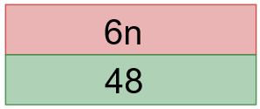
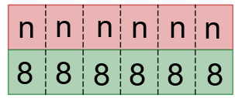
 | 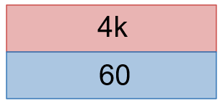
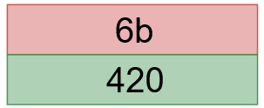
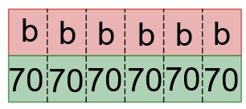
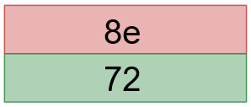
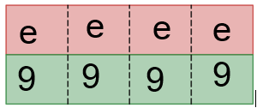
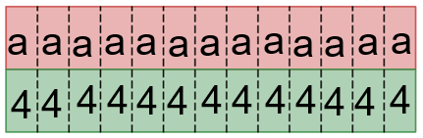
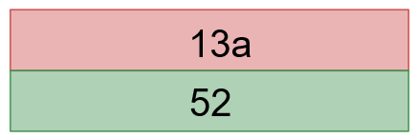
 | $$8t=3t+1005 \\ 5t=1005 \\ t=201$$
 | $$4d+2.4=7d \\ 2.4=3d \\ 0.8=d$$
 | $$5f-1005=9f \\ -1005=4f \\ -251.25=f$$
 | $$8c+1=5c+43 \\ 3c+1=43 \\ 3c=42 \\ c=14$$
 | $$12p+4=7p+49 \\ 12p=7p+45 \\ 5p=45 \\ p=9$$

Appendix C – incorrect worked examples
- Sam didn’t solve this problem correctly. Here is their working:
$$2a+5=a+7$$
$$2+5=7$$
- You can’t remove the pronumeral because if I have 2 lots of a number and take one of them away, I still have one of the number.
- Your turn: $5y+4=y+12$
$$4y+4=12 \\ 4y=8 \\ y=\frac{8}{4}=2$$
- Renee didn’t solve this problem correctly. Here is her working:
$$6p+1=4p-5$$
$$2p+1=-5$$
$$2p=-4$$
$$p=-2$$
- Renee added 1 to the -5, rather than doing the inverse which is to subtract 5.
- Your turn: $6n-5=5n+1$
$$n-5=1 \\ n=6$$

- Shannon didn’t solve this problem correctly. Here is their working:
$$12p-3=9p-6$$
$$3p-3=-6$$
$$p-3=-2$$
$$p=1$$
- Shannon divided by 3, which is incorrect. We should be doing the order of operations backwards which means we should have dealt with the -3 before dividing.
- Your turn: $15n-6=9n-9$
$$15n=9n-3 \\ 6n=-3 \\ n=-\frac{1}{2}$$

Appendix D – sharing sides
- $x+x+6+6=x+6+6$$$2x+12=x+12 \\ 2x=x \\ x=0$$
- $x+6+3+4=x+3+3.5+3.5+3$$$x+13=x+13 \\ x=x$$$x= ?$
$∴$ $x$ can be any number.
- $x+6+3+4=x+3+4+4+3$$$x+13=x+14$$$∴$ This must not be true

References
This resource contains NSW Curriculum and syllabus content. The NSW Curriculum is developed by the NSW Education Standards Authority. This content is prepared by NESA for and on behalf of the Crown in right of the State of New South Wales. The material is protected by Crown copyright.
Please refer to the NESA Copyright Disclaimer for more information https://educationstandards.nsw.edu.au/wps/portal/nesa/mini-footer/copyright.
NESA holds the only official and up-to-date versions of the NSW Curriculum and syllabus documents. Please visit the NSW Education Standards Authority (NESA) website https://educationstandards.nsw.edu.au/ and the NSW Curriculum website https://curriculum.nsw.edu.au/.
Mathematics K–10 Syllabus © NSW Education Standards Authority (NESA) for and on behalf of the Crown in right of the State of New South Wales, 2022.

© State of New South Wales (Department of Education), 2024
The copyright material published in this resource is subject to the Copyright Act 1968 (Cth) and is owned by the NSW Department of Education or, where indicated, by a party other than the NSW Department of Education (third-party material).
Copyright material available in this resource and owned by the NSW Department of Education is licensed under a Creative Commons Attribution 4.0 International (CC BY 4.0) license.
This license allows you to share and adapt the material for any purpose, even commercially.
Attribution should be given to © State of New South Wales (Department of Education), 2024.
Material in this resource not available under a Creative Commons license:
- the NSW Department of Education logo, other logos and trademark-protected material
- material owned by a third party that has been reproduced with permission. You will need to obtain permission from the third party to reuse its material.
Links to third-party material and websites
Please note that the provided (reading/viewing material/list/links/texts) are a suggestion only and implies no endorsement, by the New South Wales Department of Education, of any author, publisher, or book title. School principals and teachers are best placed to assess the suitability of resources that would complement the curriculum and reflect the needs and interests of their students.
If you use the links provided in this document to access a third-party's website, you acknowledge that the terms of use, including licence terms set out on the third-party's website apply to the use which may be made of the materials on that third-party website or where permitted by the Copyright Act 1968 (Cth). The department accepts no responsibility for content on third-party websites.

