Boundary battle
Students explore which perimeter is larger by comparing rectangles and compound shapes. Students then progress to using different strategies to find the perimeter of simple composite shapes, including those with lengths represented by pronumerals.

Visible learning

Learning intention
- To be able to find the perimeter of a simple composite shape.

Success criteria
- I can find the value of missing sides on a composite shape.
- I can calculate the perimeter of a simple composite shape.
- I can explain the different methods I can use to find the perimeter of a composite shape.

Syllabus outcomes
A student:
- develops understanding and fluency in mathematics through exploring and connecting mathematical concepts, choosing and applying mathematical techniques to solve problems, and communicating their thinking and reasoning coherently and clearly MAO-WM-01
- applies knowledge of the perimeter of plane shapes and the circumference of circles to solve problems MA4-LEN-C-01
- solves linear equations of up to 2 steps and quadratic equations of the form MA4-EQU-C-01
Mathematics K–10 Syllabus © NSW Education Standards Authority (NESA) for and on behalf of the Crown in right of the State of New South Wales, 2022.

Activity structure
Please use the associated PowerPoint Boundary battle to display images in this lesson.

Launch
- Display slide 2 from the PowerPoint Boundary battle. This slide shows 2 shapes where students need to decide which has the largest perimeter. Do not give students enough time to be able to count the squares or calculate the perimeters.
Figure 1 – perimeter comparison
- Using a finger vote, ask students to select which shape they believe has the largest perimeter.
- Select a student from each side of the vote to explain why they have selected that shape.
- Reveal that they both have the same perimeter.
The purpose of this activity is to show that even though the shapes look completely different in size both have the same perimeter of 56 units.

Explore

Finding the missing side
- Still displaying slide 2 from the PowerPoint Boundary battle, in a class discussion, ask students what features of the blue shape have led to it having a perimeter equal to that of a much larger shape. Use this to create a class conjecture, that you will decide whether is right or wrong by the end of the lesson.
A conjecture is a statement that is being proposed as possibly true based on partial evidence. It is like a hypothesis in science.
- Display slide 3 from the PowerPoint Boundary battle. State to students that this shape is known as a composite shape, as it is made by combining other plane shapes.
Figure 2 – composite shape
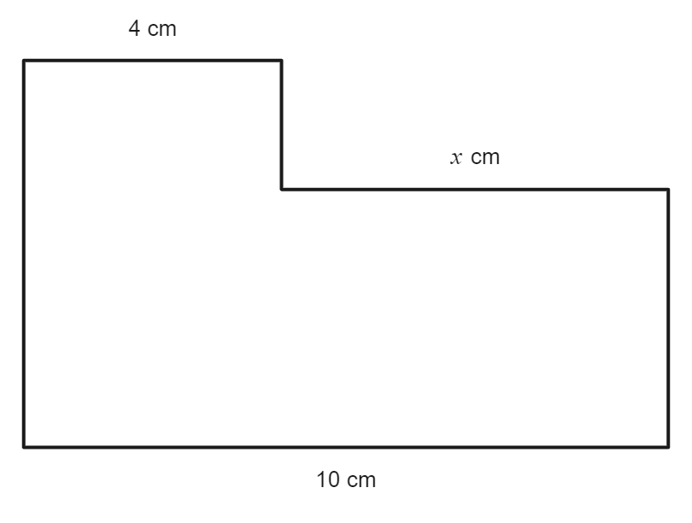
- Distribute each student a mini whiteboard (bit.ly/miniwhiteboards).
- Using the mini whiteboards, have students write down the length of the unknown side, $x$, and share their answer with the teacher.
- Display slide 4 from the PowerPoint Boundary battle. This displays a bar model used to find the value of the missing side.
Figure 3 – bar model for missing side
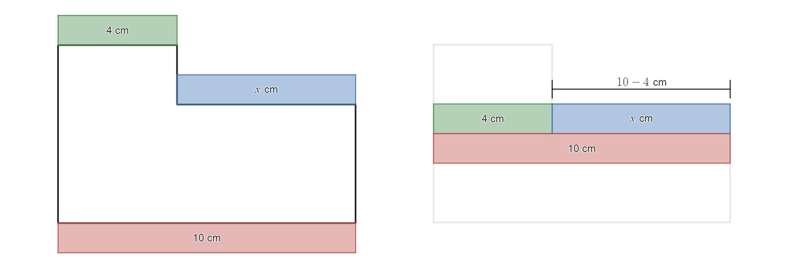
- In a Think-Pair-Share (bit.ly/thinkpairsharestrategy), ask students the following questions:
- What shapes could make up the composite shape we see?
- What do you think the question is for this diagram?
- What strategies are they using to solve it? Have we seen this elsewhere?
- Can you find the perimeter? If so, what is it?
This has assumed students have used and are familiar with bar models. Students were introduced to bar models to solve one-step equations in Lesson 3 – I see triangles of Unit 6 – triangles and quadrilaterals.
- Students should continue to use mini whiteboards to answer the Diagnostic questions (https://diagnosticquestions.com/learn) on slides 5–7 from the PowerPoint Boundary battle. Students should be given think time (bit.ly/classroomtalkmoves) before revealing their answer.
The solutions are D, A and B or C.
This is a formative assessment to see if students may need to revise inverse operations. It is suggested that if more than 10% of the class get these answers incorrect you should explain the solution to the class.
Inverse operations are first explored in Lesson 10 – inverse journeys of Unit 4 – Additive thinking –.
- Organise students into visibly random groups of 3 (bit.ly/visiblegroups) at vertical non-permanent surfaces (bit.ly/VNPSstrategy) and distribute Appendix A ‘Perimeter problems’ to groups.
- Ask students to break their shapes up into shapes they know and find and label all the missing sides, showing all their working.
- Have students do a gallery walk (bit.ly/DLSgallerywalk), where they must decide how many different strategies were used to find the missing sides and which they liked the best.
- Select random students to talk about a favourite solution they saw on the gallery walk.

Take it away
- Tell students they are now going to play a game called ‘Take it away’. In this game you are to remove a label from a side in the shape but can only take it away if you are still able to find the perimeter with the labelled lengths remaining in the diagram. The winner is the last person to remove a side label.
- Distribute the Shapes section of Appendix B ‘Take it away’, which has a collection of shapes for students to play with.
- Read the instructions aloud; these are also in Appendix B ‘Take it away’:
Play 5 games of ‘Take it away’ by following the steps below.
- Player 1 crosses out a number from one of the edges of the shape.
- Both players must agree that you could still determine the perimeter even without knowing that side length. If this is not true, the number cannot be crossed out.
- Player 2 then crosses out a number from one of the edges of the shape.
- Players take turns until no further side lengths can be removed.
- The last player to remove a side length wins.
Note: all angles in diagrams are right angles.
- Teachers should complete one game against the class to help students understand the rules.
Optional: the Desmos graph ‘Take it away animation’ (https://www.desmos.com/calculator/86jbv0m2rz) shows a game between 2 players. Select the Play button displayed below to watch the game.
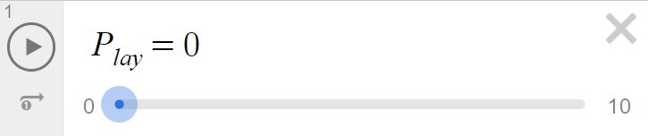
Image created using Desmos and is licensed under the Desmos Terms of Service.
- Students are to play the game in pairs. Students should play different people throughout the activity by using a strategy such as speed dating (bit.ly/strategyspeed).
- Start a class discussion about how students approached the game and what they discovered while playing.
Students should conclude that you can still find the perimeter of the shapes provided if you know:
- The length of a side that is the same as another
- That many sides add to be the same length as another.

Summarise
- Distribute Appendix C ‘What happens?’ to students. In this appendix, students must respond to the prompting questions to help articulate how to find the perimeter of shapes.
- In a Think-Pair-Share, ask students to answer the prompting questions for each scenario.
- Collect responses by selecting random students to create a class response on the board.
Students should notice that the perimeter either remains the same or it increases, even when removing area from the shape.
- Students are to decide whether the class conjecture, from the Explore section, is correct or not using evidence from the lesson. If it is not correct, they are to modify or create a new conjecture.
- Organise students into new visibly random groups of 3 and distribute Appendix D ‘More perimeter problems’ to groups. This has a collection of different compound shapes which students need to calculate the perimeter of.
- By working on vertical non-permanent surfaces (bit.ly/VNPSstrategy), have students start the activity and explain that any working that you put a circle around on their board you would like to showcase to the class and to not erase.
The teacher should be highlighting work that has come to the correct solution using different strategies.
- After groups complete at least one question each, bring them all together to do a gallery walk (bit.ly/DLSgallerywalk) of the circled solutions. Ask them to pay attention to which strategy they think is the most efficient. Ask random students, who were not in the group, to explain the approach that was taken to each solution.
- In a class discussion, have students share which method is most efficient, justifying their answers.
- Have students return to their vertical non-permanent surfaces and continue completing Appendix D.

Apply
- Display slide 8 from the PowerPoint Boundary battle and ask students how far they think it is around Australia’s coastline. This slide shows Figure 2.
Figure 2 – Australian coastline
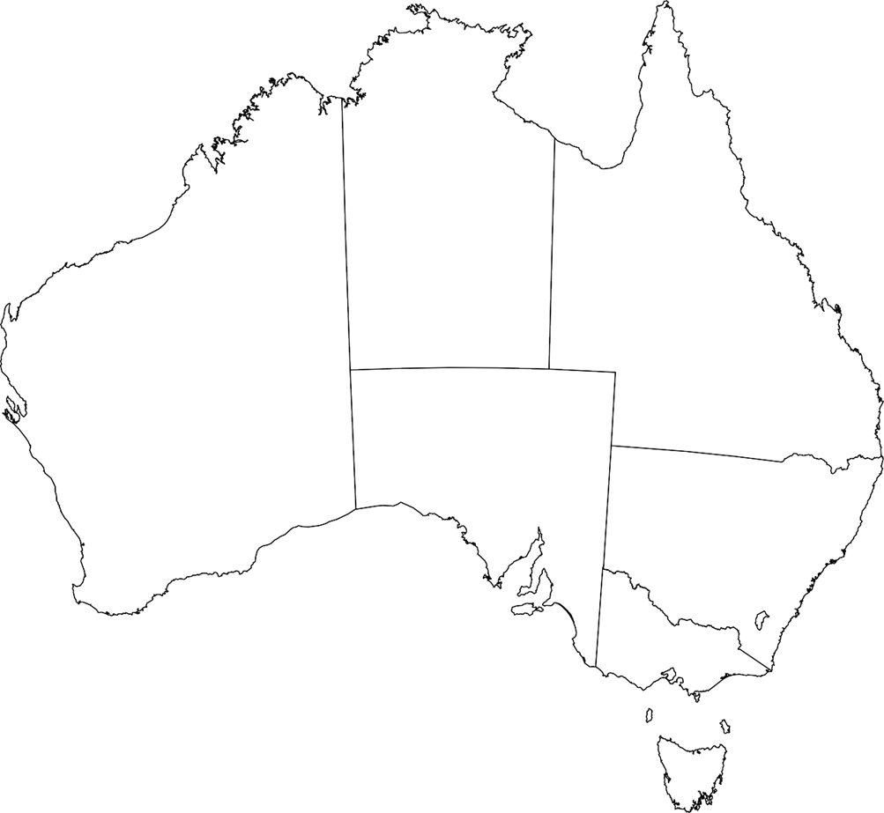
- Distribute Appendix E ‘Australian coastline estimates’. The appendix shows different estimates for the coast of Australia.
- In their groups of 3, ask students to explain why the coastline estimates would be so different, and justify their response using mathematics to support their claims.
- Groups are to share their responses with the class.
- Instruct students, on their devices, to go on Google Earth (earth.google.com). Students are to use the measuring tool to make a better estimate of the coastline of Australia. Students can pick their measurement accuracy and make assumptions using the knowledge learnt in the lesson about perimeter. Alternatively, you can give students a diagram of Australia, a ruler and scale and have them approximate the coastline of Australia.
Teachers can extend this task by asking students to estimate what would happen to the coastline of Australia when oceans rise around Australia. You can use the Geoscience Australia Terria Map website (https://maps.dea.ga.gov.au/story/DEACoastlines) to help students with their response.

Assessment and differentiation

Suggested opportunities for differentiation
Explore
- Students can use everyday language to create their conjectures before using mathematical terminology.
- Students should be encouraged to use visual representations such as a bar model to solve equations to find missing sides.
- If students find it difficult to add numbers mentally, they can be allowed to use a calculator to find the perimeter.
- Challenge students to decide whether it is better to go first or second in the game ‘Take it away’ and to justify their choice.
Summarise
- All students should be able to notice the shape maintains perimeter or increases perimeter but may explain why at different depths.
- Shapes in Appendix D may need to be completed as a whole class.
Apply
- There are no correct answers during the Apply activities and all students should be encouraged to participate and share their thoughts and reasoning.
- Students can be encouraged to extend their mathematical knowledge into fractals.
- Students should be challenged to make connections with prior knowledge they have.
- Location can be modified to connect with other key learning areas or student context.

Suggested opportunities for assessment
Explore/Summarise
- Appendix A and D could be collected and used to show the progression of learning of students.
- Monitor responses in class and group discussions to check for student understanding of strategies to find the perimeter of composite shapes.
- Students will demonstrate their working mathematically skills in discussions and justifications.
Apply
- Students will demonstrate their connection of mathematical content to the real world in discussions and justifications.

Appendix A

Perimeter problems
Find the perimeter of the following shapes. All angles in the shapes are right angles (diagrams are not to scale).
Shape | Perimeter
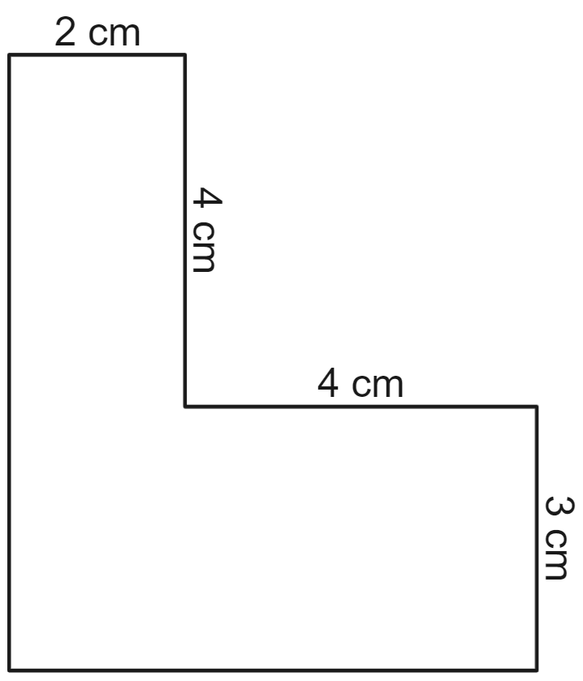
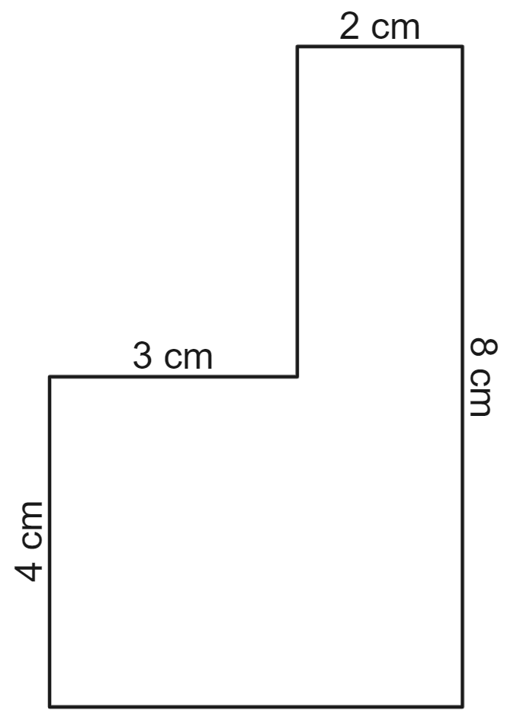
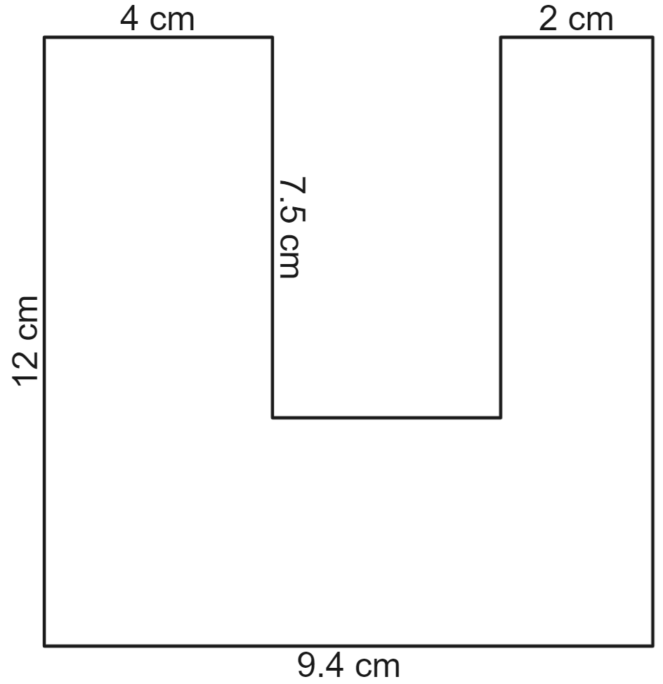
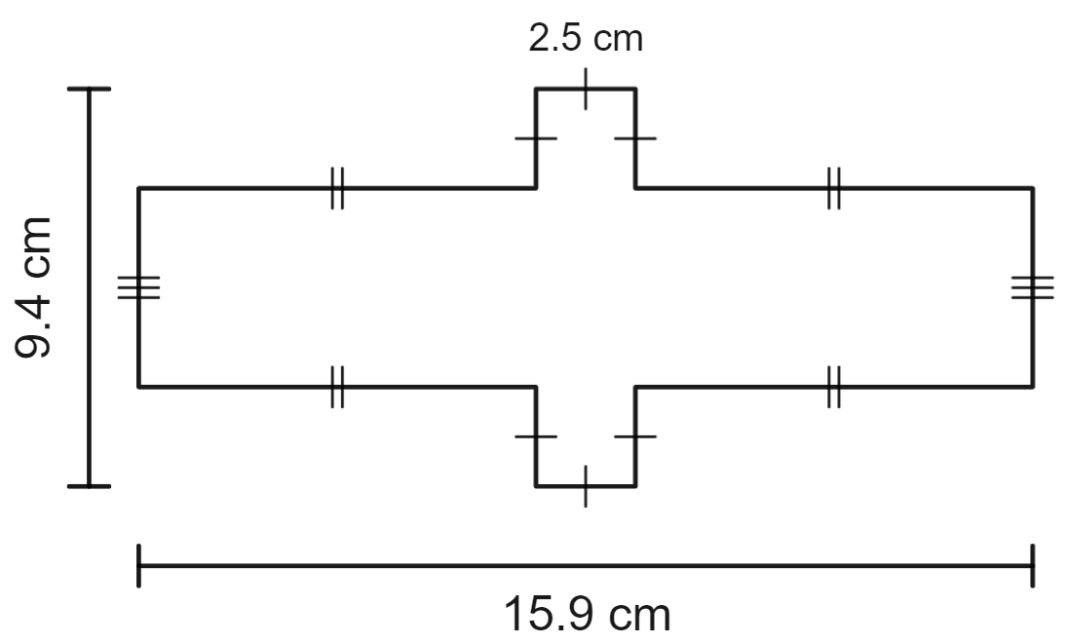

Appendix B

Take it away

Shapes
Play 5 games of ‘Take it away’ by following the steps below.
- Player 1 crosses out a number from one of the edges of the shape.
- Both players must agree that you could still determine the perimeter even without knowing that side length. If this is not true, the number cannot be crossed out.
- Player 2 then crosses out a number from one of the edges of the shape.
- Players take turns until no further side lengths can be removed.
- The last player to remove a side length wins.
Note: all angles in diagrams are right angles.

Game 1
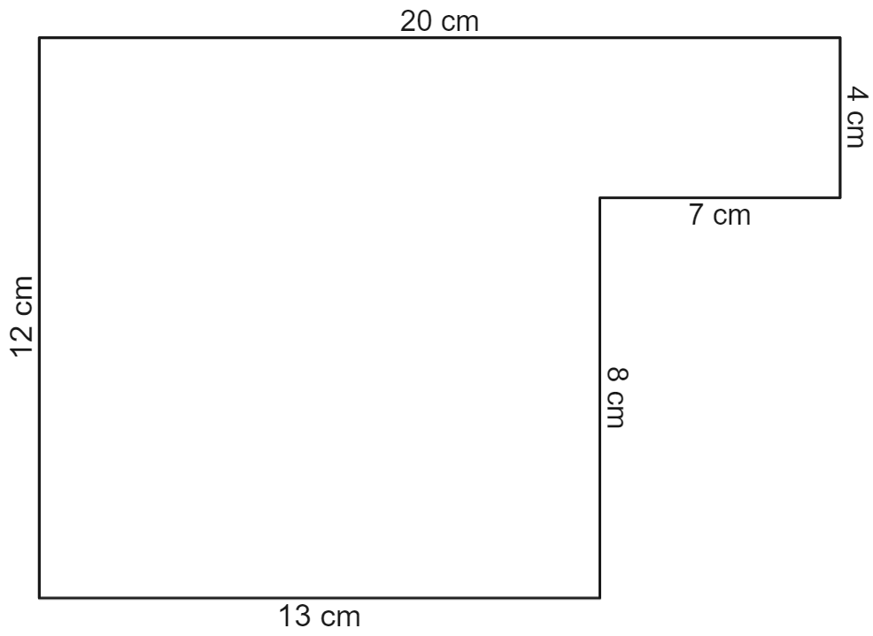

Game 2
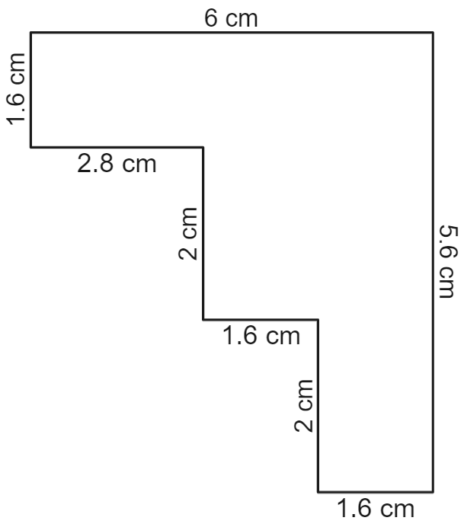

Game 3
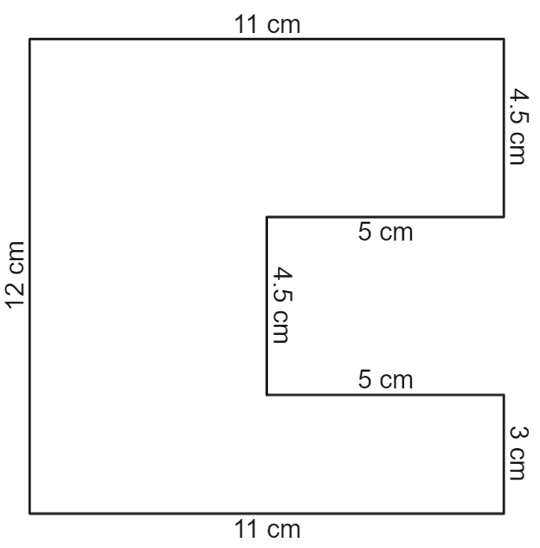

Game 4
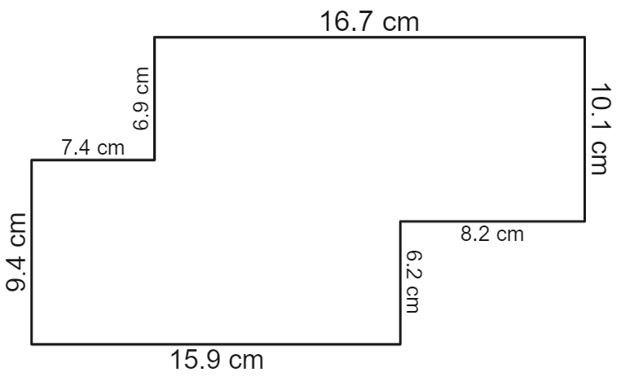

Game 5
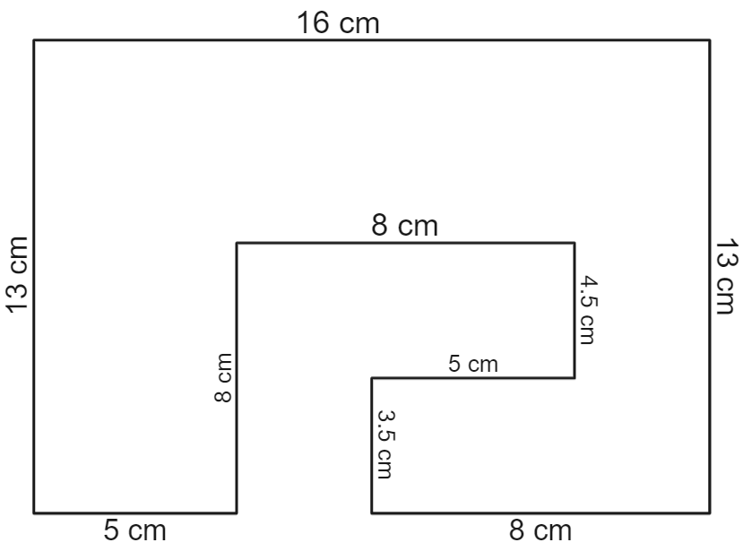

Appendix C

What happens
- What happens to the perimeter when you take a bite out of it?
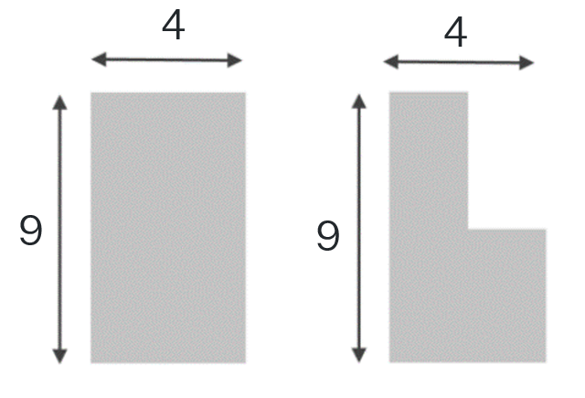
- What happens to the perimeter when you add another shape onto a corner?
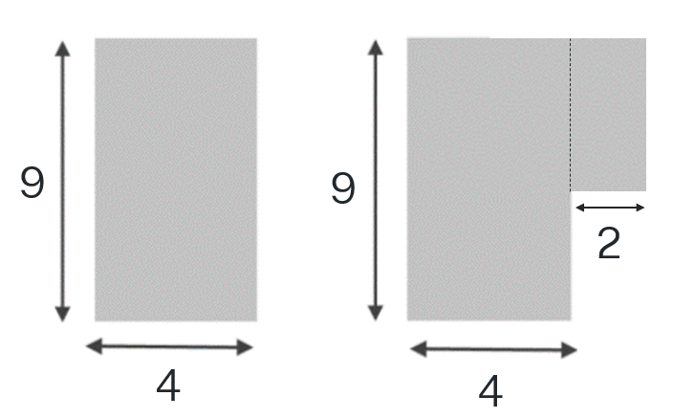
- What happens to the perimeter when you add another shape onto a side?
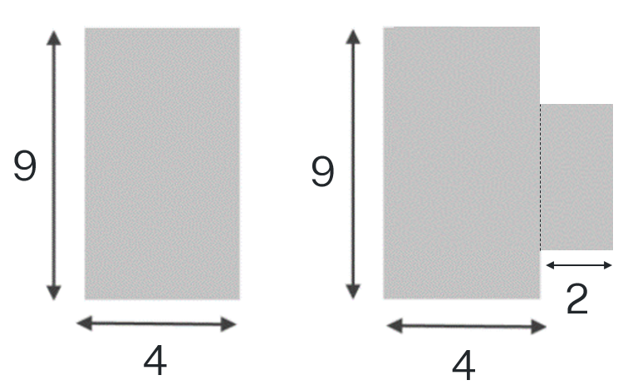

- What happens to the perimeter when the bite is in the middle of the shape?
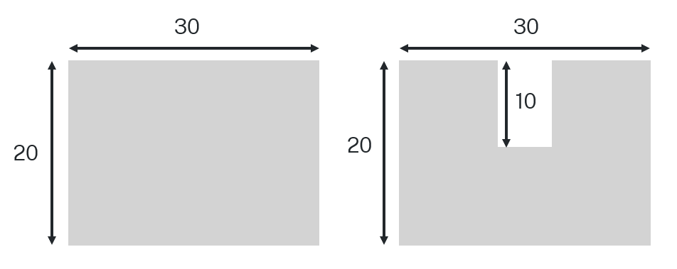

Appendix D

More perimeter problems
Find the perimeter of each shape. All angles in the shapes provided are right angles (diagrams are not to scale).
Shape | Perimeter
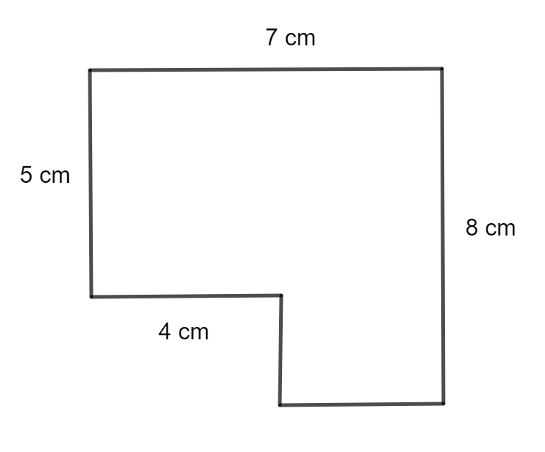
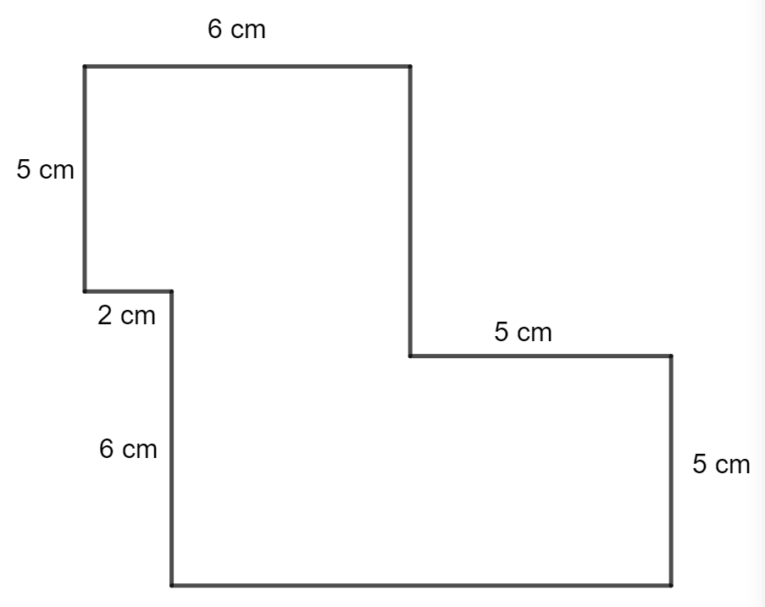
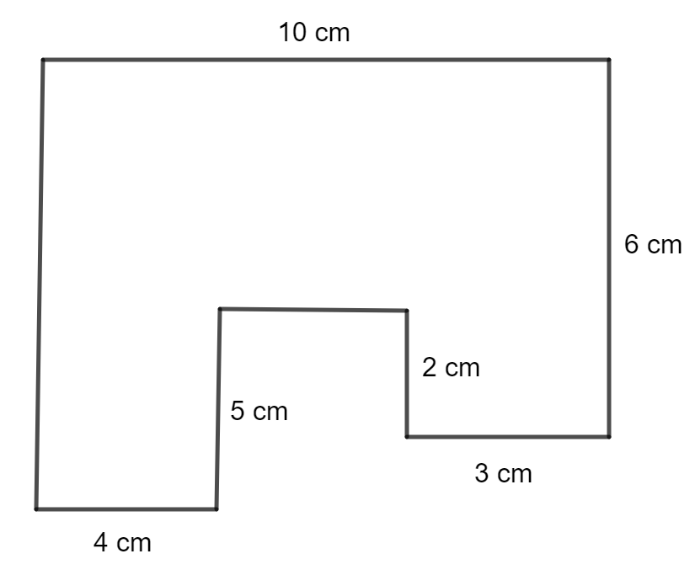
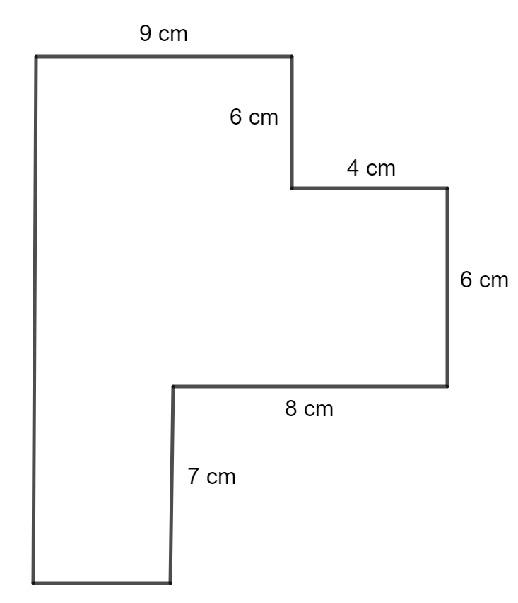
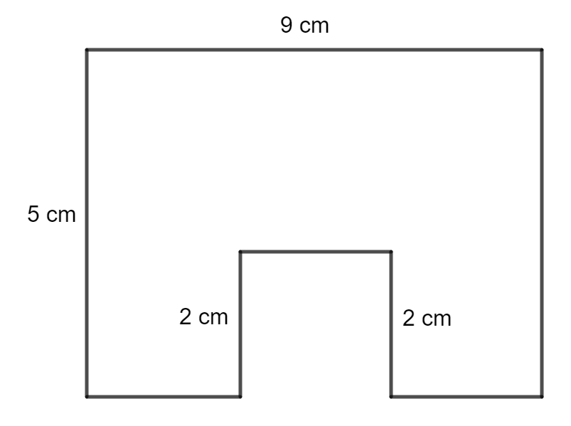
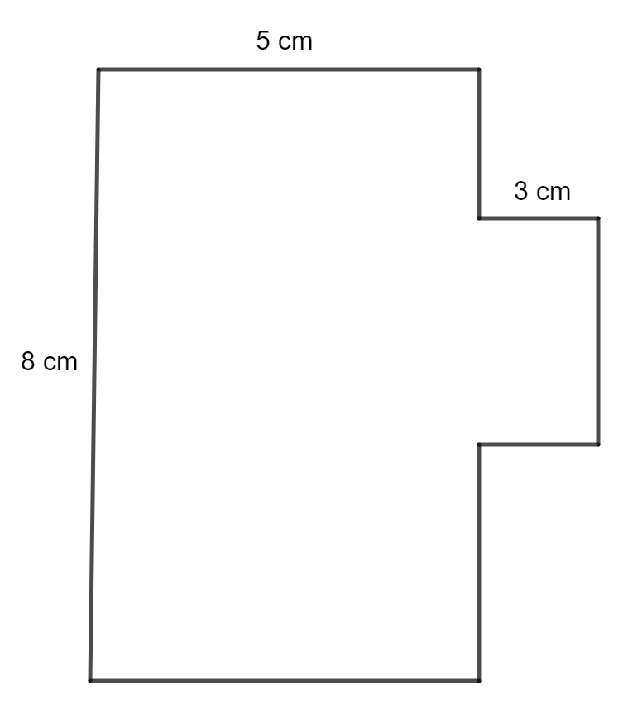
This activity has been modified from MEDIAN Don Steward mathematics teaching: harder perimeter.

Appendix E

Australian coastline estimates
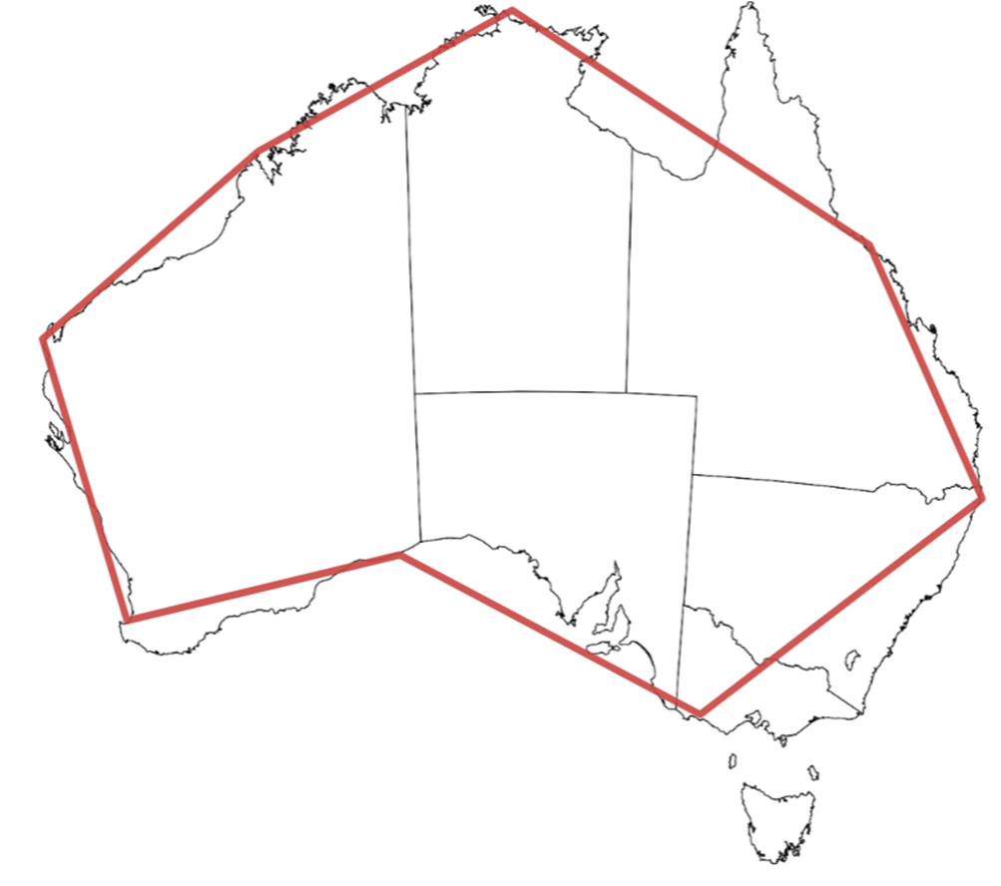 | 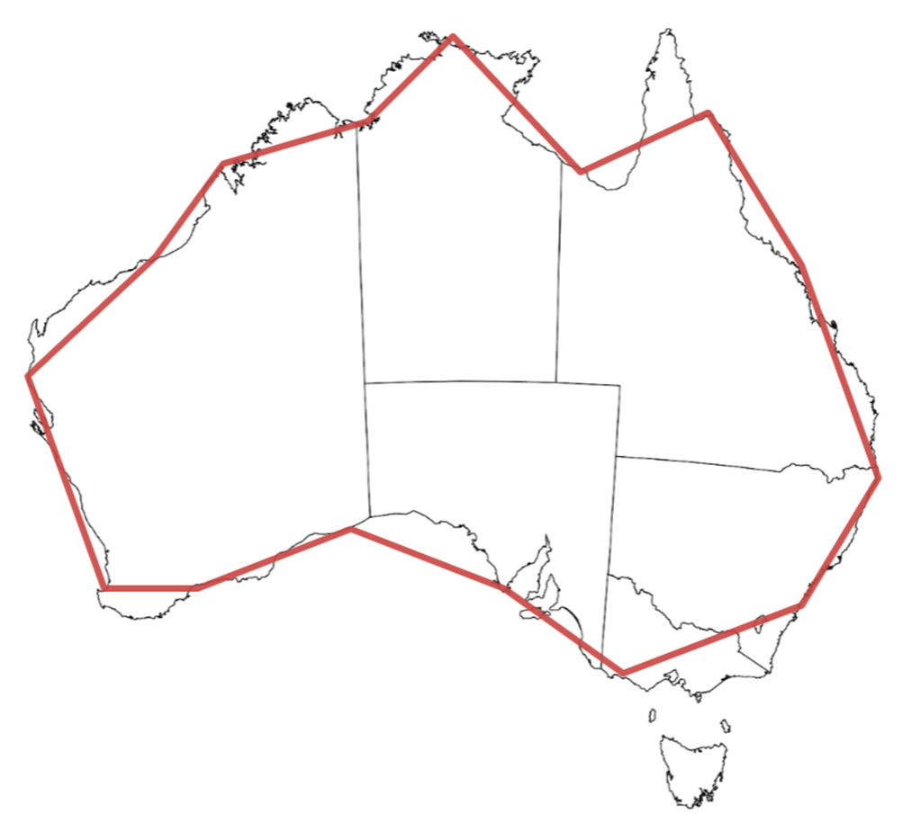 | 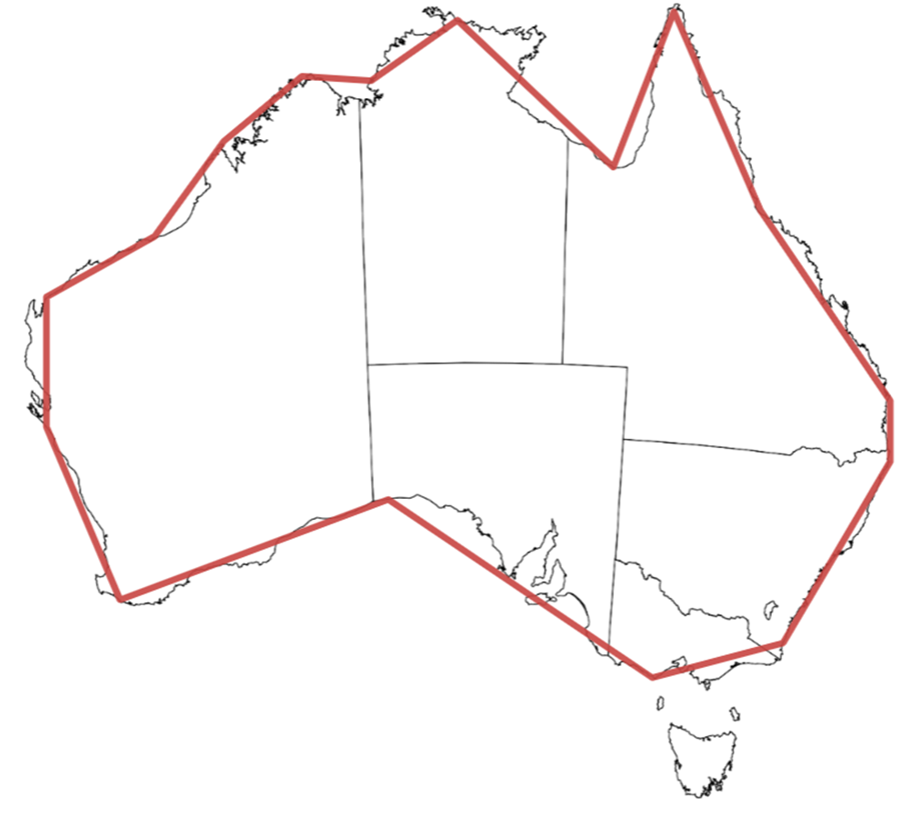
Measured in increments of 1400 km.  Coastline is approximately 10800 km. | Measured in increments of 700 km.  Coastline is approximately 11300 km. | Measured in increments of 500 km.  Coastline is approximately 12500 km.

Sample solutions

Appendix A – perimeter problems
Shape | Perimeter
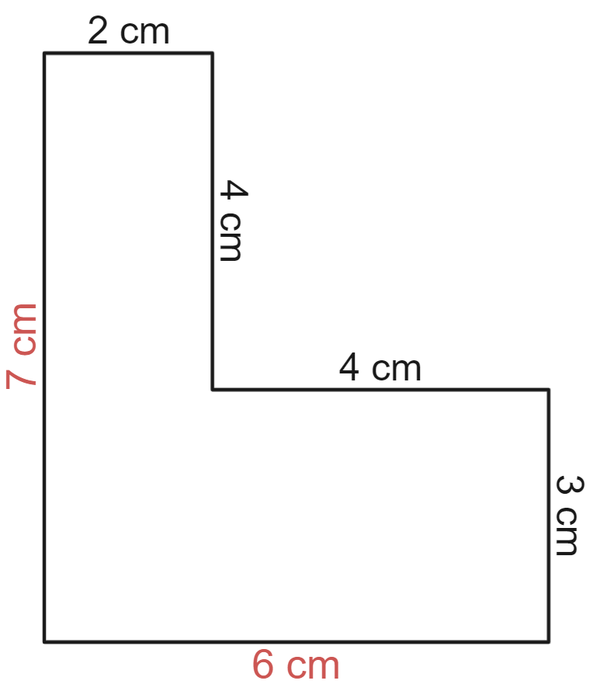 | $$P=2+4+4+3+6+7 \\ =26 cm$$
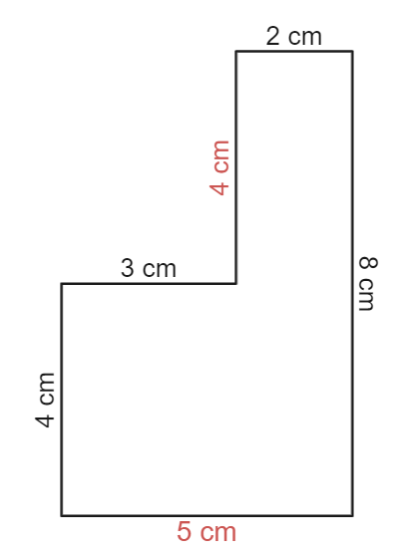 | $$P=3+4+2+8+5+4 \\ =26 cm$$
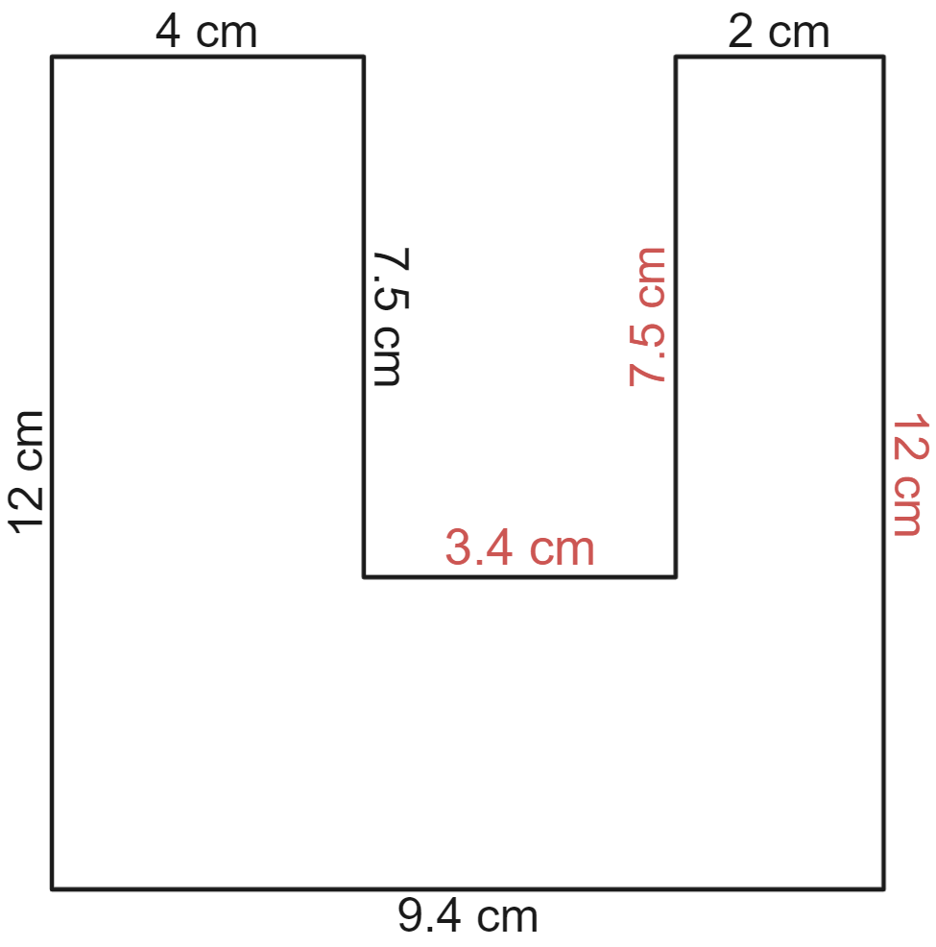 | $$P=12+4+7.5+3.4+7.5+2+12+9.4 \\ =57.8 cm$$
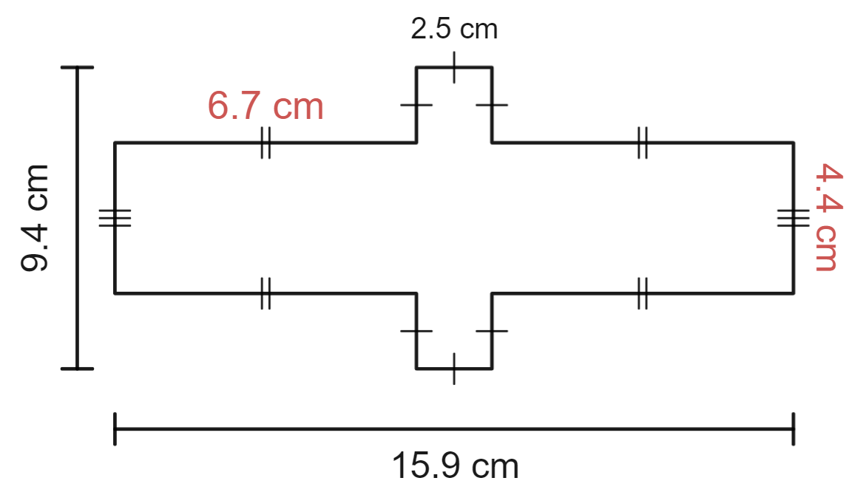  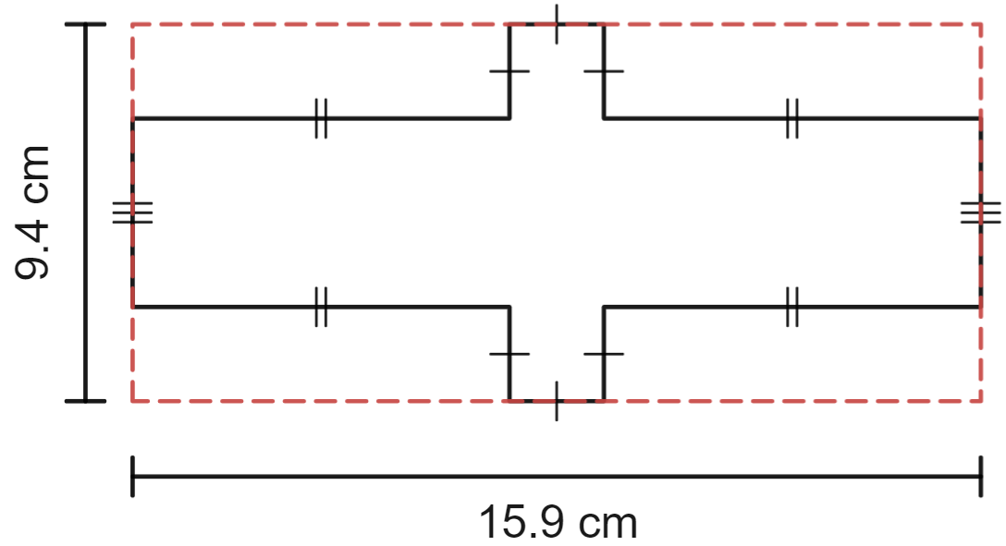 | $$P=4.4+6.7+2.5+2.5+2.5+6.7+4.4+6.7+2.5+2.5+2.5+6.7 \\ =50.6 cm$$  Alternatively, students may recognise that the perimeter can be found by extending out the sections cut from the corners.  In this case, the perimeter can be calculated as $P=2×9.4+2×15.9=50.6 cm$

Appendix D – more perimeter problems
Find the perimeter of each shape. All angles in the shapes provided are right angles (diagrams are not to scale).
Shape | Perimeter
 | $$P=7+8+3+3+4+5 \\ =30 cm$$
 | $$P=11+11+11+11 \\ =44 cm$$
 | $$P=10+6+3+2+3+5+4+9 \\ =42 cm$$
 | $$P=2×\left(9+4\right)+2×\left(6+6+7\right) \\ =26+38 \\ =64 cm$$
 | $$P=9+5+9+5+2+2 \\ =32 cm$$
 | $$P=8+8+8+8 \\ =32 cm$$

References
This resource contains NSW Curriculum and syllabus content. The NSW Curriculum is developed by the NSW Education Standards Authority. This content is prepared by NESA for and on behalf of the Crown in right of the State of New South Wales. The material is protected by Crown copyright.
Please refer to the NESA Copyright Disclaimer for more information. https://educationstandards.nsw.edu.au/wps/portal/nesa/mini-footer/copyright
NESA holds the only official and up-to-date versions of the NSW Curriculum and syllabus documents. Please visit the NSW Education Standards Authority (NESA) website https://educationstandards.nsw.edu.au/wps/portal/nesa/home and the NSW Curriculum website https://curriculum.nsw.edu.au.
Mathematics K–10 Syllabus © NSW Education Standards Authority (NESA) for and on behalf of the Crown in right of the State of New South Wales, 2022.

© State of New South Wales (Department of Education), 2024
The copyright material published in this resource is subject to the Copyright Act 1968 (Cth) and is owned by the NSW Department of Education or, where indicated, by a party other than the NSW Department of Education (third-party material).
Copyright material available in this resource and owned by the NSW Department of Education is licensed under a Creative Commons Attribution 4.0 International (CC BY 4.0) license.
This license allows you to share and adapt the material for any purpose, even commercially.
Attribution should be given to © State of New South Wales (Department of Education), 2024.
Material in this resource not available under a Creative Commons license:
- the NSW Department of Education logo, other logos and trademark-protected material
- material owned by a third party that has been reproduced with permission. You will need to obtain permission from the third party to reuse its material.
Links to third-party material and websites
Please note that the provided (reading/viewing material/list/links/texts) are a suggestion only and implies no endorsement, by the New South Wales Department of Education, of any author, publisher, or book title. School principals and teachers are best placed to assess the suitability of resources that would complement the curriculum and reflect the needs and interests of their students.
If you use the links provided in this document to access a third-party's website, you acknowledge that the terms of use, including licence terms set out on the third-party's website apply to the use which may be made of the materials on that third-party website or where permitted by the Copyright Act 1968 (Cth). The department accepts no responsibility for content on third-party websites.

