Express yourself
Students explore finding the perimeter of shapes whose sides are represented by variables.

Visible learning

Learning intentions
- To be able to solve problems involving perimeter.
- To be able to simplify algebraic expressions.

Success criteria
- I can create an expression for the perimeter of a shape.
- I can substitute values into an expression.
- I can justify the most efficient way to solve a problem.

Syllabus outcomes
A student:
- develops understanding and fluency in mathematics through exploring and connecting mathematical concepts, choosing and applying mathematical techniques to solve problems, and communicating their thinking and reasoning coherently and clearly MAO-WM-01
- applies knowledge of the perimeter of plane shapes and the circumference of circles to solve problems MA4-LEN-C-01
- generalises number properties to operate with algebraic expressions including expansion and factorisation MA4-ALG-C-01
Mathematics K–10 Syllabus © NSW Education Standards Authority (NESA) for and on behalf of the Crown in right of the State of New South Wales, 2022.

Activity structure
Please use the associated PowerPoint Express yourself to display images in this lesson.

Launch
- In a Think-Pair-Share (bit.ly/thinkpairsharestrategy) ask students to attempt to answer the following question. Use slide 2 from the PowerPoint Express yourself to display the story and read it aloud:
Photos come in standard ratios. A framing factory wants to build a computer program to quickly calculate the length of wood required for their frames. To achieve this, we need to be able to explain how to calculate the perimeter in the shortest way possible. What is the best way we can describe the perimeter of a frame?
The purpose of this activity is not for students to find the correct answer but to understand the need and benefit for a variable to represent the lengths.
- Ask students questions to further their thinking. Question suggestions are included below.
- What shape is a photo? What do we already know about that shape?
- What can we name something if we aren’t sure of its value?
- How do the corners meet? What edge of the frame would you need to go off for the length? Is that longer or shorter than the original photo?
- Initiate a sharing of ideas and reasoning using the Pose-Pause-Pounce-Bounce question strategy (PDF 557KB) (bit.ly/posepausepouncebounce).

Explore
- Display the following image of 2 squares, one with lengths, the other with a variable and each with expressions to find the perimeter. This can be found on slide 3 from the PowerPoint Express yourself.
Figure 1 – perimeter expressions
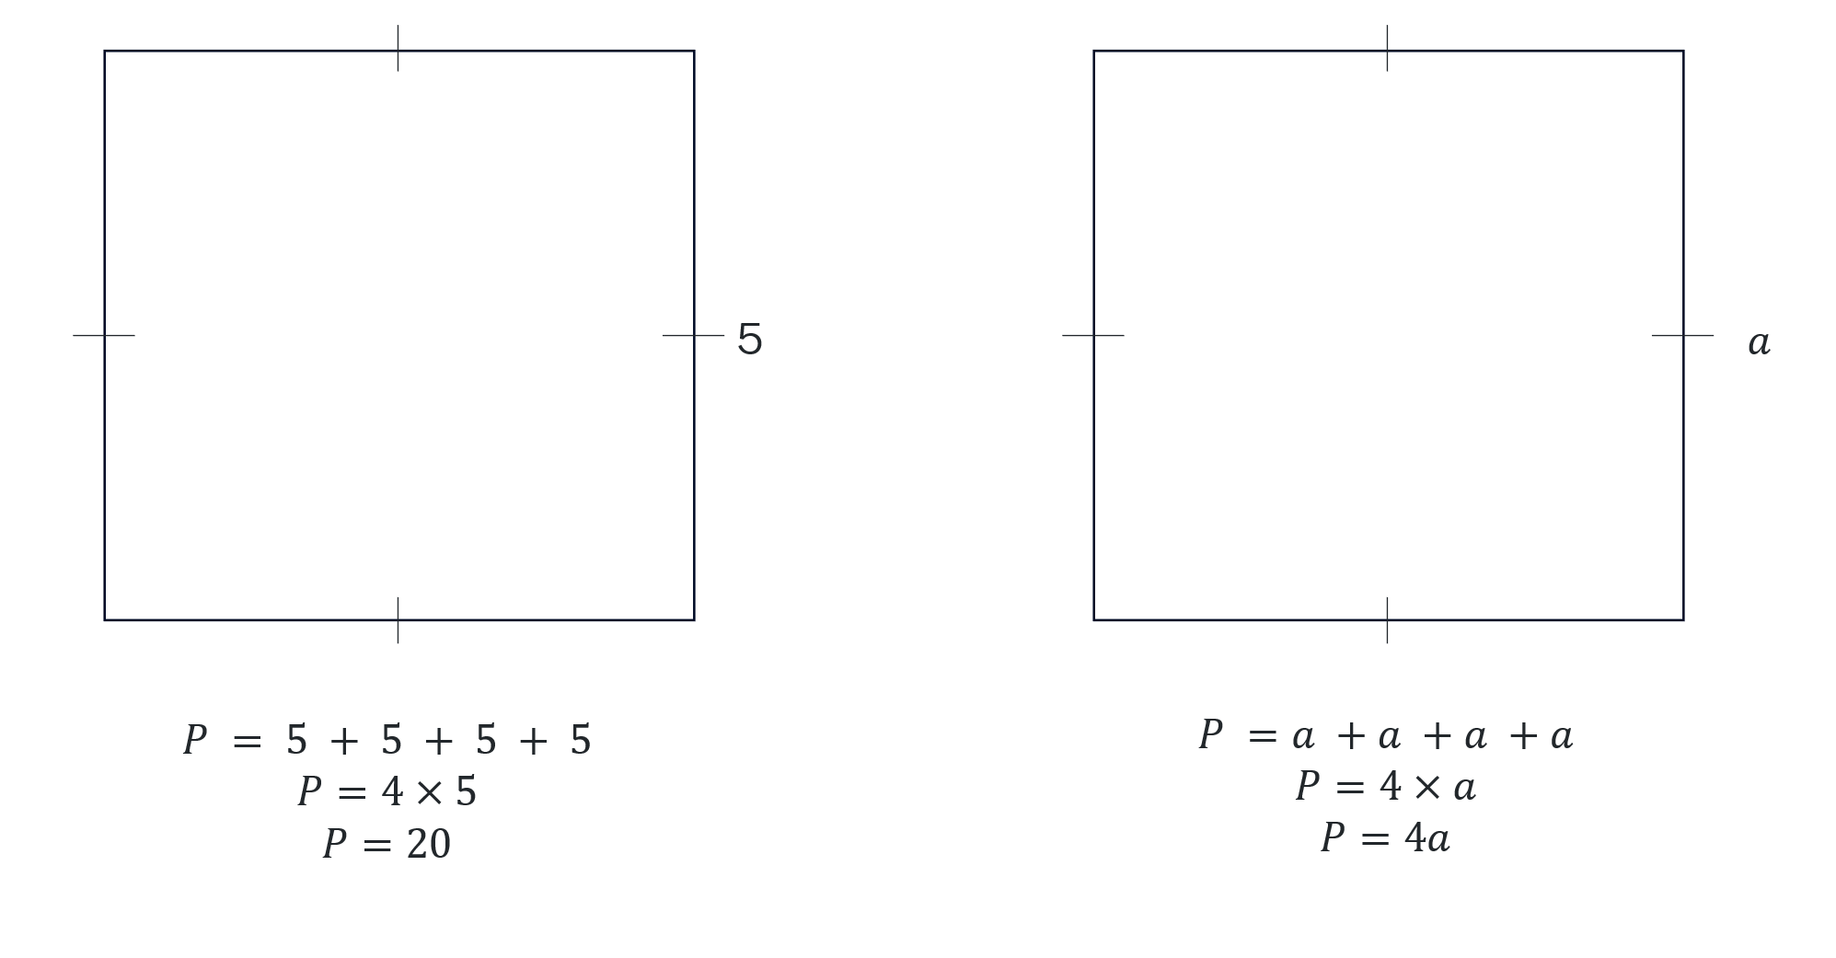
- Ask students to consider what they notice and what they wonder (bit.ly/noticewonderstrategy) about the shapes.
- Initiate a sharing of ideas and reasoning using the Pose-Pause-Pounce-Bounce question strategy.
- Explain to students that when given a generic shape we can create an expression to find the perimeter. Using variables means we can replace the values of the lengths with variables that suit our problem.
- Display slide 4 from the PowerPoint Express yourself and ask students to write an expression for the perimeter of the parallelogram.
Figure 2 – parallelogram
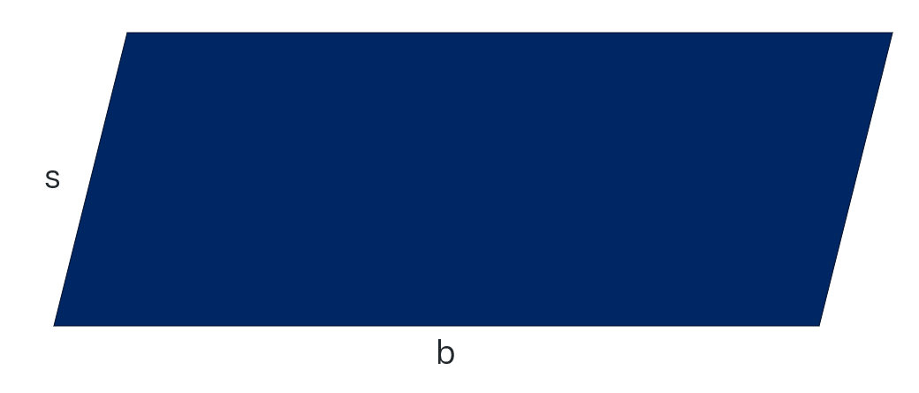
Teachers may wish to acknowledge that the variables s and b have been chosen to represent the ‘slant height’ and the ‘base length’ respectively.
- Have students check their response with the person next to them.
- Reveal the solutions to the class as: $s+b+s+b, s+s+b+b,$ $2s + 2b.$ Have students compare the different expressions for equivalence and ease of use in terms of finding the perimeter.
- In a Think-Pair-Share (bit.ly/thinkpairsharestrategy), using the scenario from the launch, ask students, ‘If we know the dimensions of the picture we want framed, how can we use this expression to find the perimeter?’
- Hand each student a copy of Appendix A ‘Expressing perimeters’.
- Still in their pairs, have students complete the worksheet.
- Lead a discussion of answers, selecting non-volunteers to share their responses.
- Organise students into visibly random groups of 3 (bit.ly/visiblegroups) and move to vertical non-permanent surfaces (bit.ly/VNPSstrategy).
- Distribute Appendix B ‘Spot the difference’ to groups. This worksheet contains shapes where students simplify and match expressions that represent the perimeter of shapes, and substitute in values to evaluate a result.
In this activity there are some expressions that when you substitute in the values stated they give the same result but have different simplified expressions. At an appropriate time in the activity, teachers should prompt students to consider the simplified expressions for perimeter as a factor for deciding which one doesn’t belong.
It is assumed that students can simplify expressions with like terms. If students are not proficient, then take this opportunity to explore the concept again by referring to Lesson 11 – stepping into the unknowns of Unit 4 – additive thinking .
- Students are to justify in their groups what is the most efficient way to find which shape doesn’t belong in each set.
- Initiate a sharing of ideas and reasoning using the Pose-Pause-Pounce-Bounce question strategy to explore how students selected which shape didn’t belong.

Summarise
- Students are to create notes to their future forgetful selves (bit.ly/notesstrategy) on creating expressions and substituting values into expressions.
- Distribute Appendix C ‘Make my shape’ to students. Individually, on blank paper, students are to draw shapes that would create the expressions listed.
- Instruct students they are to select their favourite shape they created. This shape, and associated working, is to be submitted as an exit ticket.

Apply
- By working in visibly random groups of 3 on vertical non-permanent surfaces students are to complete the NRICH activity ‘Perimeter expressions’ (https://nrich.maths.org/perimeterexpressions).
- As students work, match up groups who have found different answers and state ‘At least one of you are incorrect.’ Leave groups to debate and justify which answer is correct.
- Go on a gallery walk (bit.ly/DLSgallerywalk) of attempted solutions. Ask students to pay attention to different strategies used to attempt to solve the problem or ones different to what they tried.
- Ask random students to share their favourite strategy from the gallery walk with the class.

Assessment and differentiation

Suggested opportunities for differentiation
Launch
- To enable students, you can bring in or give dimensions for different sized photos.
- Challenge students to decide which variables would be best to use in this situation and to justify their choice.
- Students could write a computer code, potentially in a spreadsheet, that represents the situation.
Explore
- A notice and wonder strategy is used where there is no correct answer, so that all students can participate in the discussion.
- Challenge students to discuss which variables would be best to use in this situation and to justify their choice.
- If students find it difficult to add numbers mentally, they can be allowed to use a calculator to help them find the perimeter.
- Students should be challenged to make connections with prior knowledge such as simplifying algebra.
Summarise
- Challenge students to create as many shapes as possible and justify what shapes it is easiest to make shapes for.
- To enable students, have them complete the activity in random groups of 3.

Suggested opportunities for assessment
Launch
- Use assessing questions to have students explain and justify their work.
Explore
- Monitor responses when sharing solutions to check for student understanding of creating expressions and substituting in values.
Summarise
- Review students’ notes to future forgetful selves.
- Collect exit tickets from students’ favourite shape created from Appendix C ‘Make my shape’.
Apply
- Students will demonstrate their working mathematically skills in discussions and justifications.
- Teachers could ask students to explain and justify their strategy.

Appendix A

Expressing perimeters
Write an expression for the perimeter of each shape in the table below. For some problems, you will need to name sides yourself using pronumerals.
Shape | Expression
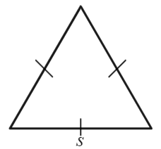
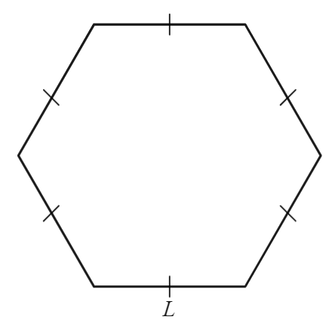
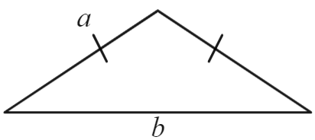
A rectangle where the length is one more than the width. (Hint: draw a diagram first)
A scalene triangle where the length of one side is double the length of another side. (Hint: draw a diagram first)

Appendix B

Spot the difference
Find the shape that doesn’t belong in each set by substituting in the value given.
- Consider the following 3 rectangles (diagrams not to scale).
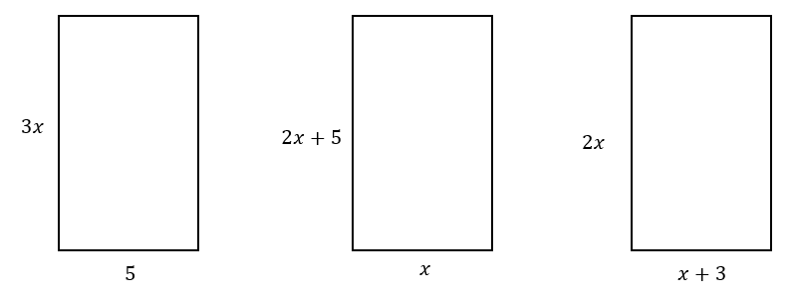
- Evaluate the perimeter when $x=2$.
- State the odd one out. Justify why.
- Consider the following 3 triangles (diagrams not to scale).
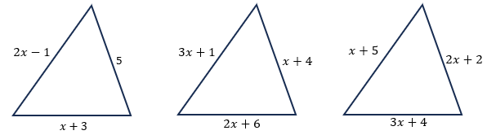
- Evaluate the perimeter when $x=6.$
- State the odd one out. Justify why.

- Consider the following 3 isosceles trapeziums (diagrams not to scale).
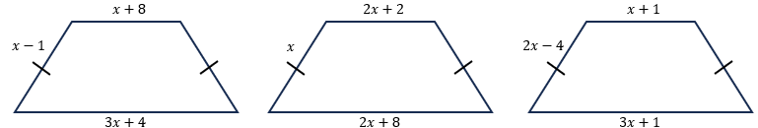
- Evaluate the perimeter when $x=8$.
- Find the odd one out. Justify why.
- Consider the following 3 quadrilaterals (diagrams not to scale).
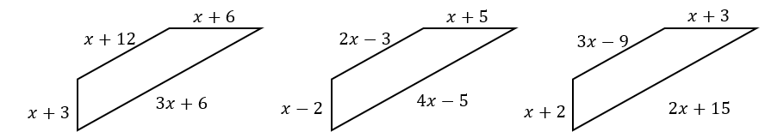
- Evaluate the perimeter when $x=16$.
- State the odd one out. Justify why.

Appendix C

Make my shape
Create as many shapes as you can so that the perimeter would simplify to any of the following expressions.
- Perimeter is 8a
- Perimeter is 4k + 2
- Perimeter is 9a + 3b
- Perimeter is 5r + 2t + 4
- Perimeter is 4a - 12c
- Perimeter is 3h + 5q + 7

Sample solutions

Appendix A – expressing perimeters
Shape | Expression
 | $$P=s+s+s=3s$$
 | $$P=L+L+L+L+L+L=6L$$
 | $$P=a+a+b=2a+b$$
A rectangle where the length is one more than the width. | $$P=w+\left(w+1\right)+w+(w+1)=4w+2$$
A scalene triangle where the length of one side is double the length of another side. | $$P=a+2a+b=3a+b$$  (Could also be $a+3b$)

Appendix B – spot the difference
- Rectangles
- 22 units, 22 units and 18 units.
- The third shape doesn’t belong as it gives a different result when we evaluate $x=2$.
- Triangle $2x-1$, $5$ and $x+3$
- 25 units, 47 units and 47 units.
- The first shape doesn’t belong as it gives a different result when we evaluate $x=6$.
- Trapezium
- 58 units, 58 units and 58 units.
- The odd shape out is the third shape as when we simplify their expressions to find the perimeter, the third shape has an expression of $8x-6 ,$ where the other 2 shapes have an expression of $6x+10$.
- Quadrilateral
- 123 units, 123 units and 123 units.
- The expressions for perimeter of the shapes simplify to be $6x+27$, $8x-5$, and $7x+11$. So, I believe the odd one out is the second shape as we subtract a constant from the expression and the others add.

Appendix C – make my shape
Possible solutions include the shapes below. Other shapes are possible.
Question | Sample answer
 | 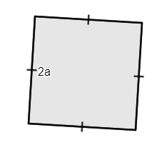
 | 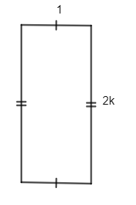
 | 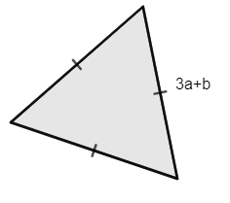
 | 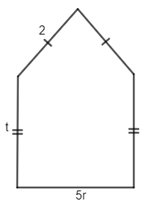
 | 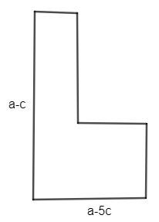
 | 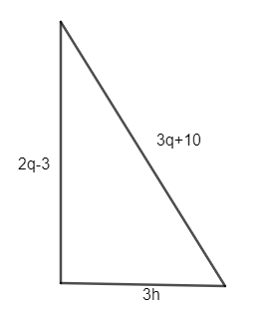

References
This resource contains NSW Curriculum and syllabus content. The NSW Curriculum is developed by the NSW Education Standards Authority. This content is prepared by NESA for and on behalf of the Crown in right of the State of New South Wales. The material is protected by Crown copyright.
Please refer to the NESA Copyright Disclaimer for more information https://educationstandards.nsw.edu.au/wps/portal/nesa/mini-footer/copyright.
NESA holds the only official and up-to-date versions of the NSW Curriculum and syllabus documents. Please visit the NSW Education Standards Authority (NESA) website https://educationstandards.nsw.edu.au/ and the NSW Curriculum website https://curriculum.nsw.edu.au/.
Mathematics K–10 Syllabus © NSW Education Standards Authority (NESA) for and on behalf of the Crown in right of the State of New South Wales, 2022.

© State of New South Wales (Department of Education), 2024
The copyright material published in this resource is subject to the Copyright Act 1968 (Cth) and is owned by the NSW Department of Education or, where indicated, by a party other than the NSW Department of Education (third-party material).
Copyright material available in this resource and owned by the NSW Department of Education is licensed under a Creative Commons Attribution 4.0 International (CC BY 4.0) license.
This license allows you to share and adapt the material for any purpose, even commercially.
Attribution should be given to © State of New South Wales (Department of Education), 2024.
Material in this resource not available under a Creative Commons license:
- the NSW Department of Education logo, other logos and trademark-protected material
- material owned by a third party that has been reproduced with permission. You will need to obtain permission from the third party to reuse its material.
Links to third-party material and websites
Please note that the provided (reading/viewing material/list/links/texts) are a suggestion only and implies no endorsement, by the New South Wales Department of Education, of any author, publisher, or book title. School principals and teachers are best placed to assess the suitability of resources that would complement the curriculum and reflect the needs and interests of their students.
If you use the links provided in this document to access a third-party's website, you acknowledge that the terms of use, including licence terms set out on the third-party's website apply to the use which may be made of the materials on that third-party website or where permitted by the Copyright Act 1968 (Cth). The department accepts no responsibility for content on third-party websites.

