Getting around
Students formalise the concept of perimeter by exploring different strategies to approach problems.

Visible learning
Learning intentions and success criteria should be shared with students during the Explore section of the learning episode.

Learning intention
- To be able to find the length around an object.

Success criteria
- I can define the perimeter of an object.
- I can find the perimeter of an object.
- I can explain the most efficient method to find the perimeter of an object.

Syllabus outcomes
A student:
- develops understanding and fluency in mathematics through exploring and connecting mathematical concepts, choosing and applying mathematical techniques to solve problems, and communicating their thinking and reasoning coherently and clearly MAO-WM-01
- applies knowledge of the perimeter of plane shapes and the circumference of circles to solve problems MA4-LEN-C-01
Mathematics K–10 Syllabus © NSW Education Standards Authority (NESA) for and on behalf of the Crown in right of the State of New South Wales, 2022.

Activity structure

Warm up
Before doing this activity, you will need to set up a Desmos classroom (bit.ly/desmosclassroomstrategy) and assign the Desmos activity ‘Polygraph: Polygon Properties’ (bit.ly/polygraphshapes). The purpose of this activity is to remind students of properties of triangles and quadrilaterals.
- Explain to students they will be playing a Desmos polygraph (bit.ly/HowToUsePolygraphs), where the aim is to guess the other person’s shape using the least number of questions.
- Instruct students to enter Desmos and engage in the Polygraph activity with someone else from the class.
If devices with internet access are unavailable, give each student in the class 2 copies of Appendix A ‘Guess which shape’ and organise students into pairs.
Each student is to select a shape from Appendix A and circle it on their copy.
Students then take it in turns asking yes/no questions of their partner about their selected shape, crossing out any possibilities they can eliminate before finally guessing which shape their partner has selected.
- Monitor student questions through the teacher dashboard. Remind students to focus on the properties of the shapes relating to:
- the length of sides
- the size of angles
- parallel sides.

Launch
- Present students with the scenario:
A farmer wants to fence in a rectangular area for their goats to graze. They have 100 metres of fencing material available. What are the possible dimensions of the fenced area?
Students can be challenged to consider non-integer values.
- In a Think-Pair-Share (bit.ly/thinkpairsharestrategy), students discuss how many different lengths the farmer can use.

Explore
- Brainstorm with the class what term they would use to describe the distance around an object and why they would use that name.
- State to students that the word perimeter has Greek origins, where the prefix ‘peri-’ means around and ‘metron’ means measure, to make the Greek word perimetros ‘around measure,’ which translates to perimeter.
- Present the learning intentions and the success criteria for this lesson to students.
- By working in pairs, have students complete all questions from Appendix B ‘All the way around’. Instruct students to show the strategy they have used for each question.
- Initiate a sharing of ideas and reasoning Pose-Pause-Pounce-Bounce question strategy (PDF 557KB) (bit.ly/posepausepouncebounce) to highlight how students calculated the perimeter.

Teachers should put emphasis on the strategies students used to find perimeter. Some techniques students may use are:
- adding all the sides
- knowing some sides are the same as others and multiplying.
If students have not made the connection, this is an opportunity to revisit multiplication as repeated addition to help strengthen their algebra skills.
- By working in visibly random groups of 3 (bit.ly/visiblegroups) on vertical non-permanent surfaces (bit.ly/VNPSstrategy) use Appendix C ‘Perimeter problems’ to give students problems involving perimeter.
- While students are solving the problem, use a marker to highlight student’s working that differs but comes to the same solution.
If groups differ in answers, pair them up and state, ‘At least one of you is incorrect.’ This should prompt the 2 groups of students to discuss their working and find their mistakes to produce an appropriate solution.
- Take students on a gallery walk (bit.ly/DLSgallerywalk) to see the different types of solutions and ask groups to explain their thinking.

Summarise
- Distribute Appendix D ‘Quadrant notes.’ This displays a template for quadrant thinking notes. This is used as a scaffold for student notes about what perimeter is and how we calculate it.
- Students work in their groups of 3 to fill in the 4 quadrants of the thinking notes on their vertical non-permanent surface, starting with the worked example then moving in a clockwise direction.
Thinking notes divide a page into 4 quadrants. The first quadrant completed is the top left which is a fill in the blanks example, created by the teacher. Groups then move in a clockwise direction to complete each quadrant. The next quadrant, top right is example 1, which is a question given to the students without the solution completed. Following this, in the bottom right, is a second example that is more open than the previous one and at times asks students to create their own example. The final quadrant, bottom left, is where students write their notes to their future forgetful selves (bit.ly/notesstrategy), that is ‘things to remember’.
- When students finish, they return to their seats and recreate the ‘thinking notes’ quadrants in their workbooks. Allow students to move around the classroom as they complete their own ‘thinking notes,’ so they can take examples from any of the groups’ work, not just their own.
- Students are to revisit Appendix B ‘All the way around.’ Students should use this worksheet to discuss the most efficient way to find the perimeter, select a method and justify their choices.

Apply
- In groups of 3, give students a physical geoboard, virtual geoboard (https://apps.mathlearningcenter.org/geoboard/) or grid paper.
- Instruct students to attempt the following challenges using their centicubes:
- Find as many shapes as possible with the perimeter of 20 cm.
- Find as many rectangles as possible with a perimeter of 24 cm.
- Find as many triangles as possible with a perimeter of 20 cm.
Students should be encouraged to either draw diagrams or write the dimensions of shapes that they discover for each scenario.
Teachers should observe student responses and look for opportunities to discuss shapes with students. For example, if students become confident enough to write dimensions without building the shapes, they may discover triangles that could not exist, such as a triangle with dimensions 11 cm, 4 cm and 5 cm.
- Initiate a sharing of ideas and reasoning using the Pose-Pause-Pounce-Bounce question strategy, to highlight students’ strategies, and their difficulties.

Assessment and differentiation

Suggested opportunities for differentiation
Explore
- To help students with the etymology of the word perimeter, you could create a word wall that connects other words with similar meaning or the same prefixes.
- To enable or challenge students in Appendix B, you could change the numbers on the shapes to be whole numbers or fractions.
- To enable students to engage with Appendix C, you could give them pictures of the objects.
- Students who are vision impaired could make shapes with geoboards to estimate the distance around.
- Challenge students to estimate how far it is around curved objects they know and justify how they found their solution.
- Students who are familiar with perimeter could solve the ‘Perimeter Challenge’ problem found at https://nrich.maths.org/11119.
Apply
- To advance students, you could ask them to use numbers that include decimals or fractions.

Suggested opportunities for assessment
Explore
- Monitor responses in class discussions to check for student understanding of how to find perimeter.
- Students will demonstrate their working mathematically skills in discussions and justifications in Appendix B ‘Perimeter problems.’

Summarise
- Review students’ notes to their future forgetful selves.
Apply
- Students will demonstrate their working mathematically skills in discussions and justifications.
- Create an exit ticket where students need to choose shapes to justify how they make a perimeter of 20.

Appendix A

Guess which shape
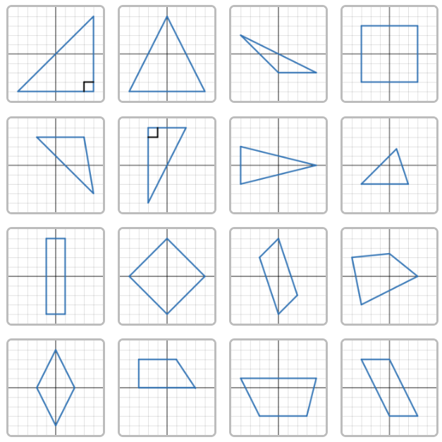

Appendix B

All the way around
- Find the perimeter of the scalene triangle.
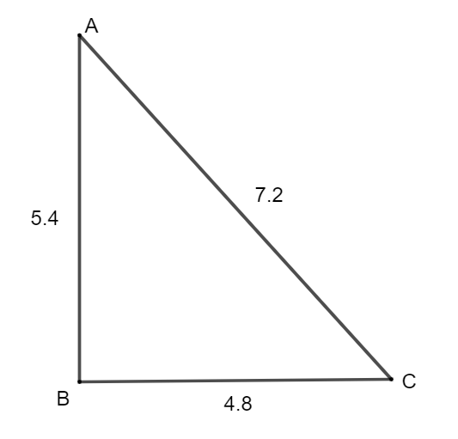
- Find the perimeter of the trapezium.
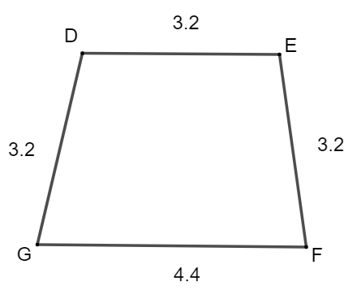
- Find the perimeter of the isosceles triangles.
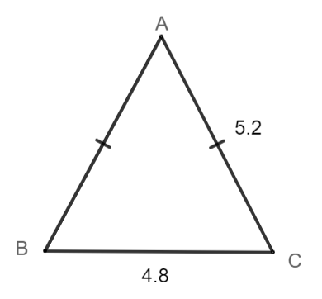
- Find the perimeter of the rectangle.
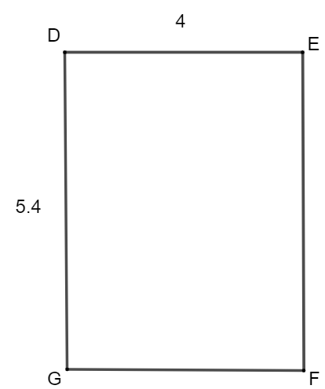
- Find the perimeter of the kite.\
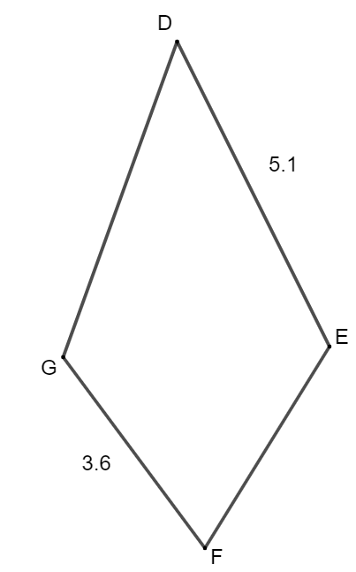
- Find the perimeter of the parallelogram.
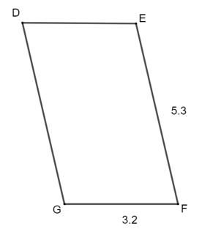
- Find the perimeter of the rhombus.
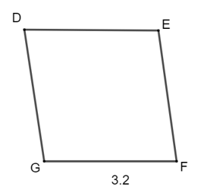
- Find the perimeter of the square.
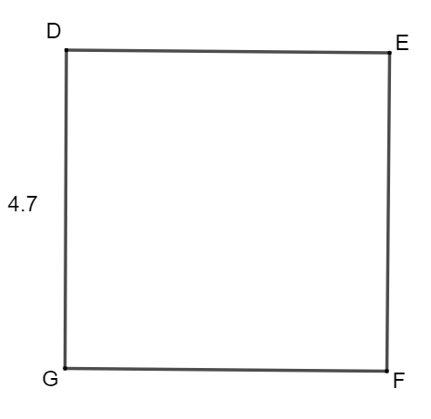
- Find the perimeter of the equilateral triangle.
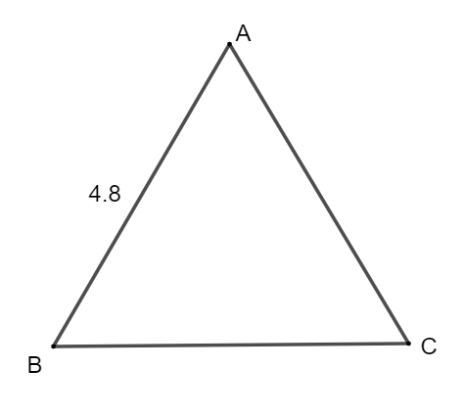
- Find the perimeter of the staircase. All angles are right angles.
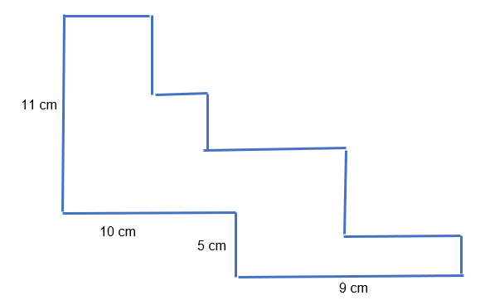

Appendix C

Perimeter problems
- A rectangular garden has a perimeter of 60 metres. The north side of the garden is 13 metres. What is the length of the east side of the garden?
- Rectangle 1 has a length of 10 metres and a width of 9 metres.
Rectangle 2 has a length of 10 metres and a width of 12 metres.
You place both rectangles side-by-side to create a new rectangle, Rectangle 3. What is the perimeter of Rectangle 3?
- Guinevere is going to put wooden skirting boards around the bottom of the walls of a rectangular bedroom. The length of the bedroom is 4.2 m. The width is one half of the length. How many metres of skirting board does Guinevere need?
- Roald wants to place a stone border around their square garden. The perimeter of the garden is 35 m. What is the length of each side?

Appendix D

Quadrant notes
Worked example  Find the perimeter of the parallelogram.  $$+ + + =$$  $$2× + 2× =$$ | Example 1  Find the perimeter of the square.
Notes to your future forgetful self | Example 2

Sample solutions

Appendix B – All the way around
- 17.4 units
- 14 units
- 15.2 units
- 18.8 units
- 17.4 units
- 17 units
- 12.8 units
- 18.8 units
- 14.4 units

Appendix C – Perimeter problems
- 17 cm
- 62 cm
- 12.6 m
- 8.75 m

Appendix D – Quadrant notes
Worked example  Find the perimeter of the parallelogram.  $$5.3 + 5.3 + 3.2 + 3.2 = 17$$  $$2×5.3+ 2× 3.2 = 17$$ | Example 1  Find the perimeter of the square.  $$4.7 + 4.7 + 4.7 + 4.7 = 18.8$$  $$4× 4.7 = 18.8$$
Notes to your future forgetful self  - The perimeter of an object is the length around the object.  - When you have a shape with sides of the same length you can count them and multiply to save time. | Example 2  Examples may vary.

Apply
- Find as many shapes as possible with the perimeter of 10 cm.
A square with side length 2.5
A triangle with sides 3, 3 and 4.
A rectangle with sides 2 and 3.
And many more.
- Find as many rectangles as possible with the perimeter of 24 cm.
1 × 11, 2 × 10, 3 × 9, 4 × 8, 5 × 7, and 6 × 6.
- Find as many triangles as possible with the perimeter of a triangle of 20 cm.
2, 9, 9
3, 8, 9
4, 7, 9
5, 6, 9
6, 6, 8
7, 7, 6
8, 8, 4
There may be more.

References
This resource contains NSW Curriculum and syllabus content. The NSW Curriculum is developed by the NSW Education Standards Authority. This content is prepared by NESA for and on behalf of the Crown in right of the State of New South Wales. The material is protected by Crown copyright.
Please refer to the NESA Copyright Disclaimer for more information https://educationstandards.nsw.edu.au/wps/portal/nesa/mini-footer/copyright.
NESA holds the only official and up-to-date versions of the NSW Curriculum and syllabus documents. Please visit the NSW Education Standards Authority (NESA) website https://educationstandards.nsw.edu.au/ and the NSW Curriculum website https://curriculum.nsw.edu.au/.
Mathematics K–10 Syllabus © NSW Education Standards Authority (NESA) for and on behalf of the Crown in right of the State of New South Wales, 2022.

© State of New South Wales (Department of Education), 2024
The copyright material published in this resource is subject to the Copyright Act 1968 (Cth) and is owned by the NSW Department of Education or, where indicated, by a party other than the NSW Department of Education (third-party material).
Copyright material available in this resource and owned by the NSW Department of Education is licensed under a Creative Commons Attribution 4.0 International (CC BY 4.0) license.
This license allows you to share and adapt the material for any purpose, even commercially.
Attribution should be given to © State of New South Wales (Department of Education), 2024.
Material in this resource not available under a Creative Commons license:
- the NSW Department of Education logo, other logos and trademark-protected material
- material owned by a third party that has been reproduced with permission. You will need to obtain permission from the third party to reuse its material.
Links to third-party material and websites
Please note that the provided (reading/viewing material/list/links/texts) are a suggestion only and implies no endorsement, by the New South Wales Department of Education, of any author, publisher, or book title. School principals and teachers are best placed to assess the suitability of resources that would complement the curriculum and reflect the needs and interests of their students.
If you use the links provided in this document to access a third-party's website, you acknowledge that the terms of use, including licence terms set out on the third-party's website apply to the use which may be made of the materials on that third-party website or where permitted by the Copyright Act 1968 (Cth). The department accepts no responsibility for content on third-party websites.

