Mathematics Stage 3 Year B – Unit 30

Contents
Unit description and duration 5
Syllabus outcomes 5
Working mathematically 6
Student prior learning 6
Lesson overview and resources 8
Lesson 1 12
Daily number sense – build to the whole 1 – 10 minutes 12
Core lesson 1 – making right angles – 20 minutes 14
Core lesson 2 – maximum number of right angles – 20 minutes 17
Discuss and connect the mathematics – 10 minutes 20
Lesson 2 23
Daily number sense – build the whole 2 – 10 minutes 23
Core lesson 1 – angle benchmarks – 20 minutes 25
Core lesson 2 – angle patterns – 20 minutes 28
Discuss and connect the mathematics – 10 minutes 30
Lesson 3 32
Daily number sense – given fraction parts – 10 minutes 32
Core lesson 1 – measuring angles at a point – 20 minutes 33
Core lesson 2 – investigating angles at a point – 20 minutes 34
Discuss and connect the mathematics – 10 minutes 36
Lesson 4 38
Daily number sense – 10 minutes 38
Core lesson 1 – angles in images – 10 minutes 38
Core lesson 2 – building with angles – 30 minutes 39
Core lesson 3 – testing – 20 minutes 40
Lesson 5 43
Daily number sense – addition – 10 minutes 43
Core lesson – duration – 40 minutes 44
Discuss and connect the mathematics – 10 minutes 47
Lesson 6 49
Daily number sense – addition and subtraction – 10 minutes 49
Core lesson – fractions of time – 40 minutes 50
Discuss and connect the mathematics – 10 minutes 53
Lesson 7 55
Daily number sense – magic – 10 minutes 55
Core lesson – zoom strategy – 35 minutes 57
Consolidation and meaningful practice – 15 minutes 60
Lesson 8 62
Daily number sense – 10 minutes 62
Core lesson – organising an excursion – 50 minutes 62
Discuss and connect the mathematics – 10 minutes 65
Resource 1 – using a protractor 67
Resource 2 – house plans 68
Resource 3 – hexagon angles 69
Resource 4 – angle of revolution 70
Resource 5 – stained glass window 71
Resource 6 – angles in images 72
Resource 7 – angles in engineering 73
Resource 8 – addition problems 74
Resource 9 – elapsed times 75
Resource 10 – word problems 76
Resource 11 – strip 77
Resource 12 – hour strips 78
Resource 13 – duration problems 79
Resource 14 – the zoom strategy 80
Resource 15 – elapsed timecards 81
Resource 16 – using Google Maps 82
Resource 17 – excursion planning 83
Syllabus outcomes and content 84
References 88
Further reading 89

Unit description and duration
This unit develops the big idea that angles are the primary structural component of many shapes.
In this 2-week unit students are provided opportunities to:
- estimate and describe the size of angles using known angles as benchmarks
- estimate, measure and compare angles using degrees
- solve problems involving duration, using 12- and 24-hour time.

Syllabus outcomes
- MAO-WM-01 develops understanding and fluency in mathematics through exploring and connecting mathematical concepts, choosing and applying mathematical techniques to solve problems, and communicating their thinking and reasoning coherently and clearly
- MA3-AR-01 selects and applies appropriate strategies to solve addition and subtraction problems
- MA3-RQF-01 compares and orders fractions with denominators of 2, 3, 4, 5, 6, 8 and 10
- MA3-RQF-02 determines and $\frac{1}{2}$, $\frac{1}{4}$, $\frac{1}{5}$ and $\frac{1}{10}$ of measures and quantities
- MA3-GM-03 measures and constructs angles, and identifies the relationships between angles on a straight line and angles at a point
- MA3-NSM-02 measures and compares duration, using 12- and 24-hour time and am and pm notation

Working mathematically
In the Mathematics K–10 Syllabus, there is one overarching Working mathematically outcome (MAO-WM-01). The Working mathematically processes should be embedded within the concepts being taught. The Working mathematically processes are:
- communicating
- understanding and fluency
- reasoning
- problem solving.
Mathematics K–10 Syllabus © NSW Education Standards Authority (NESA) for and on behalf of the Crown in right of the State of New South Wales, 2022.

Student prior learning
Before engaging in these teaching and learning activities, students would benefit from prior experience with:
- describing angles in comparison to quarter-turns as acute, right, obtuse, straight, reflex or a revolution
- recognising and describing angles as less than, equal to, about the same as or greater than a right angle
- comparing 12- and 24-hour time systems and converting between them.
In NSW classrooms there is a diverse range of students, including Aboriginal and Torres Strait Islander students, students learning English as an additional language or dialect, high potential and gifted students and students with disability. Some students may identify with more than one of these groups or possibly all of them. Refer to Curriculum planning for every student – advice for further information.

Lesson overview and resources
The table below outlines the sequence and approximate timing of lessons, learning intentions and resources.
Lesson | Content | Duration and resources
Lesson 1  Daily number sense learning intention:  - build up to the whole from a given fractional part | Lesson core concept: angles can be classified according to their features.  Core concept learning intention:  - investigate the relationships formed by the intersection of straight lines | Lesson duration: 60 minutes  - Resource 1 – using a protractor  - Ice-cream sticks  - Writing materials
Lesson 2  Daily number sense learning intention:  - build up to the whole from a given fractional part | Lesson core concept: angles are created when lines intersect.  Core concept learning intention:  - investigate the relationships formed by the intersection of straight lines | Lesson duration: 60 minutes  - Resource 2 – house plans  - Resource 3 – hexagon angles  - Coloured markers  - Writing materials
Lesson 3  Daily number sense learning intention:  - build up to the whole from a given fractional part | Lesson core concept: angles at a point form an angle of revolution and add to 360°.  Core concept learning intention:  - investigate the relationships formed by the intersection of straight lines | Lesson duration: 60 minutes  - Resource 4 – angle of revolution  - Resource 5 – stained glass window  - Protractors  - Pattern blocks  - Writing materials
Lesson 4  Daily number sense learning intention:  - teacher-identified task based on student needs | Lesson core concept: angles can be found in art, architecture and engineering.  Core concept learning intention(s):  - estimate, measure and compare angles using degrees  - investigate angles on a straight line and angles at a point | Lesson duration: 70 minutes  - Resource 6 – angles in images  - Resource 7 – angles in engineering  - Protractors  - Digital device for photographs  - Ice-cream sticks (30 per pair)  - Adhesive putty  - Sticky tape  - Weights (200 g)
Lesson 5  Daily number sense learning intention:  - choose and use efficient strategies to solve addition problems | Lesson core concept: a timeline is a number line that can help determine the duration of events.  Core concept learning intention:  - solve problems involving duration | Lesson duration: 60 minutes  - Resource 8 – addition problems  - Resource 9 – elapsed times  - Writing materials
Lesson 6  Daily number sense learning intention:  - choose and use efficient strategies to solve addition and subtraction problems | Lesson core concept: time can be described using fractions and decimals.  Core concept learning intention(s):  - solve problems involving duration in 12- and 24-hour time  - compare common fractions with related denominators  - use equivalence to add and subtract fractional quantities | Lesson duration: 60 minutes  - Resource 10 – word problems  - Resource 11 – strip  - Resource 12 – hour strips  - Resource 13 – duration problems  - Writing materials
Lesson 7  Daily number sense learning intention:  - choose and use efficient strategies to solve addition and subtraction problems | Lesson core concept: mental strategies can help to calculate the duration of events.  Core concept learning intention:  - solve problems involving duration, using 12-and 24-hour time | Lesson duration: 60 minutes  - Resource 14 – the zoom strategy  - Resource 15 – elapsed timecards  - Writing materials
Lesson 8  Daily number sense learning intention:  - teacher-identified task based on student needs | Lesson core concept: 12- and 24-hour time can be used to coordinate events in our world.  Core concept learning intention(s):  - compare 12- and 24-hour time systems and convert between them  - solve problems involving duration, using 12- and 24-hour time | Lesson duration: 70 minutes  - Resource 16 – using Google Maps  - Resource 17 – excursion planning  - Devices to access Google Maps (one per pair)  - Writing materials

Lesson 1
Core concept: angles can be classified according to their features.

Daily number sense – build to the whole 1 – 10 minutes
Daily number sense activities for Lessons 1 to 3 ‘activate’ prior number knowledge and support the learning of new content in the unit. These activities can also assist teachers to identify the starting points for learning by revealing the extent of students’ existing knowledge.
The table below contains a suggested learning intention and success criteria. These are best co-constructed with students.
Daily number sense learning intention | Daily number sense success criteria
Students are learning to:  - build up to the whole from a given fractional part. | Students can:  - generate the whole quantity from non-unit fractional parts.
- Tell students that if a fraction of a total is known, it can be used to find the total amount.
- Ask students how they could find the total length of a rope if they were given three-fifths ($\frac{3}{5}$).
- Draw a line on the board and tell students that $\frac{3}{5}$ of this rope is 15 metres long.
- Allow time for students to think and turn and talk to discuss how they could find the total length.
- Select students to share and explain their strategy. Record and test student responses.
The table below outlines stimulus prompts to generate conversation about the topic, along with anticipated responses from students.
Prompts | Anticipated student responses
- How can you find the total length of the rope? | - We would find how long one-fifth of the rope is first, then build it up to have all 5 of those amounts for the total length.  - One-fifth is 5 metres long, so the total length of the rope is 25 metres.  - We know that 3 fives is 15, so one-fifth must be 5 metres long. We would then multiply 5 metres by the 5 fifths, making a total of 25 metres.
- Ask:
- Does it matter what fraction of the length of rope you are given?
- Does the size of the fraction change your strategy?

This table details opportunities for assessment.
Assessment opportunities | Links
What to look for:  - Can students generate the whole quantity from non-unit fractional parts? [MAO-WM-01, MA3-RQF-02] | Links to National Numeracy Learning Progressions (NNLP):  - InF5.

Core lesson 1 – making right angles – 20 minutes
The table below contains a suggested learning intention and success criteria. These are best co-constructed with students.
Core concept learning intention | Core concept success criteria
Students are learning to:  - investigate the relationships formed by the intersection of straight lines. | Students can:  - identify angle types formed by the intersection of straight lines, including right angles, straight angles and angles at a point that add to 360°  - recognise that perpendicular lines intersect at right angles.
This activity is an adaptation of Lesson 1: How Many Right Angles? from reSolve by Australian Government Department of Education 2023.
- Identify examples of right angles around the classroom. Discuss the ways in which right angles create a ‘square corner’. Explain that when 2 lines meet or cross over to make a 90° angle, they are also known as perpendicular lines. Add this to an anchor chart on angles for the class.
Perpendicular: 2 lines, rays, arms or other objects that intersect at a 90° angle (a right angle).
- Display Resource 1 – using a protractor and revise how to measure angles. Alternatively, the corner of a book could be used to test a right angle.
- Provide pairs of students with 2 ice-cream sticks.
- Explain that, for this task, the ice-cream sticks cannot:
- be stacked (ice-cream sticks cannot be completely on top of one another)
- be extended (all ice-cream sticks must form an independent arm of an angle), as shown below in Figure 1.
Figure 1 – ice-cream stick rules
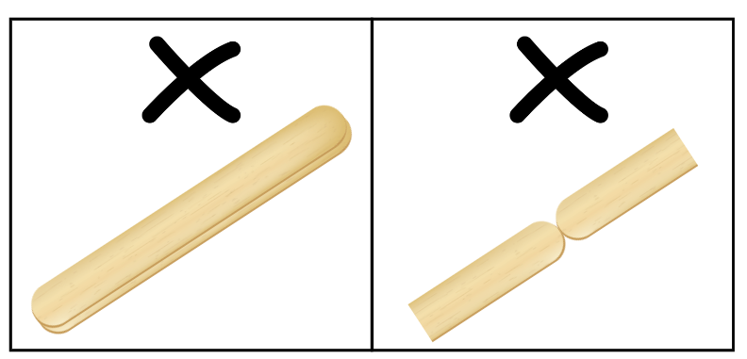
- Ask students to find how many right angles they can make by manipulating 2 ice-cream sticks and record their findings.
Note: students count the right angles made as a 2D representation, not 3D. This means that 2 ice-cream sticks can make a maximum of 4 right angles, not 8.
- After students have had time to explore, use the prompt box to discuss their findings.
The table below outlines stimulus prompts to generate conversation about the topic, along with anticipated responses from students.
Prompts | Anticipated student responses
- How many right angles can you make with 2 ice-cream sticks? | - I can make one, 2 or 4 right angles.  - We found that the 2 ice-cream sticks could not be used to make 3 right angles.
- Share the different solutions discovered and have students explain why it is not possible to make 3 right angles with 2 sticks, as shown in Figure 2.
Figure 2 – right angle solutions
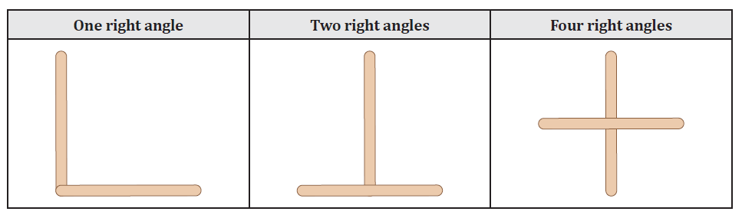
Image sourced from Lesson 1: How Many Right Angles? from reSolve by Australian Government Department of Education 2023.
- Ask students if there are any other angles that can be made by combining the right angles in their arrangements. For example:
- 2 right angles of 90° can be combined to make a straight angle of 180°.
- 3 right angles of 90° can be combined to make a reflex angle of 270°.
- 4 right angles of 90° can be combined to make a revolution angle of 360°.

Core lesson 2 – maximum number of right angles – 20 minutes
- Ask how many right angles students can make with 3 ice-cream sticks.
- Again, allow students plenty of time to explore the problem. They will find that they can create 2, 3, 4, 5, 6 and 8 right angles, but they cannot make one or 7.
- Explain that mathematicians collect and record data in an organised way to help them look for patterns. Introduce a table to record students’ data, as in Figure 3.
Figure 3 – results table
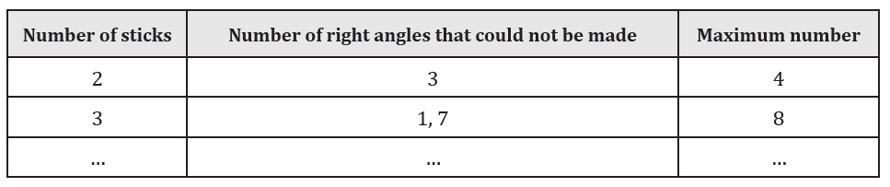
Image sourced from Lesson 1: How Many Right Angles? from reSolve by Australian Government Department of Education 2023.
- Pose the questions:
- What do you predict will happen if 4 ice-cream sticks are used?
- What about using 5 or 6 ice-cream sticks?
- What about using any number of ice-cream sticks?
- Allow students time to explore with different numbers of ice-cream sticks and to record their results in their own table.
- A class table could also be compiled and, as students find new possibilities, they can add their data to the class results.
- Students will find that the method required to create the maximum number of right angles is to produce as many intersections as possible, using the ice-cream sticks like a grid. Refer to the language of perpendicular. For example, see Figure 4.
Figure 4 – ice-cream stick intersections
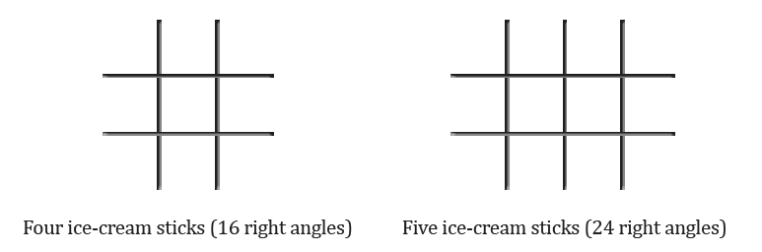
Image sourced from Lesson 1: How Many Right Angles? from reSolve by Australian Government Department of Education 2023.
This table details opportunities for differentiation.
Too hard? | Too easy?
Students cannot identify angle types formed by the intersection of straight lines, including right angles, straight angles and angles at a point that add to 360°.  - Model using the 2 ice-cream sticks and create a right angle. Use the angle identifier to confirm that the angle has 90°. Students trace the right angle into their workbook.  - Ask students to rearrange the 2 ice-cream sticks to create a right angle a different way. Support them to use the angle identifier to test them, then record their results in a table. | Students can identify angle types formed by the intersection of straight lines, including right angles, straight angles and angles at a point that add to 360°.  - Ask students to construct or draw a polygon with exactly 6 internal right angles.  - Students compare and discuss the various polygons created with another student.

Discuss and connect the mathematics – 10 minutes
- After the right angles investigation, ask students to contribute their updated findings to the class table, as in Figure 5.
Figure 5 – results table continued
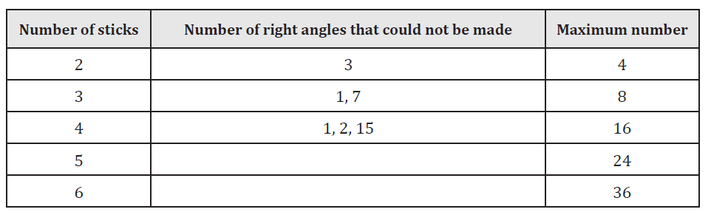
Image sourced from Lesson 1: How Many Right Angles? from reSolve by Australian Government Department of Education 2023.
- Use the prompt box below to discuss the students’ findings.
The table below outlines stimulus prompts to generate conversation about the topic, along with anticipated responses from students.
Prompts | Anticipated student responses
- What did you notice during this investigation?  - Were there any patterns that you found?  - Could you describe the results using a pattern, or mathematical rule, about the maximum number of right angles it is possible to make? | - There were more possibilities for even numbers than odd numbers of ice-cream sticks.  - Yes, there were number patterns for some of our results.  - For an even number of ice-cream sticks, the maximum number of right angles is the number of ice-cream sticks squared.  - For an odd number of ice-cream sticks, the maximum number of right angles is the number of ice-cream sticks squared minus one.
Note: although there is potential to explore higher level mathematics here, it is appropriate for Stage 3 students to collect data and look for patterns. More information on spatial reasoning with right angles can be found at reSolve.
- Ask students to think of other language used that could be added to the class anchor chart on angles.

This table details opportunities for assessment.
Assessment opportunities | Links
What to look for:  - Can students identify angle types formed by the intersection of straight lines, including right angles, straight angles and angles at a point? [MAO-WM-01, MA3-GM-03]  - Can students recognise that perpendicular lines intersect at right angles? [MAO-WM-01, MA3-GM-03] | Links to National Numeracy Learning Progressions (NNLP):  - UuM8, UGP5, UGP6.

Lesson 2
Core concept: angles are created when lines intersect.

Daily number sense – build the whole 2 – 10 minutes
The table below contains a suggested learning intention and success criteria. These are best co-constructed with students.
Daily number sense learning intention | Daily number sense success criteria
Students are learning to:  - build up to the whole from a given fractional part. | Students can:  - generate the whole quantity from non-unit fractional parts.
- Remind students that, if a fraction of a total is known, it can be used to find the total amount.
- Explain that you have seen a new outdoor table setting that you want to get but you are not sure if it will fit in your outdoor area. You know that $\frac{5}{8}$ of the table is 150 cm. Ask how long the whole table is.
- Ask students how they could find the total length of a table if they know five-eighths ($\frac{5}{8}$) of the length.
- Allow time for students to think and turn and talk to discuss how they could find the total length.
- Select students to share and explain their strategy. Record and test student responses.
- Tell students that there is another table setting you like, but $\frac{5}{8}$ of the table is 160 cm. Ask what the total length of this table would be.
- Select students to share their findings and explain their strategy. Record and test student responses.
The table below outlines stimulus prompts to generate conversation about the topic, along with anticipated responses from students.
Prompts | Anticipated student responses
- How can you find the total length of the table if $\frac{5}{8}$ of the table is 160 cm? | - We would find out how long one-eighth of the table is first, then build it up to have all 8 of those amounts for the total length.  - 160 cm divided by 5 equals 32 cm.  - One-eighth is 32 cm long, so the total length of the table is 256 cm long.  - 256 cm is the same as 2 metres and 56 centimetres, or 2.56 m.

This table details opportunities for assessment.
Assessment opportunities | Links
What to look for:  - Can students generate the whole quantity from non-unit fractional parts? [MAO-WM-01, MA3-RQF-02] | Links to National Numeracy Learning Progressions (NNLP):  - InF5.

Core lesson 1 – angle benchmarks – 20 minutes
The table below contains a suggested learning intention and success criteria. These are best co-constructed with students.
Core concept learning intention | Core concept success criteria
Students are learning to:  - investigate the relationships formed by the intersection of straight lines. | Students can:  - investigate adjacent angles that form a right angle and establish that they add to 90°  - investigate adjacent angles on a straight line and establish that they add to 180°  - investigate angles at a point and establish that they form an angle of revolution and add to 360°.
- Display Resource 2 – house plans and explain that Harry is building a house for a client. The house is being built in Orange, NSW and it needs to be built strong enough to support extra weight if it snows.
- For this design to be strong enough it needs to have:
- an angle of 90° at the centre (marked as an ‘A’ on the plans)
- at least 10 internal right angles.
- Students turn and talk with a partner to see if the design for the house meets the criteria. Students share their findings with the class.
- Ask if it would be possible for Harry to use the information provided to calculate some of the other angles without using a protractor.
- Students turn and talk with a partner, discussing how they think Harry could determine the size of the other angles.
- As a class, discuss the students’ thinking, using the prompt box below.
The table below outlines stimulus prompts to generate conversation about the topic, along with anticipated responses from students.
Prompts | Anticipated student responses
- What clues can you use to determine the size of the other angles? | - Angle A is 90°, and angle B is the same, so they both must be 90°.  - Angle A and angle B are both 90°, so together make a straight line, or a straight angle.  - Angle C and angle D are also 90°, so together they also make a straight angle.  - Angles A, B, C and D are all right angles, so together they make a revolution at a point.
- Explain that when something is known to be true, it can be used to test other things. This is called a ‘benchmark’. Tell students that right angles are useful benchmarks to estimate the size of other angles.
- Tell students that Harry measured angle G and found that it was 45°. Ask students if they can use this information to determine the size of other angles. As students begin to talk about combining angles, introduce the term ‘adjacent angles’ and ‘angles at a point’.
Adjacent angles: angles that share a vertex and an arm. They do not overlap.
Angles at a point: adjacent angles that can be joined to create an angle of revolution, or 360°.
- Students use a copy of Resource 2 – house plans and work with a partner to find the size of the other angles on the building plan.
- After giving students time to work on their plan, regroup as a class. Ask students to share their findings with the class, using the image of Resource 2 – house plans displayed on the interactive whiteboard.
- Discuss the reasoning used, as well as highlighting examples of:
- adjacent angles that form a right angle and add to 90° (for example, angles H and G)
- adjacent angles on a straight line and establish that they add to 180° (for example, angles A and B, or B and C)
- angles at a point and establish that they form an angle of revolution and add to 360° (for example, angles I, J, K and L).

Core lesson 2 – angle patterns – 20 minutes
- Display Resource 3 – hexagon angles and explain that students will be exploring what angles they can find within a hexagon.
- Model how to draw straight lines from diagonally opposite corners, creating equidistant intersecting lines as in the first image in Figure 6.
Figure 6 – hexagon angles
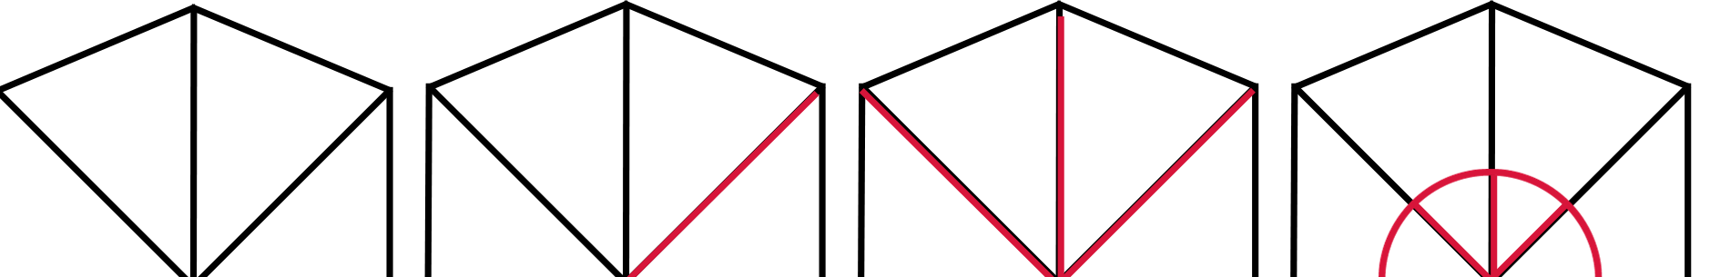

Equidistant: when 2 or more lengths are an equal distance from a central point.
- Provide students with a copy of Resource 3 – hexagon angles. With a partner, they draw straight lines from diagonally opposite corners.
- Explain that they are looking to find adjacent angles that total 90°, 180° and 360°.
- With their partner, students investigate and label:
- adjacent angles that form a right angle and add to 90°
- adjacent angles on a straight line and add to 180°
- angles at a point that form an angle of revolution and add to 360°.
This table details opportunities for differentiation.
Too hard? | Too easy?
Students cannot investigate adjacent angles that form a right angle, are on a straight line or form an angle of revolution.  - Support students to use a ruler and join the diagonally opposite corners in the hexagon. Assist them to identify and label lines that make a right angle, or 90°.  - Encourage students to find other adjacent angles that make a right angle, before looking to find angles on a straight line and an angle of revolution. Students label these and look for other combinations of adjacent angles. | Students can investigate adjacent angles that form a right angle, are on a straight line or form an angle of revolution.  - Students create their own building plan. They measure and write some of the angles, so that another student can use these to help them find the unknown angles. Encourage students to include some adjacent angles that form a right angle, are on a straight line or form an angle of revolution.  - Ask students to draw their own 2D shape and investigate the internal angles made. Then they join diagonally opposite corners with lines and measure the size of adjacent angles.

Discuss and connect the mathematics – 10 minutes
- Revise the terms ‘adjacent angles’, ‘angles at a point’ and ‘equidistant’, encouraging students to use these appropriately in their descriptions of the angles they found.
- Display Resource 3 – hexagon angles and ask students to identify where they were able to find adjacent angles that total 90°, 180° and 360°. Provide students with a coloured marker to highlight the arms and vertex of the angles.
- Discuss different ways that the same sized angle could be found in different arrangements, for example, 90°.
- Update the anchor chart, adding new vocabulary and examples of adjacent angles.
This table details opportunities for assessment.
Assessment opportunities | Links
What to look for:  - Can students investigate adjacent angles that form a right angle and establish that they add to 90°? [MAO-WM-01, MA3-GM-03]  - Can students investigate adjacent angles on a straight line and establish that they add to 180°? [MAO-WM-01, MA3-GM-03]  - Can students investigate angles at a point and establish that they form an angle of revolution and add to 360°? [MAO-WM-01, MA3-GM-03] | Links to National Numeracy Learning Progressions (NNLP):  - UuM8, UGP5, UGP6.

Lesson 3
Core concept: angles at a point form an angle of revolution and add to 360°.

Daily number sense – given fraction parts – 10 minutes
The table below contains a suggested learning intention and success criteria. These are best co-constructed with students.
Daily number sense learning intention | Daily number sense success criteria
Students are learning to:  - build up to the whole from a given fractional part. | Students can:  - generate the whole quantity from non-unit fractional parts.
- Remind students that, if a fraction of a total is known, it can be used to find the total amount.
- Explain that a pastry chef is decorating 10 cakes with strawberries. So far, he has decorated 4 cakes and has already used 60 strawberries. Each cake needs the same number of decorations. The pastry chef wants to know the number of strawberries he will need for all 10 cakes.
- Ask students, how they could find the total number of objects if they were given four-tenths ($\frac{4}{10}$) of a collection.
- Allow time for students to think and turn and talk to discuss how they could find the total number.
- Select students to share and explain their strategy. Record and test student responses.
This table details opportunities for assessment.
Assessment opportunities | Links
What to look for:  - Can students generate the whole quantity from non-unit fractional parts? [MAO-WM-01, MA3-RQF-02] | Links to National Numeracy Learning Progressions (NNLP):  - InF5.

Core lesson 1 – measuring angles at a point – 20 minutes
The table below contains a suggested learning intention and success criteria. These are best co-constructed with students.
Core concept learning intention | Core concept success criteria
Students are learning to:  - investigate the relationships formed by the intersection of straight lines. | Students can:  - investigate angles at a point and establish that they form an angle of revolution and add to 360°  - use a protractor to measure and identify types of angles.
- Display Resource 4 – angle of revolution and explain that angles meeting at a point form an angle of revolution and add to 360°.
- Show that this can be tested by measuring angles at a point with a protractor, then adding them together to see if they equal 360°.
- Display Resource 5 – stained glass window and tell students that angles meeting at a point can be found in many places. Explain that these are made by joining coloured pieces of glass.
- Students turn and talk with a partner, to find examples of angles meeting at a point form an angle of revolution.
- Provide students with Resource 4 – angle of revolution and Resource 5 – stained glass window, a protractor and their workbooks. Students measure the angles a point on Resource 4 – angle of revolution first, recording each angle and calculating the total.
- Students then use Resource 5 – stained glass window to measure and record the angles a point.
Note: students should measure more than one of the angles at a point to establish that they form angles of revolution. Students may find the lines between the pieces of glass in Resource 5 – stained glass window challenging. Explain that students can focus on measuring the angle of each coloured piece of glass that is joining at a point. If these lines were removed, the glass pieces would still meet at a point to form an angle of revolution and add to 360°.
- Once students have had time to measure multiple angles at a point, regroup students to share their findings.

Core lesson 2 – investigating angles at a point – 20 minutes
- Provide students with a collection of pattern blocks, a protractor and their workbook. Explain that they need to place the blocks together to form an angle of revolution (see Figure 7).
Figure 7 – pattern block example
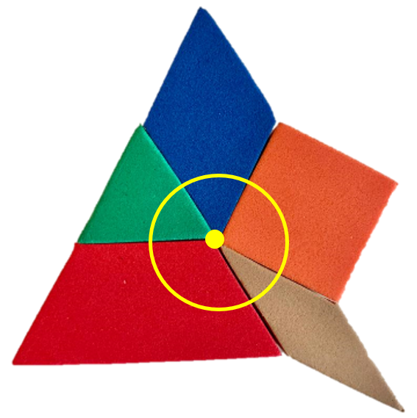
- Once students have formed an angle of revolution, they use a protractor to measure the angles and confirm that the total is 360°.
- Students then record their shapes and measurements using a labelled diagram.
- Students then use different pattern blocks to make another angle of revolution and follow the above steps.
This table details opportunities for differentiation.
Too hard? | Too easy?
Students cannot investigate angles at a point and establish that they form an angle of revolution and add to 360°.  - Support students to use a protractor and measure an angle of an individual pattern block and record the size. Support students to add another pattern block and measure and record the size. Continue until an angle of revolution has been formed.  - Provide students with another combination of pattern blocks. Ask students to identify the angles at a point in this new pattern. | Students can investigate angles at a point and establish that they form an angle of revolution and add to 360°.  - Challenge students to create a tessellating pattern with irregular polygons, then use a digital device to take a photo of it. Students then identify the repeated angles at a point in the image and mark them in the image.  - Students use their protractors to measure the angles at a point in their tessellating pattern. They can also swap tessellations with another student to measure their angles at a point.

Discuss and connect the mathematics – 10 minutes
- Regroup as a class and summarise the lesson together drawing out key mathematical ideas. Ask:
- How many degrees is an angle of revolution?
- Is there anywhere else you could find angles at a point that make an angle of revolution?
- Were there pattern blocks that did not form an angle of revolution?
- Did you face any challenges? How did you overcome these?
This table details opportunities for assessment.
Assessment opportunities | Links
What to look for:  - Can students investigate angles at a point and establish that they form an angle of revolution and add to 360°? [MAO-WM-01, MA3-GM-03]  - Can students use a protractor to measure and identify types of angles? [MAO-WM-01, MA3-GM-03] | Links to National Numeracy Learning Progressions (NNLP):  - UuM8, UGP5, UGP6.

Lesson 4
Core concept: angles can be found in art, architecture and engineering.

Daily number sense – 10 minutes
- From a class need surfaced through formative assessment data, identify a short, focused activity that targets students’ knowledge, understanding and skills. Example activities may be drawn from the following resources:
- Mathematics K–6 resources
- Universal Resources Hub.

Core lesson 1 – angles in images – 10 minutes
The table below contains suggested learning intentions and success criteria. These are best co-constructed with students.
Core concept learning intentions | Core concept success criteria
Students are learning to:  - estimate, measure and compare angles using degrees  - investigate angles on a straight line and angles at a point. | Students can:  - estimate and describe the size of angles using known angles as benchmarks  - recognise right angles, angles on a straight line and angles at a point embedded in diagrams  - create and record angle measurements using the symbol for degrees (°).
- Display Resource 6 – angles in images and ask students to identify examples of acute, right, obtuse, straight and reflex angles.
- Label angles identified from student responses.

Core lesson 2 – building with angles – 30 minutes
- Provide pairs of students with 30 ice-cream sticks, adhesive putty and sticky tape. Explain that students need to use these items to build a tower that is at least 15 cm tall and can hold a weight of 200 grams. They can only use the items provided and not all items need to be used.
- Remind students of the previous images, the angles they noticed and why these angles might be used in engineering or buildings. Pairs construct their tower, ensuring it meets the criteria.
- Once pairs have constructed their tower, provide them with a digital device to take a photograph of their tower.
- Provide pairs of students with protractors and their workbooks. Students work with their partner to find, measure and record angles in their tower. Students can use the markup tool to highlight the vertex and arms of the angles.

Core lesson 3 – testing – 20 minutes
- Regroup pairs with their constructed towers to test which tower can hold 200 grams.
- Place the weight on each tower, ensuring it can hold the weight for at least 10 seconds.
Note: more weight can be added if needed to determine which tower is the strongest. Discuss the strength and rigidity of triangular components in the structures. Point out that triangles are used in many bridges, in the long booms of construction cranes and in the structural parts of buildings (Van de Walle 2019).
- When testing each tower, discuss:
- What angles did you identify in the tower?
- Why are some towers stronger than others? What makes them stronger?
- If you built the tower again, what would you do differently?
- Would more craft sticks make the tower stronger? Why or why not?
- Why do engineers use angles in buildings and bridges?

This table details opportunities for differentiation.
Too hard? | Too easy?
Students cannot describe angle sizes using known benchmarks or measure angles using the symbol for degrees (°).  - After drawing the arms of the angles, ask students which type of angles they are likely to be.  - Support students to align their protractor accurately, then count the number of degrees in the angle starting from 0°. | Students can describe angle sizes using known benchmarks or measure angles using the symbol for degrees (°).  - Provide students with Resource 7 – angles in engineering to find, categorise, measure and record the size of the angles in one of the structures.  - Ask students to reflect on which type of angle is most common, and why.
This table details opportunities for assessment.
Assessment opportunities | Links
What to look for:  - Can students estimate and describe the size of angles using known angles as benchmarks? [MAO-WM-01, MA3-GM-03]  - Can students recognise right angles, angles on a straight line and angles at a point embedded in diagrams? [MAO-WM-01, MA3-GM-03]  - Can students create and record angle measurements using the symbol for degrees (°)? [MAO-WM-01, MA3-GM-03] | Links to National Numeracy Learning Progressions (NNLP):  - UuM7, UuM8.

Lesson 5
Core concept: a timeline is a number line that can help determine the duration of events.

Daily number sense – addition – 10 minutes
Daily number sense activities for Lessons 5 to 7 ‘loop’ back to concepts and procedures covered in previous units to assist students to build an increasingly connected network of ideas. These concepts may differ from the core concepts being covered by the unit.
The table below contains a suggested learning intention and success criteria. These are best co-constructed with students.
Daily number sense learning intention | Daily number sense success criteria
Students are learning to:  - choose and use efficient strategies to solve addition problems. | Students can:  - compare, evaluate and communicate strategies used to solve addition problems.
This activity is an adaptation of 3–6: Remote Maths – Edition 2 [PDF 417 KB] from MAV Learning Activities by The Mathematical Association of Victoria (2020).
- Discuss the various ways addition problems can be represented and solved.
- Display Resource 8 – addition problems and explain that students must choose one of the equations from the table and then use it to complete each of the 4 tasks.
- Students choose another student who completed the same equation to compare representations and solutions.
This table details opportunities for assessment.
Assessment opportunities | Links
What to look for:  - Can students compare, evaluate and communicate the strategies used to solve addition problems? [MAO-WM-01, MA3-AR-01] | Links to National Numeracy Learning Progressions (NNLP):  - AdS7, AdS8.

Core lesson – duration – 40 minutes
The table below contains a suggested learning intention and success criteria. These are best co-constructed with students.
Core concept learning intention | Core concept success criteria
Students are learning to:  - solve problems involving duration. | Students can:  - use start and finish times to calculate the elapsed time of events  - add and subtract time using a number line.
This activity is an adaptation of ‘Measure, calculate and compare elapsed Time’ time from FUSE by State of Victoria (Department of Education and Training).
- Revise students’ understanding of duration and elapsed time. Ask:
- Can you think of examples of elapsed time?
- What is the duration of the morning session?
Duration: the start and end time may not be defined, however the duration of an event or activity is constant. For example, the first half of a soccer game is always 45 minutes regardless of the start or end time.
Elapsed time: elapsed time is the amount of time between the start time and the end time of an activity or event. For example, my piano lesson starts at 10 past 4 and goes until a quarter to 5. I can calculate how long this lesson is.
- Explain that one strategy to calculate elapsed time is to use an empty number line as a timeline. Draw a number line on the board marked with the times 5:45 pm and 7:00 pm.
- Students turn and talk to discuss how the number line can be used to calculate the elapsed time.
- Select students to share and explain their strategies, testing students' ideas on a blank number line.
- If not already shared by students, demonstrate how to use an empty number line to calculate elapsed time, as in Figure 8. Model how to:
- add the remaining minutes from the current time to the next whole hour first, using one or more jumps
- use jumps to add any whole hours if needed
- add any more minutes needed to get to the final time, using one or more jumps.
Figure 8 – number line example
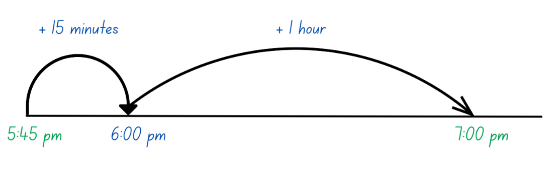
- Explain that the number line can also be used to jump backwards from an end time to calculate the elapsed time.
- Provide students with Resource 9 – elapsed times, an individual whiteboard and their workbook. Students draw a blank number line to calculate the elapsed times, recording the time in their workbook.

This table details opportunities for differentiation.
Too hard? | Too easy?
Students cannot add and subtract time using a number line.  - Support students by providing them with a hands-on clock that can be manipulated to visually model the elapsed time.  - Provide elapsed time questions that have half past and o’clock times that only require 30 minutes or hours calculated. | Students can add and subtract time using a number line.  - Challenge students to calculate the elapsed time mentally and record in their workbook.  - Students create their own elapsed time word problems for a partner to solve and record in their workbook.

Discuss and connect the mathematics – 10 minutes
- Regroup as a class and summarise the lesson. Ask:
- Did you find an empty number line useful for calculating elapsed time? Why or why not?
- Are there any other strategies you could use to calculate duration?
- Why is solving duration a useful skill?
- Does 12- or 24-hour make a difference in duration? Why or why not?

This table details opportunities for assessment.
Assessment opportunities | Links
What to look for:  - Can students use start and finish times to calculate the elapsed time of events? [MAO-WM-01, MA3-NSM-02]  - Can students add and subtract time using a number line? [MAO-WM-01, MA3-NSM-02] | Links to National Numeracy Learning Progressions (NNLP):  - MeT4, MeT5.

Lesson 6
Core concept: time can be described using fractions and decimals.

Daily number sense – addition and subtraction – 10 minutes
The table below contains a suggested learning intention and success criteria. These are best co-constructed with students.
Daily number sense learning intention | Daily number sense success criteria
Students are learning to:  - choose and use efficient strategies to solve addition and subtraction problems. | Students can:  - solve multistep word problems, including problems that require more than one operation.
- Provide students with Resource 10 – word problems and their workbook.
- Students glue Resource 10 – word problems into their book, solving the problems using an efficient strategy.
- Select students to share and explain their strategy and answers. Discuss strategies chosen as a class.

This table details opportunities for assessment.
Assessment opportunities | Links
What to look for:  - Can students solve multistep word problems, including problems that require more than one operation? [MAO-WM-01, MA3-AR-01] | Links to National Numeracy Learning Progressions (NNLP):  - AdS8, MuS8.  Links to suggested Interview for Student Reasoning (IfSR) tasks:  - IfSR- AT: 3A.5.

Core lesson – fractions of time – 40 minutes
The table below contains suggested learning intentions and success criteria. These are best co-constructed with students.
Core concept learning intentions | Core concept success criteria
Students are learning to:  - solve problems involving duration in 12- and 24-hour time  - compare common fractions with related denominators  - use equivalence to add and subtract fractional quantities. | Students can:  - represent commonly used time intervals as fractions and decimals  - solve word problems involving adding or subtracting fractional quantities with related denominators  - create equivalent fractions for half in quarters, eighths, sixths and tenths by re-dividing the whole, using diagrams and number lines.
This activity is an adaptation of ‘Measure, calculate and compare elapsed Time’ time from FUSE by State of Victoria (Department of Education and Training).
- Review students' knowledge of fractions between zero and one, recording responses on an anchor chart. For example, $\frac{1}{2}, \frac{1 }{4},\frac{1}{3 }, \frac{1}{5}.$
- Represent these on a fraction bar on the anchor chart, reviewing the position of common fraction benchmarks. For example, $\frac{1}{2}, \frac{1}{4}, \frac{3}{4}.$
- Ask students if they can name the corresponding decimals. Record responses on the anchor chart for reference during the lesson.
- Remind students that there are 60 minutes in one hour and the fractions and decimals that were shared can be used to represent time intervals.
- Display Resource 11 – strip and explain that the strip is divided into 60 parts to represent an hour. Ask:
- Why is the strip divided into 60 parts?
- How could half an hour be shown on the strip?
- How could half an hour be represented in fractions? Is there more than one way this could be represented?
- How could half an hour be represented in decimals?
- Provide students with Resource 12 – hour strips. Students calculate and colour the correct fraction and record the corresponding number of minutes for each strip (See Figure 9).
Figure 9 – Hour strip example
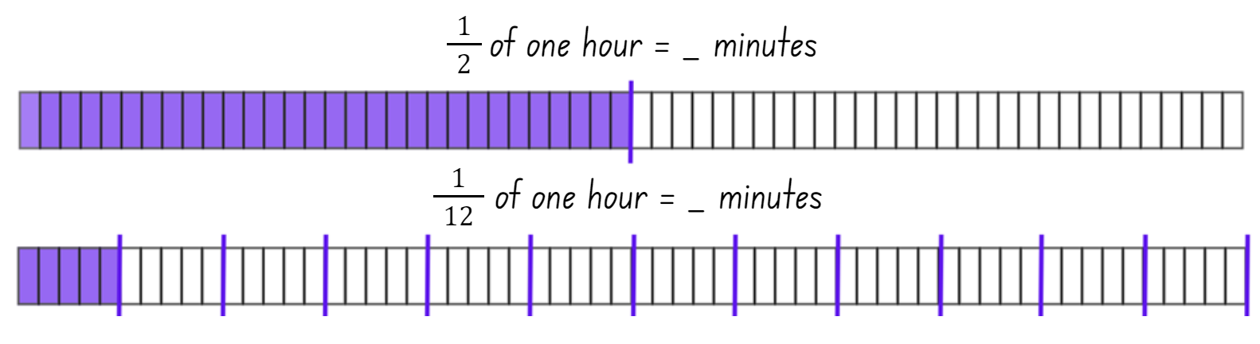
- Select students to share and justify their answers.
- Write the following problem on the board. I ran for $\frac{2}{5}$ of an hour and rode my bike for $\frac{1}{10}$ of an hour, how long did I exercise for? Demonstrate how to solve the problem using a think aloud, representing the answer as a fraction and minutes. Ask students:
- How can 2 fractions be added together when they have different denominators?
- What is an equivalent fraction for $\frac{2}{5}$ ?
- How can a fraction strip help with solving this problem?
- What is the answer when presented as a fraction?
- What is the answer presented in minutes?
- Can the answer be presented in decimals?
- Provide students with Resource 13 – duration problems and their workbooks. Students use their completed Resource 12 – hour strips to help solve the duration problems, recording the solution as a fraction and minutes in their workbook. Students should also be encouraged to record their answers as a decimal where appropriate.
This table details opportunities for differentiation.
Too hard? | Too easy?
Students cannot solve word problems involving adding or subtracting fractional quantities with related denominators.  - Assist students in calculating and highlighting the fractions on Resource 12 – hour strips. Encourage students to reference these when solving the duration problems.  - Support students’ knowledge of a half and a third by asking duration questions that only require a half or a third of an hour. | Students can solve word problems involving adding or subtracting fractional quantities with related denominators.  - Challenge students by asking them to solve and record duration questions that are longer than one hour as fractions and minutes.  - Challenge students to create their own fraction duration questions for a partner to solve and record in their workbook.

Discuss and connect the mathematics – 10 minutes
- Regroup as a class and summarise the lesson together drawing out key mathematical ideas. Ask:
- Was the hour strip helpful in calculating duration? Why or why not?
- Was representing the answer as a fraction, decimal or minutes easier? Why?
- When is it useful to present time intervals as a decimal?
- What is challenging about presenting time intervals as a decimal?
This table details opportunities for assessment.
Assessment opportunities | Links
What to look for:  - Can students represent commonly used time intervals as fractions and decimals? [MAO-WM-01, MA3-NSM-02]  - Can students solve word problems involving adding or subtracting fractional quantities with related denominators? [MAO-WM-01, MA3-RQF-02]  - Can students create equivalent fractions for half in quarters, eighths, sixths and tenths by re-dividing the whole, using diagrams and number lines? [MAO-WM-01, MA3-RQF-02] | Links to National Numeracy Learning Progressions (NNLP):  - MeT5, InF5, InF8.

Lesson 7
Core concept: mental strategies can help to calculate the duration of events.

Daily number sense – magic – 10 minutes
The table below contains a suggested learning intention and success criteria. These are best co-constructed with students.
Daily number sense learning intention | Daily number sense success criteria
Students are learning to:  - choose and use efficient strategies to solve addition and subtraction problems. | Students can:  - compare, evaluate and communicate strategies used to solve addition and subtraction problems.
This activity is an adaptation of Let’s get magical (3-digit addition and subtraction) from Mathematics K–6 resources by State of New South Wales (Department of Education).
- Provide students with either a whiteboard or their workbook.
- Ask students to choose a 3-digit number where each digit is smaller than the previous one, for example, 982 or 531. Students record the number.
- Direct students to create a new 3-digit number by reversing the digits. Subtract the second number from the first one. For example, 531 would become 135 and the subtraction would be 531–135. The answer is 396.
Note: if in the answer is 99, record it as 099.
- Next, students reverse the answer from their subtraction calculation. For example, from 396 becomes 639.
- Finally, students add the last 2 numbers together. For example, 396 + 639. The answer is 1089.
- Explain that the statement ‘the answer is always 1089’ is a hypothesis. It is important to test a hypothesis to make sure it is true.
- Students start with a different number and test the hypothesis again. Ask:
- What do you notice about the final answer?
- Why do you think this might be happening?
Note: this activity may be extended into an investigation to explore what happens with the same process, starting with a 2- or 4-digit number.
This table details opportunities for assessment.
Assessment opportunities | Links
What to look for:  - Can students compare, evaluate and communicate strategies used to solve addition and subtraction problems? [MAO-WM-01, MA3-AR-01] | Links to National Numeracy Learning Progressions (NNLP):  - AdS7, AdS8.

Core lesson – zoom strategy – 35 minutes
The table below contains a suggested learning intention and success criteria. These are best co-constructed with students.
Core concept learning intention | Core concept success criteria
Students are learning to:  - solve problems involving duration, using 12-and 24-hour time. | Students can:  - use start and finish times to calculate the duration of events  - use the zoom and mental strategies to calculate elapsed time  - represent commonly used time intervals as decimals  - solve a variety of problems involving duration, including where times are expressed in 12-hour and 24-hour notation.
- Review students understanding of duration and elapsed time from Lesson 5.
- Introduce another strategy for calculating elapsed time by displaying Resource 14 – the zoom strategy.
- Demonstrate how to use the zoom strategy:
- Identify the start time and the end time.
- Bridge the starting minutes to the closest hour.
- Identify how many hours until the finish hour.
- Identify how many minutes (if any) remain until the finish time.
- Add the hours and minutes together to find the total time (see Figure 10).
Figure 10 –zoom strategy example
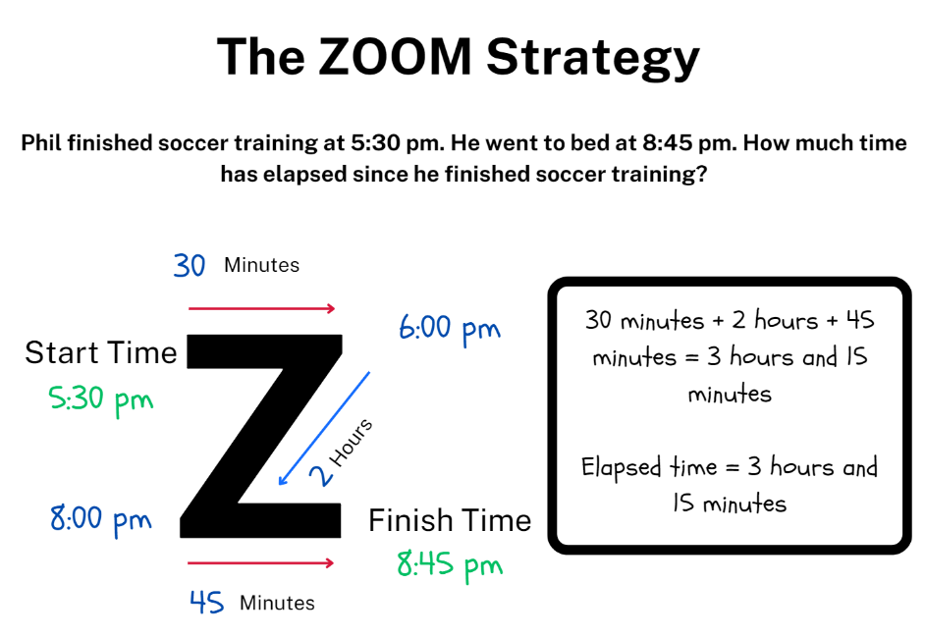
Note: if the elapsed time has a finish time that is on the hour, students will not need to use the final line of the zoom model as there are no remaining minutes to add.
- Provide students with Resource 14 – the zoom strategy (either laminated or in a reusable sleeve), Resource 15 – elapsed timecards and their workbook.
- Students use the zoom strategy to find the elapsed time of each of the cards and record their working out and answers in their workbook.
- Regroup as a class and ask:
- Did you find the zoom strategy successful for calculating elapsed time? Why or why not?
- Can you think of any other strategies you could use to calculate elapsed time?
- What elapsed time did your record for each card?
- Why is solving elapsed time a useful skill?
- Can you represent the elapsed time as a decimal?

This table details opportunities for differentiation.
Too hard? | Too easy?
Students cannot solve a variety of problems involving duration, including where times are expressed in 12-hour and 24-hour notation.  - Support students by providing them with a hands-on clock that can be used to visually model the elapsed time.  - Provide students with elapsed time questions that have half past and o’clock times and only require 30 minutes and hours calculated. | Students can solve a variety of problems involving duration, including where times are expressed in 12-hour and 24-hour notation.  - Challenge students to create their own elapsed time question for a partner to solve using the zoom strategy.  - Present students with Buses from NRICH. A bus route has a total duration of 40 minutes. Every 10 minutes, 2 buses set out, one from each end. How many buses will one bus meet on its way from one end to the other end?

Consolidation and meaningful practice – 15 minutes
- Provide students with elapsed time questions, for example, ask how much time has elapsed between 7:00 am and 11:15 am.
- Select students to share and explain their answer. Ask students:
- What strategy did you use to calculate the elapsed time?
- Is it possible to use a mental strategy to calculate the elapsed time?
- How could you represent the elapsed time as a decimal?
- Provide a range of practice questions, including 12- and 24-hour time, ensuring all students abilities are catered for.
This table details opportunities for assessment.
Assessment opportunities | Links
What to look for:  - Can students use start and finish times to calculate the duration of events? [MAO-WM-01, MA3-NSM-02]  - Can students use the zoom and mental strategies to calculate elapsed time? [MAO-WM-01, MA3-NSM-02]  - Can students represent commonly used time intervals as decimals? [MAO-WM-01, MA3-NSM-02]  - Can students solve a variety of problems involving duration, including where times are expressed in 12-hour and 24-hour notation? [MAO-WM-01, MA3-NSM-02] | Links to National Numeracy Learning Progressions (NNLP):  - MeT4, MeT5.

Lesson 8
Core concept: 12- and 24-hour time can be used to coordinate events in our world.

Daily number sense – 10 minutes
- From a class need surfaced through formative assessment data, identify a short, focused activity that targets students’ knowledge, understanding and skills. Example activities may be drawn from the following resources:
- Mathematics K–6 resources
- Universal Resources Hub.

Core lesson – organising an excursion – 50 minutes
The table below contains suggested learning intentions and success criteria. These are best co-constructed with students.
Core concept learning intentions | Core concept success criteria
Students are learning to:  - compare 12- and 24-hour time systems and convert between them  - solve problems involving duration, using 12- and 24-hour time. | Students can:  - convert between 12- and 24-hour time  - create, interpret and use timetables from real-life situations, involving 12- and 24-hour time  - use start and finish times to calculate the elapsed time of events.
Note: you can amend Resource 17 – excursion planning to reduce the number of days of the excursion to meet your students’ needs. This learning task may take more than one lesson.
- Explain to students that they will be organising an excursion for Year 6 to Canberra. The excursion will leave from their school and will need to last for 3 to 5 days including travel.
- Display Resource 16 – using Google Maps and demonstrate how to use Google Maps to locate places to visit, as well as the duration of travel. Ask:
- If Google Maps states that it takes 9 hours and 36 minutes to travel somewhere, will the trip take that exact amount of time?
- When looking at the time it takes to travel somewhere, is it better to allow more or less time?
- How can rounding time help when planning an excursion?
- Display Resource 17 – excursion planning and explain that students will need to create a timetable for the excursion to follow including, time for meals, travel, time to visit locations and sleep. Highlight that Resource 17 – excursion planning has been separated into 24 blocks to represent the hours in a day.
- Provide pairs or small groups of students with Resource 16 – using Google Maps, multiple copies of Resource 17 – excursion planning and a device that can access Google Maps. Provide students with the following criteria:
- Create a timetable for the excursion in 12- and 24- hour time.
- Plan the locations to visit and how long will be spent at each location.
- Allocate time for meals and sleep on the timetable.
- Allocate appropriate travel time on the timetable between locations by using Google Maps.
- Calculate the duration of travel time, sleep, mealtimes and location visits for the whole excursion.
Note: if there are not enough devices to complete the activity in pairs or small groups, display Google Maps on the interactive whiteboard and complete the activity as a whole class.
This table details opportunities for differentiation.
Too hard? | Too easy?
Students cannot create, interpret and use timetables from real-life situations, involving 12- and 24-hour time.  - Provide students with locations to visit and support them to use Google Maps to calculate the travel duration and how long students would stay at each location.  - Provide students with sleep and mealtimes on Resource 17 – excursion planning sheet. | Students can create, interpret and use timetables from real-life situations, involving 12- and 24-hour time.  - Challenge students to organise an excursion for a large group of Year 6 students. This will mean that not all students can be at the same location at the same time.  - Students calculate the length of time spent at different locations each day as a fraction and decimal using the day as a whole. Ask students how the fractions and decimals might change if the whole excursion was the whole.

Discuss and connect the mathematics – 10 minutes
- Regroup as a class and summarise the lesson together drawing out key mathematical ideas. Ask:
- Was Google Maps an effective tool for this activity? Why or why not?
- Could you use a physical map to complete the task? Why or why not?
- What strategy did you use to calculate the durations?
- Why is 24-hour time useful for a timetable?
- What challenges did you face while completing the activity? How did you overcome these challenges?

This table details opportunities for assessment.
Assessment opportunities | Links
What to look for:  - Can students convert between 12- and 24-hour time? [MAO-WM-01, MA3-NSM-02]  - Can students create, interpret and use timetables from real-life situations, involving 12- and 24-hour time? [MAO-WM-01, MA3-NSM-02]  - Can students use start and finish times to calculate the elapsed time of events? [MAO-WM-01, MA3-NSM-02] | Links to National Numeracy Learning Progressions (NNLP):  - MeT4, MeT5.

Resource 1 – using a protractor
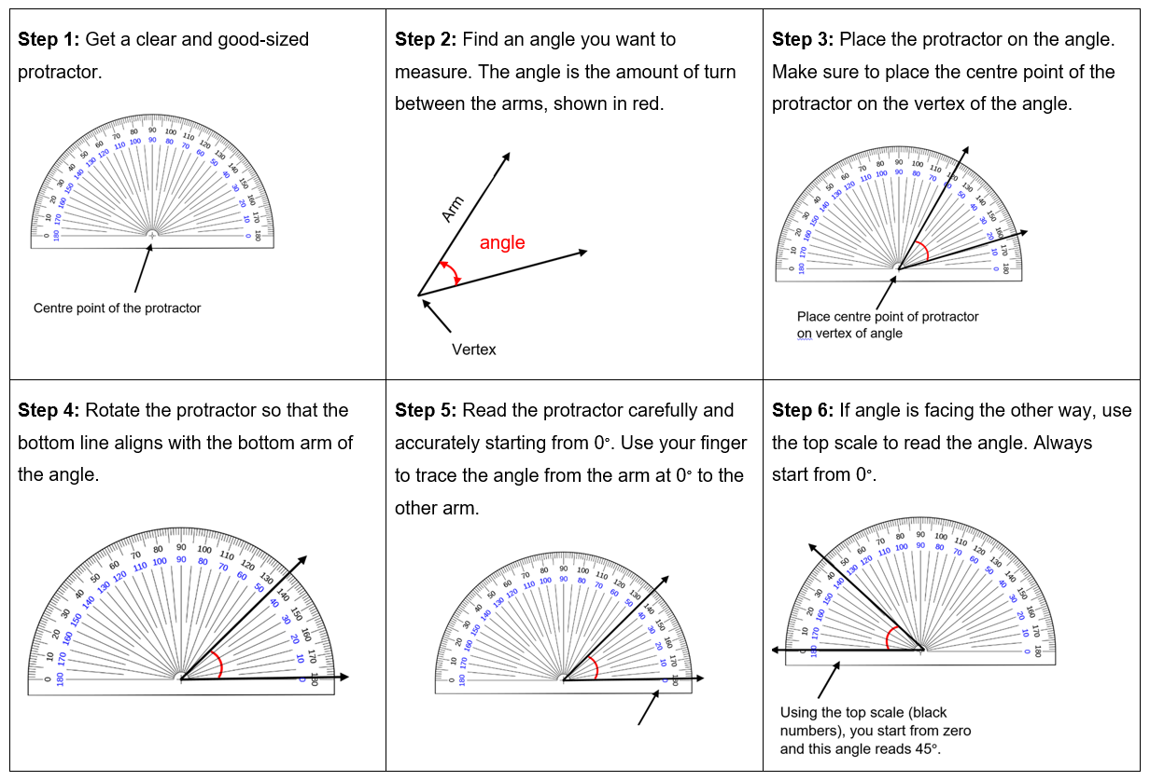

Resource 2 – house plans
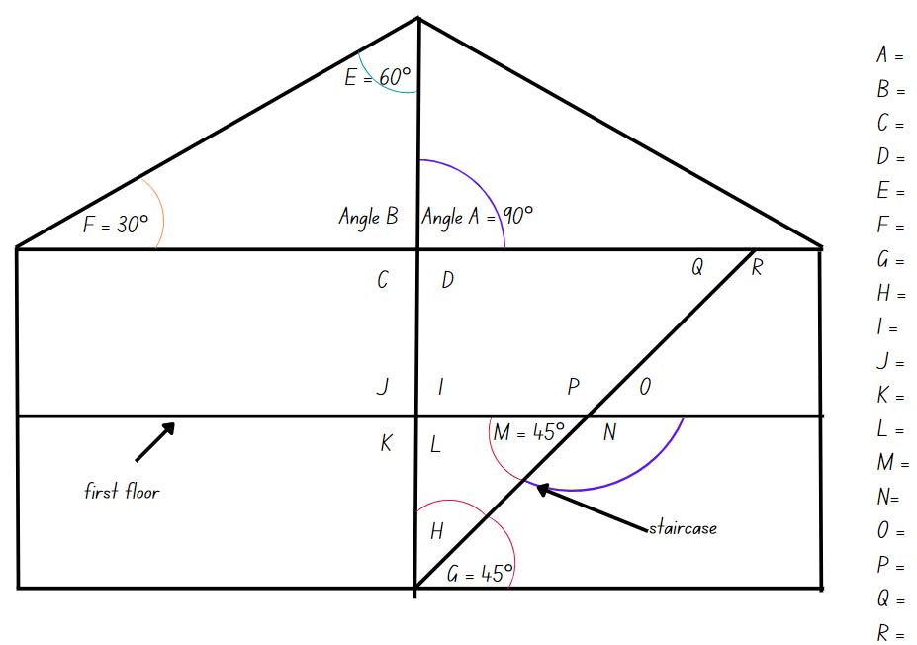

Resource 3 – hexagon angles
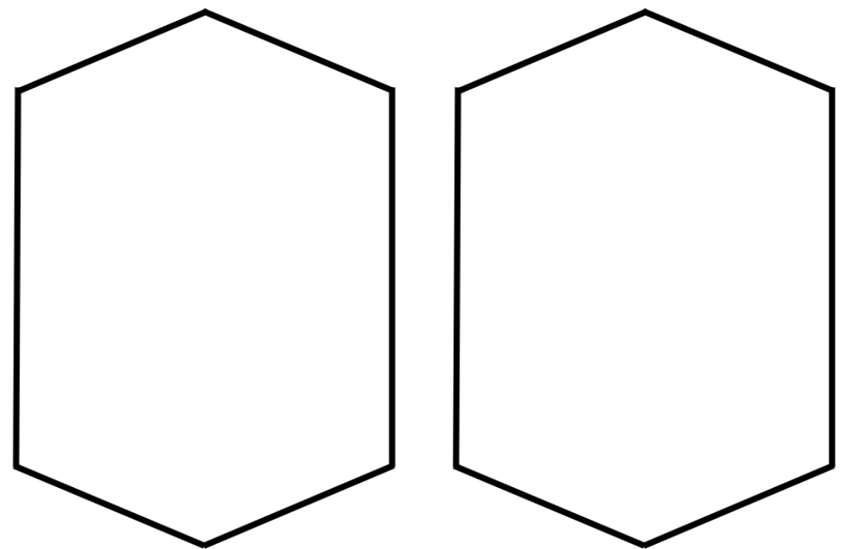

Resource 4 – angle of revolution
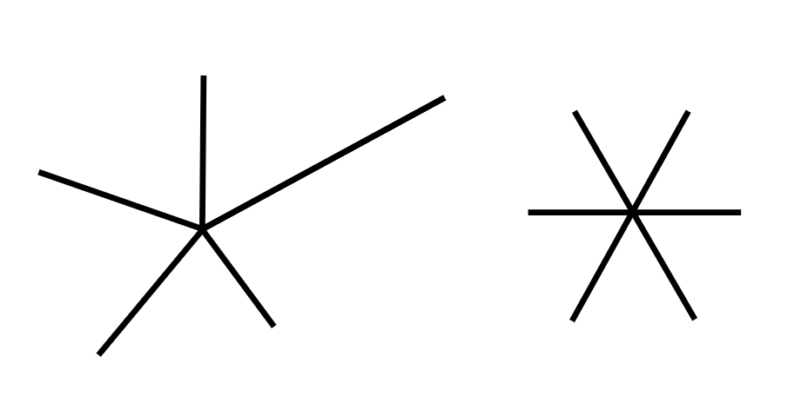

Resource 5 – stained glass window

Resource 6 – angles in images
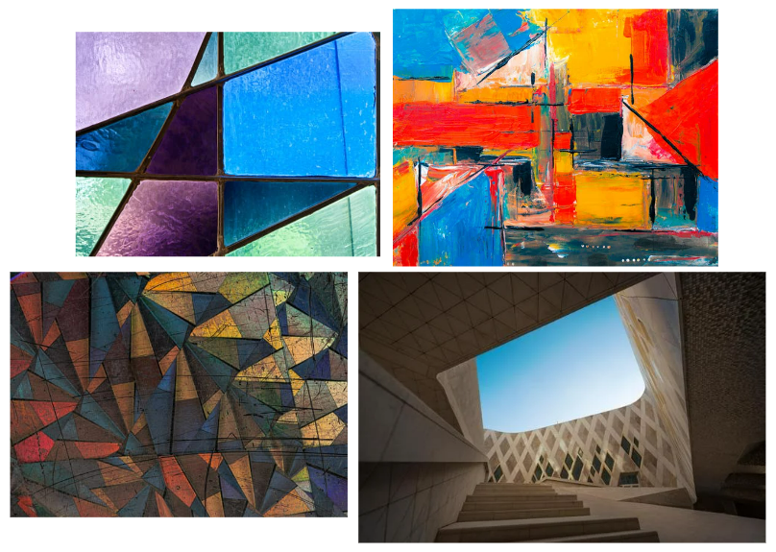

Resource 7 – angles in engineering

Resource 8 – addition problems
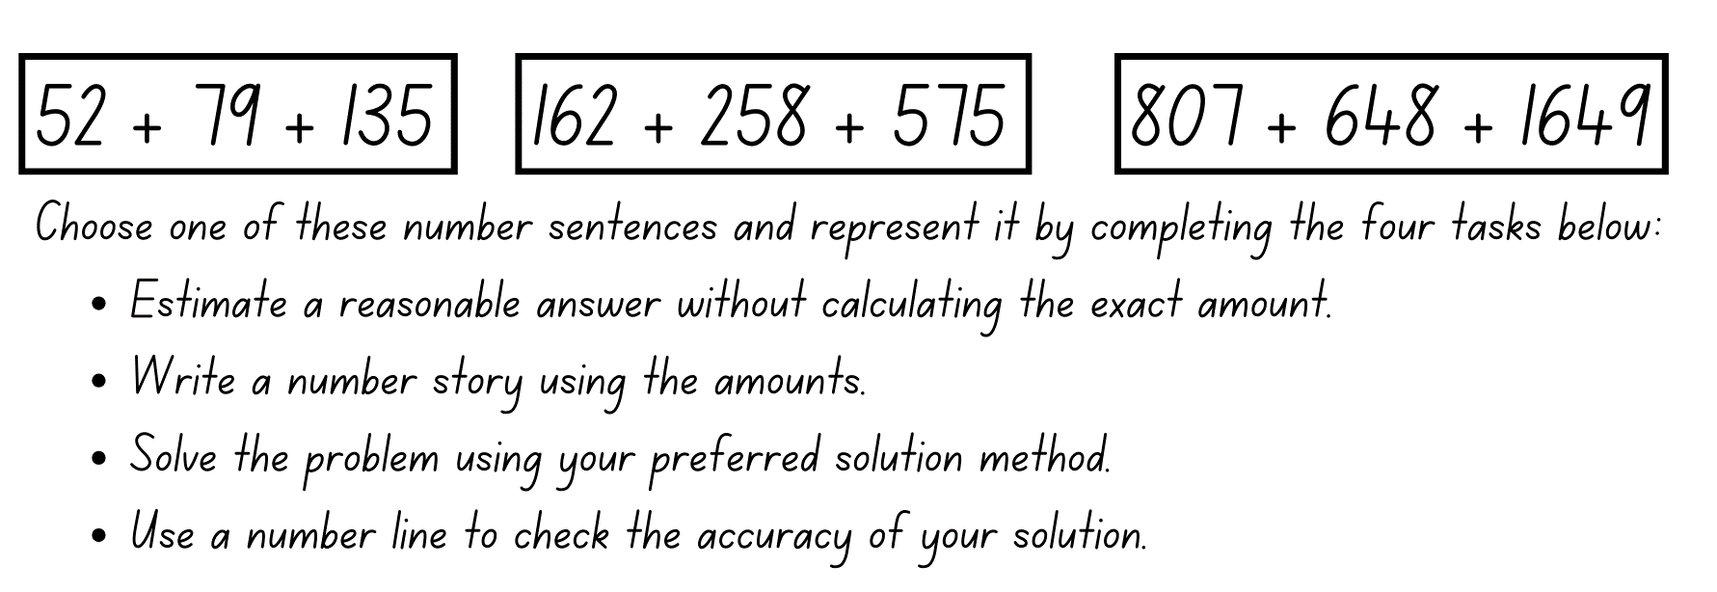

Resource 9 – elapsed times
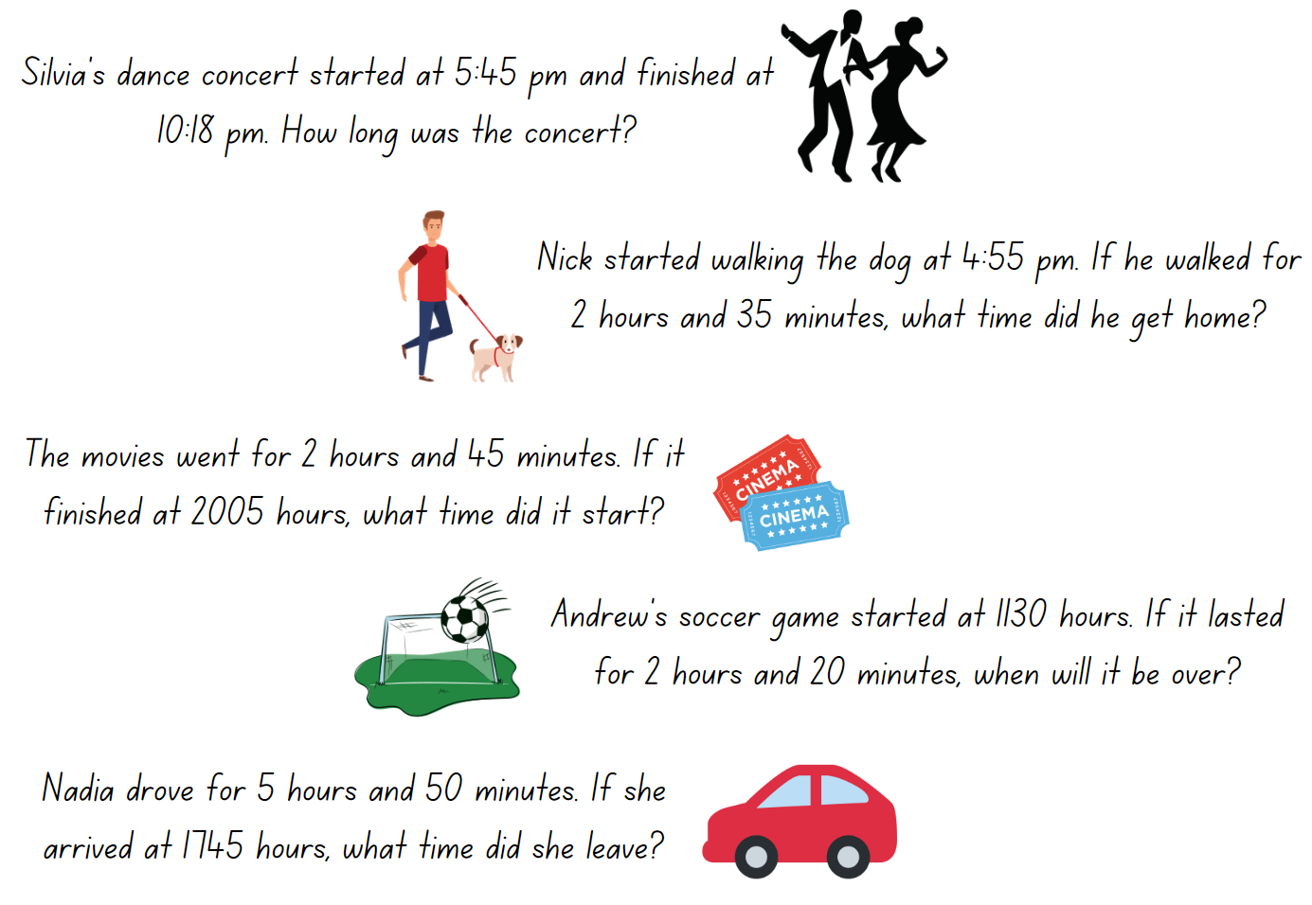

Resource 10 – word problems
Word problems | Working out
Year 6 donated 123 cans of food to the food drive. Year 5 donated 53 more cans of food than Year 6. Year 4 donated 23 less cans than year 6. How many cans did they donate altogether?
Rod wanted to be a photographer. He took 237 photos of nature and 369 of buildings. He added 419 to his portfolio. How many did he not add to his portfolio?
Carolyn has 216 points in darts. On her next throw she scores 180. How many more points does she need to reach 500 points?

Resource 11 – strip

Resource 12 – hour strips
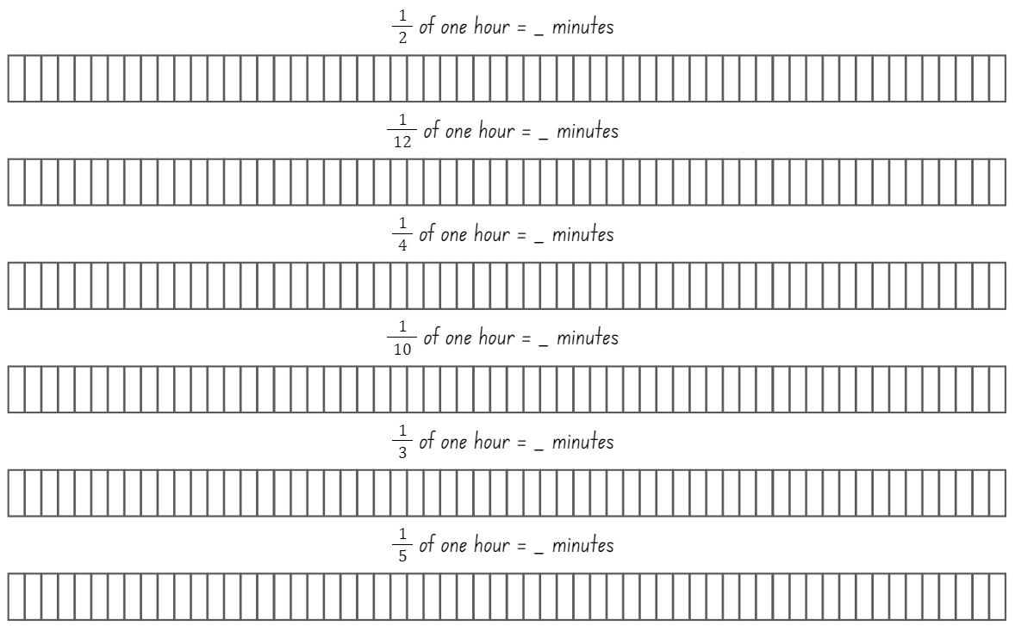

Resource 13 – duration problems
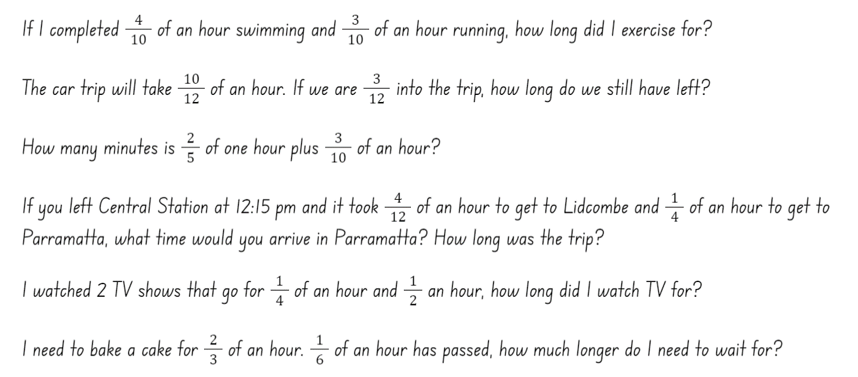

Resource 14 – the zoom strategy
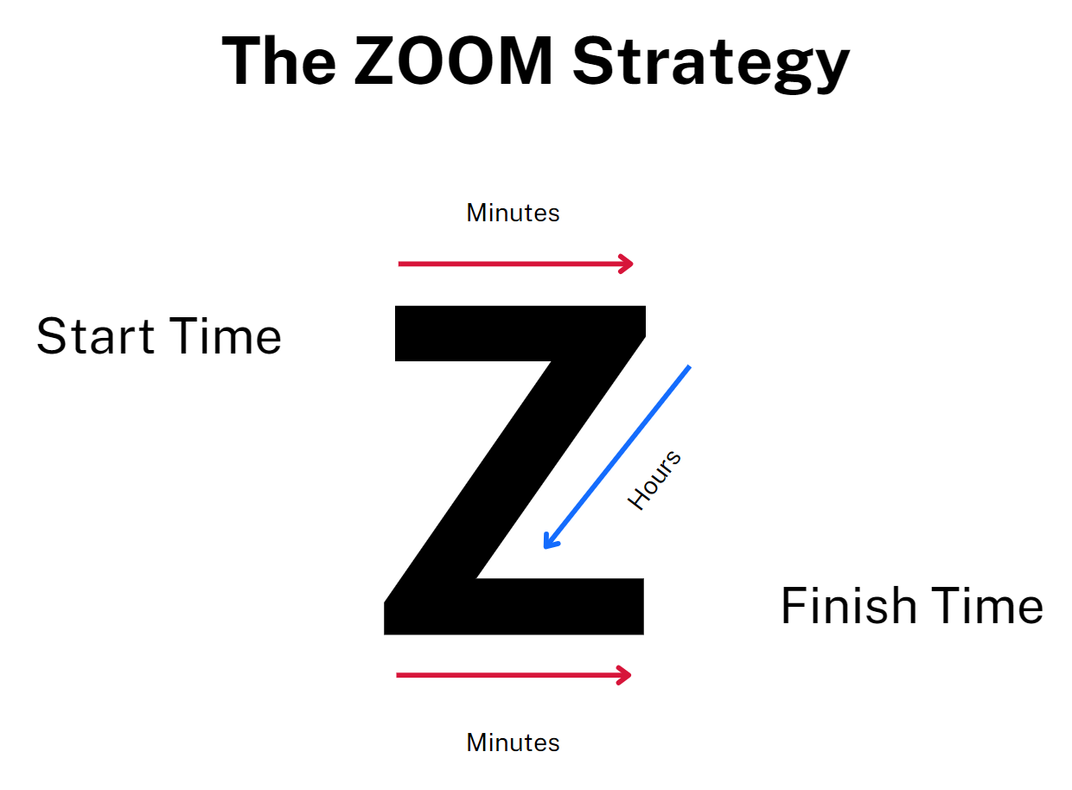

Resource 15 – elapsed timecards
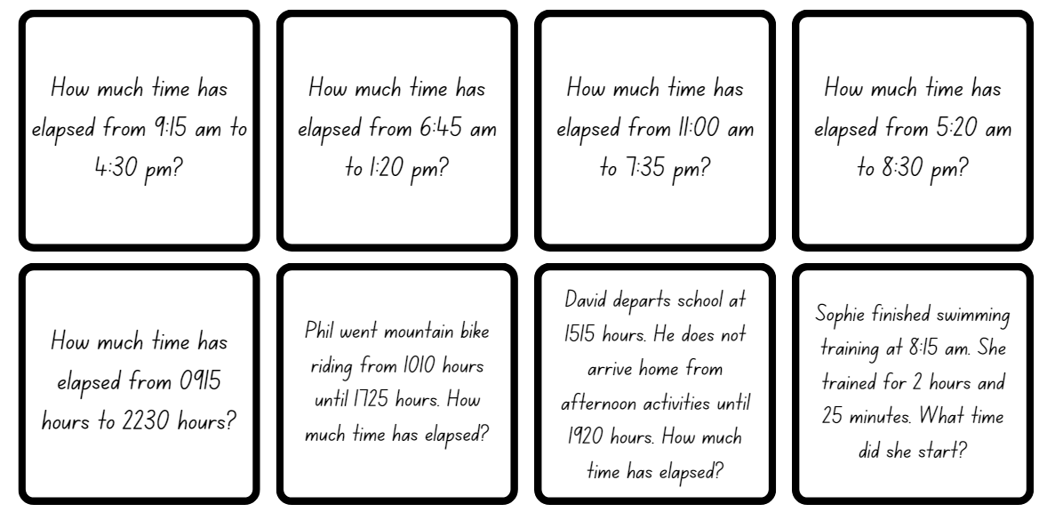

Resource 16 – using Google Maps
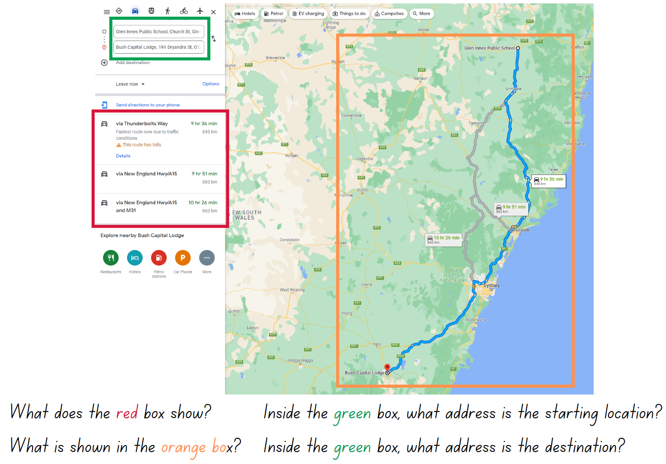
Image source from Google Maps; Glen Innes Public School to Bush Capital Lodge.

Resource 17 – excursion planning
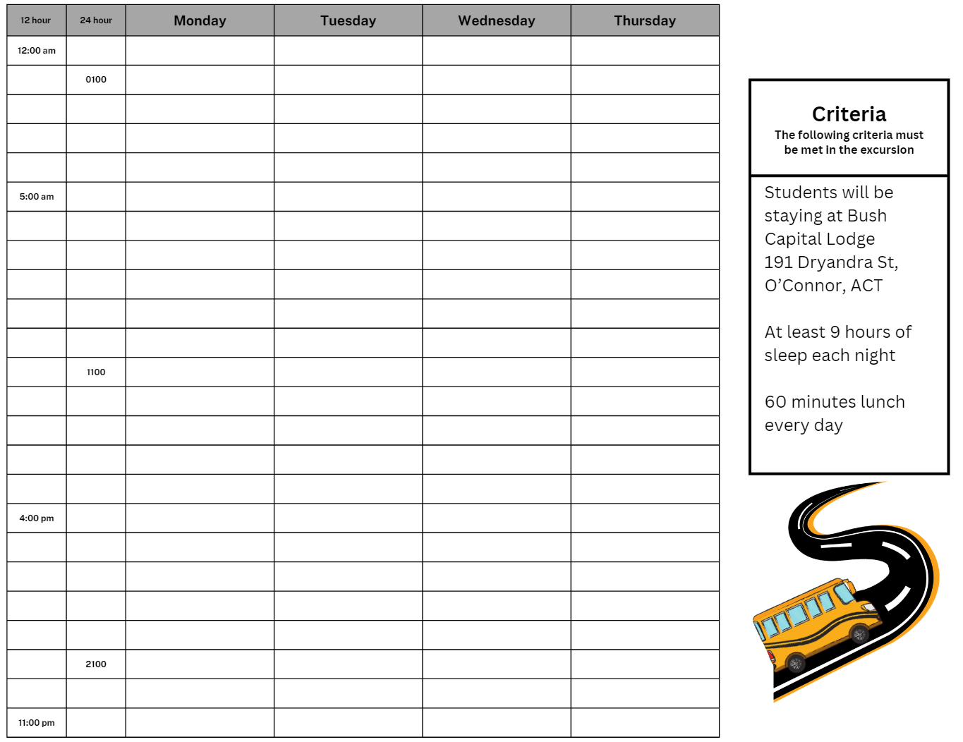

Syllabus outcomes and content
The table below outlines the syllabus outcomes and range of relevant syllabus content covered in this unit. Content is linked to National Numeracy Learning Progression version (3).
Outcomes and content | 1 | 2 | 3 | 4 | 5 | 6 | 7 | 8
Additive relations B: Choose and use efficient strategies to solve addition and subtraction problems
[MAO-WM-01, MA2-AR-01]
- Solve multistep word problems, including problems that require more than one operation |  |  |  |  | x | x
- Compare, evaluate and communicate strategies used to solve addition and subtraction problems |  |  |  |  | x | x | x
Representing quantity fractions B: Compare common fractions with related denominators
[MAO-WM-01, MA3-RQF-01, MA3-RQF-02]
- Create equivalent fractions for half in quarters, eighths, sixths and tenths by re-dividing the whole, using diagrams and number lines |  |  |  |  |  | x
Representing quantity fractions B: Build up to the whole from a given fractional part
[MAO-WM-01, MA3-RQF-01, MA3-RQF-02]
- Generate the whole quantity from non-unit fractional parts such as quarters, eighths, thirds, sixths, fifths and tenths (Reversible reasoning) | x | x | x |  |  | x
Representing quantity fractions B: Use equivalence to add and subtract fractional quantities
[MAO-WM-01, MA3-RQF-01, MA3-RQF-02]
- Solve word problems involving adding or subtracting fractional quantities with related denominators |  |  |  |  |  | x
Geometric measure B: Angles: Investigate angles on a straight line and angles at a point
[MAO-WM-01, MA3-GM-03]
- Recognise right angles, angles on a straight line and angles at a point embedded in diagrams (Reasons about spatial orientation) |  |  |  | x
- Identify the vertex and arms of angles formed by intersecting lines |  | x |  | x
Geometric measure B: Angles: Investigate the relationships formed by the intersection of straight lines
[MAO-WM-01, MA3-GM-03]
- Identify angle types formed by the intersection of straight lines, including right angles (90°), angles on a straight line (add to 180°) and angles at a point that form an angle of revolution (add to 360°) | x | x | x | x
- Recognise that perpendicular lines intersect at right angles (90°) | x | x
- Investigate adjacent angles that form a right angle and establish that they add to 90° |  | x
- Investigate adjacent angles on a straight line and establish that they add to 180° | x | x
- Investigate angles at a point and establish that they form an angle of revolution and add to 360° |  | x | x
Non-spatial measure A: Time: Compare 12- and 24-hour time systems and convert between them
[MAO-WM-01, MA3-NSM-02]
- Recognise that 24-hour time is used to avoid confusion between am and pm |  |  |  |  |  |  |  | x
- Convert between 24-hour time and 12-hour time using am or pm notation |  |  |  |  |  |  |  | x
- Read, interpret and use timetables from real-life situations, involving 12- and 24-hour time |  |  |  |  |  |  |  | x
Non-spatial measure B: Time: Solve problems involving duration, using 12- and 24-hour time
[MAO-WM-01, MA3-NSM-02]
- Use start and finish times to calculate the elapsed time of events |  |  |  |  | x |  | x | x
- Add and subtract time mentally using bridging strategies |  |  |  |  | x |  | x
- Round answers to time calculations to the nearest minute or hour |  |  |  |  |  |  |  | x
- Represent commonly used time intervals as decimals |  |  |  |  |  | x | x
- Solve a variety of problems involving duration, including where times are expressed in 12-hour and 24-hour notation |  |  |  |  | x | x | x | x
Mathematics K–10 Syllabus © NSW Education Standards Authority (NESA) for and on behalf of the Crown in right of the State of New South Wales, 2022.

References
This resource contains NSW Curriculum and syllabus content. The NSW Curriculum is developed by the NSW Education Standards Authority. This content is prepared by NESA for and on behalf of the Crown in right of the State of New South Wales. The material is protected by Crown copyright.
Please refer to the NESA Copyright Disclaimer for more information https://educationstandards.nsw.edu.au/wps/portal/nesa/mini-footer/copyright.
NESA holds the only official and up-to-date versions of the NSW Curriculum and syllabus documents. Please visit the NSW Education Standards Authority (NESA) website https://educationstandards.nsw.edu.au/wps/portal/nesa/home and the NSW Curriculum website https://curriculum.nsw.edu.au/.
Mathematics K–10 Syllabus © NSW Education Standards Authority (NESA) for and on behalf of the Crown in right of the State of New South Wales, 2022.
National Numeracy Learning Progression © Australian Curriculum, Assessment and Reporting Authority (ACARA) 2010 to present, unless otherwise indicated. This material was downloaded from the Australian Curriculum website (National Literacy Learning Progression) (accessed 20 November 2023) and was not modified.
Australian Government Department of Education 2023 (2020) 'Lesson 1: How Many Right Angles', Teaching resources, reSolve website, accessed 14 August 2023.
State of New South Wales (Department of Education) (2023) ‘Let’s get magical (3-digit addition and subtraction)’, Mathematics K–6 resources, NSW Department of Education website, accessed 1 December 2023.
State of Victoria (Department of Education and Training) (n.d) ‘Measure, calculate and compare elapsed time’, FUSE website, accessed 14 August 2023.
The Mathematical Association of Victoria (2020) 3–6: Remote Maths – Edition 2 [PDF 417 KB], MAV Learning Activities website, accessed 14 August 2023.
University of Cambridge (n.d.) Buses, NRICH website, accessed 3 August 2023.

Further reading
Siemon D, Warren E, Beswick K, Faragher R, Miller J, Horne Marj, Jazby D, Breed M, Clark J, Brady K (2022) Teaching Mathematics: Foundation to Middle Years, 3rd edn Oxford University Press, Australia.
Van de Walle J, Karp K, Bay-Williams JM, Brass A, Bentley B, Ferguson S, Goff W, Livy S, Marshman M, Martin D, Pearn C, Prodromou T, Symons D and Wilkie K (2019) Primary and Middle Years Mathematics: Teaching Developmentally, 1st Australian edn, Pearson Education Australia, Melbourne.
Note: the State of Victoria Department of Education and Training website FUSE will redirect to their new platform, ARC Learning, from Term 1 2024. Information about the transition can be found here.

© State of New South Wales (Department of Education), 2024
The copyright material published in this resource is subject to the Copyright Act 1968 (Cth) and is owned by the NSW Department of Education or, where indicated, by a party other than the NSW Department of Education (third-party material).
Copyright material available in this resource and owned by the NSW Department of Education is licensed under a Creative Commons Attribution 4.0 International (CC BY 4.0) license.
This license allows you to share and adapt the material for any purpose, even commercially.
Attribution should be given to © State of New South Wales (Department of Education), 2024.
Material in this resource not available under a Creative Commons license:
- the NSW Department of Education logo, other logos and trademark-protected material
- material owned by a third party that has been reproduced with permission. You will need to obtain permission from the third party to reuse its material.
Links to third-party material and websites
Please note that the provided (reading/viewing material/list/links/texts) are a suggestion only and implies no endorsement, by the New South Wales Department of Education, of any author, publisher, or book title. School principals and teachers are best placed to assess the suitability of resources that would complement the curriculum and reflect the needs and interests of their students.
If you use the links provided in this document to access a third-party's website, you acknowledge that the terms of use, including licence terms set out on the third-party's website apply to the use which may be made of the materials on that third-party website or where permitted by the Copyright Act 1968 (Cth). The department accepts no responsibility for content on third-party websites.

