Mathematics Stage 3 – Year A – Unit 4
Fractions represent multiple ideas and can be represented in different ways

Contents
Unit description and duration 5
Syllabus outcomes 5
Working mathematically 6
Student prior learning 6
Lesson overview and resources 8
Lesson 1 13
Daily number sense – funny fraction lines – 10 minutes 13
Core lesson – fractions on the number line – 40 minutes 15
Consolidation and meaningful practice – 10 minutes 20
Lesson 2 22
Daily number sense – number lines are used to represent fractions – 15 minutes 22
Core lesson – cross-country race – 20 minutes 23
Consolidation and meaningful practice – 15 minutes 25
Lesson 3 27
Daily number sense – pattern block fractions – 10 minutes 27
Core lesson 1 – one as a common whole – 40 minutes 30
Discuss and connect the mathematics – 10 minutes 32
Lesson 4 34
Daily number sense – 10 minutes 34
Core lesson 1 – one as the common whole – 40 minutes 34
Consolidation and meaningful practice – 10 minutes 38
Lesson 5 40
Daily number sense – factors and multiples game – 10 minutes 40
Core lesson – adding fractions – 45 minutes 41
Consolidation and meaningful practice – 10 minutes 46
Lesson 6 48
Daily number sense – 4 products in a row – 15 minutes 48
Core lesson – the answer is… – 35 minutes 50
Consolidation and meaningful practice – 15 minutes 53
Lesson 7 56
Daily number sense – improve your strategies – 15 minutes 56
Core lesson – subtracting fractions – 35 minutes 57
Discuss and connect the mathematics – 10 minutes 60
Lesson 8 63
Daily number sense – 10 minutes 63
Core lesson – beanbag toss – 40 minutes 63
Discuss and connect the mathematics – 10 minutes 66
Resource 1 – funny fraction lines 68
Resource 2 – domino fractions 69
Resource 3 – blank fraction line 70
Resource 4 – How long? 71
Resource 5 – finding fractions 72
Resource 6 – distance travelled (part 1) 73
Resource 7 – distance travelled (part 2) 74
Resource 8 – fraction mosaics 75
Resource 9 – triangle mosaic 76
Resource 10 – fraction wall 77
Resource 11 – bar model 78
Resource 12 – the magic number 79
Resource 13 – magic number differentiation 80
Resource 14 – ‘Product game’ 81
Resource 15 – modified ‘Product game’ 82
Resource 16 – ‘Product game’ questions 83
Resource 17 – making the whole 84
Resource 18 – make 2 groups 85
Syllabus outcomes and content 86
References 89

Unit description and duration
This unit develops the big idea that fractions represent multiple ideas and can be represented in different ways.
In this 2-week unit students are provided opportunities to:
- compare and order fractions using number lines and bar models
- understand what happens when a fraction exceeds a whole
- solve problems involving addition and subtraction of fractions with the same denominator.

Syllabus outcomes
- MAO-WM-01 develops understanding and fluency in mathematics through exploring and connecting mathematical concepts, choosing and applying mathematical techniques to solve problems, and communicating their thinking and reasoning coherently and clearly
- MA3-MR-01 selects and applies appropriate strategies to solve multiplication and division problems
- MA3-RQF-01 compares and orders fractions with denominators of 2, 3, 4, 5, 6, 8 and 10

Working mathematically
In the Mathematics K–10 Syllabus, there is one overarching Working mathematically outcome (MAO-WM-01). The Working mathematically processes should be embedded within the concepts being taught. The Working mathematically processes present in the Mathematics K–10 Syllabus are:
- communicating
- understanding and fluency
- reasoning
- problem solving.
Mathematics K–10 Syllabus © NSW Education Standards Authority (NESA) for and on behalf of the Crown in right of the State of New South Wales, 2022.

Student prior learning
Before engaging in these teaching and learning activities, students would benefit from prior experience with:
- creating fractional and complementary parts of a length
- modelling, labelling and describing fraction families through fraction strips and number lines
- exploring equivalence and multiplicative relationships of fractions.
In NSW classrooms there is a diverse range of students, including Aboriginal and/or Torres Strait Islander students, students learning English as an additional language or dialect, high potential and gifted students and students with disability. Some students may identify with more than one of these groups or possibly all of them. Refer to Curriculum planning for every student – advice for further information.

Lesson overview and resources
The table below outlines the sequence and approximate timing of lessons, learning intentions and resources.
Lesson | Content | Duration and resources
Lesson 1  Daily number sense learning intention:  - compare and order common unit fractions | Lesson core concept: fractions as a number can be placed on a number line.  Core concept learning intentions:  - compare and order common unit fractions  - compare common fractions with related denominators | Lesson duration: 60 minutes  - Resource 1 – funny fraction lines  - Resource 2 – domino fractions  - Resource 3 – blank fraction line (A3 copy per student group)  - Resource 4 – How long?  - Individual whiteboards  - Writing materials
Lesson 2  Daily number sense learning intention:  - compare and order common unit fractions | Lesson core concept: the common whole is 1.  Core concept learning intention:  - compare and order common unit fractions | Lesson duration: 50 minutes  - Resource 5 – finding fractions  - Resource 6 – distance travelled (part 1)  - Resource 7 – distance travelled (part 2)  - Pegs  - String  - Writing materials
Lesson 3  Daily number sense learning intention:  - recognise the role of the number 1 as representing the whole | Lesson core concept: comparing fractional parts of different sized wholes.  Core concept learning intention:  - recognise the role of the number 1 as representing the whole | Lesson duration: 60 minutes  - Resource 8 – fraction mosaics  - Resource 9 – triangle mosaic  - Pattern blocks  - Writing materials
Lesson 4  Daily number sense learning intention:  - teacher-identified task based on student needs | Lesson core concept: unit fractions can be compared and ordered on a number line.  Core concept learning intentions:  - compare and order common unit fractions  - compare common fractions with related denominators | Lesson duration: 60 minutes  - Resource 10 – fraction wall  - Writing materials
Lesson 5  Daily number sense learning intention:  - determine products and factors | Lesson core concept: adding fractions with the same denominator.  Core concept learning intention:  - solve problems involving addition of fractions with the same denominator | Lesson duration: 65 minutes  - Resource 11 – bar model  - Resource 12 – the magic number  - Resource 13 – the magic number differentiation  - Digital device (one per student)  - Writing materials
Lesson 6  Daily number sense learning intention:  - determine products and factors | Lesson core concept: add and subtract fractions with the same denominator.  Core concept learning intention:  - solve problems that involve addition and subtraction of fractions with the same denominator | Lesson duration: 65 minutes  - Resource 14 – ‘Product game’  - Resource 15 – modified ‘Product game’  - Resource 16 – ‘Product game’ questions  - Resource 17 – making the whole  - Resource 18 – make 2 groups  - Digital device (one per student)  - Transparent counters  - Writing materials
Lesson 7  Daily number sense learning intention:  - determine products and factors | Lesson core concept: subtracting fractions with the same denominator.  Core concept learning intention:  - solve problems involving subtraction of fractions with the same denominator | Lesson duration: 60 minutes  - Digital device (one per student)  - Writing materials
Lesson 8  Daily number sense learning intention:  - teacher-identified task based on student needs | Lesson core concept: mathematicians solve problems with fractions.  Core concept learning intention:  - solve problems that involve addition and subtraction of fractions with the same denominator | Lesson duration: 60 minutes  - Beanbags (10 per group)  - Chalk (3 colours per group)  - Measuring tapes  - Metre rulers  - Writing materials

Lesson 1
Core concept: fractions as a number can be placed on a number line.

Daily number sense – funny fraction lines – 10 minutes
Daily number sense activities for Lessons 1 to 3 ‘activate’ prior number knowledge and support the learning of new content in the unit. These activities can also assist teachers to identify the starting points for learning by revealing the extent of students’ existing knowledge.
The table below contains a suggested learning intention and success criteria. These are best co-constructed with students.
Daily number sense learning intention | Daily number sense success criteria
Students are learning to:  - compare and order common unit fractions. | Students can:  - compare and order unit fractions by placing them on a number line.
- Display Resource 1 – funny fraction lines and ask:
- What do you notice about these funny fraction lines?
- Do you think any of these fraction lines would be useful? Why or why not?
- Which fraction line do you think would be the least useful and why?
The table below outlines stimulus prompts to generate conversation about the topic, along with anticipated responses from students.
Prompts | Anticipated student responses
- What do you notice about these funny fraction lines? | - Some have unequal spaces.  - Some of the numbers are missing.
- Do you think any of these fraction lines would be useful? Why or why not? | - Maybe the backwards one because you could just use it from right to left.
- Which fraction line do you think would be the least useful and why? | - I think A is the least useful because the 10 tenths is way less than one whole.
- Refer to example C in Resource 1 – funny fraction lines. Highlight the equally spaced parts representing tenths. Model a number line with the fractions placed correctly as tenths on a number line. Identify where the unit fraction $\frac{1}{10}$ is placed.
- Students use individual whiteboards to place other known unit fractions on a number line.
- Ask students to use their number lines to compare the size of unit fractions. For example, explain how you know $\frac{1}{4}$ is larger than $\frac{1}{10}$.
This table details opportunities for assessment.
Assessment opportunities | Links
What to look for:  - Can students compare and order unit fractions by placing them on a number line? [MAO-WM-01, MA3-RQF-01] | Links to National Numeracy Learning Progressions (NNLP):  - InF6.

Core lesson – fractions on the number line – 40 minutes
The table below contains suggested learning intentions and success criteria. These are best co-constructed with students.
Core concept learning intentions | Core concept success criteria
Students are learning to:  - compare and order common unit fractions  - compare common fractions with related denominators. | Students can:  - compare and order unit fractions with denominators of 2, 3, 4, 5, 6, 8 and 10 by placing them on a number line  - record equivalent fractions using diagrams, words and fraction notation.
- Revise the 2 key ideas in fractional thinking:
- Fractions break up a whole into equal parts. The whole can be a length, a collection or an object, for example half a set of marbles or half a strip of paper. These are known as partitioned fractions.
- Fractions as a number, for example $\frac{1}{2}$, represent halfway between zero and one on the number line. These are known as quantity fractions.
- Explain that fractions can be represented as a fraction of a length and as a number on a number line (see Figure 1).
Figure 1 – fractions of a line and fractions on a line
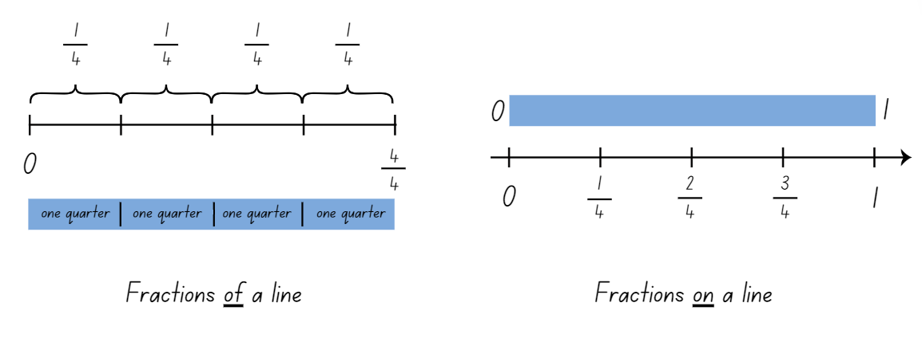
Note: fractions can be represented as a fraction of a length, on a bar model where each segment is labelled as one fractional part of the whole. For example, one-quarter, one-quarter, one-quarter and one-quarter. Fractions can also be represented as numbers on a number line. The distinction between the two is that fractions of a length indicate a part of a line or length and fractions as a number that sit at a point on a number line (Gojak and Miles 2018). The fraction that names a point on the number line describes the distance of that point from zero.
- Remind students that when writing a fraction in symbolic notation, 2 numerals are separated by a line. The numeral up the top (numerator) tells how many equal parts of the whole are selected. The numeral down the bottom (denominator) tells the total number of parts or the whole. Explain that the line represents a division between the numerator and the denominator (see Figure 2).
Figure 2 – fraction notation
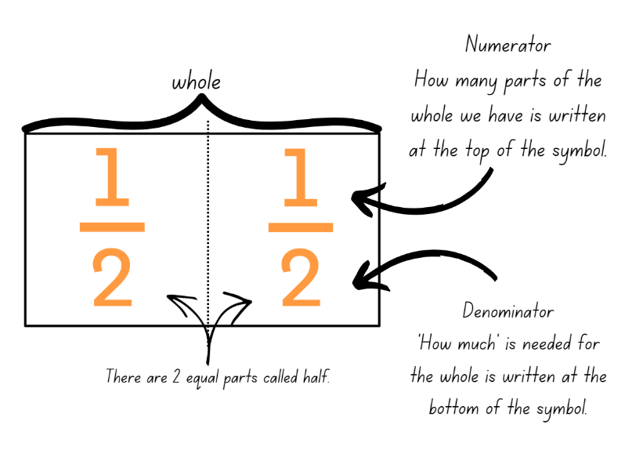
Note: the teaching advice states that to develop a quantitative sense of fractions, the emphasis is on dividing a unit whole rather than simply naming denominators or numerators. For example, rather than the fraction $\frac{1}{3}$ being described as having a numerator of 1 and a denominator of 3, understanding of $\frac{1}{3}$ is developed as the number resulting from dividing a unit whole by 3. Students were introduced to fraction notation in Stage 2 Unit 24.
- Draw a number line from 0–1 on the board. Make a mark at the one-quarter point on the line and have students identify a fraction that could be placed at that point. The fraction represents how far away from zero the point on the number line is.
- Ask students to suggest ways to name that fraction, for example, $\frac{1}{4}$ or $\frac{2}{8}$. Explain that 2 fractions are equivalent (equal) if they are the same size, or the same point on a number line.
- Provide small groups with Resource 2 – domino fractions and an A3 copy of Resource 3 – blank fraction line.
- Students take turns to choose a domino and place the fraction represented by the domino on the number line (see Figure 3).
Figure 3 – domino fractions on number line
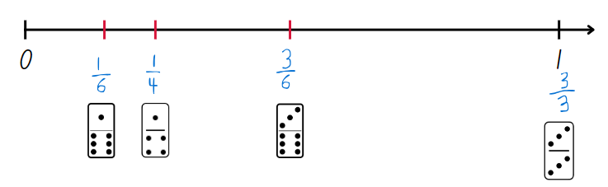
- Regroup and select students to explain the fractions represented on the domino and how they knew where to place them on the number line.
- Ask students if fractions can be represented on a number line that goes beyond one and if anyone can think of an example.
- Draw a blank number line from 0–2 on the board and ask students where the following fractions would be placed on the line:
- one-half
- three-halves
- two-quarters
- six-quarters
- two-thirds
- four-thirds.
- Using the fraction line, discuss how each fraction can be named in more than one way. Circle or highlight the following:
- one-half, two-halves, that makes one whole; three-halves, four-halves, that makes 2.
- one-third, two-thirds, 3 thirds, that is equal to one; four-thirds, five-thirds, six-thirds, that makes 2. Six-thirds can be named as 2 wholes.
- one-quarter, two-quarters, three-quarters, four-quarters, that makes one.
- Support students to make connections between fractions and wholes, for example, 7 quarters make one whole and 3 more quarters. Model the symbolic notation for this fraction as 1 $\frac{3}{4}$.
This table details opportunities for differentiation.
Too hard? | Too easy?
Students cannot compare and order unit fractions with denominators of 2, 3, 4, 5, 6, 8 and 10 by placing them on a number line or record equivalent fractions using diagrams, words and fraction notation.  - Students fold the 0–1 fraction line to find halves, thirds and quarters and mark them on the 0–1 line.  - Students use the $\frac{1}{1}$, $\frac{1}{2}$, $\frac{1}{4}$ dominoes and place them on the number line. | Students can compare and order unit fractions with denominators of 2, 3, 4, 5, 6, 8 and 10 by placing them on a number line and record equivalent fractions using diagrams, words and fraction notation.  - Students extend the fraction line beyond 2 and mark additional fractions, creating their own domino tiles.  - Students use a digital device and access Bigger than and smaller than – Maths Venns to compare fractions.

Consolidation and meaningful practice – 10 minutes
- Display Resource 4 – How long? and ask students how long the coloured strip of paper is. Responses could include:
- It is bigger than one but smaller than 2.
- It looks like one and then another third.
- It is four-thirds.
- Students turn and talk and discuss how answers could be checked to ensure accuracy.
This table details opportunities for assessment.
Assessment opportunities | Links
What to look for:  - Can students compare and order unit fractions with denominators of 2, 3, 4, 5, 6, 8 and 10 by placing them on a number line?  [MAO-WM-01, MA3-RQF-01, MA3-RQF-02]  - Can students record equivalent fractions using diagrams, words and fraction notation?  [MAO-WM-01, MA3-RQF-01, MA3-RQF-02] | Links to National Numeracy Learning Progressions (NNLP):  - InF5, InF6.

Lesson 2
Core concept: the common whole is 1.

Daily number sense – number lines are used to represent fractions – 15 minutes
The table below contains a suggested learning intention and success criteria. These are best co-constructed with students.
Daily number sense learning intention | Daily number sense success criteria
Students are learning to:  - compare and order common unit fractions. | Students can:  - compare and order fractions with denominators of 2, 3, 4, 5, 6, 8 and 10.
- Display Resource 5 – finding fractions. Explain that students are going to use a number line to order these fractions from smallest to largest. Ask:
- Which fraction cards might you place first? Explain your thinking.
- What are the challenges of placing them all on the same number line?
- Provide small groups with Resource 5 – finding fractions, pegs and string. Students place their fractions on the number line. Observe student strategies, supporting students to record zero and one on the number line first.
- If necessary, model using a half and a quarter as benchmark fractions to assist in placing other fractions on the number line.
- Regroup and ask:
- Which fractions were easiest to place and which were more challenging? Why?
- Did you group any fractions to make them easier to place? For example, halves, quarters and eighths.
- How can you prove that $\frac{1}{5}$ is smaller than $\frac{1}{2}$? Explain your thinking.
- This table details opportunities for assessment.
Assessment opportunities | Links
What to look for:  - Can students compare and order fractions with denominators of 2, 3, 4, 5, 6, 8 and 10? [MAO-WM-01, MA3-RQF-01] | Links to National Numeracy Learning Progressions (NNLP):  - InF6.

Core lesson – cross-country race – 20 minutes
The table below contains a suggested learning intention and success criteria. These are best co-constructed with students.
Core concept learning intention | Core concept success criteria
Students are learning to:  - compare and order common unit fractions. | Students can:  - compare unit fractions as numbers to the benchmark value $\frac{1}{2}$  - compare and order unit fractions by placing them on a number line.
- Display Resource 6 – distance travelled (part 1) and explain to students that the number lines show how far each student has run in the cross-country race.
- Explain that the one on each number line represents the common whole, which in this scenario is the entire distance of the race. Ask students to consider how far Amira has run and identify that this mark (placed exactly halfway between zero and one) represents $\frac{1}{2}$, so Amira has completed half of the race.
- Provide students with Resource 6 – distance travelled (part 1) and Resource 7 – distance travelled (part 2). Students label the number lines with the fraction that represents how much of the race each student has completed.
- Students determine what fraction of the distance is left for each student to complete the run (the complementary fractional part).
- Regroup as a class and ask:
- How did the benchmark value of $\frac{1}{2}$ help you identify the other unit fractions?
- Consider Jake and Omar’s distances. In terms of equivalent fractions, what is $\frac{1}{4}$ also known as? (two-eighths)
- Consider Maissa and Niamh’s distances. What is $\frac{1}{3}$ also known as? (two-sixths)
This table details opportunities for differentiation.
Too hard? | Too easy?
Students cannot compare unit fractions as numbers to the benchmark value $\frac{1}{2}$ or compare and order unit fractions by placing them on a number line.  - Label half on each number line for students to use as a benchmark to locate other unit fractions.  - Reduce the number lines used to those with fractions of half, quarter and eighth. Revise the use of repeated halving. | Students can compare unit fractions as numbers to the benchmark value $\frac{1}{2}$ and compare and order unit fractions by placing them on a number line.  - Students label non-unit fractions on the number line. For example, $\frac{2}{3}$, $\frac{3}{5}$, $\frac{6}{8}$.

Consolidation and meaningful practice – 15 minutes
- Draw a number line on the board from 0–1. Select students to place a mark on the line to represent these unit fractions: $\frac{1}{8}$, $\frac{1}{6}$, $\frac{1}{5}$, $\frac{1}{4}$, $\frac{1}{3}$, $\frac{1}{2}$. See Figure 4.
Figure 4 – marked number line
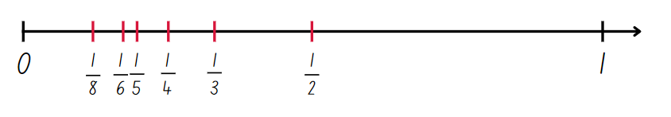
- Explain that by placing fractions on a number line, their position and relationship to the common whole, one, can be seen. On a number line fractions can be ordered and compared by size.
- Pose the scenario: Adrian says this number line is incorrect because the fractional marks are not equally spaced along the line. Is he correct? Prompt students to explain their answer and communicate their reasoning.
This table details opportunities for assessment.
Assessment opportunities | Links
What to look for:  - Can students compare unit fractions as numbers to the benchmark value $\frac{1}{2}$? [MAO-WM-01, MA3-RQF-01]  - Can students compare and order unit fractions by placing them on a number line? [MAO-WM-01, MA3-RQF-01] | Links to National Numeracy Learning Progressions (NNLP):  - InF5, InF6, InF7.  Links to suggested Interview for Student Reasoning (IfSR) tasks:  - IfSR-PT: 1A.2, 1A.3  - IfSR-MT: 3B.3, 3B.4.

Lesson 3
Core concept: comparing fractional parts of different sized wholes.

Daily number sense – pattern block fractions – 10 minutes
The table below contains a suggested learning intention and success criteria. These are best co-constructed with students.
Daily number sense learning intention | Daily number sense success criteria
Students are learning to:  - recognise the role of the number 1 as representing the whole. | Students can:  - compare thirds of different sized wholes  - justify the need for fractions to refer to the number 1 as the common whole.
Note: representing quantity fractions on the number line as numbers, rather than parts of a set of discrete items, relies on identifying ‘1’ as the abstract numerical unit that all numbers, including fractions, reference.
- Select a yellow hexagonal pattern block and state that for this task, the yellow hexagon represents one whole. One whole is always represented as ‘1’ on the number line.
- Provide pairs with a collection of pattern blocks and have them determine the fractional part of the red, blue and green blocks in relation to the yellow hexagon, one whole. (red = $\frac{1}{2}$, blue = $\frac{1}{3}$ and green =$\frac{1}{6}$).
- Model recording these fractions on a number line.
- Ask students to place a blue block on top of a yellow block and a green block on a red block (see Figure 5). Students Think-Pair-Share what they notice and what they wonder about these fractional representations.
Figure 5 – pattern block example
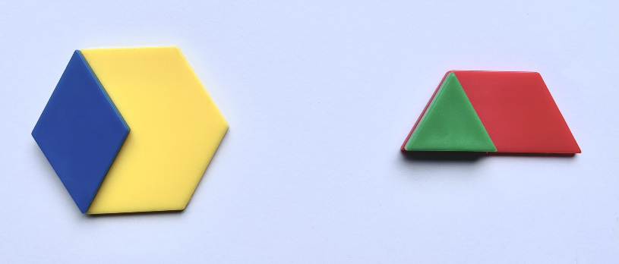
The table below outlines stimulus prompts to generate conversation about the topic, along with anticipated responses from students.
Prompts | Anticipated student responses
- What did you notice? | - Both show one-third of a whole.  - I can see each represents one-third of the whole block because if I had 3 blue rhombuses, I would cover the whole yellow block.  - The third represented by the blue rhombus is larger than the third represented by the green triangle.  - If I placed the blue rhombus in a different position on the yellow hexagon, or the green triangle in a different position on the red trapezium, it would still represent a third.
- What did you wonder? | - I wonder if these representations show equivalent fractions?  - I wonder if I placed a blue rhombus on the red trapezium, would it still represent one-third of the whole?
This table details opportunities for assessment.
Assessment opportunities | Links
What to look for:  - Can students compare thirds of different sized wholes?  [MAO-WM-01, MA3-RQF-01]  - Can students justify the need for fractions to refer to the number 1 as the common whole? [MAO-WM-01, MA3-RQF-01] | Links to National Numeracy Learning Progressions (NNLP):  - InF5.

Core lesson 1 – one as a common whole – 40 minutes
The table below contains a suggested learning intention and success criteria. These are best co-constructed with students.
Core concept learning intention | Core concept success criteria
Students are learning to:  - recognise the role of the number 1 as representing the whole. | Students can:  - compare halves and quarters of different sized wholes
- Pose the following: Emilia ate $\frac{1}{4}$ of a cake and Abdullah ate $\frac{1}{2}$ of a cake. Emilia says that she ate more than Abdullah. How could this be true?
- Students turn and talk and discuss possibilities of how this could be true. Revise that when there are different sized wholes, the size of the fractional parts is dependent on the size of the whole.
- Provide pairs with a collection of pattern blocks and have them model Emilia and Abdullah’s shares of different sized cakes (see Figure 6).
Figure 6 – possible student work sample
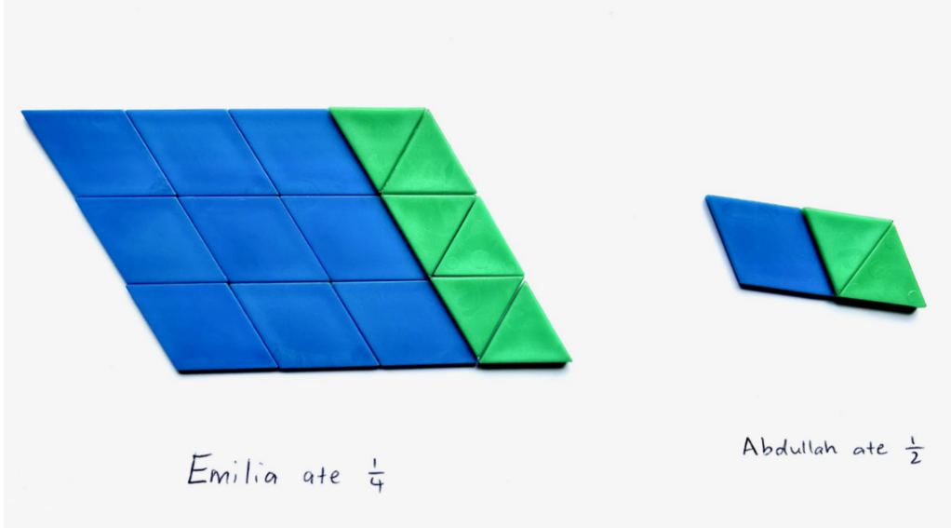
- Choose a student work sample to use as an example and model that when comparing different sized wholes, the size of the fractional parts will be different as they are proportional to the whole.
- Students explore ways to represent $\frac{1}{2}$ of a cake as smaller than $\frac{1}{3}$ of a different-sized cake using pattern blocks.
- Display and provide pairs with Resource 8 – fraction mosaics.
- Refer to image A and ask students to turn and talk and identify what the green part would be as a fraction of the whole ($\frac{1}{10}$).
- Ask students to determine and label the fraction represented by the colour green in each image. Support the use of fractional language such as whole, equivalent, equal to, thirds, one-third, sixths, two-fifths, partition and so on.
- Repeat the process, determining and labelling the fraction represented by the colour red in each image.
- Refer to images B and F on Resource 8 – fraction mosaics. Highlight that the red fractional part in B is $\frac{1}{3}$ and the red fractional part in F is $\frac{1}{2}$. Ask students to Think-Pair-Share and justify how this is true.
This table details opportunities for differentiation.
Too hard? | Too easy?
Students cannot compare halves and quarters of different sized wholes  - Recreate image D from Resource 8 – fraction mosaics using pattern blocks. Make an additional mosaic using 2 red blocks and 6 green blocks. Support students to see that each mosaic is one whole and that each whole consists of half green and half red, despite the increase in block numbers. | Students can compare halves and quarters of different sized wholes.  - Challenge students to determine the fractional part of the blue, yellow and red blocks on Resource 8 – fraction mosaics.  - Students create their own pattern block investigation and record it on isometric paper. Students work out the fractions represented by each colour of their own pattern block mosaics.

Discuss and connect the mathematics – 10 minutes
- Display Resource 9 – triangle mosaic. Ask:
- What fraction of the whole shape is represented by one green triangle block?
- What fraction of the whole shape is green?
- What fraction of the whole shape is represented by one red trapezium block?
- What fraction of the whole shape is red?
- Ask which fractions could be made if the whole shape was changed and was instead made from 2 red trapeziums and 2 green triangles?
This table details opportunities for assessment.
Assessment opportunities | Links
What to look for:  - Can students compare halves and quarters of different sized wholes? [MAO-WM-01, MA3-RQF-01] | Links to National Numeracy Learning Progressions (NNLP):  - InF5.

Lesson 4
Core concept: unit fractions can be compared and ordered on a number line.

Daily number sense – 10 minutes
- From a class need surfaced through formative assessment data, identify a short, focused activity that targets students’ knowledge, understanding and skills. Example activities may be drawn from the following resources:
- Mathematics K–6 resources
- Universal Resources Hub.

Core lesson 1 – one as the common whole – 40 minutes
The table below contains suggested learning intentions and success criteria. These are best co-constructed with students.
Core concept learning intentions | Core concept success criteria
Students are learning to:  - compare and order common unit fractions  - compare common fractions with related denominators. | Students can:  - compare unit fractions as numbers to the benchmark value$\frac{1}{2}$  - record equivalent fractions using diagrams, words and fraction notation.
Note: less than (<) and greater than (>) symbols are not specifically referenced in the Mathematics K–10 Syllabus but are important symbols for student to understand. This lesson provides an opportunity for students to use these symbols in context.
- Draw a number line on the board from 0–1. Identify and label some benchmark fractions. Explain that when fractions are represented on a number line, they always refer to the number 1 as the common whole. When the whole equals one, fractions can be compared, ordered, added and subtracted.
- Students draw a line across the width of their page. They partition and label a number line from 0–1 into tenths.
- Display Resource 10 – fraction wall and have students identify equivalent fractions for $\frac{5}{10}$ of 1 ($\frac{1}{2}$, $\frac{2}{4}$, $\frac{3}{6}$, $\frac{4}{8}$).
- Students label their number line with equivalent fractions for quarters and thirds.
- Recreate Figure 7 on the board and have students use their number line and writing materials to find a solution.
Figure 7 – equivalent fractions
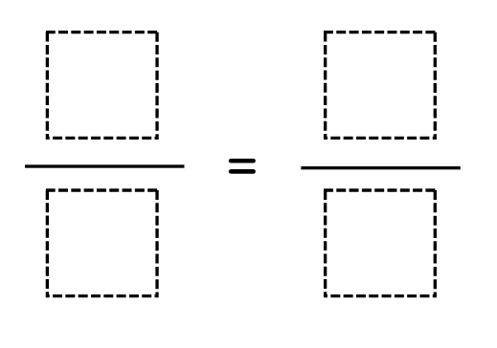
- Ask:
- How do you know that these are equivalent fractions?
- What do you notice about the denominators?
- Is there more than one correct answer for a single fraction?
- Can you think of any other equivalent fractions that are not represented on your number line?
- Using the benchmark value $\frac{1}{2}$, students compare unit fractions by using the greater than and less than symbols to create number sentences. Ask students to record multiple solutions (see Figure 8).
Figure 8 – greater than and less than
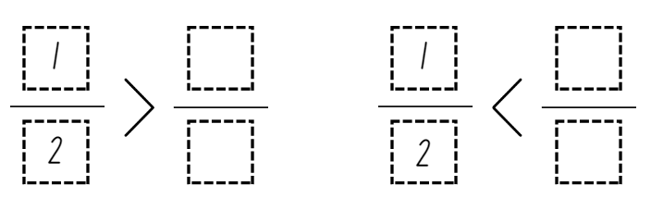
- Regroup and select students to share their solutions by adding the fractions onto a number line labelled 0–1 on the board.
- Discuss the chosen numerators and denominators for each of the missing fractions and ask students to explain why the fraction is greater than or less than half.
This table details opportunities for differentiation.
Too hard? | Too easy?
Students cannot compare unit fractions as numbers to the benchmark value $\frac{1}{2}$.  - Model naming and labelling some benchmark fractions on a number line.  - Model using the fraction wall to identify fractions smaller and larger than $\frac{1}{2}$. | Students can compare unit fractions as numbers to the benchmark value $\frac{1}{2}$.  - Students complete greater than or less than number sentences using a variety of benchmark fractions.  - Students compare non-unit fractions to $\frac{1}{2}$and identify which is larger or smaller.

Consolidation and meaningful practice – 10 minutes
- Reproduce Figure 9 on the board and ask students to copy it into their books.
Figure 9 – greater than
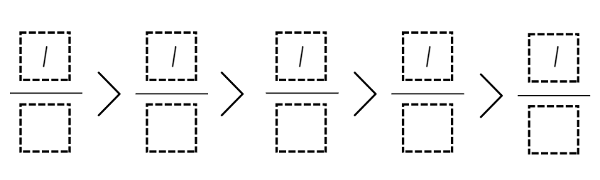
- Students share what they notice about the numerator for each fraction.
- Students select a denominator for each fraction to make the number sentence true. They can use fractions from their number lines or the fraction wall, or they can choose other fractions. For example, student responses may include $\frac{1}{3}$ > $\frac{1}{4}$> $\frac{1}{5}$ > $\frac{1}{8}$ > $\frac{1}{10}$ or $\frac{1}{1}$ >$\frac{1}{10}$ > $\frac{1}{100}$ > $\frac{1}{1 000}$ > $\frac{1}{10 000}$.
- When students have explored this, ask:
- What did you notice about the size of the parts (denominator)? With unit fractions, the greater the denominator, the smaller the fractional parts.
- Would it be easier or more challenging to complete this task if you could use choose your own numerators?
- How many unit fractions fall between 0–1 on a number line? (An infinite number.)
This table details opportunities for assessment.
Assessment opportunities | Links
What to look for:  - Can students compare unit fractions as numbers to the benchmark value $\frac{1}{2}$? [MAO-WM-01, MAMA3-RQF-01]  - Can students record equivalent fractions using diagrams, words and fraction notation? [MAO-WM-01, MA3-RQF-01,  MA3-RQF-02] | Links to National Numeracy Learning Progressions (NNLP):  - InF5, InF6, InF7.  Links to suggested Interview for Student Reasoning (IfSR) tasks:  - IfSR-PT: 1A.2, 1A.3  - IfSR-MT: 3B.3, 3B.4.

Lesson 5
Core concept: adding fractions with the same denominator.

Daily number sense – factors and multiples game – 10 minutes
Daily number sense activities for Lessons 5 to 7 ‘loop’ back to concepts and procedures covered in previous units to assist students to build an increasingly connected network of ideas. These concepts may differ from the core concepts being covered by the unit.
The table below contains a suggested learning intention and success criteria. These are best co-constructed with students.
Daily number sense learning intention | Daily number sense success criteria
Students are learning to:  - determine products and factors. | Students can:  - determine factors for a given whole number.
This activity is an adaptation of Factors and Multiples Game from NRICH by University of Cambridge.
- Model the interactive game Factors and Multiples. Choose an even number less than 50 and cross it out on the grid. Then choose a number to cross out that is a factor or multiple of the first number.
- Continue to play, modelling the language of factors and multiples. See how many numbers can be crossed out in the time available. Keep a record of this number as students will probably want to play this game multiple times.
- Some students may enjoy the challenge of playing the game in pairs, with the last person able to cross out a number being the winner.
This table details opportunities for assessment.
Assessment opportunities | Links
What to look for:  - Can students determine factors for a given whole number?  [MAO-WM-01, MA3-MR-01] | Links to National Numeracy Learning Progressions (NNLP):  - MuS6, MuS7.

Core lesson – adding fractions – 45 minutes
The table below contains a suggested learning intention and success criteria. These are best co-constructed with students.
Core concept learning intention | Core concept success criteria
Students are learning to:  - solve problems involving addition of fractions with the same denominator. | Students can:  - represent the sum of fractions with the same denominator, recreating the whole, where the result may exceed one.
- Ask students to relate what they know about using bar models to solve problems. Facilitate the discussion using the following points:
- Bar models help to visualise parts of a whole.
- Bar models show one whole divided into two or more parts.
- The bar model can be used to find one part when given the whole and other parts, or to find the whole when given the parts. Sometimes, the parts are equal.
- Display Resource 11 – bar model and ask students to Think-Pair-Share what they notice and what they wonder about the bar model image. Explain that the image could represent $\frac{1}{5}$ + $\frac{2}{5}$ = $\frac{3}{5}$ or $\frac{1}{5}$ + $\frac{2}{5}$+ $\frac{2}{5}$ = $\frac{5}{5}$. Record the fraction notation on the board.
- Explain that bar models can be useful when adding and subtracting fractions.
- Model using Amplify Polypad – Fraction Bars to demonstrate adding fractions (with the same denominator) on a bar model. Use an orange $\frac{1}{1}$ bar to provide a visual for the common whole (see Figure 10).
Figure 10 – bar model for addition
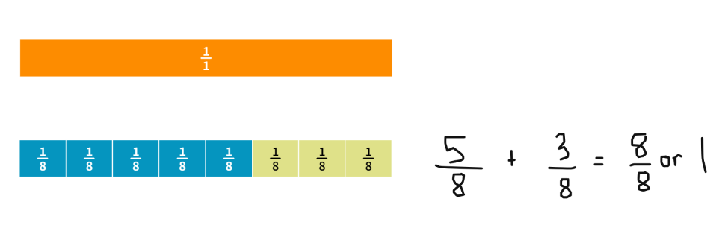
Image created using the free virtual manipulatives at Polypad by Amplify.
- Ask students to turn and talk and share why $\frac{8}{8}$ is equal to 1. (When the numerator and denominator are the same, they represent one whole.)
Note: watch the tutorial Colour Mixing Fraction Bars (1:42) to learn how to split the individual fraction parts and change the colours.
- Provide students with a digital device and ask them to represent the following using bar models and fraction notation on Amplify Polypad – Fraction Bars:
- $\frac{1}{4}$ + $\frac{3}{4}$
- $\frac{2}{6}$ +$\frac{4}{6}$
- $\frac{7}{8}$ +$\frac{1}{8}$
- $\frac{2}{5}$ + $\frac{3}{5}$
- Regroup as a class and model representing the sum of fractions where the result exceeds one (see Figure 11).
Figure 11 – exceeding the whole
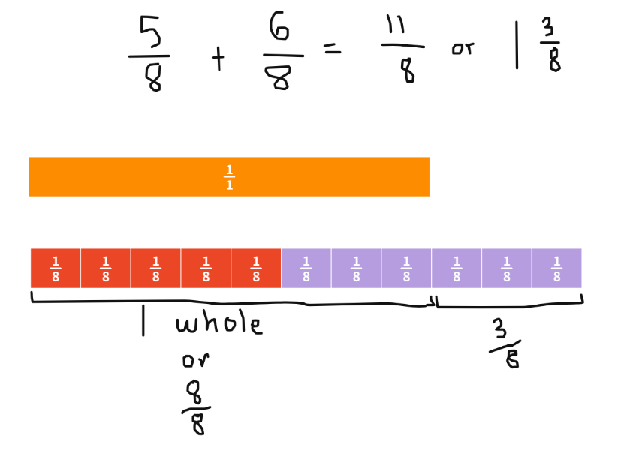
Image created using the free virtual manipulatives at Polypad by Amplify.
Note: in the syllabus, the expression ‘fraction greater than one’ is used instead of the terms improper fraction or mixed numeral.
- Explain that $\frac{11}{8}$ is equal to one whole and 3 more eighths. This can be written as 1 $\frac{3}{8}$.
- Students return to their digital device and represent the following questions where the result exceeds one whole.
- $\frac{4}{5}$ + $\frac{3}{5}$
- $\frac{7}{8}$ + $\frac{5}{8}$
- $\frac{5}{6}$ + $\frac{3}{6}$
- $\frac{2}{3}$ + $\frac{2}{3}$
- Allow students to explore and represent their own fraction sums using the bar model on Amplify Polypad – Fraction Bars.
This table details opportunities for differentiation.
Too hard? | Too easy?
Students cannot represent the sum of fractions with the same denominator or recreate the whole where it exceeds one.  - Support students to use a fraction wall or fraction tiles to recreate the sum of fractions.  - Students use fraction strips to cut and colour each of the fraction parts. Discuss the equal parts that exceed the whole and label the fraction, representing the sum where the solution exceeds one. | Students can represent the sum of fractions with the same denominator or recreate the whole where it exceeds one.  - Students investigate a fraction sum involving 3 or 4 addends.  - Students add fractions with related denominators.  - Students create a challenging word problem where the solution exceeds 2 wholes for a partner to solve.

Consolidation and meaningful practice – 10 minutes
This activity is an adaption of Magic Square Fun from Learn-With-Math-Games.com.
- Display Resource 12 – the magic number. This is a form of sudoku puzzle where each fraction needs to be placed in a box so that when added, the lines adds up to 3.
- Ask students to look at the fractions available and share what they notice. (All fractions are fifths.)
- Explain that the magic number is 3. Students think, pair, share another way to make 3 wholes by adding the fractional parts. ($\frac{15}{5}$)
- Provide pairs with writing materials and ask them to solve the puzzle.
- Regroup and select students to share their strategies and solutions.
This table details opportunities for differentiation.
Too hard? | Too easy?
Students cannot represent the sum of fractions with the same denominator or recreate the whole where it exceeds one.  - Students investigate one whole as the magic number using Resource 13 – the magic number differentiation Challenge level 1. | Students can represent the sum of fractions with the same denominator or recreate the whole where it exceeds one.  - Students investigate adding fractions with related denominators using Resource 13 – the magic number differentiation Challenge levels 2 and 3.  - Students create their own grid with a number greater than one as the magic number.
This table details opportunities for assessment.
Assessment opportunities | Links
What to look for:  - Can students represent the sum of fractions with the same denominator, recreating the whole, where the result may exceed one? [MAO-WM-01, MA3-RQF-01] | Links to National Numeracy Learning Progressions (NNLP):  - InF7, InF8.

Lesson 6
Core concept: add and subtract fractions with the same denominator.

Daily number sense – 4 products in a row – 15 minutes
The table below contains a suggested learning intention and success criteria. These are best co-constructed with students.
Daily number sense learning intention | Daily number sense success criteria
Students are learning to:  - determine products and factors. | Students can:  - use the term product to describe the result of multiplying 2 or more numbers  - model different ways to show a whole number as a product.
This activity is an adaptation of Product Game from the National Council of Teachers of Mathematics.
- Display Product Game.
- Explain that the aim is to get 4 squares in a row vertically, horizontally, or diagonally by multiplying 2 numbers each time to find a product. Explain that the term product is used to describe the result (answer) of multiplying 2 or more numbers.
- Model the game as Player 1 and the computer as Player 2. To begin the game, Player 1 moves a marker (a green square) to a number in the factor list from 1–9 along the bottom of the screen.
- Player 2 will move the other marker (also a green square) to any number in the factor list. This includes the number marked by Player 1. Students determine the product of the 2 marked numbers and colour them red for Player 2.
- Player 1 moves a marker to another number and colours the new product blue.
- Players take turns moving a marker. Each product is marked red or blue, depending on the player. Note, if a product is already coloured, the player does not get a square for that turn.
- Play continues until one player finds 4 products in a vertical, horizontal or diagonal row, or until all squares have been coloured.
Note: if there is no access to the interactive gameboard, play the game using Resource 14 – ‘Product game’ and transparent counters.
- Distribute devices to students. Students play the game in pairs. Some students may enjoy playing a more challenging version of the game using Resource 15 – modified ‘Product game’.
- Display Resource 16 – ‘Product game’ questions, and have students discuss these as they finish their game.
This table details opportunities for assessment.
Assessment opportunities | Links
What to look for:  - Can students use the term product to describe the result of multiplying 2 or more numbers? [MAO-WM-01, MA3-MR-01]  - Can students model different ways to show a whole number as a product? [MAO-WM-01, MA3-MR-01] | Links to National Numeracy Learning Progressions (NNLP):  - MuS6, MuS8.

Core lesson – the answer is… – 35 minutes
The table below contains suggested learning intentions and success criteria. These are best co-constructed with students.
Core concept learning intentions | Core concept success criteria
Students are learning to:  - solve problems that involve addition and subtraction of fractions with the same denominator. | Students can:  - represent the sum of fractions with the same denominator, recreating the whole, where the result may exceed one  - solve word problems that involve fractions with the same denominator.
- Display Resource 17 – making the whole, only revealing example A. Provide students with individual whiteboards.
- Ask students what they notice about the fractions represented in example A, drawing or writing their responses. Select students to share their findings with the class. Ask:
- Which one of the fraction strips represents one whole? How do you know?
- How many more eighths are needed to make 2 wholes?
- How could we represent the total number of fractional parts in symbolic notation? ($\frac{13}{8}$ or $1\frac{5}{8}$)
- Students Think-Pair-Share to determine possible addition sums if $\frac{13}{8}$ or 1$\frac{5}{8}$ was the answer. For example,$\frac{2}{8}$ + 1$\frac{3}{8}$.
- Reveal the remaining examples on Resource 17 – making the whole. Explain that in pairs students will investigate possible addition sums to match each example. Students can show their solutions by writing or drawing fraction strips on their individual whiteboard.
- Select pairs to share their solutions and explanations.
- Provide pairs with a digital device and an individual whiteboard. Explain that they will use the fraction bars or circles in Amplify Polypad – Fraction Bars to develop a fraction challenge for their partner, by giving an answer and having their partner develop the question, see Figure 12. Ensure students are exploring a range of fractions, applying the correct vocabulary when discussing and focussing on adding fractional parts that exceed one whole.
Figure 12 – examples of student responses
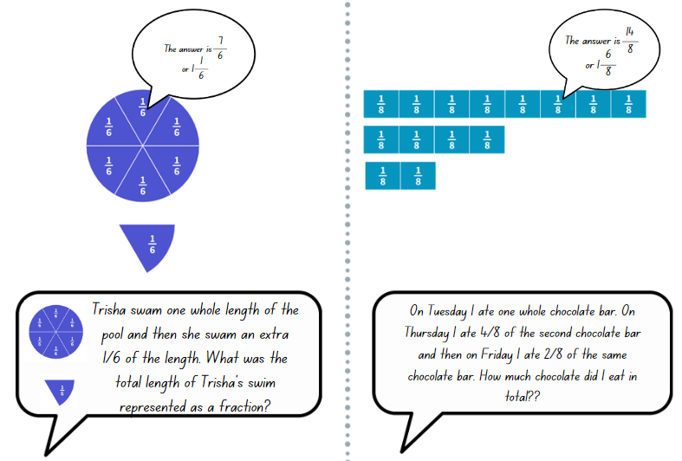
This table details opportunities for differentiation.
Too hard? | Too easy?
Students cannot solve problems that involve addition of fractions with the same denominator.  - Students use paper strip or coloured rods to represent the fractions. Support students to identify the parts and how many more are needed to make one whole.  - Model drawing a fraction strip that has equal parts and colour in the known parts to see what is missing. | Students can solve problems that involve addition of fractions with the same denominator.  - Students investigate fraction sums that exceed 2 wholes.  - Students develop addition sums that add 3 or more fractions. For example, $\frac{2}{5}$ + $\frac{4}{5}$ + 1$\frac{1}{5}$ = 2 $\frac{2}{5}$.

Consolidation and meaningful practice – 15 minutes
This activity is an adaption of ‘What's The Split?’ in Exploring the Edges of Mathematical Ideas by Epstein.
- Display Resource 18 – make 2 groups. Ask students to consider the 4 fraction sums and sort them into 2 groups.
- Select students to share their groupings and provide justification for their choices.
Note: the 2 groups do not need to be equal. For example, one group may have one equation and the other group may have 3. Students must be able to reason as to why they have organised the sums into each group. This task is dependent on students’ ability to reason and provide justifications for their choices.
The table below outlines possible solutions, along with anticipated responses from students.
Possible solutions | Anticipated student responses
- Group 1: B and C. Group 2: A and D. | - The sum of B and C both exceed one whole. A and D are less than one whole.
- Group 1: A and D. Group 2: C and D. | - A and D have related denominators, sixths and twelfths.
- Group 1: B. Group 2: A, C and D. | - B is the only sum that starts with a fractional part larger than one whole (1$\frac{2}{5}$).
This table details opportunities for assessment.
Assessment opportunities | Links
What to look for:  - Can students represent the sum of fractions with the same denominator, recreating the whole, where the result may exceed one? [MAO-WM-01, MA3-RQF-01]  - Can students solve word problems that involve fractions with the same denominator? [MAO-WM-01, MA3-RQF-01] | Links to National Numeracy Learning Progressions (NNLP):  - InF7, InF8.

Lesson 7
Core concept: subtracting fractions with the same denominator.

Daily number sense – improve your strategies – 15 minutes
The table below contains a suggested learning intention and success criteria. These are best co-constructed with students.
Daily number sense learning intention | Daily number sense success criteria
Students are learning to:  - determine products and factors. | Students can:  - use the term product to describe the result of multiplying 2 or more numbers  - model different ways to show a whole number as a product.
- Repeat the ‘Product Game’ from Lesson 6. Students try to improve the strategies they used to pick a product to win the game or win the game in less moves.
- As students finish, ask them to explain how they tried to improve their strategies from the previous game. This includes discussing what worked, what didn’t and why.
This table details opportunities for assessment.
Assessment opportunities | Links
What to look for:  - Can students use the term product to describe the result of multiplying 2 or more numbers? [MAO-WM-01, MA3-MR-01]  - Can students model different ways to show a whole number as a product? [MAO-WM-01, MA3-MR-01] | Links to National Numeracy Learning Progressions (NNLP):  - MuS6, MuS7.

Core lesson – subtracting fractions – 35 minutes
The table below contains a suggested learning intention and success criteria. These are best co-constructed with students.
Core concept learning intention | Core concept success criteria
Students are learning to:  - solve problems involving subtraction of fractions with the same denominator. | Students can:  - find the difference between fractions with the same denominator and interpret the answer  - solve word problems that involve fractions with the same denominator  - use diagrams, objects and mental strategies to subtract a unit fraction from any whole number including 1.
- Ask: If $\frac{7}{10}$ is the answer:
- What could an addition question be?
- What could a subtraction question be?
- Model using the fraction bars in Amplify Polypad – Fraction Bars to solve the subtraction equation $\frac{7}{8}$ − $\frac{2}{8}$ (see Figure 13).
Figure 13 – subtraction equation
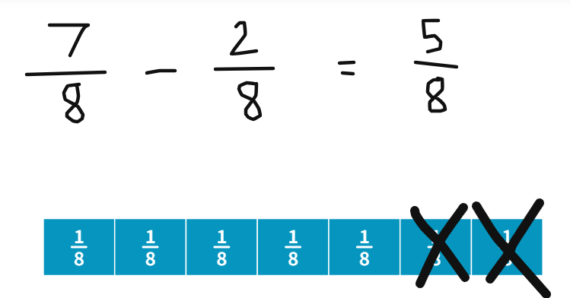
- Provide students with a digital device and ask them to use Amplify Polypad – Fraction Bars to solve the following subtraction problems:
- $\frac{9}{10}$ − $\frac{3}{10}$ = _
- $\frac{10}{12}$ − $\frac{6}{12}$ = _
- $\frac{8}{12}$ − $\frac{3}{12}$ = _
- 1$\frac{3}{4}$ − $\frac{5}{4}$ = _
- 1$\frac{5}{10}$ − $\frac{7}{10}$ = _
- Rehana and Angelina share a baguette that is cut into sixths. Rehana eats four-sixths, how much does Angelina receive? Is her share greater than or less than one-half of the baguette?
- Max has one jelly snake. He eats three-eighths of it. How much does he have left?
- Francesca has completed $\frac{4}{5}$ of the swimming race. How much further does she have left to swim?
- Ranjeet had 2 blocks of chocolate. He gave a third of one block to his sister. How much is remaining?
- A pizza was cut into eighths. After Dad ate, there were six-eighths left. My brother ate three-eighths. How much is left for me?
- Students develop their own subtraction word problems that involve fractions with the same denominator.
- Select a number of student word problems to share and solve as a class.
This table details opportunities for differentiation.
Too hard? | Too easy?
Students cannot find the difference between fractions with the same denominator and interpret the answer or use diagrams, objects and mental strategies to subtract a unit fraction from any whole number including 1.  - Use interlocking cubes to create the fraction bar length and model subtracting by removing the indicated amount. The individual cubes could be labelled with stickers to show the fractional part, for example; $\frac{1}{4}$ ,$\frac{1}{4}$,$\frac{1}{4}$ ,$\frac{1}{4}$.  - Build 2 lengths with interlocking cubes to represent the equation and ask the student to find the difference.  Students cannot solve word problems that involve fractions with the same denominator.  - Provide students with the numerical equation and interlocking cubes to solve the problems. | Students can find the difference between fractions with the same denominator and interpret the answer and use diagrams, objects and mental strategies to subtract a unit fraction from any whole number including 1.  - Solve word problems involving adding or subtracting fractional quantities with related denominators.  - Use equivalence to add and subtract fractional quantities with related denominators.  Students can solve word problems that involve fractions with the same denominator.  - Provide students with word problems that involve fractions with related denominators.

Discuss and connect the mathematics – 10 minutes
- Record the following algorithm on the board: 1$\frac{4}{5}$ −$\frac{?}{5}$ = _?
- Provide students with writing materials and encourage them to find multiple solutions, representing their thinking using diagrams, words and symbols.
- Record 2$\frac{3}{5}$ − $\frac{?}{5}$ = 1 $\frac{?}{5}$ on the board. Ask:
- How could 2$\frac{3}{5}$ be renamed?
- What could the missing digits be to complete this equation?
- Can you find multiple ways to solve this problem?
- Regroup and discuss strategies used to solve the task and the various solutions discovered.
This table details opportunities for assessment.
Assessment opportunities | Links
What to look for:  - Can students find the difference between fractions with the same denominator and interpret the answer?  [MAO-WM-01, MA3-RQF-01]  - Can students solve word problems that involve fractions with the same denominator? [MAO-WM-01, MA3-RQF-01]  - Can students use diagrams, objects and mental strategies to subtract a unit fraction from any whole number including 1?  [MAO-WM-01, MA3-RQF-01] | Links to National Numeracy Learning Progressions (NNLP):  - InF7, InF8.

Lesson 8
Core concept: mathematicians solve problems with fractions.

Daily number sense – 10 minutes
- From a class need surfaced through formative assessment data, identify a short, focused activity that targets students’ knowledge, understanding and skills. Example activities may be drawn from the following resources:
- Mathematics K–6 resources
- Universal Resources Hub.

Core lesson – beanbag toss – 40 minutes
The table below contains a suggested learning intention and success criteria. These are best co-constructed with students.
Core concept learning intention | Core concept success criteria
Students are learning to:  - solve problems that involve addition and subtraction of fractions with the same denominator. | Students can:  - represent the sum of fractions with the same denominator  - find the difference between fractions with the same denominator and interpret the answer.
- Take students outside to a hard surface and form small groups. Provide each group with 10 beanbags.
- Using metre rulers or a measuring tape, have each group draw a chalk number line from 0–2 on the ground and record halves and wholes on the line (see Figure 14).
Figure 14 – example of number line indicating half
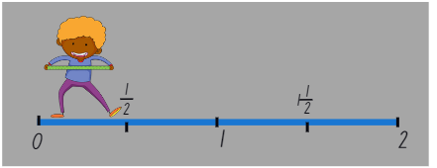
Note: ensure that number lines are at least 2 metres in length so that there is an adequate level of challenge when tossing the beanbags and that all fraction markers are equally spaced along the number line.
- Point to or move along a number line and name the fractions aloud so that students can check that they have correctly labelled their own number lines.
- Explain that groups are going to use the fractions on their number line to play the game. Students take turns to throw their beanbag and identify the fraction it lands on as well as the fractional amount needed to add to that fraction to make 2 wholes. For example, if the beanbag lands on $\frac{1}{2}$, $1\frac{1}{2}$ is required to make 2 wholes.
- Play a few rounds and then ask students to mark quarters with a different coloured chalk on their number line before continuing to play. After a few more rounds, label eighths in another coloured chalk on the number line.
- Regroup and explain to students that they will now use their number lines to subtract fractional quantities.
- Choose 2 students to model the game. Student 1 throws their beanbag and aims to land on a fraction close to 2. Student 2 throws their beanbag to any point on the number line less than their partner’s fraction. Together, the partners calculate the difference between their fractions. For example, Student 1 lands on 1$\frac{6}{8}$ and Student 2 lands on $\frac{4}{8}$. So, 1 $\frac{6}{8}$ - $\frac{4}{8}$ = 1 $\frac{2}{8}$.
- Students play the game and record their subtraction equations on the concrete near their number line.
This table details opportunities for differentiation.
Too hard? | Too easy?
Students cannot solve problems that involve addition and subtraction of fractions with the same denominator.  - Model the game and support students to identify and name the fractions aloud. Use a fraction wall to assist with adding fractions.  - Provide students with strips of paper, folded into fractional parts, to support visualisation.  - Students play the game with halves and quarters only. | Students can solve problems that involve addition and subtraction of fractions with the same denominator.  - Students label their number line with markers for thirds, fifths, sixths and tenths.  - Students extend their number line to 3.

Discuss and connect the mathematics – 10 minutes
- As a class discuss:
- What was challenging about the game? Explain.
- Was it easier to add or subtract fractions?
- What strategies did you use to add or subtract fractions?
- If you played it again, would you use the same strategy or a different strategy? Why?
This table details opportunities for assessment.
Assessment opportunities | Links
What to look for:  - Can students represent the sum of fractions with the same denominator? [MAO-WM-01, MA3-RQF-01]  - Can students find the difference between fractions with the same denominator and interpret the answer?  [MAO-WM-01, MA3-RQF-01] | Links to National Numeracy Learning Progressions (NNLP):  - InF7, InF8.

Resource 1 – funny fraction lines
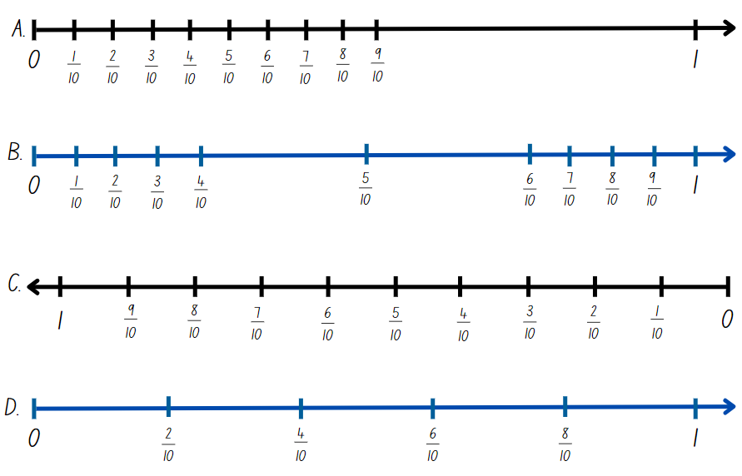

Resource 2 – domino fractions
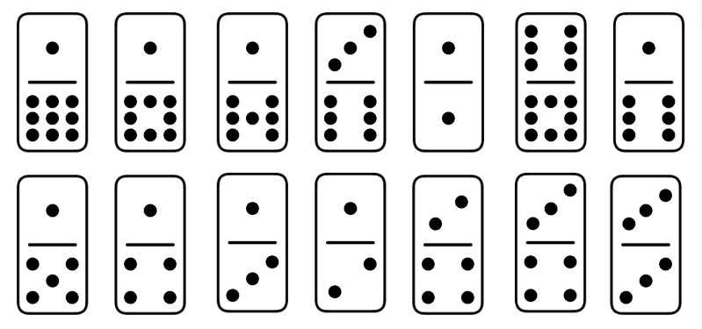

Resource 3 – blank fraction line

Resource 4 – How long?
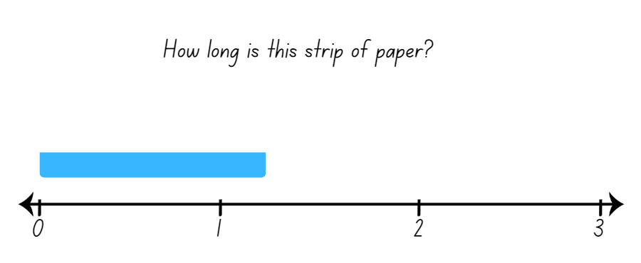

Resource 5 – finding fractions
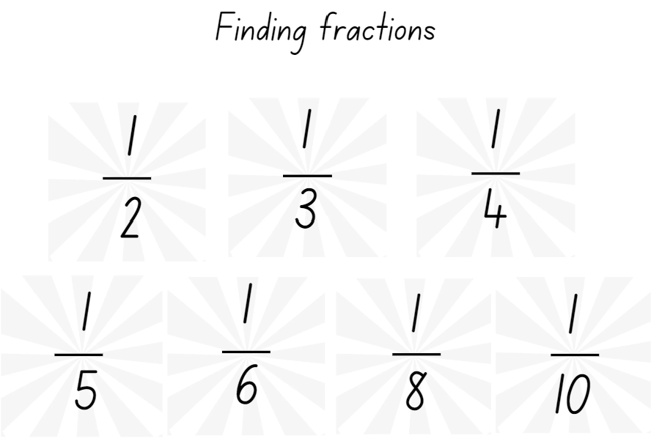

Resource 6 – distance travelled (part 1)
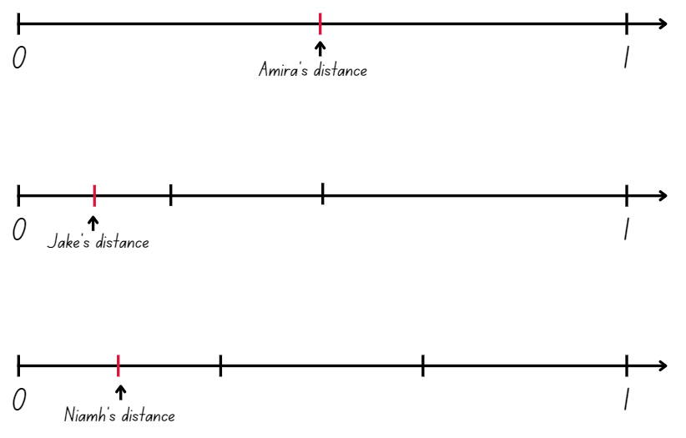

Resource 7 – distance travelled (part 2)
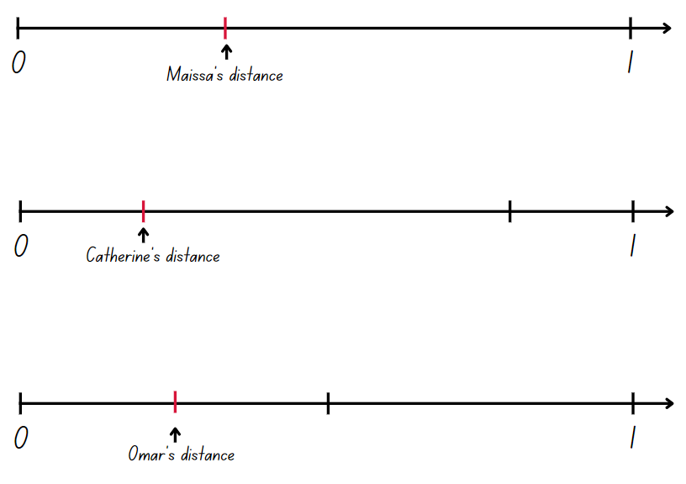

Resource 8 – fraction mosaics
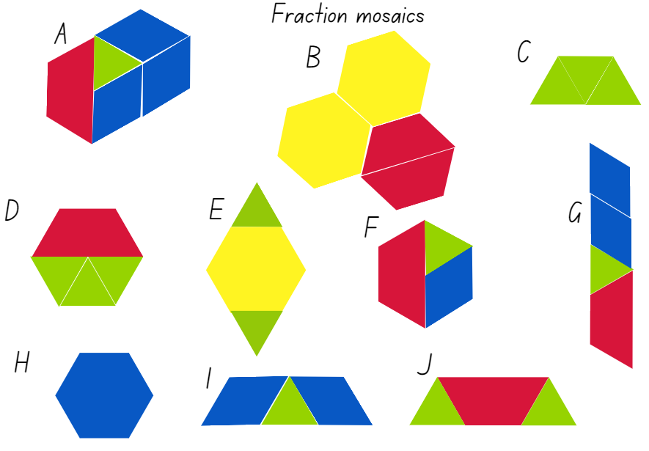

Resource 9 – triangle mosaic

Resource 10 – fraction wall
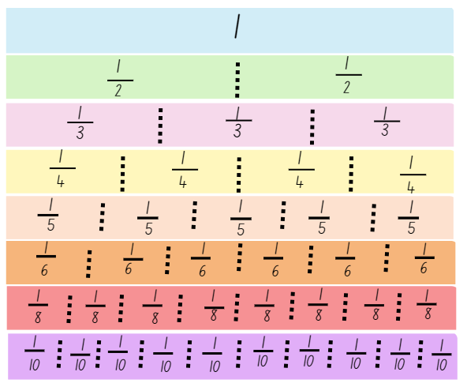

Resource 11 – bar model
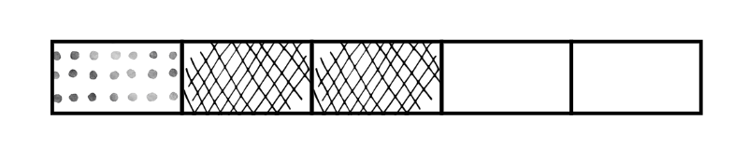

Resource 12 – the magic number
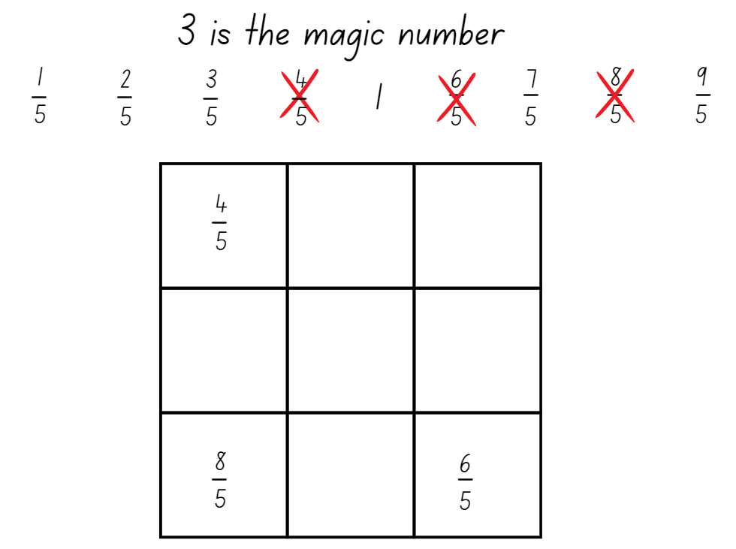

Resource 13 – magic number differentiation
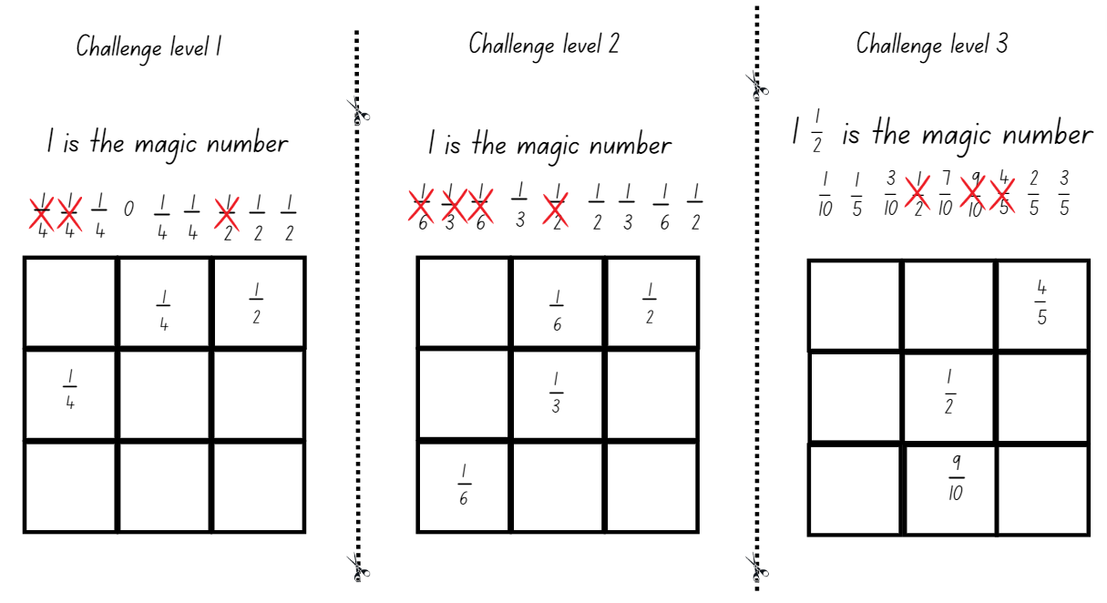

Resource 14 – ‘Product game’
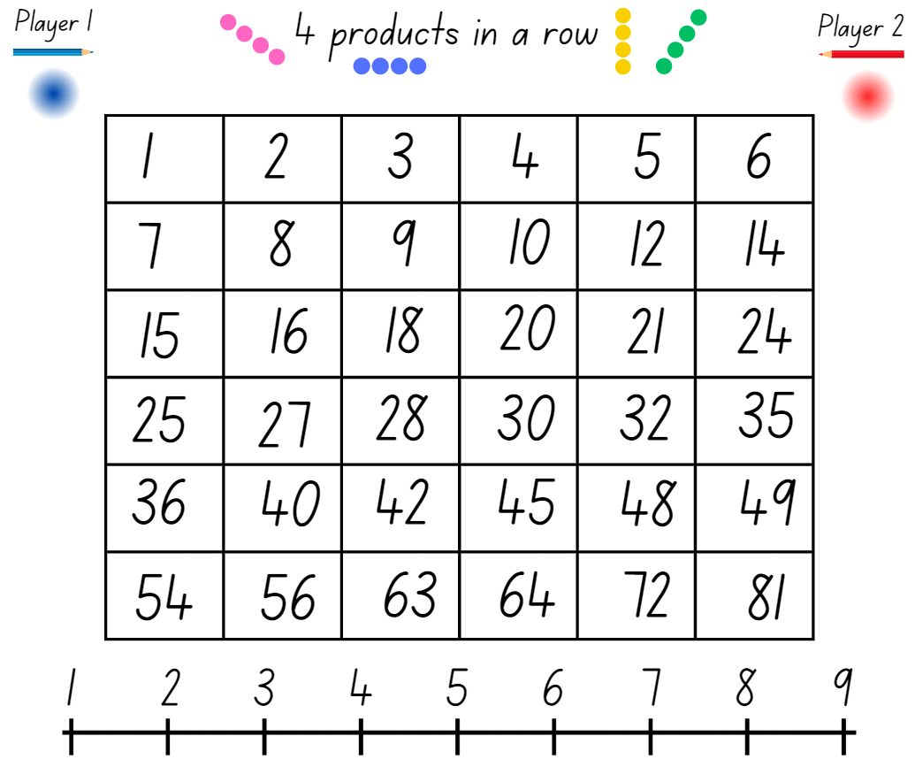

Resource 15 – modified ‘Product game’
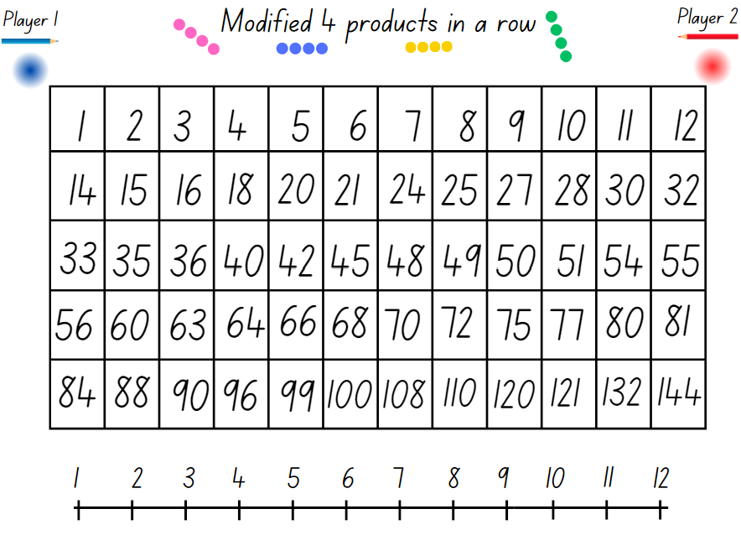

Resource 16 – ‘Product game’ questions
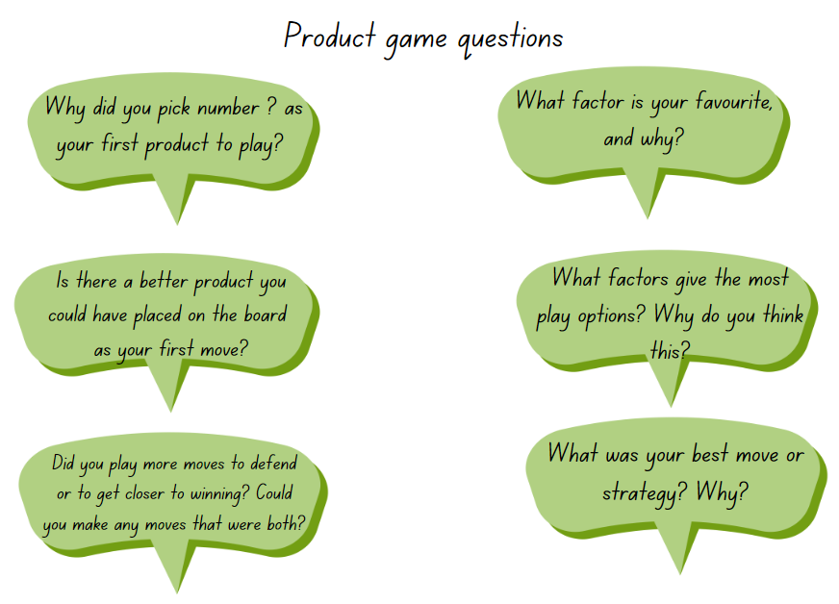

Resource 17 – making the whole
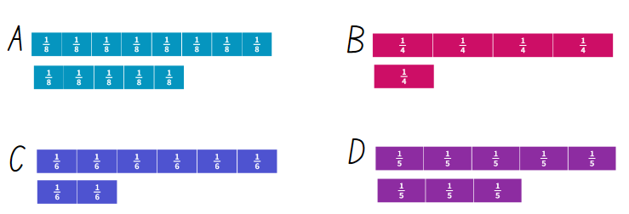

Resource 18 – make 2 groups
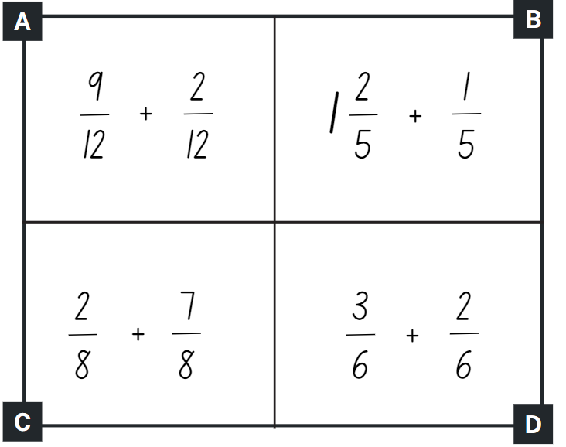

Syllabus outcomes and content
The table below outlines the syllabus outcomes and range of relevant syllabus content covered in this unit. Content is linked to National Numeracy Learning Progression (version 3).
Outcomes and content | 1 | 2 | 3 | 4 | 5 | 6 | 7 | 8
Multiplicative relations A: Determine products and factors
[MAO-WM-01, MA3-MR-01]
- Use the term product to describe the result of multiplying 2 or more numbers |  |  |  |  |  | x | x
- Model different ways to show a whole number as a product (Reasons about structure) |  |  |  |  |  | x | x
- Determine factors for a given whole number |  |  |  |  | x
Representing quantity fractions A: Recognise the role of the number 1 as representing the whole
[MAO-WM-01, MA3-RQF-01]
- Compare halves and quarters of different sized wholes |  |  | x
- Justify the need for fractions to refer to the number 1 as the common whole (Reasons about quantity) |  |  | x
Representing quantity fractions A: Compare and order common unit fractions
[MAO-WM-01, MA3-RQF-01]
- Compare unit fractions as numbers to the benchmark value $\frac{1}{2}$ |  | x |  | x
- Compare and order unit fractions with denominators of 2, 3, 4, 5, 6, 8 and 10 by placing them on a number line | x | x
Representing quantity fractions A: Solve problems involving addition and subtraction of fractions with the same denominator
[MAO-WM-01, MA3-RQF-01]
- Represent the sum of fractions with the same denominator, recreating the whole, where the result may exceed one |  |  |  |  | x | x |  | x
- Find the difference between fractions with the same denominator and interpret the answer |  |  |  |  |  |  | x | x
- Solve word problems that involve fractions with the same denominator |  |  |  |  |  | x | x
- Use diagrams, objects and mental strategies to subtract a unit fraction from any whole number including 1 (the complement principle) |  |  |  |  |  |  | x
Representing quantity fractions B: Compare common fractions with related denominators
[MAO-WM-01, MA3-RQF-01]
- Record equivalent fractions using diagrams, words and fraction notation | x |  |  | x
Mathematics K–10 Syllabus © NSW Education Standards Authority (NESA) for and on behalf of the Crown in right of the State of New South Wales, 2022.

References
This resource contains NSW Curriculum and syllabus content. The NSW Curriculum is developed by the NSW Education Standards Authority. This content is prepared by NESA for and on behalf of the Crown in right of the State of New South Wales. The material is protected by Crown copyright.
Please refer to the NESA Copyright Disclaimer for more information https://educationstandards.nsw.edu.au/wps/portal/nesa/mini-footer/copyright.
NESA holds the only official and up-to-date versions of the NSW Curriculum and syllabus documents. Please visit the NSW Education Standards Authority (NESA) website https://educationstandards.nsw.edu.au/wps/portal/nesa/home and the NSW Curriculum website https://curriculum.nsw.edu.au/.
Mathematics K–10 Syllabus © NSW Education Standards Authority (NESA) for and on behalf of the Crown in right of the State of New South Wales, 2022.
National Numeracy Learning Progression © Australian Curriculum, Assessment and Reporting Authority (ACARA) 2010 to present, unless otherwise indicated. This material was downloaded from the Australian Curriculum website (National Numeracy Learning Progression) (accessed 5 February 2024) and was not modified.
Amplify Education (2024) Amplify Polypad – Fraction Bars, Amplify Polypad website, accessed 21 February 2024.
Amplify Education (2024) ‘Colour Mixing Fraction Bars’ [video], Amplify Polypad, Amplify Polypad website, accessed 21 February 2024.
Australian Government Department of Education and Australian Academy of Science (2024) ‘Bar Model Method: Introduction’, Teaching resources, reSolve: Maths by Inquiry website, accessed 5 February 2024.
Barton C (2018) ‘Bigger than and smaller than’, Fractions, Maths Venns website, accessed 5 February 2024.
Didax, Inc (2023) ‘Fraction Tiles and Number Line’, Virtual Manipulatives, Didax website, accessed 19 February 2024.
Epstein M (5 November 2020) ‘Exploring the Edges of Mathematical Ideas’, Michaela Epstein, accessed 5 February 2024.
Gojak LM and Miles RH (2018) Your Mathematics Standards Companion, Grades 3–5, Corwin Mathematics and National Council of Teachers of Mathematics, United States of America.
Learn-With-Math-Games.com (2023) Magic Square Fun, Learn-With-Math-Games.com, accessed 5 February 2024.
NCTM (National Council of Teachers of Mathematics) (2024) ‘Product Game’, Classroom Resources, NCTM website, accessed 5 February 2024.
University of Cambridge (n.d.) Factors and Multiples Game, NRICH website, accessed 5 February 2024.

© State of New South Wales (Department of Education), 2023
The copyright material published in this resource is subject to the Copyright Act 1968 (Cth) and is owned by the NSW Department of Education or, where indicated, by a party other than the NSW Department of Education (third-party material).
Copyright material available in this resource and owned by the NSW Department of Education is licensed under a Creative Commons Attribution 4.0 International (CC BY 4.0) license.
This license allows you to share and adapt the material for any purpose, even commercially.
Attribution should be given to © State of New South Wales (Department of Education), 2023.
Material in this resource not available under a Creative Commons license:
- the NSW Department of Education logo, other logos and trademark-protected material
- material owned by a third party that has been reproduced with permission. You will need to obtain permission from the third party to reuse its material.
Links to third-party material and websites
Please note that the provided (reading/viewing material/list/links/texts) are a suggestion only and implies no endorsement, by the New South Wales Department of Education, of any author, publisher, or book title. School principals and teachers are best placed to assess the suitability of resources that would complement the curriculum and reflect the needs and interests of their students.
If you use the links provided in this document to access a third-party's website, you acknowledge that the terms of use, including licence terms set out on the third-party's website apply to the use which may be made of the materials on that third-party website or where permitted by the Copyright Act 1968 (Cth). The department accepts no responsibility for content on third-party websites.

