Mathematics Stage 3 – Unit 27

Contents
Unit description and duration 5
Syllabus outcomes 5
Working mathematically 6
Student prior learning 6
Lesson overview and resources 8
Lesson 1 14
Daily number sense – number patterns – 10 minutes 14
Core lesson – table of values – 30 minutes 17
Discuss and connect the mathematics – 10 minutes 21
Lesson 2 23
Daily number sense – estimating – 10 minutes 23
Core lesson – applying strategies – 30 minutes 25
Discuss and connect the mathematics – 15 minutes 29
Lesson 3 31
Daily number sense – multiplying decimals – 10 minutes 31
Core lesson – understanding algorithms – 40 minutes 33
Selecting strategies game 33
Algorithm errors 35
Discuss and connect the mathematics – 10 minutes 38
Lesson 4 40
Daily number sense – 10 minutes 40
Core lesson – grouping symbols matter – 25 minutes 40
Core lesson 2 – real-life context – 25 minutes 43
Discuss and connect the mathematics – 5 minutes 45
Lesson 5 47
Daily number sense – race to 12 – 10 minutes 47
Core lesson – dice division – 40 minutes 49
Discuss and connect the mathematics – 10 minutes 53
Lesson 6 55
Daily number sense – race to zero – 15 minutes 55
Core lesson 1 – sharing pizzas – 20 minutes 57
Core lesson 2 – sharing liquorice – 20 minutes 59
Discuss and connect the mathematics – 15 minutes 60
Lesson 7 62
Daily number sense – nearest to 6 – 15 minutes 62
Core lesson – splats – 30 minutes 63
Discuss and connect the mathematics – 10 minutes 66
Lesson 8 68
Daily number sense – 10 minutes 68
Core lesson – multiplicative problems – 45 minutes 68
Discuss and connect the mathematics – 10 minutes 72
Resource 1 – pattern multiples 73
Resource 2 – hexagons 74
Resource 3 – hexagon table 75
Resource 4 – blank tables 76
Resource 5 – think board 1 77
Resource 6 – think board 2 78
Resource 7 – word problems 79
Resource 8 – algorithm errors 80
Resource 9 – match the problem 81
Resource 10 – labelled 12 chart 82
Resource 11 – fraction spinner 83
Resource 12 – dice division 84
Resource 13 – sharing pizzas 87
Resource 14 – 10 liquorice straps 88
Resource 15 – 3 chocolate bars 89
Resource 16 – 3 oranges 90
Resource 17 – 4 chocolate bars 91
Resource 18 – division as fractions 92
Resource 19 – balance the scales 93
Resource 20 – splats 94
Resource 21 – student splats 95
Resource 22 – open-ended splats 96
Resource 23 – best buy shirts 97
Syllabus outcomes and content 98
References 103
Further reading 105

Unit description and duration
This unit develops the big idea that multiplicative thinking involves flexible use of multiplication and division concepts, strategies and representations.
In this 2-week unit students are provided opportunities to:
- identify, describe and apply multiplicative patterns
- learn and apply a range of concepts, strategies and representations for multiplication and division
- share their reasoning for applying multiplicative strategies in particular situations.

Syllabus outcomes
- MAO-WM-01 develops understanding and fluency in mathematics through exploring and connecting mathematical concepts, choosing and applying mathematical techniques to solve problems, and communicating their thinking and reasoning coherently and clearly
- MA3-RN-01 applies an understanding of place value and the role of zero to represent the properties of numbers
- MA3-AR-01 selects and applies appropriate strategies to solve addition and subtraction problems
- MA3-MR-01 selects and applies appropriate strategies to solve multiplication and division problems
- MA3-MR-02 constructs and completes number sentences involving multiplicative relations, applying the order of operations to calculations

Working mathematically
In the Mathematics K–10 Syllabus, there is one overarching Working mathematically outcome (MAO-WM-01). The Working mathematically processes should be embedded within the concepts being taught. The processes in the syllabus are:
- communicating
- understanding and fluency
- reasoning
- problem solving.
Mathematics K–10 Syllabus © NSW Education Standards Authority (NESA) for and on behalf of the Crown in right of the State of New South Wales, 2022.

Student prior learning
Before engaging in these teaching and learning activities, students would benefit from prior experience with:
- the structure of the place value system
- flexible methods of computation involving composing and decomposing numbers
- informal and formal written strategies for multiplying by one-digit numbers.
In NSW classrooms there is a diverse range of students, including Aboriginal and Torres Strait Islander students, students learning English as an additional language or dialect, high potential and gifted students and students with disability. Some students may identify with more than one of these groups or possibly all of them. Refer to Curriculum planning for every student – advice for further information.

Lesson overview and resources
The table below outlines the sequence and approximate timing of lessons, learning intentions and resources.
Lesson | Content | Duration and resources
Lesson 1  Daily number sense learning intentions:  - represent and describe number patterns formed by multiples  - multiply and divide decimals by powers of 10 | Lesson core concept: number patterns can be multiplicative.  Core concept learning intention:  - represent and describe number patterns formed by multiples | Lesson duration: 50 minutes  - Resource 1 – pattern multiples  - Resource 2 – hexagons  - Resource 3 – hexagon table  - Resource 4 – blank tables  - Craft sticks or matchsticks  - Writing materials
Lesson 2  Daily number sense learning intentions:  - use estimation and rounding to check the reasonableness of answers to calculations  - multiply and divide decimals by powers of 10 | Lesson core concept: known number facts and strategies support multiplicative understanding.  Core concept learning intentions:  - use partitioning and place value to multiply 2-, 3- and 4-digit numbers by one-digit numbers  - apply place value to partition, regroup and rename numbers to 1 billion  - apply efficient mental and written strategies to solve addition and subtraction problems | Lesson duration: 55 minutes  - Resource 5 – think board 1  - Resource 6 – think board 2  - Resource 7 – word problems  - Writing materials
Lesson 3  Daily number sense learning intention:  - multiply and divide decimals by powers of 10 | Lesson core concept: mathematicians use algorithms with understanding to solve multiplication problems.  Core concept learning intentions:  - select and apply strategies to solve problems involving multiplication and division with whole numbers  - multiply and divide decimals by powers of 10  - apply place value to partition, regroup and rename numbers to 1 billion | Lesson duration: 60 minutes  - Resource 8 – algorithm errors  - Calculators  - Writing materials
Lesson 4  Daily number sense learning intention:  - teacher-identified task based on student needs | Lesson core concept: the order of operations is important when solving problems.  Core concept learning intentions:  - explore the use of brackets and the order of operations to equations  - apply efficient mental and written strategies to solve addition and subtraction problems | Lesson duration: 65 minutes  - Resource 9 – match the problem  - Individual whiteboards  - Writing materials
Lesson 5  Daily number sense learning intention:  - apply known strategies to add and subtract decimals | Lesson core concept: multiplication and division have an inverse relationship that can be used to solve problems.  Core concept learning intentions:  - represent and solve division problems with whole number remainders  - use equivalent number sentences involving multiplication and division to find unknown quantities | Lesson duration: 60 minutes  - Resource 10 – labelled 12 chart  - Resource 11 – fraction spinner  - Resource 12 – dice division  - 6-sided dice  - Counters  - Dice  - Writing materials
Lesson 6  Daily number sense learning intention:  - apply known strategies to add and subtract decimals | Lesson core concept: division can be recorded using fractions.  Core concept learning intention:  - use equivalent number sentences involving multiplication and division to find unknown quantities | Lesson duration: 70 minutes  - Resource 10 – labelled 12 chart  - Resource 11 – fraction spinner  - Resource 13 – sharing pizzas  - Resource 14 – 10 liquorice straps  - Resource 15 – 3 chocolate bars  - Resource 16 – 3 oranges  - Resource 17 – 4 chocolate bars  - Resource 18 – division as fractions  - 6-sided dice  - Counters  - Writing materials
Lesson 7  Daily number sense learning intention:  - apply known strategies to add and subtract decimals | Lesson core concept: understanding equivalence supports multiplicative thinking.  Core concept learning intentions:  - use equivalent number sentences involving multiplication and division to find unknown quantities  - multiply and divide decimals by powers of 10 | Lesson duration: 55 minutes  - Resource 10 – labelled 12 chart  - Resource 11 – fraction spinner  - Resource 19 – balance the scales  - Resource 20 – splats  - Resource 21 – student splats  - Resource 22 – open-ended splats  - Counters  - Dice  - Writing materials
Lesson 8  Daily number sense learning intention:  - teacher-identified task based on student needs | Lesson core concept: worded problems can be solved using multiplicative thinking.  Core concept learning intention:  - select and apply strategies to solve problems involving multiplication and division with whole numbers | Lesson duration: 65 minutes  - Resource 23 – best buy shirts  - Writing materials

Lesson 1
Core concept: number patterns can be multiplicative.

Daily number sense – number patterns – 10 minutes
Daily number sense activities for Lessons 1 to 3 ‘activate’ prior number knowledge and support the learning of new content in the unit. These activities can also assist teachers to identify the starting points for learning by revealing the extent of students’ existing knowledge.
The table below contains a suggested learning intention and success criteria. These are best co-constructed with students.
Daily number sense learning intentions | Daily number sense success criteria
Students are learning to:  - represent and describe number patterns formed by multiples  - multiply and divide decimals by powers of 10. | Students can:  - describe a pattern formed by multiples in words  - compare the relative place value of digits to multiply and divide a decimal by powers of 10.
- Write the number sequence 10, 20, 30, 40, 50. Ask students to describe the patterns. Anticipated responses include:
- It is a growing pattern.
- Each step or term adds 10.
- It has multiples of 10.
- There are 5 terms.
- Remind students of the meaning of multiple:
Multiple: products formed using the same base number multiplied by different whole numbers, for example, 3, 6, 9, 12 and so on.
- Write the number sequence 2400, 240, 24, 2.4, 0.24, 0.024. Ask student to describe the pattern. Anticipated responses include:
- The numbers are getting smaller (left to right) or larger (right to left).
- The number is 10 times smaller than the number before it (reading left to right).
- It is multiplying by 10 as you read left to right.
- It is dividing by 10 as you read right to left.
- Explicitly revise the multiplicative relationship between the decimal numbers in the pattern, such as 0.24 is 10 times smaller than 2.4 or 0.024 is 100 times smaller than 2.4.
- Revise with students that a number is 10 times smaller when the place value of the digits is shifted one place to the right and a number is 100 times smaller when the digits are shifted 2 place-value positions to the right.
- Present Resource 1 – pattern multiples and organise students in pairs with writing materials.
- Ask students to write as many different 5-term patterns as possible. The same number may be used in more than one pattern.
- After 5 minutes, share student results.
The table below outlines stimulus prompts to generate conversation about the topic, with anticipated responses from students.
Prompts | Anticipated student responses
- What multiplicative patterns could you make with 5 terms? | - 2, 4, 6, 8, 10  - 6, 12, 18, 24, 30  - 14, 21, 28, 35, 42
- Did you find any other patterns? | - 3, 6, 12, 24, 48  - 0.05, 0.5, 5, 50, 500  - Decreasing multiplicative patterns
- Were there any numbers that you could not fit into a 5-term pattern? Why? | - 37  - It is not a multiple of 2, 5, 6 or 7.
This table details opportunities for assessment.
Assessment opportunities | Links
What to look for:  - Can students describe a pattern formed by multiples in words? [MAO-WM-01, MA3-MR-01]  - Can students compare the relative place value of digits to multiply and divide a decimal by powers of 10? [MAO-WM-01, MA3-MR-01] | Links to National Numeracy Learning Progressions (NNLP):  - NPA4, NPA5  - NPV8, NPV9.  Links to suggested Interview for Student Reasoning (IfSR) tasks:  - IfSR-MT: 4A.1, 4A.3, 4A.4, 4A.5, 4A.7.

Core lesson – table of values – 30 minutes
The table below contains a suggested learning intention and success criteria. These are best co-constructed with students.
Core concept learning intention | Core concept success criteria
Students are learning to:  - represent and describe number patterns formed by multiples. | Students can:  - use a given geometric pattern involving multiples to create a table of values  - describe a pattern formed by multiples in words, in terms of multiplication rather than addition  - determine a rule describing the relationship between the bottom number and the top number in a table.
Note: the syllabus defines a ‘pattern’ as a number of elements that repeat or follow a rule (NESA 2022). In this lesson, a ‘sequence’ means a list of numbers that may form a pattern. A ‘term’ refers to one of the numbers in a sequence.
- Display Resource 2 – hexagons. Ask:
- What do you see?
- Can you describe what is happening in this picture?
- Identify that the pattern is following a rule each time a new term or item is added to the sequence.
- Explain that mathematicians can present patterns in a table of values to show a rule and to organise information clearly.
- Ask students to turn and talk and draw what the table might look like. Students share their responses with the class.
- Display Resource 3 – hexagon table. Describe the number of hexagons as inputs and the number of sides as outputs. Ask:
- Does the pattern stop at 5 or could it continue?
- What would be the next input and output?
- What would the output be if the input was 10? How could we work that out without drawing the pattern?
- What about 15, 20, 50 and 100?
- Describe the multiplicative relationship between the inputs and the outputs in the table. For example, there are 6 sides for every hexagon, so multiply the inputs by 6 to calculate the outputs.
- Explain that when patterns are involved, using multiplication to calculate can be more efficient.
Note: to promote multiplicative thinking and reasoning in the following activity, limit materials and restrict the number of items students can create.
- Provide students with 20 to 30 craft sticks or matchsticks.
- Ask pairs of students to create a growing geometric pattern, like Resource 2 – hexagons. Encourage students to be creative with their patterns.
- Students share their geometric pattern (see Figure 1).
Figure 1 – student patterns
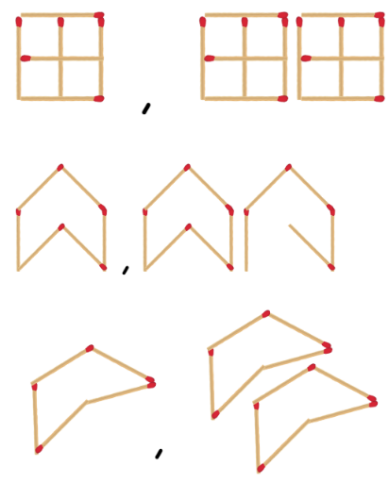
Note: ensure students do not join shapes together in the patterns as this will result in fewer sides and affect the overall rule.
- Ask students to:
- continue their pattern and use a table to record at least the first 5 terms of the pattern
- describe the pattern in words, such as ‘a new shape is added for each term’
- calculate the tenth, fifteenth, twentieth, fiftieth and hundredth term
- describe the rule, for example, ‘To work out the number of sides, I need to multiply the number of shapes by 3.’
- Using Resource 4 – blank tables, observe, record and continue other student patterns in a table.
This table details opportunities for differentiation.
Too hard? | Too easy?
Students cannot describe a pattern formed by multiples.  - Students create growing patterns using shape blocks. Support students to count and record the number of shapes and sides in each term in a table.  - Students use patterns of 2 with a prompt. For example, an insect has 2 times as many legs as wings. Ask how many legs there might be if the insect has 2 wings. Guide students to record a table showing a growing pattern of legs and wings. | Students can describe a pattern formed by multiples and determine a rule.  - Create an input/output function machine to test their partners in determining the pattern rule. Students experiment using more than one operation such as 2 × n + 1.  - Students change their pattern design so that, for new terms, additional shapes share at least one side with existing shapes. Students record the results in the table and investigate what happens to the multiplicative relationship.  - Students investigate this task from Sullivan (2017): At a sports day, when students were put into groups of 3, there was one student left over. When in groups of 4, there were 2 left over. Ask how many students might have been at the sports day. Students describe the pattern in their answers.

Discuss and connect the mathematics – 10 minutes
- Refer to the resources used in the lesson. Ask:
- How can looking for patterns help?
- How can determining a rule for a pattern help?
- How does using multiplication help when calculating large, unknown quantities?
This table details opportunities for assessment.
Assessment opportunities | Links
What to look for:  - Can students use a given geometric pattern involving multiples to create a table of values? [MAO-WM-01, MA3-MR-01]  - Can students describe a pattern formed by multiples in words, in terms of multiplication rather than addition? [MAO-WM-01, MA3-MR-01]  - Can students determine a rule describing the relationship between the bottom number and the top number in a table? [MAO-WM-01, MA3-MR-01] | Links to National Numeracy Learning Progressions (NNLP):  - NPA4, NPA5.

Lesson 2
Core concept: known number facts and strategies support multiplicative understanding.

Daily number sense – estimating – 10 minutes
The table below contains a suggested learning intention and success criteria. These are best co-constructed with students.
Daily number sense learning intention | Daily number sense success criteria
Students are learning to:  - use estimation and rounding to check the reasonableness of answers to calculations  - multiply and divide decimals by powers of 10. | Students can:  - use estimation to check the reasonableness of answers to multiplication and division calculations  - estimate the product of a decimal and a whole number to determine the magnitude of an answer.
- Explain that estimating is an important skill, both before and after calculating. Good estimates allow students to check if they have made a procedural error in their calculations. Explain that for this part of the lesson, students are not expected to calculate an answer. Instead, students should explain and convince others about what would make a reasonable estimate.
- Ask how students might estimate the answer to 4972 × 59.
- Students turn and talk to share strategies. Provide writing materials, if necessary. Anticipated responses include:
- 5000 × 60
- 60 × 4900.
- Discuss how factorising and partitioning can assist with calculation, such as 6 × 49 × 1000.
- Ask if 50 × 5000 provides a good estimate.
- Explain that in many contexts – catering, budgets, travel – estimates are made to ensure that people will have enough of something (for example, food, money, fuel).
- Discuss 60 × 4970. Ask when it might be necessary to round to the nearest 10 and if it is appropriate here. Prompt students to give reasons why or why not.
- Discuss the following problem with students: ‘I have 7 desks, each of which is 1.15 m long. What would the total length be?’ Ask students how they would round the numbers given to prove a good estimate. Anticipated responses may include:
- I know that 1.15 m is a bit more than 1, so it's going to be a bit more than 7 m.
- I know 1.15 is close to 1.1, and that 11 × 7 = 77, so it is at least 7.7 m.
- If I round 1.15 to 2, and estimate 14 m, I know that this estimate would be much too large.
- Repeat with other examples as appropriate for the class.
This table details opportunities for assessment.
Assessment opportunities | Links
What to look for:  - Can students use estimation to check the reasonableness of answers to multiplication and division calculations? [MAO-WM-01, MA3-MR-01]  - Can students estimate the product of a decimal and a whole number to determine the magnitude of an answer? [MAO-WM-01, MA3-MR-01] | Links to National Numeracy Learning Progressions (NNLP):  - NPV6, NPV7, NPV8  - MuS6, MuS7, MuS10.  Links to suggested Interview for Student Reasoning (IfSR) tasks:  - IfSR-MT: 4A.10.

Core lesson – applying strategies – 30 minutes
The table below contains suggested learning intentions and success criteria. These are best co-constructed with students.
Core concept learning intentions | Core concept success criteria
Students are learning to:  - use partitioning and place value to multiply 2-, 3- and 4-digit numbers by one-digit numbers  - apply place value to partition, regroup and rename numbers to 1 billion  - apply efficient mental and written strategies to solve addition and subtraction problems. | Students can:  - use the distributive property with the area model to partition numbers in representing multiplication problems  - regroup numbers in different forms  - use place value to add or subtract 3 or more numbers with different numbers of digits.
- Display Resource 5 – think board 1. Ask:
- What do you notice?
- What might the word problem be?
- What strategies do you see?
- Which strategy is the most effective?
- Are there strategies or ways of working out the question that aren’t on the think board?
- Revise the use of the area model to support multiplication using 475 × 8 as an example. Ask students:
- How might you partition these numbers to solve the problem using an area model?
- What is the most effective way of partitioning numbers when trying to solve a multiplication problem?
- When might you partition numbers in a non-standard form? (For example, 400 × 8 + 75 × 8)
- What other mathematical operations are used when solving a multiplication problem using the area model?
- If you use an algorithm to add numbers together, what considerations do you need to make about the place value of the numbers? (For example, line up the digits in the place value.)
- Display Resource 6 – think board 2 and ask:
- What strategy is displayed?
- How else could this problem be solved?
- What is the most efficient strategy?
- What is similar about this problem to the first think board? What is different about this think board?
- How have the numbers been grouped here? (Numbers have been factorised and rearranged to make calculating easier.)
- What properties of multiplication have been used to solve this problem? (Associative property of multiplication)
Associative property: the associative property of multiplication means that you can group factors in different ways to find the total and the result will be the same. For example, in 2 × 6 × 1 = 12, either the 2 × 6 or the 6 × 1 could be multiplied first, then multiplied by the other factor and the total will still equal 12.
- Revise the use of the distributive property with partial products by multiplying the hundreds, then the tens and then the ones.
Distributive property: multiplication of numbers is distributive over addition because the product of one number with the sum of 2 others equals the sum of the products of the first number with each of the others. For example, the product of 3 with (4 + 5) gives the same result as the sum of 3 × 4 and 3 × 5.
- Provide students with a range of multiplication problems, including examples of problems which require more than one step. Some examples are on Resource 7 – word problems.
- Students create a think board to represent at least 2 different ways that each problem could be solved.
This table details opportunities for differentiation.
Too hard? | Too easy?
Students cannot use informal written strategies such as the area model to solve multiplication and division problems.  - Students use MAB materials or digital equivalents to support their calculations.  - Students draw and label a diagram to represent the word problem. Model how to write equations that match the diagram. Support students to apply known facts and properties to solve parts of the problem. | Students can use informal written strategies such as the area model to solve multiplication and division problems.  - Have students create their own problems on a think board for other students to solve. They can design problems that require more than one step and operation to solve.  - Have students create a video as a learning tool to revise some of the strategies used in multiplying 2-, 3- and 4-digit numbers by one-digit numbers.

Discuss and connect the mathematics – 15 minutes
- Display the different questions around the classroom. Have students swap think boards with their classmates and match the think board to the problem that it represents.
- Discuss:
- What clues did you use to determine which problem was represented?
- Which strategy on the think board is the most efficient?
- Are there any strategies that you could add to the think board?
- Did you need to partition any numbers to solve the problem? If so, what was the most effective way of partitioning a number?
- What other operations did you use when solving the problem?
- What strategies did you use when adding numbers together?
This table details opportunities for assessment.
Assessment opportunities | Links
What to look for:  - Can students use the distributive property with the area model to partition numbers in representing multiplication problems? [MAO-WM-01, MA3-MR-01]  - Can students regroup numbers in different forms? [MAO-WM-01, MA3-RN-01]  - Can students use place value to add or subtract 3 or more numbers with different numbers of digits? [MAO-WM-01, MA3-AR-01] | Links to National Numeracy Learning Progressions (NNLP):  - MuS6, MuS7.  Links to suggested Interview for Student Reasoning (IfSR) tasks:  - IfSR-MT: 3A.1, 3A.2, 3A.3.  - IfSR-AT: 3A.5.

Lesson 3
Core concept: mathematicians use algorithms with understanding to solve multiplication problems.

Daily number sense – multiplying decimals – 10 minutes
The table below contains a suggested learning intention and success criteria. These are best co-constructed with students.
Daily number sense learning intention | Daily number sense success criteria
Students are learning to:  - multiply and divide decimals by powers of 10. | Students can:  - use mental strategies to multiply benchmark decimals by single-digit numbers.
- Present students with the problem 3.5 × 2. Ask students:
- How might you solve a problem like this?
- Is it possible that the answer will be larger than 8? Why or why not?
- How might partitioning 3.5 help you with solving this problem?
- Explain to students that 3.5 can be partitioned into its place value parts as 3 and 0.5. When the parts are multiplied by 2, the number sentences can be written as 3 × 2 = 6 and 0.5 × 2 = 1. 0.5 × 2 = 1 because 0.5 is the same as a half, and 2 halves make a whole.
- Present students with an additional problem such as 5.25 × 8 or 1.75 × 40. Prompt students to partition the numbers before multiplying.
- Ask students:
- Why is 5.25 × 8 easier to solve than 5.25 × 7?
- How does your knowledge of fractions help you multiply numbers with decimals?
This table details an opportunity for assessment.
Assessment opportunity | Links
What to look for:  - Can students use mental strategies to multiply benchmark decimals by single-digit numbers? [MA3-MR-01, MAO-WM-01] | Links to National Numeracy Learning Progressions (NNLP):  - NPV8  - MuS9.  Links to suggested Interview for Student Reasoning (IfSR) tasks:  - IfSR-MT: 4A.1, 4A.3, 4A.4, 4A.5, 4A.7.

Core lesson – understanding algorithms – 40 minutes
The table below contains suggested learning intentions and success criteria. These are best co-constructed with students.
Core concept learning intentions | Core concept success criteria
Students are learning to:  - select and apply strategies to solve problems involving multiplication and division with whole numbers  - multiply and divide decimals by powers of 10.  - apply place value to partition, regroup and rename numbers to 1 billion. | Students can:  - select and use efficient strategies to multiply whole numbers of up to 4 digits by one- and 2-digit numbers  - use mental strategies to multiply benchmark decimals by single-digit numbers  - regroup numbers in different forms.

Selecting strategies game
- On the board, write the equation 0.5 × 8. Ask students if they would use an algorithm, a calculator or a mental strategy.
- Select students to share their mental strategies. Anticipated responses may include:
- I know 0.5 is a half, and half of 8 is 4.
- 8 is 2 × 2 × 2. I know double 0.5 is 1. If I double that, I get 2, then double again makes 4.
- Repeat the discussion steps for the equation 0.25 × 100, again selecting students to share mental strategies.
Note: If students refer to moving the decimal point, remind them that the decimal point is fixed. Encourage students to use place value language such as, ‘I know that tens are one hundred times larger than tenths, so 20 is a hundred times larger than 0.2.’
- Prepare a range of equations that are more readily suited to a particular strategy, such as those in Figure 2. These can be adapted to an appropriate level for the students.
Figure 2 – selecting strategies prompts
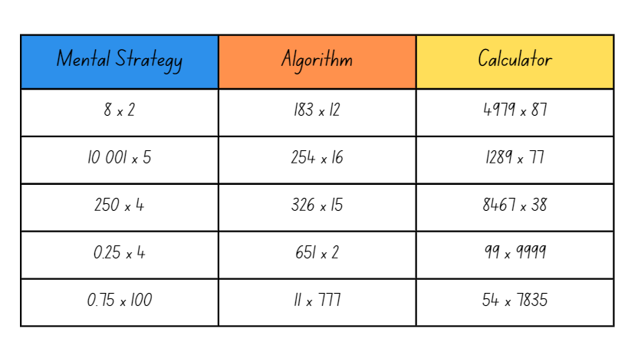
- Choose 3 students to compete against each other using either a mental strategy, a written algorithm or a calculator to develop an answer to their question. Students select their preferred strategy.
- When students are ready, display an equation, for example, 8 × 2. Students solve the problem using their strategy.
- Students compete to arrive at the correct answer the fastest. The fastest correct answer wins a point. Record the problem under the heading of the fastest strategy (see Figure 2).
- Repeat with a few different sets of numbers.
- Discuss which strategy was the most efficient. Ask students to explain why that strategy worked best for the multiplication equation.
- Explain that different strategies will suit different equations. Students should choose the most efficient strategy to help them.
- Ask students to describe a situation when using a calculator is not possible. Ask what the most efficient strategy would be in that case and what might happen if students only relied on using a calculator.
- Create an anchor chart to classify conditions when mental strategies, algorithms or calculators would be best suited.
Note: make explicit reference to mental strategies to multiply benchmark decimals by single-digit numbers and powers of 10.

Algorithm errors
- Explain that algorithms are a very useful tool for mathematicians in some situations. It is important to use them with understanding.
- Split the class into pairs and provide each pair with a copy of Resource 8 – algorithm errors. Alternatively, provide pairs with individual algorithms.
- Explain that these algorithms all have an error. Students find the error in each algorithm, explain the error and prove they are correct by writing the correct algorithm with the solution. Errors are identified in Figure 3.
Figure 3 – algorithm errors
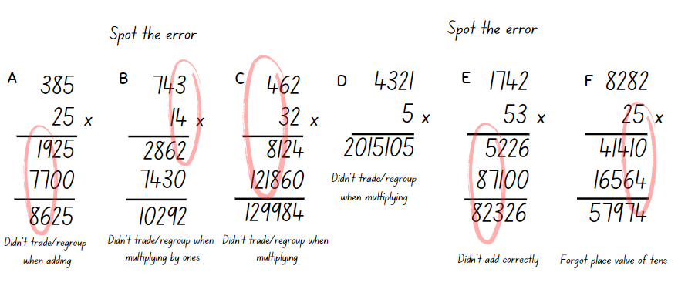
- Share student responses with the class and discuss the errors made in each algorithm. Ask students:
- How did your knowledge of place value help you identify the errors made in the algorithms?
- What place value errors did you notice in the multiplication step? (B, C, D, F)
- What place value errors did you notice in the addition step? (A, E)
- How would you describe the error in algorithm F? (The student has multiplied 8282 by 2 rather than 20. This can be easily seen because the number does not end in a zero.)
- Record errors in an anchor chart to refer to as common errors.
This table details opportunities for differentiation.
Too hard? | Too easy?
Students cannot use efficient strategies to multiply whole numbers of up to 4 digits by one- and 2-digit numbers:  - Support students by working with numbers that suit their level of understanding. Represent them by drawing regions on grid paper to show place value, such as example A (see Figure 4).  - Support students to partition larger numbers using MAB materials or digital place value cards to model place value. | Students can use efficient strategies to multiply whole numbers of up to 4 digits by one- and 2-digit numbers:  - Students make a short video or poster explaining their thinking, such as why a strategy suits certain situations.  - In pairs, students solve the unusual algorithm in Figure 4, explaining their reasoning.  - Students create their own unusual algorithm for another student to solve.
Figure 4 – differentiation
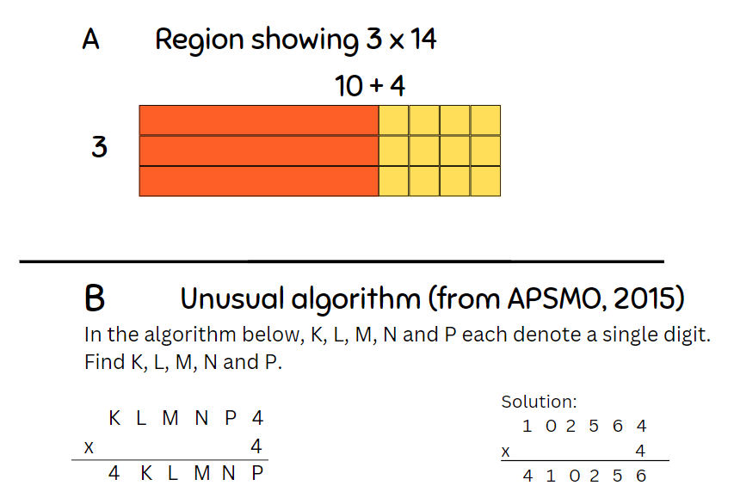

Discuss and connect the mathematics – 10 minutes
- Ask students:
- What benefits and limitations do algorithms have?
- Why don’t people just use a calculator to work things out?
- What are the benefits of mental strategies?
- What are some situations in real life where these different strategies could help us?
This table details opportunities for assessment.
Assessment opportunities | Links
What to look for:  - Can students select and use efficient strategies to multiply whole numbers of up to 4 digits by one- and 2-digit numbers? [MAO-WM-01, MA3-MR-01]  - Can students use mental strategies to multiply benchmark decimals by single-digit numbers? [MAO-WM-01, MA3-MR-01]  - Can students regroup numbers in different forms? [MAO-WM-01, MA3-RN-01] | Links to National Numeracy Learning Progressions (NNLP):  - MuS7, MuS8.  Links to suggested Interview for Student Reasoning (IfSR) tasks:  - IfSR-MT: 3A.4, 3A.5.

Lesson 4
Core concept: the order of operations is important when solving problems.

Daily number sense – 10 minutes
- From a class need surfaced through formative assessment data, identify a short, focused activity that targets students’ knowledge, understanding and skills. Example activities may be drawn from the following resources:
- Mathematics K-6 resources
- Universal Resources Hub.

Core lesson – grouping symbols matter – 25 minutes
The table below contains suggested learning intentions and success criteria. These are best co-constructed with students.
Core concept learning intentions | Core concept success criteria
Students are learning to:  - explore the use of brackets and the order of operations to write equations  - apply efficient mental and written strategies to solve addition and subtraction problems. | Students can:  - use grouping symbols () in equations to indicate operations that must be performed first  - investigate the order of operations using real-life contexts  - solve word problems, including multistep problems.
This activity is an adaptation of ‘Brackets matter’ from Challenging Mathematical Tasks: Unlocking the Potential of All Students by Sullivan.
- Pose the problem: I want to calculate the answer to 4 + 5 × 8. If I press the buttons on my phone’s calculator in that order (without pressing = until the end), the answer comes up as 44. Why does the calculator get that answer?
- Discuss the reasons with the class, identifying:
- the need to agree on the order in which to perform the operations.
- that to reduce the risk of misunderstanding an arithmetical expression or number sentence, there is an agreed convention, or rule. This convention is known as the ‘order of operations’.
- that all multiplication and division operations are completed by working left to right, before adding and subtracting. To change this order or to make the order clear, grouping symbols are used to indicate what to do first.
Note: mnemonics like BOMDAS, BIDMAS or PEMDAS can be misleading as they suggest an absolute order between addition (A) and subtraction (S) or multiplication (M) and division (D).
- Write the expression 3 + 4 × 8 − 6 ÷ 2 on the board. Using individual whiteboards, students place a single pair of grouping symbols to make as many different answers as they can.
- Discuss student responses and how grouping symbols change the order of operations. Examples include:
- (3 + 4) × 8 − 6 ÷ 2 = 53
- (3 + 4 × 8) − 6 ÷ 2 = 32
- (3 + 4 × 8 − 6) ÷ 2 = 14.5
- 3 + 4 × (8 − 6) ÷ 2 = 7
- 3 + 4 × (8 − 6 ÷ 2) = 23
- 3 + (4 × 8 − 6) ÷ 2 = 16.
- Enabling prompt: ‘What do you think the answer is to 4 + 2 × 3? Is it 10 or 18?’
- Extending prompt: ‘Have you found all the possible answers?’

Core lesson 2 – real-life context – 25 minutes
- Identify that grouping symbols allow us to complete addition and subtraction before multiplication and division. Ask:
- What might be some real-world situations where addition or subtraction are performed before multiplication or division?
- How might we represent these as number sentences?
- Use the example: Ice blocks come in variety boxes that contain 4 raspberry flavours, 6 lemon-lime flavours and 5 orange flavours. Juno buys 6 variety boxes. How many ice blocks does she have in total? ((4 + 6 + 5) × 6 = 90.)
- Ask students why it is important that the addition is completed first. Discuss students’ reasoning.
- Provide students with a copy of Resource 9 – match the problem. Students match each of the word problem cards with the correct number sentence solution.
Note: the word problems involve the same numbers combined using different operations. This is to prevent students from guessing, by simply matching numbers from the word problem instead of thinking about the operations required.
- Students work in small groups to match the number sentences to the word problems.
- Students explain, verbally or in writing, how each component of the number sentence matches the related word problem.
This table details opportunities for differentiation.
Too hard? | Too easy?
Students cannot use grouping symbols () in number sentences to indicate operations that must be performed first.  - Revise that all multiplication and division operations are completed by working left to right, before adding and subtracting. To change this order, grouping symbols are used to indicate what to do first.  - Support students to identify the operation they want to complete first in the problem, then use brackets if needed. Work through each step of the question together.  - Ask what students think the answer to 4 + 2 × 3 is:10 or 18? Support students to work through the question.  Students cannot solve problems involving grouping symbols.  - Support students to read the problem and identify the order they want to solve the operations. Help them write a number sentence that matches one of the possible solutions.  - Investigate simpler expressions such as 8 − 2 × 3. | Students can use grouping symbols () in number sentences to indicate operations that must be performed first.  - Add 2 pairs of grouping symbols to make as many different answers as possible to 1000 − 20 ÷ 10 + 300 × 2.  - Students select 10 whole numbers between one and 100. They express each of the numbers using 4 other numbers and at least 3 different operations in a number sentence, for example, 65 = 3 × 22 − 4 ÷ 4.  Students can solve problems involving grouping symbols.  - Students write their own word problems using real-life examples for other students to solve.  - Students investigate 260 – 10 ÷ 10 × 5 and see how much they can make the expression larger or smaller by only adding grouping symbols. This activity is an adaptation of ‘Parentheses are powerful’ from Parentheses: How big of a change can they make!? by Byrdseed.TV.  - Students roll 4 numbers using dice and use operations and grouping symbols to try and make the digits 0–9.  - Students play Countdown from NRICH.

Discuss and connect the mathematics – 5 minutes
- Students turn and talk to discuss:
- Is it necessary to use grouping symbols to show: 4 + (5 × 5) = 29? Why or why not?
- Why are grouping symbols important for mathematicians?
This table details opportunities for assessment.
Assessment opportunities | Links
What to look for:  - Can students use grouping symbols () in number sentences to indicate operations that must be performed first? [MAO-WM-01, MA3-MR-02]  - Can students investigate the order of operations using real-life contexts? [MAO-WM-01, MA3-MR-02]  - Can students solve word problems, including multistep problems? [MA0-WM-01, MA3-AR-01] | Links to National Numeracy Learning Progressions (NNLP):  - NPA5.

Lesson 5
Core concept: multiplication and division have an inverse relationship that can be used to solve problems.

Daily number sense – race to 12 – 10 minutes
Daily number sense activities for Lessons 5 to 7 ‘loop’ back to concepts and procedures covered in previous units to assist students to build an increasingly connected network of ideas. These concepts may differ from the core concepts being covered by the unit.
The table below contains a suggested learning intention and success criteria. These are best co-constructed with students.
Daily number sense learning intention | Daily number sense success criteria
Students are learning to:  - apply known strategies to add and subtract decimals. | Students can:  - model the addition and subtraction of decimals up to 3 decimal places using appropriate representations.
This activity is an adaptation of ‘Task 4 – I’ll race you to zero: decimal place value’ from Flexible additive strategies – Decimals by State of New South Wales (Department of Education). Resources used for this daily number sense will be reused for variations of the same game in Lesson 6 and Lesson 7.
- Provide pairs of students with:
- a copy of Resource 10 – labelled 12 chart
- a copy of Resource 11 – fraction spinner
- 2 counters
- a 6-sided die.
- Students place their counters at zero. Spin to decide who goes first.
- Students take turns to spin and roll and then decide which to use, adding the amount to their current position. For example, if a student spun 6 tenths and rolled a 4, they can choose to add 6 tenths or to add 4.
- Students explain where they need to move their counter to their partner, justifying their thinking. If their partner agrees, they move the counter to the corresponding position.
- Students take turns until someone has been able to land exactly on 12.
- Students miss a turn if they cannot move.
- Variations include:
- Have students make a number roll by cutting their 12 chart into strips and joining them into one number strip. Students can roll it up when out of use.
- Students make their own chart where the target number is 1.2 and numbers increase by hundredths, such as 0, 0.01, 0.02 and so on. Use Resource 11 – fraction spinner for tenths and the 1–6 die for hundredths.
This table details an opportunity for assessment.
Assessment opportunity | Links
What to look for:  - Can students model the addition and subtraction of decimals up to 3 decimal places using appropriate representations? [MAO-WM-01, MA3-AR-01] | Links to National Numeracy Learning Progressions (NNLP):  - AdS9.  Links to suggested Interview for Student Reasoning (IfSR) tasks:  - IfSR-AT: 4A1, 4A.2.

Core lesson – dice division – 40 minutes
The table below contains suggested learning intentions and success criteria. These are best co-constructed with students.
Core concept learning intentions | Core concept success criteria
Students are learning to:  - represent and solve division problems with whole number remainders  - use equivalent number sentences involving multiplication and division to find unknown quantities. | Students can:  - use known multiplication fact families to solve division problems for which answers may include a remainder  - use the term quotient to describe the result of a division calculation  - identify and use inverse operations to assist with the solution of number sentences.
This activity is an adaptation of Damult Dice Division from Math for Love by Finkel and Cook and Remainders from NRICH by University of Cambridge (Faculty of Mathematics).
- Explain that you are thinking of a number. It is both a multiple of 5 and a multiple of 6. Ask:
- What could my number be?
- What else could it be?
- Create a division problem using the responses provided by students, for example, 30 ÷ 6 = 5. Identify the quotient 5 as the result of a division calculation.
- Explain that you are thinking of a number that is one more than a multiple of 7. Your friend is thinking of a number that is one more than a multiple of 4. Ask if you both could be thinking of the same number.
- Students turn and talk to discuss and share their thinking.
- Explain that you are thinking of a number that leaves a remainder of one when you divide it by 7 or by 4.
- Students turn and talk to discuss the similarities and differences with the previous question and write a division question which satisfies the problem.
- Discuss student reasoning and identify that multiplication facts can be used to solve division problems involving remainders.
- Present a division problem such as 48 ÷ 5 and ask students which multiplication fact they might use to help solve it. Identify the quotient and the remainder.
- Students play the game Resource 12 – dice division in groups of 3 or more. The rules are:
- To start each round, one player rolls 3 dice.
- Using the numbers rolled, each player writes down a division problem formed by taking a 2-digit number and dividing by a third number.
- Players solve the division and leave the answer in remainder form. A player’s score is the quotient.
- Players get a 10-point bonus if there is no remainder in the answer.
- Players reveal their responses. If 2 or more players write down the same equation, they score zero points.
- The winner is the first to 150 points!
- For example, a student rolls 2, 5 and 6. Possible solutions include:
- 25 ÷ 6 = 4 r1 – 4 points
- 26 ÷ 5 = 5 r1 – 5 points
- 52 ÷ 6 = 8 r4 – 8 points
- 56 ÷ 2 = 28 – 28 plus the 10-point bonus gives 38 points!
- 62 ÷ 5 = 12 r2 – 12 points
- 65 ÷ 2 = 32 r1 – 32 points.
- Players use Resource 12 – dice division gameboard or other writing materials to keep score.
- Monitor and discuss student strategies throughout the game.
This table details opportunities for differentiation.
Too hard? | Too easy?
Students cannot use known multiplication fact families to solve division problems for which answers may include a remainder.  - Model division, including where the answer involves a remainder, using materials or diagrams. Identify the multiplication fact used to create the array.  - Students roll 3 dice. They multiply the 2 larger numbers, then add the smallest number. Support students to write a matching division equation with a remainder. For example, rolling 2, 3 and 4 could make 4 × 3 = 12 + 2 = 14. This could be written as 14 ÷ 3 = 4 remainder 2. | Students can use known multiplication fact families to solve division problems for which answers may include a remainder.  - Students may leave their answers as fractions or decimals and round down to receive their score.  - Use 10-sided dice to increase the challenge level of the division problems.

Discuss and connect the mathematics – 10 minutes
- Revise the definition of the quotient as the result of a division calculation.
- Ask students what strategies were the most effective when solving division problems and record these.
- Discuss what the remainders in the division problems might represent. For example, creating equal teams for a competition with people left over. Identify that in some problems, the remainders might represent items that cannot be shared.
- Discuss what situations might result in leftover items being shared into fractions. For example, when sharing 5 pizzas between 4 people, the leftover pizza is shared into quarters.
This table details opportunities for assessment.
Assessment opportunities | Links
What to look for:  - Can students use known multiplication fact families to solve division problems for which answers may include a remainder? [MAO-WM-01, MA3-MR-01]  - Can students use the term quotient to describe the result of a division calculation? [MAO-WM-01, MA3-MR-01]  - Can students identify and use inverse operations to assist with the solution of number sentences? [MAO-WM-01, MA3-MR-01] | Links to National Numeracy Learning Progressions (NNLP):  - MuS6, MuS7, MuS8  - NPA3, NPA4.  Links to suggested Interview for Student Reasoning (IfSR) tasks:  - IfSR-MT: 3A.6, 3A.7, 3A.8, 3A.9, 3A.10.

Lesson 6
Core concept: division can be recorded using fractions.

Daily number sense – race to zero – 15 minutes
The table below contains a suggested learning intention and success criteria. These are best co-constructed with students.
Daily number sense learning intention | Daily number sense success criteria
Students are learning to:  - apply known strategies to add and subtract decimals. | Students can:  - model the addition and subtraction of decimals up to 3 decimal places using appropriate representations.
This activity is an adaptation of Task 4 – I’ll race you to zero: decimal place value from Flexible additive strategies – Decimals by State of New South Wales (Department of Education) using resources in Lesson 5.
- Provide pairs of students with their resources from Lesson 5.
- Students place their counters at 12. Spin to decide who goes first.
- Students take turns to spin and roll and then to decide which to use, subtracting the amount to their current position. For example, if a student spun 6 tenths and rolled a 4, they can choose to subtract 6 tenths or to subtract 4.
- Students explain where they need to move their counter to their partner, justifying their thinking. If their partner agrees, they move the counter to the corresponding position.
- Students take turns until someone has been able to land exactly on zero.
- Students miss a turn if they cannot move.
- Variations include:
- Have students make a number roll by cutting their 12 chart into strips and joining them into one number strip.
- Students make their own chart, where the starting number is 1.2. Numbers decrease by hundredths, such as 1.2, 1.19, 1.18 and so on. Use Resource 11 – fraction spinner for tenths and the 1–6 die for hundredths.
This table details an opportunity for assessment.
Assessment opportunity | Links
What to look for:  - Can students model the addition and subtraction of decimals up to 3 decimal places using appropriate representations? [MAO-WM-01, MA3-AR-01] | Links to National Numeracy Learning Progressions (NNLP):  - AdS9.  Links to suggested Interview for Student Reasoning (IfSR) tasks:  - IfSR-AT: 4A1, 4A.2.

Core lesson 1 – sharing pizzas – 20 minutes
The table below contains suggested a learning intention and success criteria. These are best co-constructed with students.
Core concept learning intention | Core concept success criteria
Students are learning to:  - use equivalent number sentences involving multiplication and division to find unknown quantities. | Students can:  - recognise that division can be recorded using fractions.
This activity is an adaptation of ‘Equal sharing’ from Challenging Mathematical Tasks: Unlocking the Potential of All Students by Sullivan.
- Draw a circle to represent a pizza. Explain that Nadia wants to share the pizza with her friend. Ask:
- How much of the pizza do they both get?
- How can we represent this?
- How can we represent this as a fraction?
- How can we express this as a division equation?
- Write student responses around the image of the pizza.
- Explain that the next week, Nadia and her friend decided to order 3 pizzas to share.
- Ask students to express this in different ways using Resource 13 – sharing pizzas (see Figure 5).
Figure 5 – sharing 3 pizzas
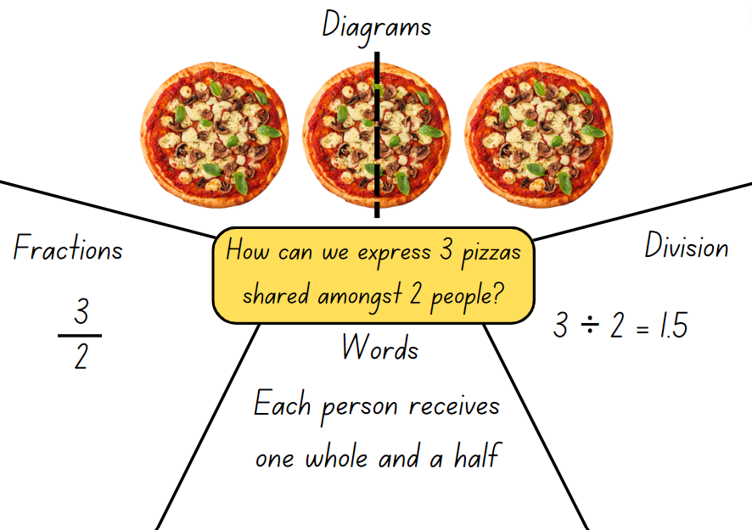
- Ask students to share how 3 halves might be expressed in different ways. Explain that division can be recorded using fractions.

Core lesson 2 – sharing liquorice – 20 minutes
- Present Resource 14 – 10 liquorice straps. Explain that 4 friends are given 10 liquorice straps to share. Ask students what fraction of liquorice strap each friend gets.
- Students work in pairs to provide at least 2 labelled options for sharing 10 liquorice straps equally between 4 children.
- Choose from 2 problems for students to solve:
- 3 chocolate bars shared between 5 people (Resource 15 – 3 chocolate bars)
- 3 oranges shared between 4 people (Resource 16 – 3 oranges.)
This table details opportunities for differentiation.
Too hard? | Too easy?
Students cannot represent and explain how division can be recorded using fractions.  - Provide students with materials, such as paper circles and squares, which students can cut up to represent sharing.  - Support students to explain and record how they shared the food between the friends.  - Ask students to solve 4 chocolate bars shared between 8 people Resource 17 – 4 chocolate bars | Students can represent and explain how division can be recorded using fractions.  - Provide additional questions to students such as:  - How many people would I have to share it between to get one-sixth each? What would happen if I shared it with 8 people?  - What would happen if I shared it with 4 people?  - How many ways can I share 8 pizzas so that everyone gets more than a whole pizza?

Discuss and connect the mathematics – 15 minutes
- Discuss as a class:
- When could expressing division as a fraction be helpful?
- Can fractions be represented as division equations? How could this be useful?
- How does this knowledge help us with division?
- Provide opportunity to practice writing division equations as fractions and discuss what students notice about the conversion using Resource 18 – division as fractions.
This table details an opportunity for assessment.
Assessment opportunity | Links
What to look for:  - Can students recognise that division can be recorded using fractions? [MAO-WM-01, MA3-MR-01] | Links to National Numeracy Learning Progressions (NNLP):  - InF6.

Lesson 7
Core concept: understanding equivalence supports multiplicative thinking.

Daily number sense – nearest to 6 – 15 minutes
The table below contains a suggested learning intention and success criteria. These are best co-constructed with students.
Daily number sense learning intention | Daily number sense success criteria
Students are learning to:  - apply known strategies to add and subtract decimals. | Students can:  - model the addition and subtraction of decimals up to 3 decimal places using appropriate representations.
This activity is an adaptation of Task 4 – I’ll race you to zero: decimal place value from Flexible additive strategies – Decimals by State of New South Wales (Department of Education) using resources in Lesson 5.
- Provide pairs of students with their resources from Lesson 5.
- The aim of this variation is to stay as close to 6 as possible by selecting amounts to add or subtract.
- Students place their counters at 6. Spin to decide who goes first.
- Students take turns to spin and roll and to decide which to use, subtracting or adding the amount to their current position. For example, if a student spun 6 tenths and rolled a 4, they can choose to add or subtract 6 tenths or to add or subtract 4.
- Students explain where they need to move their counter to their partner, justifying their thinking. If their partner agrees, they move the counter to the corresponding position.
- The winner is the student closest to 6 after 10 rolls each. Students may have a score that is higher or lower than 6.
This table details an opportunity for assessment.
Assessment opportunity | Links
What to look for:  - Can students model the addition and subtraction of decimals up to 3 decimal places using appropriate representations? [MAO-WM-01, MA3-AR-01] | Links to National Numeracy Learning Progressions (NNLP):  - AdS9.  Links to suggested Interview for Student Reasoning (IfSR) tasks:  - IfSR-AT: 4A1, 4A.2.

Core lesson – splats – 30 minutes
The table below contains suggested learning intentions and success criteria. These are best co-constructed with students.
Core concept learning intentions | Core concept success criteria
Students are learning to:  - use equivalent number sentences involving multiplication and division to find unknown quantities  - multiply and divide decimals by powers of 10. | Students can:  - complete number sentences that involve more than one operation by calculating missing numbers  - use mental strategies to multiply benchmark decimals by single-digit numbers.
This activity is an adaptation of Splat! from Steve Wyborney's Blog: I'm on a Learning Mission by Wyborney.
- Show Resource 19 – balance the scales. Discuss with students:
- What might the missing numbers be?
- How do you know?
- What other equations could balance the scale if the addition sign wasn’t there?
- What multiplication sentences using decimals or division sentences would balance the scale? (Examples include: 0.2 × 100, 0.02 × 1000, 200 ÷ 10, 2000 ÷ 100.)
- How can we represent what is shown in the image with just an equation?
- What is the purpose of the = sign? Remind students that the = sign records equivalence and it means ‘the same as’.
- Display Resource 20 – splats. Discuss with students:
- If there are 24 cubes on this page, how many are under the splats?
- How could you represent this with an equation?
- How can you represent the unknown value in an equation?
- What strategies can you use to determine how many cubes are under the splat?
- What mathematical operations do you need to solve the problem?
- Do any of the equations written need grouping symbols?
- Record student ideas as equations, such as 24 = 9 + 5 × ?
- Capture student responses and reasoning. Reinforce when grouping symbols are helpful or needed to make the order of operations clear.
- Ask students:
- If some of the cubes have been cut into halves, what strategies could you use to work out how many halves there are?
- How could these responses be recorded in an equation using decimals? An example could be all the hidden cubes are halves and are equally shared under each splat so there are 6 halves under each splat. This could be written as 24 = 9 + 5 × (6 × 0.5).
- How would the equation change if the cubes had been cut into quarters instead of halves? (24 = 9 + 5 × (12 × 0.25).)
- Provide students with Resource 21 – student splats to determine the missing numbers. Ensure that students record their missing value equations, describe their reasoning and include 2 examples involving multiplication of benchmark decimals.
This table details opportunities for differentiation.
Too hard? | Too easy?
Students cannot complete number sentences that involve more than one operation by calculating missing numbers.  - Support students with concrete materials, such as counters to model the different operations required to determine the missing values.  - Students explore equivalence with an interactive manipulative. Students write equivalent number sentences.  - Model a correct equation with 2 operations, such as 19 = 4 + 3 × 5. Guide students to change one element to change the equation, such as 4 + 5 + 2 × 5 = 19. Invite the student to make their own. | Students can complete number sentences that involve more than one operation by calculating missing numbers.  - Provide students with Resource 22 – open-ended splats. Ask students what the total could be and to record their reasoning in equations.  - Have students create their own splats for classmates to solve. Challenge students to create splats where there are multiple operations.

Discuss and connect the mathematics – 10 minutes
- Discuss with students their strategies for determining a missing value in equations. Suggested questions include:
- What strategies did you use when calculating the missing value?
- Which operations helped you the most? Why?
- What properties of multiplication helped you with determining the missing value?
- Were grouping symbols necessary (or helpful) in the equations you wrote?
This table details opportunities for assessment.
Assessment opportunities | Links
What to look for:  - Can students complete number sentences that involve more than one operation by calculating missing numbers? [MAO-WM-01, MA3-MR-02]  - Can students use mental strategies to multiply benchmark decimals by single-digit numbers? [MAO-WM-01, MA3-MR-01] | Links to National Numeracy Learning Progressions (NNLP):  - NPA3, NPA4  - MuS7, MuS8, MuS9.  Links to suggested Interview for Student Reasoning (IfSR) tasks:  - IfSR-MT: 3A.8, 3A.9.

Lesson 8
Core concept: worded problems can be solved using multiplicative thinking.

Daily number sense – 10 minutes
- From a class need surfaced through formative assessment data, identify a short, focused activity that targets students’ knowledge, understanding and skills. Example activities may be drawn from the following resources:
- Mathematics K-6 resources
- Universal Resources Hub.

Core lesson – multiplicative problems – 45 minutes
The table below contains suggested a learning intention and success criteria. These are best co-constructed with students.
Core concept learning intention | Core concept success criteria
Students are learning to:  - select and apply strategies to solve problems involving multiplication and division with whole numbers. | Students can:  - select and use efficient strategies to multiply whole numbers of up to 4 digits by one- and 2-digit numbers  - solve word problems involving rates using multiplication and division.
This activity is an adaptation of ‘Rates and ratio’ from Challenging Mathematical Tasks: Unlocking the Potential of All Students by Sullivan. The fuel consumption has an additional complexity in that a higher consumption rate is less efficient. Ensure students understand the words ‘specification’ and ‘efficient’ for this context.
- Share the following problem: The manufacturer’s specifications say that my car has a fuel consumption of 8 L/100 km. When I measured my fuel use carefully, I noticed that my car used 36 L of fuel to travel 400 km.
- Introduce or revise the forward slash symbol / and the necessary language, such as ‘per’ and ‘for each’. Students turn and talk to discuss the problem.
- Ask students:
- Is the car more efficient than the manufacturer’s claim or not?
- How can you record your thinking?
- What mathematical operations did you use to determine the answer to this problem?
- What number properties did you use to help you with this question?
- Possible solutions include:
- convert 36 L/400 km to 9 L/100 km and compare the figures
- convert 8 L/100 km to 32 L/400 km and compare the figures
- convert the units and compare so that 8 L/100 km becomes 1 L/12.5 km and 36 L/400 km becomes 1 L/11.11 km.
- Display Resource 23 – best buy shirts. Students turn and talk to discuss the problem. Ask students:
- How much would it cost to buy 10 pink shirts? 10 blue shirts? 10 green shirts?
- Which is the best value? How do you know?
- How can you represent your thinking and strategies?
- Are there other ways of determining the best value shirt?
- What mathematical operations did you use to determine the answer to this problem?
- What properties of numbers did you use to help you with this question?
- Record student responses and discuss the use of visual tools, such as bar models, tables and number lines to express their ideas.
- Students experiment using a range of strategies to represent and answer one or more of the following problems:
- A recipe requires 6 cups of flour for 15 people. How many cups of flour are required for 60 people?
- A machine produces 10 toys per minute. How long does it take the machine to produce 600 toys? How long will it take to produce 1800 toys?
- It is 800 km from Albury, Wiradjuri Country to Brewarrina, Ngemba Country. The distance from Albury to Nyngan, Ngemba Country, is 3 times the distance from Nyngan to Brewarrina. How far is it from Albury to Nyngan?
- An alarm beeps 6 times every 8 seconds. How many times does the beep sound in 2 minutes? How many times in 20 minutes?
- Amelia can buy 2 sandwiches for $5.00. How much do 9 sandwiches cost at that price?
This table details opportunities for differentiation.
Too hard? | Too easy?
Students cannot solve word problems involving rates using multiplication and division.  - Support students to create visual representations, such as bar models, tape diagrams or lines.  - Guide students to determine the value of one unit. For example, if 2 sandwiches cost $5.00, ask how much one sandwich would cost. | Students can solve word problems involving rates using multiplication and division.  - Provide students with challenging rate problems such as An Unhappy End, Printer Ink, Thunder and Lightning.  - Students solve a variety of multiplication and division problems from Australasian Problem Solving Mathematical Olympiads (APSMO) (2008–2015).

Discuss and connect the mathematics – 10 minutes
- Discuss student strategies for recording their thinking. Ask:
- What was the advantage of recording your thinking using visuals?
- What was the most effective method for recording your thinking? What makes you say that?
- Were these problems multiplication or division problems?
- Why is it important to know a variety of strategies for multiplication and division?
This table details opportunities for assessment.
Assessment opportunities | Links
What to look for:  - Can students select and use efficient strategies to multiply whole numbers of up to 4 digits by one- and 2-digit numbers? [MAO-WM-01, MA3-MR-01]  - Can students solve word problems involving rates using multiplication and division? [MAO-WM-01, MA3-MR-01] | Links to National Numeracy Learning Progressions (NNLP):  - MuS7, MuS8  - PrT4.

Resource 1 – pattern multiples
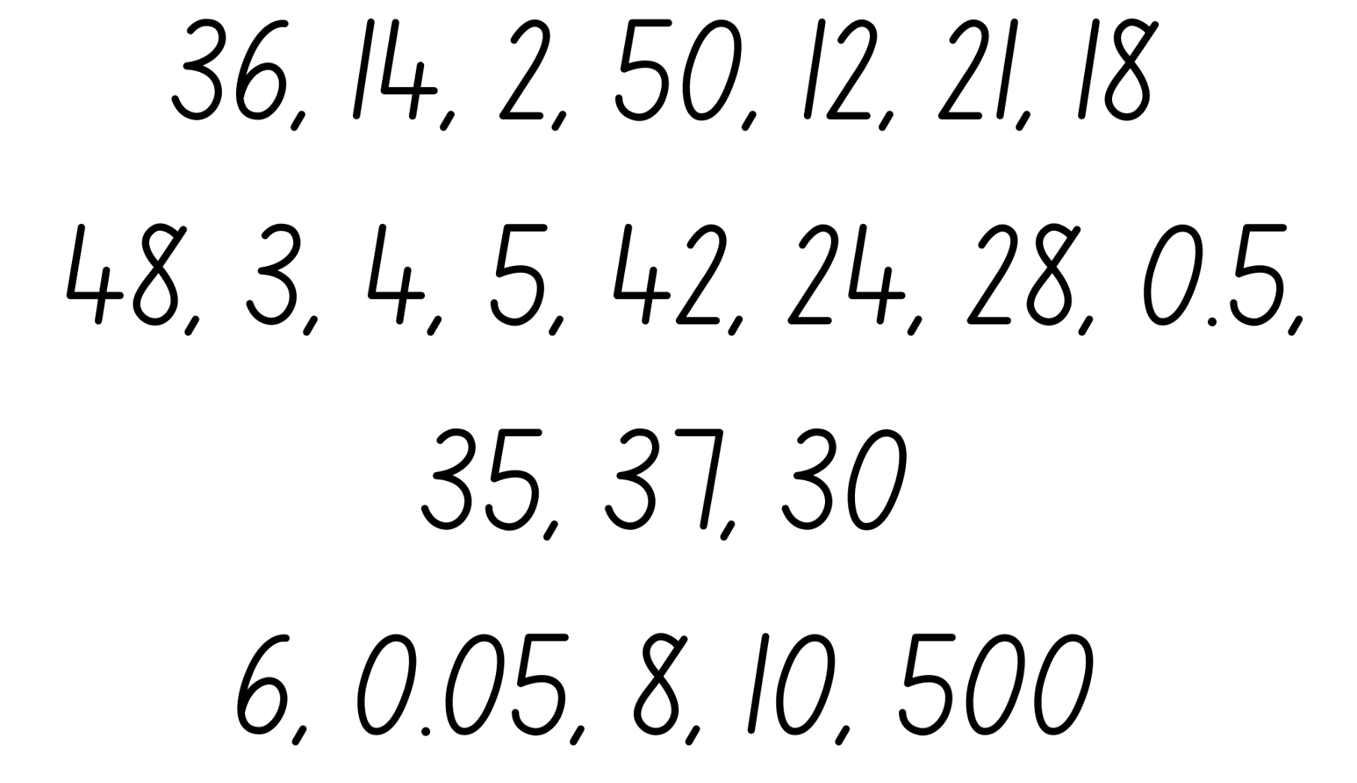

Resource 2 – hexagons
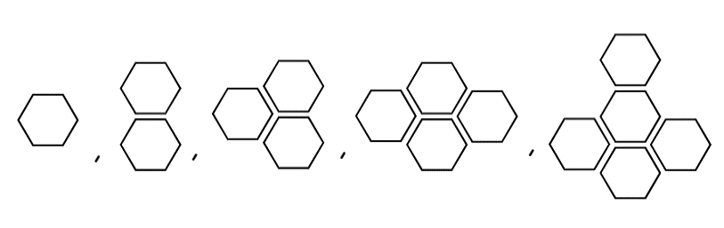

Resource 3 – hexagon table
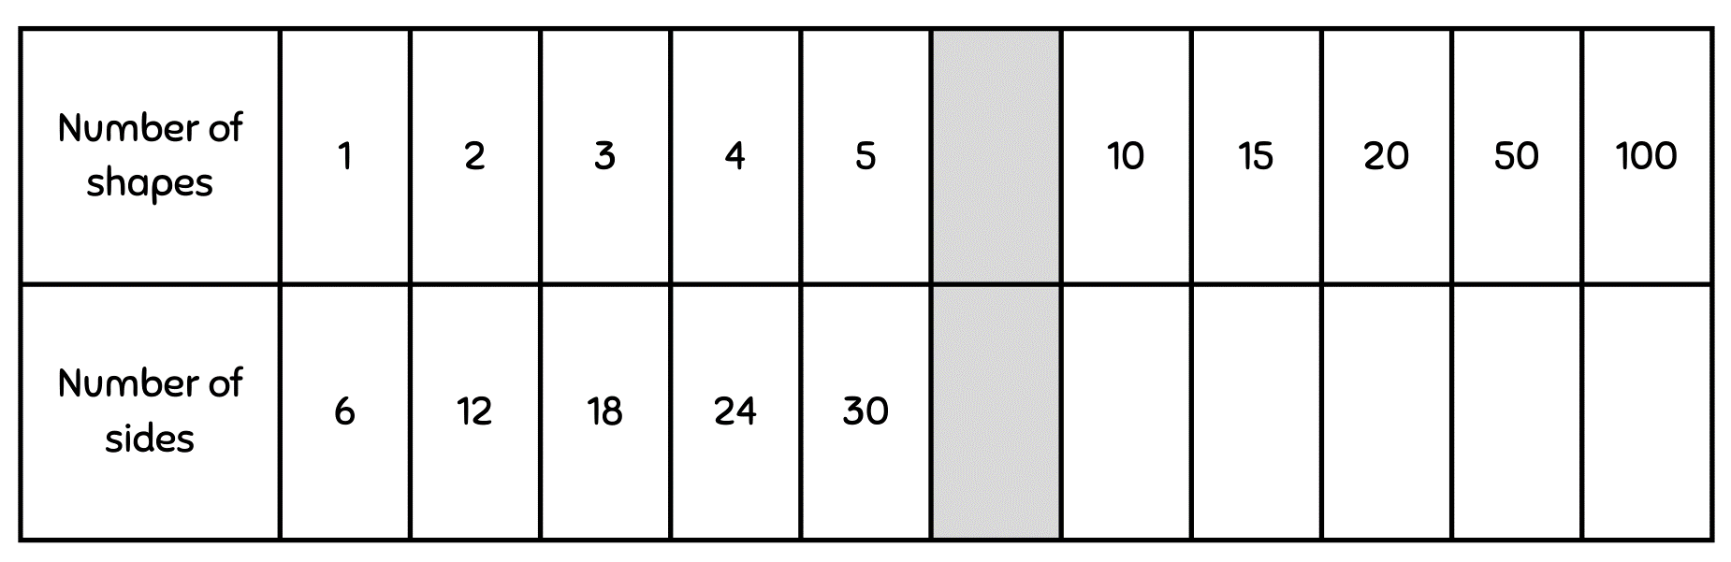

Resource 4 – blank tables
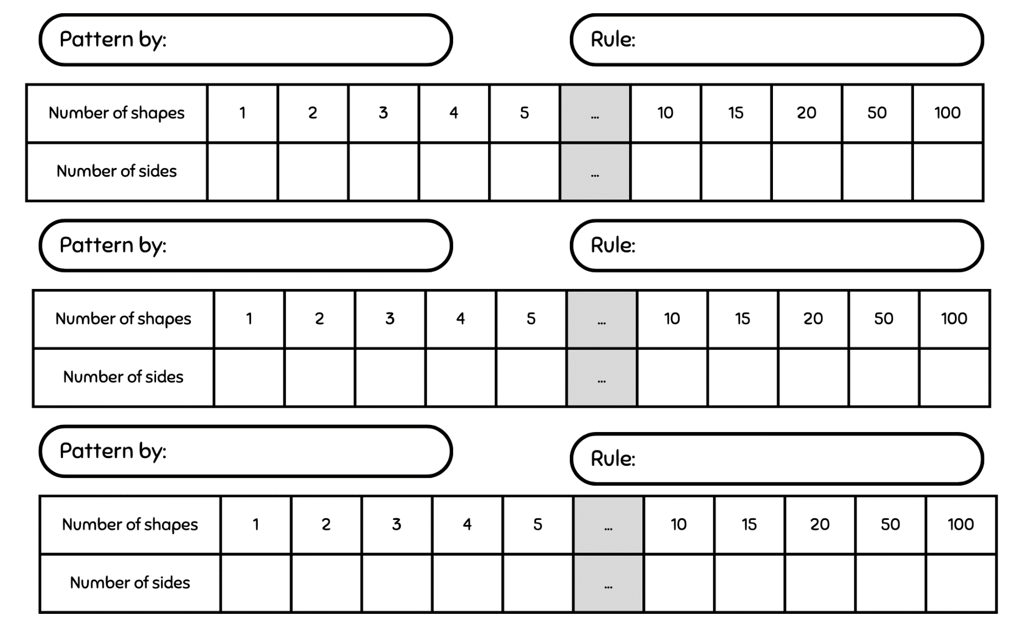

Resource 5 – think board 1
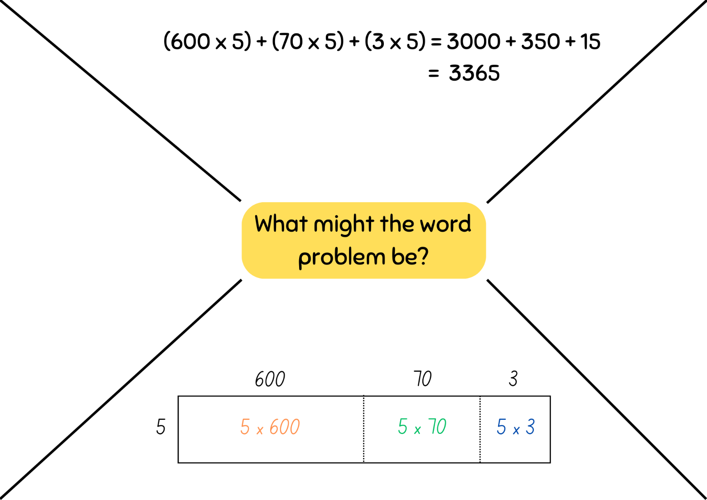

Resource 6 – think board 2

Resource 7 – word problems
- A factory produces 385 cartons of biscuits a day. How many cartons does it produce over 5 days?
- A shop sells game consoles for $638. How much money would it cost to buy 4?
- Apples are cut into 8 slices to be put onto a fruit platter. The kitchen has 12 crates of apples. If each crate has 90 apples, how many slices will there be altogether?
- It is peak hour on the train. Each carriage has 15 compartments and each compartment has 6 people in it. If the train is made up of 25 carriages, how many people are there altogether?

Resource 8 – algorithm errors
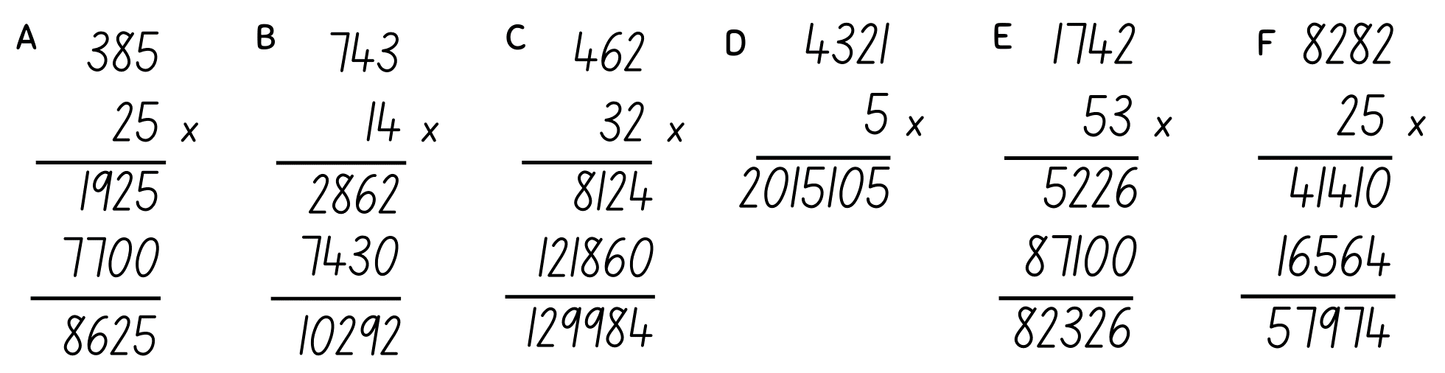

Resource 9 – match the problem
For a complete school uniform, Alex needs a pair of trousers and a shirt. A pair of trousers costs $60 and a shirt costs $40. Alex buys 2 complete school uniforms. How much will she need to pay? | 60 × 20 + 40 × 30
At the school clothing shop, trousers are sold for $60 and shirts are sold for $40. In February, the shop sold 20 pairs of trousers and 30 shirts to new students. What was the total amount of money that the clothing shop received? | 60 + 40 × 2
Slavek wants to buy a pair of jeans marked $60 and a shirt marked $40. At the cash register, the attendant tells him that the store is having a ‘pay only half’ sale. How much will Slavek need to pay? | (60 + 40) × 2
Jing-Wei wants to buy a jacket marked $60 and 2 pairs of jeans each marked $40. How much will she need to pay? | 60 + 40 ÷ 2
Each school in the region ordered 20 ‘Year 6’ jerseys that cost $60 each. The delivery charge for each school was $40. There are 30 schools in the region. What was the total cost of the jerseys for the region? | (60 + 40) ÷ 2
Rasheed wants to buy a pair of jeans marked $60 and a shirt marked $40. At the cash register, the attendant tells him that the store is having a ‘half-price shirts’ sale. How much will he need to pay? | (60 × 20 + 40) × 30

Resource 10 – labelled 12 chart
For a high resolution copy of a labelled 12 chart, see Appendix 2 of Part 4: Flexible strategies with decimals.
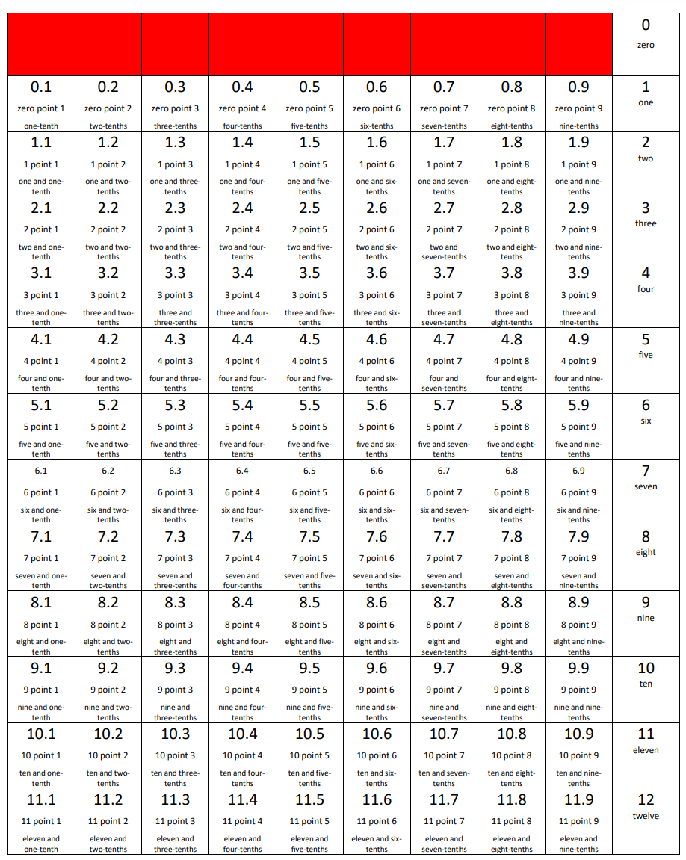

Resource 11 – fraction spinner
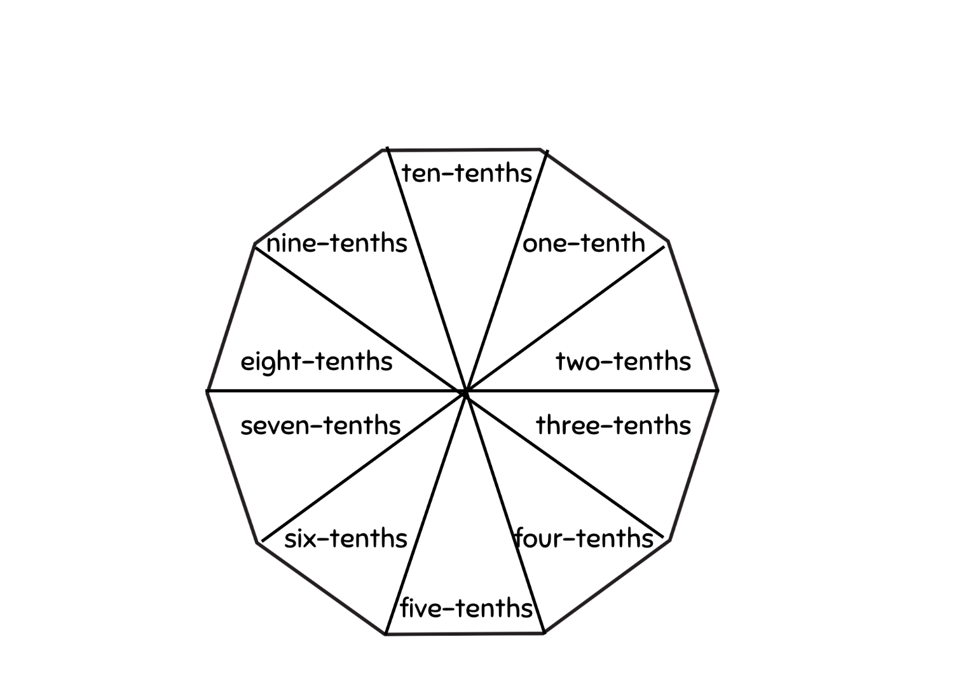

Resource 12 – dice division
Instructions
- Take turns to be the roller. Roll 3 dice.
- Using the numbers, everyone writes down a division problem formed by making a 2-digit number and dividing by the third number.
- Solve the division and leave your answer in remainder form.
- Your score is the quotient. You get a +10-point bonus if there is no remainder when you perform the division.
- Players reveal their responses. If 2 or more players write down the same equation, they score zero points.
- The winner is the first to 150 points.

Example
If I roll 2, 5 and 6, some possibilities are:
62 ÷ 5 = 12 r2 – 12 points | 25 ÷ 6 = 4 r1 – 4 points
65 ÷ 2 = 32 r1 – 32 points | 26 ÷ 5 = 5 r1 – 5 points
56 ÷ 2 = 28 plus the 10-point bonus is 38 points! | 52 ÷ 6 = 8 r4 – 8 points
Note: if 2 players have the same equation, they each score zero!

Dice division gameboard
Name:_______________________________
Division equation | Score | No remainder bonus (+10) | Total so far
65 ÷ 5 = 13 | 13 | 10 | 23

Resource 13 – sharing pizzas
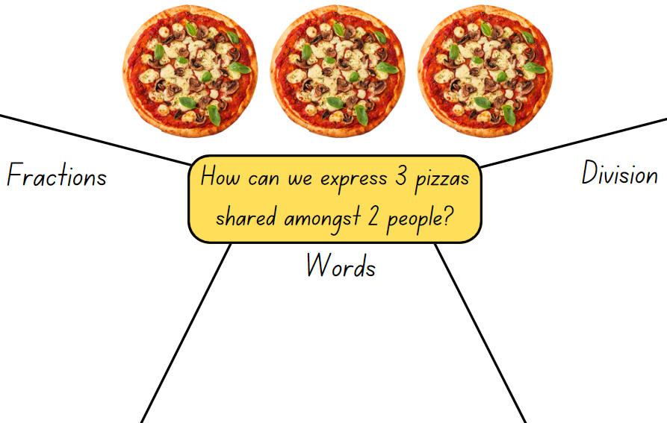

Resource 14 – 10 liquorice straps
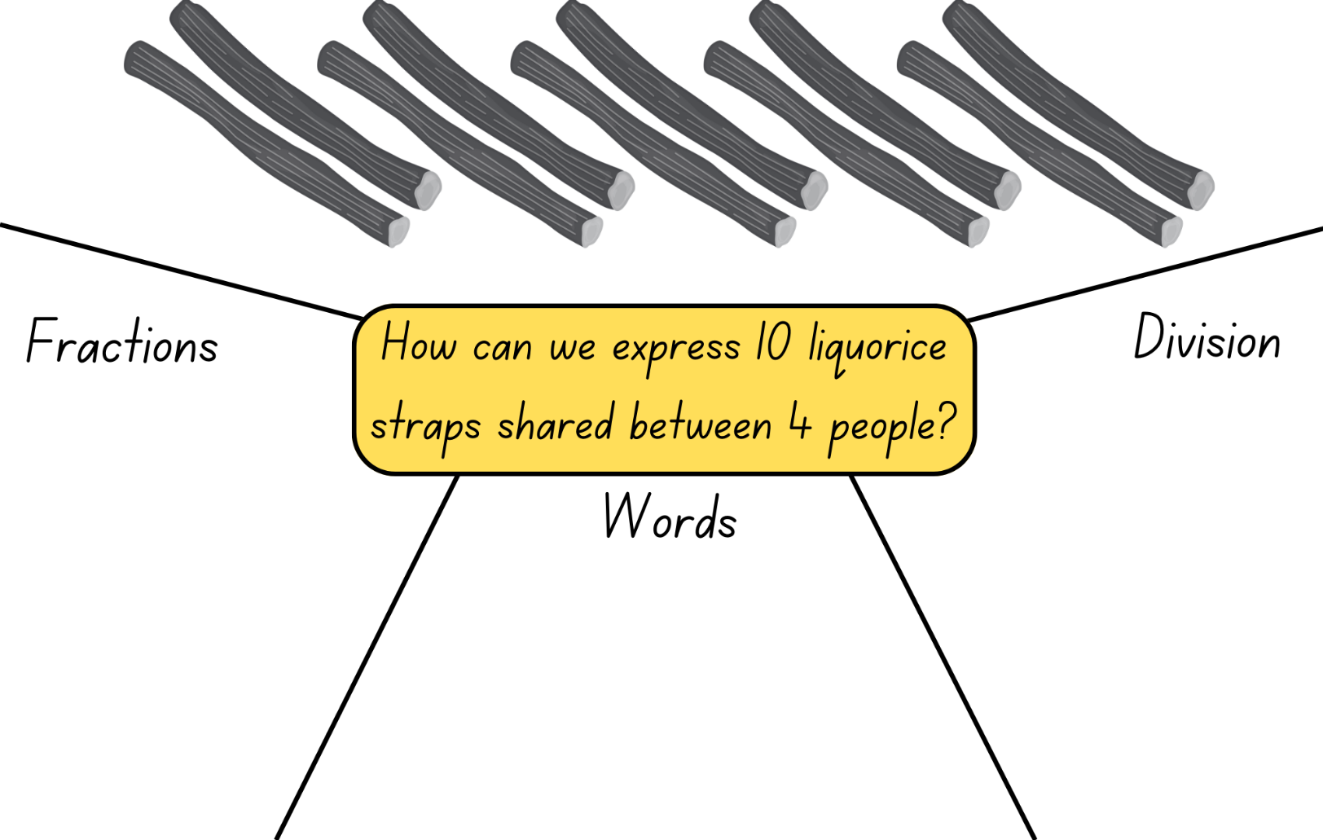

Resource 15 – 3 chocolate bars
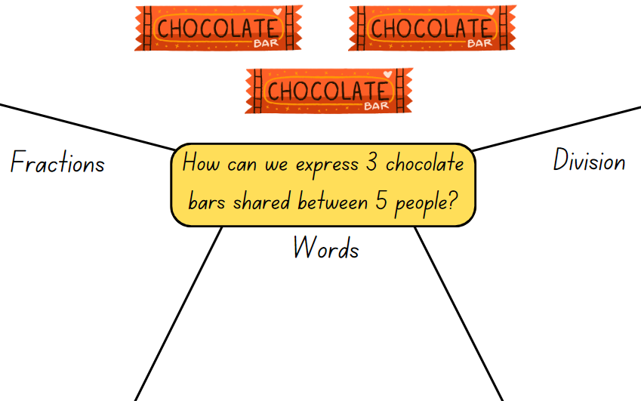

Resource 16 – 3 oranges
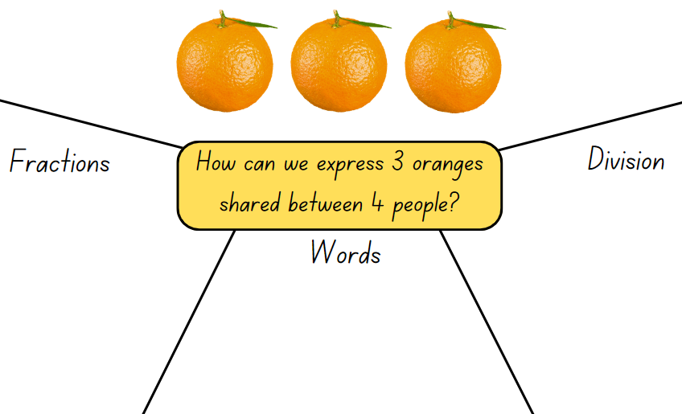

Resource 17 – 4 chocolate bars
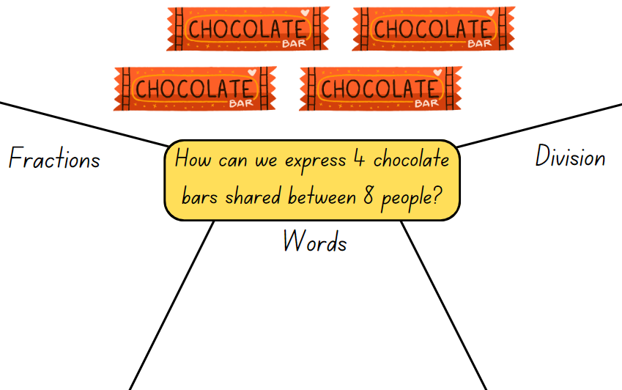

Resource 18 – division as fractions
Rewrite these division equations as fractions.
3 ÷ 2 = | 4 ÷ = | 10 ÷ 2 =
10 ÷ 5 = | 1 ÷ 2 = | 2 ÷ 3 =
30 ÷ 10 = | 50 ÷ 5 = | 24 ÷ 8 =
36 ÷ 6 = | 49 ÷ 7 = | 14 ÷ 7 =

Resource 19 – balance the scales
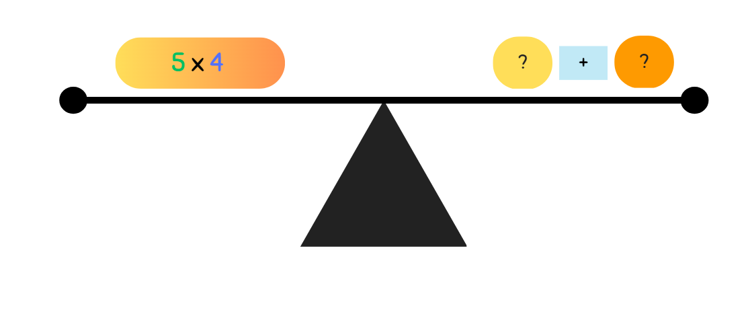

Resource 20 – splats
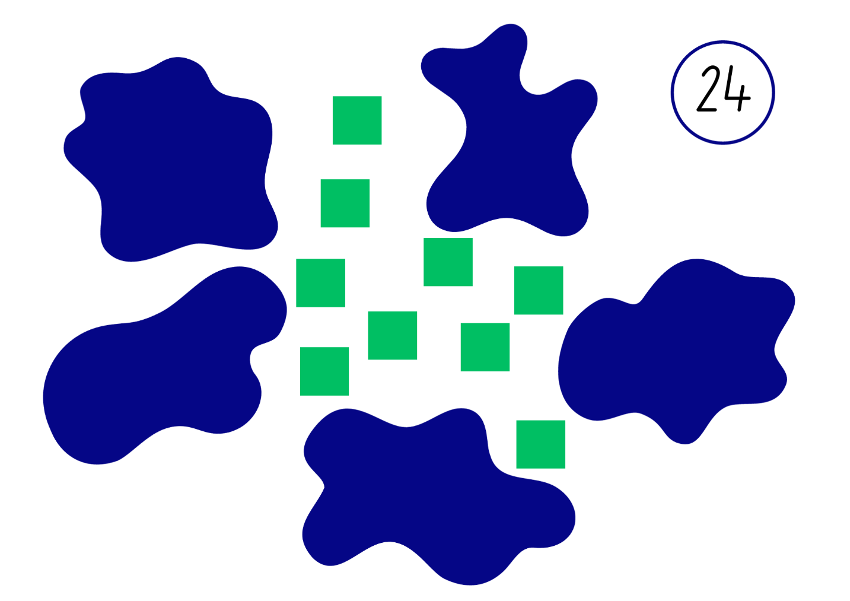
Adapted from Wyborney (2017).

Resource 21 – student splats
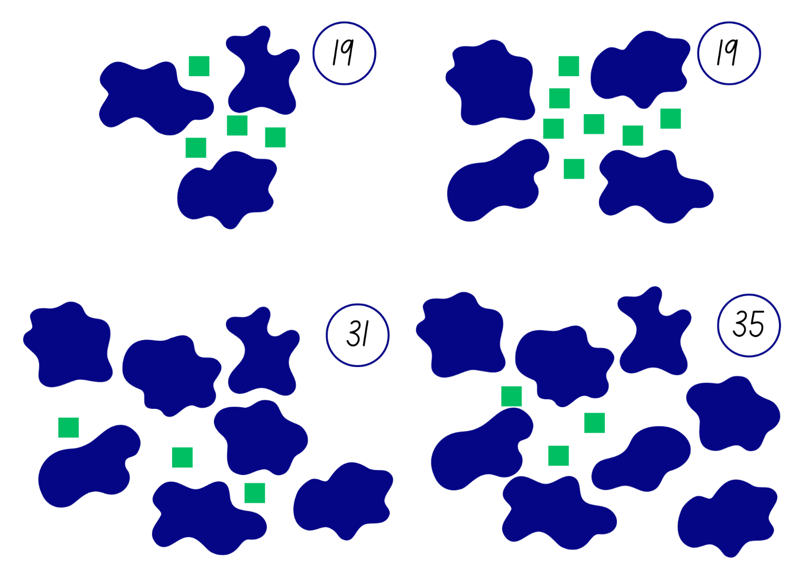
Adapted from Wyborney (2017).

Resource 22 – open-ended splats
Adapted from Wyborney (2017).

Resource 23 – best buy shirts
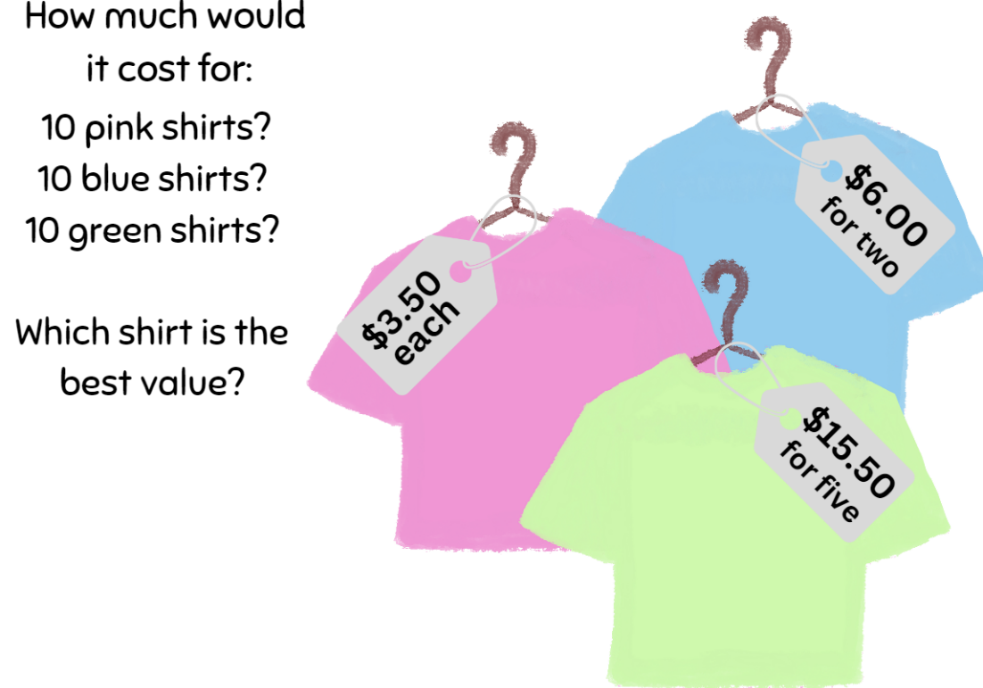

Syllabus outcomes and content
The table below outlines the syllabus outcomes and range of relevant syllabus content covered in this unit. Content is linked to National Numeracy Learning Progression version (3).
Outcomes and content | 1 | 2 | 3 | 4 | 5 | 6 | 7 | 8
Represents numbers A: Whole numbers: Apply place value to partition, regroup and rename numbers to 1 billion
[MAO-WM-01, MA3-RN-01]
- Regroup numbers in different forms (Reasons about quantity) |  | x | x
Additive relations A: Apply efficient mental and written strategies to solve addition and subtraction problems
[MAO-WM-01, MA3-AR-01]
- Solve word problems, including multistep problems |  |  |  | x
- Use place value to add or subtract 3 or more numbers with different numbers of digits |  | x
Additive relations B: Applies known strategies to add and subtract decimals
[MAO-WM-01, MA3-AR-01]
- Model the addition and subtraction of decimals up to 3 decimal places using appropriate representations |  |  |  |  | x | x | x
Multiplicative relations A: Use partitioning and place value to multiply 2-, 3- and 4-digit numbers by one-digit numbers
[MAO-WM-01, MA3-MR-01, MA3-MR-02]
- Use the distributive property with the area model to partition numbers in representing multiplication problems |  | x
Multiplicative relations A: Represent and solve division problems with whole number remainders
[MAO-WM-01, MA3-MR-01, MA3-MR-02]
- Use known multiplication fact families to solve division problems for which answers may include a remainder |  |  |  |  | x
- Use the term quotient to describe the result of a division calculation |  |  |  |  | x
Multiplicative relations A: Use estimation and rounding to check the reasonableness of answers to calculations
[MAO-WM-01, MA3-MR-01, MA3-MR-02]
- Use estimation to check the reasonableness of answers to multiplication and division calculations |  | x
Multiplicative relations B: Select and apply strategies to solve problems involving multiplication and division with whole numbers
[MAO-WM-01, MA3-MR-01, MA3-MR-02]
- Select and use efficient strategies to multiply whole numbers of up to 4 digits by one- and 2-digit numbers |  |  | x |  |  |  |  | x
- Solve word problems involving rates using multiplication and division (Reasons about relations) |  |  |  |  |  |  |  | x
Multiplicative relations B: Multiply and divide decimals by powers of 10
[MAO-WM-01, MA3-MR-01, MA3-MR-02]
- Use mental strategies to multiply benchmark decimals by single-digit numbers |  |  | x |  |  |  | x
- Compare the relative place value of digits to multiply and divide a decimal by powers of 10 | x
- Estimate the product of a decimal and a whole number to determine the magnitude of a calculator answer |  | x
Multiplicative relations B: Use equivalent number sentences involving multiplication and division to find unknown quantities
[MAO-WM-01, MA3-MR-01, MA3-MR-02]
- Complete number sentences that involve more than one operation by calculating missing numbers |  |  |  |  |  |  | x
- Identify and use inverse operations to assist with the solution of number sentences |  |  |  |  | x
- Recognise that division can be recorded using fractions |  |  |  |  |  | x
Multiplicative relations B: Represent and describe number patterns formed by multiples
[MAO-WM-01, MA3-MR-01, MA3-MR-02]
- Use a given geometric pattern involving multiples to create a table of values | x
- Describe a pattern formed by multiples in words, in terms of multiplication rather than addition | x
- Determine a rule describing the relationship between the bottom number and the top number in a table (Algebraic reasoning) | x
Multiplicative relations B: Explore the use of brackets and the order of operations to write number sentences
[MAO-WM-01, MA3-MR-01, MA3-MR-02]
- Use grouping symbols () in number sentences to indicate operations that must be performed first |  |  |  | x
- Investigate the order of operations using real-life contexts |  |  |  | x
Mathematics K–10 Syllabus © NSW Education Standards Authority (NESA) for and on behalf of the Crown in right of the State of New South Wales, 2022.

References
This document contains NSW Curriculum and syllabus content. The NSW Curriculum is developed by the NSW Education Standards Authority. This content is prepared by NESA for and on behalf of the Crown in right of the State of New South Wales. The material is protected by Crown copyright.
Please refer to the NESA Copyright Disclaimer for more information https://educationstandards.nsw.edu.au/wps/portal/nesa/mini-footer/copyright.
NESA holds the only official and up-to-date versions of the NSW Curriculum and syllabus documents. Please visit the NSW Education Standards Authority (NESA) website https://educationstandards.nsw.edu.au/ and the NSW Curriculum website https://curriculum.nsw.edu.au/home.
Mathematics K–10 Syllabus © NSW Education Standards Authority (NESA) for and on behalf of the Crown in right of the State of New South Wales, 2022.
National Numeracy Learning Progression © Australian Curriculum, Assessment and Reporting Authority (ACARA) 2010 to present, unless otherwise indicated. This material was downloaded from the Australian Curriculum website (National Numeracy Learning Progression) (accessed 20 September 2023) and was not modified.
Byrdseed, LLC (2012–2023) 'Parentheses: How big of a change can they make!?' [video], Byrdseed.TV, Byrdseed.TV, accessed 19 July 2023.
Coolmath.com LLC (2019) ‘Base Ten Blocks’, Manipulatives, Coolmath4Kids website, accessed 29 June 2023.
Didax, Inc (2023) ‘Math Balance’, Virtual Manipulatives, Didax website, accessed 30 October 2023.
Finkel D and Cook K (19 November 2019) ‘Dalmut Dice Division’, Math for Love blog, accessed 19 July 2023.
Kalman R, Phegan J and Prescott A (eds) (2008) Maths Olympiad Contest Problems: Volume 2, Australian edn, APSMO (Australasian Problem Solving Mathematical Olympiads) and MOEMS (Mathematical Olympiads for Elementary and Middle Schools), Australia.
Kalman R, Restivo N, Phegan J and McMaster H (eds) (2015) Maths Olympiad Contest Problems: Volume 3, Australian edn, APSMO and MOEMS, Australia.
Lenchner G (2005) Maths Olympiad Contest Problems: Volume 1 (Prescott A ed), Australian edn, APSMO and MOEMS, Australia.
State of New South Wales (Department of Education) (2023) ‘Flexible additive strategies – Decimals – Task 4 – I’ll race you to zero: decimal place value’, Numeracy, NSW Department of Education, accessed on 11 July 2023.
Sullivan P (2017) Challenging Mathematical Tasks: Unlocking the Potential of All Students, Oxford University Press Australia and New Zealand.
Toy Theater (2001–2023) ‘Place Value Cards’, Place Value Manipulatives, Toy Theater website, accessed 29 June 2023.
University of Cambridge (Faculty of Mathematics) (1997–2023) An Unhappy End, NRICH website, accessed 29 June 2023.
University of Cambridge (Faculty of Mathematics) (1997–2023) Countdown, NRICH website, accessed 29 June 2023.
University of Cambridge (Faculty of Mathematics) (1997–2023) Printer Ink, NRICH website, accessed 29 June 2023.
University of Cambridge (Faculty of Mathematics) (1997–2023) Remainders, NRICH website, accessed 29 June 2023.
University of Cambridge (Faculty of Mathematics) (1997–2023) Thunder and Lightning, NRICH website, accessed 29 June 2023.
Wyborney S (9 February 2017) ‘Splat!’, Steve Wyborney’s Blog: I’m on a Learning Mission, accessed 19 July 2023.

Further reading
Siemon D, Warren E, Beswick K, Faragher R, Miller J, Horne M, Jazby D, Breed M, Clark J and Brady K (2020) Teaching Mathematics: Foundations to Middle Years, 3rd edn, Oxford University Press Australia and New Zealand.
Van de Walle J, Karp K, Bay-Williams JM, Brass A, Bentley B, Ferguson S, Goff W, Livy S, Marshman M, Martin D, Pearn C, Prodromou T, Symons D and Wilkie K (2019) Primary and Middle Years Mathematics: Teaching Developmentally, 1st Australian edn, Pearson Education Australia, Melbourne.

© State of New South Wales (Department of Education), 2023
The copyright material published in this resource is subject to the Copyright Act 1968 (Cth) and is owned by the NSW Department of Education or, where indicated, by a party other than the NSW Department of Education (third-party material).
Copyright material available in this resource and owned by the NSW Department of Education is licensed under a Creative Commons Attribution 4.0 International (CC BY 4.0) license.
This license allows you to share and adapt the material for any purpose, even commercially.
Attribution should be given to © State of New South Wales (Department of Education), 2023.
Material in this resource not available under a Creative Commons license:
- the NSW Department of Education logo, other logos and trademark-protected material
- material owned by a third party that has been reproduced with permission. You will need to obtain permission from the third party to reuse its material.
Links to third-party material and websites
Please note that the provided (reading/viewing material/list/links/texts) are a suggestion only and implies no endorsement, by the New South Wales Department of Education, of any author, publisher, or book title. School principals and teachers are best placed to assess the suitability of resources that would complement the curriculum and reflect the needs and interests of their students.
If you use the links provided in this document to access a third-party's website, you acknowledge that the terms of use, including licence terms set out on the third-party's website apply to the use which may be made of the materials on that third-party website or where permitted by the Copyright Act 1968 (Cth). The department accepts no responsibility for content on third-party websites.

