Mathematics Stage 2 Year B – Unit 30

Contents
Unit description and duration 5
Syllabus outcomes 5
Working mathematically 6
Student prior learning 6
Lesson overview and resources 8
Lesson 1 14
Daily number sense – using arrays – 10 minutes 14
Core lesson 1 – measuring right angles by the amount of turn – 10 minutes 16
Core lesson 2 – identifying right angles – 40 minutes 17
Discuss and connect the mathematics – 10 minutes 22
Lesson 2 24
Daily number sense – fact families – 10 minutes 24
Core lesson 1 – bigger, smaller or equal? – 20 minutes 26
Core lesson 2– angle art – 25 minutes 27
Discuss and connect the mathematics – 15 minutes 29
Lesson 3 31
Daily number sense – solving problems with fact families – 10 minutes 31
Core lesson 1 – The Bridge – 20 minutes 33
Core lesson 2 – angles in the world – 20 minutes 34
Discuss and connect the mathematics – 10 minutes 35
Lesson 4 37
Daily number sense – 10 minutes 37
Core lesson 1 – investigating angles in letters – 10 minutes 37
Core lesson 2 – investigating angles on clocks – 30 minutes 39
Consolidation and meaningful practice – 20 minutes 42
Lesson 5 44
Daily number sense – decimals in order – 10 minutes 44
Core lesson 1 – in a minute – 20 minutes 46
Core lesson 2 – showing the time – 20 minutes 49
Discuss and connect the mathematics – 10 minutes 51
Lesson 6 53
Daily number sense – largest decimal – 10 minutes 53
Core lesson 1 – fractions of 60 – 20 minutes 55
Core lesson 2 – fractions of time – 20 minutes 59
Discuss and connect the mathematics – 10 minutes 61
Lesson 7 62
Daily number sense – fractions and decimals – 10 minutes 62
Core lesson 1 – test yourself – 10 minutes 63
Core lesson 2 – obstacle course – 30 minutes 65
Discuss and connect the mathematics – 10 minutes 67
Consolidation and meaningful practice – 10 minutes 68
Lesson 8 69
Daily number sense – 10 minutes 69
Core lesson 1 – time tools revisited – 10 minutes 70
Core lesson 2 – the Shoelace Olympics – 20 minutes 70
Consolidation and meaningful practice – time riddle – 20 minutes 72
Resource 1 – right angles and shapes 74
Resource 2 – making fact families 75
Resource 3 – mystery angles 76
Resource 4 – angle names 77
Resource 5 – angle art 78
Resource 6 – lots of buttons 79
Resource 7 – environmental angles 1 80
Resource 8 – environmental angles 2 81
Resource 9 – alphabet letters 82
Resource 10 – clock angles 83
Resource 11 – time angles 84
Resource 12 – in a minute 85
Resource 13 – showing the time 86
Resource 14 – day and night timeline 87
Resource 15 – creative arts activities 88
Resource 16 – fractions and decimals 89
Resource 17 – faulty digital clock 90
Resource 18 – check the clock 91
Syllabus outcomes and content 92
References 98

Unit description and duration
This unit develops the big idea that angles are the primary structural component of many shapes.
In this 2-week unit students are provided opportunities to:
- describe and compare angles in relation to right angles
- represent and read analog and digital time
- utilise partitioning and multiplicative relationships to represent fractional quantities of time.

Syllabus outcomes
- MAO-WM-01 develops understanding and fluency in mathematics through exploring and connecting mathematical concepts, choosing and applying mathematical techniques to solve problems, and communicating their thinking and reasoning coherently and clearly
- MA2-RN-02 represents and compares decimals up to 2 decimal places using place value
- MA2-MR-01 represents and uses the structure of multiplicative relations to 10 × 10 to solve problems
- MA2-PF-01 represents and compares halves, quarters, thirds and fifths as lengths on a number line and their related fractions formed by halving (eighths, sixths and tenths)
- MA2-GM-03 identifies angles and classifies them by comparing to a right angle
- MA2-NSM-02 represents and interprets analog and digital time in hours, minutes and seconds

Working mathematically
In the Mathematics K–10 Syllabus, there is one overarching Working mathematically outcome (MAO-WM-01). The Working mathematically processes should be embedded within the concepts being taught. The Working mathematically processes present in the Mathematics K–10 Syllabus are:
- communicating
- understanding and fluency
- reasoning
- problem solving.
Mathematics K–10 Syllabus © NSW Education Standards Authority (NESA) for and on behalf of the Crown in right of the State of New South Wales, 2022.

Student prior learning
Before engaging in these teaching and learning activities, students would benefit from prior experience with:
- identifying and naming the parts of an angle
- identifying angles as measures of turn
- reading and representing analog time using minutes and hours and solving problems involving quarter hours and half hours.
In NSW classrooms there is a diverse range of students, including Aboriginal and Torres Strait Islander students, students learning English as an additional language or dialect, high potential and gifted students and students with disability. Some students may identify with more than one of these groups or possibly all of them. Refer to Curriculum planning for every student – advice for further information.

Lesson overview and resources
The table below outlines the sequence and approximate timing of lessons, learning intentions and resources.
Lesson | Content | Duration and resources
Lesson 1  Daily number sense learning intention:  - recall multiplication facts of 2 and 4, 5 and 10 and related division facts | Lesson core concept: right angles are common because they are easy to identify, easy to make and easy to pack and stack.  Core concept learning intentions:  - identify angles as measures of turn  - compare angles to a right angle | Lesson duration: 70 minutes  - Resource 1 – right angles and shapes  - 10-sided dice  - A4 paper  - Angle identifier  - Counters  - Digital device  - Geoboards or digital geoboard  - Poster paper  - Two-dimensional shape blocks  - Writing materials
Lesson 2  Daily number sense learning intention:  - recall multiplication facts of 2 and 4, 5 and 10 and related division facts | Lesson core concept: angles are often described and compared in relation to right angles.  Core concept learning intentions:  - identify angles as measures of turn  - compare angles to a right angle | Lesson duration: 70 minutes  - Resource 2 – making fact families  - Resource 3 – mystery angles  - Resource 4 – angle names  - Resource 5 – angle art  - Angle tester  - Counters  - Writing materials
Lesson 3  Daily number sense learning intention:  - recall multiplication facts of 2 and 4, 5 and 10 and related division facts | Lesson core concept: angles can be found in art, buildings and nature.  Core concept learning intentions:  - identify angles as measures of turn  - compare angles to a right angle | Lesson duration: 60 minutes  - Resource 6 – lots of buttons  - Resource 7 – environmental angles 1  - Resource 8 – environmental angles 2  - Analog clock or digital clock  - Angle tester  - Writing materials
Lesson 4  Daily number sense learning intention:  - teacher-identified task based on student needs | Lesson core concept: the arms and vertex of an angle can be visible or invisible.  Core concept learning intentions:  - compare angles to a right angle  - represent and read analog time | Lesson duration: 70 minutes  - Resource 9 – alphabet letters  - Resource 9 – alphabet letters (one enlarged copy)  - Resource 10 – clock angles  - Resource 11 – time angles  - 2 strips of card  - Digital device  - Interactive analog clock  - Split pins  - Writing materials
Lesson 5  Daily number sense learning intention:  - make connections between decimals | Lesson core concept: halving and quartering blocks of time helps to measure and sequence events.  Core concept learning intentions:  - represent and interpret digital time displays  - model and represent unit fractions | Lesson duration: 60 minutes  - Resource 12 – in a minute  - Resource 13 – showing the time  - Active analog clock  - Digital device  - Individual whiteboards  - Static analog clock  - Playing cards  - Sticky notes  - Time tools  - Writing materials
Lesson 6  Daily number sense learning intention:  - make connections between decimal notation | Lesson core concept: dividing an hour into 60 minutes is useful as 60 has many factors.  Core concept learning intentions:  - use am and pm notation  - represent fractional quantities equal to and greater than one | Lesson duration: 60 minutes  - Resource 14 – day and night timeline  - Resource 15 – creative arts activities  - 10-sided dice  - Analog clock or interactive analog clock  - Individual whiteboards  - Writing materials
Lesson 7  Daily number sense learning intention:  - make connections between fractions and decimal notation | Lesson core concept: the context determines the most suitable standard unit, sometimes a minute is too long.  Core concept learning intention:  - represent and interpret digital time displays | Lesson duration: 70 minutes  - Resource 16 – fractions and decimals  - Resource 17 – faulty digital clock  - Analog clock or interactive analog clock  - Digital timing devices or stopwatches  - Individual whiteboards  - Writing materials
Lesson 8  Daily number sense learning intention:  - teacher-identified task based on student needs | Lesson core concept: measuring tools, like digital clocks and timers, need to be carefully handled, aligned and read.  Core concept learning intentions:  - use am and pm notation  - Represent and interpret digital time displays | Lesson duration: 60 minutes  - Resource 14 – day and night timeline  - Resource 18 – check the clock  - Analog clock or interactive analog clock  - Digital timing devices or stopwatches  - Time tools  - Writing materials

Lesson 1
Core concept: right angles are common because they are easy to identify, easy to make and easy to pack and stack.

Daily number sense – using arrays – 10 minutes
Daily number sense activities for Lessons 1 to 3 ‘activate’ prior number knowledge and support the learning of new content in the unit. These activities can also assist teachers to identify the starting points for learning by revealing the extent of students’ existing knowledge.
The table below contains a suggested learning intention and success criteria. These are best co-constructed with students.
Daily number sense learning intention | Daily number sense success criteria
Students are learning to:  - recall multiplication facts of 2 and 4, 5 and 10 and related division facts. | Students can:  - link multiplication and division fact families using arrays.
- Demonstrate to students how to link multiplication and division using arrays. Roll two 10-sided dice and use the numbers rolled to form an array.
- From the array, record multiplication and division number sentences (see Figure 1).
Figure 1 – array number sentences
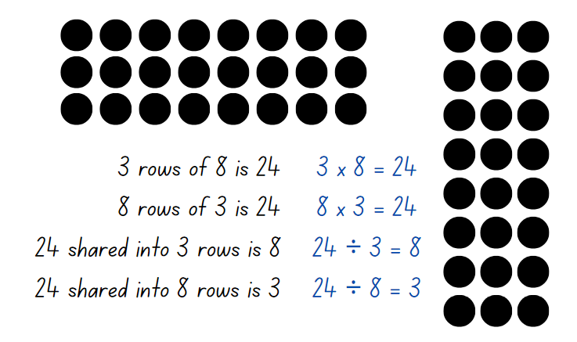
- Highlight to students:
- the link between multiplication and division
- the commutative property of multiplication.
- Once students are confident, provide them with two 10-sided dice, counters and their workbooks. Students record their number sentences in their workbook.
- Select students to share and explain their arrays and number sentences.

This table details opportunities for assessment.
Assessment opportunities | Links
What to look for:  - Can students link multiplication and division fact families using arrays? [MAO-WM-01, MA2-MR-01] | Links to National Numeracy Learning Progressions (NNLP):  - MuS6.

Core lesson 1 – measuring right angles by the amount of turn – 10 minutes
The table below contains suggested learning intentions and success criteria. These are best co-constructed with students.
Core concept learning intentions | Core concept success criteria
Students are learning to:  - identify angles as measures of turn  - compare angles to a right angle. | Students can:  - identify the arms and vertex of an angle  - use the term right angle to describe a quarter-turn in a range of orientations  - compare angles to a right angle using an informal means.
- Ask students to stand up and all face the same direction.
- Revise that measuring an angle is measuring an amount of turn.
- Give students the following instructions:
- make a half turn to the left
- make a quarter-turn to the right and another quarter-turn to the right
- make a three-quarter turn to the left
- make a quarter-turn to the right.
- Ask students to explain what instruction will bring everyone back to facing the front again.

Core lesson 2 – identifying right angles – 40 minutes
This activity is an adaptation of Connecting Shapes and Angles from Sullivan.
- Model and revise how:
- all angles have 2 straight arms and these can be different lengths
- all angles meet at a point called a vertex
- an angle tester can be used to measure square corners or right angles (Figure 2).
Figure 2 – angle tester
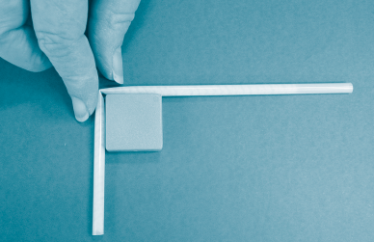
- Ask students to describe the specific attributes of a right angle and record these on the board. For example, a right angle is a quarter-turn, and the vertex is a ‘square’.
- Provide pairs of students with a variety of two-dimensional shape blocks. Explain that students will use their angle tester to identify and record which shapes have right angles and how many right angles they have.
- Offer this conjecture to students: Mathematicians say all squares and rectangles have 4 vertexes, and that each vertex is always a right angle. I am wondering:
- Is this true for all squares and rectangles? Can you explain why or why not?
- If one of the angles is not a right angle, is it still a square? Is it still a rectangle?
- If the square is tilted, is it a rhombus or is it still a square? How many right angles are there?
- If a rectangle is tilted, is it a different shape and does it still have 4 right angles?
- Allow time for students to explore the questions and develop their answers, then share as a class.
- Tell students that they will be learning many new words while they are learning about angles. As a class, use an anchor chart to record their findings and new vocabulary (see Figure 3).
Figure 3 – example anchor chart
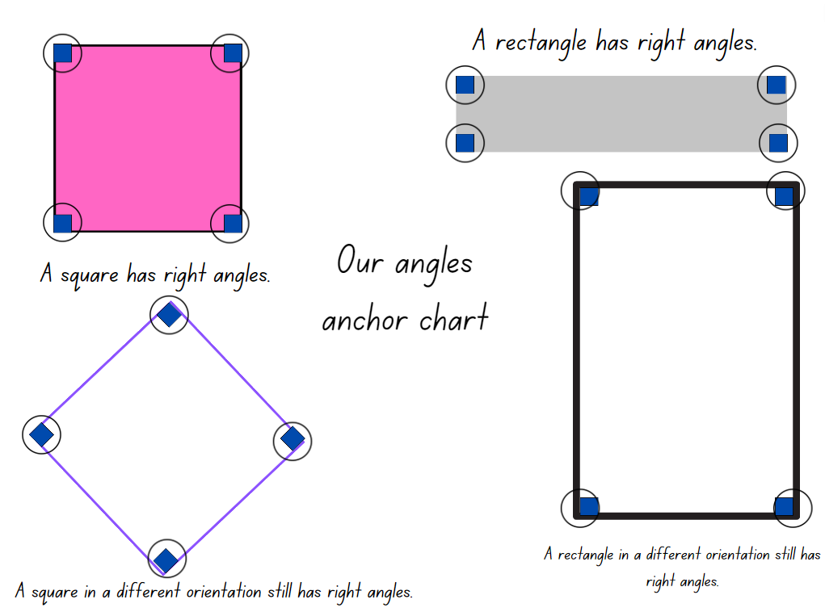
- Ask if it is possible for a triangle to have a right angle.
- Students use the digital geoboard to create triangles that have right angles.
- Ask for several students to explain their thinking, using their digital geoboard to support their reasoning.
- Display Resource 1 – right angles and shapes and explain, that in pairs, students will use their angle tester to identify and label all the right angles in each of the shapes (see Figure 4).
Figure 4 – example of recordings
- As a class discuss:
- What was a common attribute of the shapes that had no right angles?
- Which shape had the most right angles?
- Which shape had the least right angles?
- What did you notice about the vertex or the sides of the shapes with right angles?
- Provide pairs with a digital device and explain that students will use a digital geoboard to create a variety of different shapes that have more than 5 right angles. For examples see Figure 5.
Figure 5 – examples of shapes
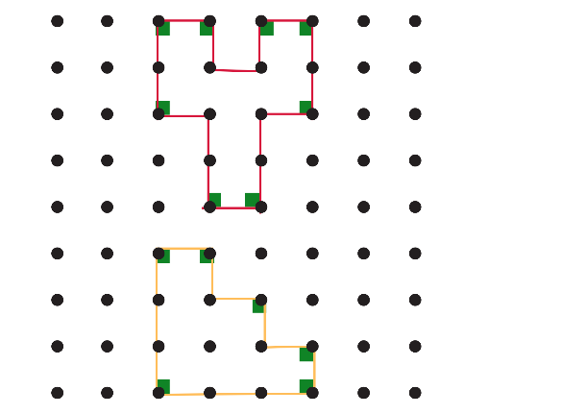
This table details opportunities for differentiation.
Too hard? | Too easy?
Students cannot compare angles to a right angle using an informal means.  - Support students to fold an A4 piece of paper, as in Figure 6. Students use the right-angle tester to informally measure and compare angles.  - Students stack 2 different two-dimensional shapes, one on top of the other to identify right angles and record their findings. | Students can compare angles to a right angle using an informal means.  - Students use the digital geoboard to create a staircase shape, as in Figure 7. Explain that this staircase has 6 internal right angles. Ask students to investigate whether the number of angles inside the staircase would double if they doubled the size of the staircase.  - Students use Resource 1 – right angles and shapes to identify how many right angles each shape has on the outside (external).
Figure 6 – right angle tester
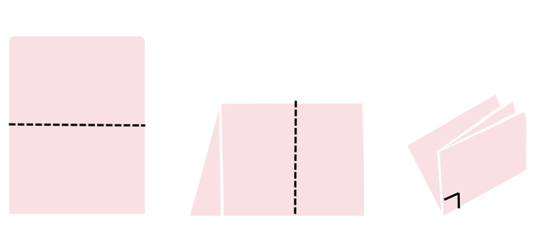
Figure 7 – staircase
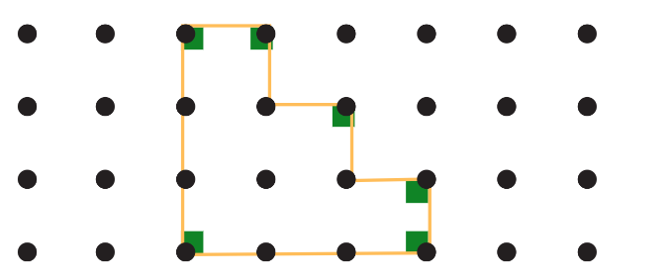

Discuss and connect the mathematics – 10 minutes
- Students go on a gallery walk to view all the created shapes. Ask students:
- What are you wondering about all the different shapes and the identified right angles?
- What is common about all the shapes? What is different?
- Can you see any other right angles?
- Did you use a strategy when designing your shape to make sure there were right angles? What did you have to think about?
- Was there a shape that you thought was creative? Why?
- Discuss new vocabulary used in the lesson and add this to the anchor chart.
This table details opportunities for assessment.
Assessment opportunities | Links
What to look for:  - Can students identify the arms and vertex of an angle? [MAO-WM-01, MA2-GM-03]  - Can students use the term right angle to describe a quarter-turn in a range of orientations? [MAO-WM-01, MA2-GM-03]  - Can students compare angles to a right angle using an informal means? [MAO-WM-01, MA2-GM-03] | Links to National Numeracy Learning Progressions (NNLP):  - UuM6.

Lesson 2
Core concept: angles are often described and compared in relation to right angles.

Daily number sense – fact families – 10 minutes
The table below contains a suggested learning intention and success criteria. These are best co-constructed with students.
Daily number sense learning intention | Daily number sense success criteria
Students are learning to:  - recall multiplication facts of 2 and 4, 5 and 10 and related division facts. | Students can:  - generate multiplication and division fact families for multiples of 2 and 4, 5 and 10.
- Display Resource 2 – making fact families and explain that 8 is a multiple of 2 and 4 (record the skip counting pattern by 2 and then by 4 to confirm that 8 is in both patterns). Explain that 2 and 4 are called factors of 8.
Factor: a number which divides another number without a remainder. For example, 1, 2, 3 and 6 are factors of 6 but 4 and 5 are not.
- Select one fact family from Resource 2 – making fact families to:
- model how to write multiplication and division sentences using fact families
- use arrays to prove the commutative property of multiplication.
Note: highlight to students that the number at the top of the triangle is the product of the 2 factors at the bottom of the triangle. For division, ensure students understand that the product of the fact family must be at the start of the sentence. Division is not commutative, so 2 ÷ 4 = 8 is not correct.
Product: the result of multiplying 2 or more numbers together, for example, 12 is the product of 4 × 3.
- Provide students with Resource 2 – making fact families. Students identify the fact families for the remaining triangles and record the number sentences.
Note: students may need concrete materials, such as counters, to manipulate while completing the activity. This activity can be differentiated by having students find other factors of the top number and writing out the fact families.
- Select students to share and explain their work and record each student’s responses for the class to see.
This table details opportunities for assessment.
Assessment opportunities | Links
What to look for:  - Can students generate multiplication and division fact families for multiples of 2 and 4, 5 and 10? [MAO-WM-01, MA2-MR-01] | Links to National Numeracy Learning Progressions (NNLP):  - MuS6.  Links to suggested Interview for Student Reasoning (IfSR) tasks:  - IfSR-MT: 2A.4, 2A.5.

Core lesson 1 – bigger, smaller or equal? – 20 minutes
The table below contains suggested learning intentions and success criteria. These are best co-constructed with students.
Core concept learning intentions | Core concept success criteria
Students are learning to:  - identify angles as measures of turn  - compare angles to a right angle. | Students can:  - use the term right angle to describe a quarter-turn in a range of orientations  - recognise and describe angles as less than, equal to, about the same as or greater than a right angle  - describe angles in comparison to quarter-turns as acute, right, obtuse, straight, reflex or a revolution.
- Review learning from the previous lesson by asking students to recall the strategies used to identify a right angle. These could include using an angle tester or comparing the angle to something that has a similar amount of turn.
- In pairs, provide students with a copy of Resource 3 – mystery angles. Students discuss and record the description for each angle. For example, the green angle opens less than a right angle.
- Ask students to share how they would describe the angles in Resource 3 – mystery angles and summarise their suggestions.
- Explain that mathematicians have names for different types of angles. Display Resource 4 – angle names and discuss the name and features that classify each of the angles.
- Explain that when 2 lines, arms or other objects meet to form a right angle, they are called perpendicular lines. Add this definition to the angles anchor chart.
Perpendicular: two lines, arms or other objects that intersect at a right angle.

Core lesson 2– angle art – 25 minutes
- Display Resource 5 – angle art and explain that this artwork has many angles within it.
- Using a paper angle tester from Lesson 1, show how to test and classify some of the angles found in the artwork.
- Demonstrate how to label the angles, to show the amount of turn between the arms (see Figure 8).
Figure 8 – labelled angle art
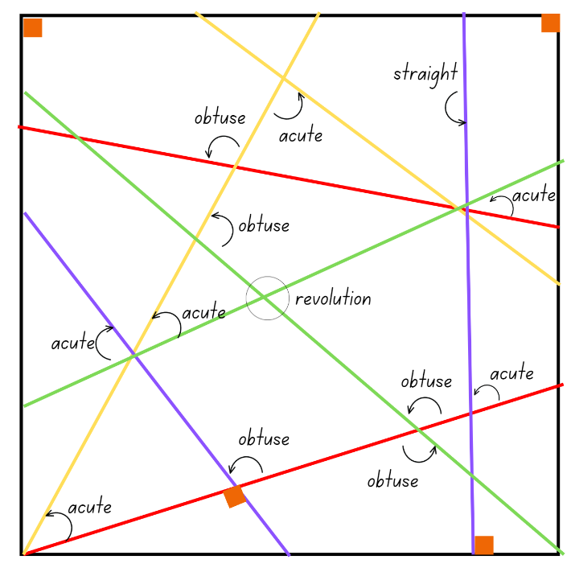
- Provide students with a copy of Resource 5 – angle art. With a partner, students identify angles in the artwork.
- Students use their angle tester to identify and label as many angles as they can.
This table details opportunities for differentiation.
Too hard? | Too easy?
Students cannot describe angles in comparison to quarter-turns as acute, right, obtuse, straight, reflex or a revolution.  - Support students to focus on a specific sized angle, for example, acute angles. Assist them to use an angle tester to identify the same sized angles in Resource 5 – angle art. Record these using the same-coloured pencil each time.  - Students then choose another category of angle to focus on, using a different coloured pencil to label them. | Students can describe angles in comparison to quarter-turns as acute, right, obtuse, straight, reflex or a revolution.  - Students design their own example of angle art using overlapping straight lines. For an added challenge, they can aim to include a specific number of each type of angle.  - Students use a digital device to take a photograph of some buildings in the school. They identify and label different examples of angles in the image.

Discuss and connect the mathematics – 15 minutes
- After students have had an opportunity to identify and label some angles, ask:
- Which type of angle have you found the most of?
- Which type of angle have you found the least of?
- Why do you think that is?
- What if someone disagreed with the label you gave an angle. How could you convince them you have labelled them correctly?
- Discuss new vocabulary used in the lesson and add this to the anchor chart.
This table details opportunities for assessment.
Assessment opportunities | Links
What to look for:  - Can students use the term right angle to describe a quarter-turn in a range of orientations? [MAO-WM-01, MA2-GM-03]  - Can students recognise and describe angles as less than, equal to, about the same as or greater than a right angle? [MAO-WM-01, MA2-GM-03]  - Can students describe angles in comparison to quarter-turns as acute, right, obtuse, straight, reflex or a revolution? [MAO-WM-01, MA2-GM-03] | Links to National Numeracy Learning Progressions (NNLP):  - UuM6, UuM7.

Lesson 3
Core concept: angles can be found in art, buildings and nature.

Daily number sense – solving problems with fact families – 10 minutes
The table below contains a suggested learning intention and success criteria. These are best co-constructed with students.
Daily number sense learning intention | Daily number sense success criteria
Students are learning to:  - recall multiplication facts about 2 and 4, 5 and 10 and related division facts. | Students can:  - generate multiplication and division fact families for multiples of 2 and 4, 5 and 10.
- Display Resource 6 – lots of buttons and explain that students will work in pairs to solve the problem. Ask:
- What is the problem asking you to find out?
- How many different parts are there to the problem? Can you use the same strategy to solve each part?
- Which strategy do you think will work best to find a solution for this problem? Why?
- How can you record the solution?
- After students have had the opportunity to work on the solution, ask:
- How do you know the strategy you are using is working?
- How can you check that the answer is correct?
- Which fact family helped you with this problem?
- Pairs of students choose a fact family and create a word problem to match.
This table details opportunities for assessment.
Assessment opportunities | Links
What to look for:  - Can students generate multiplication and division fact families for multiples of 2 and 4, 5 and 10? [MAO-WM-01, MA2-MR-01] | Links to National Numeracy Learning Progressions (NNLP):  - MuS6, MuS7.  Links to suggested Interview for Student Reasoning (IfSR) tasks:  - IfSR-MT: 2A.4, 2A.5, 2A.10.

Core lesson 1 – The Bridge – 20 minutes
The table below contains suggested learning intentions and success criteria. These are best co-constructed with students.
Core concept learning intentions | Core concept success criteria
Students are learning to:  - identify angles as measures of turn  - compare angles to a right angle. | Students can:  - use the term right angle to describe a quarter-turn in a range of orientations  - recognise and describe angles as less than, equal to, about the same as or greater than a right angle  - describe angles in comparison to quarter-turns as acute, right, obtuse, straight, reflex or a revolution.
This activity is an adaptation of the resource Dorrit Black: The Bridge Interpretive Resource [PDF 4.3 MB] from the Art Gallery of South Australia.
Note: the Australian modernist Dorrit Black’s work ‘The Bridge’ (1930) was Australia’s first cubist landscape and demonstrated a new approach to the painting of Sydney Harbour. As the eye moves across the picture plane, Black cleverly combines the passage of time in a single painting (AGSA 2019).
- Revise the angle art activity from the previous lesson, where students identified different sized angles in Resource 5 – angle art.
- Ask students if they can recall the names given to the different sized angles. Use Resource 4 – angle names to check their understanding.
- Display the artwork The Bridge from the resource Dorrit Black: The Bridge Interpretive Resource [PDF 4.3 MB]. Ask students to describe what they notice.
- Explain that this artwork was painted by the Australian artist Dorrit Black in 1930. Her artwork was the first time an Australian artist used the style of Cubism, where the subject is shown in more than one perspective. Cubist artworks often use shapes, lines and angles to draw our eye to the subject.
- With a partner, students identify and describe angles in the artwork. Students share their ideas with the class.

Core lesson 2 – angles in the world – 20 minutes
- Tell students that angles can be found all around them in natural and built environments. Show Resource 7 – environmental angles 1. Ask:
- What attributes of angles have you learnt about in previous lessons?
- Can you use these to identify an angle, or the amount of turn between the arms?
- Is the angle greater than or smaller than a right angle?
- Can you name the angle?
- Provide pairs of students with a copy of Resource 8 – environmental angles 2. Students work with their partner and use an angle tester to identify, label and name the angles in the images.
This table details opportunities for differentiation.
Too hard? | Too easy?
Students cannot describe angles in comparison to quarter-turns as acute, right, obtuse, straight, reflex or a revolution.  - Support students to focus on a specific sized angle, for example, acute angles. Assist them to use an angle tester to identify the same sized angles in Resource 8 – environmental angles 2. Record these using the same-coloured pencil each time.  - Students then choose another category of angle to focus on, using a different coloured pencil to label them. | Students can describe angles in comparison to quarter-turns as acute, right, obtuse, straight, reflex or a revolution.  - Ask students which types of angles they found the least of. Challenge students to find these angles in a natural or built environment within the school, or in a digital image.  - Provide students with a copy of Olympic Turns from NRICH. Students investigate turns and angles in various sports.

Discuss and connect the mathematics – 10 minutes
- After students have had an opportunity to identify and label some angles, ask:
- What did you notice about the angles in the images?
- Was there something that you found surprising or interesting about the angle you found?
- Were you able to find all the types of angles we have learnt about?
- Were there any types of angles that you have not been able to find?
- Where do you think these could be found in our world?
- Discuss any new vocabulary used in the lesson and add this to the anchor chart.
- Investigate additional images on the internet and create a poster of angles in the world.
This table details opportunities for assessment.
Assessment opportunities | Links
What to look for:  - Can students use the term right angle to describe a quarter-turn in a range of orientations? [MAO-WM-01, MA2-GM-03]  - Can students recognise and describe angles as less than, equal to, about the same as or greater than a right angle? [MAO-WM-01, MA2-GM-03]  - Can students describe angles in comparison to quarter-turns as acute, right, obtuse, straight, reflex or a revolution? [MAO-WM-01, MA2-GM-03] | Links to National Numeracy Learning Progressions (NNLP):  - UuM6, UuM7.

Lesson 4
Core concept: the arms and vertex of an angle can be visible or invisible.

Daily number sense – 10 minutes
- From a class need surfaced through formative assessment data, identify a short, focused activity that targets students’ knowledge, understanding and skills. Example activities may be drawn from the following resources:
- Mathematics K–6 resources

Core lesson 1 – investigating angles in letters – 10 minutes
The table below contains suggested learning intentions and success criteria. These are best co-constructed with students.
Core concept learning intentions | Core concept success criteria
Students are learning to:  - compare angles to a right angle  - represent and read analog time. | Students can:  - describe angles in comparison to quarter-turns as acute, right, obtuse, straight, reflex or a revolution  - identify 15 minutes as being a quarter-hour, 30 minutes as being a half-hour and 60 minutes as an hour  - read time on an analog clock as past the hour to half-past and then towards the hour.
- Explain that sometimes angles are hiding in objects or shapes. For example, when a door opens, the amount of turn between the door and the opening can be measured. Explain that the letters in the alphabet also have angles hiding in them.
- Display Resource 9 – alphabet letters. Explain that students will investigate each letter of the alphabet and record all the angles they can find in each letter. For example, see Figure 9.
Figure 9 – example of recording
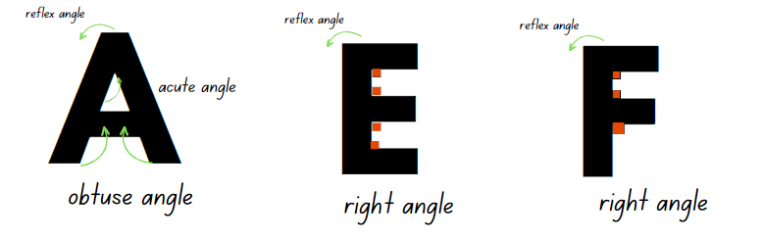
- Provide pairs of students with writing materials and Resource 9 – alphabet letters.
- As a class, discuss some examples of angles that students have identified. Select students to record the angles on an enlarged copy of Resource 9 – alphabet letters. Ask:
- What strategy did you use to identify the angles?
- Is there a letter(s) that has no angles?
- Which letter(s) has only one type of angle?
- Which letter(s) has more than one type of angle? What features of the letter made it possible for multiple angles?
- Which letter has the most angles?
- Do you think that if the letters were written in a different font there would be more or less angles? Why?
- Is there one letter that would always have no angles regardless of what font it was written in? Why or why not?

Core lesson 2 – investigating angles on clocks – 30 minutes
- Display the interactive analog clock showing 3 o’clock. State that the position of the hour hand and minute hand when showing 3 o’clock make a right angle.
Note: prior to the lesson prepare an angle tester by cutting 2 strips of card and joining these with a split pin so that both strips can be rotated as arms to measure the turn of angles.
- Ask students to consider if there are other times that would show a right angle. Select students to model other times. Ensure students use the angle tester to measure and model the time as a right angle.
- Using the interactive analog clock as a class model, measure and discuss the following times that show acute and obtuse angles:
- acute angle times: 11:10, 3:05 and 6:20
- obtuse angle times: 5:00, 7:00 and 9:20.
- Provide pairs of students with writing materials, 2 strips of card and a split pin to make an angle tester.
- Explain that pairs of students will use the first activity on Resource 10 – clock angles to identify and label which clocks show a time that makes an acute, right or obtuse angle.
- Students then use the second activity on Resource 10 – clock angles to draw times on the clock faces that show acute, right or obtuse angles.
- As a class discuss:
- What did you notice about the hour hand and minute hand when there was an acute angle?
- What did you notice about the hour hand and minute hand when there was an obtuse angle?
- What would happen to the angles if you changed the orientation of the clock? For example, turning the clock upside down.
- Can you estimate how many right-angle times there are?
- Can you estimate if there are more times that make an obtuse or acute angle? Or do you think that it is the same amount? Explain.

This table details opportunities for differentiation.
Too hard? | Too easy?
Students cannot describe angles in comparison to right angles, as acute, right, obtuse, straight, reflex or a revolution.  - Support students to use their angle tester and only identify one type of angle. Students record their findings.  - Repeat the process and support students to only identify another type of angle.  Students cannot identify 15 minutes as being a quarter-hour, 30 minutes as being a half-hour and 60 minutes as an hour.  - Support students to identify and label a quarter-hour and half-hour on a clock face.  - Help students to identify and label a quarter to the hour and the whole clock face as one hour. | Students can describe angles in comparison to right angles, as acute, right, obtuse, straight, reflex or a revolution.  - Students select a time on the clock that makes an acute angle and then record how many minutes must pass before it becomes an obtuse angle.  - In pairs, students use a digital device to record examples of objects that can rotate and change angle size becoming bigger as they ‘turn’. For example, a book or a door.  Students can identify 15 minutes as being a quarter-hour, 30 minutes as being a half-hour and 60 minutes as an hour.  - Display the NRICH resource ‘Clocks’. Students use what they know about time to find a solution.  - Students create a time problem for a partner to solve.

Consolidation and meaningful practice – 20 minutes
- Provide pairs of students with a digital device, angle tester and a copy of Resource 11 – time angles.
- Display Resource 11 – time angles and explain students will estimate and label which times they think will make an acute or an obtuse angle.
Note: the times on Resource 11 – time angles can be cut out as cards for students to sort into piles, based on their predictions about what kind of angle is formed. Alternatively, students can label the times on the resource.
- With a partner, students use a copy of Resource 11 – time angles and the interactive analog clock to make each of the displayed times. Students then use their angle tester to check if their estimates were correct.
- As a class, ask:
- Is there a time that makes a straight angle?
- What needs to happen to the hour hand to show a revolution?
- What time would it show if the clock hands made a reflex angle?
- Discuss new vocabulary used in the lesson and add this to the anchor chart.

This table details opportunities for assessment.
Assessment opportunities | Links
What to look for:  - Can students describe angles in comparison to quarter-turns, as acute, right, obtuse, straight, reflex or a revolution? [MAO-WM-01, MA2-GM-03]  - Can students identify 15 minutes as being a quarter-hour, 30 minutes as being a half-hour and 60 minutes as an hour? [MAO-WM-01, MA2-NSM-02]  - Can students read analog clock as past the hour to half-past and then towards the hour? [MAO-WM-01, MA2-NSM-02] | Links to National Numeracy Learning Progressions (NNLP):  - UuM6, UuM7  - MeT3.

Lesson 5
Core concept: halving and quartering blocks of time helps to measure and sequence events.

Daily number sense – decimals in order – 10 minutes
Daily number sense activities for Lessons 5 to 7 ‘loop’ back to concepts and procedures covered in previous units to assist students to build an increasingly connected network of ideas. These concepts may differ from the core concepts being covered by the unit.
The table below contains a suggested learning intention and success criteria. These are best co-constructed with students.
Daily number sense learning intention | Daily number sense success criteria
Students are learning to:  - make connections between decimals. | Students can:  - compare and order decimals of up to 2 decimal places.
- Provide pairs of students with playing cards with the face cards removed. Students divide the cards between them (aces are ones).
- Each students’ cards remain face down in a pile in front on them.
- On an individual whiteboard, each student draws a box large enough to fit a playing card, a dot and then 2 more boxes.
- Each student turns over 3 cards, placing them into the boxes on their whiteboard (see Figure 10).
Figure 10 – example student whiteboard
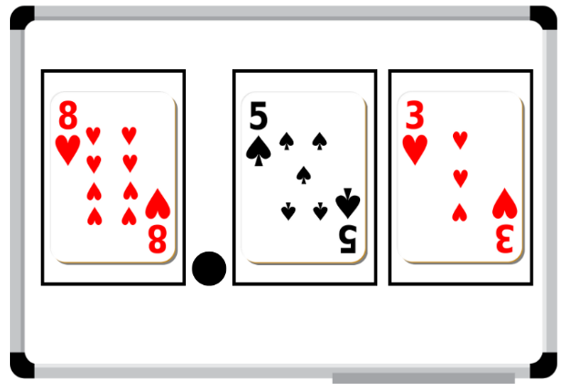
- Students then record their decimal on a sticky note.
- Pairs of students compare their decimals and place the sticky notes in ascending order.
- Repeat the process, adding the new sticky notes to the order (see Figure 11).
Figure 11 – ascending order
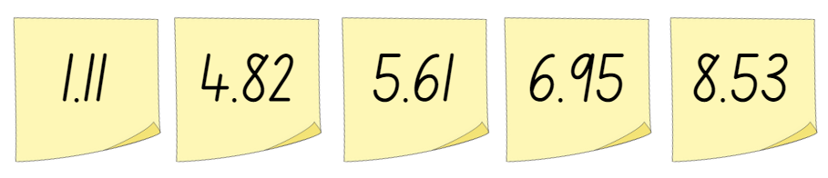
This table details opportunities for assessment.
Assessment opportunities | Links
What to look for:  - Can students compare and order decimals of up to 2 decimal places? [MAO-WM-01, MA2-RN-02] | Links to National Numeracy Learning Progressions (NNLP):  - NPV6, NPV7.  Links to suggested Interview for Student Reasoning (IfSR) tasks:  - IfSR-NP: 4D.1, 4D.4.

Core lesson 1 – in a minute – 20 minutes
The table below contains suggested learning intentions and success criteria. These are best co-constructed with students.
Core concept learning intentions | Core concept success criteria
Students are learning to:  - represent and interpret digital time displays  - model and represent unit fractions. | Students can:  - read or set the time on digital devices to the minute, recognising there are 60 seconds in one minute  - recognise that the hour is read first in a digital display  - model fractions of a given time with fraction strips and diagrams for halves and quarters.
- Show the class the static analog clock. Ask students what they know about the features, including:
- the purpose of the 2 hands
- the markings
- that it is made up of 2 number lines presented in a circle
- that one number line shows the hours and the other shows the minutes.
Note: do not show the equivalent digital times yet. These can be removed by clicking ‘off’ at the bottom right-hand corner of the clocks.
- Display the active analog clock that shows the second hand. Ask students:
The table below outlines stimulus prompts to generate conversation about the topic, along with anticipated responses from students.
Prompts | Anticipated student responses
- How many hands does an analog clock have? | - An analog clock has 2 or 3 hands, depending on if it has a seconds hand.
- What is the job of the short hand on the clock? | - The short hand is the hour hand. It travels from one number to the next in an hour.
- Which hand is the minute hand? | - The longer hand is the minute hand.
- Why is it called the minute hand? | - It is called the minute hand because it moves from one smalling marking to the next in a minute.
- Why is the second hand moving so quickly? | - The second hand moves each second. It moves all the way around the clock face in one minute, or 60 seconds.
- Explain that there are now 3 number lines on the clock, hours, minutes and seconds.
- Display Resource 12 – in a minute and explain that the 60 seconds in a minute can be shown in different ways, including on a clock face and as a number line. These include one minute or 60 seconds, half a minute or 30 seconds and a quarter of a minute or 15 seconds.
- Ask students to predict some tasks that would take approximately 15 seconds to complete, for example, 10 star jumps.
- Use the active analog clock to test their predictions.
- Remind students that timing usually starts when the seconds hand is on the 12 at the top of the clock.

Core lesson 2 – showing the time – 20 minutes
Note: ‘digital clocks permit students to read times easily, but they do not relate very well to benchmark times. To know that a digital reading of 7:58 is nearly 8:00, the student must know that there are 60 minutes in an hour, that 58 is close to 60 and that 2 minutes is not a very long time. The analog clock shows ‘close to’ times visually without the need for understanding large numbers or how many minutes are in an hour’. (Van de Walle 2019).
- Explain that times can be represented in different ways, including analog clocks, digital clocks, fractions of time and timelines.
- Create a list of all the places students have seen these different types of clocks, for example, at school, home or on a digital device.
- Display the activity Time tools and explain that they need to match the 5 times that are written on both the analog and digital clocks. In pairs, students discuss which digital and analog times match.
- Choose students to share their thinking for each of the times, then check it by completing the activity. Ask:
- What clues did you use to match the times?
- What do you think the first number in a digital time represents? Why?
- What do you think the second number in a digital time represents? Why?
- Explain that times are read with the hour first in a digital display, then the minutes after the colon. For example, 4:30 is read as ‘four-thirty’.
- Provide students with a copy of Resource 13 – showing the time and explain that they will be matching times using analog and digital clocks.
- With a partner, students say each time, then decide how to record it in Part 1 of Resource 13 – showing the time.
- After students have matched the digital and analog times, explain that times can also be shown as a fraction on analog clocks or on a bar model.
- With a partner, students read each time presented in Part 2 of Resource 13 – showing the time. They decide how to represent it as a fraction of a minute on the analog clock face and the fraction strip.
This table details opportunities for differentiation.
Too hard? | Too easy?
Students cannot read or set the time on digital devices to the minute.  - Revise the features on both analog and digital clocks using the activity Time tools.  - Using this activity, support students to read and set the time on digital devices to the minute.  Students cannot model fractions of time with fraction strips and diagrams for halves and quarters.  - Use the active analog clock to demonstrate how the second hand moves for each time in Part 2 of Resource 13 – showing the time.  - Support students to shade the appropriate amount of time on each of the fraction strips and diagrams. | Students can read or set the time on digital devices to the minute.  - With a partner, students play ‘Time match’ in Time tools.  - Provide students with 2 digital times and ask them to find how long it takes to go from one time to the other. For example, work out the elapsed time from 7:25 to 9:45.  Note: click the play tab on the left side of the screen. Then click the start button on the bottom right side of the screen. Select the ‘Time challenge’ tab across the top of the screen.  Students can model fractions of time with fraction strips and diagrams for halves and quarters.  - Provide students with 2 times and ask them to show how they could find the total. For example, ask students what the total would be if they double 45 seconds. Ask students to represent their answer in several ways.  - Challenge students to find how many minutes there are in 120 seconds and 1000 seconds.

Discuss and connect the mathematics – 10 minutes
- As a class, discuss what students noticed while working on Resource 13 – showing the time. Ask:
- Were there any patterns you noticed with seconds, minutes or hours?
- Did you find any strategies that helped you to read and write times?
- Is there anything that you are still wondering?
This table details opportunities for assessment.
Assessment opportunities | Links
What to look for:  - Can students read or set the time on digital devices to the minute, recognising there are 60 seconds in one minute? [MAO-WM-01, MA2-NSM-02]  - Can students recognise that the hour is read first in a digital display? [MAO-WM-01, MA2-NSM-02]  - Can students model fractions of time with fraction strips and diagrams for halves and quarters? [MAO-WM-01, MA2-PF-01] | Links to National Numeracy Learning Progressions (NNLP):  - MeT3.

Lesson 6
Core concept: dividing an hour into 60 minutes is useful as 60 has many factors.

Daily number sense – largest decimal – 10 minutes
The table below contains a suggested learning intention and success criteria. These are best co-constructed with students.
Daily number sense learning intention | Daily number sense success criteria
Students are learning to:  - make connections between decimal notation. | Students can:  - compare and order decimals of up to 2 decimal places.
- Provide pairs with two 10-sided dice and an individual whiteboard. Students draw a number line from zero to one.
- Students take it in turns to roll the dice and arrange them to make the largest number between zero and one with 2 decimal places, such as 0.86. Students record their decimal on the number line (see Figure 12).
Figure 12 – number line example
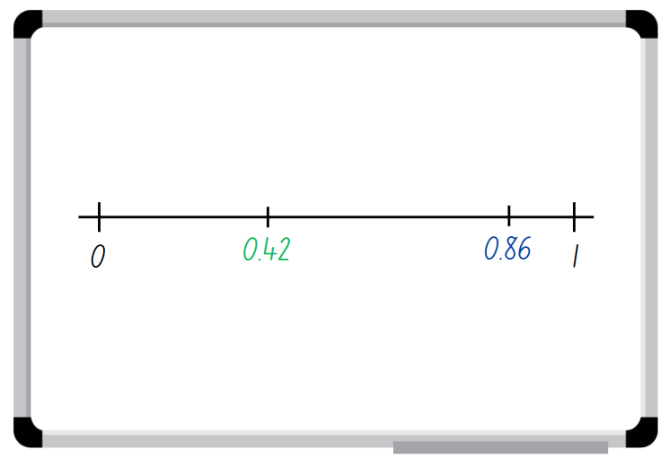
- Students repeat this process to create another decimal number each and place it on the number line.
- Students read the decimals in order from zero to one, using their place value knowledge to justify how they know the order is correct.
Note: the focus for this activity can be easily changed, for example, students could be aiming for closest to zero, closet to 0.5 or the smallest decimal.
This table details opportunities for assessment.
Assessment opportunities | Links
What to look for:  - Can students compare and order decimals of up to 2 decimal places? [MAO-WM-01, MA2-RN-02] | Links to National Numeracy Learning Progressions (NNLP):  - NPV6, NPV7.  Links to suggested Interview for Student Reasoning (IfSR) tasks:  - IfSR-NP: 4D.1, 4D.4.

Core lesson 1 – fractions of 60 – 20 minutes
The table below contains suggested learning intentions and success criteria. These are best co-constructed with students.
Core concept learning intentions | Core concept success criteria
Students are learning to:  - use am and pm notation  - represent fractional quantities equal to and greater than one. | Students can:  - record times using the colon notation with am and pm to distinguish between morning and evening  - represent totals of halves, thirds, quarters and fifths that extend beyond one.
- Display the number 60 and ask students to share what they know about it. Student responses could include:
- doubles, halving and quartering
- 3 twenties, 10 sixes and 6 tens
- 60 minutes make one hour and 60 seconds make one minute
- one quarter of 60 is 15, one-third of 60 is 20
- examples of inverse number sentences, for example, 60 ÷ 5 = 12 and 12 × 5 = 60
- examples of commutative number sentences, for example, 5 × 12 = 60 and 12 × 5 = 60.
- If not mentioned above, explicitly refer to commutative examples, inverse examples and multiplicative relationships.
- Explain to students that knowing facts about 60 is helpful when exploring and reading time.
- Show an interactive analog clock. Discuss and model on the clock face some of the facts of 60 such as in Figure 13.
Figure 13 – facts of 60 on a clock
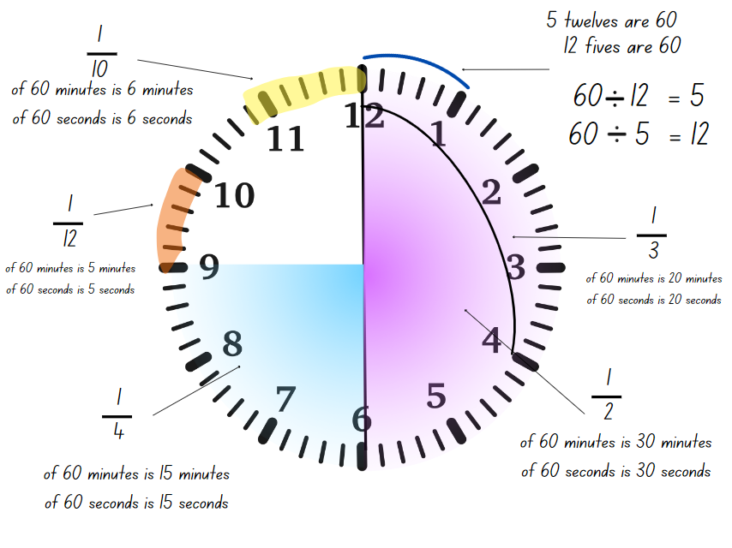
The table below outlines stimulus prompts to generate conversation about the topic, along with anticipated responses from students.
Prompts | Anticipated student responses
- Half the clock face is called half an hour. How many minutes is this?  - If I know that half of 60 minutes is 30 minutes, what else do I know?  - How many minutes are there in a quarter of an hour? How many in three-quarters?  - How many minutes are there in a third of an hour? How many in two-thirds?  - How many times will 10 minutes fit on the clock face? What fraction of an hour would 10 minutes be?  - How else can I use fractional language to describe minutes and seconds? | - There are 30 minutes in half an hour.  - If I know what half an hour is, I can find a quarter of an hour by halving it again.  - There are 15 minutes in a quarter of an hour, and 45 minutes in three-quarters of an hour.  - A third of 60 minutes is 20 minutes. Two-thirds would be 40 minutes.  - 10 minutes will fit 6 times on the clock face. This means 10 minutes is one-sixth of an hour.  - There are the same number of seconds in a minute as there are minutes in an hour. This means that the fractions of 60 minutes work for 60 seconds, too.
- Ask students to share what time they go to bed. Record the times on the board.
- Ask how students can be clear about when something is happening, either in the morning or evening.
- Display Resource 14 – day and night timeline. Students can also be given a copy to cut out and fold at each hour mark.
- Ask students:
- What can you see?
- How many hours are there on the timeline?
- How many hours are there all together on 2 timelines?
- How do we describe the 12 hours before noon (12 o’clock midnight to 11:59) and how do we describe the time after noon?
- Identify how am and pm notation are used to communicate whether a time is before or after noon. Explain that when writing times, the colon is used to separate the hours from the minutes.
- Describe some events and ask students to write the time on a whiteboard with a partner, using am or pm notation to show what time of the day it is occurring. For example, if breakfast occurs at 7 o’clock it would be written as 7:00am.

Core lesson 2 – fractions of time – 20 minutes
- Display Resource 15 – creative arts activities and explain that Serena and Brian’s school organised special creative arts workshops from 12 noon to 2 o’clock. Some workshops were longer than others and students were able to try more than one.
- Draw students’ attention to the first activity listed on Resource 15 – creative arts activities. Ask students to turn and talk with a partner, to see if they can work out how many times the music class will fit into the 2 hours.
- Ask several students to share their answer and explain their reasoning.
- If not identified, point out that each row of the creative arts timetable is like a bar model. The row for the music workshop can be divided to show that in 2 hours, the one-hour music workshop can happen twice.
- Repeat this process for the dance workshops. Ask students to share their strategies to show that in 2 hours the 30-minute dance workshop can happen 4 times.
- In pairs, students use a copy of Resource 15 – creative arts activities to find how many times each of the other workshops will be able to run in the 2 hours. The markings made for the previous workshops can be used as benchmarks to support students’ thinking.
- Explain that students can also use the last bar model to decide which of the workshops they would go to if they had the choice. Students represent these on the bar, making sure that each workshop takes up the amount of space that reflects its length of time. This bar can also be cut out so students can layer them on the lengths of time of the activities.
This table details opportunities for differentiation.
Too hard? | Too easy?
Students cannot regroup and represent totals of halves, thirds, quarters and fifths that extend beyond one.  - Support students to focus on one activity, for example, the drama workshop. Highlight that space on Resource 15 – creative arts activities and model how to use students’ knowledge of halves to build up the number of halves.  - Repeat this process for each of the other workshops, supporting students to use the time benchmarks from previous bar models to assist their calculations. | Students can regroup and represent totals of halves, thirds, quarters and fifths that extend beyond one.  - Students create a new timetable for a creative arts workshop that now runs for 2 $\frac{3}{4}$ hours. Using a number line marked zero to 2 $\frac{3}{4}$ hours, students label and mark the new duration for each activity.  - With a partner, students explore how many fractions can be combined to total 1 $\frac{1}{2}$.

Discuss and connect the mathematics – 10 minutes
- Ask students to share their own choices of workshops. For example, ask:
- What was the greatest number of creative arts workshops that could fit into the 2 hours?
- What fraction of the 2 hours did you and your partner decide to use?
- Who had the smallest amount of time left over at the end of the 2 hours? What fraction of the 2 hours is that?
This table details opportunities for assessment.
Assessment opportunities | Links
What to look for:  - Can students record times using the colon notation with am and pm to distinguish between morning and evening? [MAO-WM-01, MA2-NSM-02]  - Can students represent totals of halves, thirds, quarters and fifths that extend beyond one? [MAO-WM-01, MA2-PF-01] | Links to National Numeracy Learning Progressions (NNLP):  - MeT4  - InF5.

Lesson 7
Core concept: the context determines the most suitable standard unit, sometimes a minute is too long.
Note: this lesson features an obstacle course for students to complete. It could feature playground equipment, sporting or play equipment or a sequence of physical activities. Students can contribute to the design of the obstacle course and this can be organised prior to the lesson.

Daily number sense – fractions and decimals – 10 minutes
The table below contains a suggested learning intention and success criteria. These are best co-constructed with students.
Daily number sense learning intention | Daily number sense success criteria
Students are learning to:  - make connections between fractions and decimal notation. | Students can:  - make connections between fractions and decimal notation for key benchmark values.
- Provide students with Resource 16 – fractions and decimals. Students label the correct fractions and matching decimal benchmarks. For example, 0.5 is the same as half.
- Students then add any other matching fractions and decimals to the number lines that they know. For example, one-fifth is the same as 0.2.
- Select students to share and explain the fractions and decimals they selected.
This table details opportunities for assessment.
Assessment opportunities | Links
What to look for:  - Can students make connections between fractions and decimal notation for key benchmark values? [MAO-WM-01, MA2-RN-02] | Links to National Numeracy Learning Progressions (NNLP):  - NPV6, NPV7, InF6.  Links to suggested Interview for Student Reasoning (IfSR) tasks:  - IfSR-NP: 4D.3, 4D.7.

Core lesson 1 – test yourself – 10 minutes
The table below contains a suggested learning intention and success criteria. These are best co-constructed with students.
Core concept learning intentions | Core concept success criteria
Students are learning to:  - represent and interpret digital time displays. | Students can:  - identify situations where duration is measured in seconds  - read or set the time on digital devices to the minute or second.
This activity is an adaptation of ‘Test yourself’ from Teaching Mathematics: Foundations to Middle Years by Siemon et al.
- Tell the class that they will be estimating how long a minute is. Show the students a timing device, for example, a timer on a digital device or a stopwatch.
- Explain that, when the timer starts, students will not be able to see the seconds passing and they will have to estimate how long it is until a minute, or 60 seconds, has passed. When they think it exactly one minute, they raise their hand. Students can close their eyes so they are not influenced by their peers.
- Start the timer and observe students.
- Stop the timer and reveal the student who was the most accurate.
- Repeat the activity and see if students can improve the accuracy of their estimate. Stop the timer just after one minute.
- After revealing the student who was the most accurate, write the digital time on the board.
- Discuss how the colon can also be used to record digital times with minutes and seconds. Demonstrate how this time would be read, for example, 1:01 would be read as ‘one minute and one second’.
Note: many stopwatches measure time to the nearest hundredth of a second, however, this is not the focus of the lesson. Tell students that the purpose of the second colon and rapidly moving numbers is for measuring lengths of time accurately to less than a second. Explain that students don’t need to focus on these, instead they are recording the number of seconds taken to complete the obstacle course. Identify that the colon is not a decimal point and so the numbers are not read like decimals, but as minutes and seconds.

Core lesson 2 – obstacle course – 30 minutes
- Introduce an obstacle course for students to complete. It could feature playground equipment, sporting or play equipment or a sequence of physical activities. Students can contribute to the design of the obstacle course.
- Show students how to use a timing device that records seconds accurately, for example, a timer on a digital device or a stopwatch.
- Discuss the similarities and differences between these measuring tools and demonstrate how these times would be read, for example, 00:28 would be read as ‘28 seconds’.
- Choose a volunteer to complete the course and have students time them on their devices. Compare times captured by the students and discuss the results.
The table below outlines stimulus prompts to generate conversation about the topic, along with anticipated responses from students.
Prompts | Anticipated student responses
- Did everyone’s timers show the same? | - The times were similar, but not the same.
- If not, why not? | - When the teacher said ‘go!’ everyone pressed start at a slightly different time. The same thing happened when the student crossed the finish line.
- What could help make the timing as accurate as possible? | - Making sure that everyone is ready to start and stop timing can help to improve accuracy.
- Would hours be a useful unit of measurement for this activity? Why or why not? | - Hours aren’t a useful unit of measurement for this activity because they are too long.
- With their partner, students record the time for the first student to complete the course in digital form, for example, 00:37.
- Choose different volunteers to complete the course and repeat the process for students to practise using the timing device accurately. Discuss the range of times recorded by students on their devices. Record their results so that these can be compared.
- Variations of this activity include:
- students competing in teams to complete the course as quickly as possible
- timing the whole class to complete the course, then aiming to beat their record
- including a longer challenge, so that times include minutes and seconds
- timing the teacher to complete the course.
This table details opportunities for differentiation.
Too hard? | Too easy?
Students cannot read or set the time on digital devices to the minute or second.  - Support students to use their device to start and finish timing accurately.  - Assist students to record their time in digital form, reading each time aloud to check for understanding. | Students can read or set the time on digital devices to the minute or second.  - Students order the times from shortest to longest to establish a ‘leaderboard’.  - With a partner, students try to find the number of seconds between each time recorded. They can use a number line or bar diagram to show their thinking.

Discuss and connect the mathematics – 10 minutes
- As a class, compare the results and compile an agreed ‘leaderboard’ of times. Ask students to consider the difference between different students’ recorded times.
- Practice reading the digital times and ask:
- Why are seconds and minutes useful units of measurement?
- Did you and your partner become more confident in recording times accurately?
- Did you find any strategies that helped you to find the difference between times?
- How is measuring time similar to measuring length? How is it different?
- Is there anything that you are still wondering about measuring time in minutes and seconds?
This table details opportunities for assessment.
Assessment opportunities | Links
What to look for:  - Can students identify situations where duration is measured in seconds? [MAO-WM-01, MA2-NSM-02]  - Can students read or set the time on digital devices to the minute or second? [MAO-WM-01, MA2-NSM-02] | Links to National Numeracy Learning Progressions (NNLP):  - MeT3.

Consolidation and meaningful practice – 10 minutes
- Display Resource 17 – faulty digital clock and explain that Andrew’s digital alarm clock is broken. He has just woken up and thinks that it might be breakfast time soon.
- With a partner, students use the parts of the digital alarm clock that are shown and try to work out what time it could be. They record their possible solutions on a whiteboard.
- Students share their possible solutions with the class, justifying their thinking.

Lesson 8
Core concept: measuring tools, like digital clocks and timers, need to be carefully handled, aligned and read.

Daily number sense – 10 minutes
- From a class need surfaced through formative assessment data, identify a short, focused activity that targets students’ knowledge, understanding and skills. Example activities may be drawn from the following resources:
- Mathematics K–6 resources
- Universal Resources Hub.
The table below contains suggested learning intentions and success criteria. These are best co-constructed with students.
Core concept learning intentions | Core concept success criteria
Students are learning to:  - use am and pm notation  - represent and interpret digital time displays. | Students can:  - record times using the colon notation with am and pm to distinguish between morning and evening  - relate analog notation to digital notation for time  - read or set the time on digital devices to the minute or second, recognising there are 60 seconds in one minute.

Core lesson 1 – time tools revisited – 10 minutes
- Display Resource 14 – day and night timeline and revise the purpose of am and pm notation (to show if a time is before or after noon).
- Revisit the activity Time tools and explain that students will be playing the ‘Time challenge’ task, where they match times on an analog clock with the times displayed on a digital clock.
Note: click the play tab on the left side of the screen. Then click the start button on the bottom right side of the screen. Select the ‘Time challenge’ tab across the top of the screen.
- Model the activity, then students work with a partner to match as many times as possible.

Core lesson 2 – the Shoelace Olympics – 20 minutes
- Tell students that they will be holding the first ever Shoelace Olympics! This will involve some elite shoelace triathletes from the class competing in a shoelace triathlon event. The class will time each athlete as they compete, then compare times and find the record time.
- Revise the features of digital times on a stopwatch, including the use of the colons to separate minutes, seconds and hundredths of a second. Remind students that the hundredths of a second are not the focus of the activity.
- Decide on a series of simple challenges for students. For example:
- 5–6 students take their shoes off and line them up a short distance away.
- When the race starts, students hop to their shoes and put one on, tying up the laces.
- Students run to back to the start line, then hop back to put on their other shoe, also tying up the laces.
- Students return to the start area and finish with a simple task, for example, doing 5 star jumps.
- Students use stopwatches or digital devices to time the shoelace triathletes in the race.
- After the race, students write the times on the board. As a class, discuss how to order them from fastest to slowest, using the correct notation for recording times on a stopwatch. Students record the times in their maths book.
- Invite some other shoelace triathletes to participate in a second heat, keeping the same race conditions.
- Write the times for this race on the board so that students can record the results of the second heat.
- Ask students to compare the results from both heats and arrange them to form an overall leaderboard. They use this information to find which shoelace triathletes win the gold, silver or bronze shoelaces.
- Select students to share strategies on how they created their leaderboard. Ask:
- What did you need to know about time to help you create the leaderboard?
- Were there any times that made it difficult to create the leaderboard?
This table details opportunities for differentiation.
Too hard? | Too easy?
Students cannot relate analog notation to digital notation for time.  - Support students to use the Time tools task ‘Time Challenge’ to represent and record a variety of times using am and pm notation.  - Use the interactive clocks to make both digital and analog times for students to practice reading am and pm notations. | Students can relate analog notation to digital notation for time.  - With a partner, students create analog and digital time problems for another pair of students to solve.  - Using a digital device, students record an explanation for how to read analog and digital clocks.  - Using a digital device, students research their favourite Olympics athlete and compare the Olympic final event time with the athlete's personal best times and record how the athlete improved.

Consolidation and meaningful practice – time riddle – 20 minutes
- Display Resource 18 – check the clock. Explain that this is a time riddle and students need to use the clues to solve it.
- Provide pairs of students with writing materials and explain that students can use drawings, diagrams and/or words to explain their solution.
- As a class discuss:
- What strategy was the most useful?
- How did you use the clues?
- How did you know your solution was correct? Explain.
- Pairs of students work together to create their own version of a time riddle.
- Share a range of student time riddles for the class to solve.
This table details opportunities for assessment.
Assessment opportunities | Links
What to look for:  - Can students record times using the colon notation with am and pm to distinguish between morning and evening? [MAO-WM-01, MA2-NSM-02]  - Can students relate analog notation to digital notation for time? [MAO-WM-01, MA2-NSM-02]  - Can students read or set the time on digital devices to the minute or second, recognising there are 60 seconds in one minute? [MAO-WM-01, MA2-NSM-02] | Links to National Numeracy Learning Progressions (NNLP):  - MeT3, MeT4

Resource 1 – right angles and shapes
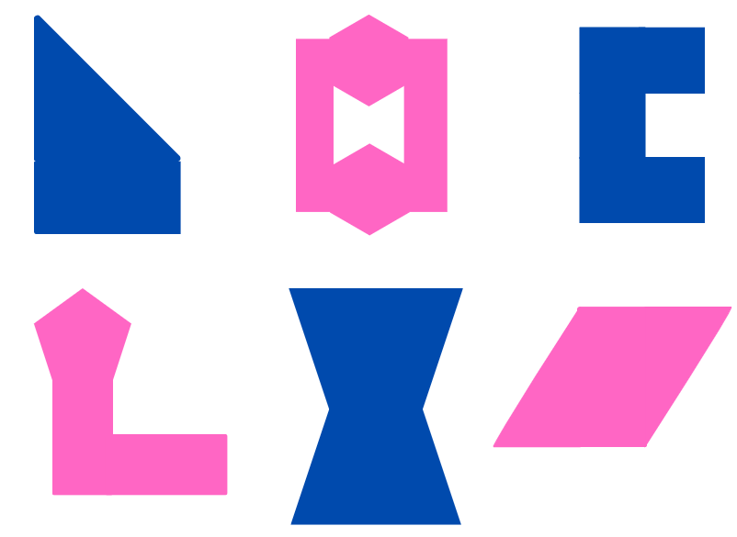

Resource 2 – making fact families
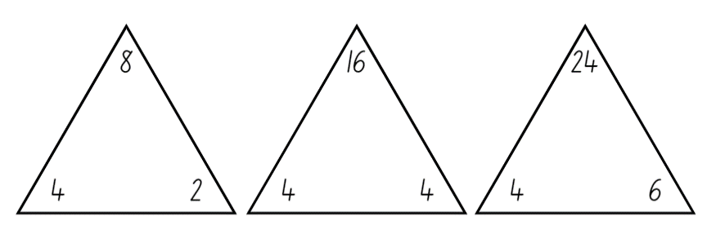

Resource 3 – mystery angles
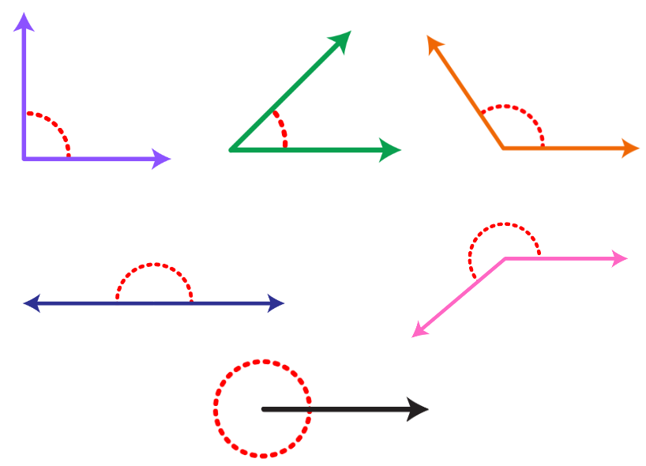

Resource 4 – angle names
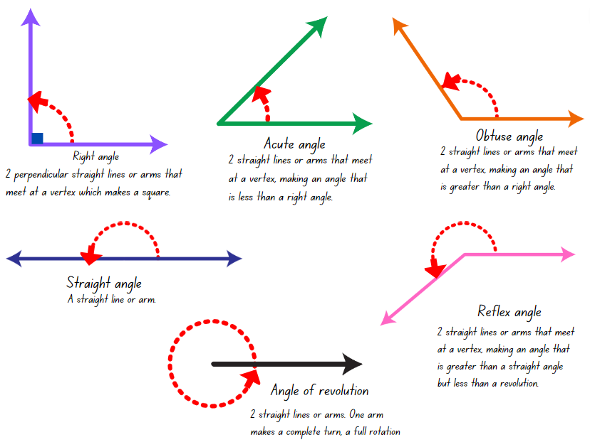

Resource 5 – angle art
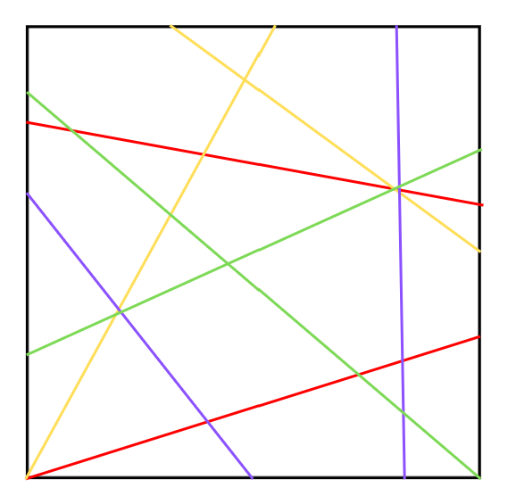

Resource 6 – lots of buttons
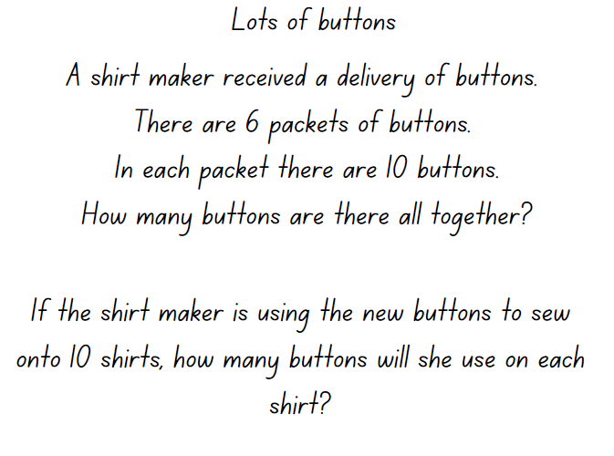

Resource 7 – environmental angles 1

Resource 8 – environmental angles 2
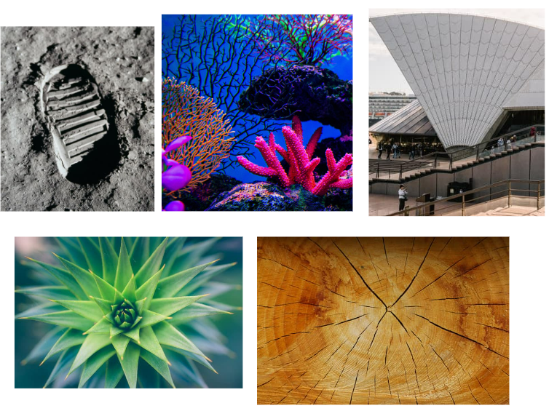

Resource 9 – alphabet letters
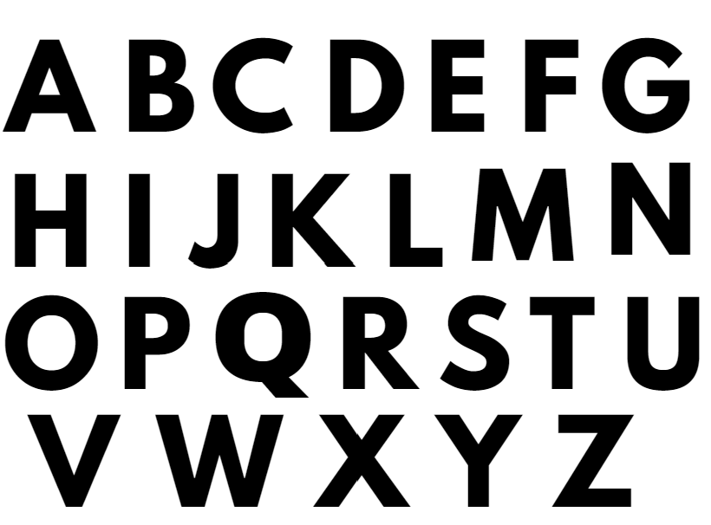

Resource 10 – clock angles
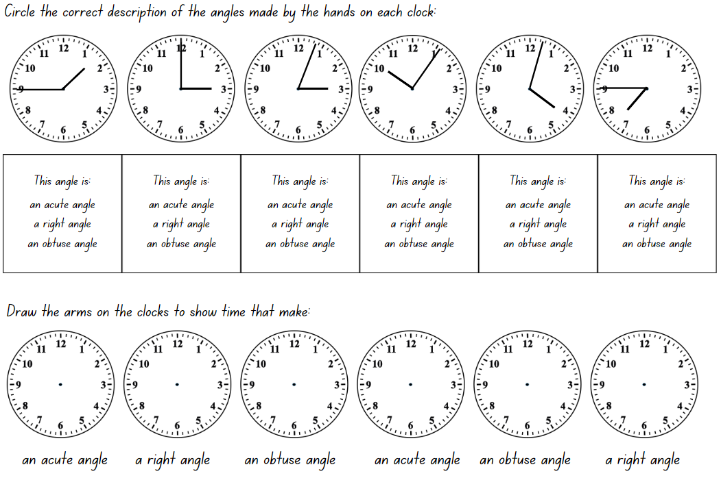

Resource 11 – time angles
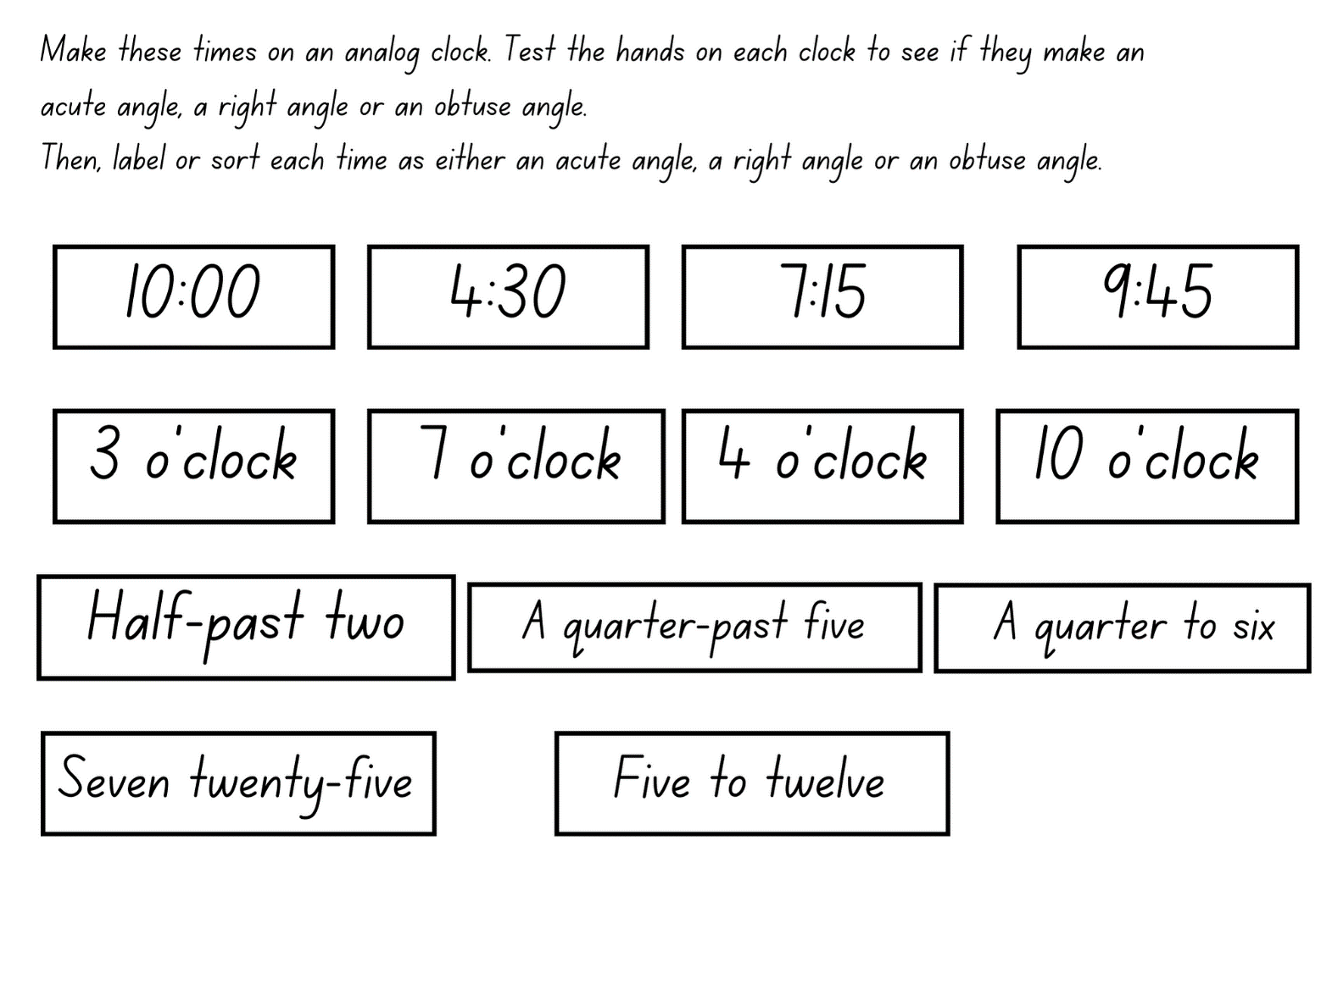

Resource 12 – in a minute
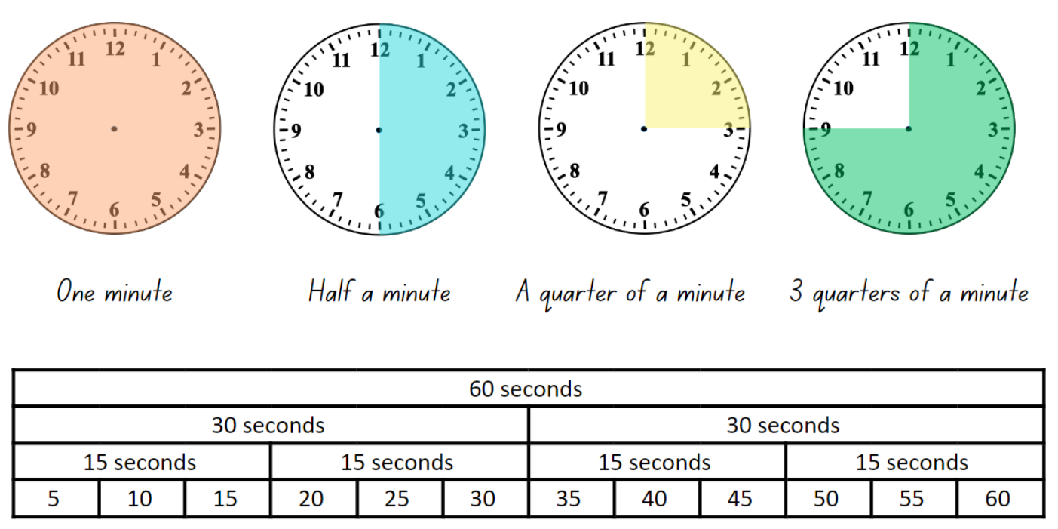

Resource 13 – showing the time
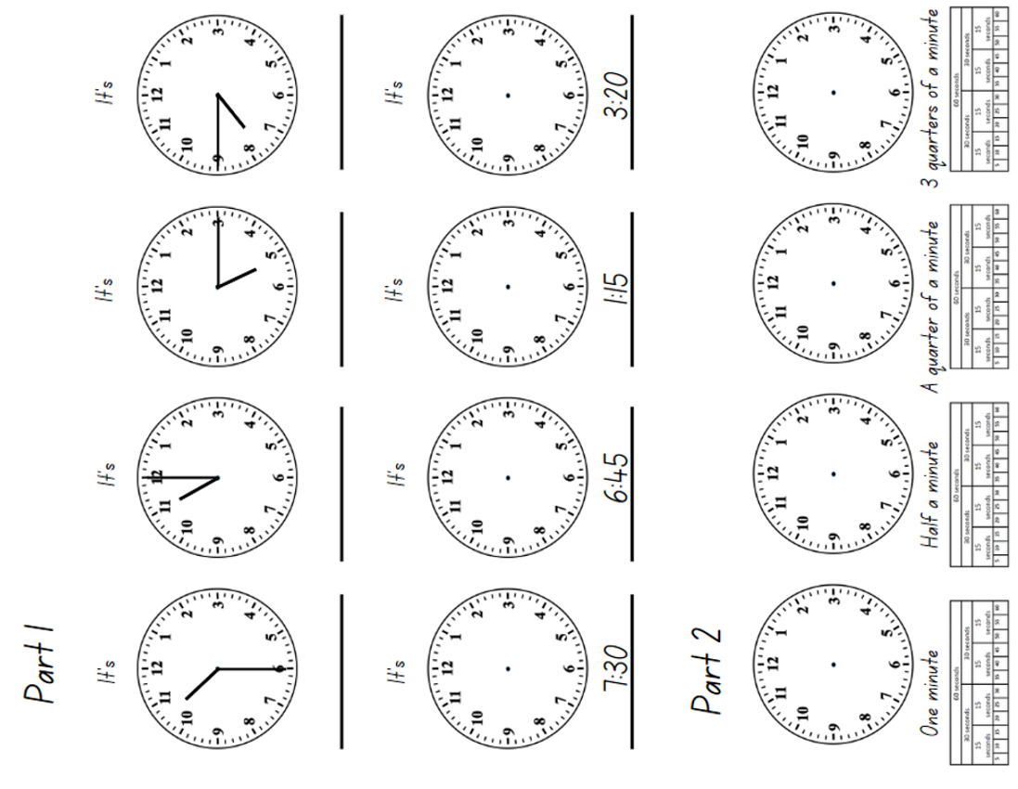

Resource 14 – day and night timeline
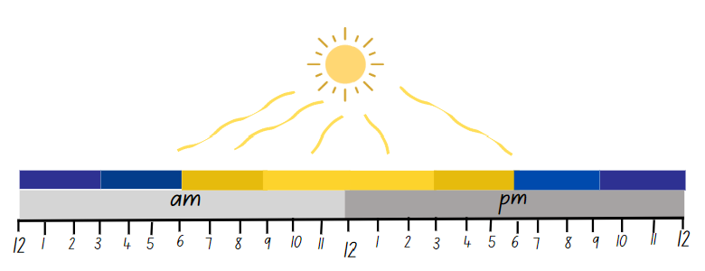

Resource 15 – creative arts activities
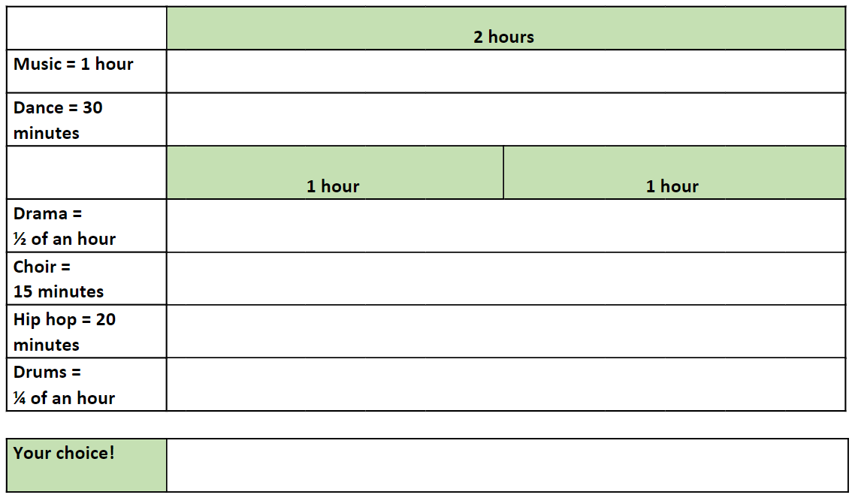

Resource 16 – fractions and decimals
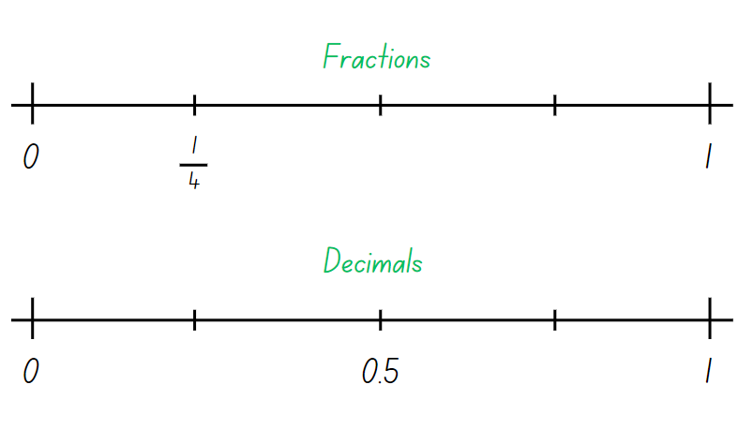

Resource 17 – faulty digital clock
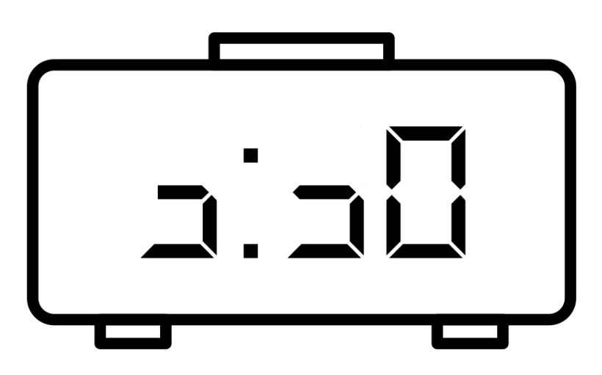

Resource 18 – check the clock
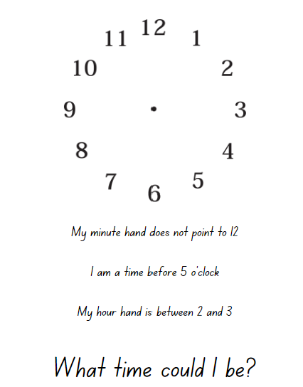

Syllabus outcomes and content
The table below outlines the syllabus outcomes and range of relevant syllabus content covered in this unit. Content is linked to National Numeracy Learning Progression version (3).
Outcomes and content | 1 | 2 | 3 | 4 | 5 | 6 | 7 | 8
Representing number using place value B: Decimals: Make connections between fractions and decimal notation
[MAO-WM-01, MA2-RN-01, MA2-RN-02]
- Compare and order decimals of up to 2 decimal places |  |  |  |  | x | x
- Make connections between fractions and decimal notation for key benchmark values (Reasons about relations) |  |  |  |  |  |  | x
Multiplicative relations A: Recall multiplication facts of 2 and 4, 5 and 10 and related division facts
[MAO-WM-01, MA2-MR-01, MA2-MR-02]
- Recognise and use the symbols for multiplied by (×), divided by (÷) and equals (=) | x | x | x
- Link multiplication and division fact families using arrays | x |  | x
- Generate multiplication fact families for multiples of 2 and 4, 5 and 10 | x | x
- Model and apply the commutative property of multiplication | x | x
Partitioned fractions A: Create fractional parts of a length using techniques other than repeated halving
[MAO-WM-01, MA2-PF-01]
- Make thirds of a length |  |  |  |  |  | x
- Create fifths of a length |  |  |  |  |  | x
Partitioned fractions A: Model and represent unit fractions, and their multiples, to a complete whole on a number line
[MAO-WM-01, MA2-PF-01]
- Model fractions with fraction strips and diagrams for halves, quarters, eighths, thirds |  |  |  |  | x | x
- Describe fraction families formed by dividing the whole into the same total number of equal parts as having the same denominator |  |  |  |  |  | x
- Determine the complementary fractional part needed to complete one whole (halves, quarters, eighths, thirds) (Reasons about relations) |  |  |  |  |  | x
Partitioned fractions B: Represent fractional quantities equal to and greater than one
[MAO-WM-01, MA2-PF-01]
- Rename 2 halves, 3 thirds, 4 quarters, 5 fifths, 6 sixths, 8 eighths and 10 tenths as one whole |  |  |  |  |  | x
- Represent totals of halves, thirds, quarters and fifths that extend beyond one |  |  |  |  |  | x
- Determine the relative location of one-quarter and one-half when a number line extends beyond one |  |  |  |  |  | x
Geometric measure A: Angles: Identify angles as measures of turn
[MAO-WM-01, MA2-GM-03]
- Identify angles with 2 arms in practical situations | x | x | x | x
- Identify the arms and vertex of an angle | x | x | x | x
- Recognise an angle as the amount of turning between 2 arms | x | x | x | x
- Compare angles and explain that the length of the arms does not affect the size of the angle (Reasons about spatial relations) | x | x | x | x
- Use the term right angle to describe a quarter-turn in a range of orientations (Reasons about spatial orientation) | x | x | x | x
Geometric measure B: Angles: Compare angles to a right angle
[MAO-WM-01, MA2- GM-03]
- Compare angles to a right angle using an informal means | x | x | x | x
- Recognise and describe angles as less than, equal to, about the same as or greater than a right angle |  | x | x | x
- Describe angles in comparison to quarter-turns as acute, right, obtuse, straight, reflex or a revolution |  | x | x | x
- Identify the arms and vertex of an angle where one arm is visible and the other arm is invisible | x |  | x | x
Non-spatial measure A: Time: Represent and read analog time
[MAO-WM-01, MA2-NSM-02]
- Use minutes to describe the duration of events |  |  |  |  |  | x
- Identify 30 minutes as being a half-hour and 60 minutes as an hour |  |  |  |  | x | x
- Connect the quarter-hour to 15 minutes |  |  |  |  | x | x
- Recognise that the position of the numerals on an analog timepiece often represents 2 different values |  |  |  |  | x | x
- Recognise that 5-minute intervals (corresponding to the hour markers) are used as benchmarks to read time on an analog clock |  |  |  |  | x | x |  | x
- Read time as past the hour to half-past and then towards the hour |  |  |  |  | x | x
- Read analog clocks to the minute |  |  |  |  | x | x | x | x
Non-spatial measure B: Time: Represent and interpret digital time displays
[MAO-WM-01, MA2-NSM-02]
- Identify situations where duration is measured in seconds |  |  |  |  | x |  | x | x
- Read or set the time on digital devices to the minute or second, recognising there are 60 seconds in one minute |  |  |  |  | x |  | x | x
- Recognise that the hour is read first in a digital display |  |  |  |  | x |  | x | x
Non-spatial measure B: Time: Use am and pm notation
[MAO-WM-01, MA2-NSM-02]
- Record times using the colon notation with am and pm to distinguish between morning and evening |  |  |  |  |  | x | x | x
- Relate the terms midday or noon and midnight to am and pm |  |  |  |  |  | x |  | x
- Relate analog notation to digital notation for time |  |  |  |  |  | x |  | x
Mathematics K–10 Syllabus © NSW Education Standards Authority (NESA) for and on behalf of the Crown in right of the State of New South Wales, 2022.

References
This resource contains NSW Curriculum and syllabus content. The NSW Curriculum is developed by the NSW Education Standards Authority. This content is prepared by NESA for and on behalf of the Crown in right of the State of New South Wales. The material is protected by Crown copyright.
Please refer to the NESA Copyright Disclaimer for more information https://educationstandards.nsw.edu.au/wps/portal/nesa/mini-footer/copyright.
NESA holds the only official and up-to-date versions of the NSW Curriculum and syllabus documents. Please visit the NSW Education Standards Authority (NESA) website https://educationstandards.nsw.edu.au/ and the NSW Curriculum website https://curriculum.nsw.edu.au.
Mathematics K–10 Syllabus © NSW Education Standards Authority (NESA) for and on behalf of the Crown in right of the State of New South Wales, 2022.
National Numeracy Learning Progression © Australian Curriculum, Assessment and Reporting Authority (ACARA) 2010 to present, unless otherwise indicated. This material was downloaded from the Australian Curriculum website (National Numeracy Learning Progression) (accessed 8 November 2023) and was not modified.
ABC (Australian Broadcasting Corporation) (2022) Time Tools: 12-hour to the minute, ABC Education website, accessed 23 November 2023.
AGSA (Art Gallery of South Australia) (2019) Dorrit Black: The Bridge Interpretive Resource [PDF 4.3 MB], Art Gallery of South Australia, accessed 23 November 2023.
Sullivan P (2018) Challenging Mathematical tasks: Unlocking the Potential of all Students, Oxford University Press, Australia.
Siemon D, Warren E, Beswick K, Faragher R, Miller J, Horne M, Jazby D, Breed M, Clark J and Brady K (2021) Teaching Mathematics: Foundations to Middle Years, 3rd edn, Oxford University Press Australia and New Zealand.
Toy Theater (n.d.) Active analog clock, Time Manipulatives, Toy Theater website, accessed 31 July 2023.
Toy Theater (n.d.) Static analog clock, Time Manipulatives, Toy Theater website, accessed 31 July 2023.
University of Cambridge (2023) Clocks, NRICH website, accessed 23 November 2023
University of Cambridge (2023) Olympic Turns, NRICH website, accessed 23 November 2023.
Van de Walle J, Karp K, Bay-Williams JM, Brass A, Bentley B, Ferguson S, Goff W, Livy S, Marshman M, Martin D, Pearn C, Prodromou T, Symons D and Wilkie K (2019) Primary and Middle Years Mathematics: Teaching Developmentally, 1st Australian edn, Pearson Education Australia, Melbourne.

© State of New South Wales (Department of Education), 2023
The copyright material published in this resource is subject to the Copyright Act 1968 (Cth) and is owned by the NSW Department of Education or, where indicated, by a party other than the NSW Department of Education (third-party material).
Copyright material available in this resource and owned by the NSW Department of Education is licensed under a Creative Commons Attribution 4.0 International (CC BY 4.0) license.
This licence allows you to share and adapt the material for any purpose, even commercially.
Attribution should be given to © State of New South Wales (Department of Education), 2023.
Material in this resource not available under a Creative Commons licence:
- the NSW Department of Education logo, other logos and trademark-protected material
- material owned by a third party that has been reproduced with permission. You will need to obtain permission from the third party to reuse its material.
Links to third-party material and websites
Please note that the provided (reading/viewing material/list/links/texts) are a suggestion only and implies no endorsement, by the New South Wales Department of Education, of any author, publisher, or book title. School principals and teachers are best placed to assess the suitability of resources that would complement the curriculum and reflect the needs and interests of their students.
If you use the links provided in this document to access a third-party's website, you acknowledge that the terms of use, including licence terms set out on the third-party's website apply to the use which may be made of the materials on that third-party website or where permitted by the Copyright Act 1968 (Cth). The department accepts no responsibility for content on third-party websites.

