Mathematics Stage 2 Year A – Unit 10
Angles are the primary structural component of many shapes
Contents
Unit description and duration 5
Syllabus outcomes 5
Working mathematically 6
Student prior learning 6
Lesson overview and resources 8
Lesson 1 13
Daily number sense – the ‘thirding strategy’ – 10 minutes 13
Core lesson – identify angles as measures of turn – 40 minutes 14
Discuss and connect the mathematics – 10 minutes 18
Lesson 2 20
Daily number sense – the ‘fifthing strategy’ – 10 minutes 20
Core lesson – angles represent an amount of turn – 40 minutes 22
Consolidation and meaningful practice – 10 minutes 25
Lesson 3 27
Daily number sense – Who is winning? – 15 minutes 27
Core lesson – square corners – 40 minutes 28
Discuss and connect the mathematics – 10 minutes 31
Lesson 4 33
Daily number sense – 10 minutes 33
Core lesson 1 – about time – 10 minutes 33
Core lesson 2 – just a minute – 30 minutes 34
Discuss and connect the mathematics – 10 minutes 36
Lesson 5 38
Daily number sense – balancing number sentences – 10 minutes 38
Core lesson 1 – clock wise – 20 minutes 40
Core lesson 2 – 20 minutes 42
Consolidation and meaningful practice – 10 minutes 45
Lesson 6 48
Daily number sense – the same as – 15 minutes 48
Core lesson 1 – clock fractions – 25 minutes 53
Core lesson 2 – the nearest minute – 15 minutes 54
Discuss and connect the mathematics – 10 minutes 56
Lesson 7 58
Daily number sense – True or false? – 10 minutes 58
Core lesson – problem solving with time – 40 minutes 59
Consolidation and meaningful practice – 20 minutes 63
Lesson 8 65
Daily number sense – 10 minutes 65
Core lesson – time to win – 30 minutes 65
Consolidation and meaningful practice – 20 minutes 68
Resource 1 – showing a turn 70
Resource 2 – exploring angles 1 71
Resource 3 – angles are everywhere 72
Resource 4 – exploring angles 2 73
Resource 5 – angle wedges 74
Resource 6 – measuring angles 75
Resource 7 – Who is winning? 76
Resource 8 – angle art 77
Resource 9 – Aboriginal time systems 78
Resource 10 – analog clock 79
Resource 11 – analog clock template 80
Resource 12 – minute hand 81
Resource 13 – number sentence board 82
Resource 14 – clock fractions 83
Resource 15 – reading the time 84
Resource 16 – number sentences 85
Resource 17 – Rebecca’s walk 86
Resource 18 – think board template 87
Resource 19 – the problem with time 88
Resource 20 – clocks 89
Resource 21 – time to win 90
Syllabus outcomes and content 91
References 94

Unit description and duration
This unit introduces the big idea that angles are the primary structural component of many shapes.
In this 2-week unit students are provided opportunities to:
- identify angles as measures of turn
- identify and name the parts of an angle
- read and represent analog time using minutes and hours and solve problems involving quarter hours and half hours.

Syllabus outcomes
- MAO-WM-01 develops understanding and fluency in mathematics through exploring and connecting mathematical concepts, choosing and applying mathematical techniques to solve problems, and communicating their thinking and reasoning coherently and clearly
- MA2-PF-01 create fractional parts of a length using techniques other than repeated halving
- MA2-AR-01 selects and uses mental and written strategies for addition and subtraction involving 2- and 3-digit numbers
- MA2-AR-02 completes number sentences involving addition and subtraction by finding missing values
- MA2-GM-03 identifies angles and classifies them by comparing to a right angle
- MA2-NSM-02 represents and interprets analog and digital time in hours, minutes and seconds

Working mathematically
In the Mathematics K–10 Syllabus, there is one overarching Working mathematically outcome (MAO-WM-01). The Working mathematically processes should be embedded within the concepts being taught. The Working mathematically processes present in the Mathematics K–10 Syllabus are:
- communicating
- understanding and fluency
- reasoning
- problem solving.
Mathematics K–10 Syllabus © NSW Education Standards Authority (NESA) for and on behalf of the Crown in right of the State of New South Wales, 2022.

Student prior learning
Before engaging in these teaching and learning activities, students would benefit from prior experience with:
- full turns, half turns and quarter turns of objects and shapes
- halves and quarters of lengths
- analog clocks, including half hour and o’clock.

In NSW classrooms there is a diverse range of students, including Aboriginal and/or Torres Strait Islander students, students learning English as an additional language or dialect, high potential and gifted students and students with disability. Some students may identify with more than one of these groups or possibly all of them. Refer to Curriculum planning for every student – advice for further information.

Lesson overview and resources
The table below outlines the sequence and approximate timing of lessons, learning intentions and resources.
Lesson | Content | Duration and resources
Lesson 1  Daily number sense learning intention:  - create fractional parts of a length using techniques other than repeated halving | Lesson core concept: angles can represent the amount of turn.  Core concept learning intention:  - identify angles as measures of turn | Lesson duration: 60 minutes  - Resource 1 – showing a turn  - Resource 2 – exploring angles 1  - Resource 3 – angles are everywhere  - Paper strips  - Writing materials
Lesson 2  Daily number sense learning intention:  - create fractional parts of a length using techniques other than repeated halving | Lesson core concept: angles can be estimated, compared and ordered.  Core concept learning intention:  - identify angles as measures of turn | Lesson duration: 60 minutes  - Resource 4 – exploring angles 2  - Resource 5 – angle wedges  - Resource 6 – measuring angles  - Paper strips  - Writing materials
Lesson 3  Daily number sense learning intention:  - create fractional parts of a length using techniques other than repeated halving | Lesson core concept: the term ‘right angle’ can be used to describe a quarter-turn.  Core concept learning intention:  - identify angles as measures of turn | Lesson duration: 65 minutes  - Resource 3 – angles are everywhere  - Resource 7 – Who is winning?  - Resource 8 – angle art  - Paper strips  - Pattern blocks  - Pipe cleaners  - Straws  - Writing materials
Lesson 4  Daily number sense learning intention:  - teacher-identified task based on student needs | Lesson core concept: time cannot be seen or touched, but its length can measured.  Core concept learning intention:  - represent and read analog time | Lesson duration: 60 minutes  - Resource 9 – Aboriginal time systems  - Stopwatch or timer  - Writing materials
Lesson 5  Daily number sense learning intention:  - use the principle of equality | Lesson core concept: halving and quartering blocks of time helps to measure and sequence events.  Core concept learning intention:  - represent and read analog time | Lesson duration: 60 minutes  - Resource 10 – analog clock  - Resource 11 – analog clock template  - Resource 12 – minute hand  - 10-sided dice  - Scissors  - Split pins  - Writing materials
Lesson 6  Daily number sense learning intention:  - use the principle of equality | Lesson core concept: the 2 hands on an analog clock indicate separate but related quantities.  Core concept learning intention:  - represent and read analog time | Lesson duration: 65 minutes  - Resource 13 – number sentence board  - Resource 14 – clock fractions  - Resource 15 – reading the time  - Playing cards  - Writing materials
Lesson 7  Daily number sense learning intention:  - use the principle of equality | Lesson core concept: analog clocks have number lines superimposed onto one another, each reflecting different units.  Core concept learning intention:  - represent and read analog time | Lesson duration: 70 minutes  - Resource 16 – number sentences  - Resource 17 – Rebecca’s walk  - Resource 18 – think board template  - Resource 19 – the problem with time  - Writing materials
Lesson 8  Daily number sense learning intention:  - teacher-identified task based on student needs | Lesson core concept: five-minute intervals on analog clocks are useful for reading the time.  Core concept learning intention:  - represent and read analog time | Lesson duration: 60 minutes  - Resource 20 – clocks  - Resource 21 – time to win  - Reusable sleeves  - Writing materials

Lesson 1
Core concept: angles can represent the amount of turn.

Daily number sense – the ‘thirding strategy’ – 10 minutes
Daily number sense activities for Lessons 1 to 3 ‘activate’ prior number knowledge and support the learning of new content in the unit. These activities can also assist teachers to identify the starting points for learning by revealing the extent of students’ existing knowledge.
The table below contains a suggested learning intention and success criteria. These are best co-constructed with students.
Daily number sense learning intention | Daily number sense success criteria
Students are learning to:  - create fractional parts of a length using techniques other than repeated halving. | Students can:  - make thirds of a length.
This activity is an adaptation of ‘Thirding strategy’ from Teaching Mathematics: Foundations to Middle Years by Siemon et al.
- Provide students with a paper strip and writing materials. Ask students to fold the paper in half.
- Revise a half and that 2 halves make a whole.
- As a class, discuss strategies to make thirds and where $\frac{1}{3}$ would be placed on the paper strip. Ask, ‘Do you think $\frac{1}{3}$ is more or less than $\frac{1}{2}$? How do you know?’
- Use the paper strip to make folds and explain the thirding strategy to students:
- Estimate half on the paper strip.
- Estimate a $\frac{1}{3}$ as something less than half, leaving room for 2 more equal parts.
- Halve the remaining part, making 3 equal parts in total.
- As a class label the partitioned strip with thirds.
This table details opportunities for assessment.
Assessment opportunities | Links
What to look for:  - Can students make thirds of a length? [MAO-WM-01, MA2-PF-01] | Links to National Numeracy Learning Progressions (NNLP):  - InF2, InF3, InF4.

Core lesson – identify angles as measures of turn – 40 minutes
The table below contains suggested learning intentions and success criteria. These are best co-constructed with students.
Core concept learning intentions | Core concept success criteria
Students are learning to:  - identify angles as measures of turn. | Students can:  - recognise an angle as the amount of turning between 2 arms  - identify the arms and vertex of an angle  - identify angles with 2 arms in practical situations.
- Ask for volunteers to stand up and give them instructions to move by making either a half turn (facing the other direction), full turn (turning around and facing the same direction) or a quarter turn (half of a half turn).
- After the demonstration ask the class to stand up, all facing the same direction. Give directions to move by making either a half turn, full turn or quarter turn. The direction of turn can also be introduced, for example, make a half turn to the right.
- After several turns, ask:
- Which turn was the biggest?
- Which turn was the smallest?
- Is there another way you could show a turn by using your body?
- Explain that measuring an angle is measuring an amount of turn. Explain that angles can be found in every part of students’ lives.
Angle: formed by 2 straight lines meeting at a common endpoint, called the vertex. An angle describes the amount of turn between the 2 arms (lines).
- Display Resource 1 – showing a turn and ask:
- Which turn is the biggest?
- How do you know?
- Use Resource 1 – showing a turn to explain that an angle is made when 2 straight arms join at a vertex. The size of an angle describes how much turn there is between 2 straight arms.
Note: students may have misconceptions that one angle is greater in size than another based on the length of arms of the angles. Explain that it is the amount of turn that is measured, not the length of the arms.
- Provide pairs with Resource 2 – exploring angles 1. With their partner, students identify the angle in each image, labelling the arms, vertex and the amount of turn.
- Regroup as a class and discuss the ways that students identified the angles in the images.
- Display Resource 3 – angles are everywhere. Explain that angles can be found wherever there are 2 straight lines that join at a vertex. Provide an example from one of the images. Highlight that:
- It is the amount of turn that is measured in an angle, not the length of the arms.
- The arms can be different lengths in an angle.
- A pair of arms can have an angle on both sides of the vertex.
- An angle can be presented in a different orientation, but the amount of turn remains the same.
- Provide pairs of students with Resource 3 – angles are everywhere. Students identify and label as many angles as they can find in each of the images by placing a small circle to show the vertex and a line to show the amount of turn between the 2 arms.
This table details opportunities for differentiation.
Too hard? | Too easy?
Students cannot identify the arms, vertex and amount of turn in an angle.  - Support students to identify the arms and vertex in each image in Resource 2 – exploring angles 1.  - Help students to identify the amount of turn in each angle. Support students to use their arms to indicate how much turn is represented in each angle.  Students cannot identify angles in practical situations.  - Support students to identify the angles in each image in Resource 3 – angles are everywhere.  - Help students to describe the amount of turn in each angle, then highlight it on the image. | Students can identify the arms, vertex and amount of turn in an angle.  - Ask students to compare the amount of turn in each angle, numbering them in order from smallest to largest.  - Challenge students to identify examples of angles in the school. They record these and compare the amount of turn in each.  Students can identify angles in practical situations.  - Students write instructions to move from one location to another. They describe the steps and turns needed, for example, 2 steps and a quarter turn to the left.  - Students test another student’s instructions to see if they arrive at the expected location.

Discuss and connect the mathematics – 10 minutes
- As a class, discuss ways to identify angles in Resource 3 – angles are everywhere. Ask:
- Did you find any angles in unexpected places?
- What did you notice during this activity?
- Is there anything that you are still wondering about?
This table details opportunities for assessment.
Assessment opportunities | Links
What to look for:  - Can students recognise an angle as the amount of turning between 2 arms? [MAO-WM-01, MA2-GM-03]  - Can students identify the arms and vertex of an angle?  [MAO-WM-01, MA2-GM-03]  - Can students identify angles with 2 arms in practical situations? [MAO-WM-01, MA2-GM-03] | Links to National Numeracy Learning Progressions (NNLP):  - UuM4, UuM5.

Lesson 2
Core concept: angles can be estimated, compared and ordered.

Daily number sense – the ‘fifthing strategy’ – 10 minutes
The table below contains a suggested learning intention and success criteria. These are best co-constructed with students.
Daily number sense learning intention | Daily number sense success criteria
Students are learning to:  - create fractional parts of a length using techniques other than repeated halving. | Students can:  - make thirds of a length  - make fifths of a length.
This activity is an adaptation of the ‘Fifthing strategy’ from Teaching Mathematics: Foundations to Middle Years by Siemon et al.
- Provide students with a paper strip and writing materials. Revise the strategies for identifying thirds in Lesson 1.
- Students fold the paper strip to show thirds, using the halfway point as a reference.
- Ask students to consider how they could show fifths on their paper strip. Ask:
- Would a fifth be larger or smaller than a third? How do you know?
- Would a fifth be larger or smaller than a quarter? How do you know?
- How can you use quarters on your fraction strip to find fifths?
- Explain the fifthing strategy to students:
- Estimate half, then estimate one-quarter.
- Estimate one-fifth as something slightly less than one-quarter.
- As 4 more equal parts are needed, halve and halve again the remaining part.
- Fold to create 5 equal parts in total.
- After folding and checking for 5 equal fifths, students draw a bar diagram that represents their folded fraction strip. They label the parts of the bar diagram to show each fifth.
This table details opportunities for assessment.
Assessment opportunities | Links
What to look for:  - Can students make thirds of a length? [MAO-WM-01, MA2-PF-01]  - Can students make fifths of a length? [MAO-WM-01, MA2-PF-01] | Links to National Numeracy Learning Progressions (NNLP):  - InF2, InF3, InF4.

Core lesson – angles represent an amount of turn – 40 minutes
The table below contains suggested learning intentions and success criteria. These are best co-constructed with students.
Core concept learning intentions | Core concept success criteria
Students are learning to:  - identify angles as measures of turn. | Students can:  - recognise an angle as the amount of turning between 2 arms  - compare angles and explain that the length of the arms does not affect the size of the angle.
This activity is an adaptation of ‘A unit angle’ from Primary and Middle Years Mathematics: Teaching Developmentally, 1st Australian edn by Van De Walle et al.
- Display Resource 4 – exploring angles 2. Revise that all angles have 2 straight arms (lines) which have a joining point called a vertex (corner).
- As students identify the features of the angles, for example the arms and vertex, record these on the images. Ask:
- What do you see?
- How are these angles the same?
- How are these angles different?
- Are there any angles that have the same amount of turn?
- How can we be certain that 2 angles have the same amount of turn?
- Would the size of the angle change if the length of the arms changed?
- Explain that students need a way of comparing and measuring the amount of turn between angles.
- Demonstrate that one way to compare 2 angles is by placing one on top of the other. For example, by placing an open pair of scissors on top of an open stapler to compare the amount of turning.
- Provide each student with an angle wedge from Resource 5 – angle wedges to use as an informal way of measuring angles.
- Explain that these wedges can be used as a unit of angular measure by counting the number of wedges that will fit in each angle.
- Use an angle wedge to measure and record the number of wedges needed to cover the turn of the angles from the open scissors and stapler.
- Provide pairs with Resource 6 – measuring angles. Students use their wedges to count how many are needed to fill or cover the spread of an angle (see Figure 1).
Figure 1 – measuring angles with an angle wedge
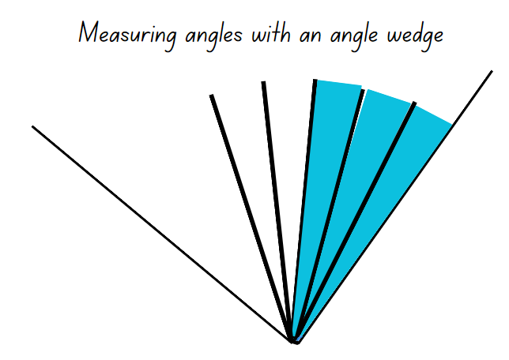
- Students record how many wedges were needed to measure the space between the 2 arms in their workbooks.
- Pairs then discuss and label the amount of turn for the angles, ordering these from the smallest amount of turning to the largest.
This table details opportunities for differentiation.
Too hard? | Too easy?
Students cannot recognise an angle as the amount of turning between 2 arms.  - Provide 2 strips of card that overlap at one end and are then joined with a split pin to form rotatable arms of an angle for students to use to make turns.  - Support students to use the card strips when discussing the amount of turning in each angle in Resource 4 – exploring angles 2.  Students cannot compare angles and explain that the length of the arms does not affect the size of the angle.  - Support students to estimate how many wedges will cover the turn for each angle in Resource 6 – measuring angles. Students then order their estimates from the smallest to biggest angle and check their estimates by using their card strips.  - In pairs, students make an angle using the card strips for their partner to measure using the wedge. They count how many are needed to cover the space in between the 2 arms. | Students can recognise an angle as the amount of turning between 2 arms.  - In pairs, students use a digital device to photograph 3 objects in the classroom that show angles that have a $\frac{1}{4}$ turn, $\frac{1}{2}$ turn and a $\frac{3}{4}$ turn.  - Students create a digital display of the angles they photographed labelling the turns.  Students can compare angles and explain that the length of the arms does not affect the size of the angle.  - In pairs, students challenge their partner to find an angle in the classroom that measures, for example, less than 12 wedges or more than 7 wedges.  - Students use their wedge to explore if all $\frac{1}{4}$ turn angles need the same number of wedges to cover the amount of space in between the 2 arms.

Consolidation and meaningful practice – 10 minutes
- Select 3 students to identify an example of an angle in the classroom.
- Students estimate how many wedges would be needed to measure the amount of turning for each angle and explain their reasoning. Ask:
- What parts of the angles did you use for your estimate?
- What strategies did you use for your estimate?
- Is there anything else you used to base your estimate on?
- Does the size of the angle change if the length of the arms change?
- Choose students to measure the angles using their wedge. Discuss how accurate the estimates were and which strategies were most helpful in estimating.
This table details opportunities for assessment.
Assessment opportunities | Links
What to look for:  - Can students recognise an angle as the amount of turning between 2 arms? [MAO-WM-01, MA2-GM-03]  - Can students compare angles and explain that the length of the arms does not affect the size of the angle?  [MAO-WM-01, MA2-GM-03] | Links to National Numeracy Learning Progressions (NNLP):  - UuM4, UuM5.

Lesson 3
Core concept: the term ‘right angle’ can be used to describe a quarter-turn.

Daily number sense – Who is winning? – 15 minutes
The table below contains a suggested learning intention and success criteria. These are best co-constructed with students.
Daily number sense learning intention | Daily number sense success criteria
Students are learning to:  - create fractional parts of length using techniques other than repeated halving. | Students can:  - make thirds of a length  - create fifths of a length.
This activity is an adaptation of ‘Who is winning?’ from Primary and Middle Years Mathematics: Teaching Developmentally, 1st Australian edn by Van De Walle et al.
- Provide pairs of students with multiple paper strips of the same length and writing materials. Revise how to identify thirds and fifths of a length from Lesson 1 and Lesson 2.
- Display Resource 7 – Who is winning? and explain that the 6 students are in a race. The fractions show the distance they have already run.
- Provide pairs of students with a paper strip for each runner.
- With their partner, students use a paper strip to mark and represent the fraction distance for each runner. Students then compare the fractional representations for each runner to determine who is winning the race.
- Discuss students' strategies used to identify and represent the position of each fraction.
This table details opportunities for assessment.
Assessment opportunities | Links
What to look for:  - Can students make thirds of a length? [MAO-WM-01, MA2-PF-01]  - Can students create fifths of a length? [MAO-WM-01, MA2-PF-01] | Links to National Numeracy Learning Progressions (NNLP):  - InF2, InF3, InF4.

Core lesson – square corners – 40 minutes
The table below contains suggested learning intentions and success criteria. These are best co-constructed with students.
Core concept learning intentions | Core concept success criteria
Students are learning to:  - identify angles as measures of turn. | Students can:  - compare angles  - use the term right angle to describe a quarter-turn in a range of orientations.
This activity is an adaptation of ‘Square corners’ from Teaching about angles: Stage 2 (PDF 3.36 MB) by State of New South Wales, Department of Education and Training, Professional Support and Curriculum Directorate.
- Display Resource 3 – angles are everywhere and ask students to identify angles where the 2 arms are different lengths.
- Ask students to look for angles that are the same size but orientated differently. For example, angles the same size that are left facing or right facing.
- Use a bent drinking straw to show that an angle has 2 lines and a point. Insert a pipe cleaner into the straw, so that when an angle is made the straw holds its shape.
- Tell students that this is an angle tester that shows the amount of turn in different angles, like the angle wedge from Lesson 2.
- Explain that different angles can be given names to identify them. Introduce the term right angle and describe it as a quarter-turn.
- Demonstrate how to bend the straw into a right angle by folding it over one vertex of a square pattern block (see Figure 2).
Figure 2 – angle tester
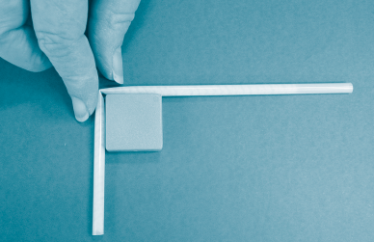
- Display 2D shape pattern blocks, as in Figure 3. Discuss and identify which pattern blocks have right angles.
Figure 3 – 2D shapes and angles
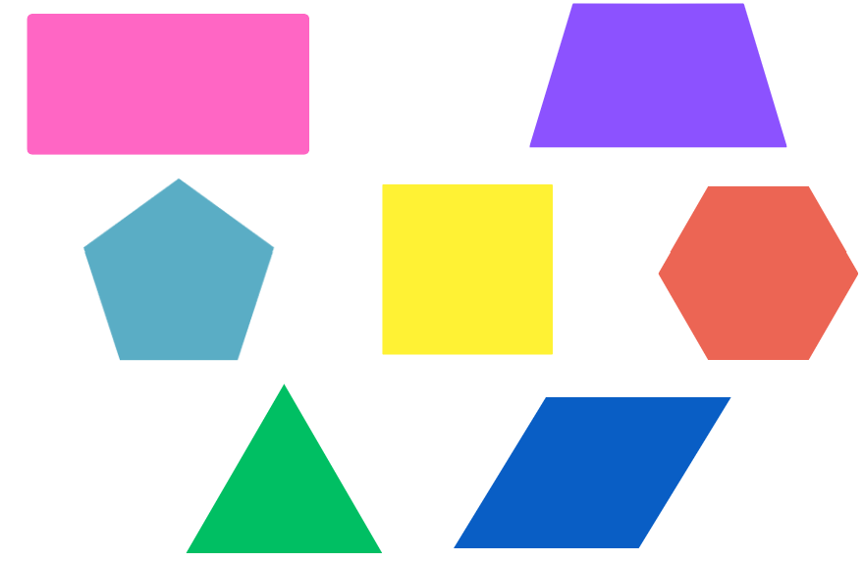
- Provide students with straws and pipe cleaners to make their own angle tester. Have students work in pairs to:
- search for right angles in the classroom
- make a sketch, marking the right angle(s) in colour, ensuring both lines meet at the vertex
- use their straw angle tester to check that the drawn angle is the correct size.
This table details opportunities for differentiation.
Too hard? | Too easy?
Students cannot use the term right angle to describe a quarter-turn in a range of orientations.  - Use Resource 3 – angles are everywhere to show examples of angles with the same size in different orientations.  - Identify examples of right angles in Resource 3 – angles are everywhere. Students check them using their angle tester. angle tester. | Students can use the term right angle to describe a quarter-turn in a range of orientations.  - Provide students with a copy of Resource 8 – angle art. Students identify and shade right angles in green.  - After finding the right angles, students identify and shade angles smaller than a right angle in yellow and angles larger than a right angle in blue.

Discuss and connect the mathematics – 10 minutes
- As a class, discuss examples of right angles found in the classroom. Create a list of right angles that students identified. Ask:
- How did you check that the angles were all right angles?
- What does it mean to say that the vertex is ‘square’ in a right angle?
- How many right angles do you think there would be in this classroom?
- Were all the right angles you found the same? What was the same? What was different?
- Discuss if any of the examples of right angles could be found in other contexts, for example in the playground, school hall, at home.
This table details opportunities for assessment.
Assessment opportunities | Links
What to look for:  - Can students compare angles? [MAO-WM-01, MA2-GM-03]  - Can students use the term right angle to describe a quarter-turn in a range of orientations? [MAO-WM-01, MA2-GM-03] | Links to National Numeracy Learning Progressions (NNLP):  - UuM4, UuM5.

Lesson 4
Core concept: time cannot be seen or touched, but its length can be measured.

Daily number sense – 10 minutes
- From a class need surfaced through formative assessment data, identify a short, focused activity that targets students’ knowledge, understanding and skills. Example activities may be drawn from the following resources:
- Mathematics K–6 resources
- Universal Resources Hub.

Core lesson 1 – about time – 10 minutes
The table below contains suggested learning intentions and success criteria. These are best co-constructed with students.
Core concept learning intentions | Core concept success criteria
Students are learning to:  - represent and read analog time. | Students can:  - predict and measure activities that take one minute  - use minutes to describe the duration of events.
Note: some Aboriginal and/or Torres Strait Islander students may need support in code switching between Eastern Standard Time and Cultural ways of understanding time. Aboriginal and Torres Strait Islander Peoples have a connection and understanding of natural cycles; these cycles are used to indicate time. For example, lunar cycles or tides inform hunting, fishing and agricultural practices (Australians Together 2023).
- Explain that sometimes people think of time as a line, with activities in an order: first, second, third and so on, or with one activity before another. Another way of thinking about time is as a cycle, with activities that repeat and happen at a certain time in the cycle.
- Display Resource 9 – Aboriginal time systems and explain that in Aboriginal and Torres Strait Islander cultures, time is thought of as a cycle, rather than as a line. It is flexible and shifts according to people’s needs and what’s happening on Earth.
- Refer to the images in Resource 9 – Aboriginal time systems and say that, for example, a fish trap isn’t set each day at the same time because tides don’t come in and out at the same time every day. Coastal fish traps need to be set up at particular times of day when the tide is coming in or going out to catch the fish.

Core lesson 2 – just a minute – 30 minutes
This activity is an adaptation of Just a minute from NZ Maths by New Zealand Ministry of Education.
- Explain that using time is important in many parts of life, for example, when travelling, in music, going to events and for farmers when planting and harvesting.
- Give an example of when time was not used well and something went wrong, for example, missing the bus.
- Explain to students that you are wondering about the length of one minute.
- Discuss the following statements and what students think is being asked in each instance:
- Wait one minute
- Hang on a minute
- Just give me a minute.
- Ask students to share their thinking. Explain that these are common sayings that are used to mean a short amount of time.
- Students turn and talk with a partner about how long one minute is and what events take one minute to complete.
- Ask the class to stand up. Explain that you will start a timer and students will sit down when they think one minute has passed.
- After completing this task, discuss which student was the closest.
- Repeat the activity, seeing if students can refine the accuracy of their estimate.
- As a class, discuss the length of one minute and list some events and tasks that take one minute. Record the suggestions.
- Select students to test if a particular suggested task takes one minute, for example, tying both shoelaces 5 times, writing their name 30 times or doing 25 star jumps. Use a stopwatch or a one-minute sand timer to tell students when to start and finish.
- Explain that, in pairs, students will select 3 tasks they think can be repeated multiple times in one minute.
- Provide pairs of students with writing materials to record how many times each task was successfully repeated in one minute.
- Use a stopwatch or a one-minute sand timer to tell students when to start and finish for each task.
This table details opportunities for differentiation.
Too hard? | Too easy?
Students cannot predict and measure activities that take one minute.  - Show students how one minute is measured using a sand timer or stopwatch while a task is completed.  - Students work in small groups to predict, draw and test activities that take one minute. | Students cannot predict and measure activities that take one minute.  - Ask students to work out how many times they would be able to complete the task in 5 minutes, 10 minutes or half an hour. They record their thinking to share with the class.  - Students choose one task and test if they can do more repetitions in one minute.

Discuss and connect the mathematics – 10 minutes
- Regroup as a class and summarise the lesson together drawing out key mathematical ideas. Ask:
- What did you notice about the length of one minute?
- Do you think one minute is longer or shorter than you initially thought?
- Did you have a task that you incorrectly estimated the length of time taken?
- Now that you know the length of one minute, what are some events that would take 5 minutes to complete?
- What are some events that would take 15 minutes to complete?
- What are some events that would take 30 minutes to complete?
This table details opportunities for assessment.
Assessment opportunities | Links
What to look for:  - Can students predict and measure activities that take one minute? [MAO-WM-01, MA2-NSM-02]  - Can students use minutes to describe the length of events? [MAO-WM-01, MA2-NSM-02] | Links to National Numeracy Learning Progressions (NNLP):  - MeT2, MeT3.

Lesson 5
Core concept: halving and quartering blocks of time helps us measure and sequence events.

Daily number sense – balancing number sentences – 10 minutes
Daily number sense activities for Lessons 5 to 7 ‘loop’ back to concepts and procedures covered in previous units to assist students to build an increasingly connected network of ideas. These concepts may differ from the core concepts being covered by the unit.
The table below contains a suggested learning intention and success criteria. These are best co-constructed with students.
Daily number sense learning intention | Daily number sense success criteria
Students are learning to:  - use the principle of equality. | Students can:  - use the equals sign to mean ‘the same as’.
- Provide pairs with two 6-sided dice and an individual whiteboard.
- Students roll the dice to form a 2-digit number, for example, 26. Students roll again to form another 2-digit number, for example, 32.
- Students record the number sentence 26 + 32 =.
- In pairs, students then calculate two other 2-digit numbers that could be written on the other side of the equal sign that would balance the number sentence. For example, 26 + 32 = 43 + 15.
- Students roll the 2 dice several times and repeat the process, recording a variety of balanced number sentences.
- Ask the class:
- What strategies were most useful when selecting the two additional numbers?
- How did you check that each side was the same as the other?
- How could you convince someone that your number sentence shows equality?
Note: the activity can be adapted by using 3 dice to create 3-digit numbers.
This table details opportunities for assessment.
Assessment opportunities | Links
What to look for:  - Can students use the equals sign to mean ‘the same as’?  [MAO-WM-01, MA2-AR-01, MA2-AR-02] | Links to National Numeracy Learning Progressions (NNLP):  - NPA3.  Links to suggested Interview for Student Reasoning (IfSR) tasks:  - IfSR-AT: 2A.1.

Core lesson 1 – clock wise – 20 minutes
The table below contains suggested learning intentions and success criteria. These are best co-constructed with students.
Core concept learning intentions | Core concept success criteria
Students are learning to:  - represent and read analog time. | Students can:  - identify 30 minutes as a half-hour and 60 minutes as an hour  - connect the quarter-hour to 15 minutes  - read time as past the hour and then towards the hour.
This activity is an adaptation of Clock wise (time) from NZ Maths by New Zealand Ministry of Education.
- As a class, brainstorm words used to describe time. For example, 5 o’clock, a quarter past, half past, a quarter to, six thirty, hours, minutes and seconds.
- Explain that there are different ways to describe and measure time. One way is to use analog clocks.
- Display Resource 10 – analog clock and discuss the face, drawing out the students' experiences with clocks and time. Ask:
- What do you notice about the clock face?
- What numbers are there? Why do the numbers stop at 12?
- How are the numbers arranged? Why do you think that is?
- What clocks do you have at home?
- What is the biggest clock you have ever seen?
- What are times during your day? For example, when do you get up and what time do you go to school?
- Provide students with Resource 11 – analog clock template or a paper plate to construct an analog clock. Model the following process for students and support them to construct their clock:
- Students fold their circle in half and half again.
- Colour each quarter a different colour. This helps reinforce the concept of quarters and halves.
- Identify that each quarter hour makes a right-angle corner in the centre of the clock face.
- Draw numbers onto the clock-face, beginning by placing the 12, 3, 6, and 9 on the $\frac{1}{4}$ ‘lines’. Discuss their position.
- Explain that once students reach half past the hour, they should read the time towards the next hour. For example, 20 minutes to 4 o’clock.
- Show how to add the remaining numbers evenly around the clock face.
- Use a split pin to attach the hour hand to the clock. Alternatively, students can hold a pencil to their clock’s face to show hours.

Core lesson 2 – 20 minutes
- Discuss times of the day when common events happen and record these as a list.
- Start with events that start on the hour, such as an alarm clock goes off at 7 o’clock, school starts at 9 o’clock, lunch is at one o’clock and home time is 3 o’clock.
- On a mind map record the shared events and times in the hour space (see Figure 4).
Figure 4 – hour mind map
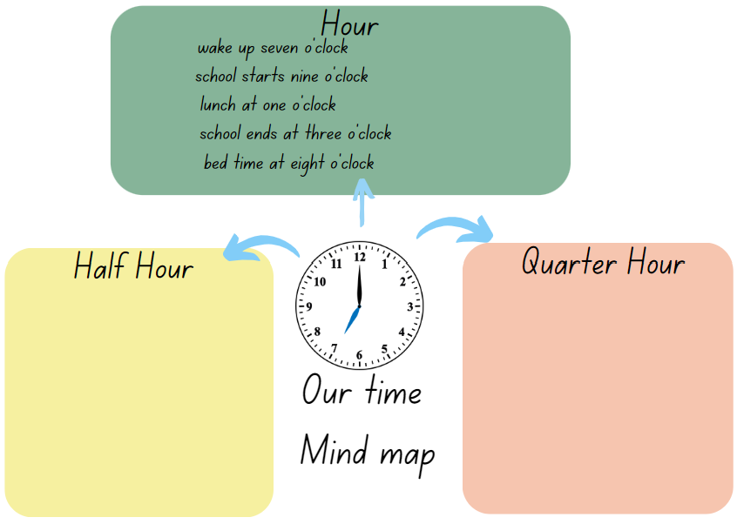
- As a class, model some of these times on the analog clocks made in Core lesson 1.
- Revise that the hour hand (the short hand) indicates the hour time.
- Discuss other common events that occur on the half and quarter hour and record these as in Figure 5.
Figure 5 – a mind map showing hour, half hour and quarter hour
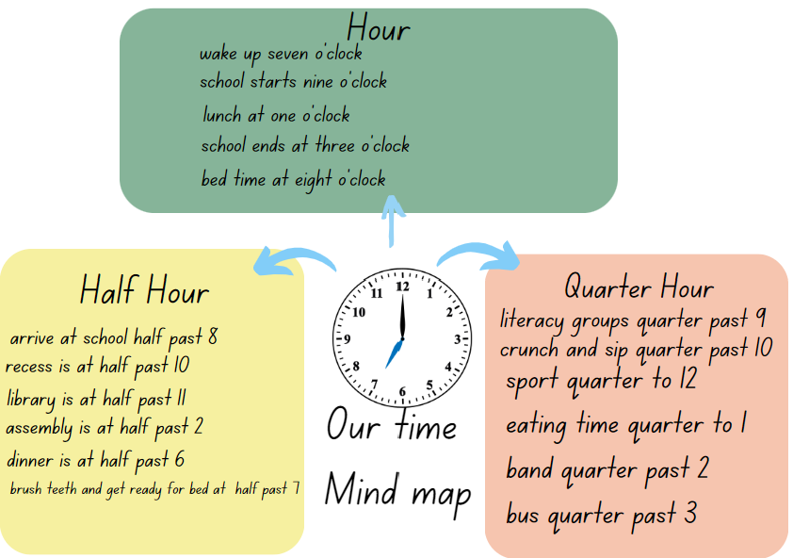
- Revise the role of the minute hand by looking at a clock with both hands. Explain that the minute hand moves on the clock every minute. Discuss what happens to the minute hand as the hour hand moves around the clock face.
- Provide students with Resource 12 – minute hand to be added to the analog clocks made in Core lesson 1. Ask students:
- Why does the minute hand point to the 12 with all the o’clock times?
- If one of the hands was missing do you think you could still tell the time? Why not?
- Ensure students recognise that the minute hand indicates how many minutes have passed since the o’clock time and with hour times zero minutes have passed.
- Display half past 10 on a clock. State an example of something that happens at 10 o’clock. For example, the time recess begins. Model that the clock shows half past time and ask students to model this on their analog clocks made in Core lesson 1. Ask:
- How can you describe the position of the hour and minute hands?
- Why does the minute hand point to the 6?
- Ensure students see the relationship between $\frac{1}{2}$ of the circle and the position of the minute hand pointing to the 6. Ask, ‘What is the hour hand pointing to?’
- Ensure students understand that the minute hand moves around the clock making one full rotation in 60 minutes and the hour hand moves around the clock making a full rotation in 12 hours.
- Ask the students to show half past 3 on their clocks. As a class, discuss the placement of the hands.
- Discuss the events that occur on the quarter-hours. Show the quarter-past times identified in discussion on the clock and ask students to show the time on their own clocks. Continue to add to the mind map if students suggest additional events.
- Ask students to record some of their favourite or important times of the day and show these times on their clocks. Students could do this with a partner first, before sharing one time with the whole class.
This table details opportunities for differentiation.
Too hard? | Too easy?
Students cannot identify 30 minutes as half an hour, 60 minutes as an hour or 15 minutes as quarter of an hour.  - Support students to identify and label a quarter-hour and half-hour on their clock. Read as quarter-past and half-past.  - Help students to identify and label a quarter to the hour and the whole clock face as one hour.  Students cannot read time as past the hour to half-past and then towards the hour.  - Model the minute hand representing time past the half-hour.  - Show how times after half-past are read. For example, 45 minutes past the hour is read as ‘a quarter to’ the next hour. | Students can identify 30 minutes as half an hour, 60 minutes as an hour or 15 minutes as quarter of an hour.  - With a partner, students represent a time on their clock. Their partner tries to think of a different way to describe the time. For example, half past 7 is 30 minutes after 7 o’clock.  - Show the NRICH resource ‘Clocks’ and explain that these clocks have been reflected in a mirror. Students use what they know about analog clocks to find the times shown.

Consolidation and meaningful practice – 10 minutes
This activity is an adaptation of Hinea's watch's hands from NZ Maths by New Zealand Ministry of Education.
- Provide pairs of students with writing materials and analog clocks made in Core lesson 1.
- Explain to students that on a watch or a clock, sometimes only one hand is visible because the minute hand and the hour hand are in the same position. For example, 12:00, 1:05, 2:11, 3:16, 4:22, 5:27, 6:32, 7:38, 8:44, 9:49, 10:55.
- Ask students to estimate how many times a day the minute hand and hour hand are in the same position and justify their answer. Keep records of estimates to be revisited. Ask:
- What strategies did you use? (For example, using angles as benchmarks).
- Was there a pattern?
- Did you change your estimate as you problem solved and found some solutions?
- How far or close was the final answer to your initial estimate?
- How many times does this happen?
This table details opportunities for assessment.
Assessment opportunities | Links
What to look for:  - Can students identify 30 minutes as being a half-hour and 60 minutes as an hour? [MAO-WM-01, MA2-NSM-02]  - Can students connect the quarter-hour to 15 minutes?  [MAO-WM-01, MA2-NSM-02]  - Can students read time as past the hour and then towards the hour? [MAO-WM-01, MA2-NSM-02] | Links to National Numeracy Learning Progressions (NNLP):  - MeT3.

Lesson 6
Core concept: the 2 hands on an analog clock indicate separate but related quantities.

Daily number sense – the same as – 15 minutes
The table below contains a suggested learning intention and success criteria. These are best co-constructed with students.
Daily number sense learning intention | Daily number sense success criteria
Students are learning to:  - use the principle of equality. | Students can:  - use the equals sign to record equal number sentences.
This activity is an adaptation of Let’s Play: Number Sentences by Russo.
Note: prior to the lesson, remove all the picture cards. It is optional to use the picture cards if appropriate to increase the level of challenge.
- Demonstrate how to play the game by playing against a student or the whole class.
- Deal 4 cards face up on Resource 13 – number sentence board and place the remainder of the cards in a centre pile (see Figure 6).
Figure 6 – number sentence board
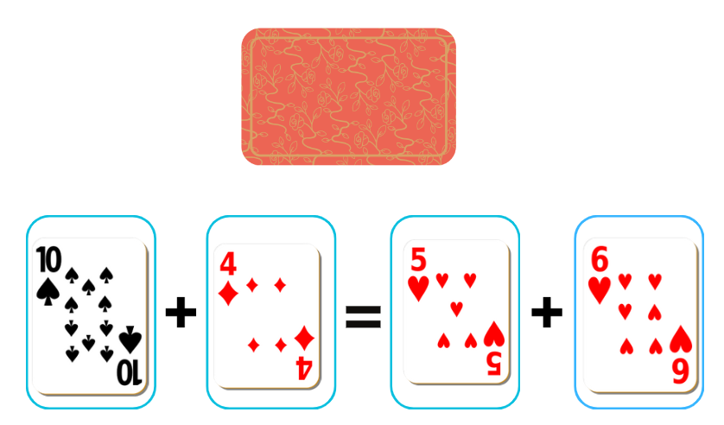
- Player 1 picks a card from the centre pile and decides which of the 4 slots to place the card. For example, Player 1 picks a 7 and places it in one of the slots, then reads out the number sentence stating whether it is true or not. For example, 10 plus 4 is not the same as 7 plus 6 (see Figure 7).
Figure 7 – gameplay
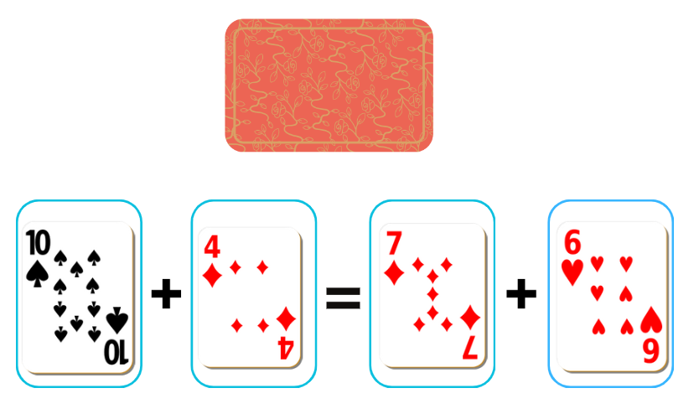
- Player 2 then picks a card and places it in one of the slots. For example, player 2 picks a 7 and reads out the number sentence stating if it is true or not (see Figure 8).
Figure 8 – gameplay 2
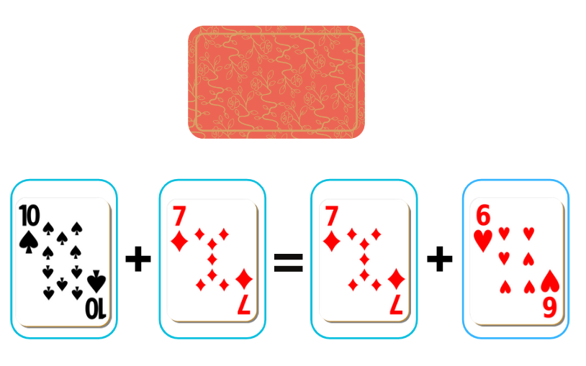
- Play continues until a player selects a card that makes a true statement. For example, Player 1 picks a 3, places it in a slot and reads 10 plus 3 is the same as 7 plus 6 (see Figure 9).
Figure 9 – gameplay 3
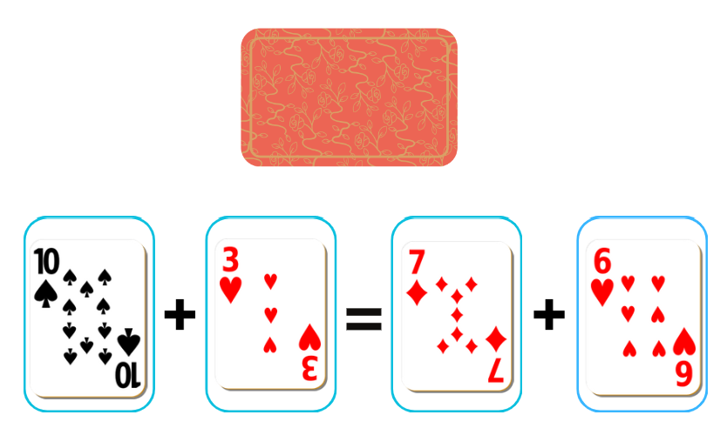
- Players record the number sentences on their whiteboard and that is the end of a round. The cards on the game board are placed at the bottom of the pile, 4 new cards are dealt and play starts again.
This table details opportunities for assessment.
Assessment opportunities | Links
What to look for:  - Can students use the equals sign to record equal number sentences? [MAO-WM-01, MA2-AR-01] | Links to National Numeracy Learning Progressions (NNLP):  - NPA3.  Links to suggested Interview for Student Reasoning (IfSR) tasks:  - IfSR-AT: 2A.1.

Core lesson 1 – clock fractions – 25 minutes
The table below contains suggested learning intentions and success criteria. These are best co-constructed with students.
Core concept learning intentions | Core concept success criteria
Students are learning to:  - represent and read analog time. | Students can:  - use the 5-minute intervals to read time on an analog clock  - read analog clocks to the minute  - read time as past the hour and then towards the hour.
- Provide students with Resource 14 – clock fractions to cut out.
Note: these could be pre-cut for students to save time.
- Explain that as the minute hand moves around the clock face, it shows the fraction of an hour.
- Show students how the $\frac{1}{2}$ piece can be laid over the analog clock to show where the minute hand has moved. Explain that this shows the fraction of time that has passed and how many minutes this is equivalent to.
- Discuss the value of each fraction, the number of minutes they represent and how much time is left in the hour. Point out that the smaller fractions allow time to be recorded very accurately, while the 5-minute intervals assist counting by fives.
- With a partner, students experiment with making combinations of minutes that total one hour. They record these as both a diagram and as a number sentence.
- Ask:
- What did you notice while you were making combinations of an hour?
- What was the simplest combination you made?
- Which combination had the most fractions?
- Were there any patterns that you saw?
- Is there anything else that you are wondering?

Core lesson 2 – the nearest minute – 15 minutes
- Explain that some times can be said in different ways, for example, one fifty-five is also the same as 5 minutes to 2.
- Students turn and talk with a partner about other times that can be expressed in more than one way.
- Ask students to share their thinking. Record and discuss some of the examples shared.
- Show Resource 15 – reading the time and explain that students will work with a partner to match some times that are written in different ways. They will also be reading times written in words, then writing them on an analog clock by drawing the hands.
This table details opportunities for differentiation.
Too hard? | Too easy?
Students cannot read time as past the hour and then towards the hour.  - Use an analog clock to demonstrate how the minute hand moves ‘past’ a given hour.  - Model times that have the minutes hand moving towards the hour and discuss ways they can be read.  Students cannot use the 5-minute intervals to read time on an analog clock.  - Support students by first finding where the hour hand should be to show that specific time. Then identify the number of minutes to be shown.  - Model how to count by multiples of 5, then use the minute marks to count by ones to find the time indicated by the minute hand. | Students can use the 5-minute intervals to read time on an analog clock.  - Working with a partner, students use their combined time fractions to work out as many combinations as possible that total 90 minutes.  - Students work with a partner to solve Wonky Watches from NRICH, recording their thinking.

Discuss and connect the mathematics – 10 minutes
- Ask students to think about strategies that have helped them to read the time on analog clocks.
- Students turn and talk with a partner to share their thinking, then share these ideas with the class.
- Display a variety of times on the board and select students to read the times.
- Choose some of the displayed times and ask questions such as:
- How many more minutes until the next hour?
- If it is 7:45, what time would it be in half an hour?
- If it is 9:15 what time would it be in 2 hours and 45 minutes?
This table details opportunities for assessment.
Assessment opportunities | Links
What to look for:  - Can students use the 5-minute intervals to read time on an analog clock? [MAO-WM-01, MA2-NSM-02]  - Can students read analog clocks to the minute?  [MAO-WM-01, MA2-NSM-02]  - Can students read time as past the hour and then towards the hour? [MAO-WM-01, MA2-NSM-02] | Links to National Numeracy Learning Progressions (NNLP):  - MeT3.

Lesson 7
Core concept: analog clocks have number lines superimposed onto one another, each reflecting different units.

Daily number sense – True or false? – 10 minutes
The table below contains a suggested learning intention and success criteria. These are best co-constructed with students.
Daily number sense learning intention | Daily number sense success criteria
Students are learning to:  - use the principle of equality. | Students can:  - recognise and explain when a number sentence has the same value on both sides of the equals sign.
This activity is an adaptation of True or false from NRICH by University of Cambridge.
- Display the number sentence 27 + 13 = 11 + 29. Ask students to turn and talk about if the number sentence is true or false.
- Select students to explain how they know that the number sentence is true or false.
- Emphasise to students that the equals sign means ‘the same as’ or ‘balance’ and not just the ‘total’ or the ‘answer’.
- Display Resource 16 – number sentences and ask students the following questions for each number sentence:
- Is the number sentence true or false?
- How do you know you are correct?
- Could you decide without doing any calculating? What strategy did you use?
This table details opportunities for assessment.
Assessment opportunities | Links
What to look for:  - Can students recognise and explain when a number sentence has the same value on both sides of the equals sign?  [MAO-WM-01, MA2-AR-01] | Links to National Numeracy Learning Progressions (NNLP):  - NPA3.  Links to suggested Interview for Student Reasoning (IfSR) tasks:  - IfSR-AT: 2A.1.

Core lesson – problem solving with time – 40 minutes
The table below contains suggested learning intentions and success criteria. These are best co-constructed with students.
Core concept learning intentions | Core concept success criteria
Students are learning to:  - represent and read analog time. | Students can:  - identify 30 minutes as being a half-hour and 60 minutes as an hour  - connect the quarter-hour to 15 minutes  - apply appropriate strategies to find solutions to time problems.
This activity is an adaptation of Clock wise (time) from NZ Maths by New Zealand Ministry of Education.
- Display Resource 17 – Rebecca’s walk and provide pairs of students with writing materials.
- As a class, read the problem and ask:
- What is the problem asking you to find out?
- Where would you start to solve the problem?
- Which strategy do you think will work best to find a solution for this problem? Why?
- How can you use the clock hands to help you find the solution?
- How could you record your solution?
- In pairs, students work through the problem and share solutions with the class.
- Explain that think boards are a useful way to record and show representations of steps and strategies being used to find solutions to problems. Display Resource 18 – think board template.
- Using the template and the shared solutions for the problem ‘Rebecca’s walk’, co-construct a think board displaying how fractions, angles and diagrams can be used to solve time problems (see Figure 10).
Figure 10 – example of solutions
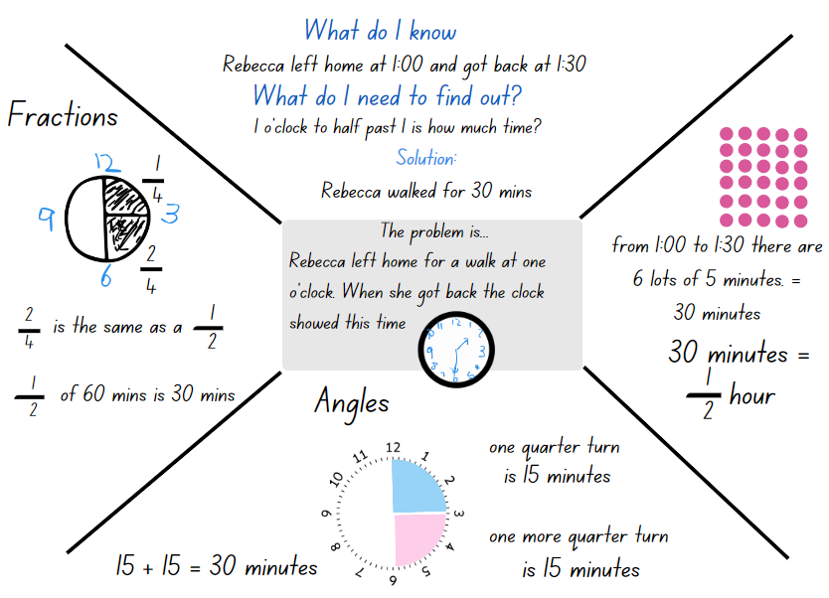
- Explain that students will solve time problems, individually or in pairs, using think boards to record strategies and their solution.
- Provide students with Resource 18 – think board template and Resource 19 – the problem with time to start the activity.
- Once students are finished, regroup as a class. Ask:
- Which problem was the most challenging? Why?
- Did you use the same steps each time to solve each problem? Explain.
- How did the think board help you plan and solve each problem?
This table details opportunities for differentiation.
Too hard? | Too easy?
Students cannot solve time problems and identify 30 minutes as being a half-hour and 60 minutes as an hour.  - Support students to use their analog clock and count aloud as the hand moves around the whole clock face, counting the 60 individual minute markers. Cover half the clock face and, repeat counting only the 30 individual minute markers as the hand moves around half the clock face.  - With a partner, students use their analog clock to solve the first problem from Resource 19 – the problem with time. Ask students to explain their thinking and help them to record their ideas on Resource 18 – think board template. | Students can solve time problems and identify 30 minutes as being a half-hour and 60 minutes as an hour.  - Challenge students to write time problems for a partner to solve.  - Students work with a partner to read time and order clocks using What is the Time? from NRICH.

Consolidation and meaningful practice – 20 minutes
- Display the interactive game Stop the Clock from NRICH.
- Split the class into 2 teams.
- Explain that to start the game the clock is set to 6 o’clock.
- Each team has the option to move the hands of the clock on by ½ hour or by one hour. For example, Team A chooses ½ hour, so the clock hands move to show 6:30. Team B now chooses to move one hour so the hands move to show 7:30.
- Play continues until a team successfully moves the hands exactly onto 12 o’clock.
- After a few rounds ask:
- Is it better to choose half hour, one hour or a combination of both? How do you know?
- How did you decide which option to pick at each step?
- Was there one option that you would have liked to change after seeing the result?
- How was this game challenging?
This table details opportunities for assessment.
Assessment opportunities | Links
What to look for:  - Can students identify 30 minutes as being a half-hour and 60 minutes as an hour? [MAO-WM-01, MA2-NSM-02]  - Can students connect the quarter-hour to 15 minutes?  [MAO-WM-01, MA2-NSM-02]  - Can students apply appropriate strategies to find solutions to time problems? [MAO-WM-01, MA2-NSM-02] | Links to National Numeracy Learning Progressions (NNLP):  - MeT3.

Lesson 8
Core concept: five-minute intervals on analog clocks are useful for reading the time.

Daily number sense – 10 minutes
- From a class need surfaced through formative assessment data, identify a short, focused activity that targets students’ knowledge, understanding and skills. Example activities may be drawn from the following resources:
- Mathematics K–6 resources
- Universal Resources Hub.

Core lesson – time to win – 30 minutes
The table below contains suggested learning intentions and success criteria. These are best co-constructed with students.
Core concept learning intentions | Core concept success criteria
Students are learning to:  - represent and read analog time. | Students can:  - recognise that the quarter-hour and 5-minute intervals are used as benchmarks to read time on an analog clock  - read analog clock as past the hour to half-past and then towards the hour.
The activity is an adaptation of Time to Win from The Mathematical Isles of What If? by Merrill.
- Revise students’ knowledge of reading analog time. Ask:
- What do the 2 hands represent?
- What do the numbers represent?
- How many minutes are in an hour?
- What would the time be if the hour hand is on the 3 and the minute hand is on the 12?
- How many minutes are in a quarter of an hour?
- Revise quarter past and quarter to as being 15 minutes past the hour and 15 minutes to the hour.
- Display Resource 20 – clocks and demonstrate how to play ‘The Landing Spot’ by playing against a student or the whole class. The rules are:
- The game starts at a designated time, for example, 9 o’clock. The players choose a time as a target, for example, 11 o’clock.
- To win the game, a player must be the person to land on the target time on one of their turns.
- Players take it in turns to add time to the clock, choosing between either 15 or 30 minutes. The new time is then written on the next clock face.
- As the game progresses, players must think carefully about which choice time can help them be the one to land on the target time.
- Play the game as a class to familiarise students with the rules, as in Figure 11.
Figure 11 – landing spot example
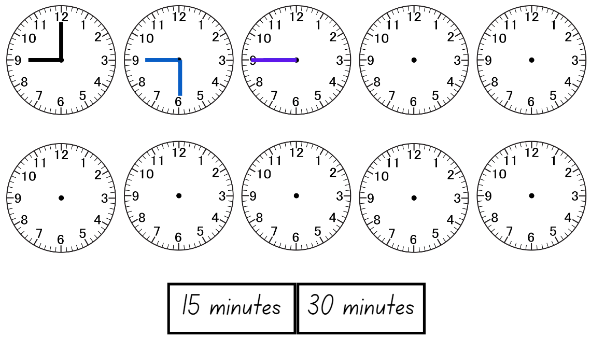
- Provide pairs of students with a copy of Resource 20 – clocks in a reusable sleeve and whiteboard markers.
- Once students have made it up to 11 o’clock, regroup and demonstrate how to extend the game to play ‘Time to Win’:
- Provide pairs of students with Resource 21 – time to win in a reusable sleeve. Explain that this game is similar, but now when it is their turn, the players can add any of the 5 possibilities and draw the correct time on the clock. The game starts at a designated ‘quarter to....’ time, for example, a quarter to 9. The players choose a time as a target, for example, a quarter to 1.
- The first player to make it to the ‘quarter to....’ target time is the winner.
- Students play multiple rounds taking it in turns to go first.
This table details opportunities for differentiation.
Too hard? | Too easy?
Students cannot add time intervals and represent the time on an analog clock.  - Provide students with mini clocks to manipulate when adding the times before recoding.  - Allow students to only add hours and half hours starting at 9 o’clock and ending at 3 o’clock. The first student to reach 3 o’clock wins. | Students can add time intervals and represent the time on an analog clock.  - Challenge students to aim to be the first player to read and record a ‘quarter past...’ time.  - Students come up with another time possibility to add. For example, 25 minutes.

Consolidation and meaningful practice – 20 minutes
This activity is an adaptation of ‘Angles on clocks’ from Challenging Mathematical tasks: Unlocking the Potential of all Students by Sullivan.
- Provide students with Resource 20 – clocks in a reusable sleeve and tell students that the 2 hands on the clock make a right angle and the minute hand is on the 3. Ask students what the time might be.
- Students draw the possible times on Resource 20 – clocks.
- Select students to share and justify their answers, recording students’ responses.
- Continue with different times, hands on the clock and angles.
This table details opportunities for assessment.
Assessment opportunities | Links
What to look for:  - Can students recognise that the quarter-hour and 5-minute intervals are used as benchmarks to read time on an analog clock? [MAO-WM-01, MA2-NSM-02]  - Can students read analog clock as past the hour to half-past and then towards the hour? [MAO-WM-01, MA2-NSM-02] | Links to National Numeracy Learning Progressions (NNLP):  - MeT3.

Resource 1 – showing a turn
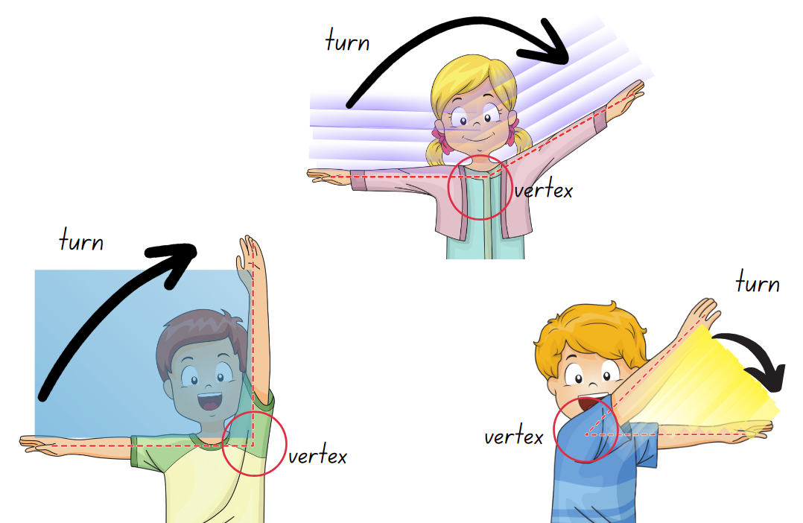

Resource 2 – exploring angles 1
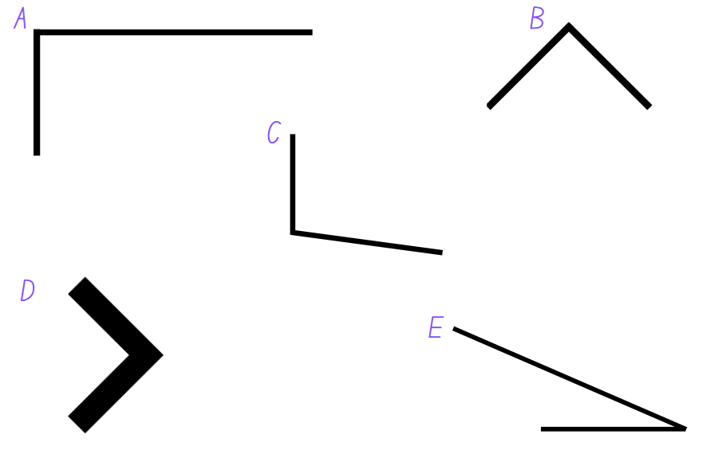

Resource 3 – angles are everywhere

Resource 4 – exploring angles 2
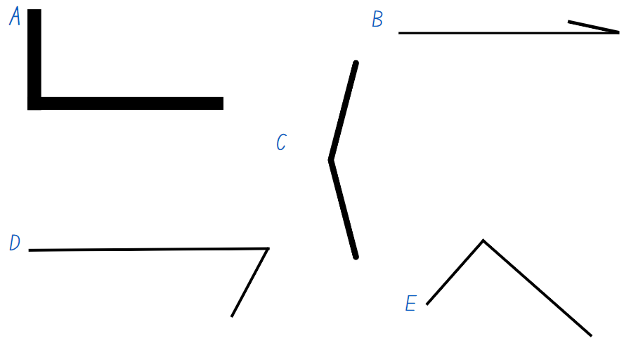

Resource 5 – angle wedges
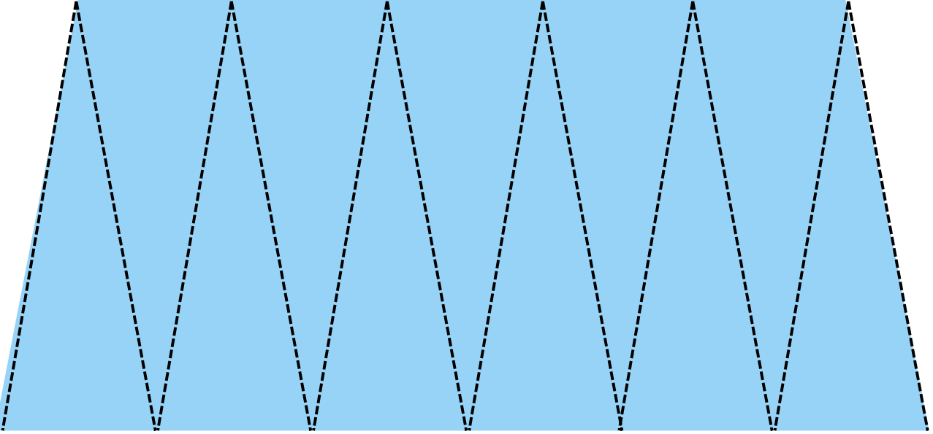

Resource 6 – measuring angles
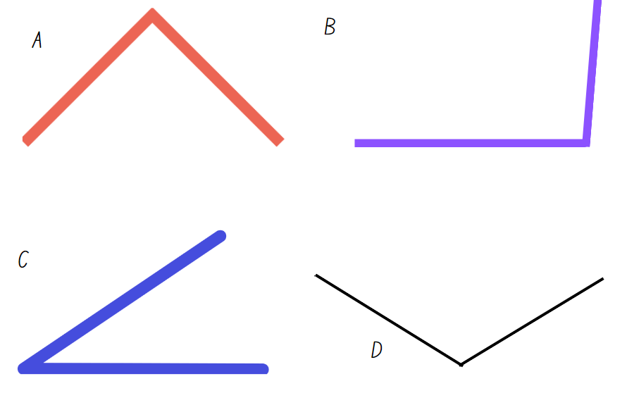

Resource 7 – Who is winning?
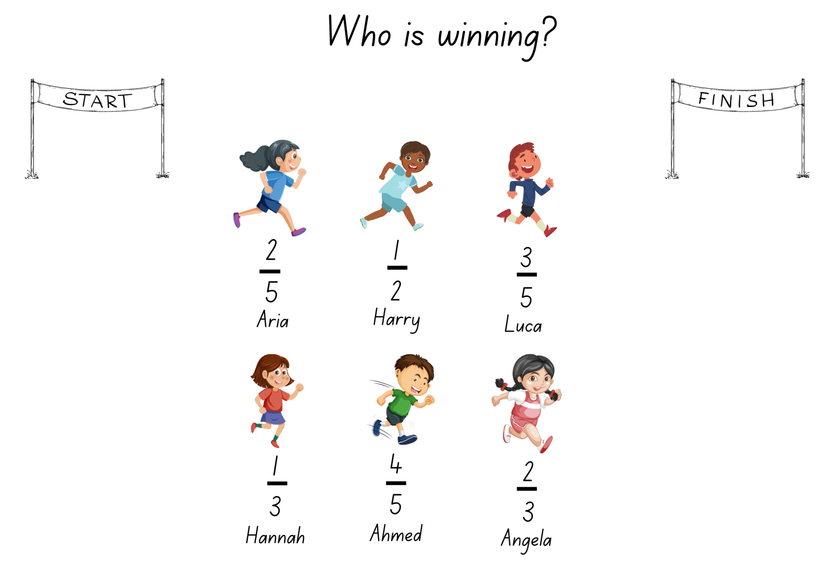

Resource 8 – angle art
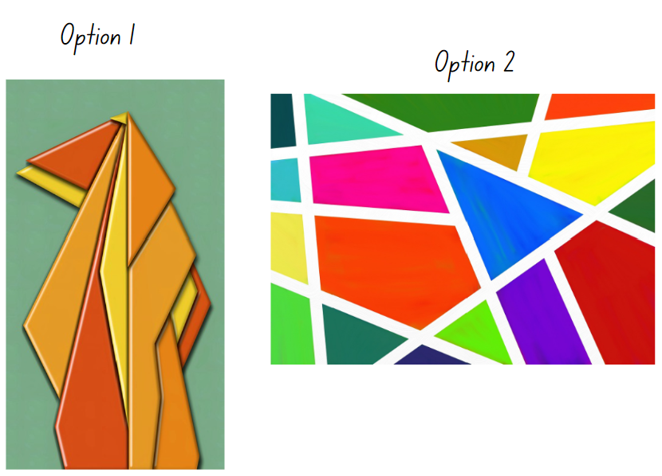

Resource 9 – Aboriginal time systems

Resource 10 – analog clock
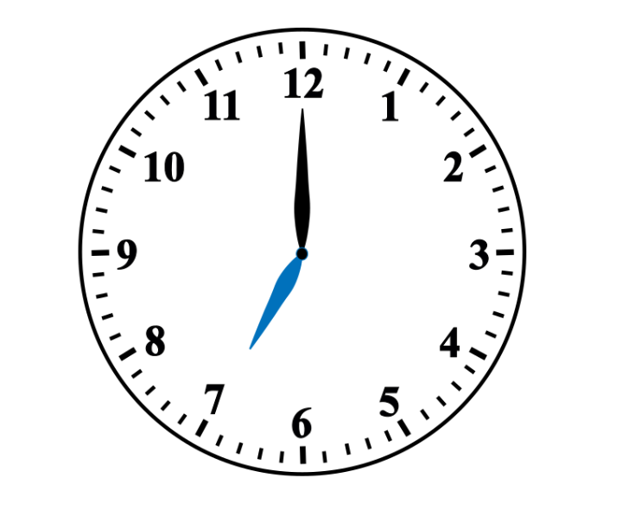

Resource 11 – analog clock template
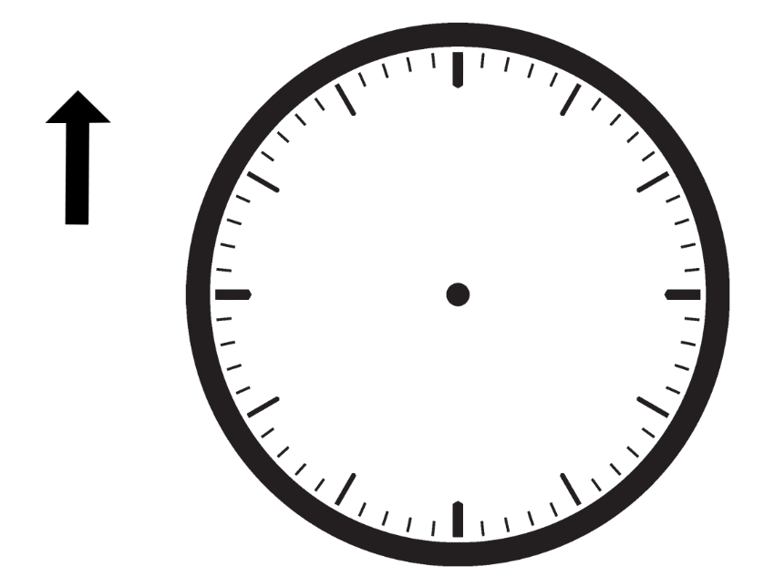

Resource 12 – minute hand
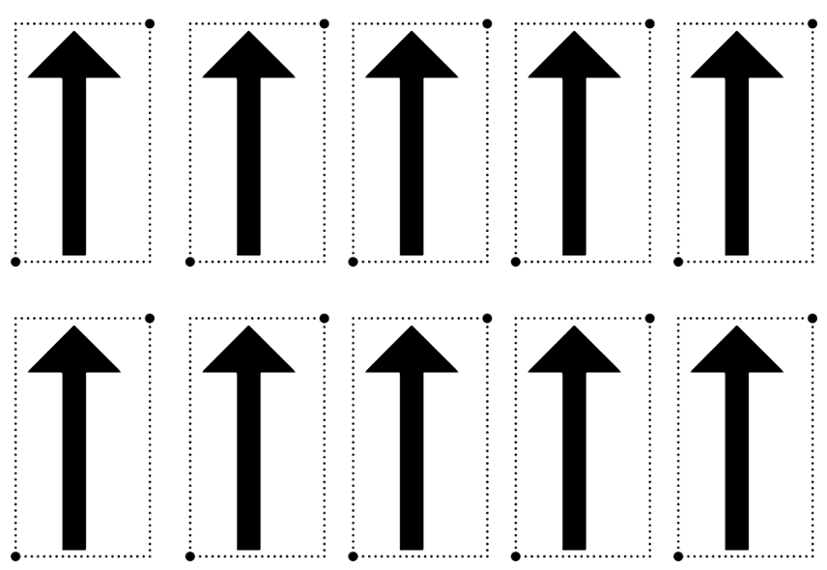

Resource 13 – number sentence board
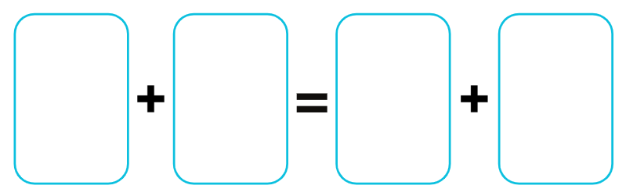

Resource 14 – clock fractions
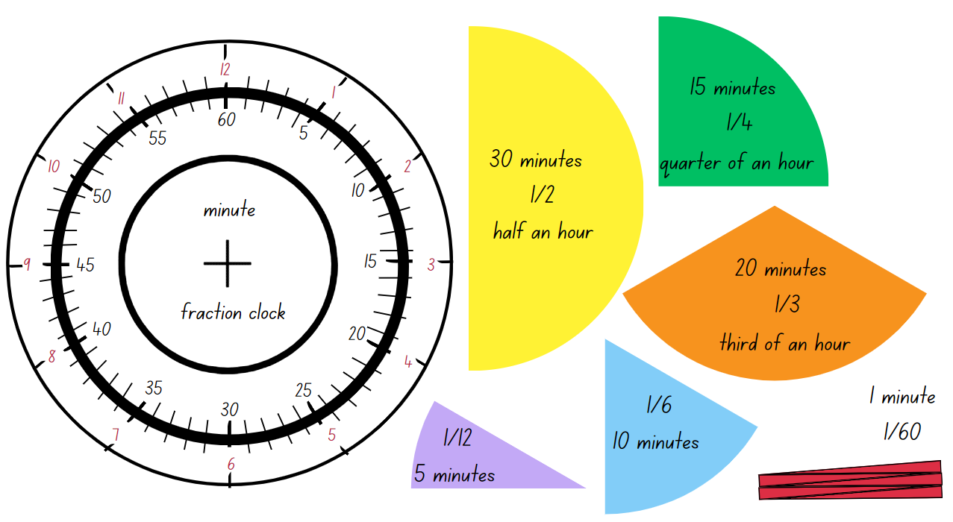

Resource 15 – reading the time
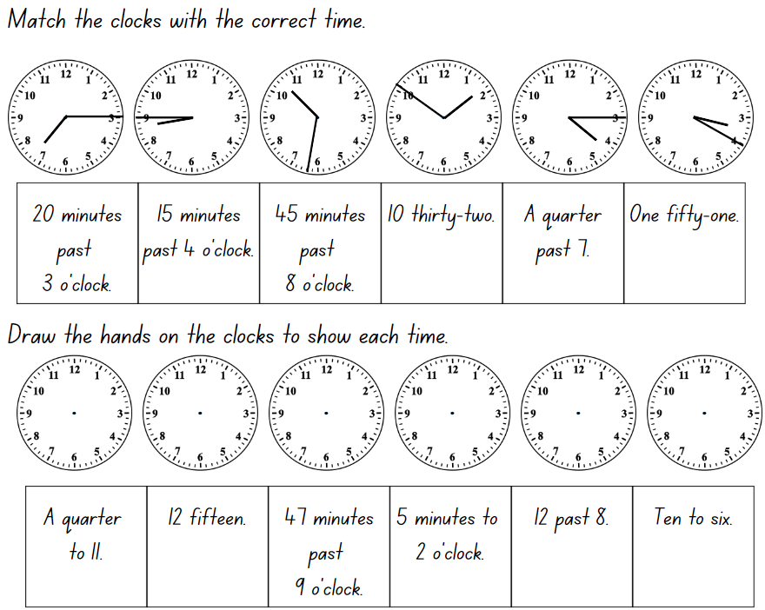

Resource 16 – number sentences
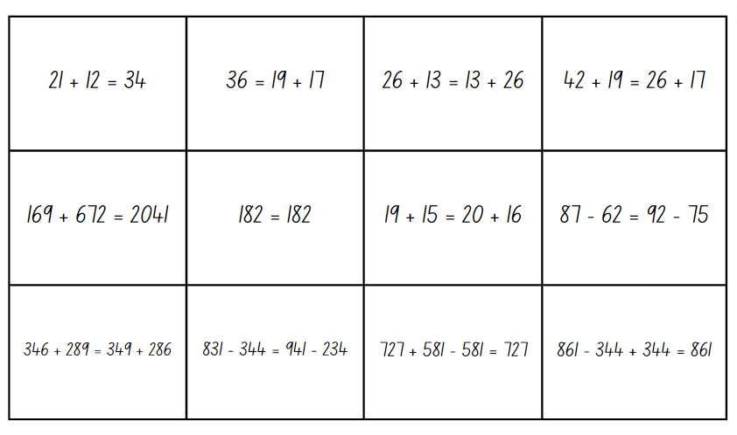

Resource 17 – Rebecca’s walk
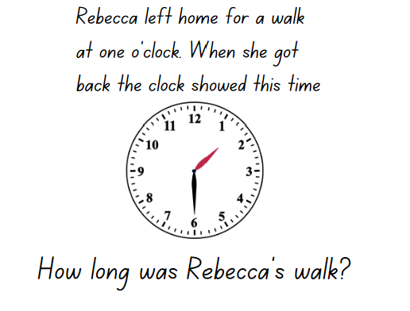

Resource 18 – think board template
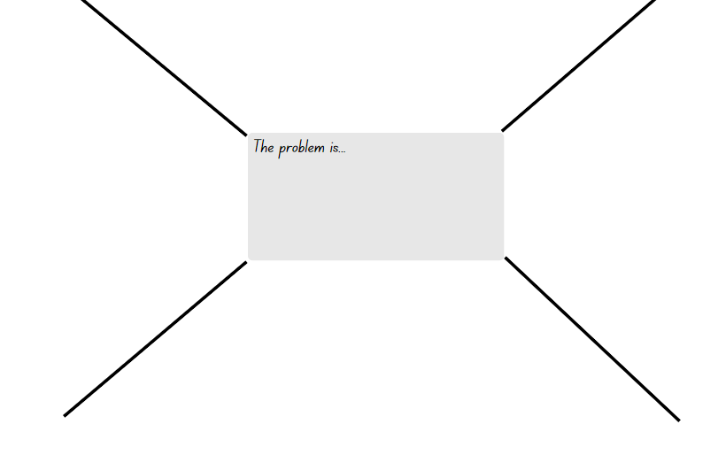

Resource 19 – the problem with time
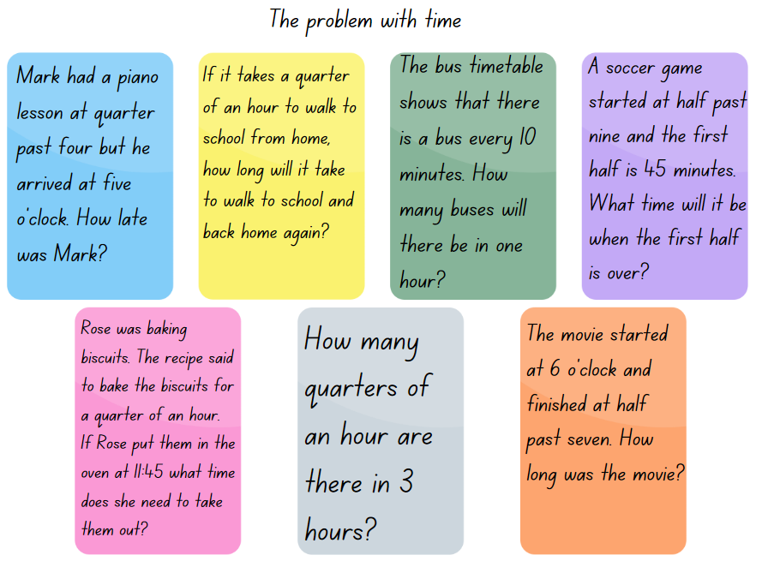

Resource 20 – clocks
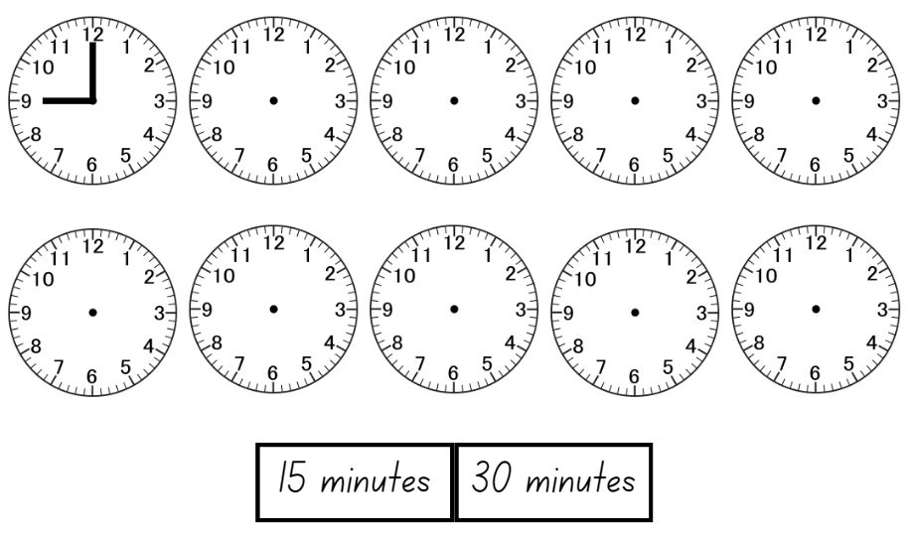

Resource 21 – time to win
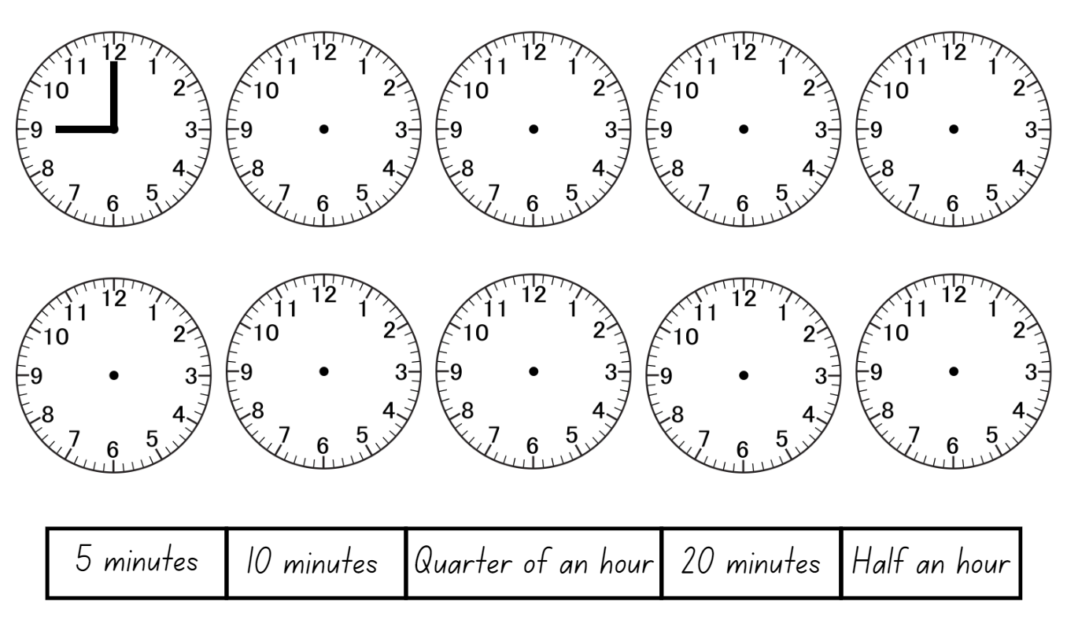

Syllabus outcomes and content
The table below outlines the syllabus outcomes and range of relevant syllabus content covered in this unit. Content is linked to National Numeracy Learning Progression (version 3).
Outcomes and content | 1 | 2 | 3 | 4 | 5 | 6 | 7 | 8
Additive relations A: Use the principal of equality
MAO-WM-01, MA2-AR-01, MA2-AR-02
- Recognise equal differences and record them in number sentences |  |  |  |  |  |  | x
- Use the equals sign to mean 'the same as', rather than to perform an operation |  |  |  |  | x | x | x
Partitioned fractions A: Create fractional parts of a length using techniques other than repeated halving
MAO-WM-01, MA2-PF-01
- Make thirds of a length | x |  | x
- Create fifths of a length |  | x | x
Partitioned fractions A: Model and represent unit fractions, and their multiples, to a complete whole on a number line
MAO-WM-01, MA2-PF-01
- Model fractions with fraction strips and diagrams for halves, quarters, eighths, thirds | x | x | x |  | x | x | x
Geometric measure A: Angles: Identify angles as measures of turn
MAO-WM-01, MA2-GM-03
- Identify angles with 2 arms in practical situations | x
- Identify the arms and vertex of an angle | x
- Recognise an angle as the amount of turning between 2 arms | x | x
- Compare angles and explain that the length of the arms does not affect the size of the angle |  | x | x
- Use the term right angle to describe a quarter-turn in a range of orientations |  |  | x |  |  |  |  | x
Non-spatial measure A: Time: Represent and read analog time
MAO-WM-01, MA2-NSM-02
- Use minutes to describe the duration of events |  |  |  | x
- Identify 30 minutes as being a half-hour and 60 minutes as an hour |  |  |  |  | x |  | x | x
- Connect the quarter-hour to 15 minutes |  |  |  |  | x |  | x | x
- Recognise that the position of the numerals on an analog timepiece often represents 2 different values |  |  |  |  |  | x | x
- Recognise that 5-minute intervals (corresponding to the hour markers) are used as benchmarks to read time on an analog clock |  |  |  |  |  | x |  | x
- Read time as past the hour to half-past and then towards the hour |  |  |  |  | x | x | x | x
- Read analog clocks to the minute |  |  |  |  |  | x | x
Mathematics K–10 Syllabus © NSW Education Standards Authority (NESA) for and on behalf of the Crown in right of the State of New South Wales, 2022.

References
This resource contains NSW Curriculum and syllabus content. The NSW Curriculum is developed by the NSW Education Standards Authority. This content is prepared by NESA for and on behalf of the Crown in right of the State of New South Wales. The material is protected by Crown copyright.
Please refer to the NESA Copyright Disclaimer for more information https://educationstandards.nsw.edu.au/wps/portal/nesa/mini-footer/copyright.
NESA holds the only official and up-to-date versions of the NSW Curriculum and syllabus documents. Please visit the NSW Education Standards Authority (NESA) website https://educationstandards.nsw.edu.au/wps/portal/nesa/home and the NSW Curriculum website https://curriculum.nsw.edu.au/.
Mathematics K–10 Syllabus © NSW Education Standards Authority (NESA) for and on behalf of the Crown in right of the State of New South Wales, 2022.
National Numeracy Learning Progression © Australian Curriculum, Assessment and Reporting Authority (ACARA) 2010 to present, unless otherwise indicated. This material was downloaded from the Australian Curriculum website (National Numeracy Learning Progression) (accessed 8 November 2023) and was not modified.
Australians Together (2023) Teacher guide Y5 maths: Comparing 12- and 24-hour time systems and Indigenous concepts of time (PDF 2.32 MB), Australians Together, accessed 19 July 2023.
Merrill J (2022) Time to Win, The Mathematical Isles of What If...? website, accessed 19 July 2023.
New Zealand Ministry of Education (n.d.) ‘Clock wise (time)’, Resource Finder, NZ Maths website, accessed 19 July 2023.
New Zealand Ministry of Education (n.d.) ‘Hinea's watch's hands’, Resource Finder, NZ Maths website, accessed 19 July 2023.
New Zealand Ministry of Education (n.d.) ‘Just a minute’, Resource Finder, NZ Maths website, accessed 19 July 2023.
Queensland University of Technology (2014) Yumi Deadly Maths: Measurement Prep to Year 9, prepared by the Yumi Deadly Centre, Queensland.
Russo J (2021) ‘Let's Play: Number Sentences’, Prime Number, 36(2):4–5, accessed 19 July 2023.
Siemon D, Warren E, Beswick K, Faragher R, Miller J, Horne M, Jazby D, Breed M, Clark J and Brady K (2021) Teaching Mathematics: Foundations to Middle Years, 3rd edn, Oxford University Press Australia and New Zealand.
State of NSW, Department of Education and Training, Professional Support and Curriculum Directorate (2003) Teaching about angles: Stage 2 (PDF 3.36 MB), Department of Education and Training, accessed 20 November 2023.
Sullivan P (2018) Challenging Mathematical tasks: Unlocking the Potential of all Students, Oxford University Press, Australia.
University of Cambridge (n.d) True or False?, NRICH website, accessed 19 July 2023.
University of Cambridge (n.d) Wonky Watches, NRICH website, accessed 19 July 2023.
University of Cambridge (n.d.) Clocks, NRICH website, accessed 19 July 2023.
University of Cambridge (n.d.) Stop the Clock, NRICH website, accessed 19 July 2023.
University of Cambridge (n.d.) What Is the Time?, NRICH website, accessed 19 July 2023.
Van de Walle J, Karp K, Bay-Williams JM, Brass A, Bentley B, Ferguson S, Goff W, Livy S, Marshman M, Martin D, Pearn C, Prodromou T, Symons D and Wilkie K (2019) Primary and Middle Years Mathematics: Teaching Developmentally, 1st Australian edn, Pearson Education Australia, Melbourne.

© State of New South Wales (Department of Education), 2023
The copyright material published in this resource is subject to the Copyright Act 1968 (Cth) and is owned by the NSW Department of Education or, where indicated, by a party other than the NSW Department of Education (third-party material).
Copyright material available in this resource and owned by the NSW Department of Education is licensed under a Creative Commons Attribution 4.0 International (CC BY 4.0) license.
This license allows you to share and adapt the material for any purpose, even commercially.
Attribution should be given to © State of New South Wales (Department of Education), 2023.
Material in this resource not available under a Creative Commons license:
- the NSW Department of Education logo, other logos and trademark-protected material
- material owned by a third party that has been reproduced with permission. You will need to obtain permission from the third party to reuse its material.
Links to third-party material and websites
Please note that the provided (reading/viewing material/list/links/texts) are a suggestion only and implies no endorsement, by the New South Wales Department of Education, of any author, publisher, or book title. School principals and teachers are best placed to assess the suitability of resources that would complement the curriculum and reflect the needs and interests of their students.
If you use the links provided in this document to access a third-party's website, you acknowledge that the terms of use, including licence terms set out on the third-party's website apply to the use which may be made of the materials on that third-party website or where permitted by the Copyright Act 1968 (Cth). The department accepts no responsibility for content on third-party websites.

