Mathematics Stage 2 Year A – Unit 9

Contents
Unit description and duration 4
Syllabus outcomes 4
Working mathematically 5
Student prior learning 5
Lesson overview and resources 7
Lesson 1 13
Daily number sense – ascending and descending order – 10 minutes 13
Core lesson – using features to describe shapes and objects – 40 minutes 15
Consolidation and meaningful practice – 10 minutes 18
Lesson 2 20
Daily number sense – What’s the nearest? – 10 minutes 20
Core lesson – making and describing three-dimensional objects – 45 minutes 21
Discuss and connect the mathematics – 15 minutes 26
Lesson 3 28
Daily number sense – Larger or smaller? – 15 minutes 28
Core lesson – deconstructing everyday packages – 40 minutes 29
Discuss and connect the mathematics – 10 minutes 32
Lesson 4 34
Daily number sense – 10 minutes 34
Core lesson – exploring nets of prisms and pyramids – 50 minutes 34
Discuss and connect the mathematics – 10 minutes 37
Lesson 5 40
Daily number sense – What’s my number? – 15 minutes 40
Core lesson – How many litres? – 40 minutes 42
Discuss and connect the mathematics – 15 minutes 45
Lesson 6 47
Daily number sense – What’s my number? – 15 minutes 47
Core lesson – investigating formal units to measure capacity – 40 minutes 49
Discuss and connect the mathematics – 10 minutes 51
Lesson 7 54
Daily number sense – How many ways? – 15 minutes 54
Core lesson – ordering and comparing capacities – 40 minutes 55
Discuss and connect the mathematics – 5 minutes 59
Consolidation and meaningful practice – 10 minutes 59
Lesson 8 61
Daily number sense – 10 minutes 61
Core lesson – planning a class party – 35 minutes 61
Discuss and connect the mathematics – 15 minutes 64
Consolidation and meaningful practice – 10 minutes 64
Resource 1 – 2D features A 66
Resource 2 – 2D features B 67
Resource 3 – Which one doesn’t belong? 68
Resource 4 – prisms 69
Resource 5 – deconstructed net 70
Resource 6 – 3D nets 71
Resource 7 – nets of cubes 72
Resource 8 – pyramid nets 73
Resource 9 – recording table 74
Resource 10 – capacity cards 75
Syllabus outcomes and content 76
References 81
Further reading 82

Unit description and duration
This unit develops the big idea that what needs to be measured determines the unit of measurement.
In this 2-week unit students are provided opportunities to:
- compare and describe features of three-dimensional objects by exploring models, sketches and diagrams
- construct and deconstruct nets of three-dimensional objects
- use formal units (litres and millilitres) to measure capacity and scaled instruments to measure and compare capacities.

Syllabus outcomes
- MAO-WM-01 develops understanding and fluency in mathematics through exploring and connecting mathematical concepts, choosing and applying mathematical techniques to solve problems, and communicating their thinking and reasoning coherently and clearly
- MA2-RN-01 applies an understanding of place value and the role of zero to represent numbers to at least tens of thousands
- MA2-2DS-01 compares two-dimensional shapes and describes their features
- MA2-3DS-01 makes and sketches models and nets of three-dimensional objects including prisms and pyramids
- MA2-3DS-02 estimates, measures and compares capacities (internal volumes) using litres, millilitres and volumes using cubic centimetres

Working mathematically
In the Mathematics K–10 Syllabus, there is one overarching Working mathematically outcome (MAO-WM-01). The Working mathematically processes should be embedded within the concepts being taught. The Working mathematically processes present in the Mathematics K–10 Syllabus are:
- communicating
- understanding and fluency
- reasoning
- problem solving.
Mathematics K–10 Syllabus © NSW Education Standards Authority (NESA) for and on behalf of the Crown in right of the State of New South Wales, 2022.

Student prior learning
Before engaging in these teaching and learning activities, students would benefit from prior experience with:
- naming, comparing and describing features of two-dimensional shapes
- exploring faces, vertices and edges of three-dimensional objects
- using uniform informal units such as blocks and cups to measure capacity of different sized containers.
In NSW classrooms there is a diverse range of students, including Aboriginal and Torres Strait Islander students, students learning English as an additional language or dialect, high potential and gifted students and students with disability. Some students may identify with more than one of these groups or possibly all of them. Refer to Curriculum planning for every student – advice for further information.

Lesson overview and resources
The table below outlines the sequence and approximate timing of lessons, learning intentions and resources.
Lesson | Content | Duration and resources
Lesson 1  Daily number sense learning intention:  - order numbers in the thousands | Lesson core concept: comparing features adds precision to the description of objects.  Core concept learning intentions:  - compare and describe features of two-dimensional shapes  - use models of three-dimensional objects to compare and describe key features | Lesson duration: 60 minutes  - Resource 1 – 2D features A  - Resource 2 – 2D features B  - 9-sided dice (0–9)  - A3 size triangle, square, circle, trapezium and rectangle  - Sticky notes  - Three-dimensional geometrical models  - Writing materials
Lesson 2  Daily number sense learning intention:  - order numbers in the thousands | Lesson core concept: objects can be modelled in physical and virtual environments.  Core concept learning intentions:  - make models of 3-dimensional objects to compare and describe key features  - connect three-dimensional objects and two-dimensional representations | Lesson duration: 70 minutes  - Resource 3 – Which one doesn’t belong?  - Resource 4 – prisms  - 9-sided dice (0–9)  - A few everyday butter knives  - Plasticine  - Rulers  - Writing materials
Lesson 3  Daily number sense learning intention:  - order numbers in the thousands | Lesson core concept: mathematicians construct and deconstruct objects to explore their features.  Core concept learning intentions:  - make models of three-dimensional objects to compare and describe key features  - use features of two-dimensional shapes to describe three-dimensional models | Lesson duration: 65 minutes  - Resource 5 – deconstructed net  - 9-sided dice (0–9)  - A3 paper  - Range of cardboard packaging  - Scissors  - Sticky tape  - Writing materials
Lesson 4  Daily number sense learning intention:  - teacher-identified task based on student needs | Lesson core concept: mathematicians construct and deconstruct objects to explore their features.  Core concept learning intentions:  - make models of three-dimensional objects to compare and describe key features  - use features of two-dimensional shapes to describe three-dimensional objects | Lesson duration: 70 minutes  - Resource 6 – 3D nets  - Resource 7 – nets of cubes  - Resource 8 – pyramid nets  - Paper  - Scissors  - Sticky notes  - Writing materials
Lesson 5  Daily number sense learning intention:  - apply place value to partition and rename numbers up to 4 digits | Lesson core concept: standard units are an efficient way to communicate capacity.  Core concept learning intention:  - measure and order containers using litres | Lesson duration: 70 minutes  - One litre containers  - Containers larger than one litre  - Containers smaller than one litre  - Scaled containers less than one litre  - Water  - Writing materials
Lesson 6  Daily number sense learning intention:  - apply place value to partition numbers up to 4 digits | Lesson core concept: metric units of measurement relate to our base-10 place value system.  Core concept learning intentions:  - measure and order containers using litres  - use scaled instruments to measure and compare capacities (internal volumes) | Lesson duration: 65 minutes  - 3 different sized everyday cups  - MAB materials  - One litre containers  - Scaled measuring cup  - Scaled measuring jug  - Teaspoon  - Transparent one litre container  - Water  - Writing materials
Lesson 7  Daily number sense learning intention:  - apply place value to partition and regroup numbers up to 4 digits | Lesson core concept: everyday objects have an internal volume.  Core concept learning intentions:  - measure and order containers using litres  - use scaled instruments to measure and compare capacities (internal volumes) | Lesson duration: 70 minutes  - Containers of various sizes and shapes  - MAB materials  - Scaled measuring jug  - Water  - Writing materials
Lesson 8  Daily number sense learning intention:  - teacher-identified task based on student needs | Lesson core concept: different spatial structures may have the same capacity.  Core concept learning intentions:  - measure and order containers using litres  - read, represent and order numbers in the thousands | Lesson duration: 70 minutes  - Resource 9 – recording table  - Resource 10 – capacity cards  - Different sized bowls with a capacity of one litre  - Different sized bowls with a capacity of more than one litre  - Home scavenger hunt containers  - Scaled measuring jug  - Writing materials

Lesson 1
Core concept: comparing features adds precision to the description of objects.

Daily number sense – ascending and descending order – 10 minutes
Daily number sense activities for Lessons 1 to 3 ‘activate’ prior number knowledge and support the learning of new content in the unit. These activities can also assist teachers to identify the starting points for learning by revealing the extent of students’ existing knowledge.
The table below contains a suggested learning intention and success criteria. These are best co-constructed with students.
Daily number sense learning intention | Daily number sense success criteria
Students are learning to:  - order numbers in the thousands. | Students can:  - arrange 4-digit numbers in ascending and descending order.
- Small groups of students roll a 9-sided dice 4 times to create a 4-digit number. Students read the number aloud and record the number on a sticky note.
- Roll the dice again and repeat the process. Arrange the 2 numbers made so far in ascending order.
- Repeat 3 or 4 more times, arranging the numbers in ascending order.
- Students read the list of numbers aloud starting from the smallest.
- Repeat the process with new numbers, this time using descending order to arrange the numbers.
- As a class, discuss how to order one set of pre-prepared numbers that include internal zeros.
This table details opportunities for assessment.
Assessment opportunities | Links
What to look for:  - Can students arrange 4-digit numbers in ascending order? [MAO-WM-01, MA2-RN-01]  - Can students arrange 4-digit numbers in descending order? [MAO-WM-01, MA2-RN-01] | Links to National Numeracy Learning Progressions (NNLP):  - NPV6.

Core lesson – using features to describe shapes and objects – 40 minutes
Note: in Lesson 8, students will be learning to measure and order containers using litres. To provide a wide range of containers, students can be asked to bring containers from home. This can also be communicated to parents/carers, for example:
This week, students in (class) will be learning to measure and order containers using litres. To provide a wide range of containers, it would be helpful if students are able bring any containers from home that are able to hold water. Containers that hold different amounts would be appreciated, for example 100 millilitres, 250 millilitres (one quarter of a litre), 500 millilitres (half a litre), 1000 millilitres (1 L) or 2000 millilitres (2 L). These containers can be stored in the classroom until they are used on (day).
Thank you for your support, (Teacher).
The table below contains suggested learning intentions and success criteria. These are best co-constructed with students.
Core concept learning intentions | Core concept success criteria
Students are learning to:  - compare and describe features of two-dimensional shapes  - use models of three-dimensional objects to compare and describe key features. | Students can:  - describe and compare two-dimensional shapes, including triangles, rectangles, circles, squares and trapeziums  - identify the differences between prisms, pyramids and cylinders.
Note: this lesson revises Stage 1 content, particularly to revise syllabus vocabulary.
- Display or draw a circle, square and rectangle on the board. Ask students what they can see and what these are examples of. Explain they are all two-dimensional shapes.
- Display a large triangle, square, circle, trapezium and rectangle in the classroom. Provide small groups of students with Resource 1 – 2D features A. Ask students to match feature cards with shapes and justify their mathematical thinking.
- Identify whether any shapes have been matched to more than one feature card. Discuss why, supporting correct use of vocabulary and identifying any misconceptions.
- Display a set of three-dimensional geometrical models. Ask students if they can see any two-dimensional shapes on the models. Support students to see that the faces are two-dimensional shapes.
- Discuss the features of the three-dimensional models, revising vocabulary.
Face: a flat surface of a three-dimensional object with only straight edges.
Edge: the line segment formed where 2 faces of a 3D object meet.
Vertex: the point where 3 or more faces of a 3D object meet.
Curved surface: not classified as a face. Flat surfaces with curved boundaries are not faces. For example, cylinders, cones and spheres.
- Create an anchor chart that includes features, such as faces, vertices, edges and surfaces (see Figure 1).
Figure 1 – anchor chart example
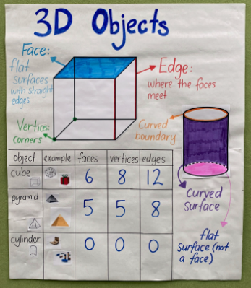
Note: ensure that syllabus language regarding cylinders has been discussed. For example, curved and flat surfaces and boundaries.

This table details opportunities for differentiation.
Too hard? | Too easy?
Students cannot identify the differences between prisms, pyramids and cylinders.  - Model counting sides, faces and vertices of three-dimensional objects.  - Students count how many faces, sides and vertices are on a cube. | Students can identify the differences between prisms, pyramids and cylinders.  - Give students Resource 2 – 2D features B. They identify possible two-dimensional shapes, noting when a feature could be allocated to more than one shape.  - Students sketch three-dimensional geometrical models.

Consolidation and meaningful practice – 10 minutes
- Take students on a three-dimensional object scavenger hunt around the school grounds.
- Give students a sticky note and pencil. They each find one object and write a clue for that object, based on features. For example:
- My object has 12 edges and 6 faces.
- My object has one curved surface and 2 flat surfaces.
- Collect the sticky notes. Read aloud the clues and have students guess the everyday objects. For example, electricity box, rainwater tank. Ask students:
- What similarities did you notice with the objects?
- What differences did you notice?
- Are there other 3D objects that are similar or different to these?
This table details opportunities for assessment.
Assessment opportunities | Links
What to look for:  - Can students describe and compare two-dimensional shapes, including triangles, rectangles, circles, squares and trapeziums? [MAO-WM-01, MA2-2DS-01]  - Can students identify the differences between prisms, pyramids and cylinders? [MAO-WM-01, MA2-3DS-01] | Links to National Numeracy Learning Progressions (NNLP):  - UGP2, UGP3, UGP4.  - UGP5.

Lesson 2
Core concept: objects can be modelled in physical and virtual environments.

Daily number sense – What’s the nearest? – 10 minutes
The table below contains a suggested learning intention and success criteria. These are best co-constructed with students.
Daily number sense learning intention | Daily number sense success criteria
Students are learning to:  - order numbers in the thousands. | Students can:  - identify the closest thousand to a 4-digit number  - arrange 4-digit numbers in ascending or descending order.
- In small groups, students roll four 9-sided dice to make a 4-digit number. Students read the number aloud and record it on a sticky note. Identify the nearest thousand. For example, 8524 is closest to 9000 and 8203 is closest to 8000.
- Students repeat the process 5 times.
- Students order the collection of 4-digit numbers in ascending or descending order and explain their reasoning.
- Repeat the process.
- At the end of this activity, display the number 9537 and discuss how the closest thousand is 10 000.
This table details opportunities for assessment.
Assessment opportunities | Links
What to look for:  - Can students identify the closest thousand to a 4-digit number? [MAO-WM-01, MA2-RN-01]  - Can students arrange 4-digit numbers in ascending or descending order? [MAO-WM-01, MA2-RN-01] | Links to National Numeracy Learning Progressions (NNLP):  - NPV7.  - NPV6.  Links to suggested Interview for Student Reasoning (IfSR) tasks:  - IfSR-NP: 4C.8.

Core lesson – making and describing three-dimensional objects – 45 minutes
The table below contains suggested learning intentions and success criteria. These are best co-constructed with students.
Core concept learning intentions | Core concept success criteria
Students are learning to:  - make models of three-dimensional objects to compare and describe their key features  - connect three-dimensional objects and two-dimensional representations. | Students can:  - identify the differences between prisms (including cubes), pyramids and cylinders  - construct models of prisms, pyramids and cylinders using physical or virtual manipulatives and identify their features  - identify features of prisms, pyramids and cylinders from geometrical models.
This activity is adapted from Which one doesn’t belong? by Persico.
- Display the anchor chart from Lesson 1. Review the features of three-dimensional objects, for example, faces, edges, vertices, flat and curved surfaces and curved boundaries.
- Display Resource 3 – Which one doesn’t belong?. Explain that there could be reasons why each geometrical model is not part of the group. Tell students that there are no wrong answers, but each answer needs to be justified. Students turn and talk to discuss which model doesn’t belong.
Note: the teaching advice for Stage 2 states that formal names for particular prisms and pyramids are not introduced in Stage 2. Prisms and pyramids are to be treated as classes for the grouping of all prisms and all pyramids. Names for particular prisms and pyramids are introduced in Stage 3.
- As a class, students share ideas for each model and explain their reasoning.

The table below outlines stimulus prompts to generate conversation about the topic, along with anticipated responses from students.
Prompts | Anticipated student responses
- Who thinks the cube doesn’t belong? | - The cube is the only object with vertices.  - The cube is the only object with edges.
- Who thinks the cone doesn’t belong? | - The cone is the only one with a point.  - The cone is the only one with one flat surface and one curved surface.
- Who thinks the sphere doesn’t belong? | - The sphere is the only one with one surface.  - The sphere is the only one you could play handball with.
- Who thinks the cylinder doesn’t belong? | - The cylinder is the only one with 2 flat surfaces.  - The cylinder is the only one that looks like a baked bean can.

- Display Resource 4 – prisms and discuss features.
- In small groups, students construct models of prisms with plasticine. Students place each model on A4 paper and record the number of faces, vertices and edges for each prism. Students discuss the features with their group.
- Students make parallel cuts to their models to explore how the faces remain the same size and shape all the way through the object. Explain that these are congruent shapes (see Figure 2).
Figure 2 – cutting prisms
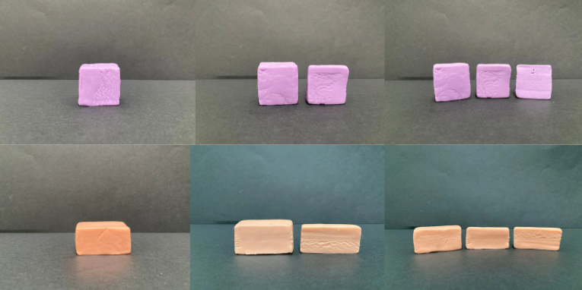
Congruent: an exact match between every part of one figure with the corresponding part of another figure, regardless of orientation. For example, congruent figures can be exactly superimposed on each other.
- Ask students what they notice. For example, if the prism has a triangle as a face and a section is cut off, the face is still a triangle.
- Repeat the activity for cylinders as seen in Figure 3. Students cut layers off from one end. Discuss how the flat surface is always a circle.
Figure 3 – cutting a pyramid and a cylinder
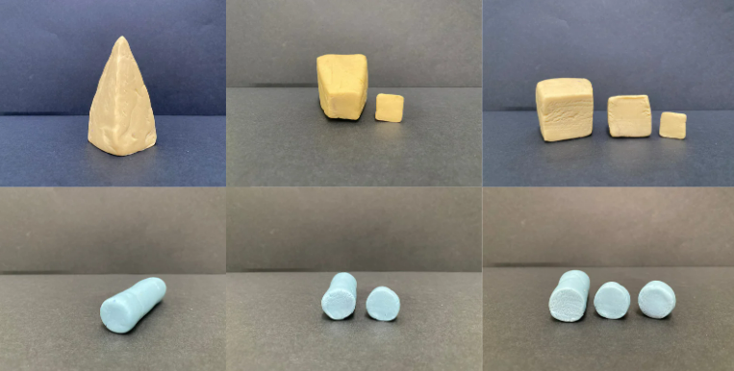
- Repeat the activity for pyramids as seen in Figure 3. Students cut layers off from the top. Support students to notice the shape of the face remains the same but increases in size as each layer is cut from the top of the pyramid.
Note: when using plasticine, the sides of objects might not be completely straight due to the nature of the material. Explain to students that a model isn’t always an exact replica. Show students some three-dimensional geometrical models to reinforce correct recognition.

This table details opportunities for differentiation.
Too hard? | Too easy?
Students cannot make and/or cut three-dimensional objects.  - Model how to make and cut a prism. Students copy each step.  - Repeat the process for a pyramid and a cylinder. | Students can make and/or cut three-dimensional objects.  - Students record the prisms, pyramids and cylinders showing what happens with each cut.  - Students explore and describe the similarities and differences between prisms and pyramids.

Discuss and connect the mathematics – 15 minutes
- In small groups, students write a definition for a prism, pyramid and cylinder using the features. For example, referring to the faces, vertices, edges, curved and flat surfaces.
- As a class, compare definitions. Decide on a class definition for each object. Return to the definitions in subsequent lessons as students gain further understanding.
- Explore how Minecraft Education is used to create three-dimensional objects.
Note: the Stage 2 teaching advice states that some students may not be able to access physical manipulatives for constructing three-dimensional models. As an alternative, it is appropriate to use digital technologies to assist in creating two-dimensional representations of three-dimensional objects.
This table details opportunities for assessment.
Assessment opportunities | Links
What to look for:  - Can students identify features of prisms, pyramids and cylinders from geometrical models? [MAO-WM-01, MA2-3DS-01]  - Can students construct models of prisms, pyramids and cylinders using physical or virtual manipulatives and identify their features? [MAO-WM-01, MA2-3DS-01]  - Can students identify the differences between prisms, pyramids and cylinders? [MAO-WM-01, MA2-3DS-01] | Links to National Numeracy Learning Progressions (NNLP):  - UGP3.  - UGP5.

Lesson 3
Core concept: mathematicians construct and deconstruct objects to explore their features.

Daily number sense – Larger or smaller? – 15 minutes
The table below contains a suggested learning intention and success criteria. These are best co-constructed with students.
Daily number sense learning intention | Daily number sense success criteria
Students are learning to:  - order numbers in the thousands. | Students can:  - recognise and describe how rearranging digits changes the size of a number.
- Model the following process:
- Roll four 9-sided dice to make and record a 4-digit number.
- Read the number aloud.
- Swap the positions of 2 of the dice and record the new number.
- Explain how the new number is larger or smaller than the original number.
- In small groups, students repeat the process multiple times. Students order the 4-digit numbers in ascending or descending order.
- Some students may enjoy the challenge of working out the difference between 2 numbers and explaining the strategy used.
This table details opportunities for assessment.
Assessment opportunities | Links
What to look for:  - Can students read a 4-digit number aloud? [MAO-WM-01, MA2-RN-01]  - Can students explain how rearranging digits makes a number larger or smaller? [MAO-WM-01, MA2-RN-01] | Links to National Numeracy Learning Progressions (NNLP):  - NPV6.  Links to suggested Interview for Student Reasoning (IfSR) tasks:  - IfSR-NP: 4C.5.

Core lesson – deconstructing everyday packages – 40 minutes
The table below contains suggested learning intentions and success criteria. These are best co-constructed with students.
Core concept learning intentions | Core concept success criteria
Students are learning to:  - make models of three-dimensional objects to compare and describe key features  - use features of two-dimensional shapes to describe three-dimensional models. | Students can:  - deconstruct everyday packages that are prisms (including cubes) and cylinders to create nets  - identify, describe and compare features of three-dimensional objects.
- Display a range of everyday packaging that shows examples of prisms, cubes and cylinders. For example, cereal boxes, tissue boxes, chocolate bar packaging and chip containers (see Figure 4). Explain that mathematicians call these three-dimensional objects.
Figure 4 – everyday packaging
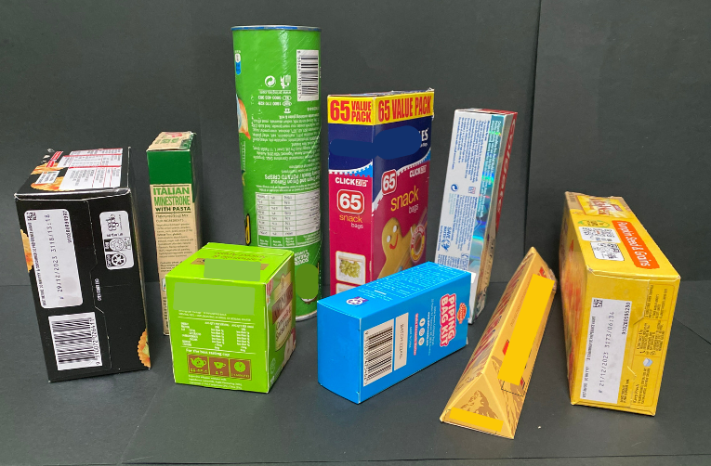
- Students explore and describe faces, edges and vertices for each three-dimensional object.
- Model how to cut a package along the edges to open it out. Explain that this is called a net (see Figure 5).
Figure 5 – unfolding packages
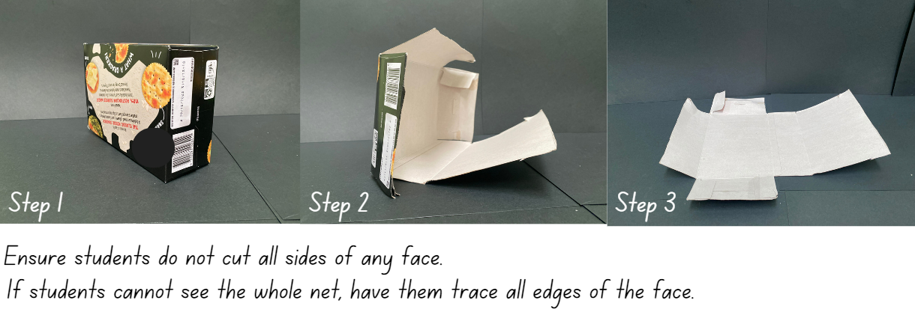
- Provide small groups of students with a variety of everyday packages. Groups cut along the edges and flatten their packages into nets.
Note: any tabs on the packaging must be secured with sticky tape to create an accurate representation of the net.
- Groups trace around the nets on A3 paper. Compare the shapes and sides of the nets.
- Students fold the nets back into the original packaging format and place the packaging beside the corresponding net drawing.
- Go on a gallery walk to observe the nets and drawings. Ask students:
- What do you notice?
- If you translate (slide), reflect (flip) or rotate (turn) an unfolded package drawing is it still the same? How do you know?
- What is similar or different?
This table details opportunities for differentiation.
Too hard? | Too easy?
Students cannot deconstruct everyday packages or make net drawings.  - Support students to deconstruct everyday packages. Point to each side of the opened package and state the name of the two-dimensional shape. For example, square or rectangle.  - Support students to draw around nets of everyday packages. | Students can deconstruct everyday packages and make net drawings.  - Students predict and draw nets of everyday packages before deconstructing. Compare and discuss any differences between their predicted net and the deconstructed net.  - Provide students with other prisms, for example, a prism that has a hexagon for each end face. Discuss the similarities with other prisms. Students predict and draw nets for these.

Discuss and connect the mathematics – 10 minutes
- Display Resource 5 – deconstructed net.
- Students draw the three-dimensional object the net will make on individual whiteboards.
- Look at the constructed object drawings and ask students:
- What three-dimensional object did you draw from this net? Was it a prism, pyramid or cylinder? How do you know?
- Could this net represent another three-dimensional object? How do you know?
This table details opportunities for assessment.
Assessment opportunities | Links
What to look for:  - Can students deconstruct everyday packages that are prisms and cylinders to create nets? [MAO-WM-01, MA2-3DS-01]  - Can students identify, describe and compare features of three-dimensional objects? [MAO-WM-01, MA2-2DS-01, MA2-3DS-01] | Links to National Numeracy Learning Progressions (NNLP):  - UGP4, UGP5.  - UGP3.

Lesson 4
Core concept: mathematicians construct and deconstruct objects to explore the features.

Daily number sense – 10 minutes
- From a class need surfaced through formative assessment data, identify a short, focused activity that targets students’ knowledge, understanding and skills. Example activities may be drawn from the following resources:
- Mathematics K–6 resources
- Universal Resources Hub.

Core lesson – exploring nets of prisms and pyramids – 50 minutes
The table below contains suggested learning intentions and success criteria. These are best co-constructed with students.
Core concept learning intentions | Core concept success criteria
Students are learning to:  - make models of three-dimensional objects to compare and describe key features  - use features of two-dimensional shapes to describe three-dimensional objects. | Students can:  - use nets to construct prisms (including cubes)  - investigate the variety of nets that can be used to create a particular prism  - use understanding of two-dimensional shapes to compare and describe three-dimensional objects.
- Display the net drawings from Lesson 3. As a class, sort them into groups. Ask how they are the same or different and how students know.
- Display Resource 6 – 3D nets. Ask students to predict whether a prism or pyramid can be made from each net. Support students to explain their thinking using language to identify the features of two-dimensional shapes and three-dimensional objects.
- Look at the cube net. Revise that it contains 6 congruent squares. Ask students if they could make a net for a cube using 6 squares in any other arrangement.
Congruent: an exact match between every part of one figure with the corresponding part of another figure, regardless of orientation. For example, congruent figures can be exactly superimposed on each other.
- In small groups, students investigate net possibilities by drawing, cutting and folding card.
- As a class, compare and discuss results. Support students to see which solutions are the same and which are different. Display Resource 7 – nets of cubes. Ask students:
- Were there any nets that were the same as yours?
- Were there any nets that were different?
- If you flip or turn a net, is it the same or different? How do you know?
- Do all the nets make the cube? Why not? How can you explain this using mathematical language? (see Figure 6).
Figure 6 – correct and incorrect
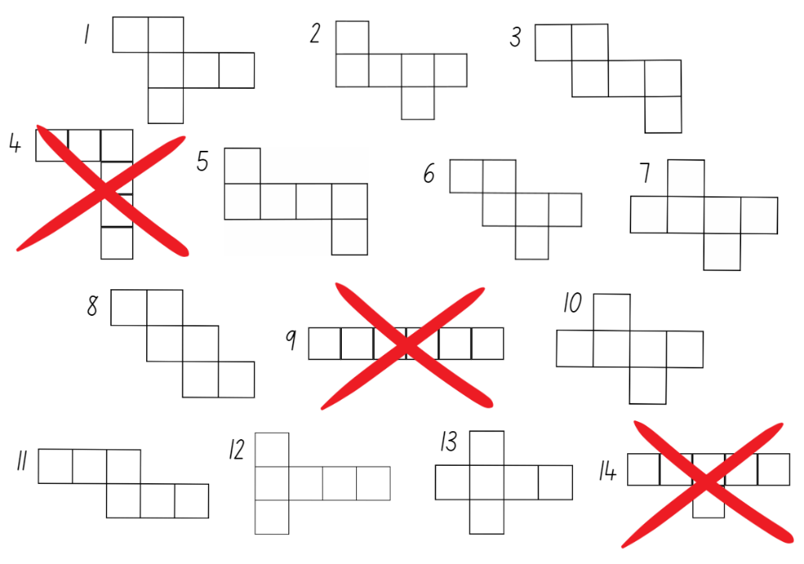

This table details opportunities for differentiation.
Too hard? | Too easy?
Students cannot create three-dimensional objects from nets.  - Provide students with Resource 7 – nets of cubes to explore which will make the prism and which won’t.  - Support students to draw, cut and fold nets. | Students can create three-dimensional objects from nets.  - Students explore nets for another prism.  - Students explore nets for a pyramid.

Discuss and connect the mathematics – 10 minutes
- Display Resource 8 – pyramid nets.
- Explain to students that one net is correct and one is incorrect. Ask them to predict which is correct or incorrect and why.
- Small groups of students use Resource 8 – pyramid nets to explore which net is correct or incorrect (see Figure 7).
Figure 7 – pyramid net folding
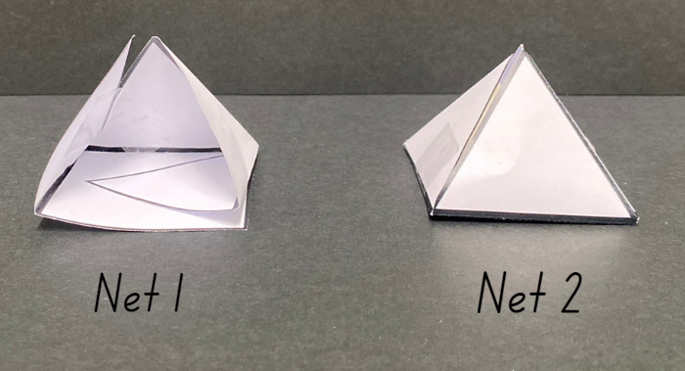
- Students record which net is correct or incorrect and explain their reasoning on a sticky note. Display the sticky notes near Resource 8 – pyramid nets. Ask a selection of students to share their reasoning.
- Support students to use rich, dialogic talk moves, by asking:
- Does anyone have something else to add to this idea?
- Do you agree or disagree with this idea? Yes, because ...
- Can you say some more about that please? What else do you see, think, wonder?
- How is your thinking similar or different?

This table details opportunities for assessment.
Assessment opportunities | Links
What to look for:  - Can students use nets to construct prisms (including cubes)? [MAO-WM-01, MA2-3DS-01]  - Can students investigate the variety of nets that can be used to create a particular prism? [MAO-WM-01, MA2-3DS-01]  - Can students use their understanding of two-dimensional shapes to compare and describe three-dimensional objects? [MAO-WM-01, MA2-2DS-01, MA2-3DS-01] | Links to National Numeracy Learning Progressions (NNLP):  - UGP3.

Lesson 5
Core concept: standard units are an efficient way to communicate capacity.

Daily number sense – What’s my number? – 15 minutes
Daily number sense activities for Lessons 5 to 7 ‘loop’ back to concepts and procedures covered in previous units to assist students to build an increasingly connected network of ideas. These concepts may differ from the core concepts being covered by the unit.
The table below contains a suggested learning intention and success criteria. These are best co-constructed with students.
Daily number sense learning intention | Daily number sense success criteria
Students are learning to:  - apply place value to partition and rename numbers up to 4-digits. | Students can:  - record numbers using standard place value form.
- Tell students that you have thought of a 3- or 4-digit number. They must work out what it is by asking questions that require a ‘yes’ or ‘no’ answer. Ask students to think of questions that will give them useful information, such as:
- Is the number an even number?
- Is the number a 4-digit number?
- Is the number larger than 500?
- Does the number have less than 7 hundreds?
- Following each question, prompt students to think about possible answers and eliminated numbers. Support students to think about the most effective questions to ask next, by using the information they already know.
- When the mystery number has been guessed, students record the number using standard place value form. For example, 523 = 500 + 20 + 3 or 5 hundreds, 2 tens and 3 ones.
- Ask students:
- Which questions provided the most useful information about the mystery number?
- Were there any other questions that would help find the mystery number in a more efficient way?
Note: students will play this game in small groups in Lesson 6.
This table details opportunities for assessment.
Assessment opportunities | Links
What to look for:  - Can students use an understanding of place value to ask questions to find a mystery number? [MAO-WM-01, MA2-RN-01]  - Can students record numbers using standard place value form? [MAO-WM-01, MA2-RN-01] | Links to National Numeracy Learning Progressions (NNLP):  - NPV4, NPV5, NPV6.  Links to suggested Interview for Student Reasoning (IfSR) tasks:  - IfSR-NP: 4B.3.

Core lesson – How many litres? – 40 minutes
The table below contains suggested learning intentions and success criteria. These are best co-constructed with students.
Core concept learning intentions | Core concept success criteria
Students are learning to:  - measure and order containers using litres. | Students can:  - use the litre as a unit to measure capacities  - record capacities using the abbreviation for litres (L)  - estimate the capacity of a container in litres and check by measuring.
This activity is an adaptation of ‘How many litres’ from Teaching measurement: Stage 2 and Stage 3 by State of New South Wales (Department of Education).
- Revise the difference between volume and capacity. Volume is the space taken up by a three-dimensional object. Capacity is the internal volume, which is how much a three-dimensional object can hold.
- Provide the example: Linda is going on a road trip around Australia in her caravan. She needs to know the volume of the caravan, so that she knows how much space the caravan takes up when parking it in her garage. Linda also needs to know the capacity (internal volume) of the caravan, so she knows how much she can fit inside when packing.
Capacity (internal volume): the amount a container can hold and is measured in units such as millilitres (mL), litres (L).
Note: capacity is only used in relation to containers and generally refers to measurement of liquid. The capacity of a container will be slightly less than its volume as capacity is based on the inside dimensions, while volume is determined by the outside dimensions. It is recommended that the terms ‘capacity’ and ‘internal volume’ be used interchangeably.
- Ask students for other examples of the difference between volume and capacity.
- Revise how, in previous lessons, students measured capacity using concrete materials, such as water, sand, beads and blocks. Review the use of formal units of measurement in length, such as metres and centimetres. Ask students if they have heard of a formal unit of measurement for internal volume or capacity. Some students may mention litres or millilitres.
- Introduce the term litres and explain why they are important. Formal units allow measures to be communicated easily and with more accuracy. Ask students to give examples of times they have heard the term litres. For example, litres of petrol or milk.
- Show students everyday one litre containers.
- Model estimating, measuring and recording the capacity (internal volume) of a bucket using one of the everyday containers. Prompt students to consider whether to refine their estimate after adding the first 2 litres of water. Model the process and record the capacity of the bucket using the abbreviation for litres (L).
- Give small groups of students one everyday litre container and 4 larger containers. For example, buckets, ice cream containers, tote trays or bins.
- Ask students to estimate and record the capacity of each container to the nearest litre. Students turn and talk to their group, explaining how they reached their estimate.
- Students measure and record the capacity of the containers using a one litre measure and the abbreviation for litres (L).
- Students may adjust their estimates after measuring the capacity of the first container. Students should discuss this change with the group and record.
- Move between groups, asking students:
- What did you notice with capacities of your containers?
- What was the capacity of each container?
- Did you change any estimates when you started to fill containers? Why?
- Show students a container with a capacity of less than one litre. Start to fill the smaller container with a one litre container. Stop when the small container is full. Ask students what the problem is. If students do not respond, ask what they measure length with if a distance is smaller than a metre. This should prompt students to realise that they need a unit of measurement smaller than a litre.
This table details opportunities for differentiation.
Too hard? | Too easy?
Students cannot estimate, use and record capacity (internal volume) using litres.  - Support students using scaled instruments when measuring and recording capacity.  - Give students one container only to estimate and measure. | Students can estimate, use and record capacity (internal volume) using litres.  - Students estimate, use and record capacities using millilitres and litres. For example, one litre and 500 millilitres.  - Students record capacities using decimal representations of the metric system. For example, 1.5 L.

Discuss and connect the mathematics – 15 minutes
- Show students a collection of labelled containers with the capacity of less than one litre, such as 500 millilitres, 250 millilitres.
- Ask students to estimate how many times each container will have to be filled to make one litre. Students check and record by filling with water. Ask students:
- What did you notice?
- Could you find any patterns? For example, it takes two 500 millilitre containers to fill one litre, so 500 millilitres must be half of one litre.
This table details opportunities for assessment.
Assessment opportunities | Links
What to look for:  - Can students use the litre as a unit to measure capacities? [MAO-WM-01, MA2-3DS-02]  - Can students record capacities using the abbreviations for litres (L)? [MAO-WM-01, MA2-3DS-02]  - Can students estimate the capacity of a container in litres and check by measuring? [MAO-WM-01, MA2-3DS-02] | Links to National Numeracy Learning Progressions (NNLP):  - UuM6.

Lesson 6
Core concept: metric units of measurement relate to our base-10 place value system.

Daily number sense – What’s my number? – 15 minutes
The table below contains a suggested learning intention and success criteria. These are best co-constructed with students.
Daily number sense learning intention | Daily number sense success criteria
Students are learning to:  - apply place value to partition numbers up to 4-digits. | Students can:  - record numbers using standard place value form  - recognise non-standard place value form.
- This lesson is a continuation of the ‘Daily number sense’ from Lesson 5. In small groups, students play ‘What’s my number?’ taking turns to create and guess a mystery number.
- Move between groups, supporting effective questioning and recording.
- As a class, take one 4-digit number and state the place value of each digit. For example, 3517 can be described as 3000 + 500 + 10 + 7.
- Ask students how they could partition 3517:
- without using tens – 3 thousands, 5 hundreds and 17 ones or 3000 + 500 +17
- without using hundreds – 3 thousands, 51 tens and 7 ones or 3000 + 510 + 7.
- Explain that this is called non-standard place value form. At this point, some students may need to use 2- or 3-digit numbers to revise this concept before working with 4-digit numbers.
Note: use MAB materials to demonstrate how 1 ten equals 10 ones and 5 hundreds equals 50 tens as necessary.
This table details opportunities for assessment.
Assessment opportunities | Links
What to look for:  - Can students record numbers using standard place value form? [MAO-WM-01, MA2-RN-01]  - Can students recognise non-standard place value form? [MAO-WM-01, MA2-RN-01] | Links to National Numeracy Learning Progressions (NNLP):  - NPV4, NPV5, NPV6.  Links to suggested Interview for Student Reasoning (IfSR) tasks:  - IfSR-NP: 4B.3.

Core lesson – investigating formal units to measure capacity – 40 minutes
The table below contains suggested learning intentions and success criteria. These are best co-constructed with students.
Core concept learning intentions | Core concept success criteria
Students are learning to:  - measure and order containers using litres  - use scaled instruments to measure and compare capacities (internal volumes). | Students can:  - recognise the need for formal units to measure capacity accurately  - recognise the need for a formal unit smaller than the litre to measure capacity  - estimate the capacity of a container to common benchmark values, such as 250 mL, and check by measuring.
- Show students a transparent everyday one litre container that is partly filled with water. For example, a 1 L water bottle.
- Ask students to estimate how much water is in it. Revise with students how they used cups to measure internal volume (capacity) in Stage 1.
- Use 3 different-sized everyday cups to pour water into the container. Mark the water level on the container after each pour.
- Prompt students to notice that the marks after each pour are not equally spaced. This activity should prompt students to recognise the need for a standard formal unit of measure.

- Ask students:
- Why are the marks for each cup not equally spaced?
- Have you used cups to measure anything before?
- Is a cup an efficient unit of measurement? Why or why not?
- Discuss the need for a formal unit smaller than a litre to measure internal volume (capacity). Show students a scaled measuring cup and explain that it will always contain 250 millilitres. Explain that this is a common measuring instrument. To extend student understanding of small units of measurement, show one standard teaspoon of water and explain that it is 5 millilitres of liquid.
- Give students a range of one litre containers. Students estimate and record how many scaled measuring cups it will take to fill the containers.
- Check by filling containers with water and keeping tally marks to record how many cups are needed for each. Allow students to refine their estimates after adding one cup of liquid.
- Discuss how many cups were needed to fill each of the containers. Students should realise that each container takes 4 cups. Ask students how they could record this mathematically. For example, 4 lots of 250 mL, 1000 mL or 1 L. A useful benchmark for estimating internal volume is that one measuring cup holds a quarter of a litre (250 mL).
This table details opportunities for differentiation.
Too hard? | Too easy?
Students cannot recognise the need for formal units to measure internal volume (capacity).  - Show students 2 transparent containers. Fill one using a scaled measuring cup and the other using an everyday cup. Look at the differences and discuss which cup is more useful for communicating measurement.  - Provide further opportunities for students to explore using scaled measuring cups to measure capacity. | Students can recognise the need for formal units to measure internal volume (capacity).  - Students complete the activity using other formal units to measure capacity. For example, using half of a scaled measuring cup.  - Students solve problems to calculate how many millilitres containers might hold. For example, if Sarah had one litre of water and used it to fill 4 containers, how much might each container hold?

Discuss and connect the mathematics – 10 minutes
- Show students a scaled measuring jug and discuss features. Mark the jug as in Figure 8.
Figure 8 – measuring jug activity
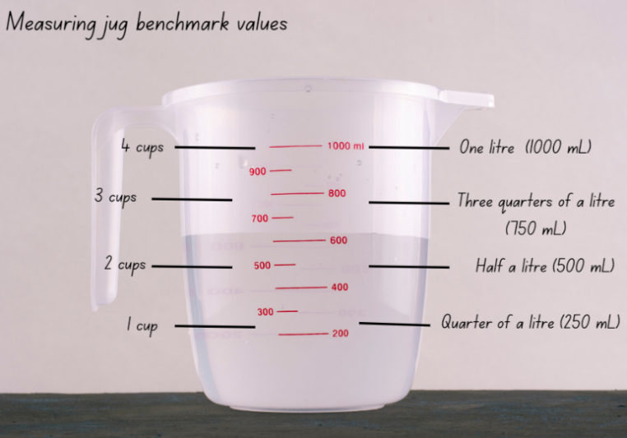
- Support students to make connections between cups and the benchmarks of a quarter of a litre, half a litre, three-quarters of a litre and one whole litre. Discuss how many millilitres would be in each cup and in one litre.
- Explain that units of measurement relate to our base-10 place value system.
- Create an anchor chart of internal volume (capacity) that includes the definition for internal volume (capacity) and formal units of measurement.
This table details opportunities for assessment.
Assessment opportunities | Links
What to look for:  - Can students recognise the need for formal units to measure capacity accurately? [MAO-WM-01, MA2-3DS-02]  - Can students recognise the need for a formal unit smaller than the litre to measure capacity? [MAO-WM-01, MA2-3DS-02]  - Can students estimate the capacity of a container to common benchmark values, such as 250 mL, and check by measuring? [MAO-WM-01, MA2-3DS-02] | Links to National Numeracy Learning Progressions (NNLP):  - UuM6.

Lesson 7
Core concept: everyday objects have an internal volume.

Daily number sense – How many ways? – 15 minutes
The table below contains a suggested learning intention and success criteria. These are best co-constructed with students.
Daily number sense learning intention | Daily number sense success criteria
Students are learning to:  - apply place value to partition and regroup numbers up to 4-digits. | Students can:  - partition and record 4-digit numbers in non-standard forms.
- Display 4627. Ask students to describe this number using standard partitioning. This is 4000 + 600 + 20 + 7 or 4 thousands, 6 hundreds, 2 tens and 7 ones. Record these on the board.
- Ask students how it could be described if they could not use tens. The number could now be described as 4000 + 600 + 27 or 4 thousands, 6 hundreds and 27 ones. Record this on the board.
- Ask students to turn and talk to work out how they could describe 4627 without using thousands.
- In small groups, students choose a 4-digit number and explore describing it in as many ways as possible.
- Move between groups, supporting understanding of place value.
- Some students may need to model a number using MAB materials to support thinking. Others may need to work with non-standard place value forms for 2- and 3-digit numbers first.
- Some students may enjoy the challenge of logically working out how many ways are possible using different combinations of tens and ones, hundreds and tens and so on. For example, 4 thousands, 5 hundreds, 12 tens and 7 ones and then 4 thousands, 4 hundreds, 22 tens and 7 ones and so on.
This table details opportunities for assessment.
Assessment opportunities | Links
What to look for:  - Can students partition 4-digit numbers in non-standard forms? [MAO-WM-01, MA2-RN-01] | Links to National Numeracy Learning Progressions (NNLP):  - NPV5, NPV6.  Links to suggested Interview for Student Reasoning (IfSR) tasks:  - IfSR-NP: 4B.3.

Core lesson – ordering and comparing capacities – 40 minutes
The table below contains suggested learning intentions and success criteria. These are best co-constructed with students.
Core concept learning intentions | Core concept success criteria
Students are learning to:  - measure and order containers using litres  - use scaled instruments to measure and compare capacities (internal volumes). | Students can:  - relate the litre to familiar everyday containers  - record capacities using the abbreviation for litres (L)  - estimate the capacity of a container in litres and check by measuring  - relate benchmark values to familiar everyday containers.
This activity is an adaptation of ‘Choose Me’ from Teaching measurement: Stage 2 and Stage 3 by State of New South Wales (Department of Education).
- Tell students that they have 3 containers that have the capacity of 2, 4 and 6 litres. They can only use these containers to fill a small shell pool. Ask how the containers can be used to measure exactly 10 litres of water and how many ways students can solve the problem.
- Explore and discuss answers. Possible solutions:
- 2 L+ 2 L + 2 L + 2 L + 2 L = 10 L
- 4 L + 6 L = 10 L
- 2 L + 4 L + 4 L = 10 L
- 6 L + 2 L + 2 L = 10 L.
- Display a large group of containers of various sizes and shapes. For example, drink bottles, take-away food or margarine containers. Ask the class:
- Which one looks like it holds the most?
- Which one looks like it holds the least?
- What do you notice?
- Students choose a container which they estimate has the capacity of one litre.
- Students measure and record the capacity (internal volume) of their chosen container by using a litre unit as a measure.
- Students use labels more than one litre, exactly one litre or less than one litre or to the nearest benchmark value. For example, half a litre, a quarter of a litre and three-quarters of a litre.
- Discuss results with class. Ask students:
- How accurate were your estimates?
- What did you notice?
- In small groups, students sort further containers into groups of more than one litre, exactly one litre and less than one litre.
- Ask students if there are any other ways these containers can be grouped.
- Students group containers in different ways. For example, one litre, half a litre (500 mL), quarter of a litre (250 mL) or three-quarters of a litre (750 mL).
- Ask students to explain the reasoning behind new groupings.
- Compare between groups. Ask the class:
- Which container holds the most? How do you know?
- Which container holds the least? How do you know?
- Are there any containers that do not fit into these categories?
- What did you notice?
This table details opportunities for differentiation.
Too hard? | Too easy?
Students cannot measure, order and compare containers using litres.  - Support students to measure, order and compare containers using litres.  - Give students 2 containers to order and compare. Then add a third container to compare, discussing their reasoning. | Students can measure, order and compare using litres.  - Students think of other benchmark measurements such as a fifth or a tenth (200 millilitres and 100 millilitres). Add these to their descriptions of measurements.  - Students calculate the difference in capacity between 2 or more containers.

Discuss and connect the mathematics – 5 minutes
- Tell students they are going to go on a scavenger hunt at home. They will collect a range of containers that hold 100 millilitres, 250 millilitres (one quarter of a litre), 500 millilitres (half a litre), 1000 millilitres (1 L) or 2000 millilitres (2 L) to bring to school the next day.
Note: the sample text provided in the Lesson 1 note can be used to communicate with parents/carers.

Consolidation and meaningful practice – 10 minutes
- Revise the benchmarks on the measuring jug. Ensure that the one litre measuring jugs are marked as in Figure 8 from Lesson 6.
- Take one container and pour the water into the measuring jug to record the exact measurement. Ask students:
- What benchmark value is the closest to the capacity of your container?
This table details opportunities for differentiation.
Too hard? | Too easy?
Students cannot measure, order and compare containers using litres.  - Support students to measure, order and compare containers using litres.  - Give students 2 containers to order and compare. Then add a third container to compare and discuss their reasoning. | Students can measure, order and compare using litres.  - Students think of other benchmark measurements such as a fifth or a tenth (250 millilitres and 100 millilitres). Add these to their descriptions of measurements.  - Students calculate the difference in capacity between 2 or more containers.
This table details opportunities for assessment.
Assessment opportunities | Links
What to look for:  - Can students relate the litre to familiar everyday containers? [MAO-WM-01, MA2-3DS-02]  - Can students record capacities using the abbreviation for litres (L)? [MAO-WM-01, MA2-3DS-02]  - Can students estimate the capacity of a container in litres and check by measuring? [MAO-WM-01, MA2-3DS-02]  - Can students relate benchmark values to familiar everyday containers? [MAO-WM-01, MA2-3DS-02] | Links to National Numeracy Learning Progressions (NNLP):  - UuM4.  - UuM6.

Lesson 8
Core concept: different spatial structures may have the same capacity.

Daily number sense – 10 minutes
- From a class need surfaced through formative assessment data, identify a short, focused activity that targets students’ knowledge, understanding and skills. Example activities may be drawn from the following resources:
- Mathematics K–6 resources
- Universal Resources Hub.

Core lesson – planning a class party – 35 minutes
The table below contains suggested learning intentions and success criteria. These are best co-constructed with students.
Core concept learning intentions | Core concept success criteria
Students are learning to:  - measure and order containers using litres  - read, represent and order numbers in the thousands. | Students can:  - recognise that one litre containers can be a variety of shapes  - record capacities using the abbreviation for litres (L)  - estimate the internal volume of a container in litres and check by measuring  - read and arrange numbers of up to at least 4 digits in ascending and descending order.
This activity is an adaptation of Morning tea volumes from NZ Maths by the New Zealand Ministry of Education.
- Students share the containers they have brought from home. See Lesson 7 – discuss and connect the mathematics. Ask students:
- Which one looks like it holds the most?
- Which one looks like it holds the least?
- What do you notice?
- Group the containers by capacity. Ask students which capacities were most and least common.
- Display a variety of bowls. At least 2 should have a capacity of one litre and some should have more. Ask students which of the containers from home they think are about the same size.
- Explain that the class needs to cater for a party with jelly and soft drink. Ask students:
- Which bowl do you think will hold the most jelly?
- Which bowl do you think will hold the least?
- Which bowls will hold a similar amount?
- Give groups of students 3 different bowls and a scaled measuring jug.
- Students use Resource 9 – recording table to estimate and record the capacities of their bowls to the nearest half a litre. For example, two and a half litres.
- Students compare the results of their estimates and measurements with another group.
- Using information from Resource 9 – recording table, students solve the following problems:
- If one packet of jelly crystals makes one litre of jelly, how many packets would be needed for each bowl?
- How many packets would be needed for all the bowls?
Note: if bowls have capacities between one and 2 litres, students can work to the nearest packet of jelly or use fractions of packets.
This table details opportunities for differentiation.
Too hard? | Too easy?
Students cannot measure and/or order containers using litres.  - Support students to measure, order and compare containers using litres.  - Students order and compare 2 containers. | Students can measure and order containers using litres.  - Students measure containers to the millilitre and record using decimal notation.  - Students calculate the difference in capacities between containers.

Discuss and connect the mathematics – 15 minutes
- Remind students that there is usually soft drink at a party too. Tell students that one glass holds 250 mL. Ask:
- How many one litre bottles of soft drink will I need for everyone in our class to have one glass of soft drink?
- If I bought 2 litre-bottles of soft drink, how many will I need?
- How can I make sure that every glass has the same amount of soft drink?
- Some students may enjoy the challenge of working out how many bottles would be needed if only 600 mL bottles were available at the shops, or if 1.25 L bottles were purchased.

Consolidation and meaningful practice – 10 minutes
- In small groups, students use Resource 10 – capacity cards to order capacities using understanding of place value. For example, 750 mL is smaller than one litre.
- Move between groups checking for understanding.
- Some students may enjoy the challenge of writing more cards and placing them correctly in the place value sequence.
This table details opportunities for assessment.
Assessment opportunities | Links
What to look for:  - Do students recognise that one-litre containers can be a variety of shapes? [MAO-WM-01, MA2-3DS-02]  - Can students record capacities using the abbreviation for litres (L)? [MAO-WM-01, MA2-3DS-02]  - Can students estimate the internal volume of a container in litres and check by measuring? [MAO-WM-01, MA2-3DS-02]  - Can students read and arrange numbers of up to at least 4 digits in ascending and descending order? [MAO-WM-01, MA2-RN-01] | Links to National Numeracy Learning Progressions (NNLP):  - UuM6  - NPV5, NPV6.  Links to suggested Interview for Student Reasoning (IfSR) tasks:  - IfSR-NP: 4B.2, 4C.5.

Resource 1 – 2D features A
I have straight sides | I have curved sides
I have 4 sides | I have 3 sides
I have 4 vertices | I have 3 vertices
All my sides are equal | 2 of my sides are equal

Resource 2 – 2D features B
I have a pair of parallel sides | I have 4 right angles
I have 4 lines of symmetry | I am a quadrilateral
I have 4 equal sides and no right angles | All my sides are equal
I am rigid | My opposite sides are equal length

Resource 3 – Which one doesn’t belong?
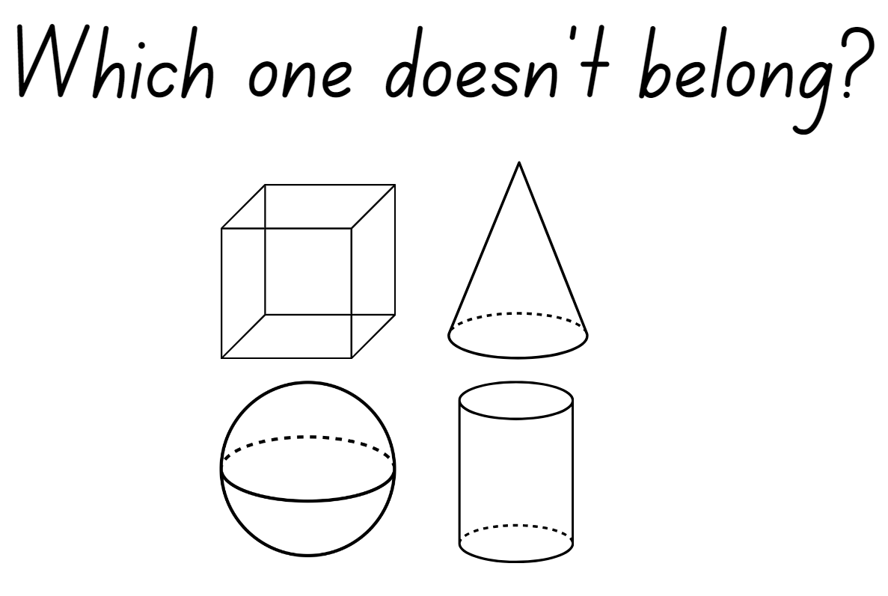

Resource 4 – prisms
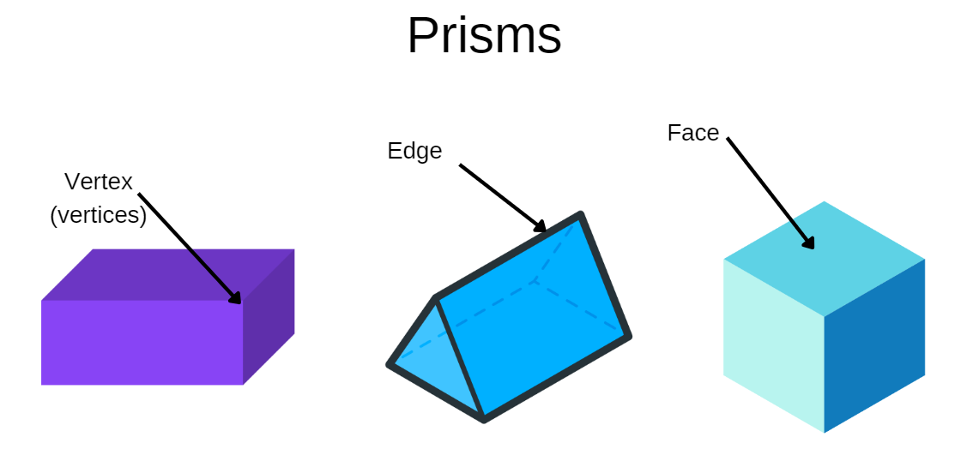

Resource 5 – deconstructed net
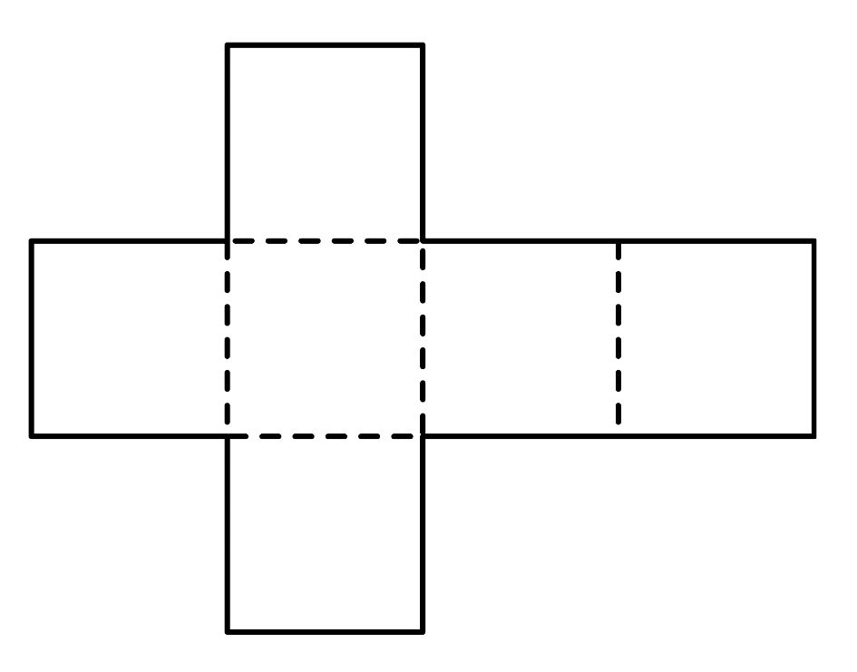

Resource 6 – 3D nets
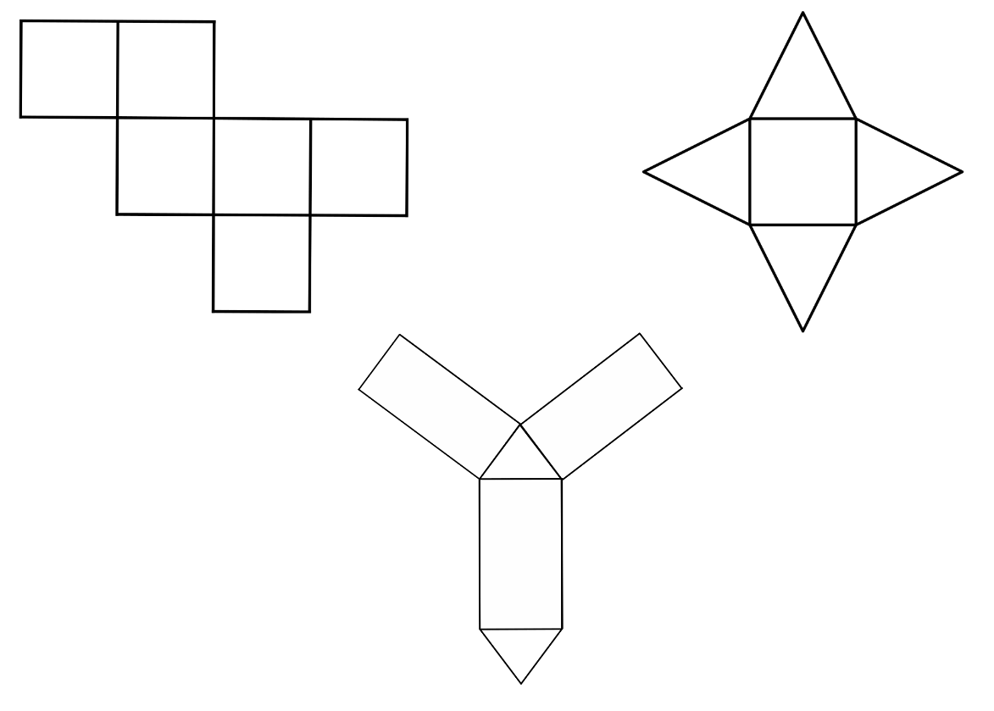

Resource 7 – nets of cubes
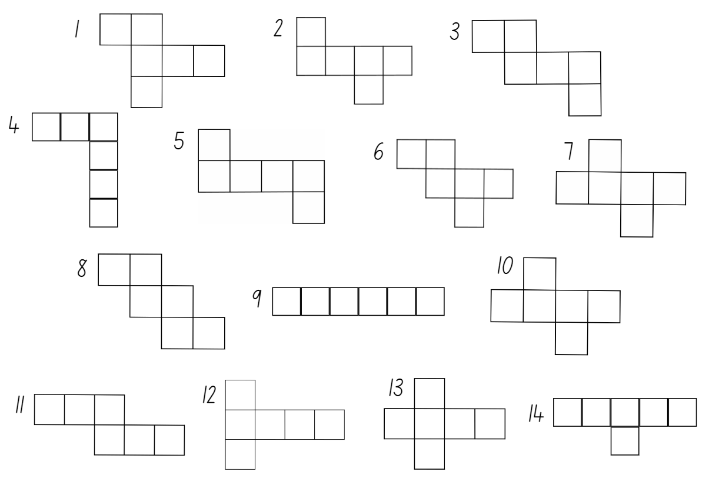

Resource 8 – pyramid nets
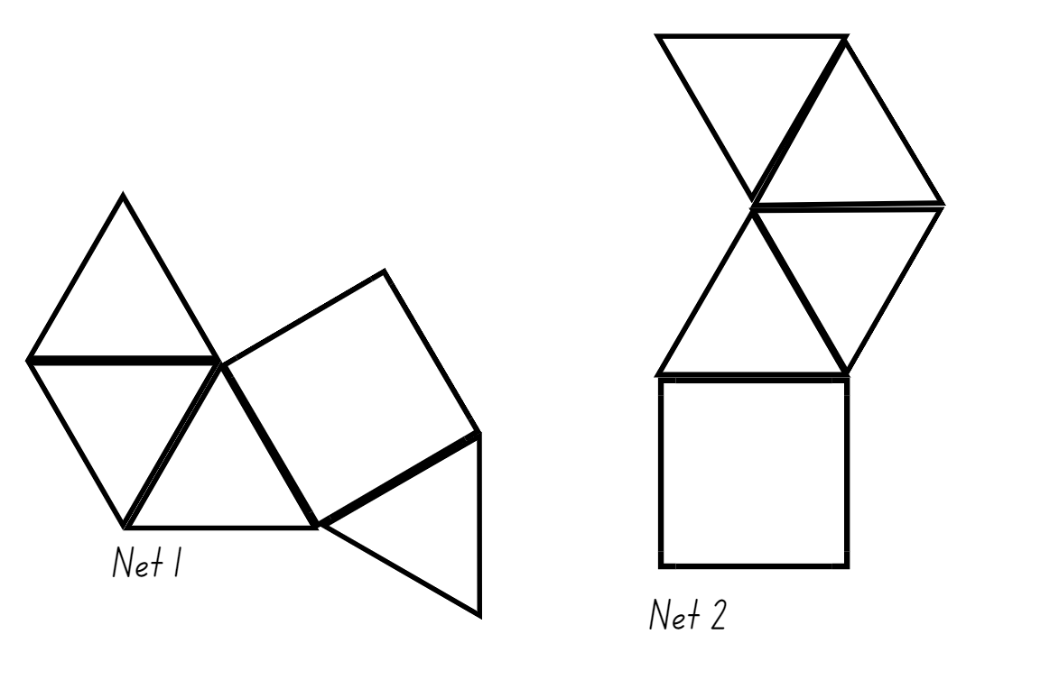

Resource 9 – recording table
Bowl | Estimated internal volume (capacity) | Measured internal volume (capacity)
1
2
3

Resource 10 – capacity cards
750 millilitres | 1500 mL
2500 mL | 250 mL
1000 mL | 500 millilitres
4000 mL | 2.5 L

Syllabus outcomes and content
The table below outlines the syllabus outcomes and range of relevant syllabus content covered in this unit. Content is linked to National Numeracy Learning Progression version (3).
Outcomes and content | 1 | 2 | 3 | 4 | 5 | 6 | 7 | 8
Representing numbers using place value A: Whole numbers: Read, represent and order numbers to thousands
MAO-WM-01, MA2-RN-01
- Read and order numbers of up to at least 4 digits | x | x | x |  |  |  |  | x
Representing numbers using place value A: Apply place value to partition and regroup numbers up to 4 digits
MAO-WM-01, MA2-RN-01
- Record numbers using standard place value form | x | x | x |  | x | x
- Partition numbers of up to 4 digits in non-standard forms (Reasons about quantity) |  |  |  |  |  | x | x
Representing numbers using place value B: Whole numbers: Order numbers in the thousands
MAO-WM-01, MA2-RN-01
- Arrange numbers in the thousands in ascending and descending order | x | x |  |  |  |  |  | x
- Recognise and describe how rearranging digits changes the size of a number (Reasons about relations) |  |  | x
- Identify the nearest thousand, 10 thousand or 100 thousand to numbers |  | x
Two-dimensional spatial structure A: 2D shapes: Compare and describe features of two-dimensional shapes
MAO-WM-01, MA2-2DS-01
- Describe and compare two-dimensional shapes, including parallelograms, rectangles, rhombuses, squares, trapeziums and kites | x |  |  | x
Three-dimensional spatial structure A: 3D objects: Make models of three-dimensional objects to compare and describe key features
MAO-WM-01, MA2-3DS-01
- Identify the differences between prisms (including cubes), pyramids and cylinders | x | x
- Construct models of prisms, pyramids and cylinders using physical or virtual manipulatives, identifying their features |  | x |  | x
- Deconstruct everyday packages that are prisms (including cubes) to create nets |  |  | x
- Investigate the variety of nets that can be used to create a particular prism |  |  |  | x
Three-dimensional spatial structure A: Volume: Measure and order containers using litres
MAO-WM-01, MA2-3DS-02
- Recognise the need for formal units to measure capacity (internal volume) accurately |  |  |  |  |  | x
- Use the litre as a unit to measure capacities (internal volumes) to the nearest litre |  |  |  |  | x
- Relate the litre to familiar everyday containers |  |  |  |  |  |  | x
- Recognise that one-litre containers can be a variety of shapes (Reasons about spatial structure) |  |  |  |  |  |  |  | x
- Record capacities (internal volumes) using the abbreviation for litres (L) |  |  |  |  | x |  | x | x
- Estimate the capacity (internal volume) of a container in litres and check by measuring |  |  |  |  | x | x | x | x
Three-dimensional spatial structure B: 3D objects: Connect three-dimensional objects and two-dimensional representations
[MAO-WM-01, MA2-3DS-01]
- Identify features of prisms and pyramids (faces, vertices and edges) and cylinders (curved/flat surfaces and boundaries) from images | x | x | x
Three-dimensional spatial structure B: Volume: Use scaled instruments to measure and compare capacities (internal volumes)
[MAO-WM-01, MA2-3DS-02]
- Recognise the need for a formal unit smaller than the litre to measure capacity (internal volume) |  |  |  |  |  | x |  | x
- Use a scaled instrument to relate 1000 millilitres to one litre |  |  |  |  |  |  |  | x
- Relate benchmark values to familiar everyday containers |  |  |  |  |  |  | x | x
Mathematics K–10 Syllabus © NSW Education Standards Authority (NESA) for and on behalf of the Crown in right of the State of New South Wales, 2022.

References
This resource contains NSW Curriculum and syllabus content. The NSW Curriculum is developed by the NSW Education Standards Authority. This content is prepared by NESA for and on behalf of the Crown in right of the State of New South Wales. The material is protected by Crown copyright.
Please refer to the NESA Copyright Disclaimer for more information https://educationstandards.nsw.edu.au/wps/portal/nesa/mini-footer/copyright.
NESA holds the only official and up-to-date versions of the NSW Curriculum and syllabus documents. Please visit the NSW Education Standards Authority (NESA) website https://educationstandards.nsw.edu.au/ and the NSW Curriculum website https://curriculum.nsw.edu.au/.
Mathematics K–10 Syllabus © NSW Education Standards Authority (NESA) for and on behalf of the Crown in right of the State of New South Wales, 2022.
National Numeracy Learning Progression © Australian Curriculum, Assessment and Reporting Authority (ACARA) 2010 to present, unless otherwise indicated. This material was downloaded from the Australian Curriculum website (National Literacy Learning Progression) (accessed 15 November 2023) and was not modified.
New Zealand Ministry of Education (n.d.) ‘Morning tea volumes’, Resource, NZ Maths website, accessed 15 November 2023.
State of New South Wales (Department of Education) (n.d.) Minecraft: Education Edition, Learning tools, NSW Department of Education website, accessed 15 November 2023.
State of New South Wales (Department of Education) (2017) Teaching measurement: Stage 2 and Stage 3, NSW Department of Education: Learning and Teaching Directorate, accessed 15 November 2023.
Persico A (2019) 101 Daily 'Which One Doesn't Belong?' Activities for Grades 1–8, independently published by Mashup math.

Further reading
NSW Education Standards Authority (NESA) (2022) Mathematics K–10 Syllabus: Stage 2 teaching advice, NSW Curriculum website, accessed 1 December 2023.
.
© State of New South Wales (Department of Education), 2023
The copyright material published in this resource is subject to the Copyright Act 1968 (Cth) and is owned by the NSW Department of Education or, where indicated, by a party other than the NSW Department of Education (third-party material).
Copyright material available in this resource and owned by the NSW Department of Education is licensed under a Creative Commons Attribution 4.0 International (CC BY 4.0) license.
This licence allows you to share and adapt the material for any purpose, even commercially.
Attribution should be given to © State of New South Wales (Department of Education), 2023.
Material in this resource not available under a Creative Commons licence:
- the NSW Department of Education logo, other logos and trademark-protected material
- material owned by a third party that has been reproduced with permission. You will need to obtain permission from the third party to reuse its material.
Links to third-party material and websites
Please note that the provided (reading/viewing material/list/links/texts) are a suggestion only and implies no endorsement, by the New South Wales Department of Education, of any author, publisher, or book title. School principals and teachers are best placed to assess the suitability of resources that would complement the curriculum and reflect the needs and interests of their students.
If you use the links provided in this document to access a third-party's website, you acknowledge that the terms of use, including licence terms set out on the third-party's website apply to the use which may be made of the materials on that third-party website or where permitted by the Copyright Act 1968 (Cth). The department accepts no responsibility for content on third-party websites.

