Mathematics Stage 2 Year A – Unit 8
Visual representations help understand aspects of the world (chance and position)
Contents
Unit description and duration 5
Syllabus outcomes 5
Working mathematically 6
Student prior learning 6
Lesson overview and resources 10
Lesson 1 16
Daily number sense – partitioning a line– 10 minutes 16
Core lesson – tools used in mapping – 40 minutes 17
Discuss and connect the mathematics – 10 minutes 22
Lesson 2 24
Daily number sense – complementary fractions– 15 minutes 24
Core lesson – navigating landmark maps – 40 minutes 26
Discuss and connect the mathematics – 10 minutes 28
Lesson 3 30
Daily number sense – re-create wholes – 10 minutes 30
Core lesson – grid references – 40 minutes 32
Discuss and connect the mathematics – 10 minutes 37
Lesson 4 39
Daily number sense – 10 minutes 39
Core lesson – everyday application of directions – 40 minutes 39
Discuss and connect the mathematics – 10 minutes 42
Lesson 5 43
Daily number sense – target number – 10 minutes 43
Core lesson – language of chance – 30 minutes 45
Consolidation and meaningful practice – 20 minutes 47
Lesson 6 52
Daily number sense – closest to 100 – 10 minutes 52
Core lesson – fair and unfair – 40 minutes 54
Discuss and connect the mathematics – 10 minutes 58
Lesson 7 60
Daily number sense – closest to … – 15 minutes 60
Core lesson – equal chance – 40 minutes 62
Discuss and connect the mathematics – 10 minutes 64
Lesson 8 66
Daily number sense – 10 minutes 66
Core lesson – combinations – 35 minutes 66
Consolidation and meaningful practice – 15 minutes 71
Resource 1 – position representations 73
Resource 2 – object map 74
Resource 3 – pointer 75
Resource 4 – landmark map 76
Resource 5 – bookshelf 77
Resource 6 – bookshelf with grid 78
Resource 7 – landmark map with grid 79
Resource 8 – Journey to Numberland 80
Resource 9 – example supermarket 82
Resource 10 – supermarket instructions 83
Resource 11 – 100 square grid 84
Resource 12 – shopping list 85
Resource 13 – supermarket map 86
Resource 14 – supermarket instructions 2 87
Resource 15 – chance representations 88
Resource 16 – chance scale 89
Resource 17 – chance statements 90
Resource 18 – carnival game 91
Resource 19 – what is fair? 92
Resource 20 – fairness reference sheet 94
Resource 21 – random generators 95
Resource 22 – carnival host v player 96
Resource 23 – mystery bags 97
Resource 24 – mystery bags support 98
Resource 25 – coloured cubes key 99
Resource 26 – two dice bingo 100
Syllabus outcomes and content 101
References 105
Further reading 107

Unit description and duration
This unit introduces the big idea that visual representations help understand aspects of our world for chance and position.
In this 2-week unit students are provided opportunities to:
- use directional language to interpret and locate positions on a grid map while describing routes between points
- predict and describe possible outcomes from chance experiments
- use visualisation, language and multiple representations of position and chance concepts.

Syllabus outcomes
- MAO-WM-01 develops understanding and fluency in mathematics through exploring and connecting mathematical concepts, choosing and applying mathematical techniques to solve problems, and communicating their thinking and reasoning coherently and clearly
- MA2-AR-01 selects and uses mental and written strategies for addition and subtraction involving 2- and 3-digit numbers
- MA2-PF-01 represents and compares halves, quarters, thirds and fifths as lengths on a number line and their related fractions formed by halving (eighths, sixths and tenths)
- MA2-GM-01 uses grid maps and directional language to locate positions and follow routes
- MA2-CHAN-01 records and compares the results of chance experiments

Working mathematically
In the Mathematics K–10 Syllabus, there is one overarching Working mathematically outcome (MAO-WM-01). The Working mathematically processes should be embedded within the concepts being taught. The Working mathematically processes are:
- communicating
- understanding and fluency
- reasoning
- problem solving.
Mathematics K–10 Syllabus © NSW Education Standards Authority (NESA) for and on behalf of the Crown in right of the State of New South Wales, 2022.

Student prior learning
Before engaging in these teaching and learning activities, students would benefit from prior experience with:
- describing and following directions to positions and objects in models and drawings
- interpreting simple maps by identifying objects in different locations
- identifying and describing the chance of possible outcomes for familiar activities and events.

In NSW classrooms there is a diverse range of students, including Aboriginal and Torres Strait Islander students, students learning English as an additional language or dialect, high potential and gifted students and students with disability. Some students may identify with more than one of these groups or possibly all of them. Refer to Curriculum planning for every student – advice for further information.

Teachers can support student learning and reasoning in this unit by connecting language, representations and visualisation for both position and chance (see Figure 1 and Figure 2). This model of support is adapted from content provided by Adjunct Professor Marj Horne in Big ideas to start strong across K–6 – Module 3: We measure to learn about, navigate and describe the world around us (NSW DoE 2023).
Figure 1 – pedagogical support – position
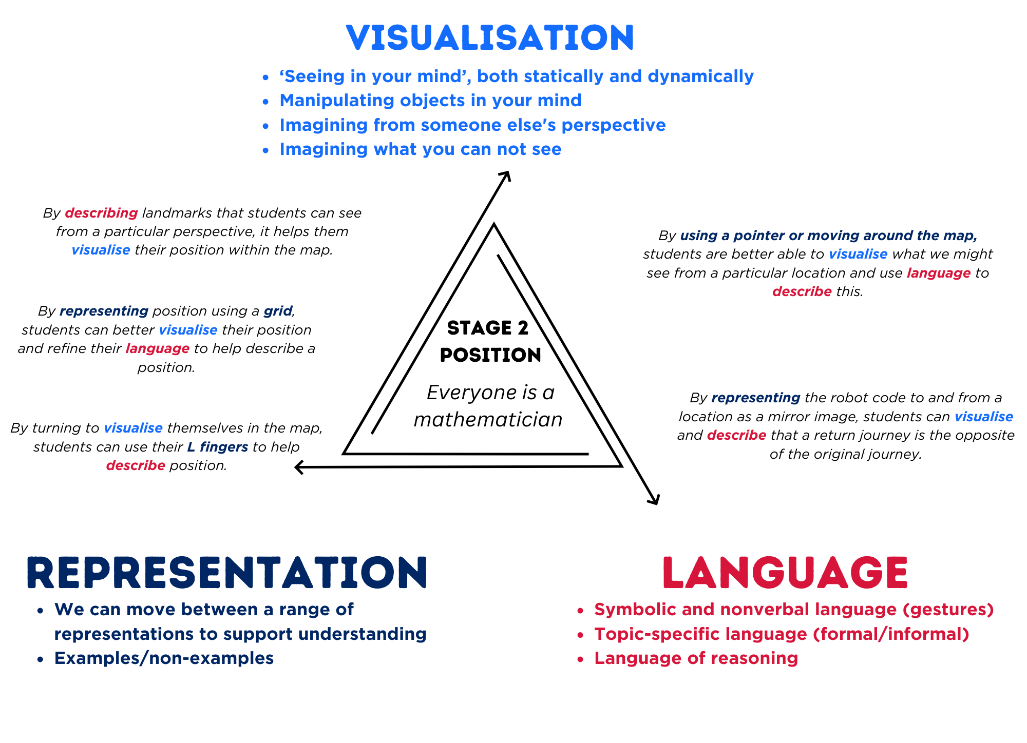
Figure 2 – pedagogical support – chance
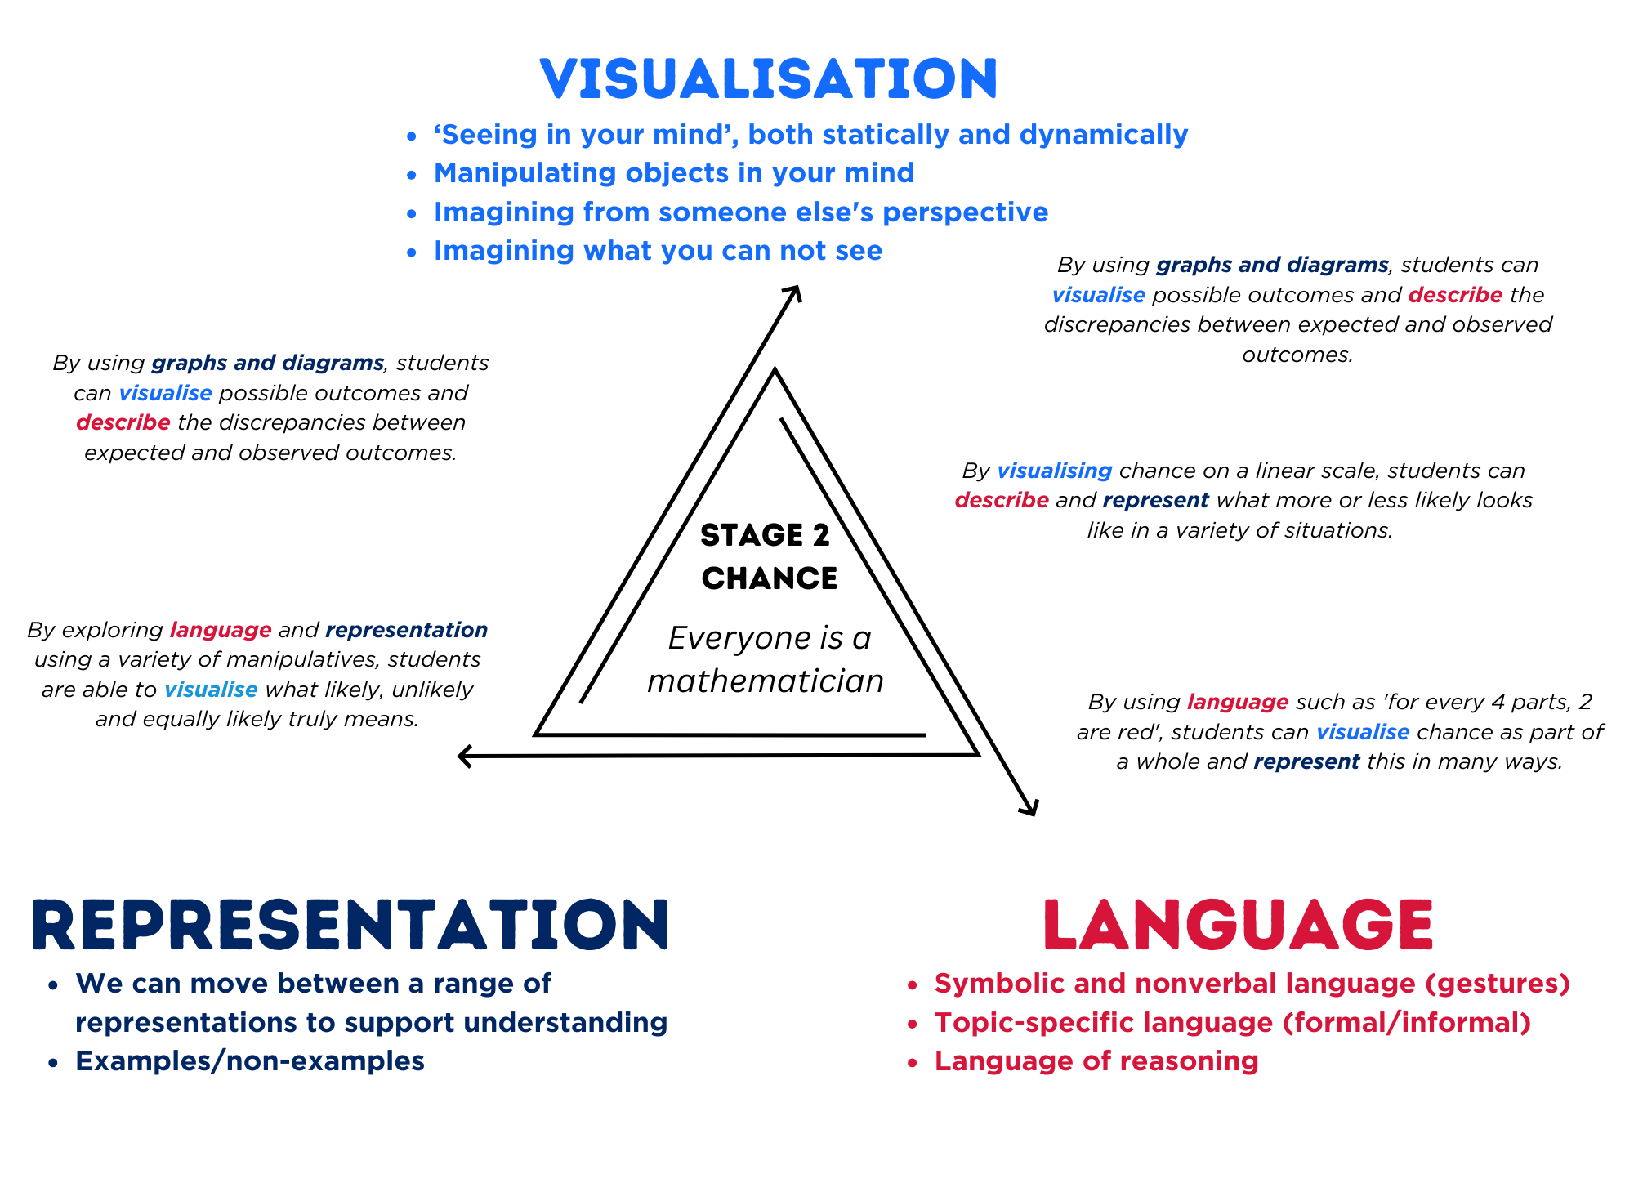

Lesson overview and resources
The table below outlines the sequence and approximate timing of lessons, learning intentions and resources.
Lesson | Content | Duration and resources
Lesson 1  Daily number sense learning intention:  - model and represent unit fractions, and their multiples, to a complete whole on a number line | Lesson core concept: Aboriginal and Torres Strait Islander peoples were the original map makers.  Core concept learning intentions:  - interpret movement on a map  - use directional language and describe routes with grid maps | Lesson duration: 60 minutes  - Resource 1 – position representations  - Resource 2 – object map  - Resource 3 – pointer  - What are song lines? (1:52)  - Gujingga Songline (4:01)  - 4 identical cardboard/paper strips  - Counters  - Envelopes  - Scissors  - Sticky notes  - Various classroom objects  - Writing materials
Lesson 2  Daily number sense learning intention:  - model and represent unit fractions, and their multiples, to a complete whole on a number line | Lesson core concept: natural resources, landmarks and universal directional language can be used to navigate.  Core concept learning intentions:  - interpret movement on a map  - use directional language and describe routes with grid maps | Lesson duration: 65 minutes  - Resource 3 – pointer  - Resource 4 – landmark map  - 2 identical cardboard/paper strips  - Scissors  - Sticky notes  - String  - Various materials, such as dominoes, cotton balls, paper and blocks  - Writing materials
Lesson 3  Daily number sense learning intention:  - model and represent unit fractions, and their multiples, to a complete whole on a number line | Lesson core concept: map locations can be identified using grid references.  Core concept learning intentions:  - locate positions on grid maps  - create and interpret grid maps | Lesson duration: 60 minutes  - Resource 5 – bookshelf  - Resource 6 – bookshelf with grid  - Resource 7 – landmark map with grid  - Resource 8 – Journey to Numberland  - Writing materials
Lesson 4  Daily number sense learning intention:  - teacher-identified task based on student needs | Lesson core concept: maps identify locations within a local environment.  Core concept learning intentions:  - create and interpret grid maps  - use directional language and describe routes with grid maps | Lesson duration: 60 minutes  - Resource 9 – example supermarket  - Resource 10 – supermarket instructions  - Resource 11 – 100 square grid  - Resource 12 – shopping list  - Resource 13 – supermarket map  - Resource 14: Supermarket instructions 2  - Writing materials
Lesson 5  Daily number sense learning intention:  - recognise and explain the connection between addition and subtraction | Lesson core concept: the outcome of chance experiments can be described and recorded.  Core concept learning intentions:  - identify possible outcomes from chance experiments  - describe the likelihood of outcomes of chance events | Lesson duration: 60 minutes  - Resource 15 – chance representations.  - Resource 16 – chance scale  - Resource 17 – chance statements  - Resource 18 – carnival game  - Coloured counters  - Cups  - Writing materials
Lesson 6  Daily number sense learning intention:  - recognise and explain the connection between addition and subtraction | Lesson core concept: outcomes from chance experiments can be predicted, recorded and compared.  Core concept learning intentions:  - identify possible outcomes from chance experiments  - describe the likelihood of outcomes of chance events | Lesson duration: 60 minutes  - Resource 19 – what is fair?  - Resource 20 – fairness reference sheet  - Resource 21 – random generators  - Resource 22 – carnival host vs player  - Class set of dice  - Individual whiteboards  - Playing cards (Ace to 10)  - Writing materials
Lesson 7  Daily number sense learning intention:  - recognise and explain the connection between addition and subtraction | Lesson core concept: outcomes from chance experiments can be predicted, recorded and compared.  Core concept learning intentions:  - identify possible outcomes from chance experiments  - describe the likelihood of outcomes of chance events | Lesson duration: 65 minutes  - Resource 23 – mystery bags  - Resource 24 – mystery bags support  - Coloured counters  - Individual whiteboards  - Playing cards (Ace to10)  - Writing materials
Lesson 8  Daily number sense learning intention:  - teacher-identified task based on student needs | Lesson core concept: record and compare the results of chance experiments.  Core concept learning intentions:  - identify possible outcomes from chance experiments  - describe the likelihood of outcomes of chance events | Lesson duration: 60 minutes  - Resource 25 – coloured cubes key  - Resource 26 – two dice bingo  - Coloured cubes  - Writing materials

Lesson 1
Core concept: Aboriginal and Torres Strait Islander peoples were the original map makers.

Daily number sense – partitioning a line– 10 minutes
Daily number sense activities for Lessons 1 to 3 ‘activate’ prior number knowledge and support the learning of new content in the unit. These activities can also assist teachers to identify the starting points for learning by revealing the extent of students’ existing knowledge.
The table below contains a suggested learning intention and success criteria. These are best co-constructed with students.
Daily number sense learning intention | Daily number sense success criteria
Students are learning to:  - model and represent unit fractions and their multiples to a complete whole on a number line. | Students can:  - model halves, quarters and eighths.
These fraction activities build on concepts taught in Stage 2 Unit 4. It is important that students can describe the relationship between the size of the denominator and the size of the fractional part – the larger the denominator, the smaller the fractional part.
- Mr Rashim drew a line and marked a half, a quarter and an eighth on the line. Ask students to draw what this may have looked like.
- Ask students to share their drawing with a partner and explain their thinking.
This table details opportunities for assessment.
Assessment opportunities | Links
What to look for:  - Can students model halves, quarters and eighths?  [MAO-WM-01, MA2-PF-01] | Links to National Numeracy Learning Progressions (NNLP):  - InF2, InF3, InF4.

Core lesson – tools used in mapping – 40 minutes
The table below contains suggested learning intentions and success criteria. These are best co-constructed with students.
Core concept learning intentions | Core concept success criteria
Students are learning to:  - interpret movement on a map  - use directional language and describe routes with grid maps. | Students can:  - describe a route taken on a map using landmarks and directional language (including Aboriginal stories, trading routes or songlines of journeys)  - use natural resources and landmarks to identify north, south, east and west.
Note: for each lesson on position in this unit and Stage 2 Unit 28, students can enhance their understanding of position by using various representations or tools. These representations and tools can be collaboratively constructed with students or provided as a resource, see Resource 1 – position representations.

This lesson has been developed in consultation with the Aboriginal Outcomes and Partnerships Directorate of the Department of Education. Teachers are encouraged to work with their school’s Aboriginal Education team and local Aboriginal Education Consultative Group to develop learning resources with local Aboriginal knowledge wherever possible. Aboriginal and Torres Strait Islander peoples should be aware that websites in this lesson may contain images, voices and names of deceased persons.
- View and discuss the video What are song lines? (1:52).
- Explain to students that songlines are navigational tracks, whereby Elders or trained Aboriginal people ‘sing the landscape’ to help move from location to location. Songlines include landmarks, localised plants and animals and water sources. Aboriginal peoples travelled along songlines for trade, to attend ceremonies and access resources, see Nicholls (2017) and ABC (2023).
- As a class, define and construct an anchor chart for the terms:
- landmarks
- map
- navigate
- compass points (north, south, east, west).
- Discuss directions and tools with the class. Ask students:
- When would we use directions?
- What is important to include in the directions that we give?
- What tools did Aboriginal peoples use to help them navigate?
- How can we tell which way is north, south, east or west?
- View and discuss the video Gujingga Songline (4:01)
- Ask students what things were included in songlines. Draw attention to the use of landmarks and why they are useful in songlines.
- Explain that Aboriginal peoples developed excellent navigational knowledge and often had their own terms for compass points in different languages. Many Aboriginal peoples used a variety of techniques to find compass points, including the Southern Cross to mark south and the sun to mark east and west, see Stellar navigation and mathematics.
- Mark north, south, east and west on the classroom walls in the appropriate directions.
- As a class, play ‘Simon Says’ using half turns on compass points (start facing north). For example, Simon says make a half turn to the right. Ask students:
- What way are you now facing?
- What do you see?
- Explain the difference between a quarter-turn and a half-turn, relating it to a clock if needed.
- As a class, play ‘Simon Says’ again but incorporate both half- and quarter-turns to the right and left, asking the above questions after each turn.
- Display Resource 2 – object map. Explain to students that they will be creating their own oral map for the objects they place on their tabletop.
Note: following cultural protocols, only certain people carry songlines. In this activity, students will create their own oral map, contextualised to their landscape and surroundings. To respect cultural protocols, please do not call these oral maps songlines.
- Model how to give direction using landmarks and compass points. For example, start at the paper, go north to the highlighter, make a quarter-turn to the right and go east to the paperclip.
- In groups of 4, students place classroom objects on their desks to create an object map. Using sticky notes, students label each side of their map with north, south, east and west. Each student stands on a different side of the desk, see Figure 3.
Figure 3 – object map activity
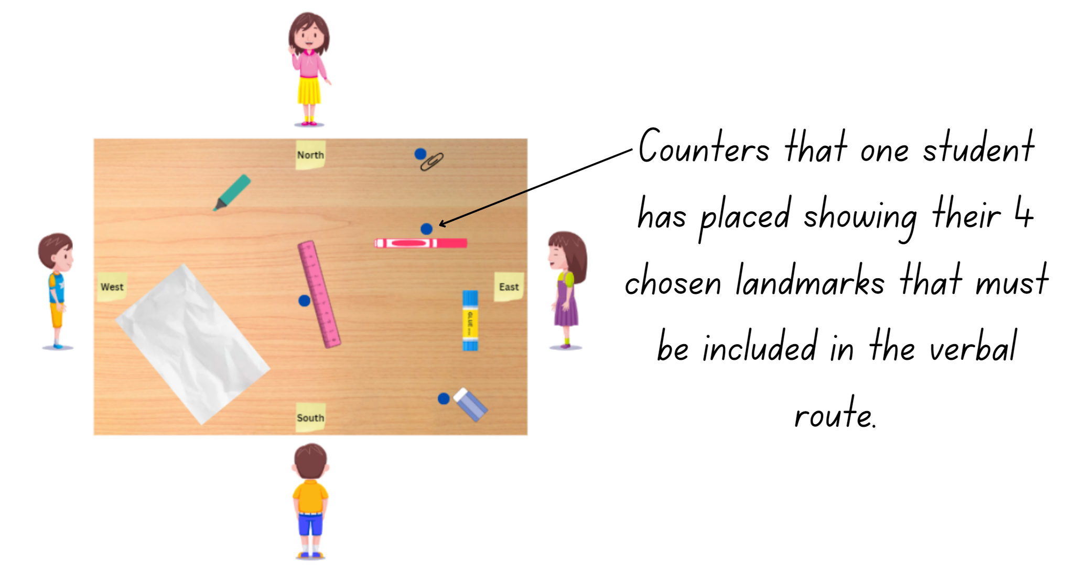
- One student creates a challenge by placing 4 counters next to specific landmarks to be visited. All students take turns to verbally describe a route (oral map) that includes those 4 chosen landmarks using compass points and landmark names.
- Students then move positions around the table and a different student sets a new challenge using the counters.
This table details opportunities for differentiation.
Too hard? | Too easy?
Students cannot provide or use given directions to follow routes.  Students visit 2 landmarks in their route. Support students to use compass directions for direction of travel.  - Provide students with Resource 3 – pointer to support the description of the oral map. | Students can provide or use given directions to follow routes.  - Students plan both an outbound and return journey to 4 locations on the map.  - Students describe what they can see from a particular perspective and their partner identifies the direction they are facing. For example, students describe that they can see a pen to their right and a rubber to their left, then ask which direction they are facing.  - Investigate the use of a stick to determine cardinal directions.

Discuss and connect the mathematics – 10 minutes
- As a class, discuss the following:
- What is important to include in the directions that we give?
- How can tools such as compass points and landmarks help us to give and understand directions?
- Is one more effective than the other? Why?

This table details opportunities for assessment.
Assessment opportunities | Links
What to look for:  - Can students describe a route taken on a map using landmarks and directional language (including Aboriginal stories, trading routes or songlines of journeys)? [MAO-WM-01, MA2-GM-01]  - Can students use natural resources and landmarks to identify north, south, east and west? [MAO-WM-01, MA2-GM-01] | Links to National Numeracy Learning Progressions (NNLP):  - PoL4.

Lesson 2
Core concept: natural resources, landmarks and universal directional language can be used to navigate.

Daily number sense – complementary fractions– 15 minutes
The table below contains a suggested learning intention and success criteria. These are best co-constructed with students.
Daily number sense learning intention | Daily number sense success criteria
Students are learning to:  - model and represent unit fractions, and their multiples, to a complete whole on a number line | Students can:  - model fractions with diagrams for halves, quarters, eighths and thirds on a number line  - determine the complementary fractional part needed to complete one whole.
- Revise the term ‘complementary’ in relation to fractions.
- Draw a diagram with a fractional part missing, see Figure 4.
Figure 4 – complementary fraction
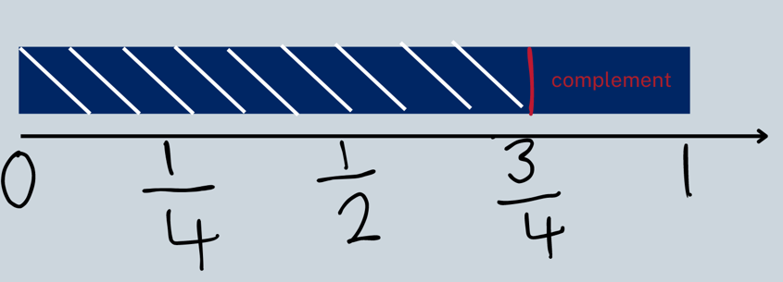
- Ask student to identify the complementary fractional part needed to complete one whole and explain their reasoning.
- Students create their own diagram and have a partner identify the complementary fraction.
- Ask students to collect and keep their fraction strips in an envelope. Place all pieces into the envelope and keep for Lesson 3.
This table details opportunities for assessment.
Assessment opportunities | Links
What to look for:  - Can students model fractions with diagrams for halves, quarters, eighths and thirds on a number line? [MAO-WM-01, MA2-PF-01]  - Can students determine the complementary fractional part needed to complete one whole? [MAO-WM-01, MA2-PF-01] | Links to National Numeracy Learning Progressions (NNLP):  - InF5.

Core lesson – navigating landmark maps – 40 minutes
The table below contains suggested learning intentions and success criteria. These are best co-constructed with students.
Core concept learning intentions | Core concept success criteria
Students are learning to:  - interpret movement on a map  - use directional language and describe routes with grid maps. | Students can:  - orient a map to determine directions to travel  - use a grid map and compass directions (N, S, E, W) to plan, describe and show a route from one location to another.
Note: the purpose of this lesson is to use concrete representations to support students to visualise themselves within a landscape and to use landmarks and directional language effectively to describe a journey.
- Show students a real landmark map from your local area, such as a park, council area or school site. If none are available, display Resource 4 – landmark map or a map of Taronga Western Plains Zoo.
- Discuss what landmarks students can see and how they may be useful in navigating.
- In groups of 4, students physically re-create the map using real objects. For example, use dominoes to represent houses, a cotton ball to represent a tree, blue paper to represent the lake.
- Students place sticky notes labelling north, south, east and west where appropriate.
- Each student stands on one side of the table, looking into the map. Each student places their Resource 3 – pointer on their chosen point on the map. They then describe what they can see around them facing the direction their arrow is pointing on the map. For example, you can see the lake in front of you, a house is behind you. The hospital is on your left.
- Each student has a turn at doing this from at least 2 different locations.
- As a class, ask students what they noticed as their place changed within the map.
- Provide each group a length of string. Using the string, students create a route from one side of the table to a chosen location or exit point, see Figure 5.
Figure 5 – landmark map with string
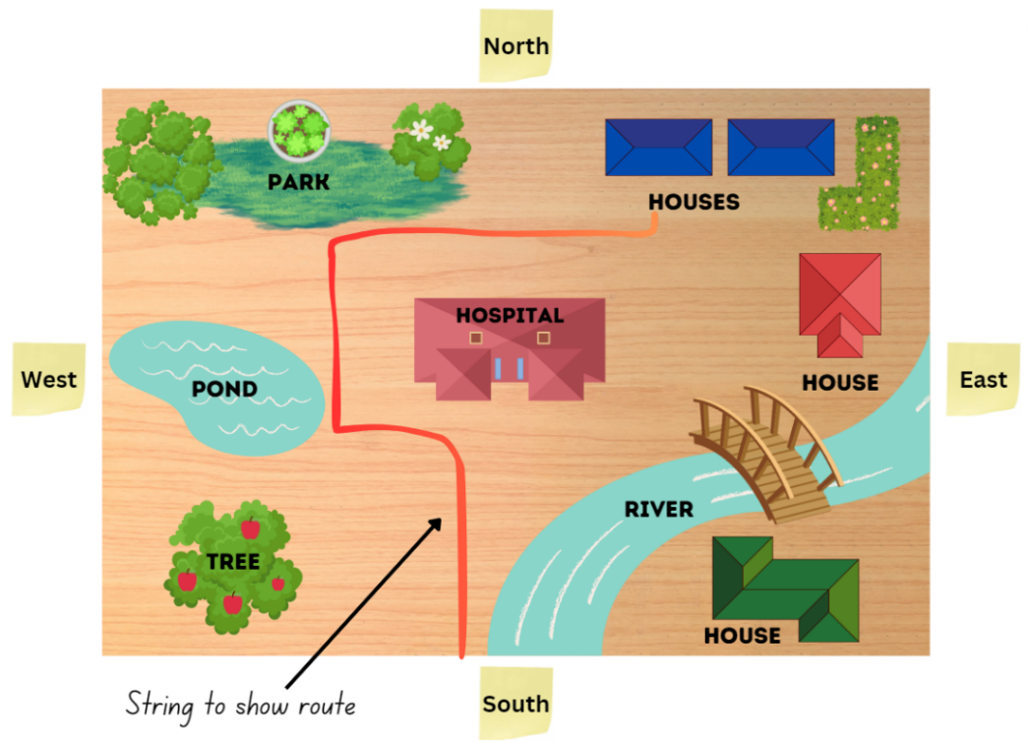
- As a group, students describe the route through the map using landmarks and compass points. For example, travel west until you reach the river then turn north and travel until you pass the pond. Turn west and travel until you reach the park.
This table details opportunities for differentiation.
Too hard? | Too easy?
Students cannot orient a map to determine directions to travel.  - Students use Resource 3 – pointer to support route directions.  - Students make a simple route with one turn through the map. | Students can orient a map to determine directions to travel.  - Encourage students to create a more complex route with their string. Students include the amount of turn (quarter-turn/half-turn) and left/right in their directions.  - Students plan a return journey for their route.

Discuss and connect the mathematics – 10 minutes
- As a class, discuss the following:
- What is important to include in the directions that you give?
- How did positioning yourself within the map help you?
- Did you notice anything about using left/right when facing different directions?
- How can tools such as compass points and landmarks help us to give and understand directions?
This table details opportunities for assessment.
Assessment opportunities | Links
What to look for:  - Can students orientate a map to determine directions to travel? [MAO-WM-01, MA2-GM-01]  - Can students use a grid map and compass directions (N, S, E, W) to plan, describe and show a route from one location to another? [MAO-WM-01, MA2-GM-01] | Links to National Numeracy Learning Progressions (NNLP):  - Pol3, Pol5.

Lesson 3
Core concept: map locations can be identified using grid references.

Daily number sense – re-create wholes – 10 minutes
The table below contains a suggested learning intention and success criteria. These are best co-constructed with students.
Daily number sense learning intention | Daily number sense success criteria
Students are learning to:  - Model and represent unit fractions, and their multiples, to a complete whole on a number line. | Students can:  - determine the complementary fractional part needed to complete one whole (halves, quarters, eighths, thirds)  - recreate the whole unit from a fractional part ( $\frac{1}{2}$, $\frac{1}{4}$, $\frac{1}{3}$ and $\frac{1}{8}$ ).
- Draw a diagram of a fractional part, see Figure 6.
Figure 6 – recreating wholes
- Ask:
- If this is a quarter of the strip, how big is the whole strip?
- How do you know?
- Can you make or draw a model or diagram to show the whole?
- Select students to share their models and explain their reasoning.
This table details opportunities for assessment.
Assessment opportunities | Links
What to look for:  - Can students determine the complementary fractional part needed to complete one whole (halves, quarters, eighths, thirds)? MAO-WM-01, MA2-PF-01]  - Can students recreate the whole unit from a fractional part ($\frac{1}{2}$, $\frac{1}{4}$, $\frac{1}{3}$ and $\frac{1}{8}$)? MAO-WM-01, MA2-PF-01] | Links to National Numeracy Learning Progressions (NNLP):  - InF2, InF3, InF4.

Core lesson – grid references – 40 minutes
The table below contains suggested learning intentions and success criteria. These are best co-constructed with students.
Core concept learning intentions | Core concept success criteria
Students are learning to:  - locate positions on grid maps  - create and interpret grid maps. | Students can:  - locate positions by coordinating horizontal and vertical references  - use the array (row and column) structure of grid maps to locate position, horizontal before vertical  - identify and mark locations on maps and plans, given their grid references.
Note: the purpose of this lesson is to introduce students to the grid reference system and identify how a specific location can be given using a grid reference system.
- Display Resource 5 – bookshelf. Ask students how they could describe the location of items. Anticipated responses may include that the bear is on the top shelf on the left. Repeat for several items.
- Ask students questions using the prompt table.
The table below outlines stimulus prompts to generate conversation about the topic, along with anticipated responses from students.
Prompts | Anticipated student responses
- What does the arrangement of the toys remind you of? | - Toys are positioned in line with each other in rows and columns. This is like a grid map.
- How are they positioned? | - The toys are positioned in arrays.
- How can we draw an array or region? | - With dots or by using rows and columns.
- If you represent a box with rows and columns, what does this remind you of? | - Rows and columns of boxes remind me of a grid.
- If you draw a grid over the bookshelf, would this make describing the location easier? | - Yes, if you add grid references to it.
- Display Resource 6 – bookshelf with grid. Ask:
- How can we now describe the location of a particular toy?
- How can we describe the spaces on the grid? Anticipated responses include labelling them with numbers or letters.
Note: this resource may elicit some discussion about the use of letters and numbers and the order of how spaces are described. When using grid reference systems, such as those found on maps, the convention dictating the horizontal component of direction is named first, followed by the vertical component, such as A2.
- Label the columns and rows following the discussion, see Figure 7.
Figure 7 – bookshelf grid map
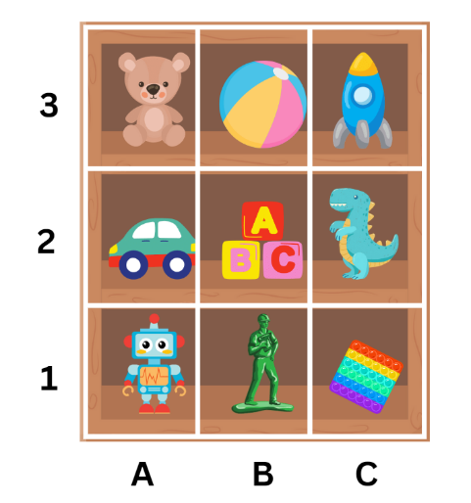
- Ask students to give the location of a few items using the revised system.
- Ask students to turn and talk about the following questions:
- How has using the grid reference system changed the way you describe location?
- Does using a grid make it easier to represent or visualise a location?
- What was easy or difficult?
- Ask students to share their reasoning with the class.
- Display Resource 7 – landmark map with grid. Review the directional language needed to use landmarks and compass points to navigate.
- Explain that students will use the 4 compass points and the grid system to record directions for a journey in their workbook or using a digital device. The route will need to make a stop at 3–4 identified landmarks, see Figure 8.
Figure 8 – student work sample
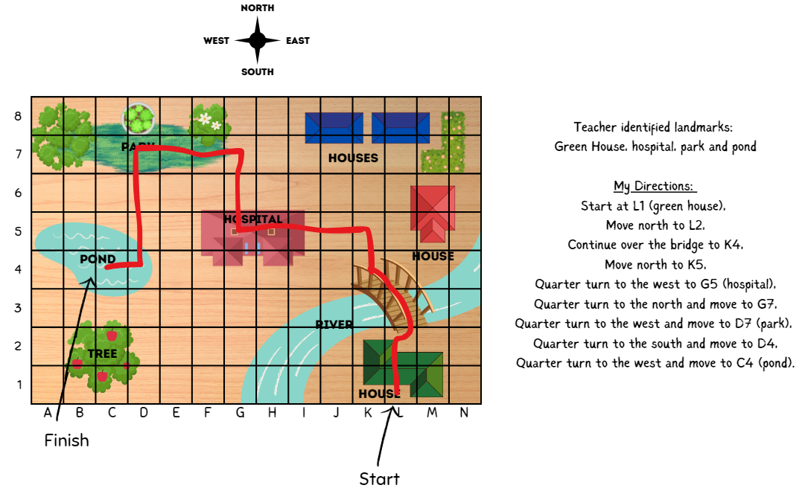
- Provide pairs of students a copy of Resource 7 – landmark map with grid and writing materials.

This table details opportunities for differentiation.
Too hard? | Too easy?
Students cannot locate positions on grid maps.  - Students track with their finger along one column or one row and name the landmarks they come across.  - Encourage students to use their fingers or rulers to cross reference the row and column to locate a specific landmark using a grid map.  - Students can shade the rows and columns to help determine specific locations on the grid. | Students can locate positions on grid maps.  - Students engage in a barrier activity using a blank grid. Student A describes a route involving 3–5 turns from a designated start and end point. Student B attempts to follow and mark the directions on their copy of a blank grid. Both students compare maps.  - Students engage in Journey to Numberland. See Resource 8 – Journey to Numberland (adapted from Journeys in Numberland from NRICH by University of Cambridge).

Discuss and connect the mathematics – 10 minutes
- Regroup as a class and ask students:
- Where have you seen the grid reference system used before? Draw in the real-life context of maps.
- How has the grid reference system changed the way you describe a location?
- Does using a grid make it easier to represent or visualise a location?
- Is using a grid system more effective than using only landmarks?
- Are there times when one system would be better than the other?
This table details opportunities for assessment.
Assessment opportunities | Links
What to look for:  - Can students locate positions by coordinating grid references? [MAO-WM-01, MA2-GM-01]  - Can students use the array (row and column) structure of grid maps to locate position, horizontal before vertical?  [MAO-WM-01, MA2-GM-01]  - Can students identify and mark locations on maps and plans, given their grid references? [MAO-WM-01, MA2-GM-01] | Links to National Numeracy Learning Progressions (NNLP):  - PoL5.

Lesson 4
Core concept: maps identify locations within a local environment.

Daily number sense – 10 minutes
- From a class need surfaced through formative assessment data, identify a short, focused activity that targets students’ knowledge, understanding and skills. Example activities may be drawn from the following resources:
- Mathematics K–6 resources
- Universal Resources Hub.

Core lesson – everyday application of directions – 40 minutes
The table below contains suggested learning intentions and success criteria. These are best co-constructed with students.
Core concept learning intentions | Core concept success criteria
Students are learning to:  - create and interpret grid maps  - use directional language and describe routes with grid maps. | Students can:  - create simple maps and plans from an aerial view, labelling grid references  - identify and mark locations on maps and plans, given their grid references  - use a given grid map and compass directions (N, S, E, W) to plan, describe and show a route from one location to another.
This activity is an adaptation of Banana Cake from NZ Maths by New Zealand Ministry of Education.
The purpose of this lesson is to provide an opportunity for students to apply their understanding of the grid reference system to assist in describing and interpreting routes in everyday situations.
- Brainstorm where students might use maps in everyday life.
- Discuss what landmarks look like in a supermarket. For example, items are grouped by product type in different aisles or sections.
- Display Resource 9 – example supermarket.
- Students Think-Pair-Share to consider the following questions:
- How does the grid help when representing locations?
- How does it help describe a route?
- Would compass points ever be useful in this situation? Why or why not?
- Model how to construct a map where objects/landmarks take up multiple squares on a grid. See Resource 9 – example supermarket.
- Provide students with a copy of Resource 10 – supermarket instructions and Resource 11 – 100 square grid.
- Students label the horizontal axis with letters and vertical axis with numbers on Resource 11 – 100 square grid.
- Students create a supermarket map by shading and labelling using the given instructions and grid paper.
- In pairs, students create and record in their workbooks 2 routes through the supermarket to gather the supplies on Resource 12 – shopping list to make their banana cake.
This table details opportunities for differentiation.
Too hard? | Too easy?
Students cannot create a simple map or plan from an aerial view, labelling grid references.  - Provide students with Resource 13 – supermarket map. Support students to locate items on the shopping list.  - Ask students to only map locations with single grid references using Resource 14 – supermarket instructions 2. | Students can create a simple map or plan from an aerial view, labelling grid references.  - Students find the shortest route to collect all ingredients and justify why this is the shortest route.  - Students write their route using directional language, including landmarks and compass points.

Discuss and connect the mathematics – 10 minutes
- As a class, discuss the following:
- How do grid representations help you to navigate?
- How do grid references change the language that you use when describing routes?
- When is it most effective to use grid references? Why?
This table details opportunities for assessment.
Assessment opportunities | Links
What to look for:  - Can students create simple maps and plans from an aerial view, labelling grid references? [MAO-WM-01, MA2-GM-01]  - Can students identify and mark locations on maps and plans, given their grid references? [MAO-WM-01, MA2-GM-01]  - Can students use a given grid map and compass directions (N, S, E, W) to plan, describe and show a route from one location to another? [MAO-WM-01, MA2-GM-01] | Links to National Numeracy Learning Progressions (NNLP):  - PoL5.

Lesson 5
Core concept: the outcome of chance experiments can be described and recorded.

Daily number sense – target number – 10 minutes
Daily number sense activities for Lessons 5 to 7 ‘loop’ back to concepts and procedures covered in previous units to assist students to build an increasingly connected network of ideas. These concepts may differ from the core concepts being covered by the unit.
The table below contains a suggested learning intention and success criteria. These are best co-constructed with students.
Daily number sense learning intention | Daily number sense success criteria
Students are learning to:  - recognise and explain the connection between addition and subtraction. | Students can:  - use number relation principles to solve related problems  - explain and check solutions to problems, including using the inverse operation.
This activity is an adaptation of Target Number from Math for Love.
- Write a 2-digit ‘target’ number on the board.
- Using whiteboards, students write down as many different number sentences that have the target number as the answer. Students use addition and/or subtraction as the operations. For example, 32 + 7 – 4 = 35.
- Students turn and talk to a partner and share one of their number sentences, then describe the strategies they used to create it.
- Regroup as a class and discuss students’ reasoning for their ideas. Highlight different ideas that promote the understanding that different strategies can be more effective for different problems. For example, inverse operations, bar model or complement principle.
Note: the activity can be adapted by using 3-digit numbers. To reinforce the concept of equivalence, consider also presenting the target in this form: 35 = 32 + 7 – 4.
This table details opportunities for assessment.
Assessment opportunities | Links
What to look for:  - Can students use number relation principles to solve related problems? [MAO-WM-01, MA2-AR-01]  - Can students explain and check solutions to problems, including by using the inverse operation? [MAO-WM-01, MA2-AR-01] | Links to National Numeracy Learning Progressions (NNLP):  - AdS7.

Core lesson – language of chance – 30 minutes
The table below contains suggested learning intentions and success criteria. These are best co-constructed with students.
Core concept learning intentions | Core concept success criteria
Students are learning to:  - identify possible outcomes from chance experiments  - describe the likelihood of outcomes of chance events. | Students can:  - use the term outcome to describe any possible result of a chance experiment  - record all possible combinations in a chance situation  - use the terms equally likely, likely and unlikely to describe the chance of everyday events occurring.

For each lesson on chance in this unit and Stage 2 Unit 28, students can enhance their understanding by using various representations or tools. These representations and tools can be constructed with students or provided as a resource for them, see Resource 15 – chance representations.
Note: the purpose of this lesson is to explore terms such as fair, unfair, possible, impossible, likely, unlikely, equally likely and certain in the context of everyday statements and chance situations to develop a shared understanding of the terms.
- Explain that the word ‘outcome’ means any possible result of a situation. Discuss situations with different possible outcomes, such as weather, sport, card games or board games.
- Explain that in mathematics outcome has a specific meaning. Share the syllabus definition of outcome.
Outcome: a possible result from an experiment or trial.
- Discuss outcomes of random generators such as rolling dice, spinning a spinner, dealing cards from a deck, taking coloured counters from a bag.
- Display, read and discuss Resource 16 – chance scale.
- Display, read and discuss Resource 17 – chance statements.
- Provide students with a copy of Resource 17 – chance statements and ask them to position each statement along the chance scale.
- Share student solutions. Ask:
- Is impossible the opposite of possible? (See note below)
- What makes something certain or impossible?
- What makes something more likely or less likely?
- What does equally likely mean? The equal chance of each outcome occurring.
Note: certain is the opposite of impossible. Anything that is not impossible, is possible. Therefore, possible includes a scale of things that are more and less likely, equally likely and certain. Impossible means that the outcome can never occur. Certain means that it will definitely occur.
- Co-construct definitions and create an anchor chart for the terms on the chance scale.

Consolidation and meaningful practice – 20 minutes
This activity is an adaptation of Two and One from NRICH by University of Cambridge.
- Display the game Two and One. Read the instructions and play the game by selecting the Run once button several times. Discuss the results.
- Ask students to turn and talk about what might happen after 100 turns. Select the Run ×100 button. Examine the results for long stretches of losses. Discuss the results and ask if they were as predicted.
- Display Resource 18 – carnival game and read instructions.
- Students explore the idea of fair and unfair by playing the carnival game for 5–10 minutes.
- Stop the game. Select students to share their scores as hosts and players.
The table below outlines stimulus prompts to generate conversation about the topic, along with anticipated responses from students.
Prompts | Anticipated student responses
- Is this game fair? Why or why not? | - It is not fair because there are more blue counters.  - It is more likely that blue will end up in the middle because there are more blue counters.  - It is hard for me to win because red has a 1 in 3 chance of being in the middle. Blue has a 2 in 3 chance of being in the middle.  - It is not fair if the host remembers where the red counter is.
- How can the game be changed to make it impossible to win? | - Make all the counters are blue.  - Make sure there are no red counters.
- How can the game be changed to make it certain that the player will win? | - Make sure all the counters are red.
- Can the game be changed to make it fair? | - We could change a blue to green counter.  Note: this is still not fair as there is still a 1 in 3 chance of red in the middle.  - We could make 2 of the counters red.  Note: this changes the chance of red in the centre in favour of the player. It is still not a fair game.  - With an odd number of counters, you cannot make it fair.
- Is it always true that, if there is not an equal chance of winning, the game is not fair? | - Yes, if it is not equal for both players then it is not a fair game.  - No, you do not need to have an equal chance, it just needs to be easier for the player to win.  Note: for a game to be fair, both parties must have an equal chance of winning.
This table details opportunities for differentiation.
Too hard? | Too easy?
Students cannot describe the likelihood of outcomes of chance events.  - Students sort the statements on Resource 17 – chance statements into 2 categories – likely and unlikely.  - Provide students with manipulatives to explore discussion questions from the carnival game. For example, swap out a blue counter for a green counter and play the game. | Students can describe the likelihood of outcomes of chance events.  - Students can create their own chance statements for a partner to sort on the chance scale.  - Students explore whether the carnival game is fair or unfair using 2 red and 2 blue counters. Nominate 2 spots as the winner’s spot. The player wins if a red counter lands in either spot, see Figure 9. Ask if the game is now fair and whether students can derive a rule for fair and unfair versions of this game.
Figure 9 – modified carnival game
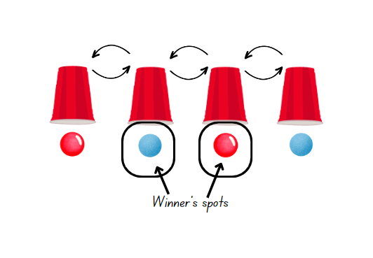

This table details opportunities for assessment.
Assessment opportunities | Links
What to look for:  - Can students use the term outcome to describe any possible result of a chance experiment? [MAO-WM-01, MA2-CHAN-01]  - Can students record all possible combinations in a chance situation? [MAO-WM-01, MA2-CHAN-01]  - Can students use the terms equally likely, likely and unlikely to describe the chance of everyday events occurring? [MAO-WM-01, MA2-CHAN-01] | Links to National Numeracy Learning Progressions (NNLP):  - UnC2, UnC3, CPr8.

Lesson 6
Core concept: outcomes from chance experiments can be predicted, recorded and compared.

Daily number sense – closest to 100 – 10 minutes
The table below contains a suggested learning intention and success criteria. These are best co-constructed with students.
Daily number sense learning intention | Daily number sense success criteria
Students are learning to:  - recognise and explain the connection between addition and subtraction. | Students can:  - use number relation principles to solve related problems.  - use the complement principle of addition and subtraction.
This activity is an adaptation of Closest to 100 (additive strategies) from Mathematics K–12 by State of New South Wales (Department of Education).
- The aim of the game is to use addition or subtraction to get close to a total of 100.
- The winner of the game is the player with the lowest points.
- Provide pairs of students with a whiteboard and a pack of cards, Ace–10.
- Player 1 shuffles the cards and puts them in a central pile. Player 2 takes 6 cards and places them face up for everyone to see.
- Each card can only be used once, and it can be used to form a one- or 2-digit number. Not all cards need to be used.
- Players score zero points if they can get exactly 100. Players score points based on the difference between their total and 100. For example, a total of 94 would score 6 points.
- Students record their number sentence and score on their whiteboard.
- Ask students to represent their equation using a bar model. Discuss how the complement principle highlights an inverse principle, see Figure 10.
Figure 10 – bar model example
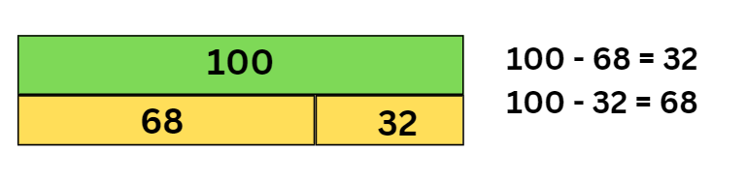
Note: a bar model is made up of rectangles, representing the part-part-whole relationship. The whole bar on top is labelled 100, and 2 rectangles below are labelled 68 and 32. The rectangles are collectively the same length as the whole bar and show the proportion of their value.

This table details opportunities for assessment.
Assessment opportunities | Links
What to look for:  - Can students use number relation principles to solve related problems? [MAO-WM-01, MA2-AR-01]  - Can students use the complement principle of addition and subtraction? [MAO-WM-01, MA2-AR-01] | Links to National Numeracy Learning Progressions (NNLP):  - AdS7.

Core lesson – fair and unfair – 40 minutes
The table below contains suggested learning intentions and success criteria. These are best co-constructed with students.
Core concept learning intentions | Core concept success criteria
Students are learning to:  - identify possible outcomes from chance experiments  - describe the likelihood of outcomes of chance events. | Students can:  - record all possible outcomes in a chance experiment where the outcomes are equally likely  - compare the likelihood of obtaining particular outcomes in a simple chance experiment by predicting, conducting the experiment and comparing the results with the prediction.
Note: the purpose of this lesson is to explore different representations of fair and unfair so that students develop a shared understanding that, for a game to be fair, everyone must have an equal chance of winning.
- Display Resource 19 – what is fair? Identify and discuss examples and non-examples of what fair looks like.
- Distribute copies of Resource 19 – what is fair?
- In groups of 4, students cut and sort the cards into 2 groups labelled fair and unfair.
- Conduct a gallery walk for students to consider how other groups have sorted the cards.
- As a class, discuss the following questions:
- What did you consider when deciding if a card was fair or unfair?
- Can fair look different?
- Can things appear fair and still be unfair?

Note: examples of student ideas for fair and unfair may include whether it was half-half, whether all the sections were the same size (therefore an equal chance of each outcome), whether students considered the outcomes of what they wanted in relation to all possible outcomes, and whether students considered an unfair situation to be fair just because the chance was in their favour. Use Resource 20 – fairness reference sheet to facilitate class discussion.
- Explain that the students are going to design their own carnival games using random generators. Students will work in pairs with one person as the carnival game host and the other as a player. Roles can be swapped throughout activity.
- Discuss the idea that the carnival game host will want to ensure the player loses more than they win. They have an interest in making the game unfair.
- The challenge for the player is to ensure that the game is fair.
- Model using a dice and how this can be achieved by using the following prompts, along with anticipated responses from students.
Prompts | Anticipated student responses
- How do you win the game? | - Rolling 4 on a die.
- How likely is this to occur? | - Any number has the same chance and there are 6 numbers, so it is a one in 6 chance.  - I may not roll a 4 at all.  - It is unlikely that I will roll a 4 because there are 5 other options.
- Is this fair? Why or why not? (See Resource 20 – fairness reference sheet). | - It is fair because each number has an equal chance.  - It is unfair because there are 5 other numbers and so it is 5 times more likely that I will roll one of them.
- Would the carnival game host be happy with this game? Why or why not? | - Yes, because they are more likely to win.  - Yes, because it is hard for me to roll a 4.
- What do we mean by fair? | - Fair means that I have a good chance of winning.  - Fair means that everyone has an equal chance of winning.
- How could the player change this game to make sure it is fair? | - By changing the aim of the game so there is an equal chance of getting what the player wants.  - By changing the rules so you win by rolling an even number.
- Give each pair a copy of Resource 21 – random generators.
- Students design a simple game using one random generator at a time. The carnival host sets the rules to ensure the game is unfair. The player changes the generators or the rules to ensure they have a fair chance of winning.
This table details opportunities for differentiation.
Too hard? | Too easy?
Students cannot describe the likelihood of outcomes of chance events.  - Students sort simple chance generators. For example, students only use the spinner and dice cards.  - Give students a fair and unfair game situation. Ask them to choose which they would prefer if they were the carnival host or the player, see Resource 22 – carnival host vs player. | Students can describe the likelihood of outcomes of chance events.  - Students create their own chance representations to be sorted into fair and unfair.  - Ask students to consider how the idea of fair and unfair might change if they were to use 2 coins or 2 dice, where winning means getting 2 heads or 2 tails, or a 4 on each dice.

Discuss and connect the mathematics – 10 minutes
- Ask a class, discuss:
- As the carnival game host, how did you ensure your game was unfair? What did you need to think about?
- As the player, how did you change the game so that it became fair?
- What language or representation helped you to think about this challenge? (List possible outcomes, draw the generators or use language such as ‘for every 4 sections on the spinner, one is red, therefore I have a one in 4 chance’).
- What do you now consider to be fair?
This table details opportunities for assessment.
Assessment opportunities | Links
What to look for:  - Can students record all possible outcomes in a chance experiment where the outcomes are equally likely? [MAO-WM-01, MA2-CHAN-01]  - Can students compare the likelihood of obtaining particular outcomes in a simple chance experiment by predicting, conducting the experiment and comparing the results with the prediction? [MAO-WM-01, MA2-CHAN-01] | Links to National Numeracy Learning Progressions (NNLP):  - UnC3, CPr8.

Lesson 7
Core concept: outcomes from chance experiments can be predicted, recorded and compared.

Daily number sense – closest to … – 15 minutes
The table below contains a suggested learning intention and success criteria. These are best co-constructed with students.
Daily number sense learning intention | Daily number sense success criteria
Students are learning to:  - recognise and explain the connection between addition and subtraction. | Students can:  - demonstrate how addition and subtraction are inverse operations.
This activity is an adaptation of Closest to 100 (additive strategies) from Mathematics K–12 by State of New South Wales (Department of Education).
- Repeat Lesson 6 ‘Daily number sense’ with a different target number.
- The aim of the game is to use addition or subtraction to get close to a target total.
- The winner of the game is the player with the lowest points.
- In pairs provide students with a whiteboard and a pack of cards Ace–10.
- Player 1 shuffles the cards and puts them in a central pile. Player 2 takes 6 cards and places them face up for everyone to see.
- Each card can only be used once, and it can be used to form a one- or 2-digit number. Not all cards need to be used.
- Players score zero points if they can get to the target number. Otherwise, players score points based on the difference between their total and the selected target number.
- Students record their number sentence and score on their whiteboard.
- Ask students to represent their equation using a bar model and record the inverse operations for their number sentence. See Figure 11.
Figure 11 – inverse operations example
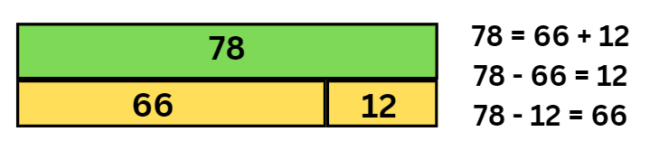
Note: a bar model is made up of rectangles, representing the part-part-whole relationship. The whole bar on top is labelled 78 and the 2 rectangles below are labelled 66 and 12. The rectangles are collectively the same length as the whole bar and show the proportion of their value.
- Repeat the task for a new target number.
This table details opportunities for assessment.
Assessment opportunities | Links
What to look for:  - Can students demonstrate how addition and subtraction are inverse operations? [MAO-WM-01, MA2-AR-01] | Links to National Numeracy Learning Progressions (NNLP):  - AdS7.

Core lesson – equal chance – 40 minutes
The table below contains suggested learning intentions and success criteria. These are best co-constructed with students.
Core concept learning intentions | Core concept success criteria
Students are learning to:  - identify possible outcomes from chance experiment  - describe the likelihood of outcomes of chance events. | Students can:  - use the term outcome to describe any possible result of a chance experiment  - use the terms equally likely, likely and unlikely to describe the chance of everyday events occurring  - compare the likelihood of obtaining particular outcomes in a simple chance experiment by predicting, conducting the experiment and comparing the results with the prediction.
Note: the purpose of this lesson is to explore how an equally likely outcome, such as a 1 in 2 chance, can be represented differently.
This lesson is an adaptation from Module 3 ‘Hexagon Fill’ from Big ideas to start strong across K–6 by State of New South Wales (Department of Education).
- Draw or display Resource 23 – mystery bags on the whiteboard.
- Draw a red, blue, purple and yellow counter in each bag. Ask:
- What is the chance of pulling out a red counter from each bag? (1 in 4)
- How can we change what is in each bag to have a 1 in 2 chance of picking a red counter? (Work through Resource 24 – mystery bags support)
- What does a 1 in 2 chance mean in this game? (For every 2 counters, one counter is red.)
- Provide students with a selection of coloured counters and Resource 23 – mystery bags. In small groups students represent a 1 in 3 chance in different ways.

This table details opportunities for differentiation.
Too hard? | Too easy?
Students cannot identify possible outcomes from chance experiments.  - Reduce the challenge by providing students with 2 mystery bags instead of 3.  - Students can use 2 coloured counters instead of 3. | Students can identify possible outcomes from chance experiments.  - Students sort counters to represent a 1 in 5 chance. Discuss the minimum and maximum quantities they can use.  - Ask students to consider if having an equal chance of picking a red counter across all 3 bags means the game is fair. (It is fair if the outcome is to pick a red counter from any bag, but, within each bag themselves, there is not an even chance of picking a red counter).

Discuss and connect the mathematics – 10 minutes
- Summarise key mathematical concepts and discuss as a class:
- What could a 1 in 3 chance look like? What did you need to consider?
- What language or representation helped your thinking? For example, for every 3 counters, one of them is red or grouping the counters into groups of 3 where one is red.
- How did a 1 in 2 chance look different or the same as a 1 in 3 chance?
- Which has a higher chance of occurring: a 1 in 2 chance or a 1 in 3 chance? Why?
This table details opportunities for assessment.
Assessment opportunities | Links
What to look for:  - Can students use the term outcome to describe any possible result of a chance experiment? [MAO-WM-01, MA2-CHAN-01]  - Can students use the terms equally likely, likely and unlikely to describe the chance of everyday events occurring? [MAO-WM-01, MA2-CHAN-01]  - Can students compare the likelihood of obtaining particular outcomes in a simple chance experiment by predicting, conducting the experiment and comparing the results with the prediction? [MAO-WM-01, MA2-CHAN-01] | Links to National Numeracy Learning Progressions (NNLP):  - UnC3, CPr8.

Lesson 8
Core concept: record and compare the results of chance experiments.

Daily number sense – 10 minutes
- From a class need surfaced through formative assessment data, identify a short, focused activity that targets students’ knowledge, understanding and skills. Example activities may be drawn from the following resources:
- Mathematics K–6 resources
- Universal Resources Hub.

Core lesson – combinations – 35 minutes
The table below contains suggested learning intentions and success criteria. These are best co-constructed with students.
Core concept learning intentions | Core concept success criteria
Students are learning to:  - identify possible outcomes from chance experiments  - describe the likelihood of outcomes of chance events. | Students can:  - record all possible combinations in a chance situation where the outcomes are equally likely  - compare the likelihood of obtaining particular outcomes in a simple chance experiment by predicting, conducting the experiment and comparing the results with the prediction.
Note: the purpose of this lesson is to develop a systematic approach to listing all possible outcomes in a chance situation. Some students may draw the connection that by listing combinations, they can then describe the likelihood of a particular combination occurring.
This lesson is an adaptation of The Hair Colour Game from NRICH by University of Cambridge (Faculty of Mathematics).
- Display Resource 25 – coloured cubes key. Explain the categories on the key.
- Provide students with a collection of coloured cubes or writing materials.
- Ask pairs of students to work out how many clothing combinations they can represent using the coloured cubes.
- Regroup as a class and ask students:
- What strategy did you use when making your combinations? (For example, starting with one colour of shorts and adding all the different colour T-shirts)
- Have you made every combination possible? How do you know?
- What is the most effective way to represent the combinations so that you can visualise the situation? (Shorts on the bottom and T-shirts on the top)
- Is there another way to represent our thinking? (Using a tree diagram)
- Model combinations using a tree diagram and discuss how this representation can be used to systematically include possible combinations, see Figure 12.
Figure 12 – tree diagram
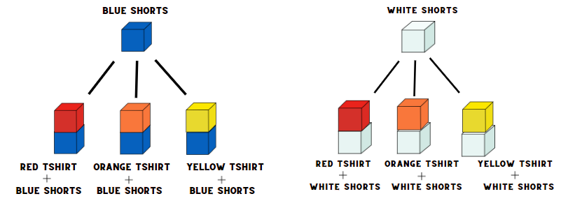
- In pairs, students can use coloured cube models to support thinking. Ask students to Think-Pair-Share using the questions from the prompt table.

The table below outlines stimulus prompts to generate conversation about the topic, along with anticipated responses from students.
Prompts | Anticipated student responses
- What is the chance that a student is wearing blue shorts? | - There are only 2 colours of shorts, so it is a 1 in 2 chance.
- Is it equally likely that a student is wearing different colour shorts? Explain your reasoning. | - Yes, because there are only 2 colours of shorts, they must be wearing one of the 2.
- What is the chance that a student is wearing an orange T-shirt? | - 1 in 3 because there are 3 T-shirt colours.
- Is it equally likely that a student will not be wearing an orange T-shirt? Explain your reasoning. | - Yes, because they are either wearing an orange T-shirt or not. (Misconception)  - No because there are 2 other colours they could wear, so there is a 1 in 3 chance of wearing orange and a 2 in 3 chance of wearing something else.  - The student is twice as likely not to be wearing orange.
- Is it less likely that a student is wearing a red T-shirt than an orange T-shirt? Explain your reasoning. | - No, it is the same.  - There is still a 1 in 3 chance that they will wear red.
- Is it equally likely that a student is wearing a red T-shirt or an orange T-shirt? Explain your reasoning. | - Same as above.
- If the teacher gives a prize to all students wearing white shorts, does everyone have a fair chance of winning? | - Yes, because there are only 2 options for shorts, and both represent a 1 in 2 chance. Therefore, all students are equally likely to win.
- If the teacher gives a prize to all students wearing an orange T-shirt, does everyone have a fair chance of winning? | - No, because there are 3 options for T-shirts and orange represents a 1 in 3 chance, therefore 2 in 3 students do not have a chance of winning.
- Students share their thinking with the class.
This table details opportunities for differentiation.
Too hard? | Too easy?
Students cannot identify possible outcomes from chance experiments.  - Students only use manipulatives to list possible outcomes of combination events.  - Students use 2 pairs of shorts and 2 coloured T-shirts to form combinations. | Students can identify possible outcomes from chance experiments.  - Students use 3 different T-shirts and 3 different shorts to make combinations.  - Students create a bingo board to use in a game using the sum of 2 dice. See Resource 26 – two dice bingo. (Activity adapted from Two dice bingo from NRICH by University of Cambridge)

Consolidation and meaningful practice – 15 minutes
- Challenge students to consider the possible combinations if we added a third piece of clothing, for example, a hat in 2 different colours. Students create combinations using coloured cubes or the tree diagram.
- Regroup as a class and ask:
- This time, what strategy did you use when making your combinations?
- Have you made all the possible combinations? How do you know?
- How does an extra 2 items of clothing affect the number of combinations?
- Which representation most helped you to visualise the situation?

This table details opportunities for assessment.
Assessment opportunities | Links
What to look for:  - Can students record all possible combinations in a chance situation where the outcomes are equally likely?  [MAO-WM-01, MA2-CHAN-01]  - Can students compare the likelihood of obtaining particular outcomes in a simple chance experiment by predicting, conducting the experiment and comparing the results with the prediction? [MAO-WM-01, MA2-CHAN-01] | Links to National Numeracy Learning Progressions (NNLP):  - UnC3, CPr8.

Resource 1 – position representations
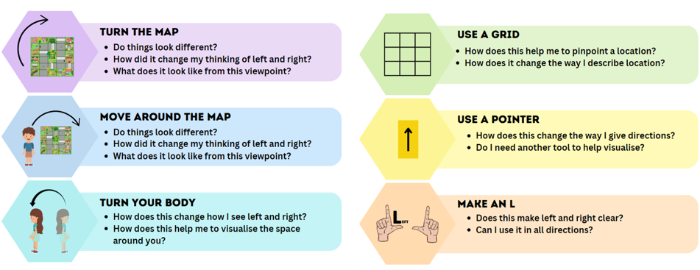

Resource 2 – object map
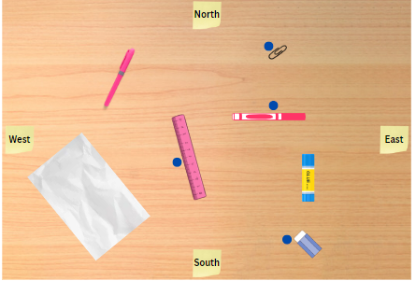

Resource 3 – pointer

Resource 4 – landmark map
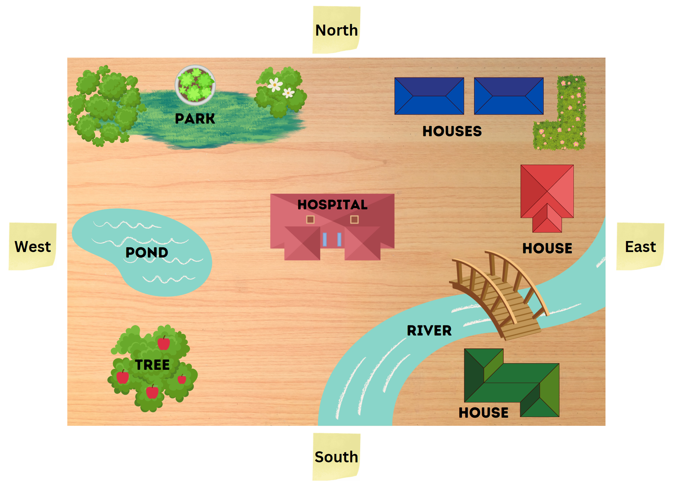

Resource 5 – bookshelf
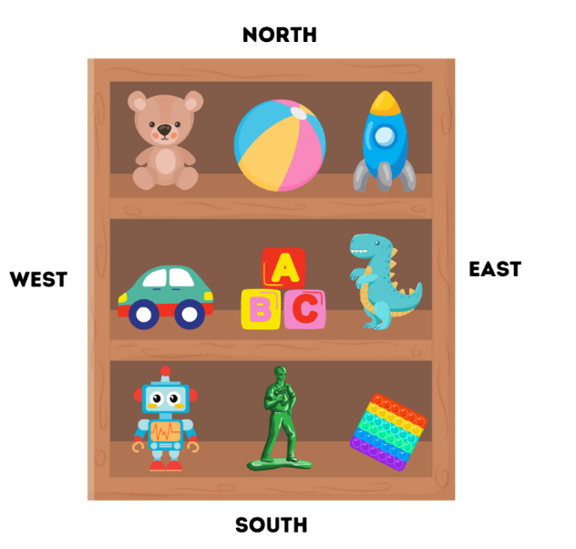

Resource 6 – bookshelf with grid
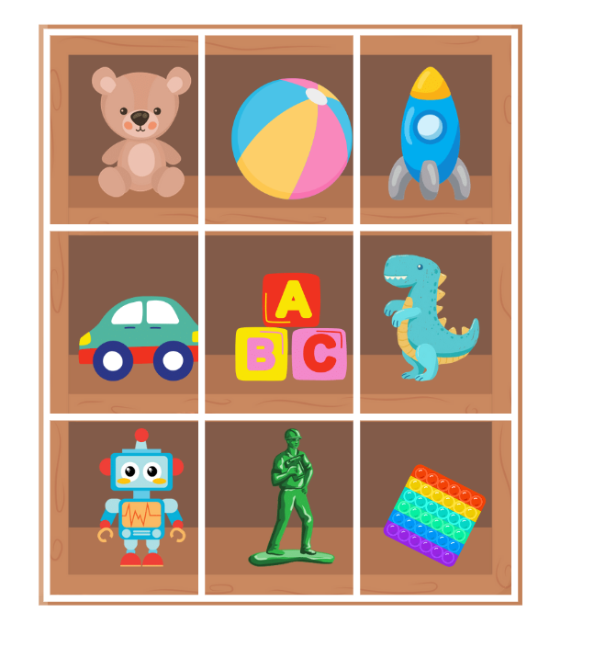

Resource 7 – landmark map with grid
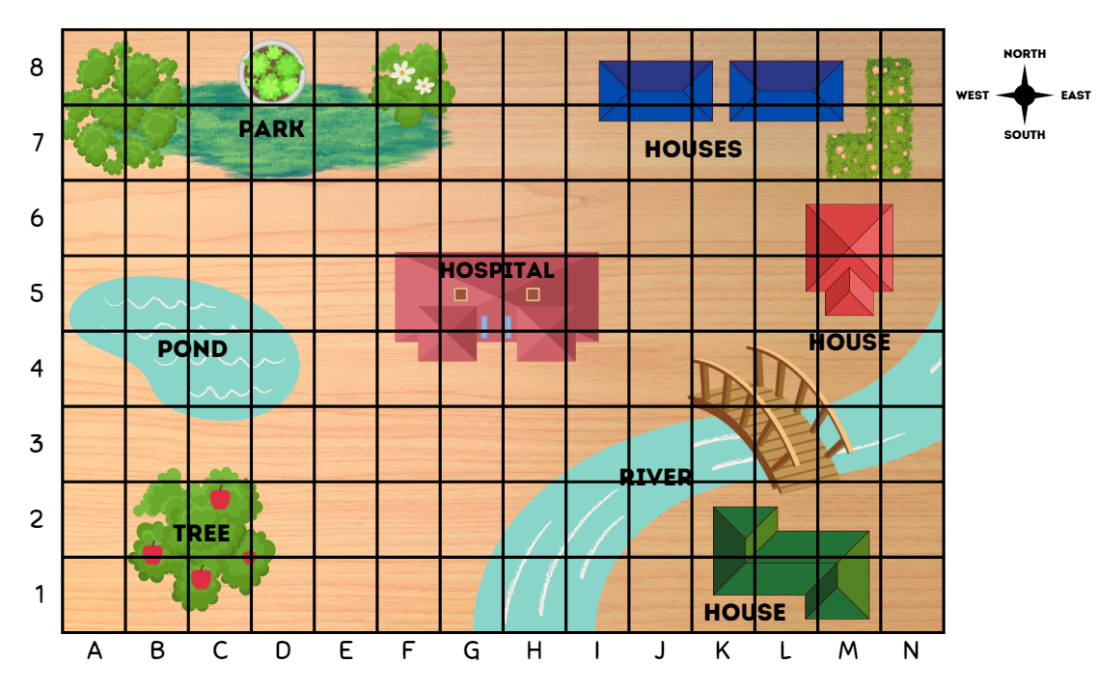

Resource 8 – Journey to Numberland
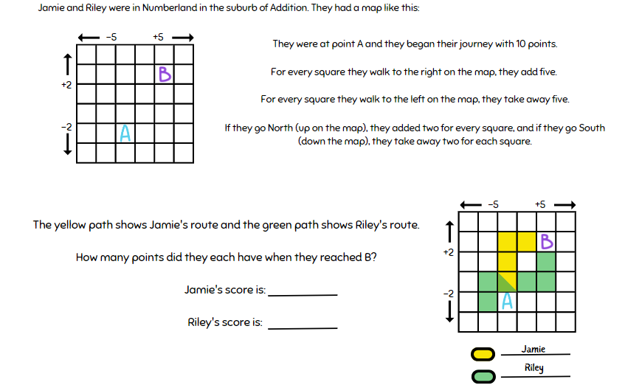
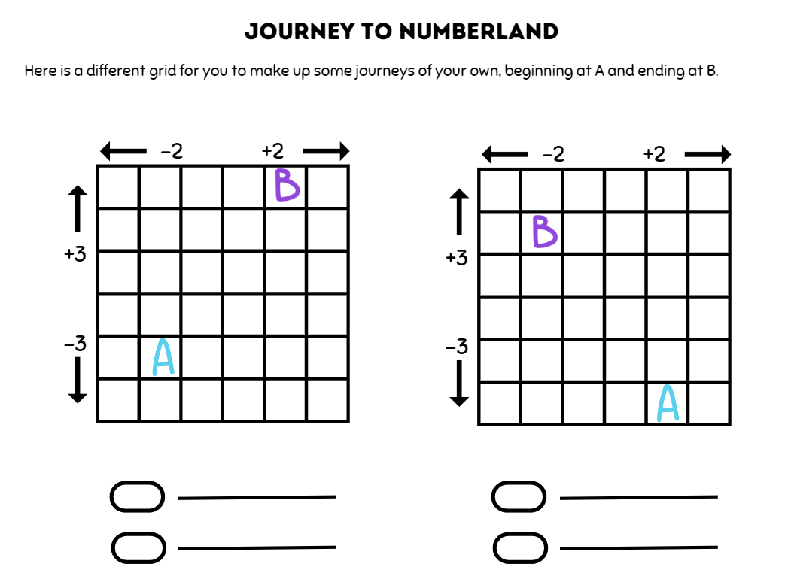

Resource 9 – example supermarket
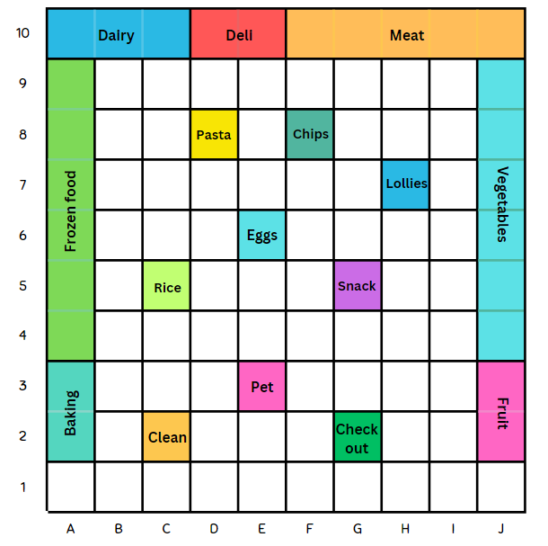

Resource 10 – supermarket instructions
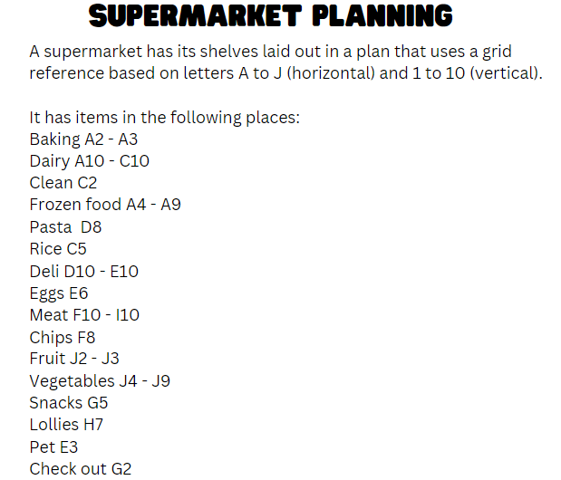

Resource 11 – 100 square grid

Resource 12 – shopping list
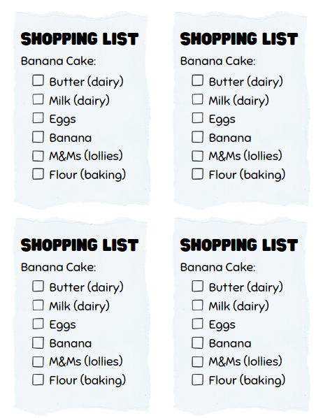

Resource 13 – supermarket map
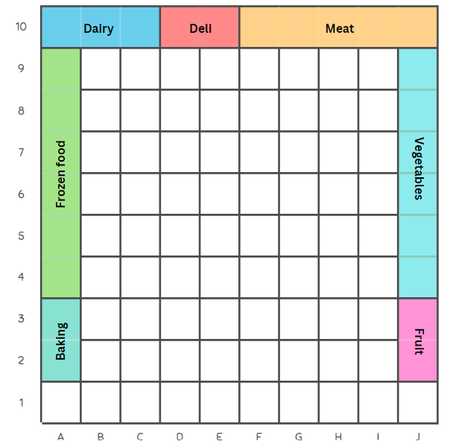

Resource 14 – supermarket instructions 2
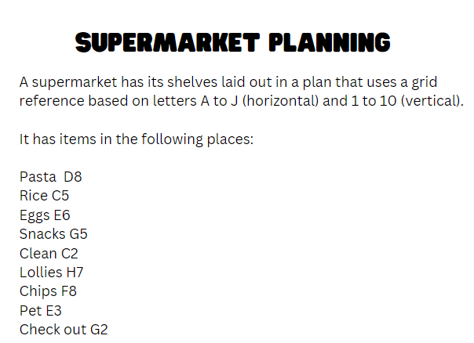

Resource 15 – chance representations
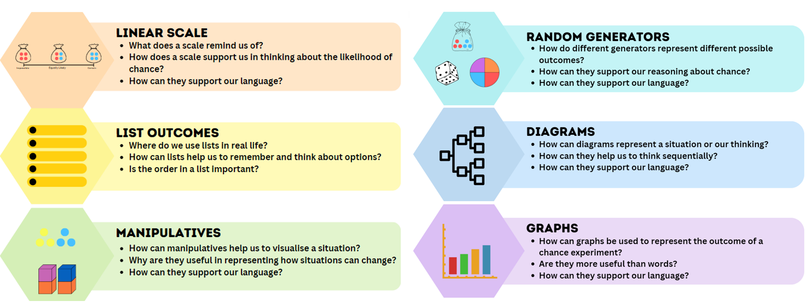

Resource 16 – chance scale
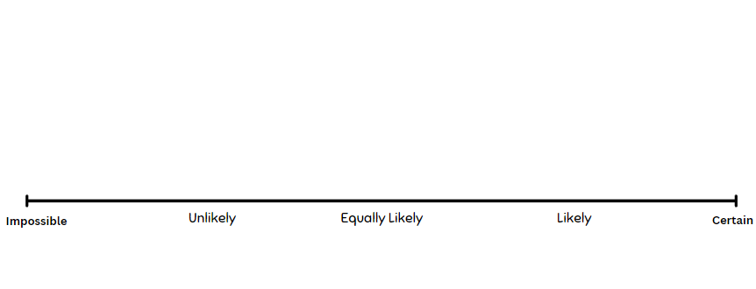

Resource 17 – chance statements
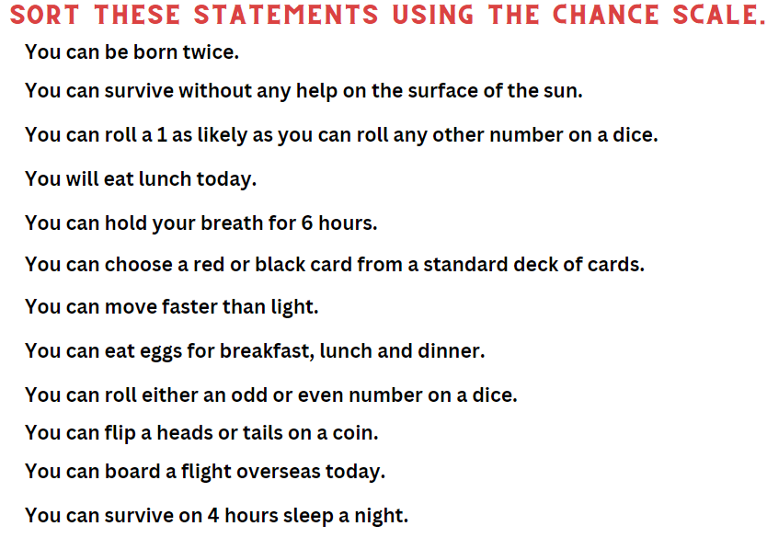

Resource 18 – carnival game
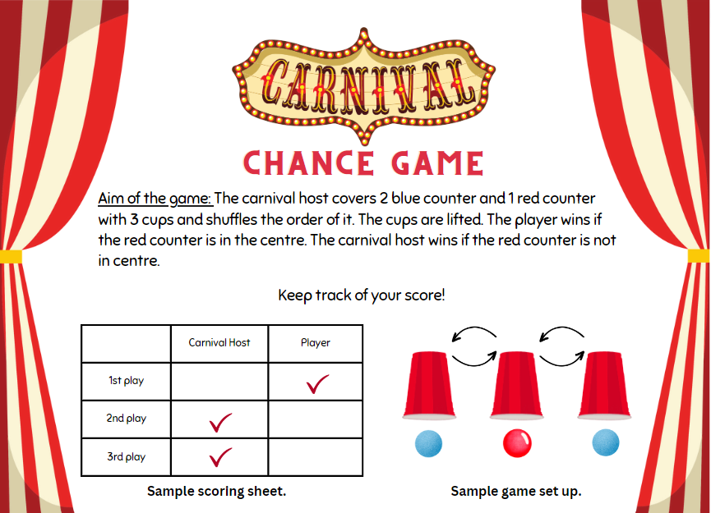

Resource 19 – what is fair?
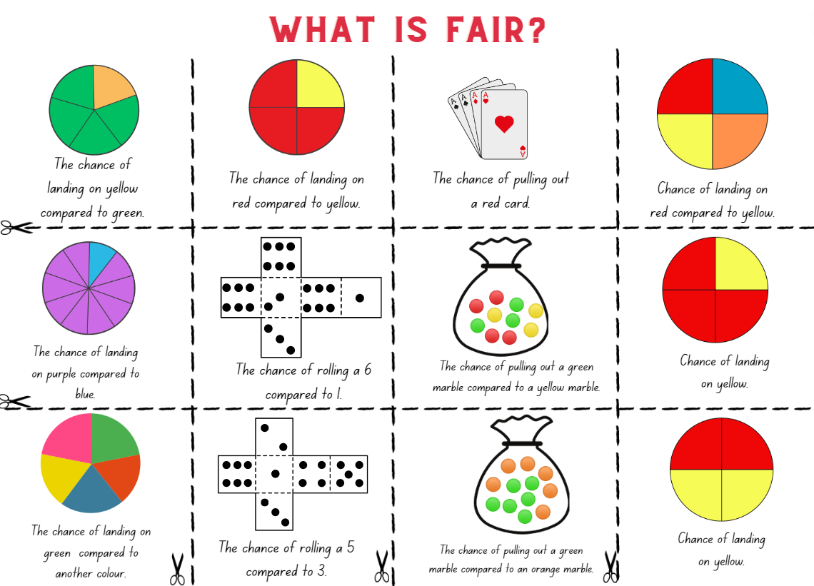
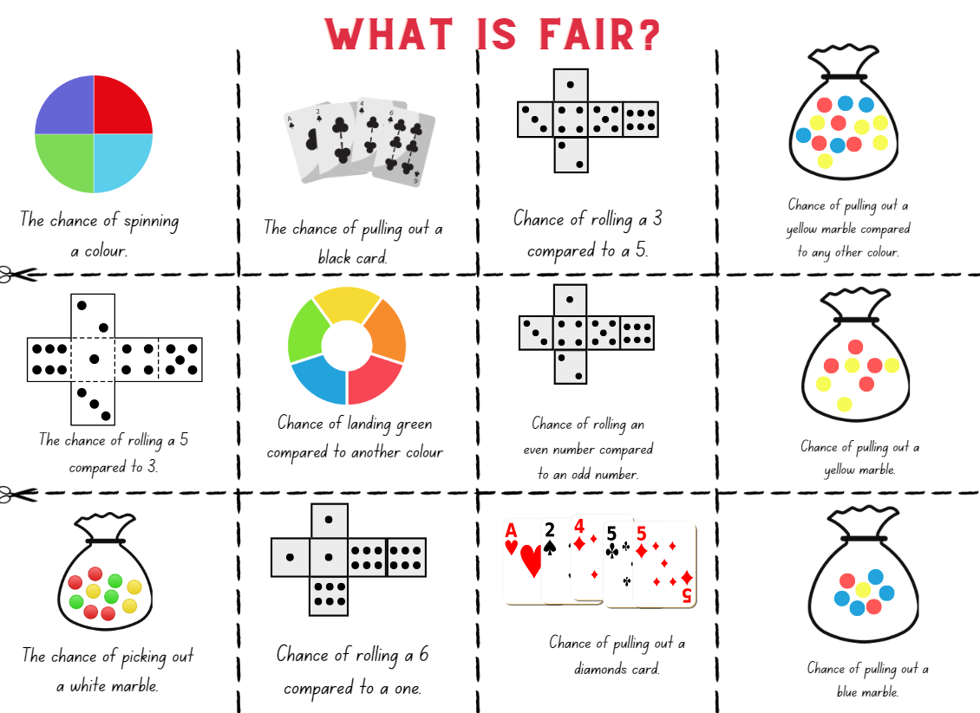

Resource 20 – fairness reference sheet
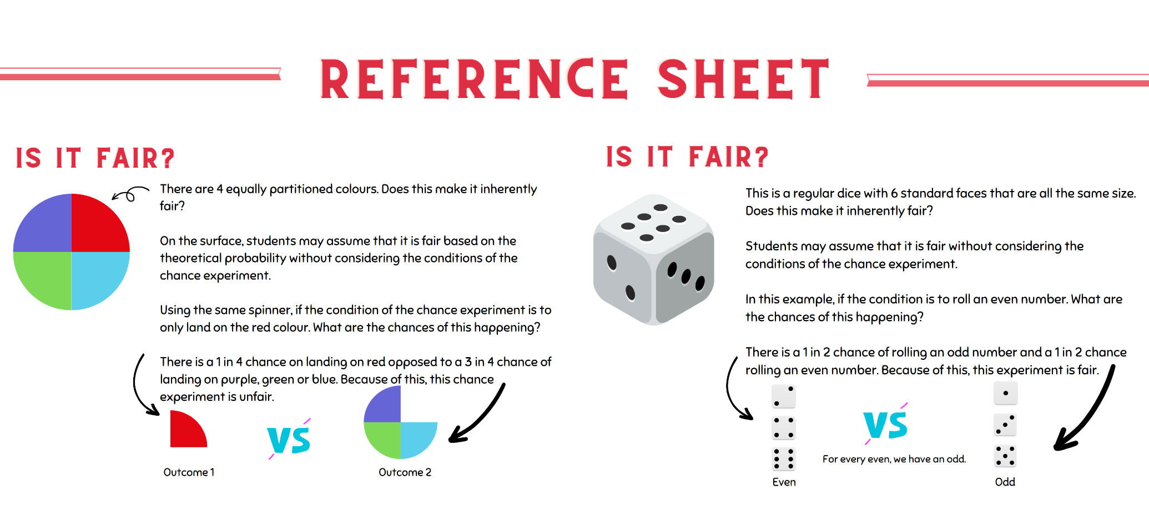

Resource 21 – random generators
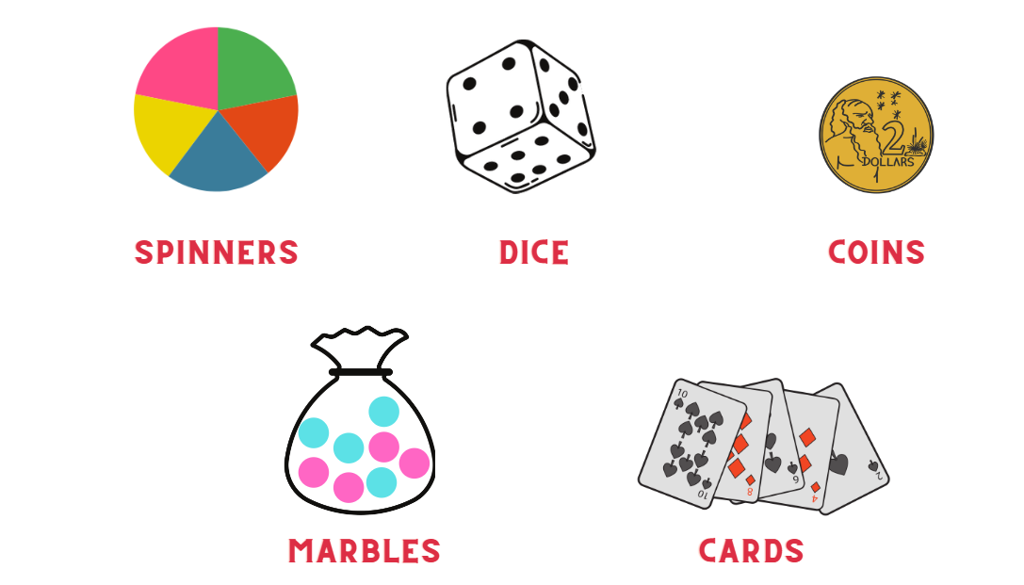

Resource 22 – carnival host v player
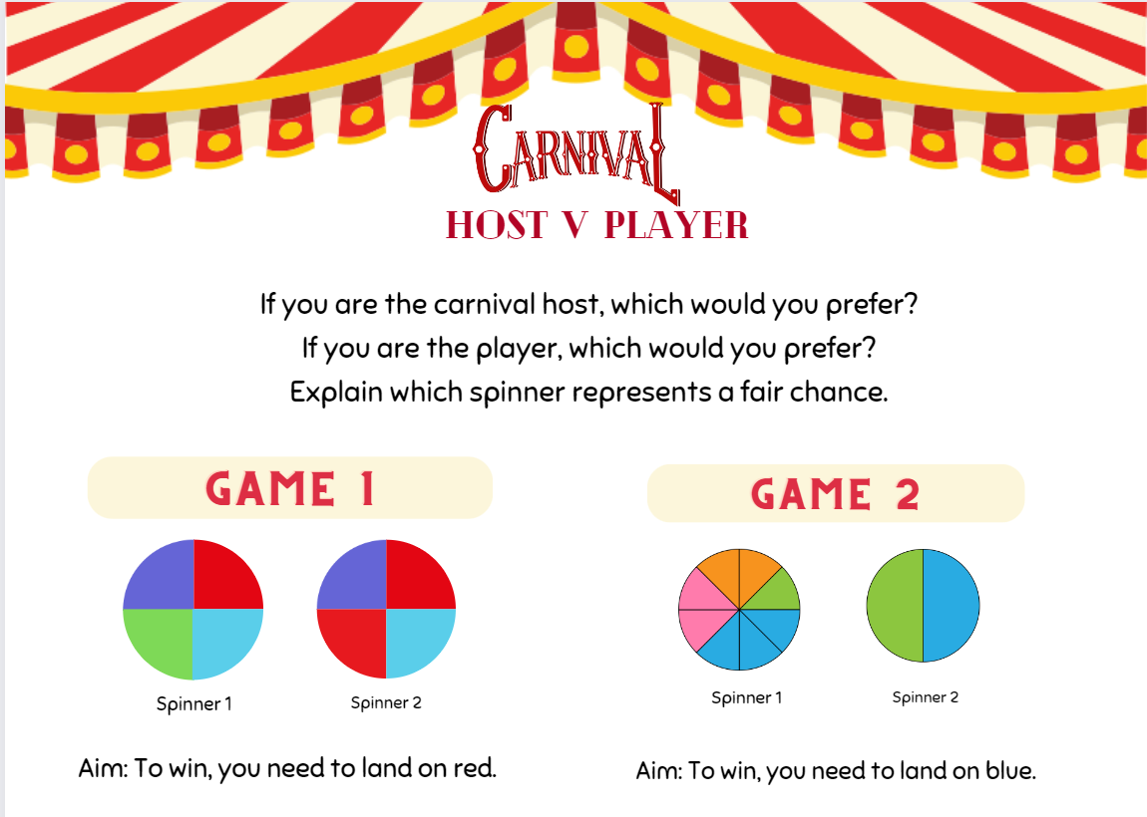

Resource 23 – mystery bags
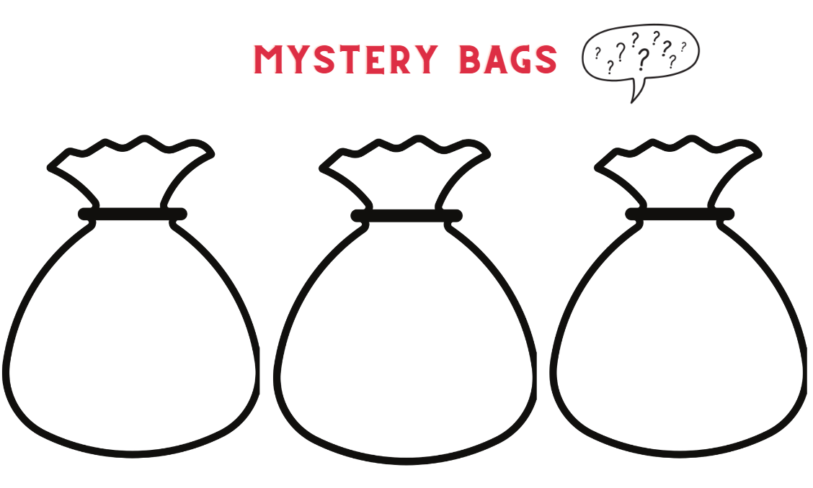

Resource 24 – mystery bags support
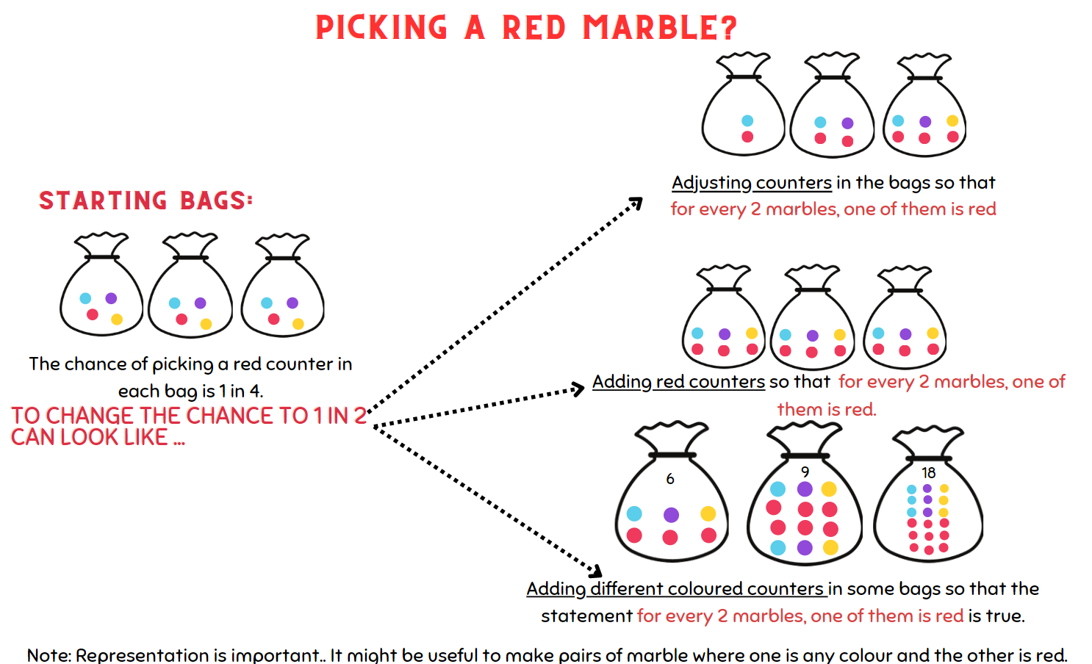

Resource 25 – coloured cubes key
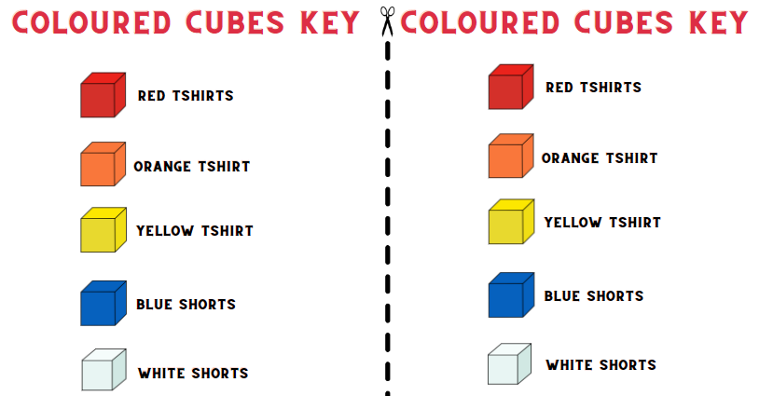

Resource 26 – two dice bingo
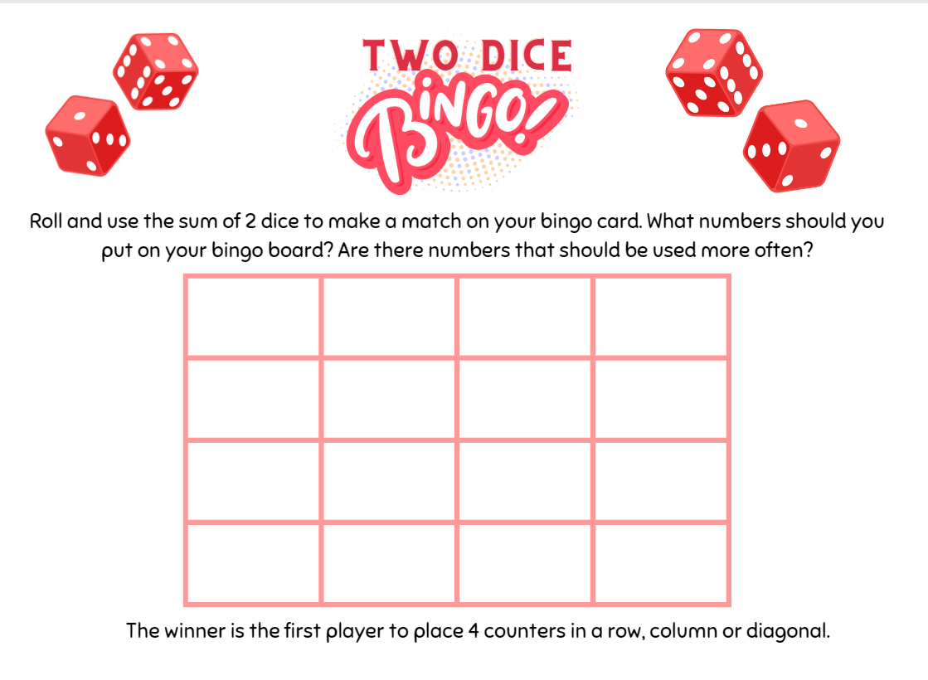

Syllabus outcomes and content
The table below outlines the syllabus outcomes and range of relevant syllabus content covered in this unit. Content is linked to National Numeracy Learning Progression version (3).
Outcomes and content | 1 | 2 | 3 | 4 | 5 | 6 | 7 | 8
Additive relations A: Recognise and explain the connection between addition and subtraction
MAO-WM-01, MA2-AR-01
- Use number relation principles to solve related problems (Reasons about relations) |  |  |  |  | x | x
- Demonstrate how addition and subtraction are inverse operations |  |  |  |  |  |  | x
- Use the complement principle of addition and subtraction (Reasons about relations) |  |  |  |  |  | x
- Explain and check solutions to problems, including by using the inverse operation |  |  |  |  | x
Partitioned fractions A: Model and represent unit fractions, and their multiples, to a complete whole on a number line
MAO-WM-01, MA2-PF-01
- Model fractions with fraction strips and diagrams for halves, quarters, eighths, thirds | x | x | x
- Determine the complementary fractional part needed to complete one whole (halves, quarters, eighths, thirds) (Reasons about relations) |  | x | x
- Recreate the whole unit from a fractional part ($\frac{1}{2}$, $\frac{1}{4}$, $\frac{1}{3}$ and $\frac{1}{8}$) (Reversible reasoning) |  | x | x
Geometric measure A: Position: Interpret movement on a map
MAO-WM-01, MA2-GM-01
- Orient a map to determine directions to travel | x | x
Geometric measure A: Position: Locate positions on grid maps
MAO-WM-01, MA2-GM-01
- Locate positions by coordinating horizontal and vertical references |  |  | x
- Use the array (row and column) structure of grid maps to locate position, horizontal before vertical |  |  | x | x
Geometric measure B: Position: Create and interpret grid maps
MAO-WM-01, MA2-GM-01
- Create simple maps and plans from an aerial view, labelling grid references |  |  |  | x
- Identify and mark locations on maps and plans, given their grid references |  |  | x | x
Geometric measure B: Position: Use directional language and describe routes with grid maps
MAO-WM-01, MA2-GM-01
- Use a given grid map and compass directions (N, S, E, W) to plan, describe and show a route from one location to another |  | x |  | x
- Use natural resources or landmarks to identify north, south, east, west | x
Chance A: Identify possible outcomes from chance experiments
MAO-WM-01, MA2-CHAN-01
- Use the term outcome to describe any possible result of a chance experiment |  |  |  |  | x |  | x
- Record all possible outcomes in a chance experiment where the outcomes are equally likely |  |  |  |  |  | x
- Record all possible combinations in a chance situation where the outcomes are equally likely |  |  |  |  | x |  |  | x
Chance B: Describe the likelihood of outcomes of chance events
MAO-WM-01, MA2-CHAN-01
- Use the terms equally likely, likely and unlikely to describe the chance of everyday events occurring |  |  |  |  | x |  | x
- Compare the likelihood of obtaining particular outcomes in a simple chance experiment by predicting, conducting the experiment and comparing the results with the prediction |  |  |  |  |  | x | x | x
Mathematics K–10 Syllabus © NSW Education Standards Authority (NESA) for and on behalf of the Crown in right of the State of New South Wales, 2022.

References
This resource contains NSW Curriculum and syllabus content. The NSW Curriculum is developed by the NSW Education Standards Authority. This content is prepared by NESA for and on behalf of the Crown in right of the State of New South Wales. The material is protected by Crown copyright.
Please refer to the NESA Copyright Disclaimer for more information https://educationstandards.nsw.edu.au/wps/portal/nesa/mini-footer/copyright.
NESA holds the only official and up-to-date versions of the NSW Curriculum and syllabus documents. Please visit the NSW Education Standards Authority (NESA) website https://educationstandards.nsw.edu.au/wps/portal/nesa/home and the NSW Curriculum website https://curriculum.nsw.edu.au/.
Mathematics K–10 Syllabus © NSW Education Standards Authority (NESA) for and on behalf of the Crown in right of the State of New South Wales, 2022.
National Numeracy Learning Progression © Australian Curriculum, Assessment and Reporting Authority (ACARA) 2010 to present, unless otherwise indicated. This material was downloaded from the Australian Curriculum website (National Numeracy Learning Progression) (accessed 15th October 2023 and was not modified.
Evolve Communities (12 May 2021) ‘What are Songlines? [video]’, Evolve Communities, YouTube, accessed 27 July 2023.
Malcolm L and Willis O (8 July 2016) ‘Songlines: the Indigenous memory code’, ABC listen, accessed 4 August 2023.
Math Engaged (n.d.) Rhythm & Fractions, Math Engaged website, accessed 10 August 2023.
Math for Love (2015) ‘Target number’, Lesson, Math for Love website, accessed 10 August 2023.
New Zealand Ministry of Education (n.d.) Banana cake, NZ Maths website, accessed 10 August 2023.
Nicholls C (20 December 2017) ‘Songlines: Tracking the Seven Sisters is a must-visit exhibition for all Australians’, The Conversation, accessed 10 August 2023.
NSW AECG (New South Wales Aboriginal Education Consultative Group Inc.) (2023) AECG [website] accessed 10 August 2023.
Queensland Rural Medical Education Australia (18 October 2013) ‘What are song lines?’ [video], Rural Medical Education Australia, YouTube, accessed 10 August 2023.
Siemon D, Warren E, Beswick K, Faragher R, Miller J, Horne M, Jazby D, Breed M, Clark J, Brady K (2020) Teaching Mathematics: Foundation to middle years, 3rd edn Oxford University Press, Australia.
State of New South Wales (Department of Education) (2023) Big ideas to start strong across K–6, Department of Education website accessed 10 August 2023.
State of New South Wales (Department of Education) (2023) Closest to 100, Department of Education website, accessed 10 August 2023.
University of Cambridge (Faculty of Mathematics) (2022) Two dice bingo, NRICH website, accessed 10 August 2023.
University of Cambridge (Faculty of Mathematics) (n.d.) Journeys in Numberland, NRICH website, accessed 10 August 2023.
University of Cambridge (Faculty of Mathematics) (n.d.) The Hair Colour Game, NRICH website, accessed 10 August 2023.
University of Cambridge (Faculty of Mathematics) (n.d.) Two and One, NRICH website, accessed 10 August 2023.
University of Melbourne (2023) ‘Stellar navigation and mathematics’, Aboriginal and Torres Strait Islander School Curricula: Resources, Indigenous Knowledge Institute website, accessed 26 July 2023.
Yubulyawan Dreaming Project (2015) ‘Gujingga Songline (featuring Yidumduma Bill Harney)’ [video], Paul Taylor, YouTube, accessed 26 July 2023.

Further reading
Van de Walle J, Karp K, Bay-Williams JM, Brass A, Bentley B, Ferguson S, Goff W, Livy S, Marshman M, Martin D, Pearn C, Prodromou T, Symons D and Wilkie K (2019) Primary and Middle Years Mathematics: Teaching Developmentally, 1st Australian edn, Pearson Education Australia, Melbourne.
© State of New South Wales (Department of Education), 2023
The copyright material published in this resource is subject to the Copyright Act 1968 (Cth) and is owned by the NSW Department of Education or, where indicated, by a party other than the NSW Department of Education (third-party material).
Copyright material available in this resource and owned by the NSW Department of Education is licensed under a Creative Commons Attribution 4.0 International (CC BY 4.0) license.
This license allows you to share and adapt the material for any purpose, even commercially.
Attribution should be given to © State of New South Wales (Department of Education), 2023.
Material in this resource not available under a Creative Commons license:
- the NSW Department of Education logo, other logos and trademark-protected material
- material owned by a third party that has been reproduced with permission. You will need to obtain permission from the third party to reuse its material.
Links to third-party material and websites
Please note that the provided (reading/viewing material/list/links/texts) are a suggestion only and implies no endorsement, by the New South Wales Department of Education, of any author, publisher, or book title. School principals and teachers are best placed to assess the suitability of resources that would complement the curriculum and reflect the needs and interests of their students.
If you use the links provided in this document to access a third-party's website, you acknowledge that the terms of use, including licence terms set out on the third-party's website apply to the use which may be made of the materials on that third-party website or where permitted by the Copyright Act 1968 (Cth). The department accepts no responsibility for content on third-party websites.

