Mathematics Stage 2 – Year A – Unit 4
Fractions represent multiple ideas and can be represented in different ways
Contents
Unit description and duration 5
Syllabus outcomes 5
Working mathematically 6
Student prior learning 6
Lesson overview and resources 8
Lesson 1 13
Daily number sense – What is half? – 10 minutes 13
Core lesson – a fraction represents equal parts of a whole – 40 minutes 15
Discuss and connect the mathematics – 10 minutes 18
Lesson 2 20
Daily number sense – partitioning a line – 10 minutes 20
Core lesson – my fraction wall – 45 minutes 21
Discuss and connect the mathematics – 10 minutes 25
Lesson 3 27
Daily number sense – broken fraction wall – 10 minutes 27
Core lesson 1 – representing fractions – 15 minutes 28
Core lesson 2 – making wholes – 20 minutes 30
Discuss and connect the mathematics – 10 minutes 31
Lesson 4 33
Daily number sense – 10 minutes 33
Core lesson 1 – finding the complement – 20 minutes 33
Core lesson 2 – fractions on a number line – 20 minutes 36
Discuss and connect the mathematics – 10 minutes 38
Lesson 5 40
Daily number sense – cover the multiples – 15 minutes 40
Core lesson – finding the whole – 40 minutes 42
Discuss and connect the mathematics – 5 minutes 45
Lesson 6 46
Daily number sense – doubling and doubling again – 15 minutes 46
Core lesson – complementary fractions – 35 minutes 47
Consolidation and meaningful practice – 10 minutes 50
Lesson 7 52
Daily number sense – What is missing? – 15 minutes 52
Core lesson – What could the whole be? – 45 minutes 53
Discuss and connect the mathematics – 10 minutes 57
Lesson 8 58
Daily number sense – 10 minutes 58
Core lesson – making and exceeding the whole – 40 minutes 58
Consolidation and meaningful practice – 10 minutes 63
Resource 1 – Is it exactly half? 65
Resource 2 – shaded fractional part 66
Resource 3 – Which one doesn’t belong? 67
Resource 4 – broken fraction wall 68
Resource 5 – fractions of a length 69
Resource 6 – quarters and tenths 70
Resource 7 – fractions on a number line 71
Resource 8 – complementary fractional parts 72
Resource 9 – ‘Multiples’ gameboard 73
Resource 10 – ‘Multiples’ rule cards 74
Resource 11 – finding the whole 75
Resource 12 – different sized wholes 76
Resource 13 – doubling and halving 77
Resource 14 – chocolate bar 1 78
Resource 15 – chocolate bar 2 79
Resource 16 – picture frame problem 80
Resource 17 – frame beginnings 81
Resource 18 – ‘Rob the nest’ score sheet 82
Syllabus outcomes and content 83
References 87

Unit description and duration
This unit introduces the big idea that fractions represent multiple ideas and can be represented in different ways.
In this 2-week unit students are provided opportunities to:
- create fractional and complementary parts of a length
- model, label and describe fractions through fraction strips and fraction walls
- recreate the whole from a fractional part.

Syllabus outcomes
- MAO-WM-01 develops understanding and fluency in mathematics through exploring and connecting mathematical concepts, choosing and applying mathematical techniques to solve problems, and communicating their thinking and reasoning coherently and clearly
- MA2-MR-01 represents and uses the structure of multiplicative relations to 10 × 10 to solve problems
- MA2-MR-02 completes number sentences involving multiplication and division by finding missing values
- MA2-PF-01 represents and compares halves, quarters, thirds and fifths as lengths on a number line and their related fractions formed by halving (eighths, sixths and tenths)

Working mathematically
In the Mathematics K–10 Syllabus, there is one overarching Working mathematically outcome (MAO-WM-01). The Working mathematically processes should be embedded within the concepts being taught. The Working mathematically processes present in the Mathematics K–10 Syllabus are:
- communicating
- understanding and fluency
- reasoning
- problem solving.
Mathematics K–10 Syllabus © NSW Education Standards Authority (NESA) for and on behalf of the Crown in right of the State of New South Wales, 2022.

Student prior learning
Before engaging in these teaching and learning activities, students would benefit from prior experience with:
- folding paper strips to find the midpoint, halves, quarters and eighths
- using concrete materials to identify the 2 equal or unequal parts of a whole
- using representations, such as drawings, diagrams and/or words to explore halves, quarters and eighths.
In NSW classrooms there is a diverse range of students, including Aboriginal and/or Torres Strait Islander students, students learning English as an additional language or dialect, high potential and gifted students and students with disability. Some students may identify with more than one of these groups or possibly all of them. Refer to Curriculum planning for every student – advice for further information.

Lesson overview and resources
The table below outlines the sequence and approximate timing of lessons, learning intentions and resources.
Lesson | Content | Duration and resources
Lesson 1  Daily number sense learning intention:  - model and represent unit fractions to complete a whole | Lesson core concept: a fraction represents equal parts of a whole.  Core concept learning intention:  - model and represent unit fractions to complete a whole on a number line | Lesson duration: 60 minutes  - Resource 1 – Is it exactly half?  - Resource 2 – shaded fraction part  - Equal length strips of paper  - Writing materials
Lesson 2  Daily number sense learning intention:  - model and represent unit fractions, and their multiples, to a complete whole on a number line | Lesson core concept: fractional parts can be made without repeated halving.  Core concept learning intention:  - model and represent unit fractions, and their multiples, to a complete whole on a number line | Lesson duration: 65 minutes  - Resource 3 – Which one doesn’t belong?  - Equal length strips of paper (coloured optional – 5 per student)  - Writing materials
Lesson 3  Daily number sense learning intention:  - model and represent unit fractions, and their multiples, to a complete whole on a number line | Lesson core concept: fraction strips can be used to represent fractions.  Core concept learning intention:  - model and represent unit fractions, and their multiples, to a complete whole on a number line | Lesson duration: 65 minutes  - Resource 4 – broken fraction wall  - Resource 5 – fractions of a length  - Resource 6 – quarters and tenths  - Writing materials
Lesson 4  Daily number sense learning intention:  - teacher-identified task based on student needs | Lesson core concept: fraction strips and number lines can be used to represent fractions.  Core concept learning intention:  - model and represent fractions to a complete whole on a number line | Lesson duration: 60 minutes  - Resource 5 – fractions of a length  - Resource 7 – fractions on a number line  - Resource 8 – complementary fractional parts  - Digital device (one per student pair)  - Website: Fraction number line  - Writing materials
Lesson 5  Daily number sense learning intention:  - identify multiples of 2, 4, 5 and 10 | Lesson core concept: partitioned fractions can have different sized wholes.  Core concept learning intention:  - model and represent unit fractions to a complete whole on a number line | Lesson duration: 60 minutes  - Resource 9 – ‘Multiples’ gameboard  - Resource 10 – ‘Multiples’ rule cards  - Resource 11 – finding the whole  - Resource 12 – different sized wholes  - Website: Cuisenaire Environment  - Coloured rods (optional)  - Digital device (one per student pair)  - Writing material
Lesson 6  Daily number sense learning intention:  - use arrays to establish multiplication facts from multiples of 2 and 4 | Lesson core concept: complementary fractional parts create a whole.  Core concept learning intention:  - model and represent unit fractions, and their multiples, to a complete whole on a number line | Lesson duration: 60 minutes  - A3 paper  - Glue  - Large collection of counters  - Paper strips  - Writing materials
Lesson 7  Daily number sense learning intention:  - use arrays to establish multiplication facts from multiples of 2 and 4, 5 and 10 | Lesson core concept: different sized wholes create different sized parts.  Core concept learning intention:  - model and represent unit fractions, and their multiples, to complete a whole on a number line | Lesson duration: 70 minutes  - Resource 13 – doubling and halving  - Resource 14 – chocolate bar 1  - Resource 15 – chocolate bar 2  - Resource 16 – picture frame problem  - Resource 17 – frame beginnings  - Glue  - Large paper  - Scissors  - Writing materials
Lesson 8  Daily number sense learning intention:  - teacher-identified task based on student needs | Lesson core concept: making and exceeding the whole.  Core concept learning intention:  - represent fractional quantities greater than one whole  - model equivalent fractions as lengths | Lesson duration: 60 minutes  - Resource 18 – ‘Rob the nest’ score sheet  - Different coloured beanbags  - Hoops  - Writing materials

Lesson 1
Core concept: a fraction represents equal parts of a whole.

Daily number sense – What is half? – 10 minutes
Daily number sense activities for Lessons 1 to 3 ‘activate’ prior number knowledge and support the learning of new content in the unit. These activities can also assist teachers to identify the starting points for learning by revealing the extent of students’ existing knowledge.
The table below contains a suggested learning intention and success criteria. These are best co-constructed with students.
Daily number sense learning intention | Daily number sense success criteria
Students are learning to:  - model and represent unit fractions to complete a whole. | Students can:  - model fractions with fraction strips and diagrams for halves.
- Explain that some words used in mathematics are also used in our everyday language. When we use them in mathematics the meaning is usually more precise or sometimes different from the everyday meaning. An example of this is the word ‘half’.
- Ask students, ‘Where have you seen or used the word ‘half’ outside of the maths classroom?’ For example, half-time, half-a-dozen, half-an-hour, halfback, halfway, 9-and-a-half years old.
- Explain that, sometimes in everyday use, half can be used to mean approximately half, close to half, breaking things into 2 pieces, or sharing things between 2 people.
- Ask students: ‘What does half mean in mathematics?’ Reinforce the understanding that half means exactly 2 parts that are equal.
- Display Resource 1 – Is it exactly half? Ask students to consider each example and determine which images represent half as exactly 2 parts that are equal and those that don’t.
- Invite students to draw, model or represent their own illustration of half. Discuss which representations accurately show half as a mathematical term.
Note: fractional language can be confusing. Students often use the fractional term ‘half’ as an everyday adjective to describe part of an object, rather than as a mathematical term related to equal partitioning of a known whole. Research suggests that tasks such as cutting toast or an apple to represent fractions can be misleading for students as the parts are NOT ‘exactly equal’. This is why it is not unusual to hear young children referring to the ‘bigger half’ (Gould 2013).
This table details opportunities for assessment.
Assessment opportunities | Links
What to look for:  - Can students model fractions with fraction strips and diagrams for halves? [MAO-WM-01, MA2-PF-01] | Links to National Numeracy Learning Progressions (NNLP):  - MuS6, InF2.  Links to suggested Interview for Student Reasoning (IfSR) tasks:  - IfSR-MT: 1B.1, 2B.2, 2B.6.

Core lesson – a fraction represents equal parts of a whole – 40 minutes
The table below contains a suggested learning intention and success criteria. These are best co-constructed with students.
Core concept learning intentions | Core concept success criteria
Students are learning to:  - model and represent unit fractions to complete a whole on a number line | Students can:  - model fractions with fraction strips for halves, quarters and eighths  - use fraction notation for halves, quarters and eighths.
Note: in Stage 2, fractions are represented by partitioning lengths. This enables students to measure with partitioned unit fractions. Stage 2 focuses on fractions with denominators of 2, 3, 4 and 8, as well as 5 and 10. They are represented as measures by partitioning lengths.
- Provide each student with 3 equal length strips of paper. Each strip should be a different colour.
- Students choose one strip and fold it in half.
- Ask students whether they have made a half or about a half. Students explain and justify their answers. Where necessary, students refold their strips to ensure it accurately represents 2 equal lengths of the whole strip.
- Students fold another paper strip in half, then half again. Before they open it out, ask:
- How many parts do you think you have made? How do you know?
- Are the parts equal? How do you know?
- Students unfold their paper strip to check their answer. Ask what the fraction name is for 4 equal parts.
- Students discuss how to fold the strip to show 8 equal parts, or eighths. Ask:
- What will you have to think about before folding the paper strip to find the fraction?
- How will you know that each part is an eighth of the whole length?
- How many equal parts will you have after you’ve folded to get an eighth?
- How many times will you need to repeatedly fold the strip in half to make eighths?
- Observe students while they are creating the fractional parts, reinforcing equality and the number of parts required for each fraction.
- State that fractions can be recorded in words or in symbols. Display the symbol for one-half (see Figure 1). Explain that the 2 shows how much the whole is (2 parts) and the 1 shows how many equal parts of the whole are selected (1 part).
Figure 1 – fraction notation
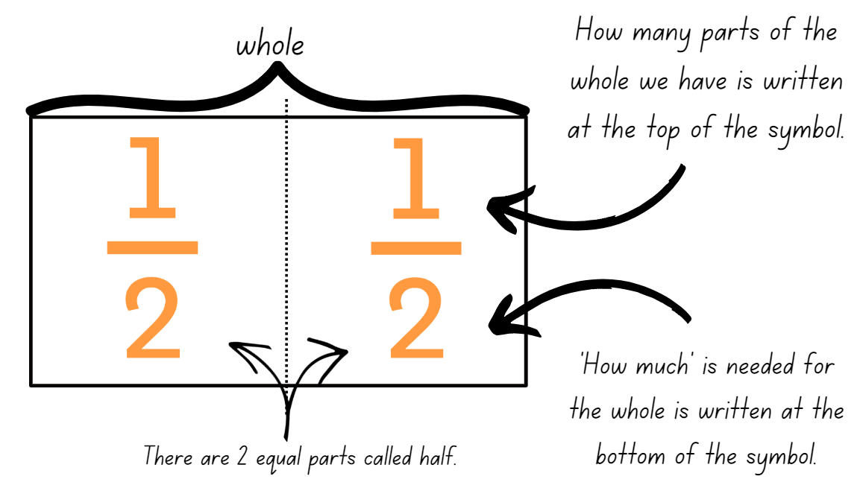
- Draw a strip on the board and partition it into quarters. Label the quarters with text ‘one-quarter’. Ask:
- What is the whole? How much is that? (4 parts)
- How many of the equal parts is each quarter? (1 part)
- How might you label each of the equal parts using the fraction symbol ($\frac{1}{4}$)
- Repeat with eighths.
- Students label their fraction strips using fraction notation. Use different coloured strips of paper or colour each strip in a different colour. These will be used in the next lesson to create a fraction wall.
Note: use language that will assist students to develop early fraction ideas. For example, rather than saying ‘1 over 2’, ‘1 of 2’ or ‘1 on 2’ (describing the symbol only), refer to the fractional relationship by saying ‘one half of the whole strip’. The teaching advice states that the terms numerator and denominator are used in Stage 3.
This table details opportunities for differentiation.
Too hard? | Too easy?
Students cannot model fractions with fraction strips for halves, quarters and eighths.  - Model halves by folding the strip into 2 equal parts to see the relationship between the parts and the whole length.  - Model repeatedly folding a strip to find quarters and eighths. Reinforce 8 parts make eighths, 4 parts make quarters and so on. | Students can model fractions with fraction strips for halves, quarters and eighths.  - Students make a poster describing fraction symbols and provide labelled examples.

Discuss and connect the mathematics – 10 minutes
- Display Resource 2 – shaded fraction part. Ask:
- What fraction of the whole is represented by the shaded part?
- Could the shaded part represent a half? Why or why not?
- How many times does the shaded part fit into the whole? How could we be sure of this?
- Provide students with the strip from Resource 2 – shaded fractional part and ask them to investigate by folding and labelling the equal parts with the fraction symbol ($\frac{1}{8}$).
- Students share and discuss their findings.
This table details opportunities for assessment.
Assessment opportunities | Links
What to look for:  - Can students model fractions with fraction strips for halves, quarters and eighths? [MAO-WM-01, MA2-PF-01]  - Can students use fraction notation for halves, quarters and eighths? [MAO-WM-01, MA2-PF-01] | Links to National Numeracy Learning Progressions (NNLP):  - InF2, InF3, InF4.

Lesson 2
Core concept: fractional parts can be made without repeated halving.

Daily number sense – partitioning a line – 10 minutes
The table below contains a suggested learning intention and success criteria. These are best co-constructed with students.
Daily number sense learning intention | Daily number sense success criteria
Students are learning to:  - model and represent unit fractions and their multiples to a complete whole on a number line. | Students can:  - model fractions for halves, quarters and eighths.
Note: this task could be recreated and completed outdoors as a hands-on task.
- Explain that Mrs Sutherland drew a line in the playground and needed to know where to mark a half, a quarter and an eighth of the line.
- Ask students, ‘How could the line be partitioned into half, quarters and eighths?’
- Students turn and talk and brainstorm strategies to partition the line into equal parts.
- Regroup and discuss ways to create a fraction using strategies other than repeated halving.
This table details opportunities for assessment.
Assessment opportunities | Links
What to look for:  - Can students model fractions for halves, quarters and eighths? [MAO-WM-01, MA2-PF-01] | Links to National Numeracy Learning Progressions (NNLP):  - InF2, InF3, InF4.

Core lesson – my fraction wall – 45 minutes
The table below contains a suggested learning intention and success criteria. These are best co-constructed with students.
Core concept learning intentions | Core concept success criteria
Students are learning to:  - model and represent unit fractions, and their multiples, to a complete whole on a number line. | Students can:  - model fractions with fraction strips for thirds, fifths, sixths and tenths  - create fractional parts of a length using techniques other than repeated halving.
- Students review their fraction strips showing halves, quarters and eighths from Lesson 1.
- Provide students with at least 5 more paper strips of different colours (or have students colour them with pencils). Explain they are going to create more fraction strips and use them to build a fraction wall.
- Ask students the name of the fraction that is created when a whole is divided into 3 equal parts. Write ‘one-third’ in words on the board.
- Remind students of the fraction notation they have learned about in the previous lesson: ‘How much’ is needed for the whole is written at the bottom of the fraction symbol. ‘How many’ parts of the whole we have is written on the top of the fraction symbol.
- Introduce the fraction symbol for one-third ($\frac{1}{3})$and ask students how this relates to what they know about ‘how much’ and ‘how many’. Ask:
- How many thirds make a whole?
- What is the same about a half and a third? What makes them different?
- Do you think it will be more challenging to fold a half or a third? Why?
- Students turn and talk about strategies to fold a paper strip into 3 equal lengths. Share and communicate ideas, for example:
- I could use what I know about a half and estimate that one-third is a little less than half. I could estimate the length of the parts and fold to check.
- I could make 2 folds by looping my whole paper strip and then keep adjusting them till they were equal (see Figure 2).
Figure 2 – making three equal lengths by looping
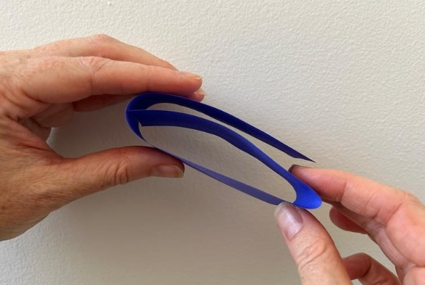
- Students problem solve in pairs or small groups to fold a strip into thirds. Check for accuracy. Reinforce equal lengths and using the full length of the strip to represent the whole.
- Students investigate different sequences of folds to produce different fractional lengths of fifths, sixths and tenths. For example:
- folding a strip into 5 equal parts, and name them as fifths (looping is the easiest strategy)
- folding a strip into 2 equal parts, then fold the halves into 3 equal parts to get sixths
- folding a strip into 3 equal parts, then folding the thirds in half. Ask why this results in the same number of equal parts as when folding the strip into halves, and then folding the halves into 3 equal parts.
- fifth, then halve to produce tenths
- halve, then fifth to produce tenths
- some students may third the thirds to produce ninths.
- Students label their fractions and order them by the length of each unit. Glue all strips onto A4 card to build a fraction wall (see Figure 3).
Figure 3 – my fraction wall
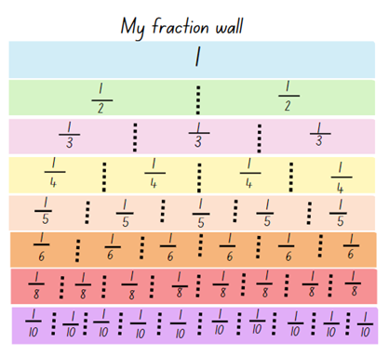
- Ask:
- How many halves make a whole?
- How many fifths make a whole?
- How many tenths make a whole?
- What else do you notice? Draw students’ attention to see that more partitions produce smaller equal parts and that some fractions are the same size on the wall, for example, 2 quarters, 3 sixths, 4 eighths and 5 tenths.
This table details opportunities for differentiation.
Too hard? | Too easy?
Students cannot model fractions with fraction strips for thirds, fifths, sixths and tenths or create fractional parts of a length using techniques other than repeated halving.  - Model creating thirds by holding the strip as a loop and estimating where 2 folds can be made to create 3 equal parts. Students check estimation by folding and comparing the 3 parts. Repeat to model fifths.  - Model fractions using concrete materials such as coloured rods.  - Students use their fraction wall to explore thirds, fifths, sixths and tenths. | Students can model fractions with fraction strips for thirds, fifths, sixths and tenths using techniques other than repeated halving.  - Students explore equivalence by folding strips of paper. They identify, create and label as many fractions equivalent to one-third as possible.

Discuss and connect the mathematics – 10 minutes
- Display Resource 3 – Which one doesn’t belong?
- Students consider what is the same and what is different about each picture. They communicate their reasoning to another student.
- As a class, share and discuss ideas explaining why one of the pictures does not belong.
- Some sample responses are:
- A doesn’t belong because it’s the only one that shows a whole divided into different sized parts.
- B doesn’t belong because it’s the only one that shows a half as equal sized curved lengths.
- C doesn’t belong because it’s the only one that shows a whole divided into 5 equal lengths.
- D doesn’t belong because it’s the only one that shows a half as two-quarters of a straight line.
This table details opportunities for assessment.
Assessment opportunities | Links
What to look for:  - Can students model fractions with fraction strips for thirds, fifths, sixths and tenths? [MAO-WM-01, MA2-PF-01]  - Can students create fractional parts of a length using techniques other than repeated halving? [MAO-WM-01, MA2-PF-01] | Links to National Numeracy Learning Progressions (NNLP):  - InF4, InF5.

Lesson 3
Core concept: fraction strips can be used to represent fractions.

Daily number sense – broken fraction wall – 10 minutes
The table below contains a suggested learning intention and success criteria. These are best co-constructed with students.
Daily number sense learning intention | Daily number sense success criteria
Students are learning to:  - model and represent unit fractions, and their multiples, to a complete whole on a number line. | Students can:  - determine the fractional part needed to make a whole.
- Display Resource 4 – broken fraction wall and explain that Maya’s little brother scribbled on her fraction wall. She has forgotten how many fractional parts are missing from each length.
- Students turn and talk and discuss how they could support Maya to understand what is missing.
- Students share their strategies with the class.
- Ask students, ‘How does the fraction symbol help you determine how many parts are needed to make the whole?’
This table details opportunities for assessment.
Assessment opportunities | Links
What to look for:  - Can students determine the fractional part needed to make a whole? [MAO-WM-01, MA2-PF-01] | Links to National Numeracy Learning Progressions (NNLP):  - InF3, InF4.

Core lesson 1 – representing fractions – 15 minutes
The table below contains a suggested learning intention and success criteria. These are best co-constructed with students.
Core concept learning intentions | Core concept success criteria
Students are learning to:  - model and represent unit fractions, and their multiples, to a complete whole on a number line. | Students can:  - model fractions using fraction strips and number line diagrams  - recreate the whole from a fractional part.
- Using student fraction walls, review concepts from the previous lessons. For example, ask students how many equal parts they have when they divide the whole length into quarters. State that 4 quarters make a whole. Repeat the process for thirds and fifths or according to student needs.
- Draw a line on the board to represent the whole length of a ribbon. Divide the line into 4 equal parts to show the fractional parts as quarters of the line, see Figure 4.
Figure 4 – fractions of a line
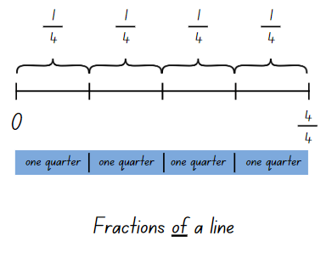
- Explain that each segment shows one-quarter of the whole. Demonstrate how to record the notation for the fractional parts above the line.
- Provide students with Resource 5 – fractions of a length. Students record the fractional notation for halves, thirds, quarters and eighths above the line.

Core lesson 2 – making wholes – 20 minutes
Note: when printing Resource 6 – quarters and tenths, ensure that each set makes the same size whole. Cut cards prior to the lesson.
- Tell students they are going to play a fractions game where they need to recreate the whole from a fractional part.
- Provide each student with Resource 6 – quarters and tenths.
Note: there are 2 different sized sets of wholes so half of the students will receive one size, and the remaining group will receive a different size. This encourages students to think about the size of the parts they combine with as they will need 4 equal sized quarters to form the whole.
- Students shade one-quarter of their strip and fold it so only the shaded quarter is showing.
- On a signal, students form groups to make exactly one whole or 4 quarters. When they have made a whole, students hold their strips next to each other to show 4 equal-sized quarters which makes a whole.
- Students then choose to keep one-quarter of their strip shaded or change the shaded fraction to represent two-quarters or three-quarters of the whole of the strip.
- On a signal, students combine to make a whole.
- Using Resource 6 – quarters and tenths, repeat the process for the fractions game with tenths. Students can choose to shade two-, three-,
four-, five- or six-tenths on their card.
This table details opportunities for differentiation.
Too hard? | Too easy?
Students cannot model fractions using fraction strips and number line diagrams or recreate the whole from a fractional part.  - Provide students with 2 strips of different lengths that have been folded into quarters. Students colour $\frac{1}{4}$ in red and $\frac{3}{4}$ in yellow and label the fractional parts that form the whole. | Students can model fractions using fraction strips and number line diagrams and recreate the whole from a fractional part.  - Students combine fractional parts other than quarters and tenths to make a whole.

Discuss and connect the mathematics – 10 minutes
- Explain that in the game students were recreating a whole from a fractional part. Ask:
- How did you know how many equal parts you needed to make the whole?
- How did you determine the fractional parts required to make the whole when students coloured more than one-quarter of their strip?
- If one person coloured two-quarters of their strip and another person coloured three-quarters of their strip, could they join their strips to make a whole? Why or why not?
- If one person had coloured three-tenths, how many more tenths would they need to recreate the whole?
- How does the fraction symbol help you determine how many parts are needed to make the whole? How could a number line help?
This table details opportunities for assessment.
Assessment opportunities | Links
What to look for:  - Can students model fractions using fraction strips and number line diagrams? [MAO-WM-01, MA2-PF-01]  - Can students recreate the whole from a fractional part?  [MAO-WM-01, MA2-PF-01] | Links to National Numeracy Learning Progressions (NNLP):  - InF2, InF3, InF4, InF5.

Lesson 4
Core concept: fraction strips and number lines can be used to represent fractions.

Daily number sense – 10 minutes
- From a class need surfaced through formative assessment data, identify a short, focused activity that targets students’ knowledge, understanding and skills. Example activities may be drawn from the following resources:
- Mathematics K–6 resources
- Universal Resources Hub.

Core lesson 1 – finding the complement – 20 minutes
The table below contains a suggested learning intention and success criteria. These are best co-constructed with students.
Core concept learning intentions | Core concept success criteria
Students are learning to:  - model and represent fractions to a complete whole on a number line. | Students can:  - model fractions with diagrams for halves, quarters, eighths and thirds on a number line  - determine the complementary fractional part needed to complete a whole.
- Review Maya’s broken wall (from Lesson 3) and the strategies that were used to repair Maya’s broken wall. Tell students they will be using the same thinking to complete the following investigation.
- Display Fraction number line.
- Drag a green whole length and 7 pink eighths onto the screen.
- Model finding the fraction represented by all the pink fractional parts together. Identify the complementary fractional part needed to complete one whole. Record using the pencil tool as shown in Figure 5.
Figure 5 – finding the complement
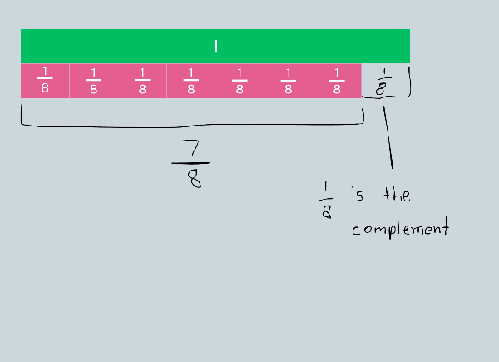
- Repeat, displaying 3 quarters and ask students to determine the complementary fractional part.
- Provide pairs of students with a digital device to use Fraction number line. Students take turns creating a fractional part for their partner. The partner identifies the complement and records this using the pencil tool. Repeat and swap roles.
This table details opportunities for differentiation.
Too hard? | Too easy?
Students cannot determine the complementary fractional part needed to complete a whole.  - Provide students with a strip of paper and ask them to repeatedly halve it into quarters. Students colour 3 quarters and then determine the complementary fractional part by the number of parts left uncoloured. Repeat with eighths.  - Using Fraction number line students drag the green bar and 4 orange quarter-bars. Remove one quarter-bar to demonstrate the complement.  - Students use their fraction wall to identify complementary fractional parts. | Students can determine the complementary fractional part needed to complete a whole.  - Students find the complementary fractional part from non-unit fractions. For example, two-eighths.

Core lesson 2 – fractions on a number line – 20 minutes
- Revise how to record fraction notation of a length by labelling the equal parts above the line. Display Resource 5 – fractions of a length.
- Explain that fractions can also be represented as a number on a number line.
Note: the distinction between the 2 is that fractions of a length indicate a ‘part’ of a line or length and fractions as a number sit at a ‘point’ on a number line. This may be the first time students understand that there are numbers between 0 and 1.
- Draw a line on the board and label 0 and 1 to show where the line starts and finishes. Place 3 equally spaced marks on the line and explain that each mark represents the position of a fraction as a number.
- Students turn and talk and determine the fractions that would be placed on the number line between 0 and 1.
- Select students to name and label the marks using fraction notation (see Figure 6).
Figure 6 – fractions of a line and fractions on a line
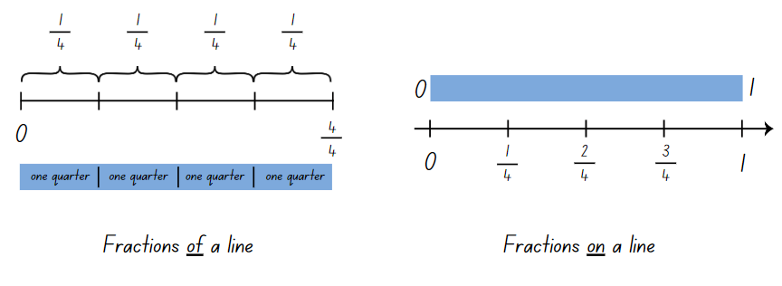
- Ask students to consider the similarities and differences between the 2 fraction representations and situations where each may be useful.
The table below outlines stimulus prompts to generate conversation about the topic, along with anticipated responses from students.
Prompts | Anticipated student responses
- What are some similarities between the 2 fraction representations? | - Both lines start at 0.  - Both represent quarters.  - There are 4 equal partitions on both lines.
- What are some differences between the 2 fraction representations? | - Fractions of a line – the line ends at $\frac{4}{4}$ whereas fractions on a line, the line ends at one but the arrow indicates it keeps going.  - Fractions of a line – the equal parts are labelled as $\frac{1}{4}$, but fractions on a line are labelled with the fraction as a number.  - Fractions on a line – indicates a number as a point on a number line.
- Can you think of any situations where either representation may be useful? | - Fractions of a line – cutting a slab cake into equal slices.  - Fractions on a line – units of measurement, for example measuring a $\frac{3}{4}$cup of milk.
- Repeat the number line demonstration with a line segmented into eighths.
- Provide students with Resource 7 – fractions on a number line. Students record the missing fractions on the number line.
This table details opportunities for differentiation.
Too hard? | Too easy?
Students cannot model fractions with diagrams for halves, quarters, eighths and thirds on a number line.  - Provide students with 3 strips of paper and have them repeatedly halve to create halves, quarters and eighths. Glue the strips onto paper and draw a number line directly under each strip. Support students to create marks on the line where the fold lines are and label the fractions on the number line.  - Students can use their fraction wall as a scaffold to help make diagrams for halves, quarters and thirds on the number line. | Students can model fractions with diagrams for halves, quarters, eighths and thirds on a number line.  - Students draw a number line from 0–2 and label the fractions for halves, quarters, eighths and thirds.

Discuss and connect the mathematics – 10 minutes
- Display Resource 8 – complementary fractional parts. Students determine the complementary fractional part needed to complete the whole for each length.
Complement: the amount you must add to something to make it ‘whole’ (Math Open Reference 2011).
- Share the definition of ‘complement’. Ask students how this definition supports their understanding of complementary fractional parts.
This table details opportunities for assessment.
Assessment opportunities | Links
What to look for:  - Can students model fractions with diagrams for halves, quarters, eighths and thirds on a number line? [MAO-WM-01, MA2-PF-01]  - Can students determine the complementary fractional part needed to complete a whole? [MAO-WM-01, MA2-PF-01] | Links to National Numeracy Learning Progressions (NNLP):  - InF2, InF3, InF4.

Lesson 5
Core concept: partitioned fractions can have different sized wholes.

Daily number sense – cover the multiples – 15 minutes
Daily number sense activities for Lessons 5 to 7 ‘loop’ back to concepts and procedures covered in previous units to assist students to build an increasingly connected network of ideas. These concepts may differ from the core concepts being covered by the unit.
The table below contains a suggested learning intention and success criteria. These are best co-constructed with students.
Daily number sense learning intention | Daily number sense success criteria
Students are learning to:  - identify multiples of 2, 4, 5 and 10. | Students can:  - identify multiples of 2, 4, 5 and 10  - relate doubling to multiplication facts for multiples of 2
This activity is an adaptation of Common Multiples from NZ Maths by New Zealand Ministry of Education.
- Display Resource 9 – ‘Multiples’ gameboard. Model the game by randomly choosing a card from Resource 10 – ‘Multiples’ rule cards and asking which numbers can be covered up with counters. For example, getting the rules card 4 means that the multiples 4, 8, 12, 16, 20, 24, 28 and 32 can be covered. Place the rules card on the bottom of the pile and draw another card. As you model the game, highlight patterns related to multiples such as doubles.
- Repeat twice more. If a number is identified as a multiple of more than one rules card, multiple counters can be placed on that number. For example, 20 will be a multiple of 2, 5 and 10.
- After 3 turns, count how many numbers on the gameboard are covered.
- Provide small groups of students with Resource 9 – ‘Multiples’ gameboard and Resource 10 – ‘Multiples’ rule cards. Students take turns to draw a rules card. They cover the multiples of that rule card on their gameboard only and justify their thinking. After 3 turns each, students work out who has covered the most multiples.
- Ask students to identify and discuss which numbers have more than one counter on them and why some numbers on their board are uncovered.
- Some students may enjoy the challenge of:
- working with other multiples, such as 3, 7 and 9, and making their own gameboards to play with
- thinking about why some numbers on the gameboard never get covered.
This table details opportunities for assessment.
Assessment opportunities | Links
What to look for:  - Can students identify multiples of 2, 4, 5 and 10?  [MAO-WM-01, MA2-MR-01]  - Can students relate doubling to multiplication facts for multiples of 2? [MAO-WM-01, MA2-MR-01] | Links to National Numeracy Learning Progressions (NNLP):  - MuS6.

Core lesson – finding the whole – 40 minutes
The table below contains a suggested learning intention and success criteria. These are best co-constructed with students.
Core concept learning intentions | Core concept success criteria
Students are learning to:  - model and represent unit fractions to complete a whole on a number line. | Students can:  - recreate the whole unit from a fractional part.
This activity has been adapted from Primary and Middle Years Mathematics: Teaching Developmentally, 1st Australian edn by Van De Walle et al.
- Display Cuisenaire Environment and drag one of each rod onto the background. Explain that these rods will help to visualise the fractions in the following questions (see Figure 7).
Figure 7 – Cuisenaire Environment
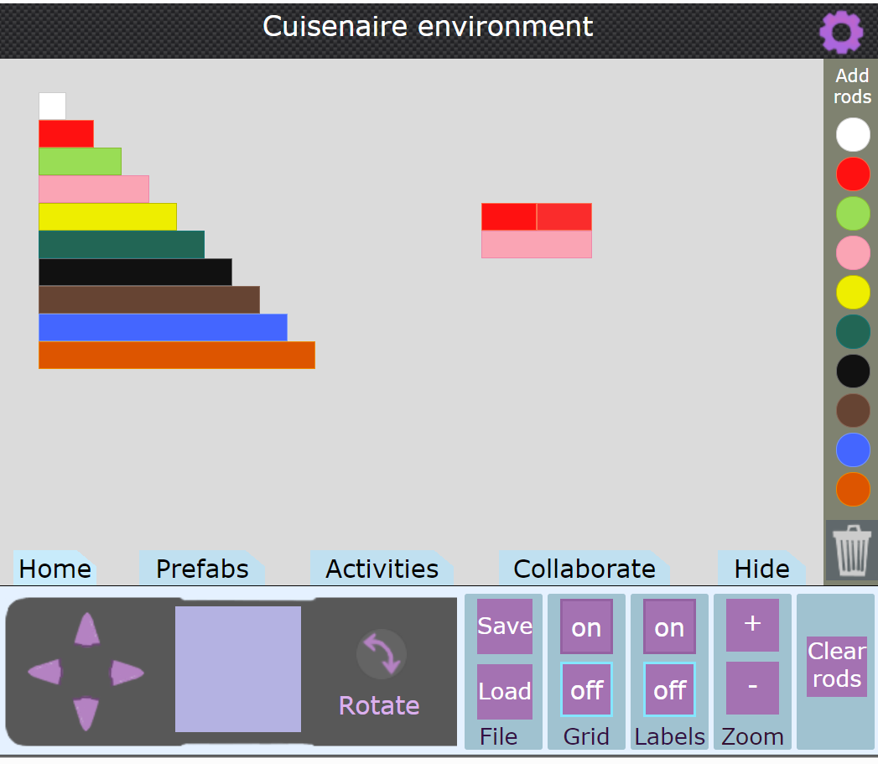
Image created using Cuisenaire Environment by University of Cambridge.
- Drag a red rod onto the background. Explain that this red rod is half the length of the whole. Ask students, ‘Which coloured rod is the whole?’
- Students turn and talk to determine the length of the whole.
- Prompt students to communicate their reasoning to the class.
- Model dragging an additional red block onto the background to make two-halves. Explain that two-halves is equivalent to the whole length. Drag the equivalent rod of the same length underneath, showing the pink rod represents the whole.
- Provide pairs with a digital device to access Cuisenaire Environment.
- Display Resource 11 – finding the whole and have students to investigate the lengths of each whole when given a fractional part.
- Regroup as a class and select students share their findings.
- Explain to students that we can use reversible reasoning to find the length of a fractional part if we know the length of the whole. Pose the following question for students to solve: If brown is the whole, find one-quarter. (red)
This table details opportunities for differentiation.
Too hard? | Too easy?
Students cannot recreate the whole unit from a fractional part.  - Students complete questions 1, 4, 5, 8, 9 and 10 which recreate the whole from one fractional part.  - Use hands on materials such as coloured rods or coloured strips of paper to manipulate the fractional parts. | Students can recreate the whole unit from a fractional part.  - Students create their own ‘coloured rods’ from coloured paper strips, ensuring equal sized wholes before folding and cutting fractional parts.  - Students solve the following problems:  - If dark green is one whole, which rod is two-thirds? (pink)  - If dark green is one whole, which rod is three-halves? (blue)  - Students create their own problems for their partner to solve.

Discuss and connect the mathematics – 5 minutes
- Display Resource 12 – different sized wholes. Explain that each image represents 2 halves and a whole.
- Using the interactive whiteboard (or an enlarged printed copy), draw a number line under each whole. Record the marks for zero, half and one. Ask:
- If you joined a light green rod and a yellow rod to make a new whole, would they still represent halves of the whole? Why or why not?
- How do different sized wholes impact the size of the fractional parts?
This table details opportunities for assessment.
Assessment opportunities | Links
What to look for:  - Can students recreate the whole unit from a fractional part? [MAO-WM-01, MA2-PF-01] | Links to National Numeracy Learning Progressions (NNLP):  - InF5.

Lesson 6
Core concept: complementary fractional parts create a whole.

Daily number sense – doubling and doubling again – 15 minutes
The table below contains a suggested learning intention and success criteria. These are best co-constructed with students.
Daily number sense learning intention | Daily number sense success criteria
Students are learning to:  - use arrays to establish multiplication facts from multiples of 2 and 4. | Students can:  - use the array structure to coordinate the number of groups with the number in each group  - relate doubling to multiplication facts for multiples of 2.
- Model placing 2 counters, then another two counters to make a 2 × 2 array. Ask students to describe what has happened. For example, doubling the 2 counters or making twice as many counters. Some students may say ‘adding’. Reinforce the multiplicative strategy of doubling.
- Ask students how many counters there will be if the number is doubled. Place 4 more counters to extend the array. Count the total number of counters aloud emphasising the doubling. For example, 2, double 2 is 4, double 4 is 8.
- Provide pairs of students with a large collection of counters.
- Ask students how many counters there will be if the total number is doubled again. Students use the counters to show doubling 8, using the counters to make an array. Count the total number of counters aloud emphasising the doubling. For example, 2, double 2 is 4, double 4 is 8, double 8 is 16.
- Students repeat the process again, modelling with counters and counting the doubling aloud.
- Discuss how doubling and doubling again can help to find an answer to a multiplication problem when multiplying by 4.
This table details opportunities for assessment.
Assessment opportunities | Links
What to look for:  - Can students use the array structure to coordinate the number of groups with the number in each group? [MAO-WM-01,  MA2-MR-01]  - Can students relate doubling to multiplication facts for multiples of 2? [MAO-WM-01, MA2-MR-01] | Links to National Numeracy Learning Progressions (NNLP):  - MuS5, MuS6.

Core lesson – complementary fractions – 35 minutes
The table below contains a suggested learning intention and success criteria. These are best co-constructed with students.
Core concept learning intentions | Core concept success criteria
Students are learning to:  - model and represent unit fractions, and their multiples, to a complete whole on a number line. | Students can:  - model fractions with strips and diagrams for halves, quarters, eighths and thirds  - describe complementary fractional parts needed to complete one whole.
The following activities have been adapted from Open-Ended Maths Activities: Using Good Questions to Enhance Learning Mathematics by Sullivan and Lilburn.
- Provide students with multiple strips of white paper.
- Pose the question: How many different ways can you colour the length so that $\frac{3}{4}$ is red and $\frac{1}{4}$ is yellow? See Figure 8 for examples of correct solutions.
Figure 8 – correct solutions
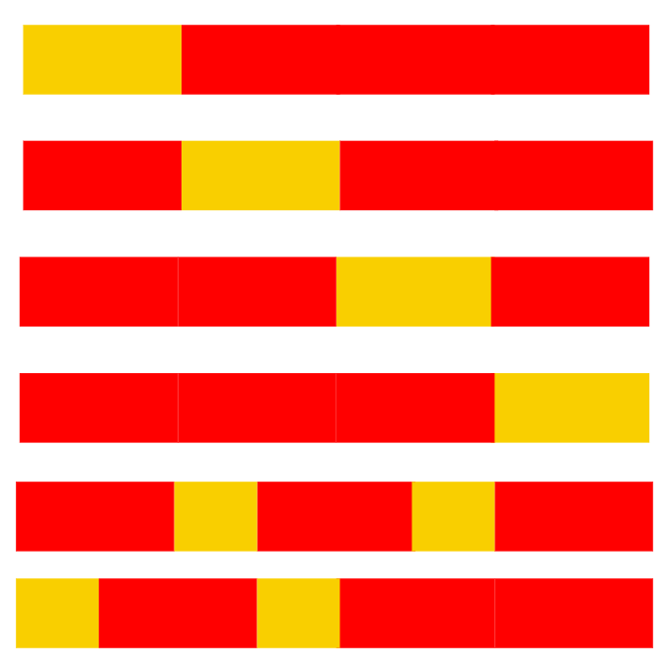
- Ask students to colour their lengths and label the fractional parts using fraction notation.
- Regroup and discuss the different options.
- Provide students with additional strips of paper. State that this time $\frac{2}{5}$of the strip is green and the rest is blue. What would the coloured strip look like? Students colour and label the fractional parts using fraction notation.
- Ask students to investigate possible options for what the strip might look like if 3 colours were used to represent fractional parts of the whole length where $\frac{3}{8}$ is green. For example, $\frac{3}{8}$ green, $\frac{1}{8}$ blue and $\frac{4}{8}$ yellow. Students colour and label the fractional parts using fraction notation.
- Students glue their strips onto an A3 piece of paper. Use a gallery walk to explore the various ways whole lengths can be partitioned.
This table details opportunities for differentiation.
Too hard? | Too easy?
Students cannot describe complementary fractional parts needed to complete one whole or model fractions with strips and diagrams for halves, quarters, eighths and thirds.  - Provide students with strips of paper that have been pre-folded into quarters and eighths.  - Students refer to their fraction wall to determine the complementary parts. | Students can describe complementary fractional parts needed to complete one whole or model fractions with strips and diagrams for halves, quarters, eighths and thirds.  - Students draw a number line under each whole length. Record the marks for 0 and 1, before adding in the fractions as numbers on the number line.  - Students fold a strip into eighths and colour and label complementary fractional parts.

Consolidation and meaningful practice – 10 minutes
- Explain that 2 friends shared a liquorice strap that was cut into eighths. Each friend does not need to have an equal share. Ask students to determine the fraction of the liquorice strap that each friend may have eaten. Students represent their thinking in a labelled drawing.
- Repeat the task with 3 or 4 friends sharing the 8 pieces.
This table details opportunities for assessment.
Assessment opportunities | Links
What to look for:  - Can students model fractions with strips and diagrams for halves, quarters, eighths and thirds? [MAO-WM-01, MA2-PF-01]  - Can students describe complementary fractional parts needed to complete one whole? [MAO-WM-01, MA2-PF-01] | Links to National Numeracy Learning Progressions (NNLP):  - InF2, InF3, InF4.

Lesson 7
Core concept: different sized wholes create different sized parts.

Daily number sense – What is missing? – 15 minutes
The table below contains a suggested learning intention and success criteria. These are best co-constructed with students.
Daily number sense learning intention | Daily number sense success criteria
Students are learning to:  - use arrays to establish multiplication facts from multiples of 2 and 4, 5 and 10. | Students can:  - recognise the relationship between one multiple and its double  - apply doubling and halving to solve equations with missing parts.
- Explain that students are going to solve doubling and halving problems with a missing part. The missing part could be a number or a symbol.
- Model one equation from Resource 13 – doubling and halving. For example, if the card _ × 2 = 10 is chosen, the missing number is 5. Using the think aloud strategy, explain that halving is helpful. The missing number is half of 10. Explain that thinking of the inverse can also helpful. The missing number is doubled to make 10.
- Students solve problems in pairs or small groups, finding the missing number, stating the strategy and recording in their workbooks.
This table details opportunities for assessment.
Assessment opportunities | Links
What to look for:  - Can students recognise the relationship between one multiple and its double? [MAO-WM-01, MA2-MR-01]  - Can students apply doubling and halving to solve equations with missing parts? [MAO-WM-01, MA2-MR-01] | Links to National Numeracy Learning Progressions (NNLP):  - MuS6.

Core lesson – What could the whole be? – 45 minutes
The table below contains a suggested learning intention and success criteria. These are best co-constructed with students.
Core concept learning intentions | Core concept success criteria
Students are learning to:  - model and represent unit fractions, and their multiples, to complete a whole on a number line. | Students can:  - recreate the whole unit from a fractional part.
- Explain that when students can only see part of an object, they can use fractions to work out the part they cannot see.
- Display Resource 14 – chocolate bar 1. Explain that the visible chocolate is only a fraction of the whole bar. Ask students to turn and talk about what they can see and what they cannot see.
- As a class, discuss ideas and decide what the whole chocolate bar looks like. For example, students can see $\frac{2}{6}$and another $\frac{4}{6}$are hidden inside the wrapper. Select students to draw and label the remaining fraction of the chocolate bar.
- Display Resource 15 – chocolate bar 2. Tell students that Alice is looking at a chocolate bar that has been partially covered by a cloth. Ask:
- What fraction of the chocolate might Alice think is uncovered and why?
- How many equal parts of chocolate would make the whole chocolate bar?
- Students turn and talk to discuss possibilities and record ideas using labelled diagrams (see Figure 9).
Figure 9 – recording fractions: some possibilities
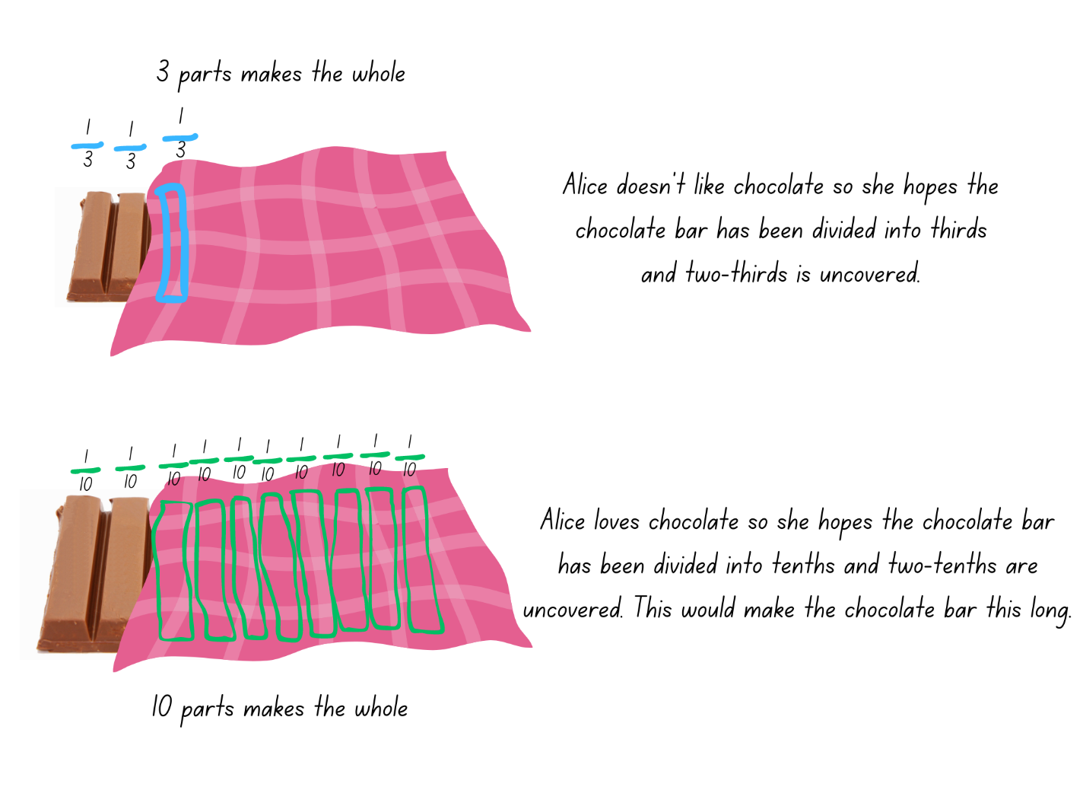
- Display Resource 16 – picture frame problem. Explain that the framer only had time to make one-third of the frame. Ask students how the frame could be finished. Draw the other two-thirds of the frame, as in Figure 10, and label the fractions.
Figure 10 – recoding picture frame fractions
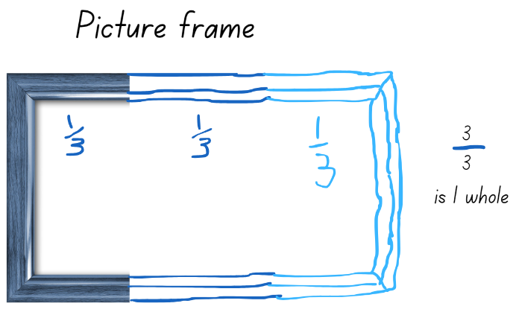
- Display Resource 16 – picture frame problem again. Ask students, ‘What if the framer had only made one-fifth of the whole frame?’ Students consider what the rest of the frame could look like. Provide small groups of students with large paper and Resource 17 – frame beginnings. Students cut and paste the frame beginnings and record different ways that they could be finished (see Figure 11).
Figure 11 – examples of recording picture frame fractions
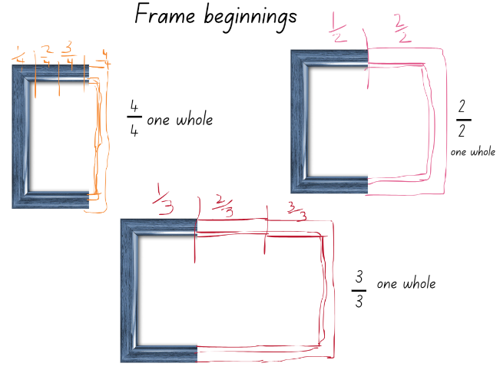
This table details opportunities for differentiation.
Too hard? | Too easy?
Students cannot recreate the whole unit from a fractional part.  - Students work with cubes to explore recreating the whole.  - Model further possibilities for students using Resource 17 – frame beginnings. | Students can recreate the whole unit from a fractional part  - Students research artworks that would fit into their frames. For example, portraits, landscapes, panoramas.  - Students choose a classroom object, hide part of it and ask another student what fraction could be unseen.

Discuss and connect the mathematics – 10 minutes
- Select students to share a variety of solutions to the framing problem. Prompt students to use appropriate fractional language to communicate their mathematical thinking. Key terminology related to this activity could include whole, dependent on the whole, fractional parts, thirds, quarters, fifths, tenths.
This table details opportunities for assessment.
Assessment opportunities | Links
What to look for:  - Can students explore the different wholes that can be made from a given fractional part? [MAO-WM-01, MA2-PF-01] | Links to National Numeracy Learning Progressions (NNLP):  - InF5.

Lesson 8
Core concept: making and exceeding the whole.

Daily number sense – 10 minutes
- From a class need surfaced through formative assessment data, identify a short, focused activity that targets students’ knowledge, understanding and skills. Example activities may be drawn from the following resources:
- Mathematics K–6 resources
- Universal Resources Hub.

Core lesson – making and exceeding the whole – 40 minutes
The table below contains a suggested learning intention and success criteria. These are best co-constructed with students.
Core concept learning intentions | Core concept success criteria
Students are learning to:  - represent fractional quantities greater than one whole  - model equivalent fractions as lengths. | Students can:  - rename 2 halves, 3 thirds, 4 quarters, 5 fifths, 6 sixths, 8 eighths and 10 tenths as wholes  - describe parts left over as fractions, for example, 5 wholes and 2 fifths  - represent totals of halves, quarters and eighths that extend beyond one  - recognise the need to have equal wholes to compare partitioned fractions.
Note: this lesson needs to be delivered in a large space. Ensure each team has access to an individual whiteboard and marker.
- Explain that students are going to play a game called ‘Islands’:
- Students slowly move around an open space.
- Teacher calls out ‘fifths make the whole’.
- Students calculate the number of fifths required to make a whole, quickly form groups of 5 and sit down.
- After all possible groups are formed, discuss as a class how many wholes were created and how many students or fifths are left over. For example, 5 wholes and 2 fifths.
- Repeat the steps using quarters, eighths, tenths, sixths and halves.
- Explain to the class they will now play a modified version of ‘Rob the nest’ that involves fractions.
- Familiarise students with the game and explain the rules as follows:
- Divide the class into 4 equal teams and line up behind a team hoop.
- Taking turns, one member from each team collects one coloured beanbag from the communal ‘nest’ and places it in their team’s hoop.
- Repeat this process until the communal nest is empty.
- One at a time, players can now collect one beanbag of their choice from an opponent’s hoop, remembering that teams cannot guard or defend their own hoop.
- After 5 minutes, blow a whistle to signify the end of the round.
- After the initial round, explain that the beanbags are worth different points. Teams apply these fraction values to their beanbags to work out a total:
- green = one whole or 1
- red = $\frac{1}{2}$
- blue = $\frac{1}{4}$
- yellow = $\frac{1}{8}$
- Students use Resource 18 – ‘Rob the nest’ score sheet to record their scores (see Figure 12).
Figure 12 – ‘Rob the nest’ score sheet example
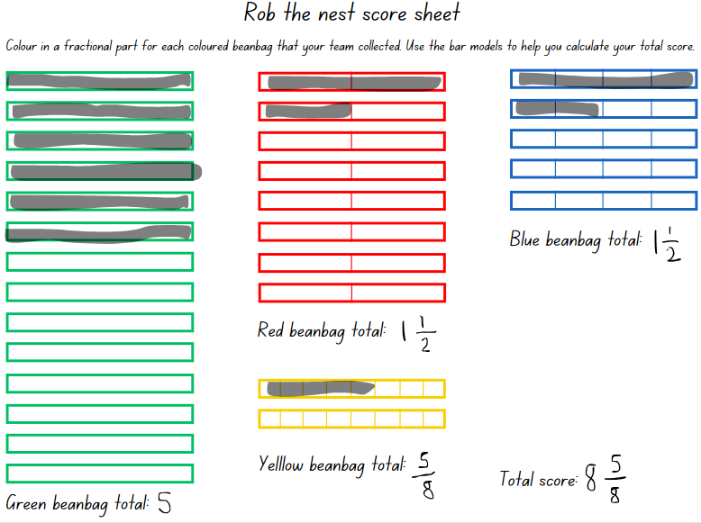
- Ask:
- Did your team collect enough beanbags to represent one or more wholes?
- What is your team total for wholes, halves, quarters and eighths? How could you combine them? This is the team total.
- How could you name leftover beanbags as a fraction?
Note: representing fractional quantities greater than one whole has not yet been explicitly taught. This lesson introduces this idea by prompting students to visualise equivalence and fractional lengths beyond one whole when colouring in the fraction bars. Further opportunities to explore equivalent fractions and fractional quantities greater than one whole are in Stage 2 Unit 16.
- Play ‘Rob the nest Round 2’. Students may want to be more strategic with their bean bag choices using the known value of beanbag colours as in activity 6. The aim of this round is to create as many wholes as possible, using any beanbag configuration. Points in this round will only be counted for complete wholes.
This table details opportunities for differentiation.
Too hard? | Too easy?
Students cannot work out the value of the pile using fractions.  - Model task for students.  - Students work with 2 colours of beanbags only, for example, those representing halves and quarters. | Students can use fractions to work out the value of the pile.  - Students assign other fraction values to the 4 colours.  - Students use their understanding of complementary fractions to work out the total value.

Consolidation and meaningful practice – 10 minutes
- After returning to the classroom, make a pile of beanbags consisting of 3 red, 6 blue, 4 yellow and one green.
- Display Resource 18 – ‘Rob the nest’ score sheet and model colouring the fraction bars to represent the coloured beanbags in the pile.
- Highlight the equivalent fractions of $\frac{4}{8}$, $\frac{2}{4}$ and $\frac{1}{2}$ represented on the score sheet and demonstrate how 2 of these fractional lengths can be combined to make one whole.
- Ask students to calculate the total for each colour as well as the overall total for the pile of beanbags.
This table details opportunities for assessment.
Assessment opportunities | Links
What to look for:  - Can students rename 2 halves, 3 thirds, 4 quarters, 5 fifths, 6 sixths, 8 eighths and 10 tenths as wholes?  [MAO-WM-01, MA2-PF-01]  - Can students describe parts left over as fractions, for example, 5 wholes and 2 fifths? [MAO-WM-01, MA2-PF-01]  - Can students represent totals of halves, quarters and eighths that extend beyond one? [MAO-WM-01, MA2-PF-01]  - Can students recognise the need to have equal wholes to compare partitioned fractions? [MAO-WM-01, MA2-PF-01] | Links to National Numeracy Learning Progressions (NNLP):  - InF5.

Resource 1 – Is it exactly half?
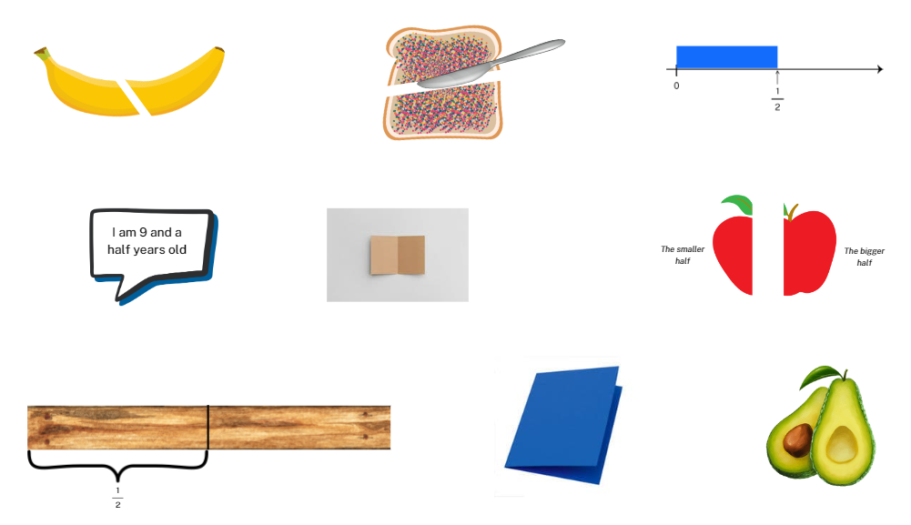

Resource 2 – shaded fractional part

Resource 3 – Which one doesn’t belong?
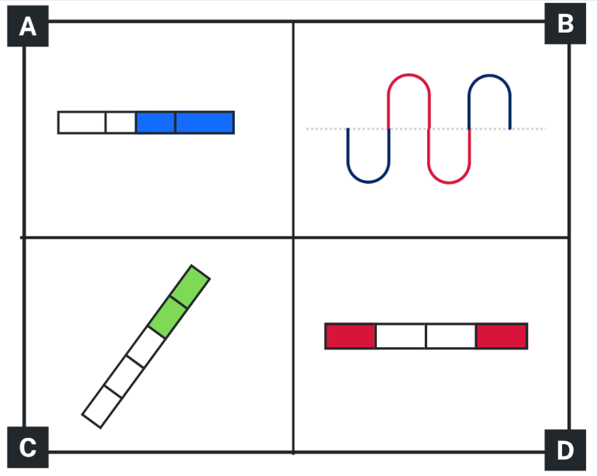

Resource 4 – broken fraction wall
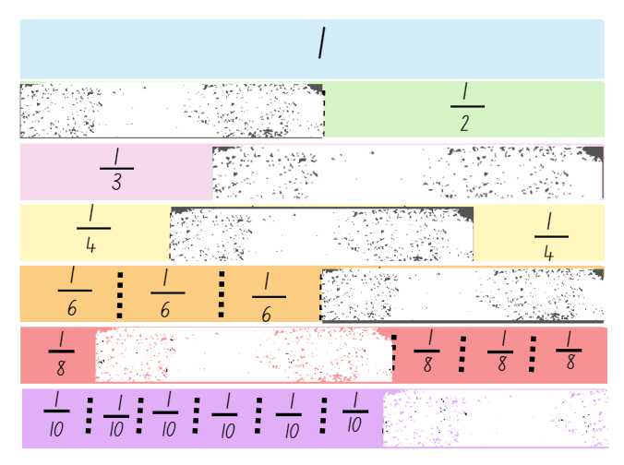

Resource 5 – fractions of a length
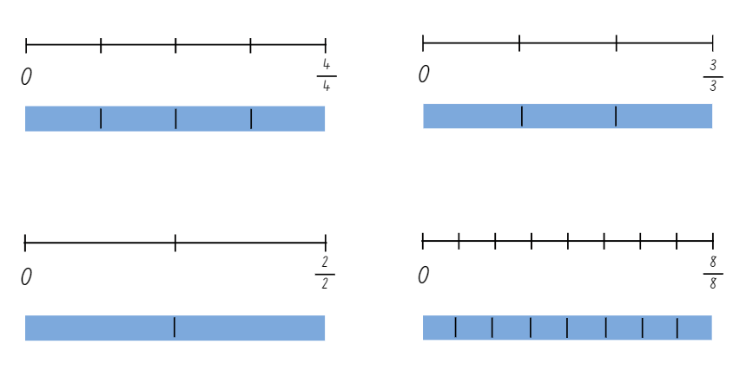

Resource 6 – quarters and tenths
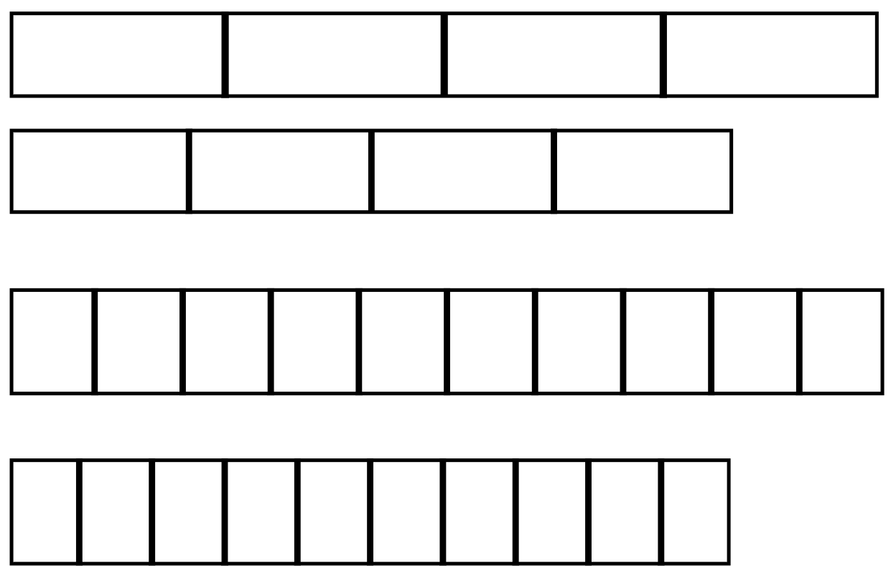

Resource 7 – fractions on a number line
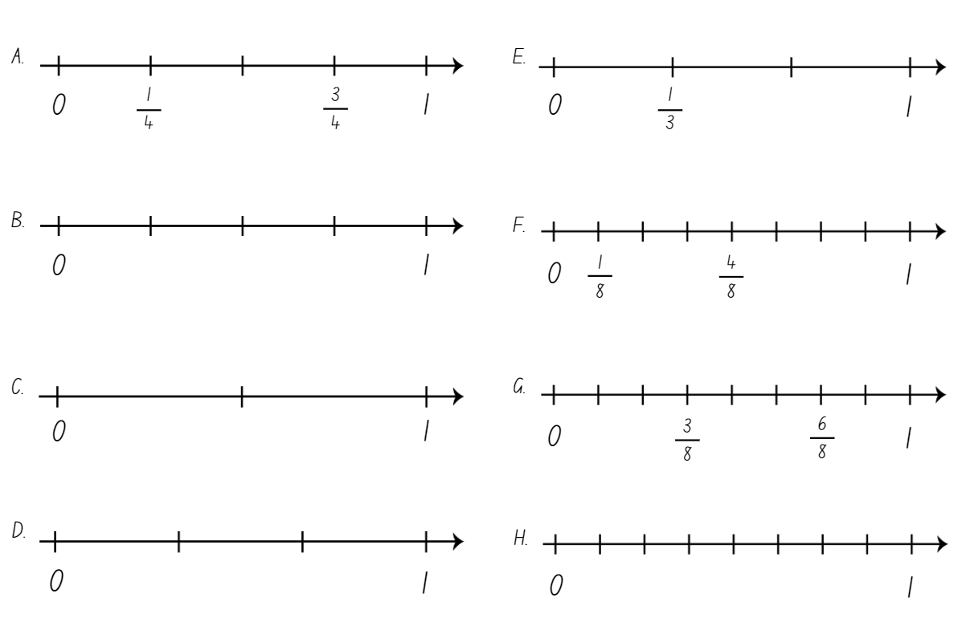

Resource 8 – complementary fractional parts
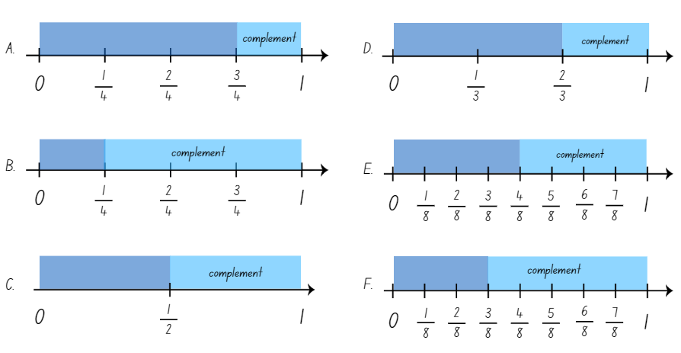

Resource 9 – ‘Multiples’ gameboard
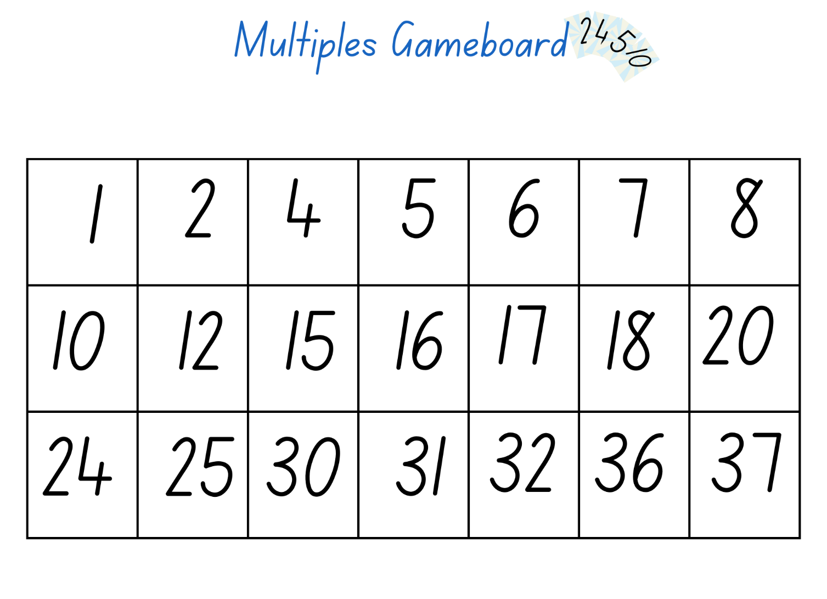

Resource 10 – ‘Multiples’ rule cards
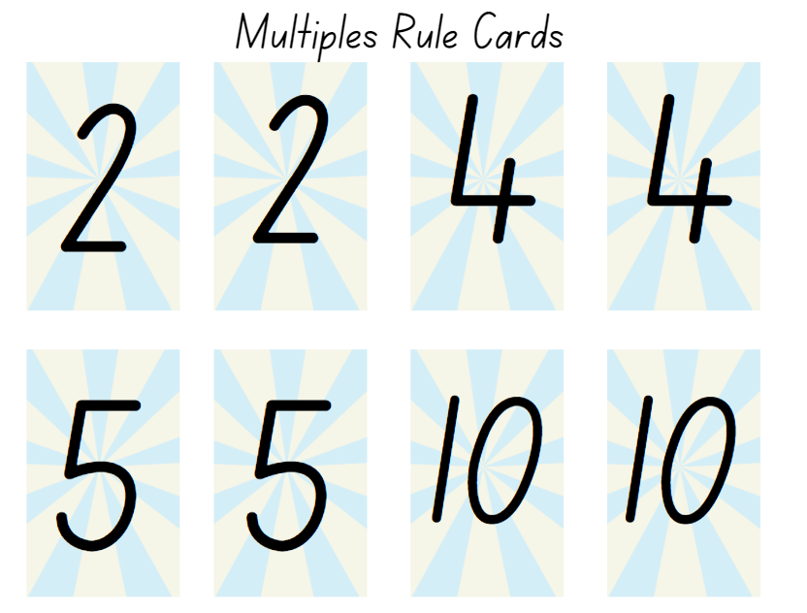

Resource 11 – finding the whole
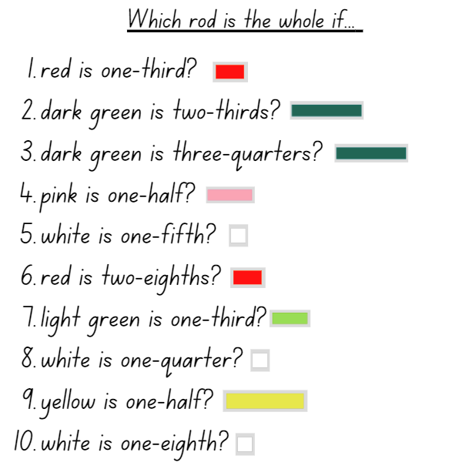

Resource 12 – different sized wholes
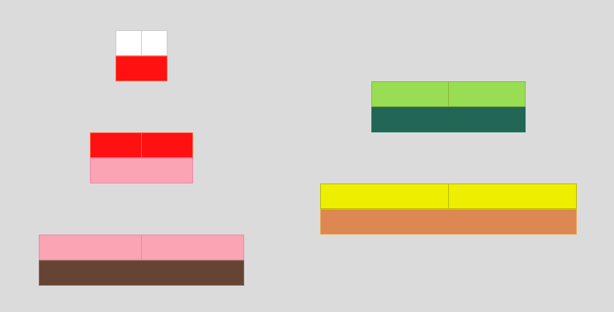

Resource 13 – doubling and halving
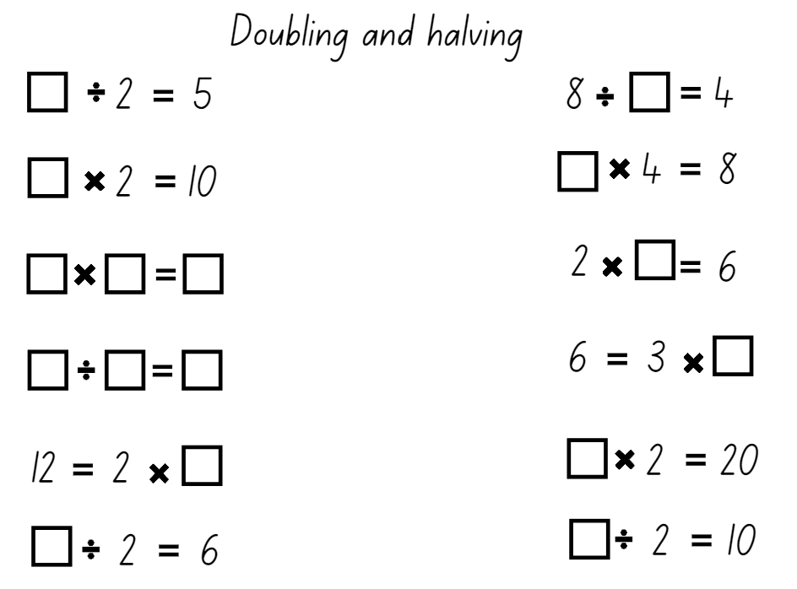

Resource 14 – chocolate bar 1
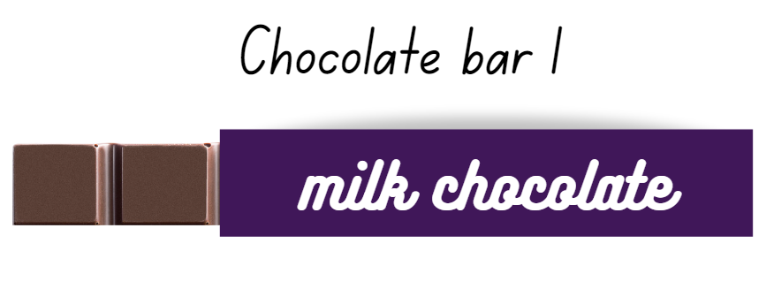

Resource 15 – chocolate bar 2
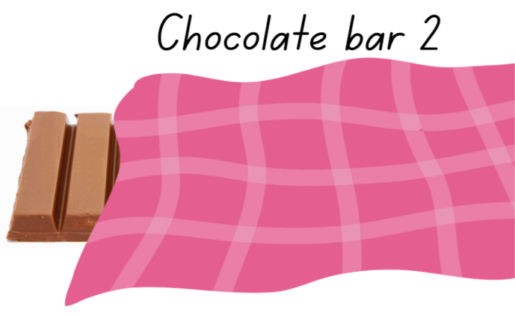

Resource 16 – picture frame problem

Resource 17 – frame beginnings
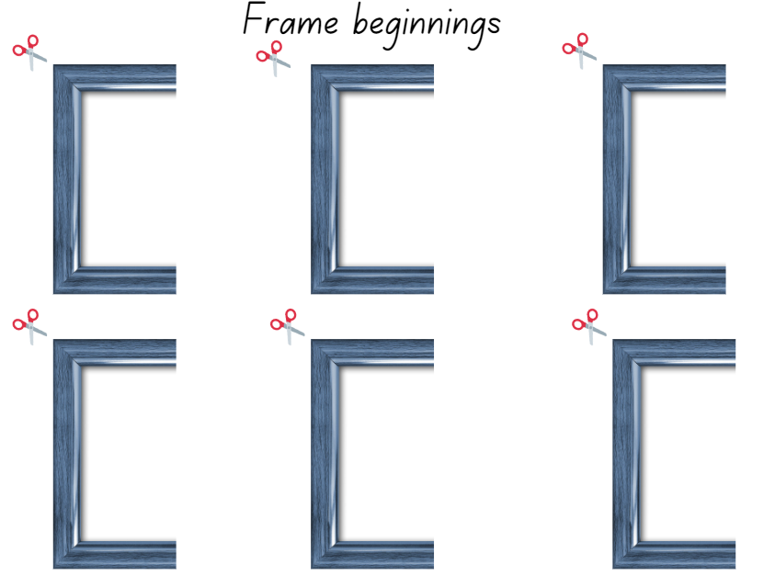

Resource 18 – ‘Rob the nest’ score sheet
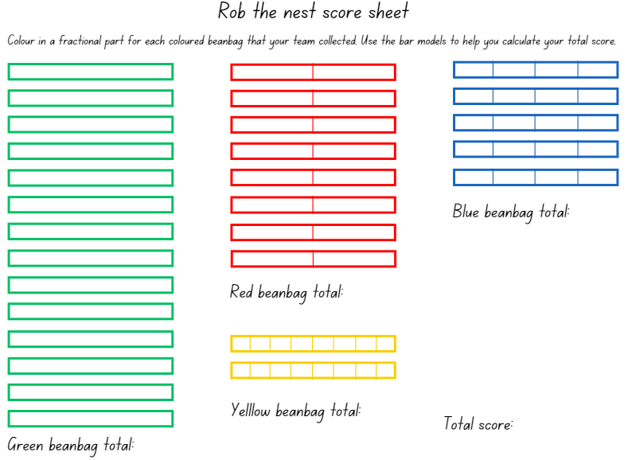

Syllabus outcomes and content
The table below outlines the syllabus outcomes and range of relevant syllabus content covered in this unit. Content is linked to National Numeracy Learning Progression (version 3).
Outcomes and content | 1 | 2 | 3 | 4 | 5 | 6 | 7 | 8
Multiplicative relations A: Use arrays to establish multiplication facts from multiples of 2 and 4, 5 and 10
[MAO-WM-01, MA2-MR-01]
- Use the array structure to coordinate the number of groups with the number in each group |  |  |  |  |  | x
- Relate doubling to multiplication facts for multiples of 2 |  |  |  |  | x | x
- Recognise that doubling is multiplying by 2 and halving is dividing by 2 (Reasons about relations) |  |  |  |  | x |  | x
- Recognise the relationship between one multiple and its double (Reasons about relations) |  |  |  |  | x |  | x
Multiplicative relations A: Recall multiplication facts of 2 and 4, 5 and 10 and related division facts
[MAO-WM-01, MA2-MR-01]
- Generate multiplication fact families for multiples of 2 and 4, 5 and 10 |  |  |  |  | x
Multiplicative relations B: Represent and solve word problems with number sentences involving multiplication or division
[MAO-WM-01, MA2-MR-01]
- Complete number sentences involving multiplication and division by calculating missing numbers (Reasons about relations) |  |  |  |  |  |  | x
Partitioned fractions A: Create fractional parts of a length using techniques other than repeated halving
[MAO-WM-01, MA1-PF-01]
- Make thirds of a length | x | x |  | x |  | x | x
- Create fifths of a length |  | x |  | x |  | x | x
Partitioned fractions A: Model and represent unit fractions, and their multiples, to a complete whole on a number line
[MAO-WM-01, MA2-PF-01]
- Model fractions with fraction strips and diagrams for halves, quarters, eighths, thirds | x | x | x | x |  | x
- Describe fraction families formed by dividing the whole into the same total number of equal parts as having the same denominator | x
- Determine the complementary fractional part needed to complete one whole (halves, quarters, eighths, thirds) (Reasons about relations) |  |  |  | x |  | x |  | x
- Recreate the whole unit from a fractional part ($\frac{1}{2}$, $\frac{1}{4}$, and $\frac{1}{8}$) (Reversible reasoning) |  |  | x |  | x |  | x | x
Partitioned fractions B: Model equivalent fractions as lengths
[MAO-WM-01, MA2-PF-01]
- Recognise the need to have equal wholes to compare partitioned fractions (Reasoning about relations) |  |  |  |  |  |  |  | x
Partitioned fractions B: Represent fractional quantities equal to and greater than one
[MAO-WM-01, MA2-PF-01]
- Rename 2 halves, 3 thirds, 4 quarters, 5 fifths, 6 sixths, 8 eighths and 10 tenths as one whole |  |  |  |  |  |  |  | x
- Represent totals of halves, thirds, quarters and fifths that extend beyond one |  |  |  |  |  |  |  | x
Mathematics K–10 Syllabus © NSW Education Standards Authority (NESA) for and on behalf of the Crown in right of the State of New South Wales, 2022.

References
This resource contains NSW Curriculum and syllabus content. The NSW Curriculum is developed by the NSW Education Standards Authority. This content is prepared by NESA for and on behalf of the Crown in right of the State of New South Wales. The material is protected by Crown copyright.
Please refer to the NESA Copyright Disclaimer for more information https://educationstandards.nsw.edu.au/wps/portal/nesa/mini-footer/copyright.
NESA holds the only official and up-to-date versions of the NSW Curriculum and syllabus documents. Please visit the NSW Education Standards Authority (NESA) website https://educationstandards.nsw.edu.au/wps/portal/nesa/home and the NSW Curriculum website https://curriculum.nsw.edu.au/.
Mathematics K–10 Syllabus © NSW Education Standards Authority (NESA) for and on behalf of the Crown in right of the State of New South Wales, 2022.
National Numeracy Learning Progression © Australian Curriculum, Assessment and Reporting Authority (ACARA) 2010 to present, unless otherwise indicated. This material was downloaded from the Australian Curriculum website (National Numeracy Learning Progression) (accessed 17 January 2024) and was not modified.
Gould P (2013) ‘Australia's next top fraction model’, Australian Primary Mathematics Classroom, 18(3):5–12.
Math Open Reference (2011) Complement, Math Open Reference website, accessed 2 February 2024.
New Zealand Ministry of Education (n.d.) ‘Common multiples’, Resources, NZ Maths website, accessed 17 January 2024.
New Zealand Ministry of Education (n.d.) ‘Little Bites at Big Multiplications and Divisions’, Resources, NZ Maths website, accessed 17 January 2024.
Sullivan P and Lilburn P (2017) Open-Ended Maths Activities: Using Good Questions to Enhance Learning Mathematics, 2nd edn, Oxford University Press Australia and New Zealand, Great Britain.
University of Cambridge (n.d.) Cuisenaire Environment, NRICH website, accessed 17 January 2024.
Van de Walle J, Karp K, Bay-Williams JM, Brass A, Bentley B, Ferguson S, Goff W, Livy S, Marshman M, Martin D, Pearn C, Prodromou T, Symons D and Wilkie K (2019) Primary and Middle Years Mathematics: Teaching Developmentally, 1st Australian edn, Pearson Education Australia, Melbourne.

© State of New South Wales (Department of Education), 2023
The copyright material published in this resource is subject to the Copyright Act 1968 (Cth) and is owned by the NSW Department of Education or, where indicated, by a party other than the NSW Department of Education (third-party material).
Copyright material available in this resource and owned by the NSW Department of Education is licensed under a Creative Commons Attribution 4.0 International (CC BY 4.0) license.
This license allows you to share and adapt the material for any purpose, even commercially.
Attribution should be given to © State of New South Wales (Department of Education), 2023.
Material in this resource not available under a Creative Commons license:
- the NSW Department of Education logo, other logos and trademark-protected material
- material owned by a third party that has been reproduced with permission. You will need to obtain permission from the third party to reuse its material.
Links to third-party material and websites
Please note that the provided (reading/viewing material/list/links/texts) are a suggestion only and implies no endorsement, by the New South Wales Department of Education, of any author, publisher, or book title. School principals and teachers are best placed to assess the suitability of resources that would complement the curriculum and reflect the needs and interests of their students.
If you use the links provided in this document to access a third-party's website, you acknowledge that the terms of use, including licence terms set out on the third-party's website apply to the use which may be made of the materials on that third-party website or where permitted by the Copyright Act 1968 (Cth). The department accepts no responsibility for content on third-party websites.

