Mathematics Stage 2 – Unit 27

Contents
Unit description and duration 5
Syllabus outcomes 5
Working mathematically 6
Student prior learning 6
Lesson overview and resources 8
Lesson 1 14
Daily number sense – multiples tennis – 10 minutes 14
Core lesson 1 – doubling for × 2, × 4 and × 8 – 30 minutes 16
Discuss and connect the mathematics – 10 minutes 20
Core lesson 2 – × 3 and × 6 – 20 minutes 22
Discuss and connect the mathematics – 10 minutes 23
Lesson 2 26
Daily number sense – doubling practice – 10 minutes 26
Core lesson – strategies for nines – 40 minutes 28
Discuss and connect the mathematics – 10 minutes 31
Lesson 3 34
Daily number sense – arrays game – 10 minutes 34
Core lesson – partial arrays – 30 minutes 36
Discuss and connect the mathematics – 15 minutes 39
Lesson 4 41
Daily number sense – teacher choice – 10 minutes 41
Core lesson – linking division to multiplication facts – 40 minutes 41
Discuss and connect the mathematics – 10 minutes 46
Lesson 5 48
Daily number sense – 10 times bigger – 10 minutes 48
Core lesson – repeated halving – 30 minutes 49
Discuss and connect the mathematics – 10 minutes 53
Lesson 6 55
Daily number sense – place value houses – 10 minutes 55
Core lesson – associative property – 40 minutes 57
Discuss and connect the mathematics – 10 minutes 61
Lesson 7 63
Daily number sense – 10, 100 and 1000 times bigger – 10 minutes 63
Core lesson – looking for tens – 30 minutes 65
Discuss and connect the mathematics – 5 minutes 68
Consolidation and meaningful practice – 20 minutes 69
Lesson 8 73
Daily number sense – teacher choice – 10 minutes 73
Core lesson – doubles, tens or partition – 30 minutes 73
Discuss and connect the mathematics – 10 minutes 77
Resource 1 – two arrays 79
Resource 2 – three arrays 80
Resource 3 – multiplication chart 81
Resource 4 – doubles fill 82
Resource 5 – × 3 × 6 84
Resource 6 – doubles fill 2 85
Resource 7 – Double Double Up 87
Resource 8 – an array 88
Resource 9 – an array 2 89
Resource 10 – arrays of 9 90
Resource 11 – tiling problem 91
Resource 12 – partial arrays 92
Resource 13 – total of 15 93
Resource 14 – fact family triangle 94
Resource 15 – Factors fun game 95
Resource 16 – fact families 97
Resource 17 – 1s, 10s, 100s and 1000s 98
Resource 18 – array cake 99
Resource 19 – tennis ball problem 100
Resource 20 – Would you rather ...? 101
Resource 21 – gameboard 102
Resource 22 – recording sheet 103
Resource 23 – problem solving 104
Resource 24 – sort ’n’ solve 105
Resource 25 – 1–10 spinner 106
Resource 26 – 7 sixes 107
Resource 27 – 23 × 3 108
Resource 28 – sort ‘n’ solve 2 109
Syllabus outcomes and content 110
References 115
Further reading 117

Unit description and duration
This unit develops the big idea that multiplicative thinking involves flexible use of multiplication and division concepts, strategies and representations.
In this 2-week unit students are provided opportunities to:
- develop, consolidate and apply derived strategies for multiplication facts to 10 × 10
- explore and apply the inverse relationship between multiplication and division
- explore and apply the associative and distributive properties of multiplication.

Syllabus outcomes
- MAO-WM-01 develops understanding and fluency in mathematics through exploring and connecting mathematical concepts, choosing and applying mathematical techniques to solve problems, and communicating their thinking and reasoning coherently and clearly
- MA2-RN-01 applies an understanding of place value and the role of zero to represent numbers to at least tens of thousands
- MA2-MR-01 represents and uses the structure of multiplicative relations to 10 × 10 to solve problems
- MA2-MR-02 completes number sentences involving multiplication and division by finding missing values

Working mathematically
In the Mathematics K–10 Syllabus, there is one overarching Working mathematically outcome (MAO-WM-01). The Working mathematically processes should be embedded within the concepts being taught. The Working mathematically processes present in the Mathematics K–10 Syllabus are:
- communicating
- understanding and fluency
- reasoning
- problem solving.
Mathematics K–10 Syllabus © NSW Education Standards Authority (NESA) for and on behalf of the Crown in right of the State of New South Wales, 2022.

Student prior learning
Before engaging in these teaching and learning activities, students would benefit from prior experience with:
- generating and describing patterns
- using arrays to establish multiplication facts from multiples of 2 and 4, 5 and 10
- representing and solving problems involving multiplication fact families.

In NSW classrooms there is a diverse range of students, including Aboriginal and Torres Strait Islander students, students learning English as an additional language or dialect, high potential and gifted students and students with disability. Some students may identify with more than one of these groups or possibly all of them. Refer to Curriculum planning for every student – advice for further information.

Lesson overview and resources
The table below outlines the sequence and approximate timing of lessons, learning intentions and resources.
Lesson | Content | Duration and resources
Lesson 1  Daily number sense learning intention:  - use known number facts and strategies for multiplication | Lesson core concept: number patterns can be multiplicative.  Core concept learning intentions:  - investigate number sequences involving related multiples  - represent and use the structure of multiplicative relations to 10 × 10 to solve problems | Lesson duration: 80 minutes  - Resource 1 – two arrays  - Resource 2 – three arrays  - Resource 3 – multiplication chart  - Resource 4 – doubles fill  - Resource 5 – × 3 × 6  - Resource 6 – doubles fill 2  - Class anchor chart  - Writing materials
Lesson 2  Daily number sense learning intention:  - use known number facts and strategies for multiplication | Lesson core concept: known number facts and strategies support multiplicative understanding.  Core concept learning intention:  - use known number facts and strategies for multiplication | Lesson duration: 60 minutes  - Resource 3 – multiplication chart  - Resource 7 – Double Double Up  - Resource 8 – an array  - Resource 9 – an array 2  - Resource 10 – arrays of 9  - 6-sided dice  - Class anchor chart  - Counters  - Individual whiteboards  - Writing materials
Lesson 3  Daily number sense learning intention:  - use known number facts and strategies for multiplication | Lesson core concept: structures can support multiplicative thinking.  Core concept learning intentions:  - use the structure of the area model to represent multiplication and division  - represent and solve problems involving multiplication fact families | Lesson duration: 55 minutes  - Resource 11 – tiling problem  - Resource 12 – partial arrays  - 6-sided dice  - 10-sided dice  - Class anchor chart  - Grid paper  - Tiles or counters  - Writing materials
Lesson 4  Daily number sense learning intention:  - teacher-identified task based on student needs | Lesson core concept: multiplication and division are related.  Core concept learning intentions:  - use number properties to find related multiplication facts  - represent and solve word problems with number sentences involving multiplication and division | Lesson duration: 60 minutes  - Resource 3 – multiplication chart  - Resource 13 – total of 15  - Resource 14 – fact family triangle  - Resource 15 – Factors fun game  - Resource 16 – fact families  - Class anchor chart  - Counters  - Individual whiteboards  - Writing materials
Lesson 5  Daily number sense learning intention:  - recognise and represent numbers that are 10, 100 or 1000 times as large | Lesson core concept: doubling and halving are powerful strategies.  Core concept learning intentions:  - apply place value to partition and regroup numbers up to 4 digits  - use known number facts and strategies | Lesson duration: 50 minutes  - Resource 3 – multiplication chart  - Resource 17 – 1s, 10s, 100s and 1000s  - Resource 18 – array cake  - 9-sided dice  - Class anchor chart  - Individual whiteboards  - Writing materials
Lesson 6  Daily number sense learning intention:  - recognise and record numbers that are 10, 100 or 1000 times as large | Lesson core concept: the associative property can be used to solve multiplication problems.  Core concept learning intention:  - use number properties to find related multiplication facts | Lesson duration: 60 minutes  - Resource 19 – tennis ball problem  - Resource 20 – Would you rather …?  - Resource 21 – gameboard  - Resource 22 – recording sheet  - Class anchor chart  - Writing materials
Lesson 7  Daily number sense learning intention:  - recognise and represent numbers that are made of tens, hundreds and thousands | Lesson core concept: associative and commutative properties can be used to solve multiplication problems.  Core concept learning intentions:  - use number properties to find related multiplication facts  - operate with multiples of 10 | Lesson duration: 65 minutes  - Resource 23 – problem solving  - Resource 24 – sort ‘n’ solve  - Resource 25 – 1–10 spinner  - 9-sided dice  - Individual whiteboards  - Writing materials
Lesson 8  Daily number sense learning intention:  - teacher-identified task based on student needs | Lesson core concept: distributive properties can be used to solve multiplication problems.  Core concept learning intentions:  - apply an understanding of place value and the role of zero to represent numbers to at least tens of thousands  - represent and use the structure of multiplicative relations to 10 × 10 to solve problems | Lesson duration: 50 minutes  - Resource 26 – 7 sixes  - Resource 27 – 23 × 3  - Resource 28 – sort ‘n’ solve 2  - Scissors  - Class anchor chart  - Writing materials

Lesson 1
Core concept: number patterns can be multiplicative.

Daily number sense – multiples tennis – 10 minutes
Daily number sense activities for Lessons 1 to 3 ‘activate’ prior number knowledge and support the learning of new content in the unit. These activities can also assist teachers to identify the starting points for learning by revealing the extent of students’ existing knowledge.
The table below contains a suggested learning intention and success criteria. These are best co-constructed with students.
Daily number sense learning intention | Daily number sense success criteria
Students are learning to:  - use known number facts and strategies for multiplication. | Students can:  - apply the known strategy of doubling to connect multiples of 3 to 6 and 4 to 8  - use known facts to find unknown multiples.
- Explain that students will play a game where they use known number facts and strategies to help multiply numbers. Model how to play the game to the class and choose volunteers to make 2 teams of 3 students in each.
- Introduce the game as being like tennis, where players take turns to serve a number over a pretend tennis net.
Note: during the demonstration, pause and ask students to explain the strategies they used to find the answer.
- The rules of the game are:
- The number is the tennis ball. Teams consist of 3 students on either side.
- Each time the number is hit over the net, it increases by an agreed amount. For example, the first volley starts with the number 3 and doubles each time it is hit over the net.
- Students from each team raise their hand if they would like to hit the number back over the net. If yes, and students say the correct answer, the number returns over the net for the other team. Students cannot hit the number again until everyone on their team has had a turn.
- After 10 multiples have been returned correctly, the team that served the number first gets a point.
- A student from one team serves first, by saying the number to be multiplied or doubled.
- Remind students to use known number facts and strategies to help them as they play.
- Start the first round of the game, focusing on multiples of 2, 3, 4, 5 and 10.
This table details opportunities for assessment.
Assessment opportunities | Links
What to look for:  - Can students apply the known strategy of doubling to connect multiples of 3 to 6 and 4 to 8? [MAO-WM-01, MA2-MR-01, MA2-MR-01]  - Can students use known facts to find unknown multiples? [MAO-WM-01, MA2-MR-01, MA2-MR-01] | Links to National Numeracy Learning Progressions (NNLP):  - MuS6.

Core lesson 1 – doubling for × 2, × 4 and × 8 – 30 minutes
The table below contains suggested learning intentions and success criteria. These are best co-constructed with students.
Core concept learning intentions | Core concept success criteria
Students are learning to:  - investigate number sequences involving related multiples  - represent and use the structure of multiplicative relations to 10 × 10 to solve problems. | Students can:  - generate number patterns using related multiples  - investigate number patterns involving related multiples  - apply the known strategy of doubling to connect multiples of 3 to 6 and 4 to 8.
Note: to help students develop fluency with multiplication and related division facts, focusing on reasoning strategies is important. Learning number facts should be built from known facts, not simply memorised. In this lesson, the double and the double, double strategies are examples of the associative property of multiplication. This concept is explicitly taught and further explored in Lesson 6 and Lesson 7 of this unit.
- Show students Resource 1 – two arrays. Ask:
- What do you notice?
- What is the same or different about these 2 arrays?
- What has changed between array 1 and array 2?
- What multiplication facts or number patterns do you see here?
Note: see Figure 1 for some anticipated responses and prompts.
Figure 1 – anticipated responses
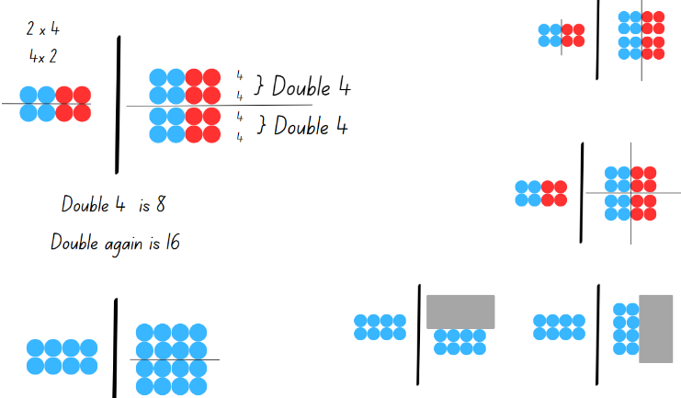
- Display Resource 2 – three arrays. Ask:
- How has the first array changed?
- How many times has the array doubled?
- How could you represent these as number sentences?
- Explain that the first array is doubling 8 to make 16, then the second array is doubling 16 to make 32.
- Remind students about the term ‘multiples’.
Multiples: a series of products formed using the same base number multiplied by different whole numbers. For example, 3, 6, 9, 12 and so on are multiples of 3.
- Provide students with a copy of Resource 3 – multiplication chart. Ask students to:
- highlight the multiples of 2 and discuss with students what they notice about the pattern
- highlight the multiples of 4 and discuss what similarities and patterns they notice
- highlight the multiples of 8 and discuss what similarities, differences and pattern they notice.
- Draw attention to the repetition of 4, 8, 12, 16 in the multiples of 2 and 4. Discuss other patterns and connections that the multiples of 2, 4 and 8 have.
- Explain that knowing doubles can help with × 4 and × 8 facts. When students multiply by 2, double once. When they multiply by 4, double twice. When they multiply by 8, double 3 times.
- Work with students to practice repeated doubling. For example:
- If we are trying to solve 4 × 7, how could we use repeated doubling?
- If we are trying to solve 8 × 6, how could we use repeated doubling?
- Display Resource 4 – doubles fill. Read and explain the instructions. Model how to record on the game board.
This activity is an adaptation of 'Doubles fill' from Mathematics K–6 resources by State of New South Wales (Department of Education). It has a video example of the game being played.
- To promote discussion and sharing strategies, ask students to play the game in pairs versus pairs.
This table details opportunities for differentiation.
Too hard? | Too easy?
Students cannot double number facts or identify patterns.  - Use concrete materials to model the number and the doubling.  - Continue to use arrays to represent doubling patterns. Students practice doubling a 2-row array to create a 4-row array. Calculate the total number in each array and write a matching number sentence. | Students can use doubling to find multiplication facts.  - Adjust game challenge by using numbers beyond 10.  - Students investigate how doubling might be used to find other unknown multiplications, such as × 16 and × 32.  - Students read and explore doubling in the Room Doubling task.  - Present additional problems for students to solve. For example, explain that a student received a $1 coin. Ask how many times the student would need to double their coin for every student in the school to receive $2.

Discuss and connect the mathematics – 10 minutes
- Ask how the doubling strategies students have learned can help them to continue patterns or find large amounts.
- Work with students to record helpful hints, short cuts or strategies for × 2, × 4 and × 8 multiplication facts.
- Explain that students will record their strategies using a multiplication chart to illustrate the relationship between × 2, × 4 and × 8 multiplication facts.
- Display a blank Resource 3 – multiplication chart. As a class, colour code the facts that appear in × 2, × 4 and × 8 (see Figure 2).
Figure 2 – × 2, × 4 and × 8
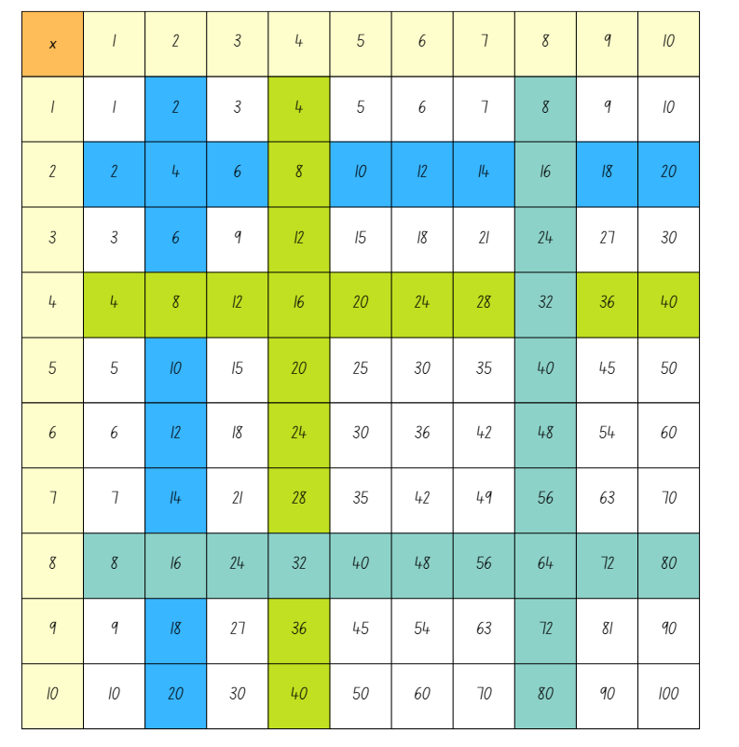
- Describe the strategy for students to record, such as:
- If you know × 2 multiplication facts, you can double it to find × 4.
- If you can work out × 4 by doubling × 2 multiplication facts, you can work out × 8 multiplication facts by doubling × 4 facts.

Core lesson 2 – × 3 and × 6 – 20 minutes
- Display Resource 5 – × 3 × 6 and ask:
- How has the first array changed?
- How could you represent these as number sentences?
- How many times has it doubled?
- Give students a blank copy of Resource 3 – multiplication chart. Ask students to highlight the multiples of 3. Discuss what students notice about the pattern.
- Ask students to highlight the multiples of 6. Ask what similarities and patterns students notice between the multiples of 3 and 6.
- Tell students that knowing multiples of 3 can be used to work out multiples of 6. This is because 6 is 2 threes. When multiplying by 6, students should think of threes and double it.
Note: if students do not know that multiples of 3 are doubles + one more group, use this opportunity to revise or teach this concept.
- Work with students to practice repeated doubling and explaining their reasoning. For example, to solve 6 × 7, students can use the known multiplication fact 3 × 7 = 21. 6 is double 3 and double 21 is 42, so 6 × 7 = 42.
- Display Resource 6 – doubles fill 2. Read and explain the instructions. Model how to record on the game board.
This table details opportunities for differentiation.
Too hard? | Too easy?
Students cannot double number facts or identify patterns.  - Use concrete materials to model the number and the doubling.  - Continue to use arrays to represent doubling patterns. | Students can use doubling to find multiplication facts.  - Adjust game challenge by using numbers beyond 10.  - Students read and explore the idea in the Room Doubling task.  - Present additional problems for students to solve. For example, explain that a single student received $3. Ask how many times that student would need to double their coins for every student in the school to receive $6.

Discuss and connect the mathematics – 10 minutes
- Ask students how they can use what they have learned to help solve multiplication problems.
- Explain that you will record the strategy on a multiplication chart to illustrate the relationship between 3 × and 6 × multiplication facts.
- Present a blank Resource 3 – multiplication chart. As a class, write in or colour code the number facts that appear in both 3 × and 6 × (see Figure 3).
Figure 3 – 3 ×, 6 ×
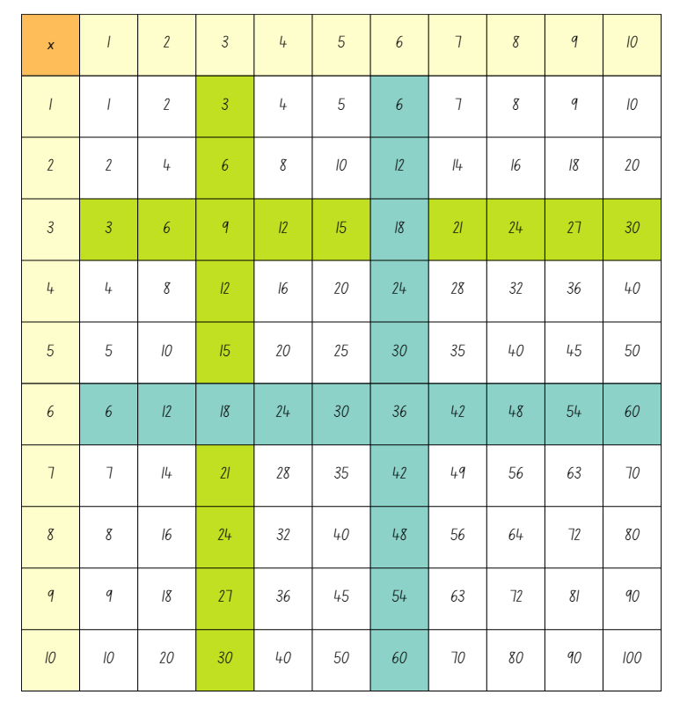
- Describe the strategy for students to record, such as:
- 3 × multiplication facts are the same as double and one more.
- You can use 3 × multiplication facts by doubling to find 6 ×.
- Record the strategy on a multiplication strategy anchor chart. This can be added to in future lessons.
This table details opportunities for assessment.
Assessment opportunities | Links
What to look for:  - Can students create number patterns using related multiples? [MAO-WM-1, MA2-MR-01]  - Can students apply the known strategy of doubling to connect multiples of 3 to 6 and 4 to 8? [MAO-WM-1, MA2-MR-01]  - Can students choose and apply mathematical techniques to solve multiplication problems, and communicate their thinking and reasoning coherently and clearly? [MAO-WM-1, MA2-MR-01] | Links to National Numeracy Learning Progressions (NNLP):  - NPA3, NPA4  - MuS6.

Lesson 2
Core concept: known number facts and strategies support multiplicative understanding.

Daily number sense – doubling practice – 10 minutes
The table below contains a suggested learning intention and success criteria. These are best co-constructed with students.
Daily number sense learning intention | Daily number sense success criteria
Students are learning to:  - use known number facts and strategies for multiplication. | Students can:  - apply the known strategy of doubling to connect multiples of 3 to 6 and 4 to 8  - use known facts to find unknown multiples.
This activity is an adaptation from ‘Double Double Up’ from Dr Paul Swan Board Game Pack Years 3–4 by Swan.
- In pairs, provide students a copy of Resource 7 – Double Double Up and a 6-sided dice.
- Explain that the aim of the game is to place 4 counters in a row, column or diagonally within the box of numbers in the centre of the board game. To play the game, partners take turns to:
- roll the dice and move along the outside track
- double the number they land on, then double the number again. Students use mental strategies and individual whiteboards to work out the answer
- place a counter on the answer in the box of numbers in the centre square.
- The first player with 4 counters in a row wins the game.
This table details opportunities for assessment.
Assessment opportunities | Links
What to look for:  - Can students apply the known strategy of doubling to connect multiples of 3 to 6 and 4 to 8? [MAO-WM-01, MA2-MR-01, MA2-MR-01]  - Can students use known facts to find unknown multiples? [MAO-WM-01, MA2-MR-01, MA2-MR-02] | Links to National Numeracy Learning Progressions (NNLP):  - MuS6.

Core lesson – strategies for nines – 40 minutes
The table below contains suggested learning intention and success criteria. These are best co-constructed with students.
Core concept learning intention | Core concept success criteria
Students are learning to:  - use known number facts and strategies for multiplication. | Students can:  - use multiplication facts with multiples of 10 to multiply a one-digit number by a multiple of 10  - use place value to rename groups of 10 for multiplication  - recognise the relationship between one multiple and its double  - use known facts to find unknown multiples, including × 9 facts.
This activity is an adaptation of Imagining dots (arrays) from Mathematics K–6 resources by State of New South Wales (Department of Education). The Imagining dots (arrays) has helpful video explanations of distributive thinking and a simple transition to the area model.
- Review the multiplication strategies on the anchor chart from Lesson 1.
- Show students Resource 8 – an array. Ask students:
- What do you see?
- How can you calculate the total?
- Annotate the array to show different student ideas (see Figure 4).
Figure 4 – 5 tens
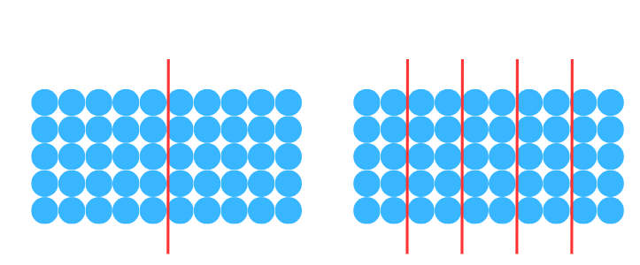
- Show students Resource 9 – an array 2. Ask:
- What do you see?
- How can you work it out?
- What strategies could I use if I didn’t know my 9 times tables?
- Annotate the array to show different student ideas (see Imagining dots (arrays) in Figure 5).
Figure 5 – imagining dots
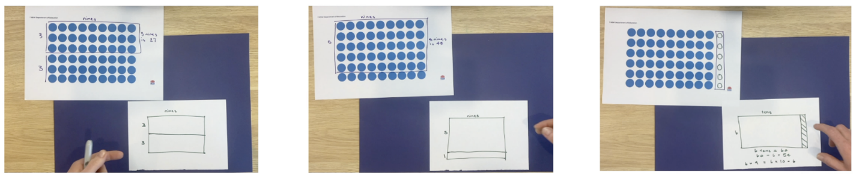
- Provide students with Resource 10 – arrays of 9. Ask students to calculate these nines problems in at least 2 ways: 5 × 9, 7 × 9 and 9 × 9.
This table details opportunities for differentiation.
Too hard? | Too easy?
Students cannot use known facts to find unknown multiples.  - Provide students with fact families for multiples of 10. Support students by adding counters to make an array showing tens, then model taking away one group to determine the total of nines.  - Provide students with 10 ten-frames. Place 9 counters in a frame to establish that 9 is one less than 10. Repeat for various multiples of 9. | Students can use known facts to find unknown multiples.  - Students write down the multiplication facts for multiplying by 9. Ask what patterns they notice and why that pattern appears.  - Show students the Nine times table (0:33) finger trick. Ask why this trick works and whether a trick like this could work for other numbers.  - Students investigate questions, such as 23 × 99. Ask what makes these numbers easy to work with and what numbers students could apply this strategy to.

Discuss and connect the mathematics – 10 minutes
- Ask students how they could use what they have learned to help them solve multiplication problems.
- Present a blank Resource 3 – multiplication chart. As a class, write in or colour code the number facts that appear in both × 5, × 10 and × 9 facts (see Figure 6).
Figure 6 – × 5, × 10 and × 9 facts
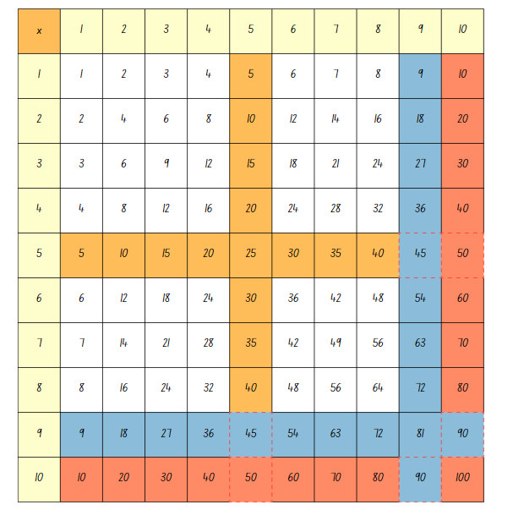
- Describe the strategies for students to record, such as:
- I know × 10 multiplication facts because multiplying by 10 shifts the numbers to the left in the place value column.
- If I know × 10 multiplication facts, I can halve it to find × 5.
- If I know × 10 multiplication facts, I can take away one group to find × 9 facts.
- Record the strategies on the multiplication strategies anchor chart. This can be added to in future lessons.
This table details opportunities for assessment.
Assessment opportunities | Links
What to look for:  - Can students recognise the relationship between one multiple and its double? [MAO-WM-01, MA2-MR-01]  - Can students apply the known strategy of multiplying by 10 and removing one group to calculate × 9? [MAO-WM-01, MA2-MR-01]  - Can students use known facts to find unknown multiples? [MAO-WM-01, MA2-MR-01]  - Can students choose and apply mathematical techniques to solve multiplication problems, and communicate their thinking and reasoning coherently and clearly? [MAO-WM-1, MA2-MR-01] | Links to National Numeracy Learning Progressions (NNLP):  - MuS6.

Lesson 3
Core concept: structures can support multiplicative thinking.

Daily number sense – arrays game – 10 minutes
The table below contains a suggested learning intention and success criteria. These are best co-constructed with students.
Daily number sense learning intention | Daily number sense success criteria
Students are learning to:  - use known number facts and strategies for multiplication. | Students can:  - apply the known strategy of doubling to connect multiples of 3 to 6 and 4 to 8  - use known facts to find unknown multiples.
This activity is an adaptation of ‘Arrays Games’ from Dr Paul Swan Board Game Pack Years 3–4 by Swan.
- This can be played between students in pairs or by dividing the class into 2 teams.
- Display a grid on the whiteboard. Students share a piece of grid paper if they are playing the game in pairs. Explain that the aim of the game is to capture the greatest area of the grid.
- To play the game, each player or team takes turns to:
- Roll a 6-sided and a 10-sided dice.
- Use the 2 numbers rolled to create an array on the grid. The player shades the inside of the rectangle and writes the calculation inside the array. Mental strategies and individual whiteboards can be used to calculate the answer. Encourage students to use known facts and doubling strategies to determine the answer.
- The winner is the team or player who captures the greatest area in a set time.
This table details opportunities for assessment.
Assessment opportunities | Links
What to look for:  - Can students apply the known strategy of doubling to connect multiples of 3 to 6 and 4 to 8? [MAO-WM-01, MA2-MR-01, MA2-MR-02]  - Can students use known facts to find unknown multiples? [MAO-WM-01, MA2-MR-01, MA2-MR-02] | Links to National Numeracy Learning Progressions (NNLP):  - MuS6.

Core lesson – partial arrays – 30 minutes
The table below contains suggested learning intentions and success criteria. These are best co-constructed with students.
Core concept learning intentions | Core concept success criteria
Students are learning to:  - use the structure of an area model to represent multiplication and division  - represent and solve problems involving multiplication fact families. | Students can:  - create and represent multiplicative structures, moving from arrays to partially covered area models  - find the total of partially covered arrays.
This activity is an adaptation of the ‘Complete the array task’ from Top Drawer Teachers: Resources for teachers of mathematics by The Australian Association of Mathematics Teachers.
- Revise the multiplication strategies anchor chart.
- Remind students that the commutative property of multiplication applies so that arrays can be rotated. Share the definition of commutative property.
Commutative property: two numbers can be added or multiplied in any order and the solution will be the same. ‘Commutative law’, ‘commutativity’ and ‘turn-around facts’ are interchangeable terms.
- Display Resource 11 – tiling problem and present the following problem: Tanvi the tiler has started paving the courtyard. She has finished the edges but hasn’t finished filling the rest. Ask how many tiles will cover the whole rectangle when she is finished. Students think of 2 or more ways that they might work it out.
- Students turn and talk. Ask:
- What is the most efficient way to work it out?
- What number sentences could we use to represent this problem?
- What might the tiling pattern look like when it is finished?
Note: encourage students to use derived strategies, such as knowing 3 × 4 = 12 means students can double, or knowing 3 × is double and one more group, so it is 16 + 8.
- Introduce the partner game ‘How many tiles?’
- One student (the creator) rolls 2 dice (two 6- or 10-sided dice of different colours). One die determines the number of rows and the other die, the number in each row.
- The creator uses tiles or counters to make the top row and left-hand column of the partial rectangular array.
- The partner (thinker) verbalises the number of rows and number of tiles or counters in each row as a fact, such as 3 × 6 or 3 sixes.
- The thinker calculates the total number of tiles or counters needed to complete the array and records how they worked it out (see Figure 7).
Figure 7 – How many tiles?
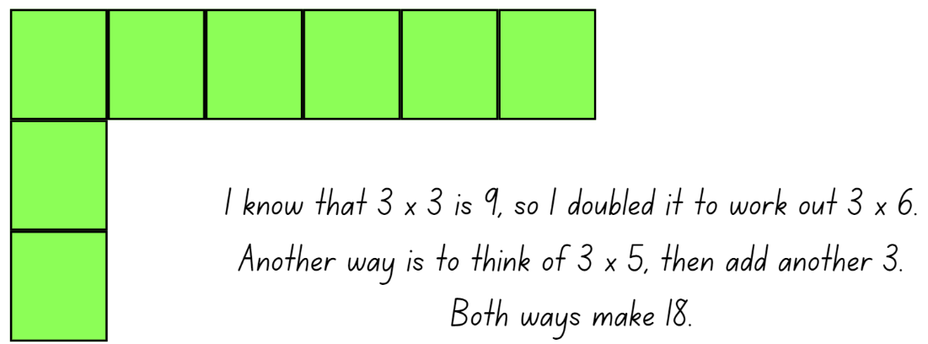
- Students swap roles and repeat the activity.
This table details opportunities for differentiation.
Too hard? | Too easy?
Students cannot find the total of partially covered arrays.  - Show students a completed array and then partially cover using paper. Remove the cover to allow students to skip count rows.  - Allow students to add counters to the partial array. Skip count in rows to determine the total. | Students can find the total of partially covered arrays.  - Extend the numbers in larger ranges or pose problems with combined arrays of different sizes.  - Pose the problem: Can you work out how many counters fit onto an A4 page if you only have 5 counters? Explain how you worked it out. This activity is an adaptation of 'How Many Coins' from Challenging Mathematical Tasks by Sullivan.

Discuss and connect the mathematics – 15 minutes
- Display Resource 12 – partial arrays. Students turn and talk to consider:
- How much of an array do you need to see to calculate how many there are altogether?
- Can you tell which are arrays? Why or why not?
- Do I have enough information to work out exactly how many dots there are on each array? Why or why not?
- How many counters might be underneath B or C?
- What if I told you that C had 18 counters? What number sentences could we write?
- Record student strategies on the multiplication strategies anchor chart.
This table details opportunities for assessment.
Assessment opportunities | Links
What to look for:  - Can students create and represent multiplicative structures, moving from arrays to partially covered area models? [MAO-WM-01, MA2-MR-01]  - Can students find the total of partially covered arrays? [MAO-WM-01, MA2-MR-01]  - Are students using derived strategies for solving multiplication problems? [MAO-WM-01, MA2-MR-01] | Links to National Numeracy Learning Progressions (NNLP):  - MuS5, MuS6.  Links to suggested Interview for Student Reasoning (IfSR) tasks:  - IfSR-MT: 2A.1, 2A.3.

Lesson 4
Core concept: multiplication and division are related.

Daily number sense – teacher choice – 10 minutes
- From a class need surfaced through formative assessment data, identify a short, focused activity that targets students’ knowledge, understanding and skills. Example activities may be drawn from the following resources:
- Mathematics K–6 resources
- Universal Resources Hub.

Core lesson – linking division to multiplication facts – 40 minutes
The table below contains suggested learning intentions and success criteria. These are best co-constructed with students.
Core concept learning intentions | Core concept success criteria
Students are learning to:  - use number properties to find related multiplication facts  - represent and solve word problems with number sentences involving multiplication and division. | Students can:  - link multiplication and division facts  - generate and recall multiplication fact families up to 10 × 10  - complete number sentences involving multiplication and division by calculating missing numbers.
- Display Resource 13 – total of 15 and ask:
- How could you determine the missing number?
- What multiplication fact families can you use to determine the missing number?
- What do you have to multiply by 3 to get to 15?
- What division number sentences could you write for this image?
- Display Resource 14 – fact family triangle and ask:
- What do you remember about the fact family triangles?
- How can you use these facts with multiplication and division?
- What are the correct names for the numbers in the fact families?
- Remind students that, for multiplication, the 2 bottom numbers are factors and the third number is the product.
Product: the result of multiplying 2 or more numbers together. For example, 12 is the product of 4 × 3.
Factor: a number which divides another number without a remainder. For example, 1, 2, 3 and 6 are factors of 6 but 4 and 5 are not.
- Ask students to write different ways of representing these facts as number sentences using multiplication or division. Anticipated responses include:
- 3 × 5 = 15 and 5 × 3 = 15
- 15 ÷ 3 = 5 and 15 ÷ 5 = 3.
- Display Resource 3 – multiplication chart. Explain that the same fact families are represented on the chart.
- Locate the number facts for 3 × 5 = 15 and 5 × 3 = 15. Explain that the chart can be used in the same way as the fact family triangles for writing 4 number sentences.
- Model for other fact families, as required.
Note: for the next activity, students use multiplication facts to write a division number sentence with one value missing. Their partner determines the missing value. Display or provide Resource 3 – multiplication chart for students to refer to.
- In pairs, students use individual whiteboards to record a division number sentence with one factor missing. Their partner then determines the missing value by writing the associated multiplication number sentence (see Figure 8). The partners then swap roles. Repeat several times to promote fluency.
Figure 8 – missing values
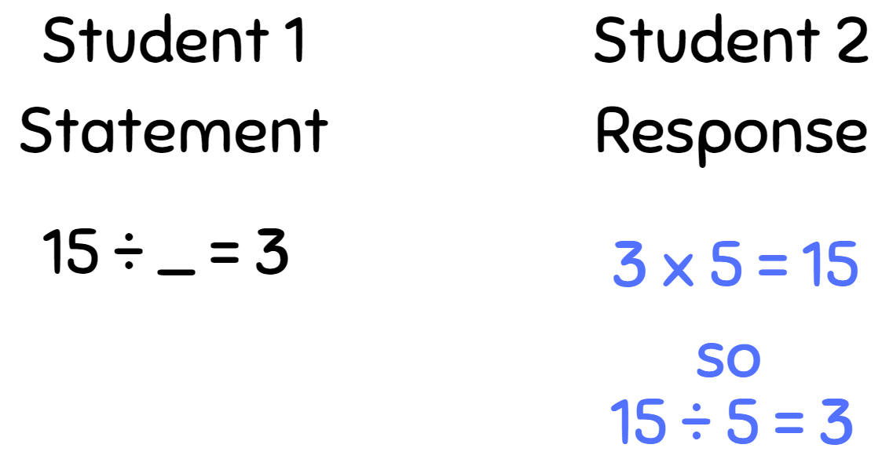
- Organise students into pairs to play the Factors fun game. Using the template on Resource 15 – Factors fun game, prepare game board, spinner, recording sheet, counters and pencils. Watch the Factors Fun (8:25) video about the steps and reasoning used in this game.
- Students take turns to spin the spinner and divide the number by the chosen divisor, for example, 5.
- Players work out the solution and explain their thinking to their partner.
- The partner records their thinking and, if they agree, the player places one of their counters on the number on the game board, claiming that place.
- If the number is taken, students miss a turn.
- If there are no new counters that can be added to the game board, players have to move an existing counter to a new place.
- Players win by getting 4 counters in a row (in any orientation, including a square).
- If preferred, students can use 5 or 6 counters, looking for 4 in a row.
- Observe student reasoning and completed gameboards (see Figure 9).
Figure 9 – Factors fun board
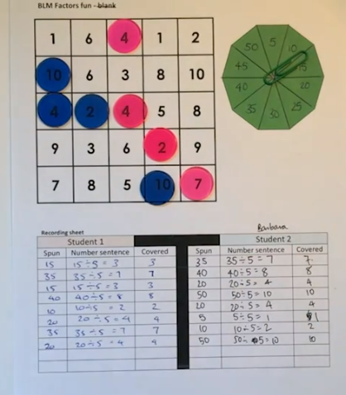
This table details opportunities for differentiation.
Too hard? | Too easy?
Students cannot complete number sentences involving multiplication and division by calculating missing numbers.  - Provide students with a set of multiplication fact families, such as Resource 16 – fact families. Locate and the colour the relevant facts on a copy if Resource 3 – multiplication chart.  - Focus on multiplication facts for 2, 4, 5, 10. Support students by providing grid paper to draw a rectangle and represent the equation using the area model or regions. Guide students to write sentences. | Students can complete number sentences involving multiplication and division by calculating missing numbers.  - Extend to multiples of other numbers.  - Play the Remainders game from the NRICH website. Ask students to record their guesses and explain their reasoning process.  - Support students by providing them with Factors and Multiples Game (paper copy or online via NRICH).

Discuss and connect the mathematics – 10 minutes
- Ask students:
- How are multiplication and division related?
- How can this help us? Why is this useful?
- What is a good strategy we should remember when solving multiplication and division questions?
- Add the strategy to the multiplication strategies anchor chart from previous lessons.
This table details opportunities for assessment.
Assessment opportunities | Links
What to look for:  - Can students link multiplication and division facts? [MAO-WM-01, MA2-MR-01, MA2-MR-02]  - Can students generate and recall multiplication fact families up to 10 × 10? [MAO-WM-01, MA2-MR-01, MA2-MR-02]  - Can students complete number sentences that involve multiplication and division by calculating missing numbers? [MAO-WM-01, MA2-MR-01, MA2-MR-02]  - Can students choose and apply mathematical techniques to solve multiplication and division problems, and communicate their thinking and reasoning coherently and clearly? [MAO-WM-01, MA2-MR-01, MA2-MR-02] | Links to National Numeracy Learning Progressions (NNLP):  - MuS6  - NPA4.

Lesson 5
Core concept: doubling and halving are powerful strategies.

Daily number sense – 10 times bigger – 10 minutes
Daily number sense activities for Lessons 5 to 7 ‘loop’ back to concepts and procedures covered in previous units to assist students to build an increasingly connected network of ideas. These concepts may differ from the core concepts being covered by the unit.
The table below contains a suggested learning intention and success criteria. These are best co-constructed with students.
Daily number sense learning intention | Daily number sense success criteria
Students are learning to:  - recognise and represent numbers that are 10, 100 or 1000 times as large. | Students can:  - record numbers that are 10, 100 and 1000 times larger than a given number.
- Provide students with Resource 17 – 1s, 10s, 100s and 1000s and a 9-sided die.
- Students roll the dice and record the number rolled. Students then record the numbers that are 10, 100 and 1000 times larger than the number rolled.
- Students repeat 4 more times.
Note: a 20-sided die may be used to make the activity more challenging.
This table details opportunities for assessment.
Assessment opportunities | Links
What to look for:  - Can students record each number as a multiple of 10, 100 and 1000? [MAO-WM-01, MA2-RN-01] | Links to National Numeracy Learning Progressions (NNLP):  - MUS7.

Core lesson – repeated halving – 30 minutes
The table below contains suggested learning intentions and success criteria. These are best co-constructed with students.
Core concept learning intentions | Core concept success criteria
Students are learning to:  - apply place value to partition and regroup numbers up to 4 digits  - use known number facts and strategies. | Students can:  - record numbers using standard place value form  - partition numbers of up to 4 digits in non-standard forms  - apply the known strategy of doubling to connect multiples of 3 to 6 and 4 to 8  - apply the inverse relationship of multiplication and division.
- Provide students with individual whiteboards. Display Resource 18 – array cake. Ask:
- How would you divide this cake if you wanted to share it between 2 people?
- How do you know the cake has been shared equally?
- What strategies can you use to halve the cake?
- How can we represent halves?
- How can you prove this using your multiplication facts?
- What would it look like if we split the cake between 4 people?
- Can this be done with just one knife cut?
- What do you notice about ÷ 2 and ÷ 4? Are they related?
- Model different strategies showing 48 shared between 4, using half then half again (see Figure 10). Emphasise that initial partitions can be varied to make halving easier, such as 40 and 8, which are then halved and halved again (see example C in Figure 10).
Figure 10 – sharing cake
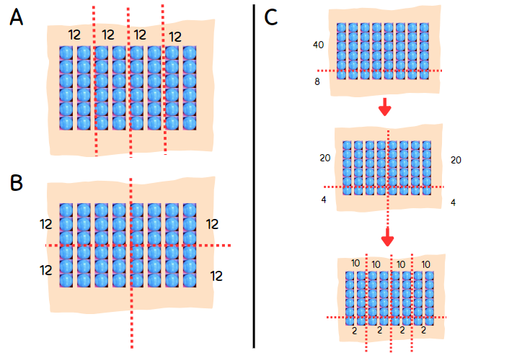
- Ask students to consider how to share 36 between 4. Students turn and talk and share ideas on their individual whiteboards.
- Ask what students could do if they did not know how to halve 36. Model non-standard partitions to make halving easier (see Figure 11).
Figure 11 – sharing 36
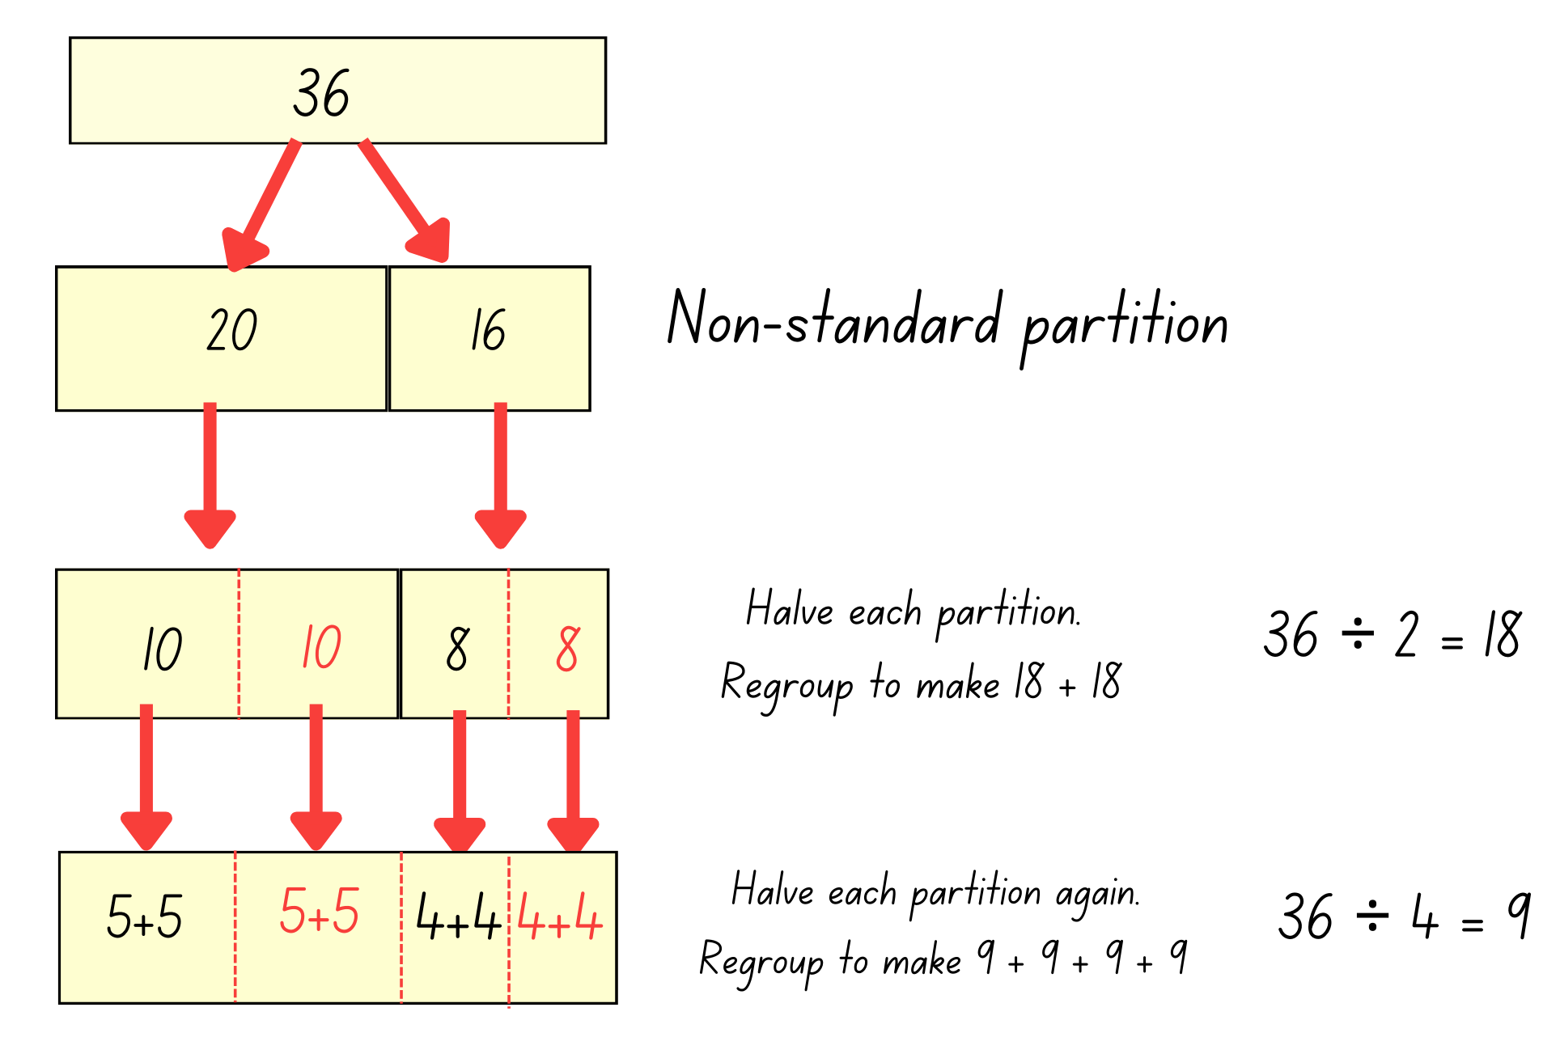
- Explain that students will complete an investigation to answer the following questions:
- What other numbers can you halve and halve again to work out if they can be shared equally into 4 groups?
- Which of these numbers can be halved one more time to be shared equally into 8 groups?
Note: the video for Let's talk – how many ways? (10:25) has a number of examples of student reasoning for how to divide by 4. Depending on the number being divided, this reasoning may be extended to dividing by 8.
- Allow time for students to investigate numbers, drawing regions and arrays for numbers they investigate. Share numbers with the class as students determine numbers divisible by 4 and 8.
- Students share their arrays and regions to prove how many times a number can be halved and which category they fall into. This will create an anchor chart for the class.
This table details opportunities for differentiation.
Too hard? | Too easy?
Students cannot apply the strategy of repeated halving.  - Provide students with a starting number such as 16. Support students to make an array, then partition or cut up the array to halve and halve again.  - Identify the multiples of 4 on Resource 3 – multiplication chart. Ask students to make or draw arrays for each number and partition into half and half again. | Students can apply the strategy of repeated halving.  - Provide Resource 3 – multiplication chart. Students investigate which numbers can only be halved once; which can be halved twice; which can be halved, halved and halved again and any patterns they notice.  - Students identify a number than can be halved and its related multiples of 10, 100 and 1000. For example, 4, 40, 400 and 4000. Students investigate the effect of multiplying numbers by 10, 100 or 1000 to determine how many more times a number can be halved. Ask students to explain how they can prove their results.

Discuss and connect the mathematics – 10 minutes
- Annotate the multiplication anchor chart with the strategy students have learnt today. For example, when dividing by 2, halve a number once. When dividing by 4, halve and halve again. When dividing by 8, halve and halve and halve again. If a number is tricky to halve, use non-standard partitioning to make the numbers easier to work with.
- Display Resource 3 – multiplication chart. Identify where the numbers discovered by the students are located on the chart. Draw attention to the multiples of 2, 4 and 8 and where those multiples intersect. Repeat for multiples of 3 and 6.
This table details opportunities for assessment.
Assessment opportunities | Links
What to look for:  - Can students record numbers using standard place value form? [MAO-WM-01, MA2-RN-01]  - Can students partition numbers of up to 4 digits in non-standard forms [MAO-WM-01, MA2-RN-01]  - Can students apply the known strategy of doubling to connect multiples of 3 to 6 and 4 to 8? [MAO-WM-01, MA2-MR-01]  - Can students apply the inverse relationship of multiplication and division? [MAO-WM-01, MA2-MR-02]  - Can students choose and apply mathematical techniques to solve multiplication and division problems, and communicate their thinking and reasoning coherently and clearly? [MAO-WM-01, MA2-MR-01, MA2-MR-02] | Links to National Numeracy Learning Progressions (NNLP):  - NPV4, NPV5, NPV6  - MuS6, MuS7.  Links to suggested Interview for Student Reasoning (IfSR) tasks:  - IfSR-AT: 3B.2, 3B.4  - IfSR-MT: 2A.5, 2A.10.

Lesson 6
Core concept: the associative property can be used to solve multiplication problems.

Daily number sense – place value houses – 10 minutes
The table below contains a suggested learning intention and success criteria. These are best co-constructed with students.
Daily number sense learning intention | Daily number sense success criteria
Students are learning to:  - recognise and record numbers that are 10, 100 or 1000 times as large. | Students can:  - represent numbers that are 10, 100 and 1000 times larger than a given number.
- Draw a place value house on the whiteboard, large enough for students to stand in front of each column (see Figure 12).
Figure 12 – place value house
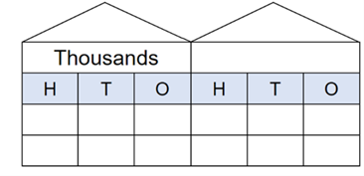
- Ask 6 students to represent numbers by standing or squatting in front of the place value house. A student stands to represent the number one and squats to represent zero.
- Allocate a student to each write a number on the board.
- Ask students to represent 101. The student in the hundreds place and the student in the ones place will stand. All others must squat.
Note: initial numbers must be limited to a maximum of 111 to ensure larger numbers will fit inside the place value house.
- Ask students to represent the number 100 times larger than 101. To represent the number 10 100, only the ten thousands and hundreds place students remain standing. All others squat.
- Continue providing numbers with ones and zeros and numbers that are 10, 100 and 1000 times larger.
- Rotate students regularly to ensure all are involved.
Note: an alternative is to form teams of 6 students. Provide a number and have students allocate themselves to a place value and the teams create their number representations.
This table details an opportunity for assessment.
Assessment opportunity | Links
What to look for:  - Can students arrange ones and zeros to represent numbers that are 10, 100 and 1000 times larger than a given number? [MAO-WM-01, MA2-RN-01] | Links to National Numeracy Learning Progressions (NNLP):  - NPV8, NPV9.

Core lesson – associative property – 40 minutes
The table below contains a suggested learning intention and success criteria. These are best co-constructed with students.
Core concept learning intention | Core concept success criteria
Students are learning to:  - use number properties to find related multiplication facts. | Students can:  - use the associative property within multiplication to regroup the factors  - use flexible partitioning within multiplication.
This activity is an adaptation of Primary and Middle Years Mathematics: Teaching Developmentally by Van de Walle. The purpose of the opening questions is to engage students in reasoning and justifying their choices.
- Offer one of the following scenarios to the students:
- Would you rather start a long-distance race by running fast or slow?
- Would you rather swim 50 m using only your hands or only your feet?
- Students turn and talk to develop their reasoning.
- Select students to share their views and reasoning. Explain that they will be sharing which strategies they would use to solve a problem.
- Display Resource 19 – tennis ball problem.
- Explain that each tennis ball costs $2. There are 3 tennis balls in each can. Ask how much it would cost for 6 cans.
- Guide students to consider the problem in 2 ways:
- find out the cost for each can and then the total cost, 6 × (3 × 2)
- find out how many balls there are in total and then the cost (6 × 3) × 2.
Note: students may use grouping symbols to indicate which part of the number sentence is completed first. This style of grouping symbols (…) is called ‘parentheses’ in the Mathematics K–10 Syllabus teaching advice.
- Ask students which method they would rather use and why.
- Explain that being able to change the order of multiplication is called the ‘associative property’ or ‘associative law’. Share the definition.
Associative property: when more than 2 numbers are added or multiplied, the result is unchanged regardless of how they are grouped or associated. For example, 6 × 3 × 2 can be calculated as 18 × 2 or 6 × 6 or 12 × 3.
- Present Resource 20 – Would you rather …?
- Explain that the array represents 5 × 8 and can be rewritten as 5 × 2 × 4.
- Ask if students would rather complete 2 × 4 (shown in red) and then multiply by 5, or 5 × 2 (shown in purple) and then multiply by 4.
- Display Resource 21 – gameboard and Resource 22 – recording sheet.
- Read the activity instructions with the students and share an example (see Figure 13).
Figure 13 – gameboard example
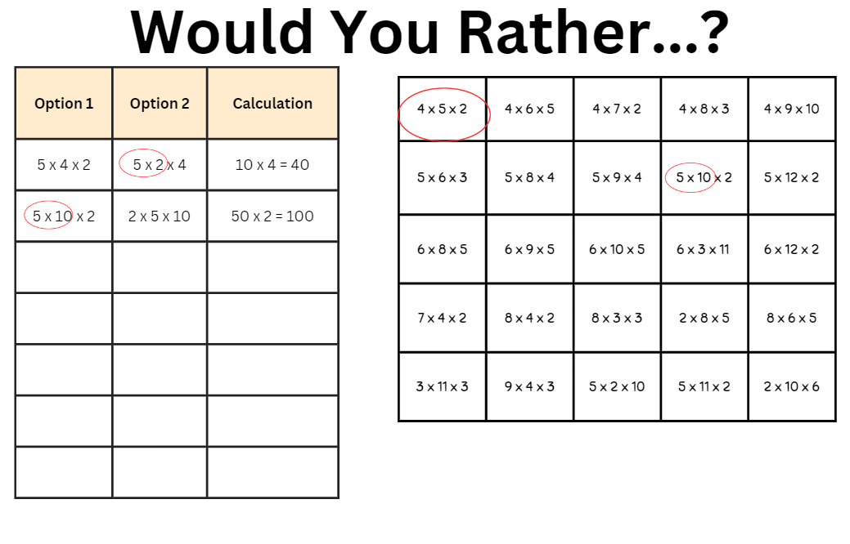
This table details opportunities for differentiation.
Too hard? | Too easy?
Students cannot break numbers into factors or use the associative property within multiplication to regroup factors.  - Provide students with number sentences and guide them to choose 2 numbers that can be multiplied easily.  - Students rewrite gameboard facts using the commutative property, such as 4 × 5 = 5 × 4, and ask what sentence they would rather solve. | Students can use the associative property within multiplication to regroup factors.  - Students roll dice to create more challenging numbers to factorise, such as 14 × 5 becomes 7 × (2 × 5).  - Students create word problems using a number sentence and the associative property.

Discuss and connect the mathematics – 10 minutes
- Discuss student strategies. Ask:
- Which numbers were easy to multiply?
- Why might different people have different strategies to solve problems?
- How might this strategy help us recall multiplication facts or solve problems?
- Add any new strategy to the multiplication strategies anchor chart from previous lessons.
- Explain that the associative property of multiplication allows students to regroup factors and multiply them in an order that they choose.
- Present the problem 5 × 5 × 5 × 2 × 2 × 2. Guide students to notice that by regrouping the factors they can rewrite it as (5 × 2) × (5 × 2) × (5 × 2) = 1000.
This table details opportunities for assessment.
Assessment opportunities | Links
What to look for:  - Can students use number properties to find related multiplication facts? [MAO-WM-01, MA2-MR-01]  - Can students use the associative property within multiplication to regroup factors? [MAO-WM-01, MA2-MR-01] | Links to National Numeracy Learning Progressions (NNLP):  - MuS6, MuS7.  Links to suggested Interview for Student Reasoning (IfSR) tasks:  - IfSR-MT: 2A.7.

Lesson 7
Core concept: associative and commutative properties can be used to solve multiplication problems.

Daily number sense – 10, 100 and 1000 times bigger – 10 minutes
The table below contains a suggested learning intention and success criteria. These are best co-constructed with students.
Daily number sense learning intention | Daily number sense success criteria
Students are learning to:  - recognise and represent numbers that are made of tens, hundreds and thousands. | Students can:  - recognise and record the number of tens, hundreds, or thousands in a number.  - describe how making a number 10, 100 or 1000 times as large changes the place value of digits.
- Provide pairs of students three 9-sided dice and an individual whiteboard.
- Ask students to draw a place value chart on their whiteboard (see Figure 14).
Figure 14 – place value chart
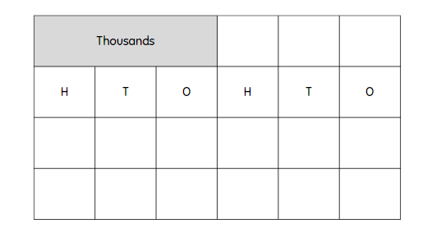
- Students roll the dice and arrange the dice to form the smallest number possible. For example, rolling a 5, 1 and 9, the dice could be arranged to form the number 159.
- Students record the number that is 10 times larger.
- On the second roll of the dice, students form the largest number possible and record the number that is 100 times larger.
- On the third roll of the dice, students form any number and record the number that is 1000 times larger.
- Repeat this 3 times so that students can practice numbers 10, 100 and 1000 times larger.
- Vary the task by asking students to select specific numbers, such as those that have an even hundreds digit, or an odd unit digit, or a number with even thousands and tens digits.
This table details opportunities for assessment.
Assessment opportunities | Links
What to look for:  - Can students identify and record the ones, tens, hundreds and thousands in a number? [MAO-WM-01, MA2-RN-01]  - Can students describe how making a number 10, 100 or 1000 times as large changes the place value of digits? [MAO-WM-01, MA2-RN-01] | Links to National Numeracy Learning Progressions (NNLP):  - NPV4, NPV5, NPV6.

Core lesson – looking for tens – 30 minutes
The table below contains suggested learning intentions and success criteria. These are best co-constructed with students.
Core concept learning intentions | Core concept success criteria
Students are learning to:  - use number properties to find related multiplication facts  - operate with multiples of 10. | Students can:  - use the commutative property of multiplication  - apply the commutative and associative properties to multiply by multiples of 10.
Note: it is a common misconception that multiplying by 10 can be done by simply ‘adding a zero’ and multiplying by 100 can be done by ‘adding 2 zeroes’. This approach should be avoided as it detracts from a deeper understanding of place value, multiplicative thinking and the link between them.
- Display and read Resource 23 – problem solving. Ask:
- Where have you seen strategies like these before?
- What properties of multiplication are Phil and Lisa using?
- Which strategy would you use? Why?
- What are some advantages of Lisa’s strategy (doubling)?
- What are some advantages of Phil’s strategy (looking for tens)?
- Remind students of the definitions of ‘associative property’ and ‘commutative property’ of multiplication.
Associative property: when more than 2 numbers are added or multiplied, the result is unchanged regardless of how they are grouped or associated. For example, 6 × 3 × 2 can be calculated as 18 × 2 or 6 × 6 or 12 × 3.
Commutative property: two numbers can be added or multiplied in any order and the solution will be the same. ‘Commutative law’, ‘commutativity’ and ‘turn-around facts’ are interchangeable terms.
- Present the problems 30 × 7 and 21 × 4. Discuss which is most suited to doubling.
- Explain that for 30 × 7, 30 can be broken up into its factors of 3 × 10. This strategy can be called looking for tens.
- Students solve 30 × 7 by applying Phil’s strategy (looking for tens) on an individual whiteboard.
- Present additional looking for tens number sentences for guided learning, as needed.
- Display Resource 24 – sort ‘n’ solve. Ask students to list number sentences under the heading of the strategy that would use.
- Ask students to compare their lists with others’ and share their reasoning.
- Students then solve each number sentence using their chosen strategy. Students cross check each other’s answers.
This table details opportunities for differentiation.
Too hard? | Too easy?
Students cannot apply the commutative and associative properties to multiply by multiples of 10.  - Support students with a multiplication chart to locate and use number facts.  - Provide base-10 blocks to model question cards and focus on renaming, such as 40 × 3 = 4 tens × 3 = 4 × 3 tens. | Students can apply the commutative and associative properties to multiply by multiples of 10.  - Students generate larger numbers or experiment with multiplying by 100 or 1000.  - Offer the open-ended problem __ __ × __ = __ __ 0 where the spaces represent a missing digit. Students identify as many solutions as possible.

Discuss and connect the mathematics – 5 minutes
- Ask why it is important to have more than one strategy for multiplication.
- Identify that breaking up numbers into factors (factorising) is an effective strategy when multiplying by multiplies of 10.
- Model using equivalent number sentences such as 40 × 5 = 4 × 10 × 5 = 4 × 5 × 10.
- Discuss and record a strategy that can be used when multiplying by multiples of 10.
Note: for Stage 2 content, students apply the associative property of multiplication to regroup factors. Factorising is part of Stage 3 content.
This table details opportunities for assessment.
Assessment opportunities | Links
What to look for:  - Can students use the commutative property of multiplication? [MAO-WM-01, MA2-MR-01]  - Can students apply the commutative and associative properties to multiply by multiples of 10? [MAO-WM-01, MA2-MR-01,] | Links to National Numeracy Learning Progressions (NNLP):  - MuS6, MuS7.

Consolidation and meaningful practice – 20 minutes
- Explain that the class will play a game where the goal is to make 1000. In this game students will practise multiplying one-digit numbers by multiples of 10.
- The steps for the game are:
- Spin on a 1–10 spinner or dice to determine the one-digit number (see Resource 25 – 1–10 spinner).
- Players choose to multiply that number by 10, 20, 30, 40, 50 or 60.
- Players record the equation and product.
- Repeat the process another 6 times, adding the products each time to get a progressive total (see Figure 15).
- The winner is the player whose total is closest to 1000 after 7 spins.
Figure 15 – make 1000 example
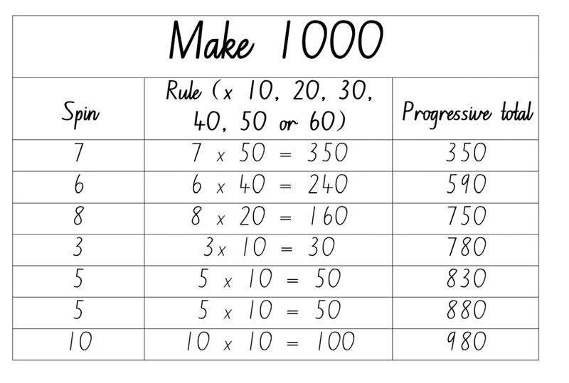
- Model the game with the class. Discuss options after each spin, demonstrating strategies to determine the product for each option before deciding which rule to apply. Ensure students understand the progressive total and how to calculate it.
- After the final total has been determined, discuss decisions made during the game and different strategies that could lead to a total closer to 1000. Remind students that the winner is the player with the total closest to 1000 and explain that sometimes, the closest total might be higher than 1000.
This table details opportunities for differentiation.
Too hard? | Too easy?
Students cannot apply the commutative and associative properties to multiply by multiples of 10.  - Students focus on multiplying numbers by 10 only.  - Support students with a multiplication chart to locate and use number facts. Ask students to model the product using base-10 materials.  - Provide base-10 blocks to model question cards and focus on renaming, such as 40 × 3 = 4 tens × 3 = 4 × 3 tens. | Students can apply the commutative and associative properties to multiply by multiples of 10.  - Students use larger dice to create more challenging problems such as 15 × 30 and race to 10 000.  - Students may choose to multiply by 100 or 1000 and race to a target number of their choice.
This table details opportunities for assessment.
Assessment opportunities | Links
What to look for:  - Can students apply the commutative and associative properties to multiply by multiples of 10? [MAO-WM-01, MA2-MR-01]  - Can students select multiples to solve problems and justify their selection? [MAO-WM-01, MA2-MR-01] | Links to National Numeracy Learning Progressions (NNLP):  - MuS7.

Lesson 8
Core concept: distributive properties can be used to solve multiplication problems.

Daily number sense – teacher choice – 10 minutes
- From a class need surfaced through formative assessment data, identify a short, focused activity that targets students’ knowledge, understanding and skills. Example activities may be drawn from the following resources:
- Mathematics K–6 resources
- Universal Resources Hub.

Core lesson – doubles, tens or partition – 30 minutes
The table below contains suggested learning intentions and success criteria. These are best co-constructed with students.
Core concept learning intentions | Core concept success criteria
Students are learning to:  - apply an understanding of place value and the role of zero to represent numbers to at least tens of thousands  - represent and use the structure of multiplicative relations to 10 × 10 to solve problems. | Students can:  - record numbers using standard place value form  - partition numbers of up to 4 digits in non-standard forms  - use flexible partitioning to solve multiplication problems.
- Pose the scenario: ‘A student ate 13 jellybeans. Their friend ate 4 times as many.’ Ask how many jellybeans the student’s friend ate.
- Students turn and talk and discuss their strategies. Record student responses. Anticipated responses include double, double 13 and 10 × 4 + 3 × 4.
- Explain that, when solving multiplication problems, sometimes a number can be partitioned using knowledge of place value or addition to make the numbers easier to work with. It also can help students work out unknown multiplication facts from known multiplication facts.
- Display Resource 26 – 7 sixes. Ask students to consider how they could make the array easier to work with by partitioning it into different sections (see Figure 16).
Figure 16 – partitioning arrays
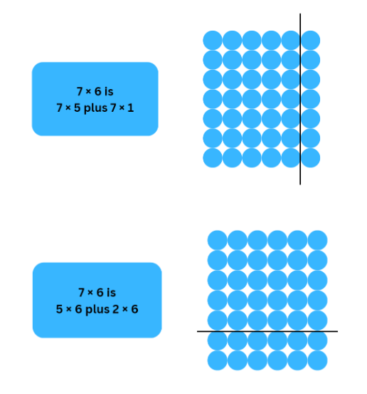
- Model how to record student thinking using number sentences. Tell students that the parentheses will help explain their thinking to someone else, as well as show how they have partitioned numbers and worked with them.
- Pose the question 23 × 3 to students. Display Resource 27 – 23 ×3.
- Students turn and talk about how they could partition the region to determine how many there are altogether. Record student thinking using open arrays and models writing the number sentence. Some anticipated student responses are set out in Figure 17.
Figure 17 – 23 × 3
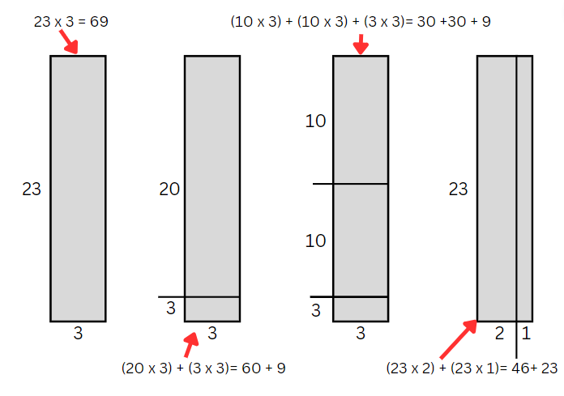
- Explain that, for multiplication, partitioning works due to the distributive property of multiplication.
Note: the distributive property can be defined as ‘Multiplication of numbers is distributive over addition because the product of one number with the sum of 2 others equals the sum of the products of the first number with each of the others. For example, 3 × 9 = 3 × (4 + 5) = 3 × 4 + 3 × 5.’ (NESA 2023)
- Provide students with a copy of Resource 28 – sort 'n' solve 2.
- Students cut up and sort the multiplication number sentences into the strategy headings.
- In small groups, students share, compare and justify their choices.
- Ask students to solve at least one multiplication problem from each strategy category. Ask if their chosen strategy was helpful.
- Share solutions with the class where students used different strategies. Ask students to explain their reasoning and evaluate their chosen strategy.
This table details opportunities for differentiation.
Too hard? | Too easy?
Students cannot use flexible partitioning within multiplication.  - Support students by representing the multiplication sentences using arrays, grid paper or regions. Support students to partition these representations and sort according to their strategy.  - Support students to use strategies or anchor charts from previous lessons to assist with these multiplication problems. | Students can use flexible partitioning within multiplication.  - Students create their own multiplication number sentences that can be solved in 2 or more ways.  - Students can develop their own headings for multiplication strategies and provide additional multiplication number sentences that fit into those categories.

Discuss and connect the mathematics – 10 minutes
- After completing the Sort ‘n’ Solve activity, ask students:
- Are there some multiplication number sentences that fit in multiple headings?
- Which ones are the most flexible (have more than one or 2 ways) to solve? Explain or prove why.
- Are there any other strategies that are not in the headings that you could use?
- What other headings could you make?
- Add any new strategies to the multiplication strategies anchor chart from previous lessons.
This table details opportunities for assessment.
Assessment opportunities | Links
What to look for:  - Can students record numbers using standard place value form? [MAO-WM-01, MA2-RN-01]  - Can students partition numbers of up to 4 digits in non-standard forms? [MAO-WM-01, MA2-RN-01]  - Can students use flexible partitioning within multiplication? [MAO-WM-01, MA2-RN-01, MA2-MR-01] | Links to National Numeracy Learning Progressions (NNLP):  - NPV5, NPV6  - MuS7.

Resource 1 – two arrays
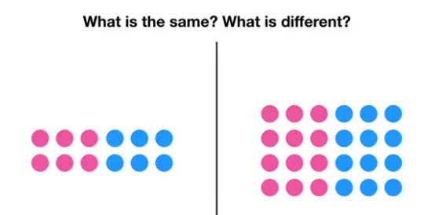

Resource 2 – three arrays
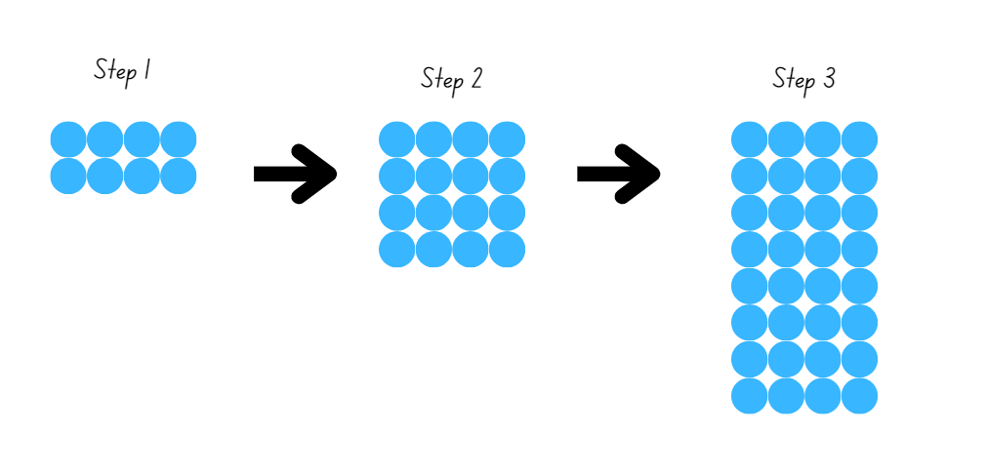

Resource 3 – multiplication chart
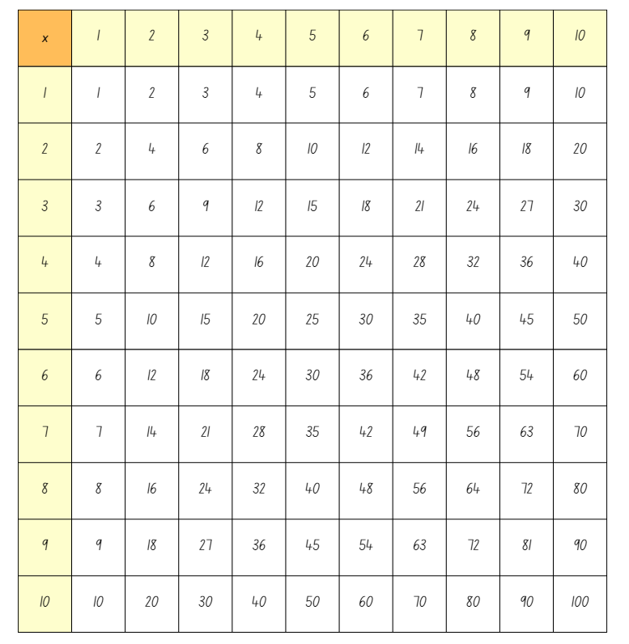

Resource 4 – doubles fill
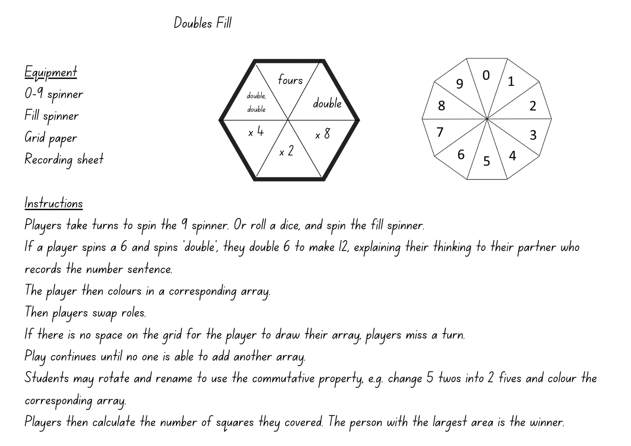
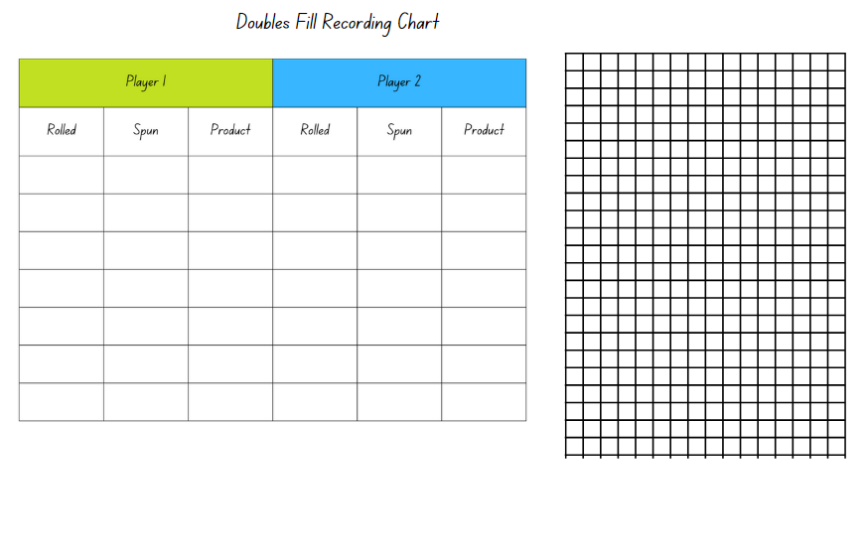

Resource 5 – × 3 × 6
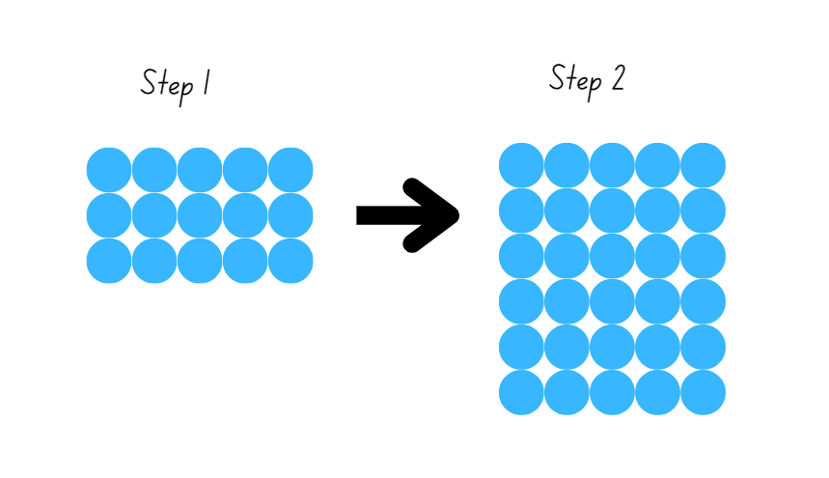

Resource 6 – doubles fill 2
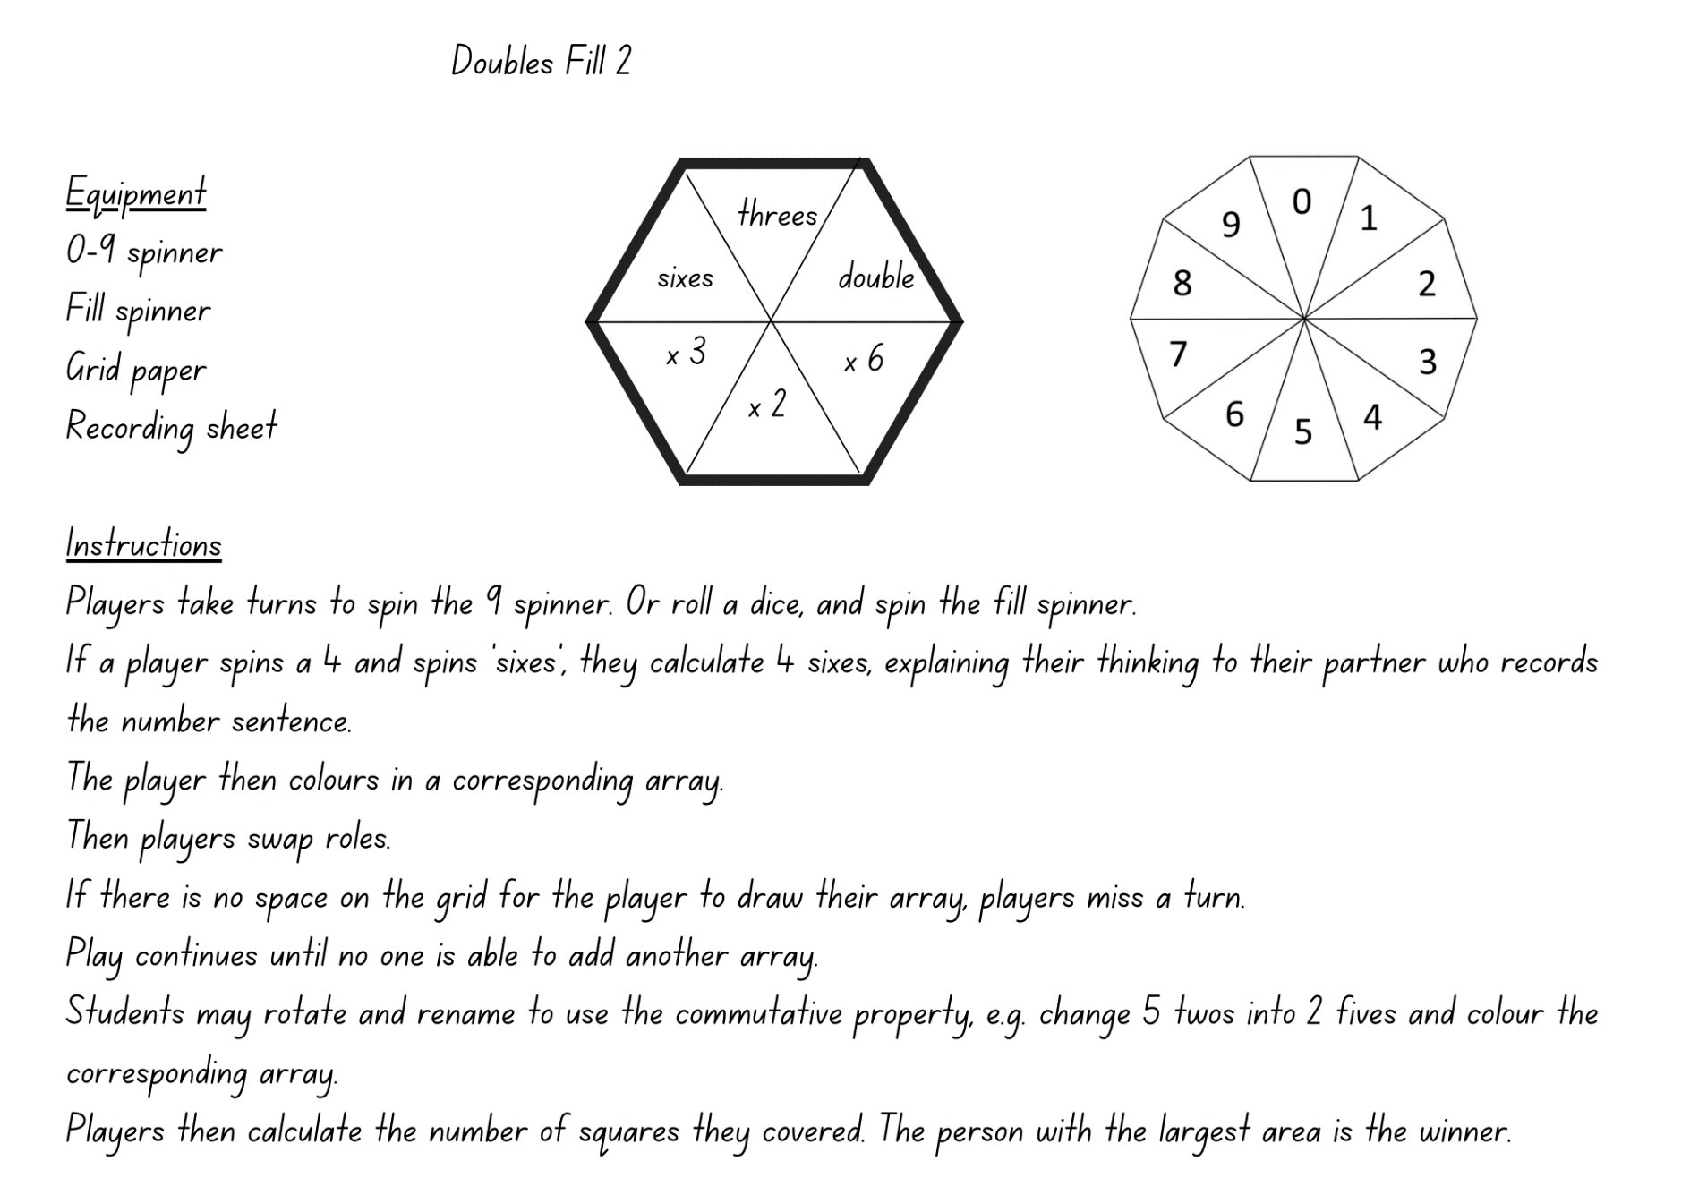

Resource 7 – Double Double Up
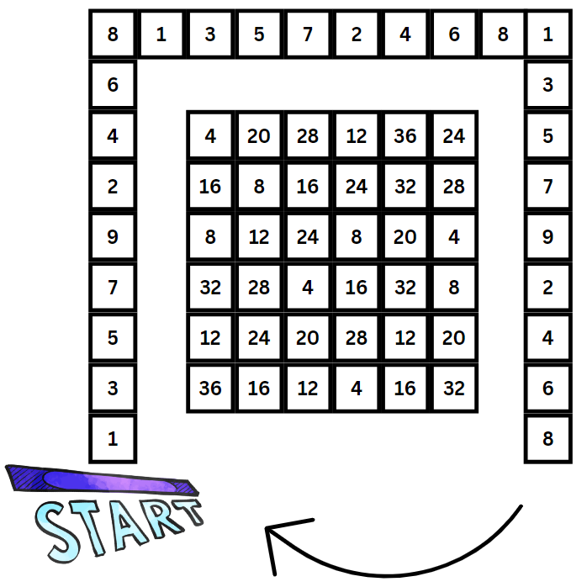
This image has been adapted from ‘Double Double Up’ from Dr Paul Swan Board Game Pack Years 3–4 by Swan.

Resource 8 – an array

Resource 9 – an array 2

Resource 10 – arrays of 9
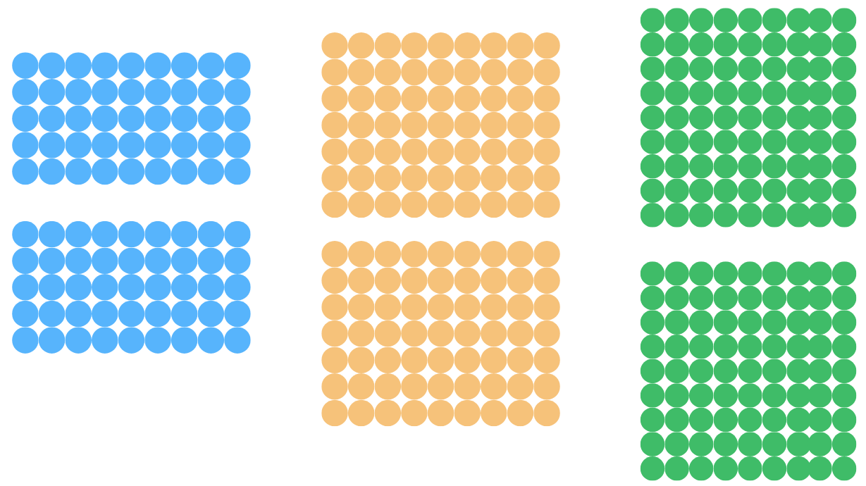

Resource 11 – tiling problem
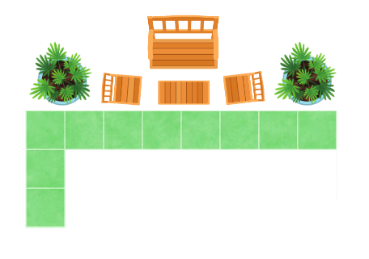

Resource 12 – partial arrays
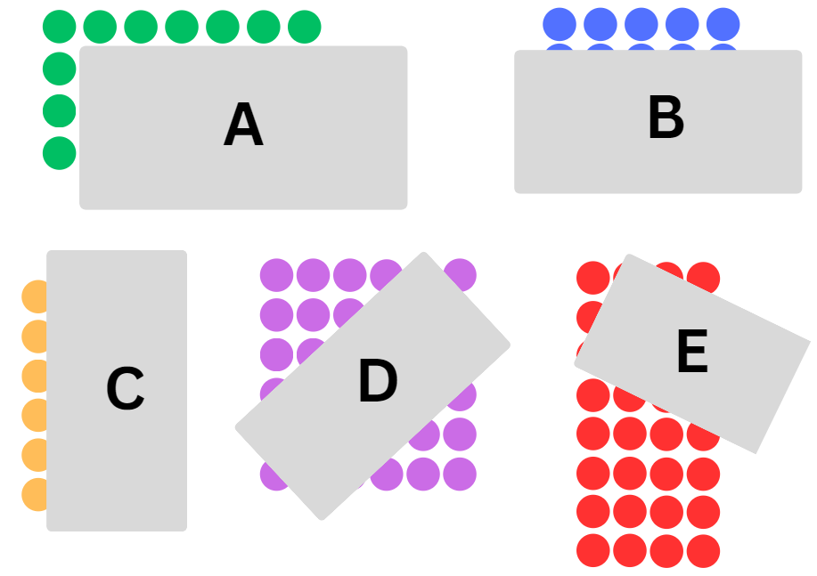

Resource 13 – total of 15
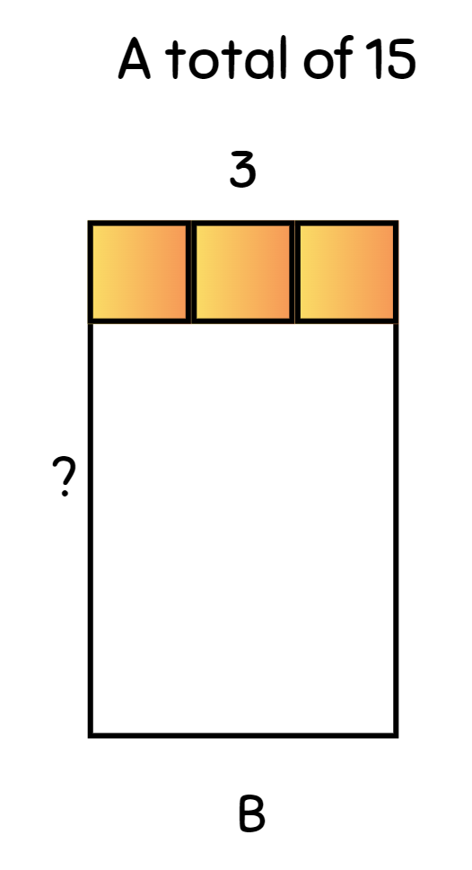

Resource 14 – fact family triangle
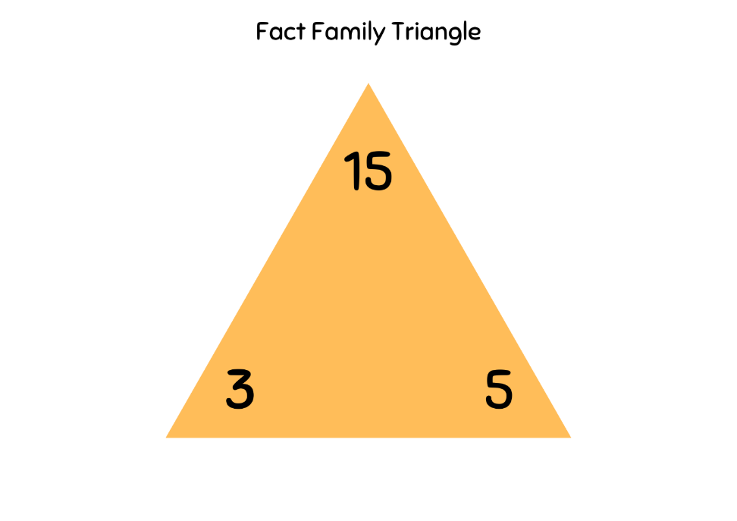

Resource 15 – Factors fun game
Equipment | 3 pencils, workbook, game board, paper clip, 4 to 6 different counters per player
Instructions | - Select a number to focus on, for example multiples of 9.  - Fill in the spinner with multiples of your chosen number.  - Take turns to spin the spinner and divide the number by the chosen divisor (for example, 9).  - Players work out the solution and explain their thinking to their partner.  - The partner records their thinking and if they agree, the player can place one of their counters on the number on the game board, claiming that place.  - If the number is taken, students miss a turn.  - If there are no new counters that can be added to the game board, players must move an existing counter to a new place.  - Players win by getting 4 counters in a row (in any orientation, including a square).  - If preferred, students can use 5 or 6 counters, looking for 4 in a row.

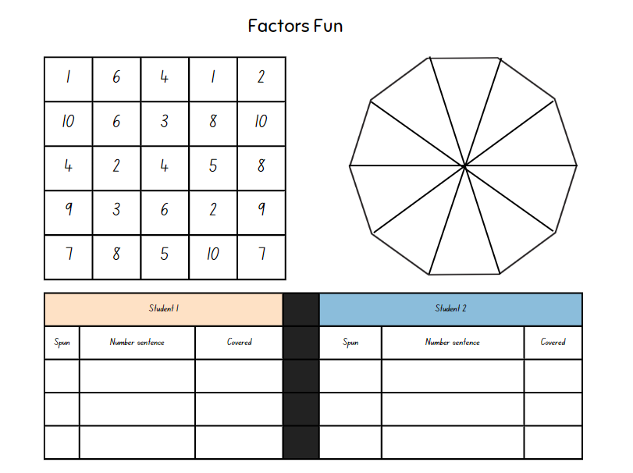

Resource 16 – fact families
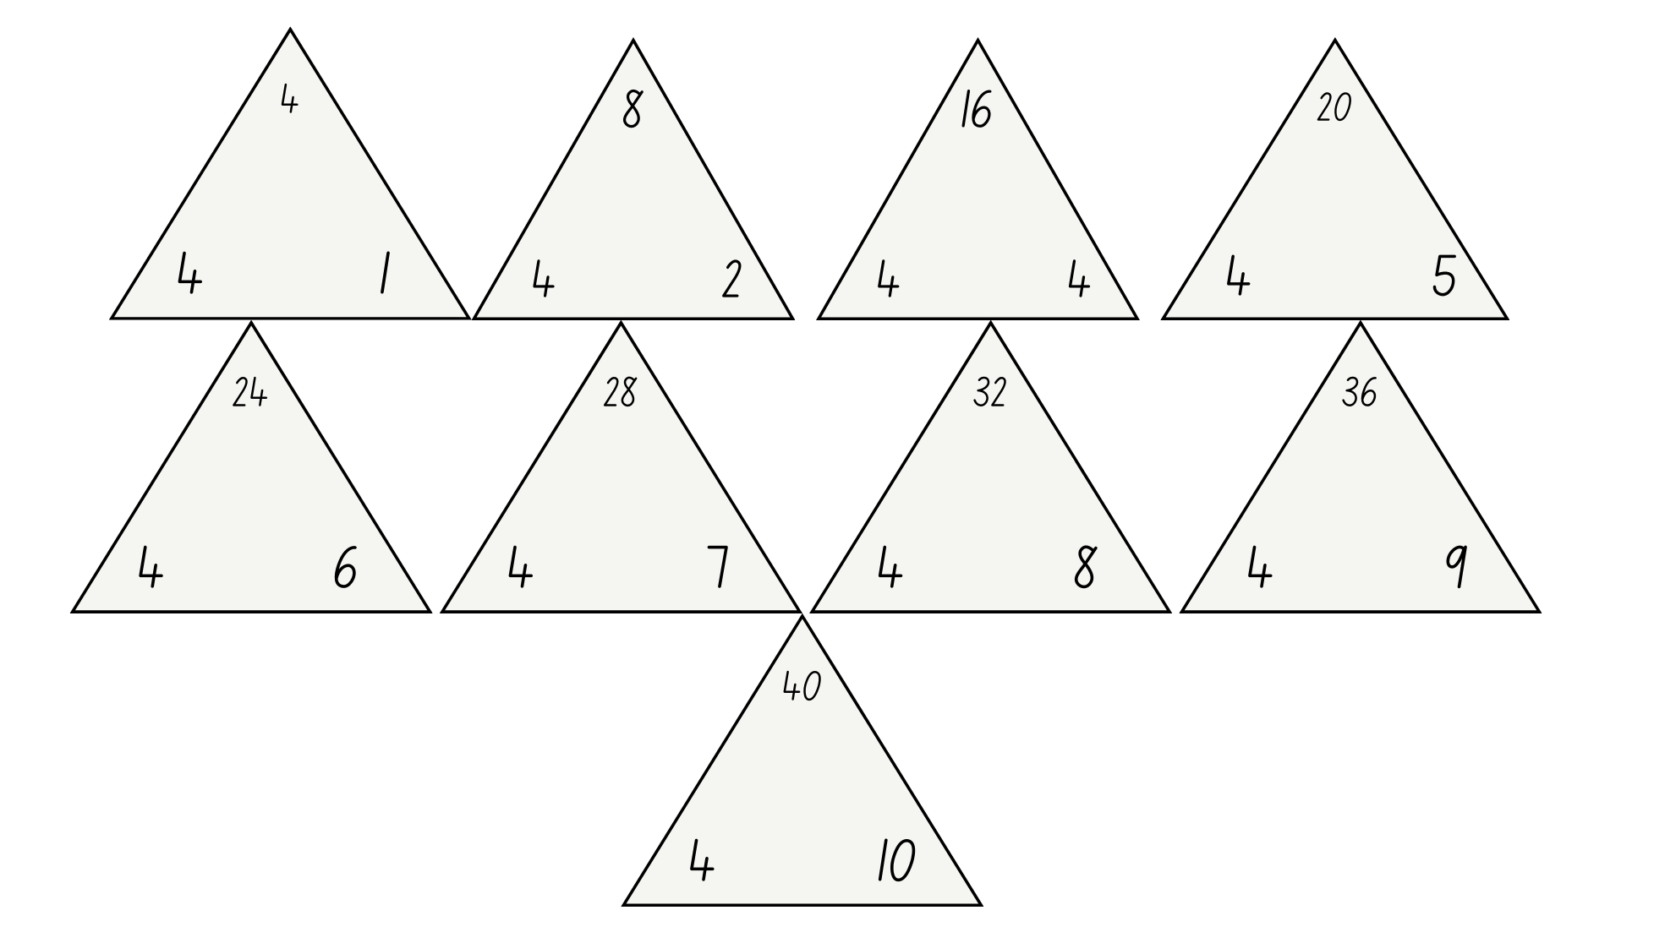

Resource 17 – 1s, 10s, 100s and 1000s
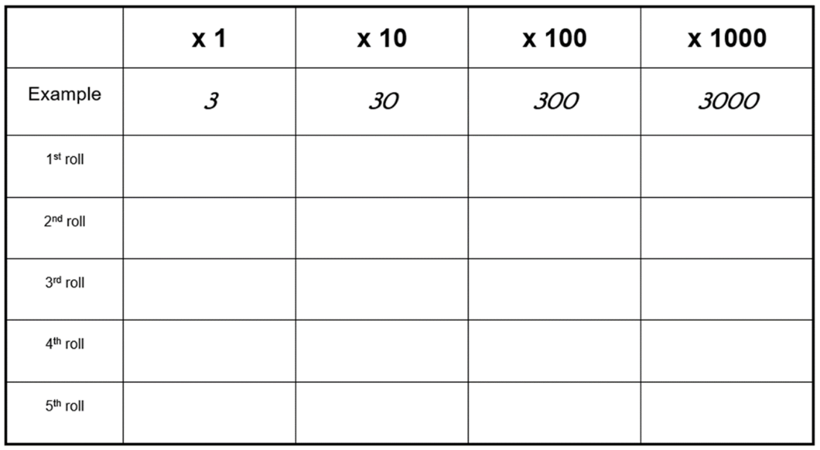

Resource 18 – array cake
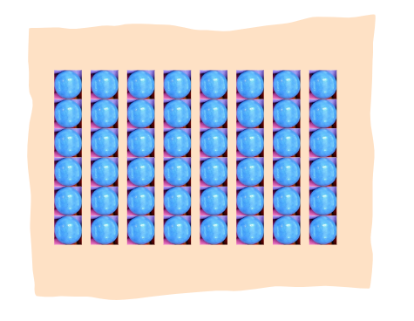

Resource 19 – tennis ball problem
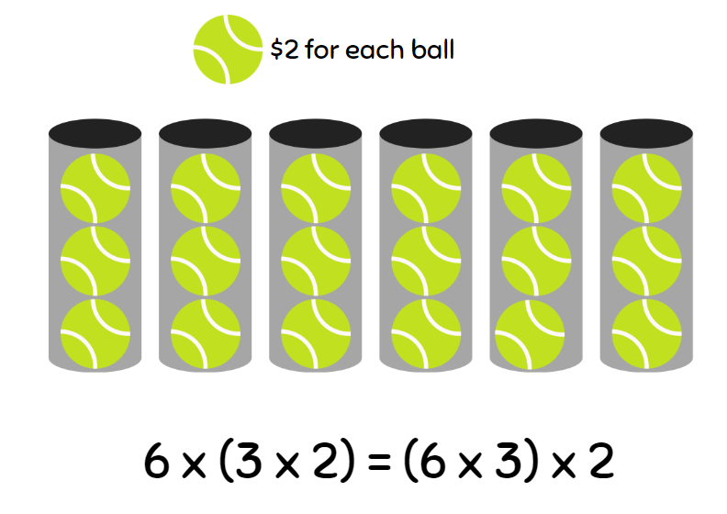

Resource 20 – Would you rather ...?
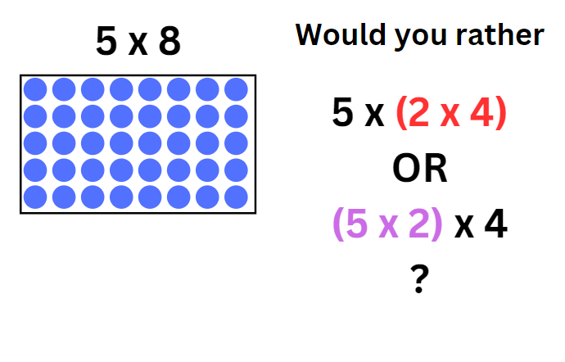

Resource 21 – gameboard
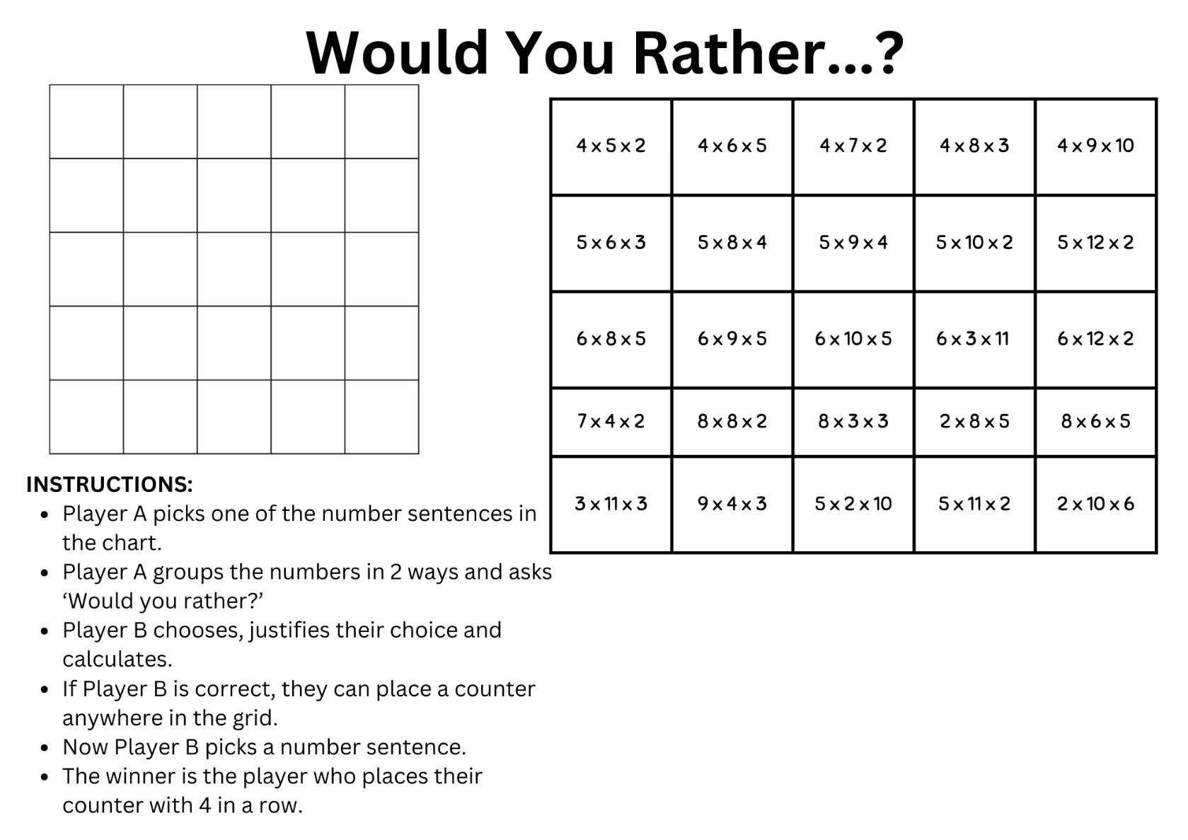

Resource 22 – recording sheet
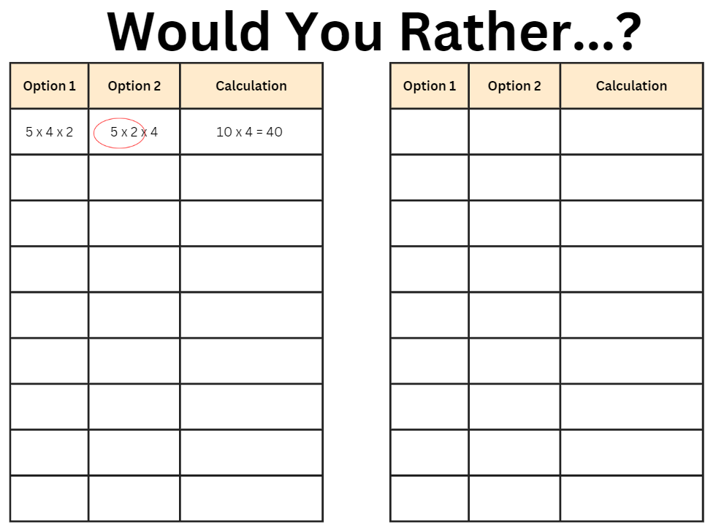

Resource 23 – problem solving
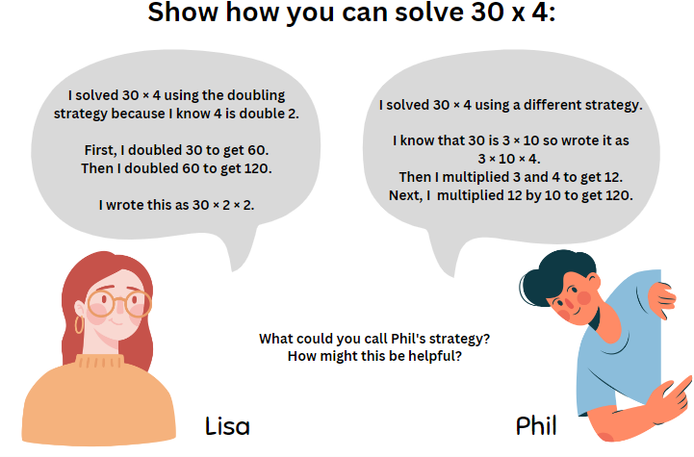

Resource 24 – sort ’n’ solve
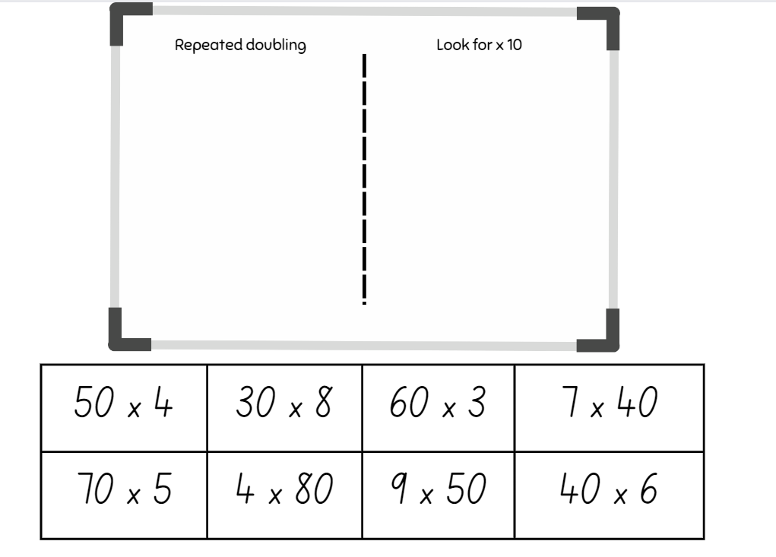

Resource 25 – 1–10 spinner
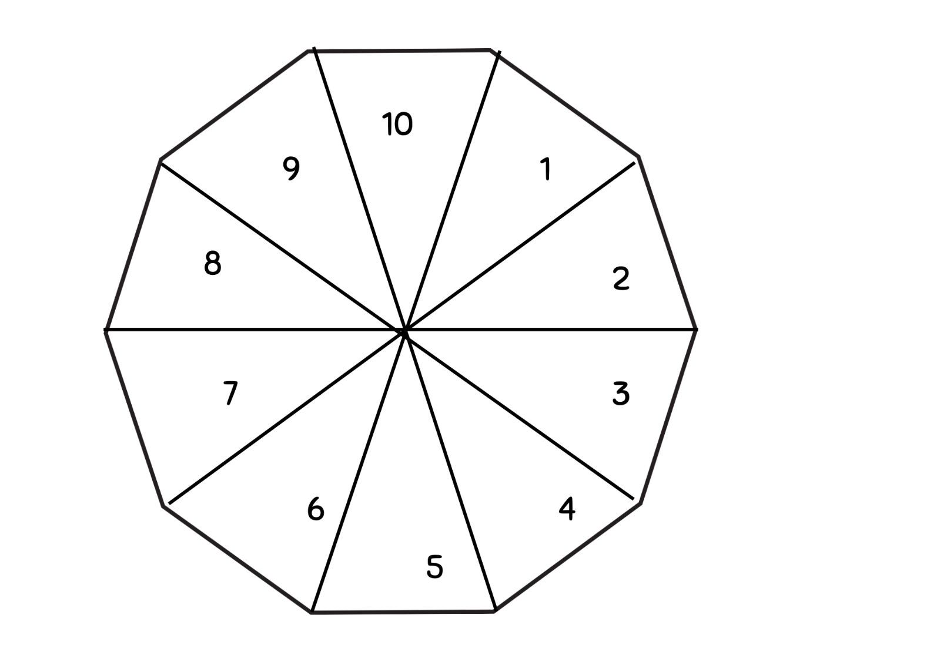

Resource 26 – 7 sixes
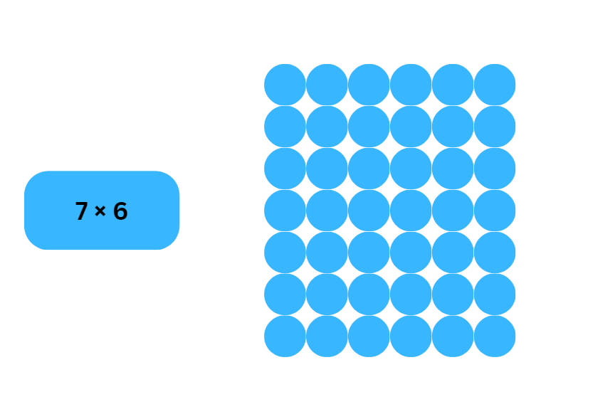

Resource 27 – 23 × 3
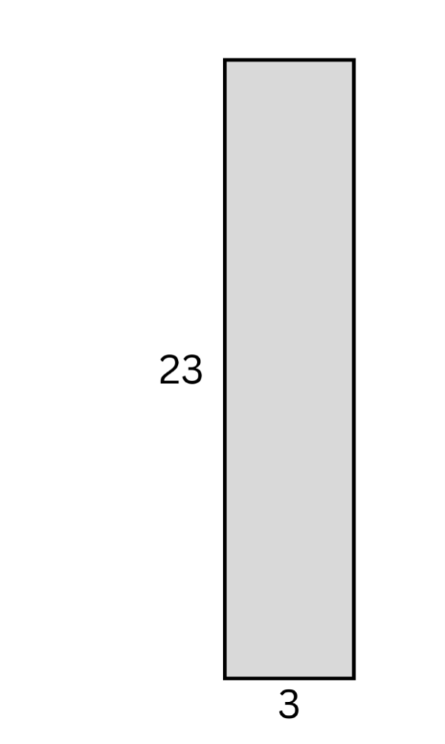

Resource 28 – sort ‘n’ solve 2
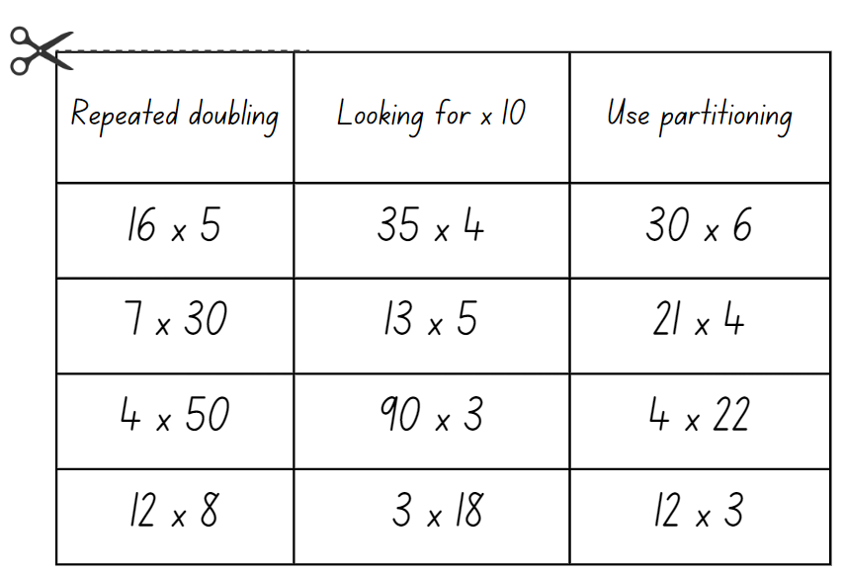

Syllabus outcomes and content
The table below outlines the syllabus outcomes and range of relevant syllabus content covered in this unit. Content is linked to National Numeracy Learning Progression version (3).
Outcomes and content | 1 | 2 | 3 | 4 | 5 | 6 | 7 | 8
Representing numbers using place value A: Whole numbers: Apply place value to partition and regroup numbers up to 4 digits
MAO-WM-01, MA2-RN-01
- Record numbers using standard place value form |  | x | x |  | x | x | x | x
- Partition numbers of up to 4 digits in non-standard forms (Reasons about quantity) |  | x | x |  | x | x | x | x
Representing numbers using place value B: Whole numbers: Recognise and represent numbers that are 10, 100 or 1000 times as large
MAO-WM-01, MA2-RN-01
- Recognise the number of tens, hundreds or thousands in a number |  |  |  |  | x | x | x
- Describe how making a number 10, 100 or 1000 times as large changes the place value of digits |  |  |  |  | x | x | x
Multiplicative relations A: Represent and solve problems involving multiplication fact families
MAO-WM-01, MA2-MR-01, MA2-MR-02
- Describe multiplication problems using for each and times as many |  |  |  | x
- Find the total of partially covered arrays |  |  | x | x
- Apply the inverse relationship of multiplication and division (Reasons about relations) |  |  |  | x | x
Multiplicative relations B: Investigate number sequences involving related multiples
MAO-WM-01, MA2-MR-01, MA2-MR-02
- Generate number patterns using related multiples | x |  |  |  | x
- Investigate number patterns involving related multiples | x | x |  |  | x
Multiplicative relations B: Use known number facts and strategies
MAO-WM-01, MA2-MR-01, MA2-MR-02
- Apply the known strategy of doubling to connect multiples of 3 to 6 and 4 to 8 (Reasons about relations) | x | x | x |  | x
- Use known facts to find unknown multiples (Reasons about relations) | x | x | x |  | x
Multiplicative relations B: Use the structure of the area model to represent multiplication and division
MAO-WM-01, MA2-MR-01, MA2-MR-02
- Create and represent multiplicative structure, moving from arrays to partially covered area models |  |  | x
Multiplicative relations B: Use number properties to find related multiplication facts
[MAO-WM-01, MA2-MR-01, MA2-MR-02]
- Use the commutative property of multiplication |  |  |  |  |  | x | x
- Use the associative property within multiplication to regroup the factors (Reasons about structure) |  |  |  |  |  | x | x
- Use flexible partitioning within multiplication (Reasons about relations) |  |  |  |  | x | x | x | x
- Generate and recall multiplication fact families up to 10 × 10 | x | x |  | x | x
Multiplicative relations B: Operate with multiples of 10
MAO-WM-01, MA2-MR-01, MA2-MR-02
- Use multiplication facts with multiples of 10 to multiply a one-digit number by a multiple of 10 |  | x
- Use place value to rename groups of 10 to multiply |  | x
- Apply the commutative and associative properties to multiply by multiples of 10 |  |  |  |  | x | x | x
Multiplicative relations B: Represent and solve word problems with number sentences involving multiplication or division
MAO-WM-01, MA2-MR-01, MA2-MR-02
- Use the equals sign to record equivalent number relationships involving multiplication (Reasons about relations) |  |  |  |  |  | x
- Complete number sentences involving multiplication and division by calculating missing numbers (Reasons about relations) |  |  |  | x |  | x
- Represent and solve multiplication and division (both sharing and grouping) word problems using number sentences |  |  |  | x |  | x
Mathematics K–10 Syllabus © NSW Education Standards Authority (NESA) for and on behalf of the Crown in right of the State of New South Wales, 2022.

References
This resource contains NSW Curriculum and syllabus content. The NSW Curriculum is developed by the NSW Education Standards Authority. This content is prepared by NESA for and on behalf of the Crown in right of the State of New South Wales. The material is protected by Crown copyright.
Please refer to the NESA Copyright Disclaimer for more information https://educationstandards.nsw.edu.au/wps/portal/nesa/mini-footer/copyright.
NESA holds the only official and up-to-date versions of the NSW Curriculum and syllabus documents. Please visit the NSW Education Standards Authority (NESA) website https://educationstandards.nsw.edu.au/ and the NSW Curriculum website https://curriculum.nsw.edu.au.
Mathematics K–10 Syllabus © NSW Education Standards Authority (NESA) for and on behalf of the Crown in right of the State of New South Wales, 2022.
National Numeracy Learning Progression © Australian Curriculum, Assessment and Reporting Authority (ACARA) 2010 to present, unless otherwise indicated. This material was downloaded from the Australian Curriculum website (National Literacy Learning Progression) accessed 21 September 2023 and was not modified.
ABC (Australian Broadcasting Corporation) (2015) 'Education: Nine times table' [video], ABC Education, ABC website, accessed 11 July 2023.
Bay-Williams J and Kling G (2019) Math Fact Fluency: 60+ Games and Assessment Tools to Support Learning and Retention, Association for Supervision and Curriculum Development, United States.
ESA (Education Services Australia Ltd) and AAMT (The Australian Association of Mathematics Teachers) (n.d.) ‘Complete the array slide presentation’, Mental computation: Downloads, Top Drawer Teachers: Resources for Teachers of Mathematics website, accessed 11 July 2023.
Joshua A (2006) enrich-e-matics Book 3, 3rd edn, Pearson Education Australia, Melbourne.
Malola M, Stephens M and Symons D (2021) ‘Key teaching stages for developing multiplicative thinking in students’, The Australian Mathematics Education Journal, 3(1)9–15.
NESA (NSW Education Standards Authority) (2022) ‘Mathematics K–10 Syllabus: Glossary’, Mathematics syllabuses, NESA website, accessed 20 July 2023.
Russo T and Russo J (2022) ‘Short Activity: Exploring Arrays’, Australian Primary Mathematics Classroom, 27(2)16–17, accessed 11 July 2023.
Siemon D, Warren E, Beswick K, Faragher R, Miller J, Horne M, Jazby D, Breed M, Clark J and Brady K (2020) Teaching Mathematics: Foundations to Middle Years, 3rd edn, Oxford University Press Australia and New Zealand.
State of New South Wales (Department of Education) (2023) ‘Doubles fill’, Mathematics K-6 resources, NSW Department of Education website, accessed 26 September 2023.
State of New South Wales (Department of Education) (2023) ‘Factors fun’, Mathematics K-6 resources, NSW Department of Education website, accessed 11 July 2023.
State of New South Wales (Department of Education) (2023) ‘Imagining dots (arrays)’, Mathematics K-6 resources, NSW Department of Education website, accessed 11 July 2023.
State of New South Wales (Department of Education) (2023) ‘Let’s talk – how many ways?’, Mathematics K-6 resources, NSW Department of Education website, accessed 11 July 2023.
State of New South Wales (Department of Education) (2023) ‘Mathematics K–6 resources’, Curriculum resources mathematics K–12, NSW Department of Education website, accessed 11 July 2023.
Sullivan P (2017) Challenging Mathematical Tasks, Oxford University Press Australia and New Zealand.
Swan P (2003) Dice Dazzlers, A-Z Type, Australia.
Swan P (2021) ‘Games and Activities’, Dr Paul Swan: Excellence in Mathematics, accessed 11 July 2023.
Swan P (2021) ‘Dr Paul Swan Board Game Pack Years 3–4’, Games & Puzzles, Dr Paul Swan website, accessed 11 July 2023.
University of Cambridge (Faculty of Mathematics) (1997–2023) Factors and Multiples Game, NRICH website, accessed 26 September 2023.
University of Cambridge (Faculty of Mathematics) (1997–2023) Room Doubling, NRICH website, accessed 26 September 2023.
University of Cambridge (Faculty of Mathematics) (1997–2023) Round and Round a Circle, NRICH website, accessed 11 July 2023.
University of Cambridge (Faculty of Mathematics) (1997–2023) The Remainders Game, NRICH website, accessed 11 July 2023.
Van de Walle J, Karp K, Bay-Williams JM, Brass A, Bentley B, Ferguson S, Goff W, Livy S, Marshman M, Martin D, Pearn C, Prodromou T, Symons D and Wilkie K (2019) Primary and Middle Years Mathematics: Teaching Developmentally, 1st Australian edn, Pearson Education Australia, Melbourne.

Further reading
AAMT (The Australian Association of Mathematics Teachers) (2021) ‘Growing Mathematically’, Online Resources, AAMT website, accessed 7 June 2023.
Sullivan P (2021) ‘Teaching through problem solving Primary and Middle Years’, MANSW (Mathematical Association of NSW) Pamphlets, PAMphlet 95.
Way J (2014) ‘Using Questioning to Stimulate Mathematical Thinking’, NRICH: Primary Teacher Article Collection, accessed 21 June 2023.
© State of New South Wales (Department of Education), 2023
The copyright material published in this resource is subject to the Copyright Act 1968 (Cth) and is owned by the NSW Department of Education or, where indicated, by a party other than the NSW Department of Education (third-party material).
Copyright material available in this resource and owned by the NSW Department of Education is licensed under a Creative Commons Attribution 4.0 International (CC BY 4.0) license.
This license allows you to share and adapt the material for any purpose, even commercially.
Attribution should be given to © State of New South Wales (Department of Education), 2023.
Material in this resource not available under a Creative Commons license:
- the NSW Department of Education logo, other logos and trademark-protected material
- material owned by a third party that has been reproduced with permission. You will need to obtain permission from the third party to reuse its material.
Links to third-party material and websites
Please note that the provided (reading/viewing material/list/links/texts) are a suggestion only and implies no endorsement, by the New South Wales Department of Education, of any author, publisher, or book title. School principals and teachers are best placed to assess the suitability of resources that would complement the curriculum and reflect the needs and interests of their students.
If you use the links provided in this document to access a third-party's website, you acknowledge that the terms of use, including licence terms set out on the third-party's website apply to the use which may be made of the materials on that third-party website or where permitted by the Copyright Act 1968 (Cth). The department accepts no responsibility for content on third-party websites.

