Mathematics Stage 2 – Unit 21

Contents
Unit description and duration 5
Syllabus outcomes 5
Working mathematically 6
Student prior learning 6
Lesson overview and resources 8
Lesson 1 13
Daily number sense – Hit it 5000 – 15 minutes 13
Core lesson – place value houses – 30 minutes 15
Consolidation and meaningful practice – 20 minutes 18
Lesson 2 20
Daily number sense – Hit it 99 999 – 15 minutes 20
Core lesson – place value – 35 minutes 22
Consolidation and meaningful practice – 10 minutes 27
Lesson 3 29
Daily number sense – expanded form – 15 minutes 29
Core lesson – exploring decimals – 45 minutes 30
Discuss and connect the mathematics – 5 minutes 36
Lesson 4 39
Daily number sense – 10 minutes 39
Core lesson 1 – the role of zero – 15 minutes 39
Core lesson 2 – the role of zero in decimals – 25 minutes 40
Discuss and connect the mathematics – 10 minutes 42
Lesson 5 44
Daily number sense – number lines – 15 minutes 44
Core lesson 1 – Fibonacci sequence – 20 minutes 47
Core lesson 2 – multiplicative patterns – 20 minutes 50
Consolidation and meaningful practice – 20 minutes 51
Lesson 6 54
Daily number sense – place value game – 15 minutes 54
Core lesson – multiples of 10 – 40 minutes 56
Discuss and connect the mathematics – 15 minutes 59
Lesson 7 61
Daily number sense – more or less – 15 minutes 61
Core lesson – useful arrays – 35 minutes 63
Discuss and connect the mathematics – 10 minutes 66
Lesson 8 68
Daily number sense – 10 minutes 68
Core lesson 1 – number patterns talk – 20 minutes 68
Core lesson 2 – connecting doubles – 20 minutes 71
Discuss and connect the mathematics – 10 minutes 73
Resource 1 – place value houses 75
Resource 2 – number cards 76
Resource 3 – place value houses template 77
Resource 4 – expanded form memory 78
Resource 5 – decimal strip 80
Resource 6 – number line 0-3 81
Resource 7 – call out cards 82
Resource 8 – bingo gameboards 83
Resource 9 – Fibonacci spiral 87
Resource 10 – Fibonacci sequence 88
Resource 11 – place value gameboard 89
Resource 12 – multiplication patterns 1 90
Resource 13 – more or less 91
Resource 14 – multiplication patterns 2 92
Syllabus outcomes and content 93
References 101

Unit description and duration
This unit develops the big idea that our number system extends infinitely to very large and very small numbers.
In this 2-week unit students are provided opportunities to:
- partition, rename, represent and order numbers up to 6-digits
- apply place value to recognise, name and order decimals to tenths
- use multiplicative structures such as arrays to solve problems.

Syllabus outcomes
- MAO-WM-01 develops understanding and fluency in mathematics through exploring and connecting mathematical concepts, choosing and applying mathematical techniques to solve problems, and communicating their thinking and reasoning coherently and clearly
- MA2-RN-01 applies an understanding of place value and the role of zero to represent numbers to at least tens of thousands
- MA2-RN-02 represents and compares decimals up to 2 decimal places using place value
- MA2-MR-01 represents and uses the structure of multiplicative relations to 10 × 10 to solve problems

Working mathematically
In the Mathematics K–10 Syllabus, there is one overarching Working mathematically outcome (MAO-WM-01). The Working mathematically processes should be embedded within the concepts being taught. The Working mathematically processes present in the Mathematics K–10 Syllabus are:
- communicating
- understanding and fluency
- reasoning
- problem solving.
Mathematics K–10 Syllabus © NSW Education Standards Authority (NESA) for and on behalf of the Crown in right of the State of New South Wales, 2022.

Student prior learning
Before engaging in these teaching and learning activities, students would benefit from prior experience with:
- reading, representing, partitioning and ordering numbers up to 4-digits
- creating, continuing and describing number patterns
- representing and explaining multiplication as the combining of equal groups.
In NSW classrooms there is a diverse range of students including Aboriginal and Torres Strait Islander students, students learning English as an additional language or dialect, high potential and gifted students and students with disability. Some students may identify with more than one of these groups, or possibly all of them. Refer to Curriculum planning for every student – advice for further information.

Lesson overview and resources
The table below outlines the sequence and approximate timing of lessons, learning intentions and resources.
Lesson | Content | Duration/Resources
Lesson 1  Daily number sense learning intention:  - use place value to name numbers | Lesson core concept: numbers can be renamed in equivalent ways using place value.  Core concept learning intentions:  - read, represent and order numbers up to thousands  - recognise and represent numbers that are 10, 100 or 1000 times as large | Lesson duration: 65 minutes  - Resource 1 – place value house  - Resource 2 – number cards  - 9-sided dice  - Individual whiteboards  - MAB materials  - Writing materials
Lesson 2  Daily number sense learning intention:  - use place value to name numbers | Lesson core concept: the position of each digit in a number corresponds to its size.  Core concept learning intentions:  - read, represent and order numbers in the thousands  - apply place value to partition numbers up to 6-digits | Lesson duration: 60 minutes  - Resource 1 – place value houses  - Resource 3 – place value houses template  - 9-sided dice  - Individual whiteboards  - Writing materials
Lesson 3  Daily number sense learning intention:  - apply place value to partition numbers up to 6-digits | Lesson core concept: the place value system can be extended to decimals.  Core concept learning intention:  - extend the place value system from whole numbers to tenths | Lesson duration: 65 minutes  - Resource 4 – expanded form memory  - Resource 5 – decimal strip  - Resource 6 – number line 0-3  - Scissors  - Two strips of paper with 10 equal markings  - Writing materials
Lesson 4  Daily number sense learning intention:  - teacher identified task based on student needs | Lesson core concept: zero plays an important role.  Core concept learning intentions:  - read, represent and order numbers to thousands  - extend the place value system from whole numbers to tenths | Lesson duration: 60 minutes  - Resource 1 – place value houses  - Resource 7 – call out cards  - Resource 8 – bingo gameboards  - Transparent counters (15 per student)  - Writing materials
Lesson 5  Daily number sense learning intention:  - read, represent and order numbers to thousands | Lesson core concept: number patterns can be multiplicative.  Core concept learning intentions:  - generate and describe patterns  - investigate number sequences involving related multiples | Lesson duration: 75 minutes  - Resource 9 – Fibonacci spiral  - Resource 10 – Fibonacci sequence  - Calculators  - Large scale number line  - Number chart  - Sticky notes  - Writing material
Lesson 6  Daily number sense learning intention:  - read, represent and order 5-digit numbers in a sequence | Lesson core concept: known number facts and strategies can support multiplicative understanding.  Core concept learning intention(s):  - operate with multiples of 10  - use known number facts and strategies | Lesson duration: 70 minutes  - Resource 11 – place value gameboard  - Resource 12 – multiplication patterns 1  - 9-sided dice  - Counters or other concrete materials  - MAB materials  - Writing materials
Lesson 7  Daily number sense learning intention:  - read, record and order 5-digit numbers in ascending and descending order. | Lesson core concept: structures can support multiplicative thinking.  Core concept learning intentions:  - use arrays to establish multiplication facts  - use number properties to find related multiplication facts | Lesson duration: 60 minutes  - Resource 13 – more or less  - 6-sided dice  - Grid paper  - Plain paper  - Writing materials
Lesson 8  Daily number sense learning intention:  - teacher-identified task based on student needs | Lesson core concept: doubling and halving are powerful strategies.  Core concept learning intentions:  - generate and describe patterns  - use known number facts and strategies | Lesson duration: 60 minutes  - Resource 12 – multiplication patterns 1  - Resource 14 – multiplication patterns 2  - Writing materials

Lesson 1
Core concept: numbers can be renamed in equivalent ways using place value.

Daily number sense – Hit it 5000 – 15 minutes
Daily number sense activities for Lessons 1 to 3 ‘activate’ prior number knowledge and support the learning of new content in the unit. These activities can also assist teachers to identify the starting points for learning by revealing the extent of students’ existing knowledge.
The table below contains a suggested learning intention and success criteria. These are best co-constructed with students.
Daily number sense learning intention | Daily number sense success criteria
Students are learning to:  - use place value to name numbers. | Students can:  - name, read and record 4-digit numbers.
This activity is an adaptation of Hit it (3-digit numbers) from Mathematics K–6 resources by State of New South Wales (Department of Education).
- Provide pairs with markers, a whiteboard and a 9-sided die.
- Students draw a gameboard on their whiteboard with 4 place value labels and 4 lines to represent the 4 digits (see Figure 1).
Figure 1 – Hit it 5000
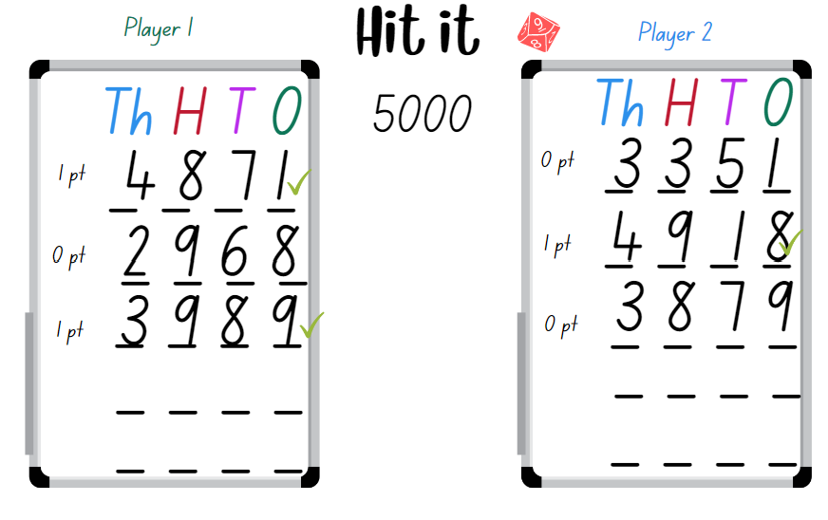
- The aim of the game is to make numbers as close to 5000 as possible without going over, with the highest number winning a point. The player with the most points after 5 rounds is declared the winner.
- Students take turns to roll the die. After each roll, write the number on one of the lines. Once the 4 blank lines are full, players read their number and identify which number is the closest to 5000. This player wins a point.
Note: a variation to this task is to select a target number that is a multiple of thousands between 1000 and 9000.
The table below details opportunities for assessment.
Assessment opportunities | Links
What to look for:  - Can students name, read and record 4-digit numbers using place value? [MAO-WM-01, MA2-RN-01] | Links to National Numeracy Learning Progressions (NNLP):  - NPV6.  Links to suggested Interview for Student Reasoning (IfSR) tasks:  - IfSR-NP: 4C.5.

Core lesson – place value houses – 30 minutes
The table below contains suggested learning intentions and success criteria. These are best co-constructed with students.
Core concept learning intentions | Core concept success criteria
Students are learning to:  - read, represent and order numbers up to thousands  - recognise and represent numbers that are 10, 100 or 1000 times as large. | Students can:  - represent numbers up to thousands using MAB materials and numerals  - describe how making a number 10, 100, 1000 times as large changes the value of digits  - arrange numbers in ascending and descending order.
- Display a collection of MAB materials and revise their value. A cube has a value of 1000, a flat has a value of 100, a long has a value of 10 and a mini has the value of one.
- Display 485 using MAB materials. Select a student to name and describe the number represented.
- Display Resource 1 – place value houses and explain that this is one way of representing numbers to highlight the place value structure of ones, tens, hundreds and thousands.
- Record 485 on Resource 1 – place value houses and explain how each number represents a value.
- Provide pairs of students with Resource 1 – place value houses and MAB materials. Ask:
- Can you make the number 10 times larger than 485? What is the name of the new number? Can you make this number with MAB materials? Can you record this number?
- Can you make the number 100 times larger than 485? What is the name of the new number? Can you make this number with MAB materials? Can you record this number?
- Can you make the number 1000 times larger than 485? What is the name of the new number? Can you make this number with MAB materials? Can you record this number?
- What happens to the value of each digit?
- How does making a number 10 times, 100 times or 1000 times larger change the place value of the digits? For example, when 485 is made 10 times as large, the 4 in the hundreds place becomes a 4 in the thousands place, the 8 in the tens place becomes an 8 in the hundreds place, and the 5 in the ones place represents the number of tens in the tens place.
- Tell students they are going to investigate if the numbers always change their place when they make numbers 10, 100 and 1000 times larger.
- In pairs students select a 4-digit number to investigate between 1000 and 5000. Encourage students to use MAB materials and Resource 1 – place value houses to record their findings. Students investigate making their number 10 times, 100 times and 1000 times larger.
- Regroup as a class and discuss the students’ findings, highlighting that when numbers are made 10, 100 or 1000 times larger, the place value of the digits changes.
The table below details opportunities for differentiation.
Too hard? | Too easy?
Students cannot describe how making a number 10, 100 or 1000 times larger changes the place value of digits.  - Provide students with MAB materials to make with 2-digit numbers.  - Provide students with MAB materials and a place value house to explore 3-digit numbers. | Students can describe how making a number 10, 100 or 1000 times larger changes the place value of digits.  - Provide students with MAB materials and challenge them to make numbers that are 200 times as large. Ask students how this changes the numbers. Explain your thinking.  - In pairs, students use yes and no questions to play Mastermind.

Consolidation and meaningful practice – 20 minutes
This activity is an adaptation of Our Place Value System (10:00) from ABC iView by ABC (Australian Broadcasting Corporation). Video to be viewed by the teacher to support vocabulary and explanation of the task (3:45).
- Display Resource 2 – number cards. With a partner, students use the displayed cards to form as many numbers as possible and record their answers on a whiteboard. Ask students the following questions:
- Can you name the numbers you have formed?
- What is the largest number you can form using all the cards? How can you check your answer?
- What is the smallest 5-digit number you can make? How do you know?
- Can you place your numbers in order, from smallest to largest?
- How many numbers can be made using all the cards?
- Did you encounter any challenges while making the number? If so, how did you overcome them?
- Ask students to select one number on their whiteboard and to record the number that is 10, 100 and 1000 times larger. Ask students to describe how making a number 10 times, 100 times or 1000 times larger changes the place value of digits.
This table details opportunities for assessment.
Assessment opportunities | Links
What to look for:  - Can students represent numbers up to thousands using MAB materials and numerals? [MAO-WM-01, MA2-RN-01]  - Can students describe how making a number 10, 100 or 1000 times as large changes the place value of digits? [MAO-WM-01, MA2-RN-01]  - Can students arrange numbers in ascending and descending order? [MAO-WM-01, MA2-RN-01] | Links to National Numeracy Learning Progressions (NNLP):  - NPV6, NPV7, NPV8, NPV9.  Links to suggested Interview for Student Reasoning (IfSR) tasks:  - IfSR-NP: 4B.2, 4B.6.

Lesson 2
Core concept: the position of each digit in a number corresponds to its size.

Daily number sense – Hit it 99 999 – 15 minutes
The table below contains a suggested learning intention and success criteria. These are best co-constructed with students.
Daily number sense learning intention | Daily number sense success criteria
Students are learning to:  - use place value to name numbers. | Students can:  - name, read and record 5-digit numbers.
This activity is an adaptation of Hit it (3-digit numbers) from Mathematics K–6 resources by State of New South Wales (Department of Education).
- Provide pairs with markers, a whiteboard and a 9-sided die.
- Students draw a gameboard on their whiteboard with 5 lines to represent the 5-digits (see Figure 2).
- The aim of the game is to make numbers as close to 99 999 as possible, with the closest number winning a point. The player with the most points after 5 rounds is declared the winner (see Figure 2).
Figure 2 – Hit it 99 999
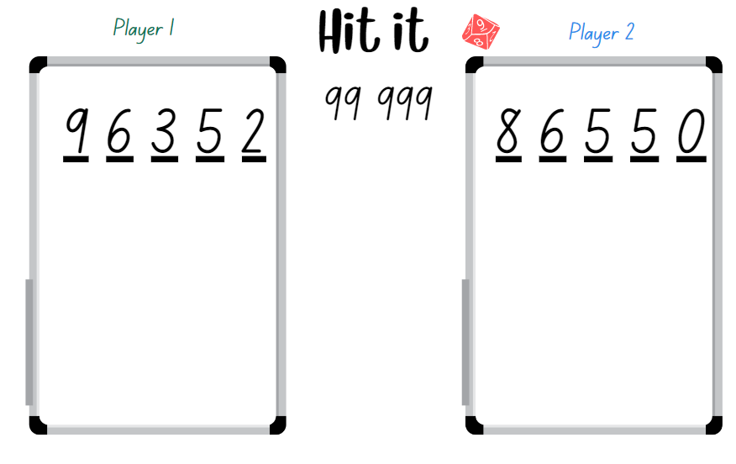
- Students take turns to roll the die. After each roll, place the number on one of the lines to begin forming a 5-digit number.
- Once the 5 blank lines are full, players read their numbers and explain which they think is the closest to 99 999. The winner gets one point.
The table below details opportunities for assessment.
Assessment opportunities | Links
What to look for:  - Can students name and record 5-digit numbers? [MAO-WM-01, MA2-RN-01] | Links to National Numeracy Learning Progressions (NNLP):  - NPV6, NPV7.

Core lesson – place value – 35 minutes
The table below contains suggested learning intentions and success criteria. These are best co-constructed with students.
Core concept learning intentions | Core concept success criteria
Students are learning to:  - read, represent and order numbers in the thousands  - apply place value to partition numbers up to 6-digits. | Students can:  - read and record numbers using place value  - recognise the quantity value of digits in large numbers  - use place value to expand the number  - arrange numbers in ascending and descending order.
- Display Resource 1 – place value house and a 9-sided die. Roll a 9-sided die 6 times and record each digit on the place value house creating a 6-digit number (see Figure 3).
Figure 3 – place value house
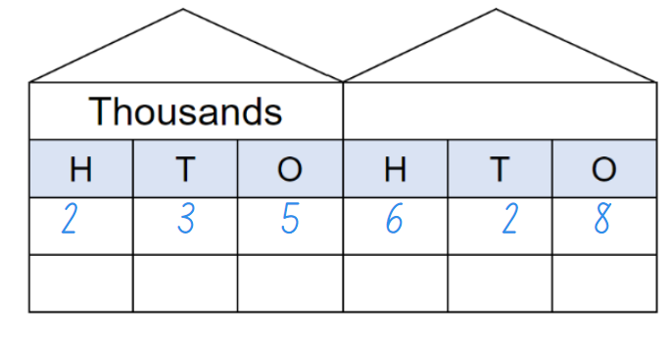
- Select a student to read the 6-digit number aloud.
- Explain to students that the quantity value of the numbers is clear when they read the number aloud. For example, the number 235 628 is read as two hundred and thirty-five thousand, six hundred and twenty-eight.
- Identify the quantity value of the 6 as 600.
Quantity value is the amount a digit represents in a number. For example, the quantity value of the 5 in 546 is 500, and the quantity value of the 4 is 40.
- Ask students to turn and talk to identify the quantity values of each digit in 235 628. Invite students to share their thinking with the class.
- Record the number 235 628 in expanded notation and explain the quantity value of each digit. For example, 235 628 = 200 000 + 30 000 + 5 000 + 600 + 20 + 8. Explain to students that, by recording a number using expanded form, they can identify the quantity values of each digit in large numbers.
- Display a new 6-digit number by rearranging the digits from the previously displayed number. For example, 536 228.
- Ask students to read the new number and record the expanded form on their whiteboards.
- In pairs, provide students with Resource 3 – place value template and a 9-sided die. Ask students to roll the die 6 times and record a 6-digit number on the first place value house of the template.
- Students record the expanded form beside the remaining place value houses (see Figure 4).
Figure 4 – example expanded notation
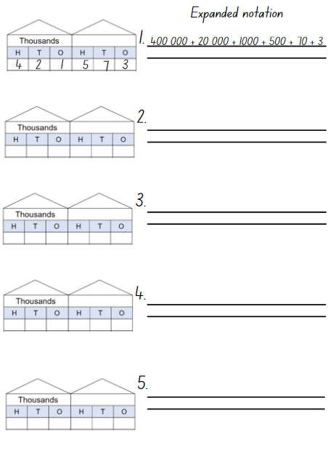
- Regroup as a class and ask:
- What do you know or understand about place value? Explain your thinking.
- How can you represent numbers using place value?
- How can rearranging the digits change the size of your number?
- Can you name the quantity value for the second digit in one of your selected numbers?
- Can you name the quantity value for the third digit in one of your selected numbers?
The table below details opportunities for differentiation.
Too hard? | Too easy?
Students cannot represent numbers up to 6-digits in expanded place value form.  - Provide students with number cards displaying 3-digit numbers to name and record using expanded place value form.  - Provide MAB materials for students to use to support expanding the number. | Students can represent numbers up to 6-digits in standard place value form.  - Challenge students to use their five 6-digit numbers and record the standard place value form for each of the numbers that is 10 times as large.  - Challenge students to use their five 6-digit numbers and record the standard place value form for each of the numbers that is 100 times as large.

Consolidation and meaningful practice – 10 minutes
- Students use the 5 recorded numbers from the place value houses and arrange these in both ascending and descending order on a whiteboard. Ask students:
- How do you know that your numbers are ordered from the smallest to the largest?
- Which digit did you pay most attention to when deciding? Why?
- Are there rules that can be followed when arranging numbers in order of size? What are the rules?
- What strategy did you use to order your numbers in descending order?
- What was challenging when you were deciding the sequence of the numbers in both the descending and ascending order?
This table details opportunities for assessment.
Assessment opportunities | Links
What to look for:  - Can students recognise the number of tens, hundreds or thousands in a number? [MAO-WM-01, MA2-RN-01]  - Can students use place value to expand the number? [MAO-WM-01, MA2-RN-01]  - Can students arrange 6-digit numbers in ascending and descending order? [MAO-WM-01, MA2-RN-02] | Links to National Numeracy Learning Progressions (NNLP):  - NPV6, NPV7.

Lesson 3
Core concept: the place value system can be extended to decimals.

Daily number sense – expanded form – 15 minutes
The table below contains a suggested learning intention and success criteria. These are best co-constructed with students.
Daily number sense learning intention | Daily number sense success criteria
Students are learning to:  - apply place value to partition numbers up to 6-digits. | Students can:  - use place value to expand the number.
- Revise the expanded place value form from the previous lesson.
- Provide student pairs copies of Resource 4 – expanded form memory. Students cut out the cards, shuffle the cards and place them face down.
- Player 1 selects one card and then selects another card. If the cards match, the student keeps the 2 cards and has another turn. If there is no match the student returns the cards face down and Player 2 takes a turn.
- Play continues until there are no cards left. The player with the greatest number of cards at the end of the game wins.

The table below details opportunities for assessment.
Assessment opportunities | Links
What to look for:  - Can students use place value parts to expand the number? [MAO-WM-01, MA2-RN-01] | Links to National Numeracy Learning Progressions (NNLP):  - NPV5, NPV6.

Core lesson – exploring decimals – 45 minutes
The table below contains a suggested learning intention and success criteria. These are best co-constructed with students.
Core concept learning intention | Core concept success criteria
Students are learning to:  - extend the place value system from whole numbers to tenths. | Students can:  - divide a length representing one whole into 10 equal parts and label the parts using decimal notation  - use the decimal point as a marker to identify the position of the ones digit  - express decimals as tenths  - locate tenths on a number line  - recognise that 10 tenths is recorded as 1.0.
- Display a strip of paper labelled with a zero at one end and a one at the other, with equal spaced lines to represent the tenths (see Figure 5).
Figure 5 – decimals 1
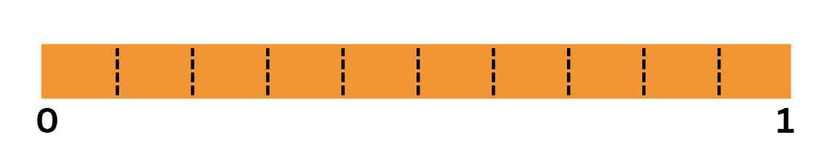
- Ask students:
- What do you notice about the strip?
- What do you notice about the spaced markings?
- What do think is between zero and one? How do you know?
- Using the marker, cut a tenth out of the strip of paper. Ask students:
- What do you notice?
- What do you think this smaller piece represents? What does this remind you of?
- Is this piece part of a whole or something else? Explain your answer.
- Discuss how many pieces students would have if they continued to cut the paper strip at the marks between zero and one. Prompt students to prove their answer.
- Explain to students that there are smaller numbers between whole numbers called decimals. Tell students the smaller part is named one-tenth, which is one-tenth of the whole. The whole has been partitioned into 10 equal parts. Label the piece ‘1 tenth’ (see Figure 6).
Figure 6 – 1 tenth
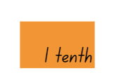
Decimal: used to describe aspects of the base-10 number system. The decimal point separates the whole number part of a number from its decimal part.
- Move the one tenth up onto a new line and move another tenth up next to it (see Figure 7).
Figure 7 – 2 tenths
- Ask students to look at the first tenth that is labelled and make a prediction about what the second piece can be named.
- Have students share their ideas identifying that the second one makes 2 tenths (see Figure 8).
Figure 8 – adding tenths
- Repeat the same steps moving each tenth up and naming it 3 tenths, 4 tenths, 5 tenths until 10 tenths. Ask students if they can rename 10 tenths in a different way. Highlight to students that 10 tenths make one whole.
- Explain that students are extending the place value system to numbers smaller than a whole and this can be represented using decimal notation.

Note: to support place value conceptual understanding, 6.1 would be read as ‘six and one-tenth’. The word ‘and’ connects the decimal fraction with the whole number and makes a link with common fractions. When recording decimal notation, students partition one into 10 equal pieces to form tenths when recording decimal notation. The primary purpose of the decimal point is to show where the ones column is.
- Model writing the decimal notation for one-tenth as 0.1. Explain to students there are zero ones and one tenth. Discuss the purpose of the decimal point.
- Ask students to turn and talk to a partner about how they would write two-tenths using decimal notation. Have students share their thinking with the class.
- Provide students with Resource 5 – decimal strip. Students label the strip using decimal notation.
- Display only the 2 tenths on the board. Then add another whole strip to the 2 tenths (see Figure 9).
Figure 9 – tenths on a line
- Ask students:
- What do we have now?
- How can we record this?
- How can we say this number?
- Model recording 1.2 and reading the decimal as ‘one and two-tenths’. Explain that students have one whole and 2 tenths. Make a connection to a number line representation. These 2 extra tenths are part of the next whole on the number line (see Figure 10).
Figure 10 – 1.2 on a line
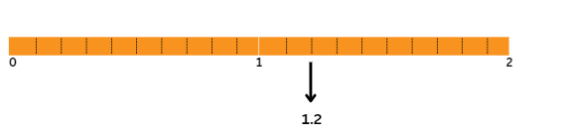
- Provide each pair of students with Resource 6 – number line 0-3 and writing materials.
- Explain that, in pairs, students will investigate where the following selected decimals would be recorded on the marked intervals on the given number line.
- Record decimals, such as 1.7, 0.9, 2.5 and 3.0, and provide time for students to Think-Pair-Share and record the decimals on their number line.
- As a class regroup and discuss:
- Which decimal did you choose to record first? Why?
- What strategy did you use to determine where to record each of the decimals?
- Which decimal was the most challenging to decide where to record? Why?
- How did you use the markers to help you?
- How did you use the whole numbers already on the number line to help you?
- What is something interesting you noticed?
This table details opportunities for differentiation.
Too hard? | Too easy?
Students cannot record decimals on a number line.  - Students use a labelled zero to one paper strip with equally spaced markers. Support students to partition and label the whole with creases or folds making 10 tenths.  - Support students to use a number line labelled zero to one and provide decimals such as 0.2, 0.5 and 0.7 to be recorded. | Students can use the decimal point to read and name a whole number to the left of the decimal point and tenths to the right of the decimal point.  - Challenge students to create their own number line starting at a selected number and ending at a selected number, equally partitioning and recording all the tenths decimals.  - Provide students with a number line that has missing tenths decimals. Students problem solve and record their solutions.

Discuss and connect the mathematics – 5 minutes
- Display 0.3 and 3.0 on the board and ask students:
- What do you wonder about these 2 decimals?
- What is the same and what is different?
- How would you name each one? Can you convince me that is how you say it?
- Which one is the biggest? Why and how do you know?
- On a number line labelled 0–3, where would these numbers be recorded? How do you know?
This table details opportunities for assessment.
Assessment opportunities | Links
What to look for:  - Can students divide a length representing one whole into 10 equal parts and label the parts using decimal notation? [MAO-WM-01, MA2-RN-02]  - Can students use the decimal point as a marker to identify the position of the ones digit? [MAO-WM-01, MA2-RN-02]  - Can students express decimals as tenths? [MAO-WM-01, MA2-RN-02]  - Can students locate tenths on a number line? [MAO-WM-01, MA2-RN-02]  - Can students recognise that 10 tenths is recorded as 1.0? [MAO-WM-01, MA2-RN-02] | Links to National Numeracy Learning Progressions (NNLP):  - NPV6, NPV7, NPV8.  Links to suggested Interview for Student Reasoning (IfSR) tasks:  - IfSR-NP: 4D.3.

Lesson 4
Core concept: zero plays an important role.

Daily number sense – 10 minutes
- From a class need surfaced through formative assessment data, identify a short, focused activity that targets students’ knowledge, understanding and skills. Example activities may be drawn from the following resources:
- Mathematics K–6 resources
- Universal Resources Hub.

Core lesson 1 – the role of zero – 15 minutes
The table below contains suggested learning intentions and success criteria. These are best co-constructed with students.
Core concept learning intentions | Core concept success criteria
Students are learning to:  - read, represent and order numbers to thousands  - extend the place value system from whole numbers to tenths. | Students can:  - identify the number before and after a whole number with an internal zero digit  - express decimals as tenths  - identify the role of zero in decimal numbers  - use the decimal point as a marker to identify the position of the ones digit when expressing tenths.
- Display the following numbers, 1200, 1020, 1002, 12 902, 309 050.
- Ask students to read them aloud and to identify the number before and after.
- Display Resource 1 – place value houses and select students to record each of the numbers in the correct place value houses and to name the numbers.
- Discuss the role of the zero in each of the recorded numbers. Identify to students that the zero helps to name numbers and is also a place holder.

Core lesson 2 – the role of zero in decimals – 25 minutes
- Explain to students that zero plays an important role in whole numbers and it also plays an important role in decimals.
- Record the decimal 0.5 on the board and ask students to turn and talk about the role of the zero in this decimal and why it is important.
- As a class, discuss that the zero in decimals can be a place holder and it helps students understand how to say and write decimals.
- Refer to the 0.5 on the board and explain that, for decimals between zero and one, the zero is written in the ones place to reduce the risk of misreading the decimal as a whole number. Record .5 and explain that this could be confused for 5.
This activity is an adaptation of Missing Number Bingo from NZ Maths by the New Zealand Ministry of Education.
Note: prior to the lesson collect multiple transparent counters, prepare the bingo ‘call out’ decimal numbers from Resource 7 – call out cards and copy the bingo gameboards Resource 8 – bingo gameboards, ensuring there is a copy for each student.
- Provide each student with a bingo board and 15 transparent counters.
- Explain that you will call out decimal numbers and students need to identify the corresponding decimal on their bingo board and cover it with a counter. Ensure that students understand that some of the decimals on their bingo card are written in words using tenths and others are presented as decimal notations.
- Explain that when a student covers all the decimals on their bingo board they must call out ‘Bingo!’ The first student to cover all their decimals wins the game.
This table details opportunities for differentiation.
Too hard? | Too easy?
Students cannot recognise and name decimal numbers.  - Provide modified bingo gameboards and call out cards and support students to use place value houses to assist with identifying the decimals.  - Students refer to the number line from Lesson 3. Support students to make and name various decimal numbers. | Students can identify and name various decimal numbers using tenths.  - Challenge students to create their own modified decimals bingo game with instructions.  - Provide students with a modified gameboard that has decimal notations that includes hundredths.

Discuss and connect the mathematics – 10 minutes
- Ask students:
- What is the role of zero in whole numbers?
- Is this different or the same for decimal numbers? Explain your thinking.
- How would you explain what a decimal is to a friend who has never heard of decimals? Can you draw a representation on a whiteboard to explain your thinking?
This table details opportunities for assessment.
Assessment opportunities | Links
What to look for:  - Can students identify the number before and after a whole number with an internal zero digit? [MAO-WM-01, MA2-RN-01]  - Can students express decimals as tenths? [MAO-WM-01, MA2-RN-02]  - Can students identify the role of zero in decimal numbers? [MAO-WM-01, MA2-RN-02]  - Can students use the decimal point as a marker to identify the position of the ones digit when expressing tenths? [MAO-WM-01, MA2-RN-02] | Links to National Numeracy Learning Progressions (NNLP):  - NPV4, NPV5, NPV6, NPV7.

Lesson 5
Core concept: number patterns can be multiplicative.

Daily number sense – number lines – 15 minutes
Daily number sense activities for Lessons 5 to 7 ‘loop’ back to concepts and procedures covered in previous units to assist students to build an increasingly connected network of ideas. These concepts may differ from the core concepts being covered by the unit.
The table below contains a suggested learning intention and success criteria. These are best co-constructed with students.
Daily number sense learning intention | Daily number sense success criteria
Students are learning to:  - read, represent and order numbers to thousands. | Students can:  - compare and describe the relative size of numbers by placing numbers on a number line.
This activity is an adaptation of ‘What’s in the box?’ from Learning to Think Mathematically with the Number Line [PDF 1.1 KB] by Frykholm.
- Create a large-scale number line on the floor of the classroom. Using sticky notes write the number 17 and place it near the start of the number line (see Figure 11).
Figure 11 – numbers on a line 1
- Take a blank sticky note and ask students where this sticky note could be positioned on the number line. Have students explain their reasoning. Encourage students to think about the fact that the empty sticky note can go anywhere on the line as the number line is open, and the card could represent any number on the line. Place the card on the number line (see Figure 12).
Figure 12 – numbers on a line 2
- Next, take a sticky note with the number 50 on it and place it on the number line to the right of the blank note (see Figure 13).
Figure 13 – numbers on a line 3
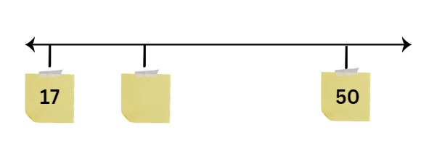
- Ask students if they would like to change their thinking about what the blank sticky note number could now be. Have some students share their thinking.
- Move the sticky note with the number 50 right next to the blank sticky note (see Figure 14).
Figure 14 – numbers on a line 4
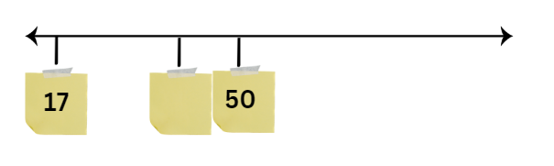
- In pairs, have students discuss the following:
- Do we have to change the number we selected for our blank sticky note? Why or why not?
- What is a better number to put in there? Explain your thinking.
- What if we changed the first sticky note with the number 17 to a 30? Would the blank sticky note have to change?
- What if we changed the 50 to 100? Would the blank sticky note change?
- As a class, select some of the students to share their reasoning and ideas.
This table details opportunities for assessment.
Assessment opportunities | Links
What to look for:  - Can students compare and describe the relative size of numbers by positioning numbers on a number line? [MAO-WM-01, MA2-RN-01] | Links to National Numeracy Learning Progressions (NNLP):  - NPV4.

Core lesson 1 – Fibonacci sequence – 20 minutes
The table below contains suggested learning intentions and success criteria. These are best co-constructed with students.
Core concept learning intentions | Core concept success criteria
Students are learning to:  - generate and describe patterns  - investigate number sequences involving related multiples. | Students can:  - continue a number pattern that increases by a constant amount  - investigate number patterns  - generate number patterns using multiples.
This activity is an adaptation of ‘Finding Fibonacci’ from Mindset Mathematics: Visualizing and Investigating Big Ideas, Grade 4 by Boaler et al.
Note: the Fibonacci pattern is a famous number sequence that was first introduced by Leonardo of Pisa, known as Fibonacci. The sequence begins with one and one. Then each number after is the sum of the 2 previous numbers in the pattern. The pattern can continue infinitely and is found throughout nature including in the structure of pinecones, flowers and the nautilus shell.
- Display the following number sequence 1, 1, 2, 3, 5, 8, 13.
- Tell students that this is a famous pattern that can be found in nature. Ask students:
- What is happening in this pattern?
- What do you notice?
- What do you wonder?
- As a class discuss the pattern and what could be the next number in the sequence. Record students’ predictions and reasoning.
- Display Resource 9 – Fibonacci spiral. Explain to students that this spiral shows the first 7 values of the sequence.
- In pairs, provide copies of Resource 9 – Fibonacci spiral and ask students to try and match the sequence to the spiral. Have students annotate the sequence on the spiral (see Figure 15).
Figure 15 – Fibonacci spiral
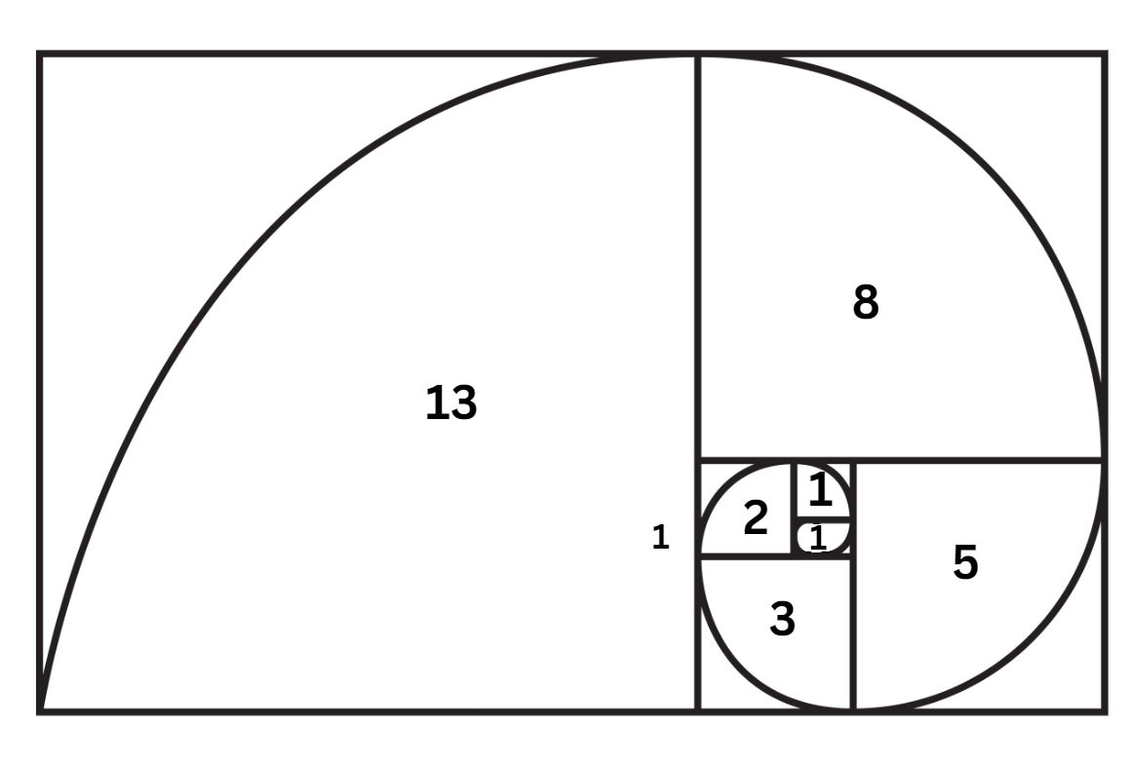
- Provide additional materials including paper. Encourage students to draw the next 5 sequences in the pattern.
Note: students may want to use colour to better see each square and the visual pattern.
- As a class discuss:
- What is the pattern? How does it work?
- How does the spiral represent the pattern?
- How did you predict what will happen next in the sequence?
- How did the visual pattern help you understand the sequence?
- How did the number sentence help you understand the visual pattern?

Core lesson 2 – multiplicative patterns – 20 minutes
- Display Resource 10 – Fibonacci sequence
- Explain to students that this table represents the Fibonacci pattern. The top row identifies the number in the sequence and the bottom row is the Fibonacci sequence.
- Tell students that there are some interesting multiplicative patterns that can be identified in the Fibonacci sequence.
- In pairs, provide students copies of Resource 10 – Fibonacci sequence and a calculator. Ask students to work with their partner to identify multiplicative patterns.
Note: there are multiplicative patterns in the Fibonacci sequence. Look at the third number in the sequence, 2. Every third number in the sequence is a multiple of 2. Look at the fourth number in the sequence, 3. Every fourth number in the sequence is a multiple of 3. Look at the fifth number in the sequence. Every fifth number in the sequence is a multiple of 5 and so on.
- As a class, discuss:
- What multiplicative patterns did you identify? Is there a rule for that?
- How did you identify the multiplicative relationship?
- Is there a way to record what you have found out that might help us see more patterns?
- What is the same and what is different about the patterns?

Consolidation and meaningful practice – 20 minutes
- Tell students that, just like Fibonacci, they are going to create their own number and visual patterns using their knowledge of related multiples. Revise multiples and identify multiplicative patterns on a number chart.
Multiples: products formed using the same base number multiplied by different whole numbers, for example, 3, 6, 9, 12.
- Students work in pairs to create a secret multiplicative pattern for their class to solve using numbers and pictures like the Fibonacci sequence (see Figure 16).
Figure 16 – example pattern
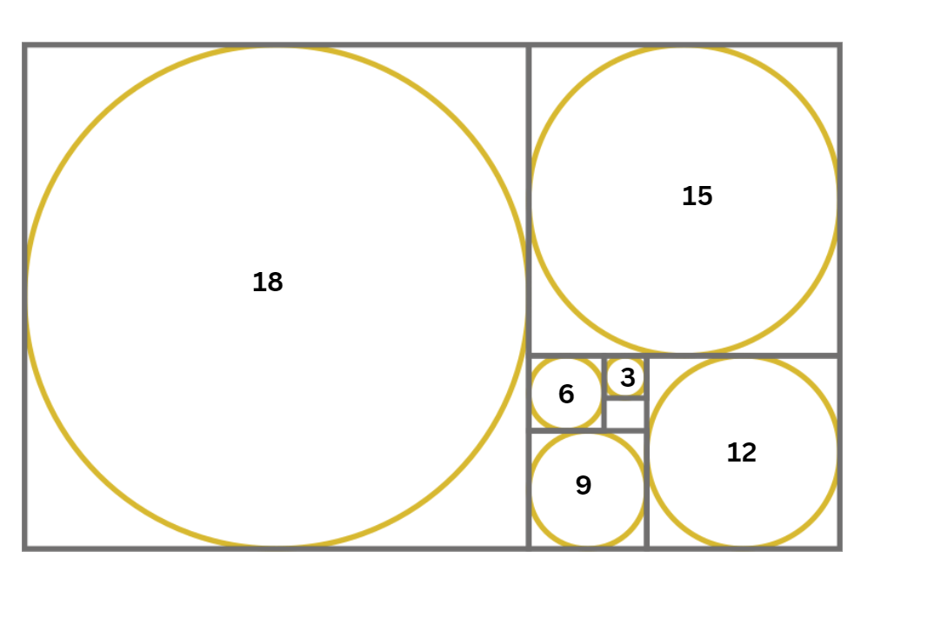
- Encourage students to use colours and select a name for their puzzle.
- Students share their puzzles with another pair of students. The other students need to identify the multiplicative pattern.
- As a class discuss:
- How did you figure out the pattern?
- What did others notice in your pattern?
- Did you rely more on the numbers or the picture to work out the other pairs pattern?
- What made your pattern interesting?
- If you were to make another pattern, what would you do differently?
This table details opportunities for differentiation.
Too hard? | Too easy?
Students cannot generate number patterns using related multiples.  - Provide a multiplication chart to support students to identify related multiples.  - Have students count using skip counting or rhythmic counting to prompt identification of related multiples. | Students can generate number patterns using related multiples.  - Challenge students to create a number pattern using non-standard multiples such as multiples of 8 starting from 43.  - Students create their own multi step multiplicative pattern such as multiples of 5 and add 2. For example, 7, 12, 17, 22. Have a partner identify the rule.

This table details opportunities for assessment.
Assessment opportunities | Links
What to look for:  - Can students continue a number pattern that increases by a constant amount? [MAO-WM-01, MA2-MR-01]  - Can students investigate number patterns? [MAO-WM-01, MA2-MR-01]  - Can students generate number patterns using multiples? [MAO-WM-01, MA2-MR-01] | Links to National Numeracy Learning Progressions (NNLP):  - NPA3, NPA4.

Lesson 6
Core concept: known number facts and strategies can support multiplicative understanding.

Daily number sense – place value game – 15 minutes
The table below contains a suggested learning intention and success criteria. These are best co-constructed with students.
Daily number sense learning intention | Daily number sense success criteria
Students are learning to:  - read, represent and order 5-digit numbers in a sequence. | Students can:  - read and order numbers of up to at least 5 digits.
This activity is an adaptation of The place value game from Mathematics K–6 resources by State of New South Wales (Department of Education).
- Explain that the aim of the game is to order 5-digit numbers in an ascending sequence on a gameboard.
- Provide pairs with five 9-sided dice and a copy of Resource 11 – place value gameboard for each player.
- Students roll the dice and create a 5-digit number. For example, 6, 2, 8, 3 and 9 could be recorded as 62 389, 36 892, 29 863, 38 269, 93 628 or 39 286. Players record their chosen number in the most appropriate position between 10 000 and 100 000 (see Figure 17).
Figure 17 – example gameboard
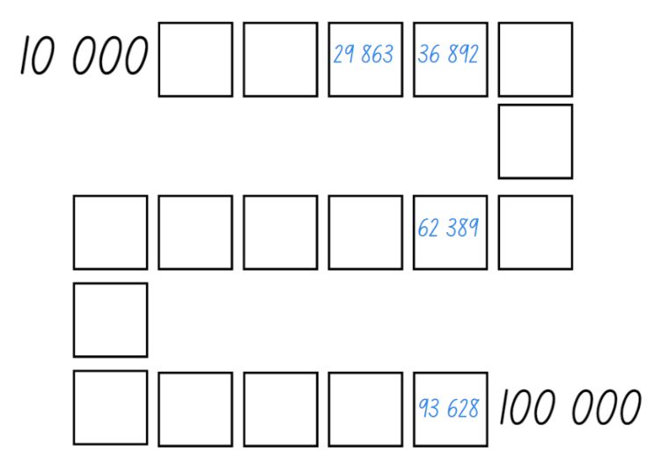
- If numbers cannot be placed, students miss their turn. Play continues until all boxes are filled.
Note: the game can also be played as a whole class. It is recommended to use dice that have a zero as it is important that students understand the role of zero in changing the value of the 5-digit numbers created. Using a reusable sleeve for the gameboard and non-permanent markers will allow students to play multiple games.

This table details opportunities for assessment.
Assessment opportunities | Links
What to look for:  - Can students read and order numbers of up to at least 5-digits? [MAO-WM-01, MA2-RN-02] | Links to National Numeracy Learning Progressions (NNLP):  - NPV6, NPV7.

Core lesson – multiples of 10 – 40 minutes
The table below contains suggested learning intentions and success criteria. These are best co-constructed with students.
Core concept learning intentions | Core concept success criteria
Students are learning to:  - operate with multiples of 10  - use known number facts and strategies. | Students can:  - multiply a one-digit number by a multiple of 10  - use place value to rename groups of 10 to multiply  - use the commutative property to multiply by multiples of 10  - use known facts to find unknown multiples  - recognise and use the symbols for multiplied by and equals.
This activity is an adaptation of Multiply Multiples 3 from NRICH by University of Cambridge.
- Display Resource 12 – multiplication patterns 1 or an interactive multiplication chart. Highlight the multiples of 10 and ask students what they notice.
- Explain to students that understanding place value can help solve multiplication problems.
- Display the number sentence 10 × 2 = 20 × 1. Provide pairs of students with MAB materials or a multiplication chart to help prove or disprove the statement.
- As a class, share some of the students’ strategies identifying that the equation is true.
- Display the number sentence 60 × 4 = _. Students turn and talk to a partner about how they can solve this equation.
- Prompt students to identify that 60 × 4 is 4 groups of 6 tens, which is equal to 24 tens, which is 240.
- Provide students with MAB materials and ask them to solve the following equations explaining their reasoning:
- 40 × 3 =
- 80 × 2 =
- 20 × 5 =
- 70 × 4 =
- 30 × 6 =
- Tell students to select one of the number sentences and create a diagram or use concrete materials to explain their strategy.
- Conduct a gallery walk to view other students thinking gallery walk.
This table details opportunities for differentiation.
Too hard? | Too easy?
Students cannot multiply a one-digit number by a multiple of 10.  - Have students use the multiplication chart to identify single digits multiplied by 10. Have students create models using concrete materials.  - Identify the connection between the multiples of 5 and multiples of 10 on the multiplication charts. Have students discuss their connection. | Students can multiply a one-digit number by a multiple of 10.  - Ask students to explain how knowing 4 × 20 = 80 could help someone work out 4 × 19. Have students explain their thinking using a diagram.  - Ask students to determine what 4 × 200 would be and explain their thinking using concrete materials or a diagram.

Discuss and connect the mathematics – 15 minutes
- Display the following on the board 40 × 3 = _0 × _.
- As a class discuss:
- Can you identify one possible solution?
- Are there any other solutions? How do you know?
- What do you notice about the numbers?
This table details opportunities for assessment.
Assessment opportunities | Links
What to look for:  - Can students multiply a one-digit number by a multiple of 10? [MAO-WM-01, MA2-MR-01, MA2-MR-02]  - Can students use place value to rename groups of 10 to multiply? [MAO-WM-01, MA2-MR-01, MA2-MR-02]  - Can students use the commutative property to multiply by multiples of 10? [MAO-WM-01, MA2-MR-01, MA2-MR-02]  - Can students use known facts to find unknown multiples? [MAO-WM-01, MA2-MR-01, MA2-MR-02]  - Can students recognise and use the symbols for multiplied by and equals? [MAO-WM-01, MA2-MR-01, MA2-MR-02] | Links to National Numeracy Learning Progressions (NNLP):  - CPr6  - MuS5, MuS6, MuS7.  Links to suggested Interview for Student Reasoning (IfSR) tasks:  - IfSR-MT: 2A.8.

Lesson 7
Core concept: structures can support multiplicative thinking.

Daily number sense – more or less – 15 minutes
The table below contains a suggested learning intention and success criteria. These are best co-constructed with students.
Daily number sense learning intention | Daily number sense success criteria
Students are learning to:  - read, record and order 5-digit numbers in ascending and descending order. | Students can:  - name and read 5-digit numbers  - order 5-digit numbers in ascending and descending order.
- Organise students into small groups of 4, made up of 2 teams of 2 students. Provide groups with Resource 13 – more or less, five 6-sided dice and writing materials.
- Explain that Team 1 will roll the 5 dice and make a 5-digit number. Team 1 writes the 5-digit number in the first row, deciding if they want their number to be the ‘more’ number or the ‘less’ number for this round.
- Team 2 rolls the 5 dice and makes a 5-digit number that is either more than or less than the first team’s number (see Figure 18).
Figure 18 – example of gameboard
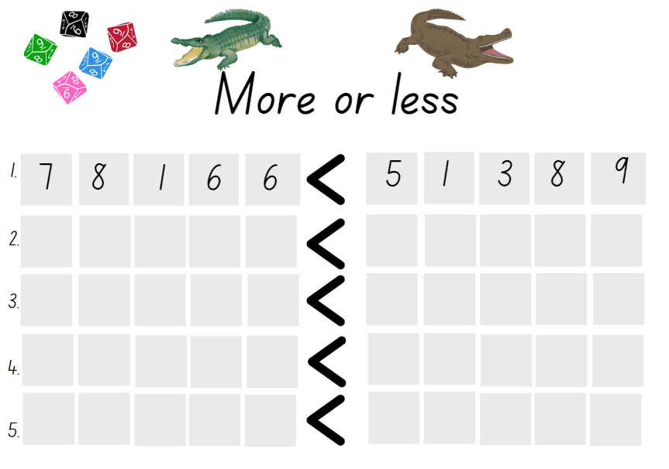
- After 5 rounds, both teams read and order the numbers to see which team made the largest and smallest numbers. Play again alternating the team that rolls first.
This table details opportunities for assessment.
Assessment opportunities | Links
What to look for:  - Can students rearrange digits in 4- and 5-digit numbers and then rename the new number? [MAO-WM-01, MA2-RN-01]  - Can students partition a 4- and 5-digit number and recognise how many ones, tens, and thousands there are? [MAO-WM-01, MA2-RN-01] | Links to National Numeracy Learning Progressions (NNLP):  - NPV5, NPV6, NPV7.  Links to suggested Interview for Student Reasoning (IfSR) tasks:  - IfSR-AT: 3B.2, 3B.4.

Core lesson – useful arrays – 35 minutes
The table below contains suggested learning intentions and success criteria. These are best co-constructed with students.
Core concept learning intentions | Core concept success criteria
Students are learning to:  - use arrays to establish multiplication facts  - use number properties to find related multiplication facts. | Students can:  - use arrays to coordinate the number of groups with the number in each group  - recall multiplication facts  - recognise and use the symbols for multiplied by and equals  - identify the commutative property of multiplication.
This activity is an adaptation of ‘Cover the field’ from Mindset Mathematics: Visualizing and Investigating Big Ideas, Grade 4 by Boaler et al.
Note: by playing this game students will represent a multiplicative structure to create an array.
- Explain that the aim of the game is to cover the field as completely as possible and record a multiplication equation for each rectangle made.
- Provide pairs of students with four 6-sided dice, plain paper, grid paper and markers.
- Players take turns rolling the 4 dice and use the values shown to form a multiplication equation. Students must combine 2 pairs of dice to become the side of each rectangle or array. For example, if 6, 4, 3 and one are rolled, the player might choose the sum 4 + 3 = 7 and 6 + 1 = 7. The rectangle becomes 7 × 7. Alternatively, students might make the sum 3 + 6 = 9 and 4 + 1 = 5, in which case the rectangle would be 9 × 5.
- Using the plain paper, students record the strategy they used to form the array they are going to cover on their field (see Figure 19).
Figure 19 – example student recording
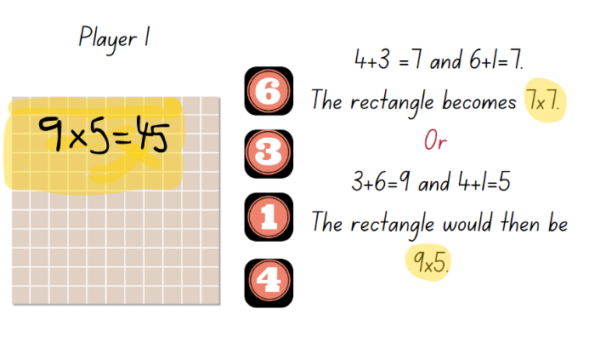
- Once students have decided on the rectangle, they draw it on the field. The rectangle cannot overlap with an existing rectangle or be broken into smaller pieces.
- Students label and record their multiplication equation on the rectangle formed. Play ends when one player rolls the 4 dice and cannot make any rectangle that will fit on the field. The winner is the player with the most rectangles covered.
This table details opportunities for differentiation.
Too hard? | Too easy?
Students cannot create and represent multiplicative structure using an array model.  - Support students to create the pairs of numbers and identify the corresponding array on the grid.  - Provide students with one of the side numbers, so they only need to create the total for the other length of the array. | Students can create and represent multiplicative structure using the array model.  - Students repeat the game, but this time aiming to cover the smallest area possible by using the difference between one pair of numbers rolled.  - In pairs, students repeat the activity using one sheet of grid paper, competing to fill the most squares on the page.

Discuss and connect the mathematics – 10 minutes
- Regroup as class and ask:
- What did you notice as you played the game?
- Did your decisions change from the beginning of the game to the end of the game?
- If you wanted to make the biggest rectangle, how would you use your dice combinations?
- If you wanted to make the smallest rectangle, how would you use your dice combinations?
- What made this game challenging? How did you overcome the challenge?

This table details opportunities for assessment.
Assessment opportunities | Links
What to look for:  - Can students use arrays to coordinate the number of groups with the number in each group? [MAO-WM-01, MA2-MR-01]  - Can students recall multiplication facts? [MAO-WM-01, MA2-MR-01]  - Can students recognise and use the symbols for multiplied by and equals? [MAO-WM-01, MA2-MR-01]  - Can students identify the commutative property of multiplication? [MAO-WM-01, MA2-MR-01] | Links to National Numeracy Learning Progressions (NNLP):  - MuS5, MuS6, MuS7.

Lesson 8
Core concept: doubling and halving are powerful strategies.

Daily number sense – 10 minutes
- From a class need surfaced through formative assessment data, identify a short, focused activity that targets students’ knowledge, understanding and skills. Example activities may be drawn from the following resources:
- Mathematics K–6 resources
- Universal Resources Hub.

Core lesson 1 – number patterns talk – 20 minutes
The table below contains suggested learning intentions and success criteria. These are best co-constructed with students.
Core concept learning intentions | Core concept success criteria
Students are learning to:  - generate and describe patterns  - use known number facts and strategies. | Students can:  - investigate and continue number patterns involving related multiples  - use the known strategy of doubling to connect multiples of 3 to 6 and 4 to 8  - recognise the connection between even numbers and multiplication facts  - identify the commutative property of multiplication.
This activity is an adaptation of Multiplication Table Patterns (grades 3–4) from Deep Math Projects by Burkhart.
- Display Resource 14 – multiplication patterns 2.
- Ask students what they notice and wonder. Give students time to discuss and think about the image.
The table below outlines stimulus prompts to generate conversation about the topic, along with anticipated responses from students.
Prompts | Anticipated student responses
- What do you notice? | - There are numbers surrounded by coloured squares.  - The colours on opposite sides are the same.  - If I take 3 from the 12 add it to the 6, there will be 3 nines in a row.  - I can use the same idea to make 3 in a row of numbers in other purple and blue squares.
- What are you wondering? | - Why are there different colours in the squares?
- How do the sums of the blue and purple numbers compare to each other? | - The left blue number is smaller than the middle number by the same amount that the right blue number is bigger.  - The same thing happens with the purple numbers.  - The blue sum equals the purple sum. These sums are double the number in the middle.
- How do the sums of the brown and green numbers compare to each other? | - The browns always add up to 2 more than double the middle number.  - The greens always add up to 2 less than double the middle number.
- What happens if I add all 8 shaded numbers? | - The sum of the 4 blues and purples equals the sum of the 4 greens and browns.  - The sum of all of the coloured numbers is 8 times the middle number.
- What if I make squares around other middle numbers? Will the patterns be the same? Why do these things happen? | - Yes. The patterns will be the same.
- Record their noticing and wonderings using a T-chart.
Note: all patterns have regularities that students can perceive visually, auditorily and somatically (through tactile or action-based sensations). To discern, describe, extend, adjust, make and translate patterns, students need to be able to identify the repeating core, or pattern rule, which repeats over and over and over again.

Core lesson 2 – connecting doubles – 20 minutes
- Provide students with Resource 12 – multiplication patterns 1. Explain that students are going to use the multiplication chart to generate and investigate the number patterns involving related multiples.
- Students highlight the 2, 4, 8 multiples using one coloured highlighter. In pairs, students discuss the patterns and answer the following questions:
- What connection can you make between the twos, fours, eights?
- Why do these patterns exist?
- Will these patterns continue forever? Why or why not?
- What else do you notice?
- Students highlight the 3, 6 and 9 multiples in a different coloured highlighter. In pairs, students discuss any patterns and answer the following questions:
- What connection can you make between the threes, sixes and nines?
- Why do these patterns exist?
- Will these patterns continue forever? Why or why not?
- What else do you notice?
Note: students need to recognise that the commutative property of multiplication is that the product of a and b is the same as b and a.
- Ask students to create a sequence of steps to describe how to generate related multiple of 2, 4, 8 and 3, 6 and 9. Have students swap their sequence of steps with a partner to test and create the next 5 sequences in the pattern.
This table details opportunities for differentiation.
Too hard? | Too easy?
Students cannot investigate number patterns involving related multiples.  - Provide students with concrete materials to make the patterns.  - Provide number lines or number charts to support identifying the next number in the pattern | Students can investigate number patterns involving related multiples.  - Provide students a copy of the multiplication grid. Have students identify other patterns in related multiples such as 5 and 10.  - Ask students to highlight the 3, 5 and 8 columns. Ask students to identify products of these multiples. Prompt students to explain what they notice and what conjectures they can make.

Discuss and connect the mathematics – 10 minutes
- Display Resource 12 – multiplication patterns 1.
- Review the power of doubling and halving to support understanding of multiplicative relationships.
- Ask students:
- Is it true that multiples of even numbers are always even numbers? How do you know?
- What about multiples of an odd number? What do you notice?
- Will this sequence always work? How can you test your solution?

This table details opportunities for assessment.
Assessment opportunities | Links
What to look for:  - Can students investigate and continue number patterns involving related multiples? [MAO-WM-01, MA2-MR-01]  - Can students use the known strategy of doubling to connect multiples of 3 to 6 and 4 to 8? [MAO-WM-01, MA2-MR-01]  - Can students recognise the connection between even numbers and multiplication facts? [MAO-WM-01, MA2-MR-01]  - Can students identify the commutative property of multiplication? [MAO-WM-01, MA2-MR-01] | Links to National Numeracy Learning Progressions (NNLP):  - NPA3, NPA4  - MuS6.  Links to suggested Interview for Student Reasoning (IfSR) tasks:  - IfSR- MT: 2A.2, 2A.4, 2A.6, 2A.9.

Resource 1 – place value houses
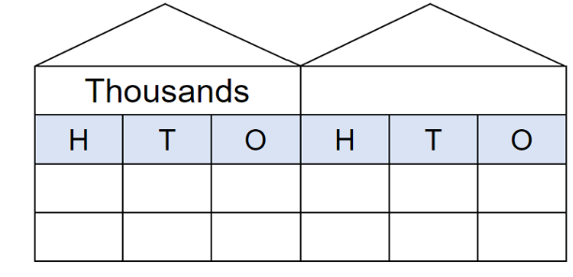

Resource 2 – number cards
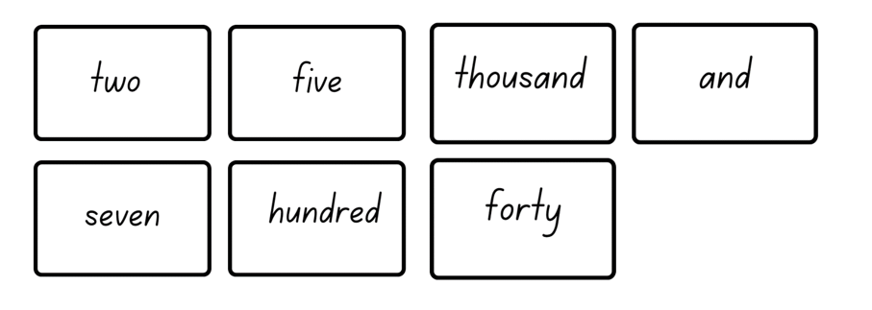

Resource 3 – place value houses template
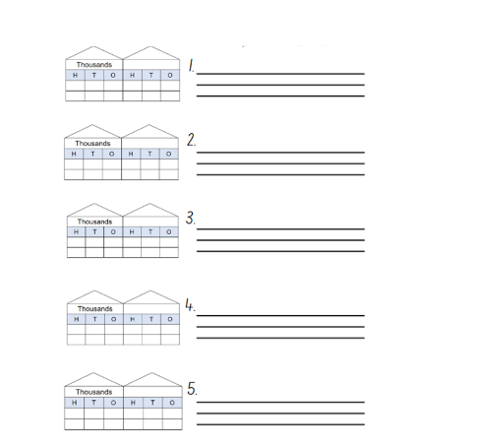

Resource 4 – expanded form memory
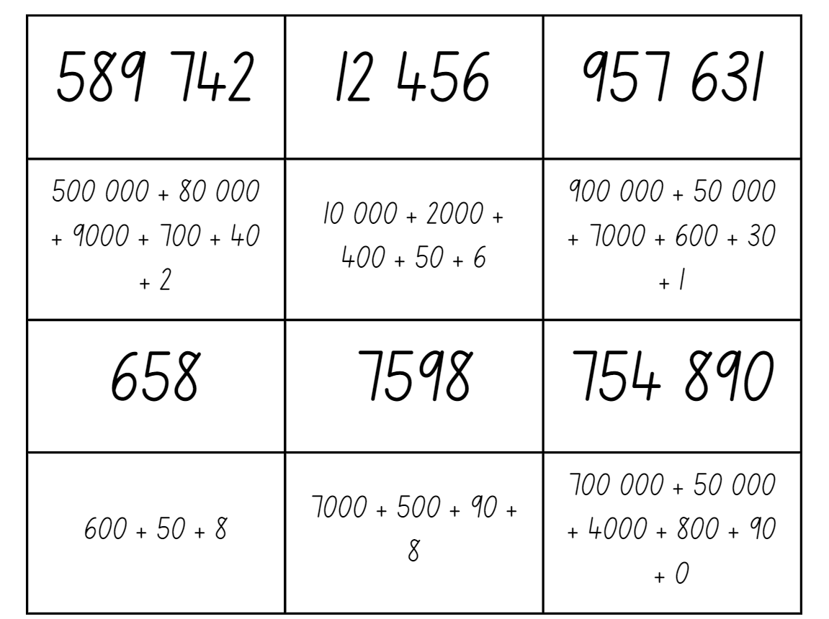
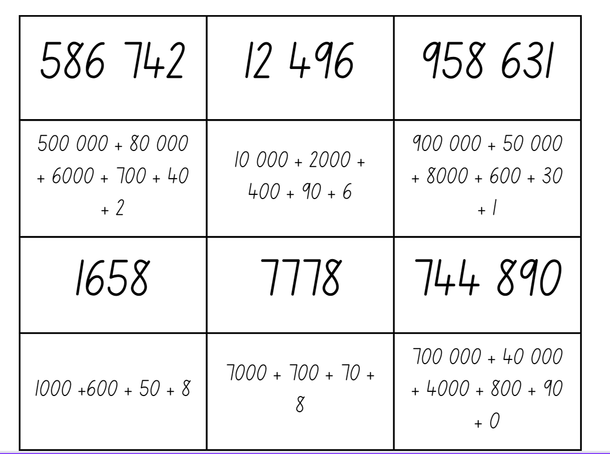

Resource 5 – decimal strip

Resource 6 – number line 0-3
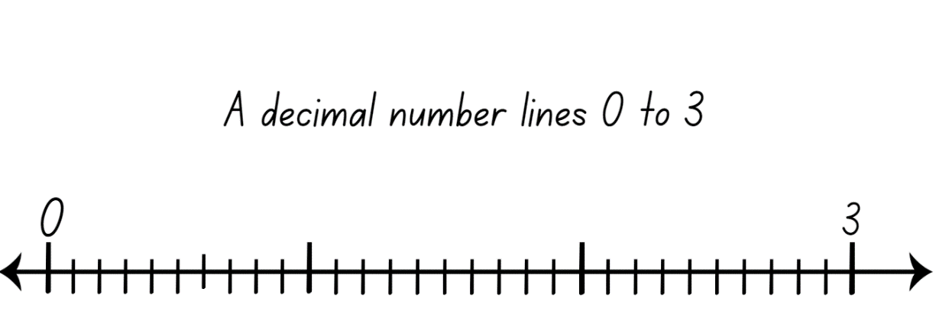

Resource 7 – call out cards
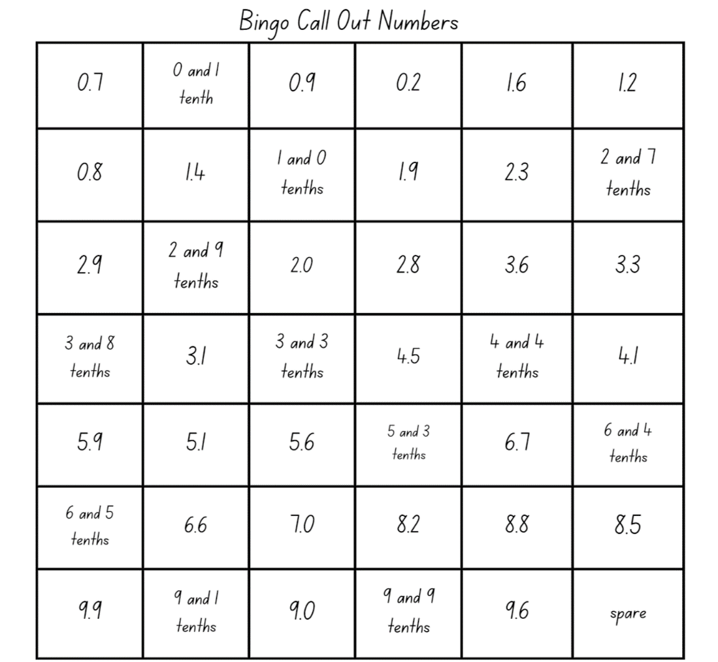

Resource 8 – bingo gameboards
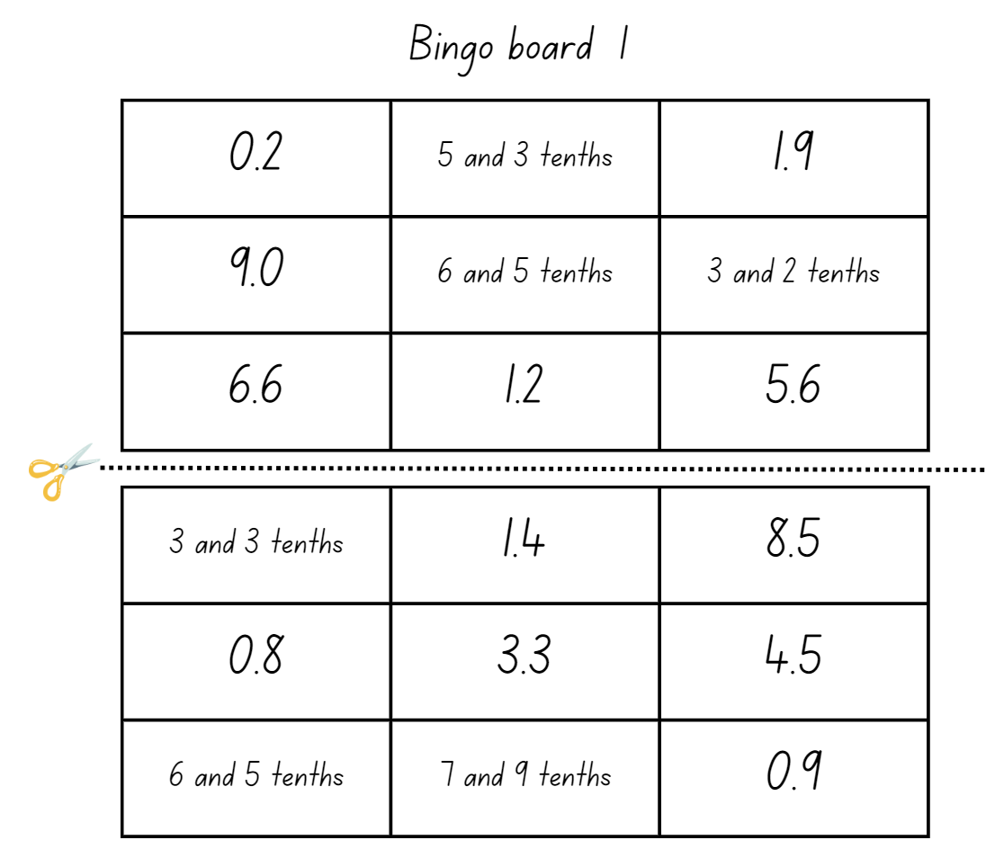

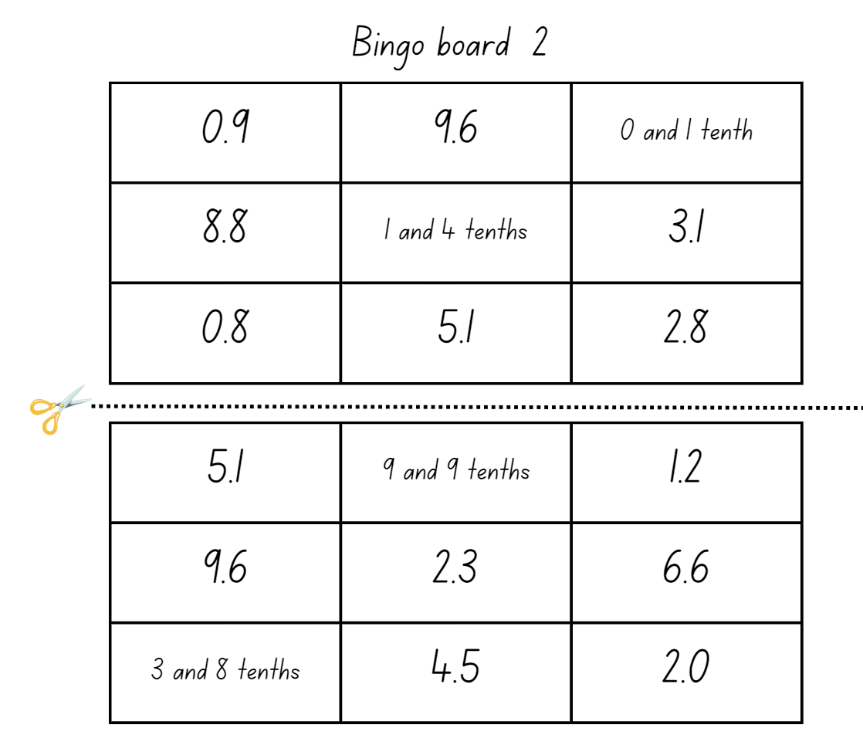

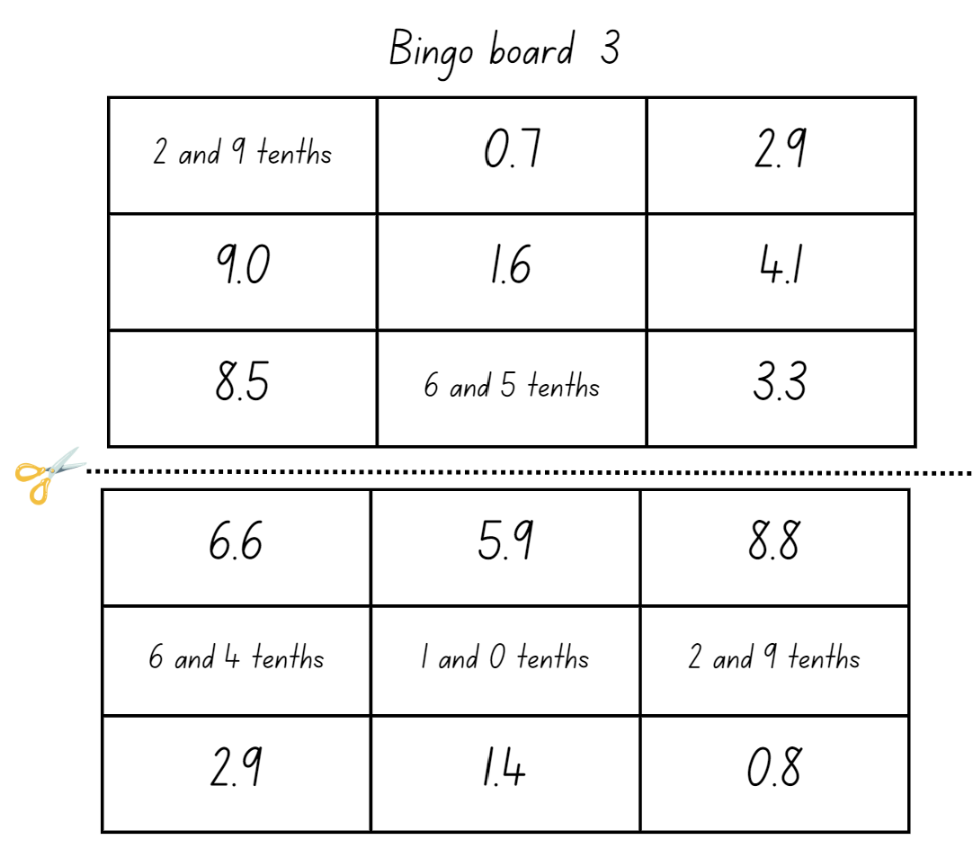

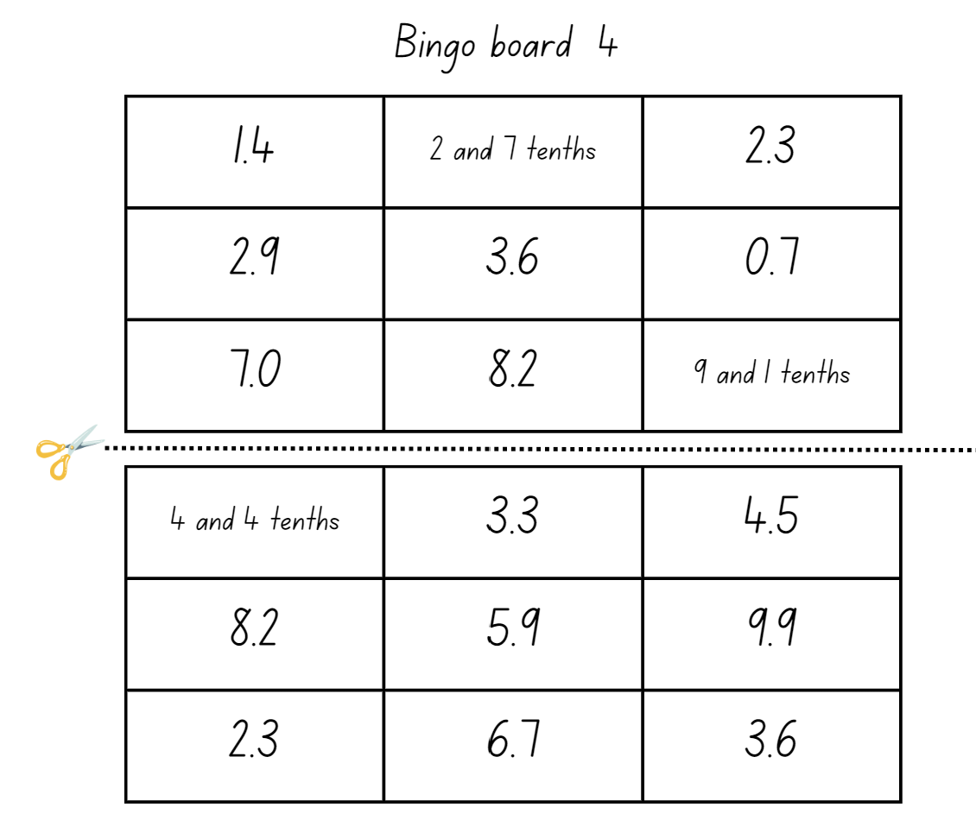

Resource 9 – Fibonacci spiral
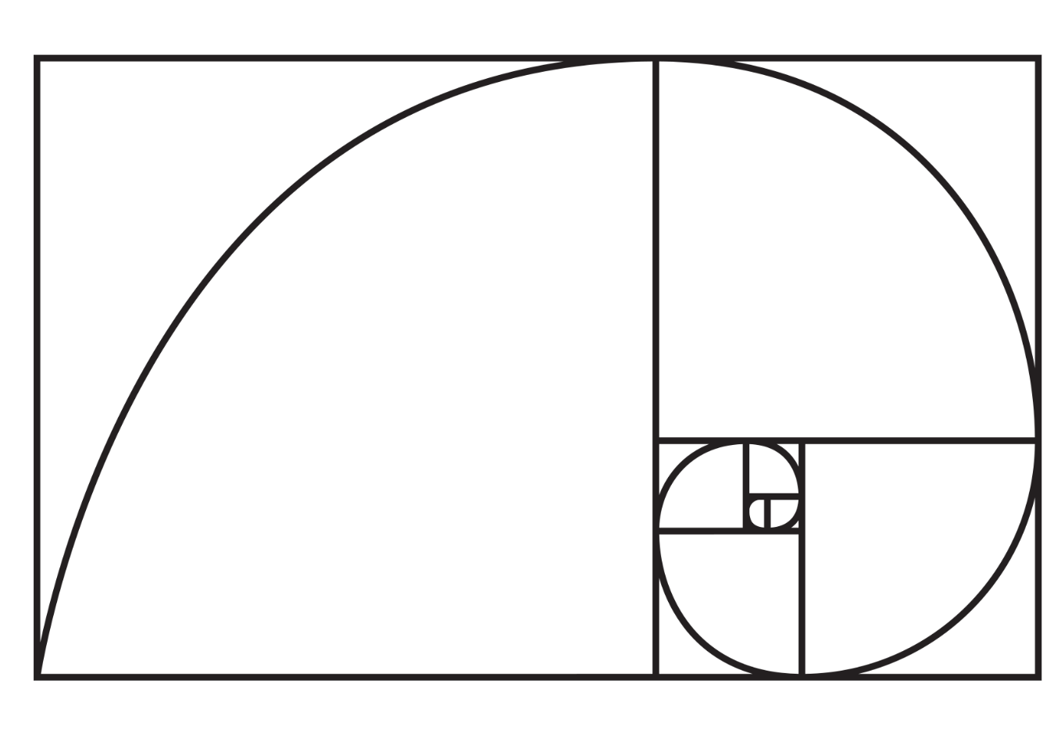

Resource 10 – Fibonacci sequence
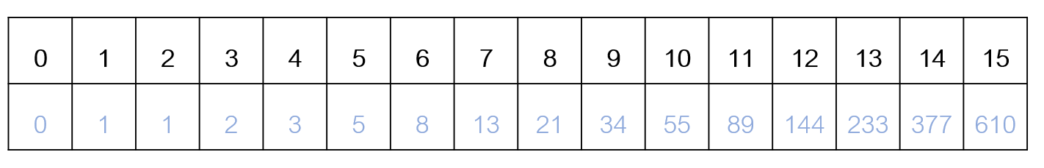

Resource 11 – place value gameboard
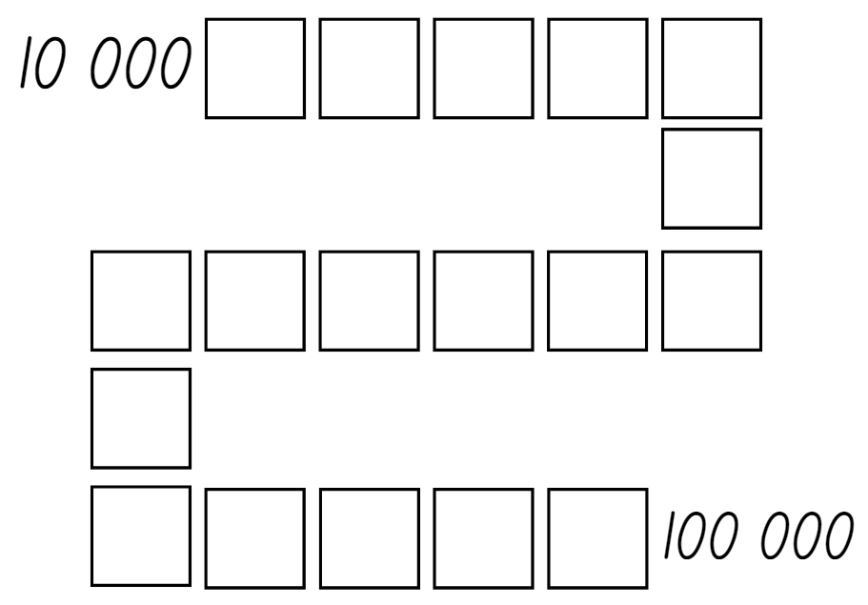

Resource 12 – multiplication patterns 1
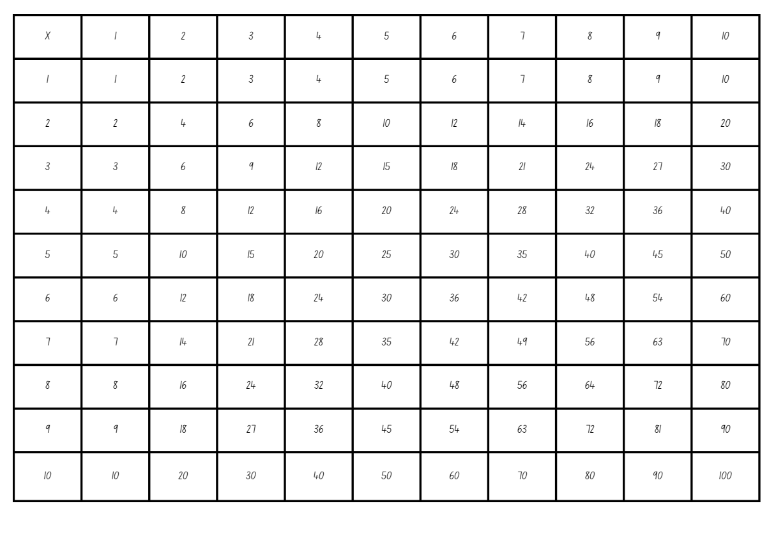

Resource 13 – more or less
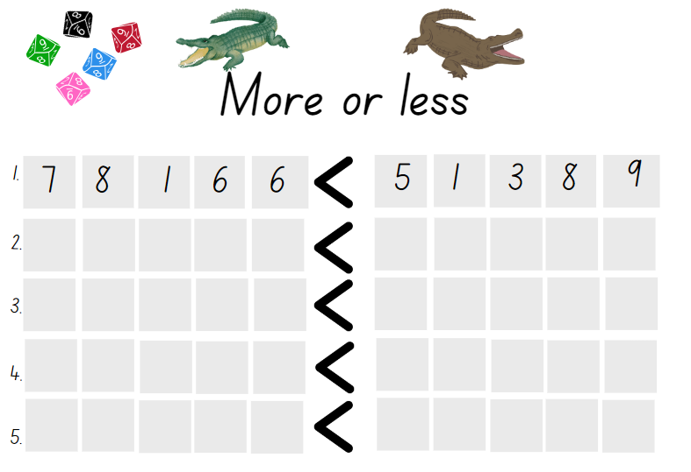

Resource 14 – multiplication patterns 2
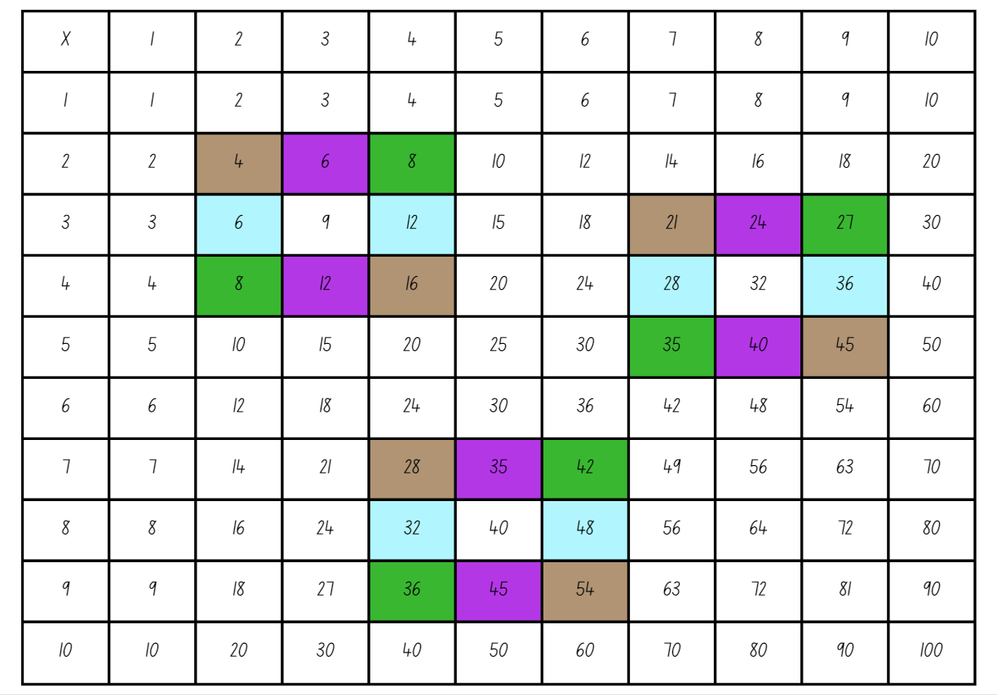

Syllabus outcomes and content
The table below outlines the syllabus outcomes and range of relevant syllabus content covered in this unit. Content is linked to National Numeracy Learning Progression version (3).
Outcomes and content | 1 | 2 | 3 | 4 | 5 | 6 | 7 | 8
Representing numbers using place value A: Whole numbers: Read, represent and order numbers to thousands
MAO-WM-01, MA2-RN-01
- Group physical or virtual objects to show the structure of tens, hundreds and a thousand | x | x | x
- Regroup numbers flexibly, recognising one thousand as 10 hundreds and one hundred as 10 tens or 100 ones | x | x | x
- Compare and describe the relative size of numbers by positioning numbers on a number line (Reasons about quantity) |  | x |  | x | x | x | x
- Count forwards and backwards by tens and hundreds on and off the decade |  | x |  | x
- Represent numbers up to and including thousands using physical or virtual manipulatives, words, numerals, diagrams and digital displays | x | x | x
- Read and order numbers of up to at least 4 digits | x | x | x | x | x | x | x
- Identify the number before and after a number with an internal zero digit |  |  |  | x
Representing numbers using place value A: Whole numbers: Apply place value to partition and regroup numbers up to 4 digits
MAO-WM-01, MA2-RN-01
- Record numbers using standard place value form | x | x |  |  | x | x | x
Representing numbers using place value B: Whole numbers: Order numbers in the thousands
MAO-WM-01, MA2-RN-01, MA2-RN-02
- Arrange numbers in the thousands in ascending and descending order | x | x |  |  |  | x | x
- Recognise and describe how rearranging digits changes the size of a number (Reasons about relations) | x | x |  |  |  | x | x
- Identify the nearest thousand, 10 thousand or 100 thousand to numbers |  | x
Representing numbers using place value B: Whole numbers: Apply place value to partition, regroup and rename numbers up to 6 digits
MAO-WM-01, MA2-RN-01, MA2-RN-02
- Name thousands using the place value grouping of ones, tens and hundreds of thousands | x | x | x
- Use place value to expand the number notation |  | x | x
Representing numbers using place value B: Whole numbers: Recognise and represent numbers that are 10, 100 or 1000 times as large
MAO-WM-01, MA2-RN-01, MA2-RN-02
- Recognise the number of tens, hundreds or thousands in a number | x | x | x | x |  | x | x
- Describe how making a number 10, 100 or 1000 times as large changes the place value of digits | x |  |  |  |  | x
Representing numbers using place value B: Decimals: Extend the application of the place value system from whole numbers to tenths and hundredths
MAO-WM-01, MA2-RN-01, MA2-RN-02
- Divide a length representing one whole into 10 equal parts and label the divisions using decimal notation |  |  | x
- Use the decimal point as a marker to identify the position of the ones digit when expressing tenths as decimals |  |  | x | x
- Recognise that 10-tenths is recorded as 1.0 and regroup when using decimal notation |  |  | x
- Represent and compare tenths as decimals using linear representations (Reasons about relations) |  |  | x
- Express decimals as both tenths and hundredths |  |  | x | x
- Locate and order decimals representing tenths and hundredths on a number line, describing their relative size |  |  | x
- Interpret zero digits at the end of a decimal |  |  | x | x
- Distinguish between the role of zero in various positions |  |  | x | x
Multiplicative relations A: Generate and describe patterns
MAO-WM-01, MA2-MR-01
- Model, describe and record patterns of multiples |  |  |  |  | x | x
- Create and continue a variety of number patterns that increase or decrease by a constant amount |  |  |  |  | x
- Recognise the significance of the final digit of a whole number in determining whether a given number is even or odd (Reasons about relations) |  |  |  |  | x
Multiplicative relations A: Use arrays to establish multiplication facts from multiples of 2 and 4, 5 and 10
MAO-WM-01, MA2-MR-01
- Create and represent multiplicative structure, using the term multiples when connecting grouping to arrays |  |  |  |  |  |  | x | x
- Use the array structure to coordinate the number of groups with the number in each group |  |  |  |  |  |  | x | x
- Relate doubling to multiplication facts for multiples of 2 |  |  |  |  | x |  | x | x
- Recognise that doubling is multiplying by 2 and halving is dividing by 2 (Reasons about relations) |  |  |  |  | x |  |  | x
- Recognise the relationship between one multiple and its double (Reasons about relations) |  |  |  |  | x |  |  | x
Multiplicative relations A: Recall multiplication facts of 2 and 4, 5 and 10 and related division facts
MAO-WM-01, MA2-MR-01
- Recognise and use the symbols for multiplied by (×), divided by (÷) and equals (=) |  |  |  |  | x | x | x | x
- Generate multiplication fact families for multiples of 2 and 4, 5 and 10 |  |  |  |  | x | x | x | x
- Model and apply the commutative property of multiplication |  |  |  |  | x | x | x | x
Multiplicative relations B: Investigate number sequences involving related multiples
MAO-WM-01, MA2-MR-01
- Generate number patterns using related multiples |  |  |  |  | x |  |  | x
- Investigate number patterns involving related multiples |  |  |  |  | x |  |  | x
Multiplicative relations B: Use known number facts and strategies
MAO-WM-01, MA2-MR-01
- Apply the known strategy of doubling to connect multiples of 3 to 6 and 4 to 8 (Reasons about relations) |  |  |  |  |  |  | x | x
- Use known facts to find unknown multiples (Reasons about relations) |  |  |  |  |  | x | x | x
Multiplicative relations B: Use number properties to find related multiplication facts
MAO-WM-01, MA2-MR-01
- Use the commutative property of multiplication |  |  |  |  |  | x | x | x
- Use flexible partitioning within multiplication (Reasons about relations) |  |  |  |  |  | x | x
- Generate and recall multiplication fact families up to 10 x 10 |  |  |  |  |  | x | x | x
Multiplicative relations B: Operate with multiples of 10
MAO-WM-01, MA2-MR-01
- Apply the commutative and associative properties to multiply by multiples of 10 |  |  |  |  |  | x
Mathematics K–10 Syllabus © NSW Education Standards Authority (NESA) for and on behalf of the Crown in right of the State of New South Wales, 2022.

References
This resource contains NSW Curriculum and syllabus content. The NSW Curriculum is developed by the NSW Education Standards Authority. This content is prepared by NESA for and on behalf of the Crown in right of the State of New South Wales. The material is protected by Crown copyright.
Please refer to the NESA Copyright Disclaimer for more information https://educationstandards.nsw.edu.au/wps/portal/nesa/mini-footer/copyright.
NESA holds the only official and up-to-date versions of the NSW Curriculum and syllabus documents. Please visit the NSW Education Standards Authority (NESA) website https://educationstandards.nsw.edu.au/wps/portal/nesa/home/ and the NSW Curriculum website https://curriculum.nsw.edu.au.
Mathematics K–10 Syllabus © NSW Education Standards Authority (NESA) for and on behalf of the Crown in right of the State of New South Wales, 2022.
National Numeracy Learning Progression © Australian Curriculum, Assessment and Reporting Authority (ACARA) 2010 to present, unless otherwise indicated. This material was downloaded from the Australian Curriculum website (National Literacy Learning Progression) (accessed 28 August 2023) and was not modified.
ABC (Australian Broadcasting Corporation) (2020) ‘Episode 12 Years 3-4: Our Place Value System’ [television program], Mini Lessons: Maths (series 1, episode 12), ABC iView, Australia, accessed 18 May 2023.
Boaler J, Munson J and Williams C (2017) Mindset Mathematics: Visualizing and Investigating Big Ideas, Grade 4, Jossey-Bass, San Francisco.
Burkhart J (2015–2023) Deep Math Projects, 5280 MATH website, accessed 5 July 2023.
Frykholm J (2010) Learning to Think Mathematically with the Number Line: A Resource for Teachers, A Tool for Young Children [PDF 1.07MB], The Math Learning Center, accessed 5 July 2023.
New Zealand Ministry of Education (n.d.) ‘Missing Number Bingo’, Resource Finder, NZ Maths, accessed 5 July 2023.
Siemon D, Warren E, Beswick K, Faragher R, Miller J, Horne M, Jazby D & Breed M (2020) Teaching Mathematics Foundations to Middle Years, 3rd edn, Oxford University Press, Victoria.
State of New South Wales (Department of Education) (2023) ‘Hit it (3-digit numbers)’, Mathematics K-6 resources, NSW Department of Education website, accessed 18 May 2023.
State of New South Wales (Department of Education) (2023) ‘Place value game’, Mathematics K-6 resources, NSW Department of Education website, accessed 18 May 2023.
University of Cambridge (Faculty of Mathematics) (n.d.) Multiply Multiples 3, NRICH website, accessed 5 July 2023.
© State of New South Wales (Department of Education), 2023
The copyright material published in this resource is subject to the Copyright Act 1968 (Cth) and is owned by the NSW Department of Education or, where indicated, by a party other than the NSW Department of Education (third-party material).
Copyright material available in this resource and owned by the NSW Department of Education is licensed under a Creative Commons Attribution 4.0 International (CC BY 4.0) license.
This license allows you to share and adapt the material for any purpose, even commercially.
Attribution should be given to © State of New South Wales (Department of Education), 2023.
Material in this resource not available under a Creative Commons license:
- the NSW Department of Education logo, other logos and trademark-protected material
- material owned by a third party that has been reproduced with permission. You will need to obtain permission from the third party to reuse its material.
Links to third-party material and websites
Please note that the provided (reading/viewing material/list/links/texts) are a suggestion only and implies no endorsement, by the New South Wales Department of Education, of any author, publisher, or book title. School principals and teachers are best placed to assess the suitability of resources that would complement the curriculum and reflect the needs and interests of their students.
If you use the links provided in this document to access a third-party's website, you acknowledge that the terms of use, including licence terms set out on the third-party's website apply to the use which may be made of the materials on that third-party website or where permitted by the Copyright Act 1968 (Cth). The department accepts no responsibility for content on third-party websites.

