Mathematics Stage 2 – Unit 7

Contents
Unit description and duration 5
Syllabus outcomes 5
Working mathematically 6
Student prior learning 6
Lesson overview and resources 8
Lesson 1 13
Daily number sense – number talk – 15 minutes 13
Core lesson – growing and shrinking patterns – 40 minutes 15
Discuss and connect the mathematics – 10 minutes 18
Lesson 2 19
Daily number sense – multiple patterns – 15 minutes 19
Core lesson – groups to arrays – 50 minutes 21
Discuss and connect the mathematics – 10 minutes 25
Lesson 3 27
Daily number sense – multiplicative patterns – 15 minutes 27
Core lesson 1 – arrays – 15 minutes 28
Core lesson 2 – doubling is a powerful strategy – 20 minutes 31
Discuss and connect the mathematics – 10 minutes 32
Lesson 4 34
Daily number sense – 10 minutes 34
Core lesson – halving – 40 minutes 34
Discuss and connect the mathematics – 20 minutes 40
Lesson 5 42
Daily number sense – Where do you fit? – 10 minutes 42
Core lesson – commutative city – 45 minutes 43
Discuss and connect the mathematics – 15 minutes 47
Lesson 6 48
Daily number sense – before and after – 10 minutes 48
Core lesson – the Division District – 40 minutes 50
Discuss and connect the mathematics – 10 minutes 53
Lesson 7 56
Daily number sense – from here to there – 10 minutes 56
Core lesson – fact families – 40 minutes 58
Discuss and connect the mathematics – 15 minutes 62
Lesson 8 64
Daily number sense – 10 minutes 64
Core lesson – solving problems – 40 minutes 64
Discuss and connect the mathematics – 10 minutes 67
Resource 1 – patterns 68
Resource 2 – Patterns or not? 69
Resource 3 – growing and shrinking 70
Resource 4 – square number patterns 71
Resource 5 – number circles 72
Resource 6 – nests and carton 73
Resource 7 – nests and carton 2 74
Resource 8 – nests cards 75
Resource 9 – multiplicative tables 1 77
Resource 10 – multiplicative tables 2 78
Resource 11 – unusual muffin trays 79
Resource 12 – muffin tray 80
Resource 13 – muffin tray arrays 81
Resource 14 – double trays 82
Resource 15 – a farmer’s field 83
Resource 16 – halving game cards 84
Resource 17 – blank game cards 88
Resource 18 – building arrays 89
Resource 19 – grid page 90
Resource 20 – city cards 91
Resource 21 – building array – division 92
Resource 22 – making fact families 93
Resource 23 – arrays to facts 94
Resource 24 – Fact family or not? 95
Resource 25 – think board 1 96
Resource 26 – think board 2 97
Resource 27 – think board 3 98
Resource 28 – problems to solve 99
Resource 29 – blank think board 100
Syllabus outcomes and content 101
References 106
Further reading 107

Unit description and duration
This unit introduces the big idea that multiplicative thinking involves flexible use of multiplication and division concepts, strategies and representations.
In this 2-week unit students are provided opportunities to:
- generate and describe patterns
- use arrays to establish multiplication facts from multiples of 2 and 4, 5 and 10
- represent and solve problems involving multiplication fact families.

Syllabus outcomes
- MAO-WM-01 develops understanding and fluency in mathematics through exploring and connecting mathematical concepts, choosing and applying mathematical techniques to solve problems, and communicating their thinking and reasoning coherently and clearly
- MA2-RN-01 applies an understanding of place value and the role of zero to represent numbers to at least tens of thousands
- MA2-MR-01 represents and uses the structure of multiplicative relations to 10 × 10 to solve problems
- MA2-MR-02 completes number sentences involving multiplication and division by finding missing values

Working mathematically
In the Mathematics K–10 Syllabus, there is one overarching Working mathematically outcome (MAO-WM-01). The Working mathematically processes should be embedded within the concepts being taught. The Working mathematically processes present in the Mathematics K–10 Syllabus are:
- communicating
- understanding and fluency
- reasoning
- problem solving.
Mathematics K–10 Syllabus © NSW Education Standards Authority (NESA) for and on behalf of the Crown in right of the State of New South Wales, 2022.

Student prior learning
Before engaging in these teaching and learning activities, students would benefit from prior experience with:
- making and using equal groups
- identifying and describing patterns
- modelling doubling and halving with fractions.

In NSW classrooms there is a diverse range of students, including Aboriginal and Torres Strait Islander students, students learning English as an additional language or dialect, high potential and gifted students and students with disability. Some students may identify with more than one of these groups or possibly all of them. Refer to Curriculum planning for every student – advice for further information.

Lesson overview and resources
The table below outlines the sequence and approximate timing of lessons, learning intentions and resources.
Lesson | Content | Duration and resources
Lesson 1  Daily number sense learning intention:  - generate and describe patterns | Lesson core concept: patterns and structures are the basis for multiplicative thinking.  Core concept learning intention:  - generate and describe multiplicative patterns | Lesson duration: 65 minutes  - Resource 1 – patterns  - Resource 2 – Patterns or not?  - Resource 3 – growing and shrinking  - Resource 4 – square number patterns  - Counters or shape tiles  - Writing materials
Lesson 2  Daily number sense learning intention:  - generate and describe patterns | Lesson core concept: structures support multiplicative thinking.  Core concept learning intention:  - use arrays to establish multiplication facts from multiples of 2 and 4, 5 and 10 | Lesson duration: 75 minutes  - Resource 5 – number circles  - Resource 6 – nests and carton  - Resource 7 – nests and carton 2  - Resource 8 – Nest cards  - Individual whiteboards  - Writing materials
Lesson 3  Daily number sense learning intention:  - generate and describe patterns | Lesson core concept: doubling is a powerful strategy.  Core concept learning intention:  - use doubling to identify multiples of 2  - use doubling as a strategy to connect multiples of 3 to 6 and 4 to 8 | Lesson duration: 60 minutes  - Resource 9 – multiplicative tables 1  - Resource 10 – multiplicative tables 2  - Resource 11 – unusual muffin trays  - Resource 12 – muffin tray  - Resource 13 – muffin tray arrays  - Resource 14 – double trays  - Counters  - Writing materials
Lesson 4  Daily number sense learning intention:  - teacher-identified task based on student needs | Lesson core concept: halving is the opposite of doubling.  Core concept learning intention:  - recognise halving is the opposite of doubling  - recognise the inverse relationship of multiplication and division | Lesson duration: 70 minutes  - Resource 15 – a farmer’s field  - Resource 16 – halving game cards  - Resource 17 – blank game cards  - Individual whiteboards  - Writing materials
Lesson 5  Daily number sense learning intention:  - read and order numbers up to thousands | Lesson core concept: flexible methods of computation in multiplication and division involve composing and decomposing numbers.  Core concept learning intention:  - represent the structure of multiplicative relations to 10 × 10 | Lesson duration: 70 minutes  - Resource 18 – building arrays  - Resource 19 – grid page  - Resource 20 – city cards  - 10-sided dice  - Individual whiteboards  - Sticky notes  - Writing materials
Lesson 6  Daily number sense learning intention:  - read, represent and order numbers to thousand | Lesson core concept: multiplication and division are related.  Core concept learning intention:  - use arrays to establish multiplication facts from multiples of 2 and 4, 5 and 10  - recall multiplication facts of 2 and 4, 5 and 10 and related division facts | Lesson duration: 60 minutes  - Resource 21 – building array – division  - Resource 19 – grid page  - 10-sided dice (0–9)  - Individual whiteboards  - Writing materials
Lesson 7  Daily number sense learning intention:  - read, represent and order numbers to thousands | Lesson core concept: fact families support fluency.  Core concept learning intention:  - use number properties to find related multiplication facts | Lesson duration: 65 minutes  - Resource 22 – making fact families  - Resource 20 – city cards  - Resource 23 – arrays to facts  - Resource 24 – Fact family or not?  - 10-sided dice (0–9)  - Writing materials
Lesson 8  Daily number sense learning intention:  - teacher-identified task based on student needs | Lesson core concept: worded problems can be solved using multiplicative thinking.  Core concept learning intention:  - represent and solve problems involving multiplication fact families | Lesson duration: 60 minutes  - Resource 25 – think board 1  - Resource 26 – think board 2  - Resource 27 – think board 3  - Resource 28 – problems to solve  - Resource 29 – blank think board

Lesson 1
Core concept: patterns and structures are the basis for multiplicative thinking.

Daily number sense – number talk – 15 minutes
Daily number sense activities for lessons 1 to 3 ‘activate’ prior number knowledge and support the learning of new content in the unit. These activities can also assist teachers to identify the starting points for learning by revealing the extent of students’ existing knowledge.
The table below contains a suggested learning intention and success criteria. These are best co-constructed with students.
Daily number sense learning intention | Daily number sense success criteria
Students are learning to:  - generate and describe patterns. | Students can:  - generate, describe and record patterns of multiples.
This activity is an adaptation of ‘Growing patterns’ from Primary and Middle Years Mathematics: Teaching Developmentally by Van de Walle et al.
- Display Resource 1 – patterns. Ask:
- What do you notice?
- What do you wonder?
- What is the same and what is different?
- Record students’ ideas and vocabulary, such as: even, odd, ascending, descending, larger, smaller, difference, multiple, pattern, rule, core, number, picture, repeated addition, repeated subtraction and square numbers.
- Explain that each example represents a pattern. Share the definition of a pattern.
Pattern: a pattern in mathematics is made up of several elements that repeat or follow a rule.
- Explain that patterns and rules are the foundation for being able to think multiplicatively, which means being able to see the multiplicative relations when working with numbers. Explain that this is the main focus of the series of lessons to follow.
This table details opportunities for assessment.
Assessment opportunities | Links
What to look for:  - Can students generate, describe and record patterns of multiples? [MAO-WM-01, MA2-MR-01] | Links to National Numeracy Learning Progressions (NNLP):  - NPA3, NPA4.

Core lesson – growing and shrinking patterns – 40 minutes
The table below contains a suggested learning intention and success criteria. These are best co-constructed with students.
Core concept learning intention | Core concept success criteria
Students are learning to:  - generate and describe multiplicative patterns. | Students can:  - model, describe and record patterns  - create and continue a variety of number patterns that increase or decrease by a constant amount.
- Display Resource 2 – Patterns or not? Refer to the definition of a pattern from the Daily number sense task above and ask:
- Which of these are patterns?
- Which of these are not patterns?
- Can you explain your reasoning?
- What rules can you see?
- What would be the next item(s) in the pattern?
- Draw attention to the image with the stacks of coins. Discuss what makes this different from the other images. For example, ask if it is a large collection that is arranged randomly or with no pattern.
- Explain that you are going to focus on 2 kinds of patterns, growing and shrinking patterns. If students already noticed these in the Daily number sense activity, refer to that.
- Display Resource 3 – growing and shrinking. Examine each pattern and ask if the pattern is growing or shrinking.
- Select a student to create the next item in the sequence. Ask them to explain their reasoning and describe how much this item in the pattern has increased or decreased by.
- As a class, decide on the rule that must be followed to continue each pattern. Model appropriate language for each pattern, such as:
- the dice pattern increased by 4 each step
- the pattern grows by 3 triangles each step
- the pattern increases by 5 squares each step
- the number pattern decreases by 10 or 100 each step.
- With their partner, students continue the patterns using a range of resources, for example, counters, shape tiles or drawing materials.
- After a suitable time, pause the pattern making to ask:
- How can you work out the tenth item in the pattern without drawing or listing each one?
- How would you check it?
- How could place value help us with the tenth item?
- Allow time for students to return to pattern making and consider these questions. Monitor student responses, noting that some students may make all 10 steps.
- Students create and record some patterns of their own. Label the number of items in each step in a skip counting pattern, such as 3, 6, 9, 12.
- Ask students to work out the tenth item in their pattern without drawing or listing each one.
This table details opportunities for differentiation.
Too hard? | Too easy?
Students cannot model, describe and record patterns.  - Support students to recreate one of the patterns from Resource 3 – growing and shrinking using a range of resources, for example, counters, shape tiles, MAB or drawing materials. Support students to identify the rule.  - Ask students to create their own pattern, growing by 2 or 10 more objects in each item using MAB materials. | Students can model, describe and record patterns.  - Ask students to record the relationship between the item number and amount in each step of the pattern.  - With a partner, students develop a way to identify the hundredth item in the pattern.  - Challenge students to create, describe and record a doubling pattern.  - Students investigate square number patterns using Resource 4 – square number patterns. Ask them to identify the relationship between the item number and amount in each step of the pattern.

Discuss and connect the mathematics – 10 minutes
- Conduct a gallery walk for students to share their own patterns.
- Select 2 or 3 pattern samples to discuss. Connect students’ work to the idea that multiplicative patterns grow and shrink by a constant amount.
This table details opportunities for assessment.
Assessment opportunities | Links
What to look for:  - Can students model, describe and record patterns? [MAO-WM-01, MA2-MR-01]  - Can students create and continue a variety of number patterns that increase or decrease by a constant amount? [MAO-WM-01, MA2-MR-01] | Links to National Numeracy Learning Progressions (NNLP):  - NPA3, NPA4.  Links to suggested Interview for Student Reasoning (IfSR) tasks:  - IfSR-NP: 4A.1, 4A.2, 4A.3.

Lesson 2
Core concept: structures support multiplicative thinking.

Daily number sense – multiple patterns – 15 minutes
The table below contains a suggested learning intention and success criteria. These are best co-constructed with students.
Daily number sense learning intention | Daily number sense success criteria
Students are learning to:  - generate and describe patterns | Students can:  - create and continue a variety of number patterns that increase or decrease by a certain amount.
This activity is an adaptation of Round and Round the Circle from NRICH by University of Cambridge (Faculty of Mathematics).
- Model writing 10 steps of a twos pattern, starting from zero. For example, 0, 2, 4, 6, 8, 10 and so on.
- Display Resource 5 – number circles. Model drawing the same twos pattern starting from zero in a number circle. Verbalise the counting pattern when moving clockwise around the circle.
- Model writing 5 steps of a twos pattern, starting from one. For example, 1, 3, 5, 7, 9, 11 and so on.
- Ask students what is the same and what is different. Record student responses.
- Provide students with a copy of Resource 5 – number circles.
- Students select pairs of patterns to investigate starting from zero and from one. Number patterns can be altered to meet the learning needs of students. Investigations could include a:
- twos pattern and fours pattern
- threes pattern and sixes pattern
- fours pattern and eights pattern
- fives pattern and tens pattern.
- Ask students to communicate what they noticed about the patterns they recorded in the number circle.
- Finish by playing a circle game where students take turns to recite multiple number patterns both forwards and backwards.
This table details opportunities for assessment.
Assessment opportunities | Links
What to look for:  - Can students create and continue a variety of number patterns that increase or decrease by a certain amount? [MAO-WM-01, MA2-MR-01] | Links to National Numeracy Learning Progressions (NNLP):  - NPA3.  Links to suggested Interview for Student Reasoning (IfSR) tasks:  - IfSR-NP: 4A.1, 4A.2, 4A.3.

Core lesson – groups to arrays – 50 minutes
The table below contains a suggested learning intention and success criteria. These are best co-constructed with students.
Core concept learning intention | Core concept success criteria
Students are learning to:  - use arrays to establish multiplication facts from multiples of 2 and 4, 5 and 10. | Students can:  - use the array structure to coordinate the number of groups with the number of each group  - use the term multiples when connecting groups to arrays.
- Explain that a farmer has eggs from the chickens on their farm. The farmer must pack the eggs in boxes before sending them to market.
- Display Resource 6 – nests and carton. Ask students:
- What is different?
- What is the same?
- How can you describe what you see?
- Establish by skip counting that there are a total of 12 eggs in the nests.
- Model for students how 3 groups of 4 eggs were rearranged into equal rows called an array. Explain that it is one set of 12 eggs.
Array: an array is one of several different arrangements that can be used to model multiplicative situations involving whole numbers. It is made by arranging a set of objects, such as counters, into columns and rows. Each column must contain the same number of objects as the other columns, and each row must contain the same number of objects as the other rows.
- Explain to students that 3 groups of 4 can now be described as 3 rows of 4 or 3 fours. State 3 fours is 12.
- Display Resource 7 – nests and carton 2. Ask students to turn and talk and discuss the corresponding array.
- Ask all students to draw the array on individual whiteboards. Discuss with students how they can describe the array, using the phrases ‘5 rows of 3’ or ‘5 threes’ is 15. Ensure students read across the rows.
- Introduce the terms multiples and product.
Multiples: a series of products formed using the same base number multiplied by different whole numbers. For example, 3, 6, 9, 12 and so on are multiples of 3.
Product: the result of multiplying 2 or more numbers together. For example, 12 is the product of 4 × 3.
- As a class, skip count by threes. Record the numbers as they are said aloud. Explain that these are all multiples of 3.
- Draw attention to 12 and 15 in the list of multiples. Explain that multiples are in the array in Resource 7 – nests and carton 2 because each row has 3 in it: 4 threes is 12 and 5 threes is 15. Note that 12 is also a multiple of 4 as shown in Resource 6 – nests and carton.
- Create an anchor chart to model this language with an array, see Figure 1. Explain that each of these numbers are multiples of 4.
Figure 1 – multiples and arrays
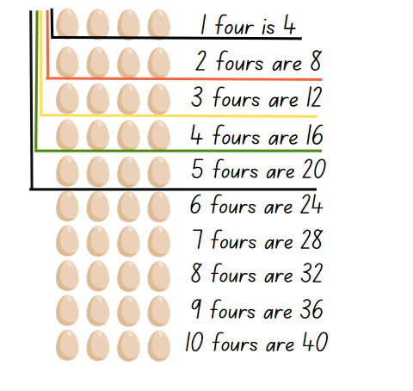
- Provide students with a copy of Resource 8 – Nest cards and writing materials.
- Explain to students that their task is to rearrange each nest card into an array and to describe what they see using words, such as ‘I see 5 threes’. For an example, see Figure 2.
Figure 2 – student work sample
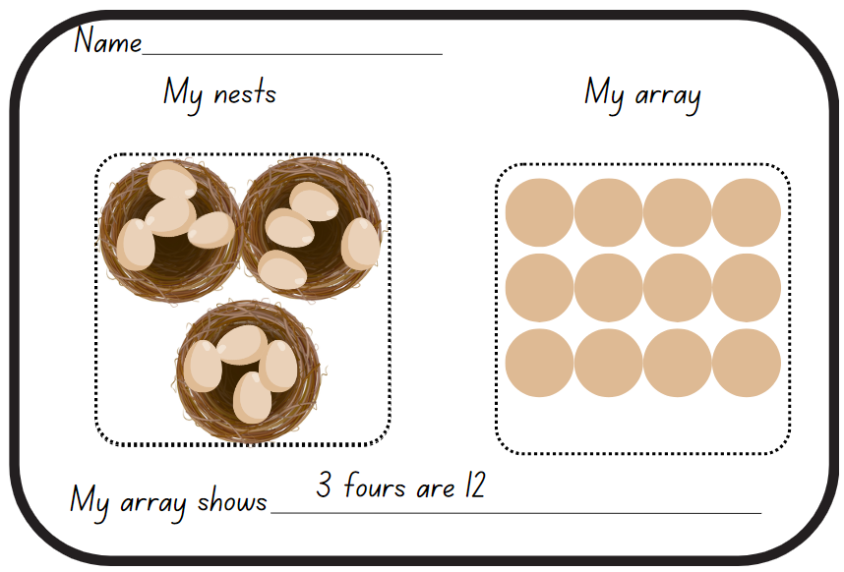
This table details opportunities for differentiation.
Too hard? | Too easy?
Students cannot use arrays to establish multiplication facts from multiples of 2 and 4, 5 and 10.  - Support students to create groups of 2 counters. Model the transformation to an array by dragging the counters. Ask students how many twos they see in the array.  - Present a 2 by 5 array. Ask students to identify the rows and how many in each row. Ask how many fives they see in the array. Repeat with other arrays with rows of 5. | Students can use arrays to establish multiplication facts from multiples of 2 and 4, 5 and 10.  - Ask students to investigate arrays that form a square and to record the number facts for those. Ask students to describe a pattern.  - Use a digital device to investigate the different arrays that eggs are packaged and sold in Australia. Label images with multiples and present to the class.

Discuss and connect the mathematics – 10 minutes
- Select student samples that represent multiples of 2, 4, 5 and 10. Ask:
- What patterns can you see?
- How do you know these arrays are multiples?
- Are there any different shaped arrays that produce the same product?
- Record the first 10 multiples of 2, 4, 5, and 10 on the class anchor chart.
This table details opportunities for assessment.
Assessment opportunities | Links
What to look for:  - Can students use the term multiples when connecting groups to arrays such as, 4 threes is 12, so 12 is a multiple of 3 and 4? [MAO-WM-01, MA2-MR-01]  - Can students coordinate the number of groups with the number in each group, such as 1 two is 2, 2 twos are 4? [MAO-WM-01, MA2-MR-01] | Links to National Numeracy Learning Progressions (NNLP):  - MuS5.

Lesson 3
Core concept: doubling is a powerful strategy.

Daily number sense – multiplicative patterns – 15 minutes
The table below contains a suggested learning intention and success criteria. These are best co-constructed with students.
Daily number sense learning intention | Daily number sense success criteria
Students are learning to:  - generate and describe patterns. | Students can:  - model, describe and record patterns of multiples  - create and continue a variety of number patterns.
This activity has been adapted from Enrich-e-matics – Book 3, 3rd edition by Joshua.
- Display Resource 9 – multiplicative tables 1.
- Examine each table one at a time. Ask students to identify the multiplicative relationship between the number pairs. Invite students to nominate other pairs that belong in each table.
- Display Resource 10 – multiplicative tables 2. Students turn and talk to nominate missing numbers and a rule that applies to this table. Possible answers for whole numbers include multiply by 1, 2, 4, 5, 10, 20. Discuss why 3, 6, 7, 8 and 9 are not possible multipliers for whole numbers.
- This activity can be extended with students making their own tables.
This table details opportunities for assessment.
Assessment opportunities | Links
What to look for:  - Can students model, describe and record patterns of multiples? [MAO-WM-01, MA2-MR-01]  - Can students create and continue a variety of number patterns? [MAO-WM-01, MA2-MR-01] | Links to National Numeracy Learning Progressions (NNLP):  - NPA3, NPA4.  Links to suggested Interview for Student Reasoning (IfSR) tasks:  - IfSR-NP: 4A.1, 4A.2, 4A.3.

Core lesson 1 – arrays – 15 minutes
The table below contains suggested learning intentions and success criteria. These are best co-constructed with students.
Core concept learning intentions | Core concept success criteria
Students are learning to:  - use doubling to identify multiples of 2  - use doubling as a strategy to connect multiples of 3 to 6 and 4 to 8. | Students can:  - relate doubling to multiplication facts for multiples of 2  - apply the known strategy of doubling to connect multiples of 3 to 6 and 4 to 8.
Note: some students may rely on repeated addition. Support these students to develop their use of doubling as a more efficient strategy for multiplicative situations.
- Introduce the story: Chef Jeff is hosting a muffin party for 6 of his friends. He plans on using muffin trays with 6 spaces to bake his famous mathematics muffins.
- With a partner, students draw what his muffin tray might look like. Ask:
- Why did you draw it this way?
- How else could you represent the muffin tray?
- Display Resource 11 – unusual muffin trays.
Note: Resource 11 – unusual muffin trays provides students with ‘non-examples’ of arrays. That is, they show examples of arrangements that may be mistaken for an array, but do not have the array structure of repeated rows.
- Ask students:
- Which one would you choose and why?
- Is this a good choice?
- Display Resource 12 – muffin tray with 6 spaces organised in an array. Explain how to correctly read the array by saying the number of rows. For example, in this muffin tray there are 3 rows of 2.
- Explain that multiples are the products made when the same base number is multiplied by different whole numbers. For example, 2, 4, 6, 8 are all multiples of 2.
- Display Resource 13 – muffin tray arrays with images of muffin trays in different orientations. Ask students:
- What do you notice about these muffin trays?
- How can you work out the total number of muffins each tray could make?
- Explain that Chef Jeff decides to invite another 6 friends so he will need to make another tray of muffins. Chef Jeff will use the muffin tray that uses 2 threes. Ask students to think about what this might look like.
- Ask students:
- How do we read this now?
- How is this written as a number sentence?
- How else could the trays be orientated?
Variation opportunity: use real muffin trays or adapt to use egg cartons with different arrays.

Core lesson 2 – doubling is a powerful strategy – 20 minutes
- Explain that Chef Jeff has decided to enter a baking competition. His kitchen has lots of different muffin trays to choose from when baking for the judges. There are a lot of judges. Ask what it would look like if he doubled the trays.
- Provide students with copies of Resource 14 – double trays or a variety of actual muffin trays.
- Students work with a partner to draw an array that shows what each tray would look like if it was doubled. Counters can also be used to create the doubled array.
- Explain that Chef Jeff has made the Master muffin chef final round! The judges have asked him to double the amount he is baking for them.
- Ask students to help Chef Jeff by drawing muffin tray arrays that have:
- double 3 rows of 4
- double 2 rows of 2
- double 4 rows of 5
- 4 muffins doubled, then doubled again.
This table details opportunities for differentiation.
Too hard? | Too easy?
Students cannot use doubling to identify multiples of 2.  - Support students to use counters to construct doubles  - Provide additional, concrete examples of array structures, such as egg cartons or muffin trays. | Students can relate doubling to multiplication facts.  - Ask students what would happen if Chef Jeff doubled the tray once or if he had 4 trays. Prompt students to share what they notice and whether they can see the pattern.  - Challenge students to describe some other shortcuts with doubling in mathematics. For example, ask if students can identify the link with ‘double double’ and multiples of 4.

Discuss and connect the mathematics – 10 minutes
- Reflect on the activity by asking students:
- Could you see any patterns in the arrays?
- How did using an array help you to find your answer when doubling?
- What is another way mathematicians describe doubling?
- How might arrays help us when calculating larger numbers?
This table details opportunities for assessment.
Assessment opportunities | Links
What to look for:  - Can students relate doubling to multiplication facts for multiples of 2? [MAO-WM-01, MA2-MR-01]  - Can students name the doubled array correctly? [MAO-WM-01, MA2-MR-01]  - Can students recognise that doubling is multiplying by 2? [MAO-WM-01, MA2-MR-01] | Links to National Numeracy Learning Progressions (NNLP):  - MuS6.

Lesson 4
Core concept: halving is the opposite of doubling.

Daily number sense – 10 minutes
- From a class need surfaced through formative assessment data, identify a short, focused activity that targets students’ knowledge, understanding and skills. Example activities may be drawn from the following resources:
- Mathematics K-6 resources
- Universal Resources Hub.

Core lesson – halving – 40 minutes
The table below contains suggested learning intentions and success criteria. These are best co-constructed with students.
Core concept learning intentions | Core concept success criteria
Students are learning to:  - recognise halving is the opposite of doubling  - recognise the inverse relationship of multiplication and division. | Students can:  - represent halving using arrays  - connect the halving and doubling strategy  - recognise that doubling is multiplying by 2 and halving is dividing by 2 (Reasons about relations).
Prior to the lesson, print multiple copies of Resource 16 – halving game cards. Cut the card sets into sets A and B as they are used at different points in the lesson.
- Display Resource 15 – a farmer’s field. Explain that Farmer Brett has some fields. They would like half of each field to be flowers and the other half to be vegetables. Each half field is to be separated by a fence. Ask:
- What does Farmer Brett mean by ‘half’?
- Which of the fields in Resource 15 – a farmer’s field are simple to halve, which are tricky? Why?
- What might the field look like?
- Explain that the farmer needs to dig holes to plant the flowers and vegetables in rows.
- Provide individual whiteboards for the students to draw different fields. Students share their fields with partners.
The table below outlines stimulus prompts to generate conversation about the topic, along with anticipated responses from students.
Anticipated student responses | Prompts
- Students draw holes in cross-section. | - Ask them to draw the field from a top-down view.
- Students drawing random collection of holes. | - What if I told you that the holes were in rows? Draw one row and ask student to make more rows.
- Students draw unequal rows. | - What if I told you that the holes were in an array? Redirect student to the class anchor chart.
- Students draw an array, then double it. | - How did doubling help you make half?
- Explain that there are exactly 12 holes in the ground organised in an array. Ask what this field might look like.
- Explore each array for 12 and model how to halve (see Figure 3).
Figure 3 – half of 12
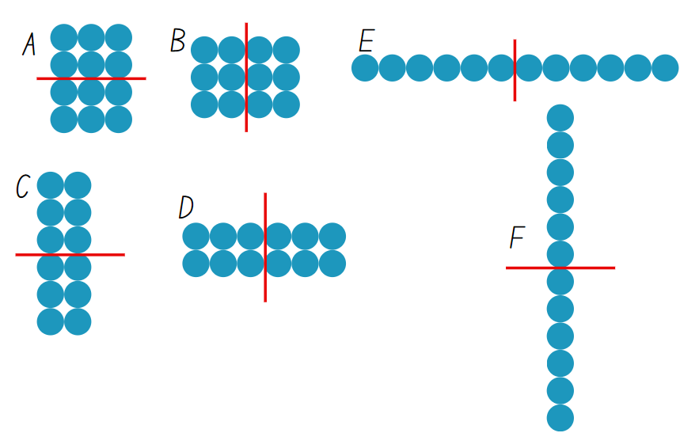
- Model partitioning that is not half. Ask students to explain why that is not half.
- Model language for halving, for example, half of 12 is 6, 6 is half of 12.
- Model language that matches each array in Figure 3:
- A – 2 threes are half of 4 threes
- B – 3 twos are half of 3 fours
- C – 3 twos are half of 6 twos
- D – 2 threes are half of 2 sixes
- E – one six is half of one twelve
- F – 6 ones are half of 12 ones
- Explain that students are going to play a matching game for halving using Resource 16 – halving game cards. Students will take it in turns to match the cards in pairs that are equivalent, that is, they have the same total.
Note: for additional challenge, the cards can be placed upside down and students turn a pair face up on each go. Students try to match the cards in pairs that are equivalent.
- Students play the game with a partner using copies of set A cards from Resource 16 – halving game cards.
- After 5 minutes, pause the game to introduce the set B cards. Explain the content of each card by referring explicitly to the number sentence and symbols.
- Distribute deck B to be mixed in with deck A. Students restart the game.
- At the end of the game, ask:
- How is halving like doubling?
- How is it different?
- Select an array from the game, model how doubling any half will produce the starting collection. Model how this will work with any number. Explain that the relationship between doubling and halving is called an inverse operation and share the definition.
Inverse operation: the operation that reverses the effect of another operation.
Examples:
- Addition and subtraction are inverse operations: Adding 3 to 7 gives 10. Subtracting 3 from 10 gets the total back to 7.
- Multiplication and division are inverse operations: Multiplying 6 by 2 gives 12. Divide 12 by 2 gets the total back to 6.
- Explain that doubling is the same as multiplying by 2 and that halving is the same as dividing by 2.
This table details opportunities for differentiation.
Too hard? | Too easy?
Students cannot halve a collection.  - Provide an even number of concrete materials. Ask students to form 2 equal groups and identify how many in each group.  - Model the doubling strategies in Lesson 2. Revise the link between halving and doubling. | Students can halve a collection.  - Explore arrays that can be divided into 4. Students identify a connection between halving and dividing by 4.  - Students select arrays from the game sets and partition in a variety of ways, explaining their thinking.  - Students play Double or Halve? from NRICH. Students may vary the target numbers and dice to adjust the challenge.

Discuss and connect the mathematics – 20 minutes
- Ask a series of questions to check understanding, such as:
- If I know that I halved a number to get 20, what number did I start with?
- If I know that I doubled a number to get 20, what number did I start with?
- How can doubling help with questions like 4 × 9, 4 × 12 or 4 × 14? (Double, then double again)
- How can halving help with questions like 24 ÷ 4, or 28 ÷ 4? (Halve, then halve again)
- For each question students turn and talk to share responses.
- Distribute Resource 17 – blank game cards. Ask students to make their own set of cards using a single doubling/halving set of related facts. Display Resource 16 – halving game cards as a model.
This table details opportunities for assessment.
Assessment opportunities | Links
What to look for:  - Can students represent halving using arrays? [MAO-WM-01, MA2-MR-01, MA2-MR-02]  - Can students connect the halving and doubling strategy? [MAO-WM-01, MA2-MR-01, MA2-MR-02]  - Can students recognise that doubling is multiplying by 2 and halving is dividing by 2 (Reasons about relations)? [MAO-WM-01, MA2-MR-01, MA2-MR-02] | Links to National Numeracy Learning Progressions (NNLP):  - MuS6, InF2, InF6.

Lesson 5
Core concept: flexible methods of computation in multiplication and division involve composing and decomposing numbers.

Daily number sense – Where do you fit? – 10 minutes
Daily number sense activities for Lessons 5 to 7 ‘loop’ back to concepts and procedures covered in previous units to assist students to build an increasingly connected network of ideas. These concepts may differ from the core concepts being covered by the unit.
The table below contains a suggested learning intention and success criteria. These are best co-constructed with students.
Daily number sense learning intention | Daily number sense success criteria
Students are learning to:  - read and order numbers up to thousands. | Students can:  - read numbers up to thousands  - arrange numbers in ascending or descending order.
- Organise students into groups of 4 to 6. Provide each group with four 10-sided dice with the numbers 0–9.
- Students take turn rolling the dice to create a 4-digit number. Students record the number on a sticky note.
- In turn each student reads their number aloud and then places themselves in ascending order.
- When each group has all members in order, combine 2 groups. Group members adjust their order to ensure they are still in ascending order.
- Continue to combine groups and adjust placements until the whole class is in ascending order.
Note: this activity can be adapted by varying the number of dice provided to students.
This table details opportunities for assessment.
Assessment opportunities | Links
What to look for:  - Can students read numbers up to thousands? [MAO-WM-01, MA2-RN-01]  - Can students arrange numbers in ascending or descending order? [MAO-WM-01, MA2-RN-01] | Links to National Numeracy Learning Progressions (NNLP):  - NPV5, NPV6.  Links to suggested Interview for Student Reasoning (IfSR) tasks:  - IfSR-NP: 4B.2, 4C.5.

Core lesson – commutative city – 45 minutes
The table below contains suggested learning intentions and success criteria. These are best co-constructed with students.
Core concept learning intentions | Core concept success criteria
Students are learning to:  - represent the structure of multiplicative relations to 10 × 10. | Students can:  - recall number facts of 2 and 4, 5 and 10 and related division facts  - use number properties to find related multiplication facts  - use the commutative property of multiplication.
- Provide students with individual whiteboards or other writing materials.
- Display Resource 18 – building arrays. Explain that this is a rectangular building with 3 floors and 2 rooms on each floor. Ask how many rooms there are altogether.
- Demonstrate that this can be written as 3 twos are 6, or 3 × 2 = 6.
- Divide the class in half. Ask one half to draw a rectangular building with 3 floors, with 5 rooms on each floor. Ask the other half to draw a rectangular building with 5 floors and 3 rooms on each floor.
- Compare the results of each group. Note that the buildings look the same when turned on their side.
- On the board, write ‘3 fives are 15’, ‘5 threes are 15’ and the 2 number sentences 3 × 5 = 15 and 5 × 3 = 15.
- Explain that this is called the commutative property.
Commutative property: two numbers can be added or multiplied in any order and the total will be the same. Commutative law, commutativity and turn-around facts are interchangeable terms.
- Instruct students to draw and label 2 array buildings using the numbers 5 and 4.
- Students draw and record other examples of commutative multiplication facts.
- Display Resource 19 – grid page on A3 or 2 A4 grid pages. Alternatively, students can use A4 10 mm grid books.
- In pairs, students use numbered cards from Resource 20 – city cards and a 10-sided die to select 2 numbers that represent the number of floors and number of rooms on each floor.
- In pairs, students create 2 related array buildings on their page. Label each building with multiplicative language such as ‘3 fours are 12’ or ‘4 threes are 12’ and a number sentence, either 3 × 4 = 12 or 4 × 3 = 12.
- Repeat with a variety of buildings. Students may choose to finish by decorating the city with trees, roads and so on. Collect work samples as they will be used again in Lesson 6.
- Conduct a gallery walk.
This table details opportunities for differentiation.
Too hard? | Too easy?
Students cannot draw arrays/regions.  - Provide a variety of grids to represent multiplication facts for 2, 4, 5 and 10. Students fill up the grids with counters and represent using words, such as 4 threes.  - Provide counters to stick to a whiteboard in an array. Use a marker to draw a grid structure around the counters. Remove the counters to reveal the region, see Figure 4 below. | Students can understand and represent the commutative property of multiplication with regions.  - Ask students to investigate different window types on their buildings, such as 2 windows per room, or windows with 4 panes. Ask how many windows would be on the building.  - Use a digital device to search for images of large office buildings. Students use arrays and other multiplicative techniques to determine the number of windows.
Figure 4 – arrays to regions
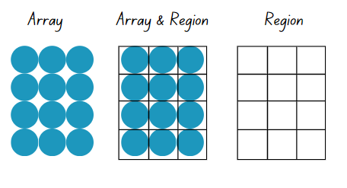

Discuss and connect the mathematics – 15 minutes
- Present several scenarios where students need advice. For example, my friend told me that 5 sevens are 35, but they don’t know what 7 times 5 equals. Ask what advice students would give my friend.
- Discuss how the commutative property can help people solve other multiplication problems, such as 9 × 5, 7 × 10 or 12 × 2. For example, this could be explained as ‘If I know ... then I also know …'.
This table details opportunities for assessment.
Assessment opportunities | Links
What to look for:  - Can students recognise that related buildings have the same number of rooms? [MAO-WM-01, MA2-MR-01, MA2-MR-02]  - Can students use commutative property to label buildings using both words and number sentences? [MAO-WM-01, MA2-MR-01, MA2-MR-02]  - Can students recall multiplication facts of 2 and 4, 5 and 10? [MAO-WM-01, MA2-MR-01, MA2-MR-02] | Links to National Numeracy Learning Progressions (NNLP):  - MuS6.

Lesson 6
Core concept: multiplication and division are related.

Daily number sense – before and after – 10 minutes
The table below contains a suggested learning intention and success criteria. These are best co-constructed with students.
Daily number sense learning intention | Daily number sense success criteria
Students are learning to:  - read, represent and order numbers to thousands. | Students can:  - read numbers up to thousands  - identify the number before and after a number.
- Provide students with a 10-sided die. Using a 10-sided dice with 0–9 will allow students to use and understand the role of the internal zero.
- Students roll the die 4 times to create a 4-digit number and record it in the middle of their individual whiteboard.
- Students identify and record the number before and the number after their 4-digit number (see Figure 5).
Figure 5 – before and after
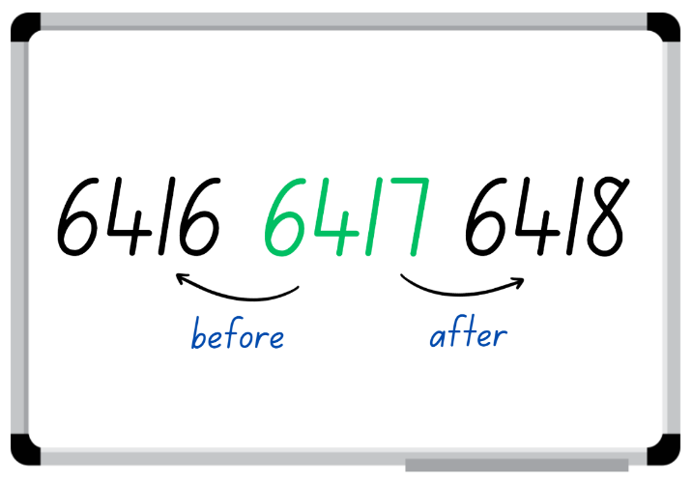
- Vary the activity by asking students to record the number 10, 100 or 1000 before and after their number.
- Select students to justify how they know a number is one, 10, 100, or 1000 before or after their number.
- Students repeat the steps with other 4-digit numbers.
This table details opportunities for assessment.
Assessment opportunities | Links
What to look for:  - Can students represent and read 4-digit numbers? [MAO-WM-01, MA2-RN-01]  - Can students order 4-digit numbers according to their value? [MAO-WM-01, MA2-RN-01] | Links to National Numeracy Learning Progressions (NNLP):  - NPV5, NPV6.  Links to suggested Interview for Student Reasoning (IfSR) tasks:  - IfSR-NP: 4B.2, 4C.5.

Core lesson – the Division District – 40 minutes
The table below contains suggested learning intentions and success criteria. These are best co-constructed with students.
Core concept learning intentions | Core concept success criteria
Students are learning to:  - use arrays to establish multiplication facts from multiples of 2 and 4, 5 and 10  - recall multiplication facts of 2 and 4, 5 and 10 and related division facts. | Students can:  - recognise and use the symbols for multiplied by (×), divided by (÷) and equals (=)  - link multiplication and division fact families using arrays  - model and apply the commutative property of multiplication.
- Review the definition and examples of commutative property from Lesson 5.
- Display Resource 21 – building array – division on the board. Explain that this is a rectangular building with 6 rooms. Hide the text on the right-hand side of the resource. Ask how many floors students can see and how many rooms there are on each floor.
- Use Resource 21 – building array – division to show that 3 floors with 2 rooms on each floor makes 6 rooms altogether. Revise the multiplication number sentences that match this image, 3 twos are 6, 3 × 2 = 6. Revise the multiplication number sentence for the commutative pair, 2 threes are 6, 2 × 3 = 6.
- Explain that this can also be written as a division sentence, 6 ÷ 3 = 2. Ask:
- What does division mean?
- Who has seen the division symbol before? What does it look like to you?
- What does each number in the division sentence represent?
- Can I change any numbers around?
- Are there any that I cannot change? Why?
Note: at this stage in learning, the dividend should remain at the beginning of the number sentence.
- Explain that an architect needs to design a rectangular building that has 10 rooms. They do not mind if the building is tall and skinny, or low and long. Ask what the building might look like. Have students draw as many examples as they can.
- Ask if any of the buildings looks similar if they were turned on their side. Identify commutative pairs, such as 2 floors 5 rooms and 5 floors of 2 rooms.
- Write the equivalent number sentence 3 × 4 = 4 × 3. Ask students whether they think this is true. Students write equivalent number sentences on their board for their rectangles.
- Ask students to write pairs of division number sentences, such as 10 ÷ 5 = 2 and 10 ÷ 2 = 5.
- Ask students to retrieve the partially completed commutative city Resource 19 – grid page from Lesson 5.
- Explain that an architect needs pairs of project managers to design rectangular buildings with 12, 13, 14,15 or 16 rooms. Allocate pairs of students to building sizes.
Note: 13 is a prime number and will only have 2 buildings. This may be a suitable selection for students manipulating counters as they try to make rows and columns.
- On the side of Resource 19 – grid page marked Division District, students design as many different rectangular buildings as possible.
- Ask students to label each building with the relevant multiplication and division number sentence.
- Group each number of rooms together (12, 13, 14, 15, 16) on separate walls or tables.
- Conduct a gallery walk. Ask:
- Have the designers drawn all the possible buildings?
- Do all the buildings have the same number of options? Why not?
- What do you notice about the building with 13 rooms? (Explain that this is called a prime number.)
- What do you notice about the building with 16 rooms? (Explain that 4 × 4 makes it a square number.)
- What difference do you notice between the odd and even numbers?
This table details opportunities for differentiation.
Too hard? | Too easy?
Students cannot use arrays to establish multiplication facts of 2 and 4, 5 and 10 and related division facts.  - Provide interlocking bricks of the same size. Ask students build 3 rectangular buildings using 8, 12 and 16 bricks. Guide the students to trace around the buildings and draw lines across to show the region/array pattern.  - Provide counters as support for forming arrays for 12 rooms. Ask the student to make rows representing one floor, then 2 floors, 3 floors and so on. Students identify how many rooms there are on each floor. | Students can use arrays to establish multiplication facts of 2 and 4, 5 and 10 and related division facts.  - Include a series of larger numbers for students to explore.  - Explore and draw square buildings with between one and 50 rooms. Ask what patterns students can identify. Ask what rules they can use to identify the next 10 buildings (without drawing them).  - Students investigate the origins of the division symbol and share its history with the class.

Discuss and connect the mathematics – 10 minutes
- Revisit a student’s Division District and write the division number sentences for the buildings.
- Read this statement, ‘My friend told me 8 divided by 4 equals 2, so 2 divided 4 must equal 8’.
- Write the matching number sentences on the board. Ask:
- What mistake did they make?
- What advice would you give them?
- Is there a rule that we can write for division sentences to get the numbers in the correct order?
- Repeat for another incorrect statement. Add the rule to the anchor chart.
- Explain that, in the next lessons, students will use related numbers such as 2, 4 and 8 in fact families. Represent the numbers in a fact family triangle such as Figure 6.
Figure 6 – fact family
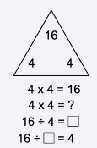
This table details opportunities for assessment.
Assessment opportunities | Links
What to look for:  - Can students recognise and use the symbols for multiplied by (×), divided by (÷) and equals (=)? [MAO-WM-01, MA2-MR-01]  - Can students link multiplication and division fact families using arrays? [MAO-WM-01, MA2-MR-01, MA2-MR-02]  - Can students model and apply the commutative property of multiplication? [MAO-WM-01, MA2-MR-01, MA2-MR-02] | Links to National Numeracy Learning Progressions (NNLP):  - MuS5, MuS6.

Lesson 7
Core concept: fact families support fluency.

Daily number sense – from here to there – 10 minutes
The table below contains a suggested learning intention and success criteria. These are best co-constructed with students.
Daily number sense learning intention | Daily number sense success criteria
Students are learning to:  - read, represent and order numbers to thousands. | Students can:  - represent and read four-digit numbers  - order four-digit numbers according to their value.
This activity is an adaptation of ‘From here to there’ from Dice Dazzlers by Swan.
- Provide pairs of students with writing material and four 10-sided dice. Using a 10-sided dice with 0–9 will allow students to use and understand the role of the internal zero.
- One student draws a gameboard with at least 12 squares. Together, students set the starting and finishing numbers and write them on the gameboard.
- The first player rolls the dice to form a number. The player must decide where to place the number on the gameboard so that the sequence of numbers remains in order, Figure 7. The next player rolls and places their number on the same gameboard. If a number cannot be placed, the player misses their turn.
Figure 7 – example of play
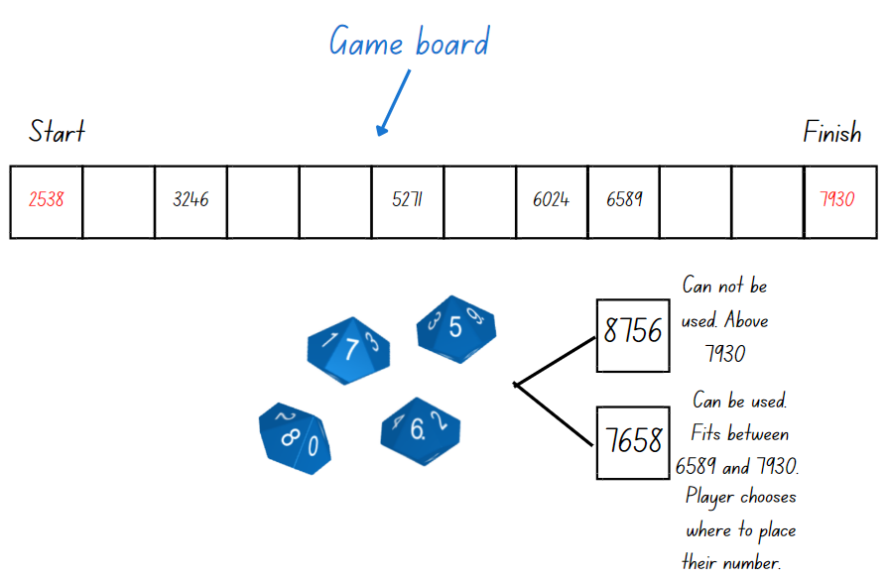
- The winner is the person who completes the sequence of numbers.
Note: different dice can be used, but you may need to guide students to understand the starting and finishing numbers. For example, if four 6-sided dice are used the maximum finishing number will be 6666 and the start number has to be above 1111.
This table details opportunities for assessment.
Assessment opportunities | Links
What to look for:  - Can students represent and read 4-digit numbers? [MA2-RN-01]  - Can students order 4-digit numbers according to their value? [MAO-WM-01, MA2-RN-01] | Links to National Numeracy Learning Progressions (NNLP):  - NPV5, NPV6.  Links to suggested Interview for Student Reasoning (IfSR) tasks:  - IfSR-NP: 4B.2, 4C.5.

Core lesson – fact families – 40 minutes
The table below contains suggested learning intentions and success criteria. These are best co-constructed with students.
Core concept learning intentions | Core concept success criteria
Students are learning to:  - use number properties to find related multiplication facts. | Students can:  - generate multiplication fact families for multiples of 2 and 4, 5 and 10  - use the equals sign to record equivalent number relationships involving multiplication  - complete number sentences involving multiplication and division by calculating missing numbers.
- Display Resource 22 – making fact families. Ask students:
- What patterns can you see?
- How are these numbers related to each other?
- What other triangles and numbers might belong to this picture?
- What would be the next item in this pattern? How do you know?
- Explain that 8 is a multiple of 2 and of 4. Skip count by 2 and then by 4 to confirm that 8 is in both patterns.
- Explain that 2 and 4 are called factors of 8. Share the definition of factor and product.
Factor: a number which divides another number without a remainder. For example, 1, 2, 3 and 6 are factors of 6 but 4 and 5 are not.
Product: the result of multiplying 2 or more numbers together, for example, 12 is the product of 4 × 3.
- Explain that the numbers in each triangle of Resource 22 – making fact families. Select one fact family to:
- Model how to write multiplication sentences and division sentences using fact families.
- Discuss what the equals sign means and why it is used. The equals sign represents balance and equality.
- Use arrays to prove the commutative property of multiplication.
Note: emphasise that the number at the top of the triangle is the product of the 2 factors at the bottom of the triangle. For division, ensure students understand that the product of the fact family must be at the start of the sentence. Division is not commutative, so 2 ÷ 4 = 8 is not correct.
- Provide writing materials. Ask pairs of students to create the fact families for one of the remaining triangles.
- Share responses and record student ideas.
- Explain that students will now generate their own fact families. Students roll a one to ten die to get one factor and draw the other factor from the cards on Resource 20 – city cards. Students write the 2 factors in the bottom corners of the triangle.
- Students generate the fact family number sentences that use these numbers.
This table details opportunities for differentiation.
Too hard? | Too easy?
Students cannot generate multiplication fact families for multiples of 2 and 4, 5 and 10.  - Limit the cards used to 2 and 4. Support students to use arrays and repeated doubling to generate fact families for multiples of 2 and 4.  - Limit the cards used to 5 and 10. Support students to use skip counting and multiple patterns of 5 and 10 to generate fact families.  - Use array cards such as those on Resource 23 – arrays to facts to support making of fact families. | Students can generate multiplication fact families for multiples of 2 and 4, 5 and 10.  - Ask students what the missing numbers might be in a triangle, if the number 16 appears at least once in one of the points of the triangle.  - Ask how many different triangles have the number 16 appear at least once and what generalisations can be made from their observations.  - Students investigate which number, less than 50, they can make the most cards for.
This table details opportunities for assessment.
Assessment opportunities | Links
What to look for:  - Can students generate multiplication fact families for multiples of 2 and 4, 5 and 10? [MAO-WM-01, MA2-MR-01, MA2-MR-02]  - Can students use the equals sign to record equivalent number relationships involving multiplication? [MAO-WM-01, MA2-MR-01, MA2-MR-02]  - Can students complete number sentences involving multiplication and division by calculating missing numbers? [MAO-WM-01, MA2-MR-01, MA2-MR-02] | Links to National Numeracy Learning Progressions (NNLP):  - MuS6  - NPA4.  Links to suggested Interview for Student Reasoning (IfSR) tasks:  - IfSR-MT: 2A.11.

Discuss and connect the mathematics – 15 minutes
- Discuss Resource 24 – Fact family or not? Ask:
- Which family has the division number sentence representing what is shown on the triangle?
- Why doesn’t the other division number sentence match the facts?
- What about the sentence 14 = 7 × 2?
Note: it is a commonly held misconception for Stage 2 students that the equals sign shows where the answer should be written. By placing the product at the start of a number sentence, students are exposed the idea of balance and equivalence.
- Show students a number sentence with a missing value next to the corresponding triangle. Discuss with students how the triangle can be used to determine the missing value, see Figure 8. Draw students’ attention to the reason why 16 is a square number.
Figure 8 – missing value
- Add an example of fact families and number sentences to the class anchor chart. Show how fact families can be used to determine the missing value in a multiplication or division sentence.

Lesson 8
Core concept: worded problems can be solved using multiplicative thinking.

Daily number sense – 10 minutes
- From a class need surfaced through formative assessment data, identify a short, focused activity that targets students’ knowledge, understanding and skills. Example activities may be drawn from the following resources:
- Mathematics K-6 resources
- Universal Resources Hub.

Core lesson – solving problems – 40 minutes
The table below contains suggested learning intentions and success criteria. These are best co-constructed with students.
Core concept learning intentions | Core concept success criteria
Students are learning to:  - represent and solve problems involving multiplication fact families. | Students can:  - represent and solve problems involving multiplication  - describe multiplication problems using ‘for each’ and ‘times as many’  - recognise and use the symbols for multiplied by (×), divided by (÷) and equals (=).
- Ask students to discuss what strategies and ideas they have learned over the course of the unit. Students turn and talk and record their ideas. Refer to the anchor charts from previous lessons. Remind students about groups of, arrays, halving, doubling and fact families.
- Present the word problem to students: A chef makes 5 muffins for each of his 4 friends. Ask how many muffins he makes.
- Discuss with students what the phrase ‘for each’ means. Ask students how they would represent this problem using 2 different strategies.
- Record student ideas using Resource 25 – think board 1 with the problem at the top and ideas underneath.
- Present the word problem to students: The chef tripped over while delivering his muffins and half of them were ruined. Ask how many are left.
- Ask students how they would represent this problem using 2 different strategies. Discuss what the phrase half means and how it can be represented.
- Record student ideas using Resource 26 – think board 2 with the problem at the top and ideas underneath.
- Show students a worked example Resource 27 – think board 3. Ask students to choose the word problem that the think board represents. Students have a choice between these word problems:
- An architect designed a building with 6 windows. Her friend Farmer Murray designed a building with 5 times as many windows.
- A chef made 6 muffins to eat. Farmer Murray ate 5 more than the chef.
- Discuss the meaning of the phrase ‘5 times as many’. Link this explicitly to multiplication.
- Display Resource 28 – problems to solve.
- Students use Resource 29 – blank think board to represent their thinking. Encourage students to represent their thinking in 2 ways on their think boards.
This table details opportunities for differentiation.
Too hard? | Too easy?
Students cannot represent and solve problems involving multiplication.  - Work with students to use concrete materials to model the problem. Support students to select a strategy appropriate to their level of understanding.  - Limit questions to doubling and halving using even numbers of counters or other concrete materials. | Students can represent and solve problems involving multiplication.  - Students read and complete the Magic plant or The tomato and the bean activities from NRICH.  - The number 16 appears somewhere in a multiplicative word problem. Ask what the problem might be and what the think board looks like.

Discuss and connect the mathematics – 10 minutes
- Select a few student work samples. Ask students to identify the problem that the think board represents. Students explain their thinking to the class.
This table details opportunities for assessment.
Assessment opportunities | Links
What to look for:  - Can students represent and solve problems involving multiplication? [MAO-WM-01, MA2-MR-01]  - Can students describe multiplication problems using ‘for each’ and ‘times as many’? [MAO-WM-01, MA2-MR-01]  - Can students recognise and use the symbols for multiplied by (×), divided by (÷) and equals (=)? [MAO-WM-01, MA2-MR-01]  - Can students explain their representations of the problems? [MAO-WM-01] | Links to National Numeracy Learning Progressions (NNLP):  - NPA4  - MuS5.  Links to suggested Interview for Student Reasoning (IfSR) tasks:  - IfSR-MT: 2A.12, 2A.13, 2A.14.

Resource 1 – patterns
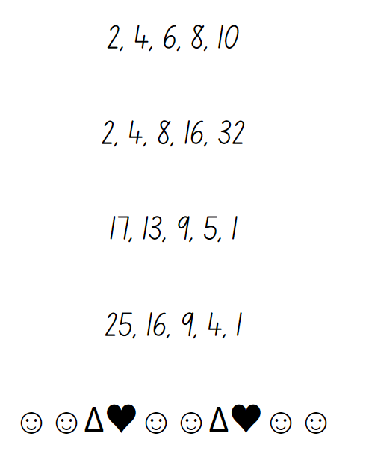

Resource 2 – Patterns or not?
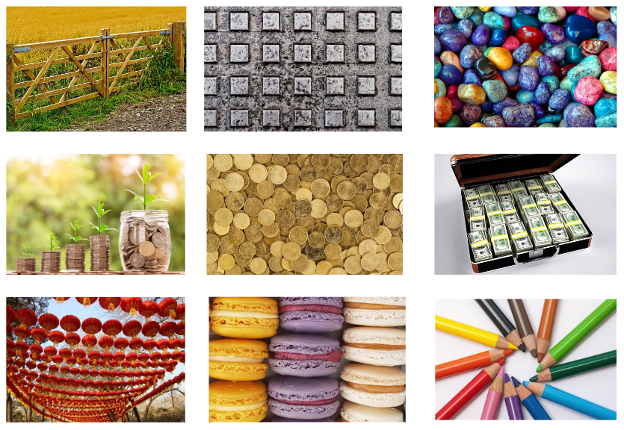

Resource 3 – growing and shrinking
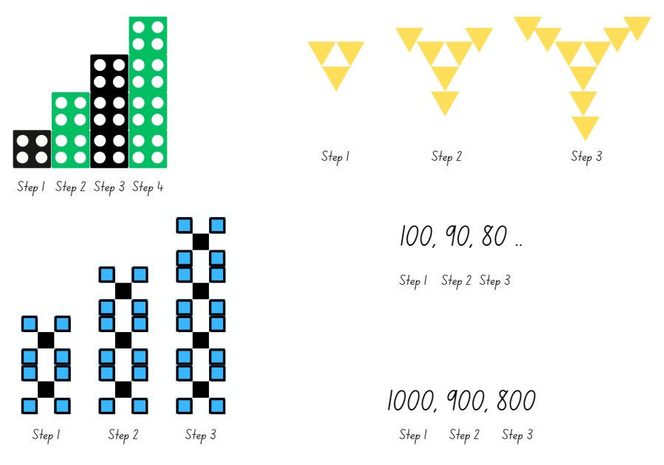

Resource 4 – square number patterns
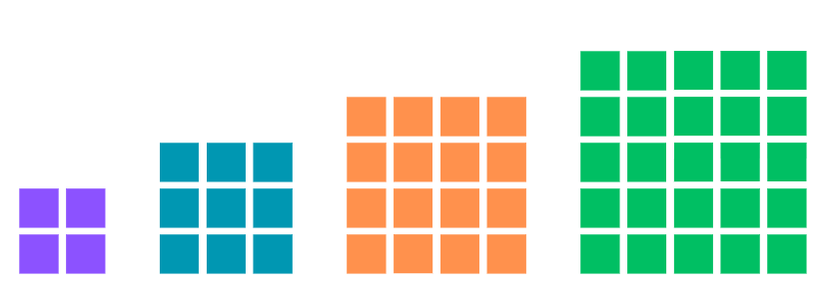

Resource 5 – number circles
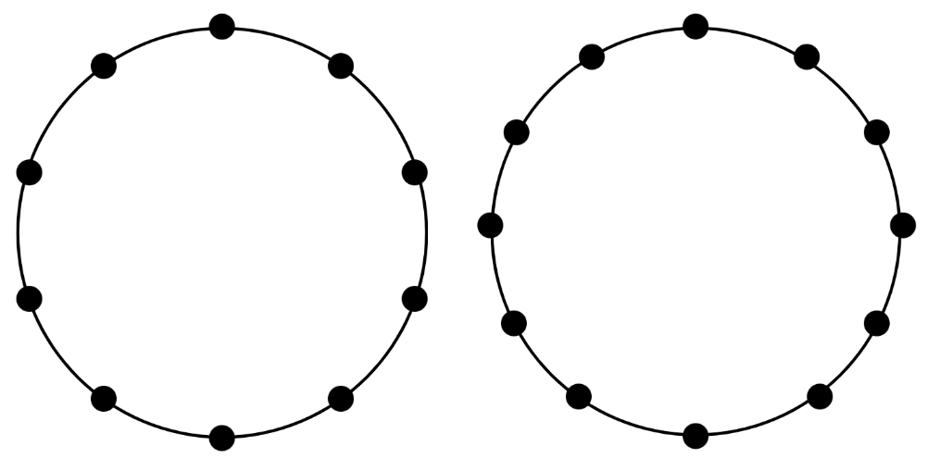

Resource 6 – nests and carton
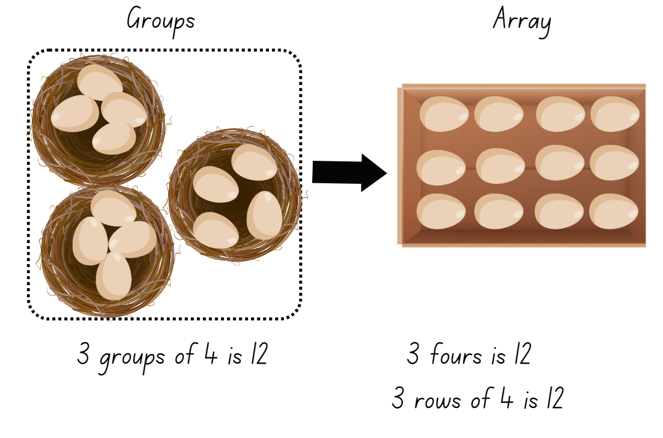

Resource 7 – nests and carton 2
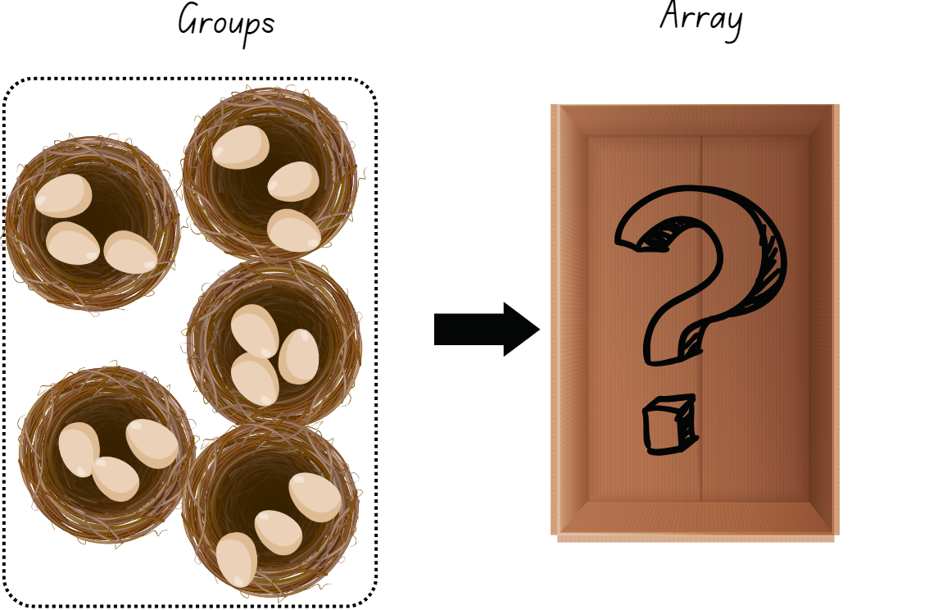

Resource 8 – nests cards
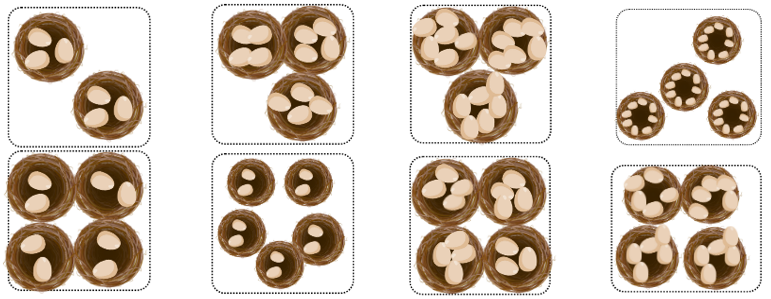
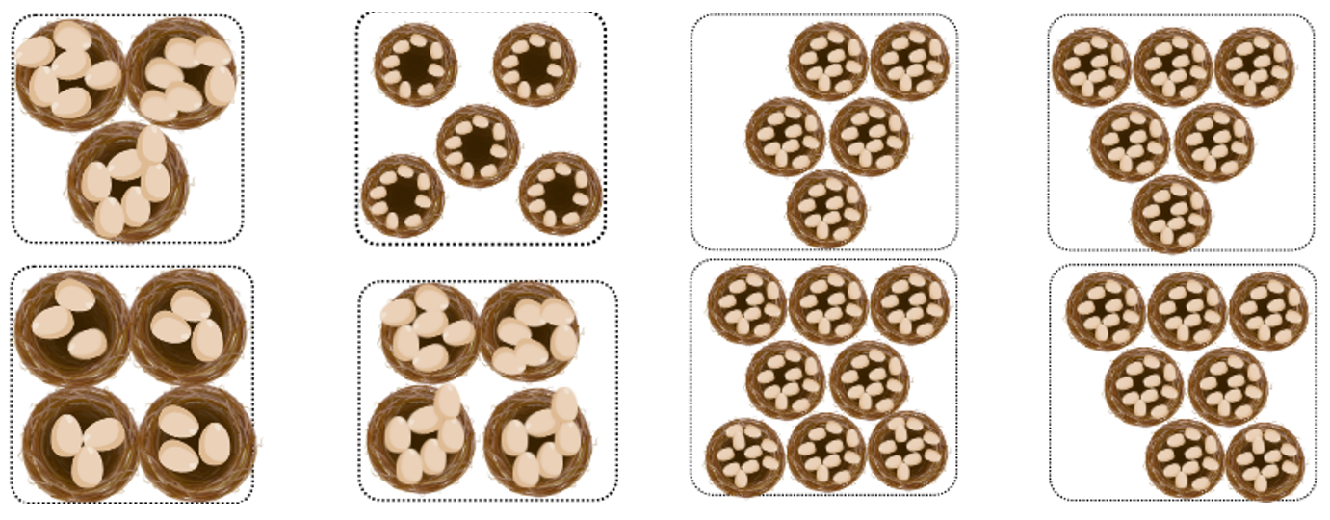

Resource 9 – multiplicative tables 1
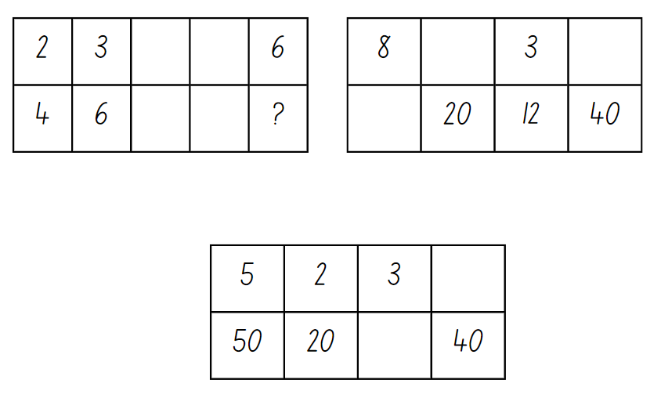

Resource 10 – multiplicative tables 2
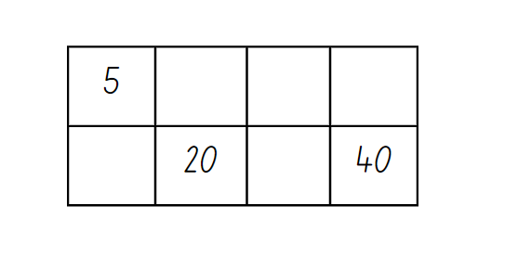

Resource 11 – unusual muffin trays
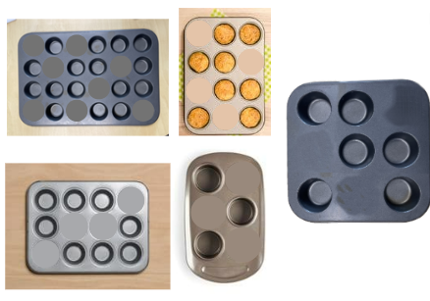

Resource 12 – muffin tray
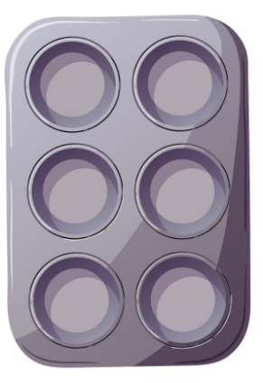
© Tatyana Yagudine via Canva.com.

Resource 13 – muffin tray arrays
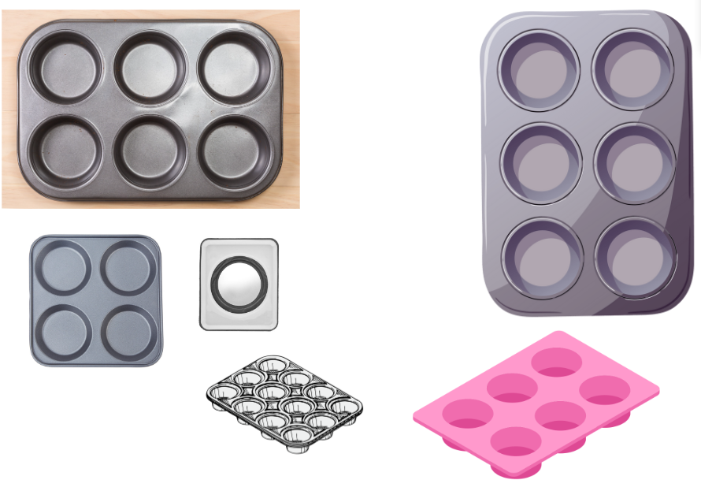

Resource 14 – double trays
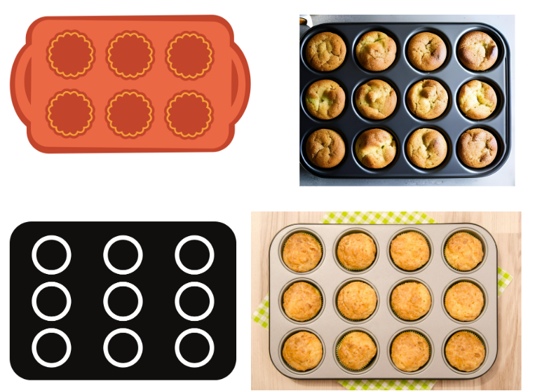

Resource 15 – a farmer’s field
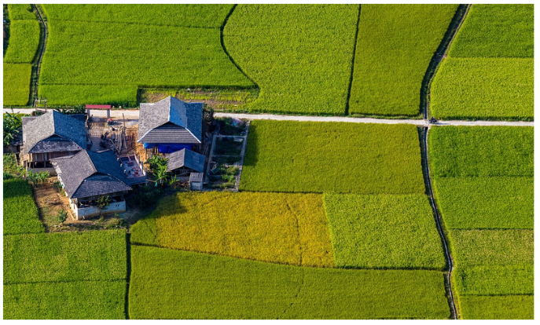
Image licensed under Pixabay Content License.

Resource 16 – halving game cards
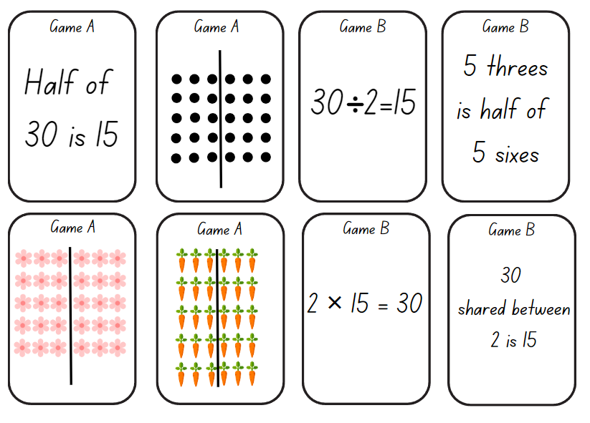
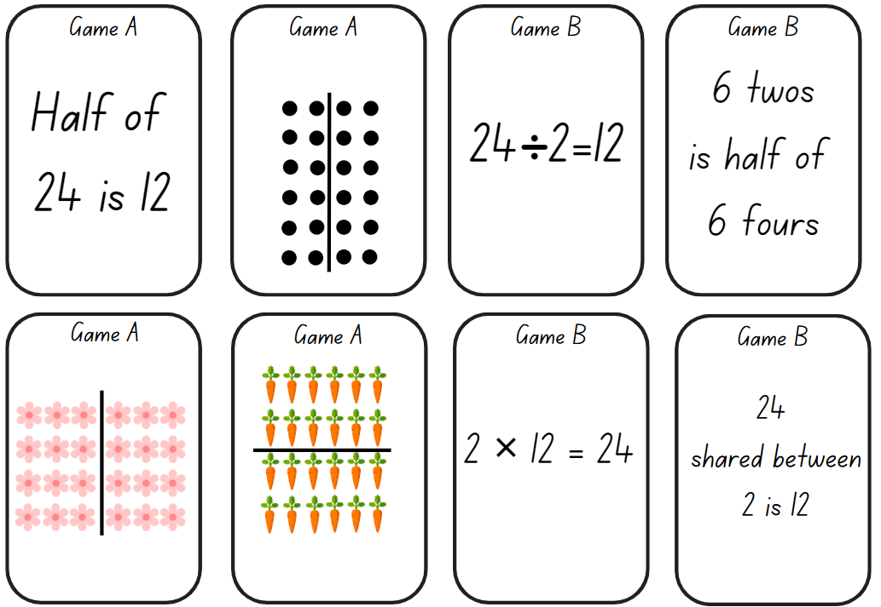
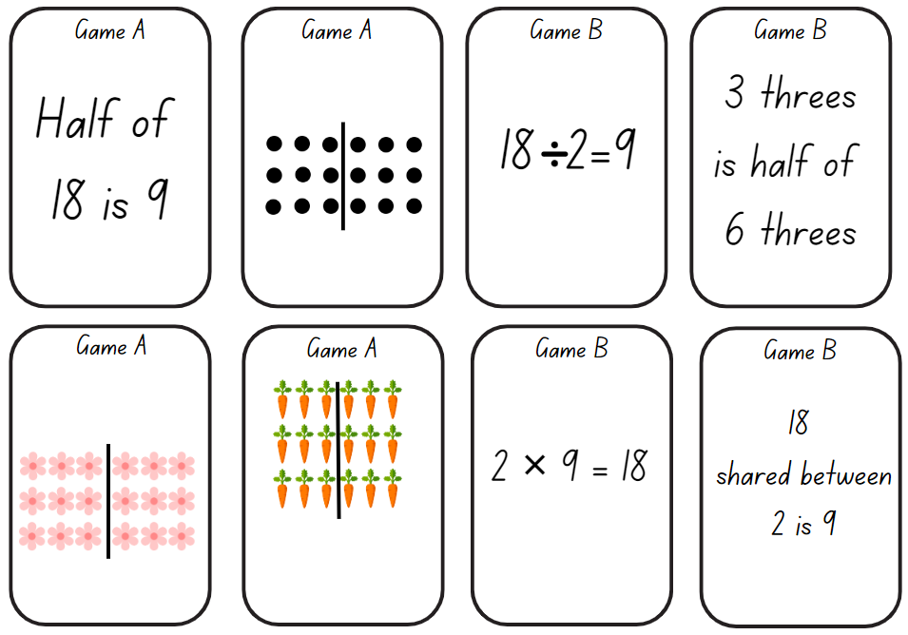
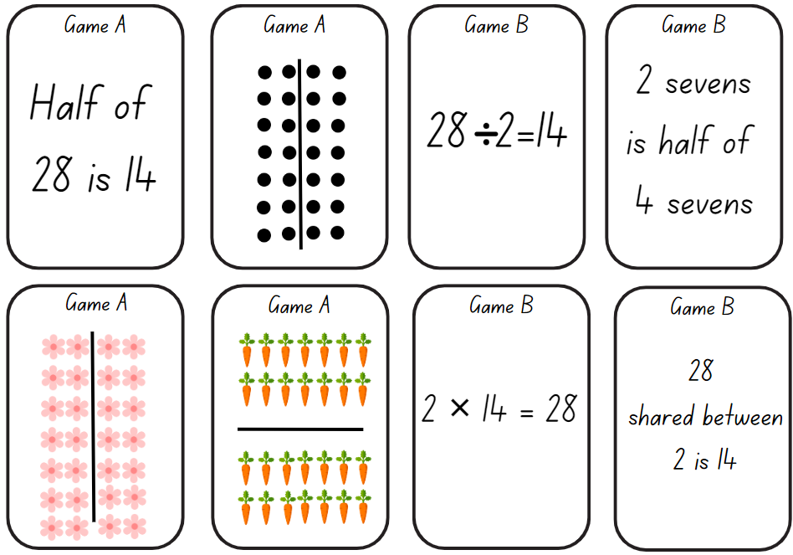

Resource 17 – blank game cards
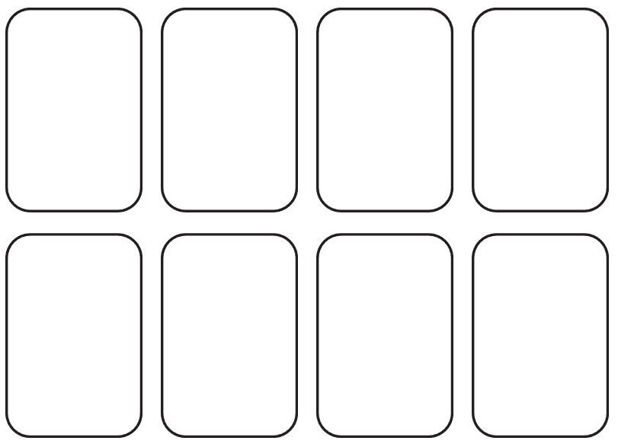

Resource 18 – building arrays
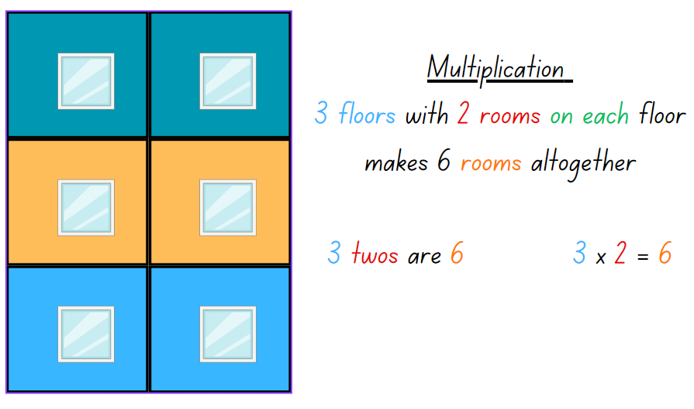

Resource 19 – grid page
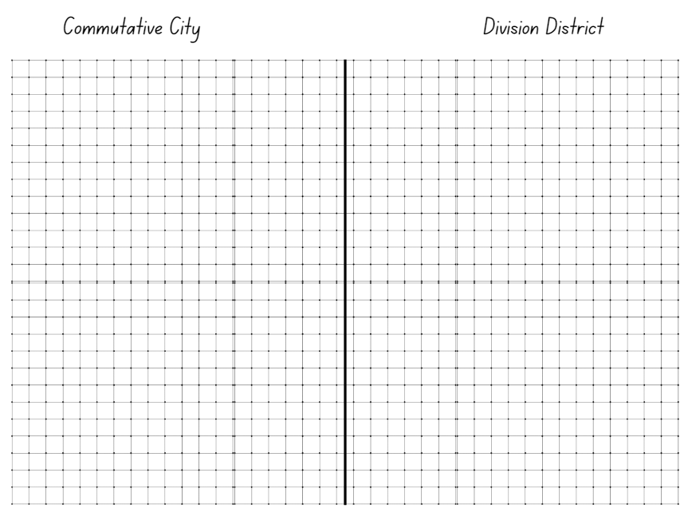

Resource 20 – city cards
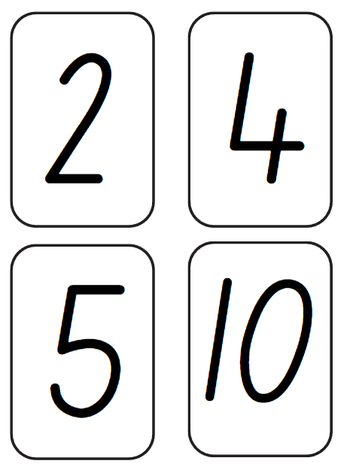

Resource 21 – building array – division
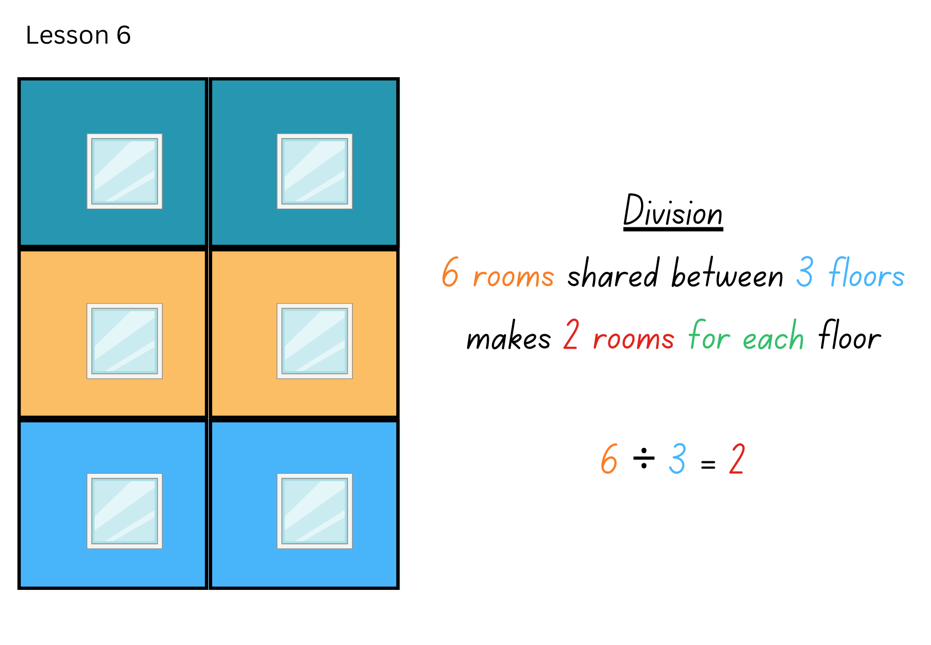

Resource 22 – making fact families
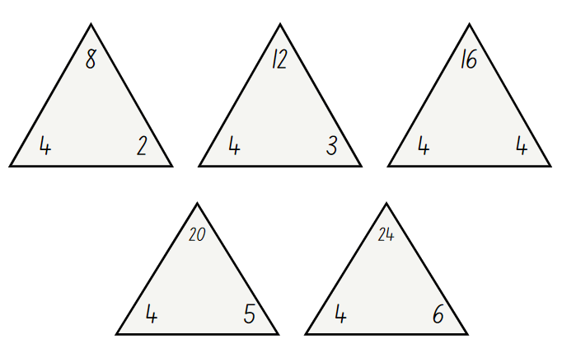

Resource 23 – arrays to facts
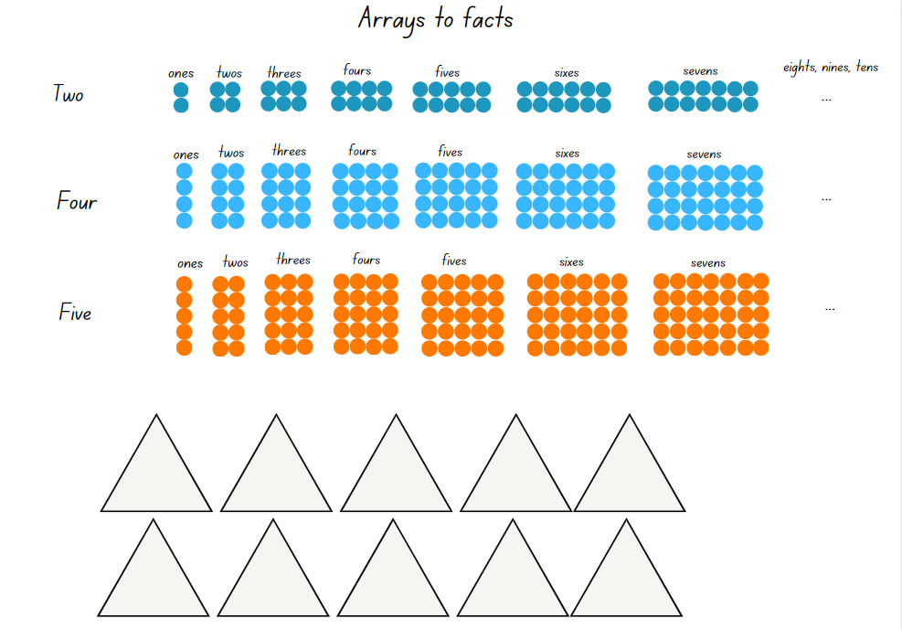

Resource 24 – Fact family or not?
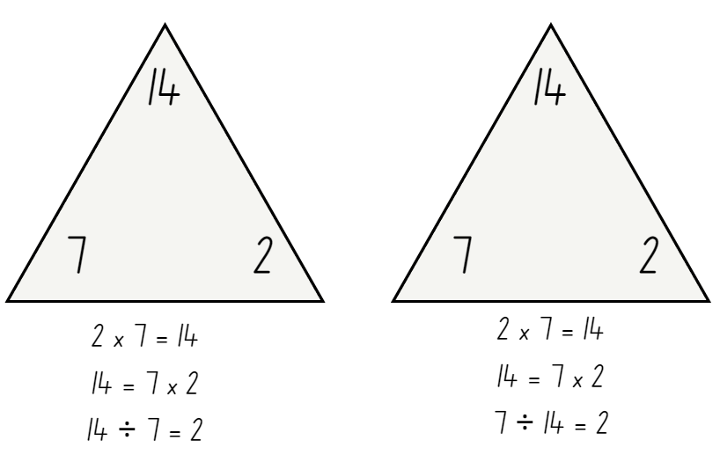

Resource 25 – think board 1
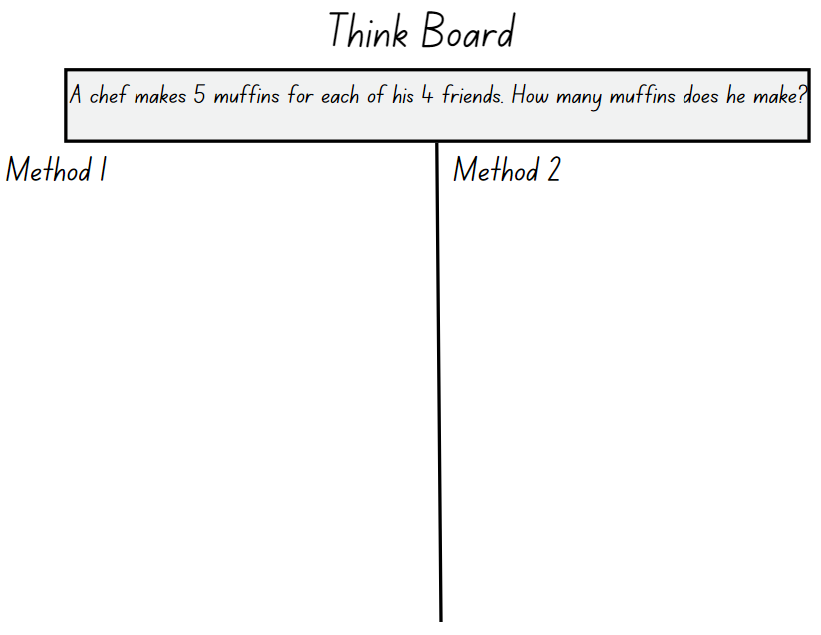

Resource 26 – think board 2
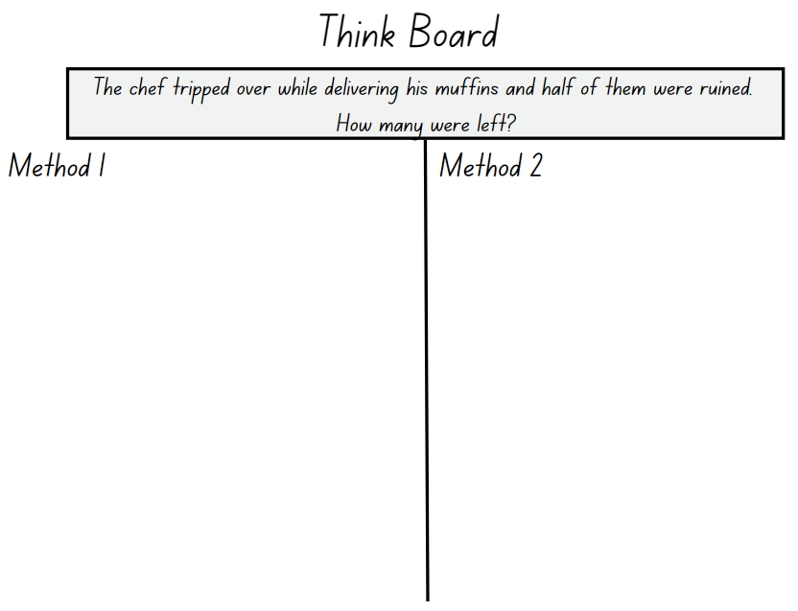

Resource 27 – think board 3
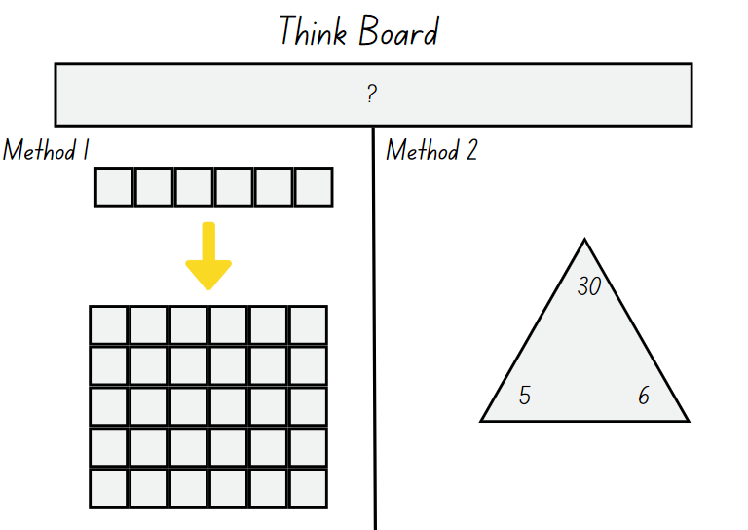

Resource 28 – problems to solve
- Heide picked 2 flowers for each of her 3 friends. How many flowers did she pick? Murray picked 3 times as many flowers as Heide. How many flowers did Murray pick?
- A farmer collected 4 eggs for each of her 5 friends. How many eggs did the farmer collect? The farmer accidently broke half of the eggs. How many were left?
- Brett is planning his birthday party. He bought 3 party bag fillers for each of his 5 friends. How many party bag fillers does he have? Brett’s mum bought twice as many party bag fillers as Brett for the birthday party. How many party bag fillers did Brett’s mum buy?
- A landscaper planted a garden bed with 7 plants for his customer. The customer wanted 4 times as many plants in the garden bed. How many plants were in the garden? The customer didn’t look after her garden and half of the plants died. How many plants are left in the garden bed?
- Andrew has 5 times as many toy cars as Phil. If Phil has 6 toy cars, how many toy cars does Andrew have?

Resource 29 – blank think board
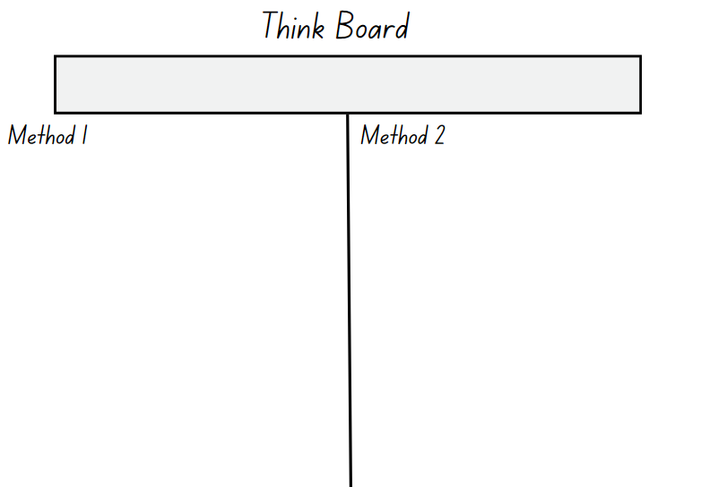

Syllabus outcomes and content
The table below outlines the syllabus outcomes and range of relevant syllabus content covered in this unit. Content is linked to National Numeracy Learning Progression version (3).
Outcomes and content | 1 | 2 | 3 | 4 | 5 | 6 | 7 | 8
Representing numbers using place value A: Whole numbers: Apply place value to partition and regroup numbers up to 4 digits
MAO-WM-01, MA2-RN-01
- Record numbers using standard place value form |  |  |  |  | x | x | x
Representing numbers using place value B: Whole numbers: Recognise and represent numbers that are 10, 100 or 1000 times as large
MAO-WM-01, MA2-RN-01
- Recognise the number of tens, hundreds or thousands in a number |  |  |  |  | x | x | x
- Describe how making a number 10, 100 or 1000 times as large changes the place value of digits |  |  |  |  | x | x | x
Multiplicative relations A: Generate and describe patterns
MAO-WM-01, MA2-MR-01
- Model, describe and record patterns of multiples | x | x | x
- Create and continue a variety of number patterns that increase or decrease by a constant amount | x | x | x
- Recognise the significance of the final digit of a whole number in determining whether a given number is even or odd (Reasons about relations) | x
- Recognise the connection between even numbers and the multiplication facts for 2 (Reasons about relations) | x
- Investigate the result of multiplying by one and zero (Reasons about relations) | x
Multiplicative relations A: Use arrays to establish multiplication facts from multiples of 2 and 4, 5 and 10
MAO-WM-01, MA2-MR-01
- Create and represent multiplicative structure, using the term multiples when connecting grouping to arrays |  | x | x
- Use the array structure to coordinate the number of groups with the number in each group |  | x | x
- Relate doubling to multiplication facts for multiples of 2 |  |  |  | x
- Recognise that doubling is multiplying by 2 and halving is dividing by 2 (Reasons about relations) |  |  |  | x
- Recognise the relationship between one multiple and its double (Reasons about relations) |  |  |  | x
- Model square numbers and record in numerical and diagrammatic form |  | x
Multiplicative relations A: Recall multiplication facts of 2 and 4, 5 and 10 and related division facts
MAO-WM-01, MA2-MR-01, MA2-MR-02
- Recognise and use the symbols for multiplied by (×), divided by (÷) and equals (=) |  |  |  |  | x | x
- Link multiplication and division fact families using arrays |  |  |  |  |  | x
- Model and apply the commutative property of multiplication |  |  |  |  |  | x
Multiplicative relations A: Represent and solve problems involving multiplication fact families
MAO-WM-01, MA2-MR-01, MA2-MR-02
- Describe multiplication problems using for each and times as many |  |  |  |  |  |  | x | x
- Find the total of partially covered arrays |  | x |  |  |  |  | x
- Apply the inverse relationship of multiplication and division (Reasons about relations) |  |  |  |  |  | x | x
Multiplicative relations B: Use known number facts and strategies
MAO-WM-01, MA2-MR-01, MA2-MR-02
- Apply the known strategy of doubling to connect multiples of 3 to 6 and 4 to 8 (Reasons about relations) |  |  |  | x
Multiplicative relations B: Use number properties to find related multiplication facts
MAO-WM-01, MA2-MR-01, MA2-MR-02
- Use the commutative property of multiplication |  |  |  |  | x
- Use the associative property within multiplication to regroup the factors (Reasons about structure) |  |  |  |  | x
- Use flexible partitioning within multiplication (Reasons about relations) |  |  | x |  | x
- Generate multiplication fact families for multiples of 2 and 4, 5 and 10 |  |  |  |  |  |  | x
Multiplicative relations B: Represent and solve word problems with number sentences involving multiplication or division
MAO-WM-01, MA2-MR-01, MA2-MR-02
- Use the equals sign to record equivalent number relationships involving multiplication (Reasons about relations) |  |  |  |  |  |  | x | x
- Complete number sentences involving multiplication and division by calculating missing numbers (Reasons about relations) |  |  |  |  |  | x | x | x
- Represent and solve multiplication and division (both sharing and grouping) word problems using number sentences |  |  |  |  |  | x | x | x
Mathematics K–10 Syllabus © NSW Education Standards Authority (NESA) for and on behalf of the Crown in right of the State of New South Wales, 2022.

References
This resource contains NSW Curriculum and syllabus content. The NSW Curriculum is developed by the NSW Education Standards Authority. This content is prepared by NESA for and on behalf of the Crown in right of the State of New South Wales. The material is protected by Crown copyright.
Please refer to the NESA Copyright Disclaimer for more information https://educationstandards.nsw.edu.au/wps/portal/nesa/mini-footer/copyright.
NESA holds the only official and up-to-date versions of the NSW Curriculum and syllabus documents. Please visit the NSW Education Standards Authority (NESA) website https://educationstandards.nsw.edu.au/ and the NSW Curriculum website https://curriculum.nsw.edu.au/.
Mathematics K–10 Syllabus © NSW Education Standards Authority (NESA) for and on behalf of the Crown in right of the State of New South Wales, 2022.
National Numeracy Learning Progression © Australian Curriculum, Assessment and Reporting Authority (ACARA) 2010 to present, unless otherwise indicated. This material was downloaded from the Australian Curriculum website (National Literacy Learning Progression) (accessed 18 September 2023) and was not modified.
AAMT (The Australian Association of Mathematics Teachers) (2021) Growing Mathematically, AAMT website, accessed 7 June 2023.
Joshua A (2006) Enrich-e-matics – Book 3, 3rd edition, Pearson Education Australia, Melbourne.
Malola M, Stephens M, Symons D (2021) ‘Key Teaching Stages for Developing Multiplicative Thinking in Students’, Australian Mathematical Education Journal, 3(1):9–15 ISSN: ISSN-2652-0176.
Russo T & Russo J (2022) ‘Short Activity: Exploring arrays’, Australian Primary Mathematics Classroom, 27(2):16–17, ISSN: ISSN-1326-0286.
Siemon D, Warren E, Beswick K, Faragher R, Miller J, Horne Marj, Jazby D, Breed M, Clark J, Brady K (2022) Teaching Mathematics: Foundation to middle years, 3rd edn, Oxford University Press, Australia.
Swan P (2003) Dice Dazzlers, A-Z Type, Australia.
University of Cambridge (Faculty of Mathematics) (1997–2023) Round and round the circle, NRICH website, accessed 7 June 2023.
Van de Walle J, Karp K, Bay-Williams JM, Brass A, Bentley B, Ferguson S, Goff W, Livy S, Marshman M, Martin D, Pearn C, Prodromou T, Symons D and Wilkie K (2019) Primary and Middle Years Mathematics: Teaching Developmentally, 1st Australian edn, Pearson Education Australia, Melbourne.

Further reading
Mathematical Association of NSW Inc (2021) Teaching through problem solving Primary and Middle Years, Pamphlet No. 95.
Way J (2014) Using Questioning to Stimulate Mathematical Thinking, NRICH website, accessed 21 June 2023.

© State of New South Wales (Department of Education), 2023
The copyright material published in this resource is subject to the Copyright Act 1968 (Cth) and is owned by the NSW Department of Education or, where indicated, by a party other than the NSW Department of Education (third-party material).
Copyright material available in this resource and owned by the NSW Department of Education is licensed under a Creative Commons Attribution 4.0 International (CC BY 4.0) license.
This license allows you to share and adapt the material for any purpose, even commercially.
Attribution should be given to © State of New South Wales (Department of Education), 2023.
Material in this resource not available under a Creative Commons license:
- the NSW Department of Education logo, other logos and trademark-protected material
- material owned by a third party that has been reproduced with permission. You will need to obtain permission from the third party to reuse its material.
Links to third-party material and websites
Please note that the provided (reading/viewing material/list/links/texts) are a suggestion only and implies no endorsement, by the New South Wales Department of Education, of any author, publisher, or book title. School principals and teachers are best placed to assess the suitability of resources that would complement the curriculum and reflect the needs and interests of their students.
If you use the links provided in this document to access a third-party's website, you acknowledge that the terms of use, including licence terms set out on the third-party's website apply to the use which may be made of the materials on that third-party website or where permitted by the Copyright Act 1968 (Cth). The department accepts no responsibility for content on third-party websites.

