Mathematics K–6 – effective teaching approaches
Participant workbook
Contents
About this workbook 2
Presentation overview 3
Learning intentions and success criteria 3
Alignment to the Australian Professional Standards for Teachers 3
Presentation notes 5
Activity 1 – Working mathematically 7
Activity 2 – explicit teaching practices 9
Where to next? 16
Evaluation 16
References 17

About this workbook
This workbook is designed to guide your thinking, reflections and plans for future action. In the workbook, you will find note-taking pages that complement the presentation and activity templates to help you engage with the content.
The note-taking pages feature focus questions specific to the content of the presentation. They also provide you with the opportunity to record your key take-aways and ideas.
The activity pages support you to collaborate with colleagues and consider how you can apply the content in your school context. Your facilitator will guide you through the activities.
This workbook can be printed double-sided or used digitally. If you have questions about the presentation, please connect with your Statewide staffroom or email mathematicsk6@det.nsw.edu.au.

Presentation overview
This session unpacks the evidence-based pedagogical shifts aligned to the K–6 component of the NSW Mathematics K–10 Syllabus. We'll explore the syllabus, evidence-base and practical strategies for the classroom, with a focus on the connectionist approach, Working mathematically and the role of explicit teaching practices. Discussion and activities will be provided to support schools to apply new learning to mathematics planning and practice.

Learning intentions and success criteria
By the end of the presentation, participants will:
- develop an understanding of the connectionist approach, Working mathematically and the role of explicit teaching in primary mathematics classrooms.
To demonstrate learning, participants will:
- explain the importance of a connectionist approach in teaching mathematics
- reflect on a recent mathematics lesson and identify the Working mathematically process addressed
- identify opportunities to embed Working mathematically question prompts into the planning phase of mathematics lesson sequences
- define explicit teaching and identify the 7 explicit teaching practices
- highlight opportunities in lesson sequences to embed explicit teaching practices.

Alignment to the Australian Professional Standards for Teachers
This presentation aligns with the following standards:
- 2.1.2 Apply knowledge of the content and teaching strategies of the teaching area to develop engaging teaching activities.
- 2.3.2 Design and implement learning and teaching programs using knowledge of curriculum, assessment and reporting requirements.
- 3.3.2 Select and use relevant teaching strategies to develop knowledge, skills, problem-solving and critical and creative thinking.
- 6.2.2 Participate in learning to update knowledge and practice targeted to professional needs and school and/or system priorities.

Presentation notes
Focus questions
- What connections exist within and across focus areas and other curriculum areas to enrich student learning in mathematics?
- How can the Working mathematically processes enrich student learning in mathematics?
- What role do explicit teaching practices play in supporting student learning?
- What ideas and practices are affirmed? What ideas and practices are new to me?
- What implications does this have for my teaching and programming in mathematics?
Key points | Notes

Key points | Notes
Summary
The 3 key ideas that I would like to apply to my practice:

Activity 1 – Working mathematically
This additional resource and formative assessment template appear as part of the Working Mathematically microlearning module (see Figure 1).
Figure 1 – question prompts for Working mathematically processes
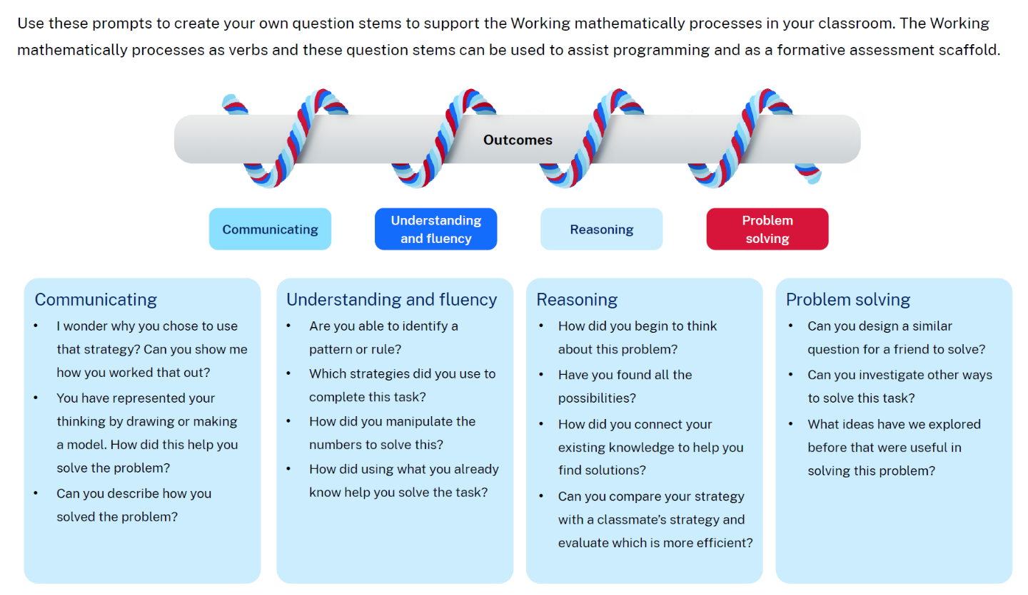
- These question prompts can be used during the planning phase of a lesson as a reflection tool for teachers to ensure the potential Working mathematically processes are highlighted in an interconnected way.
- These question prompts are also designed to guide interactions with students. This ensures that conversations highlight the Working mathematically processes, rather than focusing purely on the answer.

Pause and reflect
Reflect on a recent mathematics lesson. How did students engage in the Working mathematically processes? Are there other question prompts that would work well?
How might these question prompts be utilised during the planning phase to embed Working mathematically processes into learning sequences?

Activity 2 – explicit teaching practices
Background: an example of explicit teaching practices in mathematics
Students will have learned to estimate and describe the size of angles using known angles as benchmarks (see Figure 2). Previously, students were introduced to a ‘numberless protractor’ to measure the amount of turn in angles. By removing the formal markings, students were able to focus on aligning the protractor to count the degrees without the distraction of the complex features on a numbered protractor. In this lesson, students build on this learning to use the formal markings of a numbered protractor to estimate, measure and compare angles using degrees (see Figure 2).
Figure 2 – a progression for measuring angles
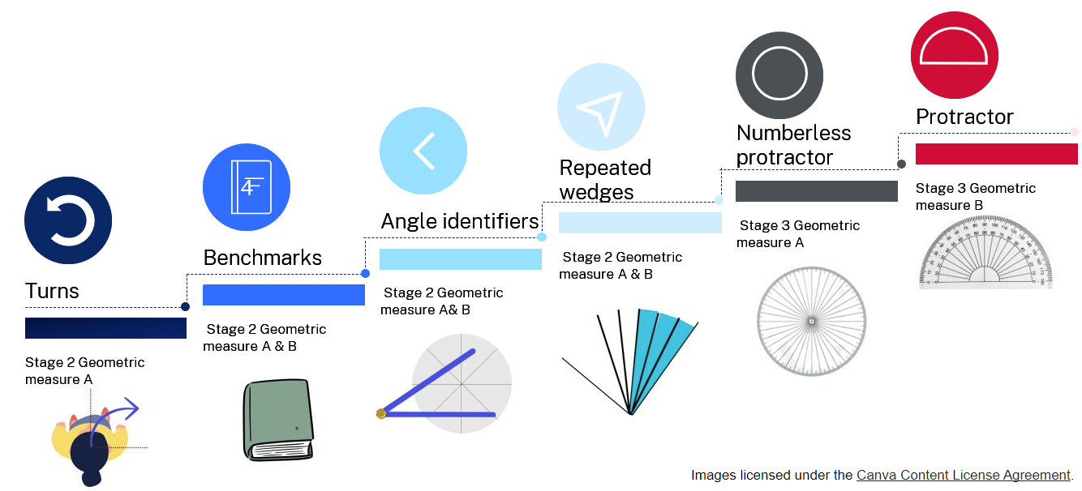
Explicit teaching practices
As you are reading the following learning activities, reflect on parts of the lesson where a teacher could use these aspects of explicit teaching practice.
‘Just in time’ explicit teaching | Whole class explicit teaching

Core lesson 1 – using a protractor – 20 minutes
The table below contains suggested learning intentions and success criteria. These are best co-constructed with students.
Core concept learning intentions | Core concept success criteria
Students are learning to:  - estimate, measure and compare angles using degrees. | Students can:  - explain how a protractor is formed and used to measure an angle  - record angle measurements using the symbol for degrees (°).
- Revise the different categories of angles, using the interactive angle display to model. Ask:
- What are the 2 mathematical tools used for measuring angles so far?
- How are these similar?
- How are these different?
- What are perpendicular lines?
Figure 3 – example of a 47° angle
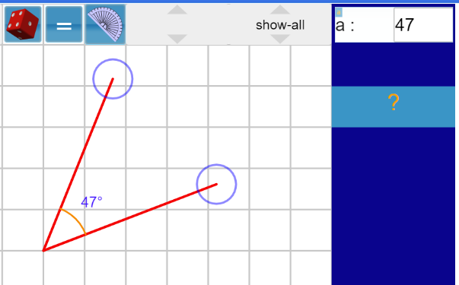
Image created using the free virtual manipulatives at Visnos.

Highlight explicit teaching practices evident in the first part of the learning sequence.
Using a protractor
Once students have revised their understanding of the different categories of angles, they are introduced to a formal protractor as another tool to measure the amount of turn. This is the next step in the progression of measuring angles from a ‘numberless protractor’. Students are shown how to correctly use the protractor before being tasked with measuring angles in both an angle hunt (see Figure 3) and measuring angle (see Figure 4).
- Introduce protractors as another mathematical tool that can be used to measure the amount of turn in angles. Ensure that each student has a protractor to handle and measure with.
- Explain that this is a numbered protractor and that, similar to the numbers on a ruler, the markings are there to help count the number of angles. Ask:
- How is a numbered protractor different to the other mathematical tools we have used?
- Display ‘Resource 10 – using a protractor’ (see Figure 4) and use it to discuss how to measure angles accurately.
- Use an enlarged copy of ‘Resource 11 – angle hunt’ (see Figure 4). Demonstrate how to position the protractor to measure an angle accurately.
Figure 4 – using a protractor and angle hunt
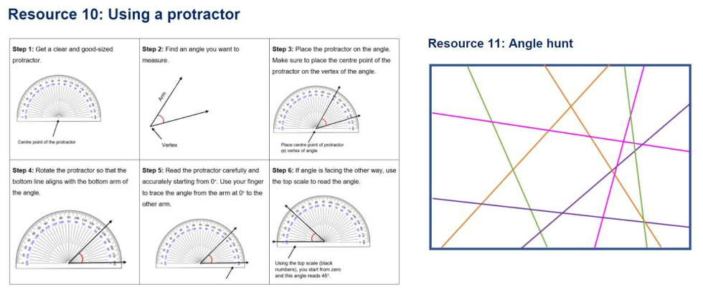

Core lesson 2 – measuring angles – 20 minutes
- Display ‘Resource 12 – measuring angles’ (see Figure 5). Explain that students will be using protractors to accurately measure and record the size of angles that they find.
- Provide students with ‘Resource 10 – using a protractor’ (see Figure 4), ‘Resource 12 – measuring angles’ (see Figure 5) and a protractor. In pairs, students work together to accurately find, measure and record the size of angles on the page.
Figure 5 – measuring angles
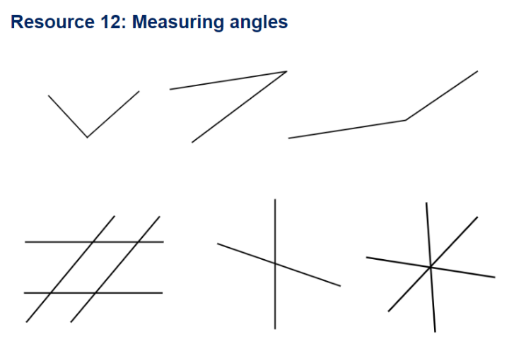
This table details opportunities for differentiation.
Too hard? | Too easy?
Students cannot estimate, describe and record angle measurements using the symbol for degrees (°).  - Support students to identify the angle they are going to measure. It can be shaded in to make it clearer to see.  - Assist students with positioning the protractor, particularly with steps 3 and 4 in ‘Resource 10 – using a protractor’ (see Figure 4. Help them to start counting from zero, holding the protractor steady to ensure accuracy. | Students can estimate, describe and record angle measurements using the symbol for degrees (°).  - Students find the total of the angles for each set of joining lines.  - Students make a short video for other students to view, explaining how to use a protractor to measure angles.
Highlight explicit teaching practices evident in this part of the learning sequence.
'The value of student talk in mathematics lessons cannot be over-emphasised. As students describe and evaluate solutions to tasks, share approaches and make conjectures, learning will occur in ways that are otherwise unlikely to take place’
(Van de Walle 2019:151)

Concluding the lesson
The end of the learning sequence is a rich opportunity for teachers to support students as they consolidate their learning.

Discuss and connect the mathematics – 10 minutes
- Regroup as a class and summarise the lesson together, drawing out key mathematical ideas. Ask:
- What were some of the benefits of using numbered protractors for measuring angles?
- Was there something that you found challenging about using the numbered protractors?
- Were there some strategies that you found helpful to use when measuring the angles?
- Did you notice anything about some of the angles you measured?
- Is there anything that you are still wondering?
This table details opportunities for assessment.
Assessment opportunities | Links
What to look for:  - Can students estimate and describe the size of angles using known angles as benchmarks? [MAO-WM-01, MA3-GM-03]  - Can students record angle measurements using the symbol for degrees (°)? [MAO-WM-01, MA3-GM-03] | Links to National Numeracy Learning Progressions (NNLP):  - UuM7, UuM8.

Highlight explicit teaching practices evident in the conclusion of the learning sequence.
When engaging in explicit instruction, you do not merely demonstrate the strategy and have students practise it; instead, you try to illuminate the decision-making along the way.
(Van de Walle 2019:111)

Where to next?
Would you like to learn more? The links below provide additional learning and resources.
- Mathematics 3–6 microlearning
- Planning, programming and assessing mathematics K–6 – resources to help you plan, program and assess mathematics from Kindergarten to Year 6.
- Teaching and Learning Support (NESA) – additional documents provided by NESA to support curriculum implementation.

Evaluation
We value your feedback. Please complete the Mathematics K–6 – effective teaching approaches evaluation to help us provide further support.
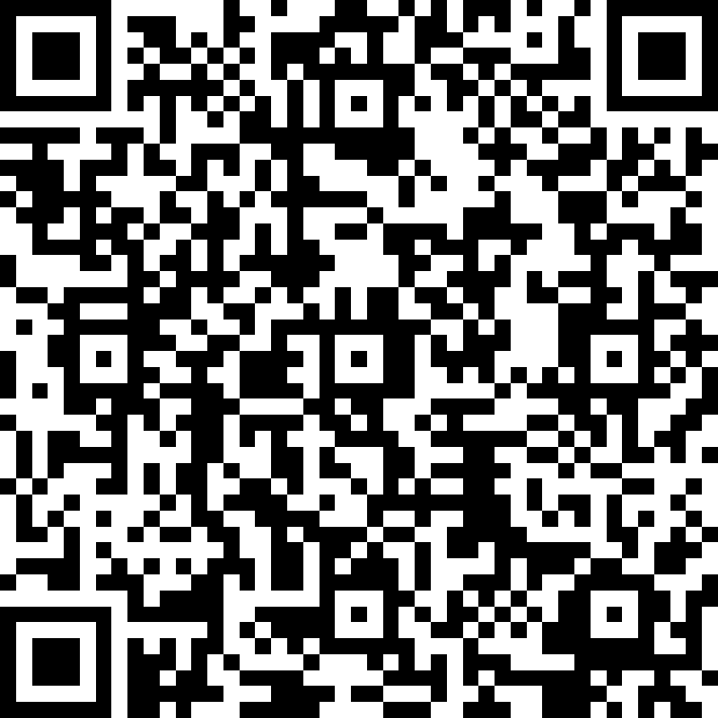

References
This resource contains NSW Curriculum and syllabus content. The NSW Curriculum is developed by the NSW Education Standards Authority. This content is prepared by NESA for and on behalf of the Crown in right of the State of New South Wales. The material is protected by Crown copyright.
Please refer to the NESA Copyright Disclaimer for more information https://educationstandards.nsw.edu.au/wps/portal/nesa/mini-footer/copyright.
NESA holds the only official and up-to-date versions of the NSW Curriculum and syllabus documents. Please visit the NSW Education Standards Authority (NESA) website https://educationstandards.nsw.edu.au/ and the NSW Curriculum website https://curriculum.nsw.edu.au.
Mathematics K–10 Syllabus © NSW Education Standards Authority (NESA) for and on behalf of the Crown in right of the State of New South Wales, 2022.
Annenberg Foundation (2023) Annenberg Learner [website], accessed 7 December 2023.
Attard C (24 January 2023) ‘Mathematics Education in 2023: Changing Times, Changing Practices?’ Engaging Maths blog, accessed 7 December 2023.
Askew M, Brown M, Rhodes V, William D and Johnson D (1997) Effective Teachers of Numeracy: Report of a study carried out for the Teacher Training Agency, Kings College, University of London.
Boaler J, Munson J and Williams C (2017) What is Mathematical Beauty? Teaching through Big Ideas and Connections [PDF 2.4 MB], accessed 7 December 2023.
Burrows P, Raymond L and Clarke D (2020) ‘A Powerful Image of Mathematical Thinking, Doing and Being: The Four Proficiencies as Verbs’, Australian Primary Mathematics Classroom, 25(3):3–5.
CESE (Centre for Education Statistics and Evaluation) (2017) Cognitive load theory: Research that teachers really need to understand, NSW Department of Education, accessed 7 December 2023.
Centre for Education Statistics and Evaluation (2020) What works best: 2020 update, NSW Department of Education, accessed 7 December 2023.
Commonwealth of Australia (2023) Mathematics Hub [website], accessed 7 December 2023.
Fisher D, Frey N and Hattie J (2017) Teaching Literacy in the Visible Learning Classroom, Grades K-5, Corwin Press, California.
Gojak LM (2013) Making Mathematical Connections, National Council of Teachers of Mathematics website, accessed 6 December 2023.
Hattie J (2008) Visible learning: A Synthesis of Over 800 Meta-Analyses Relating to Achievement, Routledge, UK.
NESA (NSW Education Standards Authority) (n.d.) Evidenced-based practices for planning and programming, NESA, accessed 7 December 2023.
NESA (2020) ‘NSW Curriculum Review – final report’, NESA, accessed 7 December 2023.
NESA (2021) ‘Proficient Teacher: Standard descriptors’, The Standards, NESA website, accessed 7 December 2023.
Ng PT (2011) ‘How the world’s most improved school systems keep getting better’ Journal of Educational Change, 12:463–468, doi:https://doi.org/10.1007/s10833-011-9174-x.
Saffin P (29 March 2022) ‘It’s time to do away with the false dichotomy in Maths instruction’, EducationHQ, accessed 7 December 2023.
Siemon D, Warren E, Beswick K, Faragher R, Miller J, Horne M, Jazby D, Breed M, Clark J and Brady K (2020) Teaching Mathematics: Foundations to Middle Years, 3rd edn, Oxford University Press Australia and New Zealand.
Van de Walle J, Karp K, Bay-Williams JM, Brass A, Bentley B, Ferguson S, Goff W, Livy S, Marshman M, Martin D, Pearn C, Prodromou T, Symons D and Wilkie K (2019) Primary and Middle Years Mathematics: Teaching Developmentally, 1st Australian edn, Pearson Education Australia, Melbourne.
© State of New South Wales (Department of Education), 2024
The copyright material published in this resource is subject to the Copyright Act 1968 (Cth) and is owned by the NSW Department of Education or, where indicated, by a party other than the NSW Department of Education (third-party material).
Copyright material available in this resource and owned by the NSW Department of Education is licensed under a Creative Commons Attribution 4.0 International (CC BY 4.0) license.
This license allows you to share and adapt the material for any purpose, even commercially.
Attribution should be given to © State of New South Wales (Department of Education), 2024.
Material in this resource not available under a Creative Commons license:
- the NSW Department of Education logo, other logos and trademark-protected material
- material owned by a third party that has been reproduced with permission. You will need to obtain permission from the third party to reuse its material.
Links to third-party material and websites
Please note that the provided (reading/viewing material/list/links/texts) are a suggestion only and implies no endorsement, by the New South Wales Department of Education, of any author, publisher, or book title. School principals and teachers are best placed to assess the suitability of resources that would complement the curriculum and reflect the needs and interests of their students.
If you use the links provided in this document to access a third-party's website, you acknowledge that the terms of use, including licence terms set out on the third-party's website apply to the use which may be made of the materials on that third-party website or where permitted by the Copyright Act 1968 (Cth). The department accepts no responsibility for content on third-party websites.

