Mathematics K–6 – effective teaching approaches
Facilitator guide
Contents
About this guide 2
Presentation overview 3
Learning intentions and success criteria 3
Alignment to the Australian Professional Standards for Teachers 3
Alignment to the School Excellence Framework 4
Preparation 5
Prior to the session 5
After the session 5
Session structure 6
Session activities 7
Participant workbook 7
Pause and reflect discussion 8
Activity 1 – Working mathematically 10
Activity 2 – explicit teaching practices 14
Where to next? 18
References 19

About this guide
This guide has been developed to assist leaders in facilitating the ‘Mathematics K–6 – understanding effective teaching approaches’ professional learning session. The guide will explore:
- how the session aligns with the Australian Professional Standards for Teachers and the School Excellence Framework
- how to structure the session to help your team effectively engage with the presentation content
- recommended activities to promote collaboration, reflection and plans for future action
- additional resources to support further professional development.
If you have questions about the session, please email mathematicsk6@det.nsw.edu.au.

Presentation overview
This session unpacks the evidence-based pedagogical shifts aligned to the K–6 component of the NSW Mathematics K–10 Syllabus. We'll explore the syllabus, evidence-base and practical strategies for the classroom, with a focus on the connectionist approach, Working mathematically and the role of explicit teaching practices. Discussion and activities will be provided to support schools to apply new learning to mathematics planning and practice.

Learning intentions and success criteria
By the end of this presentation, participants will:
- develop an understanding of the connectionist approach, Working mathematically and the role of explicit teaching in primary mathematics classrooms.
To demonstrate learning, participants will:
- explain the importance of a connectionist approach in teaching mathematics
- reflect on a recent mathematics lesson and identify the Working mathematically process addressed
- identify opportunities to embed Working mathematically question prompts into the planning phase of mathematics lesson sequences
- define explicit teaching and identify the 7 explicit teaching practices
- highlight opportunities in lesson sequences to embed explicit teaching practices.

Alignment to the Australian Professional Standards for Teachers
This professional learning session aligns with the following standards:
- 2.1.2 Apply knowledge of the content and teaching strategies of the teaching area to develop engaging teaching activities.
- 2.3.2 Design and implement learning and teaching programs using knowledge of curriculum, assessment and reporting requirements.
- 3.3.2 Select and use relevant teaching strategies to develop knowledge, skills, problem solving and critical and creative thinking.
- 6.2.2 Participate in learning to update knowledge and practice, targeted to professional needs and school and/or system priorities.

Alignment to the School Excellence Framework
This professional learning session aligns with the following elements of the School Excellence Framework:
- Assessment
- Curriculum
- Effective classroom practice
- Learning and development

Preparation
It is recommended that you are familiar with the course structure and content prior to the professional learning session. You should guide participants through the learning by:
- playing video and audio files
- reading content when required (for example, activity instructions)
- leading activities and discussions
- managing time.

Prior to the session
- Ensure all participants will have access to:
- the participant workbook (either printed or downloaded and completed electronically on a device)
- Access to the digital NSW Mathematics K–10 Syllabus 2022 (required for the Pause and reflect discussion and Activity 1)
- A mathematics lesson plan or learning sequence previously developed by the participant (required for Activity 1)
- Access to the interactive angle display (required for Activity 2).
- Play any video or multimedia on your browser to ensure they have loaded for your session.
- Consider room or equipment set up for the day.

After the session
- Direct participants to complete the evaluation survey using the QR code in their participant workbook.

Session structure
This session should take approximately 90 minutes to complete. We recommend following the structure below.
Item | Duration
Welcome and Acknowledgement of Country | 2 minutes
Connectionist approach | 5 minutes
Pause and reflect discussion | 10 minutes
Working mathematically | 10 minutes
Activity 1 | 20 minutes
Explicit teaching practices | 20 minutes
Activity 2 | 20 minutes
Where to next? | 3 minutes

Session activities
Learning in this session is supported by the Participant workbook, a ‘pause and reflect’ discussion and 2 collaborative activities. These activities are designed to help your team reflect on the presentation and consider how the information can be applied to your school context.

Participant workbook
The Participant workbook can be printed double-sided or used digitally. There are note-taking pages that complement the presentation and activity templates to guide engagement with the content.
The note-taking pages are to be used while watching the presentation. They provide your team with an opportunity to reflect and think critically about the information being shared. The note-taking pages feature 3 main sections:
- Focus questions – these are questions to keep in mind while engaging with the session. They encourage your team to consider how the content in the presentation can inform their practice.
- Key points and notes – in this section, your team can record any concepts or ideas that resonate with them. The left column is for staff to write down the main points of the presentation for future reference. The right column provides them with space to expand on their thinking and provide additional detail.
- Summary – at the end of the presentation, staff can write down 3 key ideas they would like to apply to their practice. You may like to conclude the session by having your team share the reflections they have recorded.
The activity templates provide a scaffold for the ‘pause and reflect’ slides in the presentation. Further information about these activities is provided below.

Pause and reflect discussion

Underpinning research
The National Council of Teachers of Mathematics defines mathematical connections as the ability to ‘recognize and use connections among mathematical ideas; understand how mathematical ideas interconnect and build on one another to produce a coherent whole; and to recognize and apply mathematics in contexts outside of mathematics’.
Siloed knowledge is no longer enough. Today’s students need to be able to problem-solve and mathematise in an interconnected and interrelated manner. Students need to be given opportunities to build on their prior knowledge and make connections between mathematical ideas to increase both conceptual and procedural understanding.

Connectionist approach
Figure 1 – connectionist approach to Stage 3 content
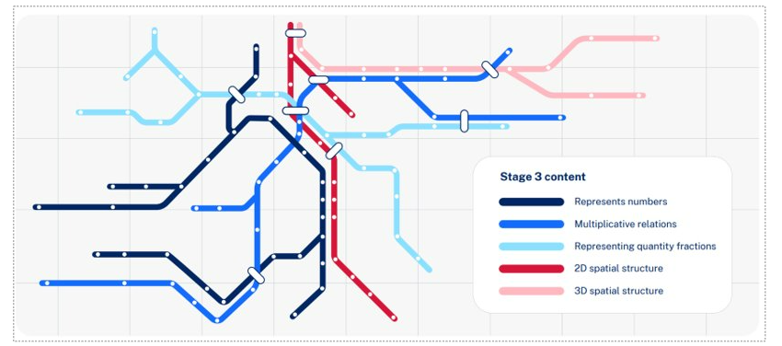

Making connections through related content K–10
The Mathematics K–10 Syllabus prioritises the importance of students making connections. The aim of the syllabus states that students make connections within mathematics and connect mathematical ideas to the world around them.
The syllabus affirms that many connections exist within and between the focus areas in mathematics. Skills and knowledge for focus areas often develop in an interrelated manner and can be addressed in parallel. This enables teachers to efficiently teach and assess essential concepts within the syllabus content, while supporting students to make connections with their learning.

Uncovering mathematics
Making meaning and sense of the world around them is critical in students' development and is a key underpinning of the mathematics syllabus. Catherine Attard, a prominent researcher in engagement in mathematics, talks about wanting students in task, not just on task, as an important consideration when planning mathematics learning sequences. Making connections when planning learning sequences helps teachers to ‘uncover’ the mathematics curriculum as opposed to ‘covering the curriculum’; a phrase coined by Marilyn Burns (2022). By making these connections, teaching practices shift to a more student-centred, sense-making approach that builds students’ conceptual understanding of mathematics as a whole.

Facilitating the discussion
The following discussion question is designed to provide participants with the opportunity to briefly reflect on the information presented about the connectionist approach. This question does not appear in the participant workbook.
What is the connectionist approach? How could you elevate connections when planning lesson sequences?
Allow 5 minutes for discussion.

Activity 1 – Working mathematically

Underpinning research
Working mathematically is the thinking and doing of mathematics. This is presented as one overarching outcome that spans across the Mathematics K–10 Syllabus. The Working mathematically processes in the syllabus are:
- communicating
- understanding and fluency
- reasoning
- problem solving.
Students learn to work mathematically by using these processes in an interconnected way. This is a significant shift from the previous syllabus where they were separated. The coordinated development of these processes results in students becoming mathematically proficient. The Working mathematically processes cannot always be explicitly taught and must be developed through rich mathematical experiences and agentic learning.
Solving problems in mathematics requires students’ understanding of concepts and relations as well as the capacity to communicate their reasoning. The content can be considered as the 'what' of the syllabus and the Working mathematically processes as the 'how' of the syllabus. The 'what' and the 'how’ are intertwined and interrelated. Students are Working mathematically when they are:
- calculating their answers efficiently
- recognising robust ways of answering questions
- choosing appropriate methods and approximations
- recalling definitions and regularly use known facts
- manipulating expressions and equations to find solutions
- reasoning and justifying their thinking using appropriate mathematical language
- solving complex problems and finding multiple solutions
Teachers implementing the Mathematics K–10 Syllabus have a great opportunity to develop deep mathematical skills and mindsets with their students.

Facilitating Activity 1
Participants are provided with suggested question prompts which are organised into the Working mathematically processes (see Figure 2).
Figure 2 – question prompts for Working mathematically processes
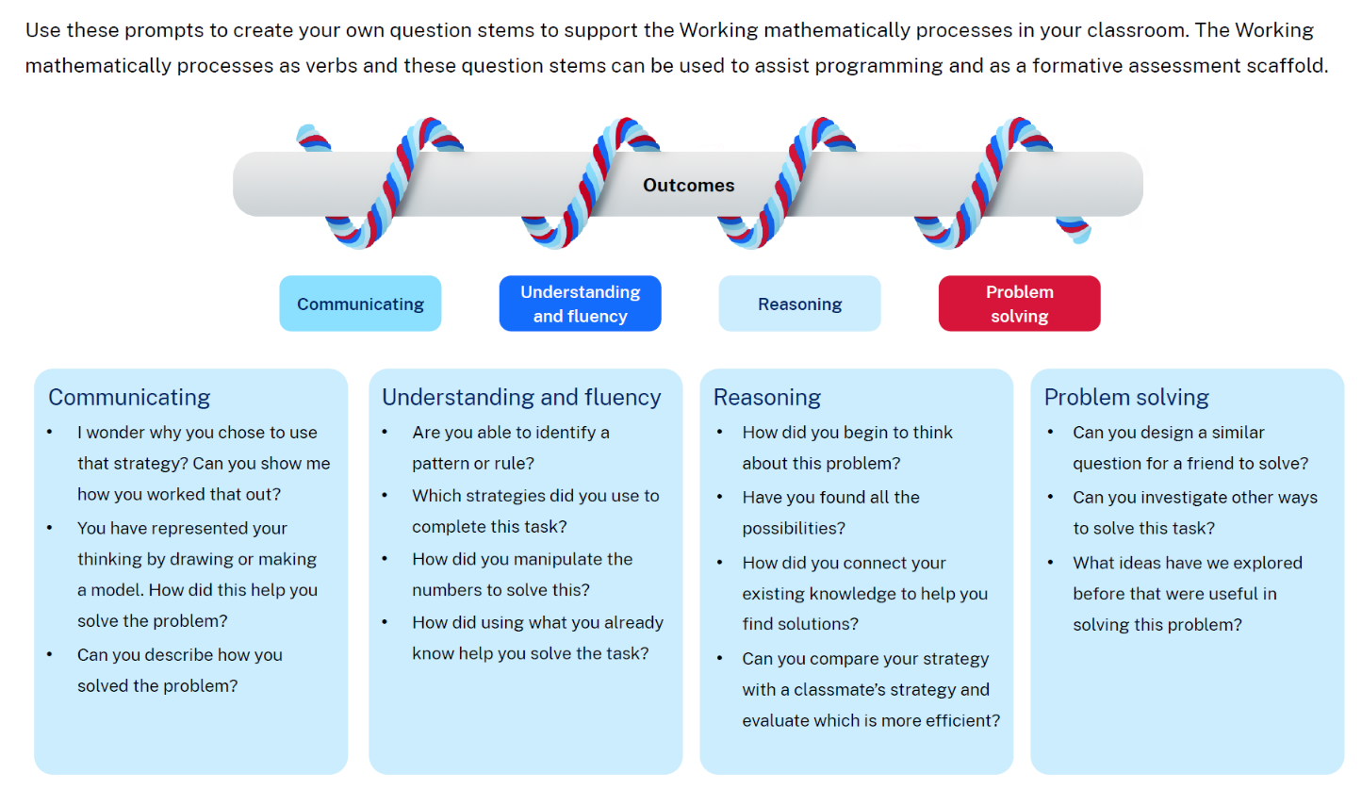
- These question prompts can be used during the planning phase of a lesson as a reflection tool for teachers to ensure the potential Working mathematically processes are highlighted in an interconnected way.
- These question prompts are also designed to guide interactions with students. This ensures that conversations highlight the Working mathematically processes, rather than focusing purely on the answer.
These reflection questions are best explored in small groups. Where possible, participants should be given opportunities to discuss these questions with colleagues that they collaboratively program with. This discussion is designed to prompt reflection on how Working mathematically processes are embedded in learning sequences and the classroom.
Reflect on a recent mathematics lesson
- How did students engage in the Working mathematically processes?
- Are there other question prompts that would work well?
As participants reflect on the Working mathematically processes, it may become obvious that some processes are favoured more than others in classrooms.
It is important to see the Working mathematically processes in an interconnected way. The coordinated development of these processes results in students becoming mathematically proficient.
A follow up question might be necessary during this discussion: How can we ensure that students are given opportunities to use these processes in an interconnected way?
During this discussion, it may be useful to ask participants to refer to the ‘Working mathematically processes as verbs’ image. This appears on slide 13 for Activity 1 in the presentation recording. This may facilitate further reflection and serve as a stimulus for brainstorming additional question prompts.
How might these question prompts be utilised during the planning phase to embed Working mathematically processes into learning sequences?
This question is designed to facilitate discussion amongst participants to identify ways to embed Working mathematically processes into learning sequences. Participants should be given opportunities to discuss with colleagues that they collaboratively program with to promote reflection and identify potential shifts in teaching and programming practices. Participants should be encouraged to select a recent learning sequence to guide discussion and use the suggested question prompts when reflecting on planning practices.
Participants’ attention should be drawn to the fact that the Working mathematically outcome does not have specific content groups or content points as it is not a focus area. It should not be taught, assessed or reported on in isolation. It must be assessed in conjunction with stage appropriate content.
Highlight to participants that the rope diagram in Figure 1 within the Participant workbook encapsulates the notion of the content as the ‘what’ and the Working mathematically processes as the ‘how’.

Activity 2 – explicit teaching practices

Background information
The lesson presented in the Participant workbook is from the sample unit Stage 3 Year A – Unit 10. This unit focuses on the big idea that angles are the primary structural component of many shapes. The lesson introduces students to the use of a protractor to formally measure angles. Students are provided opportunities to estimate, measure and compare angles using degrees. In Stage 2, they learn about measuring angles as a measure of turn, using informal units such as an angle wedge. This progression is shown in Figure 3 and page 9 of the Participant workbook.
Figure 3 – a progression for measuring angles
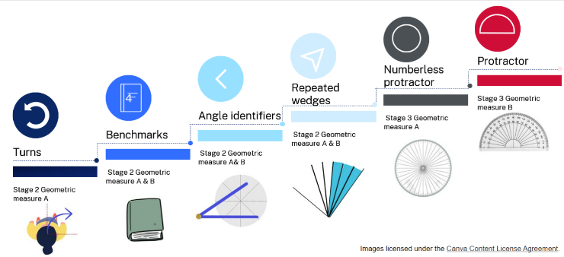
This lesson has been chosen because it has a variety of explicit teaching practice embedded throughout. As you work your way through the lesson as a group, it may be helpful to encourage your team to think about teaching this lesson with their current class, a previous class or a group of students.

Facilitating Activity 2
During Activity 2, there will be opportunities to pause and reflect on the explicit teaching practices used in that part of the lesson. Allow time for teachers to share their reflections for each of these. This is introduced on page 9 of the Participant workbook.
Explicit teaching practices
As you are reading the following learning activities, reflect on parts of the lesson where a teacher could use these aspects of explicit teaching practice.
‘Just in time’ explicit teaching | Whole class explicit teaching
After teachers consider the suggested learning intentions and success criteria for the lesson, the interactive angle display can be shown. This can support teachers to see how this resource can facilitate classroom discussion and explicit teaching practices.

Pause and reflect: start of the lesson (Participant workbook page 11)
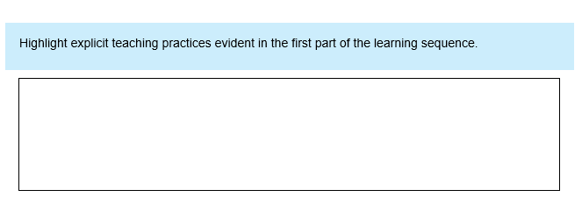
In this response box, teachers may identify that:
- explicit teaching practices have occurred prior to the learning in this lesson, as the teacher has revised the different categories of angles.
- explicit teaching practices may have occurred ‘just in time’, depending on the students’ responses to the questions about angles. The teacher can correct any student misconceptions before continuing the lesson.
If teachers are unable to identify explicit teaching practices, prompts for discussion include:
- Explicit teaching practices prior to the learning activities have helped build students’ pre-requisite knowledge to engage with the next part of the lesson.
- ‘Just in time’ explicit teaching can result from students’ responses to the questions. This enables the teacher to identify students who may require more support and guidance to be successful.

Pause and reflect: using a protractor (Participant workbook page 13)
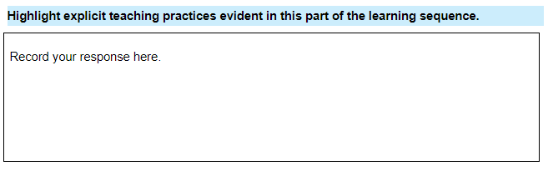
In this response box, teachers may identify that:
- explicit teaching practices highlighted could include modelling, dialogue, connections and learning needs as the teacher introduces and explains how to correctly use a formal protractor.
- explicit teaching practices may have occurred ‘just in time’, depending on the students’ responses to the questions about other mathematical tools. The teacher can correct any student misconceptions before continuing the lesson.
- explicit teaching practices may have occurred after students have engaged with the task independently. The teacher engages explicit teaching practices to make the mathematics clear and to build mathematical connections through modelling how to measure and angle accurately.
If teachers are unable to identify explicit teaching practices, prompts for discussion include:
- Effective teachers choose the right explicit teaching practice, for the right time, in order to create an optimal learning experience for their students and to make the mathematics clear.
- Teachers use their knowledge of their students, a deep understanding of the syllabus and of the mathematics, and a variety of assessment strategies to determine which particular explicit teaching practice, or combination of practices, best supports their students.

Pause and reflect: concluding the lesson (Participant workbook page 15)
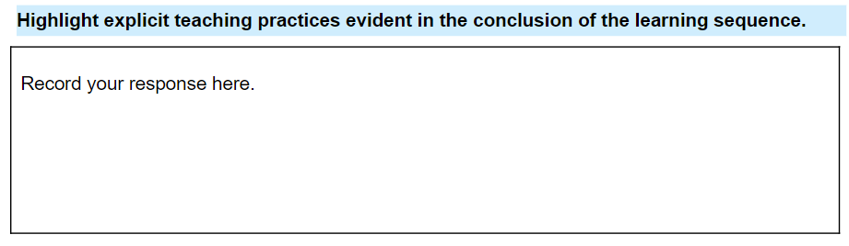
In this response box, teachers may identify that:
- explicit teaching practices include questioning, dialogue, feedback and connections as the teacher concludes the lesson.
- explicit teaching practices may have occurred ‘just in time’, depending on the students’ responses to the questions. The teacher can correct any student misconceptions and review the mathematics before concluding the lesson.
If teachers are unable to identify explicit teaching practices, prompts for discussion include:
- Explicit teaching practices after students have engaged with the learning activities, enables the teacher to make the mathematics clear and to build mathematical connections.
- Diversifying the types of questions you ask encourages deeper answers and helps students gain a stronger connection to understanding the learning, including open-ended, clarifying, scaffolding, probing and leading questions. Different types of questions have different purposes. For example, they can:
- discern what students know
- highlight key mathematical ideas
- help students make connections in their learning
- encourage students to reflect and justify responses
- support students in posing their own questions to advance their learning.

Where to next?
Would you like to learn more? The links below provide additional learning and resources. These may assist you in developing future professional learning sessions to respond to the needs of your team.
- Mathematics 3–6 microlearning
- Planning, programming and assessing mathematics K–6 – resources to help you plan, program and assess mathematics from Kindergarten to Year 6
- Teaching and learning support (NESA) – additional documents provided by NESA to support curriculum implementation

References
This resource contains NSW Curriculum and syllabus content. The NSW Curriculum is developed by the NSW Education Standards Authority. This content is prepared by NESA for and on behalf of the Crown in right of the State of New South Wales. The material is protected by Crown copyright.
Please refer to the NESA Copyright Disclaimer for more information https://educationstandards.nsw.edu.au/wps/portal/nesa/mini-footer/copyright.
NESA holds the only official and up-to-date versions of the NSW Curriculum and syllabus documents. Please visit the NSW Education Standards Authority (NESA) website https://educationstandards.nsw.edu.au/ and the NSW Curriculum website https://curriculum.nsw.edu.au.
Mathematics K–10 Syllabus © NSW Education Standards Authority (NESA) for and on behalf of the Crown in right of the State of New South Wales, 2022.
Annenberg Foundation (2023) Annenberg Learner [website], accessed 7 December 2023.
Askew M, Brown M, Rhodes V, William D & Johnson D (1997) Effective Teachers of Numeracy: Report of a study carried out for the Teacher Training Agency by the School of Education, King’s College, University of London.
Attard C (24 January 2023) ‘Mathematics Education in 2023: Changing Times, Changing Practices?’, Engaging Maths, accessed 6 December 2023.
Boaler J, Munson J and Williams C (2017) What is Mathematical Beauty? Teaching through Big Ideas and Connections [PDF 2.4 MB], YouCubed, accessed 6 December 2023.
Burns M (2022) About Teaching Mathematics: A K-8 Resource, 4th edn, Pearson Education, California.
Burrows P, Raymond L and Clarke D (2020) ‘A Powerful Image of Mathematical Thinking, Doing and Being: The Four Proficiencies as Verbs’, Australian Primary Mathematics Classroom, 25(3):3–5.
Centre for Education Statistics and Evaluation (2017) Cognitive load theory: Research that teachers really need to understand, NSW Department of Education, accessed 6 December 2023.
CESE (Centre for Education Statistics and Evaluation) (2020) What works best: 2020 update, CESE, NSW Department of Education, accessed 6 December 2023.
Commonwealth of Australia (2023) Mathematics Hub [website], accessed 6 December 2023.
Fisher D, Frey N & Hattie J (2017) Teaching Literacy in the Visible Learning Classroom, Grades K–5, Corwin Press, California.
Gojak LM (2013) Making Mathematical Connections, National Council of Teachers of Mathematics website, accessed 6 December 2023.
Hattie J (2008) Visible learning: A Synthesis of Over 800 Meta-Analyses Relating to Achievement, Routledge, UK.
NESA (NSW Education Standards Authority) (n.d.) Evidenced-based practices for planning and programming, NESA, accessed 7 December 2023.
NESA (2020) ‘NSW Curriculum Review – final report’, NESA, accessed 7 December 2023.
NESA (2021) ‘Proficient Teacher: Standard descriptors’, The Standards, NESA website, accessed 7 December 2023.
Ng PT (2011) ‘How the world’s most improved school systems keep getting better’, Journal of Educational Change, 12:463–468, doi:https://doi.org/10.1007/s10833-011-9174-x.
Saffin P (29 March 2022) ‘It's time to do away with the false dichotomy in maths instruction’, EducationHQ, accessed 6 December 2023.
Siemon D, Warren E, Beswick K, Faragher R, Miller J, Horne M, Jazby D, Breed M, Clark J and Brady K. (2021) Teaching Mathematics: Foundations to Middle Years, 3rd edn, Oxford University Press ANZ, Australia.
© State of New South Wales (Department of Education), 2024
The copyright material published in this resource is subject to the Copyright Act 1968 (Cth) and is owned by the NSW Department of Education or, where indicated, by a party other than the NSW Department of Education (third-party material).
Copyright material available in this resource and owned by the NSW Department of Education is licensed under a Creative Commons Attribution 4.0 International (CC BY 4.0) license.
This license allows you to share and adapt the material for any purpose, even commercially.
Attribution should be given to © State of New South Wales (Department of Education), 2024.
Material in this resource not available under a Creative Commons license:
- the NSW Department of Education logo, other logos and trademark-protected material
- material owned by a third party that has been reproduced with permission. You will need to obtain permission from the third party to reuse its material.
Links to third-party material and websites
Please note that the provided (reading/viewing material/list/links/texts) are a suggestion only and implies no endorsement, by the New South Wales Department of Education, of any author, publisher, or book title. School principals and teachers are best placed to assess the suitability of resources that would complement the curriculum and reflect the needs and interests of their students.
If you use the links provided in this document to access a third-party's website, you acknowledge that the terms of use, including licence terms set out on the third-party's website apply to the use which may be made of the materials on that third-party website or where permitted by the Copyright Act 1968 (Cth). The department accepts no responsibility for content on third-party websites.

