Mathematics 3–6 Multi-age – Year B – Unit 10

Contents
Unit description and duration 6
Syllabus outcomes 6
Stage 2 7
Stage 3 7
Working mathematically 8
Student prior learning 8
Lesson overview and resources 10
Lesson 1 18
Daily number sense – using arrays – 10 minutes 18
Core lesson 1 – identifying and measuring right angles – 10 minutes 21
Core lesson 2 – making angles – 20 minutes 25
Stage 2 task – finding and making internal angles 25
Stage 3 task – making right angles 28
Core lesson 3 – maximum angles – 20 minutes 32
Discuss and connect the mathematics – 10 minutes 33
Lesson 2 36
Daily number sense – fact families – 10 minutes 36
Core lesson 1 – angle benchmarks – 15 minutes 38
Core lesson 2 – angle art – 35 minutes 41
Stage 2 task – finding angles in art 41
Stage 3 task – finding angles in art and design 43
Discuss and connect the mathematics – 10 minutes 45
Lesson 3 48
Daily number sense – solving problems with fact families – 10 minutes 48
Core lesson 1 – bridge art – 15 minutes 50
Core lesson Part 2 – 35 minutes 52
Stage 2 task – angles in the environment 52
Stage 3 task – stained glass 54
Discuss and connect the mathematics – 10 minutes 56
Lesson 4 59
Daily number sense – 10 minutes 59
Core lesson 1 – investigating angles in letters – 10 minutes 59
Core lesson 2 – investigating angles in clocks – 30 minutes 61
Consolidation and meaningful practice – 15 minutes 63
Lesson 5 66
Daily number sense – decimals in order – 10 minutes 66
Core lesson – 40 minutes 68
Stage 2 task – showing time 68
Stage 3 task – duration 73
Discuss and connect the mathematics – 10 minutes 76
Lesson 6 78
Daily number sense – largest decimal – 10 minutes 78
Core lesson – fractions of time – 40 minutes 80
Discuss and connect the mathematics – 10 minutes 88
Lesson 7 90
Daily number sense – fractions and decimals – 10 minutes 90
Core lesson 1 – test yourself – 10 minutes 92
Core Lesson 2 – 30 minutes 94
Stage 2 Task – timed challenge 94
Stage 3 task – zoom strategy 96
Discuss and connect the mathematics – 10 minutes 98
Lesson 8 101
Daily number sense – 10 minutes 101
Core lesson – organising an excursion – 50 minutes 101
Discuss and connect the mathematics – 10 minutes 105
Resource 1 – right angles and shapes 107
Resource 2 – using a protractor 108
Resource 3 – making fact families 109
Resource 4 – house plans 110
Resource 5 – angle names 111
Resource 6 – angle art 112
Resource 7 – hexagon angles 113
Resource 8 – lots of buttons 114
Resource 9 – environmental angles 116
Resource 10 – angle of revolution 117
Resource 11 – stained glass window 118
Resource 12 – alphabet letters 119
Resource 13 – clock angles 120
Resource 14 – angles in engineering 121
Resource 15 – time angles 122
Resource 16 – in a minute 123
Resource 17 – showing the time 124
Resource 18 – elapsed time 125
Resource 19 – hour strips 126
Resource 20 – day and night timeline 127
Resource 21 – creative art activities 128
Resource 22 – duration problems 129
Resource 23 – fractions and decimals 130
Resource 24 – the zoom strategy 131
Resource 25 – elapse timecards 132
Resource 26 – excursion planning 133
Resource 27 – using Google Maps 134
Syllabus outcomes and content 135
Stage 2 135
Stage 3 141
References 146

Unit description and duration
This unit develops the big idea that angles are the primary structural component of many shapes.
In this 2-week unit students are provided opportunities to:
- measure, compare and sequence events by halving and quartering blocks of time
- represent fractional quantities of time and the multiplicative relationships
- estimate and describe the size of angles using known angles as benchmarks such as right angles
- estimate, measure and compare angles using degrees
- solve problems involving duration, using 12- and 24-hour time.
This multi-age unit is informed by the lessons in Stage 2 Year B Unit 30 and Stage 3 Year B Unit 30. Please refer to these units for additional lesson guidance.

Syllabus outcomes
- MAO-WM-01 develops understanding and fluency in mathematics through exploring and connecting mathematical concepts, choosing and applying mathematical techniques to solve problems, and communicating their thinking and reasoning coherently and clearly

Stage 2
- MA2-RN-02 represents and compares decimals up to 2 decimal places using place value
- MA2-MR-01represents and uses the structure of multiplicative relations to 10 × 10 to solve problems
- MA2-PF-01 represents and compares halves, quarters, thirds and fifths as lengths on a number line and their related fractions formed by halving (eighths, sixths and tenths)
- MA2-GM-03 identifies angles and classifies them by comparing to a right angle
- MA2-NSM-02 represents and interprets analog and digital time in hours, minutes and seconds

Stage 3
- MA3-RN-02 compares and orders decimals up to 3 decimal places
- MA3-RN-03 determines percentages of quantities, and finds equivalent fractions and decimals for benchmark fractions
- MA3-MR-01 selects and applies appropriate strategies to solve multiplication and division problems
- MA3-RQF-02 determines $\frac{1}{2}$,$\frac{1}{4}$, $\frac{1}{5}$ and $\frac{1}{10}$of measures and quantities
- MA3-GM-03 measures and constructs angles, and identifies the relationships between angles on a straight line and angles at a point
- MA3-NSM-02 measures and compares duration, using 12- and 24- hour time and am and pm notation

Working mathematically
In the Mathematics K–10 Syllabus, there is one overarching Working mathematically outcome (MAO-WM-01). The Working mathematically processes should be embedded within the concepts being taught. The Working mathematically processes present in the Mathematics K–10 Syllabus are:
- communicating
- understanding and fluency
- reasoning
- problem solving.
Mathematics K–10 Syllabus © NSW Education Standards Authority (NESA) for and on behalf of the Crown in right of the State of New South Wales, 2022.

Student prior learning
Before engaging in these teaching and learning activities, students would benefit from prior experience with:
- identifying angles as measures of turn and name the parts of an angle
- reading and representing analog time using minutes and hours and solve problems involving quarter hours and half hours
- describing angles in comparison to quarter-turns as acute, right, obtuse, straight, reflex or a revolution
- recognising and describe angles as less than, equal to, about the same as or greater than a right angle
- comparing 12- and 24-hour time systems and convert between them.
In NSW classrooms there is a diverse range of students, including Aboriginal and Torres Strait Islander students, students learning English as an additional language or dialect, high potential and gifted students and students with disability. Some students may identify with more than one of these groups or possibly all of them. Refer to Curriculum planning for every student – advice for further information.

Lesson overview and resources
To cover the content of the syllabus across Stage 2 and Stage 3, some core lessons in the unit contain both a Stage 2 and a Stage 3 task. Teachers are encouraged to adapt and contextualise the units to meet the needs of their students.
The table below outlines the sequence and approximate timing of lessons, learning intentions and resources.
Lesson | Content | Duration and resources
Lesson 1  Daily number sense  Stage 2:  - Multiplicative relations A: Recall multiplication facts of 2 and 4, 5 and 10 and related division facts  Stage 3:  - Multiplicative relations B: Use equivalent number sentences involving multiplication and division to find unknown quantities | Lesson core concept: angles can be classified according to their features.  Stage 2:  - Geometric measure A: Angles: Identify angles as measures of turn  - Geometric measure B: Angles: Compare angles to a right angle  Stage 3:  - Geometric measure B: Angles: Investigate angles on a straight line and angles at a point  - Geometric measure B: Angles: Investigate the relationships formed by the intersection of straight lines | Lesson duration: 70 minutes  - Resource 1 – right angles and shapes  - Resource 2 – using a protractor  - digital geoboard  - 10-sided dice  - Counters  - Ice-cream sticks  - Writing materials
Lesson 2  Daily number sense  Stage 2:  - Multiplicative relations A: Recall multiplication facts of 2 and 4, 5 and 10 and related division facts  Stage 3:  - Multiplicative relations B: Use equivalent number sentences involving multiplication and division to find unknown quantities | Lesson core concept: angles are created when lines intersect and are often described and compared in relation to right angles.  Stage 2:  - Geometric measure A: Angles: Identify angles as measures of turn  - Geometric measure B: Angles: Compare angles to a right angle  Stage 3:  - Geometric measure B: Angles: Investigate angles on a straight line and angles at a point  - Geometric measure B: Angles: Investigate the relationships formed by the intersection of straight lines | Lesson duration: 70 minutes  - Resource 3 – making fact families  - Resource 4 – house plans  - Resource 5 – angle names  - Resource 6 – angle art  - Resource 7 – hexagon angles  - Counters  - Writing materials
Lesson 3  Daily number sense  Stage 2:  - Multiplicative relations A: Recall multiplication facts of 2 and 4, 5 and 10 and related division facts  Stage 3:  - Multiplicative relations B: Use equivalent number sentences involving multiplication and division to find unknown quantities | Lesson core concept: angles can be found in art, buildings and nature and angles at a point form an angle of revolution and add to 360°.  Stage 2:  - Geometric measure A: Angles: Identify angles as measures of turn  - Geometric measure B: Angles: Compare angles to a right angle  Stage 3:  - Geometric measure B: Angles: Investigate angles on a straight line and angles at a point  - Geometric measure B: Angles: Investigate the relationships formed by the intersection of straight lines | Lesson duration: 70 minutes  - Resource 5 – angle names  - Resource 8 – lots of buttons  - Resource 9 – environmental angles  - Resource 10 – stained glass window  - Resource 11 – angle of revolution  - Pattern blocks  - Protractors  - Writing materials
Lesson 4  Daily number sense  - teacher-identified task based on student needs | Lesson core concept: the arms and vertex of an angle can be visible or invisible.  Stage 2:  - Geometric measure A: Angles: Identify angles as measures of turn  - Geometric measure B: Angles: Compare angles to a right angle  Stage 3:  - Geometric measure B: Angles: Investigate angles on a straight line and angles at a point  - Geometric measure B: Angles: Investigate the relationships formed by the intersection of straight lines | Lesson duration: 65 minutes  - Resource 12 – alphabet letters  - Resource 13 – clock angles  - Resource 14 – angles in engineering  - Resource 15 – time angles  - Angle tester  - Interactive analog clock  - Protractor  - Writing materials
Lesson 5  Daily number sense  Stage 2:  - Representing numbers using place value B: Decimals: Make connections between fractions and decimal notation  Stage 3:  - Represents number place A: Decimals and percentages: Compare, order and represent decimals  - Additive relations B: Applies known strategies to add and subtract decimals. | Lesson core concept: halving and quartering blocks of time or using a number line helps to measure and sequence events and duration of events.  Stage 2:  - Non-spatial measure B: Time: Represent and interpret digital time displays  Stage 3:  - Non-spatial measure B: Time: Solve problems involving duration, using 12- and 24-hour time | Lesson duration: 60 minutes  - Resource 16 – in a minute  - Resource 17 – showing the time  - Resource 18 – elapsed times  - Active analog clock  - Static analog clock  - Time tools  - Digital device  - Individual whiteboards  - Writing materials
Lesson 6  Daily number sense  Stage 2:  - Representing numbers using place value B: Decimals: Make connections between fractions and decimal notation  Stage 3:  - Represents numbers A: Decimals and percentages: Compare, order and represent decimals  - Additive relations B: Applies known strategies to add and subtract decimals. | Lesson core concept: time can be described using fractions and decimals.  Stage 2:  - Partitioned fractions B: Represent fractional quantities equal to and greater than one  - Non-spatial measure B: Time: Use am and pm notation  Stage 3:  - Representing quantity fractions B: Find fractional quantities of whole numbers (halves, quarters, fifths and tenths)  - Non-spatial measure B: Time: Solve problems involving duration, using 12- and 24-hour time | Lesson duration: 60 minutes  - Resource 19 – hour strips  - Resource 20 – fractions and decimals  - Resource 21 – day and night timeline  - Resource 22 – creative arts activities  - Resource 23 – duration problems  - Analog clock or digital analog clock  - 10-sided dice (2 per pair)  - Individual whiteboards  - Writing materials
Lesson 7  Daily number sense  Stage 2:  - Representing numbers using place value B: Decimals: Make connections between fractions and decimal notation  Stage 3:  - Represents numbers A: Decimals and percentages: Compare, order and represent decimals  - Additive relations B: Applies known strategies to add and subtract decimals. | Lesson core concept: the context determines the most suitable standard unit.  Stage 2:  - Non-spatial measure B: Time: Represent and interpret digital time displays  Stage 3:  - Non-spatial measure B: Time: Solve problems involving duration, using 12- and 24-hour time | Lesson duration: 60 minutes  - Resource 23 – fractions and decimals  - Resource 24 – the zoom strategy  - Resource 25 – elapsed timecards  - Digital timing devices or stopwatches  - Writing materials
Lesson 8  Daily number sense  - teacher-identified task based on student needs | Lesson core concept: time can be used to coordinate events in the world.  Stage 2:  - Non-spatial measure A: Time: Represent and read analog time  - Non-spatial measure B: Time: Use am and pm notation  Stage 3:  - Non-spatial measure B: Time: Solve problems involving duration, using 12- and 24-hour time | Lesson duration: 70 minutes  - Resource 26 – excursion planning  - Resource 27 – using Google Maps  - Devices to access Google Maps (one per pair/small group)  - Writing materials

Lesson 1
Core concept: angles can be classified according to their features.

Daily number sense – using arrays – 10 minutes
Daily number sense activities for Lessons 1 to 3 ‘activate’ prior number knowledge and support the learning of new content in the unit. These activities can also assist teachers to identify the starting points for learning by revealing the extent of students’ existing knowledge.
The table below contains suggested learning intentions and success criteria. These are best co-constructed with students.
Daily number sense learning intentions | Daily number sense success criteria
Students working towards Stage 2 outcomes are learning to:  - recall multiplication facts of 2 and 4, 5 and 10 and related division facts.  Students working towards Stage 3 outcomes are learning to:  - use equivalent number sentences involving multiplication and division to find unknown quantities. | Students working towards Stage 2 outcomes can:  - link multiplication and division fact families using arrays.  Students working towards Stage 3 outcomes can:  - identify and use inverse operations to assist with the solution of number sentences  - recognise that division can be recorded using fractions.
- Demonstrate to students how to link multiplication and division using arrays. Roll two 10-sided dice and use the numbers rolled to form an array.
- From the array, record multiplication and division number sentence (see Figure 1).
Figure 1 – array number sentences
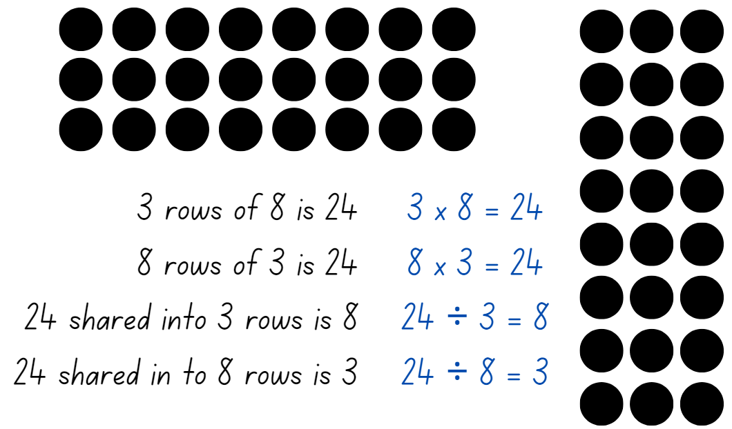
- Highlight to students:
- the link between multiplication and division
- commutative property of multiplication.
- Once students are confident, provide them with two 10-sided dice, counters and their workbooks. Students record their number sentences in their workbook.
- Select students to share end explain their arrays and number sentences.
Multi-age: Stage 3 students can record equivalent number sentence using fractions. For example, $\frac{24}{8}$ = 3. Provide Stage 3 students with an additional die to generate a fractional part of their total. Students repeat their turn if they roll a 6 on their die. Explain to students that the numerator will always remain as one. For example, if students roll a 3 then they find $\frac{1}{3}$ of 24.
This table details opportunities for assessment.
Assessment opportunities | Links
What to look for:  - Can Stage 2 students link multiplication and division fact families using arrays? [MAO-WM-01, MA2-MR-01]  - Can Stage 3 students identify and use inverse operations to assist with the solution of number sentences? [MAO-WM-01, MA3-MR-01]  - Can Stage 3 students recognise that division can be recorded using fractions? [MAO-WM-01, MA3-MR-01] | Links to National Numeracy Learning Progressions (NNLP):  - Stage 2 – MuS6  - Stage 3 – NPA3, NPA4, MuS7, InF6.  Links to suggested Interview for Student Reasoning (IfSR) tasks:  - Stage 3 – IfSR-MT: 3A.10.

Core lesson 1 – identifying and measuring right angles – 10 minutes
The table below contains suggested learning intentions and success criteria. These are best co-constructed with students.
Core concept learning intentions | Core concept success criteria
Students working towards Stage 2 outcomes are learning to:  - identify angles as measures of turn  - compare angles to a right angle.  Students working towards Stage 3 outcomes are learning to:  - investigate the relationships formed by the intersection of straight lines. | Students working towards Stage 2 outcomes can:  - identify the arms and vertex of an angle in various situations  - describe and measure quarter-turns as right angles  - informally measure and compare right angles.  Students working towards Stage 3 outcomes can:  - identify angle types formed by the intersection of straight lines, including right angles, straight angles and angles at a point that add to 360°  - recognise that perpendicular lines intersect at right angles.
This activity is an adaptation of Connecting Shapes and Angles from Sullivan.
- Ask students to stand up and all face the same direction.
- Revise that measuring an angle is measuring an amount of turn.
- Give students the following instructions:
- make a half turn to the left
- make a quarter turn to the right and another quarter turn to the right
- make a three-quarter turn to the left
- make a quarter turn to the right.
- Ask students to explain what instruction will bring you all back to facing the front again.
- Model and revise how:
- all angles have 2 straight arms and these can be different lengths
- all angles meet at a point called a vertex
- an angle tester can be used to measure square corners or right angles (see Figure 2).
Figure 2 – angle tester

- Ask students to describe the specific attributes of a right angle and record these on the board. For example, a right angle is a quarter turn, and the vertex is a ‘square’.
- Tell students that they will be learning many new words while they are learning about angles. As a class, use an anchor chart to record their findings and new vocabulary (see Figure 3).
Figure 3 – example anchor chart
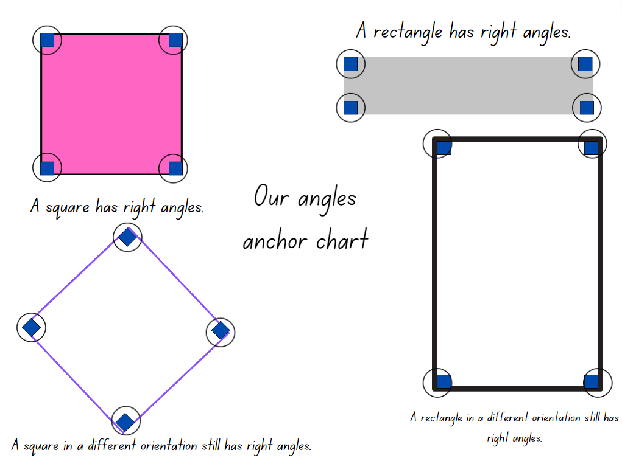
- Identify examples of right angles around the classroom. Discuss the ways in which right angles create a ‘square corner’.
Multi-age: explain to Stage 3 students that when 2 lines meet or cross over to make a 90° angle, they are also known as perpendicular lines. Add this to an anchor chart on angles for the class.
Perpendicular: 2 lines, rays, arms or other objects that intersect at a 90° angle (a right angle).

Core lesson 2 – making angles – 20 minutes
- Offer this hypothesis to students before working in stage-based tasks: Mathematicians say all squares and rectangles have 4 vertexes, and that each vertex is always a right angle. I am wondering:
- Is this true for all squares and rectangles? Can you explain why or why not?
- If one of the angles is not a right angle, is it still a square? Is it still a rectangle?
- If the square is tilted, is it a rhombus or is it still a square? How many right angles are there?
- If a rectangle is tilted, is it a different shape and does it still have 4 right angles?
- Allow time for students to explore the questions and develop their answers through stage-based activities.

Stage 2 task – finding and making internal angles
- Provide pairs of students with a variety of 2-dimensional shape blocks. Explain that students will use their angle tester to identify and record which shapes have right angles and how many right angles they have.
- Ask if there is a type of triangle that has a right angle.
- Students use the digital geoboard to model triangles that have right angles.
- Ask for several students to explain their thinking, using their digital geoboard to support their reasoning.
- Display and provide students with Resource 1 – right angles and shapes and explain, that in pairs, students will use their angle tester to identify and label all the internal right angles in each of the closed shapes as in Figure 4.
Figure 4 – example of recordings

- Provide pairs with a digital device and explain that students will use a digital geoboard to create a variety of different closed shapes that have more than 5 internal right angles. For examples, see Figure 5.
Figure 5 – examples of shapes
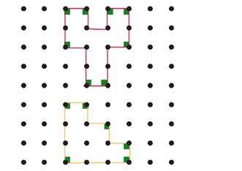

This table details opportunities for differentiation.
Too hard? | Too easy?
Students cannot identify, informally measure and compare right angles.  - Support students to fold an A4 piece of paper, as in Figure 6. Students use the right-angle tester to informally measure and compare angles.  - Students stack 2 different 2-dimensional shapes, one on top of the other to identify right angles and record their findings. | Students can identify, informally measure and compare right angles.  - Students use the digital geoboard to create a staircase shape, as in Figure 7. Explain that this staircase has 6 internal right angles. Ask students to investigate whether the number of internal angels would double if they doubled the size of the staircase.  - Students use Resource 1 – right angles and shapes to identify how many external right-angles each shape has.
Figure 6 – right angle tester
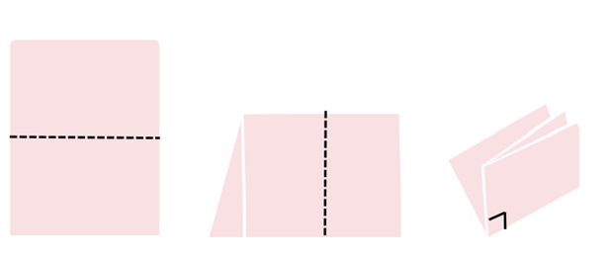
Figure 7 – staircase example
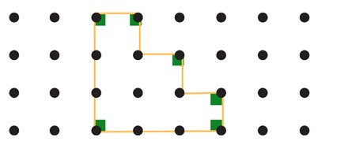

Stage 3 task – making right angles
This activity is an adaptation of ‘Lesson 1: How Many Right Angles?’ from reSolve by Australian Government Department of Education, 2023.
- Display Resource 2 – using a protractor and revise how to measure angles. Alternatively, the corner of a book could be used to test a right angle.
- Provide pairs of students with 2 ice-cream sticks.
- Explain that, for this task, the ice-cream sticks cannot be stacked or extended, as shown below in Figure 8.
Figure 8 – ice-cream stick rules
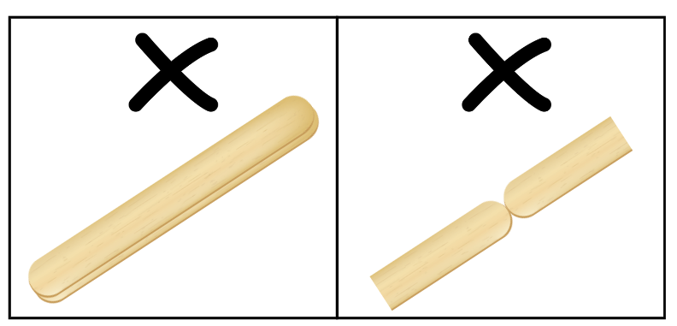
- Ask students to find how many right angles they can make by manipulating 2 ice-cream sticks, recording their findings.
Note: students count the right angles made as a 2D representation, not 3D. This means that 2 ice-cream sticks can make a maximum of 4 right angles, not 8.
- After students have had time to explore, use the prompt box to discuss their findings.
The table below outlines stimulus prompts to generate conversation about the topic, along with anticipated responses from students.
Prompts | Anticipated student responses
- How many right angles can you make with 2 ice-cream sticks? | - I can make one, 2 or 4 right angles.  - We found that the 2 ice-cream sticks could not be used to make 3 right angles.
- Share the different solutions discovered and have students explain why it is not possible to make 3 right angles with 2 sticks, as shown in Figure 9.
Figure 9 – right angle solutions
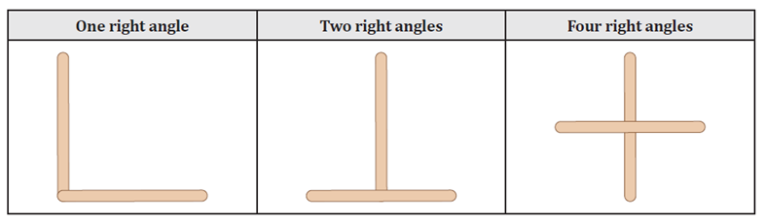
Image sourced from Lesson 1: How Many Right Angles? from reSolve by Australian Government Department of Education 2023.
- Ask students if there are any other angles that can be made by combining the right angles in their arrangements. For example:
- 2 right angles of 90° can be combined to make a straight angle of 180°.
- 3 right angles of 90° can be combined to make a reflex angle of 270°.
- 4 right angles of 90° can be combined to make a revolution angle of 360°.
- Pose the questions:
- What do you predict we will find if we use 4 ice-cream sticks?
- What about using 5 or 6 ice-cream sticks?
- What about using any number of ice-cream sticks?
- Students will find that they are able to recreate a different number of right angles by producing as many intersections as possible, using the ice-cream sticks like a grid. Refer to the language of perpendicular. For example, see Figure 10.
Figure 10 – ice-cream stick intersections
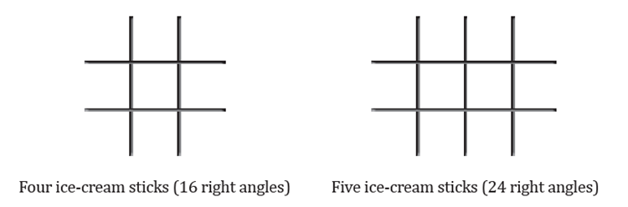
Image sourced from Lesson 1: How Many Right Angles? from reSolve by Australian Government Department of Education 2023.
This table details opportunities for differentiation.
Too hard? | Too easy?
Students cannot identify angle types formed by the intersection of straight lines, including right angles, straight angles and angles at a point that add to 360°.  - Model using the 2 ice-cream sticks and create a right angle. Use the angle identifier to confirm that the angle is 90°. Students trace the right angle into their workbook.  - Ask students to rearrange the 2 ice-cream sticks to create a right angle a different way. Support them to use the angle identifier to test them, then record their results in a table. | Students can identify angle types formed by the intersection of straight lines, including right angles, straight angles and angles at a point that add to 360°.  - Ask students to construct or draw a polygon with exactly 6 internal right angles.  - Students compare and discuss the various polygons created with another student.

Core lesson 3 – maximum angles – 20 minutes
- Ask how many right angles students can make with 3 straight lines.
- Allow students plenty of time to explore the problem.
Multi-age: Stage 2 students continue to create a variety of closed shapes using their digital geoboard. They may find that the number of straight lines may correspond to the number of sides of the closed shape but does not reflect the maximum number of internal right angles. Stage 3 students can continue to create a variety of 2D representations using ice-cream sticks. They may find that they can create 2, 3, 4, 5 and 8 right angles, but cannot make one or 7.
- Explain that mathematicians collect and record data in an organised way to help them look for patterns. Introduce a table to record students’ data.
Multi-age: Stage 2 students to record findings using a table to reflect maximum number of internal angles and maximum number of right angles. Figure 11. Stage 3 students to record findings using a table to reflect maximum number of right angles that can be made and the number of right angles that cannot be made. Figure 12.
Figure 11 – Stage 2 results table
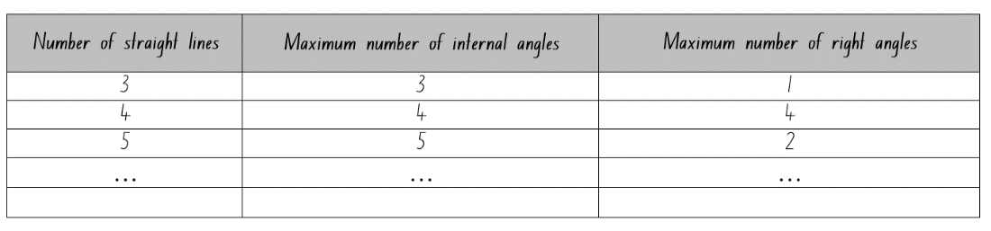
Figure 12 – Stage 3 results table
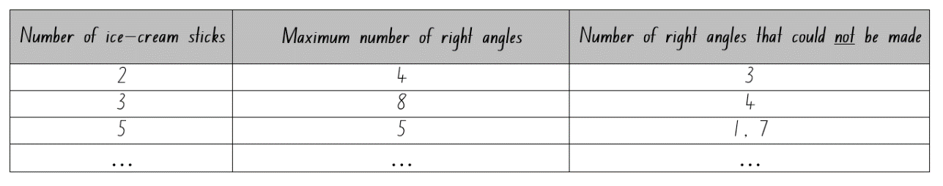

Discuss and connect the mathematics – 10 minutes
- Students go on a gallery walk to view all the created shapes on digital geoboards and ice-cream sticks.
- Ask students:
- What are you wondering about all the different shapes and the identified right angles?
- What is common about all the shapes? What is different?
- Can you see any other right angles?
- Did you use a strategy when designing your shape to make sure there were right angles? What did you have to think about?
- Discuss new vocabulary used in the lesson and add this to the anchor chart.
This table details opportunities for assessment.
Assessment opportunities | Links
What to look for:  - Can Stage 2 students identify right angles as measures of quarter turn? [MAO-WM-01, MA2-GM-03]  - Can Stage 2 students informally measure and compare right angles? [MAO-WM-01, MA2-GM-03]  - Can Stage 3 students identify angle types formed by the intersection of straight lines, including right angles, straight angles and angles at a point? [MAO-WM-01, MA3-GM-03]  - Can Stage 3 students recognise that perpendicular lines intersect at right angles? [MAO-WM-01, MA3-GM-03] | Links to National Numeracy Learning Progressions (NNLP):  - Stage 2 – UuM6, UuM7  - Stage 3 – UuM8, UGP5, UGP6.

Lesson 2
Core concept: angles are created when lines intersect and are often described and compared in relation to right angles.

Daily number sense – fact families – 10 minutes
The table below contains suggested learning intentions and success criteria. These are best co-constructed with students.
Daily number sense learning intentions | Daily number sense success criteria
Students working towards Stage 2 outcomes are learning to:  - recall multiplication facts of 2 and 4, 5 and 10 and related division facts.  Students working towards Stage 3 outcomes are learning to:  - determine products and factors. | Students working towards Stage 2 outcomes can:  - generate multiplication and division fact families for multiples of 2 and 4, 5 and 10.  Students working towards Stage 3 outcomes can:  - determine factors for a given number.
- Display Resource 3 – making fact families and explain that 8 is a multiple of 2 and of 4 (record the skip counting pattern of 2 and then by 4 to confirm that 8 is in both patterns). Explain that 2 and 4 are called factors of 8.
Factor: a number which divides another number without a remainder. For example, 1, 2, 3 and 6 are factors of 6 but 4 and 5 are not.
- Select one fact family from Resource 3 – making fact families to:
- model how to write multiplication and division sentences using fact families
- use arrays to prove the commutative property of multiplication.
Note: highlight to students that the number at the top of the triangle is the product of the 2 factors at the bottom of the triangle. For division, ensure students understand that the product of the fact family must be at the start of the sentence. Division is not commutative, so 2 ÷ 4 = 8 is not correct.
Product: the result of multiplying 2 or more numbers together, for example, 12 is the product of 4 × 3.
- Provide students with Resource 3 – making fact families. Students identify the fact families for the remaining triangles and record the number sentences.
Note: students may need concrete materials, such as counters, to manipulate while completing the activity. This activity can be differentiated by having students find other factors of the top number and writing out the fact families.
- Select students to share and explain their work and record each student’s responses for the class to see.

This table details opportunities for assessment.
Assessment opportunities | Links
What to look for:  - Can Stage 2 students generate multiplication and division fact families for multiples of 2 and 4, 5 and 10? [MAO-WM-01, MA2-MR-01]  - Can Stage 3 students determine factors for a given number? [MAO-WM-01, MA3-MR-01] | Links to National Numeracy Learning Progressions (NNLP):  - Stage 2 – MuS6  - Stage 3 – MuS6, MuS7.

Core lesson 1 – angle benchmarks – 15 minutes
The table below contains suggested learning intentions and success criteria. These are best co-constructed with students.
Core concept learning intentions | Core concept success criteria
Students working towards Stage 2 outcomes are learning to:  - identify angles as measures of turn  - compare angles to a right angle.  Students working towards Stage 3 outcomes are learning to:  - investigate the relationships formed by the intersection of straight lines. | Students working towards Stage 2 outcomes can:  - find and describe quarter-turns as right angles  - recognise and describe angles as less than, equal to, about the same as or greater than a right angle  - describe angles in comparison to quarter-turns as acute, right, obtuse, straight, reflex or a revolution.  Students working towards Stage 3 outcomes can:  - investigate adjacent angles that form a right angle and establish that they add to 90°  - investigate adjacent angles on a straight line and establish that they add to 180°  - investigate angles at a point and establish that they form an angle of revolution and add to 360°.
- Review learning from the previous lesson by asking students to recall the strategies to identify a right angle. These could include using an angle tester or comparing the angle to something that has a similar amount of turn. For example, using the corner of a book.
- Display Resource 4 – house plans and explain that Harry is building a house for a client. The house is being built in Orange, NSW and it needs to be built strong enough to support extra weight if it snows.
- For this design to be strong enough it needs to have:
- a right angle (of 90°) at the centre (marked as an ‘A’ on the plans)
- at least 10 internal right angles.
- Students turn and talk with a partner to see if the design for the house meets your criteria. Students share their findings with the class.
- Ask if it would it be possible for Harry to use the information provided to calculate some of the other angles:
- What are some ways to measure and calculate the size of other angles?
- What mathematical tools can we use to calculate the size of each angle?
- Students turn and talk with a partner, discussing how they think Harry could determine the size of the other angles.
- Explain that when something is known to be true, it can be used to test other things. This is called a ‘benchmark’. Tell students that right angles are useful benchmarks to estimate the size of other angles.
- Tell students that Harry measured angle G and found that it was half of a right angle. Ask students if they can use this information to determine the size of other angles.
Multi-age: as students begin to talk about combining angles, introduce the term ‘adjacent angles’ and ‘angles at a point’ to Stage 3.
Adjacent angles: angles that share a vertex and an arm. They do not overlap.
Angles at a point: adjacent angles that can be joined to create an angle of revolution, or 360°.

Core lesson 2 – angle art – 35 minutes

Stage 2 task – finding angles in art
- Display Figure 13. Students discuss and record the description for each angle. For example, the green angle opens less than a right angle.
Figure 13 – mystery angles
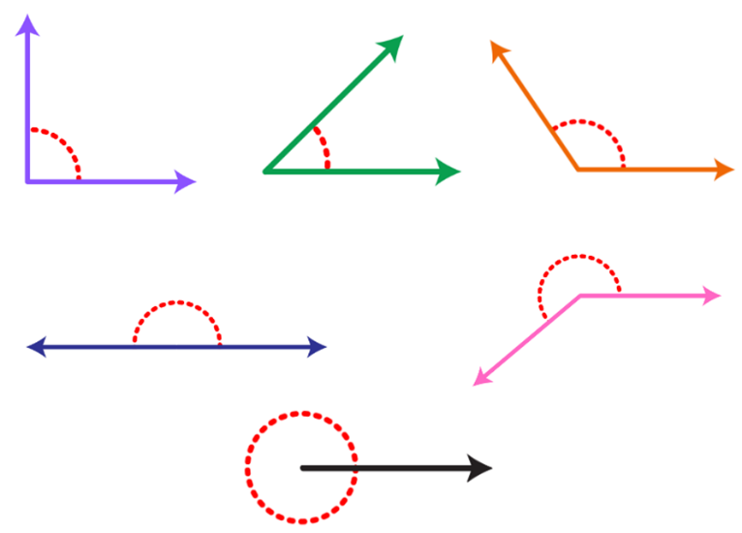
- Ask students to share how they would describe the angles and summarise their suggestions.
- Explain that mathematicians have names for different types of angles. Display Resource 5 – angle names and discuss the name and features that classify each of the angles.
- Explain that when 2 lines, arms or other objects meet to form a right angle, they are called perpendicular lines. Add this definition to the angles anchor chart.
- Display Resource 6 – angle art and explain that this artwork has many angles within it.
- Using a paper angle tester from Lesson 1, show how to test and classify some of the angles found in the artwork.
- Demonstrate how to label the angles to show the amount of turn between the arms.
- Provide students with a copy of Resource 6 – angle art. With a partner, students identify angles in the artwork.
- Students use their angle tester to identify and label as many angles as they can.
This table details opportunities for differentiation.
Too hard? | Too easy?
Students cannot describe angles in comparison to quarter-turns as acute, right, obtuse, straight, reflex or a revolution.  - Support students to focus on a specific sized angle, for example, acute angles. Assist them to use an angle tester to identify the same sized angles in Resource 6 – angle art. Record these using the same-coloured pencil each time.  - Students then choose another category of angle to focus on, using a different coloured pencil to label them. | Students can describe angles in comparison to quarter-turns as acute, right, obtuse, straight, reflex or a revolution.  - Students design their own example of angle art using overlapping straight lines. For an added challenge, they can aim to include a specific number of each type of angle.  - Students use a digital device to take a photograph of some buildings in the school. They identify and label different examples of angles in the image.

Stage 3 task – finding angles in art and design
- Students use a copy of Resource 4 – house plans and work with a partner to find the size of the other angles on the building plan.
- After giving students time to work on their plan, regroup as stage.
- Ask students to share their findings with the stage-based group, using the image of Resource 4 – house plans displayed on an interactive whiteboard.
- Discuss the reasoning used, as well as highlighting examples of:
- adjacent angles that form a right angle and add to 90° (for example, angles H and G).
- adjacent angles on a straight line and establish that they add to 180° (for example, angles A and B, or B and C).
- angles at a point and establish that they form an angle of revolution and add to 360° (for example, angles I, J, K and L).
- Display Resource 7 – hexagon angles and explain that students will be exploring what angles they can find within a hexagon.
- Model how to draw straight lines from diagonally opposite corners, creating equidistant intersecting lines as in the first image in Figure 14.
Figure 14 – hexagon angles
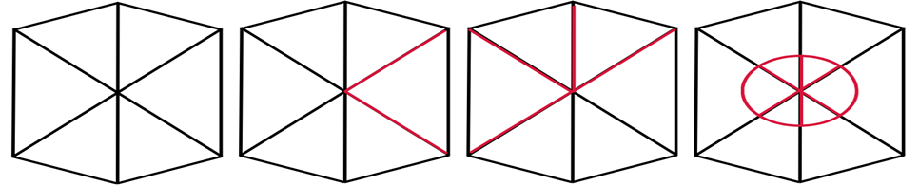
Equidistant: when 2 or more lengths are an equal distance from a central point.
- Provide students with Resource 7 – hexagon angles. With a partner, they draw straight lines from diagonally opposite corners.
- Explain that students are looking to find adjacent angles that total 90°, 180° and 360°.
- With their partner, students investigate and label:
- adjacent angles that form a right angle and add to 90°
- adjacent angles on a straight line and add to 180°
- angles at a point that form an angle of revolution.
This table details opportunities for differentiation.
Too hard? | Too easy?
Students cannot investigate adjacent angles that form a right angle, are on a straight line or form an angle of revolution.  - Support students to use a ruler and join the diagonally opposite corners in the hexagon. Assist them to identify and label lines that make a right angle, or 90°.  - Encourage students to find other adjacent angles that make a right angle, before looking to find angles on a straight line and an angle of revolution. Students label these and look for other combinations of adjacent angles. | Students can investigate adjacent angles that form a right angle, are on a straight line or form an angle of revolution.  - Students create their own building plan. They measure and write some of the angles, so that another student can use these to help them find the unknown angles. Encourage students to include some adjacent angles that form a right angle, are on a straight line or form an angle of revolution.  - Ask students to draw their own 2D shape and investigate the internal angles made. Then they join diagonally opposite corners with lines and measure the size of adjacent angles.

Discuss and connect the mathematics – 10 minutes
- After students have had an opportunity to identify and label some angles, regroup as a class and discuss new vocabulary used in the lesson.
- Update the anchor chart, adding new vocabulary and examples. Encourage students to use these appropriately in their descriptions and responses in stage-based discussions.
- Ask Stage 2 students:
- Which type of angle have you found the most of?
- Which type of angle have you found the least of?
- Why do you think that is?
- What if someone disagreed with the label you gave an angle. How could you convince them you have labelled them correctly?
- Display Resource 7 – hexagon angles for Stage 3 students and ask students to identify where they were able to find adjacent angles that total 90°, 180° and 360°.
- Discuss different ways that the same sized angle could be found in different arrangements, for example, 90°.
This table details opportunities for assessment.
Assessment opportunities | Links
What to look for:  - Can Stage 2 students find and describe quarter-turns as right angles? [MAO-WM-01, MA2-GM-03]  - Can Stage 2 students describe angles in comparison to quarter-turns as acute, right, obtuse, straight, reflex or a revolution? [MAO-WM-01, MA2-GM-03]  - Can Stage 3 students investigate adjacent angles that form a right angle and establish that they add to 90°? [MAO-WM-01, MA3-GM-03]  - Can Stage 3 students investigate adjacent angles on a straight line and establish that they add to 180°? [MAO-WM-01, MA3-GM-03]  - Can Stage 3 students investigate angles at a point and establish that they form an angle of revolution and add to 360°? [MAO-WM-01, MA3-GM-03] | Links to National Numeracy Learning Progressions (NNLP):  - Stage 2 – UuM6, UuM7  - Stage 3 – UuM8, UGP5, UGP6.

Lesson 3
Core concept: angles can be found in art, buildings and nature and angles at a point form an angle of revolution and add to 360°.

Daily number sense – solving problems with fact families – 10 minutes
The table below contains suggested learning intentions and success criteria. These are best co-constructed with students.
Daily number sense learning intentions | Daily number sense success criteria
Students working towards Stage 2 outcomes are learning to:  - recall multiplication facts about 2 and 4, 5 and 10 and related division facts  - solve problems using multiplication and division facts.  Students working towards Stage 3 outcomes are learning to:  - determine products and factors. | Students working towards Stage 2 outcomes can:  - generate multiplication and division fact families for multiples of 2 and 4, 5 and 10  - use knowledge of fact families to solve problems.  Students working towards Stage 3 outcomes can:  - determine factors for a given number.
- Display Resource 8 – lots of buttons and explain that students will work in pairs to solve the problem. Ask:
- What is the problem asking you to find out?
- Where would you start to solve the problem?
- How many different parts are there to the problem? Can you use the same strategy to solve each part?
- Which strategy do you think will work best to find a solution for this problem? Why?
- How can you record the solution?
- After students have had the opportunity to work on the solution, ask:
- How do you know the strategy you are using is working?
- How can you check that the answer is correct?
This table details opportunities for assessment.
Assessment opportunities | Links
What to look for:  - Can Stage 2 students generate multiplication and division fact families for multiples of 2 and 4, 5 and 10? [MA2-MR-01]  - Can Stage 2 students use knowledge of fact families to solve problems? [MAO-WM-01, MA2-MR-01]  - Can Stage 3 students determine factors for a given number? [MAO-WM-01, MA3-MR-01] | Links to National Numeracy Learning Progressions (NNLP):  - Stage 2 – MuS6  - Stage 3 – MuS6, MuS7.

Core lesson 1 – bridge art – 15 minutes
The table below contains suggested learning intentions and success criteria. These are best co-constructed with students.
Core concept learning intentions | Core concept success criteria
Students working towards Stage 2 outcomes are learning to:  - identify angles as measures of turn  - compare angles to a right angle.  Students working towards Stage 3 outcomes are learning to:  - investigate the relationships formed by the intersection of straight lines. | Students working towards Stage 2 outcomes can:  - find and describe quarter-turns as right angles  - recognise and describe angles as less than, equal to, about the same as or greater than a right angle  - describe angles in comparison to quarter-turns as acute, right, obtuse, straight, reflex or a revolution.  Students working towards Stage 3 outcomes can:  - investigate angles at a point and establish that they form an angle of revolution and add to 360°  - use a protractor to measure and identify types of angles.
This activity is an adaption of the resource Dorrit Black: The Bridge Interpretive Resource [PDF 4.3 MB] from the Art Gallery of South Australia.
Note: The Australian modernist Dorrit Black’s work 'The Bridge’ (1930) was Australia’s first cubist landscape and demonstrated a new approach to the painting of Sydney Harbour. As the eye moves across the picture plane, Black cleverly combines the passage of time in a single painting (AGSA 2019).
- Revise the angle art activity from the previous lesson, where students identified different sized angles in art.
- Ask students if they can recall the names given to the different sized angles. Use Resource 5 – angle names to check their understanding.
- Display the artwork The Bridge from the resource Dorrit Black: The Bridge Interpretive Resource [PDF 4.3 MB]. Ask students to describe what they notice.
- Explain that this artwork was painted by the Australian artist Dorrit Black in 1930. Her artwork was the first time an Australian artist used the style of Cubism, where the subject is shown in more than one perspective. Cubist artworks often use shapes, lines and angles to draw our eye to the subject.
- With a partner, students identify and describe angles in the artwork. Students share their ideas with the class.

Core lesson Part 2 – 35 minutes

Stage 2 task – angles in the environment
- Tell students that angles can be found all around them in natural and built environments. Display Figure 15 and ask:
- What attributes of angles have you learnt about in previous lessons?
- Which are you going to use to find angles in the artwork?
- Can you use these to identify an angle or the amount of turn between the arms?
- Is the angle greater than or smaller than a right angle?
- Can you name the angle?
Figure 15 – angles in the world

- Provide pairs of students with Resource 9 – environmental angles. Students work with their partner and use an angle finder to identify, label and name the angles in the images.
This table details opportunities for differentiation.
Too hard? | Too easy?
Students cannot describe angles in comparison to quarter-turns as acute, right, obtuse, straight, reflex or a revolution.  - Support students to focus on a specific sized angle, for example, acute angles. Assist them to use an angle finder to identify the same sized angles in Resource 5 – angle art. Record these using the same-coloured pencil each time.  - Students then choose another category of angle to focus on, using a different coloured pencil to label them. | Students can describe angles in comparison to quarter-turns as acute, right, obtuse, straight, reflex or a revolution.  - Ask students which types of angles they found the least of. Challenge students to find these angles in a natural or built environment within the school, or in a digital image.  - Students use a digital device to take a photograph of some buildings somewhere in the school. Students identify and label different examples of angles in the image.

Stage 3 task – stained glass
- Display Resource 10 – angle of revolution and explain that angles meeting at a point form an angle of revolution and add to 360°.
- Show that this can be tested by measuring angles at a point with a protractor, then adding them together to see if they equal 360°.
- Display Resource 11 – stained glass window and tell students that angles meeting at a point can be found in many places. Explain that these are made by joining coloured pieces of glass.
- Students turn and talk with a partner, to find examples of angles meeting at a point form an angle of revolution.
- Provide students with Resource 10 – angle of revolution and Resource 11 – stained glass window, a protractor and their workbooks. Students measure the angles a point on Resource 10 – angle of revolution first, recording each angle and calculating the total.
- Students then use Resource 11 – stained glass window, to measure and record the angles at a point.
Note: students should measure more than one of the angles at a point to establish that they form angles of revolution. Students may find the lines between the pieces of glass in Resource 11 – stained glass window challenging. Explain that students can focus on measuring the angle of each coloured piece of glass that is joining at a point. If these lines were removed, the glass pieces would still meet at a point to form an angle of revolution and add to 360°.
- Once students have had time to measure multiple angles at a point, regroup students to share their findings.
- Provide students with a collection of pattern blocks, a protractor and their workbook. Explain that they need to place the blocks together to form an angle of revolution (see Figure 16).
Figure 16 – pattern block example
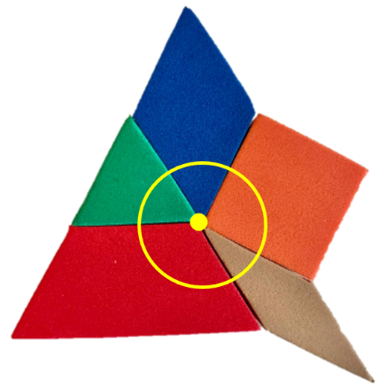
- Once students have formed an angle of revolution, they use a protractor to measure the angles and confirm that the total is 360°.
- Students then record their shapes and measurements using a labelled diagram.

This table details opportunities for differentiation.
Too hard? | Too easy?
Students cannot measure and add angles at a point.  - Use a digital device to take a photo of their combination of pattern blocks. Support students to identify the individual angles in the image of their pattern blocks by annotating the photo. Show how, when these adjacent angles are combined, they create an angle of revolution.  - Take an image of another combination of pattern blocks. Ask students to identify the angles at a point in this new image. | Students can measure and angles at a point.  - Challenge students to create a tessellating pattern with their blocks, then use a digital device to take a photo of it. Students then identify the repeated angles at a point in the image and mark them in the image.  - Students use their protractors to measure the angles at a point in their pattern blocks image. They can also swap pattern block images with another student to measure their angles at a point.

Discuss and connect the mathematics – 10 minutes
- After students have had an opportunity to identify and label some angles, ask:
- What did you notice about the angles in the images and resources?
- Was there something that you found surprising or interesting about the angle you found?
- Were you able to find all of the types of angles we have learnt about?
- Were there any types of angles that you have not been able to find?
- Where do you think these could be found in our world?
Multi-age: Stage 3 students discuss additional questions relating to pattern blocks.
- Ask Stage 3 students:
- How many degrees is an angle of revolution?
- Is there anywhere else you could find angles at a point that make an angle of revolution?
- Were there pattern blocks that did not form an angle of revolution?
- Did you face any challenges? How did you overcome these?
- Discuss any new vocabulary used in the lesson and add this to the anchor chart.
This table details opportunities for assessment.
Assessment opportunities | Links
What to look for:  - Can Stage 2 students find and describe quarter-turns as right angles? [MAO-WM-01, MA2-GM-03]  - Can Stage 2 students describe angles in comparison to quarter-turns as acute, right, obtuse, straight, reflex or a revolution? [MAO-WM-01, MA2-GM-03]  - Can Stage 3 students investigate angles at a point and establish that they form an angle of revolution and add to 360°? [MAO-WM-01, MA3-GM-03]  - Can Stage 3 students use a protractor to measure and identify types of angles? [MAO-WM-01, MA3-GM-03] | Links to National Numeracy Learning Progressions (NNLP):  - Stage 2 – UuM6, UuM7  - Stage 3 – UuM7, UuM8, UGP5, UGP6.

Lesson 4
Core concept: the arms and vertex of an angle can be visible or invisible.

Daily number sense – 10 minutes
- From a class need surfaced through formative assessment data, identify a short, focused activity that targets students’ knowledge, understanding and skills. Example activities may be drawn from the following resources:
- Mathematics K–6 resources
- Universal Resources Hub.

Core lesson 1 – investigating angles in letters – 10 minutes
The table below contains suggested learning intentions and success criteria. These are best co-constructed with students.
Core concept learning intentions | Core concept success criteria
Students working towards Stage 2 outcomes are learning to:  - compare angles to a right angle  - represent and read analog time.  Students working towards Stage 3 outcomes are learning to:  - identify, estimate, measure and compare angles using degrees. | Students working towards Stage 2 outcomes can:  - describe angles in comparison to right angles, as acute, right, obtuse, straight, reflex or a revolution  - identify 15 minutes as being a quarter-hour, 30 minutes as being a half-hour and 60 minutes as an hour  - read analog clock as past the hour to half-past and then towards the hour.  Students working towards Stage 3 outcomes can:  - estimate and describe the size of angles using known angles as benchmarks  - recognise right angles, angles on a straight line and angles at a point embedded in diagrams  - create and record angle measurements using the symbol for degrees (°).
- Explain that sometimes angles are hiding in objects or shapes. For example, when a door opens, the amount of turn between the door and the opening can be measured. Explain that the letters in the alphabet also have angles hiding in them.
- Display Resource 12 – alphabet letters. Explain that students will investigate each letter of the alphabet and record all the angles they can find in each letter.
- Ask students to identify examples of acute, right, obtuse, straight and reflex angles. For example, see Figure 17.
Figure 17 – example of recording
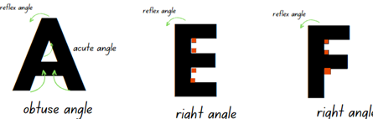
- Provide students with writing materials and Resource 12 – alphabet letters. As a class, discuss some examples of angles that students have identified. Select students to record the angles on a displayed Resource 12 – alphabet letters.
Multi-age: provide Stage 2 students with an angle tester and Stage 3 students with a protractor to measure the size of each angle.

Core lesson 2 – investigating angles in clocks – 30 minutes
- Display the interactive analog clock showing 3 o’clock. State the position of the house hand and minute hand when showing 3 o’clock make a right angle.
Note: prior to the lesson prepare an angle tester by cutting 2 strips of card and joining these with a split pin so that both strips can be rotated as arms to measure the turn of angles.
- Ask students to consider if there are other times that would show a right angle. Select student to model other times. Ensure students use the angle tester to measure and model the time as a right angle.
- Use the interactive analog clock as a class model, measure and discuss the following times that show acute and obtuse angles:
- Acute angle times: 11:10, 3:05 and 6:20
- Obtuse angle times: 5:00, 7:00 and 9:20
- Explain that pairs of students will use the first activity on Resource 13 – clock angles to identify and label which clocks show a time that makes an acute, right or obtuse angle.
- Provide pairs of students with writing materials, 2 strips of card and a split pin to make an angle tester. Ask:
- What did you notice about the house hand and minute hand when there was an acute angle?
- What did you notice about the hour hand and minute hand when there was an obtuse angle?
- What would happen to the angles if you changed the orientation of the clock. For example, turning the clock upside down.
- Can you estimate how many right-angle times there are?
- Can you estimate if there are more times that make an obtuse or acute angle? Explain.
Multi-age: Stage 2 students measure the angle formed between the 2 hands on the clock to identify the type of angle in comparison to a right angle. Students to label it as an acute, right, obtuse, straight, reflex or revolution. Stage 3 students use Resource 13 – clock angles and protractors to measure the angles of each time that is reflected on the analog clock.
This table details opportunities for differentiation.
Too hard? | Too easy?
Stage 2 students cannot describe angles in comparison to right angles, acute, obtuse, straight, reflex or a revolution.  - Support students to use their angle tester and only identify one type of angle. Students record their findings.  - Repeat the process and support students to only identify another type of angle.  Stage 3 students cannot describe angle sizes using known benchmarks or measure angles using the symbol for degrees (°).  - Support students to align their protractor accurately, then count the number of degrees in the angle starting from 0°. | Stage 2 students can describe angles in comparison to right angles, as acute, right, obtuse, straight, reflex or a revolution.  - In pairs, students use a digital device to record examples of objects that can rotate and change angle size becoming bigger as they ‘turn’. For example, a book or a door.  Stage 3 students can describe angle sizes using known benchmarks or measure angles using the symbol for degrees (°).  - Provide students with Resource 14 – angles in engineering to find, categorise, measure and record the size of the angles in one of the structures.  - Ask students to reflect on which type of angle is most common, and why.

Consolidation and meaningful practice – 15 minutes
- With a partner, students use a copy of Resource 15 – time angles and the interactive analog clock to make each of the displayed times. Students use their angle tester or protractors to check measure if their estimates were correct. Ask:
- I wonder if there is a time that makes a straight angle?
- What needs to happen to the hour hand to show a revolution?
- What time would it show if the clock hands made a reflex angle?
This table details opportunities for assessment.
Assessment opportunities | Links
What to look for:  - Can Stage 2 students describe angles in comparison to right angles, as acute, right, obtuse, straight, reflex or a revolution? [MAO-WM-01, MA2-GM-03]  - Can Stage 2 students identify 15 minutes as being a quarter-hour, 30 minutes as being a half-hour and 60 minutes as an hour? [MAO-WM-01, MA2-NSM-02]  - Can Stage 2 students read analog clock as past the hour to half-past and then towards the hour? [MAO-WM-01, MA2-NSM-02]  - Can Stage 3 students estimate and describe the size of angles using known angles as benchmarks? [MAO-WM-01, MA3-GM-03]  - Can Stage 3 students recognise right angles, angles on a straight line and angles at a point embedded in diagrams? [MAO-WM-01, MA3-GM-03]  - Can Stage 3 students create and record angle measurements using the symbol for degrees (°)? [MAO-WM-01, MA3-GM-03] | Links to National Numeracy Learning Progressions (NNLP):  - Stage 2 – UuM6, UuM7, MeT3  - Stage 3 – UuM7, UuM8.

Lesson 5
Core concept: halving, quartering blocks of time or using a number line helps to measure and sequence events and duration of events.

Daily number sense – decimals in order – 10 minutes
Daily number sense activities for Lessons 5 to 7 ‘loop’ back to concepts and procedures covered in previous units to assist students to build an increasingly connected network of ideas. These concepts may differ from the core concepts being covered by the unit.
The table below contains a suggested learning intention and success criteria. These are best co-constructed with students.
Daily number sense learning intention | Daily number sense success criteria
All students are learning to:  - make connections between decimals. | Students working towards Stage 2 outcomes can:  - compare and order decimals of up to 2 decimal places.  Students working towards Stage 3 outcomes can:  - compare and order decimals up to 3 decimal places.
- Provide pairs of students with playing cards with the face cards removed. Students divide the cards between them (aces are ones).
- Each students’ cards remain face down in a pile in front on them.
- On an individual whiteboard, each student draws a box large enough to fit a playing card, a dot and then 2 more large boxes.
- At the same time, each student turns over 3 cards, placing them into the boxes on their whiteboard (see Figure 18).
Figure 18 – example student whiteboard
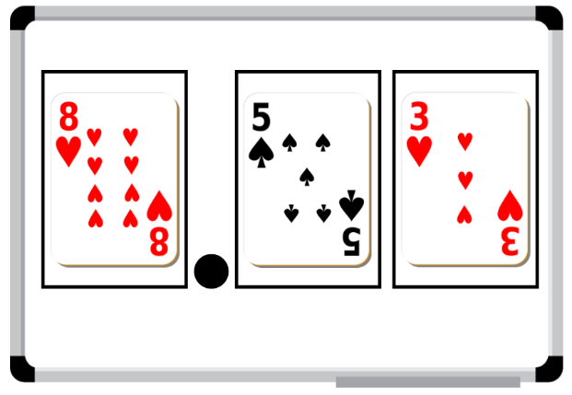
- Students then record their number on a sticky note and place the sticky notes in ascending order.
- Repeat the process, adding the new sticky notes to the order.
- Encourage students to share and discuss how they determine the placing of each stick note.
Multi-age: Stage 3 students to draw an additional playing card to generate a number with up to 3 decimal places.

This table details opportunities for assessment.
Assessment opportunities | Links
What to look for:  - Can Stage 2 students compare and order decimals of up to 2 decimal places? [MAO-WM-01, MA2-RN-02]  - Can Stage 3 students compare and order decimal numbers of up to 3 decimal places? [MAO-WM-01, MA3-RN-02] | Links to National Numeracy Learning Progressions (NNLP):  - Stage 2 – NPV6, NPV7  - Stage 3 – NPV8.  Links to suggested Interview for Student Reasoning (IfSR) tasks:  - Stage 2 – IfSR-NP: 4D.1, 4D.4  - Stage 3 – IfSR-PT: 1A.5, 1A.7  - Stage 3 – IfSR-AT: 4B.1  - Stage 3 – IfSR-NP: 4D.6.

Core lesson – 40 minutes

Stage 2 task – showing time
The table below contains suggested learning intentions and success criteria. These are best co-constructed with students.
Core concept learning intentions | Core concept success criteria
Students are learning to:  - represent and interpret digital time displays  - model and represent unit fractions. | Students can:  - read or set the time on digital devices to the minute, recognising there are 60 seconds in one minute  - recognise that the hour is read first in a digital display  - model fractions of a given time with fraction strips and diagrams for halves and quarters.
- Show the class the static analog clock. Ask students what they know about the features, including:
- the purpose of the 2 hands
- the markings
- that it is made up of 2 number lines presented in a circle
- that one number line shows the hours and the other shows the minutes.
Note: do not show the equivalent digital times yet. These can be removed by clicking ‘off’ at the bottom right-hand corner of the clocks.
- Display the active analog clock that shows the second hand. Ask students:
The table below outlines stimulus prompts to generate conversation about the topic, along with anticipated responses from students.
Prompts | Anticipated student responses
- How many hands does an analog clock have? | - An analog clock has 2 or 3 hands, if it has a seconds hand.
- What is the job of the short hand on the clock? | - The short hand is the hour hand. It travels from one number to the next in an hour.
- Which hand is the minute hand? | - The longer hand is the minute hand.
- Why is it called the minute hand? | - It is called the minute hand because it moves from one smalling marking to the next in a minute.
- Why is the second hand moving so quickly? | - The second hand moves each second. It moves all the way around the clock face in one minute, or 60 seconds.
- Explain that there are now 3 number lines on the clock, hours, minutes and seconds.
- Display Resource 16 – in a minute and explain that the 60 seconds in a minute can be shown in different ways, including on a clock face and as a number line. These include one minute or 60 seconds, ½ a minute or 30 seconds and ¼ minute or 15 seconds.
- Ask students to predict some tasks that would take approximately 15 seconds to complete, for example, 10 star jumps.
- Use the active analog clock to test this prediction, as students test how many star jumps they can complete in a minute.
- Remind students that timing usually starts when the seconds hand is on the 12 at the top of the clock.
Note: ‘digital clocks permit students to read times easily, but they do not relate very well to benchmark times. To know that a digital reading of 7:58 is nearly 8:00, the student must know that there are 60 minutes in an hour, that 58 is close to 60 and that 2 minutes is not a very long time. The analog clock shows ‘close to’ times visually without the need for understanding large numbers or how many minutes are in an hour’. (Van de Walle (2019).
- Explain that times can be represented in different ways, including analog clocks, digital clocks, fractions of time and timelines.
- Create a list of all the places students have seen these different types of clocks, for example, at school, home or on a digital device.
- Display the activity Time tools and explain that they need to match the 4 times that are written on both the analog and digital clocks. In pairs, students predict which digital and analog times match.
- Choose students to share their thinking for each of the times, then test it by completing the activity. Ask:
- What clues did you use to match the times?
- What do you think the first number in a digital time represents? Why?
- What do you think the second number in a digital time represents? Why?
- Explain that times are read with the hour first in a digital display, then the minutes after the colon. For example, 4:30 is read as ‘four-thirty’.
- Provide students with a copy of Resource 17 – showing the time and explain that they will be matching times using analog and digital clocks.
- With a partner, students say each time, then decide how to record it in Part 1 of Resource 17 – showing the time.
- After students have matched the digital and analog times, explain that times can also be shown as a fraction on analog clocks or on a bar model. Provide an example similar to the times in Part 2 of Resource 17 – showing the time.
- With a partner, students read each time presented in Part 2 of Resource 17 – showing the time. They decide how to represent it as a fraction of a minute on both the analog clock face and the fraction strip.
This table details opportunities for differentiation.
Too hard? | Too easy?
Students cannot read or set the time on digital devices to the minute.  - Revise the features on both analog and digital clocks using the activity Time tools.  - Using this activity, support students to read and set the time on digital devices to the minute.  Students cannot model fractions of time with fraction strips and diagrams for halves and quarters.  - Use the active analog clock and pause the clock at the time for each time in Part 2 of Resource 17– showing the time.  - Support students to shade the appropriate amount of time on each of the fraction strips and diagrams. | Students can read or set the time on digital devices to the minute.  - With a partner, students play ‘Time match’ in Time tools.  - Provide students with 2 digital times and ask them to find how long it takes to go from one time to the other. For example, work out the elapsed time from 7:25 to 9:45.  Students can model fractions of time with fraction strips and diagrams for halves and quarters.  - Provide students with 2 times and ask them to show how they could find the total. For example, ask students what the total would be if they double 45 seconds. Ask students to represent their answer in several ways.  - Challenge students to find how many minutes there are in 120 and 1000 seconds.

Stage 3 task – duration
The table below contains suggested learning intentions and success criteria. These are best co-constructed with students.
Core concept learning intentions | Core concept success criteria
Students are learning to:  - solve problems involving duration. | Students can:  - use start and finish times to calculate the elapsed time of events  - add and subtract time using a number line.
This activity is an adaptation of ‘Measure, calculate and compare elapsed time’ from FUSE by State of Victoria (Department of Education and Training).
- Revise students understanding of duration and elapsed time. Remind them that duration is the amount of time something takes. For example, lunch is 40 minutes long, which means it has a duration of 40 minutes. Ask:
- Can you think of examples of elapsed time?
- Between recess and lunch, how much time has elapsed? How do you know?
- What is the duration of the morning session?
Duration: the total amount of time something takes.
Elapsed time: the amount of time that has already passed.
For example, the duration of the movie was 2 hours. After one hour has elapsed, there is still one hour left.
- Explain that one strategy to calculate elapsed time is to use an empty number line as a timeline. Draw a number line on the board marked with the times 5:45 pm and 7:00 pm.
- Students turn and talk to discuss how the number line can be used to calculate the elapsed time.
- Select students to share and explain their strategies, testing students' ideas on a blank number line.
- If not already shared by students, demonstrate how to use an empty number line to calculate elapsed time, as in Figure 19. Model how to:
- add the remaining minutes from the current time to the next whole hour first, using one or more jumps
- use jumps to add any whole hours if needed
- add any more minutes needed to get to the final time, using one or more jumps.
Figure 19 – number line example
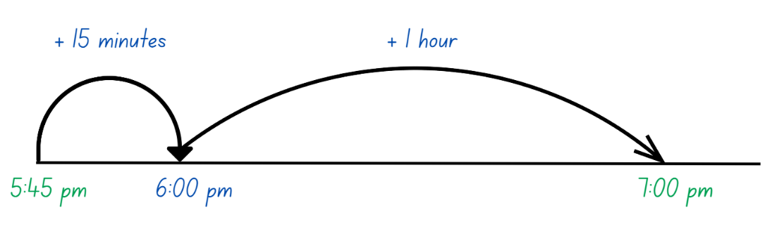
- Explain that the number line can also be used to jump backwards from an end time to calculate the elapsed time.
- Provide students with Resource 18 – elapsed times, an individual whiteboard and their workbook. Students draw a blank number line to calculate the elapsed times, recording the time in their workbook.
This table details opportunities for differentiation.
Too hard? | Too easy?
Students cannot use a number line to solve duration problems.  - Support students by providing them with a hands-on clock that can be manipulated to visually model the elapsed time.  - Provide elapsed time questions that have half past and o’clock times that only require 30 minutes or hours calculated. | Students can use a number line to solve duration problems.  - Challenge students to calculate the elapsed time mentally and record in their workbook.  - Students create their own elapsed time word problems for a partner to solve and record in their workbook.

Discuss and connect the mathematics – 10 minutes
- Regroup as a class and summarise the lesson. Ask:
- Were there any patterns you noticed with seconds, minutes or hours? (Stage 2)
- Did you find any strategies that helped you to read and write times? (Stage 2)
- Is there anything that you are still wondering? (Stage 2)
- Did you find an empty number line useful for calculating elapsed time? Why or why not? (Stage 3)
- Are there any other strategies you could use to calculate duration? (Stage 3)
- Why is solving duration a useful skill? (Stage 3)
- Does 12- or 24-hour make a difference in duration? Why or why not? (Stage 3)
This table details opportunities for assessment.
Assessment opportunities | Links
What to look for:  - Can Stage 2 students read or set the time on digital devices to the minute, recognising there are 60 seconds in one minute? [MAO-WM-01, MA2-NSM-02]  - Can Stage 2 students recognise that the hour is read first in a digital display? [MAO-WM-01, MA2-NSM-02]  - Can Stage 2 students model fractions of time with fraction strips and diagrams for halves and quarters? [MAO-WM-01, MA2-PF-01]  - Can Stage 3 students use start and finish times to calculate the elapsed time of events? [MAO-WM-01, MA3-NSM-02]  - Can Stage 3 students add and subtract time using a number line? [MAO-WM-01, MA3-NSM-02] | Links to National Numeracy Learning Progressions (NNLP):  - Stage 2 – MeT3  - Stage 3 – MeT4, MeT5.

Lesson 6
Core concept: time can be described using fractions and decimals.

Daily number sense – largest decimal – 10 minutes
The table below contains a suggested learning intention and success criteria. These are best co-constructed with students.
Daily number sense learning intention | Daily number sense success criteria
All students are learning to:  - make connections between decimals. | Students working towards Stage 2 outcomes can:  - compare and order decimals of up to 2 decimal places.  Students working towards Stage 3 outcomes can:  - compare and order decimals up to 3 decimal places using a number line.
- Provide pairs with two 10-sided dice and an individual whiteboard. Students draw a number line from zero to one.
- Students take it in turns to roll the dice and arrange them to make the largest number between zero and one with 2 decimal places, such as 0.86. Students record their decimal on the number line (see Figure 20).
Figure 20 – number line example
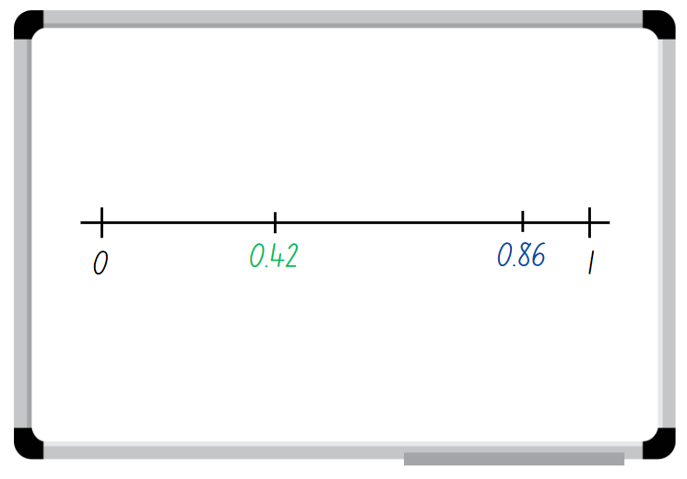
- Students repeat this process to create another decimal number each and place in order along their number line.
- Students read the decimals in order from zero to one, using their place value knowledge to justify how they know the order is correct.
Note: the focus for this activity can be easily changed, for example, students could be aiming for closest to zero, closet to 0.5 or the smallest decimal.
Multi-age: Stage 3 students use the number line to determine the differences between decimals.
This table details opportunities for assessment.
Assessment opportunities | Links
What to look for:  - Can Stage 2 students compare and order decimals of up to 2 decimal places? [MAO-WM-01, MA2-RN-02]  - Can Stage 3 students compare and order decimal numbers of up to 3 decimal places using a number line? [MAO-WM-01, MA3-RN-02] | Links to National Numeracy Learning Progressions (NNLP):  - Stage 2 – NPV6, NPV7  - Stage 3 – NPV8.  Links to suggested Interview for Student Reasoning (IfSR) tasks:  - Stage 2 – IfSR-NP: 4D.1, 4D.4  - Stage 3 – IfSR-PT: 1A.5, 1A.7  - Stage 3 – IfSR-AT: 4B.1  - Stage 3 – IfSR-NP: 4D.6.

Core lesson – fractions of time – 40 minutes
The table below contains suggested learning intentions and success criteria. These are best co-constructed with students.
Daily number sense learning intentions | Daily number sense success criteria
Students working towards Stage 2 outcomes are learning to:  - use am and pm notation  - represent fractional quantities equal to and greater than one.  Students working towards Stage 3 outcomes are learning to:  - solve problems involving duration in 12- and 24-hour time  - compare common fractions with related denominators  - use equivalence to add and subtract fractional quantities. | Students working towards Stage 2 outcomes can:  - record times using the colon notation with am and pm to distinguish between morning and evening  - represent totals of halves, thirds, quarters and fifths that extend beyond one.  Students working towards Stage 3 outcomes can:  - represent commonly used time intervals as fractions and decimals  - solve word problems involving adding or subtracting fractional quantities with related denominators  - create equivalent fractions for half in quarters, eighths, sixths and tenths by re-dividing the whole, using diagrams and number lines.
- Display the number 60 and ask students to share what they know about it. Student responses could include:
- doubles, halving and quartering
- 3 twenties, 10 sixes and 6 tens
- 60 minutes make one hour and 60 seconds make one minute
- one-quarter of 60 is 15, one-third of 60 is 20
- examples of inverse number sentences, for example, 60 ÷ 5 = 12 and 12 × 5 = 60
- examples of commutative number sentences, for example, 5 × 12 = 60 and 12 × 5 = 60.
- If not mentioned above, explicitly refer to commutative examples, inverse examples and multiplicative relationships.
- Explain to students that exploring facts about 60 is helpful when exploring and reading time.
- Show an interactive analog clock. Discuss and model on the clock face some of the facts of 60, such as in Figure 21.
Figure 21 – facts of 60 on a clock
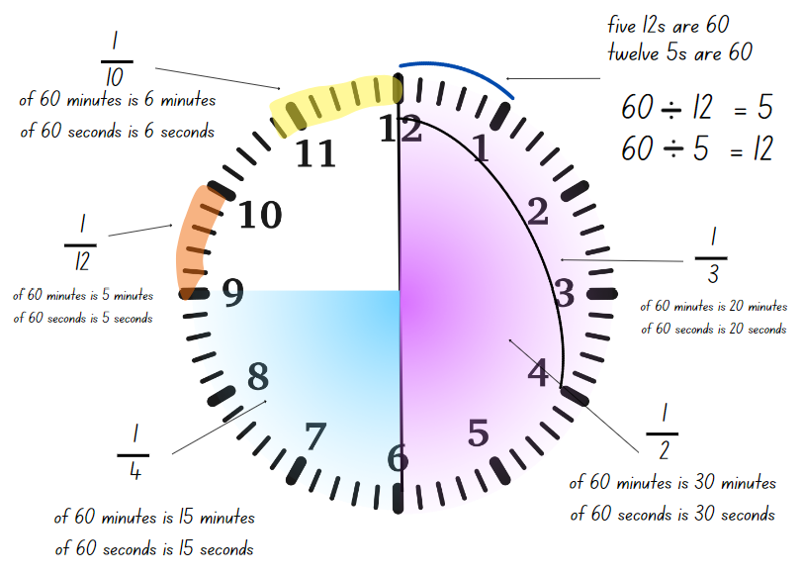
The table below outlines stimulus prompts to generate conversation about the topic, along with anticipated responses from students.
Prompts | Anticipated student responses
- Half the clock face is called half an hour. How many minutes is this? | - There are 30 minutes in half an hour.
- If I know that half of 60 minutes is 30 minutes, what else do I know? | - If I know what half an hour is, I can find a quarter of an hour by halving it again.
- How many minutes are there in a quarter of an hour? How many in 3 quarters? | - There are 15 minutes in a quarter of an hour, and 45 minutes in 3 quarters of an hour.
- How many minutes are there in a third of an hour? How many in 2 thirds? | - A third of 60 minutes is 20 minutes. 2 thirds would be 40 minutes.
- How many times will 10 minutes fit on the clock face? What fraction of an hour would 10 minutes be? | - 10 minutes will fit 6 times on the clock face. This means 10 minutes in one sixth of an hour.
- How else can I use fractional language to describe minutes and seconds? | - There are the same number of seconds in a minute as there are minutes in an hour. This means that the fractions of 60 minutes work for 60 seconds, too.
- Ask students to share what time they go to bed. Record the times on the board.
- Using an interactive analog clock, state that the current time, for example, 10 o’clock. Point out that, according to the list of bedtimes, everyone should be in bed!
- Ask how students can be clear about when something is happening, either in the morning or evening.
Multi-age: Stage 3 students should respond with 24-hour time.
- Display Resource 19 – hour strips and explain that the strips are divided into 60 parts to represent an hour. Ask:
- Why is the strip divided into 60 parts?
- How could half an hour be shown on the strip?
- How could half an hour be represented in fractions? Is there more than one way this could be represented?
- How could half an hour be represented in decimals?
- Provide Stage 3 students with Resource 19– hour strips. Stage 3 Students calculate and colour the correct fraction and record the corresponding decimal for each strip (see Figure 22).
Figure 22 – Stage 3 hour strip example
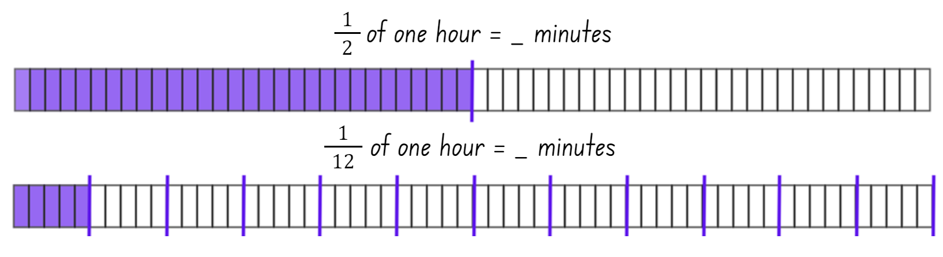
- While Stage 3 students are working independently, display Resource 20 – day and night timeline for Stage 2 students and ask:
- What can you see?
- How many hours are there in one timeline?
- How many hours are there all together in the 2 timelines?
- How do we describe the 12 hours before noon (12 o’clock midnight to 11:59) and how do we describe the time after noon?
- Identify how am and pm notation are used to communicate whether a time is before noon or after noon.
- Describe some events and ask students to write the time on a whiteboard with a partner, using am or pm notation to show what time of the day it is occurring in. For example, explain that you are having breakfast at 7 o’clock and ask how you would write it (7:00 am).
- Explain that understanding and reading time helps to be punctual, organised, to avoid confusion and plan ahead.
- Display Resource 21 – creative arts activities and explain that Serena and Brian’s school organised special creative arts workshops from 12 noon to 2 o’clock. Some workshops were longer than others and students were able to try more than one.
- Draw students’ attention to the first activity listed on Resource 21 – creative arts activities. Ask students to turn and talk with partner, to see if they can work out how many times the music class will fit into the 2 hours.
- While Stage 2 students are discussing with a partner Provide Stage 3 students with Resource 22 – duration problems and their workbooks. Explain that they should use their completed Resource 19 – hour strips to help solve the duration problems, recoding the solution in their workbook.
- Once Stage 3 students are working independently, ask several Stage 2 students to share their answer and explain their reasoning.
- If not identified, point out that each row of the creative arts timetable is like a bar model. The row for the music workshop can be divided to show that the 2 hours will allow the one hour music workshops to happen twice.
- Repeat this process for the dance workshops, with students sharing strategies they used to show that the 2 hours will fit the 30 minutes dance workshops 4 times.
- In pairs, Stage 2 students use Resource 21 – creative arts activities to find how many times each of the other workshops will be able to run in the 2 hours. The markings made for the previous workshops can be used as benchmarks to support students’ thinking.
- Explain that Stage 2 students can also use the last bar model to decide which of the workshops they would go to if they had the choice. Students represent these on the bar, making sure that each workshop takes up the amount of space that reflects its length of time. This bar can also be cut out so students can layer them on the lengths of time of the activities.

This table details opportunities for differentiation.
Too hard? | Too easy?
Stage 2 students cannot regroup and represent totals of halves, thirds, quarters and fifths that extend beyond one.  - Support students to focus on one activity, for example, the drama workshop. Highlight that space on their copy of Resource 21 – creative art activities and assist them to partition it to fit the 2 workshops, then model how to use students’ knowledge of halves to build up the number of halves.  Stage 3 students cannot solve word problems involving adding or subtracting fractional quantities with related denominators.  - Assist students in calculating and highlighting the fractions and decimals on Resource 19 – hour strips. Encourage students to reference these when solving the duration problems.  - Support students’ knowledge of $\frac{1}{2}$ and $\frac{1}{3}$ by asking duration questions that only require $\frac{1}{2}$ and $\frac{1}{3}$ of hours. | Stage 2 students can regroup and represent totals of halves, thirds, quarters and fifths that extend beyond one.  - Students create a new timetable for a creative arts workshop that now runs for 2 $\frac{3}{4}$ hours. Using a number line marked zero to 2 $\frac{3}{4}$ hours, students label and mark the new duration for each activity.  - With a partner, students explore how many fractions can be combined to total 1 $\frac{1}{2}$.  Stage 3 students can solve word problems involving adding or subtracting fractional quantities with related denominators.  - Challenge students by asking them to solve and record duration questions that are longer than one hour as fractions and minutes.  - Challenge students to create their own fraction duration questions for a partner to solve and record in their workbook.

Discuss and connect the mathematics – 10 minutes
- Regroup as a class and summarise the lesson together drawing out key mathematical ideas. Ask:
- What was the most of creative arts workshops that could fit into the 2 hours? (Stage 2)
- What was the total amount of the 2 hours that you and your partner decided to use? (Stage 2)
- Who had the smallest amount of left-over time at the end of the 2 hours? What fraction of the 2 hours is that? (Stage 2)
- Was the hour strip helpful in calculating duration? Why or why not? (Stage 3)
- Why was the strip divided into 60 sections? (Stage 3)
- Was calculating the fractions or decimals easier? (Stage 3)
- Is there another strategy that could be used to solve the problems? (Stage 3)
This table details opportunities for assessment.
Assessment opportunities | Links
What to look for:  - Can Stage 2 record times using the colon notation with am and pm to distinguish between morning and evening? [MAO-WM-01, MA2-NSM-02]  - Can Stage 2 students represent totals of halves, thirds, quarters and fifths that extend beyond one? [MAO-WM-01, MA2-PF-01]  - Can Stage 3 students represent commonly used time intervals as fractions and decimals? [MAO-WM-01, MA3-NSM-02]  - Can Stage 3 students solve word problems involving adding or subtracting fractional quantities with related denominators? [MAO-WM-01, MA3-RQF-02]  - Can Stage 3 students create equivalent fractions for half in quarters, eighths, sixths and tenths by re-dividing the whole, using diagrams and number lines? [MAO-WM-01, MA3-RQF-02] | Links to National Numeracy Learning Progressions (NNLP):  - Stage 2 – MeT4, InF5  - Stage 3 – MeT5, InF7, InF8, PrT2.

Lesson 7
Core concept: the context determines the most suitable standard unit.

Daily number sense – fractions and decimals – 10 minutes
The table below contains suggested learning intentions and success criteria. These are best co-constructed with students.
Daily number sense learning intentions | Daily number sense success criteria
Students working towards Stage 2 outcomes are learning to:  - make connections between fractions and decimal notation.  Students working towards Stage 3 outcomes are learning to:  - make connections between decimals. | Students working towards Stage 2 outcomes can:  - make connections between fractions and decimal notation for key benchmark values.  Students working towards Stage 3 outcomes can:  - compare and order decimals up to 3 decimal places using a number line.
- Provide students with Resource 23 – fractions and decimals. Students label the correct fractions and matching decimal benchmarks. For example, 0.5 is the same as half.
- Students then add any other matching fractions and decimals to the number lines that they know. For example, one-fifth is the same as 0.2.
- Select students to share and explain the fractions and decimals they selected.
Multi-age: Stage 3 students add more complex fractions and matching decimals up to 3 decimal places.
This table details opportunities for assessment.
Assessment opportunities | Links
What to look for:  - Can Stage 2 students make connections between fractions and decimal notation for key benchmark values? [MAO-WM-01, MA2-RN-02]  - Can Stage 3 students compare and order decimal numbers of up to 3 decimal places? [MAO-WM-01, MA3-RN-02] | Links to National Numeracy Learning Progressions (NNLP):  - Stage 2 – NPV6, NPV7, InF6  - Stage 3 – NPV8.  Links to suggested Interview for Student Reasoning (IfSR) tasks:  - Stage 2 – IfSR-NP 4D.3, 4D.7  - Stage 3 – IfSR-PT: 1A.5, 1A.7  - Stage 3 – IfSR-AT: 4B.1  - Stage 3 – IfSR-NP: 4D.6.

Core lesson 1 – test yourself – 10 minutes
The table below contains suggested learning intentions and success criteria. These are best co-constructed with students.
Core concept learning intentions | Core concept success criteria
Students working towards Stage 2 outcomes can:  - represent and interpret digital time displays.  Students working towards Stage 3 outcomes are learning to:  - solve problems involving duration, using 12- and 24-hour time. | Students working towards Stage 2 outcomes can:  - identify situations where duration is measured in seconds  - read or set the time on digital devices to the minute or second.  Students working towards Stage 3 outcomes can:  - use start and finish times to calculate the elapsed time of events  - use the zoom and mental strategies to calculate elapsed time  - represent commonly used time intervals as decimals  - solve a variety of problems involving duration, including where times are expressed in 12-hour and 24-hour notation.
This activity is an adaptation of ‘Test yourself’ from Teaching Mathematics: Foundations to Middle Years by Siemon et al.
- Explain that in this lesson students will learn about measuring and recording times using minutes and seconds.
- Tell the class that they will be estimating how long a minute is. Show the students a timing device, for example, a timer on a digital device or a stopwatch.
- Explain that, when the timer starts, students will not be able to see the seconds passing and they will have to estimate how long it is until a minute, or 60 seconds, has passed. When they think it exactly one minute, they raise their hand. Students can close their eyes so they are not influenced by their peers.
- Start the timer and observe which student is the most accurate.
- Stop the timer just after 60 seconds and reveal the student who was the most accurate.
- Repeat the activity and see if students can improve the accuracy of their estimate. This time, stop the timer at close to one minute.
- After revealing the student who was the most accurate, write the digital time on the board.
- Discuss how the colon can also be used to record digital times with minutes and seconds. Demonstrate how this time would be read, for example, 1:01 would be read as ‘one minute and one second’.
Note: many stopwatches measure time to the nearest hundredth of a second, however, this is not the focus of the lesson. Tell students that the purpose of the second colon and rapidly moving numbers is for measuring lengths of time accurately to less than a second. Explain that the students don’t need to focus on these, instead they are recording the number of seconds taken to complete the obstacle course. Identify that the colon is not a decimal point and so the numbers are not read like decimals, but as minutes and seconds.

Core Lesson 2 – 30 minutes

Stage 2 Task – timed challenge
- Introduce a timed writing challenge for students to complete. Students need to write their name 6 times as fast as they can.
- Show students how to use a timing device that records seconds accurately, for example, a timer on a digital device or a stopwatch.
- Discuss the similarities and differences between these measuring tools and demonstrate how these times would be read, for example, 00:28 would be read as ‘28 seconds’.
- Choose a volunteer to complete the writing challenge and have students time them on their devices. Compare times captured by the students and discuss the results.
The table below outlines stimulus prompts to generate conversation about the topic, along with anticipated responses from students.
Prompts | Anticipated student responses
- Did everyone’s timers show the same? | - The times were similar, but not the same.
- If not, why not? | - When the teacher said ‘go!’ everyone pressed start at a slightly different time. The same thing happened when the student crossed the finish line.
- What could help make the timing as accurate as possible? | - Making sure that everyone is ready to start and stop timing can help to improve accuracy.
- Would hours be a useful unit of measurement for this activity? Why or why not? | - Hours aren’t a useful unit of measurement for this activity because they are too long.
- With their partner, students record the time for the first student to write their name 6 times in digital form, for example, 00:37.
- Choose different volunteers to write their name and repeat the process for students to practise using the timing device accurately. Discuss the range of times recorded by students on their devices. Record their results so that these can be compared.
- Variations of this activity include:
- students competing in teams to write their names as quickly as possible
- timing the whole class to write their name 6 times, then aiming to beat their record
- including a longer challenge, so that times include minutes and seconds
- timing the teacher to complete the challenge!

This table details opportunities for differentiation.
Too hard? | Too easy?
Students cannot read or set the time on digital devices to the minute or second.  - Support students to use their device to start and finish timing accurately.  - Assist students to record their time in digital form, reading each time aloud to check for understanding. | Students can read or set the time on digital devices to the minute or second.  - Students order the times from shortest to longest to establish a ‘leaderboard’.  - With a partner, students try to find the number of seconds between each time recorded. They can use a number line or bar diagram to show their thinking.

Stage 3 task – zoom strategy
- Introduce another strategy for calculating elapsed time by displaying Resource 24 – the zoom strategy.
- Demonstrate how to use the zoom strategy:
- Identify the start time and the end time.
- Bridge the starting minutes to the closest hour.
- Then, identify how many hours until the finish hour.
- Identify how many minutes (if any) remain until the finish time.
- Add the hours and minutes together to find the total time (see Figure 23).
Figure 23 – Zoom strategy example
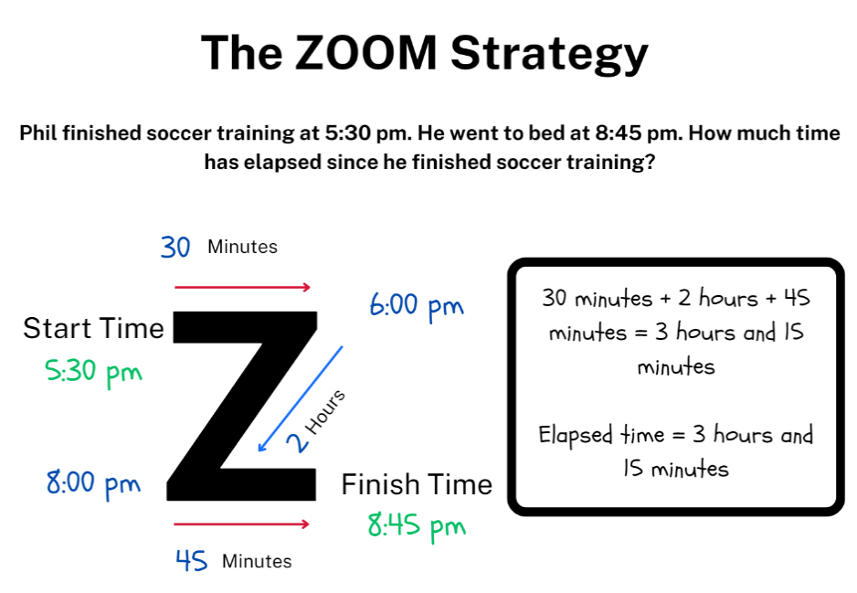
Note: if the elapsed time has a finish time that is on the hour, students will not need to use the final line of the zoom model as there are no remaining minutes to add.
- Provide students with Resource 24 – the zoom strategy (either laminated or in a reusable sleeve), Resource 25 – elapsed timecards and their workbook.
- Students use the zoom strategy to find the elapsed time of each of the cards and record their working out and answers in their workbook.
This table details opportunities for differentiation.
Too hard? | Too easy?
Students cannot solve a variety of problems involving duration, including where times are expressed in 12-hour and 24-hour notation.  - Support students by providing them with a hands-on clock that can be used to visually model the elapsed time.  - Provide students with elapsed time questions that have half past and o’clock times and only require 30 minutes and hours calculated. | Students can solve a variety of problems involving duration, including where times are expressed in 12-hour and 24-hour notation.  - Challenge students to create their own elapsed time question for a partner to solve using the zoom strategy.  - Challenge students to find the elapsed time without using the zoom strategy.

Discuss and connect the mathematics – 10 minutes
- Regroup as a class and ask:
- Why are seconds and minutes useful units of measurement? (Stage 2)
- Did you and your partner become more confident in recording times accurately? (Stage 2)
- Can you think of another challenge that could be timed on another day? (Stage 2)
- Did you find any strategies that helped you to find the difference between times? (Stage 2)
- Did you find the zoom strategy successful for calculating elapsed time? Why or why not? (Stage 3)
- Can you think of any other strategies you could use to calculate elapsed time? (Stage 3)
- What elapsed time did your record for each card? (Stage 3)
- Why is solving elapsed time a useful skill? (Stage 3)
This table details opportunities for assessment.
Assessment opportunities | Links
What to look for:  - Can Stage 2 students identify situations where duration is measured in seconds? [MAO-WM-01, MA2-NSM-02]  - Can Stage 2 students read or set the time on digital devices to the minute or second? [MAO-WM-01, MA2-NSM-02]  - Can Stage 3 students use start and finish times to calculate the duration of events? [MAO-WM-01, MA3-NSM-02]  - Can Stage 3 students use the zoom and mental strategies to calculate elapsed time? [MAO-WM-01, MA3-NSM-02]  - Can Stage 3 students represent commonly used time intervals as decimals? [MAO-WM-01, MA3-NSM-02]  - Can Stage 3 students solve a variety of problems involving duration, including where times are expressed in 12-hour and 24-hour notation? [MAO-WM-01, MA3-NSM-02] | Links to National Numeracy Learning Progressions (NNLP):  - Stage 2 – MeT3  - Stage 3 – MeT4, MeT5.

Lesson 8
Core concept: time can be used to coordinate events in the world.

Daily number sense – 10 minutes
- From a class need surfaced through formative assessment data, identify a short, focused activity that targets students’ knowledge, understanding and skills. Example activities may be drawn from the following resources:
- Mathematics K–6 resources
- Universal Resources Hub.

Core lesson – organising an excursion – 50 minutes
The table below contains suggested learning intentions and success criteria. These are best co-constructed with students.
Core concept learning intentions | Core concept success criteria
Students working towards Stage 2 outcomes are learning to:  - represent am and pm notation in real-life situations.  Students working towards Stage 3 outcomes are learning to:  - compare 12- and 24-hour time systems and convert between them  - solve problems involving duration, using 12- and 24-hour time. | Students working towards Stage 2 outcomes can:  - use minutes to describe the duration of events  - identify 30 minutes as being a half-hour and 60 minutes as an hour  - record times using the colon notation with am and pm to distinguish between morning and evening.  Students working towards Stage 3 outcomes can:  - convert between 12- and 24-hour time systems  - create, interpret and use timetables from real-life situations, involving 12- and 24-hour time  - use start and finish times to calculate the elapsed time of events.
Note: Resource 26 – excursion planning can be amended to reduce the number of days of the excursion to meet students’ needs. This learning task may take more than one lesson.
- Explain to students that they will be organising an excursion for Years 3–6 to Canberra. The excursion will leave from your school and will need to last for 3 to 5 days including travel.
- Display Resource 27 – using Google Maps and demonstrate how to use Google Maps to locate places to visit, as well as the duration of travel. Ask:
- If Google Maps states that it takes 9 hours and 36 minutes to travel somewhere, will the trip take that exact amount of time?
- When looking at the time it takes to travel somewhere, is it better to allow more or less time?
- How can rounding time help when planning an excursion?
Multi-age: Stage 2 students are not required to understand how to use maps and timetables and should be partnered with a Stage 3 student, focusing on 30 minutes as half-hour, 60 minutes and an hour and recoding time in am or pm notation.
- Display Resource 26 – excursion planning and explain that students will need to create a timetable for the excursion to follow including time for meals, travel, time to visit locations and sleep. Highlight that Resource 26 – excursion planning has been separated into 24 blocks to represent the 24-hours in a day.
- Provide mixed stage pairs or small groups of students with Resource 27 – using Google Maps multiple copies of Resource 26 – excursion planning and a device that can access Google Maps. Stage 3 Students record their times in 12-hour and 24-hour time. Provide students with the following criteria:
- Create a timetable for the excursion in 12- and 24- hour time.
- Plan the locations to visit and how long will be spent at each location.
- Allocate time for meals and sleep on the timetable.
- Allocate appropriate travel time on the timetable between locations by using Google Maps.
- Calculate the duration of travel time, sleep, mealtimes and location visits for the whole excursion.
Multi-age: Stage 2 students are not required to work with 24-hour time. To support Stage 2 students' outcomes, pre-fill the 12-hour times on Resource 26 – excursion planning and ask students to record am or pm notation in the correct locations Stage 2 students record how many minutes and activity or visit lasts.
Note: if there are not enough devices to complete the activity in pairs or small groups, display Google Maps on the Interactive Whiteboard and complete the activity as a whole class.
This table details opportunities for differentiation.
Too hard? | Too easy?
Stage 2 students cannot represent and record real lifetime time situation using am and pm notation.  - Use the interactive clocks to make both digital and analog times for students to practice reading am and pm notations.  Stage 3 students cannot create, interpret and use timetables from real-life situations, involving 12- and 24-hour time.  - Provide students with locations to visit and support them to use Google Maps to calculate the travel duration and how long students would stay at each location.  - Provide students with sleep and mealtimes on Resource 26 – excursion planning. | Stage 2 students can represent and record real lifetime time situation using am and pm notation.  - Using a digital device, students record an explanation for how to use am and pm notation to be shared with the class.  Stage 3 students can create, interpret and use timetables from real-life situations, involving 12- and 24-hour time.  - Challenge students to organise an excursion for a large group of Year 5 and 6 students. This will mean that not all students can be at the same location at the same time.  - Students calculate the length of time spent at different locations each day as a fraction and decimal.

Discuss and connect the mathematics – 10 minutes
- Regroup as a class and summarise the lesson together drawing out key mathematical ideas. Ask:
- Was Google Maps an effective tool for this activity? Why or why not?
- Could you use a physical map to complete the task? Why or why not?
- Would you attend your planned excursion? Why or why not?
- What strategy did you use to calculate the durations? (Stage 3)
- Why do we use am and pm notation? (Stage 2)
- Why is 24-hour used? (Stage 3)
This table details opportunities for assessment.
Assessment opportunities | Links
What to look for:  - Can Stage 2 students use minutes to describe the duration of events? [MAO-WM-01, MA2-NSM-02]  - Can Stage 2 students Identify 30 minutes as being a half-hour and 60 minutes as an hour? [MAO-WM-01, MA2-NSM-02]  - Can Stage 2 students record times using the colon notation with am and pm to distinguish between morning and evening? [MAO-WM-01, MA2-NSM-02]  - Can Stage 3 students convert between 12- and 24-hour time systems? [MAO-WM-01, MA3-NSM-02]  - Can Stage 3 students create, interpret and use timetables from real-life situations, involving 12- and 24-hour time? [MAO-WM-01, MA3-NSM-02]  - Can Stage 3 students use start and finish times to calculate the elapsed time of events? [MAO-WM-01, MA3-NSM-02] | Links to National Numeracy Learning Progressions (NNLP):  - Stage 2 – MeT2, MeT3, MeT4  - Stage 3 – MeT5.

Resource 1 – right angles and shapes
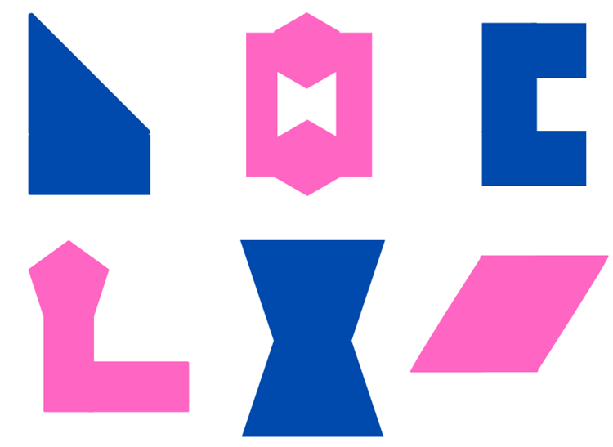

Resource 2 – using a protractor
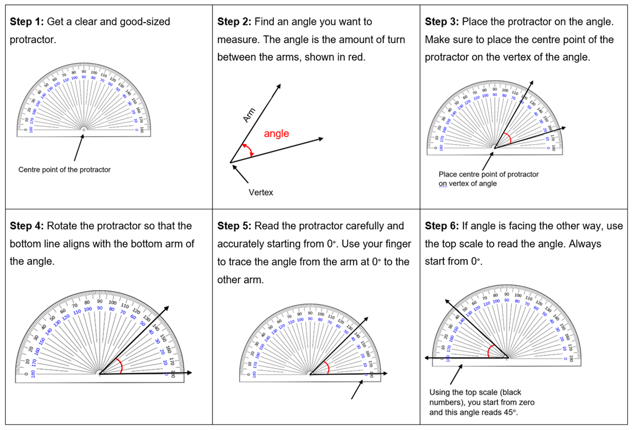

Resource 3 – making fact families
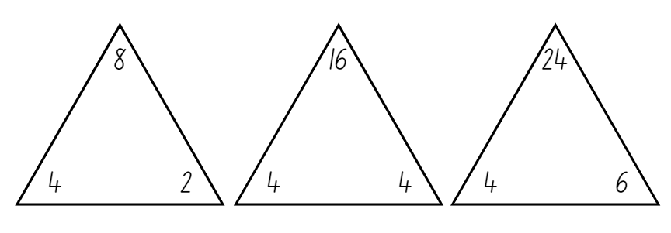

Resource 4 – house plans
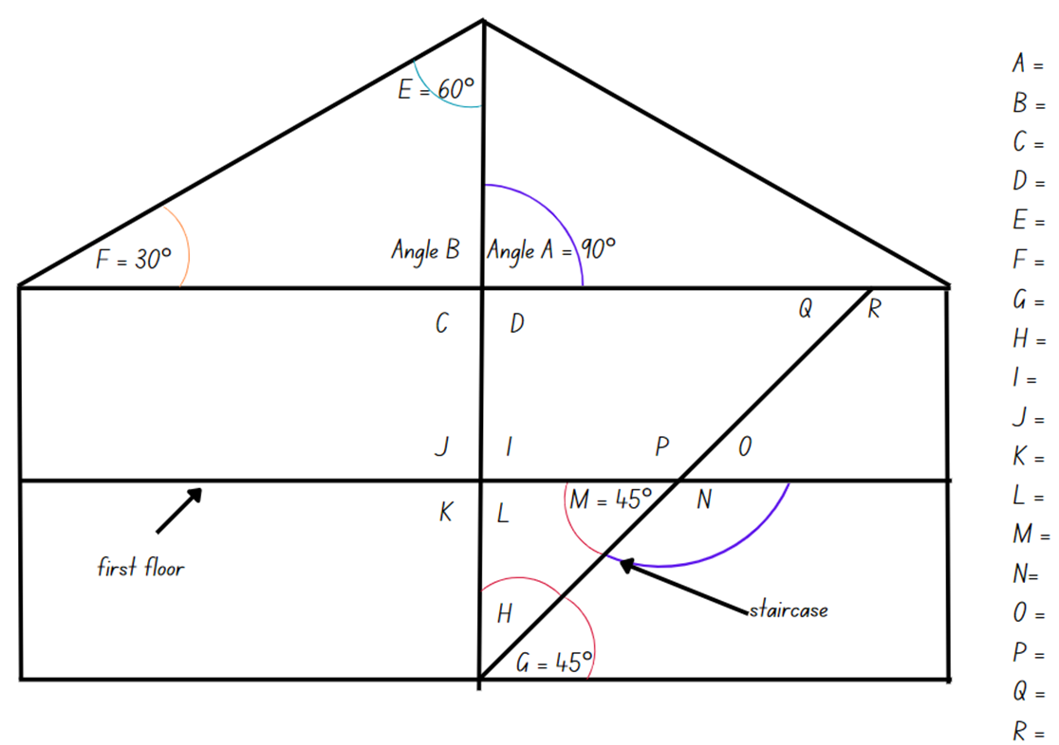

Resource 5 – angle names
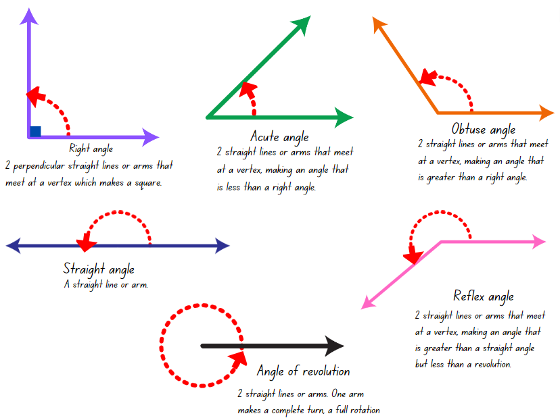

Resource 6 – angle art
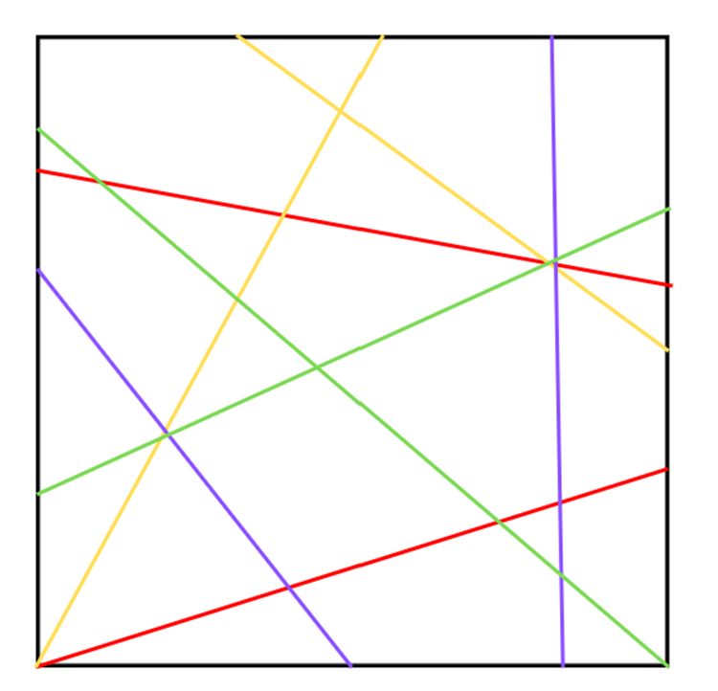

Resource 7 – hexagon angles
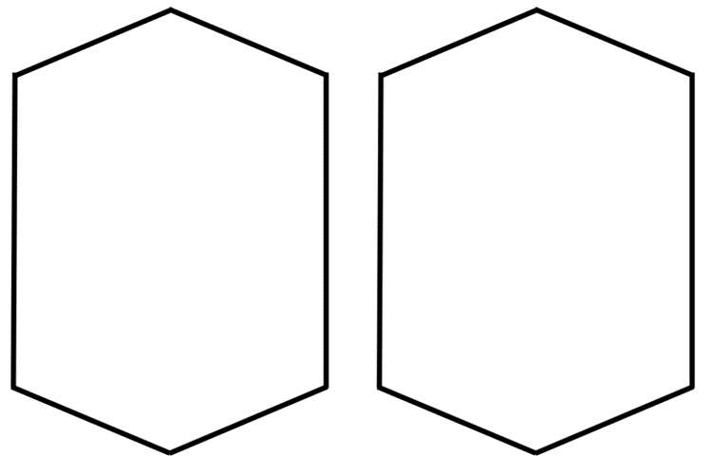

Resource 8 – lots of buttons
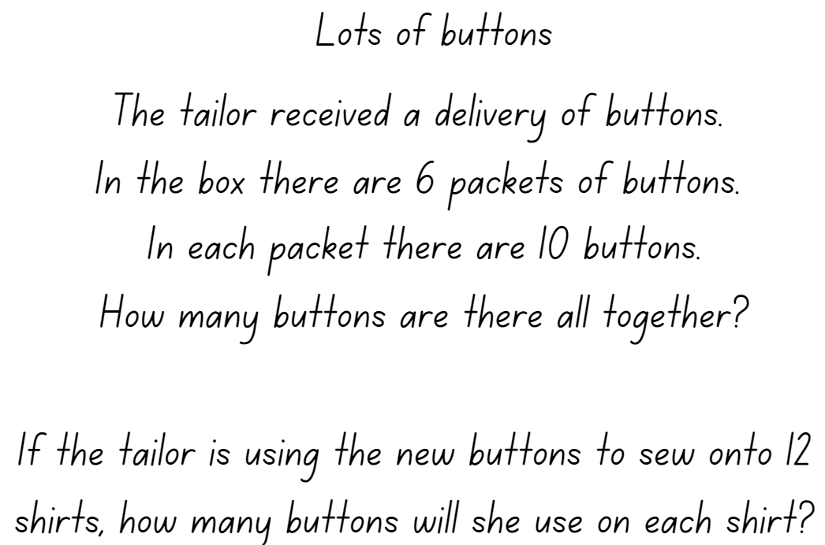

Resource 9 – environmental angles
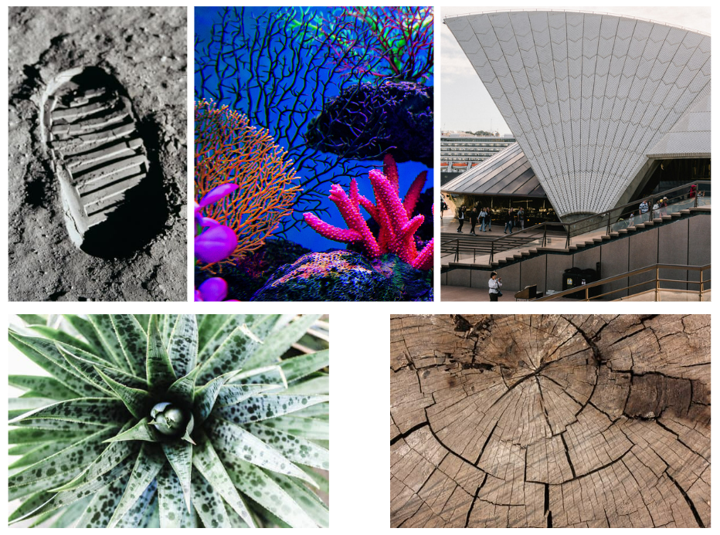

Resource 10 – angle of revolution
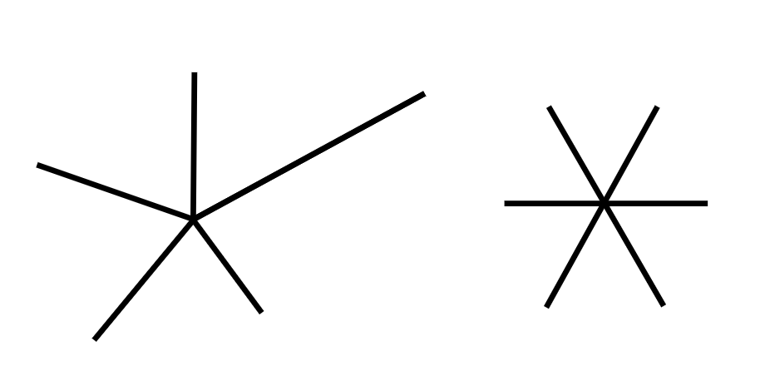

Resource 11 – stained glass window


Resource 12 – alphabet letters
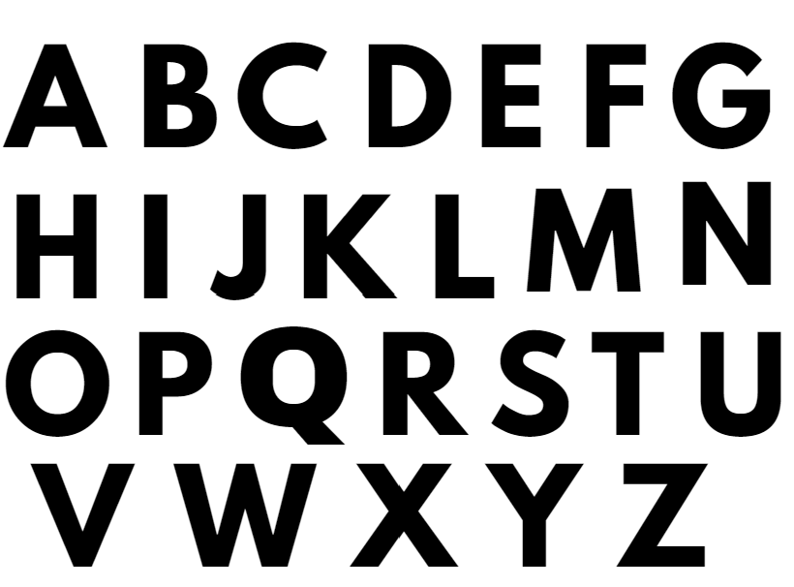

Resource 13 – clock angles
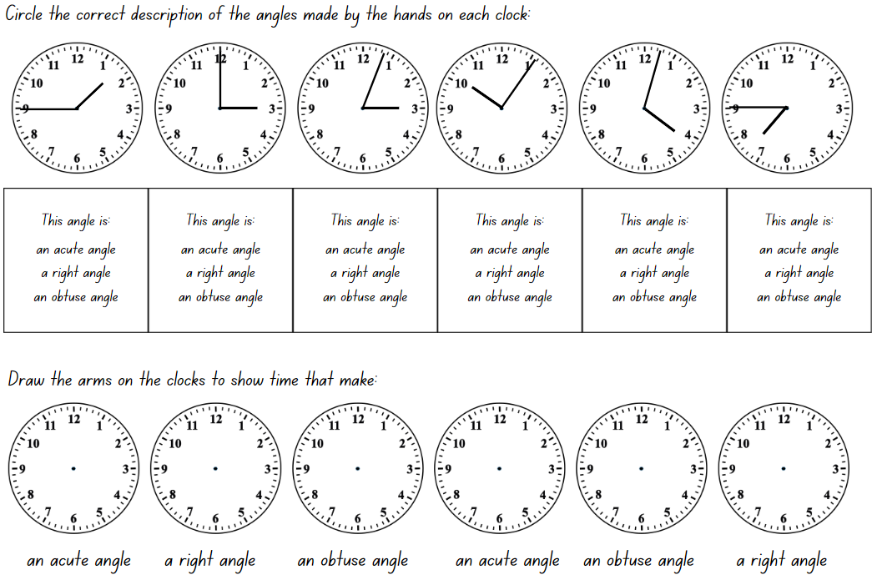

Resource 14 – angles in engineering
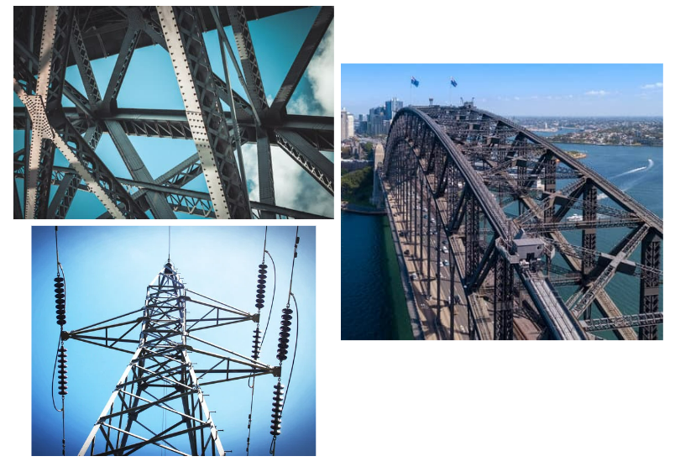

Resource 15 – time angles
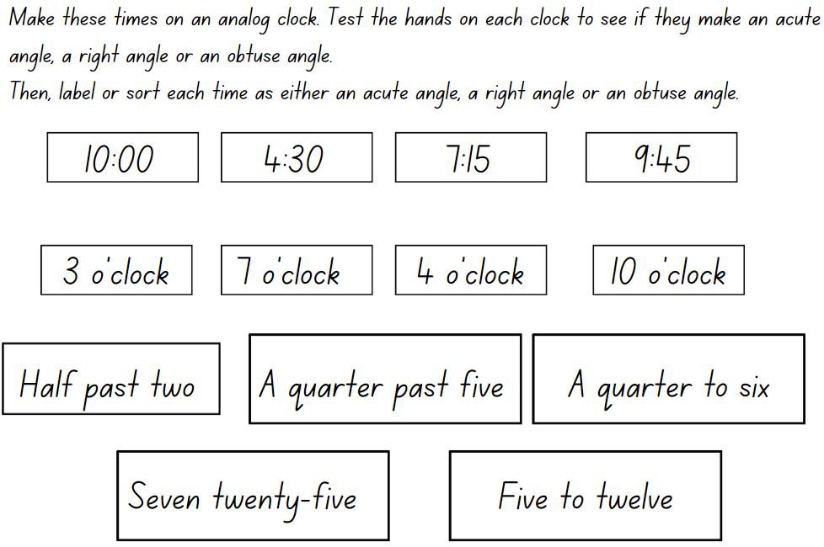

Resource 16 – in a minute
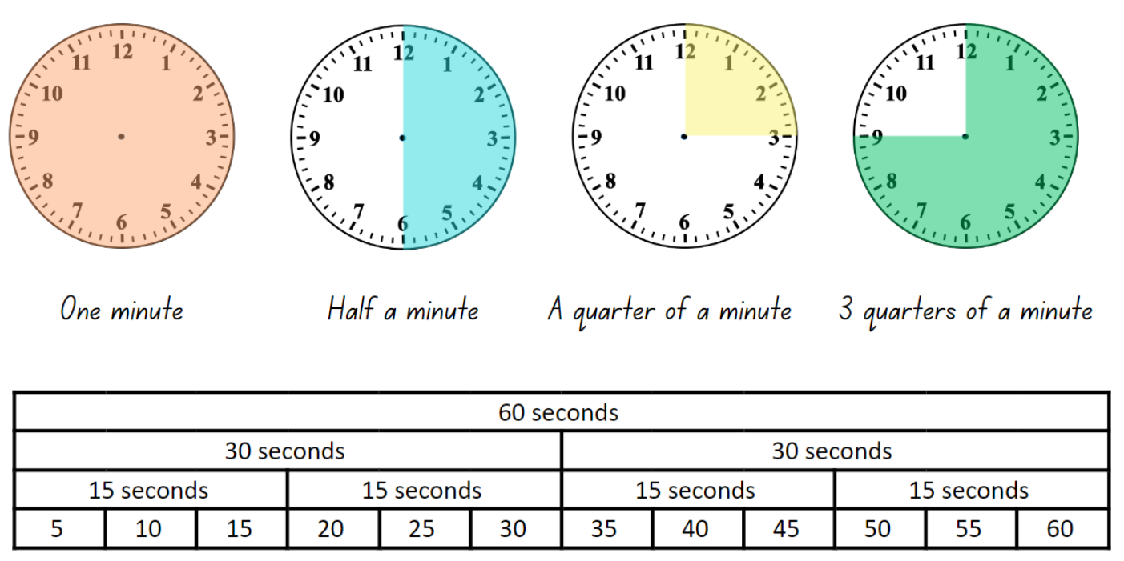

Resource 17 – showing the time
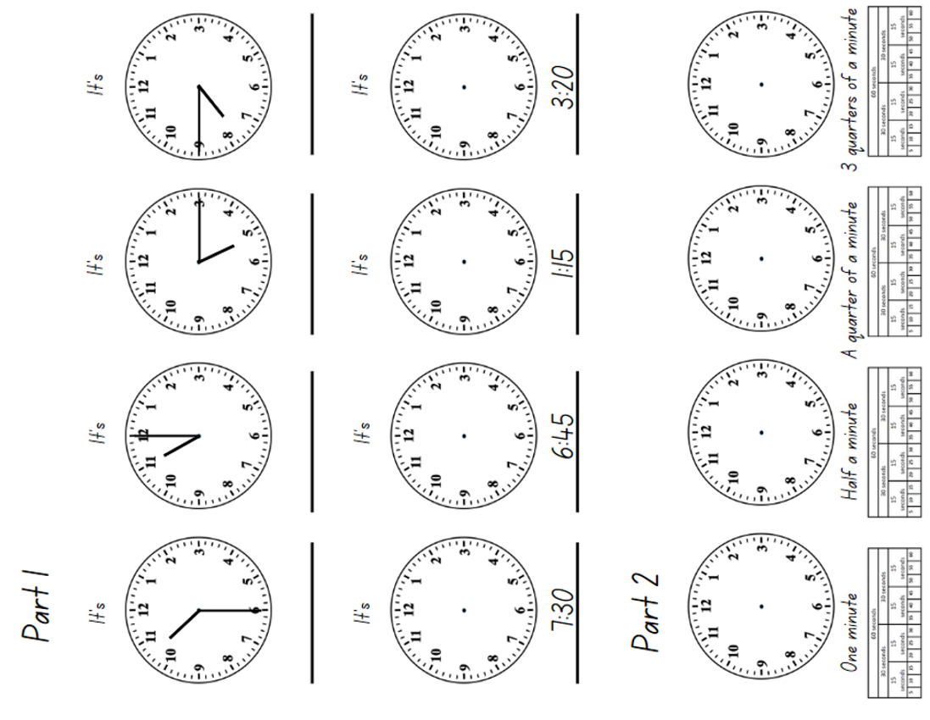

Resource 18 – elapsed time
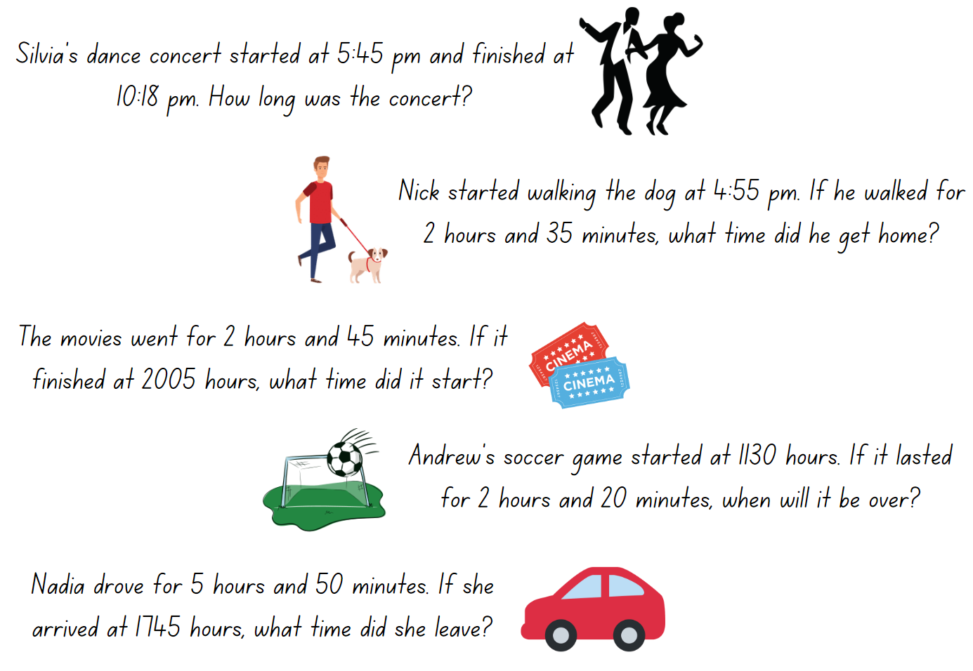

Resource 19 – hour strips
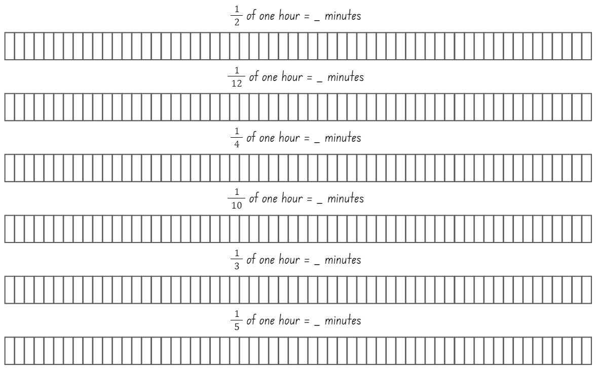

Resource 20 – day and night timeline
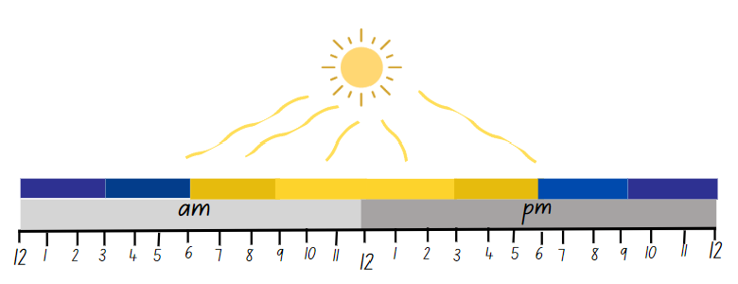

Resource 21 – creative art activities
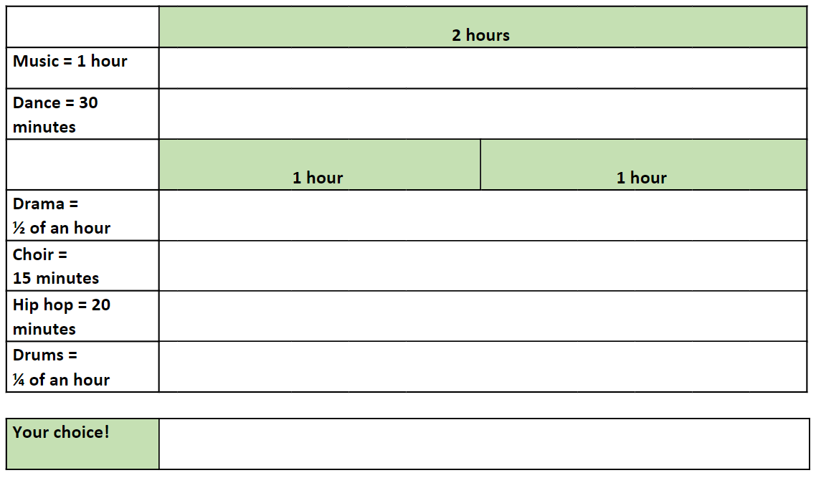

Resource 22 – duration problems
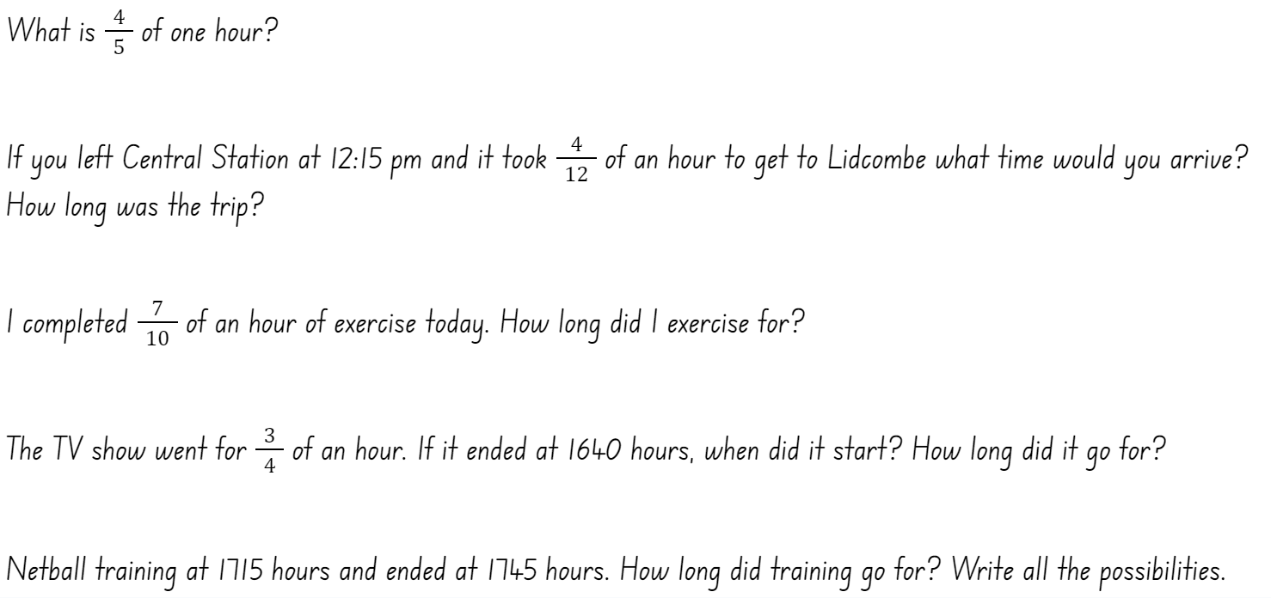

Resource 23 – fractions and decimals
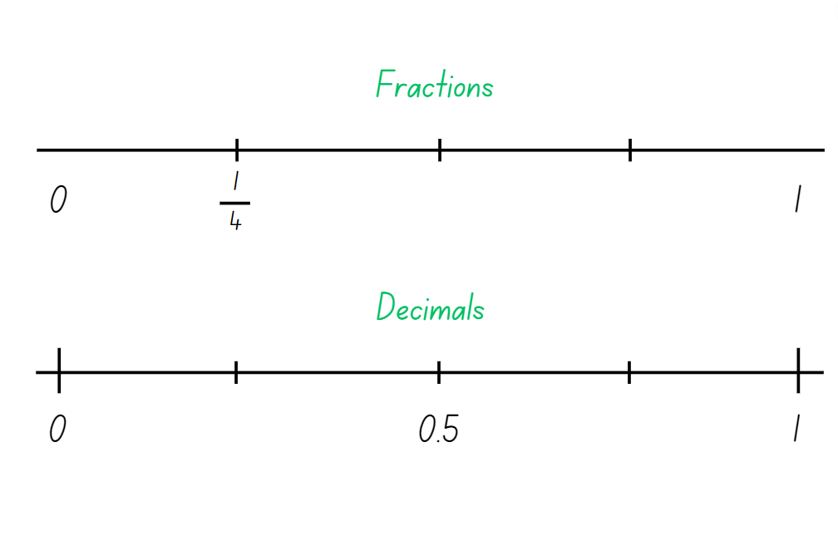

Resource 24 – the zoom strategy
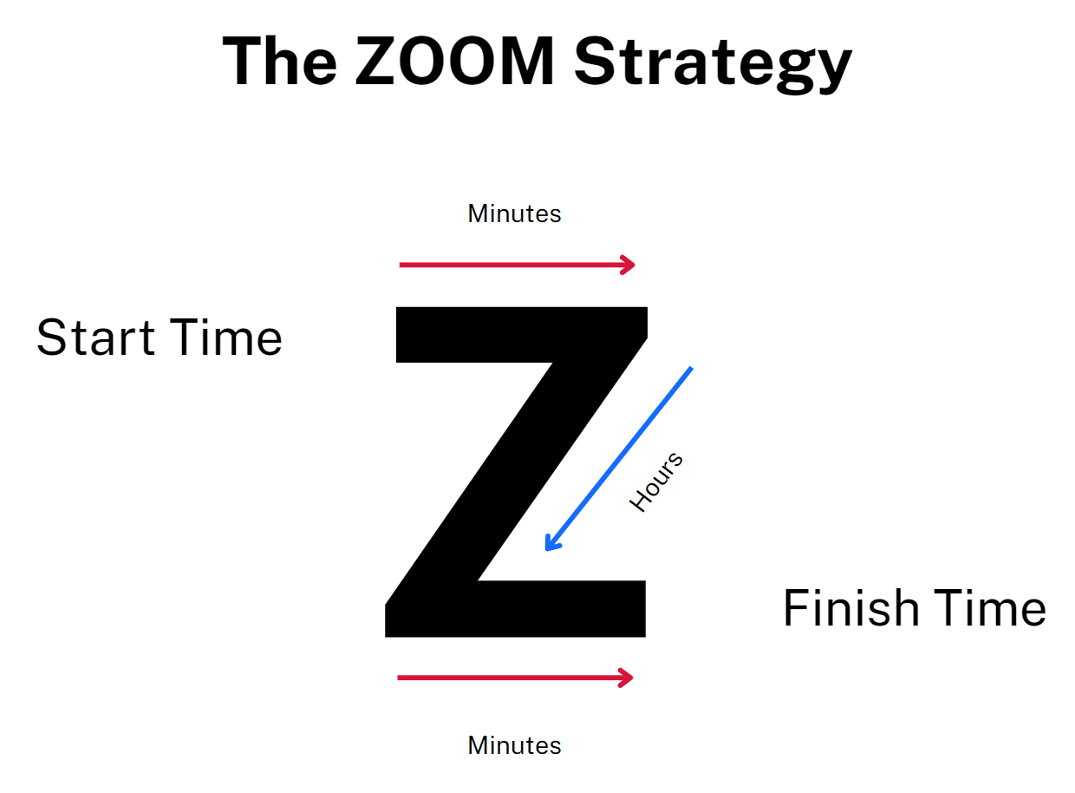

Resource 25 – elapse timecards
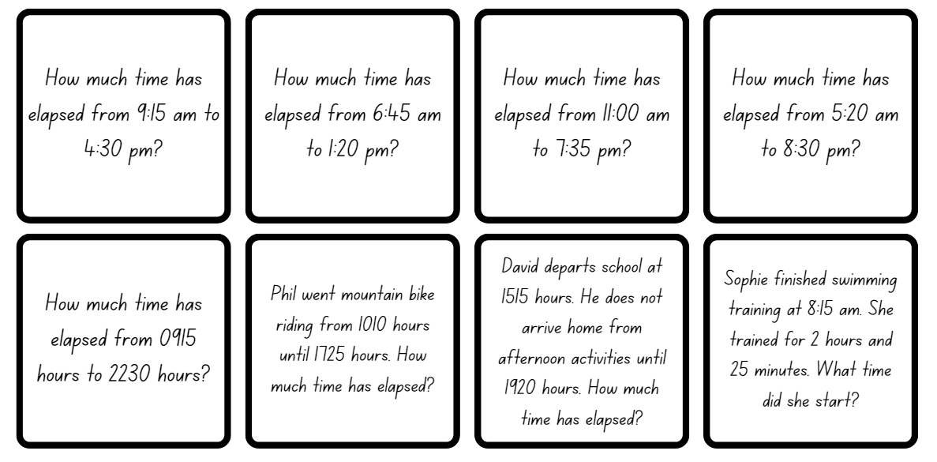

Resource 26 – excursion planning
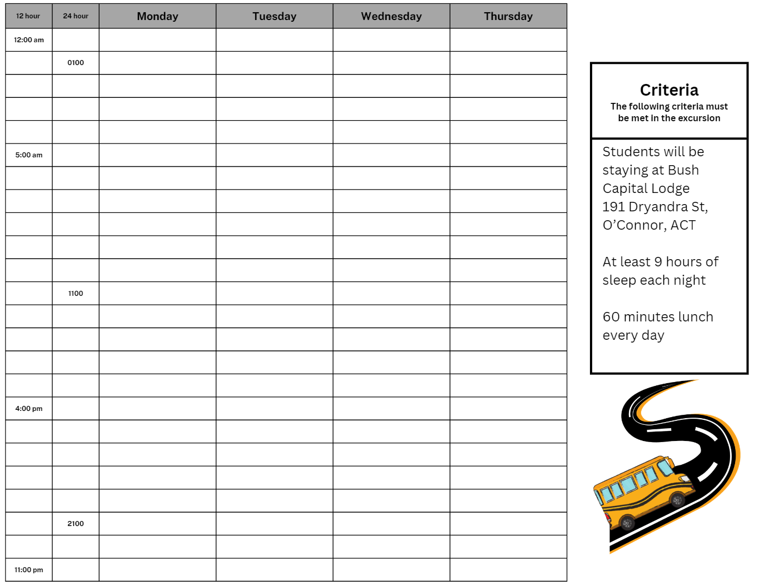

Resource 27 – using Google Maps
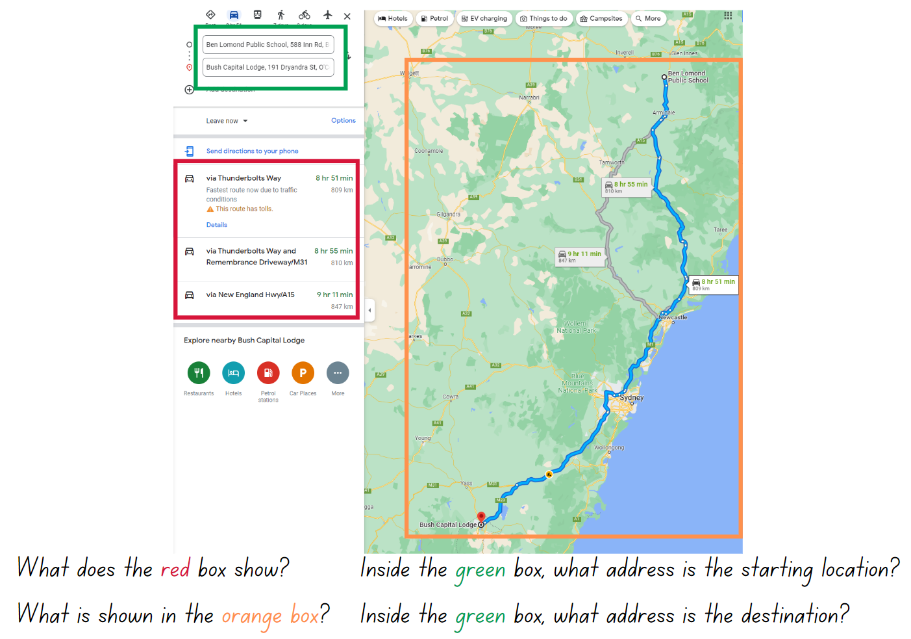
Image source from Google Maps; Ben Lomond Public School to Bush Capital Lodge.

Syllabus outcomes and content

Stage 2
The table below outlines the syllabus outcomes and range of relevant syllabus content covered in this unit. Content is linked to National Numeracy Learning Progression version (3).
Outcomes and content | 1 | 2 | 3 | 4 | 5 | 6 | 7 | 8
Representing numbers using place value B: Decimals: Make connections between fractions and decimal notation
[MAO-WM-01, MA2-RN-01, MA2-RN-02]
- Compare and order decimals of up to 2 decimal places |  |  |  |  | x | x
- Make connections between fractions and decimal notation for key benchmark values (Reasons about relations) |  |  |  |  |  |  | x
Multiplicative relations A: Recall multiplication facts of 2 and 4, 5 and 10 and related division facts
[MAO-WM-01, MA2-MR-01, MA2-MR-02]
- Recognise and use the symbols for multiplied by (x), divided by (÷) and equals (=) | x | x | x
- Link multiplication and division fact families using arrays | x |  | x
- Generate multiplication fact families for multiples of 2 and 4, 5 and 10 | x | x
- Model and apply the commutative property of multiplication | x | x
Partitioned fractions A: Create fractional parts of a length using techniques other than repeated halving
[MAO-WM-01, MA2-PF-01]
- Make thirds of a length |  |  |  |  |  | x
- Create fifths of a length |  |  |  |  |  | x
Partitioned fractions A: Model and represent unit fractions, and their multiples, to a complete whole on a number line
[MAO-WM-01, MA2-PF-01]
- Model fractions with fraction strips and diagrams for halves, quarters, eighths, thirds |  |  |  |  | x | x
- Describe fraction families formed by dividing the whole into the same total number of equal parts as having the same denominator |  |  |  |  |  | x
- Determine the complementary fractional part needed to complete one whole (halves, quarters, eighths, thirds) (Reasons about relations) |  |  |  |  |  | x
Partitioned fractions B: Represent fractional quantities equal to and greater than one
[MAO-WM-01, MA2-PF-01]
- Rename 2 halves, 3 thirds, 4 quarters, 5 fifths, 6 sixths, 8 eighths and 10 tenths as one whole |  |  |  |  |  | x
- Represent totals of halves, thirds, quarters and fifths that extend beyond one |  |  |  |  |  | x
- Determine the relative location of one-quarter and one-half when a number line extends beyond one |  |  |  |  |  | x
Geometric measure A: Angles: Identify angles as measures of turn
[MAO-WM-01, MA2- GM-03]
- Identify angles with 2 arms in practical situations | x | x | x | x
- Identify the arms and vertex of an angle | x | x | x | x
- Recognise an angle as the amount of turning between 2 arms | x | x | x | x
- Compare angles and explain that the length of the arms does not affect the size of the angle (Reasons about spatial relations) | x | x | x | x
- Use the term right angle to describe a quarter-turn in a range of orientations (Reasons about spatial orientation) | x | x | x | x
Geometric measure B: Angles: Compare angles to a right angle
[MAO-WM-01, MA2-GM-03]
- Compare angles to a right angle using an informal means | x | x | x | x
- Recognise and describe angles as less than, equal to, about the same as or greater than a right angle |  | x | x | x
- Describe angles in comparison to quarter-turns as acute, right, obtuse, straight, reflex or a revolution |  | x | x | x
- Identify the arms and vertex of an angle where one arm is visible and the other arm is invisible | x |  | x | x
Non-spatial measure A: Time: Represent and read analog time
[MAO-WM-01, MA2-NSM-02]
- Use minutes to describe the duration of events |  |  |  |  |  | x
- Identify 30 minutes as being a half-hour and 60 minutes as an hour |  |  |  |  | x | x
- Connect the quarter-hour to 15 minutes |  |  |  |  | x | x
- Recognise that the position of the numerals on an analog timepiece often represents 2 different values |  |  |  |  | x | x
- Recognise that 5-minute intervals (corresponding to the hour markers) are used as benchmarks to read time on an analog clock |  |  |  |  | x | x |  | x
- Read time as past the hour to half-past and then towards the hour |  |  |  |  | x | x
- Read analog clocks to the minute |  |  |  |  | x | x | x | x
Non-spatial measure B: Time: Represent and interpret digital time displays
[MAO-WM-01, MA2-NSM-02]
- Identify situations where duration is measured in seconds |  |  |  |  |  |  | x | x
- Read or set the time on digital devices to the minute or second, recognising there are 60 seconds in one minute |  |  |  |  | x |  | x | x
- Recognise that the hour is read first in a digital display |  |  |  |  | x |  | x | x
Non-spatial measure B: Time: Use am and pm notation
[MAO-WM-01, MA2-NSM-02]
- Record times using the colon notation with am and pm to distinguish between morning and evening |  |  |  |  |  | x | x | x
- Relate the terms midday or noon and midnight to am and pm |  |  |  |  |  | x |  | x
- Relate analog notation to digital notation for time |  |  |  |  |  | x |  | x
Mathematics K–10 Syllabus © NSW Education Standards Authority (NESA) for and on behalf of the Crown in right of the State of New South Wales, 2022.

Stage 3
The table below outlines the syllabus outcomes and range of relevant syllabus content covered in this unit. Content is linked to National Numeracy Learning Progression version (3).
Outcomes and content | 1 | 2 | 3 | 4 | 5 | 6 | 7 | 8
Represents numbers A: Decimals and percentages: Compare, order and represent decimals
[MAO-WM-01, MA3-RN-02]
- Compare and order decimal numbers of up to 3 decimal places |  |  |  |  | x | x | x
- Place decimal numbers of up to 3 decimal places on a number line |  |  |  |  |  | x | x
Represents numbers B: Decimals and percentages: Make connections between benchmark fractions, decimals and percentages
[MAO-WM-01, MA3-RN-03]
- Represent common percentages of quantities and lengths as fractions and decimals |  |  |  |  |  |  | x
Representing quantity fractions B: Recognise that a fraction can represent a division
[MAO-WM-01, MA3-RQF-01, MA3-RQF-02]
- Identify how the relationship between the number being divided and the divisor is represented in a fraction |  |  |  |  |  | x
Representing quantity fractions B: Compare common fractions with related denominators
[MAO-WM-01, MA3-RQF-01, MA3-RQF-02]
- Create equivalent fractions for half in quarters, eighths, sixths and tenths by re-dividing the whole, using diagrams and number lines |  |  |  |  |  | x
Representing quantity fractions B: Build up to the whole from a given fractional part
[MAO-WM-01, MA3-RQF-01, MA3-RQF-02]
- Generate the whole quantity from non-unit fractional parts such as quarters, eighths, thirds, sixths, fifths and tenths (Reversible reasoning) | x |  |  |  |  | x
Multiplicative Relations A: Determine products and factors
[MAO-WM-01, MA3-MR-01]
- Determine the factors for a given whole number |  | x | x
Geometric measure B: Angles: Investigate angles on a straight line and angles at a point
[MAO-WM-01, MA3-GM-03]
- Recognise right angles, angles on a straight line and angles at a point embedded in diagrams (Reasons about spatial orientation) |  |  |  | x
- Identify the vertex and arms of angles formed by intersecting lines |  | x |  | x
Geometric measure B: Angles: Investigate the relationships formed by the intersection of straight lines
[MAO-WM-01, MA3-GM-03]
- Identify angle types formed by the intersection of straight lines, including right angles (90°), angles on a straight line (add to 180°) and angles at a point that form an angle of revolution (add to 360°) | x | x | x | x
- Recognise that perpendicular lines intersect at right angles (90°) | x | x
- Investigate adjacent angles that form a right angle and establish that they add to 90° |  | x
- Investigate adjacent angles on a straight line and establish that they add to 180° | x | x
- Investigate angles at a point and establish that they form an angle of revolution and add to 360° |  | x | x
Non-spatial measure A: Time: Compare 12- and 24-hour time systems and convert between them
[MAO-WM-01, MA3-NSM-02]
- Recognise that 24-hour time is used to avoid confusion between am and pm |  |  |  |  |  |  |  | x
- Convert between 24-hour time and 12-hour time using am or pm notation |  |  |  |  |  |  |  | x
- Read, interpret and use timetables from real-life situations, involving 12- and 24-hour time |  |  |  |  |  |  |  | x
Non-spatial measure A: Time: Solve problems involving duration, using 12- and 24-hour time
[MAO-WM-01, MA3-NSM-02]
- Use start and finish times to calculate the elapsed time of events |  |  |  |  | x |  | x | x
- Add and subtract time mentally using bridging strategies |  |  |  |  | x |  | x
- Round answers to time calculations to the nearest minute or hour |  |  |  |  |  |  |  | x
- Represent commonly used time intervals as decimals |  |  |  |  |  |  |  | x
- Solve a variety of problems involving duration, including where times are expressed in 12-hour and 24-hour notation |  |  |  |  | x | x | x | x
Mathematics K–10 Syllabus © NSW Education Standards Authority (NESA) for and on behalf of the Crown in right of the State of New South Wales, 2022.

References
This resource contains NSW Curriculum and syllabus content. The NSW Curriculum is developed by the NSW Education Standards Authority. This content is prepared by NESA for and on behalf of the Crown in right of the State of New South Wales. The material is protected by Crown copyright.
Please refer to the NESA Copyright Disclaimer for more information https://educationstandards.nsw.edu.au/wps/portal/nesa/mini-footer/copyright.
NESA holds the only official and up-to-date versions of the NSW Curriculum and syllabus documents. Please visit the NSW Education Standards Authority (NESA) website https://educationstandards.nsw.edu.au/ and the NSW Curriculum website https://curriculum.nsw.edu.au/home.
Mathematics K–10 Syllabus © NSW Education Standards Authority (NESA) for and on behalf of the Crown in right of the State of New South Wales, 2022.
National Numeracy Learning Progression © Australian Curriculum, Assessment and Reporting Authority (ACARA) 2010 to present, unless otherwise indicated. This material was downloaded from the Australian Curriculum website (National Numeracy Learning Progression) accessed 24 October 2023 and was not modified.
ABC (Australian Broadcasting Corporation) (2022) Time Tools: 12-hour to the minute, ABC Education website, accessed 23 October 2023.
AGSA (Art Gallery of South Australia) (2019) Dorrit Black: The Bridge Interpretive Resource [PDF 4.3 MB], Art Gallery of South Australia, accessed 23 October 2023.
Australian Government Department of Education 2023 (2020) 'Lesson 1: How Many Right Angles', Teaching resources, reSolve website, accessed 23 October 2023.
Google Maps (n.d.) Ben Lomond Public School to Bush Capital Lodge [Google Maps], accessed 23 October 2023.
Siemon D, Warren E, Beswick K, Faragher R, Miller J, Horne Marj, Jazby D, Breed M, Clark J, Brady K (2022) Teaching Mathematics: Foundation to Middle Years, 3rd edn Oxford University Press, Australia.
State of Victoria, Department of Education and Training (n.d) ‘Measure, calculate and compare elapsed time’, FUSE website, accessed 23 October 2023.
Sullivan P (2018) Challenging Mathematical tasks: Unlocking the Potential of all Students, Oxford University Press, Australia.
Toy Theater (n.d.) Active analog clock, Time Manipulatives, Toy Theater website, accessed 23 October 2023.
Toy Theater (n.d.) Static analog clock, Time Manipulatives, Toy Theater website, accessed 23 October 2023.
Note: the State of Victoria Department of Education and Training website FUSE will redirect to their new platform, ARC Learning, from Term 1 2024. Information about the transition can be found here.

© State of New South Wales (Department of Education), 2024
The copyright material published in this resource is subject to the Copyright Act 1968 (Cth) and is owned by the NSW Department of Education or, where indicated, by a party other than the NSW Department of Education (third-party material).
Copyright material available in this resource and owned by the NSW Department of Education is licensed under a Creative Commons Attribution 4.0 International (CC BY 4.0) license.

This license allows you to share and adapt the material for any purpose, even commercially.
Attribution should be given to © State of New South Wales (Department of Education), 2024.
Material in this resource not available under a Creative Commons license:
- the NSW Department of Education logo, other logos and trademark-protected material
- material owned by a third party that has been reproduced with permission. You will need to obtain permission from the third party to reuse its material.
Links to third-party material and websites
Please note that the provided (reading/viewing material/list/links/texts) are a suggestion only and implies no endorsement, by the New South Wales Department of Education, of any author, publisher, or book title. School principals and teachers are best placed to assess the suitability of resources that would complement the curriculum and reflect the needs and interests of their students.
If you use the links provided in this document to access a third-party's website, you acknowledge that the terms of use, including licence terms set out on the third-party's website apply to the use which may be made of the materials on that third-party website or where permitted by the Copyright Act 1968 (Cth). The department accepts no responsibility for content on third-party websites.

