Mathematics 3–6 Multi-age – Year B – Unit 9

Contents
Unit description and duration 5
Syllabus outcomes 5
Stage 2 6
Stage 3 6
Working mathematically 7
Student prior learning 7
Lesson overview and resources 9
Lesson 1 18
Daily number sense – round the dice – 10 minutes 18
Core lesson – 3D properties – 40 minutes 20
Discuss and connect the mathematics – 10 minutes 24
Lesson 2 26
Daily number sense – to the nearest number – 10 minutes 26
Core lesson – 35 minutes 28
Stage 2 task – sketching time 28
Stage 3 task – nets and sketch 30
Discuss and connect the mathematics – 15 minutes 33
Lesson 3 35
Daily number sense – number targets – 15 minutes 35
Core lesson – restaurant packaging part 1 – 40 minutes 38
Discuss and connect the mathematics – 10 minutes 40
Lesson 4 42
Daily number sense – 10 minutes 42
Core lesson – restaurant packaging part 2– 50 minutes 42
Consolidation and meaningful practice – 10 minutes 45
Lesson 5 48
Daily number sense – multiplying by 10 – 10 minutes 48
Core lesson – how many litres – 40 minutes 50
Discuss and connect the mathematics – 10 minutes 56
Lesson 6 59
Daily number sense – multiple madness – 10 minutes 59
Core lesson – 40 minutes 61
Stage 2 task – What's my capacity? 61
Stage 3 task – water, water, everywhere 64
Consolidation and meaningful practice – 10 minutes 67
Lesson 7 69
Daily number sense – multiplying by multiples – 15 minutes 69
Core lesson – estimating capacity and dripping taps – 40 minutes 71
Discuss and connect the mathematics – 10 minutes 75
Lesson 8 77
Daily number sense – 10 minutes 77
Core lesson – 40 minutes 77
Stage 2 task – making your own measuring cup 77
Stage 3 task – a thirsty crow 79
Discuss and connect the mathematics – 10 minutes 83
Resource 1 – dice combinations 85
Resource 2 – Guess what? 86
Resource 3 – three-dimensional objects 87
Resource 4 – Net or not? 88
Resource 5 – cut nets 89
Resource 6 – 20 numbers 90
Resource 7 – 30 numbers 91
Resource 8 – 3D objects 92
Resource 9 – recording table A 93
Resource 10 – capacity recording table 94
Resource 11 – multiples madness 10’s 95
Resource 12 – multiples madness 100’s 96
Resource 13 – equivalence match 97
Resource 14 – equivalence cards 98
Resource 15 – water usage facts 100
Resource 16 – multiplying multiples 101
Resource 17 – converting measurements 102
Resource 18 – recording table B 103
Resource 19 – measurement cards 104
Resource 20 – capacity quiz 106
Syllabus outcomes and content 108
Stage 2 108
Stage 3 114
References 119

Unit description and duration
This unit develops the big idea that what needs to be measured determines the unit of measurement.
In this 2-week unit students are provided opportunities to:
- compare and describe features and properties of three-dimensional objects by making and exploring models, sketches and diagrams
- construct and draw models from given top, front and side views, using squared and isometric paper
- use formal units (litres and millilitres) to measure capacity and use scaled instruments to measure and compare capacities
- compare volumes of 2 or more objects by observing the change in water level when objects are submerged in a container of water
- recognise the equivalence of whole-number and decimal representations by measuring, comparing and ordering measurements of capacities of up to 3 decimal places.
This multi-age unit is informed by the lessons in Stage 2 Year B Unit 29 and Stage 3 Year B Unit 29. Please refer to these units for additional lesson guidance.

Syllabus outcomes
- MAO-WM-01 develops understanding and fluency in mathematics through exploring and connecting mathematical concepts, choosing and applying mathematical techniques to solve problems, and communicating their thinking and reasoning coherently and clearly

Stage 2
- MA2-RN-01 applies an understanding of place value and the role of zero to represent numbers to at least tens of thousands
- MA2-MR-01 represents and uses the structure of multiplicative relations to 10 × 10 to solve problems
- MA2-2DS-01 compares two-dimensional shapes and describes their features
- MA2-3DS-01 makes and sketches models and nets of three-dimensional objects including prisms and pyramids
- MA2-3DS-02 estimates, measures and compares capacities (internal volumes) using litres, millilitres and volumes using cubic centimetres

Stage 3
- MA3-RN-02 compares and orders decimals up to 3 decimal places
- MA3-RN-03 determines percentages of quantities and finds equivalent fractions and decimals for benchmark percentage values
- MA3-RQF-01 compares and orders fractions with denominators of 2, 3, 4, 5, 6, 8 and 10
- MA3-3DS-01 visualises, sketches and constructs three-dimensional objects, including prisms and pyramids, making connections to two-dimensional representations
- MA3-3DS-02 selects and uses the appropriate unit to estimate, measure and calculate volumes and capacities

Working mathematically
In the Mathematics K–10 Syllabus, there is one overarching Working mathematically outcome (MAO-WM-01). The Working mathematically processes should be embedded within the concepts being taught. The Working mathematically processes present in the Mathematics K–10 Syllabus are:
- communicating
- understanding and fluency
- reasoning
- problem solving.
Mathematics K–10 Syllabus © NSW Education Standards Authority (NESA) for and on behalf of the Crown in right of the State of New South Wales, 2022.

Student prior learning
Before engaging in these teaching and learning activities, students would benefit from prior experience with:
- comparing and describing features of three-dimensional objects by exploring concrete materials, models and sketches
- constructing and deconstructing nets of three-dimensional objects
- using decimal representations to record volume using formal units of litres and millilitres
- exploring displacement to investigate volumes of irregular solids.
In NSW classrooms there is a diverse range of students, including Aboriginal and Torres Strait Islander students, students learning English as an additional language or dialect, high potential and gifted students and students with disability. Some students may identify with more than one of these groups or possibly all of them. Refer to Curriculum planning for every student – advice for further information.

Lesson overview and resources
To cover the content of the syllabus across Stage 2 and Stage 3, some core lessons in the unit contain both a Stage 2 and a Stage 3 task. Teachers are encouraged to adapt and contextualise the units to meet the needs of their students.
The table below outlines the sequence and approximate timing of lessons, learning intentions and resources.
Lesson | Content | Duration and resources
Lesson 1  Daily number sense  Stage 2:  - Representing numbers using place value B: Whole numbers: Order numbers in the thousands  Stage 3:  - Represents numbers A: Whole numbers: Recognise, represent and order numbers in the millions | Lesson core concept: objects can be described effectively by focusing on features.  Stage 2:  - Two-dimensional spatial structure A: 2D shapes: Compare and describe features of two-dimensional shapes  - Three-dimensional spatial structure B: 3D objects: Connect three-dimensional objects and two-dimensional representations  Stage 3:  - Three-dimensional spatial structure A: 3D objects: Compare, describe and name prisms and pyramids | Lesson duration: 60 minutes  - Resource 1 – dice combinations  - Resource 2 – Guess what?  - Website: Google Maps  - 6-sided dice  - 9-sided dice  - Individual whiteboards  - Three-dimensional geometrical models  - Writing materials
Lesson 2  Daily number sense  Stage 2:  - Representing numbers using place value B: Whole numbers: Order numbers in the thousands  Stage 3:  - Represents numbers A: Whole numbers: Recognise, represent and order numbers in the millions | Lesson core concept: objects can be drawn and made by focussing on their features and properties.  Stage 2:  - Three-dimensional spatial structure A: 3D objects: Make models of three-dimensional objects to compare and describe key features  - Three-dimensional spatial structure B: 3D objects: Connect three-dimensional objects and two-dimensional representations  Stage 3:  - Three-dimensional spatial structure A: 3D objects: Compare, describe and name prisms and pyramids  - Three-dimensional spatial structure A: 3D objects: Connect three-dimensional objects with two-dimensional representation | Lesson duration: 60 minutes  - Resource 3 – three-dimensional objects  - Resource 4 – Net or not?  - Resource 5 – cut nets  - 9-sided dice  - Individual whiteboards  - Three-dimensional geometrical models  - Writing materials
Lesson 3  Daily number sense  Stage 2:  - Representing numbers using place value B: Whole numbers: Order numbers in the thousands  Stage 3:  - Represents numbers A: Whole numbers: Recognise, represent and order numbers in the millions | Lesson core concept: mathematicians draw objects from different perspectives.  Stage 2:  - Three-dimensional spatial structure B: 3D objects: Connect three-dimensional objects and two-dimensional representations  Stage 3:  - Three-dimensional spatial structure A: 3D objects: Compare, describe and name prisms and pyramids | Lesson duration: 65 minutes  - Resource 6 – 20 numbers  - Resource 7 – 30 numbers  - Resource 8 – 3D objects  - Isometric grid paper  - Packaging examples  - Writing materials
Lesson 4  Daily number sense  - teacher-identified task based on student needs | Lesson core concept: drawings are interpreted to construct, compare, describe and name prisms and pyramids.  Stage 2:  - Three-dimensional spatial structure A: 3D objects: Make models of three-dimensional objects to compare and describe key features  - Three-dimensional spatial structure B: 3D objects: Connect three-dimensional objects and two-dimensional representations  Stage 3:  - Three-dimensional spatial structure B: 3D objects: Construct prisms and pyramids  - Three-dimensional spatial structure A: 3D objects: Connect three-dimensional objects with two-dimensional representation | Lesson duration: 70 minutes  - Paper straws, pipe cleaners and/or toothpicks  - Sticky tape, sticky putty and/or modelling clay  - Isometric grid paper  - Thick poster cardboard  - Cardboard nets  - Writing materials
Lesson 5  Daily number sense  Stage 2:  - Multiplicative relations B: Operate with multiples of 10  Stage 3:  - Multiplicative relations A: Use partitioning and place value to multiply 2-, 3- and 4-digit numbers by one-digit numbers | Lesson core concept: capacity is an internal measurement and relate to our base 10 place value system.  Stage 2:  - Three-dimensional spatial structure A: Measure and order containers using litres  - Three-dimensional spatial structure B: Use scaled instruments to measure and compare internal volumes  Stage 3:  - Three-dimensional spatial structure A: Connect decimal representations to the metric system  - Three-dimensional spatial structure A: Choose appropriate units of measurement for capacity  - Represents numbers A: Compare, order and represent decimals | Lesson duration: 60 minutes  - Resource 9 – recording table A  - Resource 10 – capacity recording table  - 6-sided dice (one per pair)  - Scaled measuring cups and jugs  - Large containers – 4 per group  - Different sized containers  - Writing materials
Lesson 6  Daily number sense  Stage 2:  - Multiplicative relations B: Operate with multiples of 10  Stage 3:  - Multiplicative relations A: Use partitioning and place value to multiply 2-, 3- and 4-digit numbers by one-digit numbers | Lesson core concept: standard units are an efficient way to communicate capacity.  Stage 2:  - Three-dimensional spatial structure A: Volume: Measure and order containers using litres  - Three-dimensional spatial structure B: Volume: Use scaled instruments to measure and compare capacities (internal volumes)  Stage 3:  - Represents numbers A: Decimals and percentages: Recognise that the place value system can be extended beyond hundredths  - Three-dimensional spatial structure A: Volume: Connect decimal representations to the metric system | Lesson duration: 60 minutes  - Resource 11 – multiples madness 10’s  - Resource 12 – multiples madness 100’s  - Resource 13 – equivalence match  - Resource 14 – equivalence cards  - Resource 15 – water usage facts  - 9-sided dice (one per pair)  - Coloured counters  - Clear containers – more than 1 L  - 2 containers of less than 1 L  - Scaled 1 L measuring jugs  - 250 mL measuring cups  - Writing materials
Lesson 7  Daily number sense  Stage 2:  - Multiplicative relations B: Operate with multiples of 10  Stage 3:  - Multiplicative relations A: Use partitioning and place value to multiply 2-, 3- and 4-digit numbers by one-digit numbers | Lesson core concept: estimation is guided by using known benchmarks of capacity and our base ten place value system.  Stage 2:  - Representing numbers using place value A Whole numbers: Read, represent and order numbers to thousands  - Three-dimensional spatial structure A: Volume: Measure and order containers using litres  - Three-dimensional spatial structure B: Volume: Use scaled instruments to measure and compare capacities (internal volumes)  Stage 3:  - Represents numbers A: Decimals and percentages: Recognise that the place value system can be extended beyond hundredths  - Represents numbers A: Decimals and percentages: Compare, order and represent decimals  - Three-dimensional spatial structure A: Volume: Connect decimal representations to the metric system | Lesson duration: 65 minutes  - Resource 16 – multiplying multiples  - Resource 17 – converting measurements  - Resource 18 – recording table B  - 10-sided dice (one per pair)  - Containers from home scavenger hunt  - Scaled measuring cups and jugs  - Small everyday containers  - Writing materials
Lesson 8  Daily number sense  - teacher-identified task based on student needs | Lesson core concept: mathematicians explore capacity in different ways.  Stage 2:  - Three-dimensional spatial structure A: Volume: Measure and order containers using litres  - Three-dimensional spatial structure B: Volume: Use scaled instruments to measure and compare internal volumes  Stage 3:  - Three-dimensional spatial structure A: Volume: Use displacement to investigate volumes of irregular solids | Lesson duration: 60 minutes  - Resource 19 – measurement cards  - Resource 20 – capacity quiz  - Transparent plastic cups  - Permanent markers or elastic bands  - ‘The Crow and the Pitcher’ by Aesop  - Variety of narrow containers  - Glue stick, pair of scissors or modelling clay container  - Marbles  - Dice  - Whiteboard markers  - Writing materials

Lesson 1
Core concept: objects can be described effectively by focusing on features.

Daily number sense – round the dice – 10 minutes
Daily number sense activities for Lessons 1 to 3 ‘activate’ prior number knowledge and support the learning of new content in the unit. These activities can also assist teachers to identify the starting points for learning by revealing the extent of students’ existing knowledge.
The table below contains suggested learning intentions and success criteria. These are best co-constructed with students.
Daily number sense learning intentions | Daily number sense success criteria
Students working towards Stage 2 outcomes are learning to:  - order numbers in the thousands.  Students working towards Stage 3 outcomes are learning to:  - recognise, represent and order numbers in the millions. | Students working towards Stage 2 outcomes can:  - identify the nearest thousand to a given number.  Students working towards Stage 3 outcomes can:  - round numbers to a specified place value.
This activity is an adaptation of Round the Four Dice from NRICH by the University of Cambridge.
- Tell students four 6-sided dice are rolled revealing the numbers one, 2, 3 and 4.
- Display Resource 1 – dice combinations. Show students some of the possible 4-digit number combinations.
- Ask students to choose and record 4 numbers from Resource 1 – dice combinations on individual whiteboards. Students round each number to the nearest multiple of 1000. Ask:
- How did you work out whether to round up or round down to the nearest multiple of 1000?
- Did you round up to the nearest thousand or round down to the nearest thousand more often? Why?
- Did any of the four 4-digit numbers you chose round to the same multiple of 1000?
- In pairs, students repeat the process, using a new set of 4-digit numbers chosen from Resource 1 – dice combinations.
Multi-age: provide students working towards Stage 3 outcomes with six 9-sided dice. Students record and round each number to the nearest multiple of 100 000.
This table details opportunities for assessment.
Assessment opportunities | Links
What to look for:  - Can Stage 2 students identify the nearest thousand to a given number? [MAO-WM-01, MA2-RN-01]  - Can Stage 3 students round numbers to a specified place value? [MAO-WM-01, MA3-RN-01] | Links to National Numeracy Learning Progressions (NNLP):  - Stage 2 – NPV7  - Stage 3 – NPV6, NPV7.  Links to suggested Interview for Student Reasoning (IfSR) tasks:  - Stage 2 – IfSR-NP: 4C.8.

Core lesson – 3D properties – 40 minutes
Note: in Lesson 7, students will be learning to measure and order containers accurately using litres and millilitres. To provide a wide range of containers, students can be asked to bring containers from home. This can also be communicated to parents/carers, for example:
This week, students in (class) will be learning to measure and order containers using litres. To provide a wide range of containers, it would be helpful if students are able bring any containers from home that are able to hold water. Containers that hold different amounts would be appreciated, for example 100 millilitres, 250 millilitres (one quarter of a litre), 500 millilitres (half a litre), 1000 millilitres (1 L) or 2000 millilitres (2 L). These containers can be stored in the classroom until they are used on (day).
Thank you for your support, (Teacher).
The table below contains suggested learning intentions and success criteria. These are best co-constructed with students.
Core concept learning intentions | Core concept success criteria
Students working towards Stage 2 outcomes are learning to:  - connect three-dimensional objects and two-dimensional representations  - compare and describe features of two-dimensional shapes.  Students working towards Stage 3 outcomes are learning to:  - compare, describe and name prisms and pyramids. | Students working towards Stage 2 outcomes can:  - identify features of prisms and pyramids (faces, vertices and edges) and cylinders (curved/flat surfaces and boundaries) from images  - describe and compare two-dimensional shapes, including parallelograms, rectangles, rhombuses, squares, trapeziums and kites.  Students working towards Stage 3 outcomes can:  - compare properties of prisms and pyramids  - name prisms and pyramids according to the shape of their base.
This activity is an adaptation of Guess What? from NRICH by the University of Cambridge.
- Display three-dimensional geometrical models. For example, cube, cuboid, triangular prism, square pyramid, triangular pyramid (tetrahedron), sphere, cylinder and cone.
Multi-age: students working towards Stage 2 outcomes only need to name three-dimensional models as a prism, pyramid, cube, sphere, cylinder or cone. The teaching advice for Stage 2 states that formal names for particular prisms and pyramids are not introduced at this stage. Prisms and pyramids are to be treated as classes for the grouping of all prisms and all pyramids. Names for particular prisms and pyramids are introduced in Stage 3.
- Students record names and properties of models.
Note: prisms have 2 parallel bases, and all joining faces are rectangles. Pyramids differ from prisms as they have only one base and all the other faces are triangular. The triangular faces meet at a common vertex (the apex). Spheres, cones and cylinders are not classified as prisms or pyramids as they have curved surfaces, not faces. For example, a cylinder has 2 flat surfaces and one curved surface.
- Create and display class definitions including properties of each object, identifying and correcting misconceptions.
Multi-age: students working towards Stage 2 outcomes should be paired together and students working towards Stage 3 outcomes should be paired together for the game.
- Explain to students that they need to guess an object a partner has chosen by following these instructions:
- In pairs, each player chooses a random card from Resource 2 – Guess what?
- Students take turns asking their partner questions about properties of their three-dimensional object. Each answer should be used to get closer to guessing the object. For example, asking if it has 12 edges or 9 sides.
- The first player to identify the object wins that round.
- After playing the game, ask students which questions helped them make correct guesses and why. Students repeat the process.
- In small groups, students create a set of clue cards. For example, I have 8 edges. I have an apex. I have 4 triangle faces. I have a square face. I have 5 vertices. What am I? It is a pyramid (Stage 2). It is a square pyramid (Stage 3) (see Figure 1).
Figure 1 – clue card sample
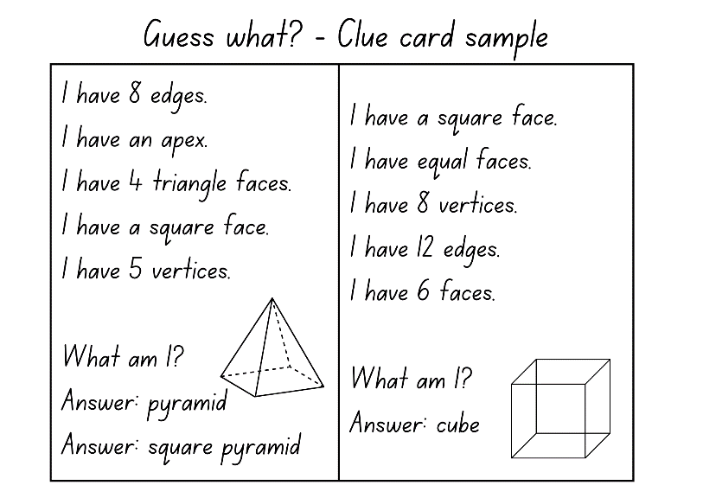
- In pairs, students take turns playing the game.
- After playing, ask:
- What did you notice?
- Were any clue cards harder to guess then others? Why or why not?
- Do some objects have the same properties?
This table details opportunities for differentiation.
Too hard? | Too easy?
Students cannot name prisms and pyramids from their properties.  - Provide students with three-dimensional objects to refer to when matching properties to the three-dimensional objects. | Students can name prisms and pyramids from their properties.  - Students identify the properties of other three-dimensional objects including, hemisphere and octagonal prisms.

Discuss and connect the mathematics – 10 minutes
- Use Google Maps to display a bird's eye view of the school. Revise that three-dimensional objects have faces that are two-dimensional shapes. Ask students to name the two-dimensional shapes they can see from the top view. Identify possible objects they can make with them. Discuss:
- What are the most common two-dimensional shapes you can see?
- What are the least common two-dimensional shapes you can see?
- What properties do the objects have?
This table details opportunities for assessment.
Assessment opportunities | Links
What to look for:  - Can Stage 2 students identify features of prisms and pyramids (faces, vertices and edges) and cylinders (curved/flat surfaces and boundaries) from images? [MAO-WM-01, MA2-3DS-01]  - Can Stage 2 students describe and compare two-dimensional shapes, including parallelograms, rectangles, rhombuses, squares, trapeziums and kites? [MAO-WM-01, MA2-2DS-01]  - Can Stage 3 students compare properties of prisms and pyramids? [MAO-WM-01, MA3-3DS-01]  - Can Stage 3 students name prisms and pyramids according to the shape of their base? [MAO-WM-01, MA3-3DS-01] | Links to National Numeracy Learning Progressions (NNLP):  - Stage 2 – UGP2, UGP3, UGP4  - Stage 3 – UGP3, UGP5.

Lesson 2
Core concept: objects can be drawn and made by focussing on their features and properties.

Daily number sense – to the nearest number – 10 minutes
The table below contains suggested learning intentions and success criteria. These are best co-constructed with students.
Daily number sense learning intentions | Daily number sense success criteria
Students working towards Stage 2 outcomes are learning to:  - order numbers in the thousands.  Students working towards Stage 3 outcomes are learning to:  - recognise, represent and order numbers in the millions. | Students working towards Stage 2 outcomes can:  - recognise and describe how rearranging digits changes the size of a number  - identify the nearest thousand to given numbers.  Students working towards Stage 3 outcomes can:  - arrange numbers using place value  - round numbers to a specified place value.
- Students write the target numbers 2000, 4000, 6000 and 8000 on individual whiteboards.
- Students roll four 0–9 dice and arrange them to make a 4-digit number as near as possible to one of the target numbers. Students say their chosen number aloud and record it next to the desired target number in any order.
- Repeat the process several times (see Figure 2).
Figure 2 – student example
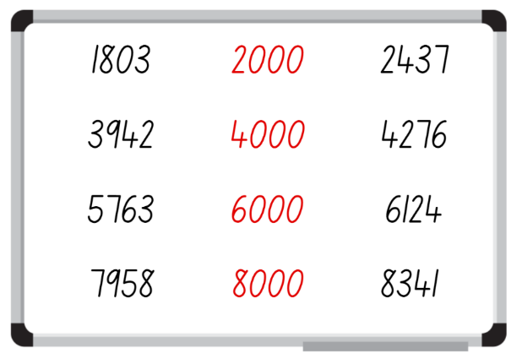
- Regroup as a class and ask:
- Who got nearest to a target number?
- Is there a 4-digit number you noticed that if the arrangement of numbers was changed, it would create a number closer to one of the target numbers? Explain your reasoning.
Multi-age: provide students working towards Stage 3 outcomes with six 0–9 dice. Students write target numbers. For example, 200 000, 600 000 and 900 000. Students arrange their 6-digit numbers rolled as near as possible to one of the target numbers. Students say their chosen number aloud and record it next to the desired target number in any order.
This table details opportunities for assessment.
Assessment opportunities | Links
What to look for:  - Can Stage 2 students recognise and describe how rearranging digits changes the size of a number? [MAO-WM-01, MA2-RN-01]  - Can Stage 2 students identify the nearest thousand to numbers? [MAO-WM-01, MA2-RN-01]  - Can Stage 3 students arrange numbers using place value? [MAO-WM-01, MA3-RN-01]  - Can Stage 3 students round numbers to a specified place value? [MAO-WM-01, MA3-RN-01] | Links to National Numeracy Learning Progressions (NNLP):  - Stage 2 – NPV7  - Stage 3 – NPV6, NPV7.  Links to suggested Interview for Student Reasoning (IfSR) tasks:  - Stage 2 – IfSR-NP: 4C.8.

Core lesson – 35 minutes

Stage 2 task – sketching time
The table below contains suggested learning intentions and success criteria. These are best co-constructed with students.
Core concept learning intentions | Core concept success criteria
Students working towards Stage 2 outcomes are learning to:  - make models of three-dimensional objects to compare and describe key features  - connect three-dimensional objects and two-dimensional representations. | Students working towards Stage 2 outcomes can:  - identify the differences between prisms, pyramids and cylinders  - create sketches of rectangular prisms and pyramids, showing depth.
- Display class definitions of prisms, pyramids and cylinders. Revise faces, vertices, edges, curved and flat surfaces and boundaries.
- Provide pairs of students with Resource 3 – three-dimensional objects. Students finger-trace around the shapes to help them understand angles and perspective for the next part of the lesson.
- Model to the class how to sketch a cube.
Note: support students to understand that two-dimensional shapes that are components of three-dimensional objects are drawn using perspective. For example, a square on the side of a drawn cube may appear to be a rhombus.
- Discuss how the square faces of the cube are drawn as rhombuses to achieve depth and perspective.
- Students use three-dimensional geometrical models to sketch prisms, pyramids and cylinders showing depth (see Figure 3).
Figure 3 – drawing three-dimensional objects
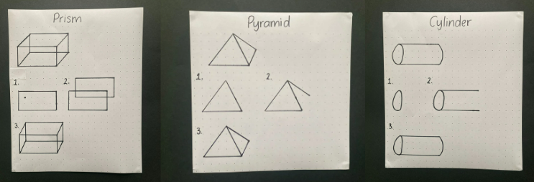
- Students count the number of faces, vertices and edges they have altogether in their sketches and record this on their paper.

Stage 3 task – nets and sketch
The table below contains suggested learning intentions and success criteria. These are best co-constructed with students.
Core concept learning intentions | Core concept success criteria
Students working towards Stage 3 outcomes are learning to:  - compare, describe and name prisms and pyramids  - connect three-dimensional objects with two-dimensional representations. | Students working towards Stage 3 outcomes can:  - name and compare properties of prisms and pyramids, according to the shape of their base  - examine a diagram to determine whether it is or is not the net of a closed three-dimensional object  - visualise, name and sketch nets of prisms and pyramids, given representations of their nets.
This activity is an adaptation of Cut Nets from NRICH by the University of Cambridge.
- Revise what students know about representing three-dimensional objects as nets.
Note: not all three-dimensional objects have nets. For example, spheres, cylinders and cones do not have a net. As they are not polyhedrons, their lack of edges means they do not have a net.
- Display Resource 4 – Net or not? Revise that a net must have flat faces, straight edges and be folded along the edges to make an enclosed object. Ask students whether each is a net or not, and why:
- A is not a net because its edges are not straight, and it has a curved surface. Cylinders do not have nets.
- B is a net because it has straight edges, flat surfaces and it can be folded to make a triangular pyramid.
- C is a net because it has straight edges, flat surfaces and it can be folded to make a cube.
- Display Resource 5 – cut nets.
- Explain that the nets of 9 objects have been cut into 2 and they can be combined in several ways to make geometrical models.
- Provide small groups of students 2 copies of Resource 5 – cut nets. Groups create a display of matched nets and solids as shown in Figure 4.
Figure 4 – matching nets student recording example
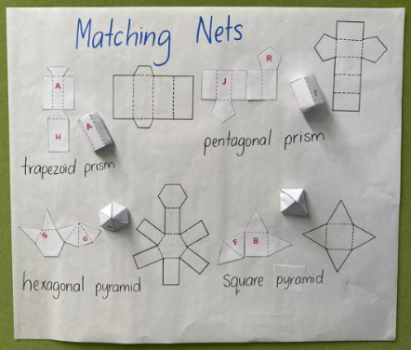
This table details opportunities for differentiation.
Too hard? | Too easy?
Stage 2 students cannot sketch prisms and pyramids, showing depth.  - Students follow guided, step-by-step instructions to draw one three-dimensional object.  Stage 3 students cannot visualise, name and/or sketch nets of prisms and pyramids, given representations of their nets.  - Provide students with three-dimensional geometrical models and labels for matching. | Stage 2 students can sketch prisms and pyramids, showing depth.  - Students use a vanishing point to draw objects.  Stage 3 students can visualise, name and sketch nets of prisms and pyramids, given representations of their nets.  - Students name and label properties of more complex three-dimensional geometrical models.

Discuss and connect the mathematics – 15 minutes
- Students display their sketches and matching nets and go on a gallery walk, discussing the following questions:
- What did you notice?
- What is similar and what is different in the sketches? (Stage 2)
- Are there any features of your sketches that need revising? (Stage 2)
- What strategies did you use to put the cut nets together? (Stage 3)
- How can you tell which are prisms and which are pyramids? (Stage 3)
- Which 2 nets were the most similar and different? (Stage 3)
- Was there more than one way to put 2 halves of some nets together? (Stage 3)
This table details opportunities for assessment.
Assessment opportunities | Links
What to look for:  - Can Stage 2 students identify the differences between prisms (including cubes), pyramids and cylinders? [MAO-WM-01, MA2-3DS-01]  - Can Stage 2 students create sketches of rectangular prisms and pyramids, showing depth? [MAO-WM-01, MA2-3DS-01]  - Can Stage 3 students name and compare properties of prisms and pyramids? [MAO-WM-01, MA3-3DS-01]  - Can Stage 3 students examine a diagram to determine whether it is or is not the net of a closed three-dimensional object? [MAO-WM-01, MA3-3DS-01]  - Can Stage 3 students visualise, name and sketch nets of prisms and pyramids, given representations of their nets? [MAO-WM-01, MA3-3DS-01] | Links to National Numeracy Learning Progressions (NNLP):  - Stage 2 – UGP3, UGP5.  - Stage 3 – UGP3, UGP5.

Lesson 3
Core concept: mathematicians draw objects from different perspectives.

Daily number sense – number targets – 15 minutes
The table below contains suggested learning intentions and success criteria. These are best co-constructed with students.
Daily number sense learning intentions | Daily number sense success criteria
Students working towards Stage 2 outcomes are learning to:  - order numbers in the thousands.  Students working towards Stage 3 outcomes are learning to:  - recognise, represent and order numbers in the millions. | Students working towards Stage 2 outcomes can:  - recognise and describe how rearranging digits changes the size of a number  - identify the nearest thousand to given numbers.  Students working towards Stage 3 outcomes can:  - arrange numbers using place value  - round numbers to a specified place value.
This activity is an adaptation of Four-digit Targets from NRICH by the University of Cambridge.
- Display Resource 6 – 20 numbers. Tell students they need to arrange the digits to make five 4-digit numbers as close to the target numbers as possible. Explain to students that they can use each digit only once. Encourage small groups of students to work strategically and systematically to get numbers nearest to the target numbers. Remind students they can adjust their answers as they progress with the problem (see Figure 5).
Figure 5 – possible student response
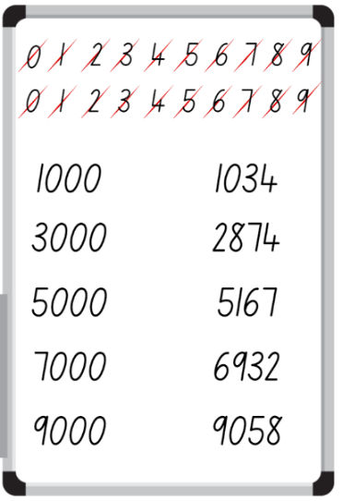
- In small groups, students share answers, asking each other:
- Who recorded the 4-digit number nearest to each target number? How do you know?
- Does your 4-digit number round up or down to the target number?
- What were the challenges in this task?
Multi-age: provide students working towards Stage 3 outcomes with Resource 7 – 30 numbers. Students arrange the digits to make five 6-digit numbers as close to the target numbers as possible. Students can adjust their answers as they progress with the problem.
This table details opportunities for assessment.
Assessment opportunities | Links
What to look for:  - Can Stage 2 students recognise and describe how rearranging digits changes the size of a number? [MAO-WM-01, MA2-RN-01]  - Can Stage 2 students identify the nearest thousand to numbers? [MAO-WM-01, MA2-RN-01]  - Can Stage 3 students arrange numbers using place value? [MAO-WM-01, MA3-RN-01]  - Can Stage 3 students round numbers to a specified place value? [MAO-WM-01, MA3-RN-01] | Links to National Numeracy Learning Progressions (NNLP):  - Stage 2 – NPV7  - Stage 3 – NPV6, NPV7.  Links to suggested Interview for Student Reasoning (IfSR) tasks:  - Stage 2 – IfSR-NP: 4C.8.

Core lesson – restaurant packaging part 1 – 40 minutes
The table below contains suggested learning intentions and success criteria. These are best co-constructed with students.
Core concept learning intentions | Core concept success criteria
Students working towards Stage 2 outcomes are learning to:  - connect three-dimensional objects and two-dimensional representations.  Students working towards Stage 3 outcomes are learning to:  - compare, describe and name prisms and pyramids. | Students working towards Stage 2 outcomes can:  - identify features of prisms and pyramids (faces, vertices and edges) from images.  Students working towards Stage 3 outcomes can:  - name prisms and pyramids according to the shape of their base  - compare properties of prisms and pyramids.
This activity is an adaptation of ‘Designing food packaging’ from the Universal Resources Hub by State of New South Wales (Department of Education).
- Give students Resource 8 – 3D objects. Students find examples of prisms and pyramids in the classroom.
- Explain that students will be designing new packaging for a restaurant. The owners want to move away from using plastic takeaway containers.
- Discuss why food packaging needs to be well constructed. Ask students if they think all packaging should be:
- made from cardboard? Why or why not?
- all the same size? Why or why not?
- easily opened? Why or why not?
- Brainstorm different types of takeaway foods and discuss the packaging currently used for those foods. For example, a pizza box.
- In pairs, students draw a sketch of one kind of takeaway food and estimate the space it takes up.
- Students transfer the sketch of their takeaway container onto isometric grid paper (see Figure 6).
Figure 6 – packaging made with prisms
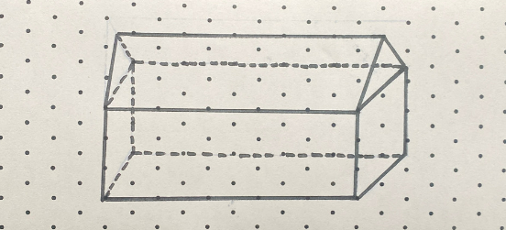
This table details opportunities for differentiation.
Too hard? | Too easy?
Students cannot visualise and/or sketch their three-dimensional objects.  - Provide students with packaging examples to sketch. | Students can visualise and sketch their three-dimensional objects.  - Students design a container that will separate 3 kinds of foods.

Discuss and connect the mathematics – 10 minutes
- Students label their design identifying the three-dimensional objects that have been used and their properties (see Figure 7).
Figure 7 – labelling packaging
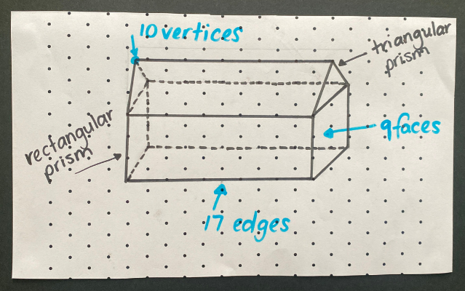
Multi-age: students working towards Stage 2 outcomes only need to name three-dimensional models as prisms. Students working towards Stage 3 outcomes can name particular prisms. For example, triangular prism and rectangular prism.
- Pairs of students share their designs, describing the three-dimensional objects they used and why.
This table details opportunities for assessment.
Assessment opportunities | Links
What to look for:  - Can Stage 2 students identify features of prisms and pyramids (faces, vertices and edges) from images? [MAO-WM-01, MA2-3DS-01]  - Can Stage 3 students name prisms and pyramids according to the shape of their base? [MAO-WM-01, MA3-3DS-01]  - Can Stage 3 students compare properties of prisms and pyramids? [MAO-WM-01, MA3-3DS-01] | Links to National Numeracy Learning Progressions (NNLP):  - Stage 2 – UGP3  - Stage 3 – UGP3, UGP5.

Lesson 4
Core concept: drawings are interpreted to construct, compare, describe and name prisms and pyramids.

Daily number sense – 10 minutes
- From a class need surfaced through formative assessment data, identify a short, focused activity that targets students’ knowledge, understanding and skills. Example activities may be drawn from the following resources:
- Mathematics K–6 resources
- Universal Resources Hub.

Core lesson – restaurant packaging part 2– 50 minutes
The table below contains suggested learning intentions and success criteria. These are best co-constructed with students.
Core concept learning intentions | Core concept success criteria
Students working towards Stage 2 outcomes are learning to:  - make models of three-dimensional objects to compare and describe key features  - connect three-dimensional objects and two-dimensional representations.  Students working towards Stage 3 outcomes are learning to:  - construct prisms and pyramids  - connect three-dimensional objects with two-dimensional representations. | Students working towards Stage 2 outcomes can:  - construct models of prisms and pyramids using physical manipulatives, identifying their features  - investigate the variety of nets that can be used to create a particular prism  - create sketches of three-dimensional objects from different views, including top, front and side views.  Students working towards Stage 3 outcomes can:  - construct skeletal models and three-dimensional models of prisms and pyramids  - visualise and sketch nets for given three-dimensional objects  - visualise and sketch three-dimensional objects from different views, including top, front and side views.
This activity is an adaptation of Designing food packaging from the Universal Resources Hub by State of New South Wales (Department of Education).
- Provide pairs of students with a range of resources. For example, paper straws, pipe cleaners, toothpicks, sticky tape, sticky putty or modelling clay. Note: students remain in the pairs they worked in for Lesson 3.
- Students create a skeletal model of their takeaway packaging design from Lesson 3 (see Figure 8).
Figure 8 – skeletal model
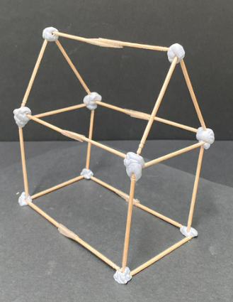
- Students sketch a net of their package on isometric grid paper (see Figure 9).
Figure 9 – net and mini model
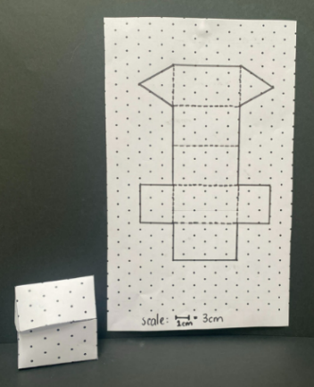
- Students draw and make nets to scale on thick poster cardboard. They then make their package.
- Choose some pairs of students to share their designs with the class. Ask students:
- Are you happy with your packaging? For example, the size. Why or why not?
- What difficulties did you experience when creating your packaging?
- Do you need to make any modifications for your packaging to be more efficient?
This table details opportunities for differentiation.
Too hard? | Too easy?
Students cannot create skeletal models and/or three-dimensional models of prisms and pyramids.  - Model building half of the skeletal model. Students complete the model.  - Provide cardboard nets for students to fold to construct a package. | Students can create skeletal models and three-dimensional models of prisms and pyramids.  - Students to construct more complex skeletal models.  - Students to draw nets of more complex three-dimensional objects and create a model.

Consolidation and meaningful practice – 10 minutes
- Students draw their packages from the front, side and top views (see Figure 10).
Figure 10 – package views
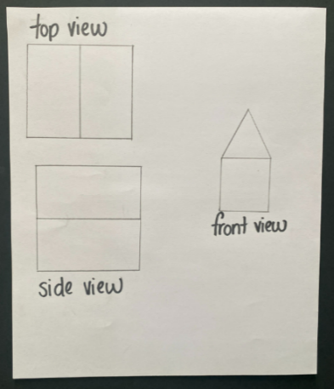
This table details opportunities for assessment.
Assessment opportunities | Links
What to look for:  - Can Stage 2 students construct models of prisms and pyramids using physical manipulatives, identifying their features? [MAO-WM-01, MA2-3DS-01]  - Can Stage 2 students investigate the variety of nets that can be used to create a particular prism? [MAO-WM-01, MA2-3DS-01]  - Can Stage 2 students create sketches of three-dimensional objects from different views, including top, front and side views? [MAO-WM-01, MA2-3DS-01]  - Can Stage 3 students construct skeletal models and three-dimensional models of prisms and pyramids? [MAO-WM-01, MA3-3DS-01]  - Can Stage 3 students visualise and sketch nets for given three-dimensional objects? [MAO-WM-01, MA3-3DS-01]  - Can Stage 3 students visualise and sketch three-dimensional objects from different views, including top, front and side views? [MAO-WM-01, MA3-3DS-01] | Links to National Numeracy Learning Progressions (NNLP):  - Stage 2 – UGP3  - Stage 3 – UGP3.

Lesson 5
Core concept: capacity is an internal measurement and relates to our base-10 place value system.

Daily number sense – multiplying by 10 – 10 minutes
Daily number sense activities for Lessons 5 to 7 ‘loop’ back to concepts and procedures covered in previous units to assist students to build an increasingly connected network of ideas. These concepts may differ from the core concepts being covered by the unit.
The table below contains a suggested learning intention and success criteria. These are best co-constructed with students.
Daily number sense learning intention | Daily number sense success criteria
All students are learning to:  - operate with multiples of 10. | Students working towards Stage 2 outcomes can:  - multiply a one-digit number by a multiple of 10.  Students working towards Stage 3 outcomes can:  - use mental strategies to multiply one-digit numbers by 10 and their multiples.
This activity is an adaptation from Counting game (by multiples of 10) from K–6 Mathematics resources by State of New South Wales (Department of Education).
- In pairs, students roll a 6-sided die 5 times. Each time, the number rolled is multiplied by 10. The totals are then added together to determine a target number. Ask students how they know that the target number is a multiple of 10.
- Explain that the object of the game is to be the person who gets to the target number first.
- Starting at zero, players take turns to roll the die and count on in tens. For example, player A rolls a 5 and counts by ten 5 times; 10, 20, 30, 40, 50. Player B rolls a 2 and counts 60, 70. This continues until an exact throw is rolled to land on the target number.
- Pairs record their die throw and counting on each turn (see Figure 11).
Figure 11 – counting game example
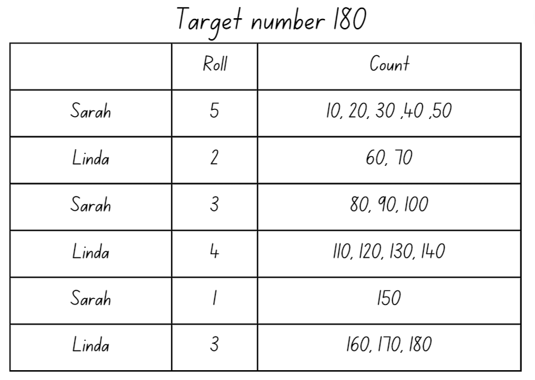
- Players repeat the process.
Multi-age: Stage 3 students use a 9-sided die and should be encouraged to multiply each roll by 10 instead of counting by tens.
This table details opportunities for assessment.
Assessment opportunities | Links
What to look for:  - Can Stage 2 students multiply a one-digit number by a multiple of 10? [MAO-WM-01, MA2-MR-01]  - Can Stage 3 students use mental strategies to multiply one-digit numbers by 10 and their multiples? [MAO-WM-01, MA3-MR-01] | Links to National Numeracy Learning Progressions (NNLP):  - Stage 2 – MuS7  - Stage 3 – MuS6, MuS7.  Links to suggested Interview for Student Reasoning (IfSR) tasks:  - Stage 3 – IfSR-MT: 3A.1, 3A.2, 3A.3.

Core lesson – How many litres? – 40 minutes
The table below contains suggested learning intentions and success criteria. These are best co-constructed with students.
Core concept learning intentions | Core concept success criteria
Students working towards Stage 2 outcomes are learning to:  - measure and order containers using litres  - use scaled instruments to measure and compare internal volumes.  Students working towards Stage 3 outcomes are learning to:  - connect decimal representations to the metric system  - choose appropriate units of measurement for capacity  - compare, order and represent decimals. | Students working towards Stage 2 outcomes can:  - record capacities using the abbreviation for litres (L)  - estimate the capacity of a container in litres and check by measuring  - use scaled instruments to relate 1000 mL to one litre.  Students working towards Stage 3 outcomes can:  - recognise the equivalence of whole number and decimal representations of measurements of capacities  - interpret decimal notation for capacities  - select and use appropriate units to measure the capacities of a variety of containers  - measure, compare and order decimal numbers of up to 3 decimal places.
Note: capacity is only used in relation to containers and generally refers to liquid. The capacity of a container will be slightly less than its volume as capacity is based on the inside dimensions, while volume is determined by the outside dimensions. It is recommended that the terms ‘capacity’ and ‘internal volume’ be used interchangeably.
- Revise the difference between volume and capacity. Volume is the space taken up by a three-dimensional object. Capacity is the internal volume, which is how much a three-dimensional object can hold.
Capacity (internal volume): refers to the amount a container can hold and is measured in units such as millilitres (mL) and litres (L).
- Ask students to share real life examples of using volume and capacity. For example, the volume of a fish tank is measured to be sure it will fit on a shelf. The capacity of the tank determines how much water will be needed to fill it.
- Revise the term ‘litres’ and that litres are represented by L. Ask students to explain why litres are useful. For example, formal units allow measures to be communicated with greater ease and accuracy. Show students an everyday container with a capacity of one litre. Explain that one litre is the same as 1000 millilitres.
Multi-age: discuss with Stage 3 students that the units of measurement for capacity can be converted to show equivalence. For example, 1000 mL = 1 L (see Figure 12).
Figure 12 – equivalent capacities
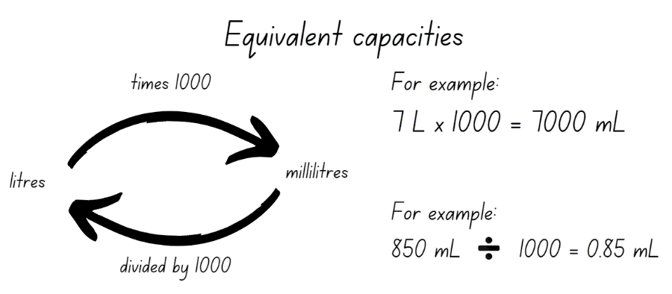
- Ask students to give everyday examples of using litres. For example, petrol or milk.
- Create an anchor chart for capacity. Return to this as necessary over Lessons 4 to 8.
- Revise scaled instruments, for example a measuring cup and/or jug. Show students a measuring jug labelled as in Figure 13. Discuss the measurements and benchmarks. Explain to students that 250 mL is equivalent to one cup.
Figure 13 – measuring jug
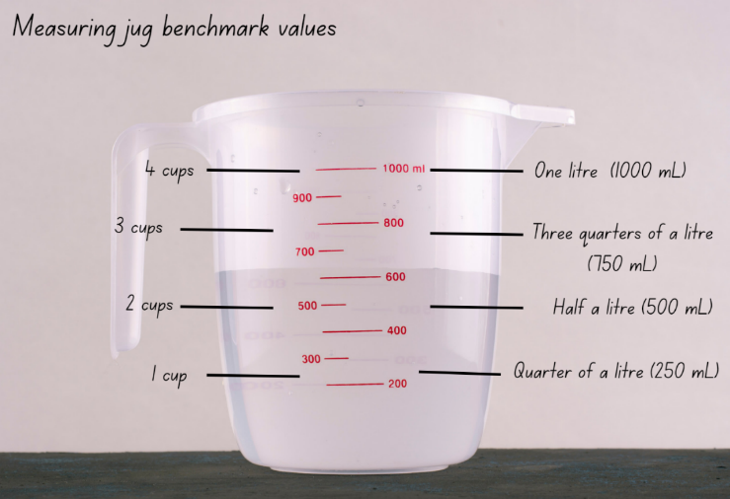
- Display a range of containers larger than one litre.
- Explain that Stage 2 students will be estimating and measuring the internal volume of each container to the nearest litre.
- Model estimating, measuring and recording the internal volume of a large container, using a litre as the measuring unit. Model recording the capacity using the abbreviation for litres (L) and adjust the estimate after adding the first 2 litres of water to the container.
- Provide groups of Stage 2 students a one litre unit of measure and 4 large containers. For example, buckets, ice cream containers, bins, tote trays.
- Stage 2 students estimate, measure and record the internal volume of each container to the nearest litre in Resource 9 – recording table A.
- While Stage 2 students are working independently, model converting millilitres to litres and record for Stage 3 students (see Figure 14).
Figure 14 – capacity recording table
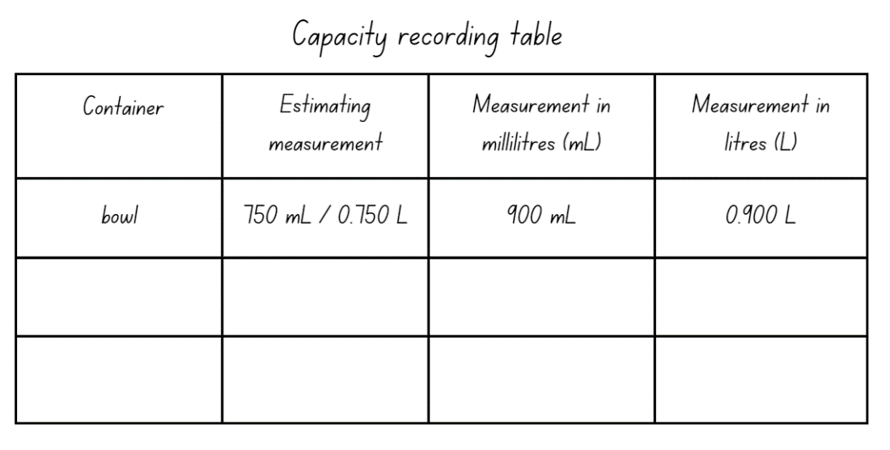
- Provide small groups of Stage 3 students with Resource 10 – capacity recording table, a measuring jug and a variety of different sized containers. Ensure that some are smaller and some larger than a litre.
- Stage 3 students estimate, measure and record the capacity of these containers in millilitres. Then they convert to litres to 3 decimal places.
- All students then order the capacities of their containers from smallest to largest.
This table details opportunities for differentiation.
Too hard? | Too easy?
Stage 2 students cannot estimate, measure and record capacities using litres.  - Give students one container to estimate, measure and record the capacity.  Stage 3 students cannot recognise and/or record the equivalence of whole-number and decimal representations of measurements.  - Give students hands on experiences to measure equivalent capacities using different measuring instruments. For example, pouring 250 mL into one cup and pouring one cup into a litre. | Stage 2 students can estimate, measure and record capacities using litres.  - Students estimate, measure and record capacities using millilitres and litres in words. For example, one litre and 500 millilitres.  Stage 3 students can recognise and record the equivalence of whole-number and decimal representations of measurements.  - Students solve problems involving decimal representations of capacity. For example, Amy buys 3 drinks: one litre of water, a 375 mL can of soft drink and a 600 mL carton of milk. How many litres did Amy buy?

Discuss and connect the mathematics – 10 minutes
- Display the following problems:
- Sarah and her 11 friends won the soccer grand final. To celebrate, Sarah’s mum bought bottles of soft drink for everyone. If everyone has one cup measuring 250 millilitres (mL), how many litres of soft drink did Sarah’s mum need to buy?
- I have 2 litres of water. I need to divide it into 5 small jugs equally. How much water in millilitres (mL) will be in each of the 5 jugs? How much water in litres (L) will be in each of the 5 jugs? The answer is 400 mL or 0.4 L.
Multi-age: revise with Stage 3 students why the zeros are removed.
- Discuss solutions. Prompt students to think about the combination of using millilitres and litres as units of measurement.
- Remind Stage 2 students to find a range of containers from home that hold 100 mL, 250 mL, 500 mL, one litre or 2 litres to bring to school.
Note: Stage 2 students will discuss containers brought from home in Lesson 7.
This table details opportunities for assessment.
Assessment opportunities | Links
What to look for:  - Can Stage 2 students estimate the internal volume of a container in litres and check by measuring? [MAO-WM-01, MA2-3DS-02]  - Can Stage 2 students record internal volumes using the abbreviation for litres? [MAO-WM-01, MA2-3DS-02]  - Can Stage 2 students use a scaled instrument to relate 1000 mL to one litre? [MAO-WM-01, MA2-3DS-02]  - Can Stage 3 students recognise the equivalence of whole-number and decimal representations of measurements of capacities? [MAO-WM-01, MA3-3DS-02]  - Can Stage 3 students interpret decimal notation for capacities? [MAO-WM-01, MA3-3DS-02]  - Can Stage 3 students select and use appropriate units to measure the capacities of a variety of containers? [MAO-WM-01, MA3-3DS-02]  - Can Stage 3 students measure, compare and order decimal numbers of up to 3 decimal places? [MAO-WM-01, MA3-RN-02] | Links to National Numeracy Learning Progressions (NNLP):  - Stage 2 – UuM6  - Stage 3 – UuM6, NPV8.  Links to suggested Interview for Student Reasoning (IfSR) tasks:  - Stage 3 – IfSR-PT: 1A.5, 1A.7  - Stage 3 – IfSR-AT: 4B.1  - Stage 3 – IfSR-NP: 4D.6.

Lesson 6
Core concept: standard units are an efficient way to communicate capacity.

Daily number sense – multiple madness – 10 minutes
The table below contains suggested learning intentions and success criteria. These are best co-constructed with students.
Daily number sense learning intentions | Daily number sense success criteria
Students working towards Stage 2 outcomes are learning to:  - operate with multiples of 10.  Students working towards Stage 3 outcomes are learning to:  - use partitioning and place value to multiply 2-, 3- and 4-digit numbers by one-digit numbers. | Students working towards Stage 2 outcomes can:  - multiply a one-digit number by a multiple of 10.  Students working towards Stage 3 outcomes can:  - use mental strategies to multiply one-digit numbers by 100 and their multiples.
This activity is an adaptation of Multiples madness (fives) from K–6 Mathematics resources by State of New South Wales (Department of Education)
- Provide pairs of Stage 2 students with Resource 11 – multiples madness 10’s and Stage 3 students with Resource 12 – multiples madness 100’s and all pairs with a 9-sided die.
- Player A has 4 counters of one colour and Player B has 4 of a different colour.
- Players take turns to roll the die and multiply the number by 10 or 100. If that multiple of 10 or 100 is available on the gameboard the player can place their coloured counter over the multiple. If the number is taken, that player misses a turn.
- A player wins by getting 4 counters in a row in any orientation.
- As players only have 4 counters, they will need to strategically choose which counter to move again once all 4 have been placed on the game board.
- Support students to reflect on the activity by asking:
- Did you prefer going first or second? Why?
- What strategy did you use? How successful was it and why?
- How might the game change if you multiplied by 20 or 200?
- Would it be easier if you had more counters? Why?

This table details opportunities for assessment.
Assessment opportunities | Links
What to look for:  - Can Stage 2 students multiply a one-digit number by a multiple of 10? [MAO-WM-01, MA2-MR-01]  - Can Stage 3 students use mental strategies to multiply one-digit numbers by 100 and their multiples? [MAO-WM-01, MA3-MR-01] | Links to National Numeracy Learning Progressions (NNLP):  - Stage 2 – MuS7  - Stage 3 – MuS6, MuS7.  Links to suggested Interview for Student Reasoning (IfSR) tasks:  - Stage 3 – IfSR-MT: 3A.1, 3A.2, 3A.3.

Core lesson – 40 minutes

Stage 2 task – What's my capacity?
The table below contains suggested learning intentions and success criteria. These are best co-constructed with students.
Core concept learning intentions | Core concept success criteria
Students are learning to:  - measure and order containers using litres  - use scaled instruments to measure and compare capacities (internal volumes). | Students can:  - recognise the need for formal units to measure capacity accurately  - recognise the need for a formal unit smaller than the litre to measure capacity.
- Display a selection of clear containers, with a capacity of at least one litre in different sizes and shapes.
- Model how to use a measuring jug to measure one litre by pouring it into one of the containers. Mark the water level on the container.
- Provide small groups of students with a selection of clear containers that have a capacity of at least one litre or larger.
- Students estimate the one litre water level of each container and mark the estimated levels with pen or rubber bands.
- Students then use a measuring jug to measure one litre, pouring it into a container and mark the water level.
- Students discuss the marks on their containers. Ask:
- What do you notice?
- How accurate were your estimates?
- Are the marks on your containers at the same level? Why or why not?
Note: students may have misconceptions about the litres being the same in different sized containers. If so, model pouring the litres from each container back into the measuring jug.
- Ask students if the containers can be used to measure capacity accurately. Students justify their thinking.
- Add new knowledge and understandings to the anchor chart.
- Give small groups of students 2 containers similar in size and shape that have a capacity of less than one litre.
- Ask students to prove which container has the largest capacity.
- Students use one litre measuring jugs to find out which container has the largest capacity.
- Ask students if there was a problem. Support them to recognise the need for formal units smaller than a litre.
- Show students a measuring cup. Revise that it holds 250 millilitres. Ask students to give examples of where they have seen millilitres used. For example, medicine, bottle of juice.
- Add new information to the anchor chart.
This table details opportunities for differentiation.
Too hard? | Too easy?
Students cannot recognise the need for formal units smaller than one litre.  - Show students examples of everyday containers measured in millilitres.  - Discuss how litres would be inappropriate for these. | Students can recognise the need for formal units smaller than one litre.  - Students compare and measure containers using litres and millilitres.  - Students record capacities using decimal notation. For example, 1.5 L.

Stage 3 task – water, water, everywhere
The table below contains suggested learning intentions and success criteria. These are best co-constructed with students.
Core concept learning intentions | Core concept success criteria
Students are learning to:  - recognise that the place value system can be extended beyond hundredths  - connect decimal representations to the metric system. | Students can:  - recognise the equivalence of whole-number and decimal representations of measurements of capacities  - interpret decimal notation for capacities and record measurements to 3 decimal places  - indicate the place value of digits in decimal numbers of up to 3 decimal places.
- Discuss equivalence and model converting between mL and L confirming place values of each number.
- Display Resource 13 – equivalence match.
- As a class, select students to draw a line matching the equivalent amounts. For example, 1500 mL is the same as one and a half litres and 1.5 L.
- As a class, discuss the answers, asking students to justify how they know these capacities are equivalent.
- Using Resource 14 – equivalence cards, in small groups, students play a game of equivalence snap. Explain that each student turns their pile of cards face down in front of them. Students turn the top card from their pile over at the same time. If the 2 cards turned over match, the player who says ‘Snap!’ first and reads aloud the matching set of cards, keeps them. If the cards don’t match, they are returned to the bottom of the pile.
- Explain to students they will be calculating how much water they use in one day.
- Ask students to create a list of activities they do each day that require water.
- Students estimate what their daily total water usage might be.
- Provide students with a container to collect and measure how much water they use when they wash their hands.
- Display Resource 15 – water usage facts.
- Students calculate how much water they use in a day, recording measurements to 3 decimal places. They compare their result to the original estimate.
- Discuss results with students, asking:
- How did you calculate your daily water usage?
- How accurate were your estimates? Why or why not?
- Ask students what they could change in their daily routines to use less water. For example, showering for 2 minutes less, brushing teeth with the tap off, using the half flush when flushing the toilet.
- Students decide on 3 water saving strategies and calculate how much water they could save each day.
- Students turn and talk, explaining how they will save water tomorrow. For example, tomorrow I am going to save 11.5 L of water by showering for half a minute less.
This table details opportunities for differentiation.
Too hard? | Too easy?
Students cannot record capacity and/or calculate equivalent measurements to 3 decimal places.  - Model decimal representation to support students finding their daily water usage.  - Give students Resource 13 – equivalence match cut into cards and provide support to match them. | Students can record and calculate equivalent measurements to 3 decimal places.  - Students calculate their average weekly, monthly and annual water usage.  - In a group of 3 or 4, students work out their combined average daily water usage.

Consolidation and meaningful practice – 10 minutes
- Display the following problems:
- Johnny has a car that takes 60 litres of petrol. The tank is one third full. How many litres does Johnny need to fill his tank?
- A toilet flush uses 12 litres of water. Amy goes to the toilet 5 times a day. How many litres of water does she use in a week?
- The average shower uses 8 litres of water a minute. If everyone in this class has a 10-minute shower tonight, how many litres of water will they use?
- Discuss strategies used to find the answer.
This table details opportunities for assessment.
Assessment opportunities | Links
What to look for:  - Can Stage 2 students recognise the need for formal units to measure capacity accurately? [MAO-WM-01, MA2-3DS-02]  - Can Stage 2 students recognise the need for a formal unit smaller than the litre to measure capacity? [MAO-WM-01, MA2-3DS-02]  - Can Stage 3 students recognise the equivalence of whole-number and decimal representations of measurements of capacities? [MAO-WM-01, MA3-3DS-02]  - Can Stage 3 students interpret decimal notation for capacities and record measurements to 3 decimal places? [MAO-WM-01, MA3-3DS-02]  - Can Stage 3 students indicate the place value of digits in decimal numbers of up to 3 decimal places? [MAO-WM-01, MA3-RN-02] | Links to National Numeracy Learning Progressions (NNLP):  - Stage 2 – UuM6  - Stage 3 – NPV7, NPV8, NPV9.

Lesson 7
Core concept: estimation is guided by using known benchmarks of capacity and our base-10 place value system.

Daily number sense – multiplying by multiples – 15 minutes
The table below contains a suggested learning intention and success criteria. These are best co-constructed with students.
Daily number sense learning intention | Daily number sense success criteria
All students are learning to:  - multiply with multiples of 10. | Students working towards Stage 2 outcomes can:  - use multiplication facts with multiples of 10 for one-digit numbers.  Students working towards Stage 3 outcomes can:  - use mental strategies to multiply one-digit numbers by 10 and their multiples.
- Provide pairs of students with a 10-sided die and 2 copies of Resource 16 – multiplying multiples.
- Players take turns to roll the die twice each turn. The first number becomes the multiplier, while the second number is turned into a multiple of 10 and that becomes the multiplicand. The player multiplies the numbers and records their thinking in Resource 16 – multiplying multiples. Students can choose which row each time, the objective being to place their rolls in ascending order according to the product (see Figure 15).
Figure 15 – example of gameboard recording
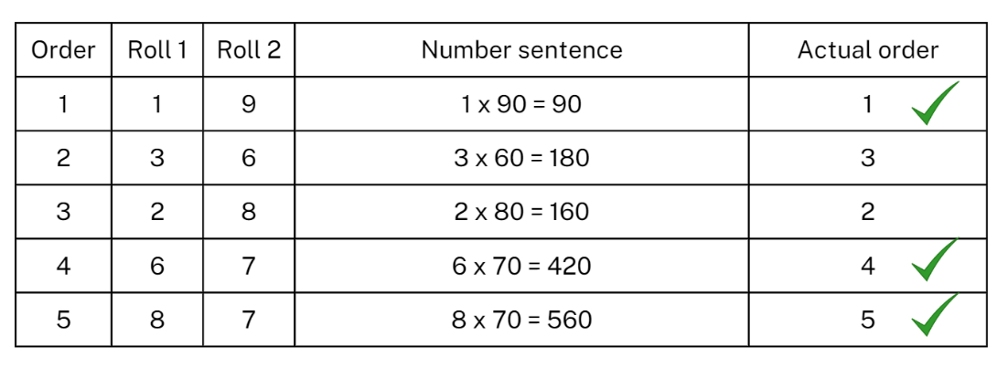
- After each turn, students will need to use prediction to decide on row placement.
- After each player has completed 5 turns, use the actual order column to record which turns were placed in the correct row. Players score a point for each correct placement. For example, the player in Figure 15 scores 3 points.
- Students repeat the process till the time is up.
- Reflect on the game, asking questions such as:
- How did you decide where to place each answer?
- Did you change your strategy after the first round? Why or why not?
- What modifications could you suggest for the game?
This table details opportunities for assessment.
Assessment opportunities | Links
What to look for:  - Can Stage 2 students use multiplication facts with multiples of 10 for one-digit numbers? [MAO-WM-01, MA2-MR-01]  - Can Stage 3 students use mental strategies to multiply one-digit numbers by 10 and their multiples? [MAO-WM-01, MA3-MR-01] | Links to National Numeracy Learning Progressions (NNLP):  - Stage 2 – MuS7  - Stage 3 – MuS6, MuS7.  Links to suggested Interview for Student Reasoning (IfSR) tasks:  - Stage 3 – IfSR-MT: 3A.1, 3A.2, 3A.3.

Core lesson – estimating capacity and dripping taps – 40 minutes
The table below contains suggested learning intentions and success criteria. These are best co-constructed with students.
Core concept learning intentions | Core concept success criteria
Students working towards Stage 2 outcomes are learning to:  - use scaled instruments to measure and compare capacities (internal volumes)  - read, represent and order numbers to thousands.  Students working towards Stage 3 outcomes are learning to:  - recognise that the place value system can be extended beyond hundredths  - compare, order and represent decimals  - connect decimal representations to the metric system. | Students working towards Stage 2 outcomes can:  - use a scaled instrument to relate 1000 millilitres to one litre and record capacity using the abbreviations for millilitres (mL) and litres (L)  - estimate the capacity of a container to common benchmark values, such as 250 mL, and check by measuring.  Students working towards Stage 3 outcomes can:  - recognise the equivalence of whole-number and decimal representations of measurements of capacities  - compare, order and record decimal measurements of up to 3 decimal places  - indicate the place value of digits in decimal numbers of up to 3 decimal places.
- Review Stage 3 students' knowledge of recent concepts by providing them with Resource 17 – converting measurements to complete independently.
- While Stage 3 students are working, discuss the containers Stage 2 students brought from home.
- Sort containers into 100 mL, 250 mL, 500 mL, 1 L and 2 L groups.
- Compare the heights and capacities of these containers. For example, a tall skinny container compared to a short, wide container. Ask:
- What do you notice?
- Are there any containers that do not fit into these categories?
- How could you sort these containers in another way?
- Discuss benchmark values of 250 mL, 500 mL, 1000 mL or 1 L. Make connections benchmark values, capacities of containers and a one litre scaled measuring jug.
- Model estimating, measuring and recording the capacity of a container using benchmark values. For example:
- I estimate this container is about 500 mL because I can see it looks the same as the 500 mL measuring jug.
- I estimate this container is 250 mL because it looks like it has the about the same capacity as the 250 mL drink bottle.
- Give groups of Stage 2 students a measuring cup and/or jug and a collection of small containers. For example, cups, butter containers, drink bottles.
- Stage 2 students use Resource 18 – recording table B to record estimates for the capacity of each container using benchmark values. Students measure and record capacities, then check their estimates. Students may adjust estimates after measuring the first container.
- While Stage 2 are measuring capacity, explain to Stage 3 students that they are going to investigate the water wastage caused by a dripping tap.
- In small groups, Stage 3 students estimate the water wastage caused by a dripping tap in 24 hours. They record their estimate in L and mL.
- Stage 3 students collect, measure and record, in L and mL, the water from a dripping tap over 20 minutes.
- Ask Stage 3 students to use this measurement to calculate how much water would be wasted in 24 hours. For example, the water collected from a dripping tap in 20 minutes is 150 mL or 0.150 L. Multiply this by 3 to find out how much water would be wasted in one hour. Multiply this answer by 24 to find out how much water would be wasted in one day. The water wastage would be 0.150 L × 3 × 24 = 10.800 L.
Note: this lesson may be extended into an investigation of dripping taps around the school.
This table details opportunities for differentiation.
Too hard? | Too easy?
Stage 2 students cannot estimate and/or measure capacities using benchmark values.  - Support students to practice estimating and measuring using a 250 mL measuring cup.  - Support students to measure and record capacities.  Stage 3 students cannot convert between millilitres and litres, litres and millilitres and/or record measurements to 3 decimal places.  - Support students to develop understanding of place value to 3 decimal places using a number slide.  - Support student understanding of equivalence by relating common measurements to benchmark values. | Stage 2 students can estimate and/or measure capacities using benchmark values.  - Students make comparisons between containers. For example, 250 mL is the same as one can, one cup or one juice box.  - Students convert estimates from litres to millilitres and millilitres to litres.  Stage 3 students can convert between millilitres and litres, litres and millilitres and record measurements to 3 decimal places.  - Students convert between millilitres and litres, litres and millilitres with large volumes of their choice.  - Students research large capacities. For example, the local dam capacity.

Discuss and connect the mathematics – 10 minutes
- Regroup as a class and summarise the lesson, drawing out key mathematical ideas. Ask:
- What did you notice?
- How accurate were your estimates? Why or why not?
- What benchmark values were your containers closest to? (Stage 2)
- Did benchmark values help you to estimate? How? (Stage 2)
- What would change the results of the dripping tape? (Stage 3)
This table details opportunities for assessment.
Assessment opportunities | Links
What to look for:  - Can Stage 2 students use a scaled instrument to relate 1000 millilitres to one litre and record capacity using the abbreviation for millilitres (mL) and litres (L)? [MA0-WM-01, MA2-3DS-02]  - Can Stage 2 students estimate the capacity of a container to common benchmark values, such as 250 mL, and check by measuring? [MA0-WM-01, MA2-3DS-02]  - Can Stage 3 students recognise the equivalence of whole-number and decimal representations of measurements of capacities? [MAO-WM-01, MA3-3DS-02]  - Can Stage 3 students compare, order and record decimal measurements of up to 3 decimal places? MAO-WM-01, MA3-RN-02, MA3-3DS-02]  - Can Stage 3 students indicate the place value of digits in decimal numbers of up to 3 decimal places? [MAO-WM-01, MA3-RN-02] | Links to National Numeracy Learning Progressions (NNLP):  - Stage 2 – UuM6  - Stage 3 – NPV7, NPV8, NPV9.

Lesson 8
Core concept: mathematicians explore capacity in different ways.

Daily number sense – 10 minutes
- From a class need surfaced through formative assessment data, identify a short, focused activity that targets students’ knowledge, understanding and skills. Example activities may be drawn from the following resources:
- Mathematics K–6 resources
- Universal Resources Hub.

Core lesson – 40 minutes

Stage 2 task – making your own measuring cup
The table below contains suggested learning intentions and success criteria. These are best co-constructed with students.
Core concept learning intentions | Core concept success criteria
Students are learning to:  - use scaled instruments to measure and compare internal volumes  - order numbers in the thousands. | Students can:  - use a scaled instrument to relate 1000 millilitres to one litre and record internal volume using the abbreviation for millilitres (mL) and litres (L)  - compare and order the internal volumes of 2 or more containers measured in millilitres  - estimate the internal volume of a container to common benchmark values, such as 250 mL, and check by measuring.
- Explain to students that they will be making a scaled measuring instrument with a plastic cup.
- Model how to mark 100 mL on a plastic cup using a scaled instrument and a marker or elastic band.
- Students continue the process with their own plastic cup until they have scaled it to the top.
- Students go on a scavenger hunt around the room. They find containers that hold approximately 100 mL, 200 mL and 500 mL and record estimates.
- Students use their plastic cup to measure and record the capacity of each container. Ask:
- How accurate were your estimates? Why or why not?
- How effective was measuring the capacity of a container using the plastic cup? How do you know?
- Display Resource 19 – measurement cards and explain to students they will be comparing and ordering different capacity measurements from smallest to largest.
- Provide students with one card from Resource 19 – measurement cards.
- Students order themselves from the smallest to the largest capacity.
This table details opportunities for differentiation.
Too hard? | Too easy?
Students cannot use scaled instruments to measure and compare capacity.  - Model measuring using scaled instruments.  - Model comparing and ordering capacities of 2 containers. Students measure a third container and order it correctly with the first 2 containers. | Students can use scaled instruments to measure and compare capacity.  - Students use decimal notation to record capacities.  - Students create capacity word problems to share with the class.

Stage 3 task – a thirsty crow
The table below contains a suggested learning intention and success criteria. These are best co-constructed with students.
Core concept learning intention | Core concept success criteria
Students are learning to:  - use displacement to investigate volumes of irregular solids. | Students can:  - recognise that an object’s volume takes up space by observing the change in water level when an object is placed in a container of water  - compare the volumes of 2 or more objects by marking the change in water level when each is submerged in a container.
- Read The Crow and the Pitcher fable by Aesop.
- Discuss what displacement means. Explain that displacement is the change in water level when an object is submerged into it. Displacement is a useful strategy to measure the volume of irregular objects.
- Model measuring the internal capacity of an irregular object using displacement. For example, a glue stick, pair of scissors or modelling clay container.
- Explain to students that they will be using displacement to calculate how many marbles would be needed to increase the water in a container, so that a bird could drink from it. The bird can only drink water from a container if it is completely full to start with.
- Show students a narrow container that is half full of water. Mark the halfway point with a whiteboard marker. Explain that you are going to add marbles until the water reaches the top of the container. Each marble will displace some water. Have students estimate how many marbles will be needed to displace enough water so that the water level is at the top of the container instead of halfway (see Figure 16).
Figure 16 – narrow container
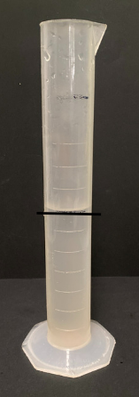
- Model dropping in marbles one a time and mark the new level each time with a whiteboard marker. After dropping in 3 marbles, ask students if they would like to refine their estimates. Keep a tally of the number of marbles used to displace enough water so the water level is at the top of the container.
- Provide small groups of students with narrow containers which are different to the container used for modelling, marbles and a whiteboard marker.
- Students pour water into a narrow container until it is half full. They mark this level. Students estimate how many marbles it will take to displace the water to the top of the container.
- Students measure the water level each time another marble is dropped in and record the results. After they have dropped in 3 marbles, they consider whether to refine their estimate.
- Discuss how many marbles were needed with the class and ask how close they were to their original estimates.
- Students repeat the process with a different object such as dice.
- Pose the problem: What is the volume of a marble?
- Students calculate how many marbles it takes to displace 100 mL in a measuring jug.
- Then students calculate the volume of one marble. Answer: One marble is equivalent to approximately 1.666 mL.
This table details opportunities for differentiation.
Too hard? | Too easy?
Students cannot recognise and/or compare the volume of objects using displacement.  - Support students to use displacement to find the volume of objects using different containers.  - Support students to compare the volume of 2 objects using displacement. | Students can recognise and compare the volume of objects using displacement.  - Ask students to find the difference in volume between 2 objects. For example, marbles and dice.  - Students calculate the volume of an object using displacement with a limited number of objects. For example, 30 marbles displace 50 mL, so 60 marbles would displace 100 mL.

Discuss and connect the mathematics – 10 minutes
- Regroup as a class and display Resource 20 – capacity quiz for Stage 2 students. Students discuss and answer questions with a partner.
- Ask Stage 3 students:
- What is displacement and what is it used for?
- Did changing the object change your estimate and/or measurement?
- How could you calculate the volume of an object using only 2 or 3 marbles, dice or other objects? How do you know?
- Did you face any challenges? How did you overcome these?
This table details opportunities for assessment.
Assessment opportunities | Links
What to look for:  - Can Stage 2 students use a scaled instrument to relate 1000 millilitres to one litre, record internal volume using the abbreviation for millilitres (mL) and litres (L)? [MAO-WM-01, MA2-3DS-02]  - Can Stage 2 students compare and order the internal volumes of 2 or more containers measured in millilitres? [MAO-WM-01, MA2-3DS-02]  - Can Stage 2 students estimate the internal volume of a container to common benchmark values, such as 250 mL, and check by measuring? [MAO-WM-01, MA2-3DS-02]  - Can Stage 3 students recognise that an object’s volume takes up space by observing the change in water level when an object is placed in a container of water? [MAO-WM-01, MA3-3DS-02]  - Can Stage 3 students compare the volumes of 2 or more objects by marking the change in water level when each is submerged in a container? [MAO-WM-01, MA3-3DS-02] | Links to National Numeracy Learning Progressions (NNLP):  - Stage 2 – UuM6  - Stage 3 – N/A.

Resource 1 – dice combinations
1243 | 1324 | 1342
2341 | 2413 | 2431
3142 | 3214 | 3241
4231 | 4312 | 4321

Resource 2 – Guess what?
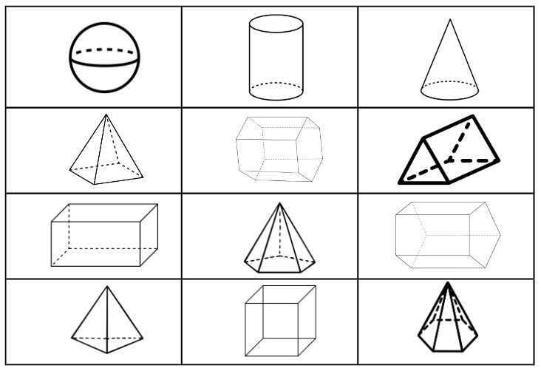

Resource 3 – three-dimensional objects
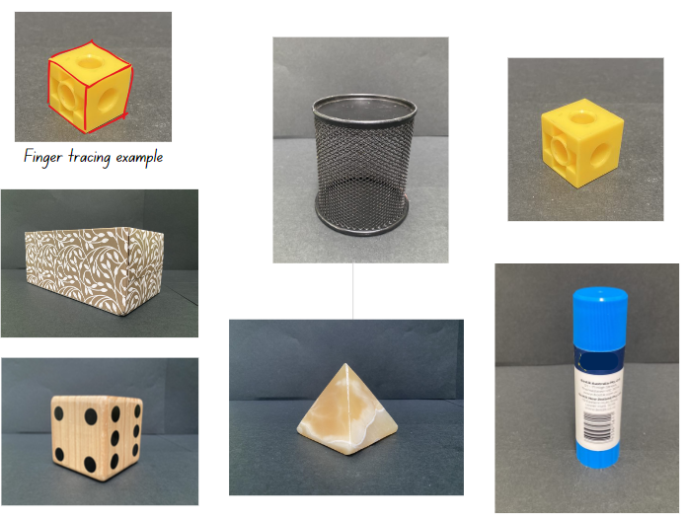

Resource 4 – Net or not?
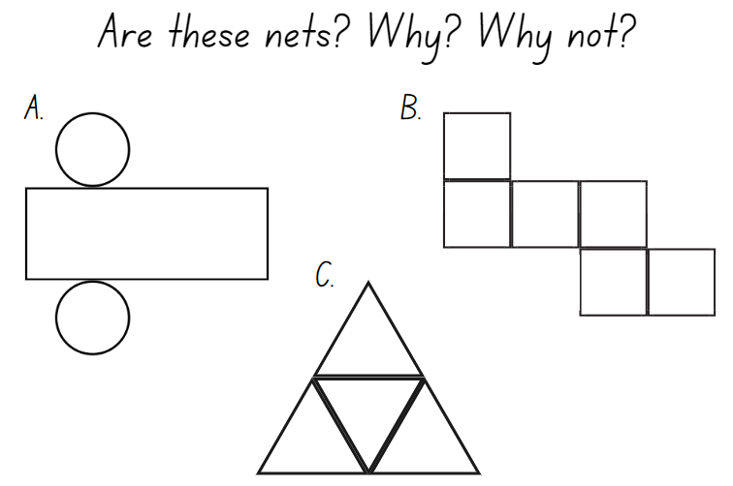

Resource 5 – cut nets
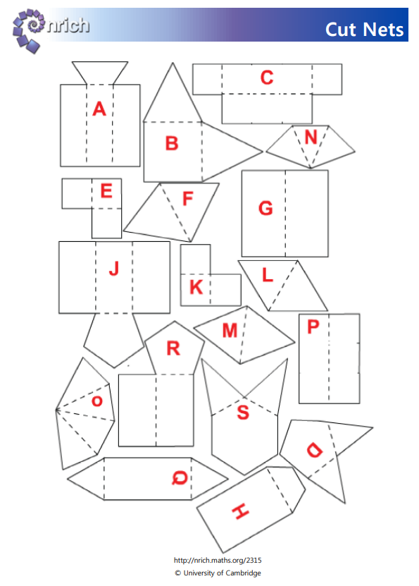

Resource 6 – 20 numbers
0 | 1 | 2 | 3 | 4 | 5 | 6 | 7 | 8 | 9
0 | 1 | 2 | 3 | 4 | 5 | 6 | 7 | 8 | 9

Target Numbers
Number closest to 1000 | Number closest to 3000 | Number closest to 5000 | Number closest to 7000 | Number closest to 9000

Resource 7 – 30 numbers
0 | 1 | 2 | 3 | 4 | 5 | 6 | 7 | 8 | 9
0 | 1 | 2 | 3 | 4 | 5 | 6 | 7 | 8 | 9
0 | 1 | 2 | 3 | 4 | 5 | 6 | 7 | 8 | 9

Target Numbers
Number closest to  100 000 | Number closest to  300 000 | Number closest to  500 000 | Number closest to  700 000 | Number closest to  900 000

Resource 8 – 3D objects
3D objects in the world
3D object name  (Stage 2) | Geometrical model | 3D object name  (Stage 3) | Real-world examples
cube | 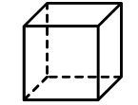 | cube
prism | 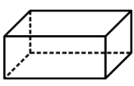 | rectangular prism (cuboid)
prism | 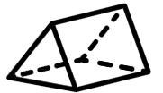 | triangular prism
prism | 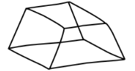 | trapezoid prism
pyramid | 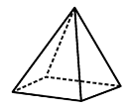 | square pyramid
pyramid | 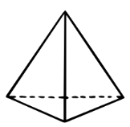 | triangular pyramid (tetrahedron)

Resource 9 – recording table A
Container | Estimate | Revised estimate | Measure (litres, L)
1
2
3

Resource 10 – capacity recording table
Container | Estimate of measurement | Measurement in millilitres (mL) | Measurement in litres (L)

Resource 11 – multiples madness 10’s
0 | 10 | 40 | 80 | 60
30 | 70 | 20 | 50 | 30
50 | 20 | 0 | 40 | 60
90 | 10 | 70 | 80 | 50
40 | 60 | 30 | 90 | 20

Resource 12 – multiples madness 100’s
100 | 100 | 400 | 800 | 600
300 | 700 | 200 | 500 | 300
500 | 200 | 100 | 400 | 600
900 | 100 | 700 | 800 | 500
400 | 600 | 300 | 900 | 200

Resource 13 – equivalence match
What is my equivalent measurement?
0.375 L |  | 0.750 L
750 mL |  | 375 mL
Quarter of a cup |  | 0.125 L
0.250 L |  | 0.500 L
1 litre |  | 1 cup
500 mL |  | 1000 mL

Resource 14 – equivalence cards
1 cup |  | 4 cups |  | 350 mL |  | 0.125 L |  | 1 litre
2 cups |  | 125 mL |  | 1 L |  | 0.125 L |  | 500 mL
$\frac{1}{4}$ cup |  | 1000 mL |  | 1500 mL |  | 0.350L |  | 250 mL

8750 mL |  | 2450 mL |  | 5 cups |  | 1.250 L |  | 1.500 L
1055 mL |  | 1900 mL |  | 75 mL |  | 1.900 L |  | 0.075 L
5 mL |  | 0.005 L |  | 8.750 L |  | 1.055 L |  | 2.450 L

Resource 15 – water usage facts
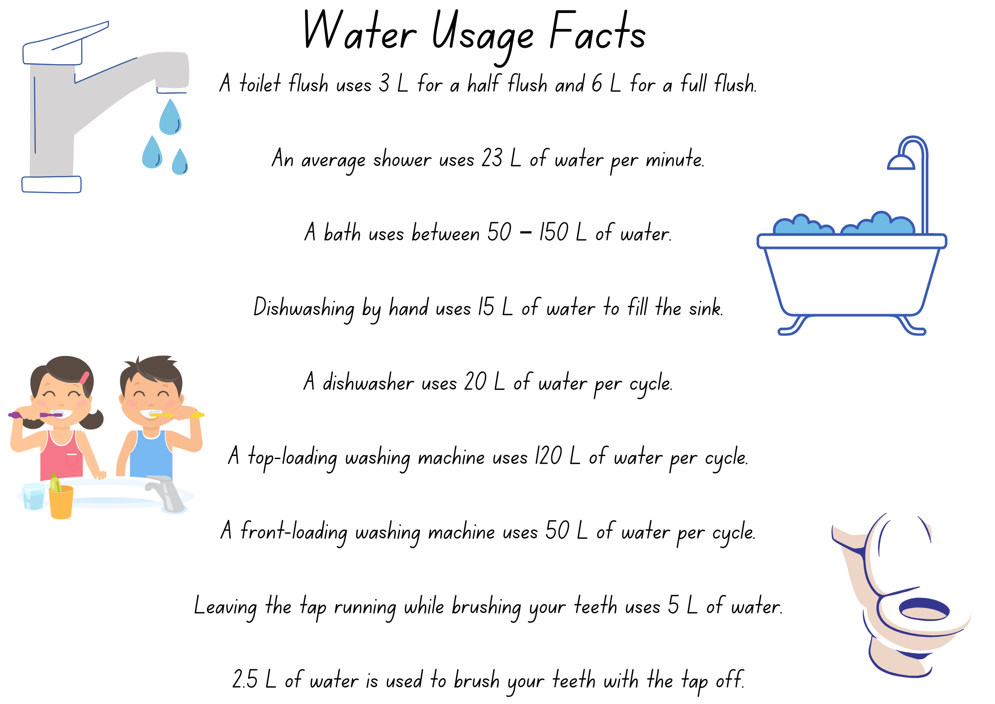

Resource 16 – multiplying multiples
Order | Roll 1 | Roll 2 | Number sentence | Actual order
1
2
3
4
5

Resource 17 – converting measurements
Sarah's measuring jug is only labelled in litres and Linda's is only labelled in millilitres. Complete the tables below to convert litres into millilitres and millilitres into litres:
Litres (L) – Sarah’s jug | Millilitres (mL) | Millilitres (mL) – Linda’s jug | Litres (L)
1.500 |  | 750
3.750 |  | 15
2.225 |  | 2300
0.250 |  | 1500
0.075 |  | 4

Resource 18 – recording table B
Estimating and recording internal volume (capacity)
Container | Estimate | Revised estimate | Measure (millilitres, mL)  Litres (L)
1
2
3

Resource 19 – measurement cards
100 mL |  | 500 mL |  | 1500 mL |  | 10 mL
1000 mL |  | 250 mL |  | 1 L |  | 2000 mL
700 mL |  | $\frac{3}{4}$ litre |  | 1.5 litres |  | $\frac{1}{2}$ litre

18 mL |  | 3 litres |  | 3 cups |  | 750 mL
4 cups |  | 1 cup |  | 150 mL |  | 2 cups
300 mL |  | 700 mL |  | 40 mL |  | 1300 mL

Resource 20 – capacity quiz
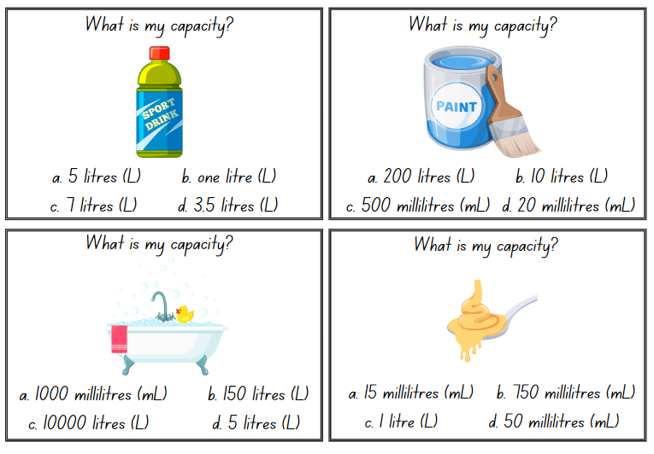
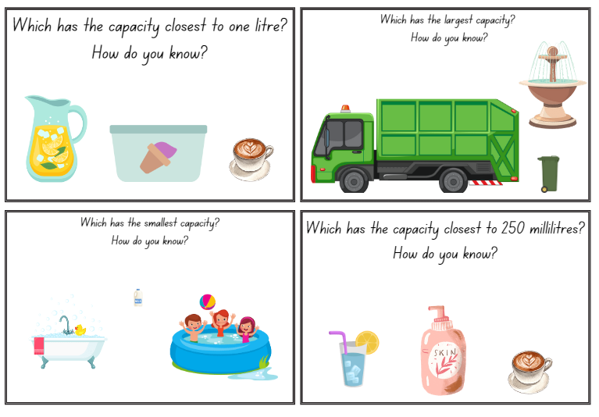

Syllabus outcomes and content

Stage 2
The table below outlines the syllabus outcomes and range of relevant syllabus content covered in this unit. Content is linked to National Numeracy Learning Progression version (3).
Outcomes and content | 1 | 2 | 3 | 4 | 5 | 6 | 7 | 8
Representing numbers using place value A: Whole numbers: Read, represent and order numbers to thousands
[MAO-WM-01, MA2-RN-01]
- Count forwards and backwards by tens and hundreds on and off the decade |  |  |  |  | x
- Read and order numbers of up to at least 4 digits |  |  |  |  |  |  | x | x
Representing numbers using place value B: Whole numbers: Order numbers in the thousands
[MAO-WM-01, MA2-RN-01]
- Arrange numbers in the thousands in ascending and descending order |  |  |  |  |  |  | x | x
- Recognise and describe how rearranging digits changes the size of a number (Reasons about relations) |  | x | x
- Identify the nearest thousand, 10 thousand or 100 thousand to numbers | x | x | x
Multiplicative relations B: Operate with multiples of 10
[MAO-WM-01, MA2-MR-01]
- Use multiplication facts with multiples of 10 to multiply a one-digit number by a multiple of 10 |  |  |  |  | x | x | x
Two-dimensional spatial structure A: 2D shapes: Compare and describe features of two-dimensional shapes
[MAO-WM-01, MA2-2DS-01]
- Describe and compare two-dimensional shapes, including parallelograms, rectangles, rhombuses, squares, trapeziums and kites | x
Three-dimensional spatial structure A: 3D objects: Make models of three-dimensional objects to compare and describe key features
[MAO-WM-01, MA2-3DS-01]
- Identify the differences between prisms (including cubes), pyramids and cylinders | x | x | x
- Construct models of prisms, pyramids and cylinders using physical or virtual manipulatives, identifying their features |  |  |  | x
- Investigate the variety of nets that can be used to create a particular prism |  |  |  | x
Three-dimensional spatial structure A: Volume: Measure and order containers using litres
[MAO-WM-01, MA2-3DS-02]
- Recognise the need for formal units to measure capacity (internal volume) accurately |  |  |  |  | x | x | x | x
- Use the litre as a unit to measure capacities (internal volumes) to the nearest litre |  |  |  |  | x | x
- Relate the litre to familiar everyday containers |  |  |  |  | x | x |  | x
- Recognise that one-litre containers can be a variety of shapes (Reasons about spatial structure) |  |  |  |  |  | x |  | x
- Record capacities (internal volumes) using the abbreviation for litres (L) |  |  |  |  | x |  | x | x
- Estimate the capacity (internal volume) of a container in litres and check by measuring |  |  |  |  |  | x | x | x
Three-dimensional spatial structure B: 3D objects: Connect three-dimensional objects and two-dimensional representations
[MAO-WM-01, MA2-3DS-01]
- Identify features of prisms and pyramids (faces, vertices and edges) and cylinders (curved/flat surfaces and boundaries) from images | x | x | x
- Create sketches of rectangular prisms and pyramids, showing depth |  | x | x | x
- Create sketches of three-dimensional objects from different views, including top, front and side views (Reasons about spatial relations) |  |  | x | x
- Draw different views on isometric grids of an object constructed from connecting cubes |  | x | x | x
- Interpret given drawings to make models of three-dimensional objects using connecting cubes (Reasons about spatial visualisation) |  |  |  | x
Three-dimensional spatial structure B: Volume: Use scaled instruments to measure and compare capacities (internal volumes)
[MAO-WM-01, MA2-3DS-02]
- Recognise the need for a formal unit smaller than the litre to measure capacity (internal volume) |  |  |  |  | x | x | x | x
- Use a scaled instrument to relate 1000 millilitres to one litre |  |  |  |  | x | x | x
- Relate benchmark values to familiar everyday containers |  |  |  |  | x |  | x | x
- Calibrate a container by marking 100 mL increments to measure capacity (internal volume) to the nearest 100 mL |  |  |  |  |  |  |  | x
- Record capacity (internal volume) using the abbreviation for millilitres (mL) and litres (L) |  |  |  |  |  |  | x | x
- Compare and order the capacities (internal volumes) of 2 or more containers measured in millilitres |  |  |  |  |  |  | x | x
- Estimate the capacity (internal volume) of a container to common benchmark values, such as 250 mL, and check by measuring |  |  |  |  |  |  | x
Mathematics K–10 Syllabus © NSW Education Standards Authority (NESA) for and on behalf of the Crown in right of the State of New South Wales, 2022.

Stage 3
The table below outlines the syllabus outcomes and range of relevant syllabus content covered in this unit. Content is linked to National Numeracy Learning Progression version (3).
Outcomes and content | 1 | 2 | 3 | 4 | 5 | 6 | 7 | 8
Represents numbers A: Whole numbers: Recognise, represent and order numbers in the millions
[MAO-WM-01, MA3-RN-01]
- Arrange numbers in the millions in ascending and descending order using place value |  | x | x
- Round numbers to a specified place value | x | x | x
Represents numbers A: Decimals and percentages: Recognise that the place value system can be extended beyond hundredths
[MAO-WM-01, MA3-RN-02]
- Indicate the place value of digits in decimal numbers of up to 3 decimal places |  |  |  |  |  | x | x
Represents numbers A: Decimals and percentages: Compare, order and represent decimals
[MAO-WM-01, MA3-RN-02]
- Compare and order decimal numbers of up to 3 decimal places |  |  |  |  | x |  | x
Multiplicative relations A: Use partitioning and place value to multiply 2-, 3- and 4-digit numbers by one-digit numbers
[MAO-WM-01, MA3-MR-01]
- Use mental strategies to multiply one-digit numbers by 10, 100, 1000 and their multiples |  |  |  |  | x | x | x
Three-dimensional spatial structure A: 3D objects: Compare, describe and name prisms and pyramids
[MAO-WM-01, MA3-3DS-01]
- Compare properties of prisms and pyramids | x | x | x
- Name prisms and pyramids according to the shape of their base | x | x | x
Three-dimensional spatial structure A: 3D objects: Connect three-dimensional objects with two-dimensional representations
[MAO-WM-01, MA3-3DS-01]
- Visualise and sketch three-dimensional objects from different views, including top, front and side views (Reasons about spatial orientation) |  | x |  | x
- Examine a diagram to determine whether it is or is not the net of a closed 3-dimensional object |  | x
- Visualise and sketch nets for given three-dimensional objects |  | x | x | x
- Visualise and name prisms and pyramids, given representations of their nets (Reasons about spatial visualisation) |  | x
Three-dimensional spatial structure A: Volume: Choose appropriate units of measurement for capacity
[MAO-WM-01, MA3-3DS-02]
- Select and use appropriate units to measure the capacities of a variety of containers |  |  |  |  | x
Three-dimensional spatial structure A: Volume: Use displacement to investigate volumes of irregular solids
[MAO-WM-01, MA3-3DS-02]
- Recognise that an object’s volume takes up space by observing the change in water level when an object is placed in a container of water |  |  |  |  |  |  |  | x
- Compare the volumes of 2 or more objects by marking the change in water level when each is submerged in a container |  |  |  |  |  |  |  | x
Three-dimensional spatial structure A: Volume: Connect decimal representations to the metric system
[MAO-WM-01, MA3-3DS-02]
- Recognise the equivalence of whole-number and decimal representations of measurements of capacities |  |  |  |  | x | x | x
- Interpret decimal notation for capacities |  |  |  |  | x | x
- Record measurements to 3 decimal places |  |  |  |  | x | x | x
Three-dimensional spatial structure B: 3D objects: Construct prisms and pyramids
[MAO-WM-01, MA3-3DS-01]
- Create skeletal models of prisms and pyramids |  |  |  | x
- Construct three-dimensional models of prisms and pyramids, given drawings of different views |  |  |  | x
Mathematics K–10 Syllabus © NSW Education Standards Authority (NESA) for and on behalf of the Crown in right of the State of New South Wales, 2022.

References
This resource contains NSW Curriculum and syllabus content. The NSW Curriculum is developed by the NSW Education Standards Authority. This content is prepared by NESA for and on behalf of the Crown in right of the State of New South Wales. The material is protected by Crown copyright.
Please refer to the NESA Copyright Disclaimer for more information https://educationstandards.nsw.edu.au/wps/portal/nesa/mini-footer/copyright.
NESA holds the only official and up-to-date versions of the NSW Curriculum and syllabus documents. Please visit the NSW Education Standards Authority (NESA) website https://educationstandards.nsw.edu.au/wps/portal/nesa/home and the NSW Curriculum website https://curriculum.nsw.edu.au.
Mathematics K–10 Syllabus © NSW Education Standards Authority (NESA) for and on behalf of the Crown in right of the State of New South Wales, 2022.
National Numeracy Learning Progression © Australian Curriculum, Assessment and Reporting Authority (ACARA) 2010 to present, unless otherwise indicated. This material was downloaded from the Australian Curriculum website (National Numeracy Learning Progression) (accessed 7 November 2023) and was not modified.
[10:01 AM] Sandrine Woo
Aesop (1919) ‘The Crow and the Pitcher’, The Aesop for Children: with Pictures by Milo Winter (Winter M illus), Rand, McNally and Co, adapted by the Library of Congress, accessed 20 December 2023.
Library of Congress Aesop Fables2023 Google (2023) Google Maps [website], accessed 3 November 2023.
State of New South Wales (Department of Education) (2023) ‘Counting game (by multiples of 10)’, K–6 Mathematics Resources, NSW Department of Education website, accessed 3 November 2023.
State of New South Wales (Department of Education) (2023) ‘Designing food packaging’, Universal Resources Hub, NSW Department of Education website, accessed 3 November 2023.
State of New South Wales (Department of Education) (2023) ‘Multiples madness (fives)’, K–6 Mathematics Resources, NSW Department of Education website, accessed 3 November 2023.
University of Cambridge (n.d.) Cut Nets, NRICH website, accessed 3 November 2023.
University of Cambridge (n.d.) Four-digit Targets, NRICH website, accessed 3 November 2023.
University of Cambridge (n.d.) Guess What?, NRICH website, accessed 3 November 2023.
University of Cambridge (n.d.) Round the Four Dice, NRICH website, accessed 3 November 2023.

© State of New South Wales (Department of Education), 2023
The copyright material published in this resource is subject to the Copyright Act 1968 (Cth) and is owned by the NSW Department of Education or, where indicated, by a party other than the NSW Department of Education (third-party material).
Copyright material available in this resource and owned by the NSW Department of Education is licensed under a Creative Commons Attribution 4.0 International (CC BY 4.0) license.
This license allows you to share and adapt the material for any purpose, even commercially.
Attribution should be given to © State of New South Wales (Department of Education), 2023.
Material in this resource not available under a Creative Commons license:
- the NSW Department of Education logo, other logos and trademark-protected material
- material owned by a third party that has been reproduced with permission. You will need to obtain permission from the third party to reuse its material.
Links to third-party material and websites
Please note that the provided (reading/viewing material/list/links/texts) are a suggestion only and implies no endorsement, by the New South Wales Department of Education, of any author, publisher, or book title. School principals and teachers are best placed to assess the suitability of resources that would complement the curriculum and reflect the needs and interests of their students.
If you use the links provided in this document to access a third-party's website, you acknowledge that the terms of use, including licence terms set out on the third-party's website apply to the use which may be made of the materials on that third-party website or where permitted by the Copyright Act 1968 (Cth). The department accepts no responsibility for content on third-party websites.

