Mathematics 3–6 Multi-age – Year B – Unit 8
Visual representations help understand aspects of the world (chance and position)
Contents
Unit description and duration 7
Syllabus outcomes 8
Stage 2 8
Stage 3 8
Working mathematically 9
Student prior learning 9
Lesson overview and resources 15
Lesson 1 24
Daily number sense – equivalent fractions – 15 minutes 24
Core lesson – 35 minutes 28
Stage 2 task – developing directional language 28
Stage 3 task – spaces versus lines 33
Consolidation and meaningful practice – 15 minutes 39
Lesson 2 42
Daily number sense – fun fractions – 10 minutes 42
Core lesson – 40 minutes 45
Stage 2 task – navigating using landmarks 45
Stage 3 task – shapeshifters 48
Discuss and connect the mathematics – 10 minutes 53
Lesson 3 55
Daily number sense – everything about my fractions – 10 minutes 55
Core lesson – 40 minutes 57
Stage 2 task – return journey 57
Stage 3 task – Cartesian plane 61
Discuss and connect the mathematics – 10 minutes 66
Lesson 4 68
Daily number sense – 10 minutes 68
Core lesson – 40 minutes 68
Stage 2 task – creating a street map 68
Stage 3 task – mirror, mirror 73
Discuss and connect the mathematics – 10 minutes 78
Lesson 5 81
Daily number sense – buying balloons – 10 minutes 81
Core lesson – 40 minutes 84
Stage 2 task – language of chance 84
Stage 3 task – numerically representing chance 89
Discuss and connect the mathematics – 15 minutes 95
Lesson 6 97
Daily number sense – candy stall – 10 minutes 97
Core lesson – 45 minutes 99
Stage 2 task – exploring randomness 99
Stage 3 task – equally likely 103
Discuss and connect the mathematics – 10 minutes 110
Lesson 7 114
Daily number sense – money problem – 10 minutes 114
Core lesson – 40 minutes 116
Stage 2 task – predicting outcomes 116
Stage 3 task – twice as likely 120
Discuss and connect the mathematics – 15 minutes 126
Lesson 8 129
Daily number sense – 10 minutes 129
Core lesson – 30 minutes 130
Stage 2 task – events that are affected by other events 130
Stage 3 task – mystery bag 134
Consolidation and meaningful practice – 20 minutes 141
Resource 1 – position representations (Stage 2) 144
Resource 2 – position representations (Stage 3) 145
Resource 3 – student maze and arrows 146
Resource 4 – I spy 147
Resource 5 – ship shore 148
Resource 6 – labelling misconceptions 149
Resource 7 – move to shoot 150
Resource 8 – street map 151
Resource 9 – x- and y-coordinates 152
Resource 10 – shapeshifters 153
Resource 11 – shapeshifters 2 154
Resource 12 – community map 155
Resource 13 – directions template 156
Resource 14 – blank Cartesian plane 157
Resource 15 – plotting shapes 158
Resource 16 – plotting points 159
Resource 17 – plotting shapes 2 160
Resource 18 – plotting points 2 161
Resource 19 – plotting points 3 162
Resource 20 – animal map 163
Resource 21 – blank street map 164
Resource 22 – pentagon mirror 165
Resource 23 – mirror, mirror 166
Resource 24 – mirror, mirror 2 2 167
Resource 25 – reflecting 168
Resource 26 – Stage 2 chance representation 171
Resource 27 – Stage 3 chance representation 172
Resource 28 – likelihood scale 173
Resource 29 – likelihood cards 174
Resource 30 – likelihood scale challenge 175
Resource 31 – spinner table 176
Resource 32 – spinner table 2 177
Resource 33 – candy stall 178
Resource 34 – student statements 179
Resource 35 – net and strips 180
Resource 36 – goat mountain climb 181
Resource 37 – random generator 182
Resource 38 – spinner 183
Resource 39 – 8-part spinner 184
Resource 40 – bag of marbles 185
Resource 41 – recording mystery bag 186
Resource 42 – class recording 187
Resource 43 – How accurate? 188
Syllabus outcomes and content 189
Stage 2 189
Stage 3 195
References 199
Further reading 201

Unit description and duration
This unit develops the big idea that visual representations help understand aspects of our world (chance and position).
In this 2-week unit students are provided opportunities to:
- use directional language to interpret and locate positions on a grid map while describing routes between points (Stage 2)
- predict and describe possible outcomes from chance experiments (Stage 2)
- use visualisation, language and multiple representations of position and chance concepts (Stage 2)
- plot and translate shapes on a Cartesian plane (Stage 3)
- explore and experiment with frequency and sample size containing equal and unequal chance (Stage 3)
- present probability outcomes and create random generators (Stage 3).
This multi-age unit is developed by lessons in Stage 2 Unit 28 and Stage 3 Unit 28. Please refer to these units for additional lesson guidance. It is essential to note that the structure of each core lesson within this Multi-age unit is arranged under a specific stage heading to ensure that all learning outcomes for both Stage 2 and Stage 3 are addressed and assessed. The separate learning experiences have been deliberately designed to meet the specific needs and abilities of the students within each stage. This separation was crucial to ensure the achievement of all learning outcomes for both stages.

Syllabus outcomes
- MAO-WM-01 develops understanding and fluency in mathematics through exploring and connecting mathematical concepts, choosing and applying mathematical techniques to solve problems, and communicating their thinking and reasoning coherently and clearly

Stage 2
- MA2-AR-01 selects and uses mental and written strategies for addition and subtraction involving 2- and 3-digit numbers
- MA2-PF-01 represents and compares halves, quarters, thirds and fifths as lengths on a number line and their related fractions formed by halving (eighths, sixths and tenths)
- MA2-2DS-02 performs transformations by combining and splitting two-dimensional shapes
- MA2-GM-01 uses grid maps and directional language to locate positions and follow routes
- MA2-CHAN-01 records and compares the results of chance experiment

Stage 3
- MA3-AR-01 selects and applies appropriate strategies to solve addition and subtraction problems
- MA3-RQF-01 compares and orders fractions with denominators of 2, 3, 4, 5, 6, 8 and 10
- MA3-GM-01 locates and describes points on a coordinate plane
- MA3-2DS-01 investigates and classifies two-dimensional shapes, including triangles and quadrilaterals based on their properties
- MA3-CHAN-01 conducts chance experiments and quantifies the probability

Working mathematically
In the Mathematics K–10 Syllabus, there is one overarching Working mathematically outcome (MAO-WM-01). The Working mathematically processes should be embedded within the concepts being taught. The Working mathematically processes present in the Mathematics K–10 Syllabus are:
- communicating
- understanding and fluency
- reasoning
- problem solving.
Mathematics K–10 Syllabus © NSW Education Standards Authority (NESA) for and on behalf of the Crown in right of the State of New South Wales, 2022.

Student prior learning
Before engaging in these teaching and learning activities, students would benefit from prior experience with:
- describing and following directions to positions and objects in models and drawings
- interpreting simple maps by identifying objects in different locations
- identifying and describing the chance of possible outcomes for familiar activities and events
- using directional language to interpret and locate positions on a grid map while describing routes between points (Stage 3)
- predicting possible outcomes from chance experiments (Stage 3)
- using visualisation, language and multiple representations of position and chance concepts (Stage 3).
In NSW classrooms there is a diverse range of students, including Aboriginal and Torres Strait Islander students, students learning English as an additional language or dialect, high potential and gifted students and students with disability. Some students may identify with more than one of these groups or possibly all of them. Refer to Curriculum planning for every student – advice for further information.

Teachers can support student learning and reasoning by connecting language, representations and visualisation for both position and chance (see Figures 1 to 4). This model of support is adapted from content provided by Adjunct Professor Marj Horne in Big ideas to start strong across K–6 – Module 3: We measure to learn about, navigate and describe the world around us (NSW DoE 2023). The printable models can be accessed in Stage 2 Unit 28 and Stage 3 Unit 28.
Figure 1 – pedagogical support – Stage 2 position
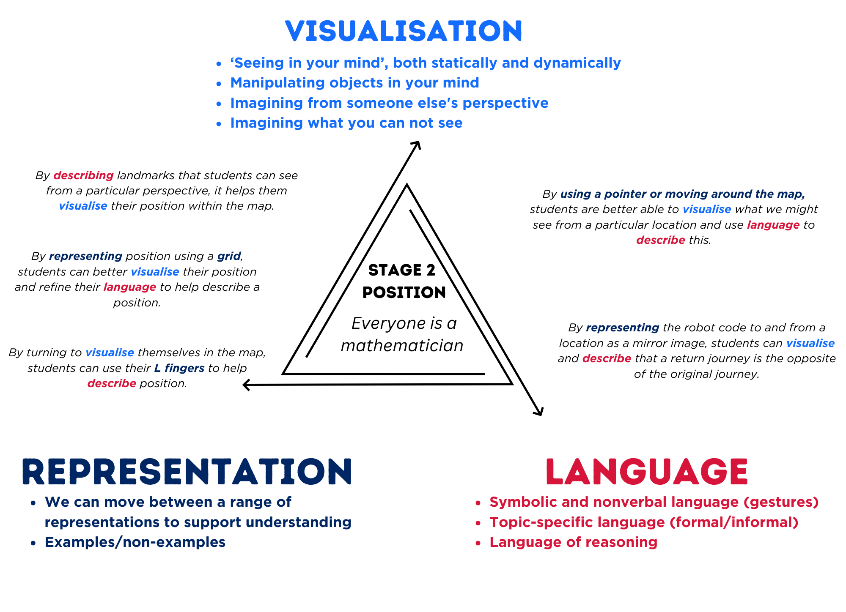
Figure 2 – pedagogical support – Stage 2 chance
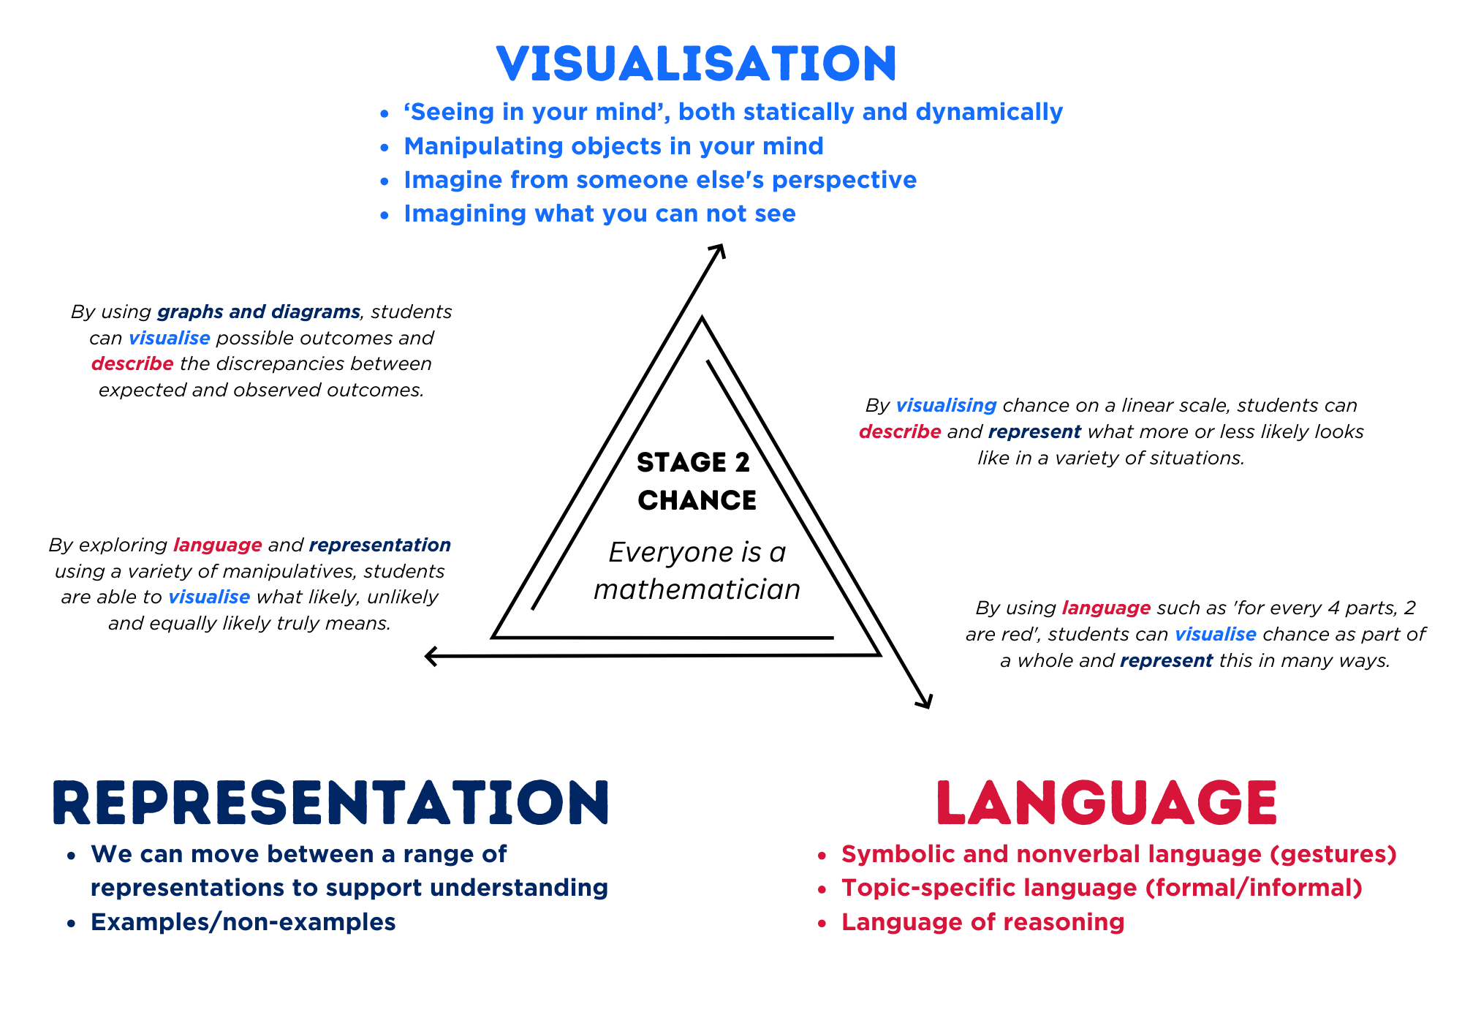
Figure 3 – pedagogical support – Stage 3 position
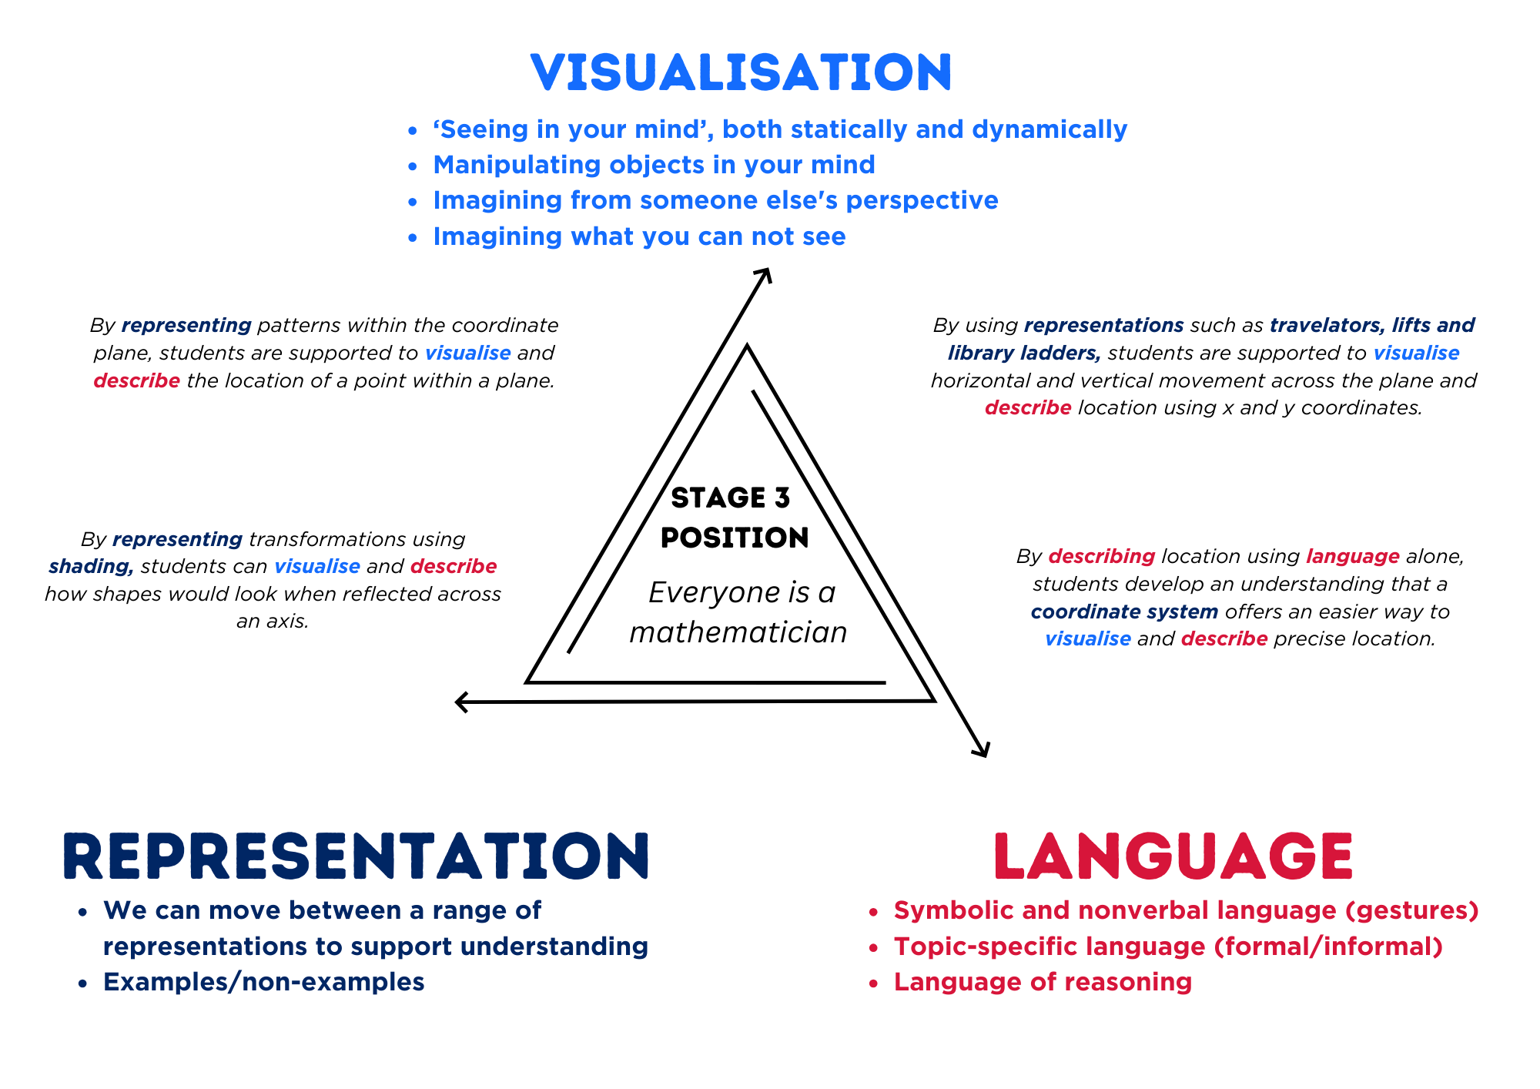
Figure 4 – pedagogical support – Stage 3 chance
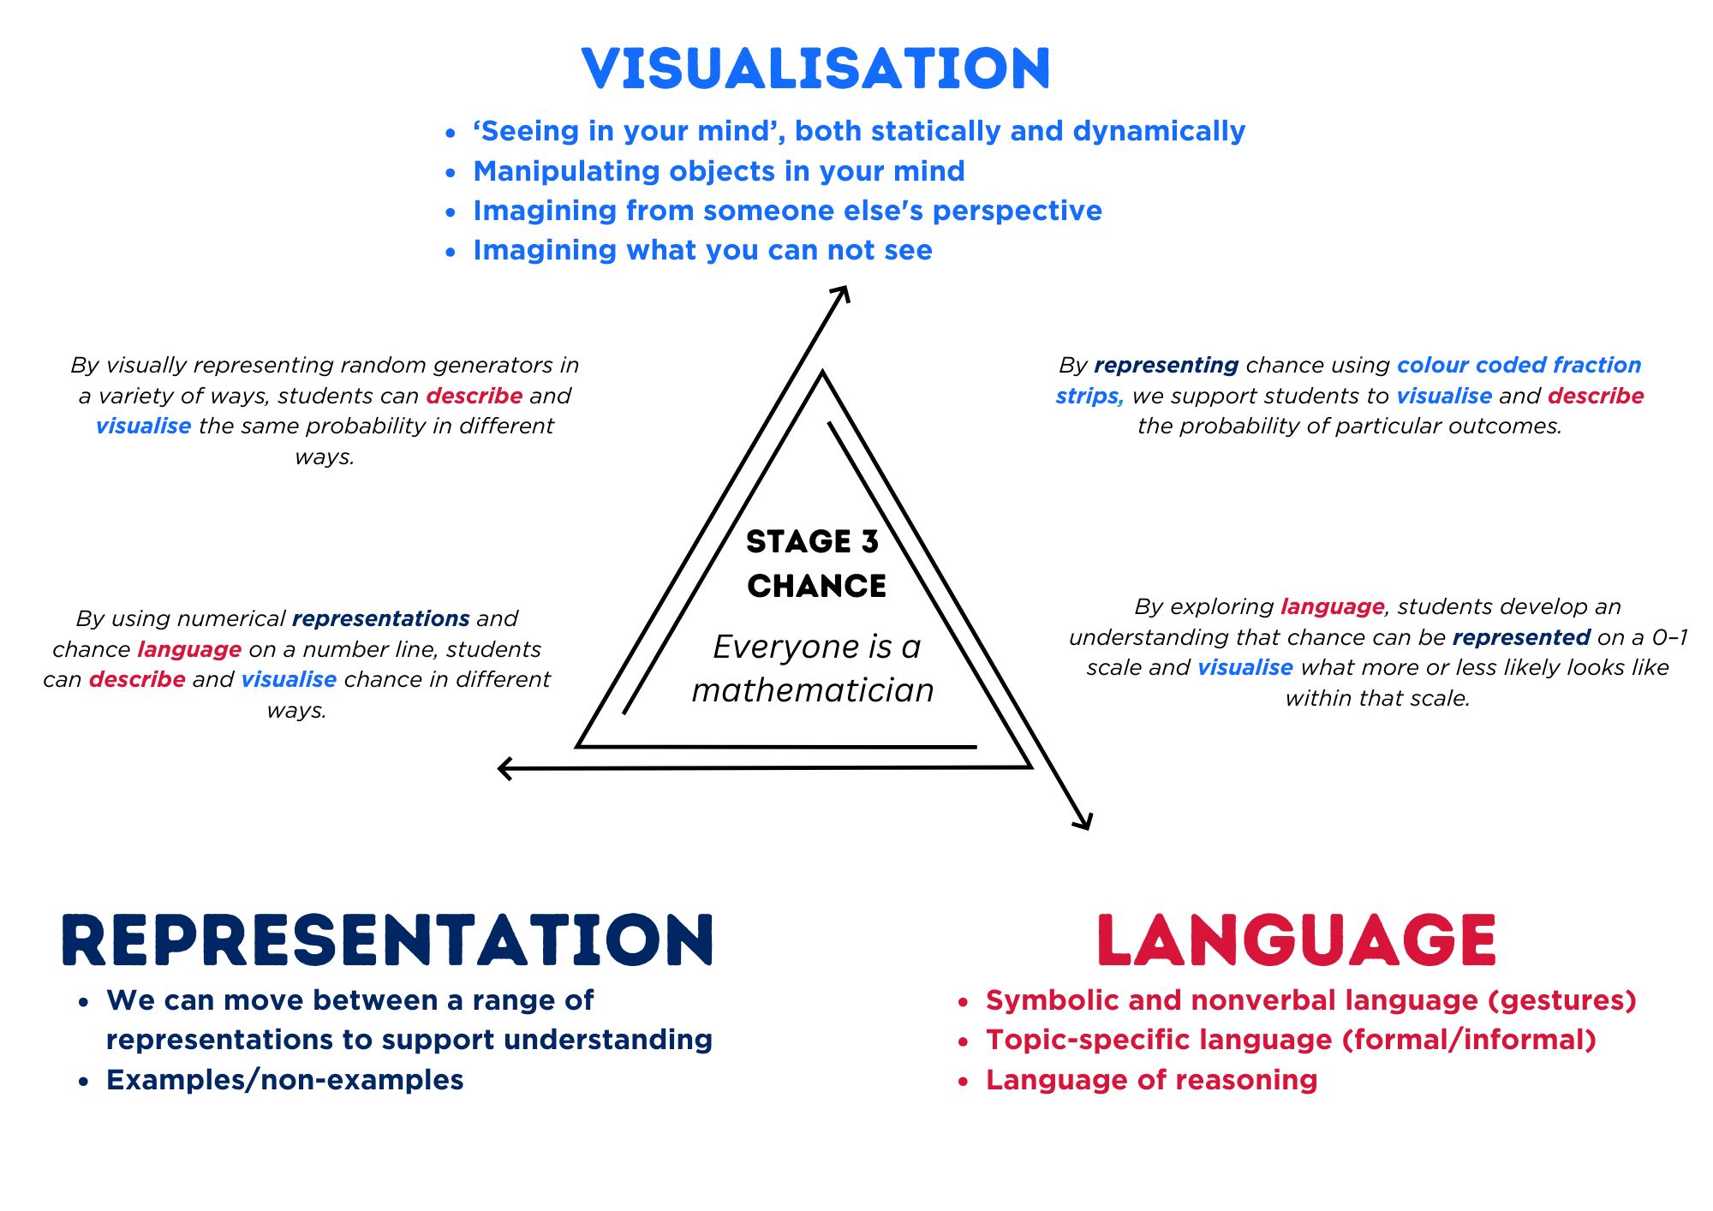

Lesson overview and resources
To cover the content of the syllabus across Stage 2 and Stage 3, some core lessons in the unit contain a Stage 2 and a Stage 3 task. Teachers are encouraged to adapt and contextualise the units to meet the needs of their students.
The table below outlines the sequence and approximate timing of lessons, learning intentions and resources.
Lesson | Content | Duration and resources
Lesson 1  Daily number sense  Stage 2:  - Partitioned fractions B: Model equivalent fractions as lengths  Stage 3:  - Representing quantity fractions B: Compare common fractions with related denominators | Lesson core concept: directional language helps navigation by explaining directions, routes and landmarks (Stage 2). Different mapping systems identify a grid area or a specific point (Stage 3).  Stage 2:  - Geometric measure A: Position: Interpret movement on a map  - Geometric measure A: Angles: Identify angles as measures of turn  - Geometric measure B: Position: Use directional language and describe routes with grid maps  Stage 3:  - Geometric measure A: Position: Explore the Cartesian coordinate system | Lesson duration: 65 minutes  - Resource 1 – position representations (Stage 2)  - Resource 2 – position representations (Stage 3)  - Resource 3 – student maze and arrows  - Resource 4 – I spy (grid and Cartesian plane)  - Resource 5 – ship shore (map and grid)  - Resource 6 – labelling misconceptions  - Resource 7 – move to shoot  - 9-sided dice  - Counters  - Envelopes  - Individual whiteboards or student workbooks  - Masking tape or chalk  - Strips of paper (equal size 2 per student)  - Writing materials
Lesson 2  Daily number sense  Stage 2:  - Partitioned fractions B: Model equivalent fractions as lengths  Stage 3:  - Representing quantity fractions B: Compare common fractions with related denominators | Lesson core concept: tools assist when navigating maps, resources and landmarks within a local environment (Stage 2). Coordinates define the point on a number plane (Stage 3).  Stage 2:  - Geometric measure A: Position: Interpret movement on a map  - Geometric measure B: Position: Use directional language and describe routes with grid maps  Stage 3:  - Geometric measure A: Position: Explore the Cartesian coordinate system  - Geometric measure B: Position: Use the 4 quadrants of the coordinate plane | Lesson duration: 60 minutes  - Resource 1 – position representations (Stage 2)  - Resource 8 – street map  - Resource 9 – x- and y-coordinates  - Resource 10 – shapeshifters  - Resource 11 – shapeshifters 2  - Highlighters  - Geoboard and some elastics, digital geoboard or a Cartesian plane template (first quadrant only)  - Individual whiteboards or student workbooks  - Writing materials
Lesson 3  Daily number sense  Stage 2:  - Partitioned fractions B: Model equivalent fractions as lengths  Stage 3:  - Representing quantity fractions B: Compare common fractions with related denominators | Lesson core concept: return journeys can be represented and described using maps (Stage 2). Coordinates define the point on a number plane (Stage 3).  Stage 2:  - Geometric measure A: Position: Interpret movement on a map  - Geometric measure B: Position: Use directional language and describe routes with grid maps  Stage 3:  - Geometric measure B: Position: Use the 4 quadrants of the coordinate plane | Lesson duration: 60 minutes  - Resource 1 – position representations (Stage 2)  - Resource 12 – community map or Bot Online Emulator (digital Community Mat)  - Resource 13 – directions template  - Resource 14 – blank Cartesian plane  - Resource 15 – plotting shapes  - Resource 16 – plotting points  - Resource 17 – plotting shapes 2  - Resource 18 – plotting points 2  - Resource 19 – plotting points 3  - If available, programmable robots such as Ozobot, Bee-Bots, Blue-Bost or Cubettos  - Individual whiteboards  - Writing materials
Lesson 4  Daily number sense  - teacher-identified task based on student needs | Lesson core concept: plan and design maps using real world applications (Stage 2). Integer coordinates change when translated (Stage 3).  Stage 2:  - Geometric measure A: Position: Interpret movement on a map  - Geometric measure B: Position: Create and interpret grid maps  Stage 3:  - Geometric measure B: Position: Use the 4 quadrants of the coordinate plane  - Two-dimensional spatial structure B: 2D shapes: Dissect two-dimensional shapes and rearrange them using translations, reflections and rotations | Lesson duration: 60 minutes  - Resource 1 – position representations (Stage 2)  - Resource 12 – community map  - Resource 20 – animal map  - Resource 21 – blank street map  - Resource 22 –pentagon mirror  - Resource 23 – mirror, mirror  - Resource 24 – mirror, mirror 2 2  - Resource 25 – reflecting  - Counters  - Digital device  - Student workbooks  - Writing materials
Lesson 5  Daily number sense  Stage 2:  - Additive relations B: Apply addition and subtraction to familiar contexts, including money and budgeting  Stage 3:  - Additive relations B: Choose and use efficient strategies to solve addition and subtraction problems | Lesson core concept: the outcomes of chance experiments can be described and recorded (Stage 2). Probability can be represented on a scale from zero to one (Stage 3).  Stage 2:  - Chance A: Identify possible outcomes from chance experiments  - Chance B: Describe the likelihood of outcomes of chance events  Stage 3:  - Chance A: List outcomes of chance experiments involving equally likely outcomes and represent probabilities  - Chance B: Create random generators and describe probabilities using fractions | Lesson duration: 65 minutes  - Resource 26 – Stage 2 chance representation  - Resource 27 – Stage 3 chance representation  - Resource 28 – likelihood scale  - Resource 29 – likelihood cards  - Resource 30 – likelihood scale challenge  - Resource 31 – spinner table  - Resource 32 – spinner table 2  - Individual whiteboards  - Writing materials
Lesson 6  Daily number sense  Stage 2:  - Additive relations B: Apply addition and subtraction to familiar contexts, including money and budgeting  Stage 3:  - Additive relations B: Applies known strategies to add and subtract decimals | Lesson core concept: data displays can be used to record and compare outcomes of chance events (Stage 2). Probability can be represented as a fraction (Stage 3).  Stage 2:  - Chance A: Identify possible outcomes from chance experiments  - Chance B: Identify when events are affected by previous events  - Data A: Organise and display data using tables and graphs  - Data A: Interpret and compare data  Stage 3:  - Chance A: List outcomes of chance experiments involving equally likely outcomes and represent probabilities  - Chance B: Create random generators and describe probabilities using fractions | Lesson duration: 65 minutes  - Resource 33 – candy stall  - Resource 34 – student statements  - Resource 35 – net and strips  - Counters  - Dice  - Grid paper  - Individual whiteboards  - Plastic coins  - Student workbooks  - Writing materials
Lesson 7  Daily number sense  Stage 2:  - Additive relations B: Apply addition and subtraction to familiar contexts, including money and budgeting  Stage 3:  - Additive relations B: Choose and use efficient strategies to solve addition and subtraction problems | Lesson core concept: the outcome of chance experiments can be predicted and recorded (Stage 2). The probability of an outcome occurring has a value (Stage 3).  Stage 2:  - Chance A: Identify possible outcomes from chance experiments  - Chance B: Describe the likelihood of outcomes of chance events  Stage 3:  - Chance A: List outcomes of chance experiments involving equally likely outcomes and represent probabilities  - Chance B: Create random generators and describe probabilities using fractions | Lesson duration: 65 minutes  - Resource 36 – Goat mountain climb  - Resource 37 – random generator  - Resource 38 – spinner  - Resource 39 – 8-part spinner  - Coloured balls or counters  - Dice  - Individual whiteboards  - Plastic coins  - Student workbooks  - Writing materials
Lesson 8  Daily number sense  - teacher-identified task based on student needs | Lesson core concept: events affected by other events impact the outcomes (Stage 2). Expected and observed frequencies align better in larger trials (Stage 3).  Stage 2:  - Chance B: Describe the likelihood of outcomes of chance events  - Chance B: Identify when events are affected by previous events  Stage 3:  - Chance B: Conduct chance experiments with both small and large numbers of trials  - Chance B: Compare observed frequencies of outcomes with expected results | Lesson duration: 60 minutes  - Resource 40 – bag of marbles  - Resource 41 – recording mystery bag  - Resource 42 – class recording  - Resource 43 – How accurate?  - Coloured cubes  - Counters  - Individual whiteboards  - Marbles  - Paper bags  - Writing materials

Lesson 1
Core concept: directional language helps navigation by explaining directions, routes and landmarks (Stage 2). Different mapping systems identify a grid area or a specific point (Stage 3).

Daily number sense – equivalent fractions – 15 minutes
Daily number sense activities for Lessons 1 to 3 ‘activate’ prior number knowledge and support the learning of new content in the unit. These activities can also assist teachers to identify the starting points for learning by revealing the extent of students’ existing knowledge.
The table below contains suggested learning intentions and success criteria. These are best co-constructed with students.
Daily number sense learning intentions | Daily number sense success criteria
Students working towards Stage 2 outcomes are learning to:  - model equivalent fractions as lengths.  Students working towards Stage 3 outcomes are learning to:  - compare common fractions with related denominators. | Students working towards Stage 2 outcomes can:  - represent the equivalence of fractions with related denominators as lengths, using concrete materials and diagrams.  Students working towards Stage 3 outcomes can:  - create equivalent fractions for half in quarters, eighths, sixths and tenths by re-dividing the whole, using diagrams and number lines.
Note: for students working towards Stage 2 outcomes, this fraction activity builds on concepts taught in Stage 2 Units 4 and 24. It is important that students can describe the relationship between the size of the denominator and the size of the fractional part – the larger the denominator, the smaller the fractional part.
- Prepare 2 identical strips of cardboard or paper per student. Have students label the first strip as one whole.
- Instruct students to fold the strip into quarters. If needed, revise how to use repeated halving.
- Ask students to label each quarter using the notation $\frac{1}{4}$ . If needed, revise the meaning of the notation (see Figure 5).
Figure 5 – fraction notation
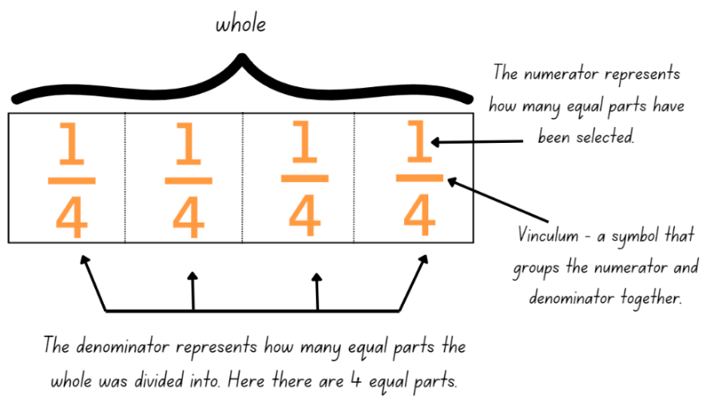
- Ask students to count aloud: one quarter, 2 quarters, 3 quarters, 4 quarters, that makes one whole.
- Ask students to fold the same strip into eighths using repeated halving and to label each eighth using the notation $\frac{1}{8}$.
- Ask students to count aloud: one eighth, 2 eighths, 3 eighths, 4 eighths, 5 eighths, 6 eighths, 7 eighths, 8 eighths, that makes one whole.
- Revise the relationship between the denominator, numerator, and the size of each folded piece (the larger the denominator, the smaller the fraction).
- Ask students to label the second strip as one whole and explain that they need to fold this strip into tenths. Ask:
- How many equal parts of the whole will you have?
- Will you use repeated halving or a different strategy? Why? Why not?
- Ask students to count aloud: one tenth, 2 tenths, 3 tenths, 4 tenths, 5 tenths, 6 tenths, 7 tenths, 8 tenths, 9 tenths, 10 tenths, that makes one whole.
- Revise that fractions represent parts of a whole. Explain that equivalent fractions are fractions that are different representations of the same value.
- Write the following fractions on the board $\frac{1}{2}$, $\frac{1}{4}$, $\frac{1}{10}$, $\frac{50}{100}$, $\frac{25}{100}$ and $\frac{10}{100}$. Ask students to explain the relationship between these fractions and justify how they are equivalent.
- Within stages, provide pairs of students with writing materials.
- Ask Stage 2 students to use their halves and quarters strip to sketch the equivalent fractions using a bar model (see Figure 6).
- Ask Stage 3 students to use their knowledge of $\frac{1}{2}$, $\frac{1}{4}$, $\frac{1}{8}$, $\frac{1}{6}$ and $\frac{1}{10}$ to sketch the equivalent fractions using a bar model, such as in Figure 6.
Figure 6 – bar model example
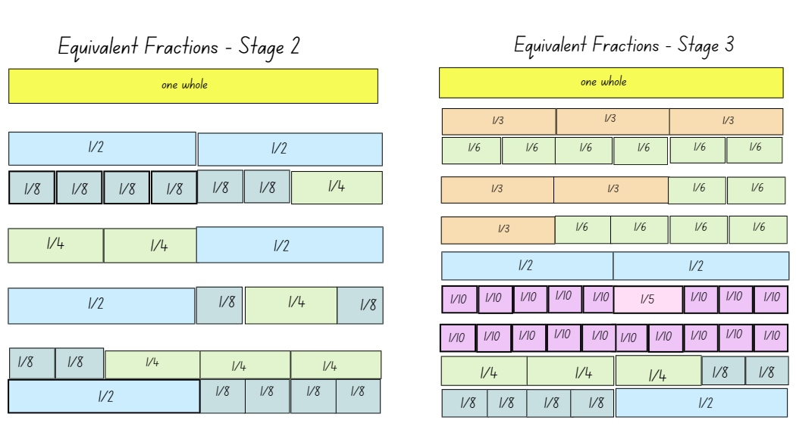
- Have students collect and keep their fraction pieces in an envelope to be used again in the next lesson.
This table details opportunities for assessment.
Assessment opportunities | Links
What to look for:  - Can Stage 2 students represent the equivalence of fractions with related denominators as lengths, using concrete materials and diagrams? [MAO-WM-01, MA2-PF-01]  - Can Stage 3 students create equivalent fractions for half in quarters, eighths, sixths and tenths by re-dividing the whole, using diagrams and number lines. [MAO-WM-01, MA3-RQF-01] | Links to National Numeracy Learning Progressions (NNLP):  - Stage 2 – InF5  - Stage 3 – InF5.

Core lesson – 35 minutes

Stage 2 task – developing directional language
The table below contains suggested learning intentions and success criteria. These are best co-constructed with students.
Core concept learning intentions | Core concept success criteria
Students working towards Stage 2 outcomes are learning to:  - interpret movement on a map  - use directional language and describe routes with grid maps  - identify angles as a measure of turn. | Students working towards Stage 2 outcomes can:  - orient a map to determine directions to travel  - describe a route taken on a map using landmarks and directional language  - use the term right angle to describe a quarter-turn in a range of orientations.
This activity is an adaptation of Amazing Mazes from NZ Maths by New Zealand Ministry of Education.
Note: the purpose of this lesson is to establish an understanding of left and right (directional language) in a variety of spatial orientations. For each lesson on position in this unit, students can enhance their understanding of position by using multiple representations or tools, such as those in Figure 7. These can be co-constructed with students on an anchor chart or provided as a resource (see Resource 1 – position representations (Stage 2)).
Figure 7 – position representations
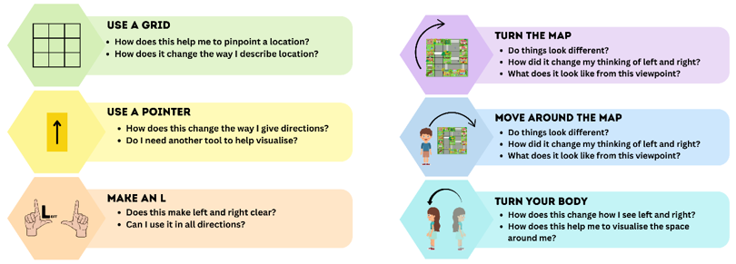
- On the floor, prepare a large masking tape or chalk maze using grid squares (see Figure 8 and a large cardboard arrow, such as in Resource 3 – student maze and arrows).
Figure 8 – masking tape maze
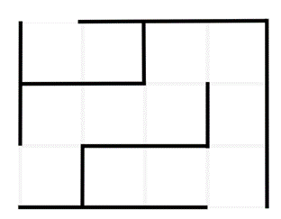
- Teach students to visually represent left and right by making L shapes with their fingers to help identify various orientations (see Figure 7). Explore left and right from different orientations in the classroom, for example, facing different walls.
- Introduce or revise quarter-turns, half-turns and three-quarter turns in each direction. Make an explicit link between a right angle and a quarter-turn.
- Ask students to determine left or right using landmarks from different orientations around the classroom. For example, if a student is facing the front, the door is to their left and the window is to their right. If a student is facing the back, the door is to their right and the window is now to their left.
- Introduce the masking tape maze (see Figure 8).
- Ask a student to navigate through the maze with directions from the class, using a large arrow to mark direction. For example, a direction might be ‘Walk forward as far as you can and make a quarter-turn right’ or ‘Walk forward 2 squares and make a quarter-turn right’.
- Ask students to think about how left and right changes based on the way they are facing.
- Using the different representations in Figure 7, brainstorm or model how these can be used to help navigate.
- Repeat navigating the maze from a different starting point or end position.
- As a class, discuss the link between representations and visualisations. Ask students:
- How can we represent the direction in which we are moving or facing? (Anticipated responses include using a pointer with an arrow to indicate direction or turning the map.)
- How can this help us to visualise?
- How can this help provide clear instructions?
- Provide students with a copy of Resource 3 – student maze and arrows.
- In pairs, students take turns giving each other directions to move through the maze from start to finish (see Figure 9).
Figure 9 – student maze examples
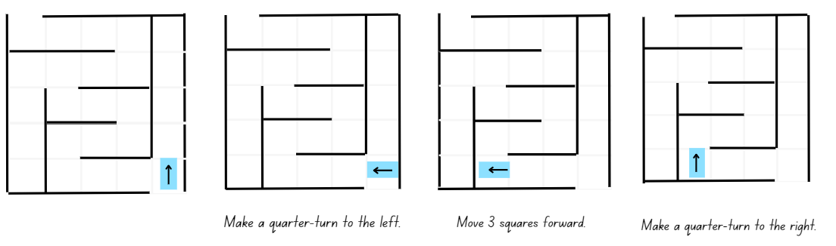
- Repeat the activity from different starting points and different starting arrow orientations.
- As a stage, regroup and discuss:
- What representations helped to visualise your position?
- Did you use more than one representation at a time, such as hand visual and pointer?
- What did you notice about your partner’s instructions?
- Would these instructions be useful in the real world?
- How might instructions change in real-life situation?
This table details opportunities for differentiation.
Too hard? | Too easy?
Students cannot use directional language and describe routes with grid maps.  - Students move through the masking tape or chalk maze with teacher support.  - Offer students a shortened end point on the maze. Navigate to that point using the pink support arrow in Resource 3 – student maze and arrows. | Students can use directional language and describe routes with grid maps.  - Students turn their student maze so the orientation changes and repeat the maze activity. For example, students enter from the left or right of the map.  - Students create their own maze and route using grid paper. Students provide directions for others to navigate the maze.

Stage 3 task – spaces versus lines
The table below contains suggested a learning intention and success criteria. These are best co-constructed with students.
Core concept learning intention | Core concept success criteria
Students working towards Stage 3 outcomes are learning to:  - explore the Cartesian coordinate system. | Students working towards Stage 3 outcomes can:  - recognise that the grid-map reference system gives the area of a location and the number plane identifies a specific point  - identify that in the coordinate system, the lines are numbered, not the spaces  - identify the point of intersection of the 2 axes as the origin, having coordinates (0, 0)  - plot and label points, given coordinates, on the number plane in the first quadrant, describing the horizontal position first, followed by the vertical position.
Note: the purpose of this lesson is to understand the structure of the Cartesian plane as 2 intersecting number lines with an origin point at (0, 0). Points can be referenced by considering horizontal and then vertical movement within the plane.
For each lesson on position in this unit, students can enhance their understanding of position by using multiple representations or tools, such as those featured in Figure 10. These can be co-constructed with students on an anchor chart or provided as a resource (see Resource 2 – position representations (Stage 3)).
Figure 10– position representations
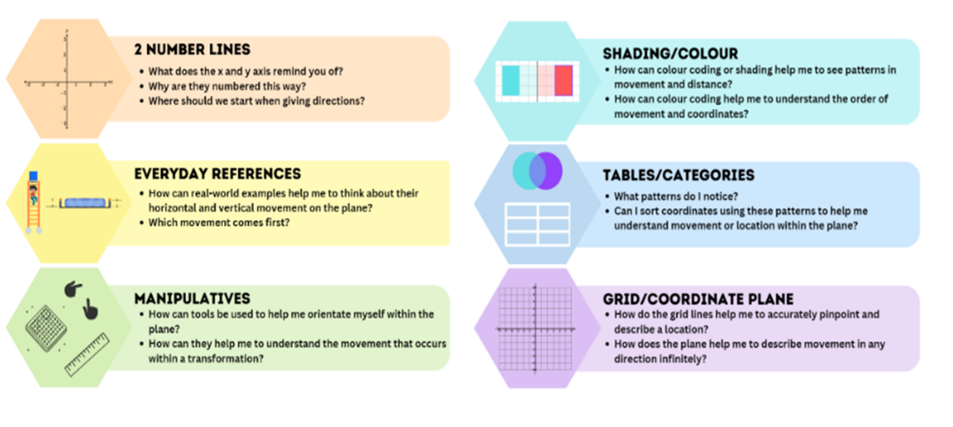
- Display Resource 4 – I spy (grid). Ask students what they can see at different grid references, such as at C1 or D1.
- Record student answers in a table for each grid reference.
Note: as students investigate the different grid references, it is likely that they will observe a variety of objects within each space.
- Repeat the same activity using Resource 4 – I spy (Cartesian plane) and record student responses.
- Compare the observed data. Discuss the lines’ accuracy in pinpointing specific locations compared to the broader coverage of spaces where many objects may be located.
- Display Resource 5 – ship shore (map) and instruct students to visualise standing on the island with the ship to their right and the shore to their left.
- Ask students:
The table below outlines stimulus prompts to generate conversation about the topic, along with anticipated responses from students.
Prompts | Anticipated student responses
- How might you describe to your partner how to get to the yellow bird? | - Go diagonally into the sky.  - Travel in a north-east direction.
- Are these directions specific enough to ensure that your partner will reach the bird? | - No, because there are other things in the sky.
- What system could you use to help describe the location of the bird? | - I could use the grid reference system.
- What might this look like when using this map? | - I would need to layer the grid on top.
- Display Resource 5 – ship shore (grid) to represent layering a grid on top of the image.
- Display Resource 6 – labelling misconceptions. Use the table below to discuss the labelling systems.
The table below outlines stimulus prompts to generate conversation about the topic, along with anticipated responses from students.
Prompts | Anticipated student responses
- What happens if all the letters in the alphabet are used? | - You could use 2 letters.  - You could use a different system.  - You could use a letter and a number.
- What problem would you have if you want to add to the map and Point A is already on the far left? | - There are no letters before A. You would need a different labelling system.
- Is it better to use letters or numbers? Why? | - It is better to use numbers because they go on forever.
- Which system will always work if you need to extend the map in any direction? | - Using the system where the zero is in the centre is best because you can never run out of numbers, no matter which direction you travel.  Note: Example B uses numbers, however, the quadrants do not mirror each other as zero is not at the centre.
- What do the 2 lines remind you of? What do they represent? | - 2 (infinite) number lines.
- How might you name these lines or axes? | - x (horizontal) and y (vertical).
- How might these help you label a point on a plane? | - I can label it (x, y) or label it (y, x)  Note: emphasise the need for a consistent system of referencing and explain that (x, y) is always used.
- Provide each student with a copy of Resource 5 – ship shore (grid).
- Students label each axis using x- and y-coordinates.
- Model the location of the yellow bird. Explain that its position can be described using the number plane to pinpoint its location. Emphasise the need to reference the x-coordinate first, then the y-coordinate.
- Students share their labelled grids and ask a peer to locate and record various objects using grid references.
This table details opportunities for differentiation.
Too hard? | Too easy?
Students cannot explore the cartesian coordinate system.  - Students describe locations moving left and right on a number line. Draw the connection that they are using lines, not the spaces.  - Students use a highlighting system that relates to a coloured coded x- and y-axis to support the order of the coordinates. | Students can explore the cartesian coordinate system.  - Place Resource 5 – ship shore (grid) on a larger piece of paper. Extend the axes in each direction. Place additional images and label them using coordinates.  - Students write an assessment rubric for rating examples A, B and C from Resource 6 – labelling misconceptions. Students share their ratings with the class.

Consolidation and meaningful practice – 15 minutes
- Display Resource 7 – move to shoot. The aim of the game is to collect the most points.
Note: it is important to draw students’ attention to the fact that the number rolled on the first dice, players must move across horizontally and the number rolled on the second dice, players must move up vertically to hit the target number. This will encourage students to think about the x-coordinate first, then the y-coordinate.
- Explain to students that Player 1 will have 10 counters of one colour and player two will have 10 counters of a different colour. In pairs, players take turns to roll two 9-sided dice and use these numbers, one at a time, as coordinates to locate the ‘target’.
- Instruct Stage 2 students that they will use the coordinates to locate the target within the grid square.
- Instruct Stage 3 students that they will use the coordinates to locate the target along the 2 intersecting lines of the grid.
- Ensure all students move along the horizontal x-axis first then vertically along the y-axis. For example, player one rolls 7 and 1. Using their finger or pointer, they move along the horizontal x-axis to locate 7 and then up the vertical y-axis to locate 1. The player then places their coloured counter on top of the target and records their ‘target’ score, 5, on an individual whiteboard. After 10 rounds, players add their scores, and the winner is the player with the highest target score after 10 rounds.
- Provide pairs of Stage 2 and Stage 3 students with a copy of Resource 7 – move to shoot, 10 counters for each player of a different colour, writing materials and two 9-sided dice.
- As a class, discuss:
- How would you describe the movement on your grid for each round?
- How does this relate to the way you named the target position you landed on?
- What strategy did you use to locate the target each round?
This table details opportunities for assessment.
Assessment opportunities | Links
What to look for:  - Can Stage 2 students orient a map to determine the direction of travel? [MAO-WM-01, MA2-GM-01]  - Can Stage 2 students describe a route taken using landmarks and directional language? [MAO-WM-01, MA2-GM-01]  - Can Stage 2 students select and apply tools and representations to solve position problems using grid maps? [MAO-WM-01, MA2-GM-01]  - Can Stage 3 students recognise that the grid-map reference system gives the area of a location and the number plane identifies a specific point? [MAO-WM-01, MA3-GM-01]  - Can Stage 3 students plot and label points, on the number plane in the first quadrant, describing the horizontal position first, followed by the vertical position? [MAO-WM-01, MA3-GM-01] | Links to National Numeracy Learning Progressions (NNLP):  - Stage 2 – PoL3, PoL4, PoL5  - Stage 3 – n/a.

Lesson 2
Core concept: tools assist when navigating maps, resources and landmarks within a local environment (Stage 2). Coordinates define the point on a number plane (Stage 3).

Daily number sense – fun fractions – 10 minutes
The table below contains suggested learning intentions and success criteria. These are best co-constructed with students.
Daily number sense learning intentions | Daily number sense success criteria
Students working towards Stage 2 outcomes are learning to:  - model equivalent fractions as lengths.  Students working towards Stage 3 outcomes are learning to:  - compare common fractions with related denominators. | Students working towards Stage 2 outcomes can:  - represent the equivalence of fractions with related denominators as lengths, using concrete materials and diagrams.  Students working towards Stage 3 outcomes can:  - order common fractions with related denominators using diagrams and number lines  - record equivalent fractions using diagrams, words and fraction notation.
This activity is an adaptation from Open-Ended Maths Activities: Using ‘Good’ Questions to Enhance Learning in Mathematics by Sullivan and Lilburn.
- Display the following problem: Tom put these fractions $\frac{1}{5}$, $\frac{5}{10}$, $\frac{1}{2}$, $\frac{4}{16}$, $\frac{1}{4}$, $\frac{6}{10}$ into 2 groups. What might the 2 groups be? How can he use a bar model to explain the 2 groups (see Figure 11)?
Figure 11 – examples of bar model explanations
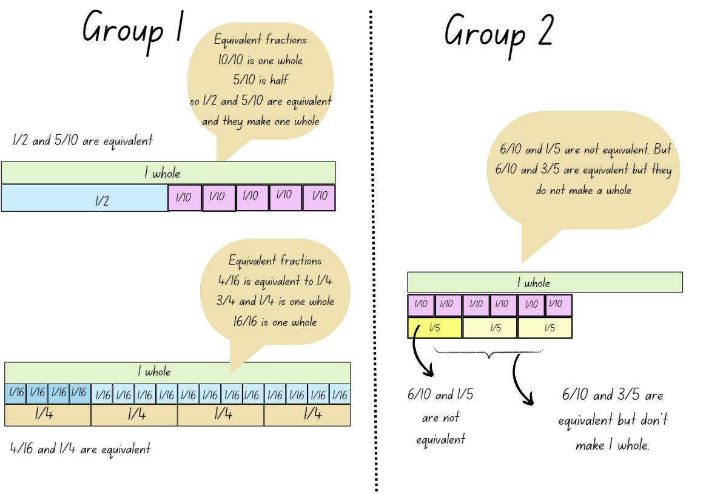
- Provide students with writing materials and instruct them to provide reasons for their groups, asking them to consider the following questions to support their explanations:
- What common characteristics or properties do you notice among these fractions?
- How do you know which ones are equivalent?
- What is helpful to make them easier to compare?
- Do any of the fractions have the same numerator or denominator? Does that matter for grouping?
- What do you notice about the denominators of these fractions?
- How can a bar model help you solve this problem?
- Are there any common factors to help with grouping? (Stage 3)
This table details opportunities for assessment.
Assessment opportunities | Links
What to look for:  - Can Stage 2 students represent the equivalence of fractions with related denominators as lengths, using concrete materials and diagrams? [MAO-WM-01, MA2-PF-01]  - Can Stage 3 students order common fractions with related denominators using diagrams and number lines? [MAO-WM-01, MA3-RQF-01]  - Can Stage 3 students record equivalent fractions using diagrams, words and fraction notation? [MAO-WM-01, MA3-RQF-01] | Links to National Numeracy Learning Progressions (NNLP):  - Stage 2 – InF5  - Stage 3 – InF5.

Core lesson – 40 minutes

Stage 2 task – navigating using landmarks
The table below contains suggested learning intentions and success criteria. These are best co-constructed with students.
Core concept learning intentions | Core concept success criteria
Students working towards Stage 2 outcomes are learning to:  - interpret movement on a map  - use directional language and describe routes with grid maps. | Students working towards Stage 2 outcomes can:  - orient a map to determine directions to travel  - describe a route taken on a map using landmarks and directional language  - use natural resources and landmarks to identify north, south, east and west  - relate compass directions to amounts of turn.
Note: the purpose of the lesson is to develop an understanding of how landmarks can be used to help orientate readers within a map and navigate.
- Tell students that Aboriginal peoples have used stars as navigational aids for thousands of years, with stars representing important landmarks on the ground (Aboriginal Astronomy 2022).
- Display Navigation & Star Maps and explain that the yellow lines show roads, while the red lines show an Aboriginal star map. Ask students what they notice about the alignment.
- Discuss the overlap between major roads and star maps. Explain that a possible reason for this is that the first European explorers were led by Aboriginal guides. Over the years, these paths of exploration have become roads and then highways. Although people use landmarks to navigate journeys, roads and highways determine most routes today. The focus of the lesson is to navigate a street map using the roads and highways shown.
- Explain that a landmark identifies land or an object that helps find a location. On a street map, a landmark gives useful information when navigating.
- Brainstorm what landmarks are in the context of Resource 8 – street map. For example, school, park, church and so on.
Note: consider downloading a street map of your local area, ensuring it has obvious landmarks and sufficient turns.
- Provide students with a highlighter and Resource 8 – street map. Split the class into Group A and Group B.
- Explain that each Group A student will write directions from starting point A to destination A. Similarly, each Group B student will write directions from starting point B to destination B.
- Ask students to consider the following while writing their set of directions:
- What visual representation can help you visualise the route?
- Is this the most effective route?
- How can you best describe the route?
Note: emphasise that students may use any of the representations explored in Lesson 1 and on Resource 1 – position representations (Stage 2) to support their understanding.
- Once written directions are completed, pair each student from Group A with one from Group B. Students take turns directing each other through the map using their set of instructions.
This table details opportunities for differentiation.
Too hard? | Too easy?
Students cannot interpret movement on a map.  - Students use a more detailed pointer or draw arrows that include left and right.  - Students describe a short, designated route to follow. For example, 2 or 3 turns to follow. | Students can interpret movement on a map.  - Provide students with a selection of pitstops to include in their route.  - Students create their own street map using grid paper. In pairs, Student A chooses the starting point and a destination on the map and Student B gives directions for Student A to follow. Swap roles and repeat the activity.

Stage 3 task – shapeshifters
The table below contains suggested learning intentions and success criteria. These are best co-constructed with students.
Core concept learning intentions | Core concept success criteria
Students working towards Stage 3 outcomes are learning to:  - explore the Cartesian coordinate system  - use the 4 quadrants of the coordinate plane. | Students working towards Stage 3 outcomes can:  - identify the point of intersection of the 2 axes as the origin, having coordinates (0, 0)  - plot and label points, given coordinates, on the number plane in the first quadrant, describing the horizontal position first, followed by the vertical position  - describe changes to coordinates when a point is translated.
Note: the purpose of this lesson is to understand how horizontal movement within the plane corresponds to a shift in the x-coordinate and vertical movement leads to a shift in the y-coordinate.
- Write the following coordinates on the board: (2, 1), (4, 1), (2, 3), (4, 3).
- Provide pairs of students with Resource 9 – x- and y-coordinates. Students group the sets of coordinates according to similarities and differences.
Note: (2, 1) and (2, 3) share the same x-coordinate. (2, 1) and (4, 1) shared the same y-coordinate.
- Draw the first quadrant and revise how to plot (2, 1) onto the plane. Model the x-coordinate then the y-coordinate.
- Repeat with (4, 1) and draw a line connecting (2, 1) and (4, 1).
- Ask students:
- What connects these 2 points? (It is a horizontal line.)
- Which coordinates change and which remain the same? (The x-coordinates change and the y-coordinates stay the same.)
- Add the point (2, 3) to the plane and connect it to (2, 1). Ask students:
- What did you notice? (It is a vertical line.)
- Which coordinates change and which remain the same? (The x-coordinates are the same and the y-coordinates change.)
- Repeat with (4, 1) and (4, 3), followed by (2, 3) and (4, 3). Ask the class:
- Is there a pattern between how the coordinates change within the plane?
- Which coordinates change when you are moving horizontally across the plane?
- Which coordinates change when you are moving vertically up and down the plane?
- What shape is now plotted on the Cartesian plane? (A square.)
- Draw a rhombus on the board.
- Ask students how they can change the coordinates of the square to make a rhombus.
The table below outlines stimulus prompts to generate conversation about the topic, along with anticipated responses from students.
Prompts | Anticipated student responses
- Do all points of the square need to be changed or just some? | - No, just slide the top pair of coordinates over to the left or right.  - No, just slide the bottom pair of coordinates over to the left or right.
- If you change the x-coordinate in the top 2 pairs of coordinates, what type of change will you be making? Horizontal or vertical? | - Horizontal.  - Side to side.
- If you move horizontally, which coordinate will you expect to see change? By how much? | - The x-coordinate would change.  - It depends on how far you slide the point over.  - The x-coordinate because the shape is not being moved up or down.
- Regroup as a stage, provide each pair a copy of Resource 10 – shapeshifters and either:
- a geoboard and some elastics
- a digital geoboard
- a Cartesian plane template (first quadrant only).
- If using a geoboard, students put the geoboard on top of a sheet of paper that marks intervals along the x- and y-axis (see Figure 12).
Figure 12 – sample geoboard
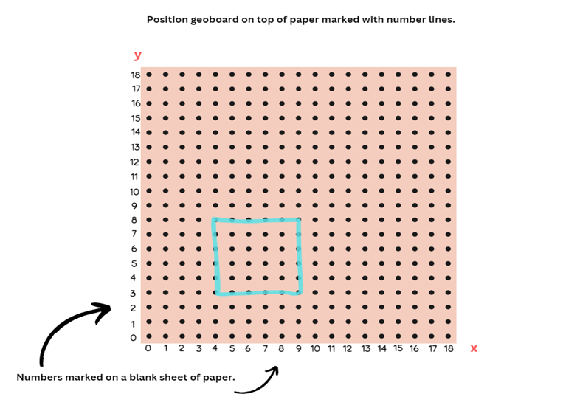
- Explain that students will be making the original shape on the plane followed by the new shape to identify the change in coordinates. Students record the new points on Resource 10 – shapeshifters.
- Students also record whether a horizontal or vertical change was made and whether the x- or y-coordinate changed.
- Discuss the following questions:
- What connection can you make between movement within the plane and changes in the x- and y-coordinates?
- How did your representation help you visualise the movement of x- and y-coordinates depending on which way the shape changed?
This table details opportunities for differentiation.
Too hard? | Too easy?
Students cannot explore the Cartesian coordinate system.  - Students focus on identifying and plotting single points in the first quadrant.  - Students identify, plot and connect a series of coordinates to form a simple shape. For example, triangle. | Students can explore the Cartesian coordinate system.  - Students determine their own coordinates for each shape and amend accordingly when changing the shape.  - Students consider the effect of a point’s diagonal shift on the x- and y-coordinates as they complete the shapeshifters task with compound rectangles. See Resource 11 – shapeshifters 2.

Discuss and connect the mathematics – 10 minutes
- As a class, regroup and ask students to Think-Pair-Share and discuss:
- What was easy or difficult? Explain why.
- What representations did you use to help you visualise the route? (Stage 2)
- Did you use more than one representation at a time? (Stage 2)
- What did you notice about your partner’s instructions? (Stage 2)
- What representations were most useful in helping you create and follow a route? (Stage 2)
- How did you know where to move the points or coordinates to adjust the square? (Stage 3)
- What was most challenging when using the x- and y-axis? (Stage 3)
This table details opportunities for assessment.
Assessment opportunities | Links
What to look for:  - Can Stage 2 students orient a map to determine the direction of travel? [MAO-WM-01, MA2-GM-01]  - Can Stage 2 students describe a route taken using landmarks and directional language? [MAO-WM-01, MA2-GM-01]  - Can Stage 2 students select and apply tools and representations to solve position problems? [MAO-WM-01, MA2-GM1-01]  - Can Stage 3 students plot and label points in the first quadrant? [MAO-WM-01, MA3-GM-01]  - Can Stage 3 students describe changes to coordinates when a point is translated? [MAO-WM-01, MA3-GM-01] | Links to National Numeracy Learning Progressions (NNLP):  - Stage 2 – PoL3, PoL4, PoL5  - Stage 3 – n/a.

Lesson 3
Core concept: return journeys can be represented and described using maps (Stage 2). Coordinates define the point on a number plane (Stage 3).

Daily number sense – everything about my fractions – 10 minutes
The table below contains suggested learning intentions and success criteria. These are best co-constructed with students.
Daily number sense learning intentions | Daily number sense success criteria
Students working towards Stage 2 outcomes are learning to:  - model equivalent fractions as lengths.  Students working towards Stage 3 outcomes are learning to:  - compare common fractions with related denominators. | Students working towards Stage 2 outcomes can:  - represent the equivalence of fractions with related denominators as length, using concrete materials and diagrams.  Students working towards Stage 3 outcomes can:  - record equivalent fractions using diagrams, words and fraction notation.
This activity is an adaptation from Mathematics Assessment for Learning Rich Tasks and Work Samples by Downton et al.
- Provide students with an individual whiteboard and writing materials.
- Ask students to choose a fraction with a denominator of 2, 3, 4, 5, 6, 8 or 10.
- Students complete the following task:
- represent your fraction on a number line
- record 3 other fractions equivalent to your fraction
- represent your fraction as part of a whole length
- give a real-life example where your fraction might be useful
- represent your fraction in a different form, for example, bar model (Stage 2), collection (Stages 2 and 3), tape diagram or circle (Stage 3).
- As a class, create a fraction gallery where students can display their work and allows students to review each other's work.
This table details opportunities for assessment.
Assessment opportunities | Links
What to look for:  - Can Stage 2 students represent the equivalence of fractions with related denominators as length, using concrete materials and diagrams? [MAO-WM-01, MA2-PF-01]  - Can Stage 3 students record equivalent fractions using diagrams, words and fraction notation? [MAO-WM-01, MA3-RQF-01] | Links to National Numeracy Learning Progressions (NNLP):  - Stage 2 – InF5  - Stage 3 – InF5.

Core lesson – 40 minutes

Stage 2 task – return journey
The table below contains suggested learning intentions and success criteria. These are best co-constructed with students.
Core concept learning intentions | Core concept success criteria
Students working towards Stage 2 outcomes are learning to:  - interpret movement on a map  - use directional language and describe routes with grid maps. | Students working towards Stage 2 outcomes can:  - orient a map to determine directions to travel  - describe a return journey between 2 locations on a grid map.
Note: the purpose of this lesson is to develop an understanding that there is a relationship (reversal and flip) between an initial and return journey when represented on a map.
- Discuss students’ journeys to and from school or other locations such as to and from the school to the local park.
- Display the digital Community Mat option from the Bee-Bot Online Emulator (see Figure 13) or printed Resource 12 – community map to use programmable robots, such as Ozobots, Bee-Bots, Blue-Bots or Cubettos, if available.
Figure 13 – Community Mat
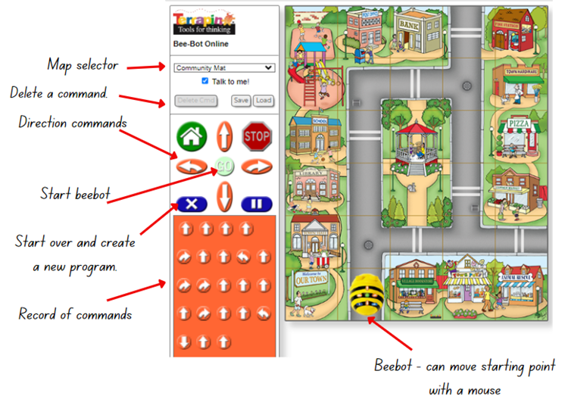
‘Community Mat’ from Bee-Bot Online Emulator © Terrapin (2023).
- Read and discuss the landmarks on the map.
- Students Think-Pair-Share, to brainstorm directional language to describe the Bee-Bot’s route from its starting position to the exit beside the fire station via the library (see Figure 14).
Figure 14 – direction example
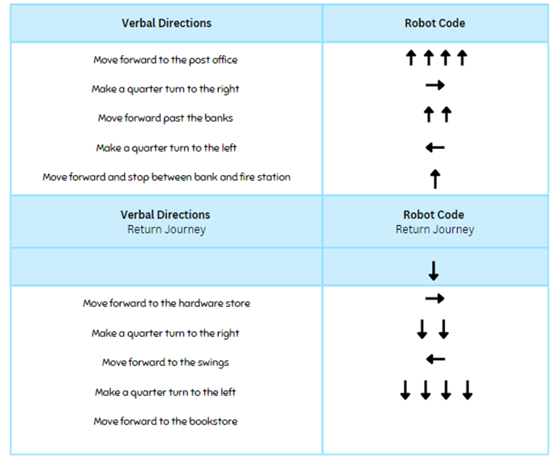
- Ask students:
- What landmarks did you find useful to help describe the journey?
- What representations did you use to help to visualise the journey?
- How were these representations helpful?
- Display Resource 13 – directions template. As a class, record verbal directions from the starting position to the grid square between the bank and the fire station.
- Model how to use the robot’s functions including how to do a half-turn to position for the return journey.
Note: on the Bee-Bot Online Emulator, the Bee-Bot’s starting position can be changed by clicking and dragging the Bee-Bot to the required location. You may then need to turn the Bee-Bot using the arrows and play button so that it faces the correct direction of travel.
- As a group, record the code for the robot using arrows in the second column (see Figure 14).
- As a group, record the directions for the return journey and then the code for the robot’s return journey.
- Ask students:
- What do you notice between the journeys?
- What is the same?
- What is different?
- What is interesting?
Note: students may notice that the code arrows form a mirror image. Use this as a discussion point in relation to the reversal of instructions and directions in a return journey.
- Give each student Resource 13 – directions template.
- In pairs, students discuss and agree on a starting point and destination.
- Each student plans and records the outbound or return journey (Student A – outbound journey, Student B – return journey on the same route) using directional language and landmarks.
- Student A reads out their directions to Student B who plans the outbound route using arrows on the template. Students test the route using the Bee-Bot website and adjust as necessary.
- Student B reads out their directions to Student A, who plans the return journey using arrows on the template. Students test the route using the from Bee-Bot website and adjust as necessary.
This table details opportunities for differentiation.
Too hard? | Too easy?
Stage 2 students cannot give directions for a return journey.  - Provide printed Resource 12 – community map and draw arrows to allow students to use concrete materials to navigate the journey.  - Give directions to a location on the map that only involves one turn. Ask student to verbalise and test instructions for the return journey. | Stage 2 students can give directions for a return journey.  - Provide students with pitstops that they must pass on their route to make the journey more complex.  - Give students a series of arrow instructions. Ask students to identify possible routes that match those instructions.

Stage 3 task – Cartesian plane
The table below contains a suggested learning intention and success criteria. These are best co-constructed with students.
Core concept learning intention | Core concept success criteria
Students working towards Stage 3 outcomes are learning to:  - use the 4 quadrants of the coordinate plane. | Students working towards Stage 3 outcomes can:  - plot and label points, given coordinates, in all 4 quadrants of the number line  - identify and record the coordinates of given points on the number plane in all 4 quadrants.
Note: the purpose of this lesson is to explore how a location can be described using all 4 quadrants of the Cartesian plane and to generalise about patterns in the number system within each quadrant.
- Display and provide each student Resource 14 – blank Cartesian plane.
- As a class, discuss and ask students questions using the prompt table.
The table below outlines stimulus prompts to generate conversation about the topic, along with anticipated responses from students.
Prompts | Anticipated student responses
- What does this remind you of? | - 2 intersecting number lines.  - 2 perpendicular number lines.  - 2 number lines that meet at 90 degrees.
- Which quadrant is most familiar to you? | - The top right quadrant because it looks like how we draw graphs.  Note: draw students’ attention to the fact that this is the first quadrant. Explain that mathematicians label the quadrants in an anticlockwise direction.
- Where can you find zero on each number line? | - At the point where they meet.  - At the centre point.  Note: students should know this from the first lesson, but you may need to address any misconceptions about the placement of zero.
- If zero appears on the x-axis and the y-axis at the point the 2 lines meet, how do we label this point using the (x, y) labelling system? | - (0, 0) represents the origin.  Note: students can label the numbers in the first quadrant on their copy of the plane.
- Ask students to label the numbers in the first quadrant on their copy of the plane. Discuss the following:
The table below outlines stimulus prompts to generate conversation about the topic, along with anticipated responses from students.
Prompts | Anticipated student responses
- How could you label the other half of the x-axis? What knowledge about number lines might assist us? | - Numbers get smaller as we move to the left and bigger as we move to the right.  - The number line extends past zero. Numbers less than zero are negative. They are to the left of zero on the number line.  - Numbers to the left of zero look like a reflection of the numbers to the right of zero but are expressed as negative number.
- How might we label the y-axis? | - See above responses.
- Ask students to label the remaining axis on the Cartesian plane.
- Plot 3 points on the existing Cartesian plane using the coordinates (4, 1), (4, 4) and (−1, 4). Do not show students the coordinates.
- Ask students to identify what the coordinates are for each point and label these accordingly.
- Revisit and emphasise that the horizontal coordinate is tracked first followed by the vertical.
- Discuss where the appropriate point would be if you were to turn these points into a rectangle.
- Plot, label and connect the fourth point.
- Ask students which quadrants the rectangle stretches across.
- In pairs, students take turns to plot 3 points of a rectangle on the Cartesian plane. Their partner identifies the coordinates for each point and labels them. Then plots, labels and connects the fourth point to make a rectangle. Students swap roles and repeat.
- Provide pairs of students with a copy of Resource 15 – plotting shapes and Resource 16 – plotting points.
- Explain that students have the choice to work on level 1, 2 or 3, which will determine the number of quadrants their shape will appear within. Explain they can change the orientation of the shape if needed.
- Using the Cartesian plane, students plot and label the coordinates of each shape.
This table details opportunities for differentiation.
Too hard? | Too easy?
Students cannot use the 4 quadrants of the coordinate plane.  - Students finding missing set of coordinates where 3 points already plotted and labelled (see Resource 17 – plotting shapes 2).  - Students focus on level 1 questions in Resource 15 – plotting shapes. | Students can use the 4 quadrants of the coordinate plane.  - Students plot shapes with more points across more quadrants. See Resource 18 – plotting points 2.  - Students are given a plane with 2 predetermined points and are asked to plot a variety of shapes (see Resource 19 – plotting points 3). Students will need to consider the geometry of these shapes and how the vertices land on points on the plane.

Discuss and connect the mathematics – 10 minutes
- Stage 2 students turn and talk:
- What made it easier and harder to navigate?
- What do you notice between the journeys?
- What is the same? What is different?
- What is interesting?
- Stage 3 students discuss:
- What did you consider when locating the missing points? (For example, x-coordinate before the y-coordinate).
- How do you know if you have plotted the point correctly?
- Do you notice any similarities in the way the coordinates are written in the first quadrant?
- What about the other quadrants? (All coordinates in the first quadrant are positive integers, they are all negative in the third quadrant , and the second and fourth quadrants have a combination of positive and negative integers.)
This table details opportunities for assessment.
Assessment opportunities | Links
What to look for:  - Can Stage 2 students orient a map to determine directions? [MAO-WM-01, MA2-GM-01]  - Can Stage 2 students describe a return journey between 2 locations? [MAO-WM-01, MA2-GM-01]  - Can students select and apply tools and representations to solve position problems? [MAO-WM-01, MA2-GM-01]  - Can Stage 3 students plot and label points on all 4 quadrants of a coordinate plane? [MAO-WM-01, MA3-GM-01]  - Can Stage 3 students identify and record the coordinates in all 4 quadrants of a coordinate plane? [MAO-WM-01, MA3-GM-01] | Links to National Numeracy Learning Progressions (NNLP):  - Stage 2 – PoL3, PoL4  - Stage 3 – n/a.

Lesson 4
Core concept: plan and design maps using real world applications (Stage 2). Integer coordinates change when translated (Stage 3).

Daily number sense – 10 minutes
- From a class need surfaced through formative assessment data, identify a short, focused activity that targets students’ knowledge, understanding and skills. Example activities may be drawn from the following resources:
- Mathematics K–6 resources
- Universal Resources Hub.

Core lesson – 40 minutes

Stage 2 task – creating a street map
The table below contains suggested learning intentions and success criteria. These are best co-constructed with students.
Core concept learning intentions | Core concept success criteria
Students working towards Stage 2 outcomes are learning to:  - interpret movement on a map  - create and interpret grid maps. | Students working towards Stage 2 outcomes can:  - describe a route taken on a map using landmarks and directional language  - create simple maps from an aerial view with landmarks  - use a given grid map and compass directions: North, South, East, West (N, S, E, W) to plan, describe and show a route from one location to another.
Note: the purpose of this lesson is to consolidate understanding of the use of landmarks and directional language to give and interpret directions on a street map.
- Review all representations students can use to give a set of directions, using either the class anchor chart from Lessons 1 to 3 or from Resource 1 – position representations.
- Discuss the language that can be used to describe location, for example, left and right, quarter-turns and landmarks.
- Ask students another way of showing direction. For example, instead of left and right, they can use east and west.
- Introduce students to the 4 compass point directions: North, South, East, West.
- Display Resource 20 – animal map and orient students to the compass points listed on the map.
- Demonstrate the relationship between directional language and physical movements on the map by modelling with a think aloud. For example, ‘Move north one square and east one square. Where are you now?’
Note: for additional support, grid references are explicitly taught in Mathematics Multi-age 3–6 – Year A – Unit 8.
- Provide each student with a copy Resource 20 – animal map. Read directions for students to follow. After each direction, select students to identify what animal they have landed on.
- Move north one square? (Answer: dolphin)
- Move west 2 squares and then north 2 squares? (Answer: octopus)
- Move east 2 squares and then north 5 squares? (Answer: fish)
- Move 3 squares north and east one square? (Answer: turtle)
- Move north 4 squares, west 3 squares and then north one square? (Answer: crab)
- Move east one square, north 4 squares, west 2 squares, south 3 squares, west 2 squares and south one square? (Answer: whale)
- Ask students to turn and talk and explore their thinking and reasoning:
- What makes it easy to identify N, S, E, W?
- What if you were to turn the map?
- How will this change your directions?
- How does this change the language that you use to give directions?
Note: when reorienting the map, the landmarks’ positions do not change. However, reorienting may affect how students describe directions, for example, they may use left or right instead of forward when moving north.
- Display Resource 21 – blank street map.
- Ask pairs or small groups of students to produce a set of directions from a start to end point. Students have 3–5 minutes to draw their own landmarks on the blank squares. Roads have been shaded and named already.
- Provide students with their workbooks or a digital device to record their directions. Use 5 counters each to mark journey points on the roads (see Figure 15).
Figure 15 – example of counters on map
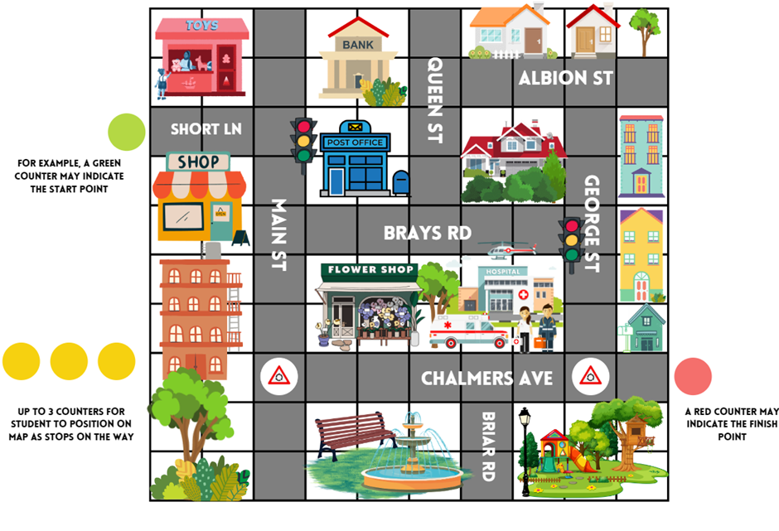
- Students can take turns to give and interpret directions based on different routes.
This table details opportunities for differentiation.
Too hard? | Too easy?
Stage 2 students cannot create and interpret grid maps.  - Students can reduce the amount of counter stops on their route.  - Students use Resource 12 – community map from Lesson 3 to create their route. | Stage 2 students can create and interpret grid maps.  - Students give directions for a return journey.  - Students access digital street maps and describe a journey to share with the class.

Stage 3 task – mirror, mirror
The table below contains suggested learning intentions and success criteria. These are best co-constructed with students.
Core concept learning intentions | Core concept success criteria
Students working towards Stage 3 outcomes are learning to:  - use the 4 quadrants of the coordinate plane  - dissect two-dimensional shapes and rearrange them using translations, reflections and rotations. | Students working towards Stage 3 outcomes can:  - plot and label points, given coordinates, in all 4 quadrants of the number plane  - identify and record the coordinates of given points on the number plane in all 4 quadrants  - describe changes to coordinates when a point is translated or reflected across an axis  - use the terms translate, reflect and rotate to describe transformations of two-dimensional shapes.
Note: the purpose of this lesson is to understand that both the x- and y-axis are mirror lines and notice how coordinates change when translated or reflected.
- Display and provide each student Resource 22 – pentagon mirror.
- Ask students to identify and label the 5 points of the pentagon on their copy.
- Ask students:
The table below outlines stimulus prompts to generate conversation about the topic, along with anticipated responses from students.
Prompts | Anticipated student responses
- Can you name some transformations for this shape? | - Flip (reflect).  - Slide (translate).  - Turn (rotate).
- What might it look like if you reflect this shape into the second quadrant? Where would you expect the shape to be located and would it look the same? | - It would look like a mirror image.  - It would look the same.  - It would look like it was slid across the same distance on the other side of the y-axis.  - If the shape was flipped, it would still look the same.  Note: not all shapes will look the same if they are reflected across a particular axis. It will depend on how the shape is orientated in relation to the axis (see Figure 14).
- What might it look like if you reflect this shape into the fourth quadrant? Where would you expect the shape to be located and would it look the same? | - No, it would look like it is upside down.  - It would still be the same size.  - The x-axis is like a line of symmetry or a mirror line.
- If you are reflecting into the second quadrant, what type of movement are you making? Will the x- or y-coordinates change? | - Horizontal.  - Side to side.  - It is moving horizontally or across, I would only expect the x-coordinate to change.
- If you are reflecting into the second quadrant, how can you work out where the points will be located? What representations can help you? | - I need to plot one point at a time (see Figure 17).  - I could work out the distance of the point from the y-axis/mirror line and keep the same distance on the other side of the y-axis.  - I can use a coloured pen, pencil or highlighter to help me work out these distances.
- Is this process the same if reflected into the fourth quadrant? | - Yes, but I will be using the x-axis as the mirror line.
Figure 16 – teacher reflections
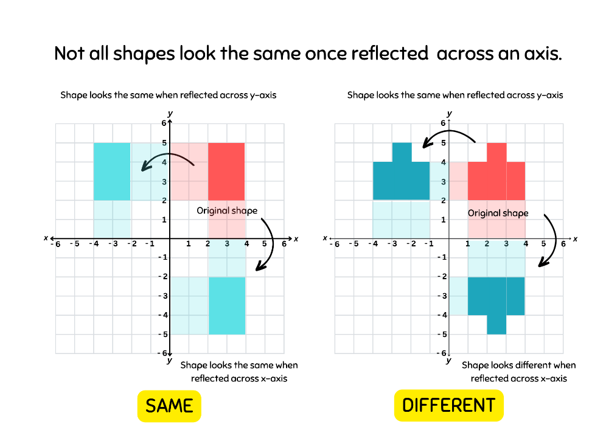
Figure 17 – reflected point
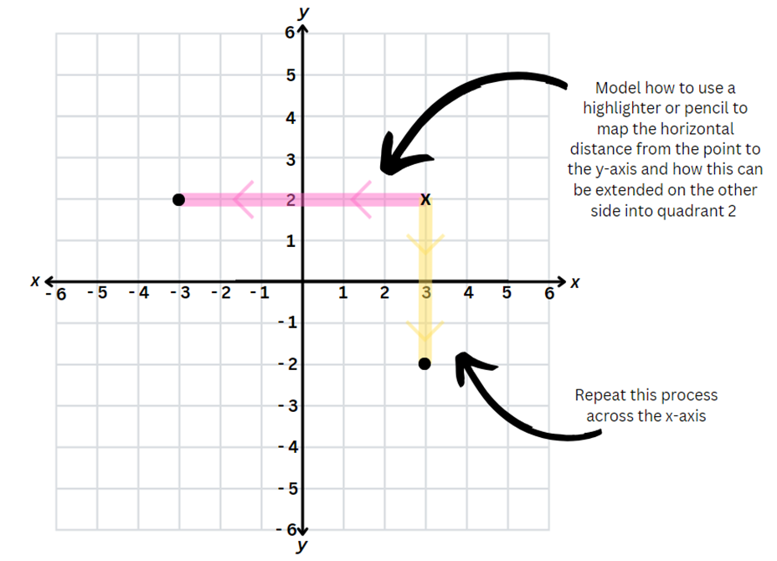
- Model how the pentagon can be reflected across the x- and y-axis using the questions above.
- Students can plot the reflections on Resource 22 – pentagon mirror. Encourage students to use different coloured pencils or highlighters for each point to help work out the distance from the x- or y-axis.
- Provide pairs of students with Resource 23 – mirror, mirror and a variety of coloured pencils or highlighters.
- In pairs, students label the original points of each shape.
- Students use coloured pencils or highlighters to support their reasoning as they reflect each shape across the x- and y-axis.
This table details opportunities for differentiation.
Too hard? | Too easy?
Stage 3 students cannot use the 4 quadrants of the coordinate plane.  - Students only reflect shapes that are aligned on the x- or y- axis reducing the number of points to be reflected. See Resource 24 – mirror, mirror 2 2.  - Provide students with shape manipulatives to physically simulate the flip across an axis. Students can use a coloured pencil or highlighter to shade the distance from the bottom or side of the shape to the mirror line. | Stage 3 students can use the 4 quadrants of the coordinate plane.  - Students reflect a stick figure from the first quadrant into the remaining quadrants (see Resource 25 – reflecting (Task 1).  - Students reflect compound shapes vertically and horizontally (see Resource 25 – reflecting (Task 2).

Discuss and connect the mathematics – 10 minutes
- As a class regroup and ask students to Think-Pair-Share and discuss:
- What representations did you use to help to visualise your journey? (Stage 2)
- How were these representations helpful? (Stage 2)
- What language was most useful for describing a route? Why? For example, left or right, using landmarks to describe a route and using compass points. (Stage 2)
- Are there times when certain language is more effective? (Stage 2)
- What did you notice about how the coordinates changed as you reflected across the x- or y- axis? (Stage 3)
- How does this relate to the direction of the reflection? (For example, I am reflecting it down along a vertical line so the x- coordinates change). (Stage 3)
- How did using coloured pencils or highlighters help to ensure your shape looks similar and is in the right place? (Stage 3)
This table details opportunities for assessment.
Assessment opportunities | Links
What to look for:  - Can Stage 2 students describe a route taken on a map using landmarks and directional language? [MAO-WM-01, MA2-GM-01]  - Can Stage 2 students use compass directions to plan, describe and show a route from one direction to another? [MAO-WM-01, MA2-GM-01]  - Can Stage 2 students select and apply tools and representations to solve position problems? [MAO-WM-01, MA2-GM-01]  - Can Stage 3 students plot, label and record coordinates in all 4 quadrants? [MAO-WM-01, MA3-GM-01]  - Can Stage 3 students describe changes to coordinates when a point is reflected across an axis? [MAO-WM-01, MA3-GM-01]  - Can Stage 3 students use the terms translate, reflect and rotate to describe transformations of two-dimensional shapes? [MAO-WM-01, MA3-2DS-01] | Links to National Numeracy Learning Progressions (NNLP):  - Stage 2 – PoL4, PoL5  - Stage 3 – UGP5, UGP6.

Lesson 5
Core concept: the outcomes of chance experiments can be described and recorded (Stage 2). Probability can be represented on a scale from zero to one (Stage 3).

Daily number sense – buying balloons – 10 minutes
Daily number sense activities for Lessons 5 to 7 ‘loop’ back to concepts and procedures covered in previous units to assist students to build an increasingly connected network of ideas. These concepts may differ from the core concepts being covered by the unit.
The table below contains suggested learning intentions and success criteria. These are best co-constructed with students.
Daily number sense learning intentions | Daily number sense success criteria
Students working towards Stage 2 outcomes are learning to:  - apply addition and subtraction to familiar contexts, including money and budgeting.  Students working towards Stage 3 outcomes are learning to:  - choose and use efficient strategies to solve addition and subtraction problems. | Students working towards Stage 2 outcomes can:  - interpret problems involving money as requiring either addition or subtraction.  Students working towards Stage 3 outcomes can:  - compare, evaluate and communicate strategies used to solve addition and subtraction problems.
This lesson is an adaptation of Buying a Balloon from NRICH by University of Cambridge.
- Display the following problem: A father bought balloons for his 4 children at the community fair. He paid for the balloons using 2 notes and 4 coins.
- In pairs, students record their solutions on individual whiteboards to the following questions. Ask:
- How much might the balloons have cost?
- What is the largest amount the father could have paid?
- What is the smallest amount the father could have paid?
- Imagine that he used 2 different notes and 2 different coins. Ask:
- How much might the balloons cost now?
- Can you find all the possible prices?
- How do you know you have found them all?
- Which of your answers seems a reasonable amount to pay for a balloon?
- As a class, share student results and reasoning for each question.
Multi-age: this problem can be adapted further for Stage 3 students to include calculations involving multiplication, addition, subtraction and understanding of currency denominations. It encourages students to think critically, apply multiple mathematical concepts and use logical reasoning to find the solutions.
This table details opportunities for assessment.
Assessment opportunities | Links
What to look for:  - Can Stage 2 students interpret problems involving money as requiring either addition or subtraction? [MAO-WM-01, MA2-AR-01]  - Can Stage 3 students compare, evaluate and communicate strategies used to solve addition and subtraction problems? [MAO-WM-01, MA3-AR-01] | Links to National Numeracy Learning Progressions (NNLP):  - Stage 2 – AdS8, UnM6, UnM7  - Stage 3 – AdS7, AdS8.  Links to suggested Interview for Student Reasoning (IfSR) tasks:  - Stage 3 – IfSR-AT: 3A.5.

Core lesson – 40 minutes
For each lesson on chance in this unit and Mathematics Multi-age – Year A – Unit 8, students can enhance their understanding by using various representations or tools. These representations and tools can be constructed with students on an anchor chart or provided as a resource (see Resource 26 – Stage 2 Chance representation and Resource 27 – Stage 3 Chance representation.)

Stage 2 task – language of chance
The table below contains suggested learning intentions and success criteria. These are best co-constructed with students.
Core concept learning intentions | Core concept success criteria
Students working towards Stage 2 outcomes are learning to:  - identify possible outcomes from chance experiments  - describe the likelihood of outcomes of chance events. | Students working towards Stage 2 outcomes can:  - use the term outcome to describe any possible result of a chance experiment  - use the terms equally likely, likely and unlikely to describe the chance of everyday events occurring.
Note: the purpose of this lesson is to examine the everyday language of chance and to develop an understanding of what that could look like.
- Ask students to consider this question: is possible the opposite of impossible? Why or why not?
Note: certain is the opposite of impossible. Anything that is not impossible, is possible. ‘Possible’ therefore includes a scale of things that are more and less likely, equally likely and certain. ‘Impossible’ means an outcome can never occur. ‘Certain’ means that it will occur.
- Display Resource 28 – likelihood scale.
- Explain that the word ‘outcome’ means any possible result of a situation. Discuss situations with different possible outcomes, such as weather, sport, card games or board games.
- Explain that in mathematics, ‘outcome’ has a specific meaning. Share the syllabus definition.
Outcome: a possible result from an experiment or trial.
- Discuss outcomes of random generators such as rolling dice, spinning a spinner, dealing cards from a deck, taking coloured counters from a bag.
- Ask students the questions in the prompt table below about the cards represented in the top scale of Resource 28 – likelihood scale.
- Model how to represent different outcomes on the likelihood scale (see Figure 18).
The table below outlines stimulus prompts to generate conversation about the topic, along with anticipated responses from students.
Prompts | Anticipated student responses
- Why do cards in the centre of the line represent an equally likely chance of drawing a red card? What are the possible outcomes and why are they equally likely? | - There are 2 red and 2 black cards, so it is equally likely that I draw a red card.  - Half of the cards are red.  - There is a 2 in 4 chance that I draw a red card which is the same as a one in 2 chance.
- How would you change the cards to show what an impossible outcome would look like if you wanted to draw a red card? | - The cards would all need to be black.
- What does ‘impossible’ mean? | - That there is zero chance that I can draw a red card because none of them are red.  - I can never draw a red card.
- How would you change the cards to show what a certain outcome would look like if you wanted to draw a red card? | - The cards would all need to be red.
- What does ‘certain’ mean? | - I will always draw a red card.  - There is no chance I can draw any card but red because they are all red.
- How can I make it unlikely to draw a red card? Where would that sit on our scale? | - ‘Unlikely’ sits between ‘equally likely’ and ‘impossible’. There would need to be fewer red cards than black.  - There would need to be 3 black cards and only one red.
- How can I make it more likely to draw a red card? Where would that sit on our scale? | - ‘More likely’ sits between ‘equally likely’ and ‘certain’.  - There would need to be 3 red cards and only one black.
Figure 18 – teacher likelihood scale
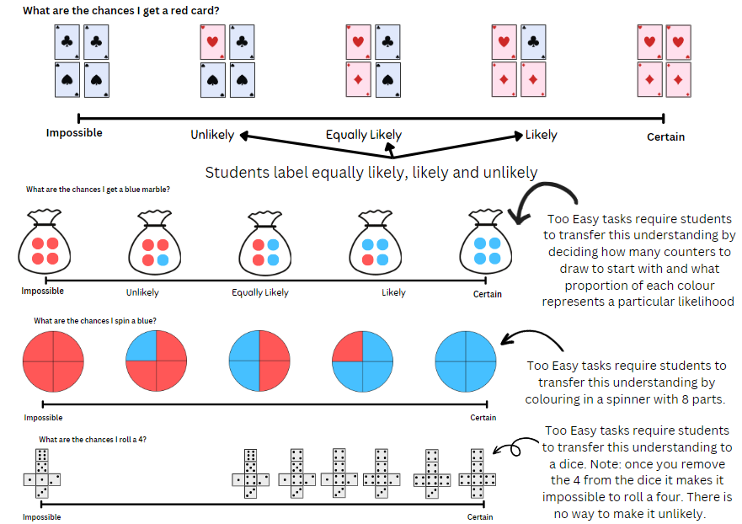
- Provide students Resource 28 – likelihood scale. In pairs, students complete the 3 scales and label ‘equally likely’, ‘likely’ and ‘unlikely’ on each scale.
- Students complete a gallery walk to observe and consider other students’ thinking.
This table details opportunities for differentiation.
Too hard? | Too easy?
Stage 2 students cannot describe the likelihood of outcomes of chance events using the terms equally likely, likely and unlikely.  - Student use Resource 29 – likelihood cards to sort and place on the scale rather than drawing.  - Students consolidate their understanding using the spinner example only on Resource 28 – likelihood scale. | Stage 2 students can describe the likelihood of outcomes of chance events using the terms equally likely, likely and unlikely.  - Give students Resource 30 – likelihood scale challenge. Students scale ‘likely’ and ‘unlikely’ in more detail.  - Using Resource 30 – likelihood scale challenge, students complete the activity with dice.

Stage 3 task – numerically representing chance
The table below contains suggested learning intentions and success criteria. These are best co-constructed with students.
Core concept learning intentions | Core concept success criteria
Students working towards Stage 3 outcomes are learning to:  - list outcomes of chance experiments involving equally likely outcomes and represent probabilities  - create random generators and describe probabilities using fractions. | Students working towards Stage 3 outcomes can:  - use the term probability to describe the numerical value that represents the likelihood of an outcome of a chance experiment  - recognise that outcomes are described as equally likely when any one outcome has the same chance of occurring as any other chance outcome  - represent probabilities of outcomes of chance experiments using fractions  - use knowledge of benchmark fractions, decimals and percentages to assign probabilities to the likelihood of outcomes.
Note: The purpose of this lesson is to make the link between how both fractions and chance can be described as parts of a whole. Students will explore how chance may be described as ‘the chance of a particular outcome occurring divided by the total possible outcomes’ and therefore it can be related to fractions.
- Draw a circle on the board, divided into half such as in Figure 19.
Figure 19 – half representation
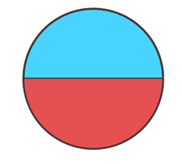
- Ask students how they would describe the red section. For example, ‘Red is half’.
- Give each student an individual whiteboard and ask them to draw a number line from 0–1, representing the red section as a fraction on the number line.
- Ask students what other ways they could describe this representation, for example 50%, 0.5 or $\frac{1}{2}$.
Note: draw students’ attention to how a fraction can represent the number of particular outcomes divided by the total possible outcomes.
- Model the number line on the board with the numerical representations (see Figure 20).
Figure 20 – representing chance
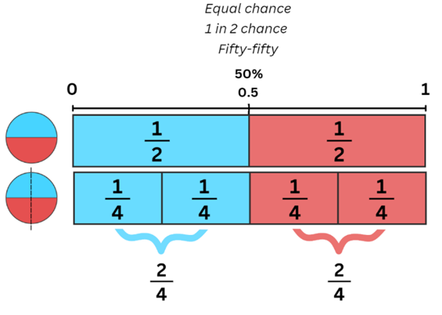
- Ask students to imagine the circle is now a spinner and ask what the chance is of landing on red. Anticipated student responses include 50:50, 1 in 2, half. Add any additional language to the modelled number line, explicitly making the connection between the chance language and numerical representations.
- Model how to colour code the number line to reflect the spinner, noting that the midpoint separates the 2 colours (see Figure 20).
- Draw a vertical line through the circle you have drawn on the board to create 4 parts.
- Ask students what the chances are of landing on red if there are now 4 outcomes, where 2 are red and 2 are blue. (Still half.)
- Discuss how the spinner would be represented on a new 0–1 number line positioned below the original for easy comparison.
- Ask students what language and numerical representations would be included on the number line (4 equal parts on the number line with 2 parts shaded red and 2 parts shaded blue; $\frac{2}{4}$ should be marked in line with $\frac{1}{2}$; for every 4 parts, 2 parts are blue and 2 parts are red, so it is equally likely to land on either).
Note: focus on showing students how the fraction is formed – number of preferred outcomes divided by the total possible outcomes.
- Students represent the number line on their individual whiteboards. Emphasise that both spinners and number lines represent an equally likely chance for either outcome occurring.
- Discuss the following with students:
The table below outlines stimulus prompts to generate conversation about the topic, along with anticipated responses from students.
Prompts | Anticipated student responses
- How can you make it less likely to land on red? | - Have more blue parts.  - Change a red section to blue.
- How can you represent this on our number line? | - By colour coding.  - By colour coding 3 parts blue and one part red.
- How can you describe this? | - One in 4 chances  - $\frac{1}{4}$  - For every 4 parts, one is red.  - For every 4 parts, 3 are blue.
- Model how to represent this on a number line with colour coding, numerical representation and chance language so that it is less likely to land on red.
- Students add this number line to their individual whiteboards.
- Using the 4-part spinner, repeat questions in the prompt box with a more likely chance of landing on red.
- Repeat activities and questions by manipulating the spinner so that it is:
- certain to land on red
- impossible to land on red.
Note: emphasise that impossible is the opposite of certain and how this relates to zero as the opposite of one.
- Give each student a copy of Resource 31 – spinner table.
- Explain that they will practice manipulating a spinner with benchmark fractions to given probabilities and represent this on a number line with numerical representations and chance language.
This table details opportunities for differentiation.
Too hard? | Too easy?
Stage 3 students cannot list outcomes of chance experiments involving equally likely outcomes and represent probabilities.  - Students can be provided with a scale that is already divided into the relevant parts, see Resource 32 – spinner table 2.  - Students complete the spinners with 6 parts only in Resource 32 – spinner table 2. | Stage 3 students can list outcomes of chance experiments involving equally likely outcomes and represent probabilities.  - Students design one or more spinners where it is impossible to represent equal chance and represent this on a 0–1 scale to support their reasoning.  - Students assign decimal and percentage values to the probabilities on a 10-part spinner.

Discuss and connect the mathematics – 15 minutes
- Review whether ‘possible’ is the opposite of ‘impossible’ and ask Stage 2 students to Think-Pair-Share where they would put possible on their likelihood scale. Prompt students to explain their reasoning.
- In pairs, Stage 2 students use Talk moves and apply the terms outcome, certain, impossible, likely, unlikely and equally likely.
- Stage 2 students discuss their ideas and co-construct definitions for these terms.
- As a Stage 3 group, discuss:
- What did you consider or think about when shading your spinners to represent equal chance?
- What did you consider or think about when representing equal chance for each spinner on the 0–1 scale?
- What did you consider or think about when representing unequal chance? For example, more or less likely.
This table details opportunities for assessment.
Assessment opportunities | Links
What to look for:  - Can Stage 2 students understand and use the term outcome to describe possible results of a chance experiment? [MAO-WM-01, MA2-CHAN-01]  - Can Stage 2 students describe the likelihood of outcomes of chance events using the terms equally likely, likely and unlikely? [MAO-WM-01, MA2-CHAN-01]  - Can Stage 3 students use the term probability to describe numerical values of chance outcomes, including ‘equally likely’ probability? [MAO-WM-01, MA3-CHAN-01]  - Can Stage 3 students represent probabilities of outcomes of chance experiments using benchmark fractions? [MAO-WM-01, MA3-CHAN-01] | Links to National Numeracy Learning Progressions (NNLP):  - Stage 2 – UnC3  - Stage 3 – UnC3, UnC4, InF6, PrT3.

Lesson 6
Core concept: data displays can be used to record and compare outcomes of chance events (Stage 2). Probability can be represented as a fraction (Stage 3).

Daily number sense – candy stall – 10 minutes
The table below contains suggested learning intentions and success criteria. These are best co-constructed with students.
Daily number sense learning intentions | Daily number sense success criteria
Students working towards Stage 2 outcomes are learning to:  - apply addition and subtraction to familiar contexts, including money and budgeting.  Students working towards Stage 3 outcomes are learning to:  - apply known strategies to add and subtract decimals. | Students working towards Stage 2 outcomes can:  - use estimation to check the validity of solutions to addition and subtraction problems, including those involving money.  Students working towards Stage 3 outcomes can:  - solve word problems involving the addition and subtraction of decimals up to 3 decimal places.
This lesson is an adaptation of The Puzzling Sweet Shop from NRICH by University of Cambridge.
- Display Resource 33 – candy stall. In pairs, students solve the following problems using estimation to check the validity of their solutions:
- Rosie went to the candy stall at the community fair with $10 to spend. What could Rosie buy if she wanted to spend all her money?
- James, Katie and Henry went into the shop too. They each had $20 to spend and they each spent all their money.
- James spent his money on just one kind of sweet, but he does not like chews. Which sweets did he buy?
- Katie bought the same number of sweets as James, but she had 3 different kinds. Which sweets did she buy?
- Henry chose 8 sweets. What could he have bought?
- How did estimation help you solve the problems?
- Ask students to record their results on an individual whiteboard.
- Select students to share their responses and communicate their reasoning.
Multi-age: Stage 3 students use the Stage 3 prices to solve the problems and have an additional challenge, that is, each person in the problem spent most of their money and had $1.50 left over.
This table details opportunities for assessment.
Assessment opportunities | Links
What to look for:  - Can Stage 2 students use estimation to check the validity of solutions to addition and subtraction problems, including those involving money? [MAO-WM-01, MA2-AR-01]  - Can Stage 3 students solve word problems involving the addition and subtraction of decimals up to 3 decimal places? [MAO-WM-01, MA3-AR-01] | Links to National Numeracy Learning Progressions (NNLP):  - Stage 2 – UnM6, UnM7  - Stage 3 – AdS9.

Core lesson – 45 minutes

Stage 2 task – exploring randomness
The table below contains suggested learning intentions and success criteria. These are best co-constructed with students.
Core concept learning intentions | Core concept success criteria
Students working towards Stage 2 outcomes are learning to:  - identify possible outcomes from chance experiments  - identify when events are affected by previous events  - organise and display data using tables and graphs  - interpret and compare data  - record and compare the results of chance experiments. | Students working towards Stage 2 outcomes can:  - predict the number of times each outcome might occur in a chance experiment involving a set number of trials  - conduct experiments and compare the predicted and actual results where the outcomes are equally likely  - identify and discuss events where the chance of one event occurring will not be affected by the occurrence of the other  - construct column graphs (with scale intervals of one)  - describe and interpret information presented column graphs.
Note: the purpose of this lesson is to address the misconception that luck influences specific outcomes. Randomness plays a role, especially in smaller sample sizes. Rolling a die illustrates this randomness, where each number has an equal chance of occurring. The actual outcomes are still unpredictable.
- Revise the language and anchor chart from Lesson 5.
- Explain that students are going to play a game where the aim is to roll a 6.
- Address that, to make it fair, every student with have the same equipment and follow the same rules.
- Students predict and record in their workbooks how many times they think they will roll a 6 in 12 rolls.
- Give each student a 6-sided die.
- Explain that students will receive a counter for every 6 they roll and the person with the most counters after 12 turns will win.
- Students roll their dice at the same time. Students who rolled a 6 are given a counter.
- Repeat 11 more times. The student with the most counters wins.
Note: As students play, take note of student statements that imply a belief that outcomes of separate rolls of a die are somehow linked.
- After the game, display Resource 34 – student statements. Ask:
- What do statements like this tell us about how we think about chance? (The idea that luck is involved, the idea that one outcome is dependent on another, the idea that one number is easier to roll than others.)
- What possible outcomes can we get from rolling a die?
- How many times did you actually get a 6?
- Was that what you predicted?
- Are you more or less likely to roll a 6 than any other number, for example, a 4? Why or why not?
- Does the outcome of one roll of the dice ever affect the outcome of another roll?
- Is the activity fair or unfair? Why or why not?
Note: students may perceive that it is unfair because they are focused on getting a 6. They may not realise that getting another number other than 6 is 5 times more likely. In the next activity, students explore the idea that every outcome of rolling a die is equally likely.
- Explain that students will now record the number they get on each roll (see Figure 21).
Figure 21 – student work sample
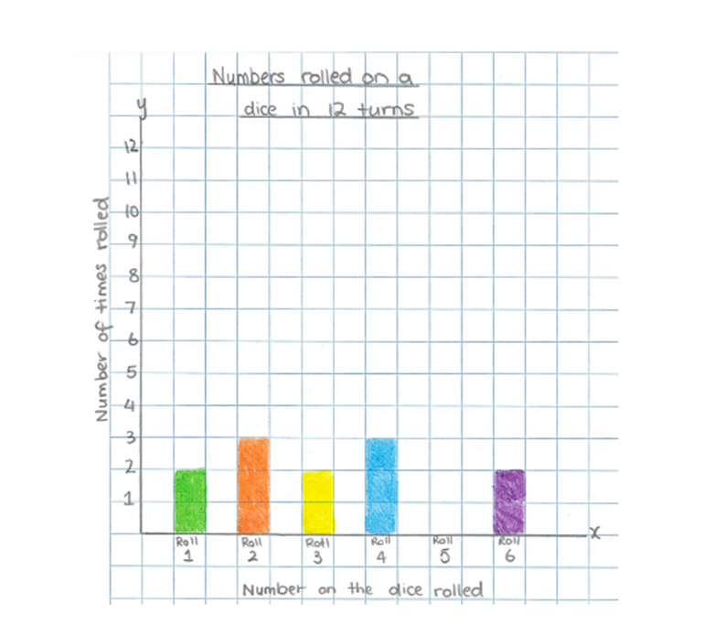
- Give each student a piece of grid paper, with numbers 1–6 along the x-axis (see Figure 21).
- Each student rolls their die 10 times, marking one square of the graph to represent each outcome.
- As a class, each student shares their data, adding it on to the class total.
- Co-construct a column graph of the whole class's outcomes.
Note: by combining whole class data, you would expect to see less variation in the frequency of each outcome. Therefore, the columns should be approximately equal. This may contrast with students’ individual graphs where randomness is more evident. Draw attention to the idea that by rolling more times, it brings the actual results closer to the predicted result.
This table details opportunities for differentiation.
Too hard? | Too easy?
Stage 2 students cannot list possible outcomes in simple chance experiments.  - Students list all outcomes when rolling a die. They learn that if there is one wanted outcome out of 6 possibilities, the chance is one in 6. Students can explore this for each dice number to understand that all outcomes are equally likely.  - Students work with a partner or with teacher guidance to roll and collect data. | Stage 2 students can list possible outcomes in simple chance experiments.  - Students predict the expected numerical chance of rolling a 6 involving a set number of trials, for example, in 240, 400 and 600 rolls, and reason as to how the actual result may vary.  - Using a spinner with 4 equal colour options, students consider what the predicted and actual graphs might look like over 10 spins compared to 400 spins. Students consider whether they can generalise their thinking across a range of situations.

Stage 3 task – equally likely
The table below contains suggested learning intentions and success criteria. These are best co-constructed with students.
Core concept learning intentions | Core concept success criteria
Students working towards Stage 3 outcomes are learning to:  - list outcomes of chance experiments involving equally likely outcomes and represent probabilities  - create random generators and describe probabilities using fractions. | Students working towards Stage 3 outcomes can:  - recognise that outcomes are described as equally likely when any one outcome has the same chance of occurring as any other outcome  - record the outcomes for chance experiments where the outcomes are not equally likely to occur and assign probabilities to the outcomes using fractions (denominators of 2, 3, 4, 5, 6, 8 and 10)  - use knowledge of benchmark fractions, decimals and percentages to assign probabilities to the likelihood of outcomes.
Note: the purpose of this lesson is to explore how equal chance can look different and to emphasise that chance can be described as the occurrence of a particular outcome divided by all possible outcomes.
- Ask each pair of students to draw Figure 22 to play ‘rooster versus rabbit’.
Figure 22 – rooster versus rabbit game
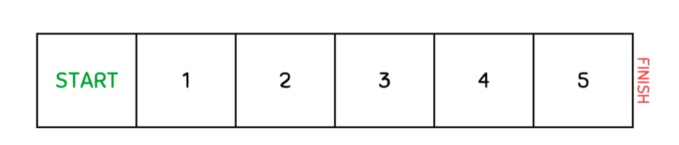
- Provide students with a plastic coin and 2 coloured counters. Students select which student will be the roaster and the rabbit.
- Explain that to move forward one space on the gameboard, students must flip a head. If students flip a tail, they must stay still. Students take turns flipping the coin to see who gets furthest in 12 flips.
- Discuss what the 2 possible outcomes are – heads move forward, tails stay still. Highlight that they are equally likely to occur.
- Students take turns to flip the coin 6 times each.
- After the 12 flips, ask students:
- If both outcomes are equally likely on a coin, did you expect both animals to move the same distance forward?
- In 6 flips of a coin, how many spaces forward would you expect to move? (3).
- How many spaces did the first animal move forward? Was it more or less than you expected?
- Did one animal get further than the other? Why do you think this happened?
Note: address randomness and explain to students that just because a particular outcome is expected to happen, does not guarantee its occurrence.
- On the board, draw 2 spinners and fraction strips (see Figure 23). Ask students to draw the spinners and fraction strips in their workbooks.
Figure 23 – equally likely
- Ask students how they might partition these fraction strips to represent each spinner.
- Students represent the first spinner (2 equal parts) on their fraction strip to show the probability of spinning each colour.
- Discuss that the first spinner has an equally likely chance of getting blue or purple and how this is represented on the fraction strip.
- Discuss that the second spinner has an unequal chance of landing on each colour based on the proportions coloured.
- Represent this second spinner on a fraction strip to show 2 portions coloured blue, one portion coloured purple and one portion coloured green.
- Discuss with students that in the first spinner, there were only 2 possible outcomes that were equally portioned (landing on blue or landing on purple). Compare it to the second spinner that shows there are 3 possible outcomes which are not equally portioned.
- Ask students:
- How could you play the ‘rooster versus rabbit’ game using the first spinner? (For example, if they land on blue, they move forward one space – like heads, and if they land on purple, they stay still).
- Is this a fair game?
- How could you use the second spinner to play the ‘rooster versus rabbit’ game and continue to have 2 possible outcomes? (Moving forward and staying still.)
- Is there a way that you can use this spinner to move forward or stay still?
Note: draw students’ attention to the relevant fraction strip that shows blue taking up half the strip with 2 colours filling the remaining half. Can students conclude that grouping outcomes together will make winning the game equally likely?
- Ask students the following questions:
- If you are just looking at the spinners, do they both represent equal chance?
- Is it possible to use an unequal chance spinner and make the game fair? (Yes, if you group some outcomes together to ensure that there is an equal chance of winning and losing.)
- What did you consider when grouping outcomes using the spinner shown? (Blue represented half of the outcomes, so I needed to group purple and green together to make up the other half).
- Display Resource 35 – net and strips. Ask students the following:
The table below outlines stimulus prompts to generate conversation about the topic, along with anticipated responses from students.
Prompts | Anticipated student responses
- If you use the die to play the ‘rooster versus rabbit’ game, rolling a one moves you forward. Is this game fair? Do you have an equal chance of moving forward compared to staying still? | - No, because there is a one in 6 chance of moving forward and 5 in 6 chances of staying still.  - No, there is more chance of staying still than moving forward.
- Is it an equal chance of rolling each number on the die? | - Yes, there is a one in 6 chance of rolling any number.
- How can you shade the dice strips to represent an equal chance of winning or losing? | - I might shade half in one colour and the other half in another colour.  - I might shade 3 outcomes out of 6 in one colour and shade the remaining in another colour.  - I might need to group outcomes together.
- What could be some possible ways of grouping the possibilities on the dice? | - 1, 2, 3 versus 4, 5, 6.  - Odd versus even.  - 1, 5, 6 versus 2, 3, 4.
- What rules can you set for our ‘rooster versus rabbit’ game to ensure that you have an equal chance of winning or losing? | - Roll a 1, 2, or 3 to move forward and stay still if you roll a 4, 5 or 6.  - Move forward if you land on an even number and stay still if you land on an odd number.  - Move forward if you land on a 1, 5 or 6 and stay still if you land on a 2, 3 or 4.
- Colour code the different proportions on fraction strips that represent moving forward and staying still. Focus on how the coloured portions are in different spaces but still represent the same proportion of 3 out of 6, making the chance of winning equally likely.
- In pairs, students agree on a rule for the game to ensure an equal chance of winning and play ‘rooster versus rabbit’.
This table details opportunities for differentiation.
Too hard? | Too easy?
Stage 3 students cannot create random generators and describe probabilities using fractions.  - Students are given a pain fraction strip to support partitioning appropriately.  - Students are provided with coloured fraction strips already colour-coded into equally likely portions. | Stage 3 students can create random generators and describe probabilities using fractions.  - Students consider the possible make-up of a bag of 8 marbles that can represent an equal chance of moving forward or staying still in the ‘rooster versus rabbit’ game. Students should consider options using 2, 3 and 4 colours.  - Students amend the dice fractions strips and rules for the ‘rooster versus rabbit’ game to allow 3 equally likely options. For example, move forward one space, move forward 2 spaces, stay still.

Discuss and connect the mathematics – 10 minutes
- Stage 2 students discuss the following questions.
The table below outlines stimulus prompts to generate discussion, along with anticipated responses from students.
Prompts | Anticipated student responses
- What do the columns in the graph tell us? | - The number of times each number was rolled on the dice.  - It shows the difference between the number of times each number was rolled.
- If you were to draw a graph that represented the predicted chance over 12 rolls, what would it look like? | - There would be 2 rolls for each number.
- How is your graph similar or different to these predicted results? What does this mean? | - Not all my columns are 2 rolls high.  - Some columns have nothing in them at all.  - Just because an outcome is expected doesn’t mean that it will happen.  - I could roll a 6, 10 out of 12 times or zero out of 12 times.
- How is our class graph similar or different to the predicted results? What does this mean? | - The columns look more similar because they are more equal in height.  - There are more than 2 rolls in each column  - The more times you roll, the closer you get to the expected result.
- Stage 3 students discuss the following questions.
The table below outlines stimulus prompts to generate conversation about the topic, along with anticipated responses from students.
Prompts | Anticipated student responses
- Is ‘equally likely’ always represented by a half-half proportion? | - It can be represented by a half-half proportion such as in a win or lose situation. However, on a dice, all outcomes are equally likely but in this case they each have a 1 in 6 chance.  - By grouping outcomes on the spinner, you also saw that a 2 in 4 chance can be grouped to look the same as a 1 in 2 chance. Therefore, it is equally likely. For every 4 possible outcomes, 2 allowed us to move forward and 2 made us stay still.  - In the dice example, 3 outcomes out of 6 are grouped so it looked the same as a 1 in 2 chance, making it equally likely. So, for every 6 outcomes, 3 allowed us to move forward and 3 allowed us to stay still.
- How did representing chance using fraction strips support you to group outcomes? | - It was easy to see with the colour-coding system whether there was an equal chance of moving forward or staying still.
This table details opportunities for assessment.
Assessment opportunities | Links
What to look for:  - Can Stage 2 students identify and discuss events where the chance of one event occurring will not be affected by the occurrence of the other? [MAO-WM-01, MA2-CHAN-01]  - Can Stage 2 students conduct experiments and compare the predicted and actual results where the outcomes are equally likely? [MAO-WM-01, MA2-CHAN-01]  - Can Stage 2 students construct, describe and interpret information presented column graphs? [MAO-WM-01, MA2-DATA-01, MA2-DATA-02]  - Can Stage 3 students use the term probability to describe numerical values of chance outcomes, including ‘equally likely probability? [MAO-WM-01, MA3-CHAN-01]  - Can Stage 3 students represent probabilities of outcomes of chance experiments using benchmark fractions? [MAO-WM-01, MA3-CHAN-01] | Links to National Numeracy Learning Progressions (NNLP):  - Stage 2 – UnC2, UnC2, CPr8, IRD3  - Stage 3 – UnC4.

Lesson 7
Core concept: the outcome of chance experiments can be predicted and recorded (Stage 2). The probability of an outcome occurring has a value (Stage 3).

Daily number sense – money problem – 10 minutes
The table below contains suggested learning intentions and success criteria. These are best co-constructed with students.
Daily number sense learning intentions | Daily number sense success criteria
Students working towards Stage 2 outcomes are learning to:  - apply addition and subtraction to familiar contexts, including money and budgeting.  Students working towards Stage 3 outcomes are learning to:  - choose and use efficient strategies to solve addition and subtraction problems. | Students working towards Stage 2 outcomes can:  - reflect on a chosen strategy for solving a problem, considering whether it can be improved.  Students working towards Stage 3 outcomes can:  - compare, evaluate and communicate strategies used to solve addition and subtraction problems.
This lesson is an adaptation of Monetary Difference from NRICH by University of Cambridge.
- Display the following problem: Alex, Bertie and Chris have sums of money totalling $150. Alex has the most money and Chris has the least amount of money in the group.
- Using this information, what amounts could Alex, Bertie and Chris have had each? List at least 3 variations.
- Ask:
- What strategies did you use to solve the problem?
- Did you have any challenges? How did you overcome them?
Note: increase the difficulty of the task by adding this information: Alex and Bertie have $55 between them, and Alex and Chris have $65 between them. Students record possible solutions on their individual whiteboard.
- Students share their responses and reflect on the most efficient strategy used to solve the problem.
Multi-age: Stage 3 students can solve monetary values with 2 decimal places to address solving word problems involving the addition and subtraction of decimals up to 3 decimal places.
This table details opportunities for assessment.
Assessment opportunities | Links
What to look for:  - Can Stage 2 students reflect on a chosen strategy for solving a problem, considering whether it can be improved? [MAO-WM-01, MA2-AR-01]  - Can Stage 3 students compare, evaluate and communicate strategies used to solve addition and subtraction problems? [MAO-WM-01, MA3-AR-01] | Links to National Numeracy Learning Progressions (NNLP):  - Stage 2 – n/a  - Stage 3 – AdS7, AdS8.  Links to suggested Interview for Student Reasoning (IfSR) tasks:  - Stage 3 – AT: 3A.5.

Core lesson – 40 minutes

Stage 2 task – predicting outcomes
The table below contains suggested learning intentions and success criteria. These are best co-constructed with students.
Core concept learning intentions | Core concept success criteria
Students working towards Stage 2 outcomes are learning to:  - identify possible outcomes from chance experiments  - describe the likelihood of outcomes of chance events. | Students working towards Stage 2 outcomes can:  - predict the number of times each outcome might occur in a chance experiment involving a set number of trials  - record all possible outcomes in a chance experiment where the outcomes are equally likely  - use the terms equally likely, likely and unlikely to describe the chance of everyday events occurring.
Note: the purpose of this lesson is to develop an understanding that chance language represents a proportional relationship of a desired outcome occurring in relation to all possible outcomes. Students must also understand that a 1 in 2 chance of an outcome occurring is more likely than a 1 in 3 chance. Like fractions, students may misconceive the bigger number to indicate ‘more likely’. For example, students may think $\frac{1}{3}$ is bigger than $\frac{1}{2}$.
- Give students Resource 36 – Goat mountain climb and display Resource 37 – random generator for ‘Goat mountain climb’. Draw students’ attention to the outcome of each generator that will allow the goat to move forward.
- Explain to students that the aim of the game is to get their goat to the top of the mountain within 12 trials, using a given random generator.
- Ask students to turn and talk about which generator would they choose and why.
- Prompt students using the following questions.
The table below outlines stimulus prompts to generate conversation about the topic, along with anticipated responses from students.
Prompts | Anticipated student responses
- What do you need to know to answer this question? | - What to land on to move the goat.  - All the possible outcomes.  - The chance of landing on the one that I want.
- How can you describe the chance of landing on the one you want to move the goat? | - It is one in however many chances.  - Describe it as a fraction.  Note: redirect the use of this language and encourage students to describe it as 1 in 4 not one-quarter.
Note: the more outcomes there are on the random generator, the more difficult it is to climb the mountain. For example, there is a 1 in 2 chance of flipping a head; however, there is a 1 in 6 chance of rolling a 3 on a die.
- Use think aloud to model how to list the possible outcomes when tossing a coin. Describe the likelihood of landing on heads.
- Explain that students will be given one of the random generators where one specified outcome will allow them to move up goat mountain.
- Split students into small groups and give them the physical manipulatives of one random generator. For example, one group will have a coin, others will have Resource 38 – spinner with 3 colours, one will have a bag of 4 different coloured balls or counters or one will have a 6-sided die.
- In their groups, students record possible outcomes in their workbooks and predict how many times their specified outcome will occur in 12 turns.
- As a Stage 2 group, ask:
- How far up the ladder do you think you will get? Can you explain why you think this?
- Based on your prediction, do you think you can win the game? Why or why not?
Note: for the group using the coin, students should predict that theoretically, a ‘head’ should appear 6 times and therefore they have a chance of winning the game. Some students may also point out that, just because this is theoretically possible, does not mean it will actually happen. This is a great opportunity to revisit the idea of randomness.
- Using their random generator, students play the game ‘Goat mountain climb’. Students can only use the random generator 12 times and can only move up the mountain when the specific outcome occurs.
- As a class, ask groups if they were successful and if the result of the game was what they predicted.
- Students swap their generator with another group and repeat the game.
This table details opportunities for differentiation.
Too hard? | Too easy?
Stage 2 students cannot identify possible outcomes from chance experiments.  - Support students to list the possible outcomes with each random generator and to describe the chance of achieving the desired outcome.  - Give students the coin random generator or the spinner to play the game with. | Stage 2 students can identify possible outcomes from chance experiments.  - Ask students how they could change the rules of the game to make each generator as likely to win as the coin.  - Ask students how they could change each random generator to make them as equally likely to win as the coin.

Stage 3 task – twice as likely
The table below contains suggested learning intentions and success criteria. These are best co-constructed with students.
Core concept learning intentions | Core concept success criteria
Students working towards Stage 3 outcomes are learning to:  - list outcomes of chance experiments involving equally likely outcomes and represent probabilities  - create random generators and describe probabilities using fractions. | Students working towards Stage 3 outcomes can:  - represent probabilities of outcomes of chance experiments using fractions  - create random generators to follow specified probabilities or proportions.
Note: the purpose of this activity is to explore how ‘twice as likely’ can look different using different random generators and how quantities within random generators can be scaled to represent the same chance so long as the portion is kept the same.
- On the board, draw a 3-part spinner with a fraction strip (see Figure 24).
Figure 24 – 3-part spinner
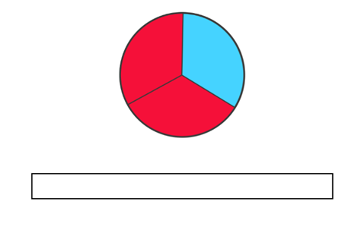
- Revisit skills of representing the spinner onto a fraction strip. Ask:
- How many equal parts does your spinner have?
- How many equal parts should your fraction strip include?
- How many parts of your fraction strip should you colour red?
- What colour will the remaining part be?
- Display both the spinner and fraction strip and discuss:
Prompts | Anticipated student responses
- What is the chance of landing on blue? | - 1 in 3
- What is the chance of landing on red? How do you know? | - 2 in 3 because for every 3 parts, 2 parts are red.
- What is another way of describing the amount of red to blue on this spinner or fraction strip? | - There is double the chance of landing on red.  - Is it 2 times more likely to land on than blue.  - It is twice as likely that I will land on red than blue.
- Using their workbooks, ask students to draw a 4-part spinner and a fraction strip (see Figure 25).
Figure 25 – 4-part spinner
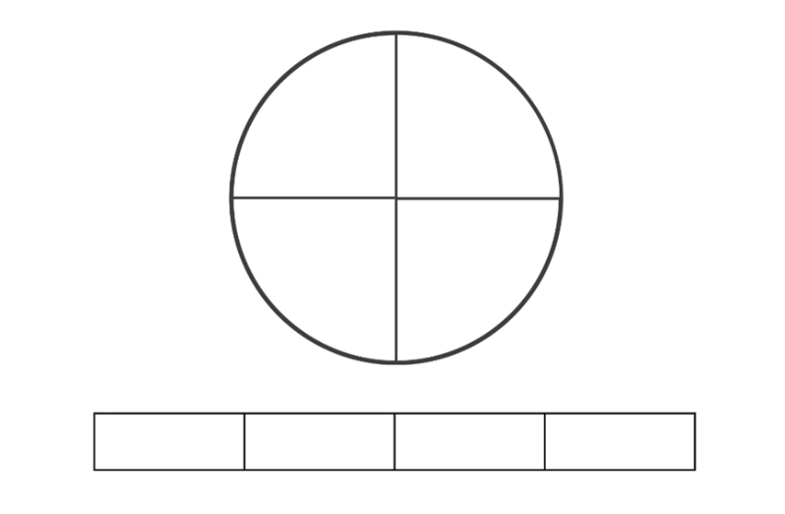
- Ask students:
- How might you shade the spinner if you want to make it twice as likely to get red as it is to get blue?
- How many colours would you need to use? (For example, 2 parts red, one part blue and one part yellow).
- What would this look like in a fraction strip?
- What language could you use to describe the chance of getting red? (For example, for every 4 sections, 2 are red and one is blue, therefore I am twice as likely to land on red as blue).
- In the 3-part spinner, it is also twice as likely to get red. How can it still be twice as likely to get red? (Red is taking up twice as much space than blue on both spinners).
- Give each student a variety of coloured counters, an individual whiteboard and a marker. Ensure that there are at least 6 of each colour.
- Students draw a mystery bag and a 6-part fraction strip on their whiteboard.
- In pairs, students place 6 counters in their bag, ensuring that it is twice as likely to select a red counter than a blue counter. Challenge each student to create a different combination to their partner.
- Students represent this on a fraction strip. As a class, discuss:
- How many different colours did you use? (For example, students could have 2 red, one blue, one green, one yellow and one purple, or 4 red and 2 blue).
- How did you ensure that you have the chance of getting red twice as likely than another colour?
Note: this is a good opportunity to discuss why a particular bag of counters shows or does not show twice as likely. Discuss strategies to rectify any bags that do not reflect twice as likely.
- Does any other colour in the bag have an equal likelihood of being drawn as red?
- Is any colour more likely to be drawn than red?
- Does it matter if other colours are equally or more likely to be drawn than red?
- What particular proportion are we concerned with? (As long as there are twice as many red counters than blue, the other combinations in the bag do not matter).
- Refer again to your drawing of the 3-part spinner. Model how to divide each part into half to create 6 equal parts.
- Ask students how the newly divided 6-part spinner could be represented on a fraction strip. For example, there will be 4 parts red and 2 parts blue.
- Ask students to predict what the fraction strip will look like if you divide each section of the spinner in half again. Anticipated student responses:
- There will be more parts.
- There will be 12 parts.
- Of the 12 parts, 8 parts will be red and 4 parts will be blue.
- Ask students to draw the fraction strip for the newly divided 12-part spinner.
- Compare the fraction strips that show 3 parts, 6 parts and 12 parts by placing them beneath each other like a fraction wall.
- Discuss how in each fraction strip, red represents twice as many parts as blue, showing a twice as likely chance. For example, some students may describe the fraction strip as ‘For each part of blue, there are 2 parts that are red’.
- Ask students to draw Figure 25 again.
- Students divide each section in half to create 8 parts, ensuring that red is still twice as likely as blue.
- Complete the fraction strip below the spinner, representing the new sections and the proportion of each colour in each.
- Students write the proportion represented by red and blue as a fraction for both fraction strips (see Figure 25).
This table details opportunities for differentiation.
Too hard? | Too easy?
Stage 3 students cannot create random generators to follow specified probabilities or proportions.  - Provide students with counters to represent each part on the spinner to support their understanding that there are twice as many red counters than blue. Students can use language such as ‘For every 2 red counters, one is blue, so red is twice as likely’.  - Provide students with a pre-shaded generator in the consolidation activity and ask them to represent it on a pre-divided fraction strip (see Resource 39 – 8-part spinner). | Stage 3 students can create random generators to follow specified probabilities or proportions.  - Students draw Figure 25 and subdivide parts as required to represent a spinner where it is 3 times more likely to land on red than blue.  - Students design another random generator where one particular outcome is 2 or 3 times more likely to occur than another outcome.

Discuss and connect the mathematics – 15 minutes
- As a Stage 2 group, discuss:
- Which groups reached the top of the mountain? Why did these groups reach the top and not the others?
- Convince a friend which generator is best to use if you want to win the game.
- How can listing all possible outcomes help you to answer this question?
- Which random generator is unlikely to move you up the mountain? Why?
- Did what you predicted actually happen? Can you explain why or why not?
- Ask Stage 3 students questions from the prompts table below.
The table below outlines stimulus prompts to generate conversation about the topic, along with anticipated responses from students.
Prompts | Anticipated student responses
- What relationship do you notice between the fractional representation of red using both fraction strips? | - In the second fraction strip, there are more sections, therefore the denominator is bigger. The numerator is also bigger.  - You divided the sections in half and it looks like we have multiplied both the numerator and denominator by 2.  - There is a proportional relationship between the numerator and denominator in both cases.
- How did using the fraction strips support you in expressing chance as a fraction? | - It is easy to determine the denominator as it is the total number of outcomes or parts.  - The numerator is the number of desired outcomes, in this case, red.
This table details opportunities for assessment.
Assessment opportunities | Links
What to look for:  - Can Stage 2 students predict the number of times each outcome might occur in a chance experiment involving a set number of trials? [MAO-WM-01, MA2-CHAN-01]  - Can Stage 2 students use the terms equally likely, likely and unlikely to describe the chance of everyday events occurring? [MAO-WM-01, MA2-CHAN-01]  - Can Stage 3 students represent probabilities of outcomes of chance experiments using fractions? [MAO-WM-01, MA3-CHAN-01]  - Can Stage 3 students create random generators to follow specified probabilities or proportions? [MAO-WM-01, MA3-CHAN-01] | Links to National Numeracy Learning Progressions (NNLP):  - Stage 2 – UnC2, UnC3, CPr8  - Stage 3 – UnC4.

Lesson 8
Core concept: events affected by other events impact the outcomes (Stage 2). Expected and observed frequencies align better in larger trials (Stage 3).

Daily number sense – 10 minutes
- From a class need surfaced through formative assessment data, identify a short, focused activity that targets students’ knowledge, understanding and skills. Example activities may be drawn from the following resources:
- Mathematics K–6 resources
- Universal Resources Hub.

Core lesson – 30 minutes

Stage 2 task – events that are affected by other events
The table below contains suggested learning intentions and success criteria. These are best co-constructed with students.
Core concept learning intentions | Core concept success criteria
Students working towards Stage 2 outcomes are learning to:  - describe the likelihood of outcomes of chance events  - identify when events are affected by previous events. | Students working towards Stage 2 outcomes can:  - compare the likelihood of obtaining particular outcomes in a simple chance experiment by predicting, conducting the experiment and comparing the results with the prediction  - compare events where the chance of one event occurring is affected by the occurrence of the other.
Note: the purpose of this activity is to examine chance situations where one outcome is dependent on another.
- Display Resource 40 – bag of marbles. Students turn and talk:
- What are the possible outcomes when drawing a marble from this bag?
- What is the chance of getting a blue marble?
- What is the chance of getting a red marble?
- Is there a way to arrange the marbles to help our thinking?
Note: there is an opportunity to discuss the fact that it is twice as likely to select a red marble then selecting a green or blue and that selecting a green or blue marble is equally likely (see Figure 26).
Figure 26 – organised bag
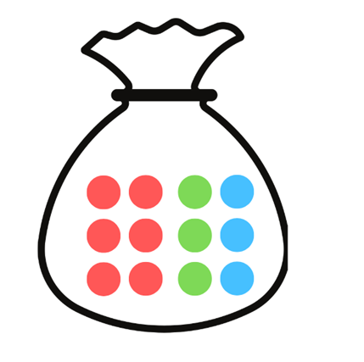
- Discuss class responses and model the language for example, ‘For every 12 marbles, 3 of them are blue, therefore I have a 3 in 12 chance of drawing a blue marble.’
Optional: display a sentence stem to support student responses. For example, ‘For every ___ marbles, ___ of them are ____, therefore I have a ___ in ___ chance of drawing a ___ marble.’
- Ask students:
- What might change if the previous marble is not returned to the bag?
- If you draw a red marble first, what is the chance of drawing a blue marble on the second draw?
- Model this with students by using counters, coloured cubes or marbles in a bag. Show students the remaining choices after the first selection is not returned.
- Provide small groups of students with Resource 40 – bag of marbles and an individual whiteboard to consider the probability of selecting a particular colour on the first draw. Students then consider how probabilities change for the second draw, for example, when a green marble is not returned to the bag.
Note: this activity helps discussions about how probability is linked to the ratio of desired outcomes to total outcomes. For instance, with 3 blue marbles to draw out of 12 marbles, the probability is 3 in 12 or 1 in 4. Encourage phrases like ‘For every 12 marbles, there are 3 chances of blue.’ Note that possibilities reduce to 11 after a marble is removed, making the second draw likelihood of blue higher (increased chance) (see Figure 27).
Figure 27 – misconceptions
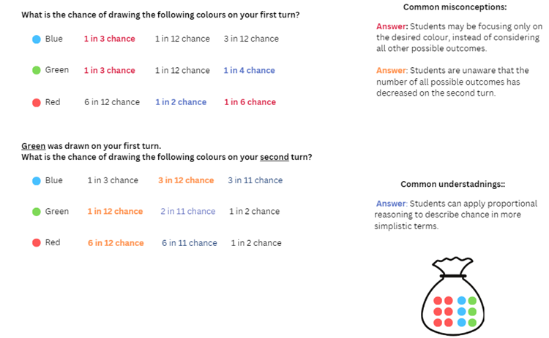
- Ask students:
- How did the language used help you to identify the chance of an outcome occurring?
- How did the way in which you represent the problem help you to identify the chance of an outcome occurring?
This table details opportunities for differentiation.
Too hard? | Too easy?
Stage 2 students cannot compare events where the chance of one event occurring is affected by the occurrence of the other.  - Give students manipulatives such as coloured cubes or counters to support their thinking.  - Students work with just 2 colours in the bag. | Stage 2 students can compare events where the chance of one event occurring is affected by the occurrence of the other.  - Students create a tree diagram for the first and second draw where different colours are chosen on the first draw.  - Students represent the probabilities that could occur on a third draw.

Stage 3 task – mystery bag
The table below contains suggested learning intentions and success criteria. These are best co-constructed with students.
Core concept learning intentions | Core concept success criteria
Students working towards Stage 3 outcomes are learning to:  - conduct chance experiments with both small and large numbers of trials  - compare observed frequencies of outcomes with expected results. | Students working towards Stage 3 outcomes can:  - assign expected probabilities to outcomes in chance experiments with random generators, including digital simulators, and compare the expected probabilities with the observed probabilities after both small and large number of trials  - determine the likely make-up of a large collection of objects by sampling objects and returning them to the collection before the next sample (sample with replacement)  - compare the expected frequencies of outcomes of chance experiments with observed frequencies, including where the outcomes are not equally likely.
Note: the purpose of this lesson is to compare the expected and observed frequencies in small and large trials. Students use various trial sizes (small, medium and large) to deduce the composition of an unknown collection, recognising that larger trials enhance accurate predictions.
- Show a paper bag and tell students that it contains 10 counters.
- Tell students that there may be blue, yellow, red or green counters in the bag. Keep the colour proportions unknown to the students (5 blue, one yellow, 2 red, 2 green).
- Explain that students will be trying to determine the colours of the counters by running different numbers of trials. Ask students:
The table below outlines stimulus prompts to generate conversation about the topic, along with anticipated responses from students.
Prompts | Anticipated student responses
- At this stage, do you have any idea of what coloured counters are inside the bag? | - No.
- How can you start to think about what colours might be in the bag? | - By drawing some counters out.
- If you know that there are 10 counters in the bag, what number of draws or trials should you start with to make a reasonable prediction? | - I should start with 10 trials because there is a chance that I would draw out one of each counter.  - If I do less than 10 trials, I could not predict the make-up of the bag.
- Form 10 groups within the class.
- Provide each group with an identical mystery paper bag each and Resource 41 – recording mystery bag.
- Ask groups to remove one counter out of the paper bag and record it on the first fraction strip on Resource 41 – recording mystery bag.
- Return the counter and remove a second counter (without looking). Repeat this process a total of 10 times.
- Each group transfers data from a fraction strip into the table on Resource 41 – recording mystery bag to show the frequency of drawing each colour.
- Explain to students that frequency means how often a particular outcome occurs. Some groups may remove all 4 colours, while some may remove 3 or fewer colours.
- Using the observed frequencies in 10 trials, ask students to predict the colours and quantities of each counter that is in the mystery bag and record it beside the table (see Figure 28).
Figure 28 – recording example
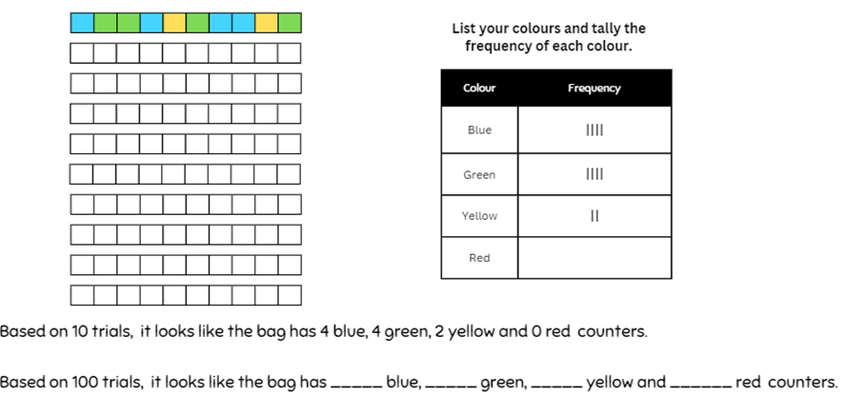
- As a class, ask:
The table below outlines stimulus prompts to generate conversation about the topic, along with anticipated responses from students.
Prompts | Anticipated student responses
- Do you think your prediction is correct? Why or why not? | - No. There is a chance I picked the same counter twice.  - Yes, because I did 10 trials and there are 10 counters.
- Is your prediction similar or different to others? What does this tell us? | - No, they are different so maybe our predictions are not as accurate.  - I noticed that others got a colour that I did not get. If all the bags are the same, that tells me that I have not picked out every counter.
- Are 10 trials enough to make an accurate prediction? How can we make a more accurate prediction? | - No, I need to do more trials to make sure I have a better opportunity to draw all the different counters.
- How many trials do you think you need to make an accurate prediction? | - Answers may vary but explain to students that they might try 100 trials.
- Students return to their groups and repeat the process of removing counters to complete their remaining fraction strips on Resource 41 – recording mystery bag.
- Students complete the tally chart on Resource 41 – recording mystery bag to keep track of the observed frequency of each colour drawn.
- Ask students to record the observed frequency of each outcome as a number in the ‘100 trials of mystery bag’.
- Ask students if they made their first prediction after 10 trials, how can they compare 100 trials to 10 trials.
Note: the total frequency of each colour will need to be divided by 10. Calculators can be provided if this process is challenging. This may result in decimals and it is important to discuss with students that these need to be rounded to reflect an actual quantity. For example, 0.4 cannot be rounded to 0 because it has been drawn and it is one. The total of the final predictions must add up to 10.
- Ask students to now make predictions of the contents of the mystery bag.
- Record these predictions beside the data table.
- Discuss with students:
The table below outlines stimulus prompts to generate conversation about the topic, along with anticipated responses from students.
Prompts | Anticipated student responses
- How has your prediction changed? | - I noticed colours that I did not pick in a trial of 10.  - Some colours appeared more and some appeared less.
- Is your prediction now more accurate? Why or why not? | - My prediction is more accurate because I now have colours that I did not draw in a trial of 10.
- If you continue doing more trials, will you be able to make an even better prediction of what is in the bag? | - I think that by selecting counters more times, I have a better idea of what might be in the bag.
- Explain to the class that they will now combine each group’s data and this will represent 1000 trials.
- Record the combined data in a table on the board and students can copy this onto the group’s relevant table on Resource 42 – class recording.
- Model how to scale the frequencies to make the data comparable with the trial of 10 (that is divide by 100).
- Using this data, students make predictions and record this beside the table.
This table details opportunities for differentiation.
Too hard? | Too easy?
Stage 3 students cannot conduct chance experiments with both small and large numbers of trials.  - Provide a calculator to students who cannot divide by 10 or 100.  - Students who find it challenging to represent probability as a fraction can be supported by writing 10 (number of trials) as the denominator in Resource 43 – How accurate? | Stage 3 students can conduct chance experiments with both small and large numbers of trials.  - Students can consider a small, medium and large number of trials that would be appropriate for a mystery bag containing 8, 15 or 20 counters.  - Students reason about what the fraction strips for 10, 100, 1000 might look like in a sample where red was twice as likely to occur.

Consolidation and meaningful practice – 20 minutes
This activity is an adaptation of Bipin's Choice from NRICH by University of Cambridge.
- Display the problem for Stage 2 students: Bipin is playing in a game show. The host tells Bipin that there are 10 balls hidden in a box; 5 are Red, 3 are Yellow and 2 are Blue. Bipin pulls out his first ball. It is red and he wins a large sum of money. Now his choices are:
- He can stop playing and take his prize.
- He can pull out another ball. If it is red, he doubles his money. If it is yellow, he leaves with nothing. If it is blue, he can pick one last ball.
- Ask students:
- How might we represent this problem?
- What language can we use to help us describe the probability of pulling out a red ball on the first draw?
- What language can we use to help us describe the probability of pulling out a red, blue or yellow ball on the second draw?
- Convince a friend of what Bipin should do and why.
Note: some students may only describe the chance within this activity.
- Reveal the contents of the mystery bag to Stage 3 students.
- Ask students how they could represent the expected frequency of drawing each colour from the bag on a fraction strip on Resource 43 – How accurate?
- Ask students to shade the fraction strips to represent observed frequency from trials of 10, 100 and 1000 on Resource 43 – How accurate?
- Students record the numerical representations for each colour on each fraction strip using Resource 43 – How accurate?, for example, 2 out of 10 or $\frac{2}{10}$.
- Ask Stage 3 students to discuss:
- What did you notice about the actual frequency in each set of trials compared to the expected probability?
- Which number of trials was closest to the expected probability?
- How did the fraction strips help you to compare the trials?
- Is it always better to conduct more trials in a chance experiment?
This table details opportunities for assessment.
Assessment opportunities | Links
What to look for:  - Can Stage 2 students compare the likelihood of obtaining particular outcomes in a simple chance experiment by predicting, conducting the experiment and comparing the results with the prediction? [MAO-WM-01, MA2-CHAN-01]  - Can Stage 2 students compare events where the chance of one event occurring is affected by the occurrence of the other? [MAO-WM-01, MA2-CHAN-01]  - Can Stage 3 students record the outcomes for chance experiments where the outcomes are not equally likely to occur using fractions? [MAO-WM-01, MA3-CHAN-01]  - Can Stage 3 students determine the likely make-up of a large collection of objects by sampling objects and returning them to the collection before the next sample? [MAO-WM-01, MA3-CHAN-01] | Links to National Numeracy Learning Progressions (NNLP):  - Stage 2 – UnC3  - Stage 3 – UnC2, UnC3, UnC5.

Resource 1 – position representations (Stage 2)
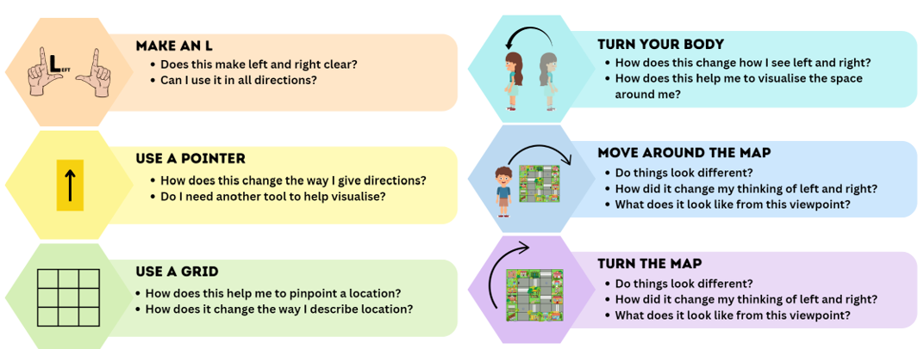

Resource 2 – position representations (Stage 3)
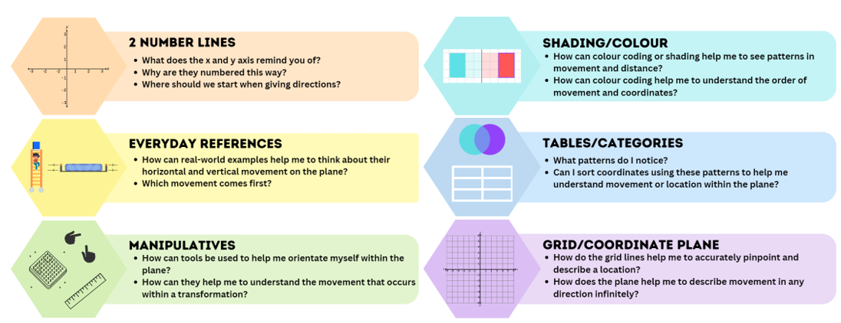

Resource 3 – student maze and arrows
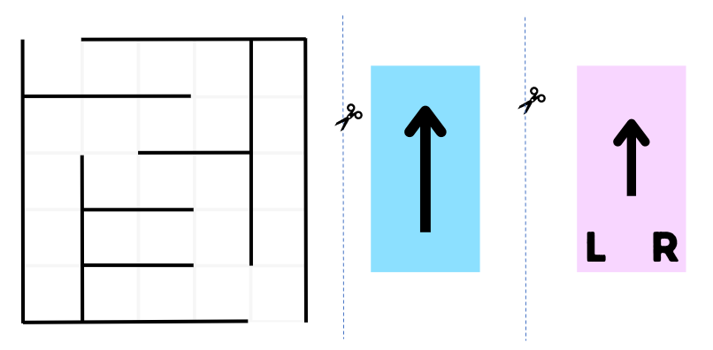

Resource 4 – I spy
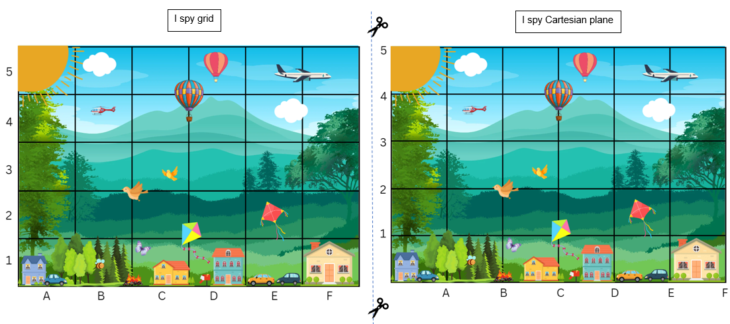

Resource 5 – ship shore
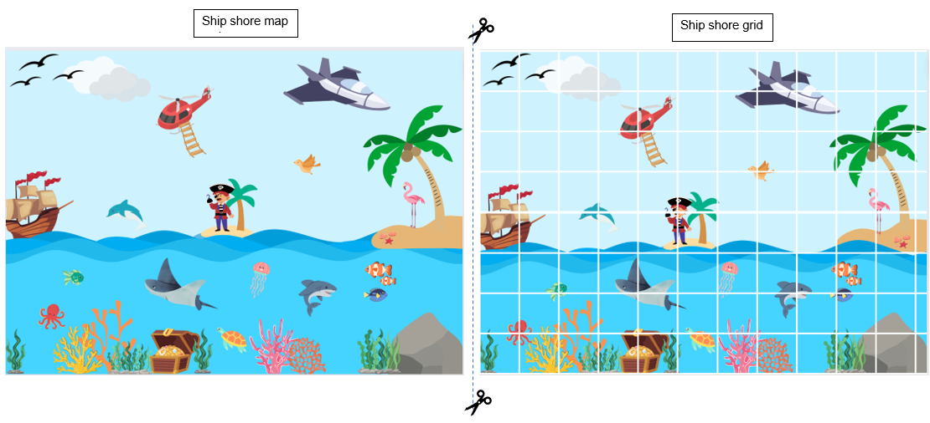

Resource 6 – labelling misconceptions
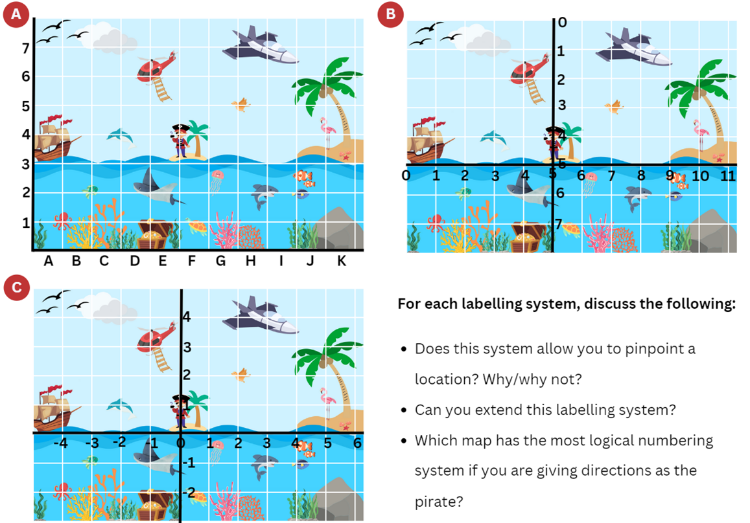

Resource 7 – move to shoot
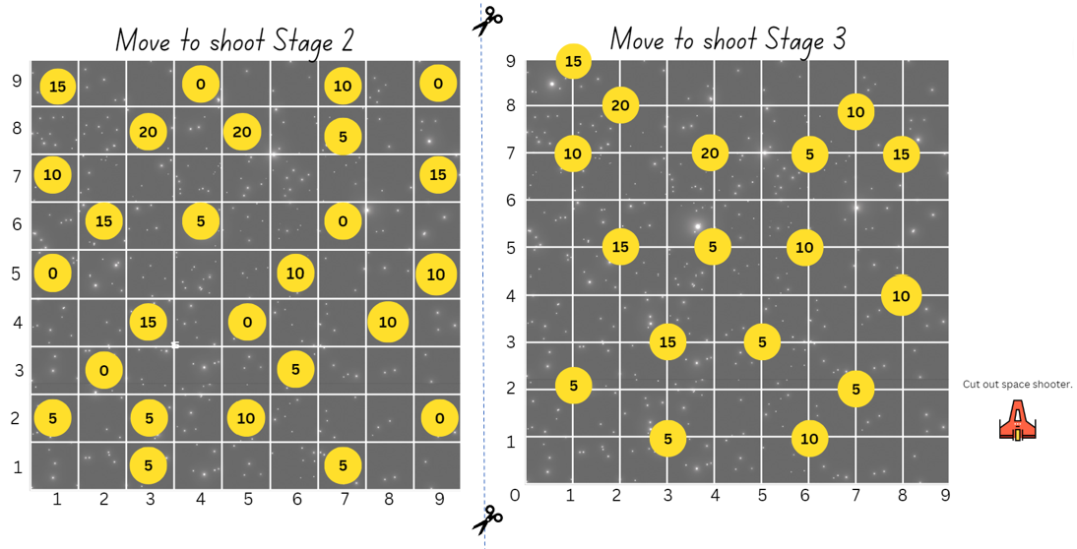

Resource 8 – street map
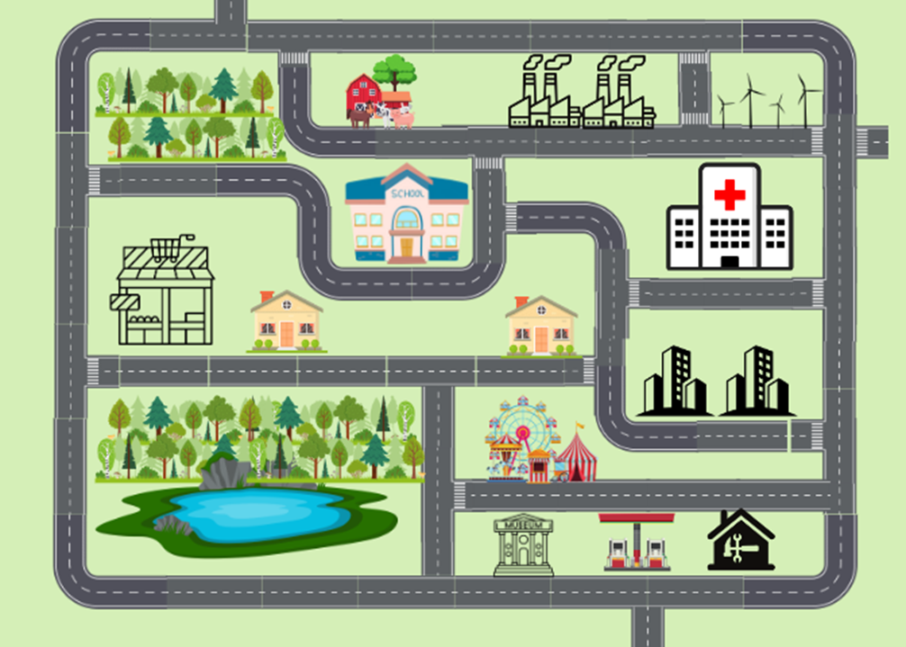

Resource 9 – x- and y-coordinates
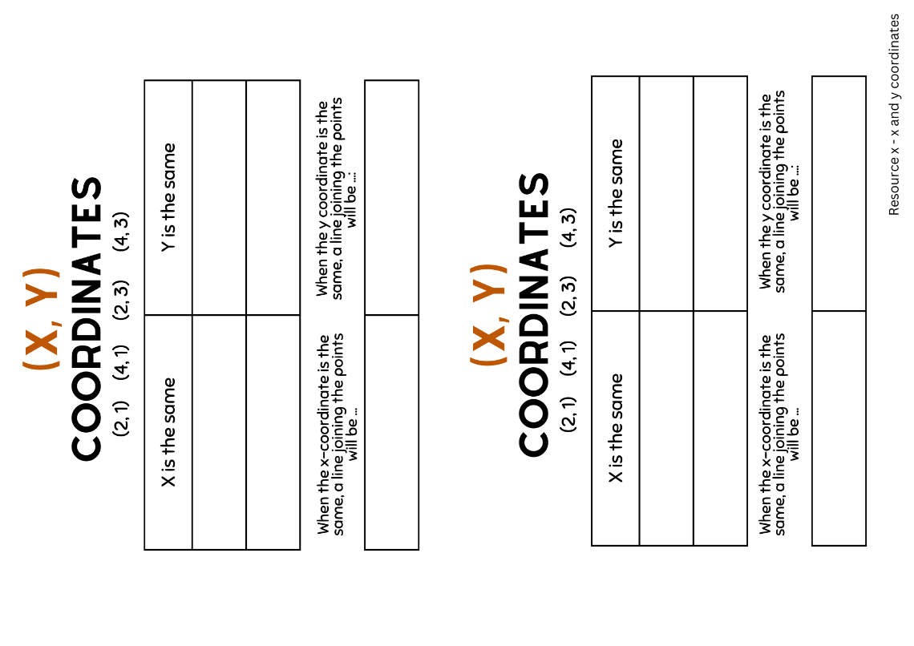

Resource 10 – shapeshifters
First shape | Second shape | Circle the change | Circle which coordinates changed
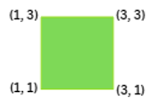 |  | Horizontal (left/right, side to side, across)  Vertical (up/down) | x-coordinate  y-coordinate
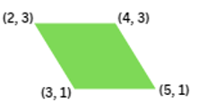 |  | Horizontal (left/right, side to side, across)  Vertical (up/down) | x-coordinate  y-coordinate
 |  | Horizontal (left/right, side to side, across)  Vertical (up/down) | x-coordinate  y-coordinate
 |  | Horizontal (left/right, side to side, across)  Vertical (up/down) | x-coordinate  y-coordinate
 |  | Horizontal (left/right, side to side, across)  Vertical (up/down) | x-coordinate  y-coordinate

Resource 11 – shapeshifters 2
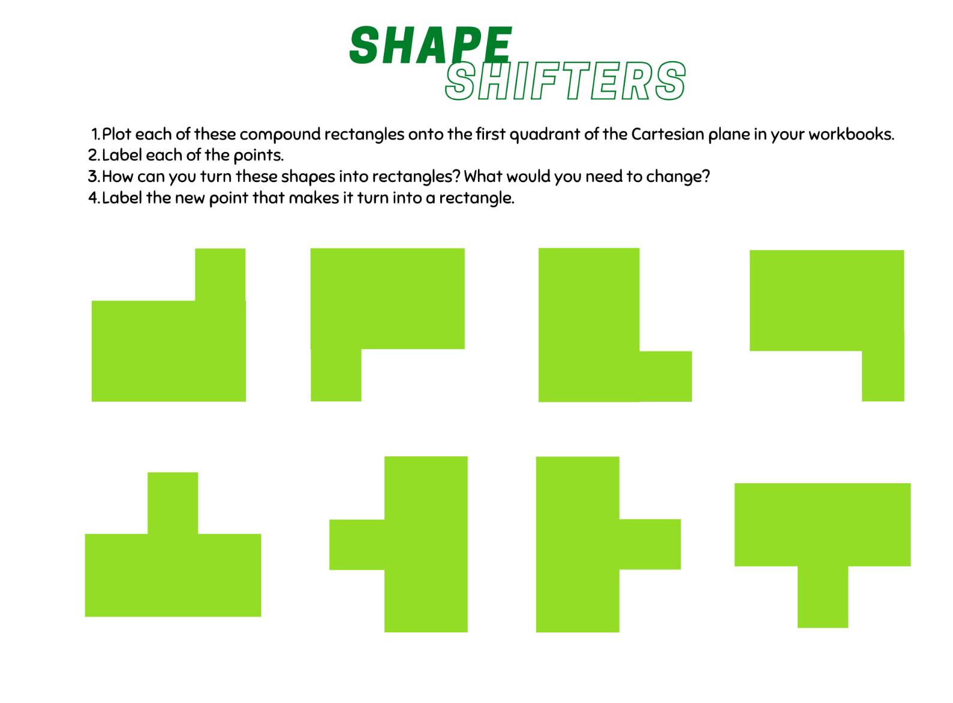

Resource 12 – community map
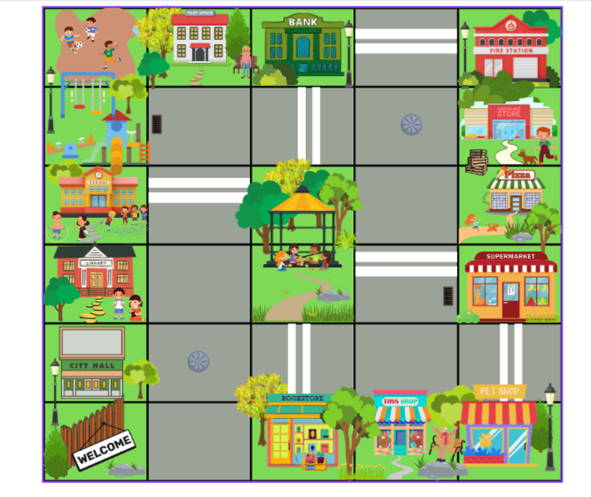

Resource 13 – directions template
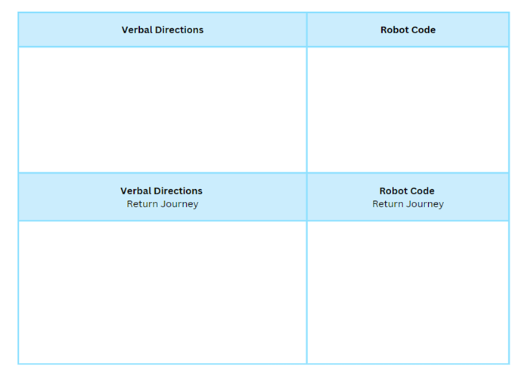

Resource 14 – blank Cartesian plane
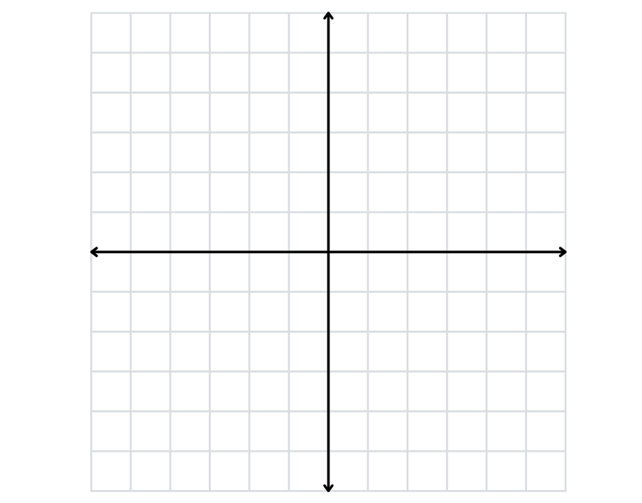

Resource 15 – plotting shapes
Level 1 – stretches across 2 quadrants | Level 2 – stretches across 3 quadrants | Level 3 – stretches across 4 quadrants
 |  | Does not have to be an isosceles
Level 1 points: (-1, 4), (1, 4), (1, 2), (__, __)  Level 2 points: (-1, 3), (1, 1), (-3, 1), (__, __)  Level 3 points: (4, 4), (-4, 4), (4, -4), (__, __) | Level 1 points: (2, 1), (5, 1), (1, -2) (__, __)  Level 2 points: (1, 1), (4, 1), (2, -2), (__, __)  Level 3 points: (6, 4), (3, - 3), (-2, 4), (__, __) | Level 1 points: (-1, 5), (1, 2), (__, __)  Level 2 points: (-2, 4), (-3, -2), (__, __)  Level 3 points: (-1, 5), (6, -2), (__, __)
Level 1 points: (-5, -4), (2, -4), (2, -2), (__, __)  Level 2 points: (-2, 2), (3, -3), (1, -5), (__, __)  Level 3 points: (1, -2), (4, 1), (-4, 3), (__, __) | Level 1 points: (1, 0), (3, 2), (4, -2), (2, -2), (__, __)  Level 2 points: (1, -1), (3, 1), (2, 3), (0, 3), (__, __)  Level 3 points: (0, 2), (2, 0), (1, -2), (-1, 2), (__, __) | Level 1 points: (1, -1), (3, -1), (5, -3), (3, -5), (1, -5), (__, __)  Level 2 points: (-3, 1), (-1, 1), (-1, -3), (-3, -3), (-5, -1), (__, __)  Level 3 points: (-6, 1), (-2, 5), (2, 5), (6, 1), (2, -3) (__, __)

Resource 16 – plotting points
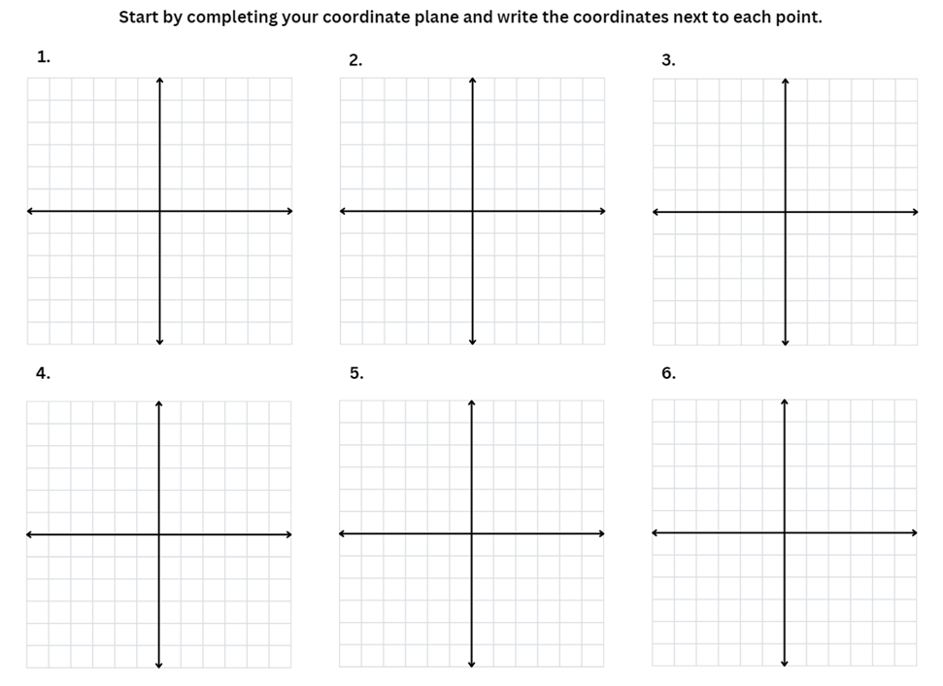

Resource 17 – plotting shapes 2
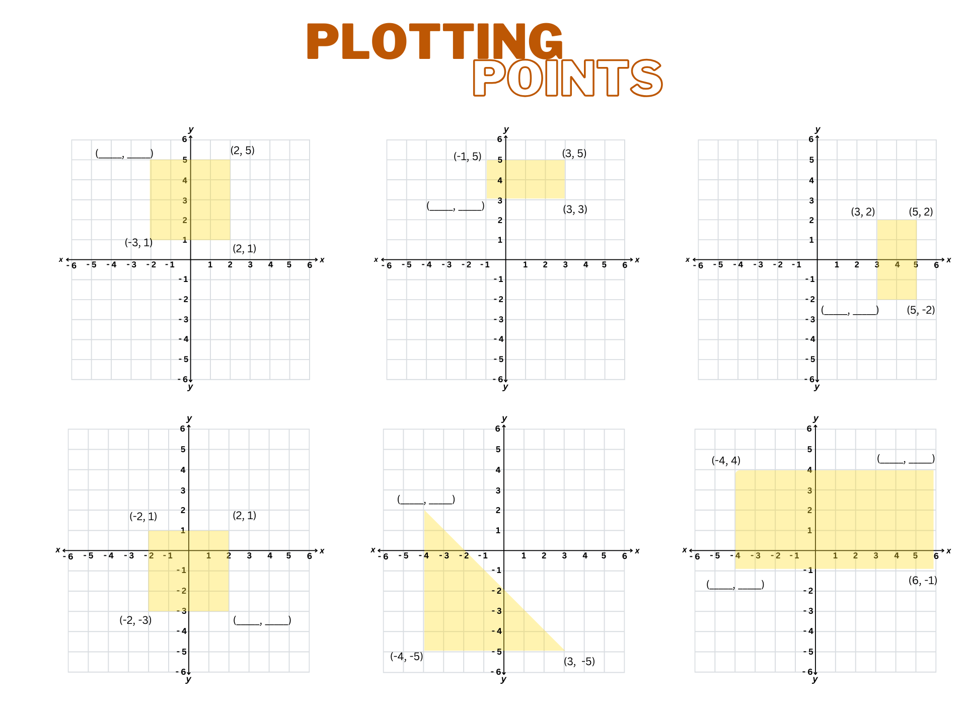

Resource 18 – plotting points 2
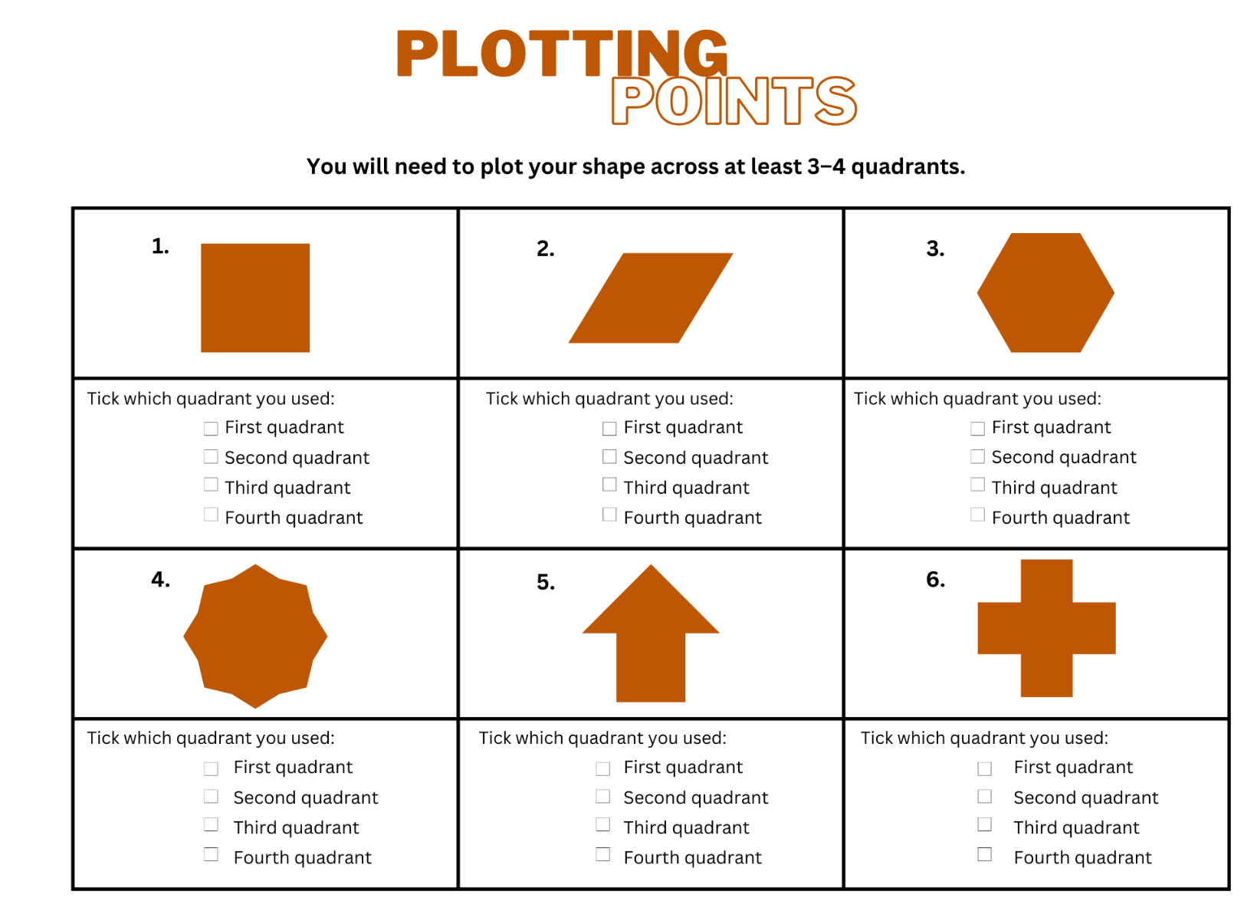

Resource 19 – plotting points 3
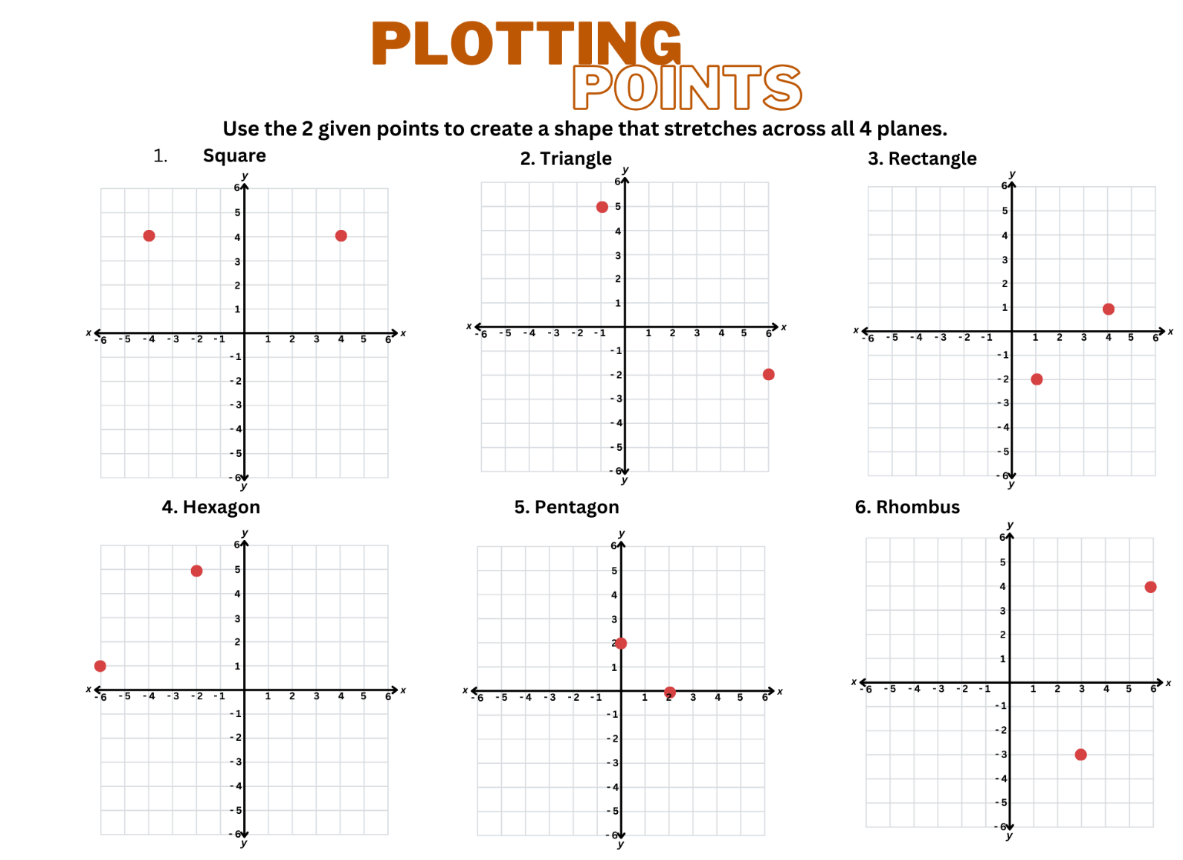

Resource 20 – animal map
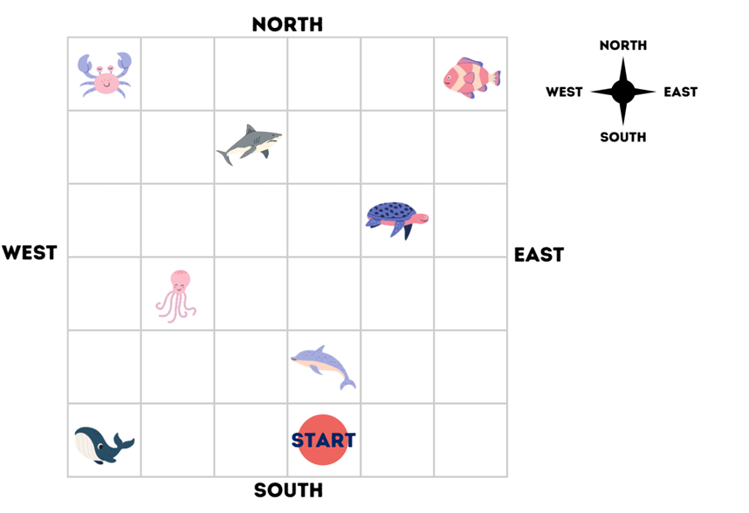

Resource 21 – blank street map
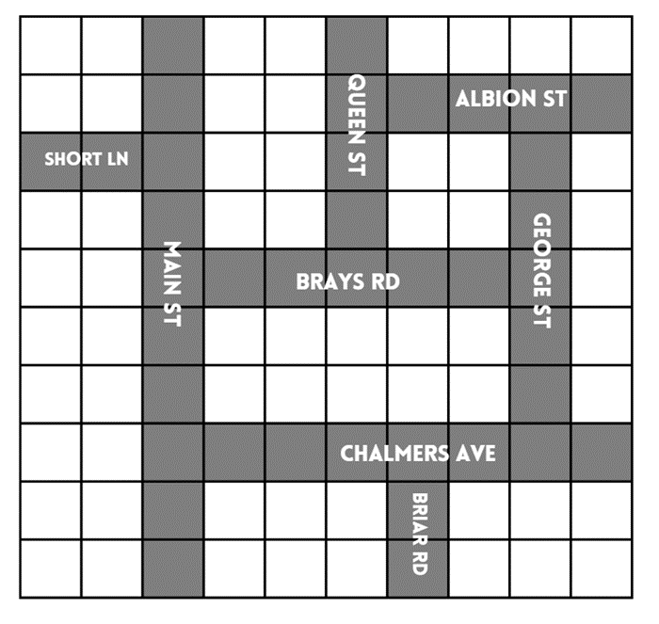

Resource 22 – pentagon mirror
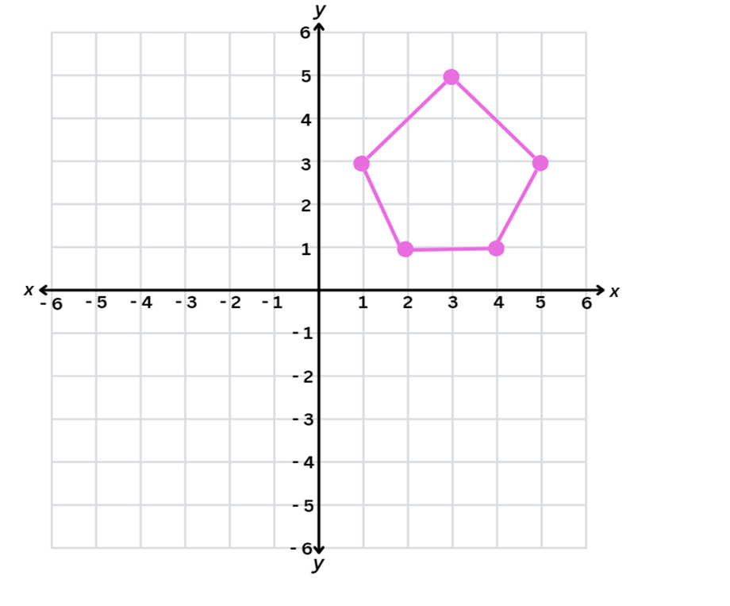

Resource 23 – mirror, mirror
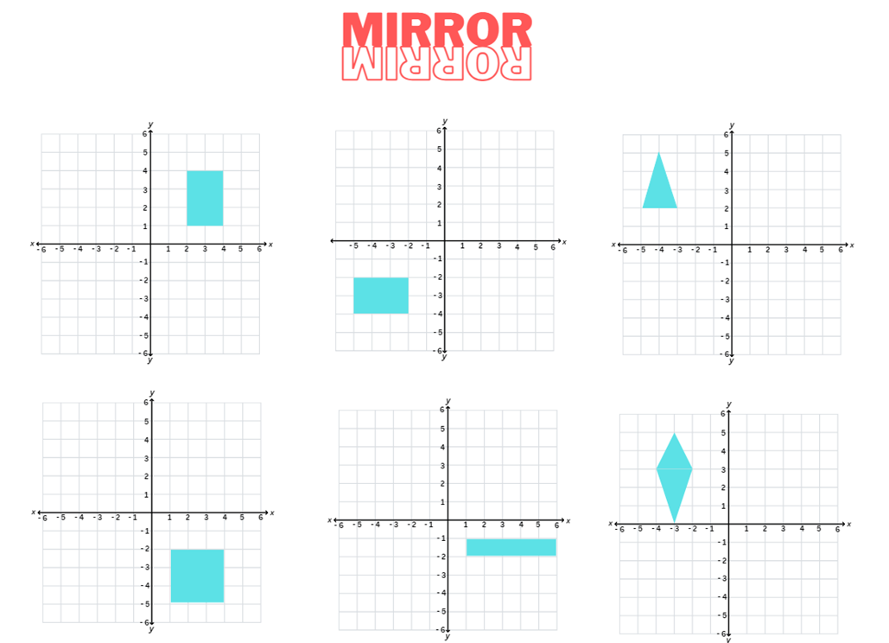

Resource 24 – mirror, mirror 2 2
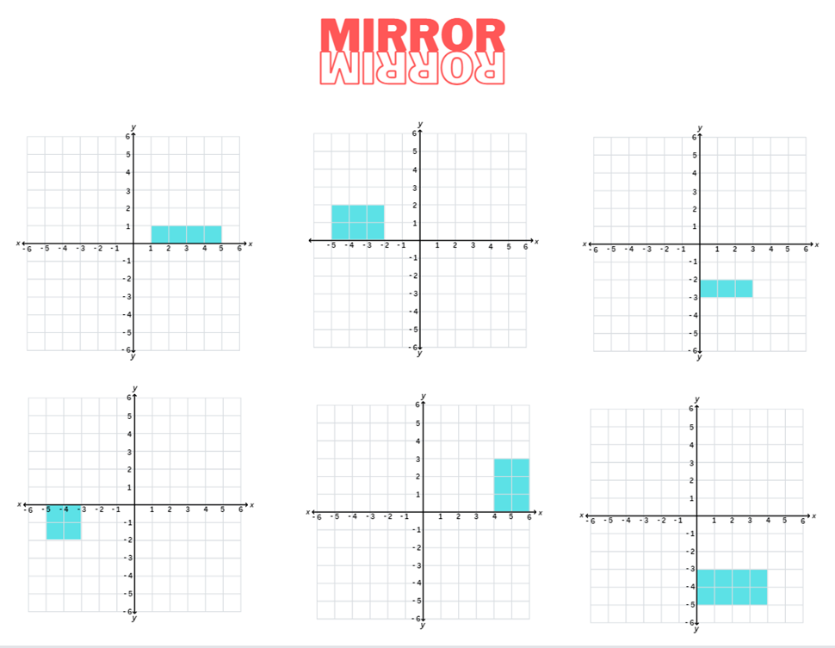

Resource 25 – reflecting
Task 1
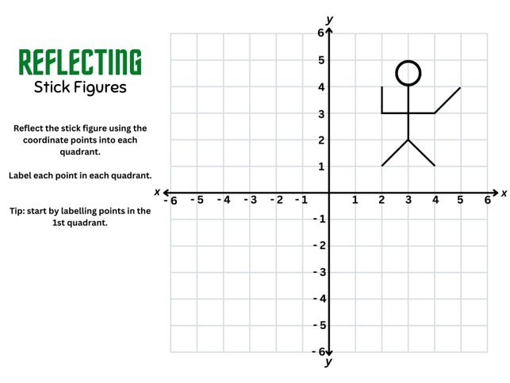
Task 2

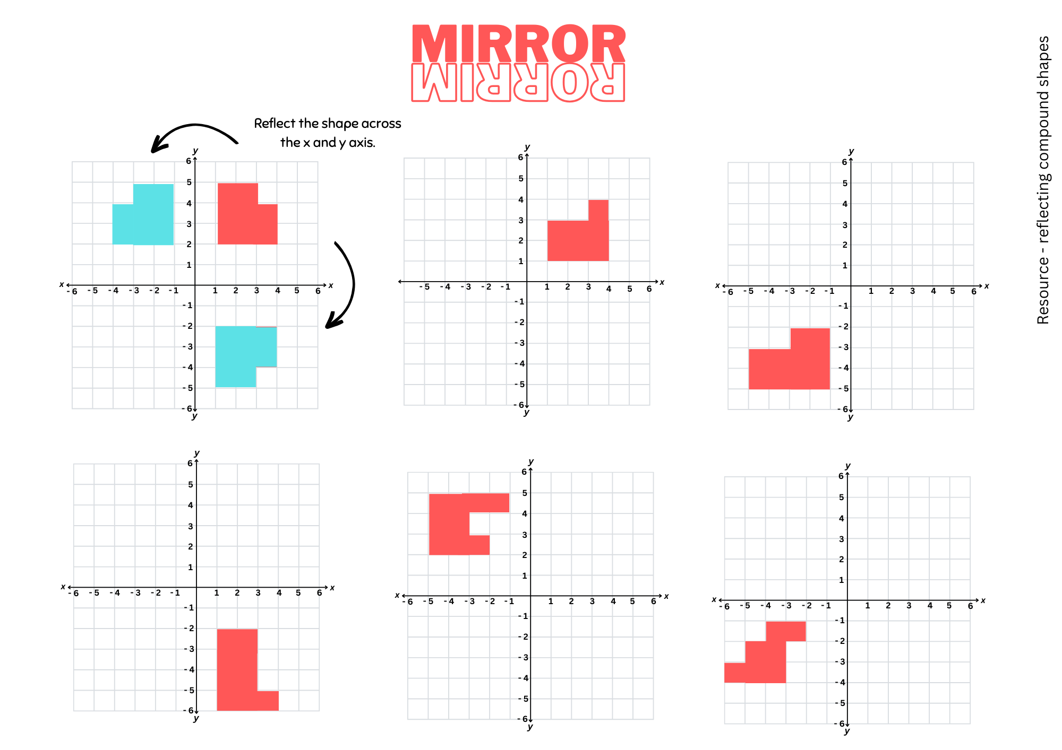

Resource 26 – Stage 2 chance representation
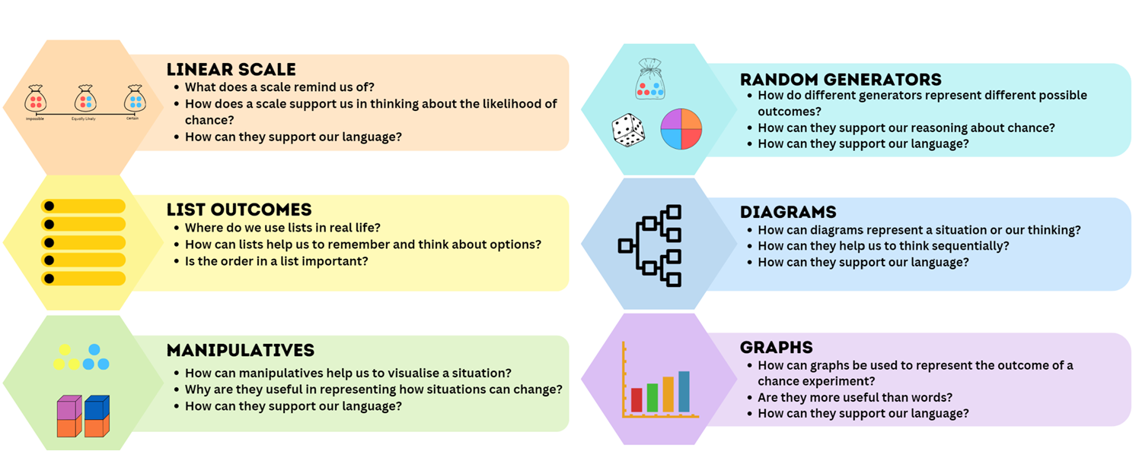

Resource 27 – Stage 3 chance representation
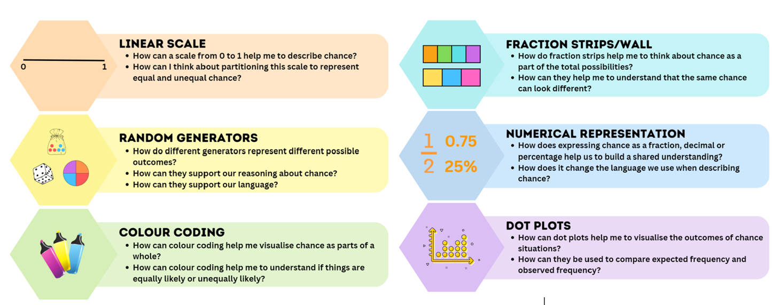

Resource 28 – likelihood scale
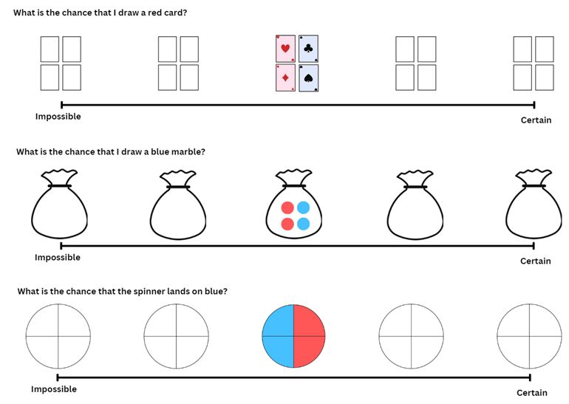

Resource 29 – likelihood cards
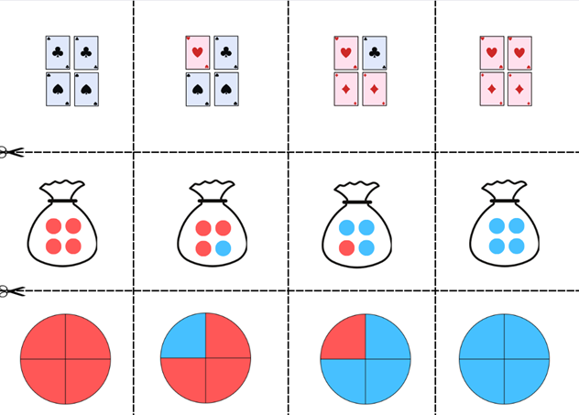

Resource 30 – likelihood scale challenge
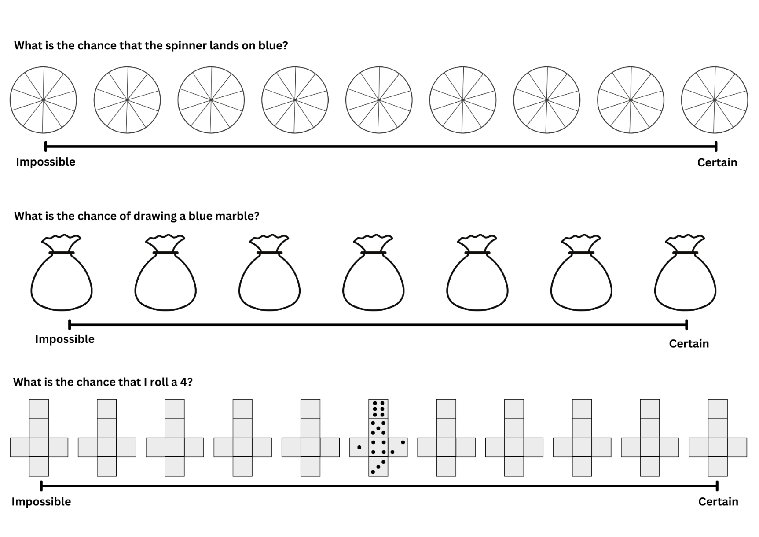

Resource 31 – spinner table
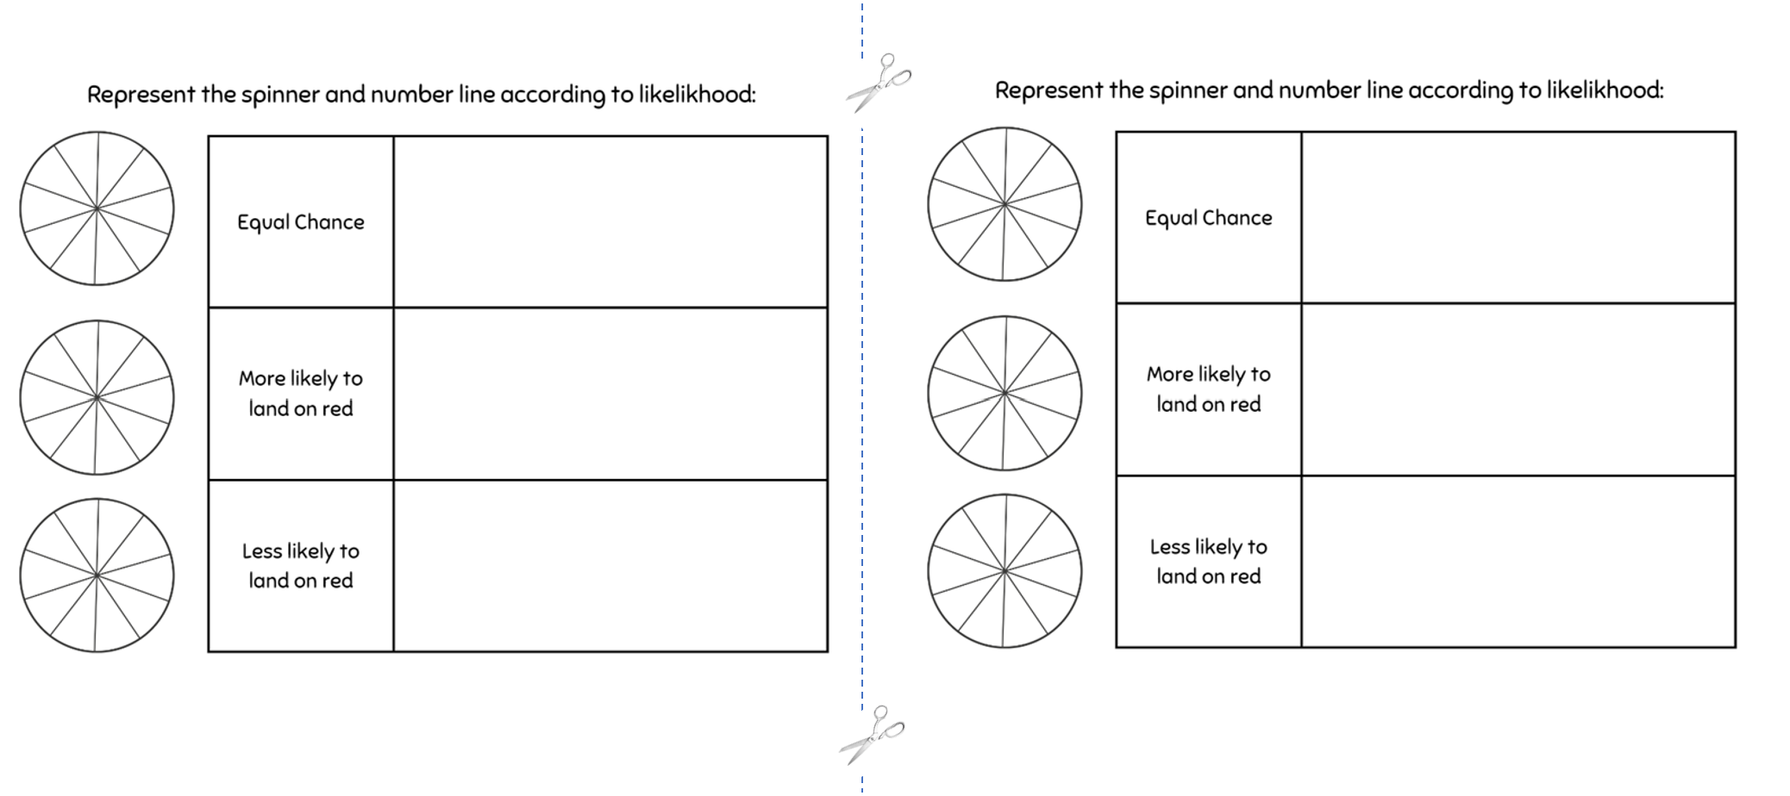

Resource 32 – spinner table 2
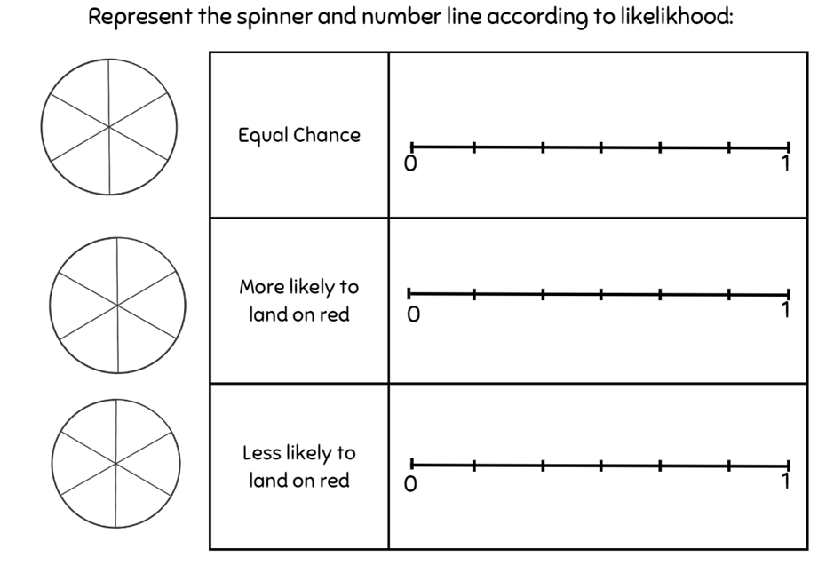

Resource 33 – candy stall
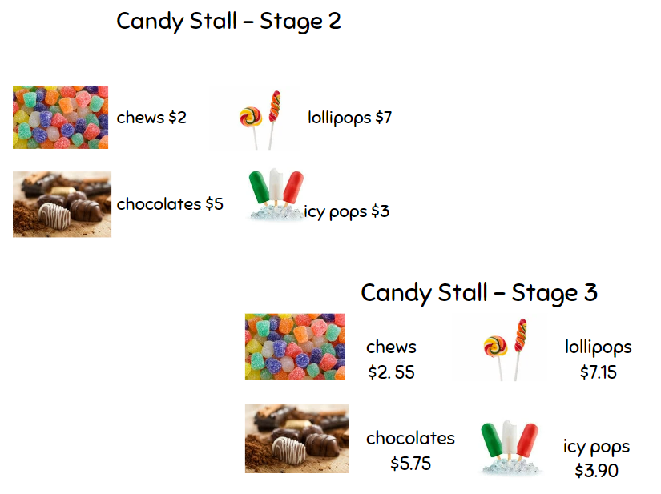

Resource 34 – student statements
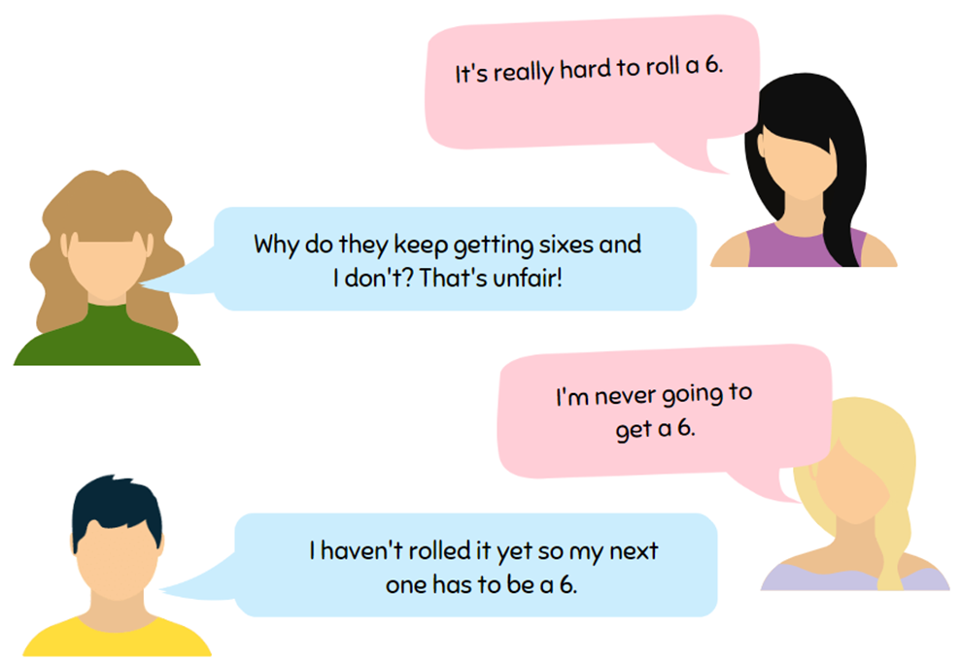

Resource 35 – net and strips
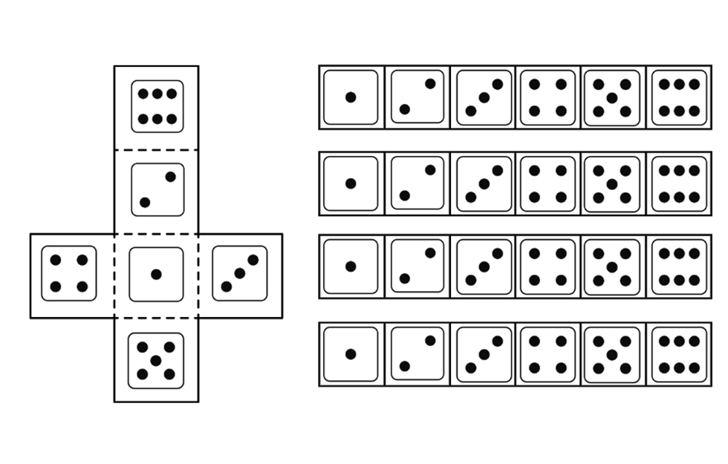

Resource 36 – goat mountain climb
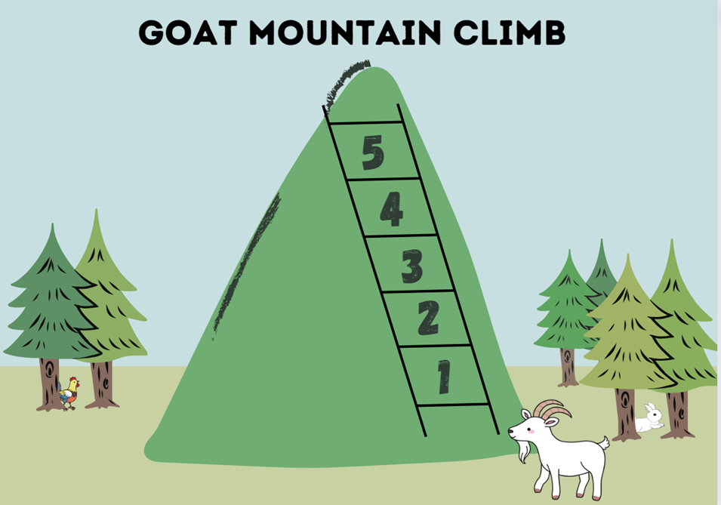

Resource 37 – random generator
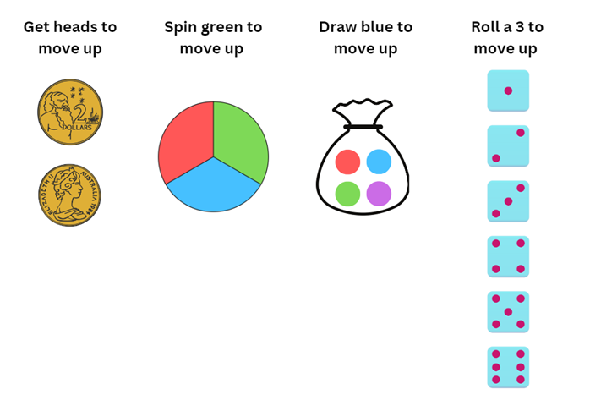

Resource 38 – spinner
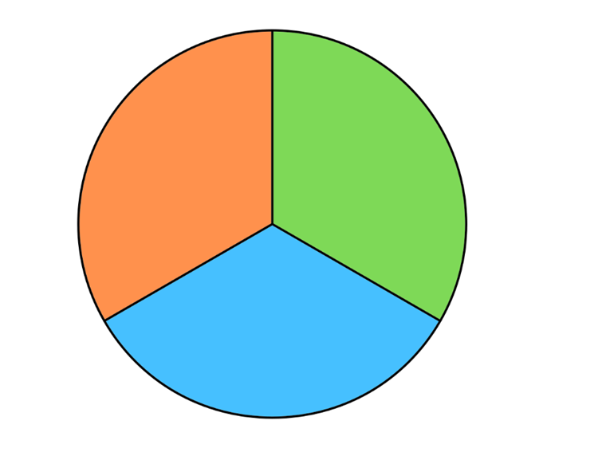

Resource 39 – 8-part spinner

Resource 40 – bag of marbles
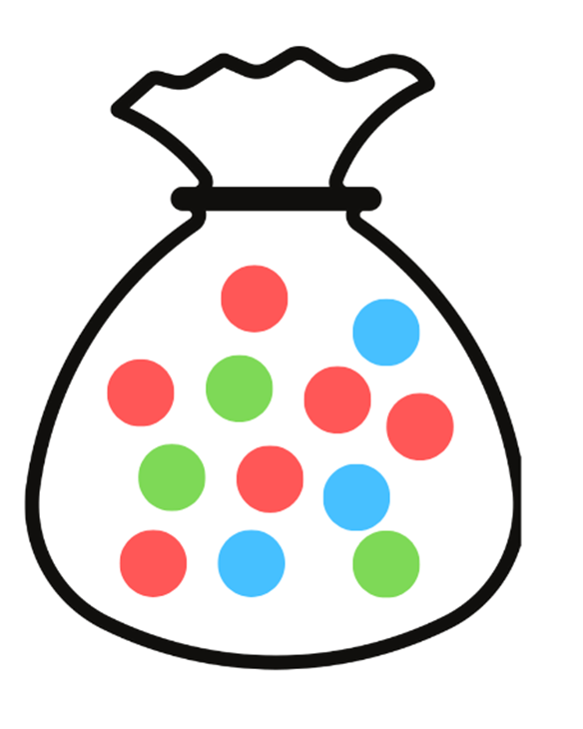

Resource 41 – recording mystery bag
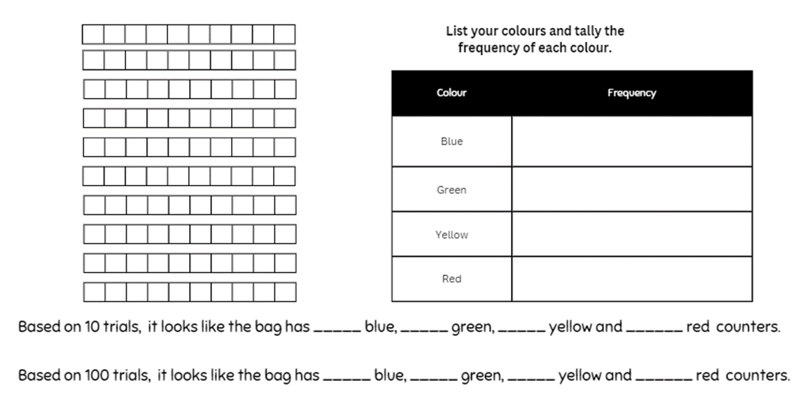

Resource 42 – class recording
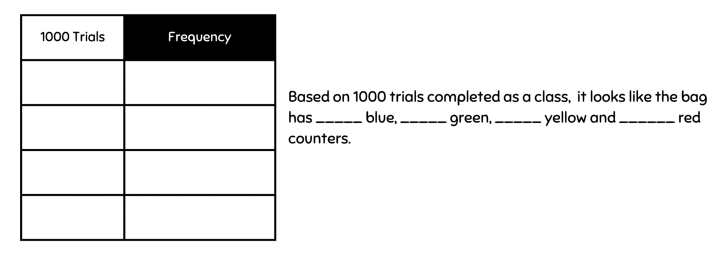

Resource 43 – How accurate?
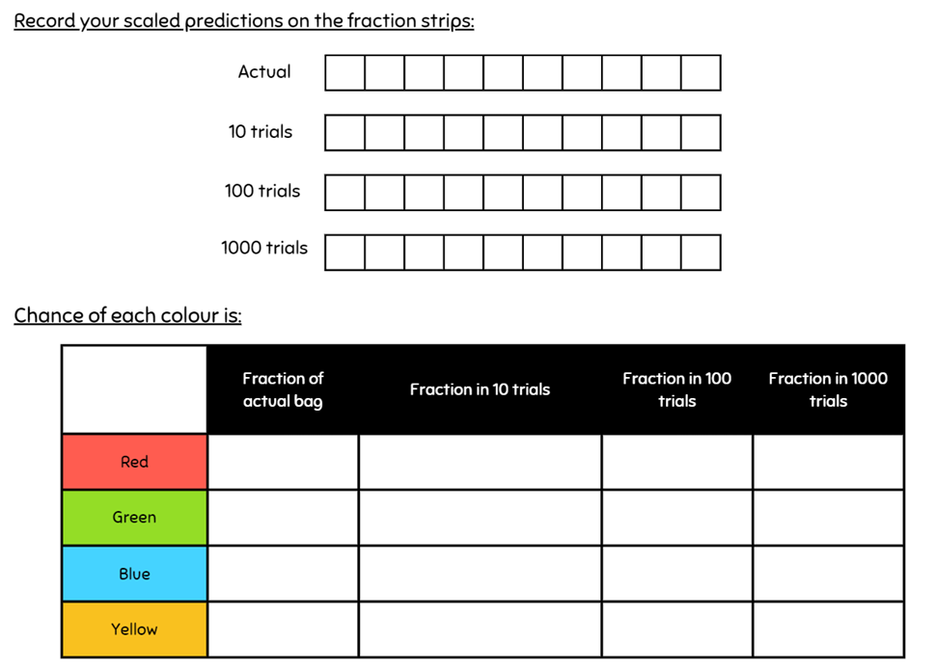

Syllabus outcomes and content

Stage 2
The table below outlines the syllabus outcomes and range of relevant syllabus content covered in this unit. Content is linked to National Numeracy Learning Progression version (3).
Outcomes and content | 1 | 2 | 3 | 4 | 5 | 6 | 7 | 8
Additive relations B: Apply addition and subtraction to familiar contexts, including money and budgeting
MAO-WM-01, MA2-AR-01
- Use estimation to check the validity of solutions to addition and subtraction problems, including those involving money |  |  |  |  |  | x
- Reflect on a chosen strategy for solving a problem, considering whether it can be improved |  |  |  |  |  |  | x
- Interpret problems involving money as requiring either addition or subtraction |  |  |  |  | x
Partitioned fractions A: Create fractional parts of a length using techniques other than repeated halving
MAO-WM-01, MA2-PF-01
- Make thirds of a length |  |  | x
- Make fifths of a length |  |  | x
Partitioned fractions B: Model equivalent fraction as lengths
MAO-WM-01, MA2-PF-01
- Represent the equivalence of fractions with related denominators as lengths, using concrete materials, diagrams and number lines | x | x | x
- Recognise the need to have equal wholes to compare partitioned fractions (Reasoning about relations) | x | x | x
- Represent fractions with the same-size whole to make valid comparisons (denominators of 2, 4 and 8; 3 and 6; 5 and 10) | x | x | x
Geometric measure A: Position: Interpret movement on a map
MAO-WM-01, MA2-GM-01
- Orient a map to determine directions to travel | x | x | x
- Use given directions to follow routes on land and Aboriginal maps without a grid reference system (Reasons about spatial structure) |  | x
- Describe a route taken on a map using landmarks and directional language | x | x |  | x
Geometric measure B: Position: Create and interpret grid maps
MAO-WM-01, MA2-GM-01
- Create simple maps and plans from an aerial view, labelling grid references |  |  |  | x
Geometric measure B: Position: Use directional language and describe routes with grid maps
MAO-WM-01, MA2-GM-01
- Use a given grid map and compass directions (N, S, E, W) to plan, describe and show a route from one location to another |  |  |  | x
- Use natural resources or landmarks to identify north, south, east, west | x | x
- Relate compass directions to amounts of turn | x | x | x
- Describe a return journey between 2 locations on a grid map (Reasons about spatial orientation) |  |  | x
Two-dimensional spatial structure A: 2D shapes: Transform shapes by reflecting, translating and rotating
MAO-WM-01, MA2-2DS-02
- Apply and describe amounts of rotation including half-turns, quarter-turns and three-quarter-turns when creating designs | x
Data A: Organise and display data using tables and graphs
MAO-WM-01, MA2-DATA-01
- Construct column graphs (with scale intervals of 1) and dot plots using relevant software where appropriate |  |  |  |  |  | x
Data A: Interpret and compare data
MAO-WM-01, MA2-DATA-02
- Describe and interpret information presented in tally tables and column graphs. |  |  |  |  |  | x
Chance A: Identify possible outcomes from chance experiments
MAO-WM-01, MA2-CHAN-01
- Use the term outcome to describe any possible result of a chance experiment |  |  |  |  | x
- Record all possible outcomes in a chance experiment where the outcomes are equally likely |  |  |  |  |  |  | x
- Predict the number of times each outcome might occur in a chance experiment involving a set number of trials (Probabilistic reasoning) |  |  |  |  |  | x | x
- Conduct experiments and compare the predicted and actual results where the outcomes are equally likely |  |  |  |  |  | x
Chance B: Describe the likelihood of outcomes of chance events
MAO-WM-01, MA2-CHAN-01
- Use the terms equally likely, likely and unlikely to describe the chance of everyday events occurring |  |  |  |  | x |  | x
- Compare the likelihood of obtaining particular outcomes in a simple chance experiment by predicting, conducting the experiment and comparing the results with the prediction |  |  |  |  |  |  |  | x
Chance B: Identify when events are affected by previous events
MAO-WM-01, MA2-CHAN-01
- Identify and discuss events where the chance of one event occurring will not be affected by the occurrence of the other |  |  |  |  |  | x
- Compare events where the chance of one event occurring is affected by the occurrence of the other (Reasons about relations) |  |  |  |  |  |  |  | x
Mathematics K–10 Syllabus © NSW Education Standards Authority (NESA) for and on behalf of the Crown in right of the State of New South Wales, 2022.

Stage 3
The table below outlines the syllabus outcomes and range of relevant syllabus content covered in this unit. Content is linked to National Numeracy Learning Progression version (3).
Outcomes and content | 1 | 2 | 3 | 4 | 5 | 6 | 7 | 8
Additive relations B: Choose and use efficient strategies to solve addition and subtraction problems
MAO-WM-01, MA3-AR-01
- Compare, evaluate and communicate strategies used to solve addition and subtraction problems |  |  |  |  | x |  | x
Additive relations B: Applies known strategies to add and subtract decimals
MAO-WM-01, MA3-AR-01
- Order common fractions with related denominators using diagrams and number lines |  |  |  |  |  | x
Representing quantity fractions B: Compare common fractions with related denominators
MAO-WM-01, MA3-RQF-01
- Order common fractions with related denominators using diagrams and number lines | x | x
- Create equivalent fractions for half in quarters, eighths, sixths and tenths by re-dividing the whole, using diagrams and number lines | x
- Record equivalent fractions using diagrams, words and fraction notation | x |  | x
Geometric measure A: Position: Explore the Cartesian coordinate system
MAO-WM-01, MA3-GM-01
- Recognise that the grid-map reference system gives the area of a location and the number plane identifies a specific point | x
- Identify that in the coordinate system the lines are numbered, not the spaces | x
- Identify the point of intersection of the 2 axes as the origin, having coordinates (0, 0) | x | x
- Plot and label points, given coordinates, on the number plane in the first quadrant, describing the horizontal position first, followed by the vertical position | x | x
Geometric measure B: Position: Use the 4 quadrants of the coordinate plane
MAO-WM-01, MA3-GM-01
- Plot and label points, given coordinates, in all 4 quadrants of the number plane |  |  | x | x
- Identify and record the coordinates of given points on the number plane in all 4 quadrants |  |  | x | x
- Describe changes to coordinates when a point is translated or reflected across an axis |  | x |  | x
Two-dimensional spatial structure B: 2D shapes: Dissect two-dimensional shapes and rearrange them using translations, reflections and rotations
MAO-WM-01, MA3-2DS-01
- Use the terms translate, reflect and rotate to describe transformations of two-dimensional shapes |  |  |  | x
Chance A: List outcomes of chance experiments involving equally likely outcomes and represent probabilities
MAO-WM-01, MA3-CHAN-01
- Use the term probability to describe the numerical value that represents the likelihood of an outcome of a chance experiment |  |  |  |  | x
- Recognise that outcomes are described as equally likely when any one outcome has the same chance of occurring as any other outcome |  |  |  |  | x | x
- Represent probabilities of outcomes of chance experiments using fractions |  |  |  |  | x |  | x
Chance B: Conduct chance experiments with both small and large numbers of trials
MAO-WM-01, MA3-CHAN-01
- Assign expected probabilities to outcomes in chance experiments with random generators, including digital simulators, and compare the expected probabilities with the observed probabilities after both small and large numbers of trials |  |  |  |  |  |  |  | x
- Determine and discuss the differences between the expected probabilities and the observed probabilities after both small and large numbers of trials |  |  |  |  |  |  |  | x
- Determine the likely make up of a large collection of objects, by sampling objects and returning them to the collection before the next sample (sampling with replacement) |  |  |  |  |  |  |  | x
Mathematics K–10 Syllabus © NSW Education Standards Authority (NESA) for and on behalf of the Crown in right of the State of New South Wales, 2022.

References
This resource contains NSW Curriculum and syllabus content. The NSW Curriculum is developed by the NSW Education Standards Authority. This content is prepared by NESA for and on behalf of the Crown in right of the State of New South Wales. The material is protected by Crown copyright.
Please refer to the NESA Copyright Disclaimer for more information https://educationstandards.nsw.edu.au/wps/portal/nesa/mini-footer/copyright.
NESA holds the only official and up-to-date versions of the NSW Curriculum and syllabus documents. Please visit the NSW Education Standards Authority (NESA) website https://educationstandards.nsw.edu.au/ and the NSW Curriculum website https://curriculum.nsw.edu.au.
Mathematics K–10 Syllabus © NSW Education Standards Authority (NESA) for and on behalf of the Crown in right of the State of New South Wales, 2022.
National Numeracy Learning Progression © Australian Curriculum, Assessment and Reporting Authority (ACARA) 2010 to present, unless otherwise indicated. This material was downloaded from the Australian Curriculum website (National Numeracy Learning Progression) (accessed 6 November 2023) and was not modified.
Australian Government Department of Education (2020) ‘Directed Number’, Teaching resources, reSolve: Maths by Inquiry website, accessed 31 October 2023.
Australian Indigenous Astronomy (2022) ‘Navigation & Star Maps’, Topics, Aboriginal Astronomy website, accessed 31 October 2023.
Clark D and Roche A (2014) Engaging Maths: 25 Favourite Lessons, 2nd edn, The Mathematics Teaching and Learning Centre, Fitzroy.
Downton A, Knight R, Clarke D and Lewis G (2015) Mathematics Assessment for Learning Rich Tasks and Work Samples, Australian Catholic University and Catholic Education Office, Melbourne.
New Zealand Ministry of Education (n.d.) ‘Amazing Mazes’, Resources, NZ Maths website, accessed 31 October 2023.
President and Fellows of Harvard College and Harvard Graduate School of Education (2015) ‘I Used to Think... Now I Think...'’, Project Zero, Harvard Graduate School of Education, accessed 31 October 2023.
State of New South Wales (Department of Education) (2023) ‘Big Ideas to Start Strong across K–6 – Module 3: We measure to learn about, navigate and describe the world around us’, Mathematics K to 6 professional learning catalogue, NSW Department of Education website, accessed 15 August 2023.
State of New South Wales (Department of Education) (2023) ‘Colour in fractions’, Mathematics K – 6 resources, NSW Department of Education website, accessed 31 October 2023.
Sullivan P and Lilburn P (2017) Open-Ended Maths Activities: Using ‘Good’ Questions to Enhance Learning in Mathematics, Revised edn, Oxford University Press Australia and New Zealand.
Terrapin (2023) Bee-Bot Online Emulator [website], accessed 16 August 2023.
University of Cambridge (n.d) Bipin’s Choice, NRICH website, accessed 31 October 2023.
University of Cambridge (n.d) Buying a Balloon, NRICH website, accessed 31 October 2023.
University of Cambridge (n.d) Monetary Difference, NRICH website, accessed 31 October 2023.
University of Cambridge (n.d) The Puzzling Sweet Shop NRICH website, accessed 31 October 2023.

Further reading
Van de Walle J, Karp K, Bay-Williams JM, Brass A, Bentley B, Ferguson S, Goff W, Livy S, Marshman M, Martin D, Pearn C, Prodromou T, Symons D and Wilkie K (2019) Primary and Middle Years Mathematics: Teaching Developmentally, 1st Australian edn, Pearson Education Australia, Melbourne.
Siemon D, Warren E, Beswick K, Faragher R, Miller J, Horne M, Jazby D, Breed M, Clark J and Brady K (2020) Teaching Mathematics: Foundations to Middle Years, 3rd edition, Oxford University Press Australia and New Zealand.

© State of New South Wales (Department of Education), 2023
The copyright material published in this resource is subject to the Copyright Act 1968 (Cth) and is owned by the NSW Department of Education or, where indicated, by a party other than the NSW Department of Education (third-party material).
Copyright material available in this resource and owned by the NSW Department of Education is licensed under a Creative Commons Attribution 4.0 International (CC BY 4.0) license.
This license allows you to share and adapt the material for any purpose, even commercially.
Attribution should be given to © State of New South Wales (Department of Education), 2023.
Material in this resource not available under a Creative Commons license:
- the NSW Department of Education logo, other logos and trademark-protected material
- material owned by a third party that has been reproduced with permission. You will need to obtain permission from the third party to reuse its material.
Links to third-party material and websites
Please note that the provided (reading/viewing material/list/links/texts) are a suggestion only and implies no endorsement, by the New South Wales Department of Education, of any author, publisher, or book title. School principals and teachers are best placed to assess the suitability of resources that would complement the curriculum and reflect the needs and interests of their students.
If you use the links provided in this document to access a third-party's website, you acknowledge that the terms of use, including licence terms set out on the third-party's website apply to the use which may be made of the materials on that third-party website or where permitted by the Copyright Act 1968 (Cth). The department accepts no responsibility for content on third-party websites.

