Mathematics 3–6 Multi-age – Year B – Unit 7

Contents
Unit description and duration 6
Syllabus outcomes 6
Stage 2 6
Stage 3 7
Working mathematically 7
Student prior learning 8
Lesson overview and resources 9
Lesson 1 19
Daily number sense – number patterns – 10 minutes 19
Core lesson – recording patterns – 35 minutes 23
Discuss and connect the mathematics – 15 minutes 27
Lesson 2 30
Daily number sense – arrays game – 10 minutes 30
Core lesson – 45 minutes 32
Stage 2 task – strategies for 9s 32
Stage 3 task – applying strategies 36
Discuss and connect the mathematics – 10 minutes 42
Lesson 3 45
Daily number sense – 10, 100 and 1000 times bigger – 10 minutes 45
Core lesson – 40 minutes 48
Stage 2 task – associative property 48
Stage 3 task – grouping symbols matter 53
Discuss and connect the mathematics – 10 minutes 57
Lesson 4 59
Daily number sense – 10 minutes 59
Core lesson – splats – 30 minutes 59
Discuss and connect the mathematics – 10 minutes 64
Lesson 5 66
Daily number sense – addition race – 15 minutes 66
Core lesson – linking division to multiplication facts – 35 minutes 68
Discuss and connect the mathematics – 10 minutes 74
Lesson 6 76
Daily number sense – subtraction race – 15 minutes 76
Core lesson – 35 minutes 78
Stage 2 task – repeated halving 78
Stage 3 task – sharing 84
Discuss and connect the mathematics – 15 minutes 87
Lesson 7 89
Daily number sense – race to the middle – 15 minutes 89
Core lesson – 45 minutes 91
Stage 2 task – looking for 10s 91
Stage 3 task – multiplication problems 95
Discuss and connect the mathematics – 10 minutes 99
Lesson 8 101
Daily number sense – 10 minutes 101
Core lesson – 30 minutes 101
Stage 2 task – doubles, tens or partition 101
Stage 3 task – selecting strategies game 105
Discuss and connect the mathematics – 10 minutes 110
Resource 1 – pattern multiples 112
Resource 2 – hexagons 113
Resource 3 – hexagon table 114
Resource 4 – blank tables 115
Resource 5 – an array 116
Resource 6 – an array 2 117
Resource 7 – arrays of 9 118
Resource 8 – think board 1 119
Resource 9 – think board 2 120
Resource 10 – algorithm errors 121
Resource 11 – multiplication chart 122
Resource 12 – gameboard 123
Resource 13 – recording sheet 124
Resource 14 – match the problem 125
Resource 15 – balance the scales 126
Resource 16 – splats 127
Resource 17 – student splats 128
Resource 18 – open ended splats 129
Resource 19 – 119 chart 130
Resource 20 – 20–70 spinner 131
Resource 21 – 12 chart 132
Resource 22 – fraction spinner 133
Resource 23 – array cake 134
Resource 24 – sharing pizzas 135
Resource 25 – sharing with friends 136
Resource 26 – division as fractions 137
Resource 27 – problem solving 138
Resource 28 – best buy shirts 139
Resource 29 – 7 sixes 140
Resource 30 – 23 × 3 141
Resource 31 – 23 × 3 142
Syllabus outcomes and content 143
Stage 2 143
Stage 3 149
References 156

Unit description and duration
This unit develops the big idea that multiplicative thinking involves flexible use of multiplication and division concepts, strategies and representations.
In this 2-week unit students are provided opportunities to:
- identify, describe and apply multiplicative patterns
- develop, consolidate and apply derived strategies for multiplication facts
- learn and apply a range of concepts, strategies and representations for multiplication and division.
This multi-age unit is informed by the lessons in Stage 2 Year B Unit 27 and Stage 3 Year B Unit 27. Please refer to these units for additional lesson guidance.

Syllabus outcomes
- MAO-WM-01 develops understanding and fluency in mathematics through exploring and connecting mathematical concepts, choosing and applying mathematical techniques to solve problems, and communicating their thinking and reasoning coherently and clearly

Stage 2
- MA2-RN-01 applies an understanding of place value and the role of zero to represent numbers to at least tens of thousands
- MA2-AR-01 selects and uses mental and written strategies for addition and subtraction involving 2- and 3-digit numbers
- MA2-MR-01 represents and uses the structure of multiplicative relations to 10 × 10 to solve problems
- MA2-MR-02 completes number sentences involving multiplication and division by finding missing values

Stage 3
- MA3-RN-01 applies an understanding of place value and the role of zero to represent the properties of numbers
- MA3-AR-01 selects and applies appropriate strategies to solve addition and subtraction problems
- MA3-MR-01 selects and applies appropriate strategies to solve multiplication and division problems
- MA3-MR-02 constructs and completes number sentences involving multiplicative relations, applying the order of operations to calculations

Working mathematically
In the Mathematics K–10 Syllabus, there is one overarching Working mathematically outcome (MAO-WM-01). The Working mathematically processes should be embedded within the concepts being taught. The Working mathematically processes present in the Mathematics K–10 Syllabus are:
- communicating
- understanding and fluency
- reasoning
- problem solving.
Mathematics K–10 Syllabus © NSW Education Standards Authority (NESA) for and on behalf of the Crown in right of the State of New South Wales, 2022.

Student prior learning
Before engaging in these teaching and learning activities, students would benefit from prior experience with:
- generating and describing patterns
- using arrays to establish multiplication facts (Stage 2)
- representing and solving problems involving multiplication fact families
- flexible methods of computation involving composing and decomposing number (Stage 3)
- informal and formal written strategies for multiplying by one-digit numbers (Stage 3).
In NSW classrooms there is a diverse range of students, including Aboriginal and Torres Strait Islander students, students learning English as an additional language or dialect, high potential and gifted students and students with disability. Some students may identify with more than one of these groups or possibly all of them. Refer to Curriculum planning for every student – advice for further information.

Lesson overview and resources
To cover the content of the syllabus across Stage 2 and Stage 3, some core lessons in the unit contain both a Stage 2 and a Stage 3 task. Teachers are encouraged to adapt and contextualise the units to meet the needs of their students.
The table below outlines the sequence and approximate timing of lessons, learning intentions and resources.
Lesson | Content | Duration and resources
Lesson 1  Daily number sense  Stage 2:  - Multiplicative relations B: Investigate number sequences involving related multiples  Stage 3:  - Multiplicative relations B: Multiply and divide decimals by powers of 10  - Multiplicative relations B: Represent and describe number patterns formed by multiples | Lesson core concept: number patterns can be multiplicative.  Stage 2:  - Multiplicative relations A: Generate and describe patterns  Stage 3:  - Multiplicative relations B: Represent and describe number patterns formed by multiples | Lesson duration: 60 minutes  - Resource 1 – pattern multiples  - Resource 2 – hexagons  - Resource 3 – hexagon table  - Resource 4 – blank tables  - Writing materials
Lesson 2  Daily number sense  Stage 2:  - Multiplicative relations B: Use known number facts and strategies  Stage 3:  - Multiplicative relations A: Determine products and factors | Lesson core concept: known number facts and strategies support multiplicative understanding.  Stage 2:  - Multiplicative relations B: Investigate number sequences involving related multiples  - Multiplicative relations B: Use known number facts and strategies  - Multiplicative relations B: Use number properties to find related multiplication facts  - Multiplicative relations B: Operate with multiples of 10  Stage 3:  - Represents numbers A: Whole numbers: Apply place value to partition, regroup and rename numbers to 1 billion  - Additive relations A: Apply efficient mental and written strategies to solve addition and subtraction problems  - Multiplicative relations A: Use partitioning and place value to multiply 2-, 3- and 4-digit numbers by one-digit numbers  - Multiplicative relations A: Select and apply mental and written strategies to multiply 2- and 3-digit numbers by 2-digit numbers | Lesson duration: 65 minutes  - Resource 5 – an array  - Resource 6 – an array 2  - Resource 7 – arrays of 9  - Resource 8 – think board 1  - Resource 9 – think board 2  - Resource 10 – algorithm errors  - Resource 11 – multiplication chart  - 10-sided dice  - 6-sided dice  - Grid paper  - Writing materials
Lesson 3  Daily number sense  Stage 2:  - Representing numbers using place value B: Whole numbers: Apply place value to partition, regroup and rename numbers up to 6 digits  Stage 3:  - Represents numbers A: Whole numbers: Apply place value to partition, regroup and rename numbers to 1 billion | Lesson core concept: the associative property can be used to solve multiplication problems (Stage 2) and the order of operations is important when solving problems (Stage 3).  Stage 2:  - Multiplicative relations B: Use number properties to find related multiplication facts  - Multiplicative relations B: Represent and solve word problems with number sentences involving multiplication or division  Stage 3:  - Additive relations A: Apply efficient mental and written strategies to solve addition and subtraction problems  - Multiplicative relations B: Explore the use of brackets and the order of operations to write number sentences | Lesson duration: 60 minutes  - Resource 12 – gameboard  - Resource 13 – recording sheet  - Resource 14 – match the problem  - Counters  - Individual whiteboards  - Whiteboard markers  - Writing materials
Lesson 4  Daily number sense  - teacher-identified task based on student needs | Lesson core concept: array structures and understanding equivalence supports multiplicative thinking.  Stage 2:  - Multiplicative relations A: Represent and solve problems involving multiplication fact families  - Multiplicative relations B: Use number properties to find related multiplication facts  Stage 3:  - Multiplicative relations B: Multiply and divide decimals by powers of 10  - Multiplicative relations B: Use equivalent number sentences involving multiplication and division to find unknown quantities | Lesson duration: 50 minutes  - Resource 15 – balance the scales  - Resource 16 – splats  - Resource 17 – student splats  - Resource 18 – open ended splats  - Writing materials
Lesson 5  Daily number sense  Stage 2:  - Additive relations A: Select strategies flexibly to solve addition and subtraction problems of up to 3 digits  Stage 3:  - Additive relations B: Applies known strategies to add and subtract decimals | Lesson core concept: multiplication and division have an inverse relationship.  Stage 2:  - Multiplicative relations B: Use number properties to find related multiplication facts  - Multiplicative relations B: Represent and solve word problems with number sentences involving multiplication or division  Stage 3:  - Multiplicative relations A: Represent and solve division problems with whole number remainders  - Multiplicative relations B: Use equivalent number sentences involving multiplication and division to find unknown quantities | Lesson duration: 60 minutes  - Resource 11 – multiplication chart  - Resource 19 – 119 chart  - Resource 20 – 20–70 spinner  - Resource 21 – 12 chart  - Resource 22 – fraction spinner  - 10-sided dice (0–9)  - 6-sided dice  - Individual whiteboards  - Whiteboard markers  - Writing materials
Lesson 6  Daily number sense  Stage 2:  - Additive relations A: Select strategies flexibly to solve addition and subtraction problems of up to 3 digits  Stage 3:  - Additive relations B: Applies known strategies to add and subtract decimals | Lesson core concept: doubling and halving are powerful strategies (Stage 2), and division can be recorded using fractions (Stage 3).  Stage 2:  - Multiplicative relations A: Represent and solve problems involving multiplication fact families  - Multiplicative relations B: Operate with multiples of 10  - Multiplicative relations B: Use known number facts and strategies  - Multiplicative relations B: Use number properties to find related multiplication facts  Stage 3:  - Multiplicative relations A: Represent and solve division problems with whole number remainders | Lesson duration: 65 minutes  - Resource 11 – multiplication chart  - Resource 19 – 119 chart  - Resource 20 – 20–70 spinner  - Resource 21 – 12 chart  - Resource 22 – fraction spinner  - Resource 23 – array cake  - Resource 24 – sharing pizzas  - Resource 25 – sharing with friends  - Resource 26 – division as fractions  - 6-sided dice  - 10-sided dice (0–9)  - Counters  - Writing materials
Lesson 7  Daily number sense  Stage 2:  - Additive relations A: Select strategies flexibly to solve addition and subtraction problems of up to 3 digits  Stage 3:  - Additive relations B: Applies known strategies to add and subtract decimals | Lesson core concept: associative and commutative properties can be used to solve multiplication problems (Stage 2) and worded problems can be solved using multiplicative thinking (Stage 3).  Stage 2:  - Multiplicative relations B: Use number properties to find related multiplication facts  - Multiplicative relations B: Operate with multiples of 10  Stage 3:  - Multiplicative relations B: Select and apply strategies to solve problems involving multiplication and division with whole numbers | Lesson duration: 70 minutes  - Resource 19 – 119 chart  - Resource 20 – 20–70 spinner  - Resource 21 – 12 chart  - Resource 22 – fraction spinner  - Resource 27 – problem solving  - Resource 28 – best buy shirts  - 6-sided dice  - 10-sided dice (0–9)  - 10-sided dice (1–10)  - Individual whiteboards  - Whiteboard markers  - Writing materials
Lesson 8  Daily number sense  - teacher-identified task based on student needs | Lesson core concept: mathematicians use different strategies to solve multiplication problems.  Stage 2:  - Representing numbers using place value B: Whole numbers: Apply place value to partition and regroup numbers up to 6 digits  - Multiplicative relations B: Use number properties to find related multiplication facts  Stage 3:  - Represents numbers A: Whole numbers: Apply place value to partition, regroup and rename numbers to 1 billion  - Multiplicative relations B: Select and apply strategies to solve problems involving multiplication and division with whole numbers  - Multiplicative relations B: Multiply and divide decimals by powers of 10 | Lesson duration: 50 minutes  - Resource 29 – 7 sixes  - Resource 30 – 23 × 3  - Resource 31 – sort and solve  - Individual whiteboards  - Whiteboard markers  - Writing materials

Lesson 1
Core concept: number patterns can be multiplicative.

Daily number sense – number patterns – 10 minutes
Daily number sense activities for Lessons 1 to 3 ‘activate’ prior number knowledge and support the learning of new content in the unit. These activities can also assist teachers to identify the starting points for learning by revealing the extent of students’ existing knowledge.
The table below contains suggested learning intentions and success criteria. These are best co-constructed with students.
Daily number sense learning intentions | Daily number sense success criteria
Students working towards Stage 2 outcomes are learning to:  - investigate number sequences involving related multiples.  Students working towards Stage 3 outcomes are learning to:  - represent and describe number patterns formed by multiples  - multiply and divide decimals by powers of 10. | Students working towards Stage 2 outcomes can:  - generate number patterns using related multiples  - investigate number patterns involving related multiples.  Students working towards Stage 3 outcomes can:  - describe a pattern formed by multiples in words, in terms of multiplication rather than addition  - compare the relative place value of digits to multiply and divide a decimal by powers of 10.
- Write the number sequence 10, 20, 30, 40, 50. Ask students to describe the pattern. Anticipated responses include:
- It is a growing pattern.
- Each step or term adds 10.
- It has multiples of 10.
- There are 5 terms.
- Remind students of the meaning of multiple.
Multiple: products formed using the same base number multiplied by different whole numbers, for example, 3, 6, 9, 12 and so on.
- Write the number sequence 2400, 240, 24, 2.4, 0.24, 0.024. Ask students to describe the pattern. Anticipated responses include:
- The numbers are getting smaller (left to right) or larger (right to left).
- The number is 10 times smaller than the number before it (reading left to right).
- It is dividing by 10 as you read right to left.
- It is multiplying by 10 as you read left to right.
- Explicitly revise the multiplicative relationship between the decimal numbers in the pattern, such as 0.24 is 10 times smaller than 2.4 or 0.024 is 100 times smaller than 2.4.
- Revise with students that a number is 10 times smaller when the place value of the digits is shifted one place to the right and a number is 100 times smaller when the digits are shifted 2 place value positions to the right.
- Display Resource 1 – pattern multiples and organise students in pairs with writing materials.
Multi-age: students working towards Stage 2 outcomes may use a series of numbers that allows for 5-term patterns containing multiples of 2, 4 or 8 to be formed.
- Ask students to use only those numbers to write as many different 5-term patterns as possible. The same number may be used in more than one pattern.
- After 5 minutes, share student results.
The table below outlines stimulus prompts to generate conversation about the topic, along with anticipated responses from students.
Prompts | Anticipated student responses
- What multiplicative patterns could you make with 5 terms? | - 2, 4, 6, 8, 10  - 6, 12, 18, 24, 30  - 14, 21, 28, 35, 42
- Did you find any other patterns? | - 3, 6, 12, 24, 48  - 0.05, 0.5, 5, 50, 500  - Decreasing multiplicative patterns.
- Were there any numbers that you could not fit into a 5-term pattern? Why? | - 37  - It is not a multiple of 2, 5, 6 or 7.
This table details opportunities for assessment.
Assessment opportunities | Links
What to look for:  - Can Stage 2 students generate number patterns using related multiples? [MAO-WM-01, MA2-MR-01]  - Can Stage 2 students investigate number patterns involving related multiples? [MAO-WM-01, MA2-MR-01]  - Can Stage 3 students describe a pattern formed by multiples in words, in terms of multiplication rather than addition? [MAO-WM-01, MA3-MR-01]  - Can Stage 3 students compare the relative place value of digits to multiply and divide a decimal by powers of 10? [MAO-WM-01, MA3-MR-01] | Links to National Numeracy Learning Progressions (NNLP):  - Stage 2 – NPA3, NPA4  - Stage 3 – NPA4, NPA5, NPV8, NPV9  Links to suggested Interview for Student Reasoning (IfSR) tasks:  - IfSR-MT: 4A.1, 4A.3, 4A.4, 4A.5, 4A.7

Core lesson – recording patterns – 35 minutes
The table below contains suggested learning intentions and success criteria. These are best co-constructed with students.
Core concept learning intentions | Core concept success criteria
Students working towards Stage 2 outcomes are learning to:  - generate and describe patterns.  Students working towards Stage 3 outcomes are learning to:  - represent and describe number patterns formed by multiples. | Students working towards Stage 2 outcomes can:  - model, describe and record patterns of multiples  - create and continue a variety of number patterns that increase or decrease by a constant amount.  Students working towards Stage 3 outcomes can:  - use a given geometric pattern involving multiples to create a table of values  - describe a pattern formed by multiples in words, in terms of multiplication rather than addition  - determine a rule describing the relationship between the bottom number and the top number in a table.
Note: the syllabus defines a ‘pattern’ as a number of elements that repeat or follow a rule. In this lesson a ‘sequence’ means a list of numbers that may form a pattern. A ‘term’ refers to one of the numbers in a sequence.
- Display Resource 2 – hexagons. Ask:
- What do you see?
- Can you describe what is happening in this picture?
- Identify that the pattern is following a rule each time a new term or item is added to the sequence.
- Explain that mathematicians present patterns in a table of values to show a rule and to organise information clearly.
- Ask students to turn and talk and draw what the table might look like. Students share their responses with the class.
- Display Resource 3 – hexagon table. Describe the number of hexagons as inputs and the number of sides as outputs. Ask:
- Does the pattern stop at 5 or could it continue?
- What would be the next input and output?
- What would the output be if the input was 10? How could we work that out without drawing the pattern?
- What about 15, 20, 50 and 100?
- Describe the multiplicative relationship between the inputs and the outputs in the table. For example, there are 6 sides for every hexagon, so multiply the inputs by 6 to calculate the outputs.
- Explain that when patterns are involved, using multiplication to calculate can be more efficient.
Note: to promote multiplicative thinking and reasoning in the following activity, limit materials and restrict the number of items students can create.
- Provide students with 20–30 craft sticks or matchsticks.
- Ask pairs of students to create a growing geometric pattern (see Figure 1). Encourage students to be creative with their patterns.
Figure 1 – growing geometric patterns
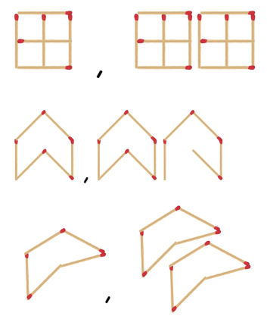
Note: ensure students do not join shapes together in the patterns as this will result in fewer sides and affect the overall rule.
- Students share their geometric pattern.
- Ask students to:
- continue their pattern and use a table to record at least the first 5 terms of the pattern
- describe the pattern in words, such as ‘a new shape is added for each term’
- calculate the tenth, fifteenth, twentieth, fiftieth and hundredth term
- describe the rule, for example ‘to work out the number of sides, I need to multiply the number of shapes by 3’.
- Using Resource 4 – blank tables, observe, record and continue other student patterns in a table.
Multi-age: students working towards Stage 2 outcomes use triangles, then compare them to hexagons to demonstrate doubling and the link between multiplying by 3 and 6. This can also be done with squares and octagons to demonstrate doubling and the link between multiplying by 4 and 8. Stage 2 students can choose to record their patterns using a method of their choice.
This table details opportunities for differentiation.
Too hard? | Too easy?
Students cannot describe a pattern formed by multiples.  - Students create growing patterns using shape blocks. Support students to count and record the number of shapes and sides in each term in a table.  - Students use patterns of 2 with a prompt. For example, an insect has 2 times as many legs as wings. Ask how many legs there might be if the insect has 2 wings. Guide students to record a table showing a growing pattern of legs and wings. | Students can describe a pattern formed by multiples.  - Create an input/output function machine to test their partners in determining the pattern rule. Students experiment using more than one operation, such as 2 × n + 1.  - Students change their pattern design so that for new terms, additional shapes share at least one side with existing shapes. Students record the results in the table and investigate what happens to the multiplicative relationship.

Discuss and connect the mathematics – 15 minutes
- Refer to the resources used in the lesson and ask:
- How can looking for patterns help?
- How can determining a rule for a pattern help?
- How did you record your thinking? Why? (Stage 2)
- Did using a table of values help? How? (Stage 3)
- How does using multiplication help when calculating large, unknown quantities?
This table details opportunities for assessment.
Assessment opportunities | Links
What to look for:  - Can Stage 2 students model, describe and record patterns of multiples? [MAO-WM-01, MA2-MR-01]  - Can Stage 2 students create and continue a variety of number patterns that increase or decrease by a constant amount? [MAO-WM-01, MA2-MR-01]  - Can Stage 3 students use a given geometric pattern involving multiples to create a table of values? [MAO-WM-01, MA3-MR-01]  - Can Stage 3 students describe a pattern formed by multiples in words, in terms of multiplication rather than addition? [MAO-WM-01, MA3-MR-01]  - Can Stage 3 students determine a rule describing the relationship between the bottom number and the top number in a table? [MAO-WM-01, MA3-MR-01] | Links to National Numeracy Learning Progressions (NNLP):  - Stage 2 – NPA3, NPA4  - Stage 3 – NPA4, NPA5.  Links to suggested Interview for Student Reasoning (IfSR) tasks:  - Stage 2 – IfSR-NP: 4A.1, 4A.2, 4A.3.

Lesson 2
Core concept: known number facts and strategies support multiplicative understanding.

Daily number sense – arrays game – 10 minutes
The table below contains suggested learning intentions and success criteria. These are best co-constructed with students.
Daily number sense learning intentions | Daily number sense success criteria
Students working towards Stage 2 outcomes are learning to:  - use known number facts and strategies.  Students working towards Stage 3 outcomes are learning to:  - determine products and factors. | Students working towards Stage 2 outcomes can:  - apply the known strategy of doubling to connect multiples of 3 to 6 and 4 to 8  - use known facts to find unknown multiples.  Students working towards Stage 3 outcomes can:  - use the term product to describe the result of multiplying 2 or more numbers  - model different ways to show a whole number as a product.
This activity is an adaptation of ‘Arrays game’ by Dr Paul Swan.
- This can be played between students in pairs, or by dividing the class into 2 teams.
- Display a grid. Students share a piece of grid paper if they are playing the game in pairs. Explain that the aim of the game is to capture the greatest area of the grid.
- To play the game, Player 1:
- Rolls a 6-sided and a 10-sided dice.
- Uses the 2 numbers rolled to create an array on the grid using a colour to shade the inside of the rectangle and writing the calculation inside the array. Students can use mental strategies and mini whiteboards to calculate the answer. Explain that the answer is called the product.
- Player 2 takes their turn and uses a different colour to shade. Encourage students to use known facts and doubling strategies to determine the answer.
- The winner is the team or player who captures the greatest area in a set time.
Multi-age: students working towards Stage 3 outcomes multiply the numbers rolled and create an array using any 2 factors of the product.
This table details opportunities for assessment.
Assessment opportunities | Links
What to look for:  - Can Stage 2 students apply the known strategy of doubling to connect multiples of 3 to 6 and 4 to 8? [MAO-WM-01, MA2-MR-01]  - Can Stage 2 students use known facts to find unknown multiples? [MAO-WM-01, MA2-MR-01]  - Can Stage 3 students use the term product to describe the result of multiplying 2 or more numbers? [MAO-WM-01, MA3-MR-01]  - Can Stage 3 students model different ways to show a whole number as a product? [MAO-WM-01, MA3-MR-01] | Links to National Numeracy Learning Progressions (NNLP):  - Stage 2 – MuS6  - Stage 3 – MuS6.

Core lesson – 45 minutes

Stage 2 task – strategies for 9s
The table below contains a suggested learning intention and success criteria. These are best co-constructed with students.
Core concept learning intentions | Core concept success criteria
Students working towards Stage 2 outcomes are learning to:  - use known number facts and strategies for multiplication. | Students working towards Stage 2 outcomes can:  - use multiplication facts with multiples of 10 to multiply a one-digit number by a multiple of 10  - use place value to rename groups of 10 for multiplication  - recognise the relationship between one multiple and its double  - apply the known strategy of doubling to connect multiples of 3 to 6 and 4 to 8  - use known facts to find unknown multiples, including 9 × facts.
This activity is an adaptation of ‘Imagining dots (arrays)’ from Math Fact Fluency: 60+ Games and Assessment Tools to Support Learning and Retention by Kling and Bay-Williams.
- Show students Resource 5 – an array. Ask:
- What do you see?
- How can you calculate the total?
- Annotate the array to show student ideas. For example, see Figure 2.
Figure 2 – calculating the total
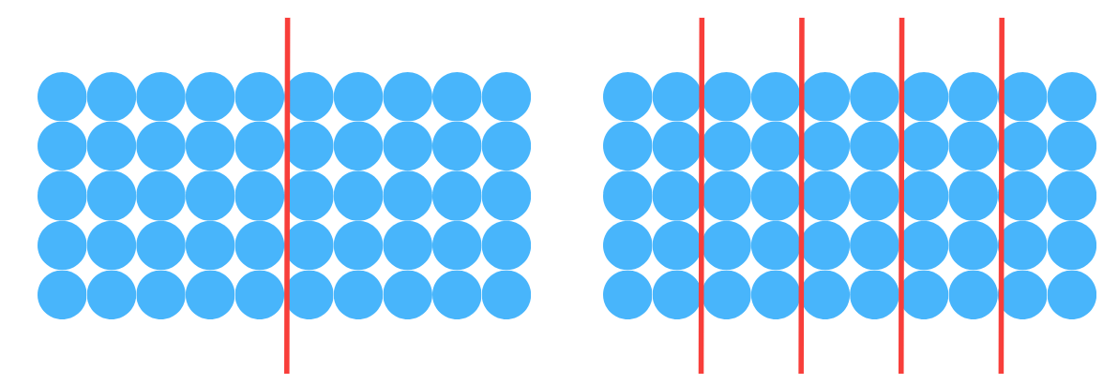
- Show students Resource 6 – an array 2. Ask:
- What do you see?
- How can you work it out?
- What strategies could you use if you do not know your 9 times tables?
- Annotate the array to show different student ideas. For example, see Figure 3
Figure 3 – calculating the total example 2
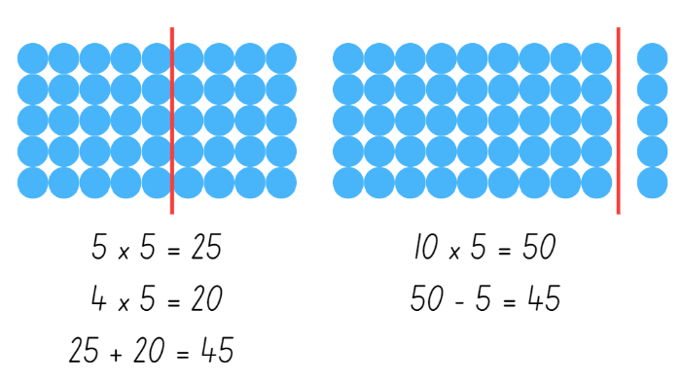
- Provide students with Resource 7 – arrays of 9. Ask students to calculate these nines problems in at least 2 ways: 5 × 9, 7 × 9 and 9 × 9.
This table details opportunities for differentiation.
Too hard? | Too easy?
Students cannot use known facts to find unknown multiples.  - Provide students with fact families for multiples of 10. Support students by adding counters to make an array showing tens, then model taking away one group to determine the total of nines.  - Provide students with 10 ten-frames. Place 9 counters in a frame to establish that 9 is one less than 10. Repeat for various multiples of 9. | Students can use known facts to find unknown multiples.  - Students write down the multiplication facts for multiplying by 9. Ask what patterns they notice and why that pattern appears.  - Show students the 9 times table finger trick (0:33). Ask why this trick works and whether a trick like this could work for other numbers.  - Students investigate questions, such as 23 × 99. Ask what makes these numbers easy to work with and what numbers students could apply this strategy to.

Stage 3 task – applying strategies
The table below contains suggested learning intentions and success criteria. These are best co-constructed with students.
Core concept learning intentions | Core concept success criteria
Students working towards Stage 3 outcomes are learning to:  - select and apply mental and written strategies to multiply 2- and 3-digit numbers by 2-digit numbers  - use partitioning and place value to multiply 2-, 3- and 4-digit numbers by one-digit numbers  - apply place value to partition, regroup and rename numbers to one billion  - apply efficient mental and written strategies to solve addition and subtraction problems. | Students working towards Stage 3 outcomes can:  - use a multiplication algorithm with understanding  - use the distributive property with the area model to partition numbers in representing multiplication problems  - regroup numbers in different forms  - use place value to add or subtract 3 or more numbers with different numbers of digits.
- Display Resource 8 – think board 1. Ask:
- What do you notice?
- What might the word problem be?
- What strategies do you see?
- Which strategy is the most effective?
- Are there strategies or ways of working out the question that aren’t on the think board?
- Revise the use of the area model to support multiplication. Ask students:
- How might you partition these numbers to solve the problem using an area model?
- What is the most effective way of partitioning numbers when trying to solve a multiplication problem?
- When might you partition numbers in a non-standard form? (For example, 400 × 8 + 75 × 8)
- What other mathematical operations are used when solving a multiplication problem using the area model?
- If you use an algorithm to add numbers together, what considerations do you need to make about the place value of the numbers? (For example, line up the digits in the place value)
- Display Resource 9 – think board 2 and ask:
- What strategy is displayed?
- How else could this problem be solved?
- What is the most efficient strategy?
- What is similar about this problem to the first think board? What is different about this think board?
- Revise the use of the distributive property with partial products by multiplying the hundreds, then the tens and then the ones.
- Provide students with a range of multiplication problems, including examples of problems which require more than one step. Some examples are:
- A factory produces 385 cartons of biscuits a day. How many cartons does it produce over 5 days?
- A shop sells game consoles for $638. How much money would it cost to buy 4?
- Apples are cut into 8 slices to be put onto a fruit platter. The kitchen has 12 crates of apples. If each crate has 90 apples, how many slices will there be altogether?
- It is peak hour on the train. Each carriage has 15 compartments, and each compartment has 6 people in it. If the train is made up of 25 carriages, how many people are there altogether?
- Students create a think board to represent at least 2 different ways that each problem could be solved.
This table details opportunities for differentiation.
Too hard? | Too easy?
Students cannot use informal written strategies such as the area model to solve multiplication and division problems.  - Students use MAB materials to support their calculations.  - Students draw and label a diagram to represent the word problem. Model how to write equations that match the diagram. Support students to apply known facts and properties to solve parts of the problem. | Students can use informal written strategies such as the area model to solve multiplication and division problems.  - Students create their own problems on a think board for other students to solve. They can design problems that require more than one step and operation to solve.  - Students create a video as a learning tool to revise some of the strategies used in multiplying 2-, 3- and 4-digit numbers by one-digit numbers.
- Explain that algorithms are a very useful tool for mathematicians in some situations. It is important to use them with understanding.
- Split the class into pairs and provide each pair with a copy of Resource 10 – algorithm errors. Alternatively, provide pairs with individual algorithms.
- Explain that these algorithms all have an error. Students find the error in each algorithm, explain the error and prove they are correct by writing the correct algorithm with the solution. Errors are identified in Figure 4.
Figure 4 – algorithm errors
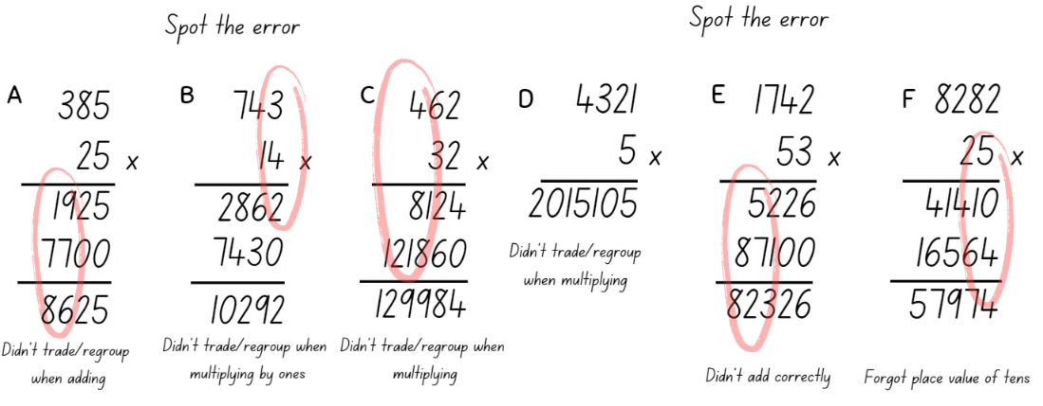
- Share student responses with the class and discuss the errors made in each algorithm.
- Record errors in an anchor chart to refer to as common errors.
This table details opportunities for differentiation.
Too hard? | Too easy?
Students cannot use efficient strategies to multiply whole numbers of up to 4 digits by one- and 2-digit numbers.  - Support students by working with numbers that suit their level of understanding. Represent them by drawing regions on grid paper to show place value, such as example A in Figure 5.  - Support students to partition larger numbers, using MAB materials to model place value. | Students can use efficient strategies to multiply whole numbers of up to 4 digits by one- and 2-digit numbers.  - Students make a short video or poster explaining their thinking, such as why a strategy suits certain situations.  - In pairs, students solve the unusual algorithm in Figure 5, explaining their reasoning.  - Students create their own unusual algorithm for another student to solve.
Figure 5 – differentiation
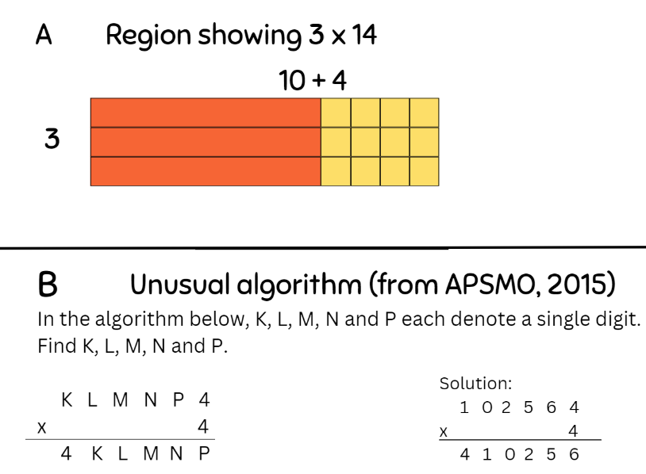

Discuss and connect the mathematics – 10 minutes
- Ask Stage 2 students how they could use what they have learned to help them solve multiplication problems. Provide a copy of Resource 11 – multiplication chart. Ask students to colour code the number facts that appear in both 5 ×,10 × and 9 × facts and describe strategies to record, such as:
- I know 10 × multiplication facts because multiplying by 10 shifts the numbers to the left in the place value column.
- If I know 10 × multiplication facts, I can halve it to find 5 ×.
- If I know 10 × multiplication facts, I can take away one group to find 9 × facts.
- Ask Stage 3 students:
- What benefits and limitations do algorithms have?
- Why don’t people just use a calculator to work things out?
- What are the benefits of mental strategies?
- What are some situations in real life where these different strategies could help us?
This table details opportunities for assessment.
Assessment opportunities | Links
What to look for:  - Can Stage 2 students use multiplication facts with multiples of 10 to multiply a one-digit number by a multiple of 10? [MAO-WM-01, MA2-MR-01]  - Can Stage 2 students use place value to rename groups of 10 for multiplication? [MAO-WM-01, MA2-MR-01]  - Can Stage 2 students recognise the relationship between one multiple and its double? [MAO-WM-01, MA2-MR-01]  - Can Stage 2 students apply the known strategy of doubling to connect multiples of 3 to 6 and 4 to 8? [MAO-WM-01, MA2-MR-01]  - Can Stage 2 students use known facts to find unknown multiples, including 9 × facts? [MAO-WM-01, MA2-MR-01]  - Can Stage 3 students use a multiplication algorithm with understanding? [MAO-WM-01, MA3-MR-01]  - Can Stage 3 students use the distributive property with the area model to partition numbers in representing multiplication problems? [MAO-WM-01, MA3-MR-01]  - Can Stage 3 students regroup numbers in different forms? [MAO-WM-01, MA3-RN-01]  - Can Stage 3 students use place value to add or subtract 3 or more numbers with different numbers of digits? [MAO-WM-01, MA3-AR-01] | Links to National Numeracy Learning Progressions (NNLP):  - Stage 2 – MuS6  - Stage 3 – MuS6, MuS7. MuS8.  Links to suggested Interview for Student Reasoning (IfSR) tasks:  - Stage 3 – IfSR-MT: 3A.1, 3A.2, 3A.3  - Stage 3 – IfSR-AT: 3A.5.

Lesson 3
Core concept: the associative property can be used to solve multiplication problems (Stage 2) and the order of operations is important when solving problems (Stage 3).

Daily number sense – 10, 100 and 1000 times bigger – 10 minutes
The table below contains suggested learning intentions and success criteria. These are best co-constructed with students.
Daily number sense learning intentions | Daily number sense success criteria
Students working towards Stage 2 outcomes are learning to:  - recognise and represent numbers that are made of tens, hundreds and thousands.  Students working towards Stage 3 outcomes are learning to:  - recognise 1000 thousands is 1 million and 1000 millions is 1 billion. | All students are learning to:  - describe how making a number 10, 100 or 1000 times as large changes the place value of digits.  Students working towards Stage 2 outcomes are learning to:  - recognise and record the number of tens, hundreds, or thousands in a number.  Students working towards Stage 3 outcomes are learning to:  - recognise and record the number of tens, hundreds, or thousands in a number.
- Provide stage-based pairs of students three 9-sided dice and an individual whiteboard.
- Ask Stage 3 students to draw the whole place value chart and Stage 2 students to draw up to and including the thousands columns (see Figure 6).
Figure 6 – place value chart
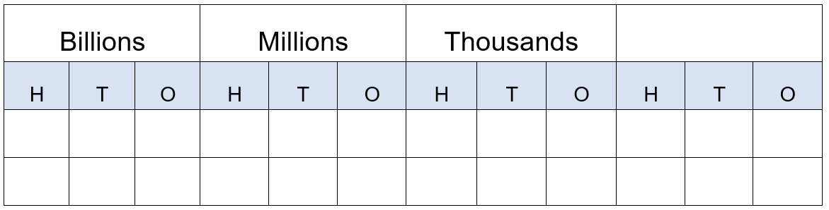
- Students roll the dice and arrange the dice to form the smallest number possible. For example, rolling a 5, 1 and 9, the dice could be arranged to form the number 159.
- Stage 2 students record the number that is 10 times larger and Stage 3 students record the number that is 1000 times larger.
- On the second roll of the dice, students form the largest number possible. Stage 2 students record the number that is 100 times larger and Stage 3 students record the number that is 10 000 times larger.
- On the third roll of the dice, students form any number. Stage 2 students record the number that is 1000 times larger and Stage 3 students record the number that is 100 000 times larger.
- Repeat this 3 times so that Stage 2 students can practice numbers 10, 100 and 1000 times larger.
Note: Stage 3 students need to recognise the relationship that 1000 thousands is 1 million and 1000 millions is 1 billion.
- Vary the task by asking students to select specific numbers, such as those that have an even hundreds digit, or an odd unit digit, or a number with even thousands and tens digits.
This table details opportunities for assessment.
Assessment opportunities | Links
What to look for:  - Can Stage 2 students identify and record the ones, tens, hundreds and thousands in a number? [MAO-WM-01, MA2-RN-01]  - Can Stage 2 students describe how making a number 10, 100 or 1000 times as large changes the place value of digits? [MAO-WM-01, MA2-RN-01]  - Can Stage 3 students name millions using the place value groupings of ones, tens and hundreds? [MAO-WM-01, MA3-RN-01]  - Can Stage 3 students recognise 1000 thousands is 1 million and 1000 millions is 1 billion? [MAO-WM-01, MA3-RN-01] | Links to National Numeracy Learning Progressions (NNLP):  - Stage 2 – NPV4, NPV5, NPV6  - Stage 3 – NPV7, NPV9.

Core lesson – 40 minutes

Stage 2 task – associative property
The table below contains a suggested learning intention and success criteria. These are best co-constructed with students.
Core concept learning intentions | Core concept success criteria
Students working towards Stage 2 outcomes are learning to:  - use number properties to find related multiplication facts. | Students working towards Stage 2 outcomes can:  - use the associative property within multiplication to regroup the factors  - use flexible partitioning within multiplication.
This lesson is adapted from Primary and Middle Years Mathematics: Teaching Developmentally by Van de Walle et al. The purpose of the opening questions is to engage students in reasoning and justifying their choices.
- Offer one of the following scenarios to the students:
- Would you rather start a long-distance race by running fast or slow?
- Would you rather swim 50 m using only your hands or only your feet?
- Students turn and talk to develop their reasoning.
- Select students to share their views and reasoning. Explain that they will be sharing which strategies they would use to solve a problem.
- Pose the tennis ball problem: Each tennis ball costs $2 and there are 3 tennis balls in each can. Ask how much it would cost for 6 cans.
- Guide students to consider the problem in 2 ways (see Figure 7):
- Find out the cost for each can and then the total cost: 6 × (3 × 2)
- Find out how many balls there are in total and then the cost: (6 × 3) × 2.
Figure 7 – tennis ball problem
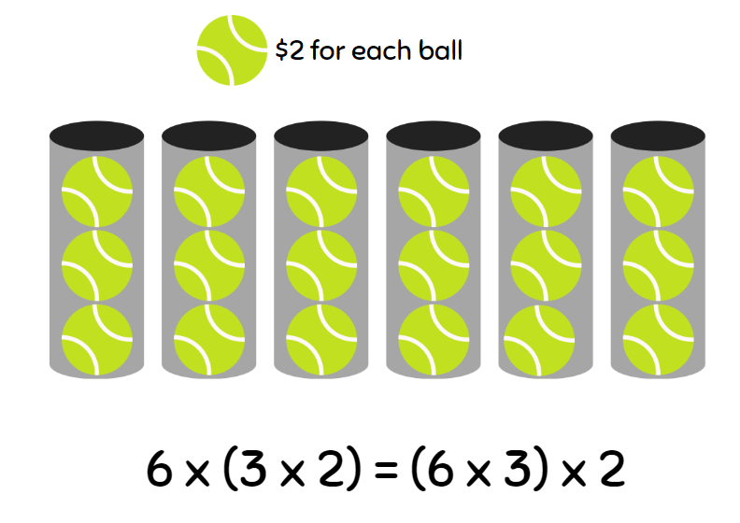
Note: students may use grouping symbols to indicate which part of the number sentence is completed first. This style of grouping symbols (…) are called parentheses in the Mathematics K–10 Syllabus teaching advice.
- Ask students which method they would rather use and why.
- Explain that being able to change the order of multiplication is called the associative property or associative law. Share the definition.
Associative property: when more than 2 numbers are added or multiplied, the result is unchanged regardless of how they are grouped or associated. For example, 6 × 3 × 2 can be calculated as 18 × 2 or 6 × 6 or 12 × 3.
- Draw Figure 8 on the board.
Figure 8 – would you rather?
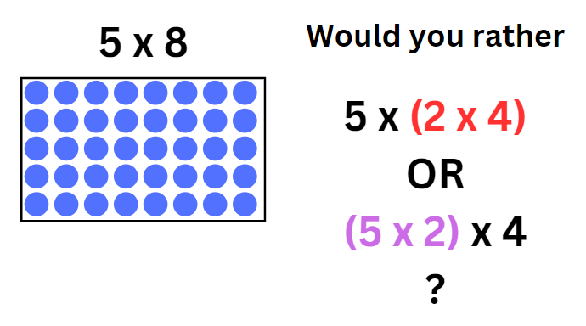
- Explain that the array represents 5 × 8 and can be rewritten as 5 × 2 × 4.
- Ask if students would rather complete 2 × 4 and then multiply by 5, or 5 × 2 and then multiply by 4.
- Distribute Resource 12 – gameboard, Resource 13 – recording sheet and counters to pairs of students.
- Read the activity instructions with the students and share an example (see Figure 9).
Figure 9 – gameboard example
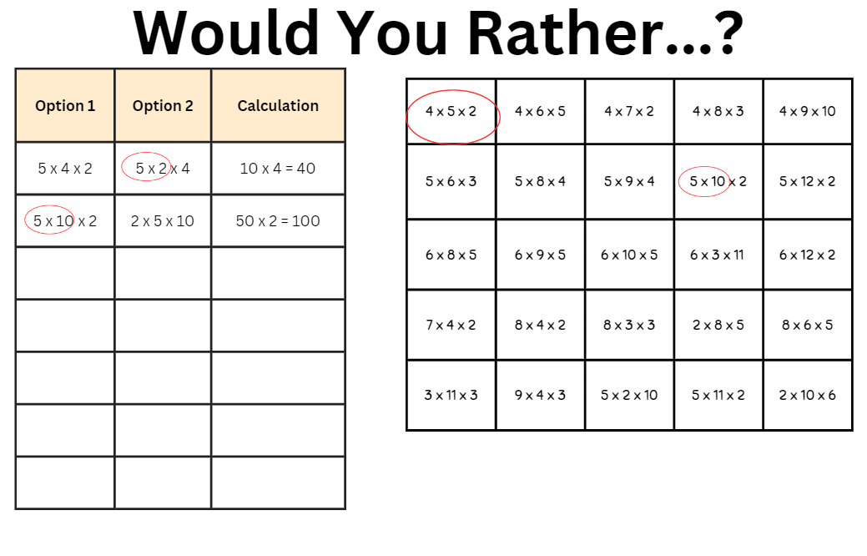
- In pairs, students play ‘Would you rather?’
This table details opportunities for differentiation.
Too hard? | Too easy?
Stage 2 students cannot use the associative property within multiplication to regroup factors.  - Provide students with number sentences and guide them to choose 2 numbers that can be multiplied easily.  - Students rewrite gameboard facts using the commutative property, such as 4 × 5 = 5 × 4, and ask what sentence they would rather solve. | Stage 2 students can use the associative property within multiplication to regroup factors.  - Students roll dice to create more challenging numbers to factorise, such as 14 × 5 becomes 7 × (2 × 5).  - Students create word problems using a number sentence and the associative property.

Stage 3 task – grouping symbols matter
The table below contains suggested learning intentions and success criteria. These are best co-constructed with students.
Core concept learning intentions | Core concept success criteria
Students working towards Stage 3 outcomes are learning to:  - explore the use of brackets and the order of operations to write number sentences  - apply efficient mental and written strategies to solve addition and subtraction problems. | Students working towards Stage 3 outcomes can:  - use grouping symbols ‘()’ in equations to indicate operations that must be performed first  - investigate the order of operations using real-life contexts  - solve word problems, including multistep problems.
This lesson is an adaptation of ‘Brackets Matter’ from Challenging Mathematical Tasks: Unlocking the potential of all students by Sullivan.
- Pose the problem: I want to calculate the answer to 4 + 5 × 8. If I press the buttons on my phone’s calculator in that order (without pressing ‘=’ until the end), the answer comes up as 44. Why does the calculator get that answer?
- Discuss the reasons with the class, identifying:
- the need to agree on the order in which to perform the operations.
- that to reduce the risk of misunderstanding an arithmetical expression or number sentence there is an agreed convention, or rule. This convention is known as the order of operations.
- that all multiplication and division operations are completed by working left to right, before adding and subtracting. To change this order or to make the order clear, grouping symbols are used to indicate what to do first.
Note: mnemonics like BOMDAS, BIDMAS or PEMDAS can be misleading as they suggest an absolute order between addition (A) and subtraction (S) or multiplication (M) and division (D).
- Write the expression 3 + 4 × 8 − 6 ÷ 2 on the board. Using individual whiteboards, students place a single pair of grouping symbols to make as many different answers as they can.
- Discuss student responses and how grouping symbols change the order of operations, such as the examples in Figure 10.
- Enabling prompt: What do you think the answer is to 4 + 2 × 3? Is it 10 or 18?
- Extending prompt: Have you found all the possible answers?
Figure 10 – possible student solutions
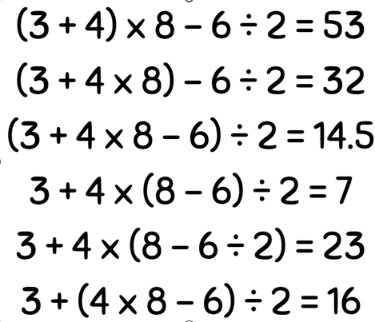
- Identify that grouping symbols allow addition and subtraction to be completed before multiplication and division. Ask students:
- What might be some real-world situations where addition or subtraction are performed before multiplication or division?
- How might we represent these as number sentences?
- Use the example: Ice blocks come in variety boxes that contain 4 raspberry flavour, 6 lemon lime flavour and 5 orange flavour. Juno buys 6 variety boxes. Ask how many ice blocks she has in total. (4 + 6 + 5) × 6 = 90.
- Ask students why it is important that the addition is completed first. Discuss students’ reasoning.
- Provide students with Resource 14 – match the problem.
Note: the word problems involve the same numbers combined using different operations. This is to prevent students from guessing, by simply matching numbers from the word problem instead of thinking about the operations required.
- Students work in small groups to match the number sentences to the word problems.
- Students explain, verbally or in writing, how each component of the number sentence matches the related word problem.
This table details opportunities for differentiation.
Too hard? | Too easy?
Stage 3 students cannot use grouping symbols ‘()’ in number sentences and solve problems involving grouping symbols.  - Support students to read the problem and identify the order they want to solve the operations. Help them write a number sentence that matches one of the possible solutions.  - Investigate simpler expressions such as 8 – 2 × 3. | Stage 3 students can use grouping symbols ‘()’ in number sentences and solve problems involving grouping symbols.  - Students add 2 pairs of grouping symbols to make as many different answers as possible to 1000 – 20 ÷ 10 + 300 × 2.  - Students write their own word problems using real-life examples for other students to solve.  - Students investigate 260 – 10 ÷ 10 × 5 and see how much they can make the expression larger or smaller by only adding grouping symbols. This activity is an adaptation of ‘Parentheses are powerful’ from Parentheses: How big of a change can they make!? by Byrdseed.TV.

Discuss and connect the mathematics – 10 minutes
- Summarise the lesson together drawing out key mathematical ideas. Ask students:
- What strategies did you use when solving the number/word sentences?
- Why might different people have different strategies to solve problems?
- Why are grouping symbols important for mathematicians?
- Is it necessary to use grouping symbols to show 4 + (5 × 5) = 29? Why or why not? (Stage 3)
This table details opportunities for assessment.
Assessment opportunities | Links
What to look for:  - Can Stage 2 students use number properties to find related multiplication facts? [MAO-WM-01, MA2-MR-01]  - Can Stage 2 students use the associative property within multiplication to regroup factors? [MAO-WM-01, MA2-MR-01]  - Can Stage 3 students use grouping symbols ‘()’ in number sentences to indicate operations that must be performed first? [MAO-WM-01, MA3-MR-02]  - Can Stage 3 students investigate the order of operations using real-life contexts? [MAO-WM-01, MA3-MR-02]  - Can Stage 3 students solve word problems, including multistep problems? [MAO-WM-01, MA3-AR-01] | Links to National Numeracy Learning Progressions (NNLP):  - Stage 2 – MuS6, MuS7  - Stage 3 – NPA5.  Links to suggested Interview for Student Reasoning (IfSR) tasks:  - Stage 2 – IfSR-MT: 2A.7.

Lesson 4
Core concept: array structures and understanding equivalence supports multiplicative thinking.

Daily number sense – 10 minutes
- From a class need surfaced through formative assessment data, identify a short, focused activity that targets students’ knowledge, understanding and skills. Example activities may be drawn from the following resources:
- Mathematics K–6 resources
- Universal Resources Hub.

Core lesson – splats – 30 minutes
The table below contains suggested learning intentions and success criteria. These are best co-constructed with students.
Core concept learning intentions | Core concept success criteria
Students working towards Stage 2 outcomes are learning to:  - find the total of a partially covered array  - use number sentences to find missing numbers.  Students working towards Stage 3 outcomes are learning to:  - use equivalent number sentences involving multiplication and division to find unknown quantities  - multiply and divide decimals by powers of 10. | Students working towards Stage 2 outcomes can:  - calculate the number of dots in an array  - use number sentences to calculate missing numbers.  Students working towards Stage 3 outcomes can:  - complete number sentences that involve more than one operation by calculating missing numbers  - use mental strategies to multiply benchmark decimals by single-digit numbers.
This activity is an adaptation of Splat! from Steve Wyborney's Blog: I'm on a Learning Mission by Wyborney.
- Show Resource 15 – balance the scales. Discuss the following questions with students:
- What might the missing numbers be?
- How do you know?
- Stage 3 students consider what other equations could balance the scale if the addition sign wasn’t there.
- Stage 3 students consider what multiplication sentences using decimals or division sentences would balance the scale? (Examples include 0.2 × 100, 0.02 × 1000, 200 ÷ 10, 2000 ÷ 100)
- How can we represent what is shown in the image with just an equation?
- What is the purpose of the = sign? Remind students that the = sign records equivalence and it means ‘the same as’.
- Display Resource 16 – splats. Ask Stage 2 students to view the left image and Stage 3 students to consider the right image.
Note: guide Stage 2 students to consider multiplication strategies to identify the total number of cubes in the array. Stage 3 students are provided the total number of cubes and consider the equations to represent the problem.
- Discuss the following questions with Stage 2 students:
- How could you find the total number of cubes in the array?
- Is there another strategy to count the cubes in this array?
- How can we find out the number of cubes underneath the splat?
- What fact family that represents this array?
- How could you represent this with a number sentence?
- Record Stage 2 student ideas as fact families and number sentences, and capture student reasoning when discussing the number of visible cubes compared to the number of covered cubes.
- Discuss the following questions with Stage 3 students:
- If there are 24 cubes on each image, how many cubes are under the splats?
- How could you represent this with an equation?
- How can you represent the unknown value in an equation?
- What strategies can you use to determine how many cubes are under the splat?
- What mathematical operations do you need to solve the problem?
- Do any of the equations written need grouping symbols?
- Record Stage 3 student ideas as equation, such as 24 = 9 + 5 × ? Capture student responses and reasoning. Reinforce when grouping symbols are helpful or needed to make the order of operations clear.
- Ask what strategies students could use if some of the cubes were halved. Share student responses.
- Ask students how these responses could be recorded in an equation using decimals. Share student responses. An example could be all the hidden cubes are halves and are equally shared under each splat so there are 6 halves under each splat. This could be written as 24 = 9 + 5 × (6 × 0.5).
- Ask students how the equation would change if the cubes had been cut into quarters instead of halves. 24 = 9 + 5 × (12 × 0.25).
- Provide students with Resource 17 – student splats to determine the missing numbers. Give Stage 2 students the partially covered arrays and Stage 3 students the non-array images.
- Stage 2 students find the total number of the partially covered array and the number of cubes underneath the splat.
- Stage 2 students record a fact family for the array, and number sentences that describe how they calculated the number of cubes in the array and the missing number of cubes under the splat. For example, 4 × 6 = 24 and then 24 − 16 = 8.
Note: there are a number of strategies that Stage 2 students may use to calculate the number of cubes under the splat, which may influence how they create a number sentence. Some students may, for example, compare the covered and uncovered cubes in each row or column to calculate the covered cubes without subtracting a number from the total number of cubes.
- Stage 3 students record their missing value equations and describe their reasoning.
This table details opportunities for differentiation.
Too hard? | Too easy?
Students cannot use the array structure to determine the total number of cubes or the unknown number.  - Use concrete materials to model the array structure.  - Use concrete materials to show the known and unknown numbers and model the respective number sentence.  Students cannot complete number sentences that involve more than one operation by calculating missing numbers.  - Support students with concrete materials, such as counters to model the different operations required to determine the missing values.  - Students explore equivalence with an interactive manipulative. Students write equivalent number sentences.  - Model a correct equation with 2 operations, such as 19 = 4 + 3 × 5. Guide students to change one element to change the equation, such as 4 + 5 + 2 × 5 = 19. Invite the student to make their own. | Students can use the array structure to determine the total number of cubes and the unknown number.  - Students create their own arrays of up to 10 rows or columns, with covered sections, for a partner to solve.  - Students write fact families for their own arrays.  Students can complete number sentences that involve more than one operation by calculating missing numbers.  - Provide student with Resource 18 – open ended splats. Ask students what the total could be and to record their reasoning in equations.  - Have students create their own splats for classmates to solve. Challenge students to create splats where there are multiple operations.

Discuss and connect the mathematics – 10 minutes
- Discuss with Stage 2 students their strategies to use the rows and columns to count the number of cubes in the array and then find out how many cubes are under the splat. Suggested questions include:
- What strategies did you use when counting the total number of cubes in the array?
- What was the most effective strategy to count the covered cubes?
- Which strategies helped you the most? Why?
- Discuss with Stage 3 students their strategies for determining a missing value in equations. Suggested questions include:
- What strategies did you use when calculating the missing value?
- Which operations helped you the most? Why?
- What properties of multiplication helped you with determining the missing value?
- Was grouping symbols necessary (or helpful) in the equations you wrote?
This table details opportunities for assessment.
Assessment opportunities | Links
What to look for:  - Can Stage 2 students calculate the number of cubes in an array? [MAO-WM-01 MA2-MR-01]  - Can Stage 2 students use number sentences to calculate missing numbers? [MAO-WM-01 MA2-MR-02]  - Can Stage 3 students complete number sentences that involve more than one operation by calculating missing numbers? [MA3-MR-02, MAO-WM-01]  - Can Stage 3 students use mental strategies to multiply benchmark decimals by single-digit numbers? [MA3-MR-02, MAO-WM-01]  - Can Stage 3 students choose and apply mathematical techniques to solve problems and communicate their thinking and reasoning coherently and clearly? [MAO-WM-01] | Links to National Numeracy Learning Progressions (NNLP):  - Stage 2 – MuS5, MuS6  - Stage 3 – NPA3, NPA4, MuS7, MuS8, MuS9.  Links to suggested Interview for Student Reasoning (IfSR) tasks:  - Stage 2 – IfSR-MT: 2A.1  - Stage 3 – IfSR-MT: 3A.8, 3A.9.

Lesson 5
Core concept: multiplication and division have an inverse relationship.

Daily number sense – addition race – 15 minutes
Daily number sense activities for Lessons 5 to 7 ‘loop’ back to concepts and procedures covered in previous units to assist students to build an increasingly connected network of ideas. These concepts may differ from the core concepts being covered by the unit.
The table below contains suggested learning intentions and success criteria. These are best co-constructed with students.
Daily number sense learning intentions | Daily number sense success criteria
Students working towards Stage 2 outcomes are learning to:  - select strategies flexibly to solve addition and subtraction problems of up to 3 digits.  Students working towards Stage 3 outcomes are learning to:  - apply known strategies to add and subtract decimals. | Students working towards Stage 2 outcomes can:  - apply known mental strategies that use partitioning to add and subtract, such as bridging the decades.  Students working towards Stage 3 outcomes can:  - model the addition and subtraction of decimals up to 3 decimal places using appropriate representations.
This activity is an adaptation of Race to zero (subtracting tens and ones) from Mathematics K–6 resources and Task 4 – I’ll race you to zero: decimal place value from Flexible additive strategies – Decimals by State of New South Wales (Department of Education). Resources used for this daily number sense will be reused for variations of the game in Lesson 6 and Lesson 7.
- Provide pairs of Stage 2 students with Resource 19 – 119 chart, Resource 20 – 20–70 spinner, 2 counters and a 10-sided die (0–9). Provide pairs of Stage 3 students with Resource 21 – 12 chart, Resource 22 – fraction spinner, 2 counters and a 6-sided die.
- Students place their counters at zero and roll the die to decide who goes first.
- Students take turns to spin the spinner and roll the die. They must decide which to use, adding the amount to their current position. For example, if a Stage 2 student spun 60 and rolled a 7, they can choose to add 60 or to add 7. If a Stage 3 student spun 6 tenths and rolled a 4, they can choose to add 6 tenths or to add 4.
- Students explain where they need to move their counter to their partner, justifying their thinking.
- Students take turns until someone has been able to land exactly on 119 (Stage 2) or 12 (Stage 3).
- Students miss a turn if they cannot move.
This table details opportunities for assessment.
Assessment opportunities | Links
What to look for:  - Can Stage 2 students apply known mental strategies that use partitioning to add and subtract, such as bridging the decades? [MAO-WM-01, MA2-AR-01]  - Can Stage 3 students model the addition and subtraction of decimals up to 3 decimal places using appropriate representations? [MAO-WM-01, MA3-AR-01] | Links to National Numeracy Learning Progressions (NNLP):  - Stage 2 – AdS7  - Stage 3 – AdS9.

Core lesson – linking division to multiplication facts – 35 minutes
The table below contains suggested learning intentions and success criteria. These are best co-constructed with students.
Core concept learning intentions | Core concept success criteria
Students working towards Stage 2 outcomes are learning to:  - use number properties to find related multiplication facts  - represent and solve word problems involving multiplication or division.  Students working towards Stage 3 outcomes are learning to:  - represent and solve division problems with whole number remainders  - use equivalent number sentences involving multiplication and division to find unknown quantities. | Students working towards Stage 2 outcomes can:  - link multiplication and division facts  - generate and recall multiplication fact families up to 10 × 10  - complete number sentences involving multiplication and division by calculating missing numbers.  Students working towards Stage 3 outcomes can:  - use known multiplication fact families to solve division problems for which answers may include a remainder  - use the term quotient to describe the result of a division calculation  - identify and use inverse operations to assist with the solution of number sentences.
- Draw Figure 11 on the board and ask students:
- How could you determine the missing number?
- What multiplication fact families can you use to determine the missing number?
- What do you have to multiply by 3 to get to 15?
- What division number sentences could you write for this image?
Figure 11 – a total of 15
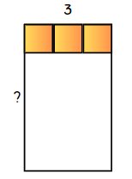
- Draw Figure 12 on the board and ask students:
- What do you remember about the fact family triangles?
- How can you use these facts with multiplication and division?
- What are the correct names for the numbers in the fact families?
Figure 12 – fact family triangle
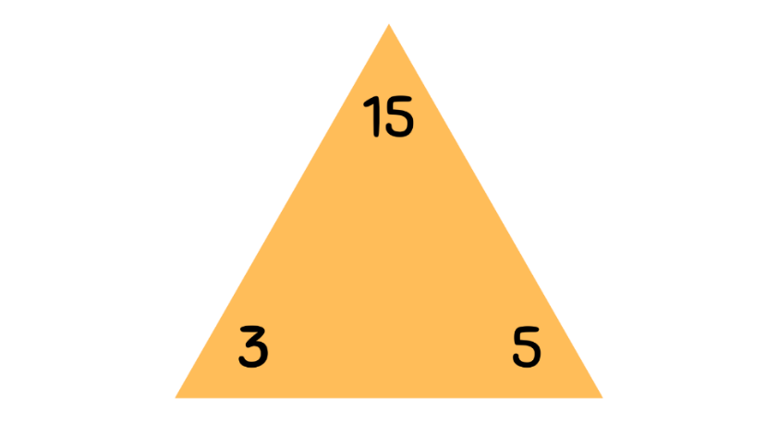
- Remind students that, for multiplication, the 2 bottom numbers are factors and the third number is the product.
Product: the result of multiplying 2 or more numbers together. For example, 12 is the product of 4 × 3.
Factor: a number which divides another number without a remainder. For example, 1, 2, 3 and 6 are factors of 6 but 4 and 5 are not.
- Ask students to write different ways of representing these facts as number sentences using multiplication or division. Anticipated responses include:
- 3 × 5 = 15 and 5 × 3 = 15
- 15 ÷ 3 = 5 and 15 ÷ 5 = 3.
- Display Resource 11 – multiplication chart. Explain that the same fact families are represented on the chart.
- Locate the number facts for 3 × 5 = 15 and 5 × 3 = 15. Explain that the chart can be used in the same way as the fact family triangles for writing 4 number sentences.
- Model for other fact families, as required.
- Remind Stage 3 students that the quotient is the result of a division calculation.
Quotient: the result of dividing one number or algebraic expression by another.
- Explain to Stage 3 that you are thinking of a number that is one more than a multiple of 7. Your friend is thinking of a number that is one more than a multiple of 4. Ask if you both could be thinking of the same number. Students turn and talk to discuss and share their thinking.
- Discuss student reasoning and identify that multiplication facts can be used to solve division problems involving remainders.
- Stage 3 students write a division question which satisfies the problem, identifying the quotient and the multiplication fact used to solve the problem.
Note: for the next activity, students use multiplication facts to write a division number sentence with one value missing. Their partner determines the missing value. Display or provide Resource 11 – multiplication chart for students to refer to. Stage 3 students must write division number sentences with remainders.
- In pairs, students use whiteboards to record a division number sentence with one value missing. Their partner then determines the missing value by writing the associated multiplication number sentence (see Figure 13). The partners then swap roles. Repeat several times to promote fluency.
Figure 13 – missing values examples
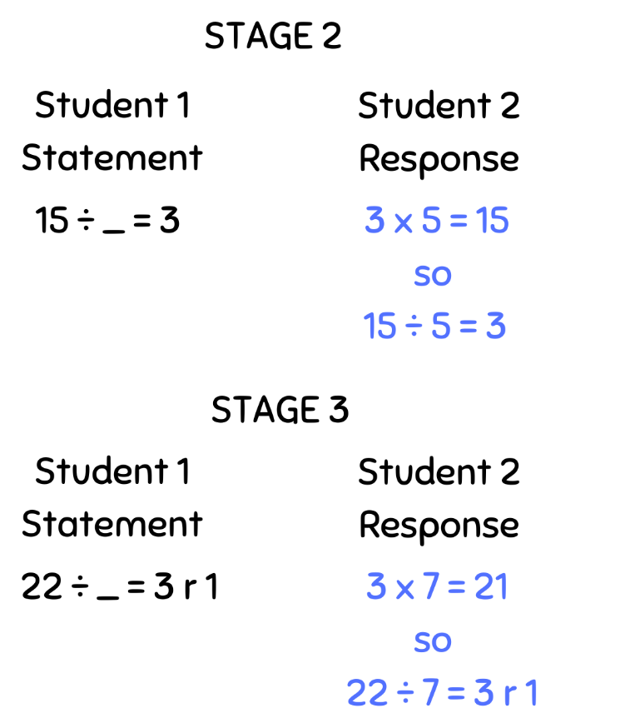
This table details opportunities for differentiation.
Too hard? | Too easy?
Students cannot complete number sentences involving multiplication or division by calculating missing numbers.  - Provide students with a set of multiplication fact families. Students locate and the colour the relevant facts on Resource 11 – multiplication chart.  - Focus on multiplication facts for 2, 4, 5, 10. Support students by providing grid paper to draw a rectangle and represent the equation using the area model or regions. | Students can complete number sentences involving multiplication or division by calculating missing numbers.  - Extend to multiples of other numbers.  - Play the Remainders game from the NRICH website. Students record their guesses and explain their reasoning process.

Discuss and connect the mathematics – 10 minutes
- Summarise the lesson together drawing out key mathematical ideas. Ask students:
- How are multiplication and division related?
- How can this help us? Why is this useful?
- What strategies were most effective when solving multiplication and division problems?
- With Stage 3 students, revise the definition of the quotient as the result of a division calculation.
- Discuss with Stage 3 what the remainders in the division problems might represent. For example, creating equal teams for a competition with people left over. Identify that in some problems the remainders might represent items that cannot be shared.
This table details opportunities for assessment.
Assessment opportunities | Links
What to look for:  - Can Stage 2 students link multiplication and division facts? [MAO-WM-01, MA2-MR-01]  - Can Stage 2 students generate and recall multiplication fact families up to 10 × 10? [MAO-WM-01, MA2-MR-01]  - Can Stage 2 students complete number sentences that involve multiplication and division by calculating missing numbers? [MAO-WM-01, MA2-MR-01, MA2-MR-02]  - Can Stage 3 students use known multiplication fact families to solve division problems for which answers may include a remainder? [MAO-WM-01, MA3-MR-01]  - Can Stage 3 students use the term quotient to describe the result of a division calculation? [MAO-WM-01, MA3-MR-01]  - Can Stage 3 students identify and use inverse operations to assist with the solution of number sentences? [MAO-WM-01, MA3-MR-01] | Links to National Numeracy Learning Progressions (NNLP):  - Stage 2 – MuS6, NPA4  - Stage 3 – MuS6, MuS7, MuS8, NPA3, NPA4.  Links to suggested Interview for Student Reasoning (IfSR) tasks:  - Stage 3 – IfSR-MT: 3A.8, 3A.9, 3A.10.

Lesson 6
Core concept: doubling and halving are powerful strategies (Stage 2) and division can be recorded using fractions (Stage 3).

Daily number sense – subtraction race – 15 minutes
The table below contains suggested learning intentions and success criteria. These are best co-constructed with students.
Daily number sense learning intentions | Daily number sense success criteria
Students working towards Stage 2 outcomes are learning to:  - select strategies flexibly to solve addition and subtraction problems of up to 3 digits.  Students working towards Stage 3 outcomes are learning to:  - apply known strategies to add and subtract decimals. | Students working towards Stage 2 outcomes can:  - apply known mental strategies that use partitioning to add and subtract, such as bridging the decades.  Students working towards Stage 3 outcomes can:  - model the addition and subtraction of decimals up to 3 decimal places using appropriate representations.
This activity is an adaptation of Race to zero (subtracting tens and ones) from Mathematics K–6 resources and Task 4 – I’ll race you to zero: decimal place value from Flexible additive strategies – Decimals by State of New South Wales (Department of Education).
- Provide students with the resources used in Lesson 5 – Daily number sense.
- Stage 2 students place their counters at 119 and Stage 3 students place their counters at 12. Students roll the die to decide who goes first.
- Students take turns to spin the spinner and roll the die. They must decide which to use, subtracting the amount from their current position. For example, if a Stage 2 student spun 60 and rolled a 7, they can choose to subtract 60 or subtract 7. If a Stage 3 student spun 6 tenths and rolled a 4, they can choose to subtract 6 tenths or to subtract 4.
- Students explain where they need to move their counter to their partner, justifying their thinking.
- Students take turns until someone has been able to land exactly on zero.
- Students miss a turn if they cannot move.
This table details opportunities for assessment.
Assessment opportunities | Links
What to look for:  - Can Stage 2 students apply known mental strategies that use partitioning to add and subtract, such as bridging the decades? [MAO-WM-01, MA2-AR-01]  - Can Stage 3 students model the addition and subtraction of decimals up to 3 decimal places using appropriate representations? [MAO-WM-01, MA3-AR-01] | Links to National Numeracy Learning Progressions (NNLP):  - Stage 2 – AdS7  - Stage 3 – AdS9.

Core lesson – 35 minutes

Stage 2 task – repeated halving
The table below contains suggested learning intentions and success criteria. These are best co-constructed with students.
Core concept learning intentions | Core concept success criteria
Students working towards Stage 2 outcomes are learning to:  - apply place value to partition and regroup numbers up to 4 digits  - use known number facts and strategies. | Students working towards Stage 2 outcomes can:  - record numbers using standard place value form  - partition numbers of up to 4 digits in non-standard forms  - apply the known strategy of doubling to connect multiples of 3 to 6 and 4 to 8  - apply the inverse relationship of multiplication and division.
- Provide students with individual whiteboards. Display Resource 23 – array cake. Ask:
- How would you divide this cake if you wanted to share it between 2 people?
- How do you know the cake has been shared equally?
- What strategies can you use to halve the cake?
- How can we represent halves?
- How can you prove this using your multiplication facts?
- What would it look like if we split the cake between 4 people?
- Can this be done with just one knife cut?
- What do you notice about ÷ 2 and ÷ 4? Are they related?
- Model different strategies showing 48 shared between 4, using half then half again (see Figure 14). Emphasise that initial partitions can be varied to make halving easier, such as 40 and 8, which are then halved and halved again (see example C in Figure 14).
Figure 14 – sharing cake
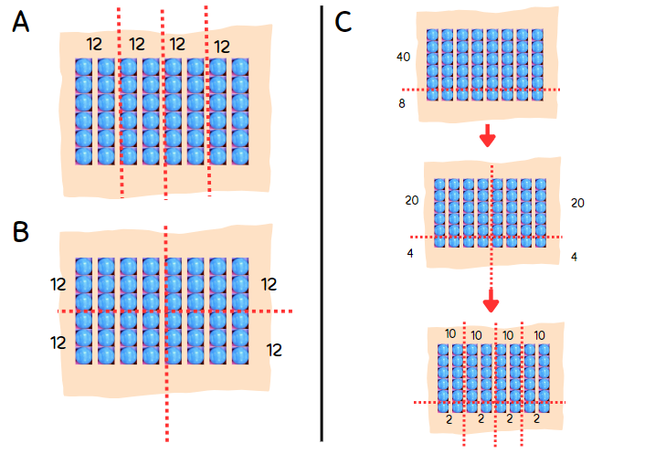
- Ask students to consider how to share 36 between 4. Students turn and talk and share ideas on their individual whiteboards.
- Ask what students could do if they did not know how to halve 36. Model non-standard partitions to make halving easier, as in Figure 15.
Figure 15 – sharing 36
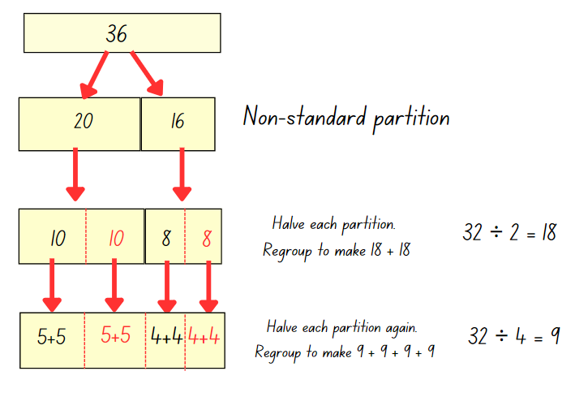
- Explain that students will complete an investigation to answer the following questions:
- What other numbers can you halve and halve again to work out if they can be shared equally into 4 groups?
- Which of these numbers can be halved one more time to be shared equally into 8 groups.
Note: the video for Let's talk – how many ways? (10:25) has a number of examples of student reasoning for how to divide by 4. Depending on the number being divided, this reasoning may be extended to dividing by 8.
- Allow time for students to investigate numbers, drawing regions and arrays for numbers they investigate. Share numbers with the class as students determine numbers divisible by 4 and 8.
- Students share their arrays and regions to prove how many times a number can be halved and which category they fall into. This will create an anchor chart for the class.
This table details opportunities for differentiation.
Too hard? | Too easy?
Stage 2 students cannot apply the strategy of repeated halving.  - Provide students with a starting number such as 16. Support students to make an array, then partition or cut up the array to halve and halve again.  - Identify the multiples of 4 on Resource 11 – multiplication chart. Ask students to make or draw arrays for each number and partition into half and half again. | Stage 2 students can apply the strategy of repeated halving.  - Provide Resource 11 – multiplication chart. Students investigate which numbers can only be halved once; which can be halved twice; which can be halved, halved and halved again and any patterns they notice.  - Students identify a number than can be halved and its related multiples of 10, 100 and 1000. For example, 4, 40, 400 and 4000. Students investigate the effect of multiplying numbers by 10, 100 or 1000 to determine how many more times a number can be halved. Ask students to explain how they can prove their results.
This table details opportunities for assessment.
Assessment opportunities | Links
What to look for:  - Can Stage 2 students record numbers using standard place value form? [MAO-WM-01, MA2-RN-01]  - Can Stage 2 students partition numbers of up to 4 digits in non-standard forms? [MAO-WM-01, MA2-RN-01]  - Can Stage 2 students apply the known strategy of doubling to connect multiples of 3 to 6 and 4 to 8? [MAO-WM-01, MA2-MR-01]  - Can Stage 2 students apply the inverse relationship of multiplication and division? [MAO-WM-01, MA2-MR-02]  - Can Stage 2 students choose and apply mathematical techniques to solve multiplication and division problems, and communicate their thinking and reasoning coherently and clearly? [MAO-WM-01, MA2-MR-01, MA2-MR-02] | Links to National Numeracy Learning Progressions (NNLP):  - Stage 2 – NPV4, NPV5, NPV6, MuS6, MuS7.  Links to suggested Interview for Student Reasoning (IfSR) tasks:  - Stage 2 – IfSR-AT: 3B.2, 3B.4  - Stage 2 – IfSR-MT: 2A.5, 2A.10.

Stage 3 task – sharing
The table below contains a suggested learning intention and success criteria. These are best co-constructed with students.
Core concept learning intention | Core concept success criteria
Students working towards Stage 3 outcomes are learning to:  - use equivalent number sentences involving multiplication and division to find unknown quantities. | Students working towards Stage 3 outcomes can:  - recognise that division can be recorded using fractions  - represent and explain how division can be recorded using fractions.
This activity is an adaptation of ‘Equal sharing’ from Challenging Mathematical Tasks: Unlocking the Potential of All Students by Sullivan.
- Draw a circle to represent a pizza. Explain that Nadia wants to share the pizza with her friend. Ask:
- How much of the pizza do they both get?
- How can we represent this?
- How can we represent this as a fraction?
- How can we express this as a division equation?
- Write student responses around the image of the pizza.
- Explain that the next week, Nadia and her friend decided to order 3 pizzas to share.
- Ask students to express this in different ways using Resource 24 – sharing pizzas, as in Figure 16.
Figure 16 – sharing 3 pizzas
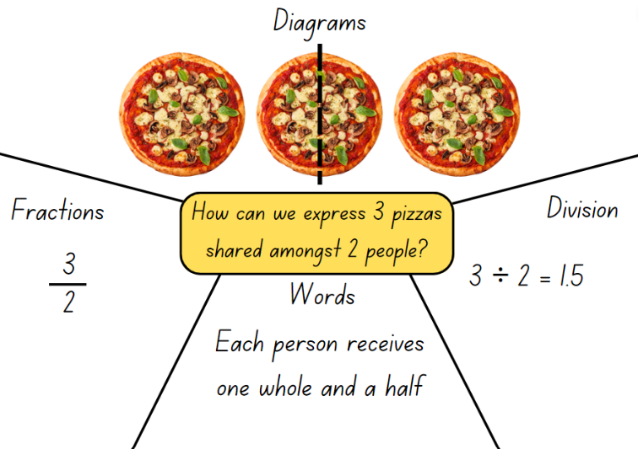
- Ask students to share how 3 halves might be expressed in different ways. Explain that division can be recorded using fractions.
- Provide students with Resource 25 – sharing with friends and explain that 4 friends are given 10 liquorice straps to share. Ask students what fraction of liquorice strap each friend gets.
- Students work in pairs to provide at least two labelled options for sharing 10 liquorice straps equally between 4 children.
- Students solve the following problems from Resource 25 – sharing with friends:
- 3 chocolate bars shared between 5 people
- 3 oranges shared between 4 people.
This table details opportunities for differentiation.
Too hard? | Too easy?
Students cannot represent and explain how division can be recorded using fractions.  - Provide students with materials, such as paper circles and squares, which students can cut up to represent sharing.  - Support students to explain and record how they shared the food between the friends.  - Ask students to solve 4 chocolate bars shared between 8 people Resource 25 – sharing with friends. | Students can represent and explain how division can be recorded using fractions.  - Provide additional questions to students, such as:  - How many people would I have to share it between to get one-sixth each?  - What would happen if I shared it with 8 people?  - What would happen if I shared it with 4 people?  - How many ways can I share 8 pizzas so that everyone gets more than a whole pizza?

Discuss and connect the mathematics – 15 minutes
- Annotate the multiplication anchor chart with the strategy that Stage 2 students have learnt today. For example, when dividing by 2, halve a number once. When dividing by 4, halve and halve again. When dividing by 8, halve and halve and halve again. If a number is tricky to halve, use non-standard partitioning to make the numbers easier to work with.
- Display Resource 11 – multiplication chart and identify where the numbers discovered by the Stage 2 students are located on the chart. Draw attention to the multiples of 2, 4 and 8 and where those multiples intersect. Repeat for multiples of 3 and 6.
- Discuss with Stage 3 students when expressing division as a fraction could be helpful. Ask:
- Can fractions be represented as division equations? How could this be useful?
- How does this knowledge help us with division?
- Provide opportunity to practice writing division equations as fractions and discuss what Stage 3 students notice about the conversion using Resource 26 – division as fractions.
This table details opportunities for assessment.
Assessment opportunities | Links
What to look for:  - Can students recognise that division can be recorded using fractions? [MA3-MR-01, MAO-WM-01]  - Can students represent and explain how division can be recorded using fractions? [MA3-MR-01, MAO-WM-01] | Links to National Numeracy Learning Progressions (NNLP):  - Stage 3 – InF6.

Lesson 7
Core concept: associative and commutative properties can be used to solve multiplication problems (Stage 2) and worded problems can be solved using multiplicative thinking (Stage 3).

Daily number sense – race to the middle – 15 minutes
The table below contains suggested learning intentions and success criteria. These are best co-constructed with students.
Daily number sense learning intentions | Daily number sense success criteria
Students working towards Stage 2 outcomes are learning to:  - select strategies flexibly to solve addition and subtraction problems of up to 3 digits.  Students working towards Stage 3 outcomes are learning to:  - apply known strategies to add and subtract decimals. | Students working towards Stage 2 outcomes can:  - apply known mental strategies that use partitioning to add and subtract, such as bridging the decades.  Students working towards Stage 3 outcomes can:  - model the addition and subtraction of decimals up to 3 decimal places using appropriate representations.
This activity is an adaptation of Race to zero (subtracting tens and ones) from Mathematics K–6 resources and Task 4 – I’ll race you to zero: decimal place value from Flexible additive strategies – Decimals by State of New South Wales (Department of Education).
- Provide students with the resources used in Lesson 5 – Daily number sense.
- The aim of this variation is to stay as close to 60 (Stage 2) and 6 (Stage 3) as possible by selecting amounts to add or subtract.
- Stage 2 students place their counters at 60 and Stage 3 students place their counters at 6. Students roll the die to decide who goes first.
- Students take turns to spin the spinner and roll the die. They must decide which to use, adding or subtracting the amount to their current position.
- Students explain where they need to move their counter to their partner, justifying their thinking.
- The winner is the student closest to 60 (Stage 2) or 6 (Stage 3) after 10 spin/rolls each. Students may have a score that is higher or lower than the target number.
This table details opportunities for assessment.
Assessment opportunities | Links
What to look for:  - Can Stage 2 students apply known mental strategies that use partitioning to add and subtract, such as bridging the decades? [MAO-WM-01, MA2-AR-01]  - Can Stage 3 students model the addition and subtraction of decimals up to 3 decimal places using appropriate representations? [MAO-WM-01, MA3-AR-01] | Links to National Numeracy Learning Progressions (NNLP):  - Stage 2 – AdS7  - Stage 3 – AdS9.

Core lesson – 45 minutes

Stage 2 task – looking for 10s
The table below contains suggested learning intentions and success criteria. These are best co-constructed with students.
Core concept learning intentions | Core concept success criteria
Students working towards Stage 2 outcomes are learning to:  - use number properties to find related multiplication facts  - operate with multiples of 10. | Students working towards Stage 2 outcomes can:  - use the commutative property of multiplication  - apply the commutative and associative properties to multiply by multiples of 10.
Note: it is a common misconception that multiplying by 10 can be done by simply ‘adding a zero’ and multiplying by 100 can be done by ‘adding 2 zeroes’. This approach should be avoided as it detracts from a deeper understanding of place value, multiplicative thinking and the link between them.
- Display and read Resource 27 – problem solving. Ask:
- Where have you seen strategies like these before?
- What properties of multiplication are Phil and Lisa using?
- Which strategy would you use? Why?
- What are some advantages of Lisa’s strategy (doubling)?
- What are some advantages of Phil’s strategy (looking for tens)?
- Remind students of the definitions of associative property and commutative property of multiplication.
Associative property: when more than 2 numbers are added or multiplied, the result is unchanged regardless of how they are grouped or associated. For example, 6 × 3 × 2 can be calculated as 18 × 2 or 6 × 6 or 12 × 3.
Commutative property: two numbers can be added or multiplied in any order and the solution will be the same. Commutative law, commutativity and turn-around facts are interchangeable terms.
- Present the problems 30 × 7 and 21 × 4. Discuss which is most suited to doubling.
- Explain that for 30 × 7, 30 can be broken up into its factors of 3 × 10. This strategy can be called looking for tens.
- Students solve 30 × 7 by applying Phil’s strategy (looking for tens) on an individual whiteboard.
- Present additional ‘looking for tens’ number sentences for guided learning, as needed.
- Write the number sentences in Figure 17 on the board. Students to list the number sentences in their workbooks under the heading of the strategy that they would use, either repeated doubling or looking for tens.
Figure 17 – sort and solve
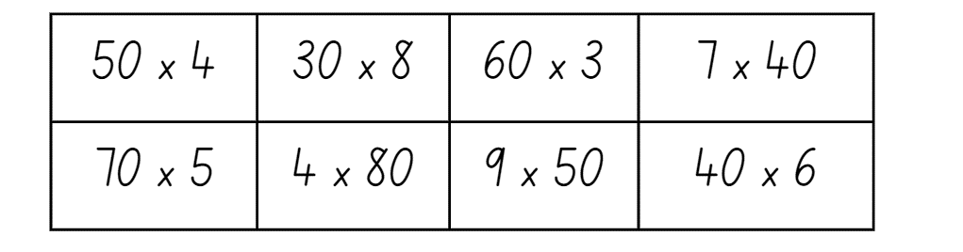
- Students to compare their lists with others’ and share their reasoning.
- Students solve each number sentence using their chosen strategy. Students cross check each other’s answers.
This table details opportunities for differentiation.
Too hard? | Too easy?
Stage 2 students cannot apply the commutative and associative properties to multiply by multiples of 10.  - Support students with a multiplication chart to locate and use number facts.  - Provide base 10 blocks to model questions and focus on renaming, such as 40 × 3 = 4 tens × 3 = 4 × 3 tens. | Stage 2 students can apply the commutative and associative properties to multiply by multiples of 10.  - Students generate larger numbers or experiment with multiplying by 100 or 1000.  - Offer the open-ended problem __ __ × __ = __ __ 0 where the spaces represent a missing digit. Students identify as many solutions as possible.
- Explain that students will play a game where the goal is to make 1000. In this game students will practise multiplying one-digit numbers by multiples of 10.
- The steps for the game are:
- Roll a 10-sided die (1-10) to determine the one-digit number.
- Players choose to multiply that number by 10, 20, 30, 40, 50 or 60.
- Players record the equation and product.
- Repeat the process another 6 times, with players adding the products each time to get a progressive total. For example, see Figure 18.
- The winner is the player whose total is closest to 1000 after 7 rounds.
Figure 18 – make 1000 example
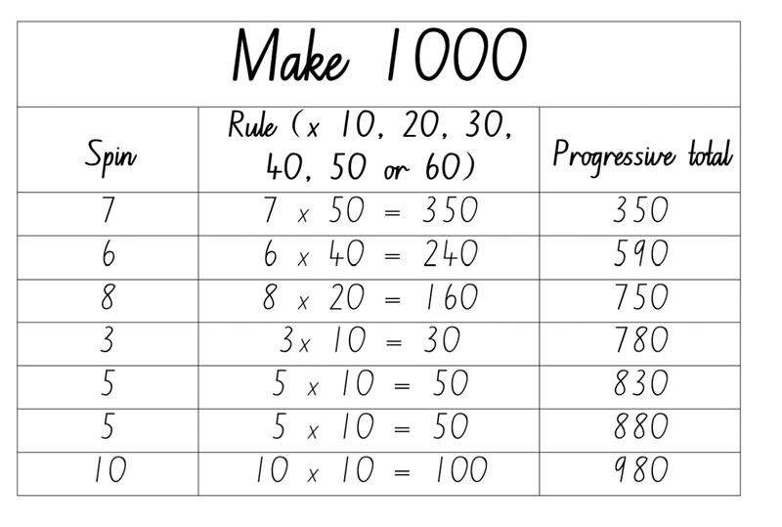
- Model the game with students. Discuss options after each spin, demonstrating strategies to determine the product for each option before deciding which rule to apply. Ensure students understand the progressive total and how to calculate it. After the final total has been determined, discuss decisions made during the game and different strategies that could lead to a total closer to 1000. Remind students that the winner is the player with the total closest to 1000 and explain that sometimes the closest total might be higher than 1000.
- Divide the class into groups and provide students with materials to play the game.

Stage 3 task – multiplication problems
The table below contains a suggested learning intention and success criteria. These are best co-constructed with students.
Core concept learning intentions | Core concept success criteria
Students working towards Stage 3 outcomes are learning to:  - select and apply strategies to solve problems involving multiplication and division with whole numbers. | Students working towards Stage 3 outcomes can:  - select and use efficient strategies to multiply whole numbers of up to 4 digits by one- and 2-digit numbers  - solve word problems involving rates using multiplication and division.
This activity is an adaptation of ‘Rates and ratio’ from Challenging Mathematical Tasks: Unlocking the Potential of All Students by Sullivan. The fuel consumption has an additional complexity in that a higher consumption rate is less efficient. Ensure students understand the words ‘specification’ and ‘efficient’ for this context.
- Share the following problem: The manufacturer’s specifications say that my car has a fuel consumption of 8 L/100 km. When I measured my fuel use carefully, I noticed that my car used 36 L of fuel to travel 400 km.
- Introduce or revise the forward slash symbol / and the necessary language, such as ‘per’ and ‘for each’. Students turn and talk to discuss the problem.
- Ask students:
- Is the car more efficient than the manufacturer’s claim or not?
- How can you record your thinking?
- What mathematical operations did you use to determine the answer to this problem?
- What number properties did you use to help you with this question?
- Possible solutions include:
- convert 36 L/400 km to 9 L/100 km and compare the figures
- convert 8 L/100 km to 32 L/400 km and compare the figures
- convert the units and compare so that 8 L/100 km becomes 1 L/12.5 km and 36 L/400 km becomes 1 L/11.11 km.
- Display Resource 28 – best buy shirts. Students turn and talk to discuss the problem. Ask students:
- How much would it cost to buy 10 pink shirts? 10 blue shirts? 10 green shirts?
- Which is the best value? How do you know?
- How can you represent your thinking and strategies?
- Are there other ways of determining the best value shirt?
- What mathematical operations did you use to determine the answer to this problem?
- What properties of numbers did you use to help you with this question?
- Record student responses and discuss the use of visual tools, such as bar models, tables and number lines to express their ideas.
- Students experiment using a range of strategies to represent and answer one or more of the following problems:
- A recipe requires 6 cups of flour for 15 people. How many cups of flour are required for 60 people?
- A machine produces 10 toys per minute. How long does it take the machine to produce 600 toys? How long will it take to produce 1800 toys?
- It is 800 km from Albury, Wiradjuri Country to Brewarrina, Ngemba Country. The distance from Albury to Nyngan, Ngemba Country, is 3 times the distance from Nyngan to Brewarrina. How far is it from Albury to Nyngan?
- An alarm beeps 6 times every 8 seconds. How many times does the beep sound in 2 minutes? How many times in 20 minutes?
- Amelia can buy 2 sandwiches for $5.00. How much do 9 sandwiches cost at that price?
This table details opportunities for differentiation.
Too hard? | Too easy?
Stage 3 students cannot solve word problems involving rates using multiplication and division.  - Support students to create visual representations, such as bar models, tape diagrams or lines.  - Guide students to determine the value of one unit. For example, if 2 sandwiches cost $5.00, ask how much one sandwich would cost. | Stage 3 students can solve word problems involving rates using multiplication and division.  - Provide students with challenging rate problems such as An Unhappy End, Printer Ink, Thunder and Lightning.  - Students solve a variety of multiplication and division problems from Australasian Problem Solving Mathematical Olympiads (APSMO) (2008–2015).

Discuss and connect the mathematics – 10 minutes
- Summarise the lesson together drawing out key mathematical ideas. Ask students:
- What is a strategy that can be used when multiplying by multiples of 10? (Stage 2)
- What was the advantage of recording your thinking using visuals? (Stage 3)
- What was the most effective method for recording your thinking? What makes you say that? (Stage 3)
- Why is it important to know a variety of strategies for multiplication and division?
This table details opportunities for assessment.
Assessment opportunities | Links
What to look for:  - Can Stage 2 students use the commutative property of multiplication? [MAO-WM-01, MA2-MR-01]  - Can Stage 2 students apply the commutative and associative properties to multiply by multiples of 10? [MAO-WM-01, MA2-MR-01]  - Can Stage 3 students select and use efficient strategies to multiply whole numbers of up to 4 digits by one- and 2-digit numbers? [MAO-WM-01, MA3-MR-01]  - Can Stage 3 students solve word problems involving rates using multiplication and division? [MAO-WM-01, MA3-MR-01] | Links to National Numeracy Learning Progressions (NNLP):  - Stage 2 – MuS6, MuS7  - Stage 3 – MuS7, MuS8, PrT4.

Lesson 8
Core concept: mathematicians use different strategies to solve multiplication problems.

Daily number sense – 10 minutes
- From a class need surfaced through formative assessment data, identify a short, focused activity that targets students’ knowledge, understanding and skills. Example activities may be drawn from the following resources:
- Mathematics K–6 resources
- Universal Resources Hub.

Core lesson – 30 minutes

Stage 2 task – doubles, tens or partition
The table below contains suggested learning intentions and success criteria. These are best co-constructed with students.
Core concept learning intentions | Core concept success criteria
Students working towards Stage 2 outcomes are learning to:  - apply an understanding of place value and the role of zero to represent numbers to at least tens of thousands  - represent and use the structure of multiplicative relations to 10 × 10 to solve problems. | Students working towards Stage 2 outcomes can:  - record numbers using standard place value form  - partition numbers of up to 6 digits in non-standard forms  - use flexible partitioning to solve multiplication problems.
- Pose the following problem: A student ate 13 jellybeans. Their friend ate 4 times as many. Ask how many jellybeans the student’s friend ate.
- Students turn and talk and discuss their strategies. Record student responses. Anticipated responses include double, double 13 and 10 × 4 + 3 × 4.
- Explain that, when solving multiplication problems, sometimes a number can be partitioned using knowledge of place value or addition to make the numbers easier to work with. It also can help students work out unknown multiplication facts from known multiplication facts.
- Display Resource 29 – 7 sixes. Ask students to consider how they could make the array easier to work with by partitioning it into different sections, see Figure 19.
Figure 19 – partitioning arrays
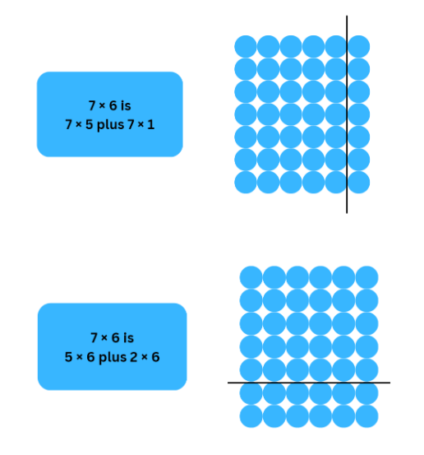
- Model how to record student thinking using number sentences. Tell students that the parentheses will help explain their thinking to someone else, as well as show how they have partitioned numbers and worked with them.
- Pose the question 23 × 3 to students. Display Resource 30 – 23 × 3.
- Students turn and talk about how they could partition the region to determine how many there are altogether. Record student thinking using open arrays and models writing the number sentence. Some anticipated student responses are set out in Figure 20.
Figure 20 – 23 × 3
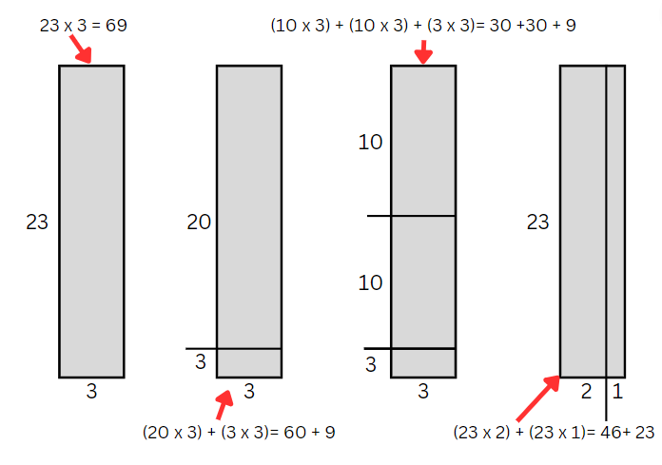
- Explain that, for multiplication, partitioning works due to the distributive property of multiplication.
Note: the distributive property is defined in the syllabus glossary as ‘Multiplication of numbers is distributive over addition because the product of one number with the sum of 2 others equals the sum of the products of the first number with each of the others. For example, 3 × 9 = 3 × (4 + 5) = 3 × 4 + 3 × 5 (NESA 2023).
- Provide students with a copy of Resource 31 – 23 × 3.
- Students cut up and sort the multiplication number sentences into the strategy headings.
- In small groups, students share, compare and justify their choices.
- Ask students to solve at least one multiplication problem from each strategy category. Ask if their chosen strategy was helpful.
- Share solutions with the class where students used different strategies. Ask students to explain their reasoning and evaluate their chosen strategy.
This table details opportunities for differentiation.
Too hard? | Too easy?
Students cannot use flexible partitioning within multiplication.  - Support students by representing the multiplication sentences using arrays, grid paper or regions. Support students to partition these representations and sort according to their strategy.  - Support students to use strategies or anchor charts from previous lessons to assist with these multiplication problems. | Students can use flexible partitioning within multiplication.  - Students create their own multiplication number sentences that can be solved in 2 or more ways.  - Students can develop their own headings for multiplication strategies and provide additional multiplication number sentences that fit into those categories.

Stage 3 task – selecting strategies game
The table below contains suggested learning intentions and success criteria. These are best co-constructed with students.
Core concept learning intentions | Core concept success criteria
Students working towards Stage 3 outcomes are learning to:  - select and apply strategies to solve problems involving multiplication and division with whole numbers  - multiply and divide decimals by powers of 10  - apply place value to partition, regroup and rename numbers to 1 billion. | Students working towards Stage 3 outcomes can:  - select and use efficient strategies to multiply whole numbers of up to 4 digits by one- and 2-digit numbers  - use mental strategies to multiply benchmark decimals by single-digit numbers  - regroup numbers in different forms.
- On the board, write the equation 0.5 × 8. Ask students if they would use an algorithm, a calculator or a mental strategy.
- Select students to share their mental strategies. Anticipated responses may include:
- I know 0.5 is a half, and half of 8 is 4
- 8 is 2 × 2 × 2. I know double 0.5 is 1. If I double that I get 2, then double again makes 4.
- Repeat the discussion steps for the equation 0.25 × 100, again selecting students to share mental strategies.
Note: if students refer to moving the decimal point, remind them that the decimal point is fixed. Encourage students to use place value language such as, I know that tens are one hundred times larger than tenths, so 20 is a hundred times larger than 0.2.
- Prepare a range of equations that are more readily suited to a particular strategy, such as those in Figure 21. These can be adapted to an appropriate level for the students.
Figure 21 – selecting strategies prompts
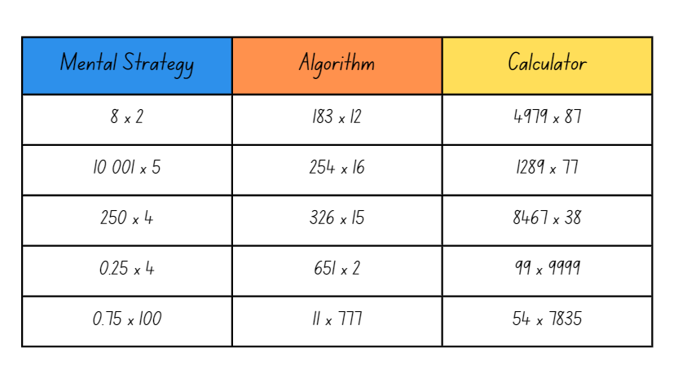
- Choose 3 students to compete against each other using either a mental strategy, a written algorithm or a calculator to develop an answer to their question. Students select their preferred strategy.
- When students are ready, display one equation, for example, 8 × 2. Students solve the problem using their strategy.
- Students compete to arrive at the correct answer the fastest. Record the problem under the heading of the fastest strategy, as shown in Figure 21.
- Repeat with a few different sets of numbers and change students so that all students participate in the game.
- Discuss which strategy was the most efficient. Ask students to explain why that strategy worked best for the multiplication equation.
- Explain that different strategies will suit different equations. Students should choose the most efficient strategy to help them.
- Ask students to describe a situation when using a calculator is not possible. Ask what the most efficient strategy would be in that case and what might happen if students only relied on using a calculator.
- Ask each group of 3 students to produce a set of algorithms similar to those in Figure 21 but not categorised into strategies.
- Students swap their individual whiteboards with another group and each group determines the best strategy to solve each algorithm.
- Discuss with Stage 3 students the strengths and weaknesses of each strategy.
- Create an anchor chart to classify conditions when mental strategies, algorithms or calculators would be best suited.
Note: make explicit reference to mental strategies to multiply benchmark decimals by single-digit numbers, and powers of 10.
This table details opportunities for differentiation.
Too hard? | Too easy?
Students cannot use efficient strategies to multiply whole numbers of up to 4 digits by one- and 2-digit numbers:  - Support students by working with numbers that suit their level of understanding. Represent them by drawing regions on grid paper to show place value, such example A in Figure 22.  - Support students to partition larger numbers, using MAB materials or digital place value cards to model place value. | Students can use efficient strategies to multiply whole numbers of up to 4 digits by one- and 2-digit numbers:  - Students make a short video or poster explaining their thinking, such as why a strategy suits certain situations.  - In pairs, students solve the unusual algorithm in Figure 22, explaining their reasoning.  - Students create their own unusual algorithm for another student to solve.
Figure 22 – differentiation 2
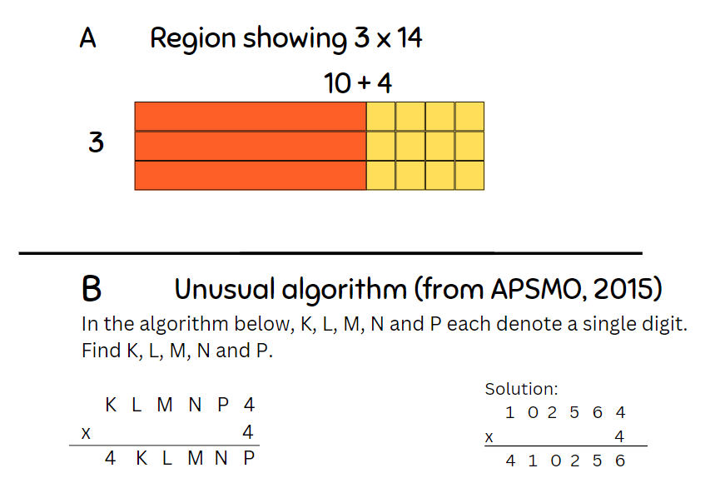

Discuss and connect the mathematics – 10 minutes
- After completing the Sort and Solve activity, ask Stage 2 students:
- Are there some multiplication number sentences that fit in multiple headings?
- Which ones are the most flexible (have more than one or 2 ways) to solve? Explain or prove why.
- Are there any other strategies that are not in the headings that you could use?
- What other headings could you make?
- Add any new strategies to the multiplication strategies anchor chart from previous lessons.
- Ask Stage 3 students:
- What benefits and limitations do algorithms have?
- Why don’t people just use a calculator to work things out?
- What are the benefits of mental strategies?
- What are some situations in real life where these different strategies could help us?
This table details opportunities for assessment.
Assessment opportunities | Links
What to look for:  - Can Stage 2 students record numbers using standard place value form? [MAO-WM-01, MA2-RN-01]  - Can Stage 2 students partition numbers of up to 4 digits in non-standard forms? [MAO-WM-01, MA2-RN-01]  - Can Stage 2 students use flexible partitioning within multiplication? [MAO-WM-01, MA2-RN-01, MA2-MR-01]  - Can Stage 3 students select and use efficient strategies to multiply whole numbers of up to 4 digits by one- and 2-digit numbers? [MA3-MR-01, MAO-WM-01]  - Can Stage 3 students use mental strategies to multiply benchmark decimals by single-digit numbers? [MA3-MR-01, MAO-WM-01]  - Can Stage 3 students regroup numbers in different forms?  [MA3-RN-01, MAO-WM-01] | Links to National Numeracy Learning Progressions (NNLP):  - Stage 2 – NPV5, NPV6, MuS7  - Stage 3 – MuS7, MuS8.  Links to suggested Interview for Student Reasoning (IfSR) tasks:  - Stage 3 – IfSR-MT: 3A.4, 3A.5.

Resource 1 – pattern multiples
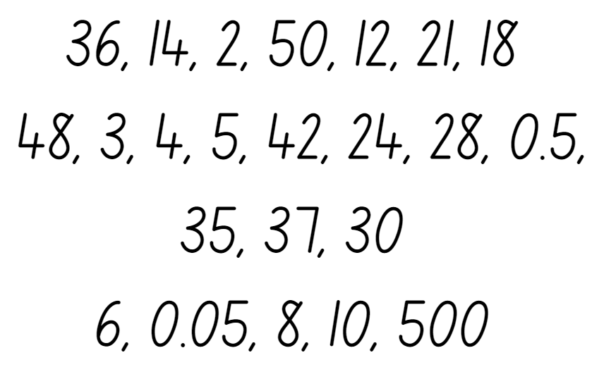

Resource 2 – hexagons
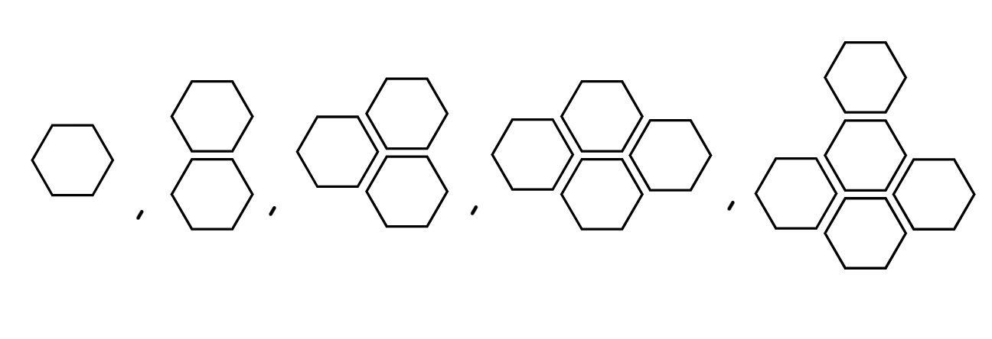

Resource 3 – hexagon table
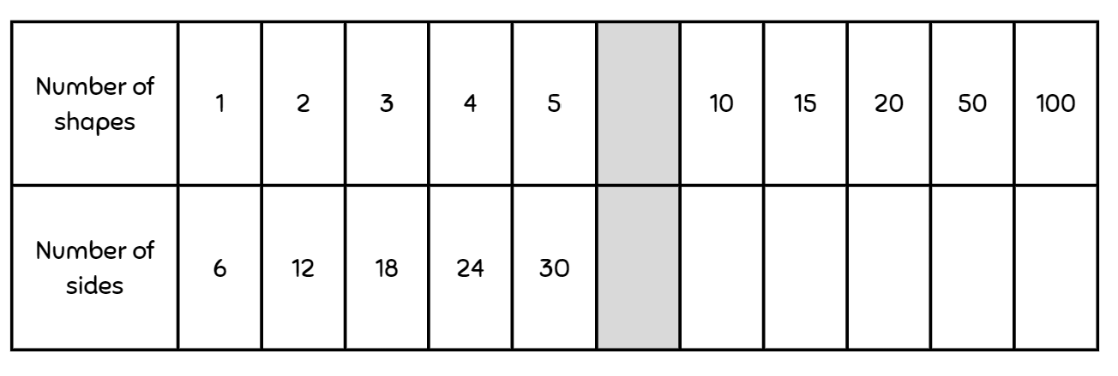

Resource 4 – blank tables
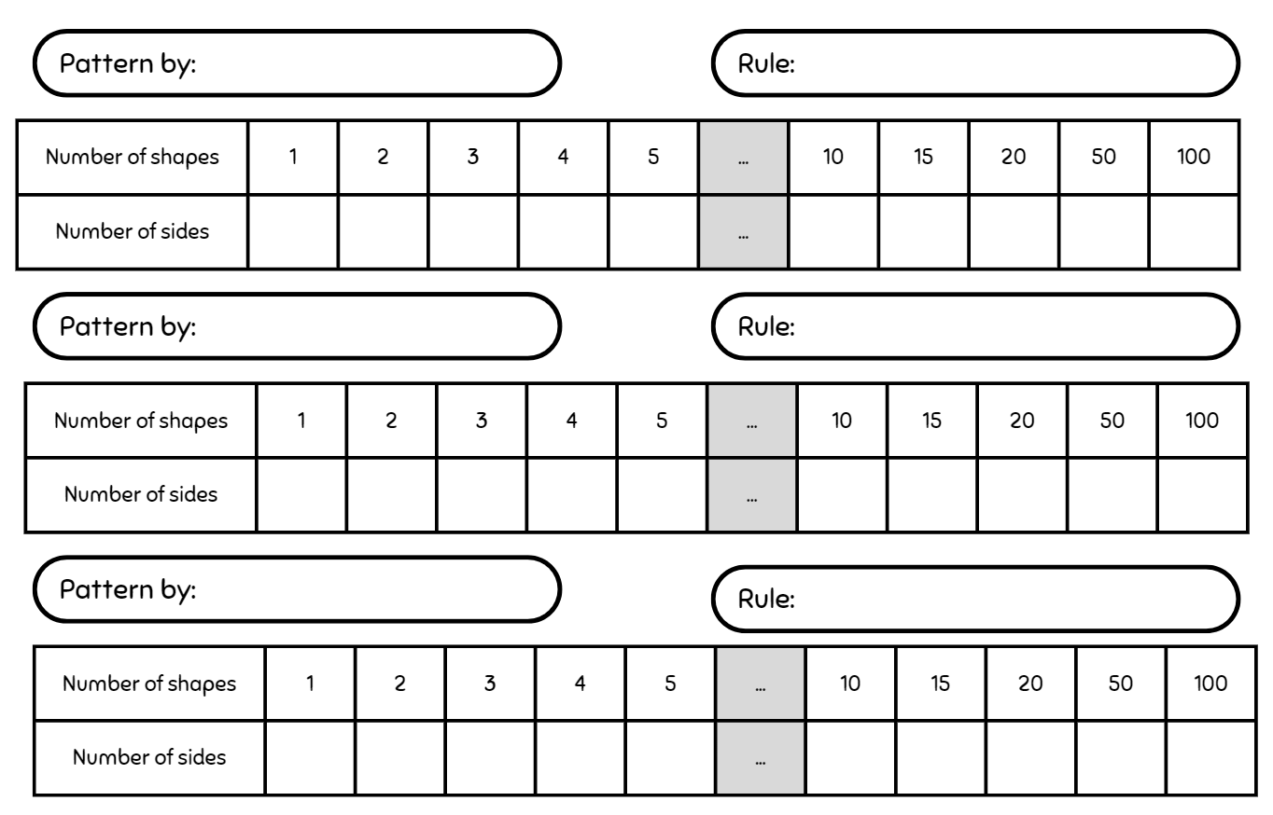

Resource 5 – an array

Resource 6 – an array 2

Resource 7 – arrays of 9
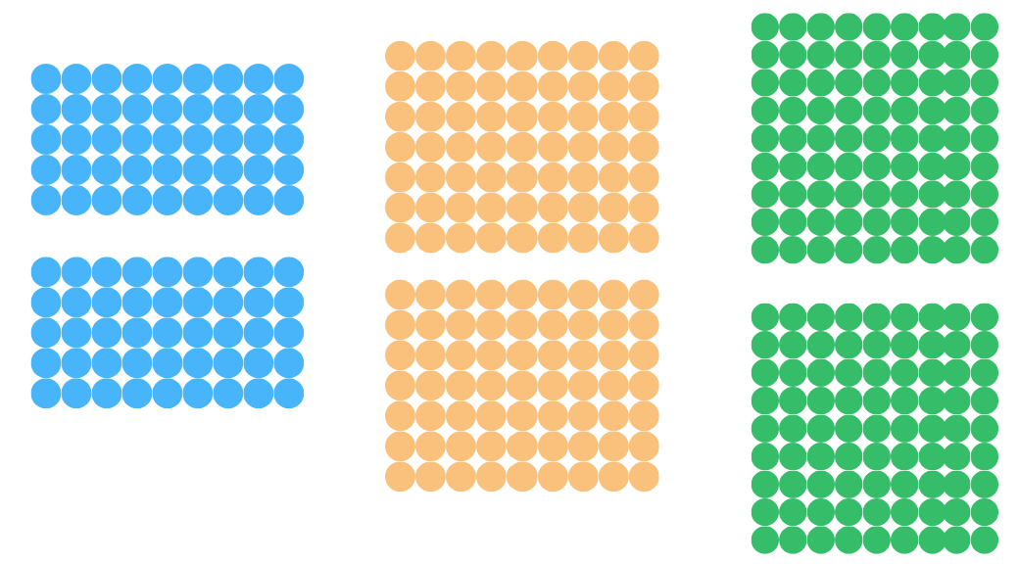

Resource 8 – think board 1
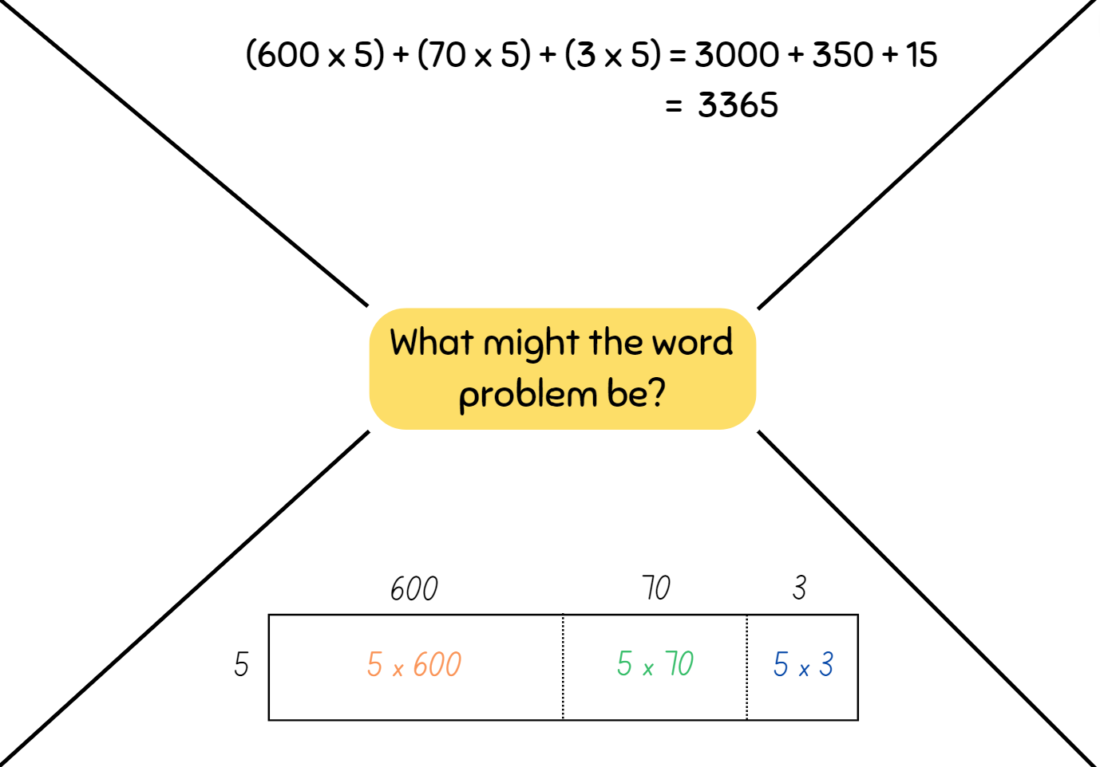

Resource 9 – think board 2
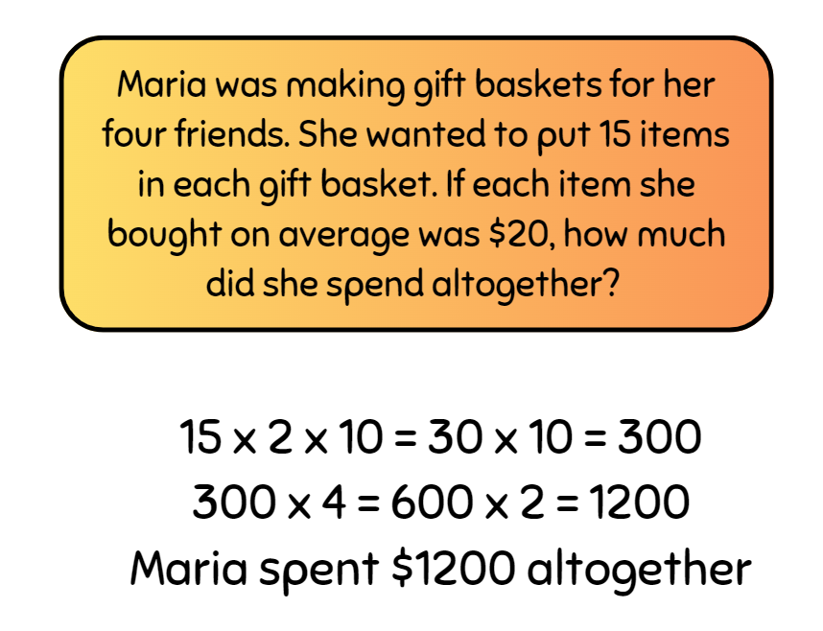

Resource 10 – algorithm errors
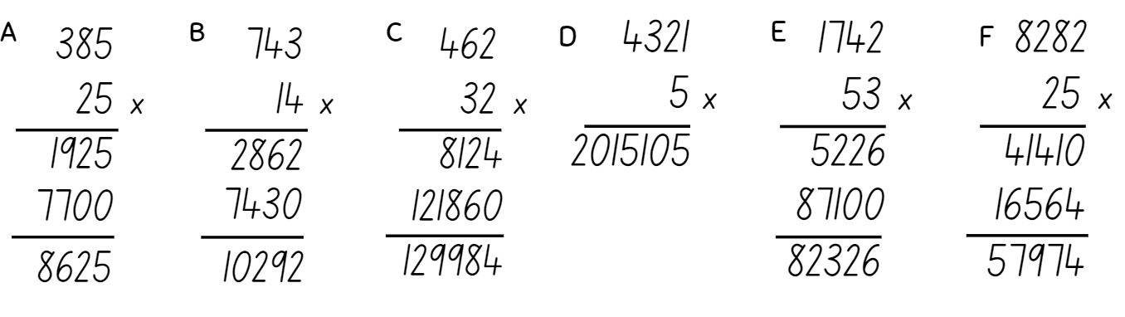

Resource 11 – multiplication chart
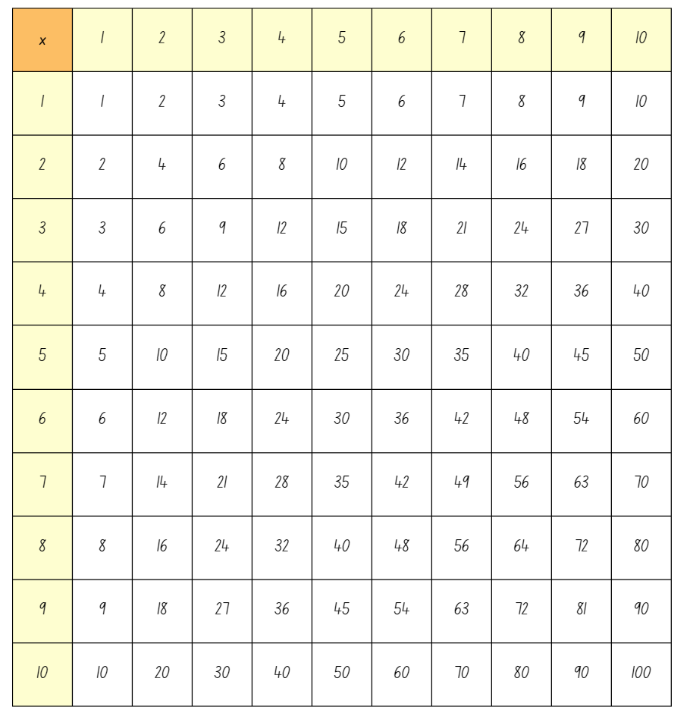

Resource 12 – gameboard
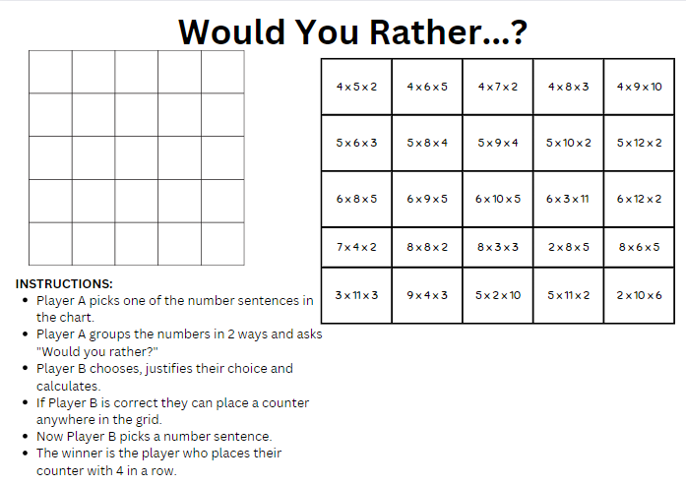

Resource 13 – recording sheet
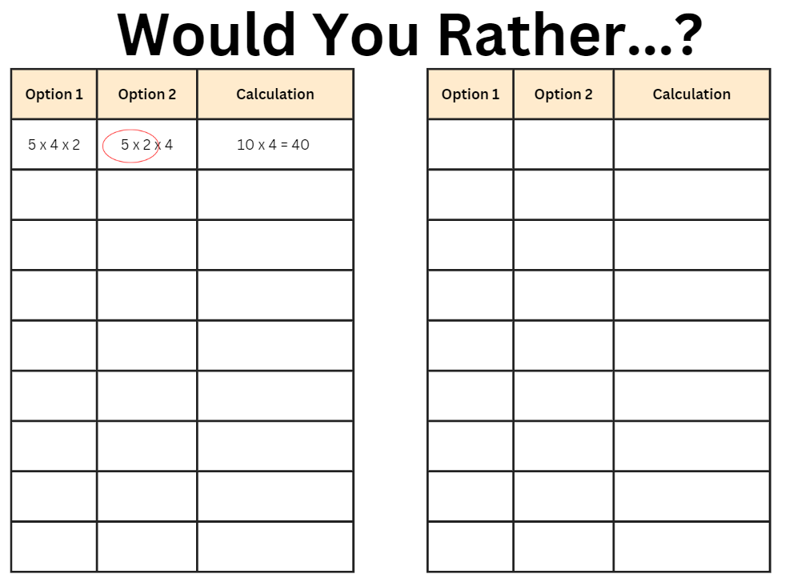

Resource 14 – match the problem
For a complete school uniform, Alex needs a pair of trousers and a shirt. A pair of trousers costs $60 and a shirt costs $40. Alex buys 2 complete school uniforms. How much will she need to pay? | 60 × 20 + 40 × 30
At the school clothing shop, trousers are sold for $60 and shirts are sold for $40. In February, the shop sold 20 pairs of trousers and 30 shirts to new students. What was the total amount of money that the clothing shop received? | 60 + 40 × 2
Slavek wants to buy a pair of jeans marked $60 and a shirt marked $40. At the cash register, the attendant tells him that the store is having a ‘pay only half’ sale. How much will Slavek need to pay? | (60 + 40) × 2
Jing-Wei wants to buy a jacket marked $60 and 2 pairs of jeans each marked $40. How much will she need to pay? | 60 + 40 ÷ 2
Each school in the region ordered 20 ‘Year 6’ jerseys that cost $60 each. The delivery charge for each school was $40. There are 30 schools in the region. What was the total cost of the jerseys for the region? | (60 + 40) ÷ 2
Rasheed wants to buy a pair of jeans marked $60 and a shirt marked $40. At the cash register, the attendant tells him that the store is having a ‘half-price shirts’ sale. How much will he need to pay? | (60 × 20 + 40) × 30

Resource 15 – balance the scales
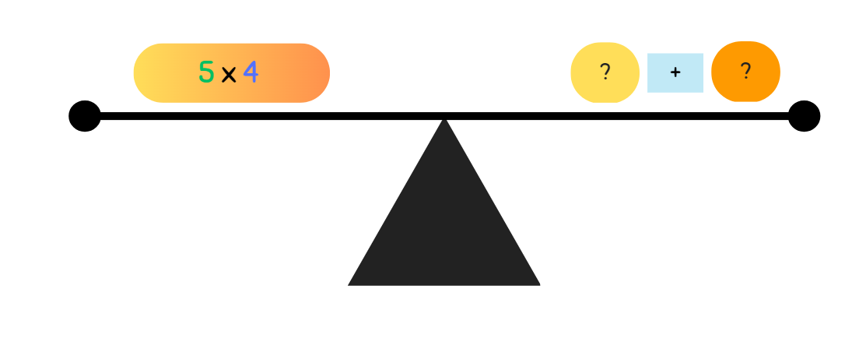

Resource 16 – splats
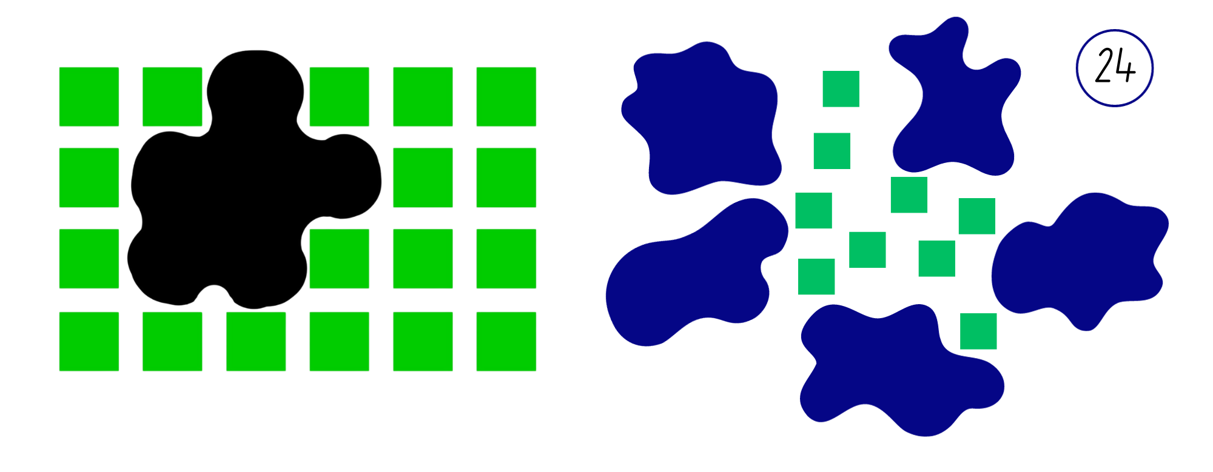
Adapted from Wyborney (2017).

Resource 17 – student splats
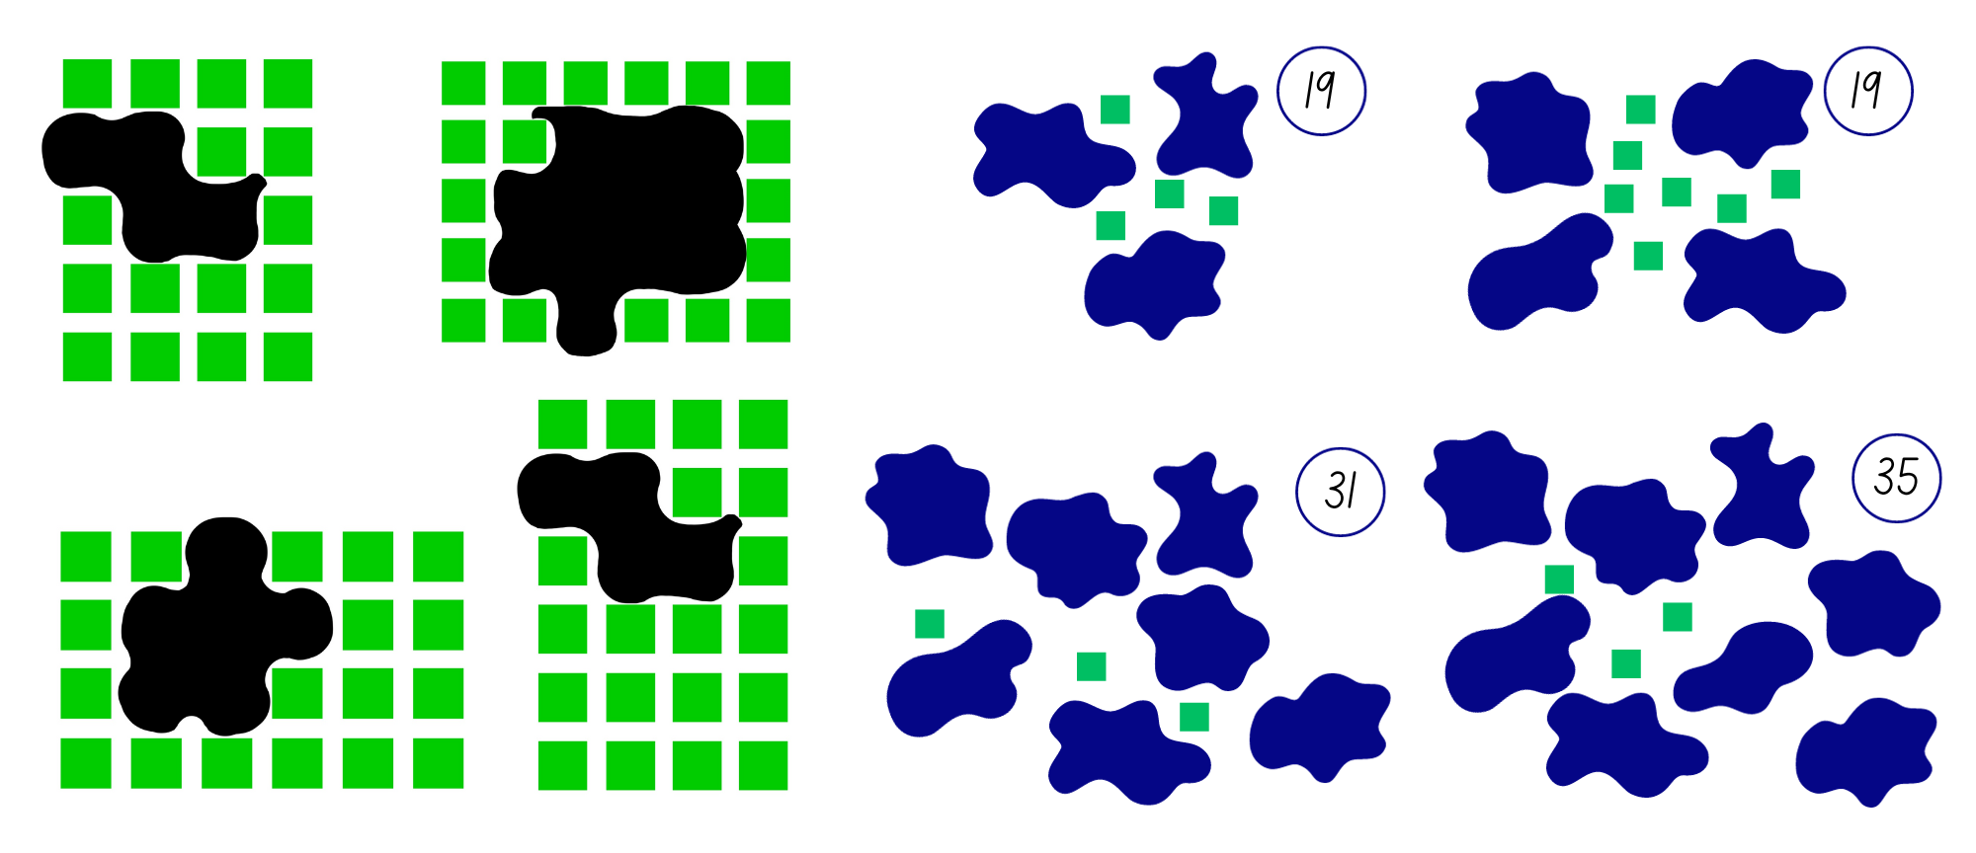
Adapted from Wyborney (2017).

Resource 18 – open ended splats
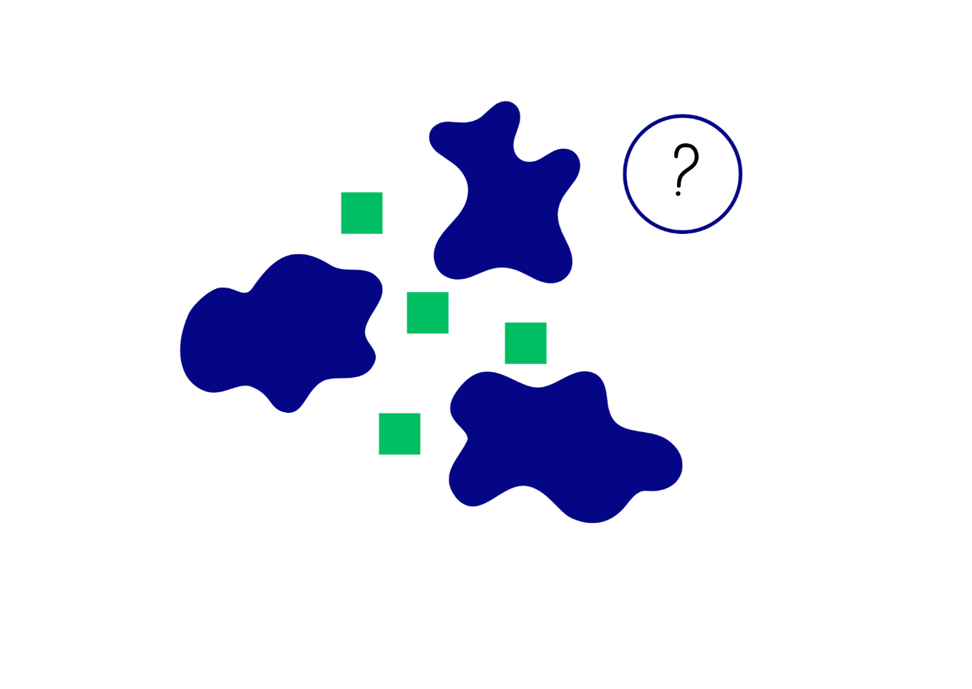
Adapted from Wyborney (2017).

Resource 19 – 119 chart
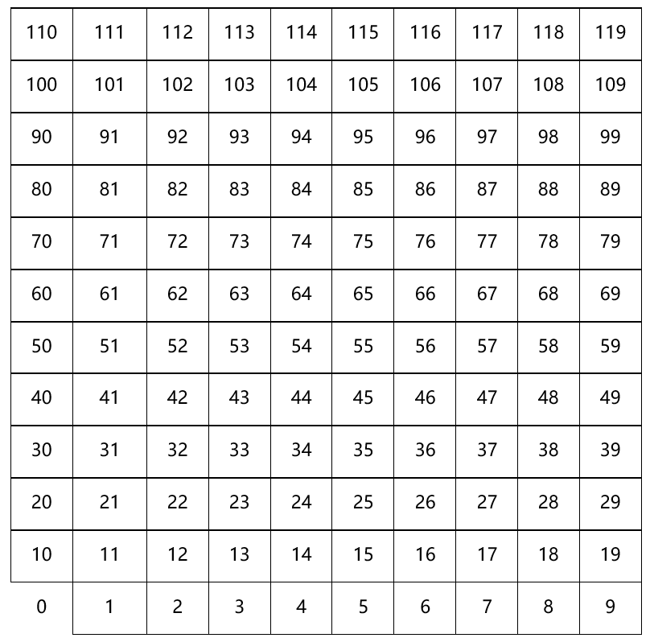

Resource 20 – 20–70 spinner
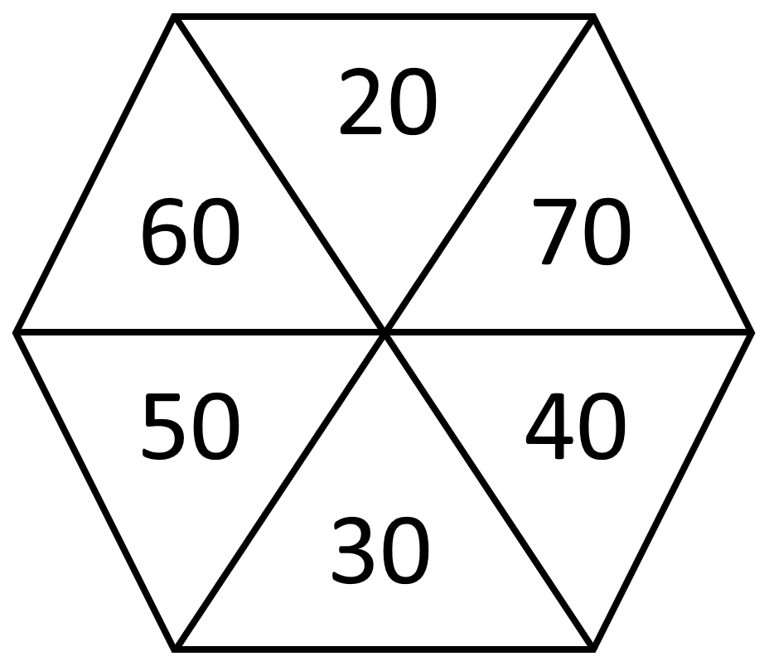

Resource 21 – 12 chart
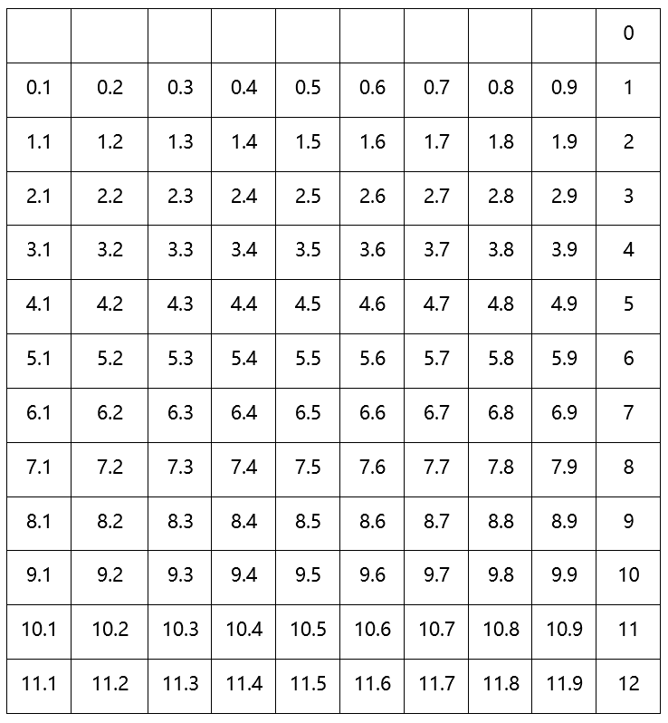

Resource 22 – fraction spinner
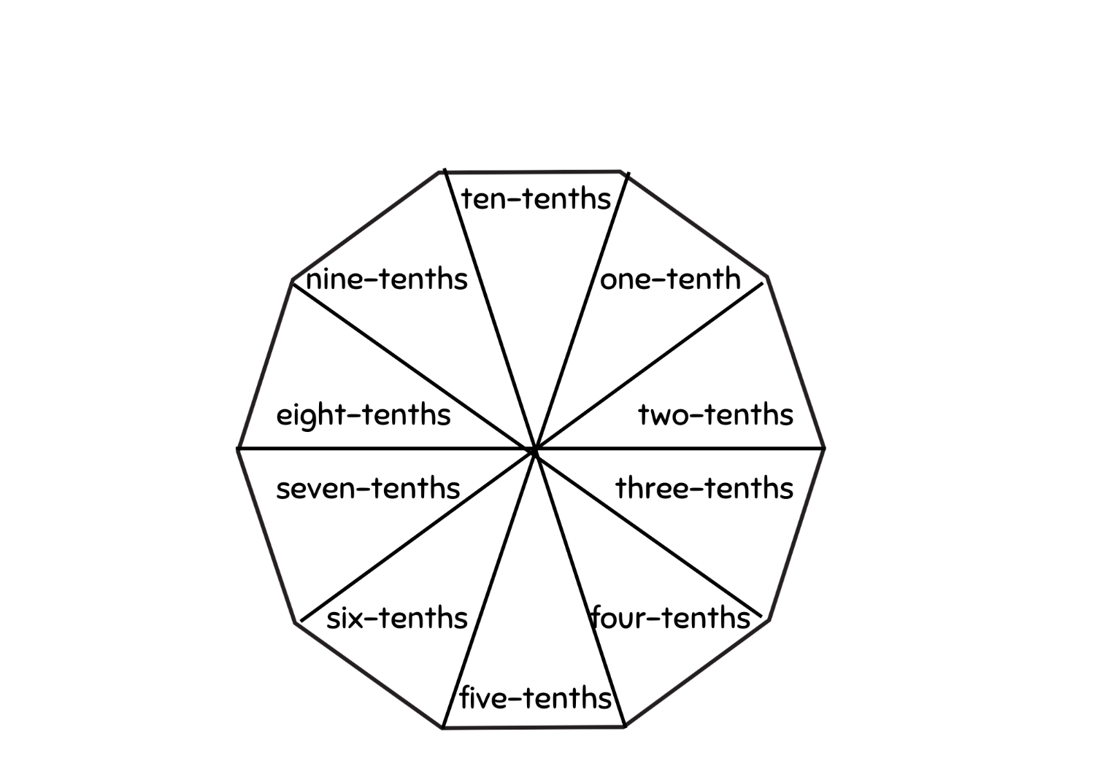

Resource 23 – array cake
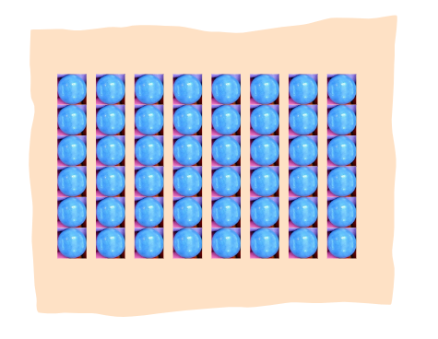

Resource 24 – sharing pizzas
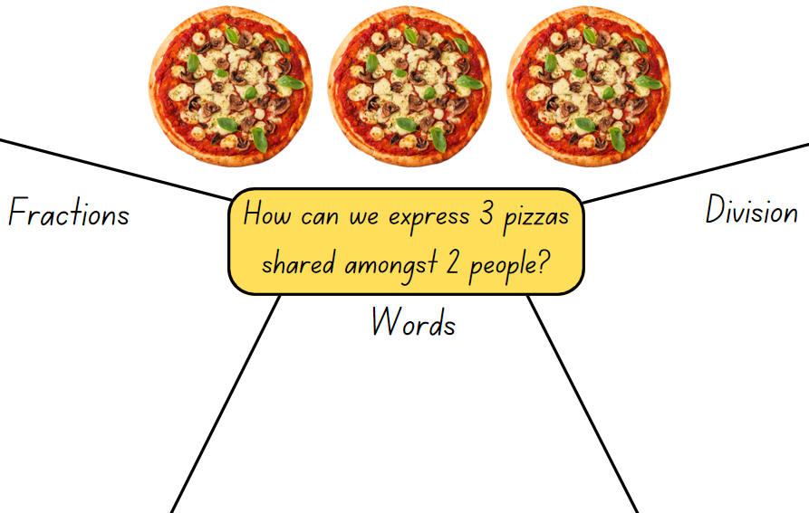

Resource 25 – sharing with friends
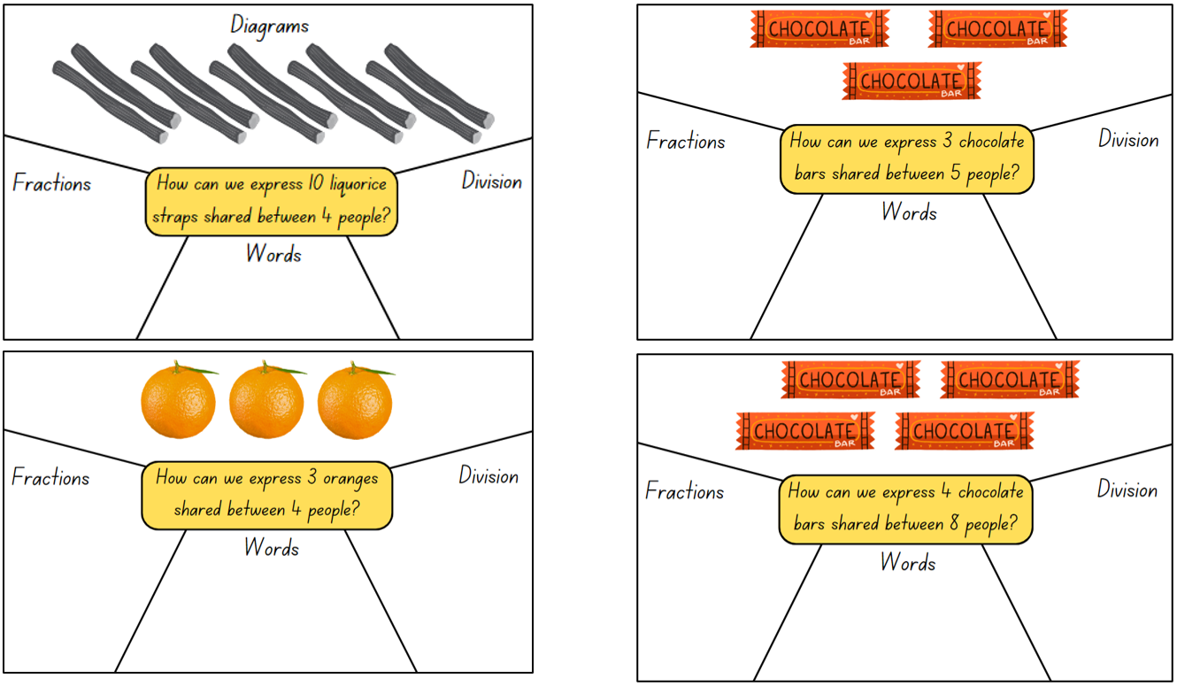

Resource 26 – division as fractions
Rewrite these division equations as fractions.
3 ÷ 2 = | 4 ÷ 2 = | 10 ÷ 2 =
10 ÷ 5 = | 1 ÷ 2 = | 2 ÷ 3 =
30 ÷ 10 = | 50 ÷ 5 = | 24 ÷ 8 =
36 ÷ 6 = | 49 ÷ 7 = | 14 ÷ 7 =

Resource 27 – problem solving
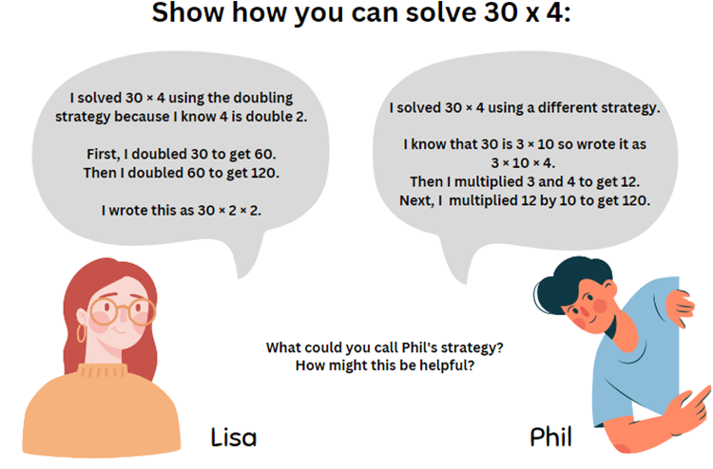

Resource 28 – best buy shirts
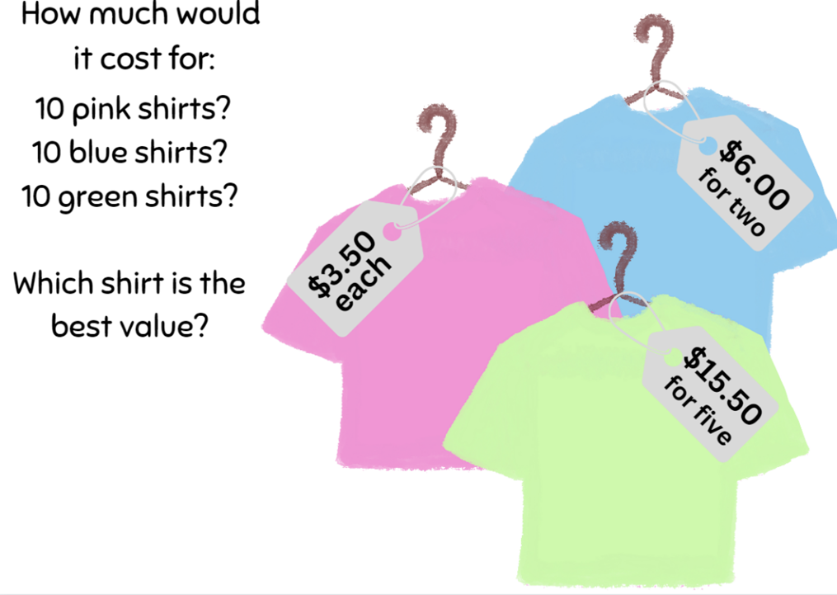

Resource 29 – 7 sixes
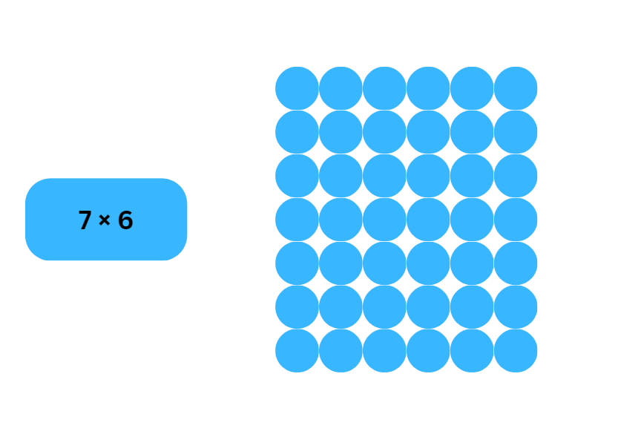

Resource 30 – 23 × 3
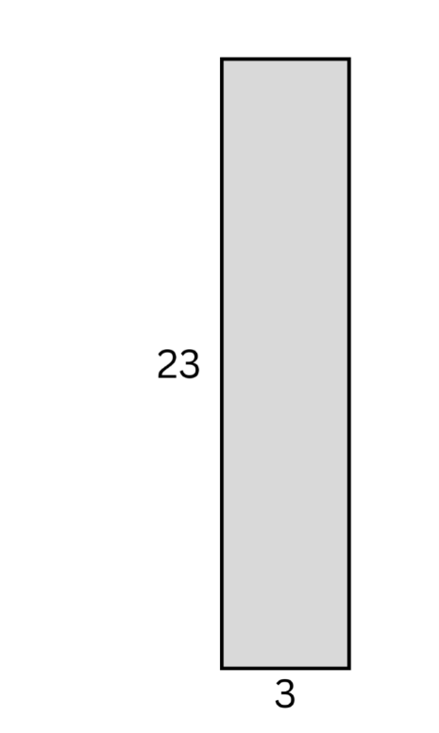

Resource 31 – 23 × 3
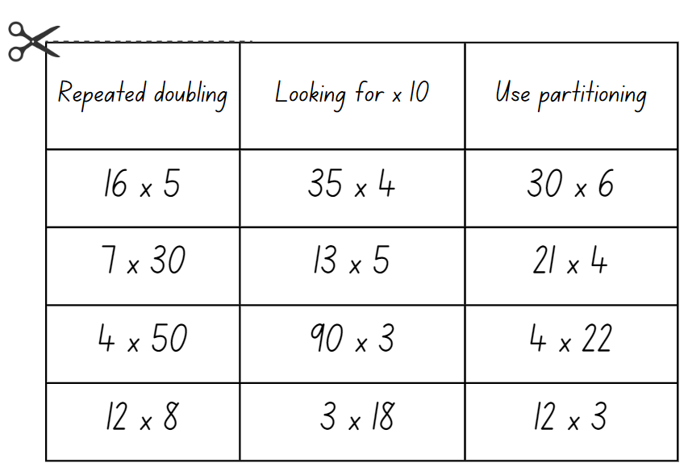

Syllabus outcomes and content

Stage 2
The table below outlines the syllabus outcomes and range of relevant syllabus content covered in this unit. Content is linked to National Numeracy Learning Progression version (3).
Outcomes and content | 1 | 2 | 3 | 4 | 5 | 6 | 7 | 8
Representing numbers using place value B: Whole numbers: Apply place value to partition, regroup and rename numbers up to 6 digits
[MAO-WM-01, MA2-RN-01]
- Name thousands using the place value grouping of ones, tens and hundreds of thousands |  |  | x
- Use place value to expand the number notation |  |  | x
- Partition numbers of up to 6 digits in non-standard forms |  |  | x
Representing numbers using place value B: Whole numbers: Recognise and represent numbers that are 10, 100 or 1000 times as large
[MAO-WM-01, MA2-RN-01]
- Recognise the number of tens, hundreds or thousands in a number |  |  | x
- Describe how making a number 10, 100 or 1000 times as large changes the place value of digits |  |  | x
Additive relations A: Select strategies flexibly to solve addition and subtraction problems of up to 3 digits
[MAO-WM-01, MA2-AR-01]
- Apply known mental strategies that use partitioning to add and subtract, such as bridging the decades |  |  |  |  | x | x | x
Multiplicative relations A: Generate and describe patterns
[MAO-WM-01, MA2-MR-01, MA2-MR-02]
- Model, describe and record patterns of multiples | x
- Create and continue a variety of number patterns that increase or decrease by a constant amount | x
Multiplicative relations A: Recall multiplication facts of 2 and 4, 5 and 10 and related division facts
[MAO-WM-01, MA2-MR-01, MA2-MR-02]
- Link multiplication and division fact families using arrays |  |  |  | x
- Generate multiplication fact families for multiples of 2 and 4, 5 and 10 |  |  |  | x
Multiplicative relations A: Represent and solve problems involving multiplication fact families
[MAO-WM-01, MA2-MR-01, MA2-MR-02]
- Describe multiplication problems using for each and times as many |  |  |  |  | x
- Find the total of partially covered arrays |  |  |  | x | x
- Apply the inverse relationship of multiplication and division (Reasons about relations) |  |  |  | x | x | x
Multiplicative relations B: Investigate number sequences involving related multiples
[MAO-WM-01, MA2-MR-01, MA2-MR-02]
- Generate number patterns using related multiples | x |  |  |  |  | x
- Investigate number patterns involving related multiples | x | x |  |  |  | x
Multiplicative relations B: Use known number facts and strategies
[MAO-WM-01, MA2-MR-01, MA2-MR-02]
- Apply the known strategy of doubling to connect multiples of 3 to 6 and 4 to 8 (Reasons about relations) | x | x |  |  |  | x
- Use known facts to find unknown multiples (Reasons about relations) |  | x |  |  |  | x
Multiplicative relations B: Use the structure of the area model to represent multiplication and division
[MAO-WM-01, MA2-MR-01, MA2-MR-02]
- Create and represent multiplicative structure, moving from arrays to partially covered area models |  |  |  | x
Multiplicative relations B: Use number properties to find related multiplication facts
[MAO-WM-01, MA2-MR-01, MA2-MR-02]
- Use the commutative property of multiplication |  |  | x |  |  |  | x
- Use the associative property within multiplication to regroup the factors (Reasons about structure) |  |  | x |  |  |  | x
- Use flexible partitioning within multiplication (Reasons about relations) |  |  | x |  |  | x | x
- Generate and recall multiplication fact families up to 10 x 10 |  | x |  | x | x | x
Multiplicative relations B: Operate with multiples of 10
[MAO-WM-01, MA2-MR-01, MA2-MR-02]
- Use multiplication facts with multiples of 10 to multiply a one-digit number by a multiple of 10 |  | x
- Use place value to rename groups of 10 to multiply |  | x
- Apply the commutative and associative properties to multiply by multiples of 10 |  | x | x |  |  |  | x
Multiplicative relations B: Represent and solve word problems with number sentences involving multiplication or division
[MAO-WM-01, MA2-MR-01, MA2-MR-02]
- Use the equals sign to record equivalent number relationships involving multiplication (Reasons about relations) |  |  | x
- Complete number sentences involving multiplication and division by calculating missing numbers (Reasons about relations) |  |  | x | x | x
- Represent and solve multiplication and division (both sharing and grouping) word problems using number sentences |  |  | x | x | x
Mathematics K–10 Syllabus © NSW Education Standards Authority (NESA) for and on behalf of the Crown in right of the State of New South Wales, 2022.

Stage 3
The table below outlines the syllabus outcomes and range of relevant syllabus content covered in this unit. Content is linked to National Numeracy Learning Progression version (3).
Outcomes and content | 1 | 2 | 3 | 4 | 5 | 6 | 7 | 8
Represents numbers A: Whole numbers: Apply place value to partition, regroup and rename numbers to 1 billion
[MAO-WM-01, MA3-RN-01]
- Recognise 1000 thousands is 1 million and 1000 millions is 1 billion |  |  | x
- Regroup numbers in different forms (Reasons about quantity) |  | x | x |  |  |  |  | x
- Partition numbers to 1 billion in non-standard forms |  |  | x
Additive relations A: Apply efficient mental and written strategies to solve addition and subtraction problems
[MAO-WM-01, MA3-AR-01]
- Solve word problems, including multistep problems |  |  | x
- Use place value to add or subtract 3 or more numbers with different numbers of digits |  | x
Additive relations B: Applies known strategies to add and subtract decimals
[MAO-WM-01, MA3-AR-01]
- Model the addition and subtraction of decimals up to 3 decimal places using appropriate representations |  |  |  |  | x | x | x
- Solve word problems involving the addition and subtraction of decimals up to 3 decimal places |  |  |  |  |  | x
- Justify why the strategy used to solve addition and subtraction word problems is appropriate (Reasons about quantity) |  |  |  |  |  | x
Multiplicative relations A: Determine products and factors
[MAO-WM-01, MA3-MR-01, MA3-MR-02]
- Use the term product to describe the result of multiplying 2 or more numbers |  |  | x
Multiplicative relations A: Use partitioning and place value to multiply 2-, 3- and 4-digit numbers by one-digit numbers
[MAO-WM-01, MA3-MR-01, MA3-MR-02]
- Use mental strategies to multiply one-digit numbers by 10, 100, 1000 and their multiples |  |  | x
- Use informal written strategies such as the area model to solve multiplication and division problems
- Use the distributive property with the area model to partition numbers in representing multiplication problems |  | x
- Use the distributive property with partial products to solve problems by multiplying the hundreds, then the tens and then the ones
- Record the product of multiplying by a one-digit number using a formal algorithm
Multiplicative relations A: Select and apply mental and written strategies to multiply 2- and 3-digit numbers by 2-digit numbers
[MAO-WM-01, MA3-MR-01]
- Use a multiplication algorithm with understanding (Reasons about relations) |  | x
Multiplicative relations A: Represent and solve division problems with whole number remainders
[MAO-WM-01, MA3-MR-01, MA3-MR-02]
- Model division, including where the answer involves a remainder, using materials or diagrams |  |  |  |  |  | x
- Record remainders in words to division problems |  |  |  |  |  | x
- Use known multiplication fact families to solve division problems for which answers may include a remainder |  |  |  |  | x | x
- Use the term quotient to describe the result of a division calculation |  |  |  |  | x | x
- Show the connection between division and multiplication involving the divisor and quotient |  |  |  |  | x | x
Multiplicative relations A: Use estimation and rounding to check the reasonableness of answers to calculations
[MAO-WM-01, MA3-MR-01, MA3-MR-02]
- Use estimation to check the reasonableness of answers to multiplication and division calculations |  |  | x
Multiplicative relations B: Select and apply strategies to solve problems involving multiplication and division with whole numbers
[MAO-WM-01, MA3-MR-01, MA3-MR-02]
- Select and use efficient strategies to multiply whole numbers of up to 4 digits by one- and 2-digit numbers |  |  |  |  |  |  | x | x
- Solve word problems involving rates using multiplication and division (Reasons about relations) |  |  |  |  |  |  | x
- Determine why different division questions have the same answer (Reasons about relations) |  |  |  |  |  |  | x
Multiplicative relations B: Multiply and divide decimals by powers of 10
[MAO-WM-01, MA3-MR-01, MA3-MR-02]
- Use mental strategies to multiply benchmark decimals by single-digit numbers |  |  |  | x |  |  |  | x
- Compare the relative place value of digits to multiply and divide a decimal by powers of 10 | x
Multiplicative relations B: Use equivalent number sentences involving multiplication and division to find unknown quantities
[MAO-WM-01, MA3-MR-01, MA3-MR-02]
- Complete number sentences that involve more than one operation by calculating missing numbers |  |  |  | x |  | x
- Identify and use inverse operations to assist with the solution of number sentences |  |  |  |  | x | x
- Recognise that division can be recorded using fractions |  |  |  | x |  | x
Multiplicative relations B: Represent and describe number patterns formed by multiples
[MAO-WM-01, MA3-MR-01, MA3-MR-02]
- Use a given geometric pattern involving multiples to create a table of values | x
- Describe a pattern formed by multiples in words, in terms of multiplication rather than addition | x
- Determine a rule describing the relationship between the bottom number and the top number in a table (Algebraic reasoning) | x
Multiplicative relations B: Explore the use of brackets and the order of operations to write number sentences
[MAO-WM-01, MA3-MR-01, MA3-MR-02]
- Recognise the need to agree on the order in which to perform operations |  |  |  |  |  | x
- Use grouping symbols () in number sentences to indicate operations that must be performed first |  |  | x |  |  | x
- Investigate the order of operations using real-life contexts |  |  | x |  |  | x
- Solve problems involving grouping symbols |  |  |  |  |  | x
Mathematics K–10 Syllabus © NSW Education Standards Authority (NESA) for and on behalf of the Crown in right of the State of New South Wales, 2022.

References
This resource contains NSW Curriculum and syllabus content. The NSW Curriculum is developed by the NSW Education Standards Authority. This content is prepared by NESA for and on behalf of the Crown in right of the State of New South Wales. The material is protected by Crown copyright.
Please refer to the NESA Copyright Disclaimer for more information https://educationstandards.nsw.edu.au/wps/portal/nesa/mini-footer/copyright.
NESA holds the only official and up-to-date versions of the NSW Curriculum and syllabus documents. Please visit the NSW Education Standards Authority (NESA) website https://educationstandards.nsw.edu.au/ and the NSW Curriculum website https://curriculum.nsw.edu.au/.
Mathematics K–10 Syllabus © NSW Education Standards Authority (NESA) for and on behalf of the Crown in right of the State of New South Wales, 2022.
National Numeracy Learning Progression © Australian Curriculum, Assessment and Reporting Authority (ACARA) 2010 to present, unless otherwise indicated. This material was downloaded from the Australian Curriculum website (National Numeracy Learning Progression) (accessed 17 October 2023) and was not modified.
Kalman R, Phegan J and Prescott A (eds) (2008) Maths Olympiad Contest Problems: Volume 2, Australian edn, APSMO (Australasian Problem Solving Mathematical Olympiads) and MOEMS (Mathematical Olympiads for Elementary and Middle Schools), Australia.
Kalman R, Restivo N, Phegan J and McMaster H (eds) (2015) Maths Olympiad Contest Problems: Volume 3, Australian edn, APSMO and MOEMS, Australia.
Kling G and Bay-Williams J (2019) Math Fact Fluency: 60+ Games and Assessment Tools to Support Learning and Retention, Association for Supervision & Curriculum Development, US.
Lenchner G (2005) Maths Olympiad Contest Problems: Volume 1 (Prescott A ed), Australian edn, APSMO and MOEMS, Australia.
State of New South Wales (Department of Education) (2023) ‘Flexible additive strategies – Decimals – Task 4 – I’ll race you to zero: decimal place value’, Numeracy, NSW Department of Education, accessed 11 October 2023.
State of New South Wales (Department of Education) (2023) ‘Let’s talk – how many ways?’, Mathematics K–6 resources, NSW Department of Education website, accessed 11 July 2023.
State of New South Wales (Department of Education) (2023) ‘Race to zero (subtracting tens and ones)’, Mathematics K-6 resources, NSW Department of Education website, accessed 11 October 2023.
Sullivan P (2017) Challenging Mathematical Tasks: Unlocking the Potential of All Students, Oxford University Press Australia and New Zealand.
Van de Walle J, Karp K, Bay-Williams JM, Brass A, Bentley B, Ferguson S, Goff W, Livy S, Marshman M, Martin D, Pearn C, Prodromou T, Symons D and Wilkie K (2019) Primary and Middle Years Mathematics: Teaching Developmentally, 1st Australian edn, Pearson Education Australia, Melbourne.
Wyborney S (9 February 2017) ‘Splat!’, Steve Wyborney's Blog: I'm on a Learning Mission, accessed 19 July 2023.

© State of New South Wales (Department of Education), 2023
The copyright material published in this resource is subject to the Copyright Act 1968 (Cth) and is owned by the NSW Department of Education or, where indicated, by a party other than the NSW Department of Education (third-party material).
Copyright material available in this resource and owned by the NSW Department of Education is licensed under a Creative Commons Attribution 4.0 International (CC BY 4.0) license.
This license allows you to share and adapt the material for any purpose, even commercially.
Attribution should be given to © State of New South Wales (Department of Education), 2023.
Material in this resource not available under a Creative Commons license:
- the NSW Department of Education logo, other logos and trademark-protected material
- material owned by a third party that has been reproduced with permission. You will need to obtain permission from the third party to reuse its material.
Links to third-party material and websites
Please note that the provided (reading/viewing material/list/links/texts) are a suggestion only and implies no endorsement, by the New South Wales Department of Education, of any author, publisher, or book title. School principals and teachers are best placed to assess the suitability of resources that would complement the curriculum and reflect the needs and interests of their students.
If you use the links provided in this document to access a third-party's website, you acknowledge that the terms of use, including licence terms set out on the third-party's website apply to the use which may be made of the materials on that third-party website or where permitted by the Copyright Act 1968 (Cth). The department accepts no responsibility for content on third-party websites.

