Mathematics 3–6 Multi-age – Year B – Unit 4
Fractions represent multiple ideas and can be represented in different ways

Contents
Unit description and duration 7
Syllabus outcomes 7
Stage 2 7
Stage 3 8
Working mathematically 8
Student prior learning 9
Lesson overview and resources 10
Lesson 1 18
Daily number sense – equivalent to half – 15 minutes 18
Core lesson – fractions on a number line – 40 minutes 21
Discuss and connect the mathematics – 10 minutes 27
Lesson 2 29
Daily number sense – equivalent fractions – 10 minutes 29
Core lesson 1 – missing lengths – 15 minutes 31
Core lesson 2 – recreating the whole – 25 minutes 32
Discuss and connect the mathematics – 10 minutes 35
Lesson 3 37
Daily number sense – fraction towers – 15 minutes 37
Core lesson – 40 minutes 39
Stage 2 task – fraction towers 39
Discuss and connect the mathematics – 10 minutes 41
Stage 3 task – painting pieces 42
Discuss and connect the mathematics – 10 minutes 46
Lesson 4 48
Daily number sense – 10 minutes 48
Core lesson – 40 minutes 48
Stage 2 task 1– worm wonderings 48
Stage 2 task 2 – snail racing 50
Discuss and connect the mathematics – 10 minutes 52
Stage 3 task – fractions are formed by dividing a whole 53
Consolidation and meaningful practice – 15 minutes 58
Lesson 5 60
Daily number sense – make 500 000 (part 1) – 15 minutes 60
Core lesson – making and exceeding the whole – 45 minutes 63
Consolidation and meaningful practice – 10 minutes 69
Lesson 6 72
Daily number sense – make 500 000 (part 2) – 15 minutes 72
Core lesson – 40 minutes 74
Stage 2 task – fractional quantities greater than one 74
Discuss and connect the mathematics – 5 minutes 77
Stage 3 task – compare and represent collections of objects 78
Discuss and connect the mathematics – 10 minutes 82
Lesson 7 83
Daily number sense – jumbled words – 15 minutes 83
Core lesson – 35 minutes 85
Stage 2 task – number lines extend beyond one 85
Stage 3 task – adding and subtracting fractions 87
Discuss and connect the mathematics – 10 minutes 90
Lesson 8 93
Daily number sense – 10 minutes 93
Core lesson – 45 minutes 93
Stage 2 task – blank number lines 93
Stage 3 task – mathematicians solve problems with fractions 96
Discuss and connect the mathematics – 10 minutes 98
Resource 1 – fraction wall 101
Resource 2 – fraction cards 102
Resource 3 – frog racing 103
Resource 4 – missing lengths 104
Resource 5 – building the whole 105
Resource 6 – predicting the whole 106
Resource 7 – tower fractions 107
Resource 8 – tower number lines 108
Resource 9 – student work sample 109
Resource 10 – painting piece 1 110
Resource 11 – painting piece 2 111
Resource 12 – painting puzzle 112
Resource 13 – painting conundrum 113
Resource 14 – snail racing 114
Resource 15 – Which one doesn’t belong? 115
Resource 16 – sharing 3 cakes 116
Resource 17 – place value houses 117
Resource 18 – ‘Rob the nest’ scoresheet 118
Resource 19 – beanbag scoresheet 119
Resource 20 – ribbon lengths 120
Resource 21 – farmer’s market cards 121
Resource 22 – mathematical reasoning prompts 122
Resource 23 – What’s the number? 123
Resource 24 – number lines 0–2 (a) 124
Resource 25 – number lines 0–2 (b) 125
Resource 26 – adding and subtracting fractions 126
Resource 27 – thirds on a number line 127
Resource 28 – blank number lines 128
Resource 29 – roll a whole 129
Resource 30 – disc game clues 130
Resource 31 – disc game box 131
Syllabus outcomes and content 132
Stage 2 132
Stage 3 135
References 140

Unit description and duration
This unit develops the big idea that fractions represent multiple ideas and can be represented in different ways.
In this 2-week unit, students are provided opportunities to:
- compare and order fractions and equivalent fractions using number lines, bar models and diagrams.
- recreate the whole from a fractional part.
- understand what happens when a fraction exceeds a whole.
This multi-age unit is informed by the lessons in Stage 2 Year B Unit 24 and Stage 3 Year B Unit 24. Please refer to these units for additional lesson guidance.

Syllabus outcomes
- MAO-WM-01 develops understanding and fluency in mathematics through exploring and connecting mathematical concepts, choosing and applying mathematical techniques to solve problems, and communicating their thinking and reasoning coherently and clearly

Stage 2
- MA2-RN-01 applies an understanding of place value and the role of zero to represent numbers to at least tens of thousands
- MA2-PF-01 represents and compares halves, quarters, thirds and fifths as lengths on a number line and their related fractions formed by halving (eighths, sixths and tenths)

Stage 3
- MA3-AR-01 selects and applies appropriate strategies to solve addition and subtraction problems
- MA3-RQF-01 compares and orders fractions with denominators of 2, 3, 4, 5, 6, 8 and 10
- MA3-RQF-02 determines $\frac{1}{2}$, $\frac{1}{4}$, $\frac{1}{5}$ and $\frac{1}{10}$ of measures and quantities

Working mathematically
In the Mathematics K–10 Syllabus, there is one overarching Working mathematically outcome (MAO-WM-01). The Working mathematically processes should be embedded within the concepts being taught. The Working mathematically processes present in the Mathematics K–10 Syllabus are:
- communicating
- understanding and fluency
- reasoning
- problem solving.
Mathematics K–10 Syllabus © NSW Education Standards Authority (NESA) for and on behalf of the Crown in right of the State of New South Wales, 2022.

Student prior learning
Before engaging in these teaching and learning activities, students would benefit from prior experience with:
- creating fractional and complementary parts of a length
- exploring fractions and equivalent fractions through fraction strips, fraction walls and number lines
- recreating the whole from a fractional part.
In NSW classrooms there is a diverse range of students, including Aboriginal and/or Torres Strait Islander students, students learning English as an additional language or dialect, high potential and gifted students and students with disability. Some students may identify with more than one of these groups or possibly all of them. Refer to Curriculum planning for every student – advice for further information

Lesson overview and resources
To cover the different fractional content of the syllabus across Stage 2 and Stage 3, some core lessons in this unit contain both a Stage 2 and a Stage 3 task. The separate learning experiences have been deliberately designed to meet the specific needs and abilities of the students within each stage. Teachers are encouraged to adapt and contextualise the units to meet the needs of their students.
The table below outlines the sequence and approximate timing of lessons, learning intentions and resources.
Lesson | Content | Duration and resources
Lesson 1  Daily number sense  Stage 2:  - Partitioned fractions B: model equivalent fractions as lengths  Stage 3:  - Representing quantity fractions B: compare common fractions with related denominators | Lesson core concept: number lines are models used to represent fractions.  Stage 2:  - Partitioned fractions A: model and represent unit fractions, and their multiples, to a complete whole on a number line  - Partitioned fractions B: model equivalent fractions as lengths  Stage 3:  - Representing quantity fractions A: compare and order common unit fractions  - Representing quantity fractions B: compare common fractions with related denominators | Lesson duration: 65 minutes  - Resource 1 – fraction wall  - Resource 2 – fraction cards  - Resource 3 – frog racing  - Website: Amplify Polypad – Fraction Bars  - Individual whiteboards  - Masking tape or string  - Small strips of paper  - Writing materials
Lesson 2  Daily number sense  Stage 2:  - Partitioned fractions B: model equivalent fractions as lengths  Stage 3:  - Representing quantity fractions B: compare common fractions with related denominators | Lesson core concept: recreating the whole from a fractional part.  Stage 2:  - Partitioned fractions A: model and represent unit fractions, and their multiples, to a complete whole on a number line  - Partitioned fractions B: model equivalent fractions as lengths  Stage 3:  - Representing quantity fractions A: recognise the role of the number 1 as representing the whole  - Representing quantity fractions B: build up to the whole from a given fractional part | Lesson duration: 60 minutes  - Resource 1 – fraction wall  - Resource 4 – missing lengths  - Resource 5 – building the whole  - Resource 6 – predicting the whole  - Individual whiteboards  - Paper strips (4 cm in length)  - Writing materials
Lesson 3  Daily number sense  Stage 2:  - Partitioned fractions A: model and represent unit fractions, and their multiples, to a complete whole on a number line  Stage 3:  - Representing quantity fractions B: compare common fractions with related denominators | Lesson core concept: equivalent fractions have related denominators (Stage 2) and compare and represent fractions of a whole shape (the area model) (Stage 3).  Stage 2:  - Partitioned fractions B: model equivalent fractions as lengths  Stage 3:  - Representing quantity fractions B: compare common fractions with related denominators | Lesson duration: 65 minutes  - Resource 7 – tower fractions  - Resource 8 – tower number lines  - Resource 9 – student work sample  - Resource 10 – painting piece 1  - Resource 11 – painting piece 2  - Resource 12 – painting puzzle (enlarged onto A3 paper)  - Resource 13 – painting conundrum  - Coloured markers  - Individual whiteboards  - Interlocking cubes  - Writing materials
Lesson 4  Daily number sense  - teacher-identified task based on student needs | Lesson core concept: equal wholes are needed to compare partitioned fractions (Stage 2) and fractions are formed by dividing a whole (Stage 3).  Stage 2:  - Partitioned fractions A: create fractional parts of a length using techniques other than repeated halving  - Partitioned fractions B: model equivalent fractions as lengths  Stage 3:  - Representing quantity fractions B: recognise that a fraction can represent a division | Lesson duration: 65 minutes  - Resource 14 – snail racing  - Resource 15 – Which one doesn’t belong?  - Resource 16 – sharing 3 cakes  - Individual whiteboards  - Strips of paper (4 per student)  - Student workbooks  - Writing materials
Lesson 5  Daily number sense  Stage 2:  - Representing numbers using place value B: apply place value to partition, regroup and rename numbers up to 6 digits  Stage 3:  - Additive relations A: apply efficient mental and written strategies to solve addition and subtraction problems | Lesson core concept: making and exceeding the whole.  Stage 2:  - Partitioned fractions B: represent fractional quantities equal to and greater than one  Stage 3:  - Representing quantity fractions B: use equivalence to add and subtract fractional quantities | Lesson duration: 70 minutes  - Resource 17 – place value houses  - Resource 18 – ‘Rob the nest’ scoresheet  - Resource 19 – beanbag scoresheet  - 9-sided dice (one per student)  - Coloured beanbags  - Hoops  - Individual whiteboards  - Writing materials
Lesson 6  Daily number sense  Stage 2:  - Representing numbers using place value B: apply place value to partition, regroup and rename numbers up to 6 digits  Stage 3:  - Additive relations A: apply efficient mental and written strategies to solve addition and subtraction problems | Lesson core concept: understanding fractional quantities greater than one (Stage 2) and compare and represent collections of objects (Stage 3).  Stage 2:  - Partitioned fractions B: represent fractional quantities equal to and greater than one  Stage 3:  - Representing quantity fractions B: compare common fractions with related denominators  - Representing quantity fractions B: find fractional quantities of whole numbers (halves, quarters, fifths and tenths) | Lesson duration: 65 minutes  - Resource 17 – place value houses  - Resource 20 – ribbon lengths  - Resource 21 – farmer’s market cards  - Resource 22 – mathematical reasoning prompts  - 6-sided dice  - 9-sided dice (one per student)  - A4 and A3 paper  - Individual whiteboards  - Scissors  - Writing materials
Lesson 7  Daily number sense  Stage 2:  - Representing numbers using place value B: apply place value to partition, regroup and rename numbers up to 6 digits  Stage 3:  - Additive relations A: apply efficient mental and written strategies to solve addition and subtraction problems | Lesson core concept: number lines extend beyond one (Stage 2) and mathematicians solve problems with fractions (related denominators). (Stage 3).  Stage 2:  - Partitioned fractions A: model and represent unit fractions, and their multiples, to a complete whole on a number line  - Partitioned fractions B: represent fractional quantities equal to and greater than one  Stage 3:  - Representing quantity fractions B: solve problems involving addition and subtraction of fractions with the same denominator  - Representing quantity fractions B: use equivalence to add and subtract fractional quantities  - Additive relations A: apply efficient mental and written strategies to solve addition and subtraction problems | Lesson duration: 60 minutes  - Resource 23 – What’s the number?  - Resource 24 – number lines 0-2 (a)  - Resource 25 – number lines 0-2 (b)  - Resource 26 – adding and subtracting fractions  - Resource 27 – thirds on a number line  - 12-sided dice  - 6-sided dice (one per student)  - Individual whiteboards  - Student workbooks  - Transparent counters  - Writing materials
Lesson 8  Daily number sense  - teacher-identified task based on student needs | Lesson core concept: fractional quantities can be greater than one (Stage 2) and mathematicians solve problems with fractions (fraction of a quantity) (Stage 3).  Stage 2:  - Partitioned fractions B: represent fractional quantities equal to and greater than one  Stage 3:  - Representing quantity fractions B: find fractional quantities of whole numbers (halves, quarters, fifths and tenths) | Lesson duration: 65 minutes  - Resource 24 – number lines 0-2 (a) (enlarged onto A3 paper)  - Resource 25 – number lines 0-2 (b)  - Resource 28 – blank number lines  - Resource 29 – roll a whole  - Resource 30 – disc game clues  - Resource 31 – disc game box  - 6-sided dice  - MAB materials  - Transparent counters  - Writing materials

Lesson 1
Core concept: number lines are models used to represent fractions.

Daily number sense – equivalent to half – 15 minutes
Daily number sense activities for Lessons 1 to 3 ‘activate’ prior number knowledge and support the learning of new content in the unit. These activities can also assist teachers to identify the starting points for learning by revealing the extent of students’ existing knowledge.
The table below contains suggested learning intentions and success criteria. These are best co-constructed with students.
Daily number sense learning intentions | Daily number sense success criteria
All students are learning to:  - model equivalent fractions as lengths.  Students working towards Stage 3 outcomes are learning to:  - compare common fractions with related denominators. | All students can:  - create equivalent fractions for half.  Students working towards Stage 2 outcomes can:  - represent the equivalence of fractions with related denominators as lengths, using concrete materials, diagrams and number lines.  Students working towards Stage 3 outcomes can:  - create equivalent fractions for half by re-dividing the whole, using diagrams and number lines.
- Revise that when a whole length is divided into 2 equal parts, each of those parts is named one-half.
- Ask students to recall the name of the parts when a whole length is partitioned into 3, 4 and 8 equal parts.
- Write $\frac{1}{2}$ on the board. Revise that when writing half with fraction notation, the 2 shows how much the whole is (2 parts) and the 1 shows how many equal parts of the whole are selected (1 part) (see Figure 1).
Figure 1 – fraction notation
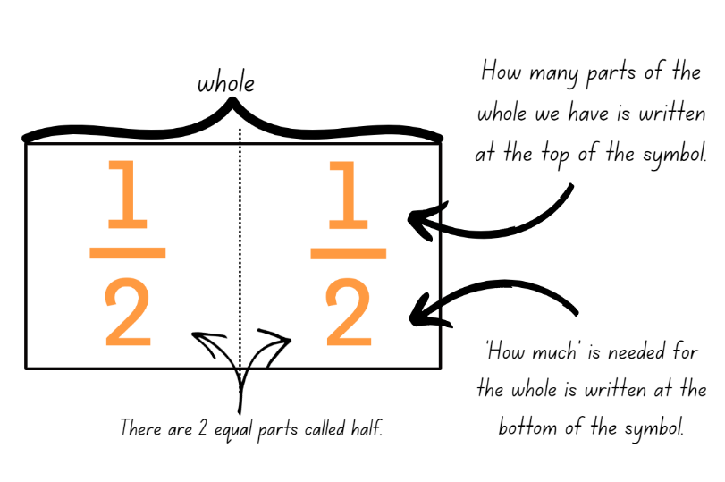
Note: use language that will assist students to develop early fraction ideas. For example, rather than saying ‘one over 2’, ‘one of 2’ or ‘one on 2’ (describing the symbol only) say ‘one half of the whole strip’. The teaching advice states that the terms numerator and denominator are used in Stage 3.
- Discuss the relationship between the numerals in the fraction representing one-half. Guide students to understand that, if the fraction is equal to half, the number of parts we have (numerator) is always half the number representing how much is needed for the whole (denominator).
- Explain that this set of fractions which represent the same value, such as all fractions equal to one-half, are called equivalent fractions.
- Provide students with individual whiteboards. Display Resource 1 – fraction wall.
- Ask students to find fractions equivalent to one-half and record the fractional notation on their whiteboards.
- Ask students to think of examples which are equivalent to one-half that are not shown on the fraction wall. Students record their ideas using fraction notation, concrete materials, diagrams or number lines.
- Students share and explain their reasoning.
- Explain that these fractions have a multiplicative relationship to each other as the number of parts we have is always exactly half of the number of parts that make the whole. For example, a student may reason that $\frac{10}{20}$ is equivalent to one-half because if 20 parts are divided into 2 equal groups, each group will have 10 parts.

Multi-age: students working towards Stage 3 outcomes can be given opportunities to work with larger denominators. When revising fraction notation remind students that a fraction represents the number that results from dividing a unit whole by the number of parts needed to make that whole. For example, the numeral on the bottom, called the denominator, shows how much the whole is, and the numeral on top, called the numerator, shows how many equal parts of the whole are selected.
This table details opportunities for assessment.
Assessment opportunities | Links
What to look for:  - Can Stage 2 students represent the equivalence of fractions with related denominators as lengths, using concrete materials, diagrams and number lines? [MAO-WM-01, MA2-PF-01]  - Can Stage 3 students create equivalent fractions for half by re-dividing the whole, using diagrams and number lines?  [MAO-WM-01, MA3-RQF-01] | Links to National Numeracy Learning Progressions (NNLP):  - Stage 2 – InF5  - Stage 3 – InF6, InF7.

Core lesson – fractions on a number line – 40 minutes
The table below contains suggested learning intentions and success criteria. These are best co-constructed with students.
Core concept learning intentions | Core concept success criteria
Students working towards Stage 2 outcomes are learning to:  - model and represent unit fractions, and their multiples, to a complete whole on a number line  - model equivalent fractions as lengths.  Students working towards Stage 3 outcomes are learning to:  - compare and order common unit fractions  - compare common fractions with related denominators. | Students working towards Stage 2 outcomes can:  - model fractions with fraction strips and number lines for halves, quarters, eighths, thirds  - represent the equivalence of fractions with related denominators as lengths, using concrete materials, diagrams and number lines.  Students working towards Stage 3 outcomes can:  - compare and order unit fractions with denominators of 2, 3, 4, 5, 6, 8 and 10 by placing them on a number line  - order common fractions with related denominators using diagrams and number lines  - record equivalent fractions using diagrams, words and fraction notation.
- Explain that fractions can be represented as parts of a length and as points on a number line (see Figure 2).
Figure 2 – fractions of a line and fraction on a line
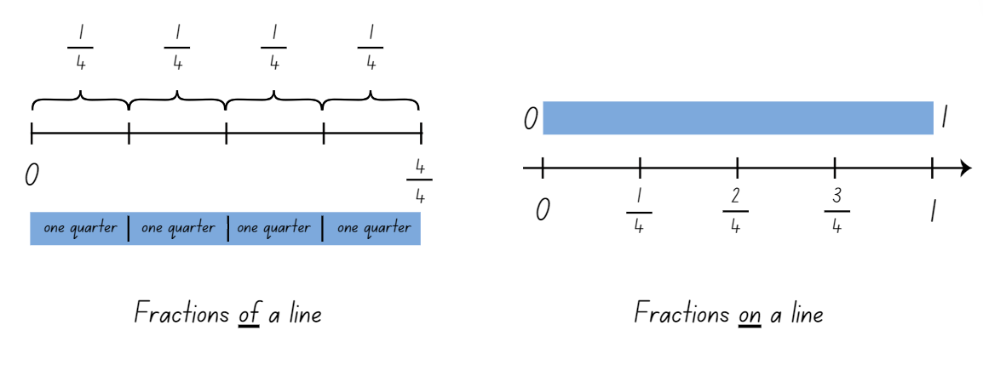
Note: fractions can be represented as a part of a length, on a bar model where each segment is labelled as one fractional part of the whole. For example, one-quarter, one-quarter, one-quarter and one-quarter. Fractions can also be represented as numbers on a number line. The distinction between the two is that fractions of a length indicate a ‘part’ of a line or length and fractions as a number that sit at a ‘point’ on a number line (Gojak and Miles 2018).
- Use Amplify Polypad – Fraction Bars to demonstrate creating a fraction wall showing a whole, halves and quarters. Use the pencil tool to draw and label a number line underneath the wall (see Figure 3).
Figure 3 – fraction bars and number line
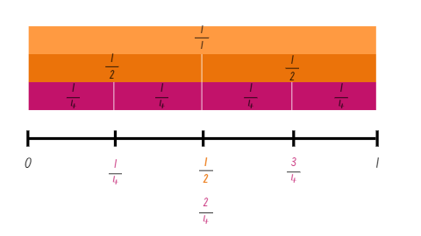
Image created using the free virtual manipulatives at Polypad by Amplify.
- Highlight that $\frac{1}{2}$ and $\frac{2}{4}$ both fall at the same point on the number line and identify that this means they are equivalent fractions.
- Remind students that when fractions are placed on a number line, they represent a number that sits at a point on the number line between 2 whole numbers.
- Draw attention to the way that the symbolic notation for quarter is different on the bar model as equal parts of a length ($\frac{1}{4}$, $\frac{1}{4}$, $\frac{1}{4}$, $\frac{1}{4}$) compared to the number line ($\frac{1}{4}$, $\frac{2}{4}$, $\frac{3}{4}$).
- Provide students with digital devices and ask them to create a fraction wall and number line with a whole, thirds and eighths.
Multi-age: students working towards Stage 3 outcomes can create a fraction wall with a wider variety of denominators.
- Ask students to consider the following questions:
- Are there any equivalent fractions in your fraction wall or on the number line? Why do you think this is?
- Which fraction is larger $\frac{1}{3}$ or $\frac{3}{8}$?
- Is there ever an occasion where $\frac{3}{8}$ is smaller than $\frac{1}{3}$? Why or why not? (Yes, if the whole length divided into thirds is longer than the whole length divided into eighths.)
- Stage 2 students create another fraction wall and number line using Amplify Polypad – Fraction Bars. For example, fifths and tenths or quarters and thirds. Encourage students to identify and record any equivalent fractions.
- Provide Stage 3 students with Resource 2 – fraction cards. Ensure students know how to read these fractions. Explain that that their task is to place these fractions on a number line from 0–3. Students may wish to draw a number line on their whiteboards, mark out a line on the floor using masking tape or use a piece of string.
- Students work with a partner to complete the task.
- Gather students together and ask:
- Which fraction was easiest to place? Why?
- Which fraction did you place on the number line first?
- How did this help you work out where the other fractions would go on the number line?
- What do you notice about the numbers on the denominator?
- Using the word denominator, can you explain why $\frac{1}{2}$ is bigger than $\frac{1}{10}$?
This table details opportunities for differentiation.
Too hard? | Too easy?
Stage 2 students cannot model fractions with fraction strips and number lines or represent the equivalence of fractions with related denominators.  - Provide students with paper strips to fold and partition the whole lengths into fractional parts prior to drawing the number line.  Stage 3 students cannot compare and order unit fractions with denominators of 2, 3, 4, 5, 6, 8 and 10 by placing them on a number line.  - Provide students with paper strips and cards labelled $\frac{1}{2}$, $\frac{1}{4}$, $\frac{1}{8}$ to put on a number line. Support students to fold the paper strips in half, half again and half again to find $\frac{1}{2}$, $\frac{1}{4}$ and $\frac{1}{8}$. Students use these as benchmarks to place unit fractions on a number line. | Stage 2 students can model fractions with fraction strips and diagrams and represent the equivalence of fractions with related denominators.  - Students fold additional strips to extend their fraction wall with fractions using denominators of their own choosing. For example, twelfths and twentieths.  Stage 3 students can compare and order unit fractions with denominators of 2, 3, 4, 5, 6, 8 and 10 by placing them on a number line.  - Pose the following question to students. Which is closer to one, $\frac{4}{5}$ or $\frac{5}{4}$? How do you know?

Discuss and connect the mathematics – 10 minutes
- Display Resource 3 – frog racing. Provide students with writing materials and ask them to represent their solutions using diagrams, fraction symbols, number lines and words.
- Regroup and discuss strategies used to solve the problem.
- In pairs, students create a similar word problem about the frog race for their partner to solve.
- Select several student problems to share with the class. Students solve the tasks, sharing their thinking and reasoning.
This table details opportunities for assessment.
Assessment opportunities | Links
What to look for:  - Can Stage 2 students model fractions with fraction strips and number lines for halves, quarters, eighths, thirds?  [MAO-WM-01, MA2-PF-01]  - Can Stage 2 students represent the equivalence of fractions with related denominators as lengths, using concrete materials, diagrams and number lines? [MAO-WM-01, MA2-PF-01]  - Can Stage 3 students compare and order unit fractions with denominators of 2, 3, 4, 5, 6, 8 and 10 by placing them on a number line? [MAO-WM-01, MA3-RQF-01, MA3-RQF-02]  - Can Stage 3 students order common fractions with related denominators using diagrams and number lines?  [MAO-WM-01, MA3-RQF-01, MA3-RQF-02]  - Can Stage 3 students record equivalent fractions using diagrams, words and fraction notation?  [MAO-WM-01, MA3-RQF-01, MA3-RQF-02] | Links to National Numeracy Learning Progressions (NNLP):  - Stage 2 – InF2, InF3, InF4, InF5  - Stage 3 – InF5, InF6.  Links to suggested Interview for Student Reasoning (IfSR) tasks:  - Stage 3 – IfSR-PT: 1A.2, 1A.3, 2A.9.

Lesson 2
Core concept: recreating the whole from a fractional part.

Daily number sense – equivalent fractions – 10 minutes
The table below contains suggested learning intentions and success criteria. These are best co-constructed with students.
Daily number sense learning intentions | Daily number sense success criteria
Students working towards Stage 2 outcomes are learning to:  - model equivalent fractions as lengths.  Students working towards Stage 3 outcomes are learning to:  - compare common fractions with related denominators. | Students working towards Stage 2 outcomes can:  - identify equivalent fractions with related denominators as lengths.  Students working towards Stage 3 outcomes can:  - record equivalent fractions using diagrams, words and fraction notation.
- Provide students with individual whiteboards. Display Resource 1 – fraction wall.
- Ask students to identify and record any fractions equivalent to $\frac{1}{2}$, $\frac{1}{3}$, $\frac{1}{4}$ and $\frac{1}{5}$ on an individual whiteboard (see Figure 4).
Figure 4 – equivalent fractions
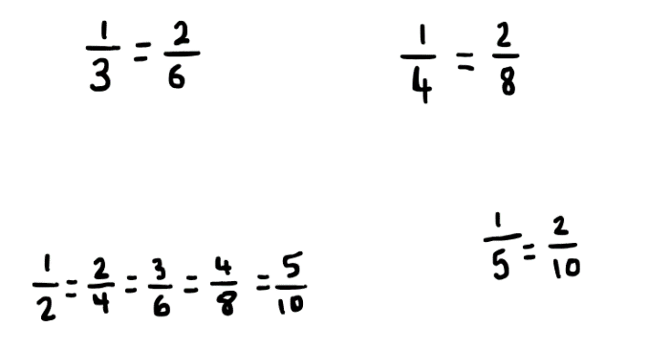
- Ask students what they notice about these groups of fractions. Highlight the multiplicative relationship between the equivalent fractions. For example, a student may reason that $\frac{1}{5}$ is equivalent to $\frac{2}{10}$ because if 10 parts are divided into 5 equal groups, each group will have 2 parts.
- Provide students with strips of paper to fold, model and label the fractions they identify as equivalent.
- Have students use the fraction wall to identify any other equivalent fractions and record these.
Multi-age: students working towards Stage 3 outcomes can work to record equivalent fractions for non-unit fractions such as $\frac{6}{8}$ or $\frac{4}{10}$.
This table details opportunities for assessment.
Assessment opportunities | Links
What to look for:  - Can Stage 2 students identify equivalent fractions with related denominators as lengths? [MAO-WM-01, MA2-PF-01]  - Can Stage 3 students record equivalent fractions using diagrams, words and fraction notation? [MAO-WM-01, MA3-RQF-01] | Links to National Numeracy Learning Progressions (NNLP):  - Stage 2 – InF5  - Stage 3 – InF6, InF7.

Core lesson 1 – missing lengths – 15 minutes
The table below contains suggested learning intentions and success criteria. These are best co-constructed with students.
Core concept learning intentions | Core concept success criteria
Students working towards Stage 2 outcomes are learning to:  - model and represent unit fractions to a complete whole  - model equivalent fractions as lengths.  Students working towards Stage 3 outcomes are learning to:  - recognise the role of the number 1 as representing the whole  - build up to the whole from a given fractional part. | Students working towards Stage 2 outcomes can:  - recreate the whole from a fractional part  - determine the complementary fractional part needed to complete one whole (halves, quarters, eighths, thirds)  - recognise the need to have equal wholes to compare partitioned fractions.  Students working towards Stage 3 outcomes can:  - compare halves and quarters of different-sized wholes  - generate the whole quantity from non-unit fractional parts such as quarters, eighths, thirds, sixths, fifths and tenths.
- Display Resource 4 – missing lengths and ask:
- How could you find the missing fractional part for each length of skipping rope?
- Which skipping rope would be the longest and which would be the shortest? How do you know?
- Ezekial stated that the orange rope must be the longest because a half is bigger than a third or a quarter. Is he correct? Why or why not?
- Provide students with Resource 4 – missing lengths. Students determine the length of each skipping rope.
- Explain that the size of the fractional parts is dependent on the length of the whole.
- Invite students to share their strategies and their work samples to determine which skipping rope is the longest and which is the shortest?

Core lesson 2 – recreating the whole – 25 minutes
- Provide Stage 2 students with a small strip of paper approximately 4 cm in length and writing materials. Use the same strip with each fraction question.
- Pose the following and ask students to represent their thinking by drawing labelled diagrams:
- If the strip is one-half, how long is the whole?
- If your strip is one-third of the whole, how long is the whole?
- If your strip is one-sixth of the whole, label two-sixths, three-sixths, four-sixths, five-sixths and six-sixths of the whole.
- If your strip is enough to make 3 wholes, label one whole?
- Encourage students to come up with 2 questions of their own for a friend to solve.
- Display Resource 5 – building the whole to Stage 3 students. Draw students’ attention to the first bar model and ask: If this is $\frac{3}{5}$ of a bar, what would the whole bar look like?
- With suggestions from Stage 3 students, discuss how to extend the bar to accurately represent the completed whole.
The table below outlines stimulus prompts to generate conversation about the topic, along with anticipated responses from students.
Prompts | Anticipated student responses
- How can the bar be extended accurately to represent the completed whole $\frac{5}{5}$? | - Before we make $\frac{5}{5}$ we need to find how long $\frac{1}{5}$ is.  - The part of the bar shown is $\frac{3}{5}$, so we can find $\frac{1}{5}$ by evenly dividing the part that is shown into three-fifths. This can be done by drawing 2 evenly spaced lines to show 3 equal segments.  - Once we know the size of $\frac{1}{5}$, we can extend the bar by another 2 segments. These are $\frac{2}{5}$ and this now makes the whole bar $\frac{5}{5}$.
- Provide pairs of Stage 3 students with Resource 5 – building the whole. They work with their partner to build each bar up to the whole from the given fractional part.
This table details opportunities for differentiation.
Too hard? | Too easy?
Stage 2 students cannot recreate the whole from a fractional part or determine the complementary fractional part needed to complete one whole (halves, quarters, eighths, thirds).  - Provide students with a strip of paper the length of a third of the green rope, a quarter or the blue rope and half of the red rope. Show students how to use the strips to iterate the length and mark the fractional parts needed to make the whole length of each rope.  Stage 3 students cannot generate the whole quantity from non-unit fractional parts such as quarters, eighths, thirds, sixths, fifths and tenths.  - Provide strips of paper to represent each partial chocolate bar from Resource 5 – building the whole. Support students to fold the strips to show the fractions for each partial chocolate bar. Use the strips to model adding the remaining fractions to make the whole.  - Model how repeated folding can be used to create fraction benchmarks. For example, folding the strip in half, half again and half again shows halves, quarters and eighths. | Stage 2 students can recreate the whole from a fractional part or determine the complementary fractional part needed to complete one whole (halves, quarters, eighths, thirds).  - Students solve problems that extend beyond the whole. For example  - If your strip is enough to make 1$\frac{1}{2}$, how long is one strip?  - If your strip is one-third of a whole what is five-thirds?  Stage 3 students can generate the whole quantity from non-unit fractional parts such as quarters, eighths, thirds, sixths, fifths and tenths.  - Provide students Resource 6 – predicting the whole. They predict which whole bar would give them the most chocolate, then determine the ascending order of the bars. Students complete each bar diagram to test the accuracy of their predictions.  - Students draw and label their own fractional parts of chocolate bars. They swap with another student, who solves them by finding the size of a full bar.

Discuss and connect the mathematics – 10 minutes
- Pose the following problem: Mikayla got $\frac{1}{4}$ of a chocolate bar. Elayna got $\frac{1}{3}$ of a chocolate bar. Mikayla says her piece is bigger. How is this possible?
- Students use writing materials to justify their thinking with a labelled diagram.
Multi-age: students working towards Stage 3 outcomes can be given the following problem: Sofia has $\frac{3}{4}$ of a chocolate bar. Her brother Lucas has $\frac{2}{8}$ of a chocolate bar. Lucas claims that he has more chocolate than Sofia. How can this be true?
- Students share their thinking. Draw attention to the importance of the size of the whole object in determining which fraction has the largest amount. Revise that when there are different sized wholes, the size of the fractional parts is dependent on the whole.
This table details opportunities for assessment.
Assessment opportunities | Links
What to look for:  - Can Stage 2 students recreate the whole from a fractional part? [MAO-WM-01, MA2-PF-01]  - Can Stage 2 students determine the complementary fractional part needed to complete one whole (halves, quarters, eighths, thirds)? [MAO-WM-01, MA2-PF-01]  - Can Stage 2 students recognise the need to have equal wholes to compare partitioned fractions? [MAO-WM-01, MA2-PF-01]  - Can Stage 3 students compare halves and quarters of different sized wholes? [MAO-WM-01, MA3-RQF-01, MA3-RQF-02]  - Can Stage 3 students generate the whole quantity from non-unit fractional parts such as quarters, eighths, thirds, sixths, fifths and tenths? [MAO-WM-01, MA3-RQF-01, MA3-RQF-02] | Links to National Numeracy Learning Progressions (NNLP):  - Stage 2 – InF5  - Stage 3 – InF5

Lesson 3
Core concept: equivalent fractions have related denominators (Stage 2). Compare and represent fractions of a whole shape (the area model) (Stage 3).

Daily number sense – fraction towers – 15 minutes
The table below contains suggested learning intentions and success criteria. These are best co-constructed with students.
Daily number sense learning intentions | Daily number sense success criteria
Students working towards Stage 2 outcomes are learning to:  - model and represent unit fractions, and their multiples, to a complete whole on a number line.  Students working towards Stage 3 outcomes are learning to:  - compare common fractions with related denominators. | Students working towards Stage 2 outcomes can:  - identify and record complementary fractions to complete one whole.  Students working towards Stage 3 outcomes can:  - order common fractions with related denominators using diagrams and number lines  - record equivalent fractions using diagrams, words and fraction notation.
- Display Resource 7 – tower fractions and ask students to record the fractions they can see in each tower.
Multi-age: students working towards Stage 3 outcomes can also record any equivalent fractions that they can see in each tower. Students then place these fractions on a number line. Students can then build their own fraction towers and order the fractions represented on a number line.
- Explain that there are no complementary fractions in Tower A, however there are complementary fractions in Towers B–E. Ask students to consider why this is the case.
- Select a student to record the fraction notation for Tower B as $\frac{1}{6}$ and $\frac{5}{6}$. State that these fractions are complementary as they represent 2 fractional parts needed to complete one whole.
- For Tower D, present the following statements:
- One student represented the fractions as $\frac{1}{6}$, $\frac{1}{6}$, $\frac{1}{6}$, $\frac{1}{6}$, $\frac{1}{6}$ and $\frac{1}{6}$
- A second student represented the fractions as $\frac{3}{6}$ and $\frac{3}{6}$
- A third student represented the fractions as $\frac{1}{2}$ and $\frac{1}{2}$.
- Ask students to provide reasoning as to which statement is correct and why.
- Students share the fraction notation they used to record the remaining towers and discuss complementary fractions and equivalence.
This table details opportunities for assessment.
Assessment opportunities | Links
What to look for:  - Can Stage 2 students identify and record complementary fractions to complete one whole? [MAO-WM-01, MA2-PF-01]  - Can Stage 3 students order common fractions with related denominators using diagrams and number lines?  [MAO-WM-01, MA3-RQF-01]  - Can Stage 3 students record equivalent fractions using diagrams, words and fraction notation? [MAO-WM-01, MA3-RQF-01] | Links to National Numeracy Learning Progressions (NNLP):  - Stage 2 – n/a  - Stage 3 – InF6, InF7.  Links to suggested Interview for Student Reasoning (IfSR) tasks:  - Stage 3 – IfSR-PT: 1A.2, 1A.3

Core lesson – 40 minutes

Stage 2 task – fraction towers
The table below contains a suggested learning intention and success criteria. These are best co-constructed with students.
Core concept learning intention | Core concept success criteria
Students working towards Stage 2 outcomes are learning to:  - model equivalent fractions as lengths. | Students working towards Stage 2 outcomes can:  - represent the equivalence of fractions with related denominators as lengths.
- In small groups, students create 4 towers using interlocking cubes of different colours. Towers must be 4, 5, 8 and 10 cubes high.
- Provide students with writing materials and coloured markers. Students draw number lines and coloured tape diagrams to show the fractional parts of each tower (see Figure 5).
Figure 5 – student example
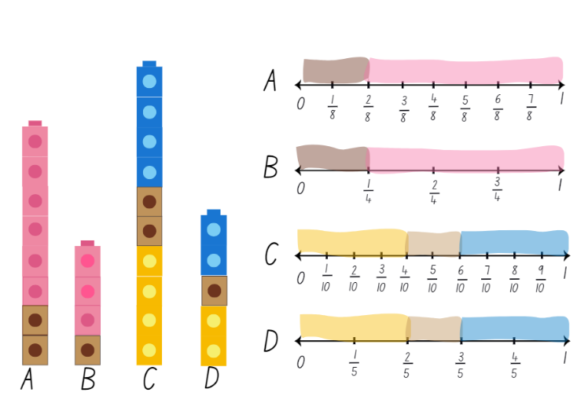
- Display Resource 8 – tower number lines. Ask students if there are any equivalent fractions.
- Highlight that in Towers A and B $\frac{2}{8}$ is equivalent to $\frac{1}{4}$ and $\frac{6}{8}$ is equivalent to $\frac{3}{4}$. Explain that the fractions $\frac{2}{8}$ and $\frac{1}{4}$ are equivalent fractions because their fractional parts are in equal proportion to the whole.
- Ask students if it is possible for a tower of 13 blocks to be built with fractional parts equivalent to Towers A and B. Remind students that both Towers A and B have proportional parts equal to $\frac{1}{4}$ and $\frac{3}{4}$.
- Using interlocking cubes, students test whether 13 blocks can be used to represent $\frac{1}{4}$ and $\frac{3}{4}$.
- Regroup and discuss whether it was possible. Ask students to suggest the number of blocks required to make a tower representing $\frac{1}{4}$ and $\frac{3}{4}$.
This table details opportunities for differentiation.
Too hard? | Too easy?
Students cannot represent the equivalence of fractions with related denominators as lengths.  - Students create towers with 2 and 4 blocks, then 3 and 6 blocks and look for relationships between them. | Students can represent the equivalence of fractions with related denominators as lengths.  - Challenge students to make towers with a different number of blocks. For example, sixths and twelfths. Students identify equivalent fractions.

Discuss and connect the mathematics – 10 minutes
- Display Resource 9 – student work sample. Discuss how Towers A and B and Towers C and D are connected because the number of parts in the whole tower (denominator) are multiplicatively related. Fractions with related denominators are factors/multiples of each other and belong to related fraction families.
- Look at how the colour portions in Tower A are twice as big as those in Tower B, but they can both be described using quarters.
- Ask students if they can identify another name for $\frac{2}{8}$. Provide the answer $\frac{1}{4}$ if not given. Remind students that these are equivalent fractions. Ask students for other names for $\frac{2}{4}$, $\frac{4}{8}$, $\frac{6}{8}$ and $\frac{3}{4}$.
- Select students to rename the equivalent fractions in Towers C and D ( $\frac{2}{10}$, $\frac{1}{5}$, $\frac{4}{10}$, $\frac{2}{5}$, $\frac{6}{10}$, $\frac{3}{5}$, $\frac{8}{10}$, $\frac{4}{5}$ and $\frac{10}{10}$, $\frac{5}{5}$, one).

Stage 3 task – painting pieces
The table below contains a suggested learning intention and success criteria. These are best co-constructed with students.
Core concept learning intention | Core concept success criteria
Students working towards Stage 3 outcomes are learning to:  - compare common fractions with related denominators. | Students working towards Stage 3 outcomes can:  - subdivide the area of a rectangle by both length and width to represent the multiplicative relationship between common fractions.  - compare and represent fractions with denominators of 2, 4 and 8; 3 and 6; 5 and 10 of a whole shape (area model).
This activity is an adaptation of ‘Painting Pieces’ in Mindset Mathematics: Visualizing and Investigating Big Ideas, Grade 4 by Boaler et al. and Fractions Rectangle from NRICH by University of Cambridge.
- Display Resource 10 – painting piece 1. Ask students what fraction the blue square represents if the yellow rectangle is the whole.
- Students turn and talk with a partner and record their thinking on an individual whiteboard. Ask:
- What strategy did you use to determine the fraction covered by the blue square?
- If the blue square is a fraction, how would you describe the yellow rectangle?
- Explain that the rectangle can be divided into 8 squares arranged as 2 by 4 and therefore the blue square represents one-eighth. Model the subdivision of the rectangle on the board if students have not already used this as a strategy (see Figure 6).
Figure 6 – subdividing a rectangle
- Display Resource 11 – painting piece 2. Students turn and talk with a partner to determine the fraction represented by the red and blue square if the yellow square represents the whole. Encourage students to record their thinking on an individual whiteboard. Ask:
- What fraction is represented by the blue square and red square?
- Was it easier to work out the fraction of the blue square or the red square? Why?
- Can you explain how you worked out the fractions by using a drawing?
- How many ways can you represent the fraction covered by the blue square? How could you explain this to someone else using drawings, diagrams or words? (see Figure 7).
- What connections can you make between fractions and multiplication?
Figure 7 – ways of showing a quarter
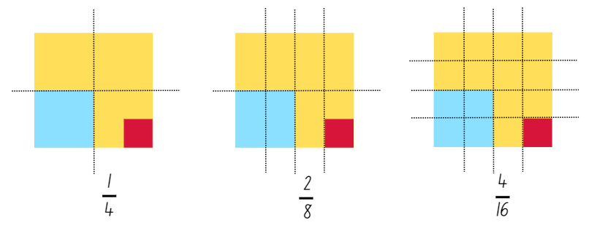
- Provide pairs of students with Resource 12 – painting puzzle. Explain that their task is to determine the fractions covered by the different colours of the painting. Students should annotate the painting to illustrate their thinking. Encourage students to record any equivalent fractions using the appropriate notation.
- Regroup as a stage and have students display their annotations of the painting puzzle and go on a gallery walk. Ask:
- Did you notice any strategies that were different to yours?
- Which colour was the easiest to determine a fraction for?
- What patterns did you notice with the fractions in the painting?
- How did multiplication help you with this task?
This table details opportunities for differentiation.
Too hard? | Too easy?
Students cannot compare and represent fractions with denominators of 2, 4 and 8; 3 and 6; 5 and 10 of a whole shape (area model).  - Support students to use the starting option on Resource 12 – painting puzzle. Students consider how many pink squares would fit along the top and side of the square.  - Use square centimetre grid paper to cut out a rectangle with the dimensions 2 × 3. Show students how thirds can be represented on the rectangle. Then halve each of those thirds to demonstrate how sixths are related to thirds. | Students can compare and represent fractions with denominators of 2, 4 and 8; 3 and 6; 5 and 10 of a whole shape (area model).  - Provide students with Resource 13 – painting conundrum. Students determine the fraction represented by each colour and to record any equivalent fractions using appropriate notation.  - Have students design their own fractional paintings. Students swap paintings with a partner and determine the fractions covered by each colour of the painting.

Discuss and connect the mathematics – 10 minutes
- Provide pairs with a whiteboard and writing materials. Ask the following question: How could you use diagrams and words to show how quarters are related to eighths?
- Select a variety of students that have recorded different diagrams and words. Ask:
- What do you notice?
- Do all the examples show a relationship between quarters and eighths? How?
- What do you still wonder about related fractions?
This table details opportunities for assessment.
Assessment opportunities | Links
What to look for:  - Can Stage 2 students represent the equivalence of fractions with related denominators as lengths? [MAO-WM-01, MA2-PF-01  - Can Stage 3 students subdivide the area of a rectangle by both length and width to represent the multiplicative relationship between common fractions?  [MAO-WM-01, MA3-RQF-01, MA3-RQF-02]  - Can Stage 3 students compare and represent fractions with denominators of 2, 4 and 8; 3 and 6; 5 and 10 of a whole shape (area model)? [MAO-WM-01, MA3-RQF-01, MA3-RQF-02] | Links to National Numeracy Learning Progressions (NNLP):  - Stage 2 – InF5.  - Stage 3 – InF5.  Links to suggested Interview for Student Reasoning (IfSR) tasks:  - Stage 3 – IfSR-PT: 1A.11.

Lesson 4
Core concept: equal wholes are needed to compare partitioned fractions (Stage 2). Fractions are formed by dividing a whole (Stage 3).

Daily number sense – 10 minutes
- From a class need surfaced through formative assessment data, identify a short, focused activity that targets students’ knowledge, understanding and skills. Example activities may be drawn from the following resources:
- Mathematics K–6 resources
- Universal Resources Hub.

Core lesson – 40 minutes

Stage 2 task 1– worm wonderings
The table below contains suggested learning intentions and success criteria. These are best co-constructed with students.
Core concept learning intentions | Core concept success criteria
Students working towards Stage 2 outcomes are learning to:  - create fractional parts of a length using techniques other than repeated halving  - model equivalent fractions as lengths. | Students working towards Stage 2 outcomes can:  - create thirds and fifths of a length  - recognise the need to have equal wholes to compare partitioned fractions  - represent fractions with the same-size whole to make valid comparisons.
- Read the following scenario to students: A cockatoo and a lorikeet each find a worm. The cockatoo ate $\frac{3}{4}$ of its worm and the lorikeet ate $\frac{2}{3}$ of its worm. Which bird had the biggest feed?
- Provide students with writing materials and ask them to communicate their thinking with labelled diagrams, fraction notation and words.
- Explain that when comparing partitioned fractions, the size of the fractional part depends on the size of the whole length. In this scenario, the answer depends on the size of the worms. If the worms were the same sized wholes, then the cockatoo would have eaten more. If, however, the whole worms were different lengths to start with, then either bird could have eaten more.
- Students draw and label 2 worms of the same length, and 2 worms of different lengths to represent this using a diagram.

Stage 2 task 2 – snail racing
- Display Resource 14 – snail racing. Explain that 4 snails made it into the final at the Snail Trail Olympics. The length of the race is the same for each snail. Students determine which snail is the closest to the finish line using the following clues:
- The snail with the blue shell has travelled $\frac{3}{4}$ of the total distance.
- The snail with the orange shell has travelled $\frac{6}{8}$ of the whole track.
- The snail with the purple shell has travelled $\frac{4}{6}$ of the total distance.
- The snail with the green shell has travelled $\frac{8}{10}$ of the whole track.
- Provide students with 4 strips of paper that are equal-sized in length (to represent each snail’s lane) and have students use repeated halving or other techniques to create the fractional parts of the lengths.
- Demonstrate looping the paper to create thirds and fifths (see Figure 8). These strips can then be folded in halves to create sixths and tenths.
Figure 8 – looping to create thirds and fifths
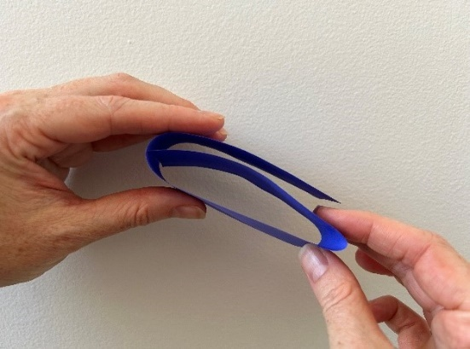
- Students use their strips of paper and writing materials to solve the problem and represent their thinking.
This table details opportunities for differentiation.
Too hard? | Too easy?
Stage 2 students cannot recognise the need to have equal wholes to compare partitioned fractions.  - Fold paper strips of 2 different lengths into half. Show that the different sized lengths created different sized halves.  Stage 2 students cannot create thirds and fifths of a length or represent fractions with the same-size whole to make valid comparisons.  - Provide pre-folded fraction strips. Students identify the distances each snail travelled and mark the position on each strip. | Stage 2 students can recognise the need to have equal wholes to compare partitioned fractions.  - Students create a poster to explain why equal wholes are needed to compare partitioned fractions, using real-life context examples.  Stage 2 students can create thirds and fifths of a length and represent fractions with the same-size whole to make valid comparisons.  - Students explore a snail trail that is not a straight line. For example, a zigzag, wavy line. Students label the distance travelled using fractions.

Discuss and connect the mathematics – 10 minutes
- Regroup as a stage and discuss students’ findings. Ask:
- Which snail is the closest to the finish line?
- Which snail is the furthest from the finish line?
- Did any snails travel the same distance in the race?
- Did you find any equivalent fractions?
- Pose this additional problem: If a fifth snail entered the race, and it was the closest to the finish line, what fraction of the total distance could it have travelled? ($\frac{5}{6}$ or $\frac{7}{8}$ or$\frac{9}{10}$).
- Display Resource 15 – Which one doesn’t belong? and ask students to Think-Pair-Share and solve the task. (C does not belong as all the others are equivalent fractions.)

Stage 3 task – fractions are formed by dividing a whole
The table below contains a suggested learning intention and success criteria. These are best co-constructed with students.
Core concept learning intention | Core concept success criteria
Students working towards Stage 3 outcomes are learning to:  - recognise that a fraction can represent a division. | Students working towards Stage 3 outcomes can:  - identify how the relationship between the number being divided and the divisor is represented in a fraction.
- Display Resource 16 – sharing 3 cakes. Discuss how 3 rectangular cakes could be shared equally between 8 people.
- Explain that repeated halving is one method that can be used to find a solution to sharing problems (see Figure 9).
Figure 9 – repeated halving
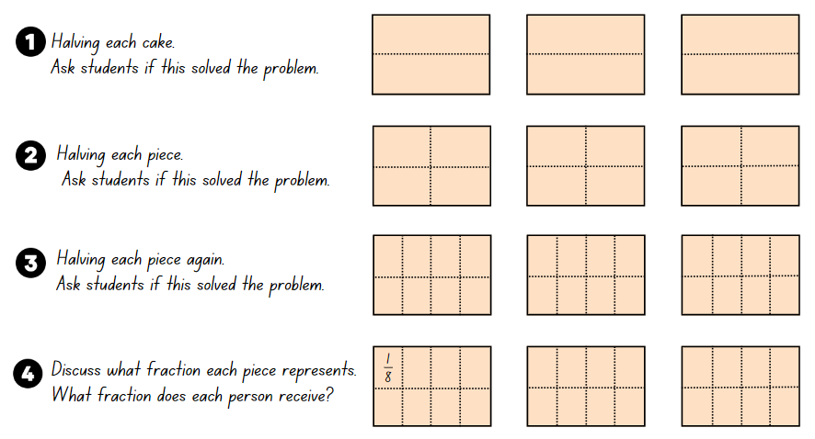
- Each time the cake is halved, record using fractional notation as in Figure 10 and ask students if the problem has been solved.
Figure 10 – halving for 3 cakes between 8 people
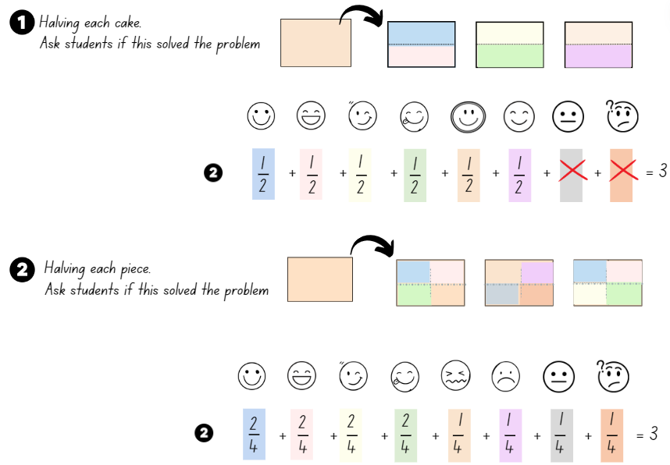
- Explain that splitting the 3 cakes into eighths will mean that each person gets an equal share of three-eighths. Record the number sentence 3 ÷ 8 = $\frac{3}{8}$, showing that each person gets three-eighths of a cake.
- Independently or in small groups, students repeat the process for 5 cakes shared equally between 8 people. Students record diagrams and fractional notation each time they make each piece half the size. Support students to find the correct answer as 5 ÷ 8 = $\frac{5}{8}$, so each person gets five-eighths of a cake.
- Select students to show and explain their working out.
- Pose the problem: How can 2 rectangular cakes be shared equally between 3 people? Ask if repeated halving could solve this problem.
- Discuss how, because these cakes are being shared by 3 people, the halving method will not work. Ask students to turn and talk with a partner to discuss alternate strategies and record them on individual whiteboards.
- Model how each cake is divided into 3 equal pieces and then shared. State that everyone would get 2 pieces each, which is written as 2 ÷ 3 = $\frac{2}{3}$.
- Pose the problem: How can 5 rectangular cakes be equally shared between 6 people?
- Students draw 5 rectangles in their book, find a solution and write a number sentence.
- Discuss solutions and have students share their working out with the class.
- Display all the number sentences found so far:
- 3 ÷ 8 = $\frac{3}{8}$
- 2 ÷ 3 = $\frac{2}{3}$
- 5 ÷ 8 = $\frac{5}{8}$
- 5 ÷ 6 = $\frac{5}{6}$
- Ask students if they can see any patterns. Collect student ideas about how to describe a pattern they noticed and record these on the board. For example, when dividing a whole number by another whole number, the answer can be written as a fraction. The number of cakes will be the denominator and the number of people sharing them will be the numerator.
- Explain that when mathematicians have an idea about why something is happening mathematically, they make a conjecture and then they try to prove it. They try it out on lots of examples to see if it works every time.
- In small groups, students test the conjecture on 3 or more examples using diagrams and number sentences. For example, exploring 6 cakes divided by 8 people, 4 divided by 10, 9 divided by 4 and so on.
- Move between groups, identifying misconceptions and supporting accurate recording using diagrams and fractional notation.
This table details opportunities for differentiation.
Too hard? | Too easy?
Stage 3 students cannot identify how the relationship between the number being divided and the divisor is represented in a fraction.  - Model how to solve the first problem, sharing 3 cakes between 8 people by folding 3 sheets of paper in half, then half again, then half again.  - Support students to colour in the halves, quarters and eighths each time to show what fraction each person gets. | Stage 3 students can identify how the relationship between the number being divided and the divisor is represented in a fraction.  - Students create their own sharing challenge for another student to solve.  - Students solve another student’s sharing challenge using fractional notation and diagrams.

Consolidation and meaningful practice – 15 minutes
- Display 8 rectangles and ask students how they could share these equally between 3 people using the least number of cuts. Together, work out that some cakes can be shared as wholes first. For example, each person could be given 2 whole cakes and the remaining 2 cakes could be partitioned into thirds. When these remaining thirds are shared between 3 people, each person receives two-thirds. Each whole cake is equivalent to three-thirds. Two whole cakes are equivalent to six-thirds. Altogether each person receives eight-thirds or $\frac{8}{3}$.
- Using the pattern found in this lesson, students write and share answers to these questions on individual whiteboards:
- 5 cakes shared between 8 = five-eighths $\frac{5}{8}$
- 3 cakes shared between 8 = three-eighths $\frac{3}{8}$
- 2 cakes shared between 3 = two-thirds $\frac{2}{3}$
- 5 cakes shared between 6 = five-sixths $\frac{5}{6}$
- 5 cakes shared between 10 = five-tenths $\frac{5}{10}$or one-half $\frac{1}{2}$.
This table details opportunities for assessment.
Assessment opportunities | Links
What to look for:  - Can Stage 2 students create thirds and fifths of a length?  [MAO-WM-01, MA2-PF-01]  - Can Stage 2 students recognise the need to have equal wholes to compare partitioned fractions? [MAO-WM-01, MA2-PF-01]  - Can Stage 2 students represent fractions with the same-size whole to make valid comparisons? [MAO-WM-01, MA2-PF-01]  - Can Stage 3 students identify how the relationship between the number being divided and the divisor is represented in a fraction? [MAO-WM-01, MA3-RQF-01, MA3-RQF-02] | Links to National Numeracy Learning Progressions (NNLP):  - Stage 2 – InF4, InF5  - Stage 3 – InF6.  Links to suggested Interview for Student Reasoning (IfSR) tasks:  - Stage 3 – IfSR-MT: 3B.5.

Lesson 5
Core concept: making and exceeding the whole.

Daily number sense – make 500 000 (part 1) – 15 minutes
Daily number sense activities for Lessons 5 to 7 ‘loop’ back to concepts and procedures covered in previous units to assist students to build an increasingly connected network of ideas. These concepts may differ from the core concepts being covered by the unit.
The table below contains suggested learning intentions and success criteria. These are best co-constructed with students.
Daily number sense learning intentions | Daily number sense success criteria
Students working towards Stage 2 outcomes are learning to:  - apply place value to partition, regroup and rename numbers up to 6 digits.  Students working towards Stage 3 outcomes are learning to:  - apply efficient mental and written strategies to solve addition and subtraction problems. | Students working towards Stage 2 outcomes can:  - name thousands using the place value of grouping ones, tens and hundreds of thousands  - use place value to expand the number notation.  Students working towards Stage 3 outcomes can:  - apply efficient strategies to solve addition problems  - use place value to add or subtract 3 or more numbers with different numbers of digits.
- Explain that students will get 6 dice rolls with a 9-sided die to make the closest possible number to 500 000, without going over.
- Provide students with Resource 17 – place value houses and a 9-sided die. After each roll, students need to decide where to place the digit. Once a digit is placed, it cannot be moved.
- After 5 throws, students communicate their reasoning to which number they would most like to be the last dice roll.
- After 6 throws, each student reads out their number to the person next to them. For example, four hundred and ninety-two thousand, five hundred and eighty-one.
- Stage 2 students then use expanded notation to record their number, emphasising the thousands, tens and ones. For example, 400 000 + 90 000 + 2000 + 500 + 80 + 1. As a class, determine who has made the number closest to 500 000. While Stage 3 students roll the die another 5 times to create a 5-digit number and then 4 times to create a 4-digit number. Students then use an efficient strategy to add the 3 rolled numbers together, with the aim of getting the largest number.
- Repeat the process in small groups, playing multiple rounds.
- Regroup as a class, ask:
- What was the closest number you made?
- What strategy did you use to add the numbers? How did you know your solution was correct? (Stage 3)
- Did you change your strategy after playing a few rounds? How?
This table details opportunities for assessment.
Assessment opportunities | Links
What to look for:  - Can Stage 2 students name thousands using the place value grouping of ones, tens and hundreds of thousands?  [MAO-WM-01, MA2-RN-01]  - Can Stage 2 students use place value to expand the number notation? [MAO-WM-01, MA2-RN-01]  - Can Stage 3 students apply efficient strategies to solve addition problems? [MAO-WM-01, MA3-AR-01]  - Can Stage 3 students use place value to add or subtract 3 or more numbers with different numbers of digits?  [MAO-WM-01, MA3-AR-01] | Links to National Numeracy Learning Progressions (NNLP):  - Stage 2 – NPV6, NPV7  - Stage 3 – AdS7, AdS8.

Core lesson – making and exceeding the whole – 45 minutes
The table below contains suggested learning intentions and success criteria. These are best co-constructed with students.
Core concept learning intentions | Core concept success criteria
Students working towards Stage 2 outcomes are learning to:  - represent fractional quantities equal to and greater than one.  Students working towards Stage 3 outcomes are learning to:  - use equivalence to add and subtract fractional quantities. | Students working towards Stage 2 outcomes can:  - rename 2 halves, 3 thirds, 4 quarters, 5 fifths, 6 sixths, 8 eighths and 10 tenths as wholes  - represent totals of halves, thirds, quarters and fifths that extend beyond one.  Students working towards Stage 3 outcomes can:  - represent fractional quantities with the same or related denominators to add and subtract fractions.
- Explain how to play the game ‘Islands’:
- Students slowly move around the classroom.
- Teacher calls out ‘fifths make the whole’.
- Students calculate the number of fifths required to make a whole, quickly form groups of 5 and sit down.
- After all possible groups are formed, discuss how many wholes were created and how many students or fifths are left over. For example, 5 wholes and two-fifths.
- Repeat steps using quarters, thirds, eighths, tenths, sixths and halves.
- Write $\frac{1}{4}$ and $\frac{1}{8}$ on the board. Ask:
- How could you represent these 2 fractions on a fraction line or with a bar model?
- How could you use these models to represent the addition $\frac{1}{4}$ + $\frac{1}{8}$?
- Students turn and talk with a partner to discuss their ideas and record fraction models on whiteboards.
- Ask:
- What strategies did you use?
- How can equivalent fractions help you when solving this addition?
- How could you use a similar drawing to represent $\frac{1}{4}$ − $\frac{1}{8}$? (Stage 3)
- Explain that fraction strips and bar models can help represent fractions and equivalence when adding and subtracting fractions. Demonstrate on the board how a fraction strip can be used to represent $\frac{1}{4}$ + $\frac{1}{8}$ and $\frac{1}{4}$ − $\frac{1}{8}$ (see Figure 11).
Figure 11 – adding and subtracting fractions
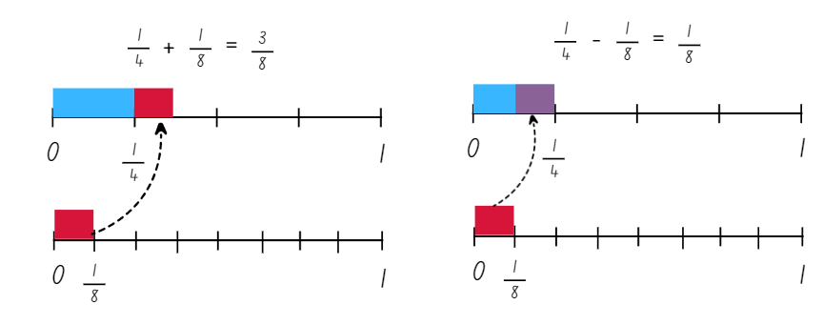
- Take the class outside and explain that students will be playing a modified version of ‘Rob the nest’ that involves fractions.
- Familiarise yourself and students with the game, explaining the rules as follows:
- Divide the class into 4 equal teams and line up behind a team hoop.
- Taking turns, one member from each team collects one coloured beanbag from the communal ‘nest’ and places it in their team’s hoop.
- Repeat this process until the communal nest is empty.
- One at a time, players can now collect one beanbag of their choice from an opponent’s hoop, remembering that teams cannot guard or defend their own hoop.
- After 5 minutes, blow a whistle to signify the end of the round.
- After the initial round, explain that the beanbags are worth different points. Teams apply these fraction values to their beanbags to work out a total:
- green = 1
- red = $\frac{1}{2}$
- blue = $\frac{1}{4}$
- yellow = $\frac{1}{8}$
Multi-age: students working towards Stage 3 outcomes can be given the following fractional values for their bean bags: green = $\frac{1}{3}$, red = $\frac{1}{6}$, blue = $\frac{1}{5}$ and yellow = $\frac{1}{10}$.
- Stage 2 students use Resource 18 – ‘Rob the nest’ scoresheet to record their scores (see Figure 12). Stage 3 students use a whiteboard to draw fraction strips and bar models to record their scores.
Figure 12 – ‘Rob the nest’ scoring example
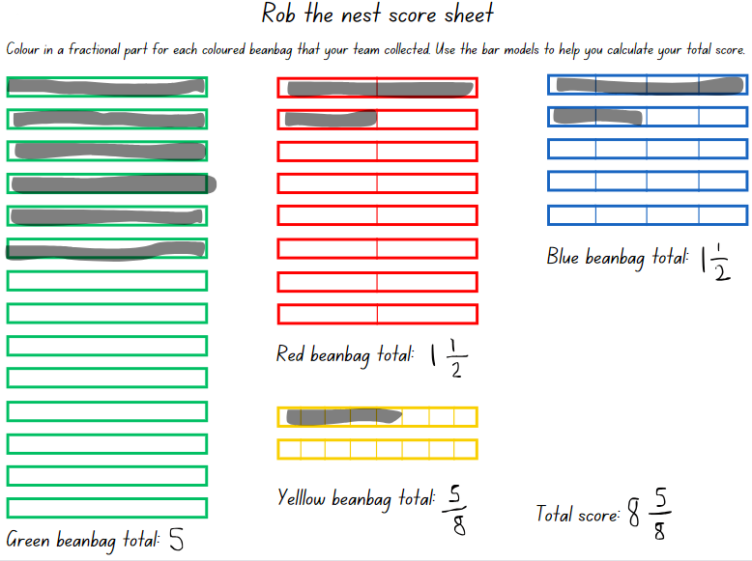
- Ask:
- Did your team collect enough beanbags to represent one or more wholes?
- What strategies did you use when creating wholes?
- What is your team total for each coloured beanbag? How could you combine them? This is the team total.
- Play another round of ‘Rob the nest’. Students may want to be more strategic with their bean bag choices using the known value of beanbag colours as in Step 15. The aim of this round is to create as many wholes as possible, using any beanbag configuration. Points in this round will only be counted for complete wholes.
This table details opportunities for differentiation.
Too hard? | Too easy?
Stage 2 students cannot rename 2 halves, 3 thirds, 4 quarters, 5 fifths, 6 sixths, 8 eighths and 10 tenths as wholes and/or represent totals of halves, thirds, quarters and fifths that extend beyond one.  - Students work with 2 colours of beanbags only, representing halves and quarters.  Stage 3 students cannot represent fractional quantities with the same or related denominators to add and subtract fractions.  - Support students to create fractions of a line using paper strips or interactive fraction bars. Model how these can be used to support calculations and an understanding of equivalence.  - Provide students with a starting fraction such as $\frac{1}{5}$. Students model this using a paper strip. Support students to determine how much more they would need to add to get $\frac{2}{5}$. | Stage 2 students can rename 2 halves, 3 thirds, 4 quarters, 5 fifths, 6 sixths, 8 eighths and 10 tenths as wholes and/or represent totals of halves, thirds, quarters and fifths that extend beyond one.  - Students assign other fraction values to the 4 colours.  Stage 3 students can represent fractional quantities with the same or related denominators to add and subtract fractions.  - Pose the following question to students: The answer is $\frac{2}{5}$. What might the question be? Encourage students to use addition and subtraction in their calculations.  - Provide the following Open Middle task to students. Using any of the digits 1–9, without repeating a digit, fill in the blanks to make a whole number sum, $\frac{?}{?}$ + $\frac{?}{?}$ = _? Can you make all whole numbers from 1–9?

Consolidation and meaningful practice – 10 minutes
- Return to the classroom. Stage 3 students use individual whiteboards to show how they would calculate:
- $\frac{1}{3}$ + $\frac{1}{6}$
- $\frac{3}{5}$ + $\frac{4}{5}$
- The difference between $\frac{3}{4}$ and $\frac{3}{8}$
- How much more is $\frac{7}{10}$ than $\frac{2}{5}$?
- Display Resource 19 – beanbag scoresheet to Stage 2 students.
- Explain that Class 4 Gold recorded the number of beanbags each team collected into a table, but they are unsure which team won.
- Model calculating Team 2’s scores using a think aloud:
- Let's calculate Team 2’s score. Four yellows is equal to 4 wholes. Three blues is equal to three-quarters. Two reds is equal to two-halves which is a whole. Ten greens is equal to ten-eighths. Ten-eighths is going to be more than a whole because eight-eighths is equal to a whole. So, the green beanbags are a whole and two-eighths. Team 2 have scored 6 wholes, with three-quarters and two-eighths left over.
- Ask Stage 2 students to think about how quarters and eighths are related, and if three-quarters and two-eighths can be added to the team score. Model comparing the length of two-eighths and one quarter and demonstrating how three-quarters and two-eighths can be combined to make a whole.
- Provide Stage 2 students with writing materials and in groups, ask students to determine the total for Team 4. Encourage students to use bar models or number lines to support their calculations.
- Regroup and ask all students:
- What strategy did you use to solve this task?
- How did your understanding of equivalent fractions help you with this task?
- How did you represent fractional quantities greater than one whole?
- How did you know when you had made a whole?
- Which complementary fractions did you find?
This table details opportunities for assessment.
Assessment opportunities | Links
What to look for:  - Can Stage 2 students rename 2 halves, 3 thirds, 4 quarters, 5 fifths, 6 sixths, 8 eighths and 10 tenths as wholes?  [MAO-WM-01, MA2-PF-01]  - Can Stage 2 students represent totals of halves, thirds, quarters and fifths that extend beyond one? [MAO-WM-01, MA2-PF-01]  - Can Stage 3 students represent fractional quantities with the same or related denominators to add and subtract fractions?  [MAO-WM-01, MA3-RQF-01] | Links to National Numeracy Learning Progressions (NNLP):  - Stage 2 – InF5.  - Stage 3 – InF8  Links to suggested Interview for Student Reasoning (IfSR) tasks:  - Stage 3 – IfSR-MT: 4B.1, 4B.3.

Lesson 6
Core concept: understanding fractional quantities greater than one. (Stage 2). Compare and represent collections of objects (Stage 3).

Daily number sense – make 500 000 (part 2) – 15 minutes
The table below contains suggested learning intentions and success criteria. These are best co-constructed with students.
Daily number sense learning intentions | Daily number sense success criteria
Students working towards Stage 2 outcomes are learning to:  - apply place value to partition, regroup and rename numbers up to 6 digits.  Students working towards Stage 3 outcomes are learning to:  - apply efficient mental and written strategies to solve addition and subtraction problems. | Students working towards Stage 2 outcomes can:  - name thousands using the place value grouping of ones, tens and hundreds of thousands  Students working towards Stage 3 outcomes can:  - apply efficient strategies to solve subtraction problems  - use place value to add or subtract 3 or more numbers with different numbers of digits.
- Repeat the game ‘Make 500 000’ from Lesson 5 using Resource 17 – place value houses. This time, after the last dice roll, students can swap 2 of their digits. For example, if students have recorded 549 662, they could swap the 5 and the 4 to make 459 662 as this would be closer to 500 000.
- Stage 3 students roll the die another 5 times to create a 5-digit number and then 4 times to create a 4-digit number. Students then use an efficient strategy to subtract the 3 rolled numbers, with the aim of getting the smallest number possible.
- Repeat the game, but this time, the digit swap must be after the fifth dice roll and no change can be made again after the last dice roll.
- Regroup as a class and ask:
- What was the closest number you made?
- Which round did you swap 2 digits and get the best result? Explain.
- What strategy did you use to subtract the numbers? How did you know your solution was correct? (Stage 3)
- Did you change your strategy after playing a few rounds? How?
This table details opportunities for assessment.
Assessment opportunities | Links
What to look for:  - Can Stage 2 students name thousands using the place value grouping of ones, tens and hundreds of thousands?  [MAO-WM-01, MA2-RN-01]  - Can Stage 3 students apply efficient strategies to solve subtraction problems? [MAO-WM-01, MA3-AR-01]  - Can Stage 3 students use place value to add or subtract 3 or more numbers with different numbers of digits?  [MAO-WM-01, MA3-AR-01] | Links to National Numeracy Learning Progressions (NNLP):  - Stage 2 – NPV7  - Stage 3 – AdS7, AdS8.  Links to suggested Interview for Student Reasoning (IfSR) tasks:  - Stage 3 – IfSR-AT: 3A.5.

Core lesson – 40 minutes

Stage 2 task – fractional quantities greater than one
The table below contains a suggested learning intention and success criteria. These are best co-constructed with students.
Core concept learning intention | Core concept success criteria
Students working towards Stage 2 outcomes are learning to:  - represent fractional quantities equal to and greater than one. | Students working towards Stage 2 outcomes can:  - rename 2 halves, 3 thirds, 4 quarters, 5 fifths, 8 eighths and 10 tenths as one whole  - regroup fractional parts beyond one.
Note: when a collection of unit fractions such as 5 quarters exceeds the whole, the reorganisation of the unit parts to form the whole relies upon a clear sense of the whole. Having a unit of measure can make the whole easier to describe. Making and exceeding the whole is an important precursor to using quantity fractions in Stage 3.
- Draw a ribbon on the board and explain that in the ribbon factory, ribbons are always made to be the same length. This drawing represents a whole length of ribbon.
- Explain that fractional parts can be regrouped when representing quantities greater than one whole.
- Pose the following scenario: Marijke needs a piece of ribbon four-thirds the length of the original ribbon.
- Model splitting the initial ribbon into 3 equal parts (thirds) and labelling the ribbon $\frac{3}{3}$. Remind students that one whole can be renamed as three-thirds.
- Draw a second ribbon the same size as the first and add an additional third to the rectangle to represent four-thirds. Label this ribbon, $\frac{4}{3}$ (see Figure 13).
Figure 13 – ribbons
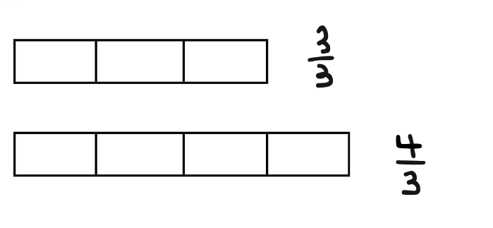
- Provide students with a copy of Resource 20 – ribbon lengths and ask students to draw 3 ribbons underneath each whole length, that are:
- Four-thirds the size of the original ribbon
- Five-quarters the size of the original ribbon
- Three-halves the size of the original ribbon.
- Provide pairs of students with A4 paper and explain that this time they will decide the size of the whole.
- Have students cut a paper strip and write ‘one whole’. Students create additional paper strips that are:
- Five-quarters the size of their strip
- Five-thirds the size of their strip
- Seven-fifths the size of their strip.
- Students glue their original and 3 additional strips onto a piece of A3 paper and label each strip.
This table details opportunities for differentiation.
Too hard? | Too easy?
Stage 2 students cannot rename 2 halves, 3 thirds, 4 quarters, 5 fifths, 8 eighths and 10 tenths as one whole or regroup fractional parts beyond one.  - Students work with one fraction family. For example, halves. Students create ribbon lengths three-halves and four-halves the length of the original ribbon.  - Students work with quarters and create ribbon lengths five-quarters, six-quarters, seven-quarters and eight-quarters the length of the original ribbon. | Stage 2 students can rename 2 halves, 3 thirds, 4 quarters, 5 fifths, 8 eighths and 10 tenths as one whole and regroup fractional parts beyond one.  - Create additional paper strips of alternate fractions that exceed the whole.  - Students determine the complementary fractional part required to make 2 whole strips for each.

Discuss and connect the mathematics – 5 minutes
- Draw a new ribbon on the board. Partition the length into quarters and select a student to draw a second ribbon that represents 6 quarters. The second ribbon will have a length greater than one whole.
- Ask students how they could use their knowledge of fractions to determine the number of quarters required to make 2 wholes or 8 quarters.
- Ask: Which would be longer, a ribbon length four-fifths of the original ribbon or a ribbon length five-quarters of the original ribbon?

Stage 3 task – compare and represent collections of objects
The table below contains suggested learning intentions and success criteria. These are best co-constructed with students.
Core concept learning intentions | Core concept success criteria
Students working towards Stage 3 outcomes are learning to:  - compare common fractions with related denominators  - find fractional quantities of whole numbers (halves, quarters, fifths and tenths). | Students working towards Stage 3 outcomes can:  - compare and represent fractions with denominators of 2, 4 and 8; 3 and 6; 5 and 10 of a collection of objects  - calculate quarters and fifths of whole numbers that are multiples of the denominator, using a tape diagram.
- Pose the following question to students: My vegetable garden has produced 20 carrots. I decide to sell one-quarter of them. How many did I sell?
- Students turn and talk with a partner and record their thinking on an individual whiteboard. Ask:
- How could you represent this problem using a bar model?
- What does the whole bar represent?
- How does multiplication or division help you with this problem?
- If not elicited in class discussion, model how the bar model in this problem represents 20 carrots and that one-quarter of the carrots can be determined by partitioning the bar into 4 equal parts. One-quarter of the carrots would be 5, because 20 ÷ 4 = 5. Draw student’s attention to the use of a common whole, ‘1’, on the number line (see Figure 14).
Figure 14 – bar model example
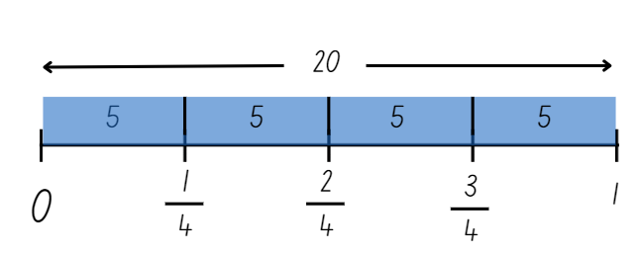
- Model how the bar model can be used to determine three-quarters of the 20 carrots.
- Pose the following problem to students: 40 sheep are out in the field and are ready to be shorn. After a day of shearing, Jasmine says she was able to shear one-quarter and Jamie was able to shear one-fifth. How many sheep did Jasmine and Jamie shear?
- Students turn and talk with a partner and record their thinking on individual whiteboards. Ask:
- What are the different parts of the problem?
- Can the same bar model be used to solve the different parts of the problem?
- What value does the bar represent in your bar model?
- How is this problem similar to the carrot problem? How is it different?
- If Jamie had sheared two-fifths, how many sheep would that be?
- Is it possible for a farmer to shear one-sixth of the sheep? (No, because it is not possible to partition 40 into 6 equal parts. 40 is not a multiple of 6.)
- Students turn and talk and record their ideas on individual whiteboards.
- Display Resource 21 – farmer’s market cards. Explain to students that they will be playing a game with a partner called The Farmer’s Market. The instructions are as follows:
- Have all the cards face up.
- Partner 1 rolls the dice. This will be the denominator for the unit fraction. For example, if a 5 is rolled, the fraction would be $\frac{1}{5}$. If a 1 is rolled, roll again.
- Look at the cards and decide which number you would like.
- Calculate the fraction of the produce card you have picked. For example, if the card is 20 lemons, calculate $\frac{1}{5}$ of 20 = 4.
- Draw a bar model to record your thinking.
- Once a produce card has been used, flip it over. It can no longer be used in this round.
- Partner 2 repeats the same steps.
- If a player rolls a denominator that cannot be used on the cards without a remainder, they miss their turn.
- Continue until all the cards have been used.
- The winner is the player with the largest collection of produce.
- Provide pairs of students with Resource 21 – farmer’s market cards, a 6-sided die and writing materials. Move around the room and support students where necessary.
This table details opportunities for differentiation.
Too hard? | Too easy?
Stage 3 students cannot compare and represent fractions with denominators of 2, 4 and 8; 3 and 6; 5 and 10 of a collection of objects.  - Support students to use a bar model to calculate quarters of a collection starting with a collection of 4, 8 and then 12. Support students to see the connection between multiples and fractions of a collection.  - Provide students with the farmer’s market game cards with the numbers 12, 20, 24, 36 and 40. Students play using halves and quarters of a collection. | Stage 3 students can compare and represent fractions with denominators of 2, 4 and 8; 3 and 6; 5 and 10 of a collection of objects.  - Students play The Farmer’s Market game with two 6-sided dice and roll the dice to determine the numerator and denominator. For example, if a 2 and 3 are rolled, students determine two-thirds of a collection.  - Pose the following problem to students. One-third of Ezri’s pencils are red. One-quarter of her pencils are green. She has 2 more red pencils than green pencils. How many pencils does she have altogether? (Sullivan 2021). How many possibilities are there? What patterns can be seen?  - Have students create their own fractions of a collection problem similar to the one above for a partner to solve.

Discuss and connect the mathematics – 10 minutes
- Regroup Stage 3 students together and reflect on the game. Discuss:
- Which denominator was the best to roll? Why?
- What strategy did you use to get the largest total possible?
- What are some other numbers under 100 that would be useful to have on the game cards?
- What are some numbers under 100 that would not be useful on the game cards? Why?
- What mathematical connections have you made?
Note: Resource 22 – mathematical reasoning prompts can be used to facilitate further discussion of students’ thinking.

Lesson 7
Core concept: number lines extend beyond one (Stage 2). Mathematicians solve problems with fractions (related denominators) (Stage 3).

Daily number sense – jumbled words – 15 minutes
The table below contains suggested learning intentions and success criteria. These are best co-constructed with students.
Daily number sense learning intentions | Daily number sense success criteria
Students working towards Stage 2 outcomes are learning to:  - apply place value to partition, regroup and rename numbers up to 6 digits.  Students working towards Stage 3 outcomes are learning to:  - apply efficient mental and written strategies to solve addition and subtraction problems. | Students working towards Stage 2 outcomes can:  - name thousands using the place value of grouping ones, tens and hundreds of thousands  - use place value to expand the number notation.  Students working towards Stage 3 outcomes can:  - use place value to add or subtract 3 or more numbers with different numbers of digits.
- Write these on the board: six, ninety, thousand, hundred, three, and, one, and, four. Students use all words from the list to make one number. They can add one hyphen to join 2 numbers together, for example, ninety-three. Students write their solution using words and expanded notation. If they find one solution, ask if that is the only solution possible. Example solutions are:
- six hundred and ninety-three thousand, four hundred and one = 600 000 + 90 000 + 3000 + 400 + 1
- four hundred and ninety-six thousand, one hundred and four = 400 000 + 90 000 + 6000 + 100 + 4
- one hundred and four thousand, six hundred and ninety-three = 100 000 + 4000 + 600 + 90 + 3.
- Stage 2 students repeat the process, choosing one option from Resource 23 – What’s the number? Some of these include zero as a challenge.
- Stage 3 students choose 2 options from Resource 23 – What’s the number? making only a 4-digit and a 3-digit number. Students then add and subtract the 3 numbers using efficient strategies, recoding their working on an individual whiteboard.
This table details opportunities for assessment.
Assessment opportunities | Links
What to look for:  - Can Stage 2 students name thousands using the place value grouping of ones, tens and hundreds of thousands?  [MAO-WM-01, MA2-RN-01]  - Can Stage 2 students use place value to expand the number notation? [MAO-WM-01, MA2-RN-01]  - Can Stage 3 students use place value to add or subtract 3 or more numbers with different numbers of digits?  [MAO-WM-01, MA3-AR-01] | Links to National Numeracy Learning Progressions (NNLP):  - Stage 2 – NPV6, NPV7  - Stage 3 – AdS7, AdS8.  Links to suggested Interview for Student Reasoning (IfSR) tasks:  - Stage 3 – IfSR-AT: 3A.5.

Core lesson – 35 minutes

Stage 2 task – number lines extend beyond one
The table below contains suggested learning intentions and success criteria. These are best co-constructed with students.
Core concept learning intentions | Core concept success criteria
Students working towards Stage 2 outcomes are learning to:  - model and represent unit fractions, and their multiples, to a complete whole on a number line  - represent fraction quantities equal to and greater than one. | Students working towards Stage 2 outcomes can:  - determine the fractional part needed to complete two wholes  - represent totals of halves, thirds, quarters and fifths that extend beyond one.
Note: Resource 24 – number lines 0–2 (a) and Resource 25 – number lines 0–2 (b) will be reused in Lesson 8.
- Discuss how five-thirds can be shown in different ways. Students turn and talk, recording ideas on individual whiteboards. Share representations with the class. Representations could include:
- paper strips
- labelled drawings
- a number line
- Display Resource 24 – number lines 0–2 (a). Highlight that the numbers in pink represent whole numbers on the number line.
- Place a transparent counter at zero on the number line divided into thirds and roll a 6-sided die. Move the counter forward that many thirds on the number line.
- Ask students to identify and record the fraction on the board. For example, if a 4 is rolled, students identify it as four-thirds and record $\frac{4}{3}$.
- Students turn and talk to determine how many more thirds would be needed to make 2 wholes. For example, to make 2 wholes from $\frac{4}{3}$ an additional $\frac{2}{3}$ is needed.
- Provide pairs with an enlarged A3 copy of Resource 24 – number lines 0–2 (a), a 6-sided die, transparent counter and writing materials.
- Students take turns rolling the dice and moving the counter that many places along the number line. Students record the fractions that together make 2 wholes, and then swap roles.
- Students begin with the number line partitioned into thirds before moving onto subsequent number lines.
This table details opportunities for differentiation.
Too hard? | Too easy?
Stage 2 students cannot represent totals of halves, thirds and quarters that extend beyond one.  - Students draw coloured rectangular strips above the number line to represent the 2 fractional parts. | Stage 2 students can represent totals of halves, thirds and quarters that extend beyond one.  - Provide students with Resource 25 – number lines 0–2 (b) and a 12-sided dice.

Stage 3 task – adding and subtracting fractions
The table below contains suggested learning intentions and success criteria. These are best co-constructed with students.
Core concept learning intentions | Core concept success criteria
Students working towards Stage 3 outcomes are learning to:  - solve problems involving addition and subtraction of fractions with the same denominator  - use equivalence to add and subtract fractional quantities  - apply efficient mental and written strategies to solve addition and subtraction problems. | Students working towards Stage 3 outcomes can:  - represent the sum of fractions with the same denominator, recreating the whole, where the result may exceed one  - find the difference between fractions with the same denominator and interpret the answer  - represent fractional quantities with the same or related denominators to add and subtract fractions  - solve word problems, including multistep problems.
- Write the following problem on the board. Jun and Ali ordered 2 pizzas of the same size. Ali ate $\frac{4}{5}$ of a whole pizza and Jun ate $\frac{3}{5}$ of a whole pizza. How much pizza is left over? Ask:
- How many wholes are there in this problem? (2 wholes. Each pizza represents one whole.)
- How could this problem be represented using a diagram?
- What strategy could you use to solve this problem?
- Students turn and talk with a partner and record their ideas on individual whiteboards.
- Select a variety of student work samples to share. Ask:
- Can you break the problem into parts? What would the parts be?
- What part of the problem did you solve first?
- How did you represent this using a diagram?
- How much pizza did Ali and Jun eat altogether?
- How much pizza is left over?
- Is there more or less than half of a whole pizza left over? How do you know?
- Provide students with Resource 26 – adding and subtracting fractions and writing materials. Students work individually or in pairs to solve the word problems and represent their thinking using diagrams, words and fractional notation in their workbooks.
- Regroup as a stage and ask:
- How did diagrams help you when solving these problems?
- What ideas have we explored before that were useful in solving this problem?
- How did you understanding of the whole help you when adding and subtracting fractions?
- How were you sure your answer was right?
This table details opportunities for differentiation.
Too hard? | Too easy?
Stage 3 students cannot represent fractional quantities with the same or related denominators to add and subtract fractions.  - Support students to create fractions using paper strips or use interactive fraction bars to solve problems with the same denominators such as problem one and 2 on Resource 26 – adding and subtracting fractions.  - Provide students with word problems that require students to build up to the whole. For example, Marcus has completed $\frac{3}{5}$ of his homework. What fraction does he still need to complete? | Stage 3 students can represent fractional quantities with the same or related denominators to add and subtract fractions.  - Ask students to create their own fraction word problems. Students swap problems with a partner and solve each other’s problems by using diagrams and fractional notation.  - Pose the following Open Middle problem to students. Using any of the digits 1–9, without repeating a digit, fill in the boxes to make the smallest (or largest) difference, $\frac{?}{?}$ − $\frac{?}{?}$

Discuss and connect the mathematics – 10 minutes
- Regroups as a class and display Resource 27 – thirds on a number line and ask:
- What is the same on both number lines?
- What is different about the number lines?
- Explain that $\frac{4}{3}$ represents one whole and one more third. As such, it can be written as $\frac{4}{3}$ or $1\frac{1}{3}$.
- Ask students to recreate a number line of their choice from Resource 24 – number lines 0–2 (a) or Resource 25 – number lines 0–2 (b) and rename the fractions as a whole and the number of additional parts. For example, $\frac{8}{6}$ can be renamed as $1\frac{2}{6}$.
- Ask:
- What ideas have we explored before that were useful in solving this task?
- How did you understanding of the whole help you to solve this task?
- How were you sure your answer was right?
Note: Resource 22 – mathematical reasoning prompts can be used to facilitate further discussion of students’ thinking.
This table details opportunities for assessment.
Assessment opportunities | Links
What to look for:  - Can Stage 2 students determine the complementary fractional part needed to complete two wholes? [MAO-WM-01, MA2-PF-01]  - Can Stage 2 students represent totals of halves, thirds, quarters and fifths that extend beyond one? [MAO-WM-01, MA2-PF-01]  - Can Stage 3 students represent the sum of fractions with the same denominator, recreating the whole, where the result may exceed one? [MAO-WM-01, MA3-RQF-01]  - Can Stage 3 students find the difference between fractions with the same denominator and interpret the answer?  [MAO-WM-01, MA3-RQF-01]  - Can Stage 3 students represent fractional quantities with the same or related denominators to add and subtract fractions?  [MAO-WM-01, MA3-RQF-01]  - Can Stage 3 students solve word problems, including multistep problems? [MAO-WM-01, MA3-AR-01] | Links to National Numeracy Learning Progressions (NNLP):  - Stage 2 – InF5  - Stage 3 – InF7, InF8, AdS8  Links to suggested Interview for Student Reasoning (IfSR) tasks:  - Stage 3 – IfSR-MT: 4B.1, 4B.3.

Lesson 8
Core concept: fractional quantities can be greater than one (Stage 2). Mathematicians solve problems with fractions (fraction of a quantity) (Stage 3).

Daily number sense – 10 minutes
- From a class need surfaced through formative assessment data, identify a short, focused activity that targets students’ knowledge, understanding and skills. Example activities may be drawn from the following resources:
- Mathematics K–6 resources
- Universal Resources Hub.

Core lesson – 45 minutes

Stage 2 task – blank number lines
The table below contains a suggested learning intention and success criteria. These are best co-constructed with students.
Core concept learning intention | Core concept success criteria
Students working towards Stage 2 outcomes are learning to:  - represent fractional quantities equal to and greater than one. | Students working towards Stage 2 outcomes can:  - represent totals of halves, thirds, quarters and fifths that extend beyond one  - determine the relative location of one-quarter and one-half when a number line extends beyond one.
- Display Resource 28 – blank number lines and ask students to determine which fractions are represented by the equidistant points.
- Draw students’ attention to the fact that there are 2 different sized lengths, as indicated by the position of the 1 on each line which represents one whole.
- Provide students with Resource 28 – blank number lines and have them record the missing fractions on the number lines.
- Regroup and display student work samples. Ask students:
- What do you notice about the quarters labelled on the work sample?
- What is the same and what is different? Why?
- Can you identify and record where the position of one-half would be on each number line?
- Provide small groups of students with Resource 29 – roll a whole, transparent counters, MAB and a 6-sided die. Give each student Resource 24 – number lines 0–2 (a).
Note: Resource 24 – number lines 0–2 (a) should be printed on A3 paper to enable easy placement of markers on all the lines.
- Explain the rules, modelling as necessary:
- The aim of the game is to reach exactly 2 on one of the number lines.
- MAB mini cubes are placed at zero on each number line as a marker.
- Each player places a different coloured transparent counter at START on the gameboard.
- The first player rolls a dice and moves the counter on the gameboard.
- This player reads the instruction, moves the MAB mini cube on the appropriate number line and states their new location.
- Continue the game, taking turns and moving along each number line on Resource 24 – number lines 0–2 (a).
- The first player to hit exactly 2 on one of the number lines wins.
- If the player goes over 2 with an instruction, they cannot use that turn.
- If students reach the end of the gameboard with no-one hitting 2, loop back to the start box and the game continues until a 2 is hit.
This table details opportunities for differentiation.
Too hard? | Too easy?
Stage 2 students cannot determine the relative location of one-quarter and one-half when a number line extends beyond one.  - Provide students with completed number lines 0–1 and 0–2 and have them use this as a model to identify the position of the fractions on the blank number line.  Stage 2 students cannot represent totals of halves, thirds, quarters and fifths that extend beyond one.  - Students play the game exploring fifths using a 6-sided die and interconnecting cubes. The student rolls the dice to decide the number of cubes to add. When a student has a whole, or 5 joined interconnecting cubes, they begin to make another whole. The student with the most wholes after 3 minutes of play wins. | Stage 2 students can determine the relative location of one-quarter and one-half when a number line extends beyond one.  - Have students determine the position of thirds and fifths on blank number lines 0–1 and 0–2.  Stage 2 students can represent totals of thirds and quarters that extend beyond one.  - Provide students with Resource 25 – number lines 0–2 (b) and have them play using knowledge of equivalent fractions of thirds/sixths and quarters/eighths.

Stage 3 task – mathematicians solve problems with fractions
The table below contains a suggested learning intention and success criteria. These are best co-constructed with students.
Core concept learning intention | Core concept success criteria
Students are learning to:  - find fractional quantities of whole numbers. | Students can:  - calculate quarters and fifths of whole numbers that are multiples of the denominator, using a tape diagram  - find $\frac{1}{2}$, $\frac{1}{4}$, $\frac{1}{5}$ and $\frac{1}{10}$ of collections.
This activity is an adaptation of Fractions in a box from NRICH by University of Cambridge.
- Explain to students that there is a game which has discs in 7 different colours. These are kept in a flat square box with a square hole for each disc. There are 10 holes in each row and 10 in each column. There is a square instruction booklet with the dimensions 4 squares in length and 4 squares in width, kept in a corner in place of some of the holes.
Note: some students will enjoy the challenge of working out the total number of discs in the box. Others may need support to work out that the booklet takes up 16 spots and subtracting this from 100 to work out that there are 84 discs altogether.
- Display Resource 30 – disc game clues and explain that there are some clues to help solve how the discs fit into the box.
- Provide small groups of students with paper and coloured counters. Groups solve the problem of how to store the discs. They draw a diagram to represent the discs in the box and record the discs as numbers and fractions.
This table details opportunities for differentiation.
Too hard? | Too easy?
Stage 3 students cannot find $\frac{1}{2}$, $\frac{1}{4}$, $\frac{1}{5}$ and $\frac{1}{10}$ of collections.  - Show students the benchmark fractions halves, quarters and twelfths on a fraction wall. Support students to use this with smaller sized collections such as 24.  - Support students to use Resource 31 – disc game box and counters in a 10 × 10 array to solve the problem. | Stage 3 students can find $\frac{1}{2}$ , $\frac{1}{4}$, $\frac{1}{5}$ and $\frac{1}{10}$ of collections.  - Students create their own ‘Store the Discs’ fractions problem with 100 discs or another total with many factors, such as 24 or 48. They swap their problem with another group to solve and discuss the solutions.  - Provide students with Peaches Today, Peaches Tomorrow from NRICH. This task requires students to work with non-unit fractions of 60 peaches.

Discuss and connect the mathematics – 10 minutes
- Regroup as a class and ask:
- How did you use your understanding of fractions today?
- Did you have to change your strategy at any point during the game? Why? (Stage 2)
- Strategically, which square was the best to land on and why? (Stage 2)
- If an instruction square could be added to the game board, what instruction would you choose? (Stage 2)
- How did you record your solution? (Stage 3)
- What number of the discs are orange? Purple? Yellow? The answers are respectively 6, 3 and 4. (Stage 3)
- How are the denominators for pink and blue discs related? And the denominators for purple and orange? (Stage 3)
- Is there more than one solution? The numbers and corresponding fractions of discs are all the same, but this can be represented in many ways. (Stage 3). See Figure 15 for one solution.
Figure 15 – one disc box solution
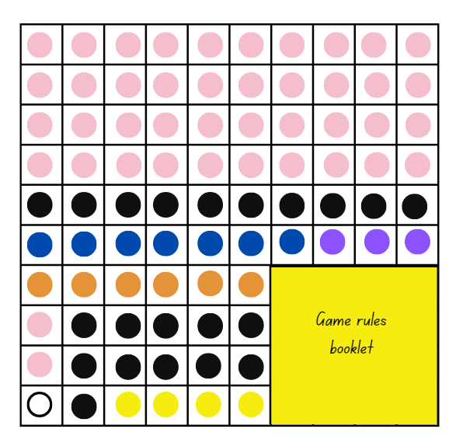

This table details opportunities for assessment.
Assessment opportunities | Links
What to look for:  - Can Stage 2 students represent totals of halves, thirds, quarters and fifths that extend beyond one? [MAO-WM-01, MA2-PF-01]  - Can Stage 2 students determine the relative location of one-quarter and one-half when a number line extends beyond one? [MAO-WM-01, MA2-PF-01]  - Can Stage 3 students calculate quarters and fifths of whole numbers that are multiples of the denominator, using a tape diagram? [MAO-WM-01, MA3-RQF-02]  - Can Stage 3 students find $\frac{1}{2}$, $\frac{1}{4}$, $\frac{1}{5}$ and $\frac{1}{10}$ of collections.?  [MAO-WM-01, MA3-RQF-02] | Links to National Numeracy Learning Progressions (NNLP):  - Stage 2 – InF5, InF6  - Stage 3 – InF8.

Resource 1 – fraction wall
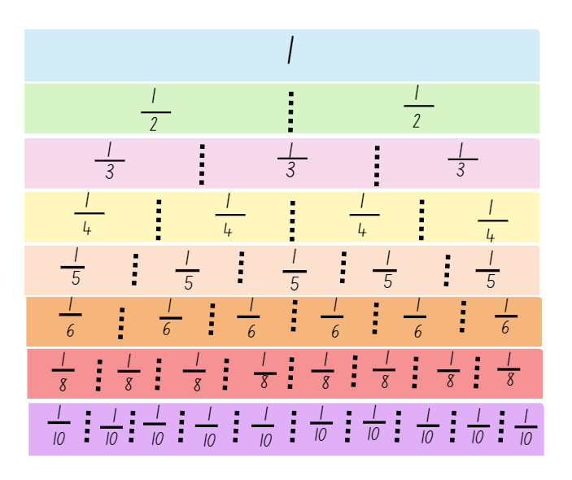

Resource 2 – fraction cards
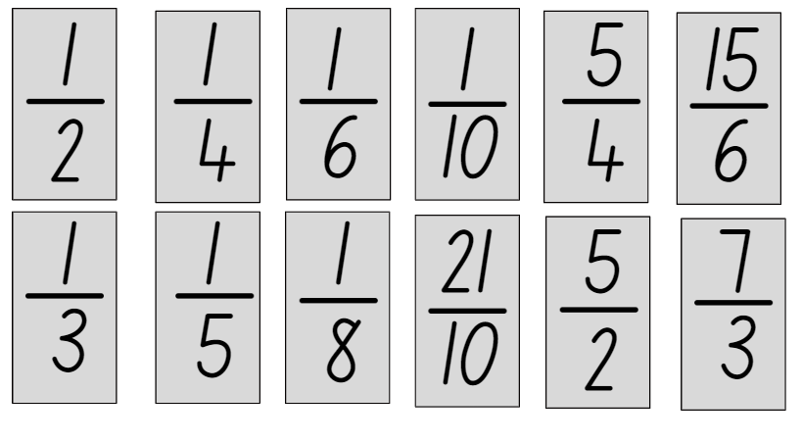

Resource 3 – frog racing
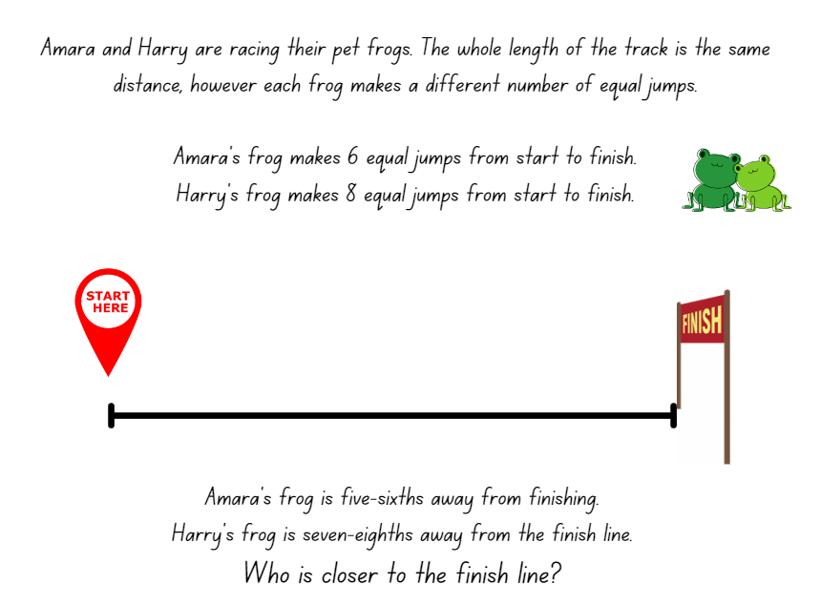

Resource 4 – missing lengths
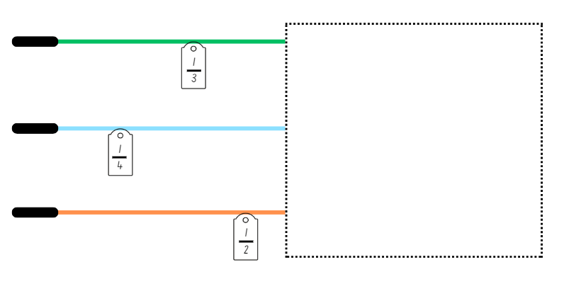

Resource 5 – building the whole
This is $\frac{3}{5}$ of a chocolate bar. Draw an accurate model of what the size of the whole bar would be.

Use each of the given fractions below to draw an accurate model of the size of each whole chocolate bar.
$$\frac{3}{8}$$
$$\frac{2}{3}$$
$$\frac{1}{6}$$
$$\frac{2}{5}$$

Resource 6 – predicting the whole
Look at each of the given fractions. Without drawing a bar diagram of the size of each whole chocolate bar, can you predict which whole bar would give you the most chocolate?
$$\frac{3}{3}$$
$$\frac{2}{6}$$
$$\frac{6}{5}$$
$$\frac{6}{10}$$
Without drawing a bar diagram of each whole chocolate bar, can you arrange the chocolate bars in ascending order of size? Test your predictions by completing the bar diagram of each whole chocolate bar. How accurate were your predictions?

Resource 7 – tower fractions
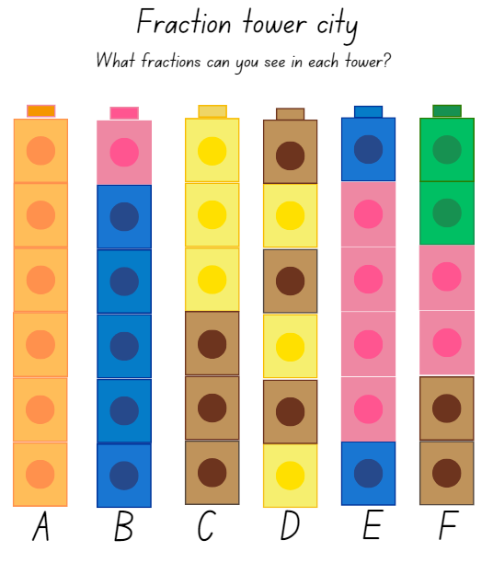

Resource 8 – tower number lines
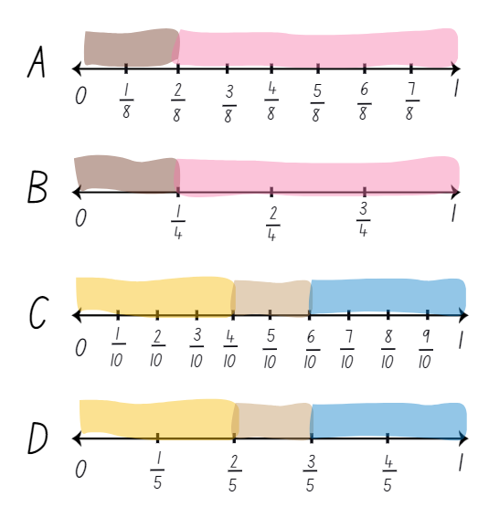

Resource 9 – student work sample
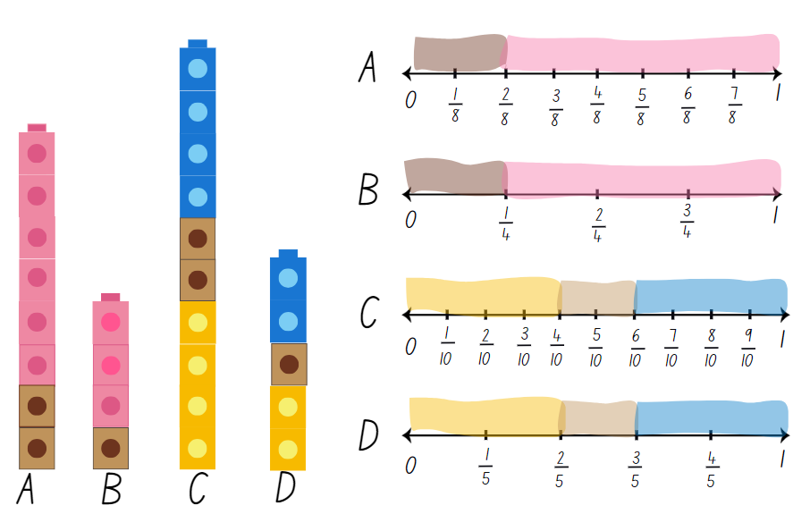

Resource 10 – painting piece 1

Resource 11 – painting piece 2

Resource 12 – painting puzzle
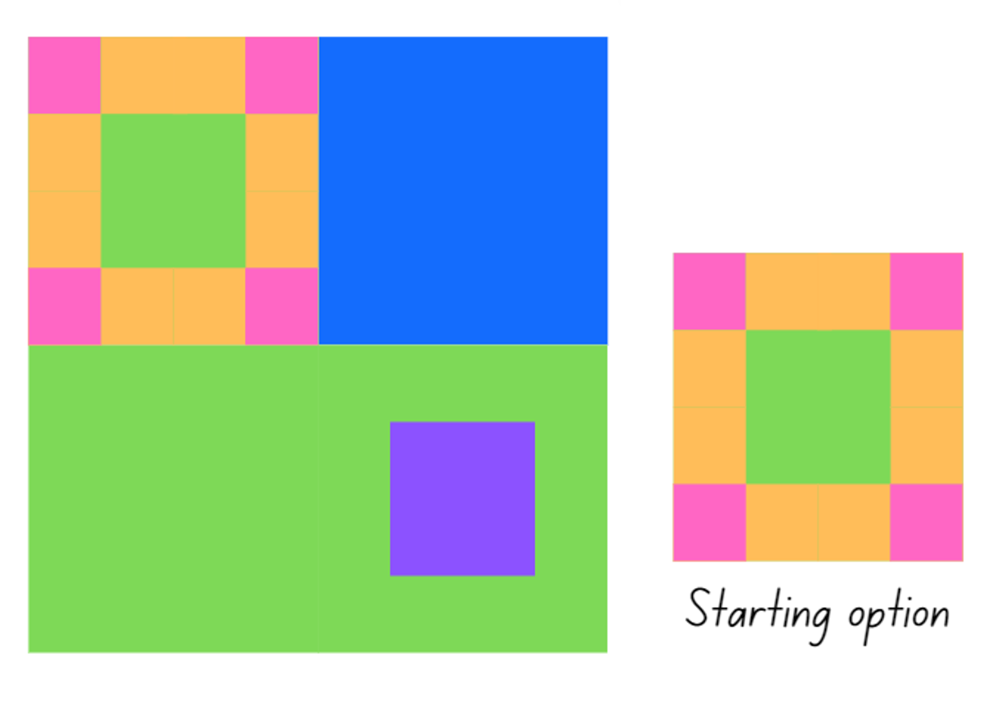

Resource 13 – painting conundrum
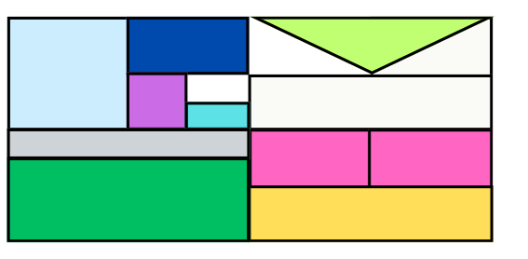

Resource 14 – snail racing

Resource 15 – Which one doesn’t belong?
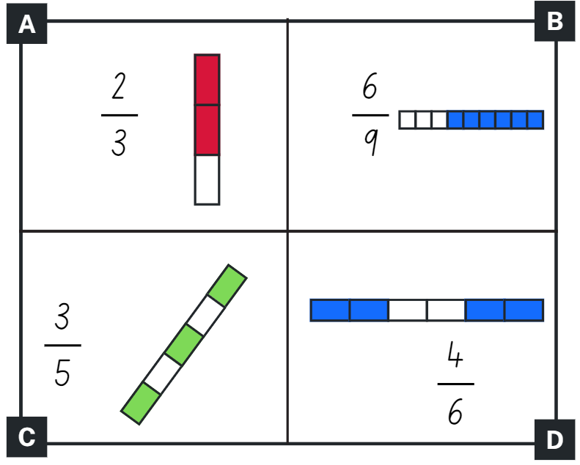

Resource 16 – sharing 3 cakes
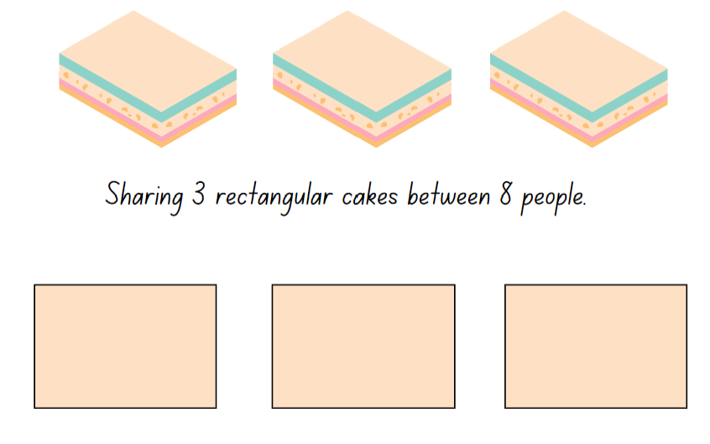

Resource 17 – place value houses
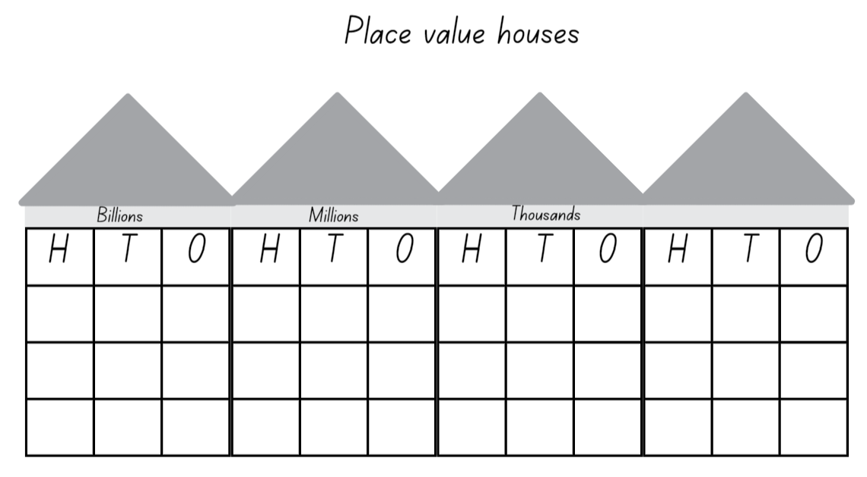

Resource 18 – ‘Rob the nest’ scoresheet
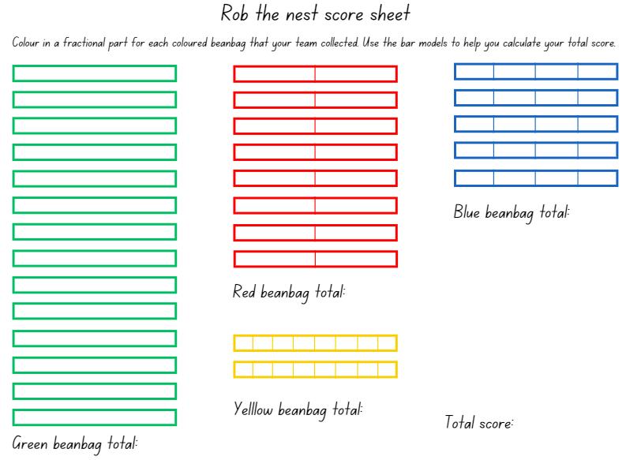

Resource 19 – beanbag scoresheet
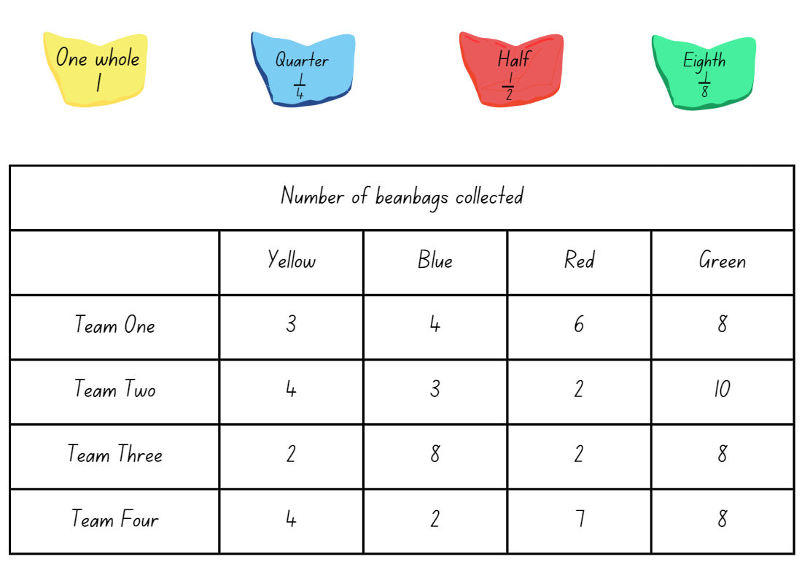

Resource 20 – ribbon lengths
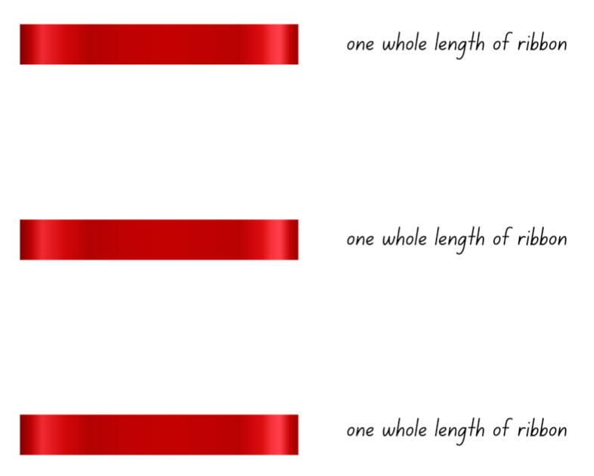

Resource 21 – farmer’s market cards
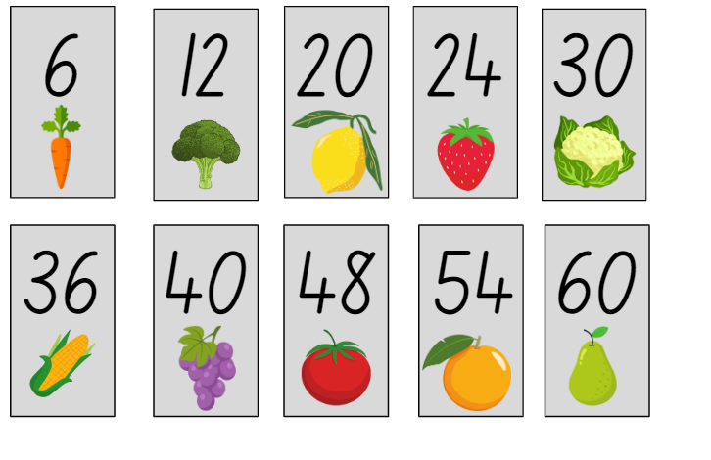

Resource 22 – mathematical reasoning prompts
Questions to prompt mathematical reasoning | Questions for collaborative reasoning | Questions to make connections with mathematical reasoning | Questions to reflect on mathematical reasoning
What is this problem about?  Could you reword that in a simpler way?  How did you begin to think about this problem?  What is another way you could solve this problem?  How could you prove __?  Can you break the problem into parts? What would the parts be?  How could you organise your thinking? | What strategy did you use? Can you convince us why it makes sense?  What do others think about this?  Did anyone get a different answer?  How would you explain this to someone who was away today? | Did you see any mathematical connections or relationships?  What ideas have we explored before that were useful in solving this problem?  Is there a pattern? Is there a general rule?  What was one thing you learned (or two, or more)?  What were the mathematical ideas in this problem?  What are the variables in this problem? What stays constant? | Is this a reasonable answer? Does it make sense?  Why do you think that? Why is that true?  Will that strategy always work?  Can you draw a picture or make a model to show that?  Does anyone want to revise his or her answer?  How were you sure your answer was right?
This resource is adapted from Kersaint (2021).

Resource 23 – What’s the number?
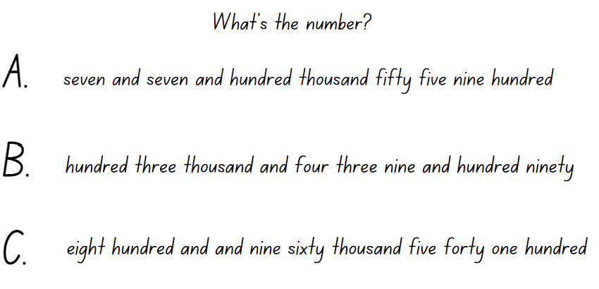

Resource 24 – number lines 0–2 (a)
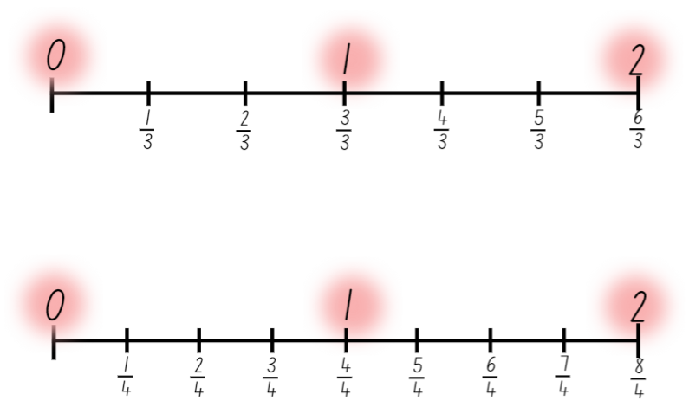

Resource 25 – number lines 0–2 (b)
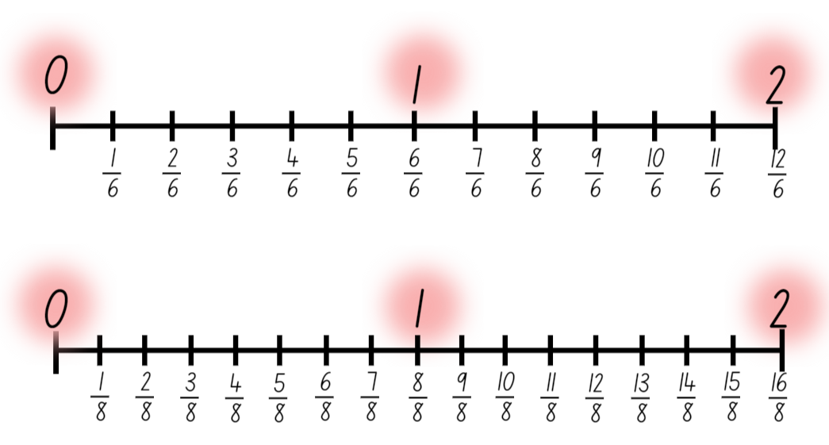

Resource 26 – adding and subtracting fractions
Problem
Indira has a toy collection and gives away $\frac{1}{8}$ to Toni and $\frac{4}{8}$ to Maroun. How much of her toy collection does she have left?
The Chan family drove $\frac{3}{5}$ of their road trip distance on the first day and $\frac{1}{5}$ on the second day. How much of the total distance is left to cover?
Sarah is baking cookies. She uses $\frac{3}{8}$ of a cup of sugar and $\frac{1}{4}$of a cup of chocolate chips. How much more sugar does she use than chocolate chips?
The gardening club planted $\frac{3}{5}$ of a garden with tomatoes and $\frac{3}{10}$ with cucumbers. What fraction of the garden is now planted with vegetables? What fraction of the garden still needs to be planted so that it is full?
Juno painted $\frac{3}{6}$ of the wall blue and $\frac{1}{3}$ of the same wall yellow. What fraction of the wall is not painted?
A construction company completes $\frac{3}{8}$ of a project in the first month and $\frac{1}{4}$ of the project in the second month. If they decide to double the size of the project, what fraction of the project remains unfinished?
Oliver spent $\frac{1}{3}$ of his salary on food and $\frac{2}{6}$ on bills. The rest went into his savings. What fraction of his salary went into savings?

Resource 27 – thirds on a number line
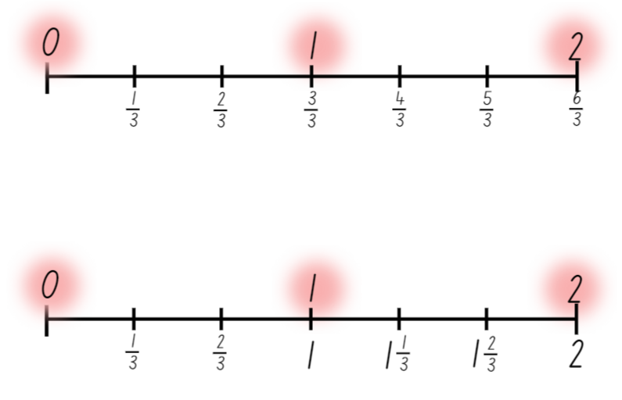

Resource 28 – blank number lines
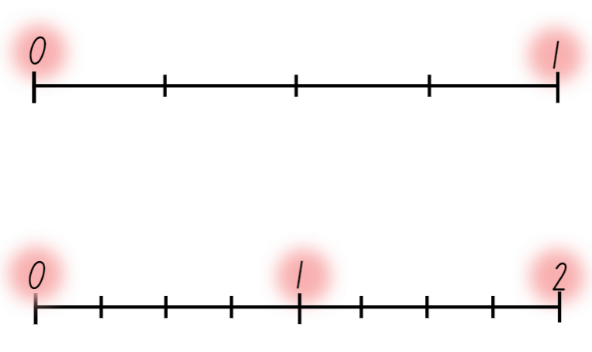

Resource 29 – roll a whole
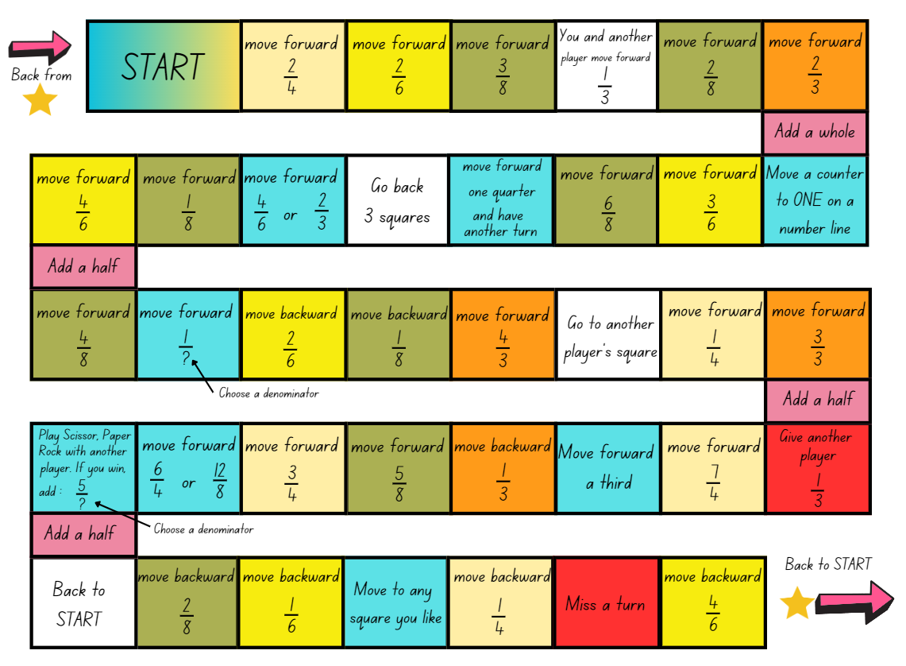

Resource 30 – disc game clues
- There is a different number of discs of each of the 7 colours.
- Half of the discs are pink, one-quarter are black and one-twelfth are blue.
- One complete row (of 10 holes) of the box is filled with all the blue and purple discs.
- One of the shortened rows (that are where the booklet is) is exactly filled with all the orange discs.
- Two of the shortened rows are filled with some of the pink discs and the rest of the pink discs exactly fill a number of complete rows of 10 in the box.
- There is just one white disc and the rest are yellow.

Resource 31 – disc game box
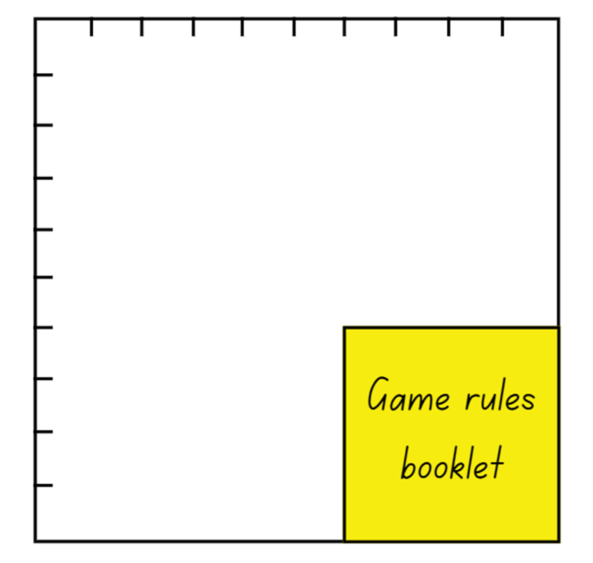

Syllabus outcomes and content

Stage 2
The table below outlines the syllabus outcomes and range of relevant syllabus content covered in this unit. Content is linked to National Numeracy Learning Progression (version 3).
Outcomes and content | 1 | 2 | 3 | 4 | 5 | 6 | 7 | 8
Representing numbers using place value B: Whole numbers: Apply place value to partition, regroup and rename numbers up to 6 digits
[MAO-WM-01, MA2-RN-01]
- Name thousands using the place value grouping of ones, tens and hundreds of thousands |  |  |  |  | x | x | x
- Use place value to expand the number notation |  |  |  |  | x |  | x
Partitioned fractions A: Create fractional parts of a length using techniques other than repeated halving
[MAO-WM-01, MA2-PF-01]
- Make thirds of a length |  |  |  | x
- Create fifths of a length |  |  |  | x
Partitioned fractions A: Model and represent unit fractions, and their multiples, to a complete whole on a number line
[MAO-WM-01, MA2-PF-01]
- Model fractions with fraction strips and diagrams for halves, quarters, eighths, thirds | x
- Determine the complementary fractional part needed to complete one whole (halves, quarters, eighths, thirds) (Reasons about relations) |  | x | x | x |  |  | x
- Recreate the whole unit from a fractional part ($\frac{1}{2}$, $\frac{1}{4}$, $\frac{1}{3}$ and $\frac{1}{8}$) (Reversible reasoning) |  | x
Partitioned fractions B: Model equivalent fractions as lengths
[MAO-WM-01, MA2-PF-01]
- Represent the equivalence of fractions with related denominators as lengths, using concrete materials, diagrams and number lines | x | x | x
- Recognise the need to have equal wholes to compare partitioned fractions (Reasoning about relations) | x | x |  | x
- Represent fractions with the same-size whole to make valid comparisons (denominators of 2, 4 and 8; 3 and 6; 5 and 10) | x |  |  | x
Partitioned fractions B: Represent fractional quantities equal to and greater than one
[MAO-WM-01, MA2-PF-01]
- Rename 2 halves, 3 thirds, 4 quarters, 5 fifths, 6 sixths, 8 eighths and 10 tenths as one whole |  |  |  |  | x | x
- Regroup fractional parts beyond one |  |  |  |  |  | x
- Represent totals of halves, thirds, quarters and fifths that extend beyond one |  |  |  |  | x |  | x | x
- Determine the relative location of one-quarter and one-half when a number line extends beyond one |  |  |  |  |  |  |  | x
Mathematics K–10 Syllabus © NSW Education Standards Authority (NESA) for and on behalf of the Crown in right of the State of New South Wales, 2022.

Stage 3
The table below outlines the syllabus outcomes and range of relevant syllabus content covered in this unit. Content is linked to National Numeracy Learning Progression (version 3).
Outcomes and content | 1 | 2 | 3 | 4 | 5 | 6 | 7 | 8
Additive relations A: Apply efficient mental and written strategies to solve addition and subtraction problems
MAO-WM-01, MA3-AR-01
- Solve word problems, including multistep problems |  |  |  |  |  |  | x | x
- Apply known strategies such as levelling, addition for subtraction, using constant difference, and bridging (Reasons about relations) |  |  |  |  | x | x | x
- Use place value to add or subtract 3 or more numbers with different numbers of digits |  |  |  |  | x | x | x
- Identify efficient and inefficient multidigit subtraction strategies |  |  |  |  |  | x
Representing quantity fractions A: Recognise the role of the number 1 as representing the whole
MAO-WM-01, MA3-RQF-01
- Compare halves and quarters of different sized wholes | x | x
- Justify the need for fractions to refer to the number 1 as the common whole (Reasons about quantity) |  | x
Representing quantity fractions A: Compare and order common unit fractions
MAO-WM-01, MA3-RQF-01
- Compare and order unit fractions with denominators of 2, 3, 4, 5, 6, 8 and 10 by placing them on a number line | x |  | x
Representing quantity fractions A: Solve problems involving addition and subtraction of fractions with the same denominator
MAO-WM-01, MA3-RQF-01, MA3-RQF-02
- Represent the sum of fractions with the same denominator, recreating the whole, where the result may exceed one |  |  |  |  | x |  | x
- Find the difference between fractions with the same denominator and interpret the answer |  |  |  |  | x |  | x
- Solve word problems that involve fractions with the same denominator |  |  |  |  |  |  | x
- Use diagrams, objects and mental strategies to subtract a unit fraction from any whole number including 1 (the complement principle) |  |  |  |  | x |  | x
Representing quantity fractions B: Recognise that a fraction can represent a division
MAO-WM-01, MA3-RQF-01
- Identify how the relationship between the number being divided and the divisor is represented in a fraction |  |  |  | x
Representing quantity fractions B: Compare common fractions with related denominators
MAO-WM-01, MA3-RQF-01, MA3-RQF-02
- Order common fractions with related denominators using diagrams and number lines | x |  | x
- Subdivide the area of a rectangle by both length and width to represent the multiplicative relationship between common fractions |  |  | x
- Compare and represent fractions with denominators of 2, 4 and 8; 3 and 6; 5 and 10 of a whole shape (area model) and a collection of objects (discrete model) |  |  | x |  |  | x |  | x
- Create equivalent fractions for half in quarters, eighths, sixths and tenths by re-dividing the whole, using diagrams and number lines | x | x | x
- Record equivalent fractions using diagrams, words and fraction notation | x | x | x
Representing quantity fractions B: Build up to the whole from a given fractional part
MAO-WM-01, MA3-RQF-01, MA3-RQF-02
- Generate the whole quantity from non-unit fractional parts such as quarters, eighths, thirds, sixths, fifths and tenths (Reversible reasoning) |  | x
Representing quantity fractions B: Use equivalence to add and subtract fractional quantities
MAO-WM-01, MA3-RQF-02
- Solve word problems involving adding or subtracting fractional quantities with related denominators |  |  |  |  |  |  | x
- Represent fractional quantities with the same or related denominators to add and subtract fractions (Reasons about relations) |  |  |  |  | x |  | x
Representing quantity fractions B: Find fractional quantities of whole numbers (halves, quarters, fifths and tenths)
MAO-WM-01, MA3-RQF-02
- Calculate quarters and fifths of whole numbers that are multiples of the denominator, using a tape diagram |  |  |  |  |  | x |  | x
- Solve word problems involving a fraction of a quantity |  |  |  |  |  | x |  | x
Mathematics K–10 Syllabus © NSW Education Standards Authority (NESA) for and on behalf of the Crown in right of the State of New South Wales, 2022.

References
This resource contains NSW Curriculum and syllabus content. The NSW Curriculum is developed by the NSW Education Standards Authority. This content is prepared by NESA for and on behalf of the Crown in right of the State of New South Wales. The material is protected by Crown copyright.
Please refer to the NESA Copyright Disclaimer for more information https://educationstandards.nsw.edu.au/wps/portal/nesa/mini-footer/copyright.
NESA holds the only official and up-to-date versions of the NSW Curriculum and syllabus documents. Please visit the NSW Education Standards Authority (NESA) website https://educationstandards.nsw.edu.au/wps/portal/nesa/home and the NSW Curriculum website https://curriculum.nsw.edu.au/.
Mathematics K–10 Syllabus © NSW Education Standards Authority (NESA) for and on behalf of the Crown in right of the State of New South Wales, 2022.
National Numeracy Learning Progression © Australian Curriculum, Assessment and Reporting Authority (ACARA) 2010 to present, unless otherwise indicated. This material was downloaded from the Australian Curriculum website (National Numeracy Learning Progression) (accessed 9 February 2024) and was not modified.
Amplify Education (2024) Amplify Polypad – Fraction Bars, Amplify Polypad website, accessed 21 February 2024.
Boaler J, Munson J and Williams C (2021) Mindset Mathematics: Visualizing and Investigating Big Ideas, Grade 1, Jossey-Bass, New Jersey.
Gojak LM and Miles RH (2018) Your Mathematics Standards Companion, Grades 3–5, Corwin Mathematics and National Council of Teachers of Mathematics, United States of America.
Kaplinsky O (2024) Adding fractions to make a whole number, Open Middle website, accessed 30 January 2024.
Kaplinsky R (2024) Subtracting fractions, Open Middle website, accessed 30 January 2024.
Kersaint G (2021) 100 questions that promote mathematical discourse, Curriculum Associates, LLC website, accessed 30 January 2024.
Sullivan P (2021) Building Engagement for Middle Years Mathematics: Learning sequences for mixed-ability classrooms, Oxford University Press Australia and New Zealand.
University of Cambridge (n.d.) Fractional Wall, NRICH website, accessed 30 January 2024.
University of Cambridge (n.d.) Fractions in a Box, NRICH website, accessed 30 January 2024.
University of Cambridge (n.d.) Fractions Rectangle, NRICH website, accessed 30 January 2024.
University of Cambridge (n.d.) Peaches Today, Peaches Tomorrow, NRICH website, accessed 30 January 2024.

© State of New South Wales (Department of Education), 2024
The copyright material published in this resource is subject to the Copyright Act 1968 (Cth) and is owned by the NSW Department of Education or, where indicated, by a party other than the NSW Department of Education (third-party material).
Copyright material available in this resource and owned by the NSW Department of Education is licensed under a Creative Commons Attribution 4.0 International (CC BY 4.0) license.
This license allows you to share and adapt the material for any purpose, even commercially.
Attribution should be given to © State of New South Wales (Department of Education), 2024.
Material in this resource not available under a Creative Commons license:
- the NSW Department of Education logo, other logos and trademark-protected material
- material owned by a third party that has been reproduced with permission. You will need to obtain permission from the third party to reuse its material.
Links to third-party material and websites
Please note that the provided (reading/viewing material/list/links/texts) are a suggestion only and implies no endorsement, by the New South Wales Department of Education, of any author, publisher, or book title. School principals and teachers are best placed to assess the suitability of resources that would complement the curriculum and reflect the needs and interests of their students.
If you use the links provided in this document to access a third-party's website, you acknowledge that the terms of use, including licence terms set out on the third-party's website apply to the use which may be made of the materials on that third-party website or where permitted by the Copyright Act 1968 (Cth). The department accepts no responsibility for content on third-party websites.

