Mathematics 3–6 Multi-age – Year A – Unit 8

Contents
Unit description and duration 7
Syllabus outcomes 7
Stage 2 8
Stage 3 8
Working mathematically 9
Student prior learning 9
Lesson overview and resources 15
Lesson 1 23
Daily number sense – making a whole – 15 minutes 23
Core lesson – 40 minutes 27
Stage 2 task – tools used in mapping 27
Stage 3 task – locating a fly 32
Discuss and connect the mathematics – 10 minutes 39
Lesson 2 43
Daily number sense – comparing fractions to make one whole – 15 minutes 43
Core lesson – 40 minutes 47
Stage 2 task – navigating landmark maps 47
Stage 3 task – library ladders 50
Discuss and connect the mathematics – 10 minutes 54
Lesson 3 57
Daily number sense – number lines – 15 minutes 57
Core lesson – 40 minutes 60
Stage 2 task – grid references 60
Stage 3 task – navigating the plane 65
Discuss and connect the mathematics – 5 minutes 69
Lesson 4 71
Daily number sense – 10 minutes 71
Core lesson – 40 minutes 71
Stage 2 task – everyday application of directions 71
Stage 3 task – coordinate patterns 74
Discuss and connect the mathematics – 10 minutes 79
Lesson 5 81
Daily number sense – target number – 10 minutes 81
Core lesson 1 – language of chance – 20 minutes 83
Stage 2 – two and one – 25 minutes 86
Stage 3 – in between – 25 minutes 88
Discuss and connect the mathematics – 10 minutes 91
Lesson 6 96
Daily number sense – closest number – 10 minutes 96
Core lesson – 40 minutes 99
Stage 2 task – fair and unfair 99
Stage 3 task – equally likely outcomes 103
Discuss and connect the mathematics – 15 minutes 110
Lesson 7 112
Daily number sense – closest to... – 10 minutes 112
Core lesson – 40 minutes 114
Stage 2 task – equal chance 114
Stage 3 task – fair but random 116
Discuss and connect the mathematics – 10 minutes 122
Lesson 8 124
Daily number sense – 10 minutes 124
Core lesson – 40 minutes 124
Stage 2 task – combinations 124
Stage 3 task – sample sizes 128
Discuss and connect the mathematics – 10 minutes 134
Resource 1 – fraction words and cards 136
Resource 2 – fraction picture cards 137
Resource 3 – Stage 2 position representations 138
Resource 4 – Stage 3 position representations 139
Resource 5 – shape guess line 140
Resource 6 – shape guess space 141
Resource 7 – blank Cartesian plane 142
Resource 8 – labelled plane cartoons 143
Resource 9 – landmark map 144
Resource 10 – library ladder 145
Resource 11 – colour library ladder 146
Resource 12 – bookshelf 1 and 2 147
Resource 13 – landmark map with grid 148
Resource 14 – journey to Numberland 149
Resource 15 – Cartesian plane 150
Resource 16 – carrot hunt 151
Resource 17 – supermarket map 152
Resource 18 – supermarket instructions 1 and 2 153
Resource 19 – 100 square grid 154
Resource 20 – target and directional cards 155
Resource 21 – Stage 2 chance representations 156
Resource 22 – Stage 3 chance representations 157
Resource 23 – chance statements 158
Resource 24 – carnival games 159
Resource 25 – numerical phrases 160
Resource 26 – colloquial terms 161
Resource 27 – cards and strips 162
Resource 28 – What is fair? 163
Resource 29 – fairness reference sheet 164
Resource 30 – random generators 165
Resource 31 – carnival host vs player 166
Resource 32 – sentence stems 167
Resource 33 – fair and unfair 168
Resource 34 – equally likely cartoons 169
Resource 35 – mystery bags 170
Resource 36 – mystery bags support 171
Resource 37 – dot plot match 172
Resource 38 – frequency thinking 173
Resource 39 – coloured cubes key 174
Resource 40 – two dice bingo 175
Resource 41 – chance bingo 176
Resource 42 – bingo set up 177
Syllabus outcomes and content 178
Stage 2 178
Stage 3 183
References 189
Further reading 191

Unit description and duration
This unit develops the big idea that visual representations help understand aspects of our world (chance and position).
In this 2-week unit students are provided opportunities to:
- use directional language to interpret and locate positions on a grid map while describing routes between points (Stage 2)
- predict and describe possible outcomes from chance experiments (Stage 2)
- compare different position systems, including Cartesian coordinates, to define precise points on a coordinate plane (Stage 3)
- understand that probability can be represented numerically between zero to one (Stage 3)
- present probability outcomes and create random generators (Stage 3)
- use visualisation, language and multiple representations of position and chance concepts. (Stage 2 and Stage 3).

Syllabus outcomes
- MAO-WM-01 develops understanding and fluency in mathematics through exploring and connecting mathematical concepts, choosing and applying mathematical techniques to solve problems, and communicating their thinking and reasoning coherently and clearly

Stage 2
- MA2-AR-01 selects and uses mental and written strategies for addition and subtraction involving 2- and 3-digit numbers
- MA2-PF-01 represents and compares halves, quarters, thirds and fifths as lengths on a number line and their related fractions formed by halving (eighths, sixths and tenths)
- MA2-GM-01 uses grid maps and directional language to locate positions and follow routes
- MA2-2DS-02 performs transformations by combining and splitting two-dimensional shapes
- MA2-CHAN-01 records and compares the results of chance experiments

Stage 3
- MA3-AR-01 selects and applies appropriate strategies to solve addition and subtraction problems
- MA3-RQF-01 compares and orders fractions with denominators of 2, 3, 4, 5, 6, 8 and 10
- MA3-GM-01 locates and describes points on a coordinate plane
- MA3-DATA-01 constructs graphs using many-to-one scales
- MA3-DATA-02 interprets data displays, including timelines and line graphs
- MA3-CHAN-01 conducts chance experiments and quantifies the probability

Working mathematically
In the Mathematics K–10 Syllabus, there is one overarching Working mathematically outcome (MAO-WM-01). The Working mathematically processes should be embedded within the concepts being taught. The Working mathematically processes present in the Mathematics K–10 Syllabus are:
- communicating
- understanding and fluency
- reasoning
- problem solving.
Mathematics K–10 Syllabus © NSW Education Standards Authority (NESA) for and on behalf of the Crown in right of the State of New South Wales, 2022.

Student prior learning
Before engaging in these teaching and learning activities, students would benefit from prior experience with:
- describing and following directions to positions and objects in models and drawings
- interpreting simple maps by identifying objects in different locations
- identifying and describing the chance of possible outcomes for familiar activities and events
- using directional language to interpret and locate positions on a grid map while describing routes between points (Stage 3)
- predicting possible outcomes from chance experiments (Stage 3).
In NSW classrooms there is a diverse range of students, including Aboriginal and Torres Strait Islander students, students learning English as an additional language or dialect, high potential and gifted students and students with disability. Some students may identify with more than one of these groups or possibly all of them. Refer to Curriculum planning for every student – advice for further information.

Teachers can support student learning and reasoning in this unit by connecting language, representations and visualisation for both position and chance, see Figures 1 to 4. This model of support is adapted from content provided by Adjunct Professor Marj Horne in ‘Big ideas to start strong across K–6’ – Module 3 NSW DOE (2023).
Figure 1 – pedagogical support – Stage 2 position
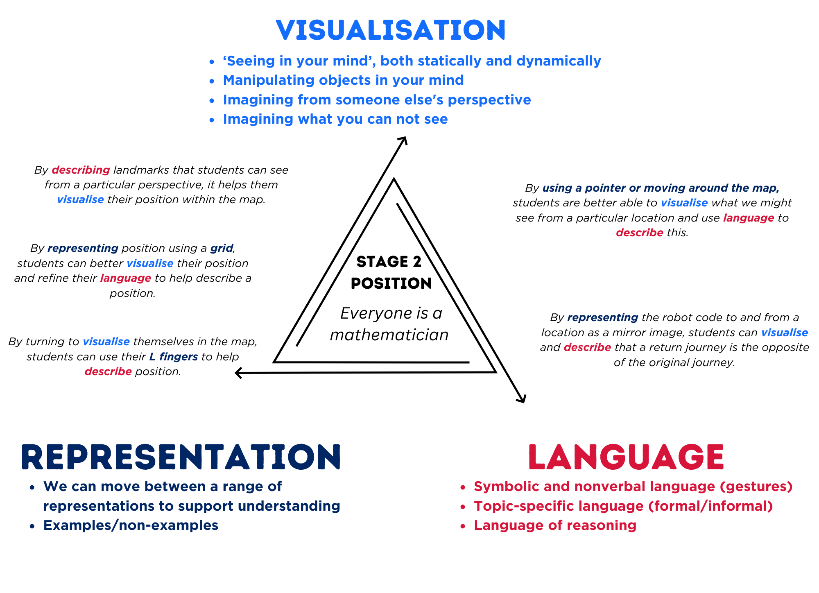
Figure 2 – pedagogical support – Stage 2 chance
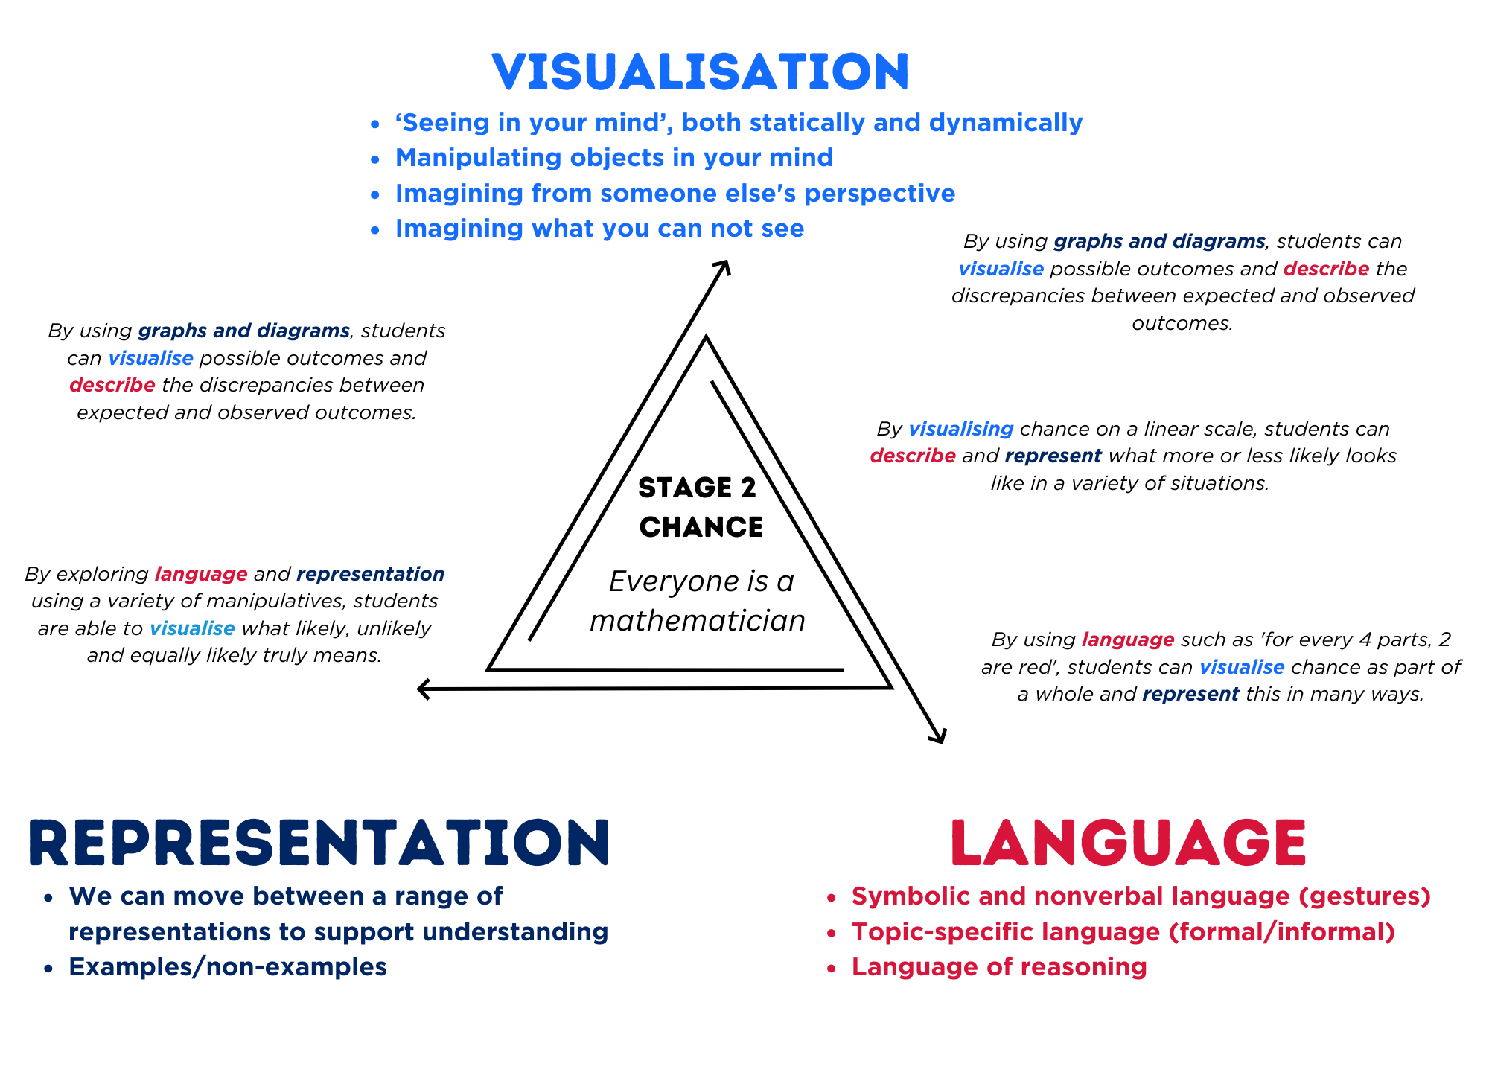
Figure 3 – pedagogical support – Stage 3 position
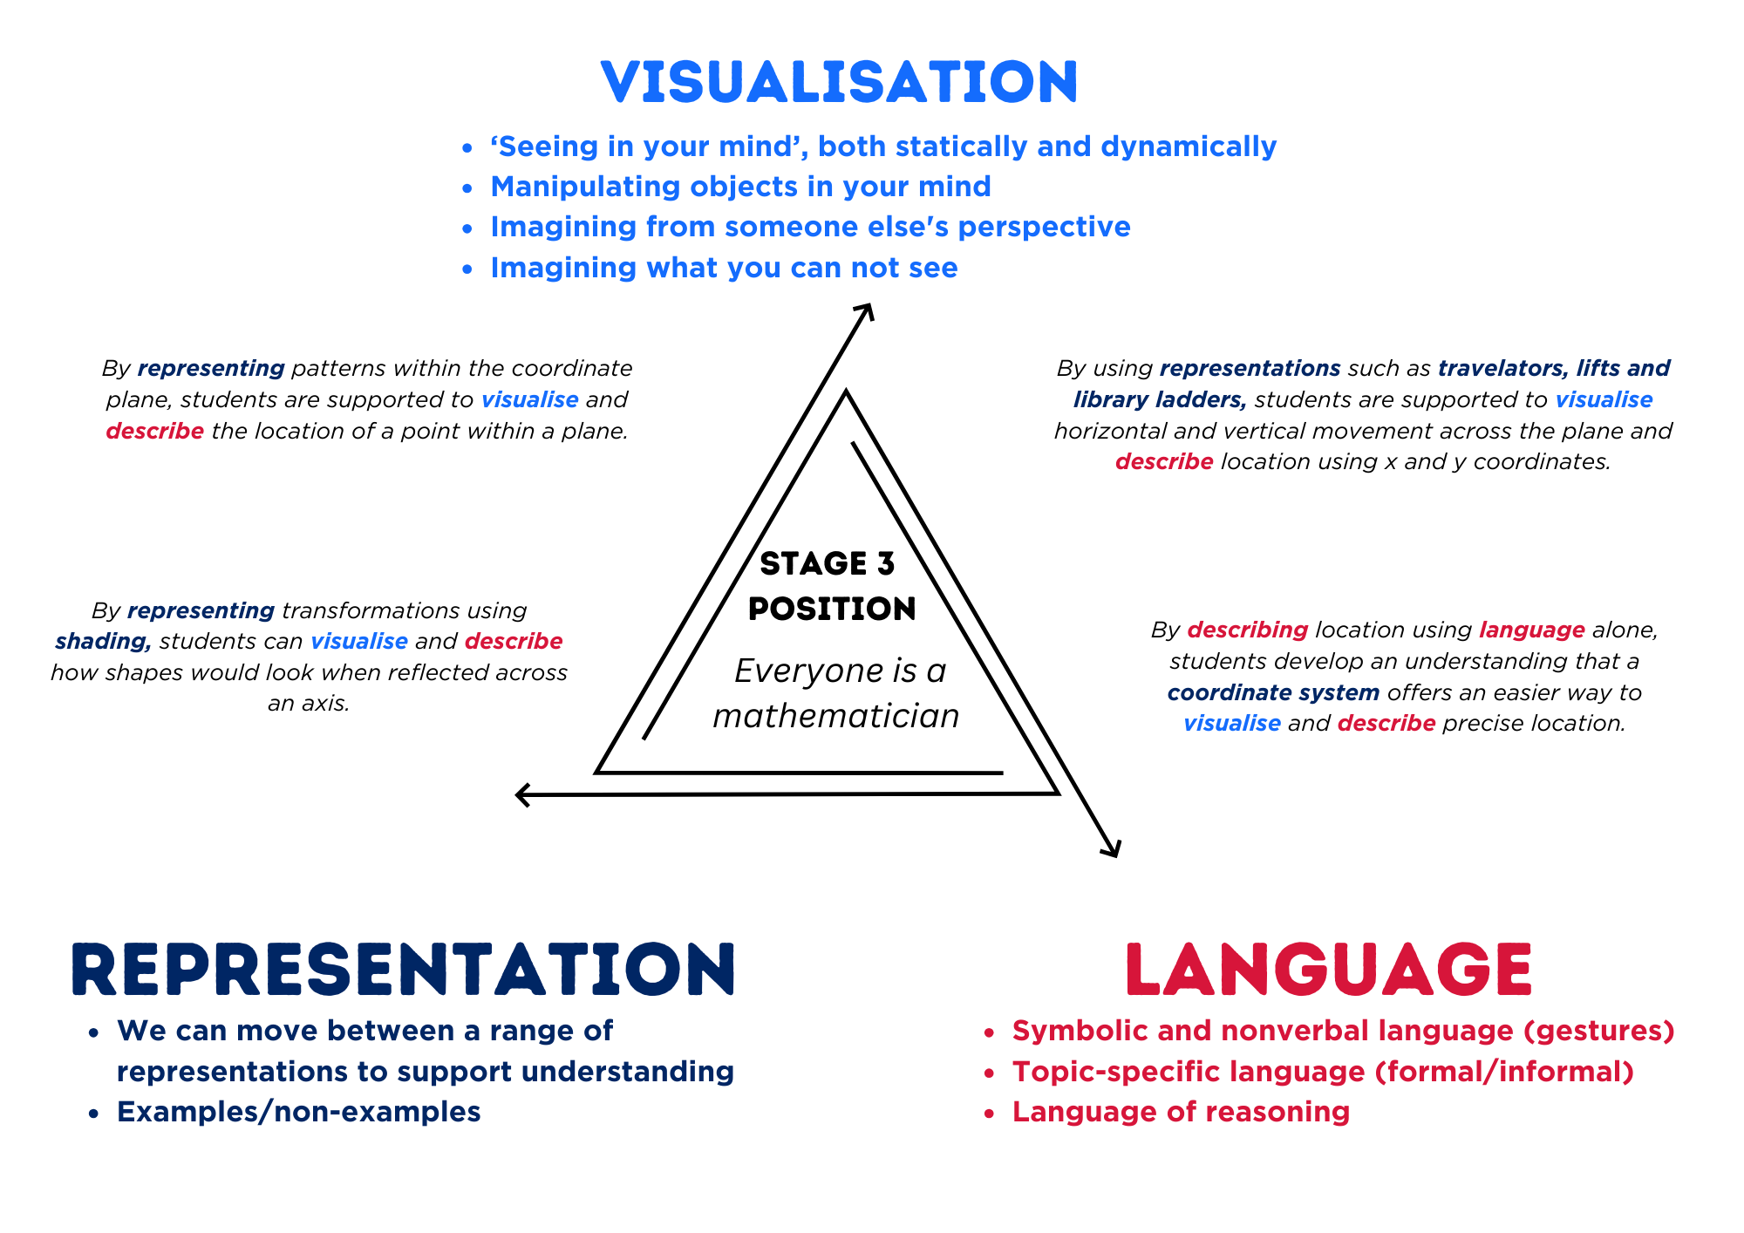
Figure 4 – pedagogical support – Stage 3 chance
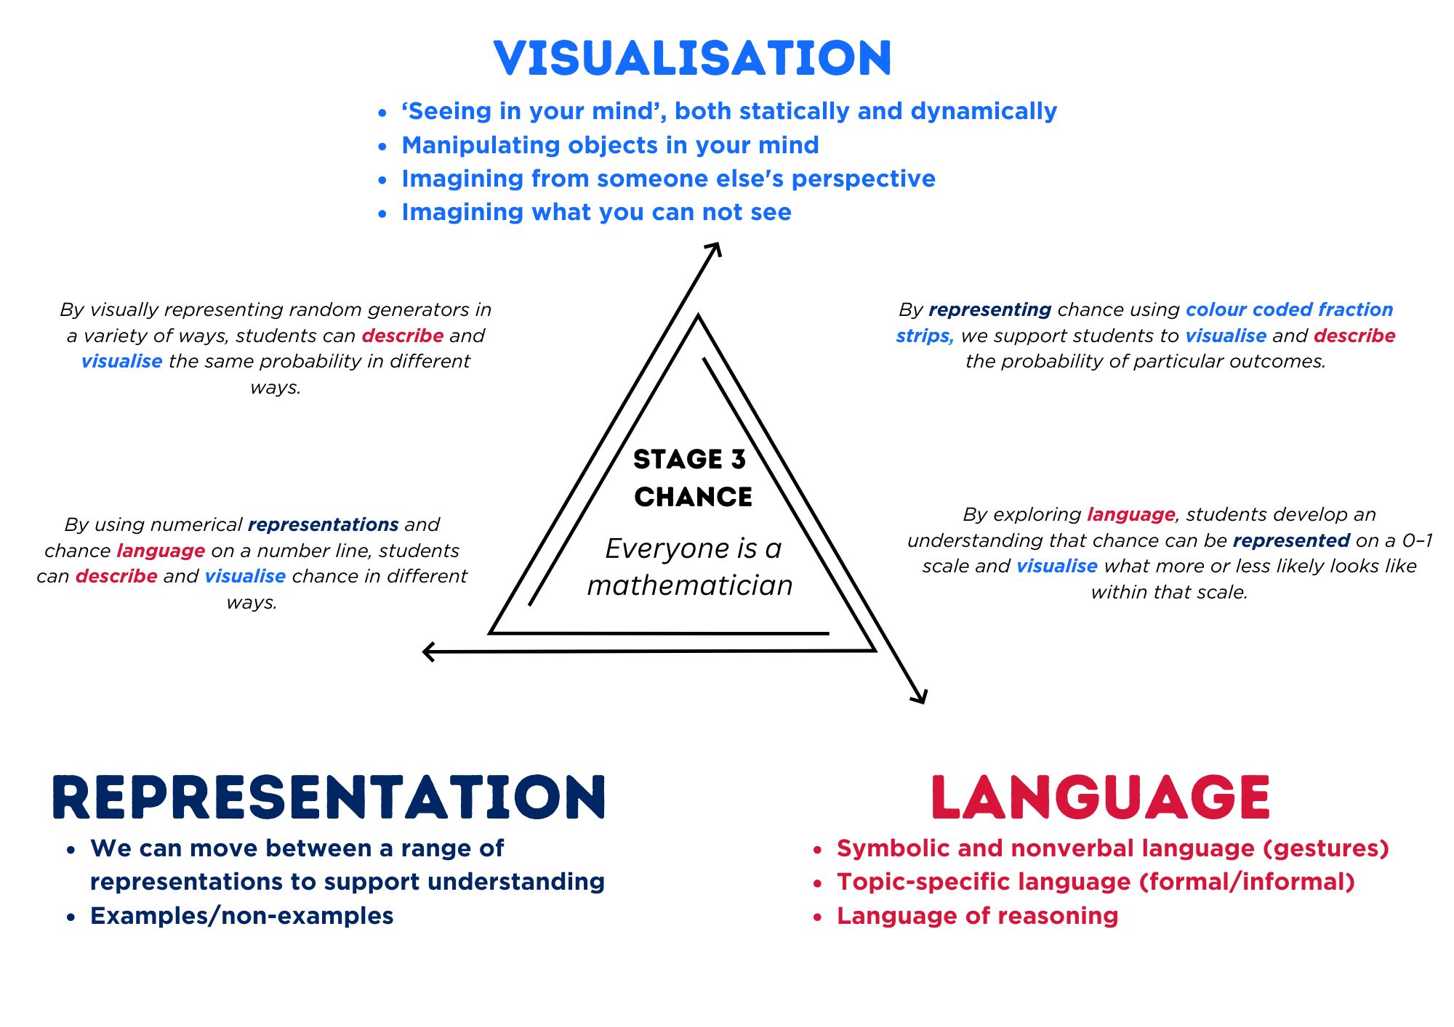

Lesson overview and resources
To cover the content of the syllabus across Stage 2 and Stage 3, some core lessons in the unit contain both a Stage 2 and a Stage 3 task. Teachers are encouraged to adapt and contextualise the units to meet the needs of their students.
The table below outlines the sequence and approximate timing of lessons, learning intentions and resources.
Lesson | Content | Duration and resources
Lesson 1  Daily number sense  Stage 2:  - Partitioned fractions A: Model and represent unit fractions, and their multiples, to a complete whole on a number line  Stage 3:  - Representing quantity fractions A: Recognise the role of the number 1 as representing the whole | Lesson core concept: Aboriginal and Torres Strait Islander peoples were the original map makers (Stage 2). Horizontal and vertical number lines intersect at zero (Stage 3).  Stage 2:  - Geometric measure A: Position: Interpret movement on a map  - Geometric measure B: Position: Use directional language and describe routes with grid maps  Stage 3:  - Geometric measure A: Position: Explore the Cartesian coordinate system | Lesson duration: 65 minutes  - Resource 1 – fraction words and cards  - Resource 2 – fraction picture cards  - Resource 3 – Stage 2 position representations  - Resource 4 – Stage 3 position representations  - Resource 5 – shape guess line  - Resource 6 – shape guess space  - Resource 7 – blank Cartesian plane  - Resource 8 – labelled plane cartoons  - Video: What are Songlines? (2:07)  - Video: Gujingga Songline (0:43)  - A3 paper for anchor chart  - Identical card/paper strips  - Sticky notes  - Writing materials
Lesson 2  Daily number sense  Stage 2:  - Partitioned fractions A: Create fractional parts of a length using techniques other than repeated halving  Stage 3:  - Representing quantity fractions B: Build up to the whole from a given fractional part | Lesson core concept: natural resources, landmarks, and universal directional language can be used to navigate (Stage 2). Number lines are used both horizontally then vertically to plot data (Stage 3).  Stage 2:  - Geometric measure A: Position: Interpret movement on a map  - Geometric measure B: Position: Use directional language and describe routes with grid maps  Stage 3:  - Geometric measure A: Position: Explore the Cartesian coordinate system | Lesson duration: 65 minutes  - Resource 4 – Stage 3 position representations  - Resource 9 – landmark map  - Resource 10 – library ladder  - Resource 11 – colour library ladder  - Map of Taronga Western Plains Zoo  - Concrete materials  - Identical card strips  - Sticky notes  - String  - Writing materials
Lesson 3  Daily number sense  Stage 2:  - Partitioned fractions A: Model and represent unit fractions, and their multiples, to a complete whole on a number line  Stage 3:  - Representing quantity fractions A: Compare and order common unit fractions | Lesson core concept: map locations can be identified using grid references (Stage 2). Coordinates define the point on a number plane using real-world applications (Stage 3).  Stage 2:  - Geometric measure A: Position: Locate positions on grid maps  - Geometric measure B: Position: Create and interpret grid maps  Stage 3:  - Geometric measure B: Position: Use the 4 quadrants of the coordinate plane | Lesson duration: 60 minutes  - Resource 4 – Stage 3 position representations  - Resource 12 – bookshelf 1 and 2  - Resource 13 – landmark map with grid  - Resource 14 – journey to Numberland  - Resource 15 – Cartesian plane  - Resource 16 – carrot hunt  - Digital device  - Writing materials
Lesson 4  Daily number sense  - teacher-identified task based on student needs | Lesson core concept: maps identify locations within a local environment (Stage 2). Integer coordinates change when reflected (Stage 3).  Stage 2:  - Geometric measure B: Position: Create and interpret grid maps  - Geometric measure B: Position: Use directional language and describe routes with grid maps  Stage 3:  - Geometric measure B: Position: Use the 4 quadrants of the coordinate plane | Lesson duration: 60 minutes  - Resource 4 – Stage 3 position representations  - Resource 15 – Cartesian plane  - Resource 17 – supermarket map  - Resource 18 – supermarket instructions 1 and 2  - Resource 19 – 100 square grid  - Resource 20 – target and directional cards  - Writing materials
Lesson 5  Daily number sense  Stage 2:  - Additive relations A: Recognise and explain the connection between addition and subtraction  Stage 3:  - Additive relations A: Apply efficient mental and written strategies to solve addition and subtraction problems | Lesson core concept: the outcome of chance experiments can be described and recorded (Stage 2). Probability can be represented on a scale from zero to one (Stage 3).  Stage 2:  - Chance A: Identify possible outcomes from chance experiments  - Chance B: Describe the likelihood of outcomes of chance events  Stage 3:  - Chance A: List outcomes of chance experiments involving equally likely outcomes and represent probabilities | Lesson duration: 65 minutes  - Resource 21 – Stage 2 chance representations  - Resource 22 – Stage 3 chance representations  - Resource 23 – chance statements  - Resource 24 – carnival game  - Resource 25 – numerical phrases  - Resource 26 – colloquial terms  - Resource 27 – cards and strips  - Counters  - Writing materials
Lesson 6  Daily number sense  Stage 2:  - Additive relations A: recognise and explain the connection between addition and subtraction  Stage 3:  - Additive relations A: Apply efficient mental and written strategies to solve addition and subtraction problems | Lesson core concept: outcomes from chance experiments can be predicted, recorded and compared (Stage 2). Outcomes in chance experiments can be equally likely (Stage 3).  Stage 2:  - Chance A: Identify possible outcomes from chance experiments  - Chance B: Describe the likelihood of outcomes of chance events  Stage 3:  - Chance A: List outcomes of chance experiments involving equally likely outcomes and represent probabilities  - Chance B: Create random generators and describe probabilities using fractions | Lesson duration: 65 minutes  - Resource 22 – Stage 3 chance representations  - Resource 28 – What is fair?  - Resource 29 – fairness reference sheet  - Resource 30 – random generators  - Resource 31 – carnival host vs player  - Resource 32 – sentence stems  - Resource 33 – fair and unfair  - Resource 34 – equally likely cartoons  - Dice  - Paper or cards strips  - Writing materials
Lesson 7  Daily number sense  Stage 2:  - Additive relations A: recognise and explain the connection between addition and subtraction  Stage 3:  - Additive relations A: Apply efficient mental and written strategies to solve addition and subtraction problems | Lesson core concept: outcomes from chance experiments can be predicted, recorded and compared (Stage 2). The frequency of outcomes has a value based on its occurrence (Stage 3).  Stage 2:  - Chance A: Identify possible outcomes from chance experiments.  - Chance B: Describe the likelihood of outcomes of chance events  Stage 3:  - Chance B: Compare observed frequencies of outcomes with expected results | Lesson duration: 60 minutes  - Resource 22 – Stage 3 chance representations  - Resource 30 – random generators  - Resource 35 – mystery bag  - Resource 36 – mystery bags support  - Resource 37 – dot plot match  - Resource 38 – frequency thinking  - Counters  - Whiteboard  - Writing materials
Lesson 8  Daily number sense  - teacher-identified task based on student needs | Lesson core concept: record and compare the results of chance experiments (Stage 2). Expected and observed probabilities align better in larger trials (Stage 3).  Stage 2:  - Chance A: Identify possible outcomes from chance experiments  - Chance B: Describe the likelihood of outcomes of chance events  Stage 3:  - Chance B: Create random generators and describe probabilities using fractions  - Chance B: Conduct chance experiments with both small and large numbers of trials | Lesson duration: 60 minutes  - Resource 22 – Stage 3 chance representations  - Resource 39 – coloured cubes key  - Resource 40 – two dice bingo  - Resource 41 – chance bingo  - Resource 42 – bingo set up  - Counters  - Writing materials

Lesson 1
Core concept: Aboriginal and Torres Strait Islander peoples were the original map makers (Stage 2). Horizontal and vertical number lines intersect at zero (Stage 3).

Daily number sense – making a whole – 15 minutes
Daily number sense activities for Lessons 1 to 3 ‘activate’ prior number knowledge and support the learning of new content in the unit. These activities can also assist teachers to identify the starting points for learning by revealing the extent of students’ existing knowledge.
The table below contains a suggested learning intention and success criteria. These are best co-constructed with students.
Daily number sense learning intention | Daily number sense success criteria
Students working towards Stage 2 outcomes are learning to:  - model and represent unit fractions to complete a whole.  Students working towards Stage 3 outcomes are learning to:  - recognise the role of 1 as representing the whole. | Students working towards Stage 2 outcomes can:  - recreate the whole unit from a fractional part ($\frac{1}{2}$,$\frac{ 1}{4}$,$\frac{1}{3}$ and $\frac{1}{8}$).  Students working towards Stage 3 outcomes can:  - refer to the number 1 as the common whole.
- Prior to the lesson prepare an identical strip of carboard or paper per student.
- Ask students to label the strip as one whole and then fold the strip into quarters. If needed, revise how to use repeated halving.
- Ask students to label each quarter using the notation $\frac{1}{4}$. If needed, revise the meaning of the notation (see Figure 5).
Figure 5 – fraction notation
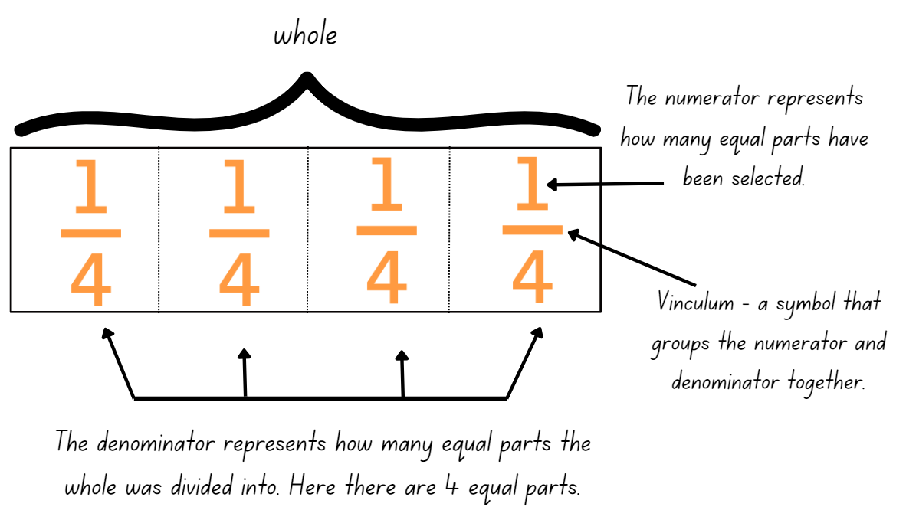
- Ask students to count aloud: one-quarter, two-quarters, three-quarters, four-quarters, that makes one whole.
- Asks students to now fold the strip into eighths using repeated halving and to label each eighths using the notation $\frac{1}{8}$.
- Ask students to count aloud: one-eighth, two-eighths, three-eighths, four-eighths, five-eighths, six-eighths, seven-eighths, eight-eighths, that makes one whole.
- Revise the relationship between the denominator, numerator and the size of each folded piece. (The larger the denominator, the smaller the fraction)
- Collect and keep student’s folded fraction strips in an envelope; they will be used again in the next lesson.
- Distribute Resource 1 – fraction words and cards to students at random.
- Students find their matching partner. Select students to justify their choice.
- Display Resource 1 – fraction words and cards and select an image.
- Ask students to identify the matching language card and to explain their reasoning.
- Ask students if there are any word and picture matches that they disagree with. Discuss misconceptions as they arise.
- Select images from Resource 1 – fraction words and cards that show an incomplete whole. Ask students to identify the complementary fraction part required to make a whole. For example, use language such as five-eighths and three-eighths make eight-eighths or one whole, such as in Figure 6.
Figure 6 – language used to describe fractions
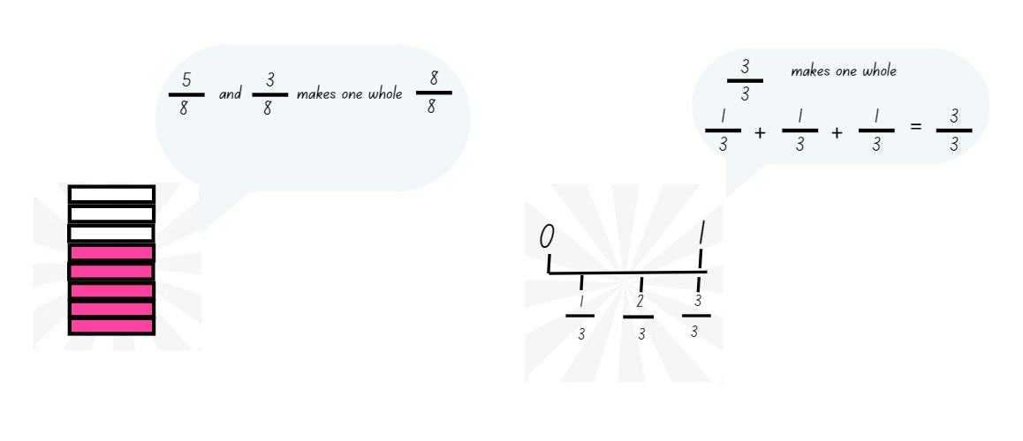
- Explain to students that the language of fractions will be relevant to upcoming lessons in chance.
Multi-age: to further support students working towards Stage 3 outcomes, it is optional to provide Resource 2 – fraction picture cards.
This table details opportunities for assessment.
Assessment opportunities | Links
What to look for:  - Can Stage 2 students model and represent unit fractions to complete a whole? [MAO-WM-01, MA2-PF-01]  - Can Stage 3 students refer to the number 1 as the common whole? [MAO-WM-01, MA3-RQF-01] | Links to National Numeracy Learning Progressions (NNLP):  - Stage 2 – InF2, InF3, InF4  - Stage 3 – InF5.

Core lesson – 40 minutes

Stage 2 task – tools used in mapping
The table below contains suggested learning intentions and success criteria. These are best co-constructed with students.
Core concept learning intentions | Core concept success criteria
Students working towards Stage 2 outcomes are learning to:  - interpret movement on a map  - use directional language and describe routes with grid maps. | Students working towards Stage 2 outcomes can:  - describe a route taken on a map using landmarks and directional language (including Aboriginal stories, trading routes or songlines of journeys)  - use natural resources and landmarks to identify north, south, east and west.
Note: for each lesson on position in this unit, students can enhance their understanding of position by using various representations or tools. These representations and tools can be collaboratively constructed with students on an anchor chart or provided as a resource, see Resource 3 – Stage 2 position representations.
This lesson has been developed in consultation with the Aboriginal Outcomes and Partnerships Directorate of the Department of Education. Teachers are encouraged to work with their school’s Aboriginal Education team and local Aboriginal Education Consultative Group to develop learning resources with local Aboriginal knowledge wherever possible. Aboriginal and Torres Strait Islander people should be aware that websites in this lesson may contain images, voices and names of deceased persons.
- View and discuss the video What are song lines? (1:52).
- Explain to students that songlines are navigational tracks, whereby Elders or trained Aboriginal people ’sing the landscape‘ to help move from location to location. Songlines include landmarks, localised plants and animals and water sources. Aboriginal peoples travelled along songlines for trade, to attend ceremonies and access resources see Nichols (2017) and ABC (2023).
- As a class, define and construct an anchor chart for the terms:
- landmarks
- map
- navigate
- compass points (north, south, east, west).
- Discuss directions and tools with the class. Ask students:
- When would we use directions?
- What is important to include in the directions that we give?
- What tools did Aboriginal peoples use to help them navigate?
- How can we tell which way is north, south, east or west?
- View and discuss the video Gujingga Songline (4:01).
- Ask students what things were included in songlines. Draw attention to the use of landmarks and why they are useful in songlines.
- Explain that Aboriginal peoples developed excellent navigational knowledge and often had their own terms for compass points in different languages. Many Aboriginal peoples used a variety of techniques to find compass points, including the Southern Cross to mark south and the sun to mark east and west (see University of Melbourne (2023)).
- Mark north, south, east and west on the classroom walls in the appropriate directions.
- As a class, play Simon Says using half turns on compass points (start facing north). For example, Simon says make a half turn to the right. Ask students:
- What way are you now facing?
- What do you see?
- Explain the difference between a quarter-turn and a half-turn, relating it to a clock if needed.
- As a class, play Simon Says again but incorporate both half- and quarter-turns to the right and left, asking the above questions after each turn.
- Explain to students that they will be creating their own oral map for the objects they place on their tabletop. For example, see Figure 7.
Figure 7 – object map
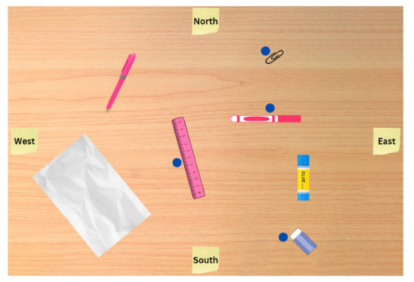
Note: following cultural protocols, only certain people carry songlines. In this activity, students will create their own oral map, contextualised to their landscape and surroundings. To respect cultural protocols, please do not call these oral maps songlines.
- Model how to give direction using landmarks and compass points. For example, start at the paper, go north to the highlighter, make a quarter turn to the right and go east to the paperclip.
- In groups of 4, students place classroom objects on their desks to create an object map. Using sticky notes, students label each side of their map with north, south, east and west. Each student should be standing on a different side of the desk (see Figure 8).
Figure 8 – object map activity
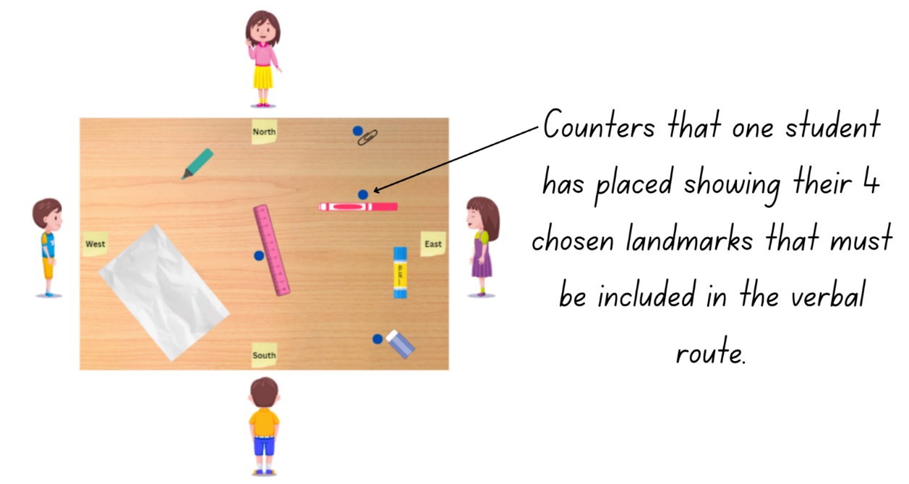
- One student creates a challenge by placing 4 counters next to specific landmarks to be visited. All students take turns to verbally describe a route (oral map) that includes those 4 chosen landmarks using compass points and landmark names.
- Students then move positions around the table and a different student sets a new challenge using the counters.

This table details opportunities for differentiation.
Too hard? | Too easy?
Stage 2 students cannot provide or use given directions to follow routes.  - Students visit 2 landmarks in their route. Support students to use compass directions for direction of travel.  - Provide students with arrows to support the description of the oral map. | Stage 2 students can provide or use given directions to follow routes.  - Students plan both an outbound and return journey to 4 locations on the map.  - Students describe what they can see from a particular perspective and their partner identifies the direction they are facing. For example, students describe that they can see a pen to their right and a rubber to their left, then ask which direction they are facing.  - Investigate the use of a stick to determine cardinal directions.

Stage 3 task – locating a fly
The table below contains suggested learning intentions and success criteria. These are best co-constructed with students.
Core concept learning intentions | Core concept success criteria
Students are learning to:  - explore the Cartesian coordinate system. | Students can:  - recognise that the grid-map reference system gives the area of a location and the number plane identifies a specific point  - identify that in the coordinate system the lines are numbered, not the spaces  - identify the point of intersection of the 2 axes as the origin, having coordinates (0, 0).
Note: the purpose of this lesson is to develop an understanding that the Cartesian plane represents two-dimensional space. It is represented by 2 infinite number lines that intersect at right angles at the origin (0, 0).
For each lesson on position in this unit and Stage 3 – Unit 28, students can enhance their understanding of position by using multiple representations or tools. These representations and tools can be co-constructed with students on an anchor chart or provided as a resource, see Resource 4 – Stage 3 position representations.
- Provide half the students with Resource 5 – shape guess lines and the other half of the students with Resource 6 – shape guess spaces.
- Explain to students that you will call out a reference. Students will then either need to:
- place a dot on the intersection if they are using Resource 5 – shape guess lines
- colour the box referred to if they are using Resource 6 – shape guess spaces.
- Model how students can use their fingers or a ruler to help locate a particular location within the grid, paying attention to where they are using lines or spaces.
- Call out the references D6, E5, E7 and F6 for students to mark (see Figure 9).
Figure 9 – student examples
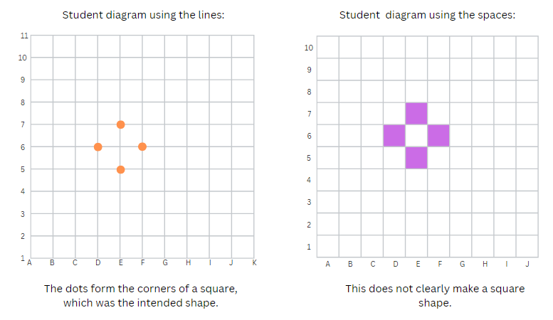
- Ask students to describe what they can see.
- Explain that you were thinking of the corners of a square, tilted on an angle. Ask if their shape reflects the idea.
- Show a student work sample of each to the class. Ask which was more accurate and why.
- Draw attention to the idea that the coordinates system in which lines are numbered is more accurate than the grid reference system.
- Ask for situations where it is important to be precise when describing location.
- Explain that in this unit they will be learning about mathematics developed in the 17th Century by René Descartes. Legend has it that one day he was lazing in bed and noticed a fly on the ceiling. He wondered how best he could describe it so that someone could know where it was without seeing it for themselves.
Note: viewing The Cartesian Plane (M251) (3:49) from (0:00–3:00) may support student understanding and engagement.
- Provide each student with a copy of Resource 7 – blank Cartesian plane.
- Explain that students will use Resource 7 – blank Cartesian plane to play a barrier game sitting back-to-back.
- The purpose of the game is to guide their partner to a fly (see Figure 10).
Figure 10 – barrier game
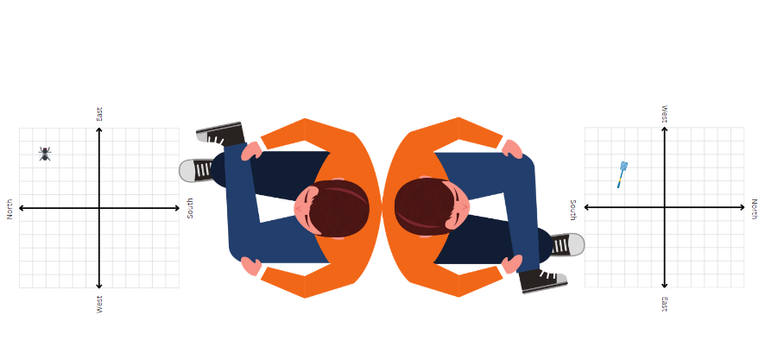
- Ask students if they would use the grid boxes or lines to be most accurate. As an option, model placing the fly on the intersection of 2 lines.
Note: students do not need to start at the origin at this time; later lesson steps will draw students to the conclusion that it would have been better to start there. Stage 2 content about compass directions can be used for additional support.
- In pairs, students sit back-to-back. Student A draws a fly (or places a counter) on their Cartesian plane. They then describe its location to Student B. Student B draws a fly swat (or places a counter) where they believe the fly is. Students check how close they were. Swap roles and repeat the activity.
- Regroup Stage 3 students and discuss using the questions in the table below. The table outlines stimulus prompts to generate conversation about the topic, along with anticipated responses from students.
Prompts | Anticipated student responses
- What language did you use to help describe the position? | - Move 2 lines up and 4 lines over.  - Move 2 lines north and 4 lines to the east.
- Was your language effective? Why or why not? | - Using compass directions was helpful because my partner knew which direction I was going in.  - It wasn’t effective because I wasn’t sure where my partner was starting from.
- Did you use a particular system to help you? | - We used the grid but we didn’t label it.  - We used the grid like a map, we used letters and numbers.  - We used the grid and labelled it with numbers on each axis.
- Did you have an agreed starting point? Why or why not? Where was it and why? | - We didn’t say a starting point.  - We started at the top of the vertical line.  - We started at the West sign.
This table details opportunities for differentiation.
Too hard? | Too easy?
Stage 3 students cannot recognise that the grid-map reference system gives the area of a location, and the number plane identifies a specific point:  - Students use Resource 6 – shape guess spaces to revise the use of grid references to locate an area.  - Students draw a number line from -5 to 5 and complete the fly activity, focusing on language such as forward 2 steps or 2 steps east/west. Repeat the activity with a vertical number line, focusing on steps north or south. | Stage 3 students can recognise that the grid-map reference system gives the area of a location, and the number plane identifies a specific point:  - Students develop their own numbering systems for the Cartesian plane and justify why they are effective or ineffective.  - Students investigate the need for an infinite grid system. using Google Earth with gridlines (see Figure 11). Students explore how lines of latitude and longitude can represent a grid, however, when zooming in on a location, smaller grid lines are required to accurately pinpoint a location.
Figure 11 – Google Earth grid
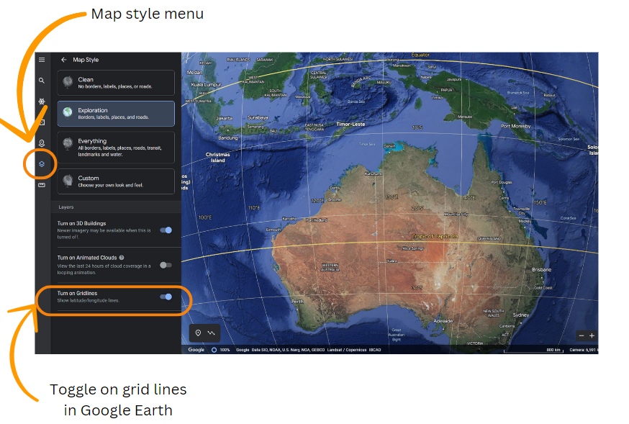
Map data © Google Data SIO, NOAA, U.S. Navy, NGA, GEBCO.

Discuss and connect the mathematics – 10 minutes
- As a class, discuss the following:
- How can tools such as compass points, landmarks and reference points help us to give and understand directions?
- Which tools do you think are the most effective when listening to instructions? When seeing instructions?
- What was challenging about the task?
- What strategy or strategies did you develop that reduced the level of challenge?
- Stage 2 students turn and talk to a partner to discuss the following questions:
- What directional language needs to be used when describing a route that includes 2 identical landmarks in 2 different positions?
- Describe the route home from school using directional language (students can draw the route to support their explanation).
- Display Resource 8 – labelled plane cartoons to Stage 3 students and discuss which is the most effective labelling system using the prompts from the table below. The table outlines stimulus prompts to generate conversation about the topic, along with anticipated responses from students.
Prompts | Anticipated student responses
- Is it better to use letters or numbers? Why? | - If you use letters, you might run out of letters.  - Using numbers means we can extend the plane easily.  - Numbers give infinite possibilities in terms of size.
- Which labelling system will always work? | - The rooster’s system because you can increase it no matter how big you want your map or grid.
- What do the 2 lines remind you of? What do they represent? | - They’re both number lines with negative and positive numbers.  - It is 2 number lines that meet at zero.  - It is 2 number lines that intersect at right angles.
- Which system has a logical start point? Why is this useful? What is it labelled? | - The rooster has a starting point of (0, 0) so it is easy to see how far you travel from the starting point.  - The other starting points are hard to remember, such as G7.
This table details opportunities for assessment.
Assessment opportunities | Links
What to look for:  - Can Stage 2 students describe a route taken on a map using landmarks and directional language? [MAO-WM-01, MA2-GM-01]  - Can Stage 2 students use natural resources and landmarks to identify north, south, east and west? [MAO-WM-01, MA2-GM-01]  - Can Stage 3 students recognise that the grid-map reference system gives the area of a location and the number plane identifies a specific point? [MAO-WM-01, MA3-GM-01]  - Can Stage 3 students identify that in the coordinate system the lines are numbered, not the spaces? [MAO-WM-01, MA3-GM-01] | Links to National Numeracy Learning Progressions (NNLP):  - Stage 2 – PoL4  - Stage 3 – n/a.

Lesson 2
Core concept: natural resources, landmarks, and universal directional language can be used to navigate (Stage 2). Number lines are used both horizontally then vertically to plot data (Stage 3).

Daily number sense – comparing fractions to make one whole – 15 minutes
The table below contains a suggested learning intention and success criteria. These are best co-constructed with students.
Daily number sense learning intention | Daily number sense success criteria
All students are learning to:  - create fractional parts of a length using techniques other than repeated halving.  Students working towards Stage 2 outcomes are learning to:  - model and represent unit fractions, and their multiples, to a complete whole.  Students working towards Stage 3 outcomes are learning to:  - build up to the whole from a given fractional part. | All students can:  - make quarters, thirds, sixths and eighths of a length.  Students working towards Stage 2 outcomes can:  - model fractions with fraction strips and diagrams for halves, quarters, eighths, thirds.  Students working towards Stage 3 outcomes can:  - generate the whole quantity from non-unit fractional parts such as quarters, eighths, thirds, sixths, fifths and tenths (Reversible reasoning).
This activity is an adaptation of the ‘Thirding strategy’ from Teaching Mathematics: Foundation to middle years, 3rd edn by Siemon et al.
- Prior to the lesson, prepare 2 identical strips of cardboard or paper per student. The strips should be the same size as those used in Lesson 1. Retrieve student envelopes from Lesson 1.
- Display a number line from zero to one. Revise a half and that two-halves make a whole.
- As a class, discuss strategies to make thirds and where $\frac{1}{3}$ would be placed on the number line. Ask students if they think $\frac{1}{3}$ is more or less than $\frac{1}{2}$. Ask how they know.
- Use the fraction strip to model and explain the thirding strategy to students:
- Estimate half on the fraction strip.
- Estimate $\frac{1}{3}$ as something less than half, leaving room for 2 more equal parts.
- Halve the remaining part, making 3 equal parts in total.
- As a class count aloud: $\frac{1}{3}, \frac{2}{3}, \frac{3}{3}$, that is one whole.
- Repeat the modelling steps to demonstrate how sixths can be made from halving thirds.
- Distribute 2 strips to each student.
- Compare the strips to those used in Lesson 1. Discuss the need to have equal sized wholes to compare partitioned fractions and the language used to name each equal part of the whole.
- Ask students to fold one of the strips into thirds and label using the notation $\frac{1}{3}$.
- Ask students to fold the remaining strip into sixths by folding into thirds, then halving. Ask students to label using the notation $\frac{1}{6}$.
- Share student strategies for folding in sixths. Ask students how they know their pieces are sixths.
- Ask students to count aloud: one-sixth, two-sixths, three-sixths, four-sixths, five-sixths, six-sixths, that makes one whole.
- Ask students to lay their strips one above the other in the order $\frac{1}{2}, \frac{1}{3}, \frac{1}{4}$ , $\frac{1}{6}$ and $\frac{1}{8}$. Ask:
- What do you notice and wonder?
- What patterns can you see?
- What is the relationship between the numerator and the size of each folded piece?
- What information does the denominator tell you?
- How many sixths make one whole?
- If there are $\frac{3}{8}$ how many more eighths will you need to make one whole?
- Is there a relationship between the fractions $\frac{1}{2}, \frac{1}{4}$ and $\frac{1}{8}$? What about $\frac{1}{3}$ and $\frac{1}{6}$? Explain.
- Ask students to collect and keep their fraction strips in an envelope and keep them for Lesson 3.
This table details opportunities for assessment.
Assessment opportunities | Links
What to look for:  - Can students model fractions with fraction strips for thirds, quarters, sixths and eighths? [MAO-WM-01, MA2-PF-01, MA3-RQF-01]  - Can Stage 2 students model, represent and compare fractions? [MAO-WM-01, MA2-PF-01]  - Can Stage 3 students generate the whole quantity from non-unit fractional parts such as quarters, eighths, thirds, sixths, fifths and tenths? [MAO-WM-01, MA3-RQF-01] | Links to National Numeracy Learning Progressions (NNLP):  - Stage 2 – InF4  - Stage 3 – InF5.

Core lesson – 40 minutes

Stage 2 task – navigating landmark maps
The table below contains suggested learning intentions and success criteria. These are best co-constructed with students.
Core concept learning intentions | Core concept success criteria
Students working towards Stage 2 outcomes are learning to:  - interpret movement on a map  - use directional language and describe routes with grid maps. | Students working towards Stage 2 outcomes can:  - orient a map to determine directions to travel  - use a given grid map and compass directions (N, S, E, W) to plan, describe and show a route from one location to another.
Note: the purpose of this lesson is to use concrete representations to support students to visualise themselves within a landscape and to use landmarks and directional language effectively to describe a journey.
- Show students a real landmark map from your local area, such as a park, council area or school site. If none are available, display Resource 9 – landmark map or a map of Taronga Western Plains Zoo.
- Discuss what landmarks students can see and how they may be useful in navigating.
- In groups of 4, students physically re-create the map using real objects. For example, use dominoes to represent houses, a cotton ball to represent a tree, blue paper to represent the lake.
- Students place sticky notes labelling north, south, east and west where appropriate.
- Each student stands on one side of the table, looking into the map. Each student draws an arrow on a sticky note and places it on their chosen point on the map. They then describe what they can see around them facing the direction their arrow is pointing on the map. For example, you can see the lake in front of you, a house is behind you. The hospital is on your left.
- Each student has a turn at doing this from at least 2 different locations.
- As a class, ask students what they noticed as their place changed within the map.
- Provide each group a length of string. Using the string, students create a route from one side of the table to a chosen location or exit point (see Figure 12).
Figure 12 – landmark map with string
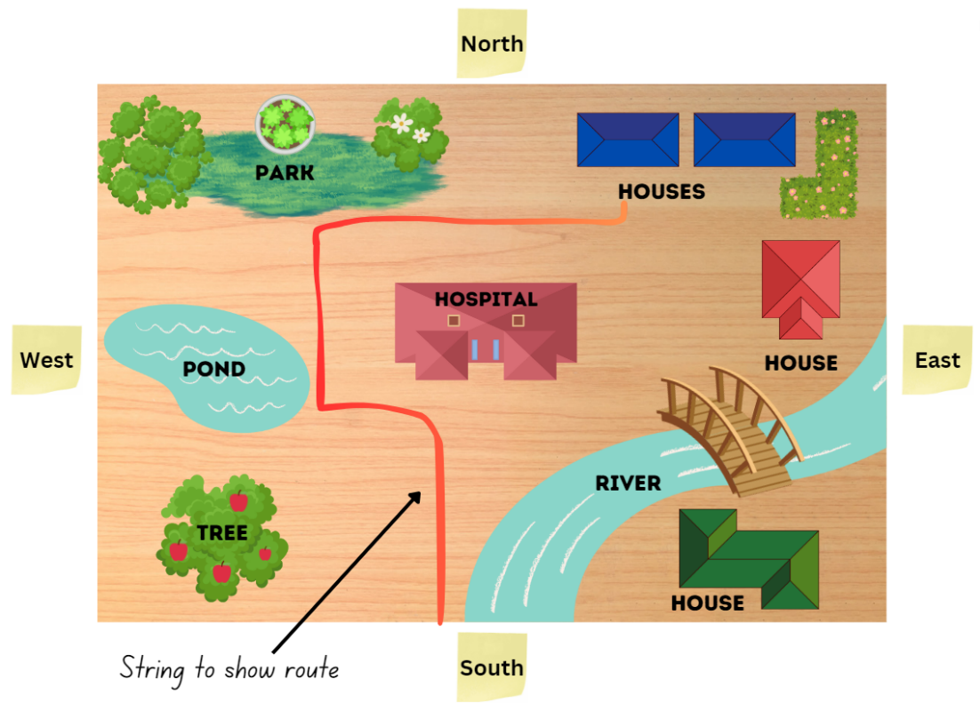
- As a group, students describe the route through the map using landmarks and compass points. For example, travel west until you reach the river then turn north and travel until you pass the pond. Turn west and travel until you reach the park.
This table details opportunities for differentiation.
Too hard? | Too easy?
Stage 2 students cannot orient a map to determine directions to travel.  - Students use their arrow to support route directions.  - Students make a simple route with one turn through the map. | Stage 2 students can orient a map to determine directions to travel.  - Encourage students to create a more complex route with their string. Students include the amount of turn (quarter-turn or half-turn) and left or right in their directions.  - Students plan a return journey for their route.

Stage 3 task – library ladders
The table below contains suggested learning intentions and success criteria. These are best co-constructed with students.
Core concept learning intentions | Core concept success criteria
Students working towards Stage 3 outcomes are learning to:  - explore the Cartesian coordinate system. | Students working towards Stage 3 outcomes can:  - plot and label points, given coordinates, on the number plane in the first quadrant, describing the horizontal position first, followed by the vertical position  - identify and record the coordinates of given points on the number plane in the first quadrant.
Note: the purpose of this lesson is to understand that location on the Cartesian plane is described using the x-coordinate, followed by the y-coordinate. Students learn to relate the x-coordinate to the horizontal number line and the y-coordinate to the vertical number line.
- Review Resource 4 – Stage 3 position representations, linking the examples to content covered in Lesson 1.
- Display Resource 10 – library ladder. Give each student a copy to track the movement with their fingers as it is modelled.
- Provide Stage 3 students with Resource 10 – library ladder. Give each student a copy to track the movement with their fingers.
- Display the prompt questions on the board.
- In pairs, students respond to the questions by recording their answers on a whiteboard or workbook.
The table below outlines stimulus prompts to generate conversation about the resource, along with anticipated responses from students.
Prompts | Anticipated student responses
- What do the lines remind you of? | - The x and y axis.
- How do you describe a location on this grid? | - Using the x- and y- coordinates. For example (x, y).
- Which coordinate comes first and why? | - The x comes first because it always does.  Note: the (x, y) order is by convention.
- Where do you start from when using this system? | - At the intersection of the lines.  - At the origin.  - At (0, 0).
- How might you describe the location of the green book? | - (4, 3)
- How do you know if you are correct? What does the x- and y-coordinate represent? | - I’m not sure.  Note: use the following questions to illustrate that x represents the horizontal number line and y represents the vertical number line.
- What would you need to do if wanted to get the green book from the origin? | - Move the ladder across so it is in line with the blue book then climb up the ladder to get it.  - Move the ladder across to the fourth line and climb up 3 lines to get the book, the book is located at (4, 3).
- When you move the ladder across, how else can you describe this movement? | - Side to side.  - Horizontal.  Note: draw connection to horizon.
- When you climb up the ladder, how else can you describe this movement? | - Vertical.
- What is the order when moving the ladder? How does it relate to the (x, y) coordinate system? | - You always describe the horizontal first and then the vertical.  - You can think about moving the ladder before climbing.
- Model how to describe the location using the (x, y) coordinate system with more examples.
- Ask students to place a rectangle representing a book at location (4, 2). Explicitly model moving the ladder across the x-axis first and before climbing up in line with the y-axis.
- In pairs, students draw 5 additional books on their shelf and ask a partner to record the location using the (x, y) coordinate system.
- Their partner describes the location of the books and records the coordinates of the book, ensuring correct order of the coordinates (x, y). Swap roles and repeat. Continue until students have recorded at least 5 coordinates.
- Ask:
- How did the ladder help you to think about the order of the coordinates when describing a point?
- What if I described a location as (0, 6) or (5, 0)? (These coordinates remain at zero on one axis. For example, when tracking along the x-axis, the y value does not change).
- If we didn’t have a ladder what other tools or representations can we use? For example, highlighter, finger or ruler.
This table details opportunities for differentiation.
Too hard? | Too easy?
Stage 3 students cannot identify and record the coordinates of given points on the number plane in the first quadrant.  - Give students Resource 11 – colour library ladder to support the correct order of coordinates.  - Give students a number line, focusing on the horizontal number line and language. Repeat the activity with a vertical number line. | Stage 3 students can identify and record the coordinates of given points on the number plane in the first quadrant.  - Using Resource 10 – library ladder, students list locations for books on the plane that will create a specific letter. Swap with a partner to plot and check.  - Students investigate patterns if the y-coordinate was always double the x-coordinate. For example, students explore what would happen if it was 3 times the x-coordinate.

Discuss and connect the mathematics – 10 minutes
- As a class, discuss the following:
- What is important to include in the directions that you give?
- How did positioning yourself within the map help you? (Stage 2)
- Did you notice anything about using left or right when facing different directions? (Stage 2)
- How can tools such as compass points and landmarks help us to give and understand directions?
- How did the ladder help you to think about the order of the coordinates when describing a point? (Stage 3)
- If I was to describe a location as (4, 1), what would the movement of the ladder look like? How could you describe that using mathematical vocabulary? For example, move 4 along the horizontal number line (x-axis) and one up parallel with the y-axis. (Stage 3)
- What if I described a location as (0, 6) or (5, 0)?
Note: these coordinates remain at zero on one axis. For example, when tracking along the x-axis, the y value does not change (Stage 3).
This table details opportunities for assessment.
Assessment opportunities | Links
What to look for:  - Can Stage 2 students orientate a map to determine directions to travel? [MAO-WM-01, MA2-GM-01]  - Can Stage 2 students use compass directions to describe a route from one location to another? [MAO-WM-01, MA2-GM-01]  - Can Stage 3 students plot and label coordinates on the number plane describing the horizontal position first, followed by the vertical position? [MAO-WM-01, MA3-GM-01]  - Can Stage 3 students identify and record coordinates on the number plane in the first quadrant? [MAO-WM-01, MA3-GM-01] | Links to National Numeracy Learning Progressions (NNLP):  - Stage 2 – PoL3, PoL5  - Stage 3 – n/a.

Lesson 3
Core concept: map locations can be identified using grid references (Stage 2). Coordinates define the point on a number plane using real-world applications (Stage 3).

Daily number sense – number lines – 15 minutes
The table below contains a suggested learning intention and success criteria. These are best co-constructed with students.
Daily number sense learning intention | Daily number sense success criteria
Students working towards Stage 2 outcomes are learning to:  - model and represent unit fractions, and their multiples, to a complete whole on a number line.  Students working towards Stage 3 outcomes are learning to:  - compare and order common unit fractions. | Students working towards Stage 2 outcomes can:  - model fractions with fraction strips for halves, quarters, eighths, thirds and sixths.  Students working towards Stage 3 outcomes can:  - compare and order unit fractions with denominators of 2, 3, 4, 5, 6, 8 and 10 by placing them on a number line.
- Draw a number line showing zero and one. Mark a point on the number line.
- Students turn and talk to discuss the best way to determine the fraction at that point.
- Select a student to share their reasoning.
- Repeat this process with a second point showing halfway on the number line and label it with the notation $\frac{2}{4}$. Ask students:
- If you know this is $\frac{2}{4}$ then where would the $\frac{1}{4}$ and $\frac{3}{4}$ point go? Explain.
- Can this fraction be represented in a different way?
- If this point was labelled with the fraction notation $\frac{3}{6}$, how many more sixths are needed to make the one whole?
- Provide pairs of students with whiteboards and writing materials. Retrieve student envelopes from Lessons 1 and 2.
- Display the fractions in Figure 13.
Figure 13 – Stage fractions
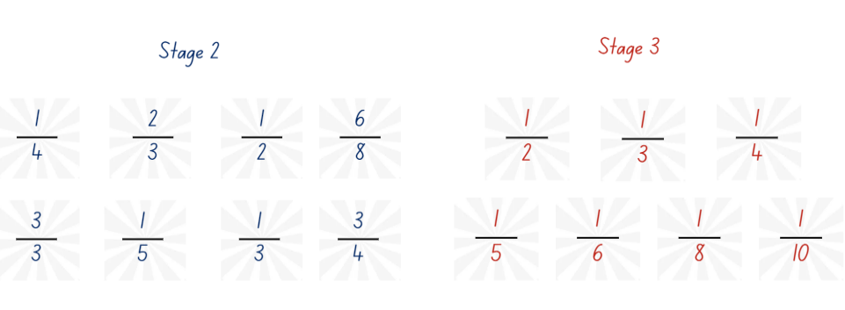
- Ask:
- How could you use a number line to order these fractions?
- What are the challenges of placing them all on the same number line?
- Which fractions might you place first? Explain your thinking.
- How can you use the fractions strips from Lesson 1 and 2 to assist you with ordering and placing them on the same number line?
- In pairs, students draw and label a number line showing zero, one and the placement of each fraction.
- Select 3 number lines from each stage to share with the class. Discuss similarities and differences. Ask students to justify any placements that differ to their peers.
- Discuss the connection between the denominator and the placement of fractions on the number line with Stage 3 students.
- Select a fraction recorded on the number line and ask Stage 2 students to identify how many more fraction units are needed to create the whole.
This table details opportunities for assessment.
Assessment opportunities | Links
What to look for:  - Can Stage 2 students model fractions with fraction strips for halves, quarters, eighths, thirds and sixths? [MAO-WM-01, MA2-PF-01]  - Can Stage 3 students compare and order fractions with denominators of 2, 3, 4, 5, 6, 8 and 10 by placing them on a number line? [MAO-WM-01, MA3-RQF-01] | Links to National Numeracy Learning Progressions (NNLP):  - Stage 2 – InF2, InF3, InF4  - Stage 3 – InF5, InF6.

Core lesson – 40 minutes

Stage 2 task – grid references
The table below contains suggested learning intentions and success criteria. These are best co-constructed with students.
Core concept learning intentions | Core concept success criteria
Students working towards Stage 2 outcomes are learning to:  - locate positions on grid maps  - create and interpret grid maps. | Students working towards Stage 2 outcomes can:  - locate positions by coordinating horizontal and vertical references  - use the array (row and column) structure of grid maps to locate position, horizontal before vertical  - identify and mark locations on maps and plans, given their grid references.
Note: the purpose of this lesson is to introduce students to the grid reference system and identify how a specific location can be given using a grid reference system.
- Display bookshelf 1 from Resource 12 – bookshelf 1 and 2. Ask students how they could describe the location of items. Anticipated responses may include that the bear is on the top shelf on the left. Repeat for several items.
- Ask students questions using the following prompt table. The table outlines stimulus prompts to generate conversation about the topic, along with anticipated responses from students.
Prompts | Anticipated student responses
- What does the arrangement of the toys remind you of? | - Toys are positioned in line with each other in rows and columns. This is like a grid map.
- How are they positioned? | - The toys are positioned in arrays.
- How can we draw an array or region? | - With dots or by using rows and columns.
- If you represent a box with rows and columns, what does this remind you of? | - Rows and columns of boxes remind me of a grid.
- If you draw a grid over the bookshelf, would this make describing the location easier? | - Yes, if you add grid references to it.
- Display bookshelf 2 with grid from Resource 12 – bookshelf 1 and 2. Ask:
- How can we now describe the location of a particular toy?
- How can we describe the spaces on the grid? Anticipated responses include labelling them with numbers or letters.
Note: this resource may elicit some discussion about the use of letters and numbers and the order of how spaces are described. When using grid-reference systems, such as those found on maps, convention dictates the horizontal component of direction is named first, followed by the vertical component, such as A2.
- Label the columns and rows following the discussion (see Figure 14).
Figure 14 – bookshelf grid map
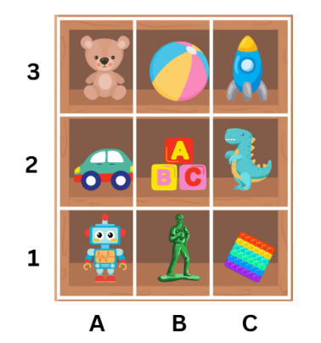
- Ask students to give the location of a few items using the revised system. Ask students to turn and talk about the following questions:
- How has using the grid reference system changed the way you describe location?
- Does using a grid make it easier to represent or visualise a location? What was easy or difficult?
- Ask students to share their reasoning with the class.
- Display Resource 13 – landmark map with grid. Review the directional language needed to use landmarks and compass points.
- Explain that students will use the 4 compass points and the grid system to record directions for a journey in their workbook or using a digital device. The route will need to make a stop at 3–4 identified landmarks (see Figure 15).
Figure 15 – student work sample
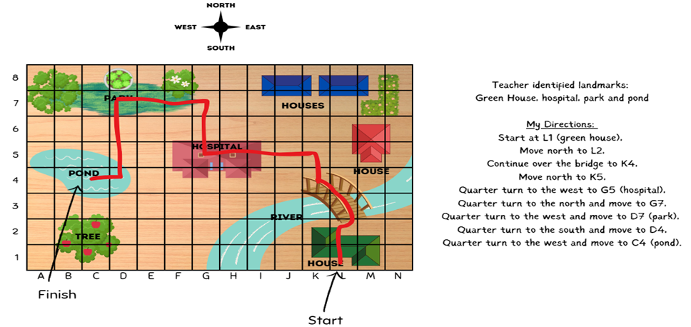
- Provide pairs of students a copy of Resource 13 – landmark map with grid and writing materials.
- Regroup Stage 2 students and ask:
- Is using a grid system more effective than using only landmarks?
- Are there times when one system would be better than the other?
This table details opportunities for differentiation.
Too hard? | Too easy?
Stage 2 students cannot locate positions on grid maps.  - Students track with their finger or a ruler along one column or one row to cross reference and name the specific landmarks they come across using a grid map.  - Students can shade the rows and columns to help determine specific locations on the grid. | Stage 2 students can locate positions on grid maps.  - Students engage in a barrier activity using a blank grid. Student A describes a route involving 3–5 turns from a designated start and end point. Student B attempts to follow and mark the directions on their copy of a blank grid. Both students compare maps.  - Students engage in Journey to Numberland. See Resource 14 – journey to Numberland (adapted from Journeys in Numberland from NRICH by University of Cambridge (Faculty of Mathematics)).

Stage 3 task – navigating the plane
The table below contains suggested learning intentions and success criteria. These are best co-constructed with students.
Core concept learning intentions | Core concept success criteria
Students working towards Stage 3 outcomes are learning to:  - use the 4 quadrants of the coordinate plane. | Students working towards Stage 3 outcomes can:  - plot and label points, given coordinates, in all 4 quadrants of the number plane  - identify and record the coordinates of given points on the number plan in all 4 quadrants.
Note: the purpose of this lesson is to support students in understanding that when identifying any location within all 4 quadrants of the Cartesian plane, it is important to think along the x-axis first to determine the x-coordinate before considering the y-coordinate. The use of travelators before lifts emphasises this idea in the context of the game played in this lesson.
- Review Resource 4 – Stage 3 position representations. Link the representations used to content covered in Lesson 2.
- Show students Resource 15 – Cartesian plane. Review the terms x-coordinate and y-coordinate and discuss that each axis on the Cartesian plane represents a number line.
- Place a point in each quadrant of the Cartesian plane. Ask students:
- How would you label the point in in each quadrant? (Students use their knowledge from previous lesson. Draw attention to the order of coordinates.)
- Have you ever used a lift or travelator? In which direction does each allow you to move?
- Display Resource 16 – carrot hunt. Identify the Origin Bunny, the lift and the travelator.
- Explain that students will use the travelator and lift to help the Origin Bunny to get to the carrots and label each location.
- Remind students that it is important to think of the horizontal number line first to help determine the x-coordinate.
- Model how the travelator can be used, noting the change in the x-coordinate only (see Figure 16).
Figure 16 – carrot hunt example
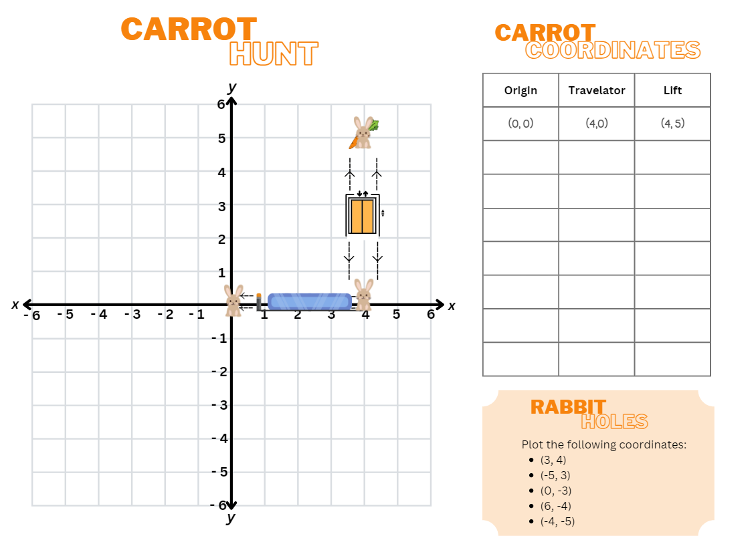
- Use a similar process to model reading the vertical number line with the y-axis using the lift and noting the change in the y-coordinate.
- Give pairs of students a copy of Resource 16 – carrot hunt.
- Student A uses the travelator to move the Origin Bunny from (0, 0) along the x-axis until it is in line with the carrot. Student A records the travelator movement. The y-coordinate should remain at zero.
- Student B uses the lift to move the Origin Bunny upwards parallel with the y-axis to the carrot and records the location.
- Students return Origin Bunny to (0, 0). Repeat the process for each carrot and complete the coordinate table.
- Students then plot rabbit holes at the locations listed on Resource 16 – carrot hunt.
- Ask students:
- Was there a pattern in how the coordinates changed when using the travelator? (Only the x-coordinate changed).
- Why was it helpful to use your travelator first? (The x-coordinate is always stated first so it is helpful to move along the x-axis first).
- Was there a pattern in how the coordinates changed when using the lift? (Only the y-coordinate changed).
This table details opportunities for differentiation.
Too hard? | Too easy?
Stage 3 students cannot identify and record the coordinates of given points on the number plane in all 4 quadrants.  - In the carrot hunt, students only work in first and second quadrant, focusing on moving along the x-axis first.  - Students access instant feedback using digital game 2. | Stage 3 students can identify and record the coordinates of given points on the number plan in all 4 quadrants.  - Students plot carrot locations that involve decimals for example (1.7, 3.2) and justify the accuracy of its location.  - Students modify the carrot game to design their own version and play with a partner.

Discuss and connect the mathematics – 5 minutes
- Regroup as a class and summarise the lesson together drawing out key mathematical ideas. Ask:
- Where have you seen the grid reference system used before? Refer to the real-life context of maps. (Stage 2)
- How has the grid reference system changed the way you describe location? (Stage 2)
- Does using a grid make it easier to represent or visualise a location or is using landmarks more effective? (Stage 2)
- What patterns did you see? (Stage 3)
- What was challenging and how did you adjust your strategies to address the challenges? (Stage 3)
- What would you do differently next time? (Stage 2 and Stage 3)
This table details opportunities for assessment.
Assessment opportunities | Links
What to look for:  - Can Stage 2 students locate positions by coordinating grid references? [MAO-WM-01, MA2-GM-01]  - Can Stage 2 students use the array (row and column) structure of grid maps to locate position, horizontal before vertical? [MAO-WM-01, MA2-GM-01]  - Can Stage 2 students identify and mark locations on maps and plans, given their grid references? [MAO-WM-01, MA2-GM-01]  - Can Stage 3 students plot and label points, given coordinates, in all 4 quadrants of the number plane? [MAO-WM-01, MA3-GM-01]  - Can Stage 3 students identify and record the coordinates of given points on the number plan in all 4 quadrants? [MAO-WM-01, MA3-GM-01] | Links to National Numeracy Learning Progressions (NNLP):  - Stage 2 – PoL5  - Stage 3 – n/a.

Lesson 4
Core concept: maps identify locations within a local environment (Stage 2). Integer coordinates change when reflected (Stage 3).

Daily number sense – 10 minutes
- From a class need surfaced through formative assessment data, identify a short, focused activity that targets students’ knowledge, understanding and skills. Example activities may be drawn from the following resources:
- Mathematics K–6 resources
- Universal Resources Hub.

Core lesson – 40 minutes

Stage 2 task – everyday application of directions
The table below contains suggested learning intentions and success criteria. These are best co-constructed with students.
Core concept learning intentions | Core concept success criteria
Students working towards Stage 2 outcomes are learning to:  - create and interpret grid maps  - use directional language and describe routes with grid maps. | Students working towards Stage 2 outcomes can:  - create simple maps and plans from an aerial view, labelling grid references  - identify and mark locations on maps and plans, given their grid references  - use a given grid map and compass directions (N, S, E, W) to plan, describe and show a route from one location to another.
This activity is an adaptation of ‘Banana cake’ from NZ Maths by the New Zealand Ministry of Education. The purpose of this lesson is to provide an opportunity for students to apply their understanding of the grid reference system to assist in describing and interpreting routes in everyday situations.
- Brainstorm where students might use maps in everyday life.
- Discuss what landmarks look like in a supermarket. For example, items are grouped by product type in different aisles or sections.
- Display Resource 17 – supermarket map.
- Students Think-Pair-Share to consider the following questions:
- How does the grid help when representing locations?
- How does it help describe a route?
- Would compass points ever be useful in this situation? Why or why not?
- Model how to construct a map where objects or landmarks take up multiple squares on a grid.
- Provide students with a copy of Resource 18 – supermarket instructions 1 and Resource 19 – 100 square grid.
- Students label the horizontal axis with letters and vertical axis with numbers on Resource 19 – 100 square grid.
- Students create a supermarket map by shading and labelling using the given instructions and grid paper.
- In pairs, students create and record in their workbooks 2 routes through the supermarket to gather the supplies to make a banana cake, such as butter, milk, eggs, bananas, flour and choc chips.
This table details opportunities for differentiation.
Too hard? | Too easy?
Stage 2 students cannot create a simple map or plan from an aerial view, labelling grid references.  - Provide students with Resource 17 – supermarket map. Support students to locate items on the shopping list.  - Ask students to only map locations with single grid references using Resource 18 – supermarket instructions 2. | Stage 2 students can create a simple map or plan from an aerial view, labelling grid references.  - Students find the shortest route to collect all ingredients and justify why this is the shortest route.  - Students write their route using directional language, including landmarks and compass points.

Stage 3 task – coordinate patterns
The table below contains suggested learning intentions and success criteria. These are best co-constructed with students.
Core concept learning intentions | Core concept success criteria
Students working towards Stage 3 outcomes are learning to:  - use the 4 quadrants of the coordinate plane. | Students working towards Stage 3 outcomes can:  - plot and label points, given coordinates, in all 4 quadrants of the number plane  - describe changes to coordinates when a point is translated or reflected across an axis.
Note: the purpose of this lesson is to understand how patterns within the coordinate plane influence how locations are described in each quadrant. Students will use their understanding of these patterns to assist in locating positions across the Cartesian plane.
- Review Resource 4 – Stage 3 position representations. Link the representations to content from Lesson 3.
- Provide students with Resource 15 – Cartesian plane and Resource 20 – target and directional cards. To make a larger plane, you may wish to use masking tape or draw a blank Cartesian plane.
- Students work in small groups to place the target cards in the correct quadrant. Explain that the cards do not need to be placed in the exact location of the point shown.
- Students then place a directional language card in each quadrant to describe direction of that quadrant from the origin (0, 0). The words forwards and backwards are adopted to represent movement along a number line.
Note: quadrants are labelled as shown in Figure 17. Quadrant labels are not explicitly stated in Stage 3 content but can be a useful label.
Figure 17 – labelled quadrants
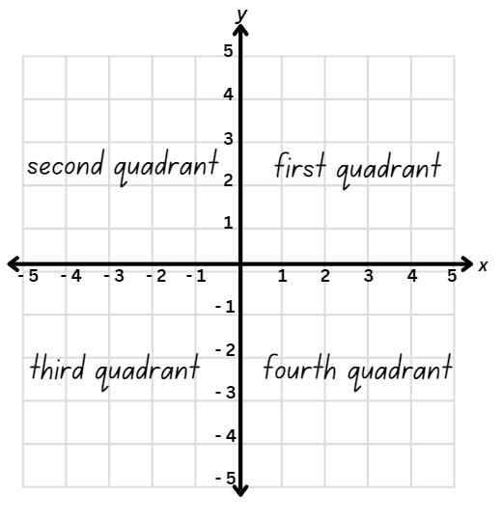
The table below outlines stimulus prompts to generate conversation about the topic, along with anticipated responses from students.
Prompts | Anticipated student responses
- What patterns do you notice in the coordinates in each quadrant? | - In the first quadrant both x and y are positive.  - In the second quadrant x is negative and y is positive.  - In the third quadrant both x and y are negative.  - In fourth quadrant x is positive, and y is negative.  - The first and third quadrants are the opposite of each other.  - The second and fourth quadrants are the opposite of each other.  - (0, 0) or the origin is the mirror point.
- How do these patterns relate to the origin? | - If both coordinates are positive, the location is in the first quadrant.  - If both coordinates are negative, the location is in the third quadrant.  - If x is positive and y is negative, the location is in in the fourth quadrant.  - If x is negative and y is positive, the location is in in the second quadrant.  - It is important to think about the x-coordinate first and then the y-coordinate.  - It is important to think about reading the Cartesian plane horizontally, before vertically.
- What does it mean to reflect? What might it mean if you were asked to reflect a point across an axis? What would you expect to see? | - Reflection is like a mirror image.  - The point will move to a different quadrant.  - The point will be the same distance away from the middle (or the axis) on both sides.  - If I reflect across the x-axis I am moving up or down so only the y-coordinate would change.  - If I reflect across the y-axis, I am moving across so only the x-coordinate will change.
- Model how to locate and plot a point in the first quadrant.
- Ask students to consider where this point might be located if it was reflected into the second quadrant.
- Show students how a coloured pencil or highlighter can be used to mark the horizontal distance from the point to the y-axis. Then model how this distance can be extended into the second quadrant to assist in locating the reflected point (see Figure 18).
Figure 18 – reflected point
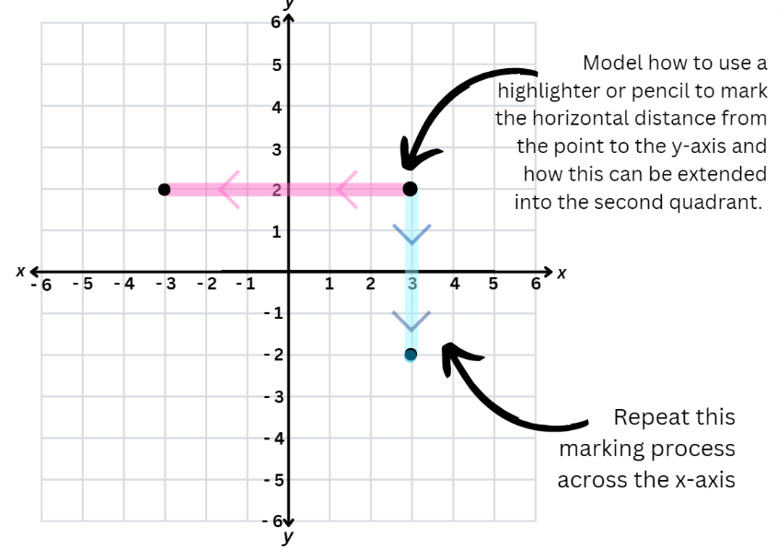
- Model how to label the reflected point emphasising how only the x-coordinate changed.
- Model a similar process for reflecting the same point across the x-axis into the fourth quadrant. Use coloured pencils or highlighters and emphasising the change in y-coordinates.
This table details opportunities for differentiation.
Too hard? | Too easy?
Stage 3 students cannot describe changes to coordinates when a point is translated or reflected across an axis.  - When completing target activity, students focus on the first and second quadrants only.  - In consolidating activity, students only reflect over the y-axis in the first and second quadrants to complete the task. | Stage 3 students can describe changes to coordinates when a point is translated or reflected across an axis.  - Students play a game that requires them to visualise the quadrants of a point within the Cartesian plane such as Show the coordinates.  - Students observe the pattern formed when reflecting across the x- and y-axis. Use this pattern to generalise about the reflection through the origin for each point they generate.

Discuss and connect the mathematics – 10 minutes
- Regroup as a class and summarise the lesson together drawing out key mathematical ideas. Ask:
- How do grid representations help you to navigate? (Stage 2)
- How do grid references change the language that you use when describing routes? (Stage 2)
- When is it most effective to use grid references? Why? (Stage 2)
- What tools can you use to help you locate a point in any quadrant? (Stage 3)
- If you are moving across the x-axis, which coordinate do you expect to see change? (Stage 3)
- If you are moving up and down the y-axis, which coordinates do you expect to see change? (Stage 3)
This table details opportunities for assessment.
Assessment opportunities | Links
What to look for:  - Can Stage 2 students create simple maps and plans from an aerial view, labelling grid references? [MAO-WM-01, MA2-GM-01]  - Can Stage 2 students identify and mark locations on maps and plans, given their grid references? [MAO-WM-01, MA2-GM-01]  - Can Stage 2 students use a given grid map and compass directions (N, S, E, W) to plan, describe and show a route from one location to another? [MAO-WM-01, MA2-GM-01]  - Can Stage 3 students plot and label points, given coordinates, in all 4 quadrants of the number plane? [MAO-WM-01, MA3-GM-01]  - Can Stage 3 students describe changes to coordinates when a point is translated or reflected across an axis? [MAO-WM-01, MA3-GM-01] | Links to National Numeracy Learning Progressions (NNLP):  - Stage 2 – PoL5.  - Stage 3 – n/a.

Lesson 5
Core concept: the outcome of chance experiments can be described and recorded (Stage 2). Probability can be represented on a scale from zero to one (Stage 3).

Daily number sense – target number – 10 minutes
Daily number sense activities for Lessons 5 to 7 ‘loop’ back to concepts and procedures covered in previous units to assist students to build an increasingly connected network of ideas. These concepts may differ from the core concepts being covered by the unit.
The table below contains a suggested learning intention and success criteria. These are best co-constructed with students.
Daily number sense learning intention | Daily number sense success criteria
Students working towards Stage 2 outcomes are learning to:  - recognise and explain the connection between addition and subtraction.  Students working towards Stage 3 outcomes are learning to:  - apply efficient mental and written strategies to solve addition and subtraction problems. | Students working towards Stage 2 outcomes can:  - use number relation principles to solve related problems  - explain and check solutions to problems, including using the inverse operation.  Students working towards Stage 3 outcomes can:  - apply known strategies such as levelling, addition for subtraction, using constant difference, and bridging.
This activity is an adaptation of ‘Target number’ from Math for love by Finkle.
- Explain to students that they will use addition and/or subtraction as the operations to solve a 2-digit ‘target’ number on the board.
Multi-age: to further support students working towards Stage 3 outcomes a 3- or 4-digit ‘target’ number can be applied.
- Using whiteboards, students write down as many different number sentences that have the target number as the answer. For example, 32 + 7 – 4 = 35.
- Students turn and talk to a partner and share one of their number sentences, then describe the strategies they used to create it.
- Regroup as a class and discuss students’ reasoning for their ideas. Highlight different ideas that promote the understanding that different strategies can be more effective for different problems. For example, inverse operations, bar model, constant difference, bridging or complement principle.
Note: the activity can be adapted by using 3-digit numbers. To reinforce the concept of equivalence, consider also presenting the target in this form: 35 = 32 + 7 – 4.
This table details opportunities for assessment.
Assessment opportunities | Links
What to look for:  - Can Stage 2 students use number relation principles to solve related problems? [MAO-WM-01, MA2-AR-01]  - Can Stage 2 students explain and check solutions to problems, including by using the inverse operation?  [MAO-WM-01, MA2-AR-01]  - Can Stage 3 apply known strategies such as levelling, addition for subtraction, using constant difference, and bridging? [MAO-WM-01, MA3-AR-01] | Links to National Numeracy Learning Progressions (NNLP):  - Stage 2 – AdS7  - Stage 3 – AdS7, AdS8.  Links to suggested Interview for Student Reasoning (IfSR) tasks:  - Stage 2 – IfSR – AT: 3A.3, 3A.4  - Stage 3 – IfSR – AT: 3A.4, 3A.5.

Core lesson 1 – language of chance – 20 minutes
The table below contains suggested learning intentions and success criteria. These are best co-constructed with students.
Core concept learning intentions | Core concept success criteria
Students working towards Stage 2 outcomes are learning to:  - identify possible outcomes from chance experiments  - describe the likelihood of outcomes of chance events.  Students working towards Stage 3 outcomes are learning to:  - list outcomes of chance experiments involving equally likely outcomes and represent probabilities. | Students working towards Stage 2 outcomes can:  - use the term ‘outcome’ to describe any possible result of a chance experiment  - record all possible combinations in a chance situation  - use the terms equally likely, likely and unlikely to describe the chance of everyday events occurring.  Students working towards Stage 3 outcomes can:  - use the term probability to describe the numerical value that represents the likelihood of an outcome of a chance experiment  - establish that the total of the probabilities of the outcomes of a chance experiment equals one  - discuss the imprecise meaning of commonly used chance words including possible, likely and unlikely.

Note: the purpose of this lesson is to explore terms like fair, unfair, possible, impossible, likely, unlikely, equally likely and certain in everyday statements and chance situations, fostering shared understanding and clarifying misconceptions through numerical values and phrases.
For each lesson on chance in this unit, students can enhance their understanding by using various representations or tools. These representations and tools can be constructed with students on an anchor chart or provided as a resource, see Resource 21 – Stage 2 chance representations and Resource 22 – Stage 3 chance representation.
- As a class explain that the word ‘outcome’ means any possible result of a situation. Discuss situations with different possible outcomes, such as weather, sport, card games or board games.
- Explain that in mathematics outcome has a specific meaning. Share the syllabus definition of outcome.
Outcome: a possible result from an experiment or trial.
- Discuss outcomes of random generators, such as rolling dice, spinning a spinner or dealing cards from a deck, taking coloured counters from a bag.
- Display a chance scale (see Figure 19) and discuss Resource 23 – chance statements.
Figure 19 – chance scale
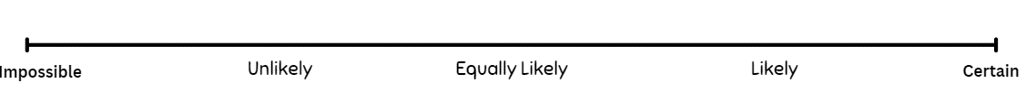
- Students turn and talk to a partner and discuss the chance language.
- Regroup as a class and select students to scale some statements and ask:
- Is impossible the opposite of possible? (See note below)
- What makes something certain or impossible?
- What makes something more likely or less likely?
- What does equally likely mean? The equal chance of each outcome occurring.
Note: certain is the opposite of impossible. Anything that is not impossible, is possible. Therefore, possible includes a scale of things that are more and less likely, equally likely and certain. Impossible means that the outcome can never occur. Certain means that it will definitely occur.

Stage 2 – two and one – 25 minutes
This activity is an adaptation of ‘Two and One’ from NRICH by University of Cambridge (Faculty of Mathematics).
- Display the game Two and One. Read the instructions and play the game by selecting the Run once button several times. Discuss the results.
- Ask students to turn and talk about what might happen after 100 turns. Select the Run ×100 button. Examine the results for long stretches of losses. Discuss the results and ask if they were as predicted.
- Display Resource 24 – carnival games and read instructions.
- Students explore the idea of fair and unfair by playing the carnival game for 5–10 minutes.
- Stop the game. Select students to share their scores as hosts and players.
This table details opportunities for differentiation.
Too hard? | Too easy?
Stage 2 students cannot describe the likelihood of outcomes of chance events.  - Students sort the statements on Resource 23 – chance statements into 2 categories – likely and unlikely.  - Provide students with manipulatives to explore discussion questions from the Carnival game. For example, swap out a blue counter for a green counter and play the game. | Stage 2 students can describe the likelihood of outcomes of chance events.  - Students can create their own chance statements for a partner to sort on the chance scale.  - Students explore whether the Carnival game is fair or unfair using 2 red and 2 blue counters. Nominate 2 spots as the winner’s spot. The player wins if a red counter lands in either spot (see Figure 20). Ask if the game is now fair and whether students can derive a rule for fair and unfair versions of this game.
Figure 20 – modified carnival game
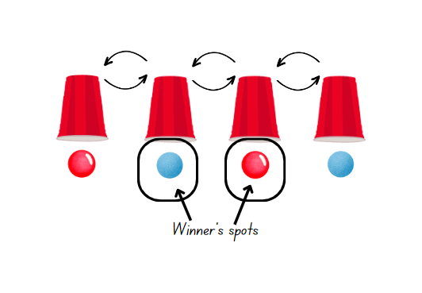

Stage 3 – in between – 25 minutes
This activity is an adaptation of In Between from NZ Maths by New Zealand Ministry of Education.
- Display Resource 26 – colloquial terms and ask students to sort the colloquial terms into 3 categories: impossible, possible, certain.
- Discuss the differences between the use of this language in everyday situations and how this may not support students in understanding these terms in the context of chance. For example, students may exaggerate that they never go outside for sport during school, when they do. Similarly, students may use always for situations that often happen, rather than situations with 100% certainty.
- Display Resource 25 – numerical phrases. Students place the numerical phrases into the same 3 categories (impossible, possible, certain).
- As a class, compare the difference between Resource 26 – colloquial terms and Resource 25 – numerical phrases.
- Discuss the idea that numerical phrases are more precise, less ambiguous, more universally understood and less subjective.
- Explain to students that they will play a card game:
- Players turn over 2 cards from a pile of 10 cards numbered 1–10.
- Players then turn over a third card.
- If the number on that card is in between the 2 previously overturned numbers, the player wins a counter (see Figure 21).
Figure 21 – in between
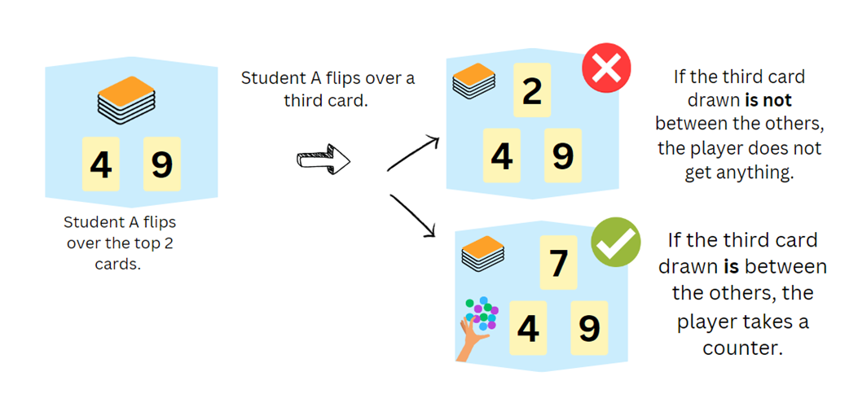
- Provide an opportunity for students to play until a one player has 5 counters.
- Regroup Stage 3 students and display Resource 27 – cards and strips.
- Model how to use the fraction strips to represent the chance of turning over an ‘in between card’ (the desired outcome) as a part of a whole (the total number of possibilities for the third card) (see Figure 22).
Figure 22 – fraction strips
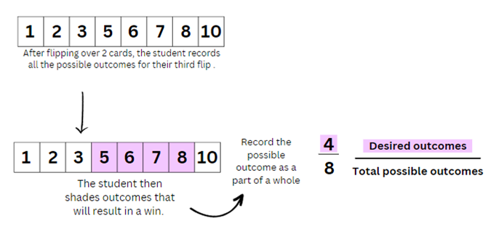
Note: as there are only 8 cards left in the deck after drawing 2, the total number of possibilities is represented as 8 on the fraction strip. Students use shading to represent the proportion of those cards that fall between the first 2 cards drawn.
- Model for students how the shading on their strips can be written as a fraction.
- In pairs, provide students with Resource 27 – card and strips and 12 counters. Students shuffle the cards. Student A draws 2 cards, makes their fraction strip to assess the chance of winning then draws a third card, taking a counter if they win. Student B repeats this process.
- The game continues until each student has had 6 turns. The player with the most counters wins.
This table details opportunities for differentiation.
Too hard? | Too easy?
Stage 3 students cannot use the term probability to describe the numerical value that represents the likelihood of an outcome of a chance experiment.  - Write the denominator for every fraction strip on Resource 27 – cards and strips.  - Provide students with a number line labelled 1–10 where they can circle the first 2 numbers that they draw and count how many numbers are left in between. | Stage 3 students can use the term probability to describe the numerical value that represents the likelihood of an outcome of a chance experiment.  - Consider how the fraction strip might change if playing with 12 or 20 cards.  - Consider how the chance might change if the number had to be in between the 2 cards drawn first and must be even.

Discuss and connect the mathematics – 10 minutes
- Summarise key mathematical concepts and discuss as a class using the prompt questions.
The table below outlines stimulus prompts to generate conversation about the topic, along with anticipated responses from students.
Prompts | Anticipated student responses
- Is the game fair? Why or why not? (Stage 2) | - It is not fair because there are more blue counters.  - It is more likely that blue will end up in the middle because there are more blue counters.  - It is hard for me to win! Red has a 1 in 3 chance of being in the middle and blue has a 2 in 3 chance of being in the middle.  - It is not fair if the host remembers where the red counter is.
- How can the game be changed to make it impossible to win? (Stage 2) | - Make all the counters are blue.  - Make sure there are no red counters.
- Is it always true that, if there is not an equal chance of winning, the game is not fair? (Stage 2) | - Yes, if it is not equal for both players then it is not a fair game.  - No, you do not need to have an equal chance, it just needs to be easier for the player to win.  Note: for a game to be fair, both parties must have an equal chance of winning.
- Were the fraction strips helpful in describing chance in numerical terms? (Stage 3) | - Yes, it was easy to turn it into a fraction.  - It was easy to see when the chance of winning was more likely or less likely.
- What did the shaded part of the fraction strip represent? (Stage 3) | - The number of cards that would allow me to win.  - The number of cards that are in between my number.
- When using the fraction strip, what did the whole fractions strip represent? (Stage 3) | - The total number of cards left after drawing 2 cards. This is important because I must express the chance of getting a desired card as a proportion of the total number of cards left.
- Why was the fraction strip divided into 8 parts? Could there have been more or less parts? (Stage 3) | - After drawing 2 cards there were 8 cards left; there are 8 total possibilities.  - There had to be 8 parts as that represented the whole (number of options left).
- Sometimes people say things like, I have put in 110% effort. Do statements like this every apply in chance? Can you say that there is 110% chance of achieving something? (Stage 3) | - No, because 100% is certain as it represents the total number of possibilities. I cannot achieve more that the total number of possibilities.
- If you were to put chance on a scale, what numbers would you use at the beginning of our scale and at the end? (Stage 3) | - Scale of zero to one.  - Scale of 0% to 100%  - Zero represents impossible and one represents certain.
- How did using the fraction strips help you to express chance as a fraction? (Stage 3) | - I could describe the chance as the number of cards in between my first 2 cards (desired outcomes) over the total number of cards left.  - It was easy to describe what I saw on the fraction strip. If my probability of winning was 4 in 8, then I could turn that into a fraction.
This table details opportunities for assessment.
Assessment opportunities | Links
What to look for:  - Can Stage 2 students use the term ‘outcome’ to describe any possible result of a chance experiment? [MAO-WM-01, MA2-CHAN-01]  - Can Stage 2 students record all possible combinations in a chance situation? [MAO-WM-01, MA2-CHAN-01]  - Can Stage 2 students use the terms equally likely, likely and unlikely to describe the chance of everyday events occurring? [MAO-WM-01, MA2-CHAN-01  - Can Stage 3 students discuss the imprecise meaning of commonly used chance words including possible, likely and unlikely? [MAO-WM-01, MA3-CHAN-01]  - Can Stage 3 students use the term probability to describe the numerical value that represents the likelihood of an outcome of a chance experiment? [MAO-WM-01, MA3-CHAN-01] | Links to National Numeracy Learning Progressions (NNLP):  - Stage 2 – UnC2, UnC3, CPr8  - Stage 3 – UnC3, UnC4, UnC5, InF5, InF6.

Lesson 6
Core concept: outcomes from chance experiments can be predicted, recorded and compared (Stage 2). Outcomes in chance experiments can be equally likely (Stage 3).

Daily number sense – closest number – 10 minutes
The table below contains a suggested learning intention and success criteria. These are best co-constructed with students.
Daily number sense learning intention | Daily number sense success criteria
Students working towards Stage 2 outcomes are learning to:  - recognise and explain the connection between addition and subtraction.  Students working towards Stage 3 outcomes are learning to:  - apply efficient mental and written strategies to solve addition and subtraction problems. | Students working towards Stage 2 outcomes can:  - use number relation principles to solve related problems  - use the complement principle of addition and subtraction.  Students working towards Stage 3 outcomes can:  - use place value to add or subtract 3 or more numbers with different numbers of digits.
This activity is an adaptation of Closest to 100 (additive strategies) from Mathematics K–6 resources by State of New South Wales (Department of Education).
- Explain to students that the aim of the game is to use addition or subtraction to get close to a total of 100.
Multi-age: to further support students working towards Stage 3 outcomes, the aim of the game is to use addition or subtraction to get close to a total of 1000 or 10 000. Stage 3 students can also use their place value understanding to solve the equations.
- The winner of the game is the player with the lowest points.
- Provide pairs of students with a whiteboard and a pack of cards from A–10. Player 1 shuffles the cards and puts them in a central pile. Player 2 takes 6 cards and places them face up for everyone to see.
- Each card can only be used once, and it can be used to form a one- or 2-digit number. Not all cards need to be used.
Multi-age: Stage 3 students can add an additional card in the pile and form 2-, 3- or 4-digit numbers to form an equation.
- Players score zero points if they can get exactly 100, 1000 or 10 000. Players score points based on the difference between their total and 100, 1000 or 10 000. For example, a total of 94 would score 6 points.
- Students record their number sentence and score on their whiteboard.
- Ask students to represent their equation using a bar model. Discuss how the complement principle highlights in inverse principle (see Figure 23).
Figure 23 – bar model example
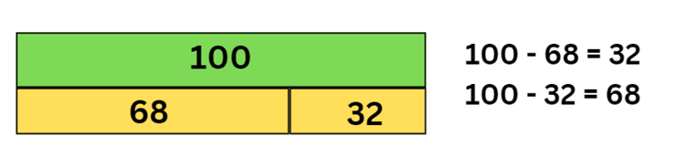
Note: a bar model is made up of rectangles, representing the part-part-whole relationship. For example, the whole bar on top is labelled 100, and 2 rectangles below are labelled 68 and 32. The rectangles are collectively the same length as the whole bar and show the proportion of their value.
This table details opportunities for assessment.
Assessment opportunities | Links
What to look for:  - Can Stage 2 students use number relation principles to solve related problems? [MAO-WM-01, MA2-AR-01]  - Can Stage 2 students use the complement principle of addition and subtraction? [MAO-WM-01, MA2-AR-01]  - Can Stage 3 students use place value to add or subtract 3 or more numbers with different numbers of digits? [MAO-WM-01, MA3-AR-01] | Links to National Numeracy Learning Progressions (NNLP):  - Stage 2 – AdS7  - Stage 3 – AdS7, AdS8.  Links to suggested Interview for Student Reasoning (IfSR) tasks:  - Stage 2 – IfSR – AT : 3A.3, 3A.4  - Stage 3 – IfSR – AT: 3A.4, 3A.5.

Core lesson – 40 minutes

Stage 2 task – fair and unfair
The table below contains suggested learning intentions and success criteria. These are best co-constructed with students.
Core concept learning intentions | Core concept success criteria
Students working towards Stage 2 outcomes are learning to:  - identify possible outcomes from chance experiments  - describe the likelihood of outcomes of chance events. | Students working towards Stage 2 outcomes can:  - record all possible outcomes in a chance experiment where the outcomes are equally likely  - compare the likelihood of obtaining particular outcomes in a simple chance experiment by predicting, conducting the experiment and comparing the results with the prediction.
Note: the purpose of this lesson is to explore different representations of fair and unfair so that students develop a shared understanding that, for a game to be fair, everyone must have an equal chance of winning.
- Display Resource 28 – What is fair?. Identify and discuss examples and non-examples of what fair looks like.
- Distribute copies of Resource 28 – What is fair?.
- In groups of 4, students cut and sort the cards into 2 groups labelled fair and unfair.
- Conduct a gallery walk for students to consider how other groups have sorted the cards.
- As a class, discuss the following questions:
- What did you consider when deciding if a card was fair or unfair?
- Can fair look different?
- Can things appear fair and still be unfair?
Note: examples of student ideas for fair and unfair may include whether it was half-half, whether all the sections were the same size (therefore an equal chance of each outcome), whether students considered the outcomes of what they wanted in relation to all possible outcomes and whether students considered an unfair situation to be fair just because the chance was in their favour. Use Resource 29 – fairness reference sheet to facilitate class discussion.
- Explain that the students are going to design their own carnival games using random generators. Students will work in pairs with one person as the carnival game host and the other as a player. Roles can be swapped throughout the activity.
- Discuss the idea that the carnival game host will want to ensure the player loses more than they win. They have an interest in making the game unfair.
- The challenge for the player is to ensure that the game is fair.
- Model using a dice and how this can be achieved by using the following prompts, along with anticipated responses from students.
Prompts | Anticipated student responses
- How do you win the game? | - Rolling 4 on a die.
- How likely is this to occur? | - Any number has the same chance and there are 6 numbers, so it is a one in 6 chance.  - I may not roll a 4 at all.  - It is unlikely that I will roll a 4 because there are 5 other options.
- If this fair? Why/why not? (See Resource 29 – fairness reference sheet). | - It is fair because each number has an equal chance.  - It is unfair because there are 5 other numbers and so it is 5 times more likely that I will roll one of them.
- Would the carnival game host be happy with this game? Why/why not? | - Yes, because they are more likely to win.  - Yes, because it is hard for me to roll a 4.
- What do we mean by fair? | - Fair means that I have a good chance of winning.  - Fair means that everyone has an equal chance of winning.
- How could the player change this game to make sure it is fair? | - By changing the aim of the game so there is an equal chance of getting what the player wants.  - By changing the rules so you win by rolling an even number.
- Give each pair a copy of Resource 30 – random generators (Stage 2).
- Students design a simple game using one random generator at a time. The carnival host sets the rules to ensure the game is unfair. The player changes the generators or the rules to ensure they have fair chance of winning.
This table details opportunities for differentiation.
Too hard? | Too easy?
Stage 2 students cannot describe the likelihood of outcomes of chance events.  - Students sort simple chance generators. For example, students only use the spinner and dice cards.  - Give students a fair and unfair game situation. Ask them to choose which they would prefer if they were the carnival host or the player, see Resource 31 – carnival host vs player. | Stage 2 students can describe the likelihood of outcomes of chance events.  - Students create their own chance representations to be sorted into fair and unfair.  - Ask students to consider how the idea of fair and unfair might change if they were to use 2 coins or 2 dice, where winning means getting 2 heads or 2 tails, or a 4 on each dice.

Stage 3 task – equally likely outcomes
The table below contains suggested learning intentions and success criteria. These are best co-constructed with students.
Core concept learning intentions | Core concept success criteria
Students working towards Stage 3 outcomes are learning to:  - list outcomes of chance experiments involving equally likely outcomes and represent probabilities  - create random generators and describe probabilities using fractions. | Students working towards Stage 3 outcomes can:  - recognise that outcomes are described as equally likely when any one outcome has the same chance of occurring as any other outcome  - represent probabilities of outcomes of chance experiments using fractions  - use knowledge of benchmark fractions, decimals and percentages to assign probabilities to the likelihood of outcome.
Note: the purpose of this lesson is to explore the idea that equally likely can have different numerical values, such as one in 2, one in 3 or one in 4, so long as every outcome has an equal chance of occurring.
- Display Resource 22 – Stage 3 chance representations. Link the representations to learning in Lesson 5.
- Display a zero to one scale. The table below outlines prompts to generate conversation about the scale, along with anticipated responses from students.
Prompts | Anticipated student responses
- Where would you write impossible and certain on this scale? | - Place impossible at zero because it cannot happen and certain at one because it will happen.
- Where would you place equally likely on this scale? Why? | - In the middle; at 0.5.  - Because I have a 50/50 or half, half chance of either outcome, it is equally likely.  - I am dividing the space equally, so it sits halfway between zero and one.  - It is halfway between impossible (0) and certain (1).  - If you break something equally you break it in half.
- What does it mean to be equally likely? | - Equal is like half.  - There is a 50/50 chance.
- Explain to students that they will now explore the conjecture that equally likely is the same as 50/50.
- Display and discuss Resource 30 – random generators (Stage 3).
- Provide students with 4 paper strips of equal size (approximately 3 cm by 20 cm).
- Explain to students that they will use the paper strips to represent the possibility of getting any outcome using these generators.
- Use the coin as an example and ask students how many possible outcomes there are when tossing a coin. List these outcomes on the board (heads/tails).
- Ask students, ‘If there are 2 possible outcomes, how could they divide their strip to represent the total possible outcomes?’. For example, fold the strip equally in half.
- Students fold one strip in half and draw a line down the centre. Label one half of the strip heads and the other half tails.
- Discuss that because the strip has been divided into 2 equal parts it represents an equal chance of either outcome occurring. The whole strip represents certainty that both outcomes will occur.
- Model different ways to describe the chance of getting heads or tails:
- For every 2 equal parts, one is heads. Therefore, I have a one in 2 chance of getting heads.
- There is a one in 2 chance of getting heads, I can represent this as half ($\frac{1}{2}$).
- There are 2 possible outcomes, represented by 2 equal parts. Therefore, there is an equal chance of each one occurring.
- There is the same chance that I will get heads compared to tails, so there is an equal chance.
Note: consider asking students for other ways to represent the chance of flipping heads or tails. Answers include 0.5 and 50%.
- Students label each part of their fraction strip as half to represent the probability of it occurring as a fraction.
- In small groups, students fold and colour code or label the remaining strips to represent the chance of each outcome occurring using the other random generators (see Figure 24).
Figure 24 – fraction strips
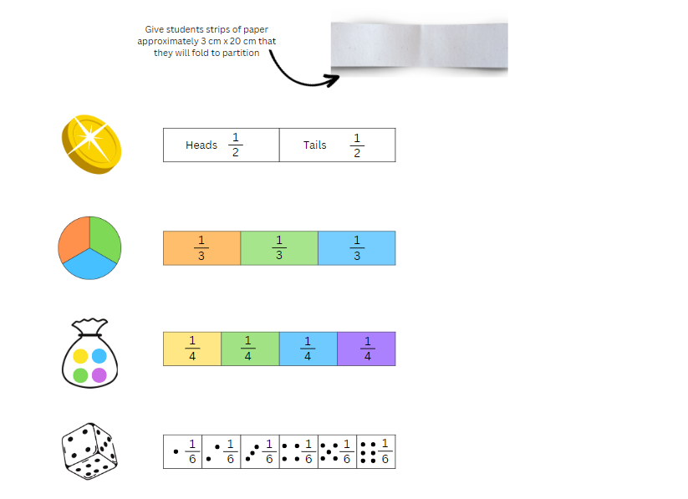
- Display Resource 32 – sentence stems. In pairs, students describe the chance of each outcome using the sentence stems.
- Ask students to line up their fraction strips, similar to a fraction wall.
- As a class, discuss the questions in the table below. The table outlines stimulus prompts to generate conversation about the topic, along with anticipated responses from students.
Prompts | Anticipated student responses
- Do each of these strips represent an equal chance of each outcome? Are all outcomes equally likely? How do you know? | - Yes, because all the parts are the same size on each strip, all outcomes have an equal chance of occurring and are therefore equally likely.
- Looking at your fraction strips and considering where you placed equally likely on your zero to one scale, do you still think equally likely is in the middle? Is equally likely a 50/50 chance? | - It can be. On one of our strips ‘equally likely’ was halfway.  - It doesn’t have to be because equally likely is about whether all outcomes have an equal chance of occurring. If there are more than 2 outcomes, then it won’t be a 50/50 chance.  - Equally likely can look different, depending on the number of possible outcomes
This table details opportunities for differentiation.
Too hard? | Too easy?
Stage 3 students cannot recognise that outcomes are described as equally likely when any one outcome has the same chance of occurring as any other outcome.  - Give students strips that are subdivided into 2, 3, 4 and 6 parts so they can colour code or label to represent equal chance.  - Explicitly name the fractions in Resource 34 – equally likely cartoon (see Figure 25) to support students in understanding that the orange and green each represent a 1 in 8 chance, whereas the other colours represent a 1 in 4 chance and therefore there is an unequal chance. | Stage 3 students can recognise that outcomes are described as equally likely when any one outcome has the same chance of occurring as any other outcome.  - Students create their own generators to represent equal chance where there are 8 or 10 possible outcomes.  - Students create their own cartoons by modifying the 3-part spinner on Resource 30 – random generators (Stage 3) to represent both equal and unequal chance.
Figure 25 – fraction model
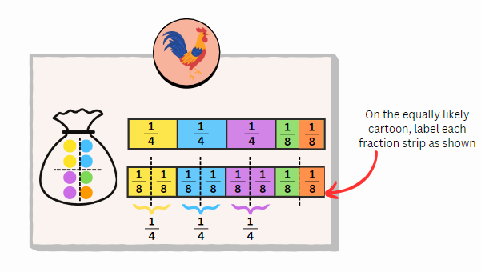

Discuss and connect the mathematics – 15 minutes
- Regroup as a class and display Resource 33 – fair and unfair. Ask students:
- In game one, would you rather be player 1 or player 2? Why?
- In game one, which player do you predict will win? Why?
- If you were the game host for game 2, which of the coloured spinners would you chose for players to use? Explain.
- If you were a game player in game 2, which of the coloured spinners would you chose to use? Explain.
- Which of the 2 games has the greater chance of a fair outcome? Unfair? Explain.
Multi-age: students working towards Stage 3 outcomes may enjoy the challenge of further discussions using Resource 34 – equally likely cartoons. Use prompt questions, such as which cartoons represent equally likely outcomes and why; which diagrams show an unequal chance and why; looking at the rooster, what is the chance of picking orange; looking at the rabbit, what is the chance of picking orange?
This table details opportunities for assessment.
Assessment opportunities | Links
What to look for:  - Can Stage 2 students record all possible outcomes in a chance experiment where the outcomes are equally likely? [MAO-WM-01, MA2-CHAN-01]  - Can Stage 2 students compare the likelihood of obtaining particular outcomes in a simple chance experiment by predicting, conducting the experiment and comparing the results with the prediction? [MAO-WM-01, MA2-CHAN-01]  - Can Stage3 students recognise that outcomes are described as equally likely when any one outcome has the same chance of occurring as any other outcome? [MAO-WM-1, MA3-CHAN-01]  - Can Stage 3 students represent probabilities of outcomes of chance experiments using fractions? [MAO-WM-1, MA3-CHAN-01] | Links to National Numeracy Learning Progressions (NNLP):  - Stage 2 – UnC2, UnC3, CPr8  - Stage 3 – UnC2, UnC3, UnC4, UnC5.

Lesson 7
Core concept: outcomes from chance experiments can be predicted, recorded and compared (Stage 2). The frequency of outcomes has a value based on its occurrence (Stage 3).

Daily number sense – closest to... – 10 minutes
The table below contains a suggested learning intention and success criteria. These are best co-constructed with students.
Daily number sense learning intention | Daily number sense success criteria
Students working towards Stage 2 outcomes are learning to:  - recognise and explain the connection between addition and subtraction.  Students working towards Stage 3 outcomes are learning to:  - apply efficient mental and written strategies to solve addition and subtraction problems. | Students working towards Stage 2 outcomes can:  - demonstrate how addition and subtraction are inverse operations.  Students working towards Stage 3 outcomes can:  - use place value to add or subtract 3 or more numbers with different numbers of digit.
This activity is an adaptation of Closest to 100 from Mathematics K–6 resources by State of New South Wales (Department of Education). The aim of the game is to use addition or subtraction to get close to a target total. The winner of the game is the player with the lowest points.
- Repeat Lesson 6 Daily number sense with a different target number.
- Students record their number sentence and score on their whiteboard.
- Regroup and share results.
This table details opportunities for assessment.
Assessment opportunities | Links
What to look for:  - Can Stage 2 students demonstrate how addition and subtraction are inverse operations? [MAO-WM-01, MA2-AR-01]  - Can Stage 3 students use place value to add or subtract 3 or more numbers with different numbers of digits? [MAO-WM-01, MA3-AR-01] | Links to National Numeracy Learning Progressions (NNLP):  - Stage 2 – AdS7  - Stage 3 – AdS7, AdS8.  Links to suggested Interview for Student Reasoning (IfSR) tasks:  - Stage 2 – IfSR – AT: 3A.3, 3A.4  - Stage 3 – IfSR – AT: 3A.4, 3A.5.

Core lesson – 40 minutes

Stage 2 task – equal chance
The table below contains suggested learning intentions and success criteria. These are best co-constructed with students.
Core concept learning intentions | Core concept success criteria
Students working towards Stage 2 outcomes are learning to:  - identify possible outcomes from chance experiments  - describe the likelihood of outcomes of chance events. | Students working towards Stage 2 outcomes can:  - use the term ‘outcome’ to describe any possible result of a chance experiment  - use the terms equally likely, likely and unlikely to describe the chance of everyday events occurring  - compare the likelihood of obtaining particular outcomes in a simple chance experiment by predicting, conducting the experiment and comparing the results with the prediction.
Note: the purpose of this lesson is to explore how an equally likely outcome, such as a 1 in 2 chance, can be represented differently.
This lesson is an adaptation of ‘Hexagon Fill in Module 3’ of professional learning Big ideas to start strong by the State of New South Wales (Department of Education).
- Draw or display Resource 35 – mystery bags on the whiteboard.
- Draw a red, blue, purple and yellow counter in each bag. Ask:
- What is the chance of pulling out a red counter from each bag? (one in 4)
- How can we change what is in each bag to have a 1 in 2 chance of picking a red counter? (Work through Resource 36 – mystery bags support).
- What does a 1 in 2 chance mean in this game? (For every 2 counters, one counter is red.)
- Provide students with a selection of coloured counters and Resource 35 – mystery bags. In small groups students represent a 1 in 3 chance in different ways.
This table details opportunities for differentiation.
Too hard? | Too easy?
Stage 2 students cannot identify possible outcomes from chance experiments.  - Reduce the challenge by providing students with 2 mystery bags instead of 3.  - Students can use 2 coloured counters instead of 3. | Stage 2 students can identify possible outcomes from chance experiments.  - Students sort counters to represent a 1 in 5 chance. Discuss the minimum and maximum quantities they can use.  - Ask students to consider if having an equal chance of picking a red counter across all 3 bags means the game is fair. (It is fair if the outcome is to pick a red counter from any bag, but, within each bag themselves, there is not an even chance of picking a red counter).

Stage 3 task – fair but random
The table below contains suggested learning intentions and success criteria. These are best co-constructed with students.
Core concept learning intentions | Core concept success criteria
Students working towards Stage 3 outcomes are learning to:  - compare observed frequencies of outcomes with expected results. | Students working towards Stage 3 outcomes can:  - use the term frequency to describe the number of times a particular outcome occurs in a chance experiment  - compare the expected frequencies of outcomes of chance experiments with observed frequencies  - explain that randomness impacts expected outcomes in chance experiments.
Note: the purpose of this lesson is to support students to calculate expected frequency based on theoretical probability, to record observed frequencies, and to note how randomness can contribute to discrepancies.
- Display Resource 22 – Stage 3 chance representations. Link the representations to learning in Lesson 6.
- Display Resource 37 – dot plot match. Explain that:
- each graph represents 12 trials (turns) using a particular generator
- the dots represent the number of times a particular outcome occurred. This is called the observed frequency.
- Share the definition of frequency:
Frequency: the number of times that a particular value occurs in a data set. For example, when rolling a die 20 times, ‘the frequency of a 6’ means how many times the number 6 comes up.
- In groups of 4, students turn and talk to match dot plots to the random generators shown.
- Select students to explain and justify their match using relevant vocabulary, including outcomes.
Note: students should be able to use the number of outcomes of each generator to match them to the number of outcomes shown on the dot plot. If required, ask students to list all possible outcomes on each generator.
- As a class, discuss the questions below.
The table below outlines prompts to generate conversation about the topic, along with anticipated responses from students.
Prompts | Anticipated student responses
- What did you think about to match a dot plot to a particular generator? | - I looked at the number of possible outcomes on the generator and looked for the same number of possible outcomes on the dot plot.
- What did you notice about the frequency of each outcome on the dot plots? | - Sometimes the columns had a lot of dots, and some had none at all.  - The columns were not always even.  - The dot plots with fewer outcomes had taller columns.  - There are 12 dots in each dot plot.
- Does the data look the way you think it should? Why or why not? | - Yes, because there were 12 trials and there were 12 dots on each dot plot.  - No, there should be at least a dot in every column as all outcomes are likely to occur.  - No, because these are equally likely random generators, which means that the columns should all be the same height.
- Display Resource 38 – frequency thinking.
- Explain to students that expected frequency is calculated based on the number of total outcomes. For example, for a generator with 2 equally likely outcomes, the expected frequency will be one in 2 for each outcome.
Note: to find the expected frequency, you multiply the probability of that event taking place by the number of trials of the experiment. Expected frequency = probability of event × number of trials. For example, rolling an even number on a 6-sided dice in a trial of 500 is
$\frac{1}{2}$ × 500 = 250.
- Discuss the questions below about Resource 38 – frequency thinking.
The table below outlines prompts to generate conversation about the topic, along with anticipated responses from students.
Prompts | Anticipated student responses
- Do you notice any patterns in how each student calculated the expected frequency for the different numbers of trials? | - Yes, as the number of trials get bigger, the expected frequency gets bigger.  - The expected frequency is always half the number of trials.
- What if the random generator had more than 2 equally likely outcomes? How would this change their thinking? | - The expected frequency would no longer be half the number of trails.  - If it was the spinner with 3 colours (from Resource 30 – random generators Stage 3) and we did 6 trials, the expected frequency would be 2 blues.
- Is there a relationship between the number of trials and the number of total possible outcomes? | - As the number of possible outcomes increases the expected frequency decreases if we run the same number of trials.  - The expected frequency decreases with more outcomes because if each outcome is equally likely we would expect to share the number of trials equally with each outcome.
- Is there a way you can calculate the expected frequency based on what we now know? | - For equal chance random generators, the expected frequency can be calculated by multiplying the probability of that event taking place by the number of trials of the experiment.
- Model how expected frequency can be represented using a dot plot graph (see Figure 26).
Figure 26 – expected frequency graphs
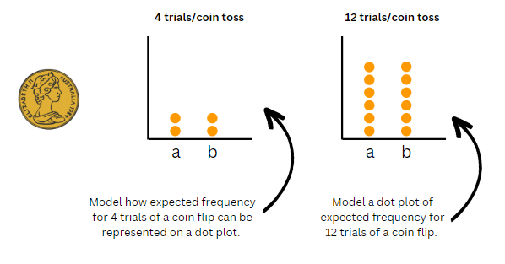
- Divide students into groups of 4. Students create a dot plot of expected frequency in 12 trials for each of the 4 generators.
- As a class, discuss the strategies they used to create their expected frequency dot plots.
- Compare the expected result dot plot with the dot plots used for the matching activity with Resource 37 – dot plot match.
- Ask the students:
- What differences do you see between the expected frequency and the observed frequency in Resource 37 – dot plot match? (The expected frequencies are all equal, but the dot plots are not).
- Why do you think these differences occur? (Just because an outcome is expected, does not mean it will actually occur. I can roll a die 10 times and never roll a 6. The results are random).
- Introduce and discuss the idea of randomness.
Note: randomness means that just because an outcome is expected, does not mean it will occur. Randomness has a bigger effect in a small number of trails.
- Explain to students that randomness, and the effect that the number of trials has on observed frequency, is further explored in Lesson 8.

Discuss and connect the mathematics – 10 minutes
- Summarise key mathematical concepts and discuss as a class:
- What could a 1 in 3 chance look like? What did you need to consider? (Stage 2)
- What language or representation helped your thinking? For example, for every 3 counters, one of them is red or grouping the counters into groups of 3 where one is red. (Stage 2)
- How did a 1 in 2 chance look different or the same as a one in 3 chance? (Stage 2)
- Which has a higher chance of occurring: a 1 in 2 chance or a 1 in 3 chance? Why? (Stage 2)
- Can you describe a task or activity that can be repeated multiple times, with some set expectations but there can also be random results? Examples may include, weather forecast, rolling a die, spinning a spinner. (Stage 3)
This table details opportunities for assessment.
Assessment opportunities | Links
What to look for:  - Can Stage 2 students use the terms equally likely, likely and unlikely to describe the chance of everyday events occurring? [MAO-WM-01, MA2-CHAN-01]  - Can Stage 2 students compare the likelihood of obtaining particular outcomes in a simple chance experiment by predicting, conducting the experiment and comparing the results with the prediction? [MAO-WM-01, MA2-CHAN-01]  - Can Stage 3 students compare the expected frequencies of outcomes of chance experiments with observed frequencies? [MAO-WM-01, MA3-CHAN-01]  - Can Stage 3 students explain that randomness impacts expected outcomes in chance experiment? [MAO-WM-01, MA3-CHAN-01] | Links to National Numeracy Learning Progressions (NNLP):  - Stage 2 – UnC2, UnC3, CPr8  - Stage 3 – UnC2, UnC3, UnC4, UnC5.

Lesson 8
Core concept: record and compare the results of chance experiments (Stage 2). Expected and observed probabilities align better in larger trials (Stage 3).

Daily number sense – 10 minutes
- From a class need surfaced through formative assessment data, identify a short, focused activity that targets students’ knowledge, understanding and skills. Example activities may be drawn from the following resources:
- Mathematics K–6 resources
- Universal Resources Hub.

Core lesson – 40 minutes

Stage 2 task – combinations
The table below contains suggested learning intentions and success criteria. These are best co-constructed with students.
Core concept learning intentions | Core concept success criteria
Students working towards Stage 2 outcomes are learning to:  - identify possible outcomes from chance experiments  - describe the likelihood of outcomes of chance events. | Students working towards Stage 2 outcomes can:  - record all possible combinations in a chance situation where the outcomes are equally likely  - compare the likelihood of obtaining particular outcomes in a simple chance experiment by predicting, conducting the experiment and comparing the results with the prediction.
Note: the purpose of this lesson is to develop a systematic approach to listing all possible outcomes in a chance situation. Some students may draw the connection that by listing combinations, they can then describe the likelihood of a particular combination occurring.
This lesson is an adaptation of The hair colour game from NRICH by The University of Cambridge (Faculty of Mathematics).
- Display Resource 39 – coloured cubes key. Explain the categories on the key.
- Provide students with a collection of coloured cubes or writing materials.
- Ask pairs of students to work out how many clothing combinations they can represent using the coloured cubes.
- Regroup as a class and ask students:
- What strategy did you use when making your combinations? (For example, starting with one colour shorts and adding all the different colour T-shirts)
- Have you made every combination possible? How do you know?
- What is the most effective way to represent the combinations so that you can visualise the situation? (Shorts on the bottom and T-shirts on the top)
- Is there another way to represent our thinking? (Using a tree diagram)
- Model combinations using a tree diagram and discuss how this representation can be used to systematically include possible combinations (see Figure 27).
Figure 27 – tree diagram
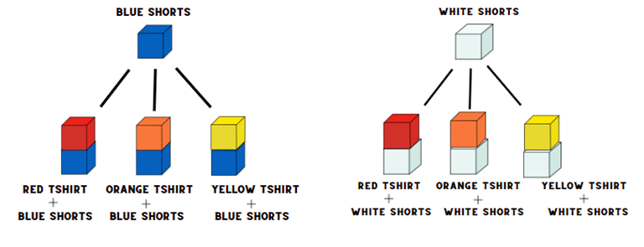
- In pairs, students can use coloured cube models to support thinking. Ask students to Think-Pair-Share using questions from the table below. The table outlines stimulus prompts to generate conversation about the topic, along with anticipated responses from students.
Prompts | Anticipated student responses
- What is the chance that a student is wearing blue shorts? | - There are only 2 colours of shorts, so it is a 1 in 2 chance.
- Is it equally likely that a student is wearing different coloured shorts? Explain your reasoning. | - Yes, because there are only 2 colours of shorts, they must be wearing one of the 2.
- What is the chance that a student is wearing an orange T-shirt? | - 1 in 3 because there are 3 T-shirts colours.
- Is it equally likely that a student will not be wearing an orange T-shirt? Explain your reasoning. | - Yes, because they are either wearing an orange T-shirt or not. (Misconception)  - No because there are 2 other colours they could wear, so there is a 1 in 3 chance of wearing orange and 2 in 3 of wearing something else.  - The student is twice as likely not to be wearing orange.
- Is it less likely that a student is wearing red T-shirt than an orange T-shirt? Explain your reasoning. | - No, it is the same.  - There is still a 1 in 3 chance that they will wear red.
- If the teacher gives a prize to all students wearing white shorts, does everyone have a fair chance of winning? | - Yes, because there are only 2 options for shorts, and both represent a 1 in 2 chance. Therefore, all students are equally likely to win.
- Students share their thinking with the class.
This table details opportunities for differentiation.
Too hard? | Too easy?
Stage 2 students cannot identify possible outcomes from chance experiments.  - Students only use manipulatives to list possible outcomes of combination events.  - Students use 2 pairs of shorts and 2 coloured T-shirts to form combinations. | Stage 2 students can identify possible outcomes from chance experiments.  - Students use 3 different T-shirts and 3 different shorts to make combinations.  - Students create a bingo board to use in a game using the sum of 2 dice. See Resource 40 – two dice bingo (activity adapted from Two-Dice Bingo from NRICH by University of Cambridge (Faculty of Mathematics)).

Stage 3 task – sample sizes
The table below contains suggested learning intentions and success criteria. These are best co-constructed with students.
Core concept learning intentions | Core concept success criteria
Students working towards Stage 3 outcomes are learning to:  - conduct chance experiments with both small and large numbers of trials  - create random generators and describe probabilities using fractions. | Students working towards Stage 3 outcomes are learning to:  - assign expected probabilities to outcomes in chance experiments with random generators, including digital simulators, and compare the expected probabilities with the observed probabilities after both small and large numbers of trials  - determine and discuss the differences between the expected probabilities and the observed probabilities after both small and large numbers of trials  - create random generators to follow specified probabilities or proportions.
Note: the purpose of this lesson is to develop an understanding that in larger sample sizes randomness has less of an effect and that expected and observed probability will be closer the more trials you conduct.
- Display Resource 22 – Stage 3 chance representations. Link the representations to learning in Lesson 7.
- Provide students with a copy of Resource 41 – chance bingo and 4 blue, green and yellow counters.
- Challenge students to design an equally likely spinner using blue, green and yellow that has a 1 in 3 chance of each.
Note: it is important that all students are using the same colours as to represent the expected probability students will combine their bingo boards to play a game later in the lesson.
- Explain to students that each square of their bingo board represents one trial, so there will be 12 trials.
- Students turn and talk to determine:
- the expected frequency of each colour (4 each)
- methods of calculating the expected frequency (divide the number of trials by the number of outcomes).
- Ask students to shade squares on their bingo board to represent a 1 in 3 chance of each colour. This can be done in multiple ways. However, the 3 rows are an opportunity to use the array structure to support student thinking.
- Display Resource 42 – bingo set up. Explain that even though the boards look different, there is still a 1 in 3 chance of each colour.
- Individually, students run 12 trials using their created spinner with a paperclip and pencil. Students mark an ‘X’ on a colour on their bingo board when the corresponding colour occurs on their spinner. If all spaces of that colour are filled with an ‘X’, students take a counter of the same colour and place it on the Counter Trash bin (see Figure 28).
Figure 28 – game board example
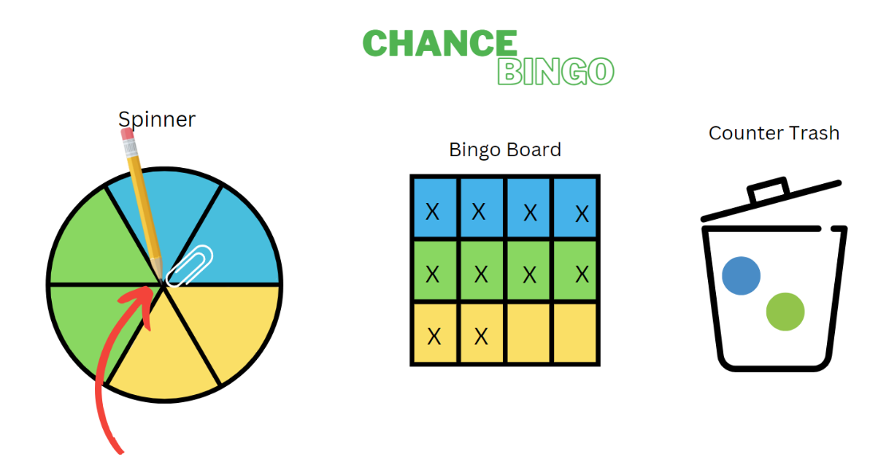
- As a class, discuss the differences between the expected frequency (as represented by the colours on the bingo board) and the observed frequencies (as represented by the ‘X’s on the bingo board). Ask students:
- Did a particular colour occur more times or fewer times than expected? How do you know? Why?
- Does your board look similar or different to other people on the table?
- What do the empty spaces on the board tell us? (That all the expected outcomes did not occur).
- If your spinner looks different to another person on your table but still represents a 1 in 3 chance, do you think that this caused the differences in your bingo boards?
Note: emphasise randomness as opposed to different representations on spinners of the same chance by reminding students that equally likely can look different as explored in Lesson 6.
- Students cut out their bingo board and combine them in groups of 6 to form a 72 square bingo board.
- Explain to students that they may now place their (previously trashed) counters anywhere on the larger group board where there is a space of the corresponding colour.
- As a class, discuss the questions in the table below.
Prompts | Anticipated student responses
- Are there fewer empty spaces on the board now? | - Yes, because we were able to place our counters on anyone’s board and so there were more options to fill the empty spaces.
- What does this tell us about running a larger number of trials? | - I learned expected frequency and observed frequency have random variation. The more trials conducted, the less variation between results and expectation.
- Are the observed frequencies in this larger trial closer to the expected frequency? | - Yes, there are fewer empty spaces in the larger trial so what actually happened is closer to what we expected.
- Do you think that running more trials would get us even closer to the expected frequency again? | - Yes, the more trials you run, the more the observed frequency will look like the expected frequency.
- Set up an online probability simulator, such as the NCTM Adjustable Spinner, with a 1 in 3 chance.
- As a class, simulate 3 separate trials: 12 spins, 72 spins and 1000 spins. After each trial, show students the experimental graph (by selecting the pie graph icon) so that students can visualise the experimental results compared to the theoretical results.
- As a class, discuss:
- the variation in the experimental graph over the same number of trials.
Note: this emphasises the randomness that occurs in small sample sizes.
- the differences they see between the smaller and larger trials.
- why this difference occurs.
- how the graph becomes closer to the expected probability as shown on the spinner when the number of trials increases.
This table details opportunities for differentiation.
Too hard? | Too easy?
Stage 3 students cannot determine and discuss the differences between the expected probabilities and the observed probabilities after both small and large numbers of trials.  - When playing bingo, students use a counter to represent the empty space in the individual and group trials. After the group trial, they combine their counters and then share them equally between the 6 people in the group. Students can then compare the number of counters they had in the individual trial. | Stage 3 students can determine and discuss the differences between the expected probabilities and the observed probabilities after both small and large numbers of trials.  - Students create their own spinners and bingo boards to represent a 1 in 2, 1 in 5 and 1 in 10 chance. Students consider the number of trials that might be suitable for a small, medium and large trial number.

Discuss and connect the mathematics – 10 minutes
- Regroup as a class and summarise the lesson together drawing out key mathematical ideas. Ask:
- When using cubes or a tree diagram, how do you know when you have made all the possible combinations? (Stage 2)
- Which representation was most helpful to visualise and solve the problem? (Stage 2)
- Were the results of the larger bingo board what you expected? Explain? (Stage 3)
- Do you think the use of a spinner led to differences in the results? What else could you use? (Stage 3)
This table details opportunities for assessment.
Assessment opportunities | Links
What to look for:  - Can Stage 2 students record all possible combinations in a chance situation where the outcomes are equally likely? [MAO-WM-01, MA2-CHAN-01]  - Can Stage 2 students compare the likelihood of obtaining particular outcomes in a simple chance experiment by predicting, conducting the experiment and comparing the results with the prediction? [MAO-WM-01, MA2-CHAN-01]  - Can Stage 3 students determine and discuss the differences between the expected probabilities and the observed probabilities after both small and large numbers of trials? [MAO-WM-01, MA3-CHAN-01]  - Can Stage 3 students create random generators to follow specified probabilities or proportions? [MAO-WM-01, MA3-CHAN-01] | Links to National Numeracy Learning Progressions (NNLP):  - Stage 2 – UnC2, UnC3, CPr8  - Stage 3 – UnC2, UnC3, UnC4, UnC5.

Resource 1 – fraction words and cards
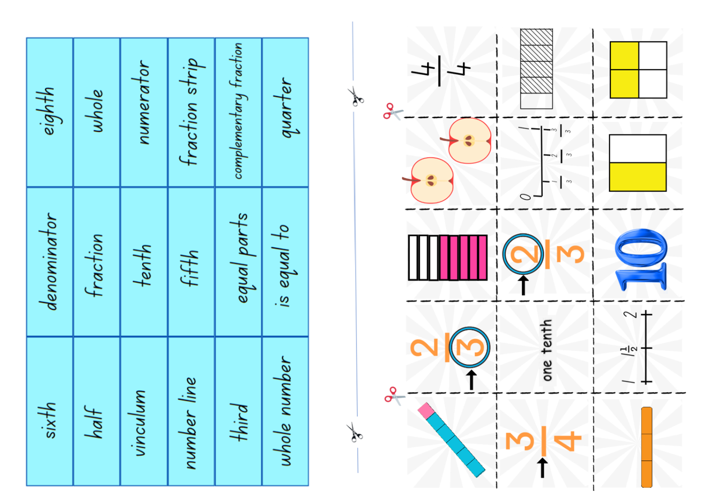

Resource 2 – fraction picture cards
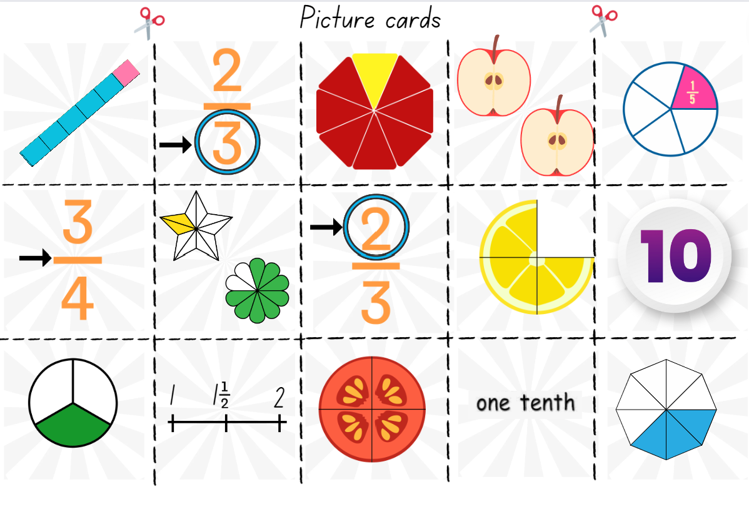

Resource 3 – Stage 2 position representations
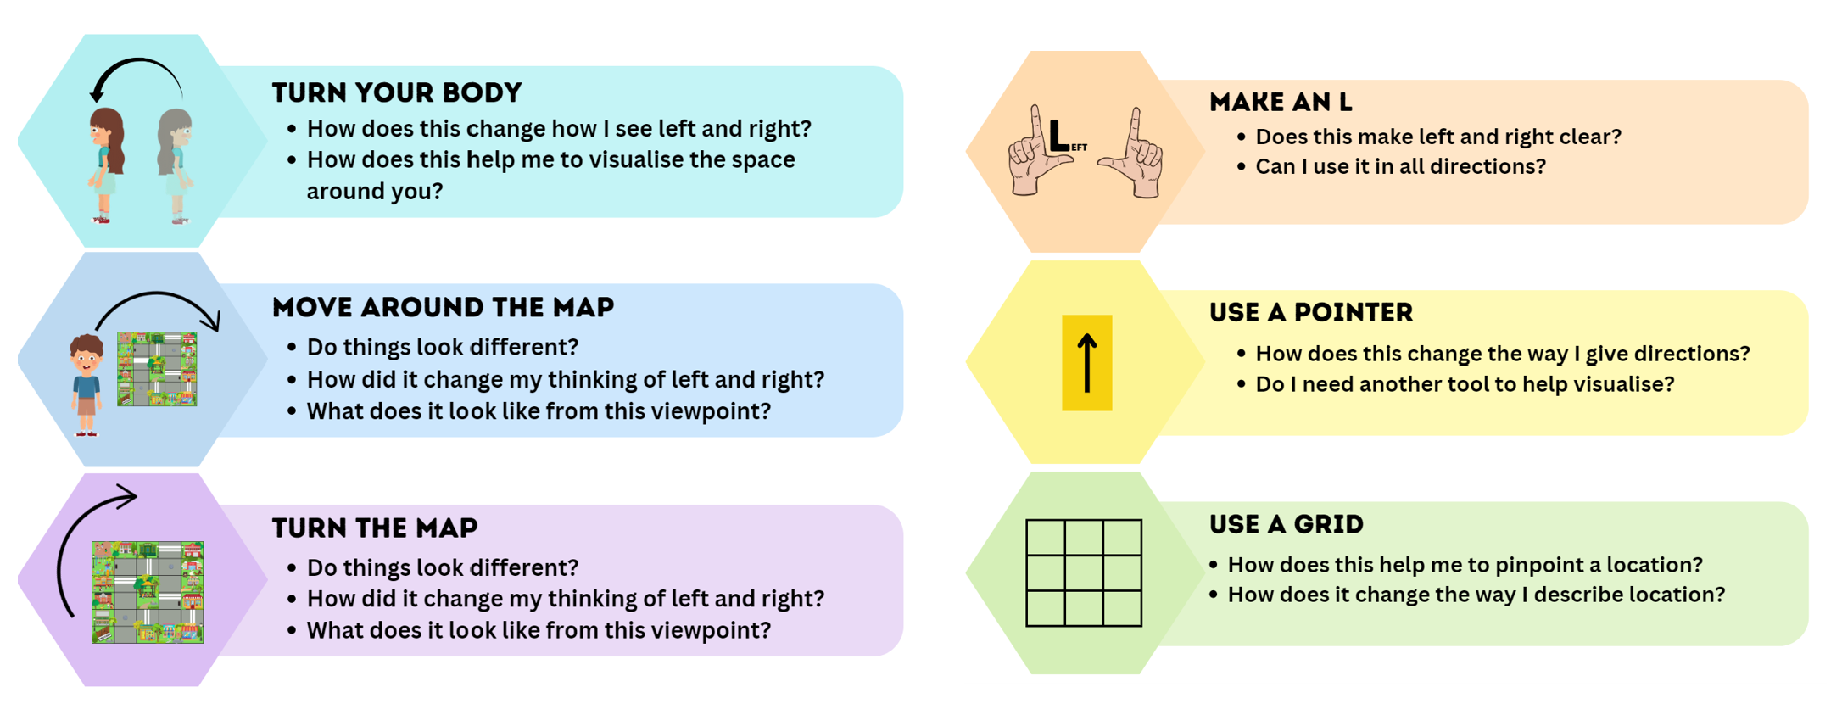

Resource 4 – Stage 3 position representations
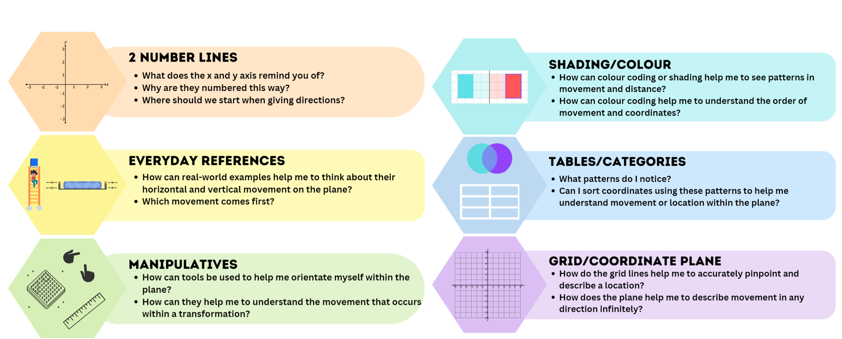

Resource 5 – shape guess line
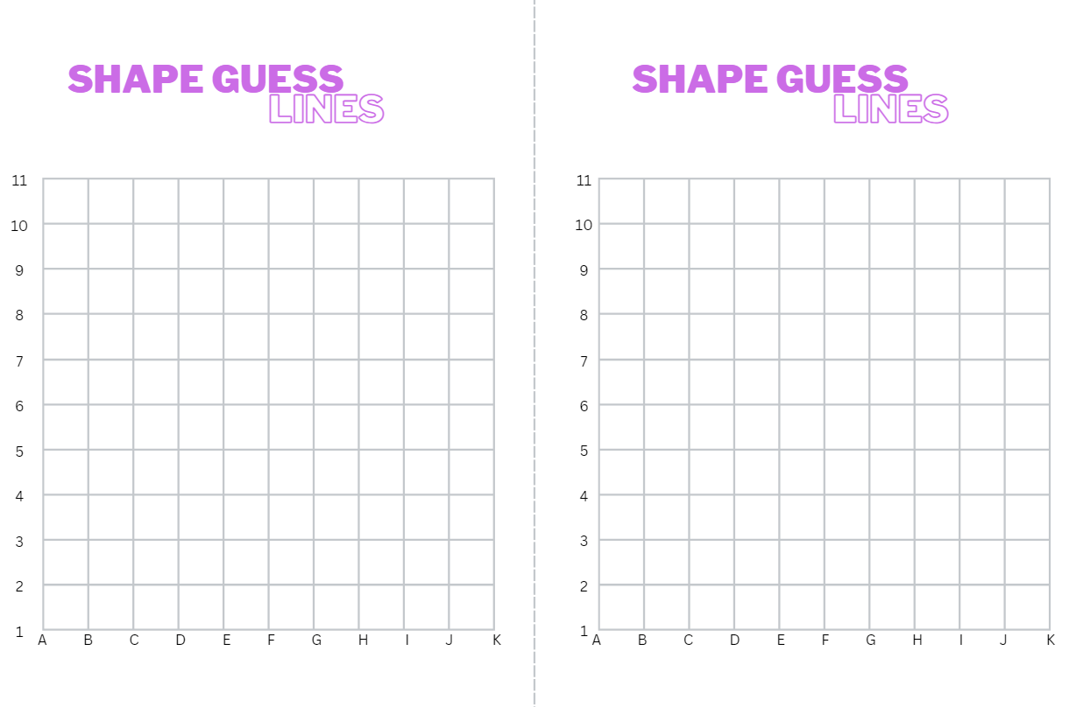

Resource 6 – shape guess space
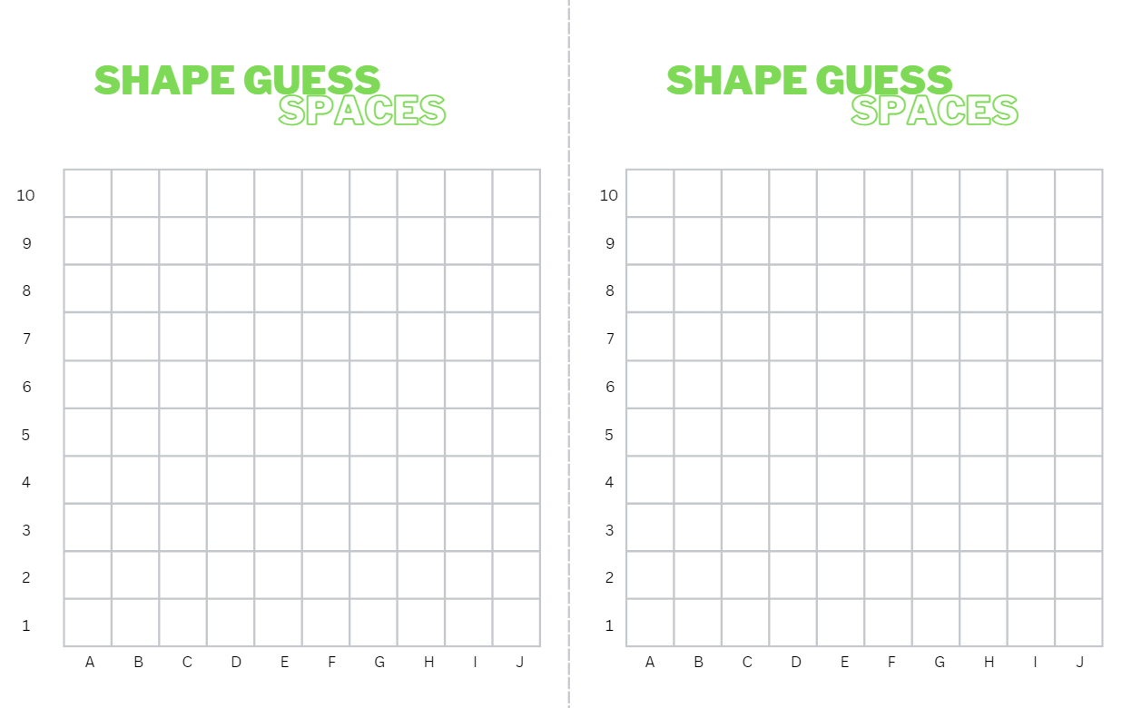

Resource 7 – blank Cartesian plane
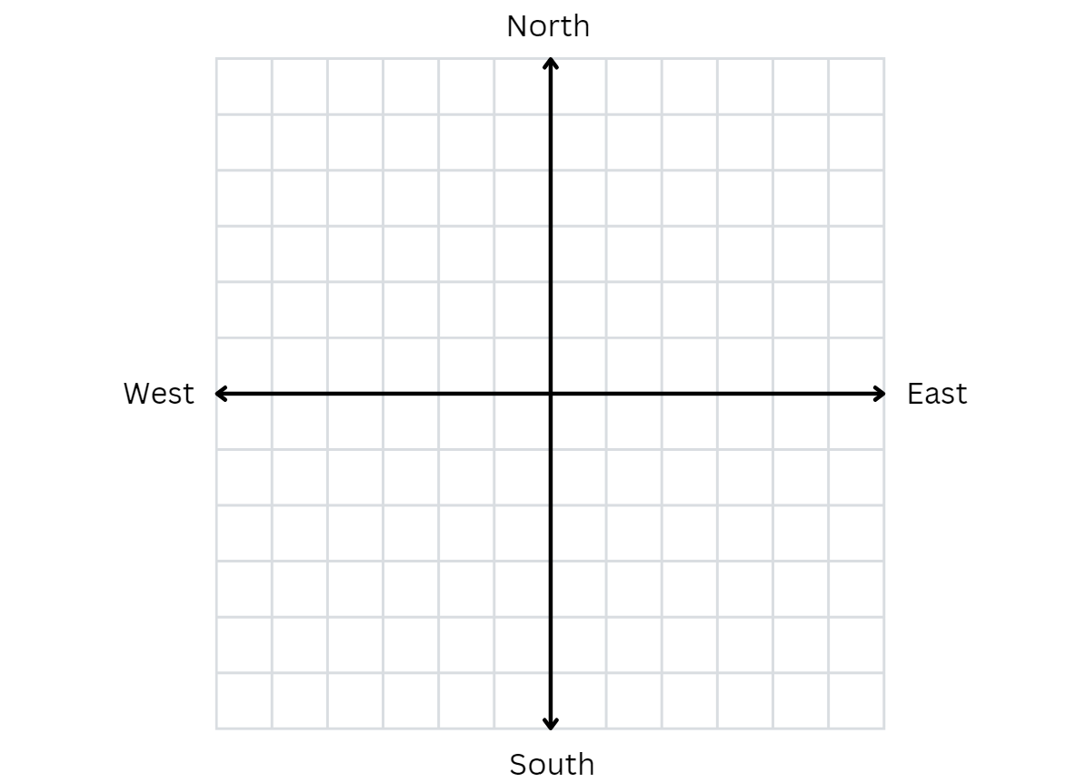

Resource 8 – labelled plane cartoons
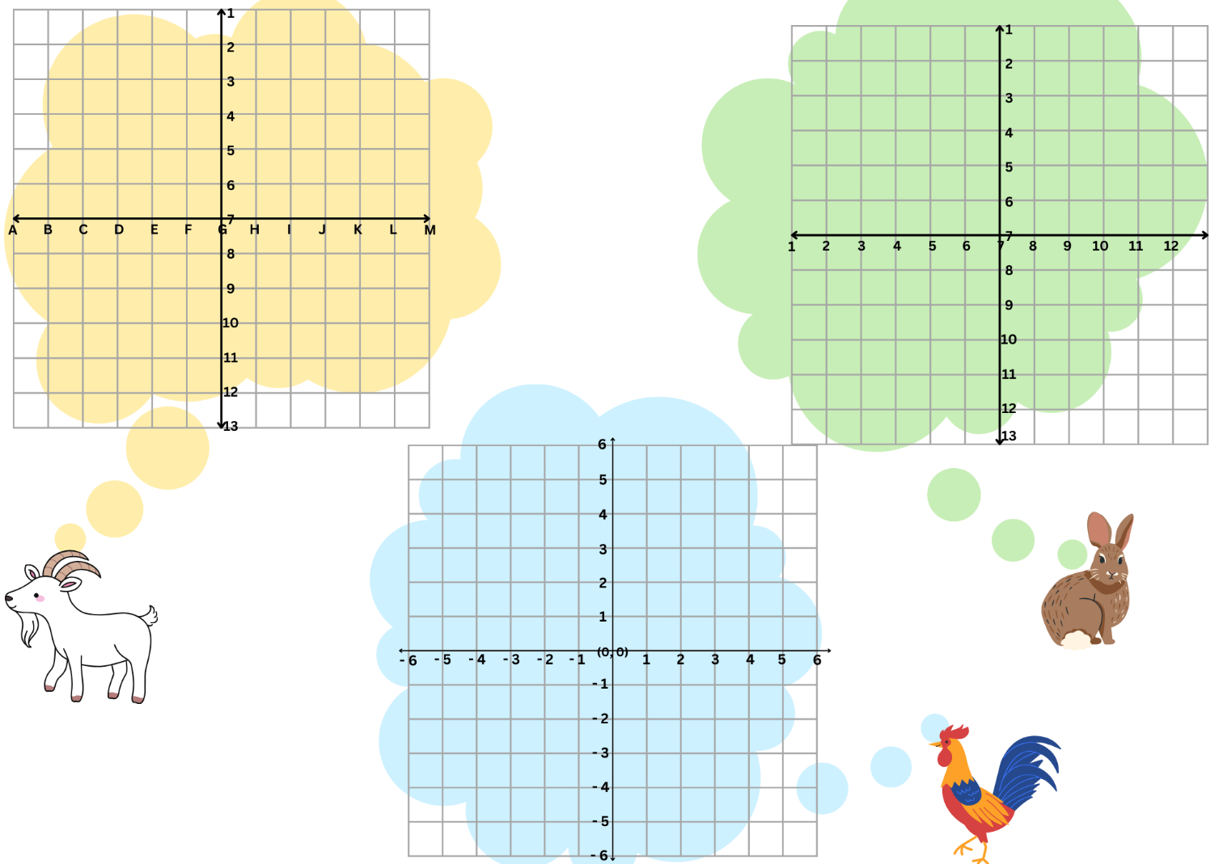

Resource 9 – landmark map
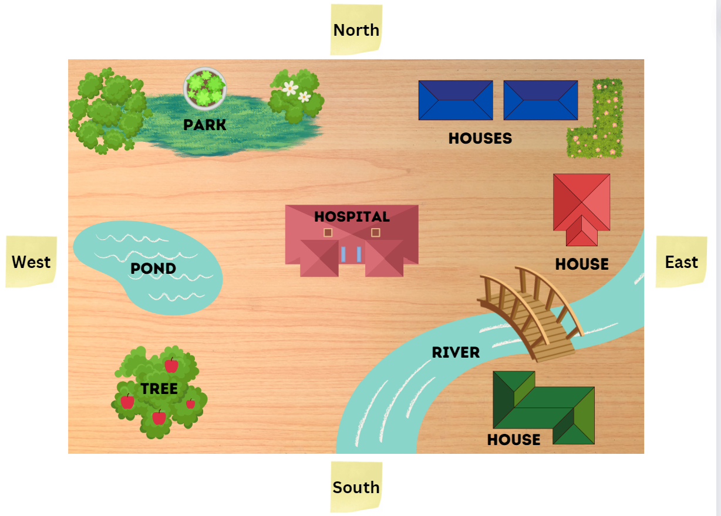

Resource 10 – library ladder
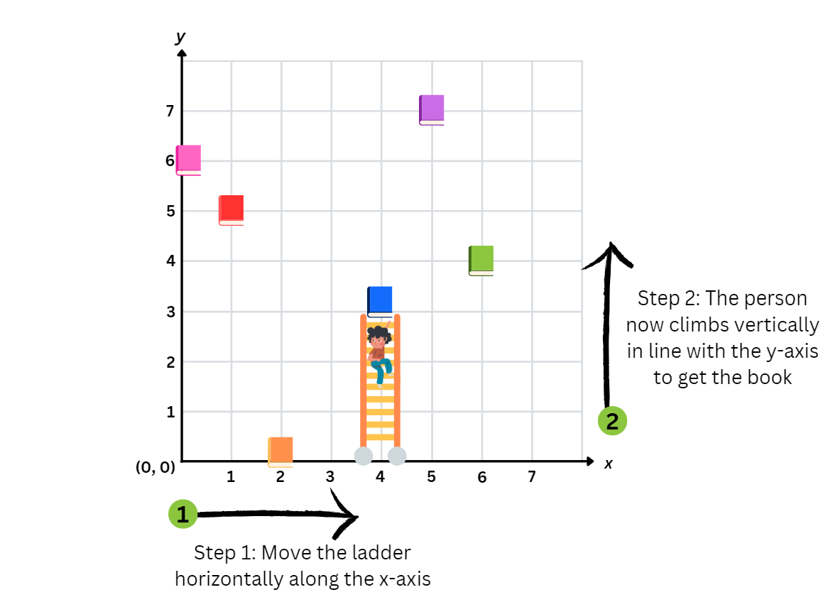

Resource 11 – colour library ladder
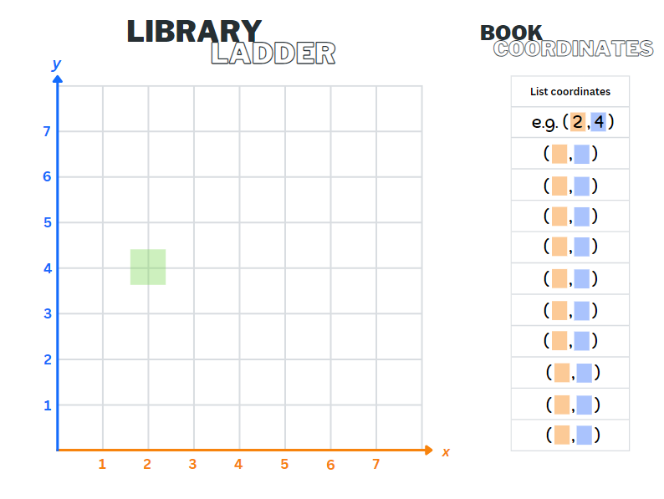

Resource 12 – bookshelf 1 and 2
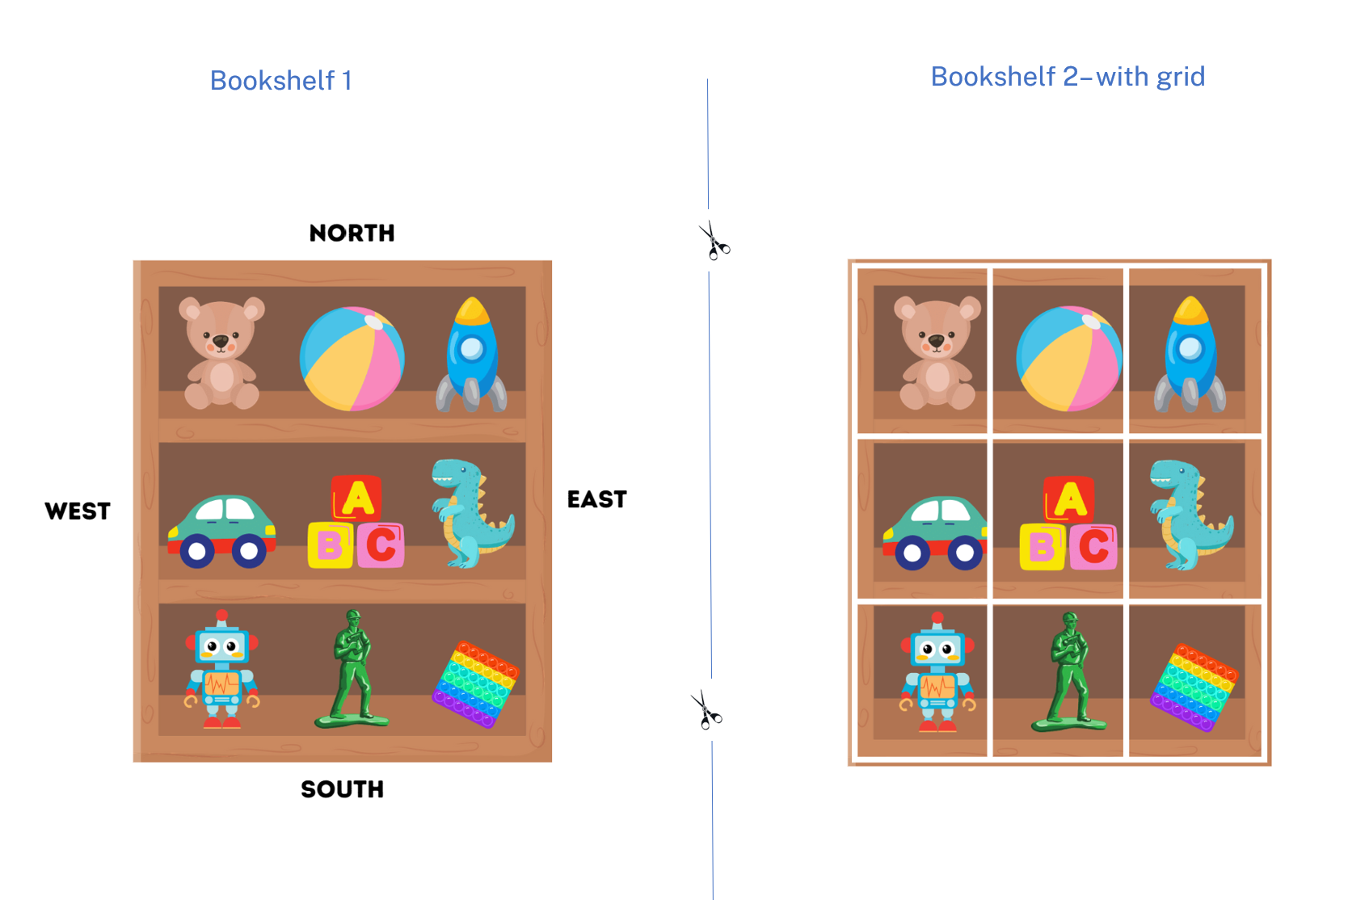

Resource 13 – landmark map with grid
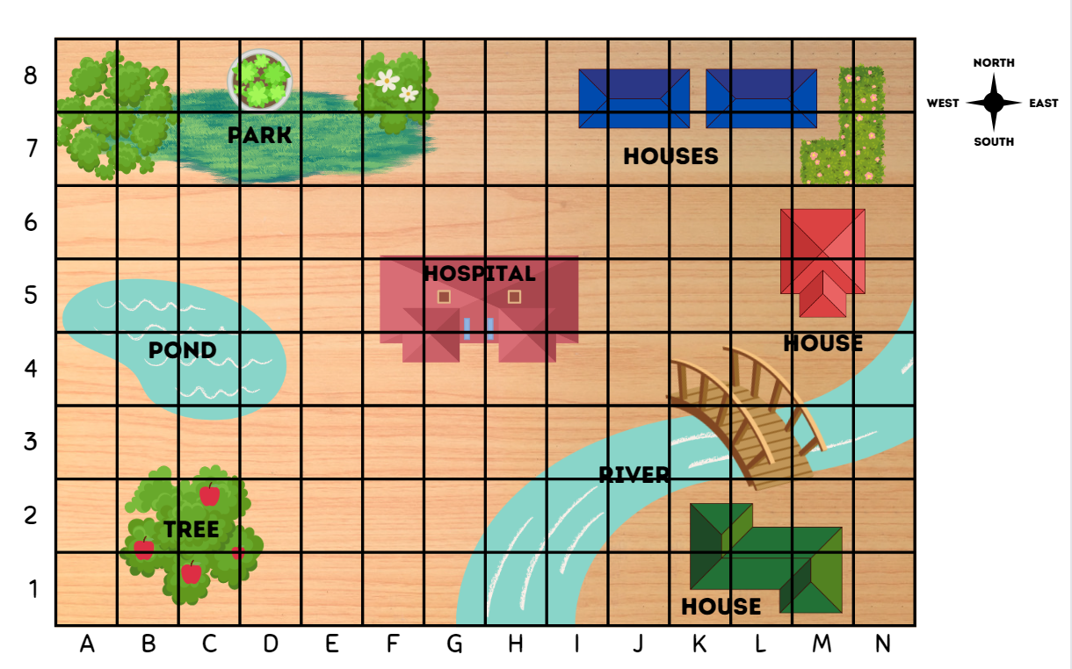

Resource 14 – journey to Numberland
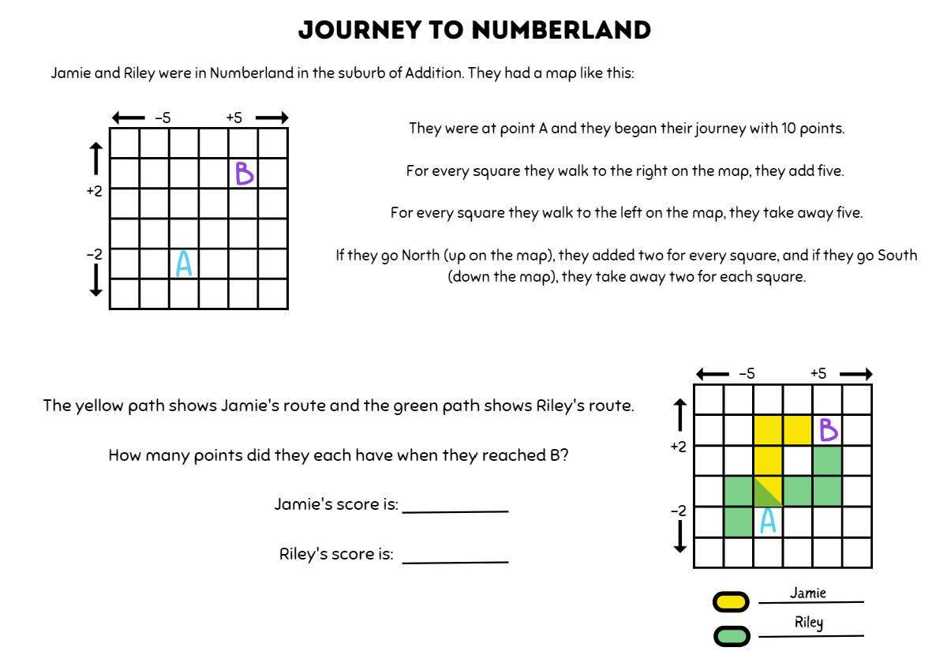

Resource 15 – Cartesian plane
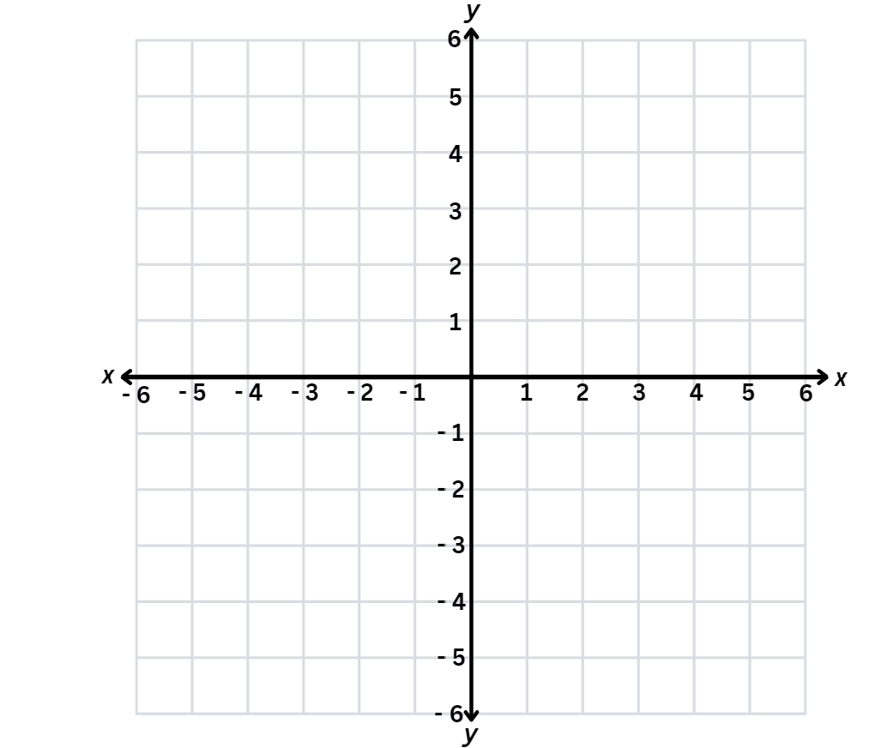

Resource 16 – carrot hunt
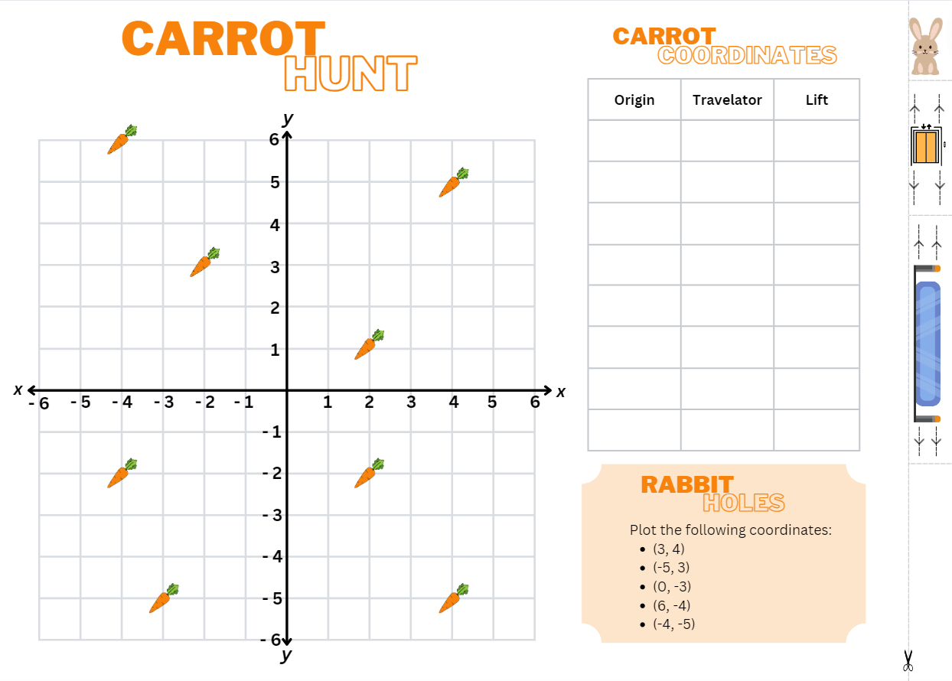

Resource 17 – supermarket map
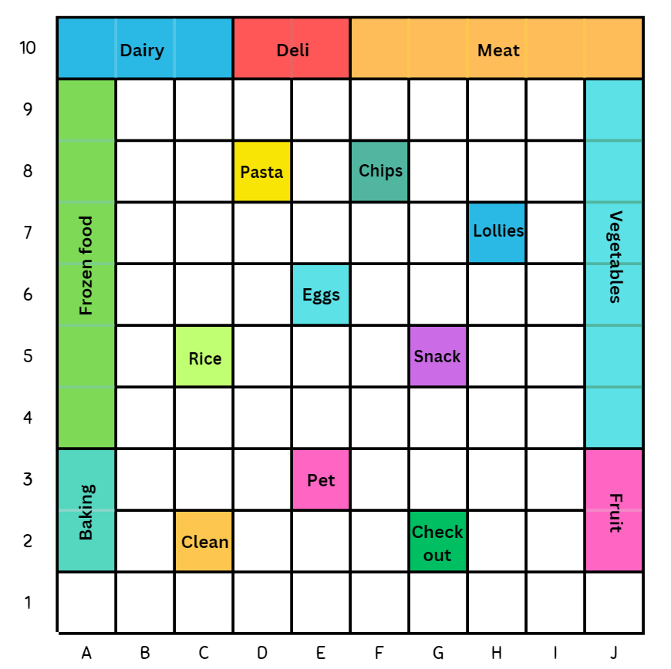

Resource 18 – supermarket instructions 1 and 2
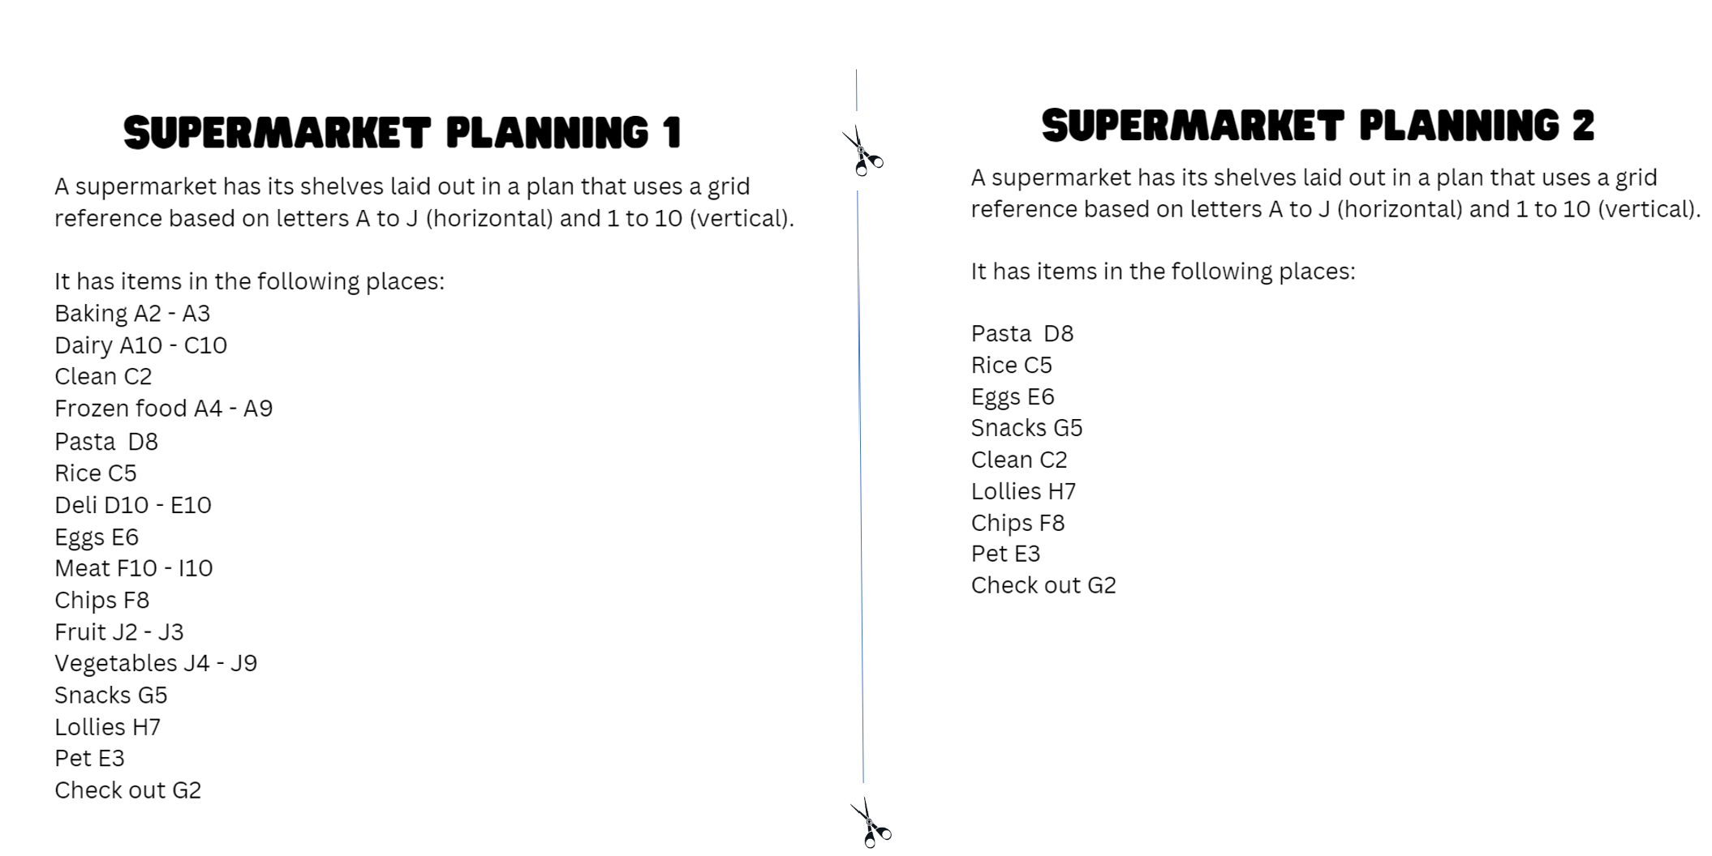

Resource 19 – 100 square grid

Resource 20 – target and directional cards
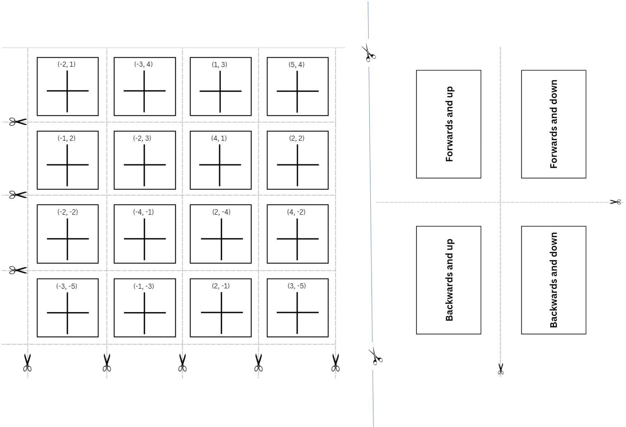

Resource 21 – Stage 2 chance representations
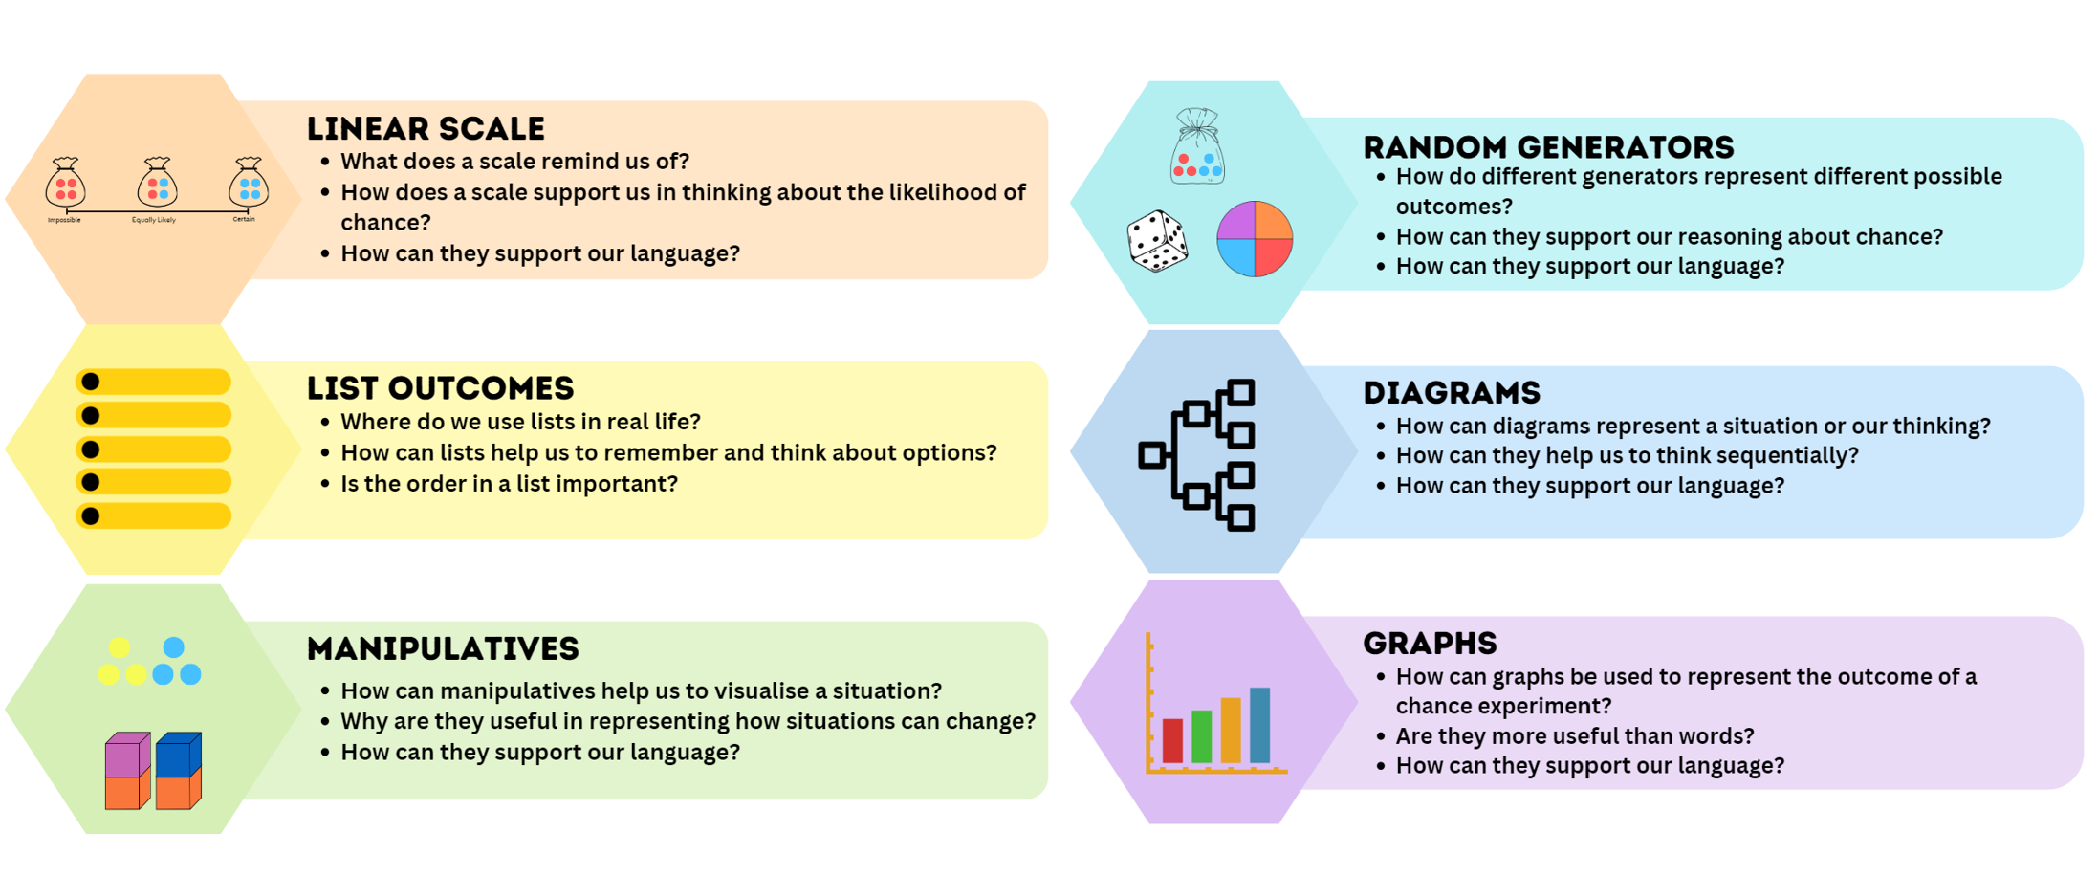

Resource 22 – Stage 3 chance representations
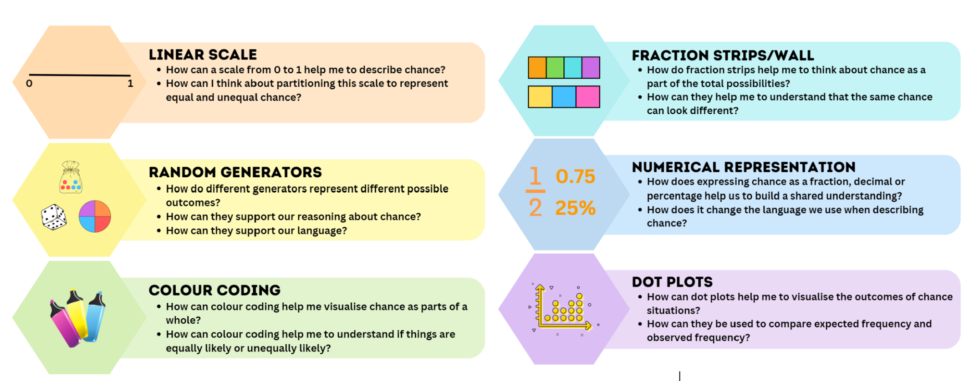

Resource 23 – chance statements
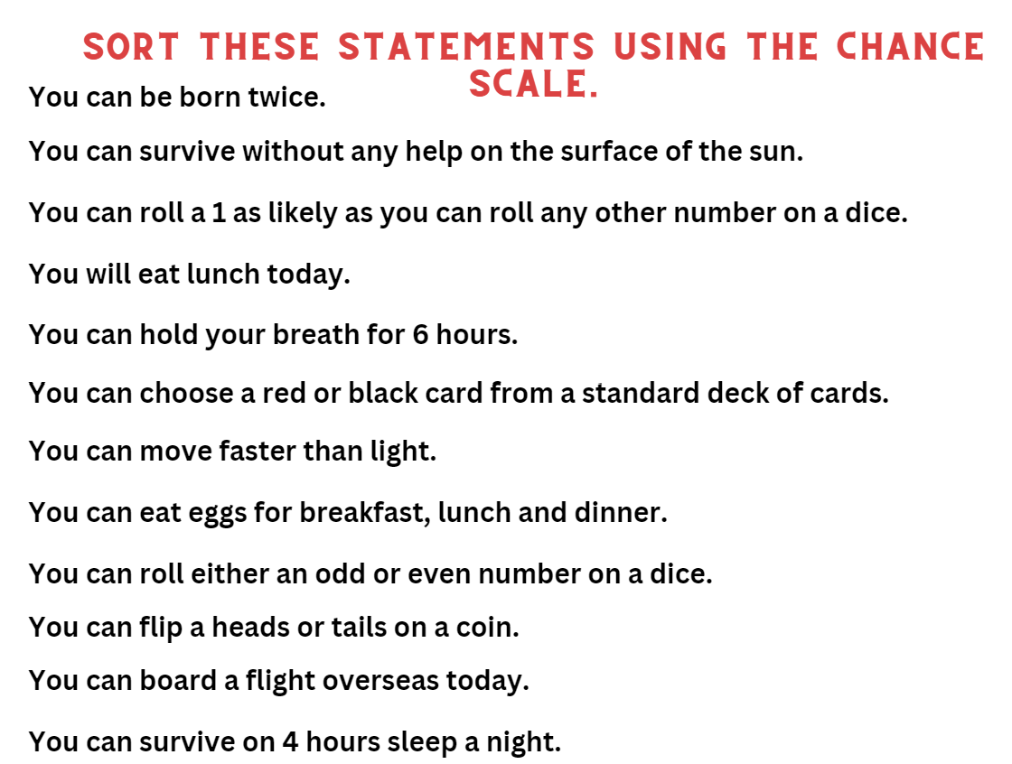

Resource 24 – carnival games
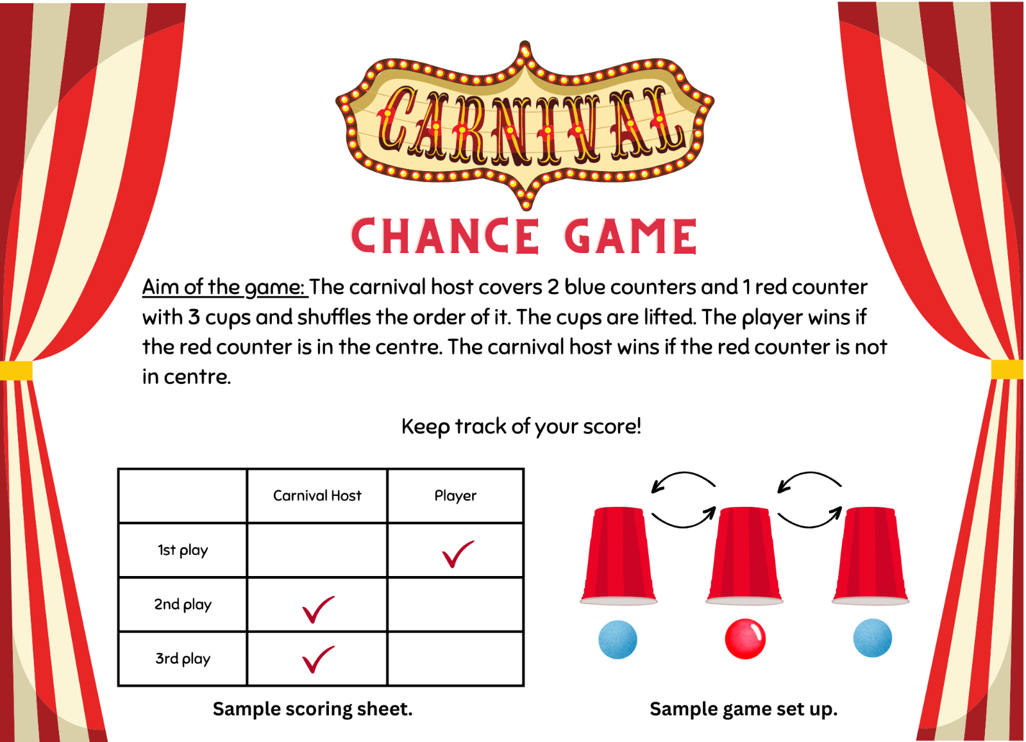

Resource 25 – numerical phrases
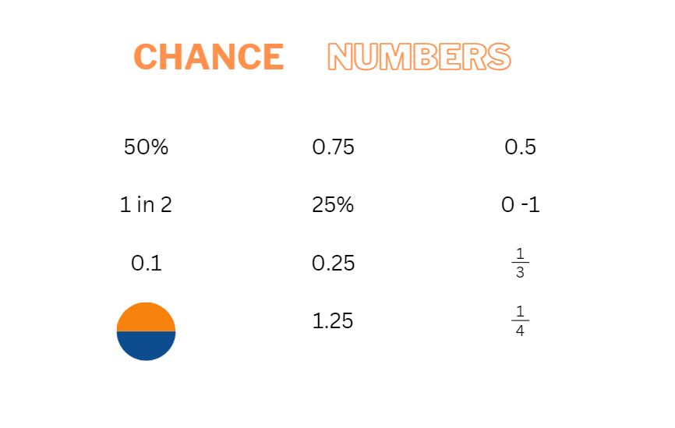

Resource 26 – colloquial terms
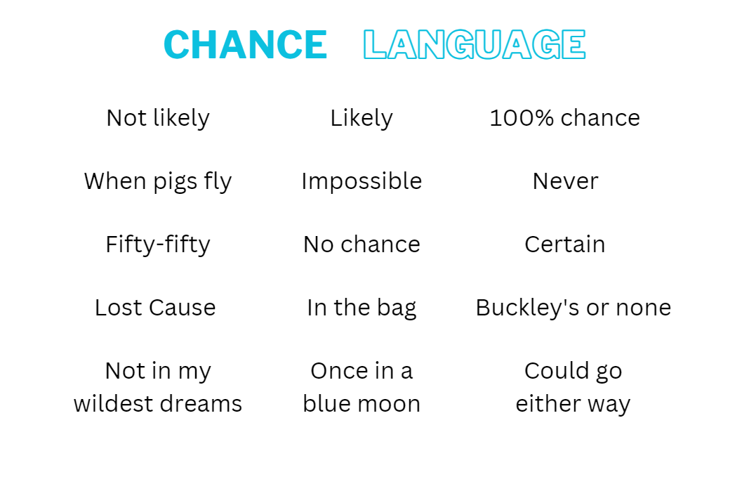

Resource 27 – cards and strips
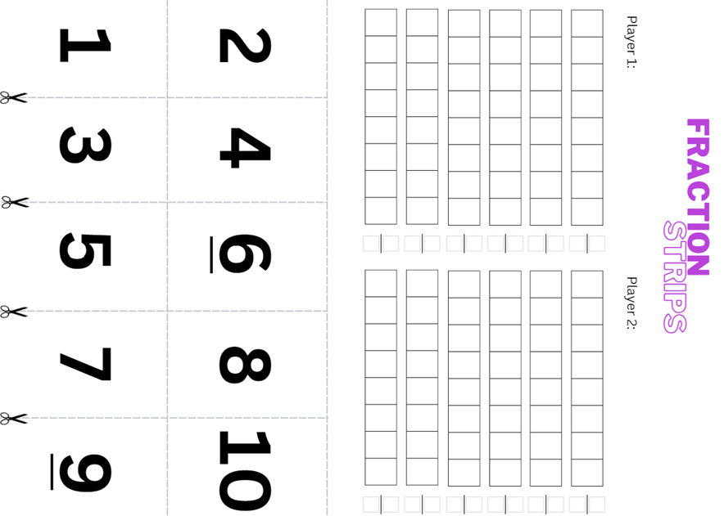

Resource 28 – What is fair?
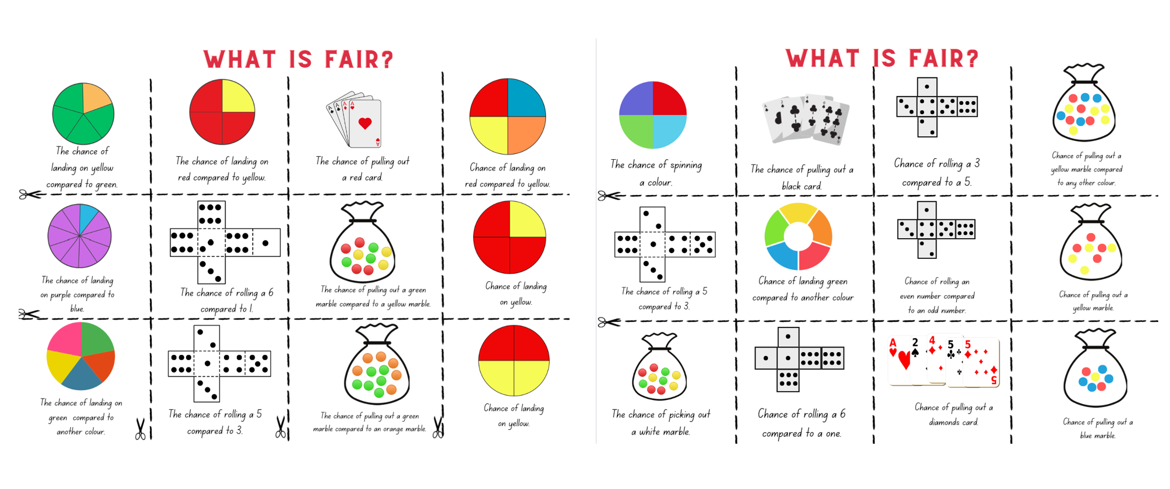

Resource 29 – fairness reference sheet
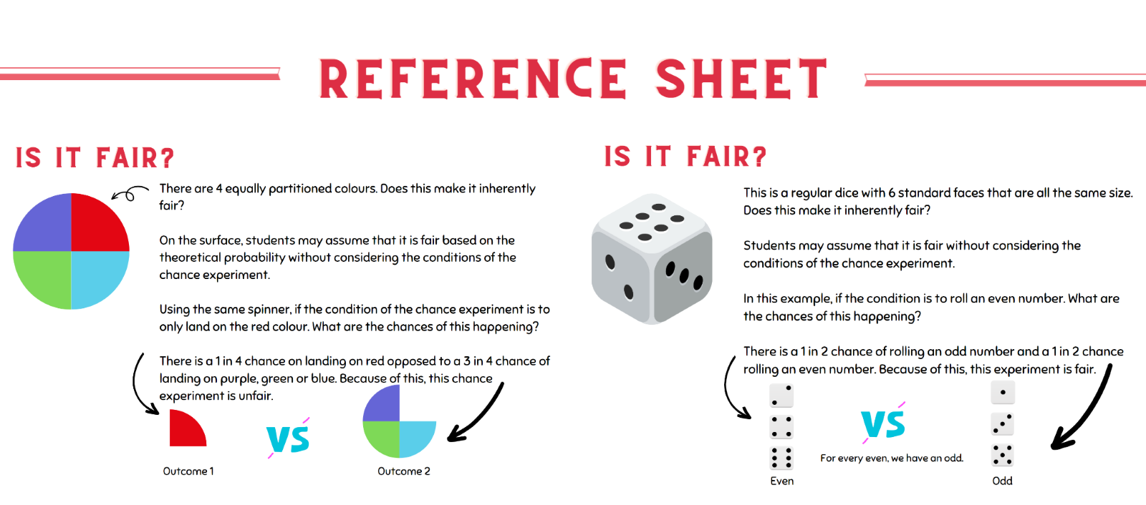

Resource 30 – random generators
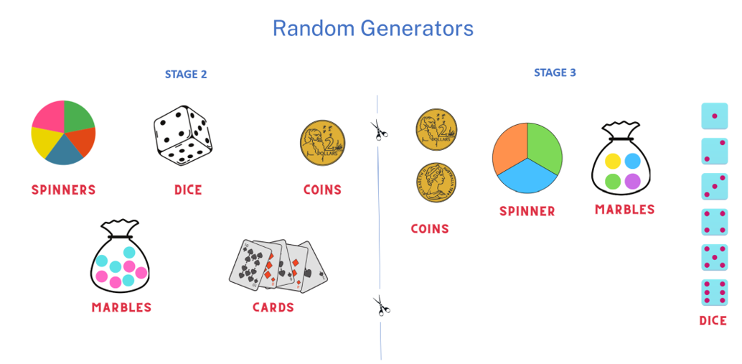

Resource 31 – carnival host vs player
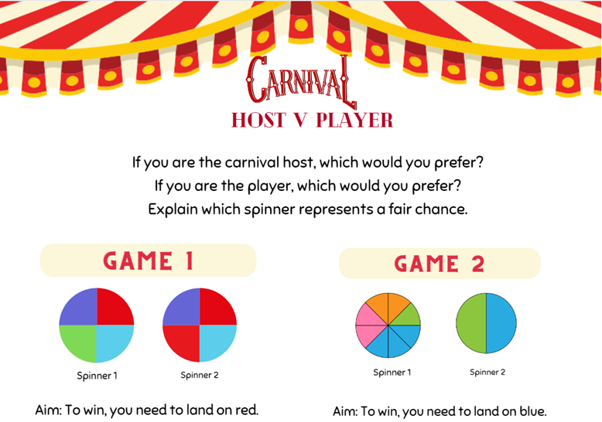

Resource 32 – sentence stems
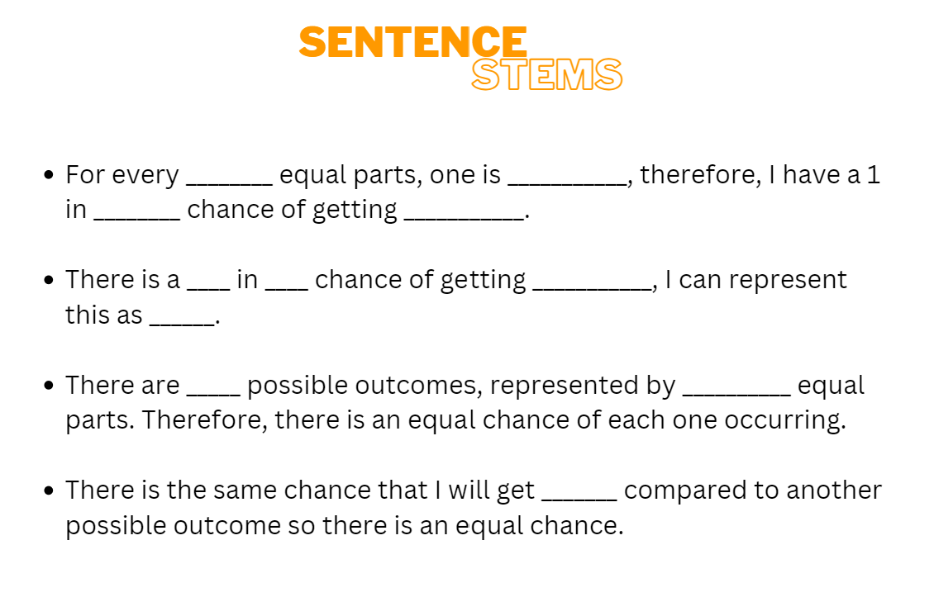

Resource 33 – fair and unfair
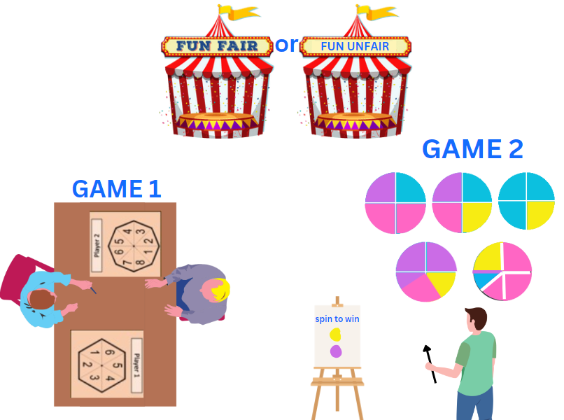

Resource 34 – equally likely cartoons
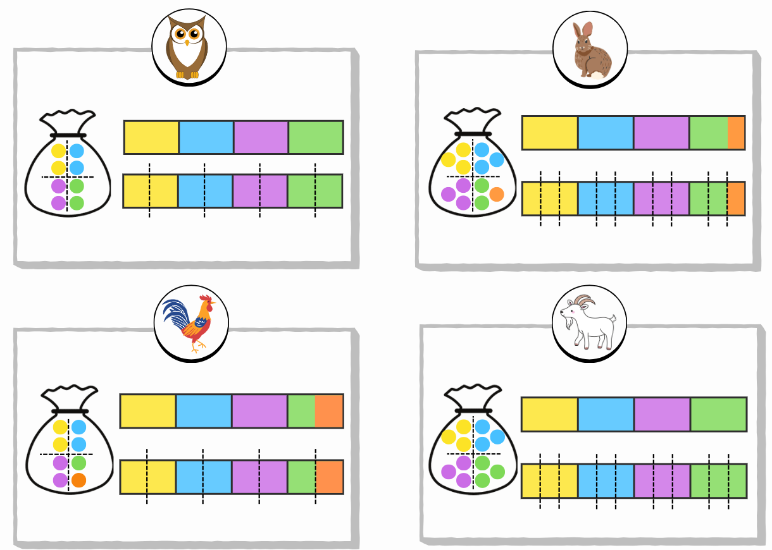

Resource 35 – mystery bags
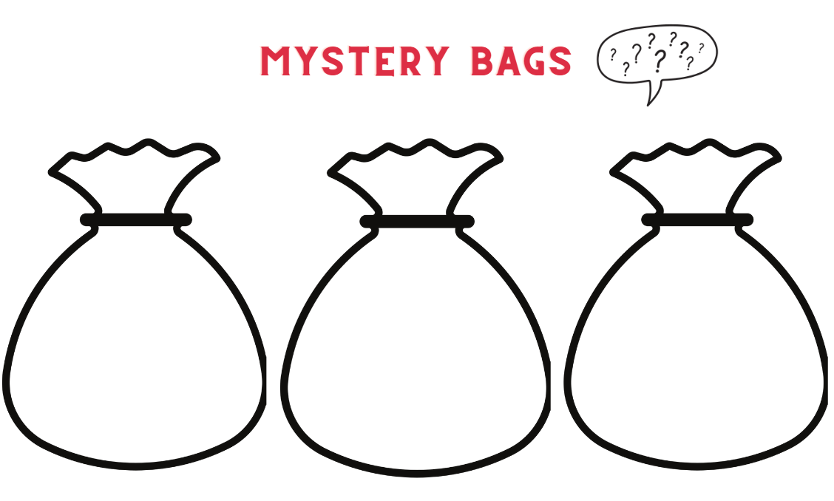

Resource 36 – mystery bags support
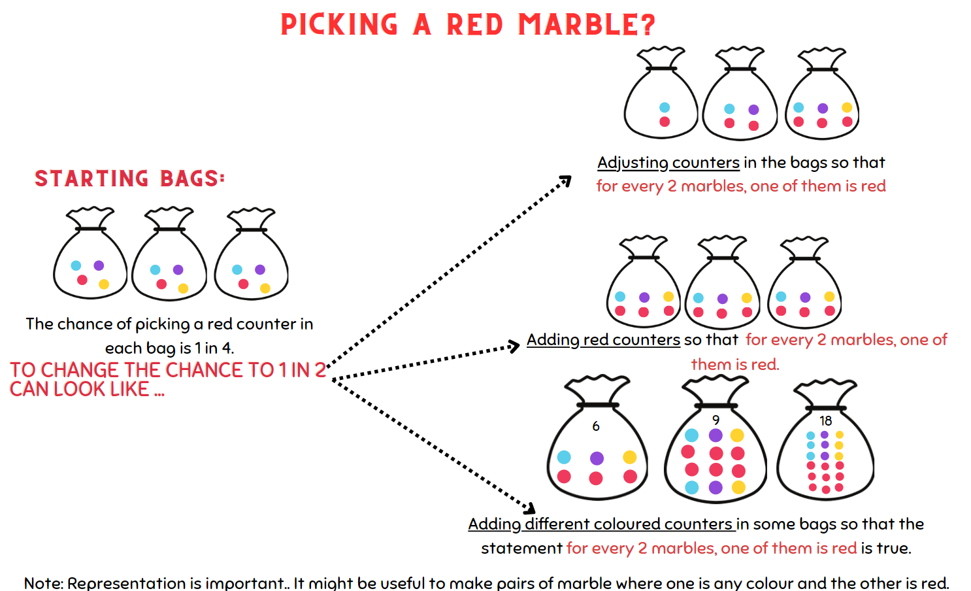

Resource 37 – dot plot match
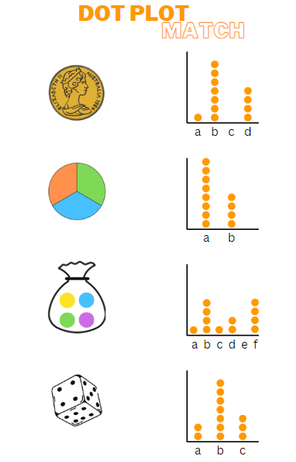

Resource 38 – frequency thinking
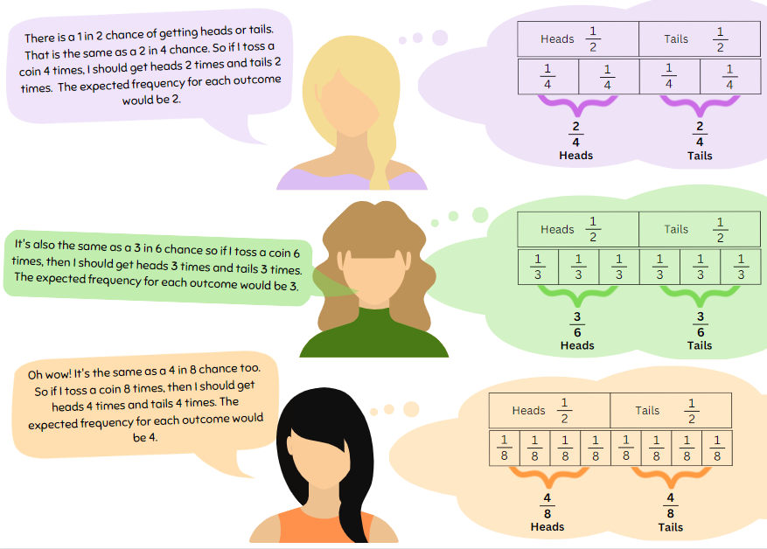

Resource 39 – coloured cubes key
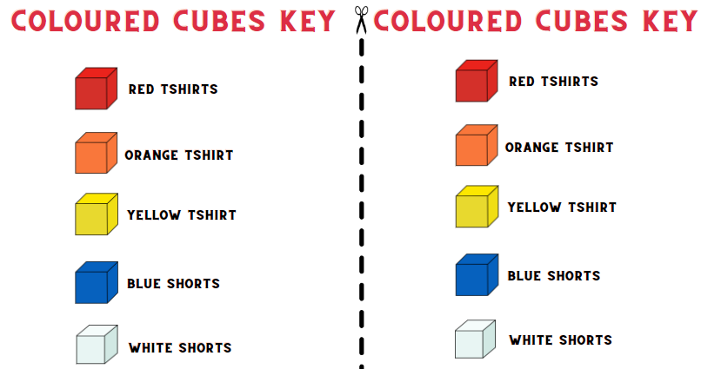

Resource 40 – two dice bingo
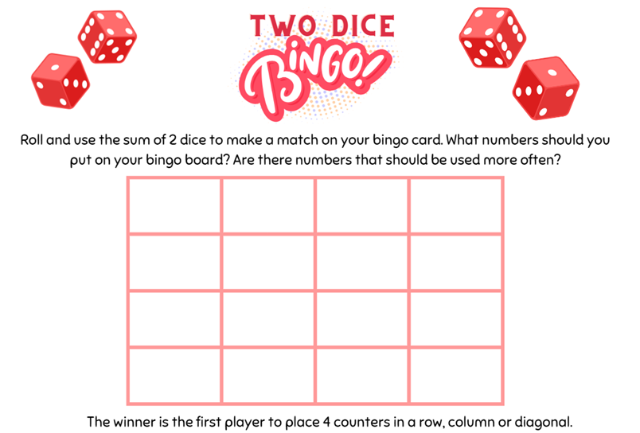

Resource 41 – chance bingo
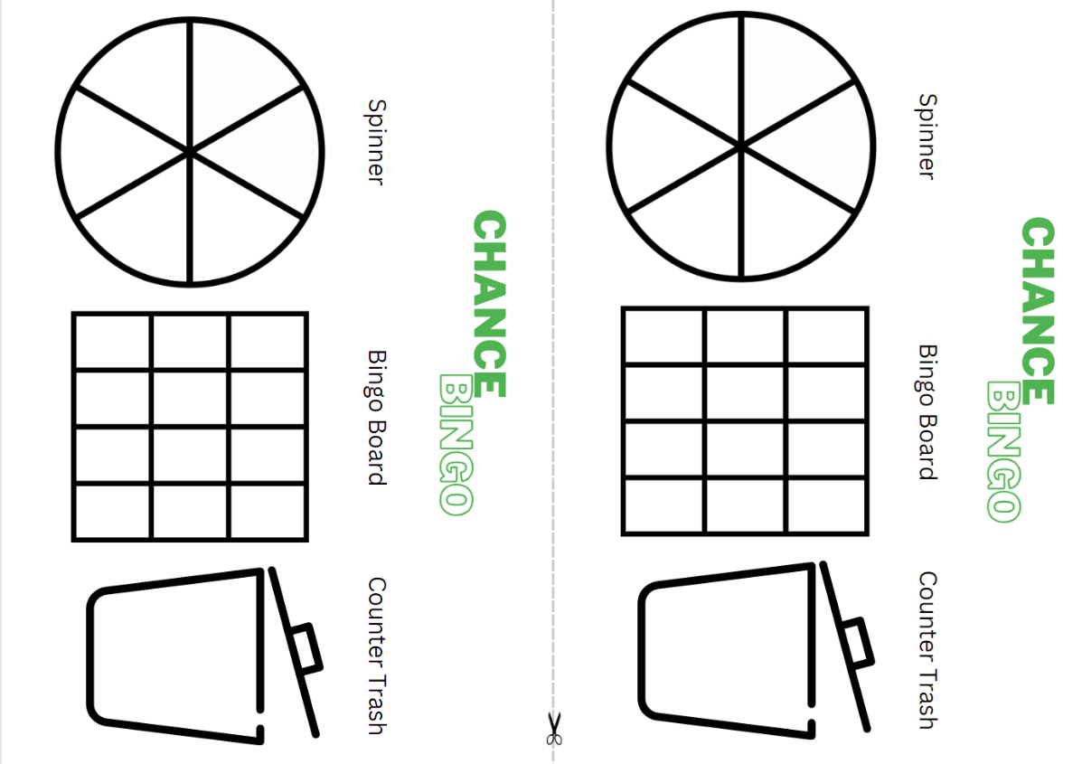

Resource 42 – bingo set up
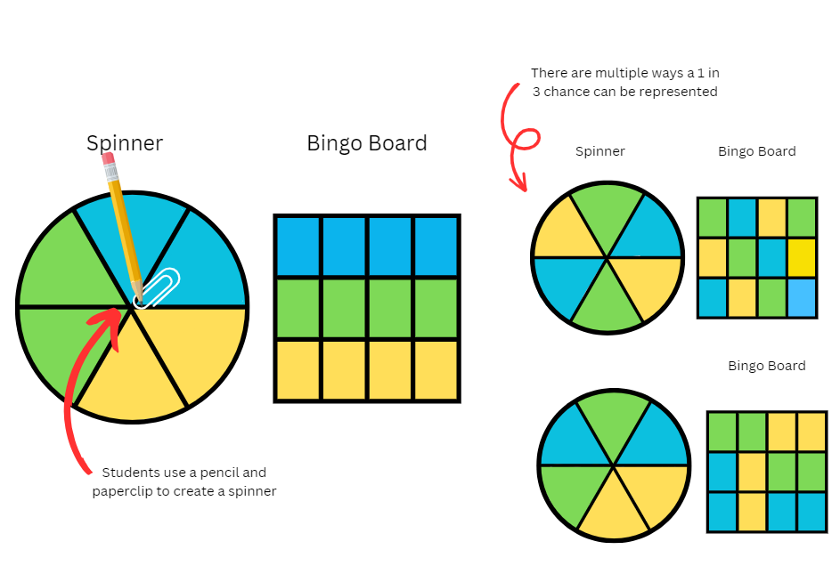

Syllabus outcomes and content

Stage 2
The table below outlines the syllabus outcomes and range of relevant syllabus content covered in this unit. Content is linked to National Numeracy Learning Progression version (3).
Outcomes and content | 1 | 2 | 3 | 4 | 5 | 6 | 7 | 8
Additive relations A: Recognise and explain the connection between addition and subtraction
MAO-WM-01, MA2-AR-01
- Use number relation principles to solve related problems (Reasons about relations) |  |  |  |  | x | x
- Demonstrate how addition and subtraction are inverse operations |  |  |  |  |  |  | x
- Use the complement principle of addition and subtraction (Reasons about relations) |  |  |  |  |  | x
- Explain and check solutions to problems, including by using the inverse operation |  |  |  |  | x
Partitioned fractions A: Create fractional parts of a length using techniques other than repeated halving
MAO-WM-01, MA2-PF-01
- Make thirds of a length |  | x
- Create fifths of a length |  | x
Partitioned fractions A: Model and represent unit fractions, and their multiples, to a complete whole on a number line
MAO-WM-01, MA2-PF-01
- Model fractions with fraction strips and diagrams for halves, quarters, eighths, thirds | x | x | x
- Recreate the whole unit from a fractional part ($\frac{1}{2}$ , $\frac{1}{4}$ , $\frac{1}{3}$ , and $\frac{1}{8}$) Reversible reasoning) | x | x
Geometric measure A: Position: Interpret movement on a map
MAO-WM-01, MA2-GM-01
- Orient a map to determine directions to travel | x | x
- Describe a route taken on a map using landmarks and directional language | x
Geometric measure A: Position: Locate positions on grid maps
MAO-WM-01, MA2-GM-01
- Locate positions by coordinating horizontal and vertical references |  |  | x
- Use the array (row and column) structure of grid maps to locate position, horizontal before vertical |  |  | x
Geometric measure B: Position: Create and interpret grid maps
MAO-WM-01, MA2-GM-01
- Create simple maps and plans from an aerial view, labelling grid references |  |  |  | x
- Identify and mark locations on maps and plans, given their grid references |  |  | x | x
Geometric measure B: Position: Use directional language and describe routes with grid maps
MAO-WM-01, MA2-GM-01
- Use a given grid map and compass directions (N, S, E, W) to plan, describe and show a route from one location to another |  | x |  | x
- Use natural resources or landmarks to identify north, south, east, west | x
Chance A: Identify possible outcomes from chance experiments
MAO-WM-01, MA2-CHAN-01
- Use the term outcome to describe any possible result of a chance experiment |  |  |  |  | x |  | x
- Record all possible outcomes in a chance experiment where the outcomes are equally likely |  |  |  |  |  | x
- Record all possible combinations in a chance situation where the outcomes are equally likely |  |  |  |  | x |  |  | x
Chance B: Describe the likelihood of outcomes of chance events
MAO-WM-01, MA2-CHAN-01
- Use the terms equally likely, likely and unlikely to describe the chance of everyday events occurring |  |  |  |  | x |  | x
- Compare the likelihood of obtaining particular outcomes in a simple chance experiment by predicting, conducting the experiment and comparing the results with the prediction |  |  |  |  |  | x | x | x
Mathematics K–10 Syllabus © NSW Education Standards Authority (NESA) for and on behalf of the Crown in right of the State of New South Wales, 2022.

Stage 3
The table below outlines the syllabus outcomes and range of relevant syllabus content covered in this unit. Content is linked to National Numeracy Learning Progression version (3).
Outcomes and content | 1 | 2 | 3 | 4 | 5 | 6 | 7 | 8
Additive relations A: Apply efficient mental and written strategies to solve addition and subtraction problems
MAO-WM-01, MA3-AR-01
- Apply known strategies such as levelling, addition for subtraction, using constant difference, and bridging (Reasons about relations) |  |  |  |  | x
- Use place value to add or subtract 3 or more numbers with different numbers of digits |  |  |  |  |  | x | x
Representing quantity fractions A: Recognise the role of the number 1 as representing the whole
MAO-WM-01, MA3-RQF-01
- Justify the need for fractions to refer to the number 1 as the common whole (Reasons about quantity) | x
Representing quantity fractions A: Compare and order common unit fractions
MAO-WM-01, MA3-RQF-01
- Compare and order unit fractions with denominators of 2, 3, 4, 5, 6, 8 and 10 by placing them on a number line |  |  | x
Representing quantity fractions B: Build up to the whole from a given fractional part
MAO-WM-01, MA3-RQF-01
- Generate the whole quantity from non-unit fractional parts such as quarters, eighths, thirds, sixths, fifths and tenths (Reversible reasoning) |  | x
Geometric measure A: Position: Explore the Cartesian coordinate system
MAO-WM-01, MA3-GM-01
- Recognise that the grid-map reference system gives the area of a location and the number plane identifies a specific point | x
- Identify that in the coordinate system the lines are numbered, not the spaces | x
- Identify the point of intersection of the 2 axes as the origin, having coordinates (0, 0) | x
- Plot and label points, given coordinates, on the number plane in the first quadrant, describing the horizontal position first, followed by the vertical position |  | x
- Identify and record the coordinates of given points on the number plane in the first quadrant |  | x
Geometric measure B: Position: Use the 4 quadrants of the coordinate plane
MAO-WM-01, MA3-GM-01
- Plot and label points, given coordinates, in all 4 quadrants of the number plane |  |  | x | x
- Identify and record the coordinates of given points on the number plane in all 4 quadrants |  |  | x | x
- Describe changes to coordinates when a point is translated or reflected across an axis |  |  |  | x
Data A: Collect categorical and discrete numerical data by observation or survey
MAO-WM-01, MA3-DATA-02
- Collect ordinal or nominal categorical data, and discrete numerical data through observation or by conducting surveys |  |  |  |  |  | x | x
Data A: Choose and use appropriate tables and graphs
MAO-WM-01, MA3-DATA-01
- Tabulate collected data with and without the use of digital technologies such as spreadsheets |  |  |  |  |  |  | x | x
Chance A: List outcomes of chance experiments involving equally likely outcomes and represent probabilities
MAO-WM-01, MA3-CHAN-01
- Use the term probability to describe the numerical value that represents the likelihood of an outcome of a chance experiment |  |  |  |  | x
- Recognise that outcomes are described as equally likely when any one outcome has the same chance of occurring as any other outcome |  |  |  |  |  | x
- Represent probabilities of outcomes of chance experiments using fractions |  |  |  |  |  | x
- Establish that the total of the probabilities of the outcomes of a chance experiment equals one |  |  |  |  | x
- Discuss the imprecise meaning of commonly used chance words including possible, likely and unlikely |  |  |  |  | x
Chance B: Compare observed frequencies of outcomes with expected results
MAO-WM-01, MA3-CHAN-01
- Use the term frequency to describe the number of times a particular outcome occurs in a chance experiment |  |  |  |  |  |  | x
- Compare the expected frequencies of outcomes of chance experiments with observed frequencies, including where the outcomes are not equally likely |  |  |  |  |  |  | x
- Explain why observed frequencies of outcomes in chance experiments may differ from expected frequencies, and how this relates to randomness |  |  |  |  |  |  | x
Chance B: Create random generators and describe probabilities using fractions
MAO-WM-01, MA3-CHAN-01
- Create random generators to follow specified probabilities or proportions |  |  |  |  |  |  |  | x
- Use knowledge of benchmark fractions, decimals and percentages to assign probabilities to the likelihood of outcomes |  |  |  |  |  | x
Chance B: Conduct chance experiments with both small and large numbers of trials
MAO-WM-01, MA3-CHAN-01
- Assign expected probabilities to outcomes in chance experiments with random generators, including digital simulators, and compare the expected probabilities with the observed probabilities after both small and large numbers of trials |  |  |  |  |  |  |  | x
- Determine and discuss the differences between the expected probabilities and the observed probabilities after both small and large numbers of trials |  |  |  |  |  |  |  | x
Mathematics K–10 Syllabus © NSW Education Standards Authority (NESA) for and on behalf of the Crown in right of the State of New South Wales, 2022.

References
This resource contains NSW Curriculum and syllabus content. The NSW Curriculum is developed by the NSW Education Standards Authority. This content is prepared by NESA for and on behalf of the Crown in right of the State of New South Wales. The material is protected by Crown copyright.
Please refer to the NESA Copyright Disclaimer for more information https://educationstandards.nsw.edu.au/wps/portal/nesa/mini-footer/copyright.
NESA holds the only official and up-to-date versions of the NSW Curriculum and syllabus documents. Please visit the NSW Education Standards Authority (NESA) website https://educationstandards.nsw.edu.au/ and the NSW Curriculum website https://curriculum.nsw.edu.au/.
Mathematics K–10 Syllabus © NSW Education Standards Authority (NESA) for and on behalf of the Crown in right of the State of New South Wales, 2022.
National Numeracy Learning Progression © Australian Curriculum, Assessment and Reporting Authority (ACARA) 2010 to present, unless otherwise indicated. This material was downloaded from the Australian Curriculum website (National Numeracy Learning Progression) (accessed 24 October 2023) and was not modified.
Aboriginal Education Consultative Group (2023) NSW AECG [website], accessed 25 October 2023.
Australian Broadcasting Corporation (2023) Episode 12 Years 3-4: Our Place Value System (series 1, episode 12) [television program], ABC iView website, accessed 25 September 2023.
Australian Government Department of Education (2020) ‘Directed Number’, Teaching resources, reSolve: Maths by Inquiry website, accessed 25 September 2023.
Australian Government Department of Education (2022) ‘Location: My Place In Space’, Teaching resources, reSolve: Maths by Inquiry website, accessed 25 September 2023.
Evolve Indigenous Cultural Awareness (12 May 2021) 'What are Songlines?' [video], Evolve Communities, YouTube, accessed 25 October 2023.
Finkel D (2017) ‘Target Number’, Free Lessons, Math for Love website, accessed 29 September 2022.
Get This In Your Head (23 November 2020) 'Get This In Your Head (Maths Revision with a Difference)' [video], Get This In Your Head, YouTube, accessed 25 October 2023.
National Council of Teachers of Mathematics (2023) Adjustable Spinner, NCTM website, accessed 25 September 2023.
New Zealand Ministry of Education (n.d.) ‘Banana cake’, Resource Finder, NZ Maths website, accessed 10 August 2023.
New Zealand Ministry of Education (n.d.) In Between, Resource Finder, NZ Maths website, accessed 25 September 2023.
Nichols C (20 December 2017) ‘Songlines: Tracking the Seven Sisters is a must-visit exhibition for all Australians’, The Conversation, accessed 25 October 2023.
Riley S (n.d.) Show the coordinates, Teacher Led website, accessed 25 September 2023.
Rural Medical Education Australia (18 October 2013) ‘What are Songlines?’ [video], Rural Medical Education Australia, YouTube, accessed 25 October 2023.
Siemon D, Warren E, Beswick K, Faragher R, Miller J, Horne Marj, Jazby D, Breed M, Clark J, Brady K (2022) Teaching Mathematics: Foundation to middle years, 3rd edn Oxford University Press, Australia.
State of New South Wales (Department of Education) (2023) ‘Closest to 100 (additive strategies)’, Mathematics K–6 resources, Department of Education website, accessed 10 August 2023.
State of New South Wales Government (Department of Education) (2023) ‘Big ideas to start strong across K–6’, Mathematics K to 6 professional learning catalogue, Department of Education website, accessed 10 August 2023.
The University of Melbourne (Australian University) (2023) Stellar navigation and mathematics, Indigenous Knowledge Institute website, accessed 25 October 2023.
University of Cambridge (Faculty of Mathematics) (n.d.) Journeys in Numberland, NRICH website, accessed 10 August 2023.
University of Cambridge (Faculty of Mathematics) (n.d.) The Hair Colour Game, NRICH website, accessed 10 August 2023.
University of Cambridge (Faculty of Mathematics) (n.d.) Two and One, NRICH website, accessed 10 August 2023.
University of Cambridge (Faculty of Mathematics) (n.d.) 'Two dice bingo', Chance Combinations, NRICH website, accessed 10 August 2023.
Yubulyawan Dreaming Project (13 March 2015) 'Gujingga Songline' [video], Paul Taylor, YouTube, accessed 25 October 2023.

Further reading
Siemon D, Warren E, Beswick K, Faragher R, Miller J, Horne Marj, Jazby D, Breed M, Clark J, Brady K (2022) Teaching Mathematics: Foundation to Middle Years, 3rd edn, Oxford University Press, Australia and New Zealand.
Van de Walle J, Karp K, Bay-Williams JM, Brass A, Bentley B, Ferguson S, Goff W, Livy S, Marshman M, Martin D, Pearn C, Prodromou T, Symons D and Wilkie K (2019) Primary and Middle Years Mathematics: Teaching Developmentally, 1st Australian edn, Pearson Education Australia, Melbourne.

© State of New South Wales (Department of Education), 2023
The copyright material published in this resource is subject to the Copyright Act 1968 (Cth) and is owned by the NSW Department of Education or, where indicated, by a party other than the NSW Department of Education (third-party material).
Copyright material available in this resource and owned by the NSW Department of Education is licensed under a Creative Commons Attribution 4.0 International (CC BY 4.0) license.
This license allows you to share and adapt the material for any purpose, even commercially.
Attribution should be given to © State of New South Wales (Department of Education), 2023.
Material in this resource not available under a Creative Commons license:
- the NSW Department of Education logo, other logos and trademark-protected material
- material owned by a third party that has been reproduced with permission. You will need to obtain permission from the third party to reuse its material.
Links to third-party material and websites
Please note that the provided (reading/viewing material/list/links/texts) are a suggestion only and implies no endorsement, by the New South Wales Department of Education, of any author, publisher, or book title. School principals and teachers are best placed to assess the suitability of resources that would complement the curriculum and reflect the needs and interests of their students.
If you use the links provided in this document to access a third-party's website, you acknowledge that the terms of use, including licence terms set out on the third-party's website apply to the use which may be made of the materials on that third-party website or where permitted by the Copyright Act 1968 (Cth). The department accepts no responsibility for content on third-party websites.

