Mathematics 3–6 Multi-age – Year A – Unit 7

Contents
Unit description and duration 6
Syllabus outcomes 6
Stage 2 7
Stage 3 7
Working mathematically 7
Student prior learning 8
Lesson overview and resources 9
Lesson 1 17
Daily number sense – What is inside? – 10 minutes 17
Core lesson – 45 minutes 20
Stage 2 task – growing and shrinking patterns 20
Stage 3 task – products and factors 23
Discuss and connect the mathematics – 5 minutes 27
Lesson 2 30
Daily number sense – the number is 12 – 10 minutes 30
Core lesson – 50 minutes 33
Stage 2 task – groups to arrays 33
Stage 3 task – factorising 37
Discuss and connect the mathematics – 10 minutes 41
Lesson 3 44
Daily number sense – multiplicative patterns – 15 minutes 44
Core lesson – 40 minutes 46
Stage 2 task – doubling is a powerful strategy 46
Stage 3 task – strategies to solve multiplication 50
Discuss and connect the mathematics – 10 minutes 54
Lesson 4 56
Daily number sense – 10 minutes 56
Core lesson – 40 minutes 56
Stage 2 task – halving 56
Stage 3 task – area model 61
Discuss and connect the mathematics – 10 minutes 67
Lesson 5 69
Daily number sense – place value mystery – 15 minutes 69
Core lesson – 45 minutes 72
Stage 2 task – commutative city 72
Stage 3 task – estimating and area model algorithms 75
Discuss and connect the mathematics – 10 minutes 80
Lesson 6 82
Daily number sense – larger numbers – 10 minutes 82
Core lesson – 40 minutes 84
Stage 2 task – the Division City 84
Stage 3 task – multiplication and division problems 88
Discuss and connect the mathematics – 10 minutes 93
Lesson 7 96
Daily number sense – ordering numbers game – 10 minutes 96
Core lesson 1 – 20 minutes 98
Core lesson 2 – 30 minutes 101
Stage 2 task – fact families 101
Stage 3 task – chipping away 103
Discuss and connect the mathematics – 10 minutes 106
Lesson 8 110
Daily number sense – 10 minutes 110
Core lesson – solving word problems – 40 minutes 110
Discuss and connect the mathematics – 10 minutes 114
Resource 1 – Patterns or not? 117
Resource 2 – growing and shrinking 118
Resource 3 – the product is 12 119
Resource 4 – nests and carton 120
Resource 5 – nests and carton 2 121
Resource 6 – nest cards 122
Resource 7 – two hundreds 124
Resource 8 – applying facts 125
Resource 9 – factorising gameboard 126
Resource 10 – multiplicative tables 1 127
Resource 11 – multiplicative tables 2 128
Resource 12 – unusual muffin trays 129
Resource 13 – muffin tray arrays 130
Resource 14 – student strategies 131
Resource 15 – a farmer’s field 132
Resource 16 – halving game cards 133
Resource 17 – area model 137
Resource 18 – building arrays 138
Resource 19 – matching algorithms 139
Resource 20 – building arrays – division 141
Resource 21 – division template 142
Resource 22 – number cards 143
Resource 23 – making fact families 147
Resource 24 – Fact family or not? 148
Resource 25 – blank think board 149
Resource 26 – Stage 2 What’s the problem? 150
Resource 27 – Stage 3 What’s the problem? 151
Resource 28 – problems to solve 152
Syllabus outcomes and content 153
Stage 2 153
Stage 3 159
References 164

Unit description and duration
This unit develops the big idea that multiplicative thinking involves flexible use of multiplication and division concepts, strategies and representations.
In this 2-week unit students are provided opportunities to:
- generate and describe patterns (Stage 2)
- use arrays to establish multiplication facts from multiples of 2 and 4, 5 and 10 (Stage 2)
- determine products and factors (Stage 3)
- use partitioning and place value to multiply 2-, 3- and 4-digit numbers by one-digit numbers (Stage 3)
- represent and solve division problems.
This multi-age unit is informed by the lessons in Stage 2 Year A Unit 7 and Stage 3 Year A Unit 7. Please refer to these units for additional lesson guidance.

Syllabus outcomes
- MAO-WM-01 develops understanding and fluency in mathematics through exploring and connecting mathematical concepts, choosing and applying mathematical techniques to solve problems, and communicating their thinking and reasoning coherently and clearly

Stage 2
- MA2-RN-01 applies an understanding of place value and the role of zero to represent numbers to at least tens of thousands
- MA2-MR-01 represents and uses the structure of multiplicative relations to 10 × 10 to solve problems
- MA2-MR-02 completes number sentences involving multiplication and division by finding missing values

Stage 3
- MA3-RN-01 applies an understanding of place value and the role of zero to represent the properties of numbers
- MA3-MR-01 selects and applies appropriate strategies to solve multiplication and division problems

Working mathematically
In the Mathematics K–10 Syllabus, there is one overarching Working mathematically outcome (MAO-WM-01). The Working mathematically processes should be embedded within the concepts being taught. The Working mathematically processes present in the Mathematics K–10 Syllabus are:
- communicating
- understanding and fluency
- reasoning
- problem solving.
Mathematics K–10 Syllabus © NSW Education Standards Authority (NESA) for and on behalf of the Crown in right of the State of New South Wales, 2022.

Student prior learning
Before engaging in these teaching and learning activities, students would benefit from prior experience with:
- making and using equal groups (Stage 2)
- identifying and describing patterns
- using arrays to represent multiplication and division
- representing and solving problems involving multiplication fact families (Stage 3).
In NSW classrooms there is a diverse range of students, including Aboriginal and Torres Strait Islander students, students learning English as an additional language or dialect, high potential and gifted students and students with disability. Some students may identify with more than one of these groups or possibly all of them. Refer to Curriculum planning for every student – advice for further information.

Lesson overview and resources
To cover the content of the syllabus across Stage 2 and Stage 3, some core lessons in the unit contain both a Stage 2 and a Stage 3 task. Teachers are encouraged to adapt and contextualise the units to meet the needs of their students.
The table below outlines the sequence and approximate timing of lessons, learning intentions and resources.
Lesson | Content | Duration and resources
Lesson 1  Daily number sense  Stage 2:  - Multiplicative relations A: Use arrays to establish multiplication facts from multiples of 2 and 4, 5 and 10  Stage 3:  - Multiplicative relations A: Determine products and factors | Lesson core concept: patterns and structures are the basis for multiplicative thinking (Stage 2). Prime numbers are building blocks (Stage 3).  Stage 2:  - Multiplicative relations A: Generate and describe patterns  Stage 3:  - Multiplicative relations A: Determine products and factors | Lesson duration: 60 minutes  - Resource 1 – Patterns or not?  - Resource 2 – growing and shrinking  - 1 cm grid paper  - Counters, shape tiles or MAB materials  - Interlocking cubes  - Poster paper  - Writing materials
Lesson 2  Daily number sense  Stage 2:  - Multiplicative relations A: Recall multiplication facts of 2 and 4, 5 and 10 and related division facts  Stage 3:  - Multiplicative relations A: Select and apply mental and written strategies to multiply 2- and 3-digit numbers by 2-digit numbers | Lesson core concept: structures and known number facts support multiplicative thinking.  Stage 2:  - Multiplicative relations A: Use arrays to establish multiplication facts from multiples of 2 and 4, 5 and 10  Stage 3:  - Multiplicative relations A: Use partitioning and place value to multiply 2-, 3- and 4-digit numbers by one-digit numbers  - Multiplicative relations A: Select and apply mental and written strategies to multiply 2- and 3-digit numbers by 2-digit numbers | Lesson duration: 70 minutes  - Resource 3 – the product is 12  - Resource 4 – nests and carton  - Resource 5 – nests and carton 2  - Resource 6 – nest cards  - Resource 7 – two hundreds  - Resource 8 – applying facts  - Resource 9 – factorising gameboard  - 6-sided dice  - Counters  - Individual whiteboards  - Whiteboard markers  - Writing materials
Lesson 3  Daily number sense  Stage 2:  - Multiplicative relations A: Generate and describe patterns  Stage 3:  - Multiplicative relations A: Use partitioning and place value to multiply 2-, 3- and 4-digit numbers by one-digit numbers | Lesson core concept: doubling is a powerful strategy (Stage 2). Flexible methods of computation in multiplication and division involve composing and decomposing numbers (Stage 3).  Stage 2:  - Multiplicative relations A: Use arrays to establish multiplication facts from multiples of 2 and 4, 5 and 10  - Multiplicative relations B: Use known number facts and strategies  Stage 3:  - Multiplicative relations A: Use partitioning and place value to multiply 2-, 3- and 4-digit numbers by one-digit numbers | Lesson duration: 65 minutes  - Resource 10 – multiplicative tables 1  - Resource 11 – multiplicative tables 2  - Resource 12 – unusual muffin trays  - Resource 13 – muffin tray arrays  - Resource 14 – student strategies  - Writing materials
Lesson 4  Daily number sense  - teacher-identified task based on student needs | Lesson core concept: halving is the opposite of doubling (Stage 2). The area model can support multiplicative thinking (Stage 3).  Stage 2:  - Multiplicative relations A: Use arrays to establish multiplication facts from multiples of 2 and 4, 5 and 10  Stage 3:  - Multiplicative relations A: Use partitioning and place value to multiply 2-, 3- and 4-digit numbers by one-digit numbers  - Multiplicative relations B: Explore the use of brackets and the order of operations to write number sentences | Lesson duration: 60 minutes  - Resource 15 – a farmer’s field  - Resource 16 – halving game cards  - Resource 17 – area model  - 1 cm grid paper  - MAB materials  - Writing materials
Lesson 5  Daily number sense  Stage 2:  - Representing numbers using place value A: Apply place value to partition and regroup numbers up to 4 digits  Stage 3:  - Represents numbers A: Whole numbers: Recognise, represent and order numbers in the millions | Lesson core concept: mathematicians use models and representations to solve multiplicative problems.  Stage 2:  - Multiplicative relations A: Recall multiplication facts of 2 and 4, 5 and 10 and related division facts  Stage 3:  - Multiplicative relations A: Use partitioning and place value to multiply 2-, 3- and 4-digit numbers by one-digit numbers  - Multiplicative relations A: Use estimation and rounding to check the reasonableness of answers to calculations | Lesson duration: 70 minutes  - Resource 18 – building arrays  - Resource 19 – matching algorithms  - 1 cm grid paper  - 10-sided dice  - Individual whiteboards  - Whiteboard markers  - Writing materials
Lesson 6  Daily number sense  Stage 2:  - Representing numbers using place value A: Whole numbers: Read, represent and order numbers to thousands  Stage 3:  - Represents numbers B: Whole numbers: Whole numbers: Apply place value to partition, regroup and rename numbers up to 6 digits | Lesson core concept: multiplication and division are related.  Stage 2:  - Multiplicative relations A: Recall multiplication facts of 2 and 4, 5 and 10 and related division facts  - Multiplicative relations B: Represent and solve word problems with number sentences involving multiplication or division  Stage 3:  - Multiplicative relations A: Select and apply mental and written strategies to multiply 2- and 3-digit numbers by 2-digit numbers | Lesson duration: 60 minutes  - Resource 20: Building array – division  - Resource 21 – division template  - Commutative cities on grid paper, from Lesson 5.  - Individual whiteboards  - Whiteboard markers  - Writing materials
Lesson 7  Daily number sense  Stage 2:  - Representing numbers using place value A: Whole numbers: Read, represent and order numbers to thousands  Stage 3:  - Represents numbers A: Whole numbers: Recognise, represent and order numbers in the millions | Lesson core concept: fact families support fluency (Stage 2). Euclidean division emphasises the relationship between multiplication and division (Stage 3).  Stage 2:  - Multiplicative relations A: Represent and solve problems involving multiplication fact families  - Multiplicative relations B: Represent and solve word problems with number sentences involving multiplication or division  Stage 3:  - Multiplicative relations A: Represent and solve division problems with whole number remainders | Lesson duration: 70 minutes  - Resource 22 – number cards  - Resource 23 – making fact families  - Resource 24 – Fact family or not?  - 9-sided dice  - 10-sided dice  - Writing materials
Lesson 8  Daily number sense  - teacher-identified task based on student needs | Lesson core concept: worded problems can be solved using multiplicative thinking.  Stage 2:  - Multiplicative relations A: Represent and solve problems involving multiplication fact families  - Multiplicative relations B: Represent and solve word problems with number sentences involving multiplication or division  Stage 3:  - Multiplicative relations A: Select and apply mental and written strategies to multiply 2- and 3-digit numbers by 2-digit numbers  - Multiplicative relations A: Select and apply strategies to divide a number with 3 or more digits by a one-digit divisor | Lesson duration: 60 minutes  - Resource 25 – blank think board  - Resource 26 – Stage 2 What’s the problem?  - Resource 27 – Stage 3 What’s the problem?  - Resource 28 – problems to solve  - Writing materials

Lesson 1
Core concept: patterns and structures are the basis for multiplicative thinking (Stage 2). Prime numbers are building blocks (Stage 3).

Daily number sense – What is inside? – 10 minutes
Daily number sense activities for Lessons 1 to 3 ‘activate’ prior number knowledge and support the learning of new content in the unit. These activities can also assist teachers to identify the starting points for learning by revealing the extent of students’ existing knowledge.
The table below contains suggested learning intentions and success criteria. These are best co-constructed with students.
Daily number sense learning intention | Daily number sense success criteria
Students working towards Stage 2 outcomes are learning to:  - use arrays to establish multiplication facts.  Students working towards Stage 3 outcomes are learning to:  - determine products and factors. | Students working towards Stage 3 outcomes can:  - use the array structure to coordinate the number of groups with the number in each group.  Students working towards Stage 3 outcomes can:  - use their knowledge of factors to reason from the known to find the unknown.
This activity is an adaptation of ‘Envelopes’ from Established 1962 by Parr.
- Draw Figure 1 on the board.
Figure 1 – What is in the envelopes?
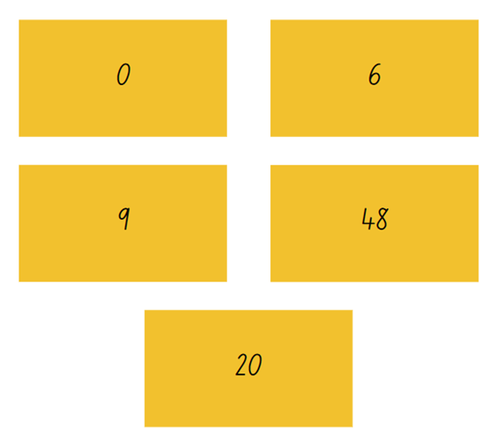
- Explain to Stage 2 students that an array has been placed inside each envelope. The array represents the number on the front of the envelope.
- Stage 2 students draw and describe an array that could represent the number on the front of each envelope. Encourage students to use the term multiples when describing the arrays. For example, 2 multiples of 3.
- Explain to Stage 3 students that 2 numbers from 0–9 have been placed inside each envelope, with each number only being used once. The product of the 2 numbers has been written on the front of each envelope.
- Revise the definition of product and factors with Stage 3.
Product: the result of multiplying 2 or more numbers together, for example, 12 is the product of 4 × 3.
Factor: a number that divides another number without a remainder. For example, 1, 2, 3 and 6 are factors of 6 but 4 and 5 are not.
- Stage 3 students work in pairs to determine which factors are in each envelope. Examples of enabling prompts include:
- What do you know about the envelope marked zero?
- Where could the 9 be? Where could it not fit? Why?
- Invite Stage 2 and Stage 3 students to share their answers and justify how they know they are correct.
This table details opportunities for assessment.
Assessment opportunities | Links
What to look for:  - Can Stage 2 students use the array structure to coordinate the number of groups with the number in each group? [MAO-WM-01, MA2-MR-01]  - Can Stage 3 students use their knowledge of factors to reason from the known to find the unknown? [MAO-WM-01, MA3-MR-01] | Links to National Numeracy Learning Progressions (NNLP):  - Stage 2 – MuS5  - Stage 3 – MuS6, MuS7.

Core lesson – 45 minutes

Stage 2 task – growing and shrinking patterns
The table below contains a suggested learning intention and success criteria. These are best co-constructed with students.
Core concept learning intentions | Core concept success criteria
Students working towards Stage 2 outcomes are learning to:  - generate and describe patterns. | Students working towards Stage 2 outcomes can:  - model, describe and record patterns  - create and continue a variety of number patterns that increase or decrease by a constant amount.
Pattern: a pattern in mathematics is made up of several elements that repeat or follow a rule.
- Display Resource 1 – Patterns or not?. Share the definition of a pattern and ask:
- Which of these are patterns?
- Which of these are not patterns?
- Can you explain your reasoning?
- What rules can you see?
- What would be the next item(s) in the pattern?
- Draw attention to the image with the stacks of coins. Discuss what makes this different from the other images. For example, ask if it is a large collection that is arranged randomly or with no pattern.
- Distribute Resource 2 – growing and shrinking to pairs of students. Examine each pattern and ask if the pattern is growing or shrinking.
- Select a student to create the next item in the sequence. Ask them to explain their reasoning and describe how much this item in the pattern has increased or decreased by.
- As a class, decide on the rule that must be followed to continue each pattern. Model appropriate language for each pattern, such as:
- the dice pattern increased by 4 each step
- the pattern grows by 3 triangles each step
- the pattern increases by 5 squares each step
- the number pattern decreases by 10 or 100 each step.
- With their partner, students continue the patterns using a range of resources, for example, counters, shape tiles, MAB or drawing materials.
- After a suitable time, pause the pattern making to ask:
- How can you work out the tenth item in the pattern without drawing or listing each one?
- How would you check it?
- How could place value help us with the tenth item?
- Allow time for students to resume pattern making and to consider these questions. Monitor student responses, noting that some students may make all 10 steps.
- Students create and record some patterns of their own. Label the number of items in each step in a skip counting pattern, such as 3, 6, 9, 12.
- Ask students to work out the tenth item in their pattern without drawing or listing each one.
- Select 2 or 3 pattern samples to discuss. Connect students’ work to the idea that multiplicative patterns grow and shrink by a constant amount.
This table details opportunities for differentiation.
Too hard? | Too easy?
Stage 2 students cannot model, describe and record patterns.  - Support students to recreate one of the patterns from Resource 2 – growing and shrinking using a range of resources, for example, counters, shape tiles, MAB or drawing materials. Support students to identify the rule.  - Ask students to create their own pattern, growing by 2 or 10 more objects in each item using MAB materials. | Stage 2 students can model, describe and record patterns.  - Students to record the relationship between the item number and amount in each step of the pattern.  - With a partner, students develop a way to identify the hundredth item in the pattern.  - Challenge students to create, describe and record a doubling pattern.

Stage 3 task – products and factors
The table below contains a suggested learning intention and success criteria. These are best co-constructed with students.
Core concept learning intentions | Core concept success criteria
Students working towards Stage 3 outcomes are learning to:  - determine products and factors. | Students working towards Stage 3 outcomes can:  - use the term product to describe the result of multiplying 2 or more numbers  - determine factors for a given whole number  - determine whether a number is prime, composite or neither (zero or one).
This lesson is an adaptation of A Prime Search from NZ Maths by the New Zealand Ministry of Education.
The level of challenge can be increased to suit the learning needs of students by selecting other numbers with multiple factors.
- Give students 12 cubes each and ask them to form rectangles using all 12 cubes. Ask:
- How many different rectangles can you find?
- Have you found all the rectangles? How do you know?
Note: highlight that factor pairs for the number 12 repeat after 3. This tells students they have found all the factors.
- Review the commutative property of multiplication, such as 12 = 4 × 3 is a rotation of 12 = 3 × 4. 3 and 4 are factors of 12, and do not need to be counted twice.
- Record each of the rectangles on grid paper. Display, such as in Figure 2. Label each rectangle with the corresponding multiplication equation, starting with the product.
Figure 2 – factors of 12
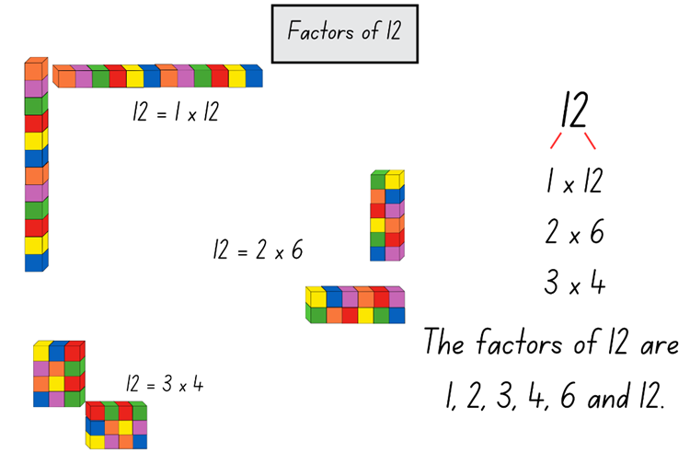
- Model the creation of a simple factor tree, see Figure 2.
- Identify that factors are found in pairs. Model the Yes/No strategy of starting at one to identify the factor pair. Then proceed sequentially through 2, 3, 4, 5 and so on to identify all factors of a number.
- Give each pair of students a number in the range 10–24. Ask them to form as many unique rectangles as they can using that number of cubes. Vary the number range to suit the learning needs of your class, selecting some prime and square numbers.
- Students form the rectangles, first with cubes, then draw regions on grid paper.
- Ask questions to draw attention to the factors of a number in a systematic way, such as arranging the first factor from lowest to highest, as in Figure 2. For example:
- How many rectangles have you found for your number?
- How do you know you have found them all?
- Did you use a system to check? What was it?
- Why do some numbers have more rectangles than others?
- What patterns can you see in your factor tree?
- Why do we use rectangles to show factors?
- Students stick or draw rectangles onto a poster labelled for their number. Students label each rectangle with a multiplication sentence and create the relevant factor tree.
- Group students that have exactly one rectangle (2 factors) and those that have more than one rectangle. Ask:
- What strategies did you use to ensure you did not miss any factors?
- Which number has the most rectangles?
- Are there any numbers that form only one rectangle?
- What patterns do you see with the ‘one rectangle’ numbers?
- What do you notice about the factors for 16? Remind students that this is a square number.
This table details opportunities for differentiation.
Too hard? | Too easy?
Stage 3 students cannot determine factors for a given number.  - Students focus on creating arrays using concrete materials to represent a given number and identify the associated fact families.  - Give students multiplication fact families on cards. Students create an array using concrete materials to match the cards. | Stage 3 students can determine factors for a given whole number.  - Students investigate a range of questions related to factors and prime numbers. Examples include which number under 100 has the most factors and how many prime numbers are there under 100?  - Students use calculators to find factors of 3- and 4-digit numbers.
- Share the definitions of prime and composite numbers.
Prime number: a prime number is a positive integer which has exactly 2 distinct factors, itself and one. Modelled as an array it has only one row. Zero is not an integer and therefore is neither prime nor composite.
Composite number: a non-zero natural number that has a factor other than one and itself. For example, all even numbers besides 2 are composite numbers. Some odd numbers are composite (for example, 21) but not all are composite (for example, 11).
- Ask students to help sort all the numbers from 0–20 under 3 headings: prime, composite or neither.

Discuss and connect the mathematics – 5 minutes
- Regroup as a class and summarise the lesson together drawing out key mathematical ideas. Ask:
- How do you know what you created is a pattern? (Stage 2)
- What rule does your pattern follow? (Stage 2)
- Do zero and one fit the definition of prime or composite? Justify your response. (Stage 3)
- What is special about the number 2? (Stage 3)
This table details opportunities for assessment.
Assessment opportunities | Links
What to look for:  - Can Stage 2 students model, describe and record patterns? [MAO-WM-01, MA2-MR-01]  - Can Stage 2 students create and continue a variety of number patterns that increase or decrease by a constant amount? [MAO-WM-01, MA2-MR-01]  - Can Stage 3 students use the term product to describe the result of multiplying 2 or more numbers? [MAO-WM-01, MA3-MR-01]  - Can Stage 3 students determine factors for a given whole number? [MAO-WM-01, MA3-MR-01]  - Can Stage 3 students determine whether a number is prime, composite or neither? [MAO-WM-01, MA3-MR-01] | Links to National Numeracy Learning Progressions (NNLP):  - Stage 2 – NPA3, NPA4  - Stage 3 – MuS6, MuS7.  Links to suggested Interview for Student Reasoning (IfSR) tasks:  - Stage 2 – IfSR-NP: 4A.1, 4A.2, 4A.3.

Lesson 2
Core concept: structures and known number facts support multiplicative thinking.

Daily number sense – the number is 12 – 10 minutes
The table below contains suggested learning intentions and success criteria. These are best co-constructed with students.
Daily number sense learning intention | Daily number sense success criteria
Students working towards Stage 2 outcomes are learning to:  - recall multiplication and division facts.  Students working towards Stage 3 outcomes are learning to:  - select and apply appropriate strategies to solve multiplication problems. | Students working towards Stage 3 outcomes can:  - generate multiplication fact families for multiples of 2 and 4.  Students working towards Stage 3 outcomes can:  - factorise numbers to aid mental multiplication.
Note: any other number with multiple factors can be selected to best suit the learning needs of your students.
- Draw Figure 3 on the board and model for Stage 2 how to record the multiplication fact family:
- 2 × 4 = 8
- 4 × 2 = 8
- 8 ÷ 2 = 4
- 8 ÷ 4 = 2
Figure 3 – fact family for 8
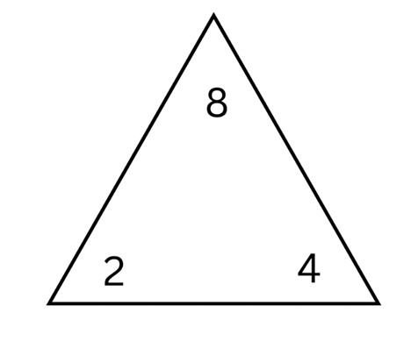
- Stage 2 students to draw and record the multiplication fact family for the numbers:
- 2, 6 and 12
- 3, 4 and 12.
- Invite Stage 2 students to share their answers and thinking.
- Stage 3 students record 3 numbers that can be multiplied together to make 12, such as 2 × 2 × 3.
- Display Resource 3 – the product is 12 for Stage 3 and use the prompt box below to discuss students’ observations.
The table below outlines stimulus prompts to generate conversation about the topic, along with anticipated responses from students.
Prompts | Anticipated student responses
- What do you notice?  - What do you wonder?  - What property of multiplication do you notice? | - The commutative property of multiplication means that the same numbers can be shown in a different order, but the outcome is the same. For example, 1 × 1 × 12 = 1 × 12 × 1.  - The associative property of multiplication means that you can group the factors in different ways to find the total and the result will be the same. For example, in 2 × 6 × 1 = 12 either the 2 × 6 or the 6 × 1 could be multiplied first, then multiplied by the other factor and the total will still equal 12.
- Display the statement 6 × 12. Ask Stage 3 students to record 3 numbers that can be multiplied to make same product, such as 6 × 3 × 4.
This table details opportunities for assessment.
Assessment opportunities | Links
What to look for:  - Can Stage 2 students generate multiplication fact families for multiples of 2 and 4? [MAO-WM-01, MA2-MR-01]  - Can Stage 3 students factorise numbers to aid mental multiplication? [MAO-WM-01, MA3-MR-01] | Links to National Numeracy Learning Progressions (NNLP):  - Stage 2 – MuS6  - Stage 3 – MuS6, MuS7.

Core lesson – 50 minutes

Stage 2 task – groups to arrays
The table below contains a suggested learning intention and success criteria. These are best co-constructed with students.
Core concept learning intentions | Core concept success criteria
Students working towards Stage 2 outcomes are learning to:  - use arrays to establish multiplication facts from multiples of 2 and 4, 5 and 10. | Students working towards Stage 2 outcomes can:  - use the array structure to coordinate the number of groups with the number of each group  - use the term multiples when connecting groups to arrays.
- Explain that a farmer has eggs from the chickens on their farm. The farmer must pack the eggs in boxes before sending them to market.
- Display Resource 4 – nests and carton. Ask students:
- What is different?
- What is the same?
- How can you describe what you see?
- Establish by skip counting that there are a total 12 eggs in the nests.
- Model how 3 groups of 4 eggs were rearranged into equal rows called an array. Explain that it is one set of 12 eggs.
Array: an array is one of several different arrangements that can be used to model multiplicative situations involving whole numbers. It is made by arranging a set of objects, such as counters, into columns and rows. Each column must contain the same number of objects as the other columns, and each row must contain the same number of objects as the other rows.
- Explain that 3 groups of 4 can now be described as 3 rows of 4 or 3 fours. State that 3 fours is 12.
- Display Resource 5 – nests and carton 2. Ask students to turn and talk and discuss the corresponding array.
- Students to draw the array on an individual whiteboard. Discuss with students how they can describe the array, using the phrases ‘5 rows of 3’ or ‘5 threes’ is 15. Ensure students read across the rows.
- Introduce the terms multiples and product.
Multiples: a series of products formed using the same base number multiplied by different whole numbers. For example, 3, 6, 9, 12 and so on are multiples of 3.
Product: the result of multiplying 2 or more numbers together. For example, 12 is the product of 4 × 3.
- As a group, skip count by threes. Record the numbers as they are said aloud. Explain that these are all multiples of 3.
- Draw attention to 12 and 15 in the list of multiples. Explain that multiples are in the array in Resource 5 – nests and carton 2 because each row has 3 in it: 4 threes is 12 and 5 threes is 15. Note that 12 is also a multiple of 4 as shown in Resource 4 – nests and carton.
- Create an anchor chart to model this language with an array, see Figure 4. Explain that each of these numbers are multiples of 4.
Figure 4 – multiples and arrays
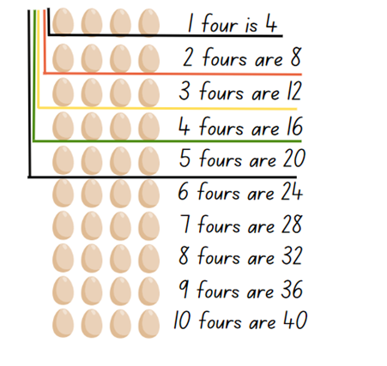
- Provide students with a copy of Resource 6 – nest cards and writing materials.
- Students rearrange each nest card into an array and describe what they see using words, such as ‘I see 5 threes’. For an example, see Figure 5.
Figure 5 – student work sample
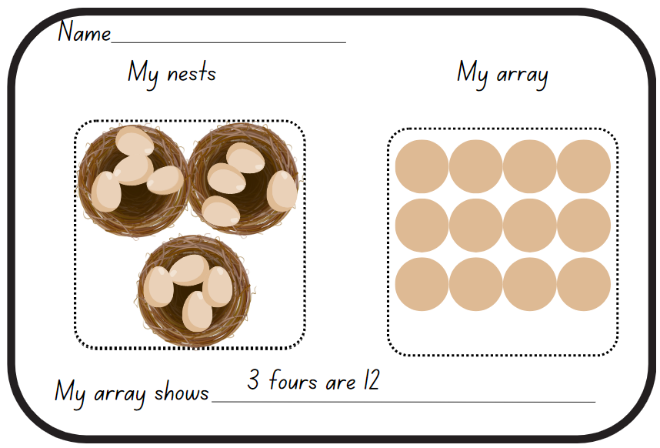
This table details opportunities for differentiation.
Too hard? | Too easy?
Stage 2 students cannot use arrays to establish multiplication facts from multiples of 2 and 4, 5 and 10.  - Support students to create groups of 2 counters. Model transforming these into an array by dragging the counters. Ask students how many twos students see in the array.  - Present a 2 by 5 array. Ask students to identify the rows and how many there are in each row. Ask how many fives they see in the array. Repeat with other arrays with rows of 5. | Stage 2 students can use arrays to establish multiplication facts from multiples of 2 and 4, 5 and 10.  - Students to investigate arrays that form a square, record the number facts and describe a pattern.  - Use a digital device to investigate the different arrays that eggs are packaged and sold in Australia. Label images with multiples and present to the class.

Stage 3 task – factorising
The table below contains suggested learning intentions and success criteria. These are best co-constructed with students.
Core concept learning intentions | Core concept success criteria
Students working towards Stage 3 outcomes are learning to:  - determine factors and products  - use partitioning and place value to multiply 2-, 3- and 4-digit numbers by one-digit numbers  - choose and apply mathematical techniques to solve problems and communicate their thinking and reasoning coherently and clearly. | Students working towards Stage 3 outcomes can:  - determine factors for a given whole number  - use mental strategies to multiply one-digit numbers by 10, 100, 1000 and their multiples  - estimate the product of 2 numbers (one-digit by 2- or 3-digit numbers) using multiples of 10 or 100.
This lesson is an adaptation of ‘Multiplying and Dividing Numbers by 10, 100...’ from Building Engagement for Middle Years Mathematics: Learning sequences for mixed-ability classrooms by Sullivan.
- Draw Figure 6 on the board. Explain that the answer is 800 MAB blocks. Ask students to think what might be in the box.
Figure 6 – two boxes
- Display Resource 7 – two hundreds. Confirm that in each box there is a hundred block. Ask students to check the answer.
- Explain that the answer can be written as 8 hundreds and expressed as the equation 2 × 100 × 4 = 800. Identify that 2 and 100 are factors of 200. Ask what the best order to multiply these numbers is.
- Pose other units that could be in the box, such as 1000, 10 000, 100 000. Ask what the answer would be then.
- Explain that dividing numbers into factors so that students can multiply them separately is called factorising. Share the definition.
Factorise: to express a number as a product. For example, 15 is factorised when expressed as a product, such as 15 = 3 × 5.
- Display the following examples on the board:
- 3 × 700
- 60 × 6
- 4 × 2000
- 3 × 1500
- 30 × 20
- Students show on whiteboards how they might factorise each of the examples. Encourage students to rename numbers to help, such as renaming 1500 as 15 hundreds or 15 × 100.
- Students turn and talk to discuss:
- Does factorising make questions like this easier to solve? Why or why not?
- Where can it help?
- Where might it not help?
- Present Resource 8 – applying facts. Ask:
- Can you factorise one or more of the numbers to make them easier to calculate?
- What is similar about these questions? What is different?
- Did factorising make the questions easier to solve? How?
Note: guide students to realise that the answer will start with ‘40’ something because of the base fact 5 × 8. Encourage students to estimate whether the product would be in the hundreds, thousands or tens of thousands.
- Students choose a multiplication fact that they are confident with and create a similar series of questions, using the previous task as a reference. Numbers used should extend to at least 4-digit numbers.
- Students trade questions with a partner and solve.
- Students trade questions back and compare the way each other have factorised.
This table details opportunities for differentiation.
Too hard? | Too easy?
Stage 3 students cannot determine factors for a given number or use mental strategies to multiply one-digit numbers by 10, 100, 1000 and their multiples.  - Use MAB materials to model even multiples of 10 and 100 and write an equation, such as 600 = 6 × 100. Split the model into 2 parts. Rewrite the equation, such as 600 = 2 × 3 × 100.  - Students use calculators to investigate and record patterns when multiplying by 10, 100 or 1000. | Stage 3 students can use mental strategies to multiply one-digit numbers by 10, 100, 1000 and their multiples.  - Challenge students to create a list of division questions using 8 × 5 = 40, such as 40 ÷ 5; 400 ÷ 8; 400 ÷ 50; 4000 ÷ 5.  - Students use calculators to investigate and record the effect of multiplying or dividing decimals by 10, 100 or 1000.
- Distribute copies of Resource 9 – factorising gameboard, a 6-sided die and 6 counters to each pair of students. Students play according to the instructions:
- Students take turns rolling the die and multiplying the number by a value on the board.
- Students write the factorised equation and solve it, using number facts they know.
- If both students agree, they add a counter to that number on the gameboard.
- If they run out of counters, students move an existing counter to a new place.
- Students win by getting 4 counters in a row horizonal, vertical, diagonal or a square.

Discuss and connect the mathematics – 10 minutes
- Select Stage 2 student samples that represent multiples of 2, 4, 5 and 10. Ask Stage 2 students:
- What patterns can you see?
- How do you know these arrays are multiples?
- Are there any different shaped arrays that produce the same product?
- Stage 2 students record the first 10 multiples of 2, 4, 5 and 10.
- Ask Stage 3 students to turn and talk and discuss the following questions:
- What patterns have you noticed when multiplying by 10, 100 and 1000? (Identify that the digits remain the same, but the place value changes).
- Is it possible to factorise both numbers, such as 60 × 50? When might that be helpful?
- What advice would you give someone who has trouble multiplying large numbers with lots of zeroes?
Note: it is a common misconception that multiplying by 10 can be done by simply ‘adding a zero’ and multiplying by 100 can be done by ‘adding 2 zeros’. This should be avoided as it detracts from a deeper understanding of place value, multiplicative thinking and the link between them.
This table details opportunities for assessment.
Assessment opportunities | Links
What to look for:  - Can Stage 2 students use the array structure to coordinate the number of groups with the number of each group? [MAO-WM-01, MA2-MR-01]  - Can Stage 2 students use the term multiples when connecting groups to arrays? [MAO-WM-01, MA2-MR-01]  - Can Stage 3 students determine factors for a given whole number? [MAO-WM-01, MA3-MR-01]  - Can Stage 3 students use mental strategies to multiply one-digit numbers by 10, 100, 1000 and their multiples? [MAO-WM-01, MA3-MR-01, MA3-MR-02]  - Can Stage 3 students estimate the product of 2 numbers (one-digit by 2- or 3-digit numbers) using multiples of 10 or 100? [MAO-WM-01, MA3-MR-01, MA3-MR-02] | Links to National Numeracy Learning Progressions (NNLP):  - Stage 2 – MuS5  - Stage 3 – MuS6, MuS7.  Links to suggested Interview for Student Reasoning (IfSR) tasks:  - Stage 3 – IfSR-MT: 3A.1, 3A.2, 3A.3.

Lesson 3
Core concept: doubling is a powerful strategy (Stage 2). Flexible methods of computation in multiplication and division involve composing decomposing numbers (Stage 3).

Daily number sense – multiplicative patterns – 15 minutes
The table below contains suggested learning intentions and success criteria. These are best co-constructed with students.
Daily number sense learning intention | Daily number sense success criteria
Students working towards Stage 2 outcomes are learning to:  - generate and describe patterns.  Students working towards Stage 3 outcomes are learning to:  - use partitioning and place value to multiply 2-, 3- and 4-digit numbers by one-digit numbers. | Students working towards Stage 2 outcomes can:  - model, describe and record patterns of multiples  - create and continue a variety of number patterns.  Students working towards Stage 3 outcomes can:  - use mental strategies to multiply one-digit numbers by 10, 100, 1000 and their multiples.
This activity is an adaptation from Enrich-e-matics: Book 3, 3rd edn by Joshua.
- Display Resource 10 – multiplicative tables 1.
- Students identify the multiplicative relationship between the number pairs.
- Invite students to nominate other pairs that belong in each table.
- Display Resource 11 – multiplicative tables 2. Students turn and talk to nominate missing numbers and a rule that applies to this table. Possible answers for whole numbers include multiply by 1, 2, 4, 5, 10, 20. Discuss why 3, 6, 7, 8 and 9 are not possible multipliers for whole numbers.
- This activity can be extended with students making their own tables.
Multi-age: students working towards Stage 3 outcomes can use tables that contain one-digit numbers and multiples of 10, 100 or 1000. For example, one-digit numbers multiplied by 500.
This table details opportunities for assessment.
Assessment opportunities | Links
What to look for:  - Can Stage 2 students model, describe and record patterns of multiples? [MAO-WM-01, MA2-MR-01]  - Can Stage 2 students create and continue a variety of number patterns? [MAO-WM-01, MA2-MR-01]  - Can Stage 3 students use mental strategies to multiply one-digit numbers by 10, 100, 1000 and their multiples? [MAO-WM-01, MA3-MR-01] | Links to National Numeracy Learning Progressions (NNLP):  - Stage 2 – NPA3, NPA4  - Stage 3 – MuS6, MuS7.  Links to suggested Interview for Student Reasoning (IfSR) tasks:  - Stage 2 – IfSR-NP: 4A.1, 4A.2, 4A.3  - Stage 3 – IfSR-MT: 3A.1, 3A.2, 3A.3.

Core lesson – 40 minutes

Stage 2 task – doubling is a powerful strategy
The table below contains suggested learning intentions and success criteria. These are best co-constructed with students.
Core concept learning intentions | Core concept success criteria
Students working towards Stage 2 outcomes are learning to:  - use arrays to establish multiplication facts from multiples of 2 and 4, 5 and 10  - use known number facts and strategies. | Students working towards Stage 2 outcomes can:  - relate doubling to multiplication facts for multiples of 2  - apply the known strategy of doubling to connect multiples of 3 to 6 and 4 to 8.
Note: some students may rely on repeated addition. Support these students to develop their use of doubling as a more efficient strategy for multiplicative situations.
- Introduce the story: Chef Jeff is hosting a muffin party for 6 of his friends. He plans on using muffin trays with 6 spaces to bake his famous mathematics muffins.
- With a partner, students draw what his muffin tray might look like. Ask:
- Why did you draw it this way?
- How else could you represent the muffin tray?
- Display Resource 12 – unusual muffin trays.
Note: Resource 12 – unusual muffin trays provides students with ‘non-examples’ of arrays. That is, they show examples of arrangements that may be mistaken for an array, but do not have the array structure of repeated rows.
- Ask students:
- Which one would you choose and why?
- Is this a good choice?
- Draw Figure 7 on the board and explain how to correctly read the array by saying the number of rows. For example, in this muffin tray there are 3 rows of 2.
Figure 7 – muffin tray
- Explain that multiples are the products made when the same base number is multiplied by different whole numbers. For example, 2, 4, 6, 8 are all multiples of 2.
- Display Resource 13 – muffin tray arrays. Ask students:
- What do you notice about these muffin trays?
- How can you work out the total number of muffins each tray could make?
- Explain that Chef Jeff decides to invite another 6 friends so he will need to make another tray of muffins. Chef Jeff will use the muffin tray that uses 2 threes. Ask students to think about what this might look like.
- Ask students:
- How do we read this now?
- How is this written as a number sentence?
- How else could the trays be orientated?
- Explain that Chef Jeff has decided to enter a baking competition. His kitchen has lots of different muffin trays to choose from when baking for the judges. There are a lot of judges. Ask what it would look like if he doubled the trays.
- Draw each of the muffin trays from Figure 8 on the board.
Figure 8 – double trays
- In pairs, students draw an array that shows what each tray would look like if it was doubled.
- Explain that Chef Jeff has made the Master muffin chef final round! The judges have asked him to double the amount he is baking for them.
- Students to help Chef Jeff by drawing muffin tray arrays that have:
- double 3 rows of 4
- double 2 rows of 2
- double 4 rows of 5
- 4 muffins doubled, then doubled again.
This table details opportunities for differentiation.
Too hard? | Too easy?
Stage 2 students cannot relate doubling to multiplication facts.  - Support students to use counters to construct doubles.  - Provide concrete examples of array structures, such as egg cartons or muffin trays. | Stage 2 students can relate doubling to multiplication facts.  - Ask students what would happen if Chef Jeff doubled the tray once or if he had 4 trays. Prompt students to share what they notice and whether they can see the pattern.  - Challenge students to describe some other shortcuts with doubling in mathematics. For example, ask if students can identify the link with ‘double double’ and multiples of 4.

Stage 3 task – strategies to solve multiplication
The table below contains a suggested learning intention and success criteria. These are best co-constructed with students.
Core concept learning intentions | Core concept success criteria
Students working towards Stage 3 outcomes are learning to:  - select and apply appropriate strategies to solve multiplication and division problems. | Students working towards Stage 3 outcomes can:  - use informal written strategies, such as the area model, to solve multiplication  - use the distributive property with the area model to partition numbers in representing multiplication problems  - partition numbers in non-standard forms  - use estimation to check the reasonableness of answers to multiplication and division calculations.
- Display Resource 14 – student strategies and read out the speech bubbles. Ask:
- Can you show what Murray’s strategy looks like?
- Can you show what Heide’s strategy looks like?
- What might you use to help you? Can you think of a strategy that might help?
- Who is correct?
- Focus on Brett’s statement and ask:
- What might Brett’s strategy be?
- Can you show what his strategy looks like?
- What might someone else’s strategy be if they joined in the conversation?
- Capture student ideas on an anchor chart, such as Figure 9. Annotate student ideas with number sentences as a method of sharing mathematical thinking.
Figure 9 – possible student strategies
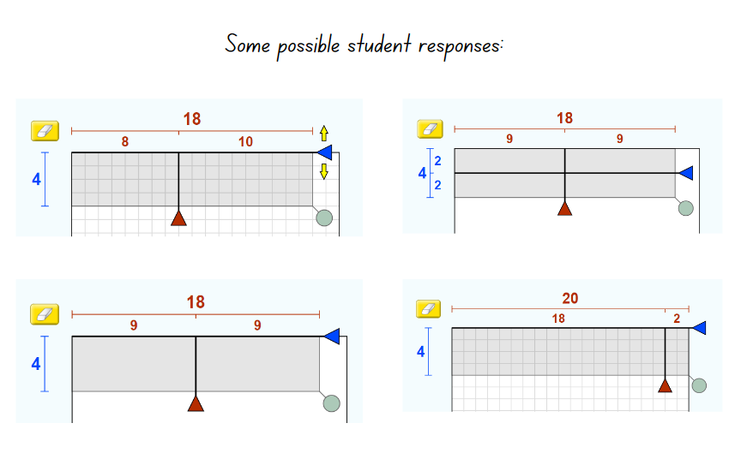
Image created using PhET Interactive Simulations, University of Colorado Boulder, https://phet.colorado.edu.
Note: explore the area model digital tool to represent different numbers in preparation for Lesson 4.
- Introduce the multiplication sentence 24 × 5. Ask students to discuss whether 200 is a reasonable answer to this, giving reasons why or why not.
- Students to create 3 possible responses and representations that Heide, Murray and Brett might use to solve the question.
Note: the question is designed to encourage students to represent the same equation in multiple ways, for example, a standard equation; multiply by 10 then halve, 12 × 5 × 2; 5 × 25 – 5.
- Invite students to share their responses and collate on an anchor chart. Review the names of the strategies used and label on the anchor chart.
This table details opportunities for differentiation.
Too hard? | Too easy?
Students cannot use informal written strategies, such as the area model, to solve multiplication.  - Support students to construct an array of 5 × 8 with concrete materials and model how to partition the array.  - Students colour a region or area on grid paper and find different ways to partition.  - Use the area model digital tool to explore different numbers. | Students can use informal written strategies such as the area model to solve multiplication.  - Provide students with a 2-digit multiplication question, such as 24 × 15. Ask if students can link this back to the original question.  - Use the area model digital tool to explore larger numbers on a 100 × 100 grid.

Discuss and connect the mathematics – 10 minutes
- Regroup as a class and summarise the lesson together drawing out key mathematical ideas. Ask:
- Could you see any patterns in the arrays? (Stage 2)
- How did using an array help you to find your answer when doubling? (Stage 2)
- What is another way mathematicians describe doubling? (Stage 2)
- How might arrays help us when calculating larger numbers? (Stage 2)
- What strategy do you think is most effective to answer 24 × 5? Why? (Stage 3)
- How does partitioning help you to represent and solve multiplication problems? (Stage 3)
This table details opportunities for assessment.
Assessment opportunities | Links
What to look for:  - Can Stage 2 students relate doubling to multiplication facts for multiples of 2? [MAO-WM-01, MA2-MR-01]  - Can Stage 2 students apply the known strategy of doubling to connect multiples of 3 to 6 and 4 to 8? [MAO-WM-01, MA2-MR-01]  - Can Stage 3 students use informal written strategies such as the area model to solve multiplication? [MAO-WM-01, MA3-MR-01]  - Can Stage 3 students use the distributive property with the area model to partition numbers in multiplication problems? [MAO-WM-01, MA3-MR-01]  - Can Stage 3 students partition numbers in non-standard forms? [MAO-WM-01, MA3-MR-01]  - Can Stage 3 students use estimation to check the reasonableness of answers to multiplication and division calculations? [MAO-WM-01, MA3-MR-01] | Links to National Numeracy Learning Progressions (NNLP):  - Stage 2 – MuS6  - Stage 3 – MuS6, MuS7.  Links to suggested Interview for Student Reasoning (IfSR) tasks:  - Stage 3 – IfSR-MT: 3A.1, 3A.2, 3A.3.

Lesson 4
Core concept: halving is the opposite of doubling (Stage 2). The area model can support multiplicative thinking (Stage 3).

Daily number sense – 10 minutes
- From a class need surfaced through formative assessment data, identify a short, focused activity that targets students’ knowledge, understanding and skills. Example activities may be drawn from the following resources:
- Mathematics K-6 resources
- Universal Resources Hub.

Core lesson – 40 minutes

Stage 2 task – halving
The table below contains a suggested learning intention and success criteria. These are best co-constructed with students.
Core concept learning intentions | Core concept success criteria
Students working towards Stage 2 outcomes are learning to:  - use arrays to establish multiplication facts from multiples of 2 and 4, 5 and 10. | Students working towards Stage 2 outcomes can:  - recognise that doubling is multiplying by 2 and halving is dividing by 2.
Note: prior to the lesson, print multiple copies of Resource 16 – halving game cards. Cut the card sets into sets A and B.
- Display Resource 15 – a farmer’s field. Explain that Farmer Brett has some fields. They would like half of each field to be flowers and the other half to be vegetables. Each half field is to be separated by a fence. Ask:
- What does Farmer Brett mean by ‘half’?
- Which of the fields in are simple to halve? Why?
- Which of the fields in are challenging to halve? Why?
- What might the field look like?
- Explain that the farmer needs to dig holes to plant the flowers and vegetables in rows.
- Provide individual whiteboards for students to draw different fields. Students share their thinking with partners.
The table below outlines stimulus prompts to generate conversation about the topic, along with anticipated responses from students.
Prompts | Anticipated student responses
- Can you draw the field from a top-down view?  - What if I told you that the holes were in rows? Draw one row and ask student to make more rows.  - What if I told you that the holes were in an array? Redirect student to the class anchor chart.  - How did doubling help you make half? | - Students draw holes in cross-section.  - Students drawing random collection of holes.  - Students draw unequal rows.  - Students draw an array, then double it.
- Explain that there are exactly 12 holes in the ground organised in an array. Ask what this field might look like.
- Explore each array for 12 and model how to halve, see Figure 10.
Figure 10 – half of 12
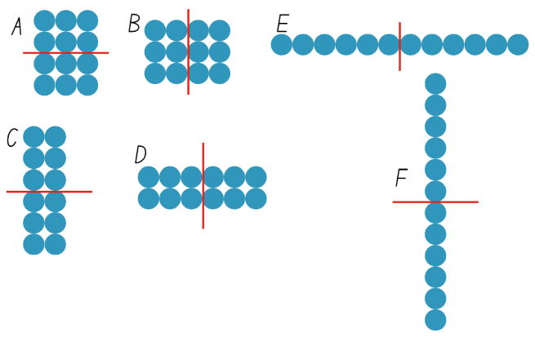
- Model partitioning that is not half. Ask students to explain why that is not half.
- Model language for halving, for example, half of 12 is 6, 6 is half of 12.
- Model language that matches each array in Figure 10:
- A – 2 threes are half of 4 threes
- B – 3 twos are half of 3 fours
- C – 3 twos are half of 6 twos
- D – 2 threes are half of 2 sixes
- E – one 6 is half of one 12
- F – 6 ones are half of 12 ones
- Explain that students are going to play a matching game for halving using Resource 16 – halving game cards. Students take it in turns to match the cards in pairs that are equivalent, that is, they have the same total.
Note: for an additional challenge, the cards can be placed upside down and students turn a pair face up on each go. Students try to match the cards in pairs that are equivalent.
- Students play the game with a partner using copies of set A cards from Resource 16 – halving game cards.
- After 5 minutes, pause the game to introduce the set B cards. Explain the content of each card by referring explicitly to the number sentence and symbols.
- Distribute deck B to be mixed in with deck A. Students restart the game.
- At the end of the game, ask:
- How is halving like doubling?
- How is it different?
- Select an array from the game, model how doubling any half will produce the starting collection. Model how this will work with any number. Explain that the relationship between doubling and halving is called an inverse operation and share the definition.
Inverse operation: the operation that reverses the effect of another operation.
Examples:
Addition and subtraction are inverse operations: adding 3 to 7 gives 10. Subtracting 3 from 10 gets the total back to 7.
Multiplication and division are inverse operations: multiplying 6 by 2 gives 12. Divide 12 by 2 gets the total back to 6.
- Explain that doubling is the same as multiplying by 2 and that halving is the same as dividing by 2.
This table details opportunities for differentiation.
Too hard? | Too easy?
Stage 2 students cannot halve a collection.  - Provide an even number of concrete materials. Ask students to form 2 equal groups and identify how many in each group.  - Model the doubling strategies in Lesson 2. Revise the link between halving and doubling. | Stage 2 students can halve a collection.  - Explore arrays that can be divided into 4. Students identify a connection between halving and dividing by 4.  - Students select arrays from the game sets and partition in a variety of ways, explaining their thinking.

Stage 3 task – area model
The table below contains suggested learning intentions and success criteria. These are best co-constructed with students.
Core concept learning intentions | Core concept success criteria
Students working towards Stage 3 outcomes are learning to:  - use partitioning and place value to multiply 2-, 3- and 4-digit numbers by one-digit numbers  - explore the use of brackets and the order of operations to write number sentences. | Students working towards Stage 3 outcomes can:  - use informal written strategies such as the area model to solve multiplication problems  - use grouping symbols () in number sentences to indicate operations that must be performed first.
- Display Resource 17 – area model. Ask students:
- What do you see, think and wonder?
- How could this help us calculate multiplication problems?
- Record responses on a whiteboard to refer to during lesson.
- Explain to students that this is called the area model. In this example, 47 has been partitioned into 4 tens and 7 ones.
- Pose the problem 5 x 18. Ask students what this would look like using MAB materials or drawn on grid paper.
- In pairs, students use MAB materials, grid paper or a digital manipulative such as the Math learning center to construct this multiplication statement, see Figure 11.
Figure 11 – constructed area model
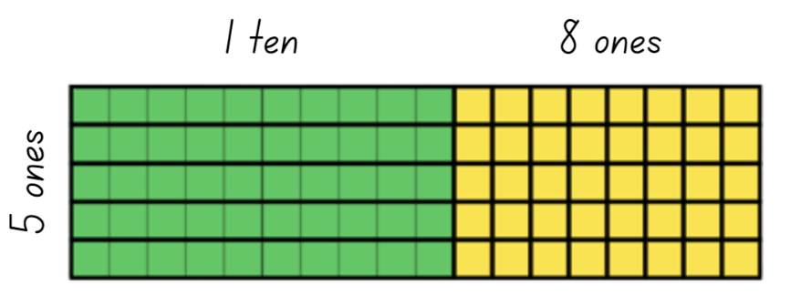
- Compare student examples.
- Demonstrate how to draw the multiplication statement as an area model using 2 examples, see Figure 12. Draw attention to Figure 12 as being simplified but equivalent to Figure 11, without showing the individual units in the grid.
Figure 12 – constructed area model
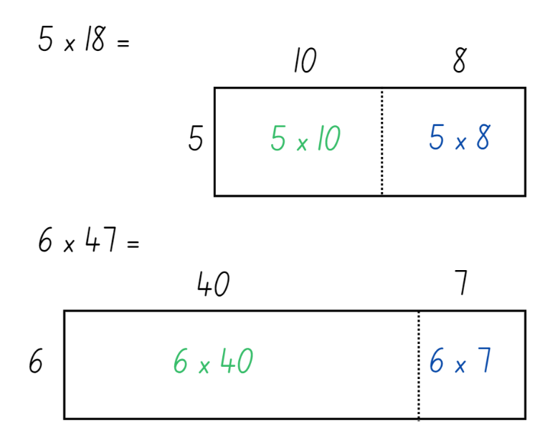
Note: when drawing the area model, it is important to consider proportionality and represent the relative sizes of the areas. In the examples from Figure 12, 10 and 8 are drawn as similar sizes. 40 is drawn as significantly larger than 7. Students should also maintain such proportions in their sketches.
- Compare the MAB example with the area model. Ask students what they notice about the 2 ways of representing the multiplication.
- Provide writing materials and pose additional single multiplier questions for student to represent with the area model. For example, 3 × 85, 4 × 265 or 6 × 4532.
- Ask students to use the area model to represent these equations on a whiteboard.
Note: the next part of the lesson exposes students to the concept of using parentheses to help organise mathematical thinking. Parentheses are often referred to as brackets but, in the teaching advice for the K–10 Mathematics syllabus, are referred to as parentheses.
- Ask students if they have seen brackets before and what they think their purpose is. Anticipated student responses include:
- Brackets appear in sentences to add additional information.
- They are used to add important information about a topic.
- Used when solving equations where the order of operations is important.
- In mathematics, brackets [ …] and braces { …} are used for other purposes.
- Ask students if they know how they could use parentheses to help organise their thinking when writing a partitioned multiplication equation.
- Demonstrate how to transfer the information in an area model to a partitioned multiplication equation, such as Figure 13.
Figure 13 – area model and parentheses
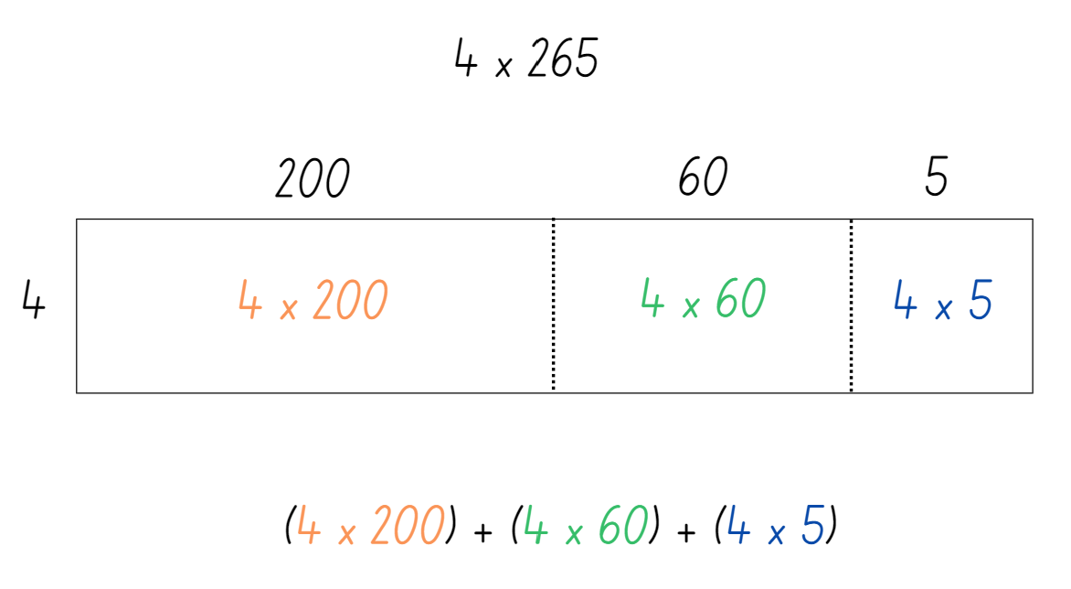
- Continue with solving the multiplication problem.
- Pose additional questions for students to represent using the area model and parentheses.
This table details opportunities for differentiation.
Too hard? | Too easy?
Stage 3 students cannot partition 2- and 3-digit numbers or transfer this to an area model.  - Use concrete materials, such as MAB materials, to represent 2-digit numbers.  - Use the area model digital tool to explore different numbers on the 20 × 20 grid, such as Figure 14.  - Use the calculation function to link the model to the number representations. | Stage 3 students can partition 2- and 3-digit numbers or transfer this to an area model.  - Use two 2-digit numbers to form a multiplication equation and express it as an area model, using parentheses to model the distributive property.  - Use the area model digital tool to explore larger numbers on a 100 × 100 grid, using parentheses to model the distributive property.
Figure 14 – area model tool
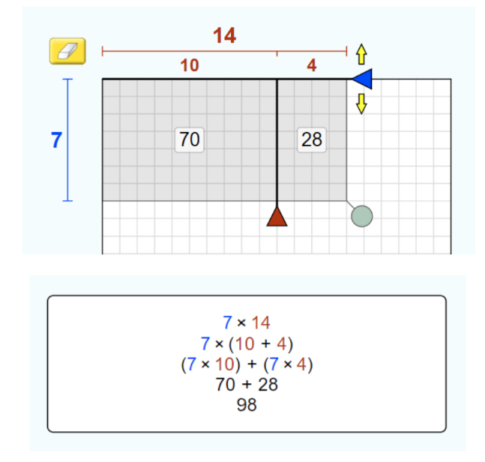
Image created using PhET Interactive Simulations, University of Colorado Boulder, https://phet.colorado.edu.

Discuss and connect the mathematics – 10 minutes
- Ask questions to check Stage 2 understanding, such as:
- If I know that I halved a number to get 20, what number did I start with?
- If I know that I doubled a number to get 20, what number did I start with?
- How can doubling help with questions like 4 × 9, 4 × 12 or 4 × 14? (Double, then double again)
- How can halving help with questions like 24 ÷ 4, or 28 ÷ 4? (Halve, then halve again)
- Reflect on the activity by asking Stage 3 students:
- When might the area model be useful for calculating multiplication problems?
- How can parentheses help us?
- Could we use the area model with different sized multiplication problems?
- What might that look like?
This table details opportunities for assessment.
Assessment opportunities | Links
What to look for:  - Can Stage 2 students recognise that doubling is multiplying by 2 and halving is dividing by 2? [MAO-WM-01, MA2-MR-01]  - Can Stage 3 students use informal written strategies such as the area model to solve multiplication problems? [MAO-WM-01, MA3-MR-01]  - Can Stage 3 students use grouping symbols () in number sentences to indicate operations that must be performed first? [MAO-WM-01, MA3-MR-01] | Links to National Numeracy Learning Progressions (NNLP):  - Stage 2 – MuS6, InF2, InF6  - Stage 3 – NPV6, MuS6, MuS7.  Links to suggested Interview for Student Reasoning (IfSR) tasks:  - Stage 3 – IfSR-MT: 3A.1, 3A.2, 3A.3.

Lesson 5
Core concept: mathematicians use models and representations to solve multiplicative problems.

Daily number sense – place value mystery – 15 minutes
Daily number sense activities for Lessons 5 to 7 ‘loop’ back to concepts and procedures covered in previous units to assist students to build an increasingly connected network of ideas. These concepts may differ from the core concepts being covered by the unit.
The table below contains suggested learning intentions and success criteria. These are best co-constructed with students.
Daily number sense learning intention | Daily number sense success criteria
Students working towards Stage 2 outcomes are learning to:  - apply place value to partition and regroup numbers up to 4 digits.  Students working towards Stage 3 outcomes are learning to:  - recognise and represent numbers in the millions. | Students working towards Stage 2 outcomes can:  - record numbers using standard place value form.  Students working towards Stage 3 outcomes can:  - name millions using the place value grouping of ones, tens and hundreds.
This activity is an adaptation of ‘I am thinking of a number’ from Open-ended Maths Activities: Using ‘Good’ Questions to Enhance Learning in Mathematics, Revised edn by Sullivan and Lilburn.
- Explain that you are going to read the clues to a mystery number and students should record them as you read. For example:
- I am larger than 10 million
- The number is a multiple of 5
- The first 3 digits add to a number greater than 5
- The tens of thousands digit is smaller than 4
- The thousands digit is even
- The hundreds digit is larger than the units digit
- The tens digit is larger than the hundreds digit and is odd.
- Students record what they think the answer could be.
- Students share their answer with a partner and justify their thinking. Allow time for students to refine their answers.
- As a class, discuss student thinking. Ask questions, such as:
- What is your answer?
- Can you explain why your answer could be correct?
- Is your answer bigger or smaller than your partner’s?
- Can you think of another possible answer?
- Can you think of an incorrect answer and explain why?
- Students work in pairs to write their own clues to a mystery number. Some of these can be shared for the class to solve.
Multi-age: students working towards Stage 2 outcomes use numbers up to 4 digits.
This table details opportunities for assessment.
Assessment opportunities | Links
What to look for:  - Can Stage 2 students record numbers using standard place value form? [MAO-WM-01, MA2-RN-01]  - Can Stage 3 students name millions using the place value grouping of ones, tens and hundreds? [MAO-WM-01, MA3-RN-01] | Links to National Numeracy Learning Progressions (NNLP):  - Stage 2 – NPV4, NPV5, NPV6  - Stage 3 – NPV7.  Links to suggested Interview for Student Reasoning (IfSR) tasks:  - Stage 2 – IfSR-AT: 3B.2.

Core lesson – 45 minutes

Stage 2 task – commutative city
The table below contains a suggested learning intention and success criteria. These are best co-constructed with students.
Core concept learning intentions | Core concept success criteria
Students working towards Stage 2 outcomes are learning to:  - represent the structure of multiplicative relations to 10 × 10. | Students working towards Stage 2 outcomes can:  - recall multiplication facts of 2 and 4, 5 and 10  - use number properties to find related multiplication facts  - use the commutative property of multiplication.
- Provide students with individual whiteboards and whiteboard markers.
- Display Resource 18 – building arrays. Explain that this is a rectangular building with 3 floors and 2 rooms on each floor. Ask how many rooms there are altogether.
- Demonstrate that this can be written as 3 twos are 6, or 3 × 2 = 6.
- Divide the group of Stage 2 students in half. Ask one half to draw a rectangular building with 3 floors, with 5 rooms on each floor. Ask the other half to draw a rectangular building with 5 floors and 3 rooms on each floor.
- Compare the results of each group. Note that the buildings look the same when turned on their side.
- On the board, write ‘3 fives are 15’, ‘5 threes are 15’ and the 2 number sentences 3 × 5 = 15 and 5 × 3 = 15.
- Explain that this is called the commutative property.
Commutative property: two numbers can be added or multiplied in any order and the total will be the same. Commutative law, commutativity and turn-around facts are interchangeable terms.
- Instruct students to draw and label 2 array buildings using the numbers 5 and 4.
- Students draw and record other examples of commutative multiplication facts.
- Have Stage 2 students form pairs and provide them with 10-millimetre grid paper, a 10-sided die.
- Allocate each pair of students one number from the following set: 2, 4, 5 or 10.
- Students roll the 10-sided die to select a second number. Each pair of students will have 2 numbers that represent the number of floors and number of rooms on each floor.
- Students create 2 related array buildings on their grid paper. They are to label each building with multiplicative language such as ‘3 fours are 12’ or ‘4 threes are 12’ and a number sentence, either 3 × 4 = 12 or 4 × 3 = 12.
- Students continue to create building arrays by using the remaining numbers from the set of 2, 4, 5 or 10.
- Students may choose to finish their city by decorating it with trees, roads and so on.
- Students conduct a gallery walk to view each other's cities. Collect work samples for use in Lesson 6.
This table details opportunities for differentiation.
Too hard? | Too easy?
Stage 2 students cannot represent the commutative property of multiplication with arrays/regions.  - Provide a variety of grids to represent multiplication facts for 2, 4, 5 and 10. Students fill up the grids with counters and represent using words, such as 4 threes.  - Provide counters to stick to a white board in an array. Use a marker to draw a grid structure around the counters. Remove the counters to reveal the region, see Figure 15. | Stage 2 students can represent the commutative property of multiplication with arrays or regions.  - Students to investigate different window types on their buildings, such as 2 windows per room, or windows with 4 panes. Ask how many windows would be on the building.  - Use a digital device to search for images of large office buildings. Students use arrays and other multiplicative techniques to determine the number of windows.
Figure 15 – arrays to regions
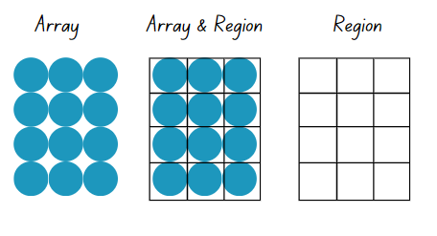

Stage 3 task – estimating and area model algorithms
The table below contains a suggested learning intention and success criteria. These are best co-constructed with students.
Core concept learning intentions | Core concept success criteria
Students working towards Stage 3 outcomes are learning to:  - use partitioning and place value to multiply 2-, 3- and 4-digit numbers by one-digit numbers. | Students working towards Stage 3 outcomes can:  - estimate the product of 2 numbers (one-digit by 2- or 3-digit numbers) using multiples of 10 or 100 and explain their thinking  - use the distributive property with the area model to partition numbers in representing multiplication problems  - represent the area model as an algorithm.
Note: while this lesson demonstrates one-digit by 3-digit multiplication; 2 by 2-digit multiplication is covered in later units.
- Write 5 × 684 on the board and ask students if 4000 would be a reasonable estimate for this equation. Students turn and talk to share why or why not.
- Read out the following 2 strategies for estimation:
- Brett rounded 684 to 700, then calculated 5 times 700, so my estimate is 3500.
- Murray rounded 684 to 600 first, then calculated 5 times 600, so my estimate is 3000.
- Ask students which scenario is a reasonable estimate and why.
- Explain that reasonable estimations are an important tool in reviewing calculations using larger numbers. Estimation should be used both before and after calculations.
- Write 3 × 485 on the board. Students turn and talk to provide an estimate to the nearest 100 and share their thinking.
- Model the steps for representing 3 × 485 using the area model. Link the area model to the expanded algorithm, as in Figure 16.
- Explain that for the algorithm, the order of calculation is from the right column. Students may find it supportive to calculate the parts of the area model in the same order.
Figure 16 – area model to algorithm
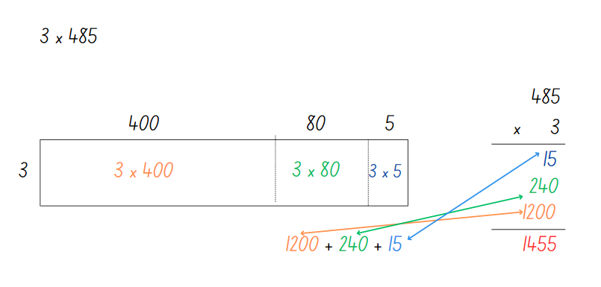
Note: when drawing the area model, it is important to consider proportionality and represent the relative sizes of the areas. In the example in Figure 16, the larger the value means the larger the area. Students should also maintain such proportions.
- Ask students:
- How could you describe the connection to someone else?
- What differences do you notice?
- What are the benefits and limitations of each?
- Where might you make errors when using the area model to calculate your answer?
- What questions do you have?
- Was your estimate reasonable?
- Explain that students will work in pairs to match a card displaying a multiplication problem as an algorithm to a card with an area model.
- Distribute cards from Resource 19 – matching algorithms to students for them to find their matching card.
- Return to the statement 5 × 684. In pairs, students use individual whiteboards to create an area model to find the solution to 5 × 684. They use this to complete the corresponding multiplication algorithm to check their answer.
- Compare the answer to the original estimate. Discuss the reasonableness of the estimate. Check for understanding with additional examples as necessary.
- Ask students if they know the steps to completing the vertical multiplication algorithm. If necessary, remind students that they follow these steps for a 3-digit by one-digit problem:
- First, multiply the ones by the ones
- Next, multiply the ones by the tens
- Then, multiply the ones by the hundreds
- Write each answer consecutively underneath the answer line
- Add up the calculated answers together and write them below another answer line
- Make sure to line up the digits from the ones place in each new answer.
- Create an anchor chart with the steps on to display in the classroom.
- Ask students:
- What do you know about algorithms?
- How are they organised?
- Explain to students that they will play Roll and Multiply. Stage 3 students:
- Roll a 10-sided die 4 times to form numbers in a one-digit by 3-digit multiplication equation and record this on a whiteboard.
- Draw an area model using partitioning to split the 3-digit number into place value parts.
- Write an algorithm in expanded form next to the area model.
- Calculate the final answer in the algorithm.
- Check their calculation with a calculator.
- Variations include using place value dice to support students to partition and using coloured whiteboard markers to assist with translating numbers between the area model and the algorithm.
This table details opportunities for differentiation.
Too hard? | Too easy?
Stage 3 students cannot use the distributive property with the area model to partition numbers in representing multiplication problems.  - Use MAB materials to support partitioning 2-digit numbers.  - Use the area model digital tool to explore different numbers on the 20 × 20 grid, such as in Figure 16. Use the calculation function to link the model to the number representations. | Stage 3 students can use the distributive property with the area model to partition numbers in representing multiplication problems.  - Present students with an algorithm with a missing number, asking them to explain what the missing number is.  - Students experiment creating 2 by 2-digit multiplication equations and representing them as area models and expanded algorithms.

Discuss and connect the mathematics – 10 minutes
- Regroup as a class and summarise the lesson together. Ask:
- What strategies helped you with the task?
- How could the commutative property help people solve other multiplication problems, such as 9 × 5, 7 × 10 or 12 × 2. For example, this could be explained as ‘If I know ... then I also know …' (Stage 2).
- What connections can you make between the area model and the algorithm? (Stage 3)
- Can you explain how algorithms work? (Stage 3)
This table details opportunities for assessment.
Assessment opportunities | Links
What to look for:  - Can Stage 2 students recall multiplication facts of 2 and 4, 5 and 10? [MAO-WM-01, MA2-MR-01]  - Can Stage 2 students use number properties to find related multiplication facts? [MAO-WM-01, MA2-MR-01]  - Can Stage 2 students use the commutative property of multiplication? [MAO-WM-01, MA2-MR-01]  - Can Stage 3 students estimate the product of 2 numbers (one-digit by 2- or 3-digit numbers) using multiples of 10 or 100 and explain their thinking? [MAO-WM-01, MA3-MR-01]  - Can Stage 3 students use the distributive property with the area model to partition numbers in representing multiplication problems? [MAO-WM-01, MA3-MR-01]  - Can Stage 3 students transfer the area model to an algorithm? [MAO-WM-01, MA3-MR-01] | Links to National Numeracy Learning Progressions (NNLP):  - Stage 2 – MuS6  - Stage 3 – MuS6, MuS7.  Links to suggested Interview for Student Reasoning (IfSR) tasks:  - Stage 3-IfSR-MT: 3A.1, 3A.2, 3A.3.

Lesson 6
Core concept: multiplication and division are related.

Daily number sense – larger numbers – 10 minutes
The table below contains suggested learning intentions and success criteria. These are best co-constructed with students.
Daily number sense learning intention | Daily number sense success criteria
Students working towards Stage 2 outcomes are learning to:  - read, represent and order numbers to thousands.  Students working towards Stage 3 outcomes are learning to:  - recognise, represent and order numbers in the millions. | Students working towards Stage 2 outcomes can:  - read numbers up to at least 4 digits  - identify the number before and after a number with an internal zero digit.  Students working towards Stage 3 outcomes can:  - name numbers in the millions using the place value grouping of ones, tens and hundreds  - round numbers to the nearest million.
This activity is an adaptation of ‘Write a number larger than…’ from Open-ended Maths Activities: Using ‘Good’ Questions to Enhance Learning in Mathematics, Revised edn by Sullivan and Lilburn.
- Stage 2 students to write four 4-digit numbers and then write the number before and after each number. Instruct students that 2 of their numbers must include a zero in the hundreds or tens place.
- Stage 3 students to write numbers that are larger than one million, 10 million and 100 million, and order them from largest to smallest.
- Select students to share their answers. Review the correct mathematical language and place value conventions when reading large numbers.
- Select students from each stage to compare or order their large numbers, and ask questions such as:
- Can you prove that your answer is larger than one million/10 million/100 hundred million? (Stage 3)
- Can you round your answers to the nearest thousand (Stage 2) or million (Stage 3)?
- Can you provide another correct answer that is smaller/larger than your original answer? (Stage 3)
This table details opportunities for assessment.
Assessment opportunities | Links
What to look for:  - Can Stage 2 students read numbers up to at least 4 digits? [MAO-WM-01, MA2-RN-01]  - Can Stage 2 students identify the number before and after a number with an internal zero digit? [MAO-WM-01, MA2-RN-01]  - Can Stage 3 students name numbers in the millions using the place value grouping of ones, tens and hundreds? [MAO-WM-01, MA3-RN-01]  - Can Stage 3 students round numbers to the nearest million? [MAO-WM-01, MA3-RN-01] | Links to National Numeracy Learning Progressions (NNLP):  - Stage 2 – NPV5, NPV6  - Stage 3 – NPV7.  Links to suggested Interview for Student Reasoning (IfSR) tasks:  - Stage 2 – IfSR-NP: 4B.2, 4C.5.

Core lesson – 40 minutes

Stage 2 task – the Division City
The table below contains a suggested learning intention and success criteria. These are best co-constructed with students.
Core concept learning intentions | Core concept success criteria
Students working towards Stage 2 outcomes are learning to:  - recall multiplication facts of 2 and 4, 5 and 10 and related division facts. | Students working towards Stage 2 outcomes can:  - recognise and use the symbols for multiplied by (×), divided by (÷) and equals (=)  - link multiplication and division fact families using arrays  - model and apply the commutative property of multiplication.
- Review the definition and examples of commutative property from Lesson 5.
- Display Resource 20: Building array – division. Hide the text on the right-hand side of the resource and explain that this is a rectangular building with 6 rooms. Ask how many floors students can see and how many rooms there are on each floor.
- Explain that the 3 floors with 2 rooms on each floor makes 6 rooms altogether. Revise the multiplication number sentences that match this image, 3 twos are 6, 3 × 2 = 6. Revise the multiplication number sentence for the commutative pair, 2 threes are 6, 2 × 3 = 6.
- Explain that this can also be written as a division sentence, 6 ÷ 3 = 2. Ask:
- What does division mean?
- Who has seen the division symbol before? What does it look like to you?
- What does each number in the division sentence represent?
- Can I change any numbers around?
- Are there any that I cannot change? Why?
Note: at this stage in learning, the dividend should remain at the beginning of the number sentence.
- Explain that an architect needs to design a rectangular building that has 10 rooms. They do not mind if the building is tall and skinny, or short and long. Ask what the building might look like. Have students draw as many examples as they can.
- Ask if any of the buildings looks similar if they were turned on their side. Identify commutative pairs, such as 2 floors 5 rooms and 5 floors of 2 rooms.
- Write the equivalent number sentence 3 × 4 = 4 × 3. Ask students whether they think this is true. Students write equivalent number sentences for their buildings.
- Students to write pairs of division number sentences, such as 10 ÷ 5 = 2 and 10 ÷ 2 = 5.
- Students to retrieve the partially completed commutative city on grid paper, from Lesson 5.
- Explain that an architect needs pairs of project managers to design rectangular buildings with 12, 13, 14, 15 or 16 rooms. Allocate pairs of students to building sizes.
Note: 13 is a prime number and will only have 2 buildings. This may be a suitable selection for students manipulating counters as they try to make rows and columns.
- On the commutative city grid paper, students to design as many different rectangular buildings as possible.
- Students label each building with the relevant multiplication and division number sentence.
- Group each number of rooms together (12, 13, 14, 15, 16) on separate walls or tables.
- Conduct a gallery walk. Ask:
- Have the designers drawn all the possible buildings?
- Do all the buildings have the same number of options? Why not?
- What do you notice about the building with 13 rooms? (Explain that this is called a prime number.)
- What do you notice about the building with 16 rooms? (Explain that 4 × 4 makes it a square number.)
- What difference do you notice between the odd and even numbers?
This table details opportunities for differentiation.
Too hard? | Too easy?
Stage 2 students cannot use arrays to establish multiplication facts of 2 and 4, 5 and 10 and related division facts.  - Provide interlocking bricks of the same size. Students build 3 rectangular buildings using 8, 12 and 16 bricks, then trace around the buildings and draw lines across to show the region/array pattern.  - Provide counters as support for forming arrays for 12 rooms. Student make rows representing one floor, then 2 floors, 3 floors and so on. Students identify how many rooms there are on each floor. | Stage 2 students can use arrays to establish multiplication facts of 2 and 4, 5 and 10 and related division facts.  - Include a series of larger numbers for students to explore.  - Explore and draw square buildings with between one and 50 rooms. Ask students to identify any patterns and what rules they can use to identify the next 10 buildings (without drawing them).

Stage 3 task – multiplication and division problems
The table below contains a suggested learning intention and success criteria. These are best co-constructed with students.
Core concept learning intentions | Core concept success criteria
Students working towards Stage 3 outcomes are learning to:  - select and apply appropriate strategies to solve multiplication and division problems. | Students working towards Stage 3 outcomes can:  - use knowledge of multiples to partition, as appropriate, and divide  - use known multiplication fact families to solve division problems.
- Describe Figure 17 to Stage 3 students and ask them draw it on an individual whiteboard.
Figure 17 – fact family
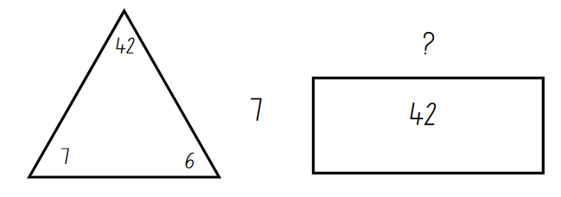
- Students turn and talk to discuss and answer the questions:
- How do we know what number is missing from the rectangle?
- How are these 2 images similar?
- How are these 2 images different?
- What relationships can you see between multiplication and division?
- Have students capture their thinking on an anchor chart.
- Draw the image from Figure 18 on the whiteboard and pose the problem 39 divided by 3.
Figure 18 – division problem
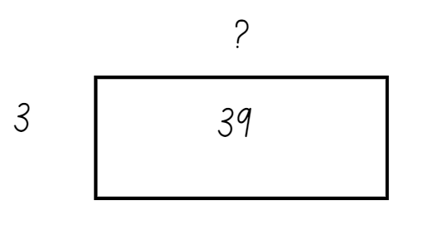
- Ask students:
- Is it possible that the answer is close to 20? Why or why not?
- How might you work out the answer?
- What fact families do you think about to answer this question?
- Capture student responses by drawing corresponding fact family triangles and recording how students choose to partition 39 into multiples of 3. Responses may include 3 tens and 3 threes, 3 twelves and 3 ones, 3 elevens and 3 twos.
Note: before proceeding to the next activity, consider whether the question posed is a suitable progression for your students. The question is designed to promote flexible partitioning, such as the student ideas represented in Figure 19. Students may benefit from a question where tens and or doubling are helpful partitions such as 120 divided by 6.
Figure 19 – anticipated student responses
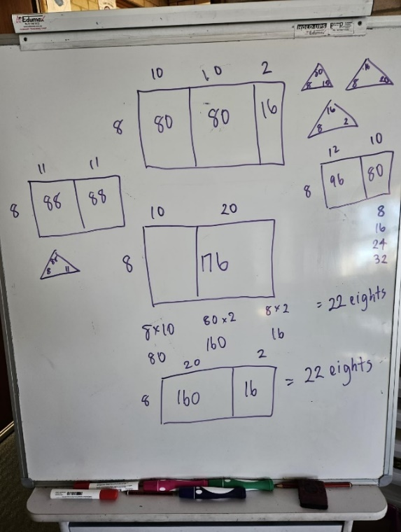
- Draw Figure 20 on the whiteboard and pose the problem 176 divided by 8 =_?
Figure 20 – division problem 2
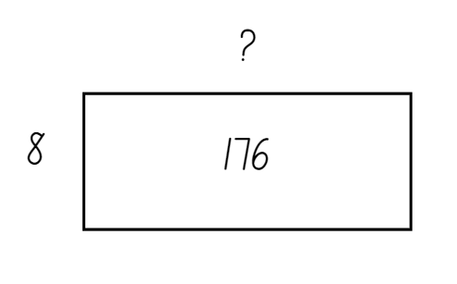
- Ask students:
- How can we partition numbers using our knowledge of multiples?
- What other properties of multiplication or division will help you solve this problem?
Note: the anticipated responses in Figure 19 include responses from students who are still developing their thinking and reasoning for this concept.
- Display 3 division questions that promote flexible partitioning of numbers in non-standard forms, such as:
- 412 ÷ 4 = ?
- 726 ÷ 6 = ?
- 959 ÷ 7 = ?
- Provide students with a copy of Resource 21 – division template to show and explain their thinking.
This table details opportunities for differentiation.
Too hard? | Too easy?
Stage 3 students cannot use knowledge of multiples to partition, as appropriate, and divide.  - Support students by providing them with fact families for 4. Use anchor charts from multiplying by 10 to support students in partitioning larger numbers.  - Provide students with questions where they can use multiples and fact families that they are familiar with. | Stage 3 students can use knowledge of multiples to partition as appropriate and divide.  - Pose the question 176 ÷ ? = ? Students identify possible dimensions of the array and develop multiple solutions. Follow up with questions, such as 726 ÷ ? = ?  - Students investigate what happens to possible partitions if they double both elements in an equation. For example, ask students if they can partition 726 ÷ 6 in the same way as 1452 ÷ 12. Encourage students to give reasons why or why not.

Discuss and connect the mathematics – 10 minutes
- Read the statement, ‘My friend told me 8 divided by 4 equals 2, so 2 divided 4 must equal 8’ to Stage 2 students.
- Write the matching number sentences on the board. Ask Stage 2 students:
- What mistake did the friend make?
- What advice would you give them?
- Is there a rule that we can write for division sentences to get the numbers in the correct order?
- Repeat for another incorrect statement.
- Explain that, in the next lessons, Stage 2 students will use related numbers such as 2, 4 and 8 in fact families. Represent the numbers in a fact family triangle such as Figure 21.
Figure 21 – fact family for 16
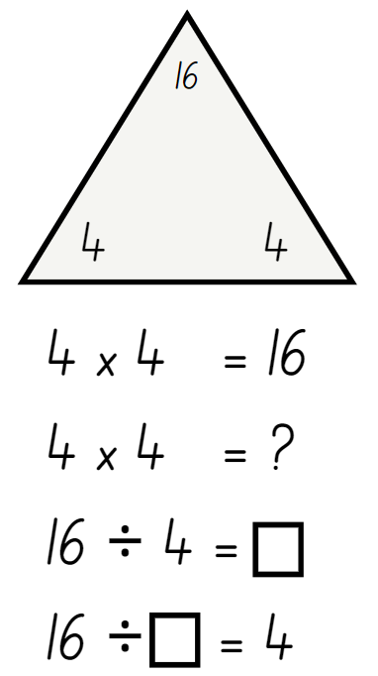
- Stage 3 students share strategies and use an anchor chart to capture ideas for one of the division questions.
- Record how Stage 3 students have partitioned with the use of multiples and the multiplication fact families they have used. Ask:
- Is there a best, or most efficient, way of partitioning numbers?
- What strategy could you suggest to another student if they were stuck with partitioning?
This table details opportunities for assessment.
Assessment opportunities | Links
What to look for:  - Can Stage 2 students recognise and use the symbols for multiplied by (×), divided by (÷) and equals (=)? [MAO-WM-01, MA2-MR-01]  - Can Stage 2 students link multiplication and division fact families using arrays? [MAO-WM-01, MA2-MR-01, MA2-MR-02]  - Can Stage 2 students model and apply the commutative property of multiplication? [MAO-WM-01, MA2-MR-01, MA2-MR-02]  - Can Stage 3 students use knowledge of multiples to partition as appropriate and divide? [MAO-WM-01, MA3-MR-01]  - Can Stage 3 students use known multiplication fact families to solve division problems? [MAO-WM-01, MA3-MR-01] | Links to National Numeracy Learning Progressions (NNLP):  - Stage 2 – MuS5, MuS6  - Stage 3 – MuS6, MuS7.  Links to suggested Interview for Student Reasoning (IfSR) tasks:  - Stage3 – IfSR-MT: 2A.8  - Stage 3 – IfSR-MT: 3A.1, 3A.2, 3A.3.

Lesson 7
Core concept: fact families support fluency (Stage 2). Euclidean division emphasises the relationship between multiplication and division (Stage 3).

Daily number sense – ordering numbers game – 10 minutes
The table below contains suggested learning intentions and success criteria. These are best co-constructed with students.
Daily number sense learning intention | Daily number sense success criteria
Students working towards Stage 2 outcomes are learning to:  - read, represent and order numbers to thousands.  - recognise and represent numbers that are 10, 100 or 1000 times as large.  Students working towards Stage 3 outcomes are learning to:  - recognise, represent and order numbers in the millions. | Students working towards Stage 2 outcomes can:  - read and order numbers of up to at least 4 digits.  - describe how making a number 10, 100 or 1000 times as large changes the place value of digits.  Students working towards Stage 3 outcomes can:  - arrange numbers in the millions in ascending and descending order.
- Divide the class into stages, then into 2 equal teams per stage.
- Explain that students will be playing a game where they will each be given a number card from Resource 22 – number cards. Teams need to arrange themselves in ascending order according to their number cards.
Multi-age: Resource 22 – number cards contains 2 pages of thousands cards for Stage 2 and 2 pages of millions cards for Stage 3.
- Provide each student with a number card from Resource 22 – number cards according to stage. Instruct students not to look at the number card until the game starts.
- Start the game. Students look at their number and teams arrange themselves in ascending order.
- When all teams have finished, check each team’s order by asking students to read their numbers aloud.
- Stage 2 students to identify the number 10, 100 and 1000 larger than their number and explain how they know they are correct.
This table details opportunities for assessment.
Assessment opportunities | Links
What to look for:  - Can Stage 2 students read and order numbers of up to at least 4 digits? [MAO-WM-01, MA2-RN-01]  - Can Stage 2 describe how making a number 10, 100 or 1000 times as large changes the place value of digits? [MAO-WM-01, MA2-RN-01]  - Can Stage 3 students arrange numbers in the millions in ascending and descending order? [MAO-WM-01, MA3-RN-01] | Links to National Numeracy Learning Progressions (NNLP):  - Stage 2 – NVP5, NVP6  - Stage 3 – NVP6, NVP7.  Links to suggested Interview for Student Reasoning (IfSR) tasks:  - Stage 2 – IfSR-NP: 4B.2, 4C.5.

Core lesson 1 – 20 minutes
The table below contains suggested learning intentions and success criteria. These are best co-constructed with students.
Core concept learning intentions | Core concept success criteria
Students working towards Stage 2 outcomes are learning to:  - use number properties to find related multiplication facts.  Students working towards Stage 3 outcomes are learning to:  - select and apply appropriate strategies to solve multiplication and division problems. | Students working towards Stage 2 outcomes can:  - generate multiplication fact families for multiples of 2 and 4, 5 and 10  - use the equals sign to record equivalent number relationships involving multiplication  - complete number sentences involving multiplication and division by calculating missing numbers.  Students working towards Stage 3 outcomes can:  - model division, including where the answer involves a remainder, using materials or diagrams  - record remainders to division problems in words  - use known multiplication fact families to solve division problems that may include a remainder.
- Draw Figure 22 on the board and ask students what they see, think and are wondering. Ask Stage 2 students to consider the 5 × 3 array only, while Stage 3 students consider the whole array including the 2 remainders.
Figure 22 – array with remainders
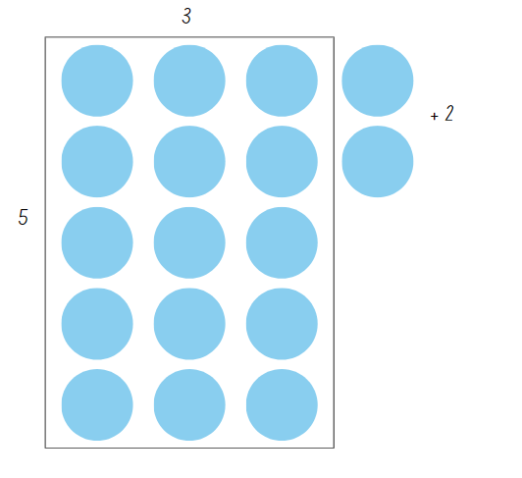
- Ask students how they might represent what is shown using a division number sentence.
- Show Stage 2 students the equation 15 ÷ 5 = 3.
- Show Stage 3 students the equation 17 ÷ 5 = 3 remainder 2. Discuss the term remainder with Stage 3.
Remainder: the part ‘left over’ when dividing a number into equal groups. The remainder forms part of the next group.
- Explain the activity Class Remainders to students.
- Start with the whole class together in a space where they can move around.
- Explain that students will be divided into an array using a number rolled from a 9-sided die. For example, if there are 28 students and a 7 is rolled, it could make 28 ÷ 7 = 4 in a 4 by 7 array.
- Roll the 9-sided dice to determine how the class needs to be represented in an array.
- Record an equation and array to show how the class has been divided. If the class cannot be evenly divided, model how the equation can be written in different ways (30 ÷ 4 = 4 remainder 2).
- Repeat several times so that there are arrays without remainders for Stage 2 students and arrays with remainders for Stage 3 students. Record thinking on an anchor chart.
- Introduce the term quotient to Stage 3 students. Use the equations recorded in the activity to help students identify the quotient.
Quotient: the result of dividing one number by another.

Core lesson 2 – 30 minutes

Stage 2 task – fact families
- Display Resource 23 – making fact families. Ask students:
- What patterns can you see?
- How are these numbers related to each other?
- What other triangles and numbers might belong to this picture?
- What would be the next item in this pattern? How do you know?
- Explain that 8 is a multiple of 2 and of 4. Skip count by 2 and then by 4 to confirm that 8 is in both patterns.
- Explain that 2 and 4 are called factors of 8. Share the definition of factor and product.
Factor: a number which divides another number without a remainder. For example, 1, 2, 3 and 6 are factors of 6 but 4 and 5 are not.
- Display Resource 23 – making fact families. Select one fact family and discuss:
- Model how to write multiplication sentences and division sentences using fact families.
- Discuss what the equals sign means and why it is used. The equals sign represents balance and equality.
- Use arrays to prove the commutative property of multiplication.
Note: emphasise that the number at the top of the triangle is the product of the 2 factors at the bottom of the triangle. For division, ensure students understand that the product of the fact family must be at the start of the sentence. Division is not commutative, so 2 ÷ 4 = 8 is not correct.
- Provide writing materials. Ask pairs of students to create the fact families for one of the remaining triangles.
- Share responses and record student ideas.
- Explain that students will now generate their own fact families. Students roll 1–10 die to get one factor and select the other factor from the numbers 2, 4, 5 or 10. Students write the 2 factors in the bottom corners of the triangle.
- Students generate the fact family number sentences that use these numbers.
- Continue for each of the numbers 2, 4, 5 and 10.
This table details opportunities for differentiation.
Too hard? | Too easy?
Stage 2 students cannot generate multiplication fact families for multiples of 2 and 4, 5 and 10.  - Support students to use arrays and repeated doubling to generate fact families for multiples of 2 and 4.  - Support students to use skip counting and multiple patterns of 5 and 10 to generate fact families. | Stage 2 students can generate multiplication fact families for multiples of 2 and 4, 5 and 10.  - Ask students what the missing numbers might be in a triangle, if the number 16 appears at least once in one of the points of the triangle.  - Ask how many different triangles have the number 16 appear at least once and what generalisations can be made from students’ observations.

Stage 3 task – chipping away
This activity is an adaption of Division – Chipping away at the whole number [PDF 487 KB] by Vingerhoets from Rob Vingerhoets Educational Consultancy.
- Explain that students will learn to use multiplication fact families to solve division problems where the answer may include a remainder.
- Use the example of 237 balloons shared between 5 people. Ask:
- What is a good estimate for 237 balloons shared between 5 people?
- Why might it be helpful to make an estimate that involves a multiple of 10?
- Can you try and make an estimate that is a multiple of 10? 20 might be helpful.
- Explain that larger division problems can be solved by chipping away at a number.
Note: clarify the meaning of the idiom to chip away at something, meaning to make progress on a larger task one piece at a time.
- Represent the 237 balloons in an area model, such as the left side of Figure 23. Based on student suggestions, model the steps to ‘chip away’ using division as shown on the right side of Figure 23.
Figure 23 – chipping away at 237
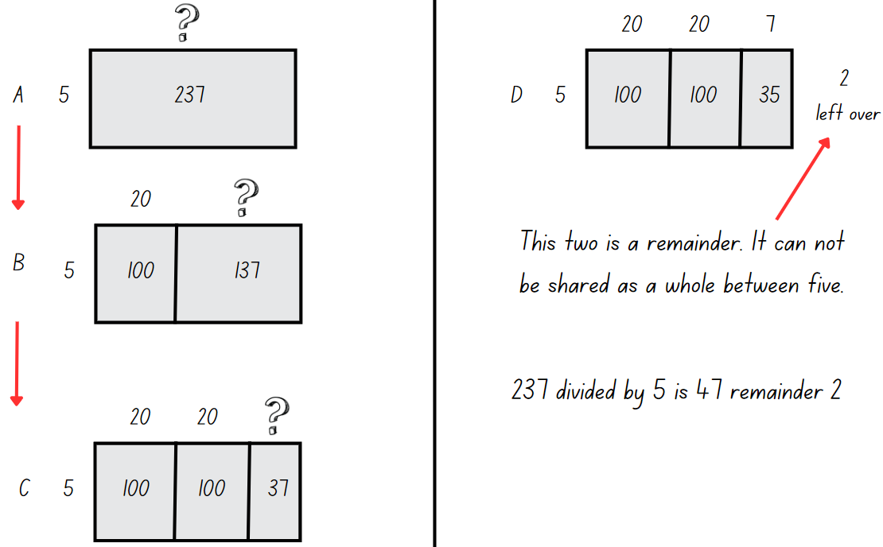
Note: the steps shown Figure 23 are possible suggestions. Represent a second or third method based on student suggestions.
- Write the following problems on the board and ask students to identify multiplication fact families:
- 312 sheep split equally between 5 paddocks
- 132 chocolates shared equally into 8 boxes
- 241 students split equally between 7 buses.
- Students use the fact families and record their strategies used to solve the problems.
This table details opportunities for differentiation.
Too hard? | Too easy?
Stage 3 students cannot use known multiplication fact families to solve division problems for which answers may include a remainder.  - Introduce the Remainders game to students. Support students to create arrays and identify the remainders.  - Support students to record their thinking as equations.  - Use the Number Explorer to explore different division problems. | Stage 3 students can use known multiplication fact families to solve division problems for which answers may include a remainder.  - Students create an instructional video on how multiplication fact families can be used to ‘chip away’ and solve division problems where the answer may include a remainder.

Discuss and connect the mathematics – 10 minutes
- Discuss Resource 24 – Fact family or not? Ask:
- Which family has the division number sentence representing what is shown in the triangle?
- Why doesn’t the other division number sentence match the facts?
- What about the sentence 14 = 7 × 2?
Note: it is a commonly held misconception for Stage 2 students that the equals sign shows where the answer should be written. By placing the product at the start of a number sentence, students are exposed the idea of balance and equivalence.
- Show students a number sentence with a missing value next to the corresponding triangle. Discuss how the triangle can be used to determine the missing value, see Figure 24. Draw attention to the reason why 16 is a square number.
Figure 24 – missing value
- Add an example of fact families and number sentences to the class anchor chart. Show how fact families can be used to determine the missing value in a multiplication or division sentence.
- Create an anchor chart to capture student ideas for one of the division questions. Record how students have used multiplication fact families and the equations that represent their strategy. Ask:
- Is there a best way of partitioning numbers?
- How did multiplication help you with division?
- What tips would you give other students if they were stuck?
- What other mathematical ideas or operations did you use when applying this strategy?
This table details opportunities for assessment.
Assessment opportunities | Links
What to look for:  - Can Stage 2students generate multiplication fact families for multiples of 2 and 4, 5 and 10? [MAO-WM-01, MA2-MR-01, MA2-MR-02]  - Can Stage 2 students use the equals sign to record equivalent number relationships involving multiplication? [MAO-WM-01, MA2-MR-01, MA2-MR-02]  - Can Stage 2 students complete number sentences involving multiplication and division by calculating missing numbers? [MAO-WM-01, MA2-MR-01, MA2-MR-02]  - Can Stage 3 students model division, including where the answer involves a remainder, using materials or diagrams? [MAO-WM-01, MA3-MR-01]  - Can Stage 3 students record remainders in words to division problems? [MAO-WM-01, MA3-MR-01]  - Can Stage 3 use known multiplication fact families to solve division problems for which answers may include a remainder? [MAO-WM-01, MA3-MR-01] | Links to National Numeracy Learning Progressions (NNLP):  - Stage 2 – MuS6, NPA4  - Stage 3 – MuS6, MuS7.  Links to suggested Interview for Student Reasoning (IfSR) tasks:  - Stage 2 – IfSR-MT: 2A.11  - Stage 3 – IfSR-MT: 2A.8.

Lesson 8
Core concept: worded problems can be solved using multiplicative thinking.

Daily number sense – 10 minutes
- From a class need surfaced through formative assessment data, identify a short, focused activity that targets students’ knowledge, understanding and skills. Example activities may be drawn from the following resources:
- Mathematics K-6 resources
- Universal Resources Hub.

Core lesson – solving word problems – 40 minutes
The table below contains a suggested learning intention and success criteria. These are best co-constructed with students.
Core concept learning intentions | Core concept success criteria
All students are learning to:  - solve multiplication and division word problems. | All students can:  - apply and record appropriate strategies to solve multiplication and division word problems.  Students working towards Stage 2 outcomes can:  - describe multiplication problems using ‘for each’ and ‘times as many’  - recognise that halving is dividing by 2  - recognise and use the symbols for multiplied by (×), divided by (÷) and equals (=).  Students working towards Stage 3 outcomes can:  - use knowledge of multiples to partition as appropriate and divide  - use and interpret remainders in solutions to division problems.
- Ask students to discuss what strategies and ideas they have learned over the course of the unit. Students turn and talk and record their ideas. Refer to the anchor charts from previous lessons.
Multi-age: strategies and ideas covered with students working towards Stage 2 outcomes include groups of, arrays, halving, doubling and fact families. Strategies and ideas covered with students working towards Stage 3 outcomes include multiplying by 10, 100, 1000, factorising, area models, partitioning, algorithms and ‘chipping away’ at a number using arrays.
- Present Stage 2 with the word problem: A chef makes 5 muffins for each of his 4 friends. How many muffins does he make? Discuss with students what the phrase ‘for each’ means.
- Ask Stage 2 students how they would represent the problem using 2 different strategies. Draw Figure 25 on the board to record student ideas.
Figure 25 – think board for chef word problem.
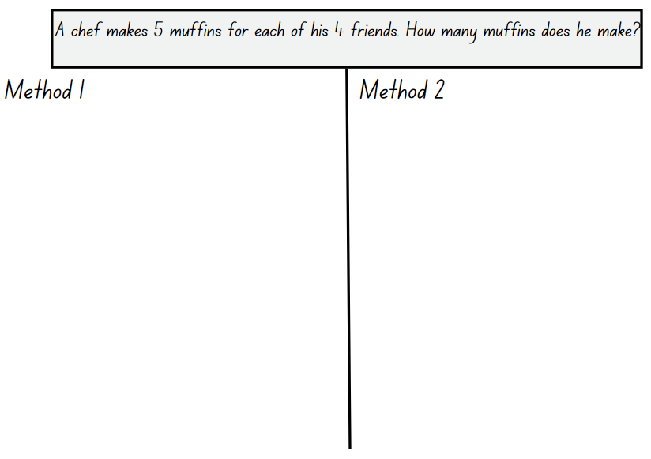
- Present Stage 3 with the word problem: A high-rise building is installed with 192 smoke alarms. If each floor is fitted with 8 smoke alarms, how many floors are there in the building?
- Ask Stage 3 students how they would represent the problem using 2 different strategies. Draw a second think board on the board to record student ideas.
- Present Stage 2 with the word problem: The chef tripped over while delivering his muffins and half of them were ruined. How many are left? Discuss what the phrase half means and how it can be represented.
- Present Stage 3 with the word problem: 4 identical computers cost $896. How much does one computer cost? Ask students whether they would estimate $200 or $300 as a reasonable answer.
- Students turn and talk to discuss how they would solve the word problem and represent the problem using 2 different strategies on Resource 25 – blank think board.
- Ask Stage 3 students how they might use estimation or an inverse operation to check their answer.
- Display Resource 26 – Stage 2 What’s the problem? for Stage 2 students and Resource 27 – Stage 3 What’s the problem? for Stage 3 students.
- Students turn and talk with a partner, discussing what the question could be to match the working out represented. Stage 2 students have a choice between the word problems:
- An architect designed a building with 6 windows. Her friend Farmer Murray designed a building with 5 times as many windows.
- A chef made 6 muffins to eat. Farmer Murray ate 5 more than the chef.
- Students share their thinking, explaining how their question could match the representations.
- Display Resource 28 – problems to solve. Students use Resource 25 – blank think board to record multiple ways to represent solutions to each word problem.
Note: explain that some problems cannot have a remainder. For example, 247 people shared between cars with 5 seats = 49 cars with a remainder of 2 people, but they cannot be left behind. Therefore, an extra car is needed. This makes a total of 50, even though the last car is not full.
This table details opportunities for differentiation.
Too hard? | Too easy?
Students cannot apply and record appropriate strategies to solve multiplication and division word problems.  - Students use concrete materials to model the problems.  - Guide students by suggesting strategies and why they might be effective.  - Identify key words within the problems to clarify what the question is asking students to do. | Students can apply and record appropriate strategies to solve multiplication and division word problems.  - Students create their own multiplication or division word problem for a peer to solve.  - Students give examples of inefficient strategies and provide reasons against their use.

Discuss and connect the mathematics – 10 minutes
- Regroup as a class and summarise the lesson together drawing out key mathematical ideas. Ask:
- Which strategies did you use today?
- Is the same strategy always the most efficient when used for different word problems? Explain your thinking.
- Which strategy did you enjoy using?
- Why is it important to be able to use a variety of strategies when solving problems?
- Which strategy would you like to practise more?
This table details opportunities for assessment.
Assessment opportunities | Links
What to look for:  - Can students apply and record appropriate strategies to solve multiplication and division word problems? [MAO-WM-01, MA2-MR-01, MA3-MR-01]  - Students working towards Stage 2 outcomes can:  - Can Stage 2 students describe multiplication problems using ‘for each’ and ‘times as many’? [MAO-WM-01, MA2-MR-01]  - Can Stage 2 students recognise that halving is dividing by 2? [MAO-WM-01, MA2-MR-01]  - Can Stage 2 students recognise and use the symbols for multiplied by (×), divided by (÷) and equals (=)? [MAO-WM-01, MA2-MR-01]  - Can Stage 3 students use knowledge of multiples to partition as appropriate and divide? [MAO-WM-01, MA3-MR-01]  - Can Stage 3 students use and interpret remainders in solutions to division problems? [MAO-WM-01, MA3-MR-01] | Links to National Numeracy Learning Progressions (NNLP):  - Stage 2 – NPA4, MuS5  - Stage 3 – MuS6, MuS7, MuS8.  Links to suggested Interview for Student Reasoning (IfSR) tasks:  - Stage 2 – IfSR-MT: 2A.12, 2A.13, 2A.14  - Stage 3 – [IfSR-MT: 3A.1, 3A.2, 3A.3, 3A.4, 3A.5, 3A.6.

Resource 1 – Patterns or not?
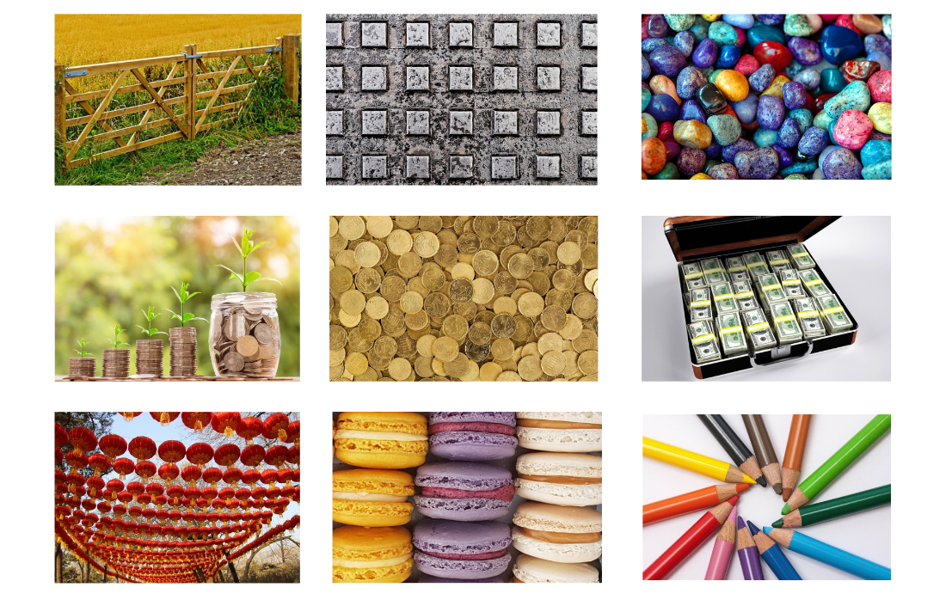

Resource 2 – growing and shrinking
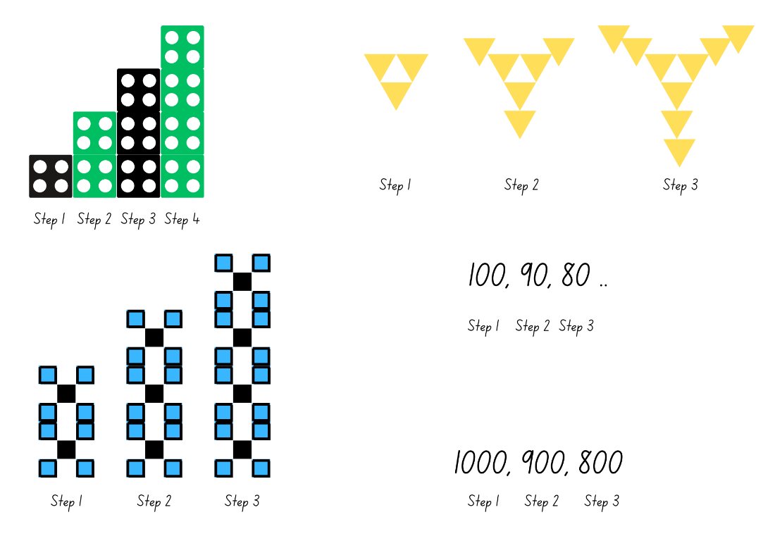

Resource 3 – the product is 12
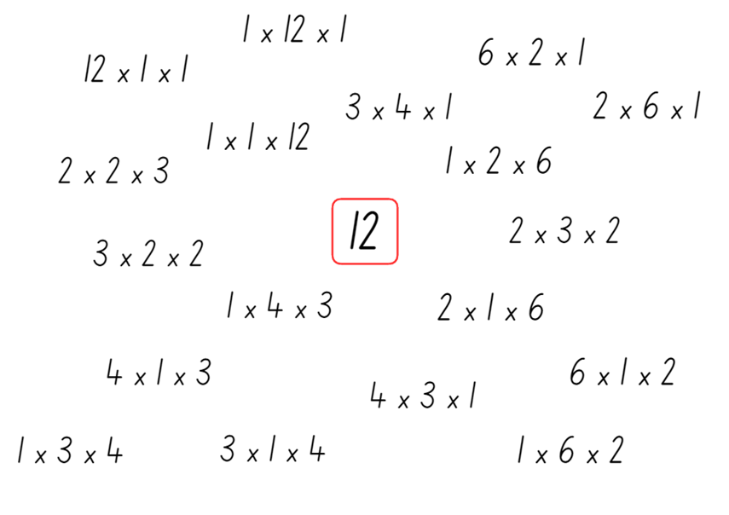

Resource 4 – nests and carton
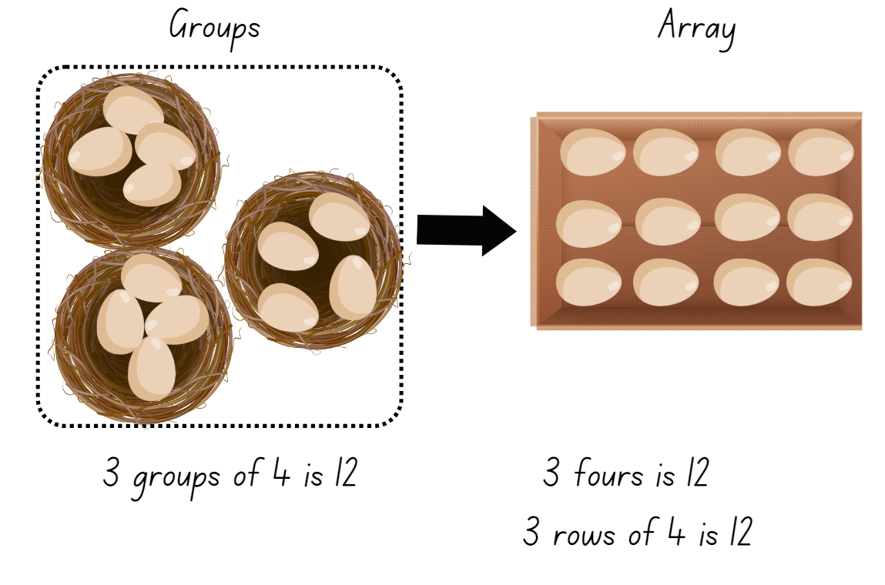

Resource 5 – nests and carton 2
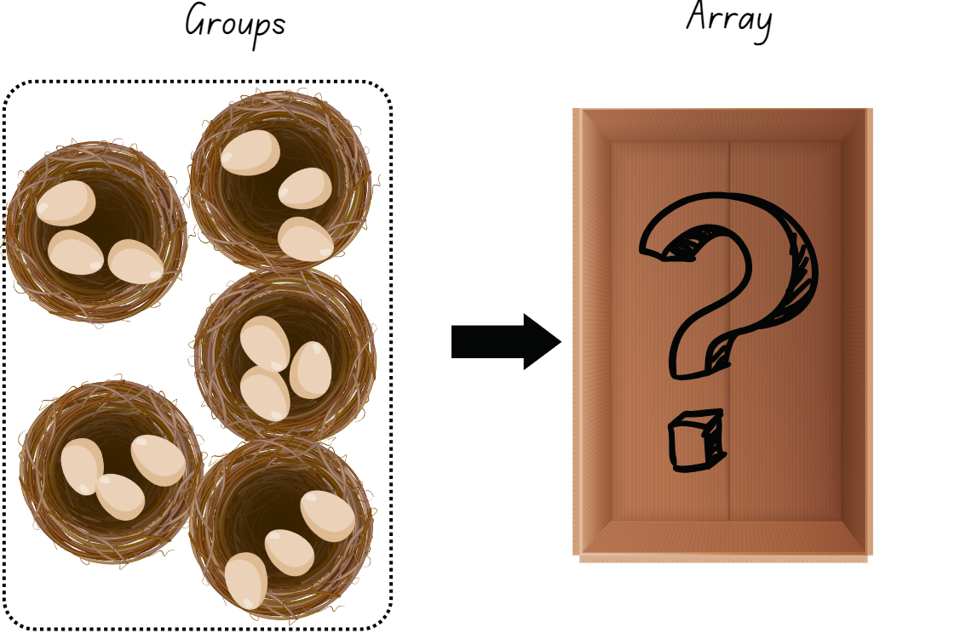

Resource 6 – nest cards
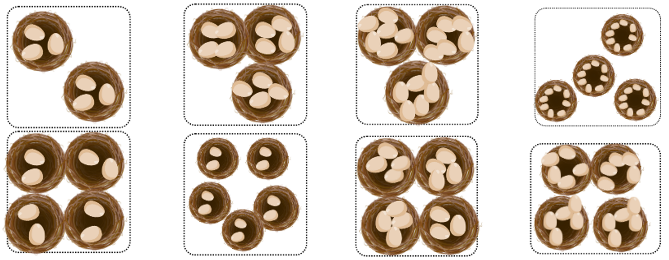
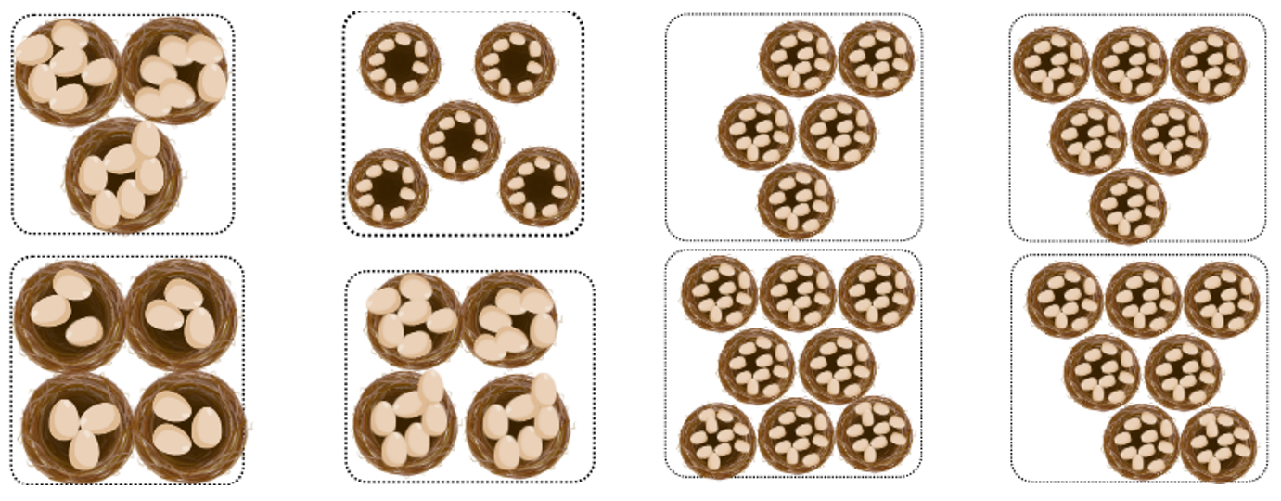

Resource 7 – two hundreds
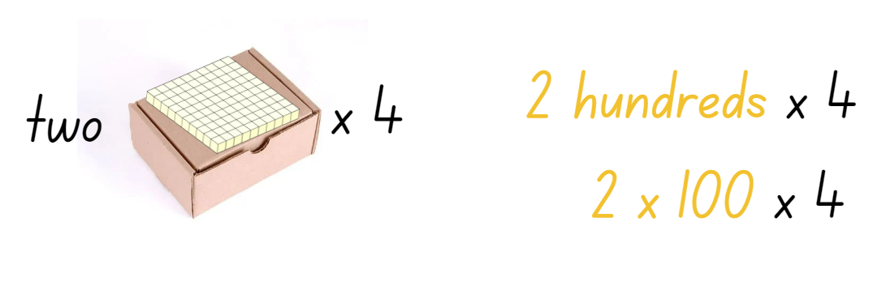

Resource 8 – applying facts
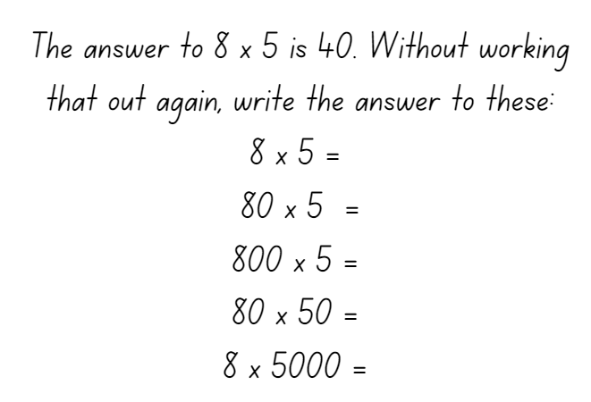

Resource 9 – factorising gameboard
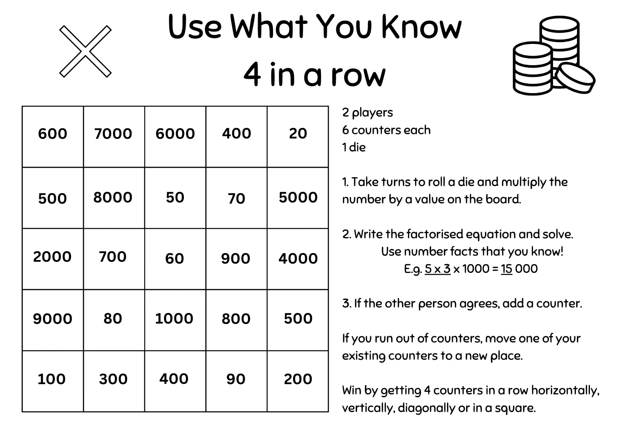

Resource 10 – multiplicative tables 1
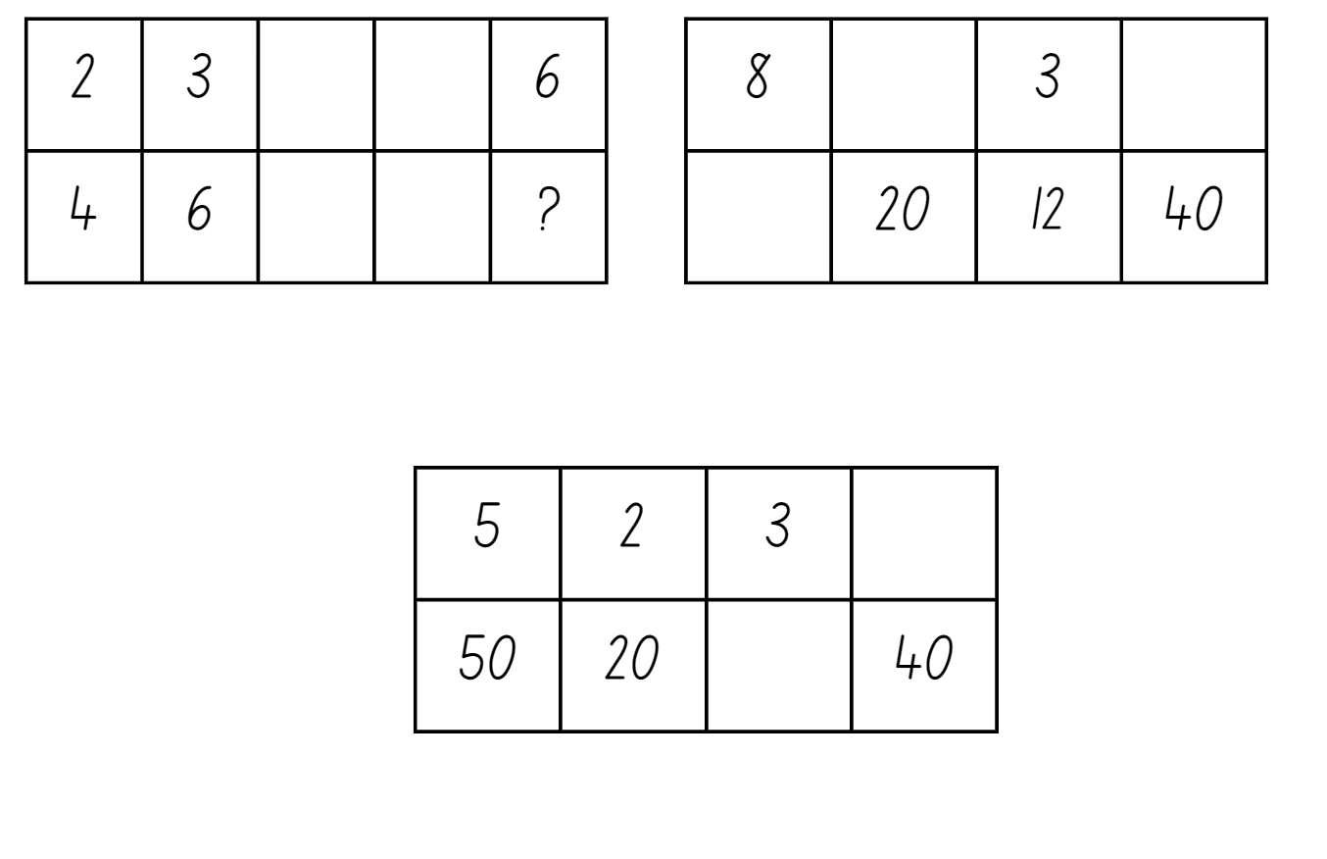

Resource 11 – multiplicative tables 2
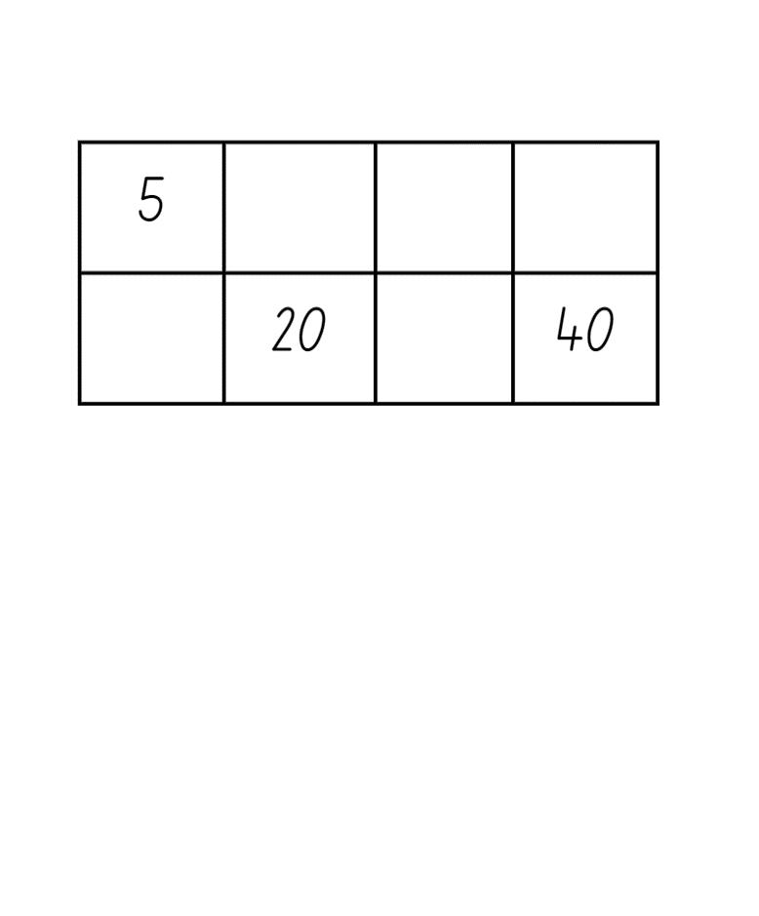

Resource 12 – unusual muffin trays
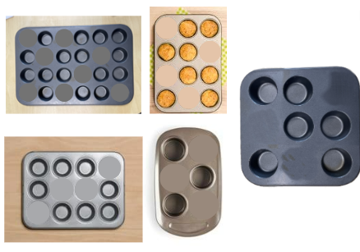

Resource 13 – muffin tray arrays
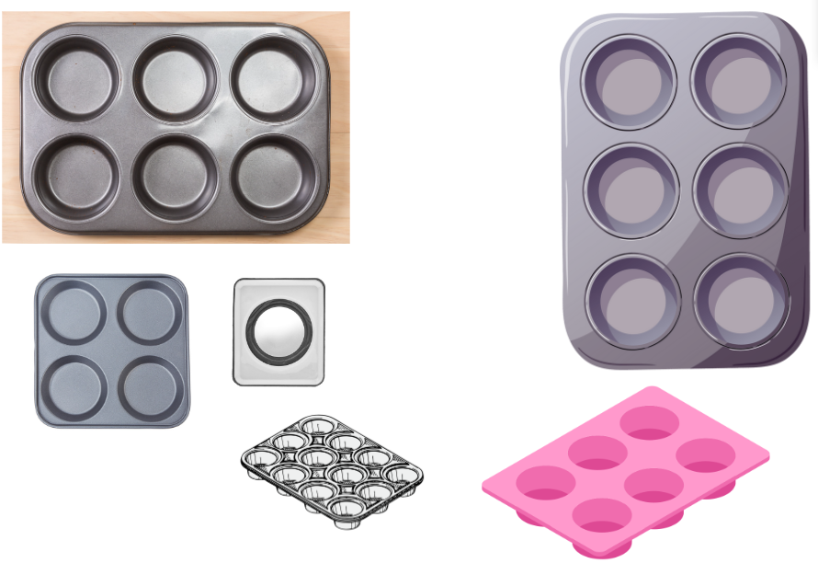

Resource 14 – student strategies
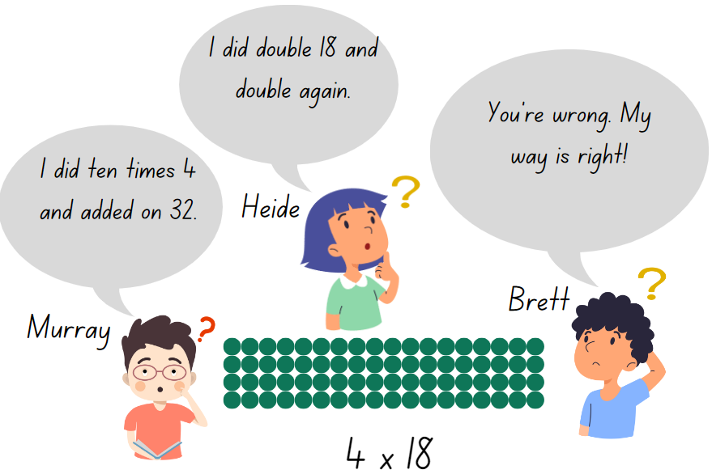

Resource 15 – a farmer’s field
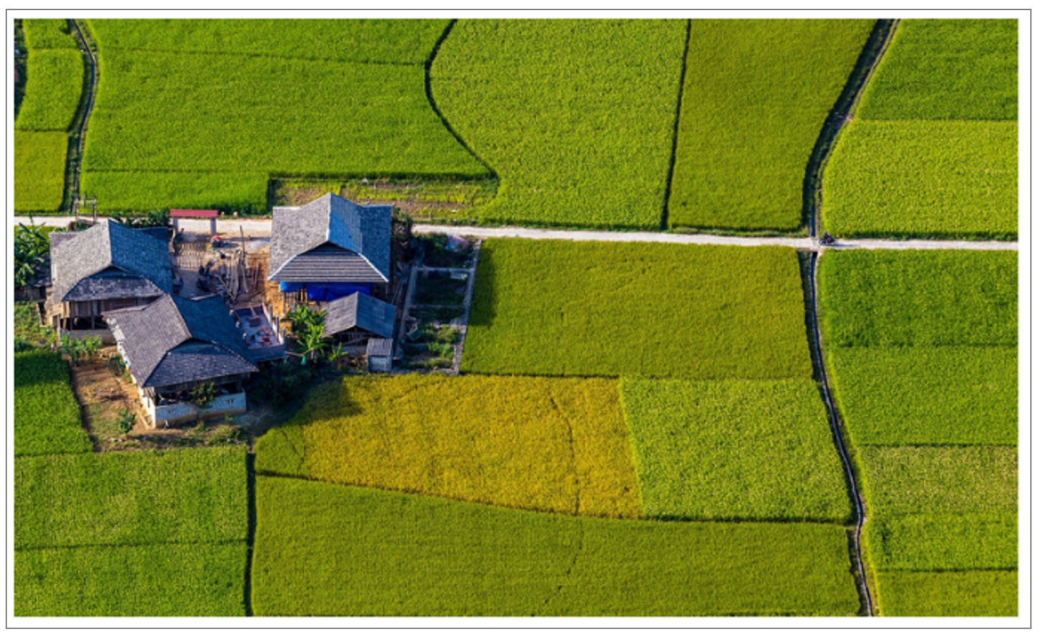
Image licensed under Pixabay Content License.

Resource 16 – halving game cards
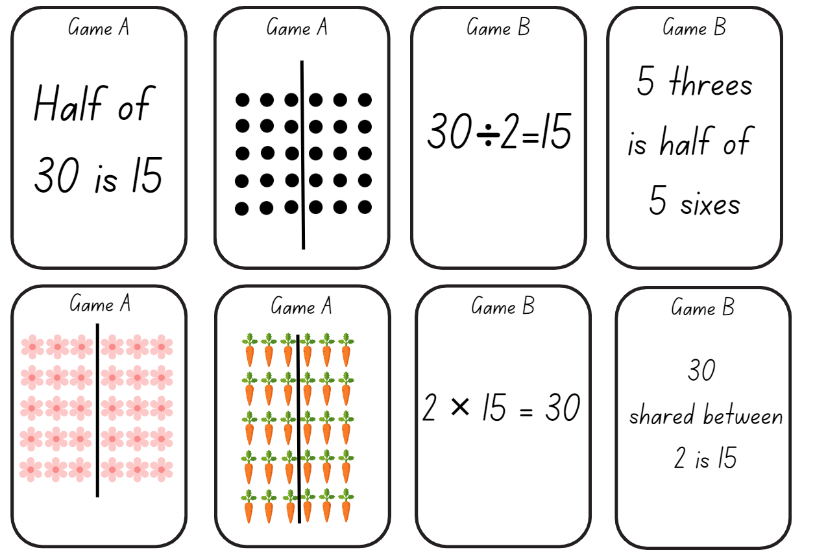
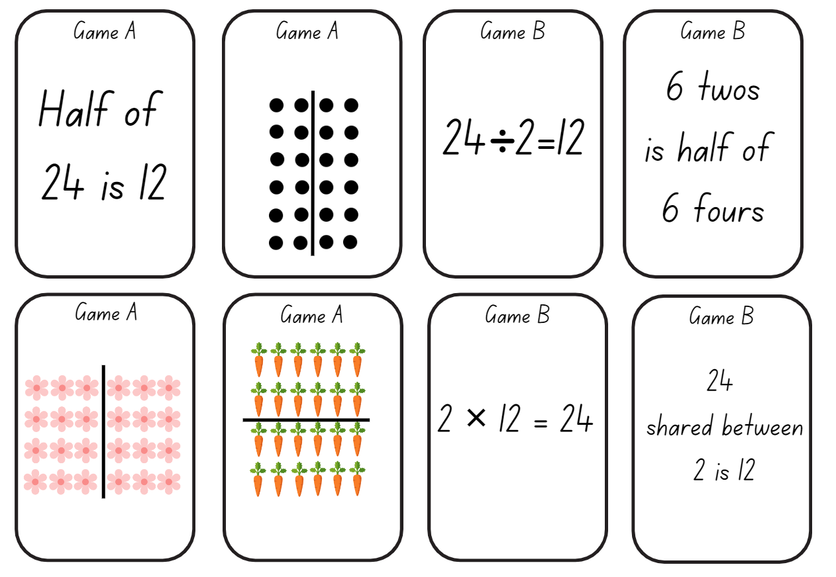
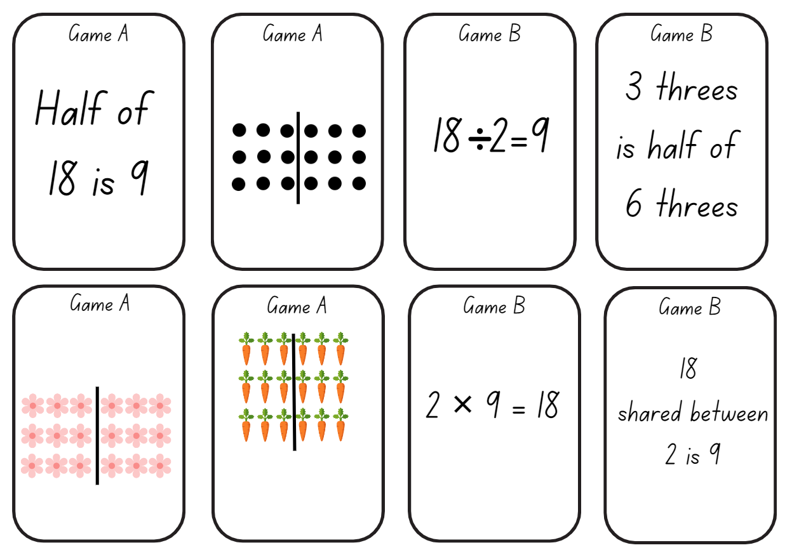
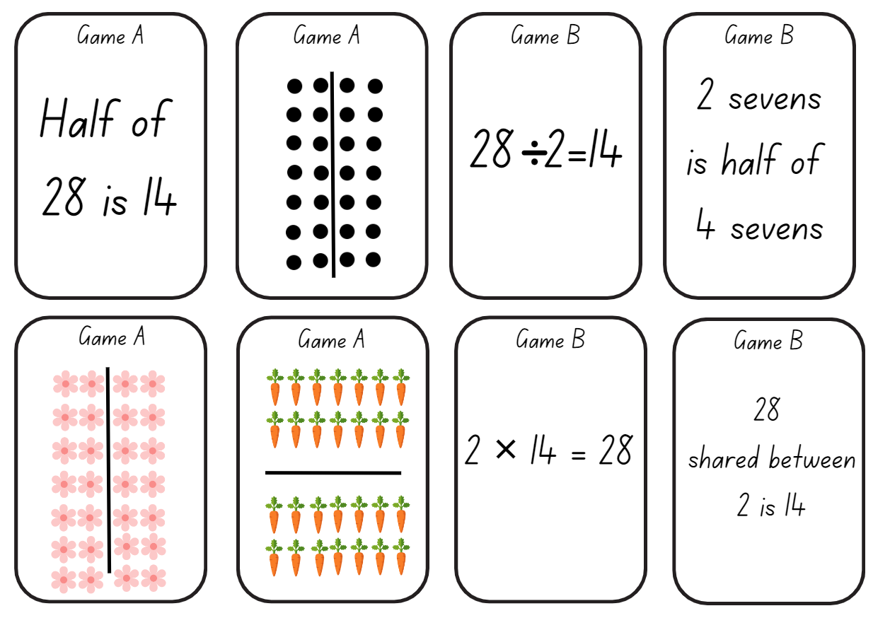

Resource 17 – area model
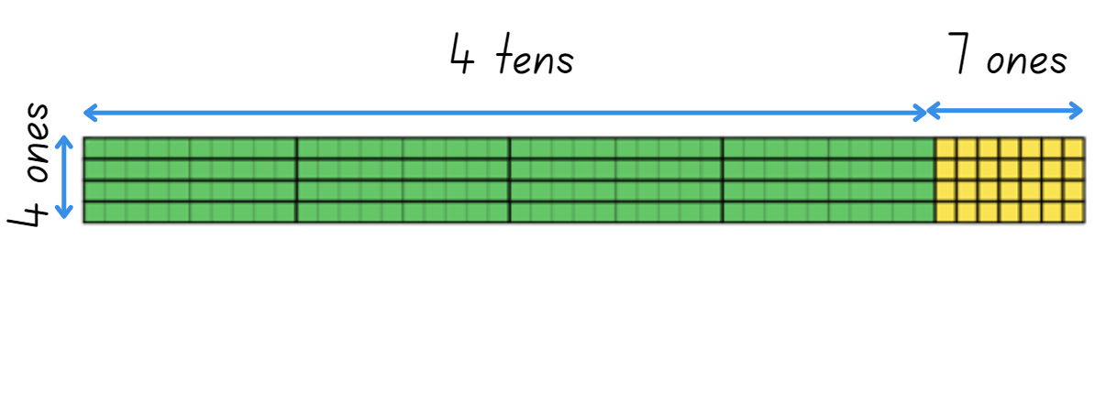

Resource 18 – building arrays
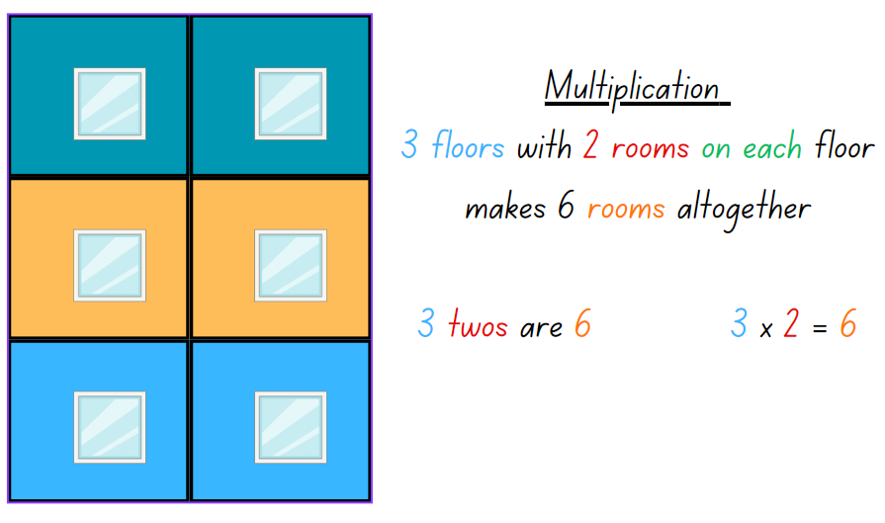

Resource 19 – matching algorithms
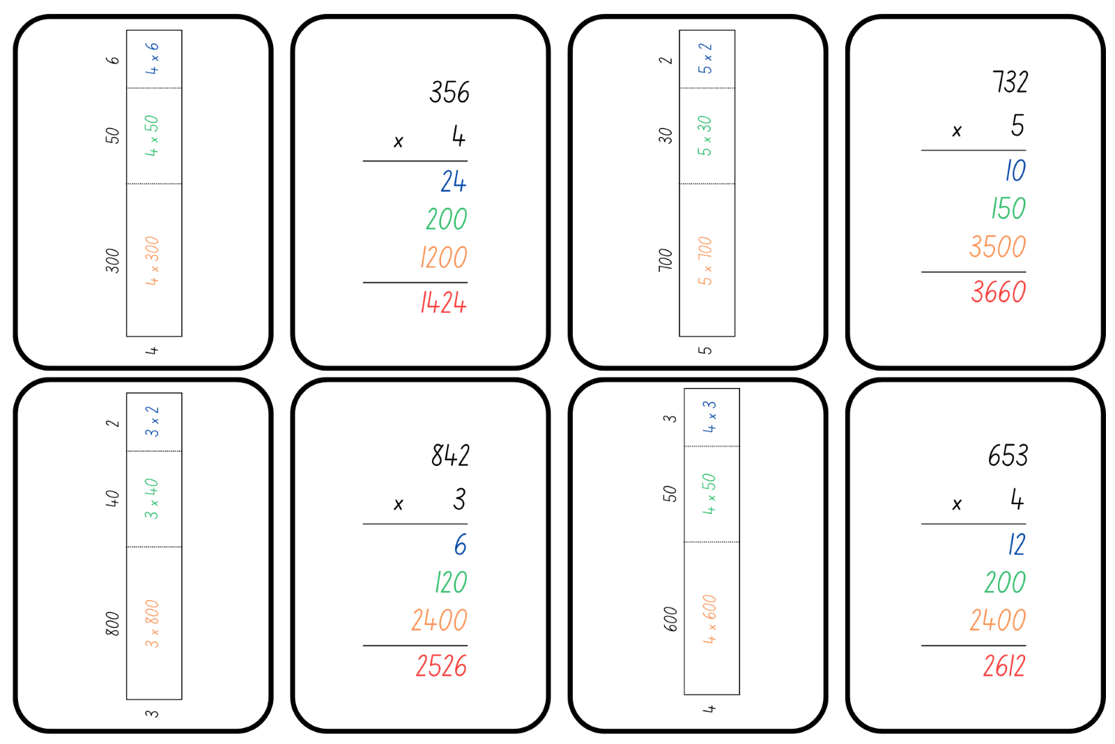
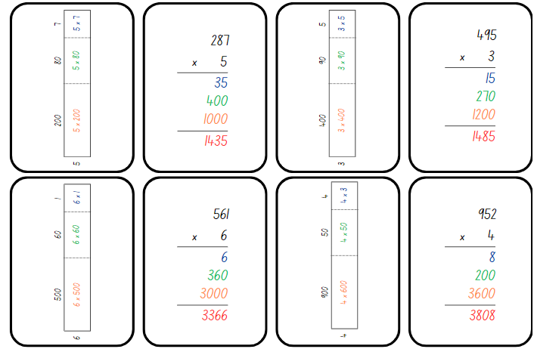

Resource 20 – building arrays – division
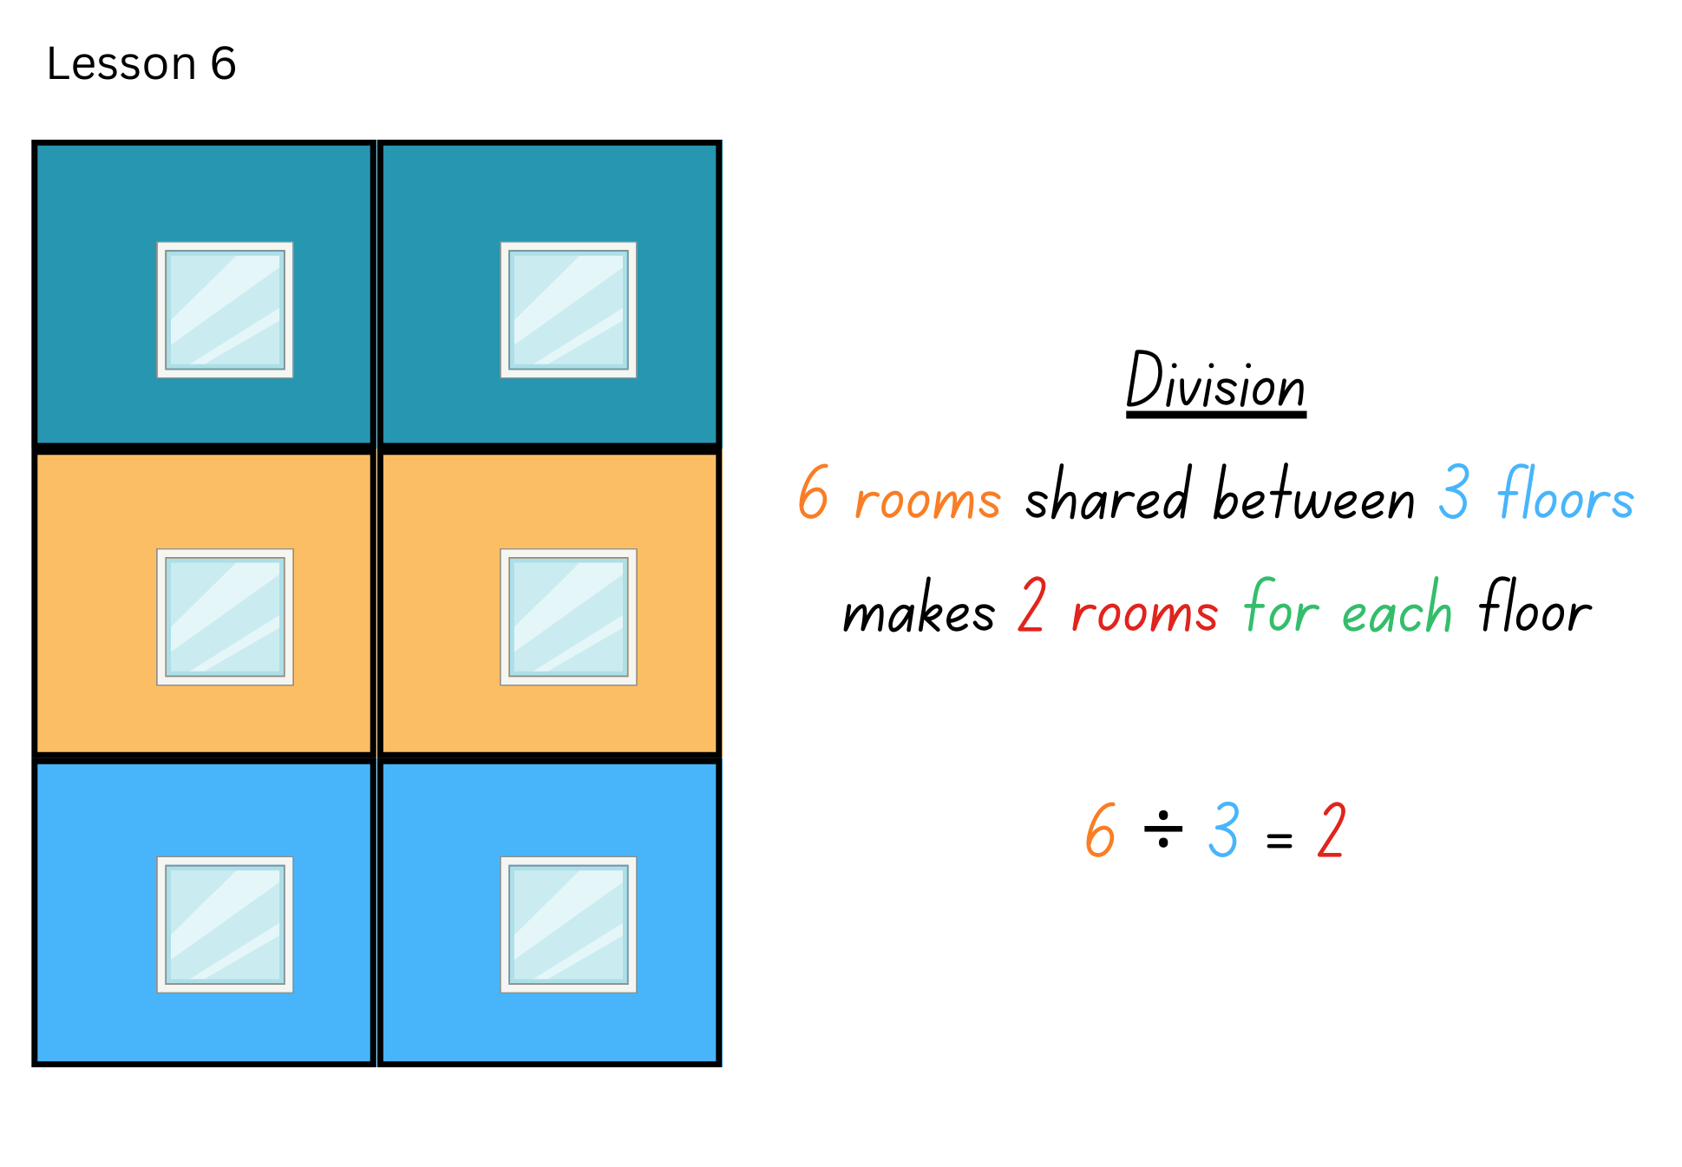

Resource 21 – division template
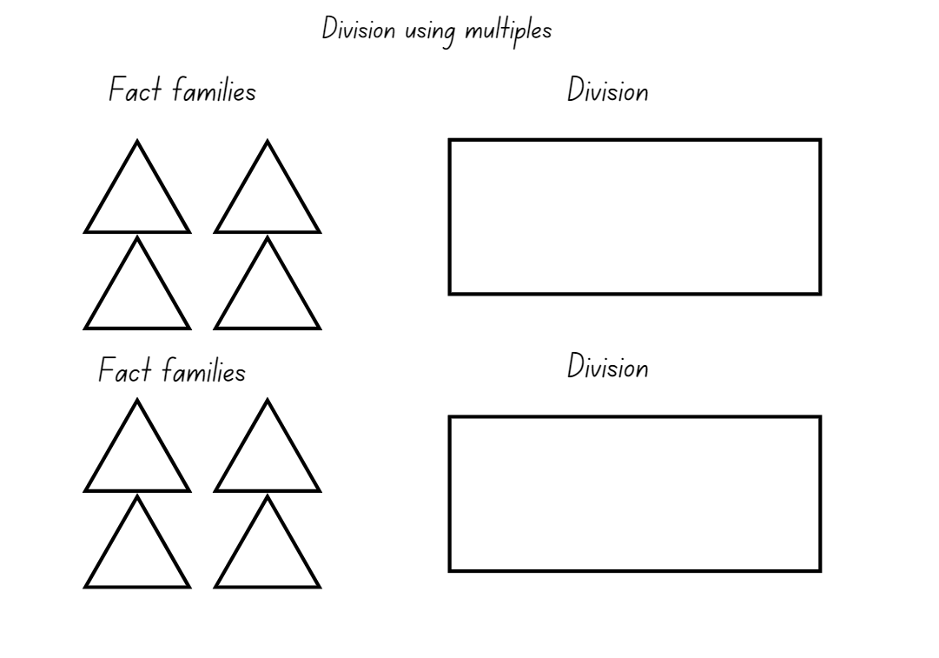

Resource 22 – number cards
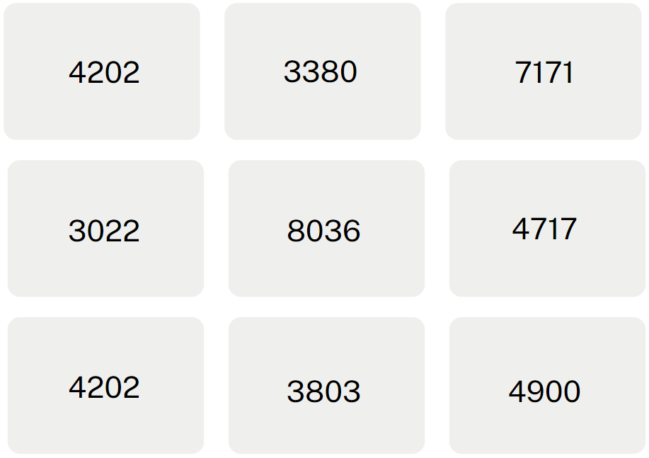
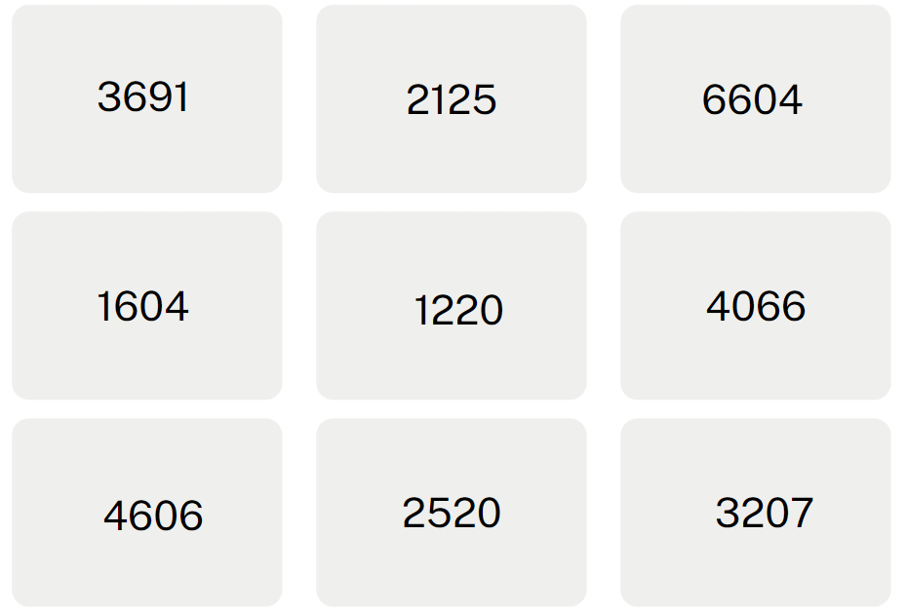
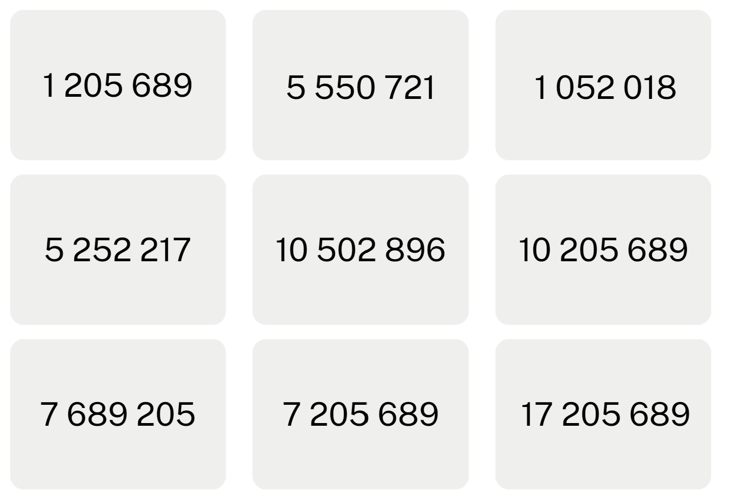
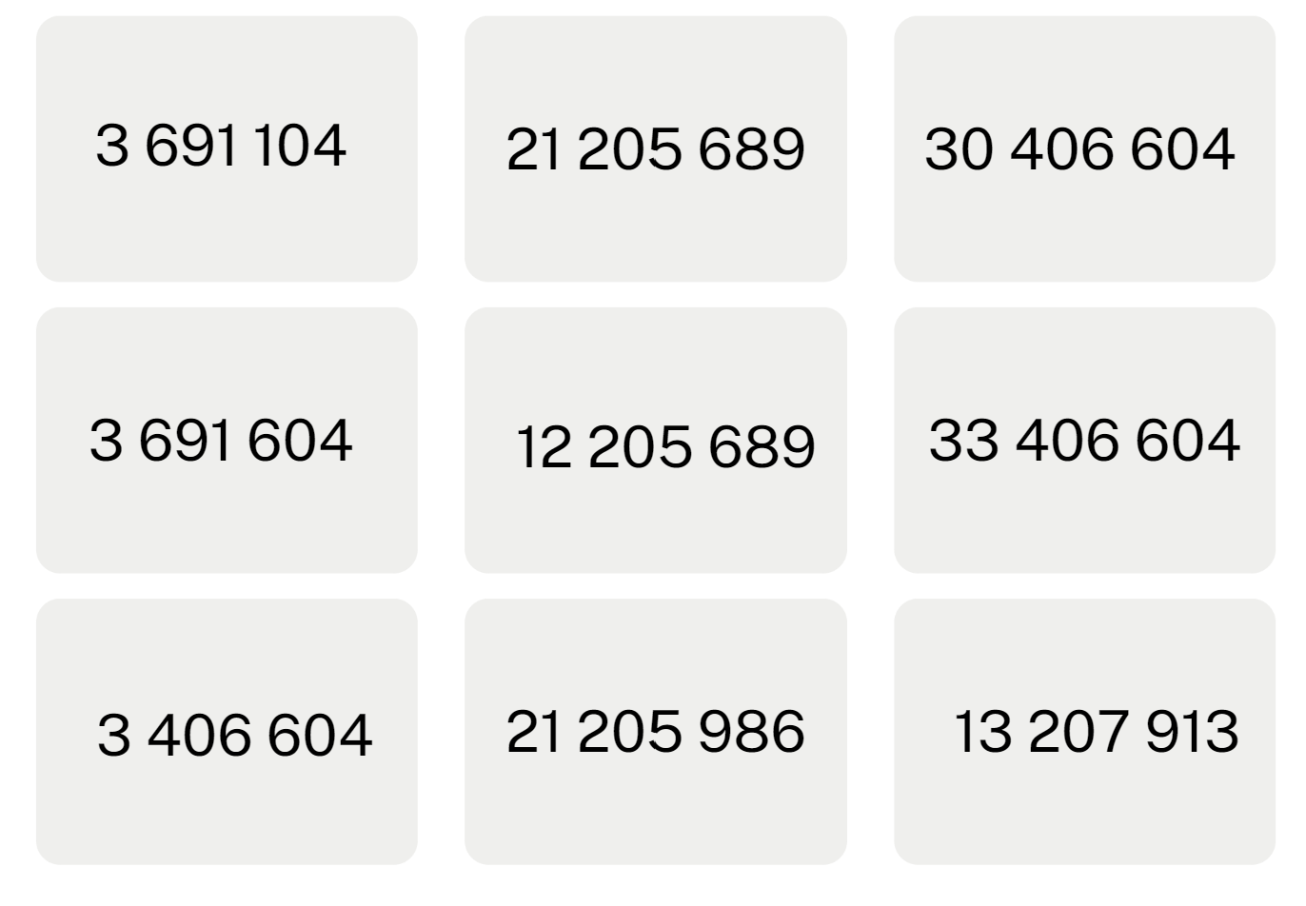

Resource 23 – making fact families
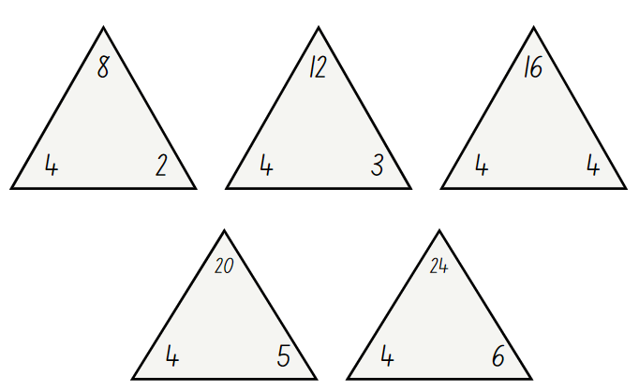

Resource 24 – Fact family or not?
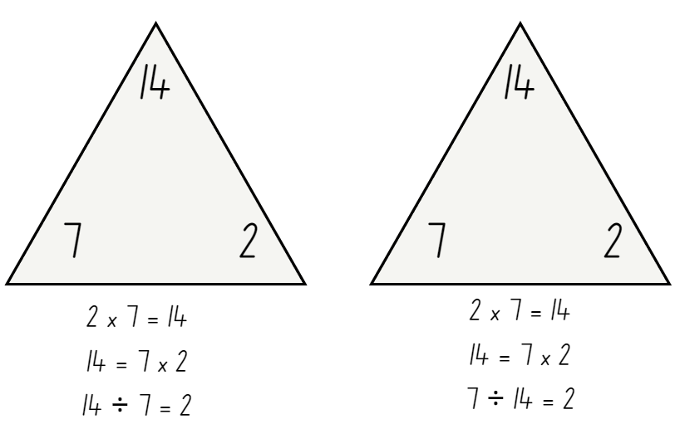

Resource 25 – blank think board
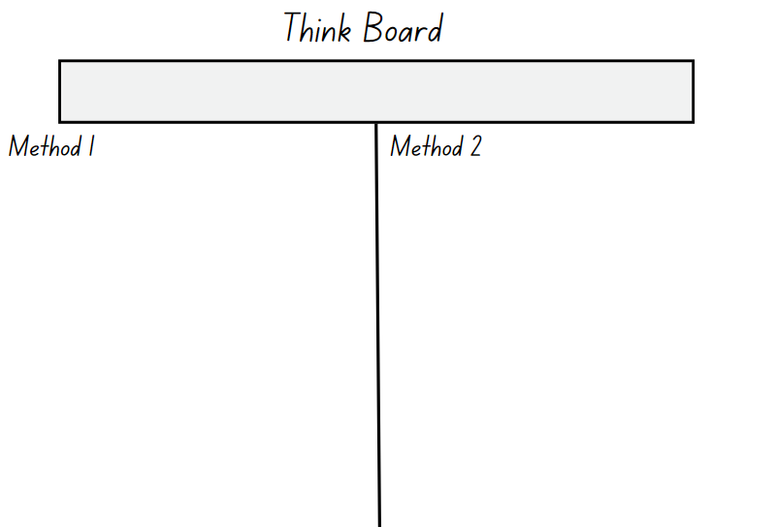

Resource 26 – Stage 2 What’s the problem?
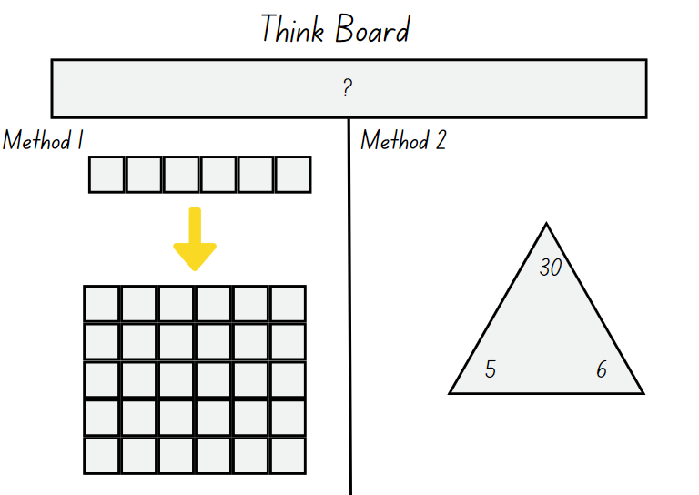

Resource 27 – Stage 3 What’s the problem?
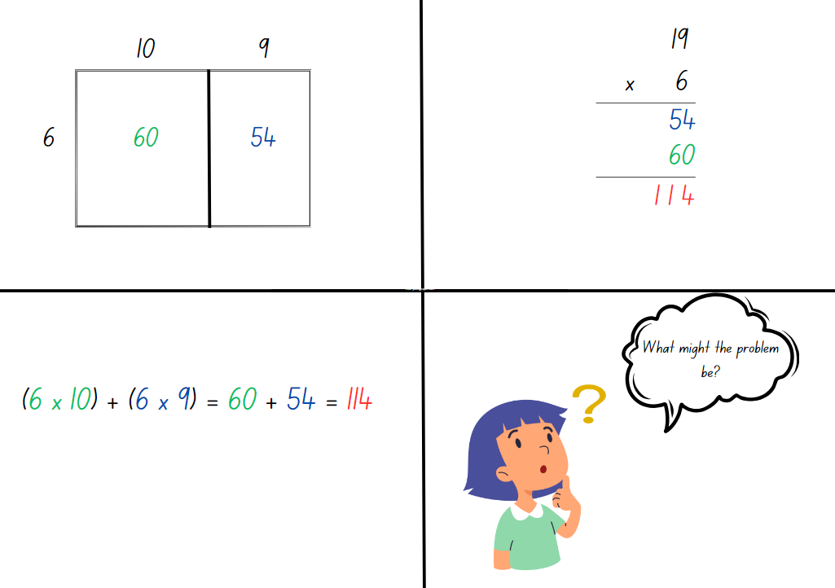

Resource 28 – problems to solve
Stage 2:
- Heide picked 2 flowers for each of her 3 friends. How many flowers did she pick? Murray picked 3 times as many flowers as Heide. How many flowers did Murray pick?
- A farmer collected 4 eggs for each of her 5 friends. How many eggs did the farmer collect? The farmer accidently broke half of the eggs. How many were left?
- Brett is planning his birthday party. He bought 3 party bag fillers for each of his 5 friends. How many party bag fillers does he have? Brett’s mum bought twice as many party bag fillers as Brett for the birthday party. How many party bag fillers did Brett’s mum buy?
- A landscaper planted a garden bed with 7 plants for his customer. The customer wanted 4 times as many plants in the garden bed. How many plants were in the garden? The customer didn’t look after her garden and half of the plants died. How many plants are left in the garden bed?
Stage 3:
- How many 5-seater cars are required to take 247 people to the beach?
- How many days old will Sonya be on her 20th birthday?
- There are 16 wallets on a table and each one has $200 inside. How much money is there altogether?
- 125 students need to be seated at tables that sit 4 or 5 to a table. How many of each table is needed?

Syllabus outcomes and content

Stage 2
The table below outlines the syllabus outcomes and range of relevant syllabus content covered in this unit. Content is linked to National Numeracy Learning Progression version (3).
Outcomes and content | 1 | 2 | 3 | 4 | 5 | 6 | 7 | 8
Representing numbers using place value A: Whole numbers: Read, represent and order numbers to thousands
MAO-WM-01, MA2-RN-01
- Read and order numbers of up to at least 4 digits |  |  |  |  |  | x | x
- Identify the number before and after a number with an internal zero digit |  |  |  |  |  | x | x
Representing numbers using place value A: Whole numbers: Apply place value to partition and regroup numbers up to 4 digits
MAO-WM-01, MA2-RN-01
- Record numbers using standard place value form |  |  |  |  | x | x | x
Representing numbers using place value B: Whole numbers: Recognise and represent numbers that are 10, 100 or 1000 times as large
MAO-WM-01, MA2-RN-01
- Recognise the number of tens, hundreds or thousands in a number |  |  |  |  | x | x | x
- Describe how making a number 10, 100 or 1000 times as large changes the place value of digits |  |  |  |  |  |  | x
Multiplicative relations A: Generate and describe patterns
MAO-WM-01, MA2-MR-01, MA2-MR-02
- Model, describe and record patterns of multiples | x |  | x
- Create and continue a variety of number patterns that increase or decrease by a constant amount | x |  | x
- Recognise the significance of the final digit of a whole number in determining whether a given number is even or odd (Reasons about relations) | x
- Recognise the connection between even numbers and the multiplication facts for 2 (Reasons about relations) | x
- Investigate the result of multiplying by one and zero (Reasons about relations) | x
Multiplicative relations A: Use arrays to establish multiplication facts from multiples of 2 and 4, 5 and 10
MAO-WM-01, MA2-MR-01, MA2-MR-02
- Create and represent multiplicative structure, using the term multiples when connecting grouping to arrays | x | x | x |  | x |  | x
- Use the array structure to coordinate the number of groups with the number in each group | x | x | x |  | x |  | x
- Record the first 10 multiples formed by counting by twos, fours, fives and tens |  | x
- Relate doubling to multiplication facts for multiples of 2 |  |  | x
- Recognise that doubling is multiplying by 2 and halving is dividing by 2 (Reasons about relations) |  |  | x | x |  |  |  | x
- Recognise the relationship between one multiple and its double (Reasons about relations) |  |  | x
- Model square numbers and record in numerical and diagrammatic form |  | x
Multiplicative relations A: Recall multiplication facts of 2 and 4, 5 and 10 and related division facts
MAO-WM-01, MA2-MR-01, MA2-MR-02
- Recognise and use the symbols for multiplied by (×), divided by (÷) and equals (=) |  |  |  |  | x | x | x | x
- Link multiplication and division fact families using arrays |  |  |  |  | x | x | x
- Generate multiplication fact families for multiples of 2 and 4, 5 and 10 |  | x |  |  |  | x | x
- Model and apply the commutative property of multiplication |  |  |  |  | x |  | x
Multiplicative relations A: Represent and solve problems involving multiplication fact families
MAO-WM-01, MA2-MR-01, MA2-MR-02
- Describe multiplication problems using for each and times as many |  |  |  |  |  |  | x | x
- Find the total of partially covered arrays |  | x
- Apply the inverse relationship of multiplication and division (Reasons about relations) |  |  |  |  |  | x | x
Multiplicative relations B: Use known number facts and strategies
MAO-WM-01, MA2-MR-01, MA2-MR-02
- Apply the known strategy of doubling to connect multiples of 3 to 6 and 4 to 8 (Reasons about relations) |  |  | x
Multiplicative relations B: Use number properties to find related multiplication facts
MAO-WM-01, MA2-MR-01, MA2-MR-02
- Use the commutative property of multiplication |  |  |  |  | x |  | x
- Use the associative property within multiplication to regroup the factors (Reasons about structure) |  |  |  |  | x
- Use flexible partitioning within multiplication (Reasons about relations) |  |  |  |  | x
- Generate multiplication fact families up to 10 × 10 |  |  |  |  |  |  | x
Multiplicative relations B: Represent and solve word problems with number sentences involving multiplication or division
MAO-WM-01, MA2-MR-01, MA2-MR-02
- Use the equals sign to record equivalent number relationships involving multiplication (Reasons about relations) |  |  |  |  |  |  | x
- Complete number sentences involving multiplication and division by calculating missing numbers (Reasons about relations) |  |  |  |  |  | x | x
- Represent and solve multiplication and division (both sharing and grouping) word problems using number sentences |  |  |  |  | x | x |  | x
Mathematics K–10 Syllabus © NSW Education Standards Authority (NESA) for and on behalf of the Crown in right of the State of New South Wales, 2022.

Stage 3
The table below outlines the syllabus outcomes and range of relevant syllabus content covered in this unit. Content is linked to National Numeracy Learning Progression version (3).
Outcomes and content | 1 | 2 | 3 | 4 | 5 | 6 | 7 | 8
Represents numbers A: Recognise, represent and order numbers in the millions
MAO-WM-01, MA3-RN-01
- Name millions using the place value grouping of ones, tens and hundreds |  |  |  |  | x | x | x
- Arrange numbers in the millions in ascending and descending order using place value |  |  |  |  | x |  | x
- Round numbers to a specified place value |  |  |  |  |  | x
Represents numbers A: Whole numbers: Apply place value to partition, regroup and rename numbers to 1 billion
MAO-WM-01, MA3-RN-01
- Regroup numbers in different forms (Reasons about quantity) |  |  |  |  | x | x
- Partition numbers to 1 billion in non-standard forms |  |  | x |  |  | x
Multiplicative relations A: Determine products and factors
MAO-WM-01, MA3-MR-01, MA3-MR-02
- Use the term product to describe the result of multiplying 2 or more numbers | x | x | x |  | x
- Model different ways to show a whole number as a product (Reasons about structure) | x | x | x |  | x
- Determine factors for a given whole number | x | x |  |  | x
- Determine whether a number is prime, composite or neither (0 or 1) | x |  |  |  | x
Multiplicative relations A: Use partitioning and place value to multiply 2-, 3- and 4-digit numbers by one-digit numbers
MAO-WM-01, MA3-MR-01, MA3-MR-02
- Use mental strategies to multiply one-digit numbers by 10, 100, 1000 and their multiples |  | x | x |  | x
- Estimate the product of 2 numbers (one-digit by 2- or 3-digit numbers) using multiples of 10 or 100 |  | x |  |  | x
- Use informal written strategies such as the area model to solve multiplication and division problems |  | x | x | x | x | x |  | x
- Use the distributive property with the area model to partition numbers in representing multiplication problems |  |  | x |  | x | x |  | x
- Use the distributive property with partial products to solve problems by multiplying the hundreds, then the tens and then the ones |  | x | x |  | x |  |  | x
- Record the product of multiplying by a one-digit number using a formal algorithm |  | x | x |  | x |  |  | x
Multiplicative relations A: Select and apply mental and written strategies to multiply 2- and 3-digit numbers by 2-digit numbers
MAO-WM-01, MA3-MR-01, MA3-MR-02
- Factorise numbers to aid mental multiplication |  | x |  |  |  | x
- Use a multiplication algorithm with understanding (Reasons about relations) |  |  |  |  |  | x |  | x
- Solve multiplication word problems |  |  |  |  |  |  |  | x
Multiplicative relations A: Represent and solve division problems with whole number remainders
MAO-WM-01, MA3-MR-01, MA3-MR-02
- Model division, including where the answer involves a remainder, using materials or diagrams |  |  |  |  |  |  | x | x
- Record remainders in words to division problems |  |  |  |  |  |  | x | x
- Use known multiplication fact families to solve division problems for which answers may include a remainder |  |  |  |  |  | x | x | x
- Use the term quotient to describe the result of a division calculation |  |  |  |  |  |  | x
- Show the connection between division and multiplication involving the divisor and quotient |  |  |  |  |  |  | x
Multiplicative relations A: Select and apply strategies to divide a number with 3 or more digits by a one-digit divisor
MAO-WM-01, MA3-MR-01, MA3-MR-02
- Estimate the result of dividing by a one-digit divisor |  |  |  |  |  | x |  | x
- Use knowledge of multiples to partition as appropriate and divide |  |  |  |  |  | x |  | x
- Apply and record appropriate strategies to solve division word problems |  |  |  |  |  |  |  | x
- Use and interpret remainders in solutions to division problems |  |  |  |  |  |  |  | x
Multiplicative relations A: Use estimation and rounding to check the reasonableness of answers to calculations
MAO-WM-01, MA3-MR-01, MA3-MR-02
- Use estimation to check the reasonableness of answers to multiplication and division calculations |  |  | x |  | x |  | x | x
Multiplicative relations B: Explore the use of brackets and the order of operations to write number sentences
MAO-WM-01, MA3-MR-01, MA3-MR-02
- Use grouping symbols () in number sentences to indicate operations that must be performed first |  |  |  | x
Mathematics K–10 Syllabus © NSW Education Standards Authority (NESA) for and on behalf of the Crown in right of the State of New South Wales, 2022.

References
This resource contains NSW Curriculum and syllabus content. The NSW Curriculum is developed by the NSW Education Standards Authority. This content is prepared by NESA for and on behalf of the Crown in right of the State of New South Wales. The material is protected by Crown copyright.
Please refer to the NESA Copyright Disclaimer for more information https://educationstandards.nsw.edu.au/wps/portal/nesa/mini-footer/copyright.
NESA holds the only official and up-to-date versions of the NSW Curriculum and syllabus documents. Please visit the NSW Education Standards Authority (NESA) website https://educationstandards.nsw.edu.au/ and the NSW Curriculum website https://curriculum.nsw.edu.au/.
Mathematics K–10 Syllabus © NSW Education Standards Authority (NESA) for and on behalf of the Crown in right of the State of New South Wales, 2022.
National Numeracy Learning Progression © Australian Curriculum, Assessment and Reporting Authority (ACARA) 2010 to present, unless otherwise indicated. This material was downloaded from the Australian Curriculum website (National Literacy Learning Progression) (accessed 21 September 2023) and was not modified.
Joshua A (2006) Enrich-e-matics: Book 3, 3rd Edition, Pearson Education Australia, Melbourne.
New Zealand Ministry of Education (n.d.) ‘A Prime Search’, Resources, NZ Maths website, accessed 18 August 2023.
Parr A (17 April 2015) ‘Envelopes’, Established 1962 blog, accessed 20 October 2023.
Reasoning support Mathematics K–6 © NSW Education Standards Authority (NESA) for and on behalf of the Crown in right of the State of New South Wales, 2022.
Sullivan P (2021) Building Engagement for Middle Years Mathematics: Learning sequences for mixed-ability classrooms, Oxford University Press ANZ.
Sullivan P and Lilburn P (2017) Open-Ended Maths Activities: Using ‘Good’ Questions to Enhance Learning Mathematics, Revised edn, Oxford University Press Australia and New Zealand.
Vingerhoets R (2009) Division – Chipping away at the whole number [PDF 487 KB] Rob Vingerhoets Educational Consultancy, accessed 18 August 2023.

© State of New South Wales (Department of Education), 2023
The copyright material published in this resource is subject to the Copyright Act 1968 (Cth) and is owned by the NSW Department of Education or, where indicated, by a party other than the NSW Department of Education (third-party material).
Copyright material available in this resource and owned by the NSW Department of Education is licensed under a Creative Commons Attribution 4.0 International (CC BY 4.0) license.
This license allows you to share and adapt the material for any purpose, even commercially.
Attribution should be given to © State of New South Wales (Department of Education), 2023.
Material in this resource not available under a Creative Commons license:
- the NSW Department of Education logo, other logos and trademark-protected material
- material owned by a third party that has been reproduced with permission. You will need to obtain permission from the third party to reuse its material.
Links to third-party material and websites
Please note that the provided (reading/viewing material/list/links/texts) are a suggestion only and implies no endorsement, by the New South Wales Department of Education, of any author, publisher, or book title. School principals and teachers are best placed to assess the suitability of resources that would complement the curriculum and reflect the needs and interests of their students.
If you use the links provided in this document to access a third-party's website, you acknowledge that the terms of use, including licence terms set out on the third-party's website apply to the use which may be made of the materials on that third-party website or where permitted by the Copyright Act 1968 (Cth). The department accepts no responsibility for content on third-party websites.

