Mathematics 3–6 Multi-age – Year A – Unit 4
Fractions represent multiple ideas and can be represented in different ways

Contents
Unit description and duration 6
Syllabus outcomes 6
Stage 2 6
Stage 3 7
Working mathematically 7
Student prior learning 8
Lesson overview and resources 9
Lesson 1 18
Daily number sense – fractions fun – 10 minutes 18
Core lesson – 40 minutes 21
Stage 2 task – a fraction represents equal parts of a whole 21
Stage 3 task – fractions as numbers on a number line 24
Discuss and connect the mathematics – 10 minutes 30
Lesson 2 32
Daily number sense – partitioning a line – 15 minutes 32
Core lesson – 25 minutes 33
Stage 2 task – my fraction wall 33
Stage 3 task – cross-country race 37
Discuss and connect the mathematics – 15 minutes 39
Lesson 3 42
Daily number sense – broken fraction wall – 10 minutes 42
Core lesson – 40 minutes 43
Stage 2 task – representing fractions 43
Stage 3 task – pattern block fractions 46
Discuss and connect the mathematics – 10 minutes 49
Lesson 4 51
Daily number sense – 10 minutes 51
Core lesson – 40 minutes 51
Stage 2 task 1 – finding the complement 51
Stage 2 task 2 – fractions on a number line 54
Stage 3 task – one as the common whole 57
Consolidation and meaningful practice – 10 minutes 60
Lesson 5 63
Daily number sense – cover the multiples – 15 minutes 63
Core lesson – 40 minutes 65
Stage 2 task – finding the whole 65
Stage 3 task – adding fractions 68
Discuss and connect the mathematics – 10 minutes 72
Lesson 6 75
Daily number sense – doubling and doubling again – 15 minutes 75
Core lesson – 40 minutes 77
Stage 2 task – complementary fractions 77
Stage 3 task – the answer is… 80
Consolidation and meaningful practice – 10 minutes 83
Lesson 7 85
Daily number sense – factors and multiples game – 10 minutes 85
Core lesson – 45 minutes 87
Stage 2 task – What could the whole be? 87
Stage 3 task – subtracting fractions 91
Discuss and connect the mathematics – 10 minutes 95
Lesson 8 97
Daily number sense – 10 minutes 97
Core lesson – making and exceeding the whole – 45 minutes 97
Consolidation and meaningful practice – 10 minutes 102
Resource 1 – Exactly half? 104
Resource 2 – domino fractions 105
Resource 3 – blank fraction line 106
Resource 4 – shaded fraction part 107
Resource 5 – finding fractions 108
Resource 6 – distance travelled (part 1) 109
Resource 7 – distance travelled (part 2) 110
Resource 8 – broken fraction wall 111
Resource 9 – fractions of a length 112
Resource 10 – quarters and tenths 113
Resource 11 – fraction mosaics 114
Resource 12 – fractions on a number line 115
Resource 13 – fractions wall 116
Resource 14 – complementary fraction parts 117
Resource 15 – ‘Multiples’ gameboard (Stage 2) 118
Resource 16 – ‘Multiples’ gameboard (Stage 3) 119
Resource 17 – ‘Multiples’ rule cards 120
Resource 18 – finding the whole 121
Resource 19 – bar model 122
Resource 20 – make 2 groups (Stage 2) 123
Resource 21 – make 2 groups (Stage 3) 124
Resource 22 – making the whole 125
Resource 23 – ‘Product game’ 126
Resource 24 – modified ‘Product game’ 127
Resource 25 – ‘Product game’ questions 128
Resource 26 – chocolate bar 1 129
Resource 27 – chocolate bar 2 130
Resource 28 – picture frame problem 131
Resource 29 – frame beginnings 132
Resource 30 – ‘Rob the nest’ score sheet 133
Syllabus outcomes and content 134
Stage 2 134
Stage 3 138
References 141

Unit description and duration
This unit introduces the big idea that fractions represent multiple ideas and can be represented in different ways.
In this 2-week unit, students are provided opportunities to:
- model, label and describe fractions through fraction strips and fraction walls
- recreate the whole from a fractional part
- compare and order fractions using number lines and bar models
- solve problems involving addition and subtraction of fractions with the same denominator.
This multi-age unit is developed by lessons in Stage 2 Year A Unit 4 and Stage 3 Year A Unit 4. Please refer to these units for additional lesson guidance.

Syllabus outcomes
- MAO-WM-01 develops understanding and fluency in mathematics through exploring and connecting mathematical concepts, choosing and applying mathematical techniques to solve problems, and communicating their thinking and reasoning coherently and clearly

Stage 2
- MA2-MR-01 represents and uses the structure of multiplicative relations to 10 × 10 to solve problems
- MA2-MR-02 completes number sentences involving multiplication and division by finding missing values
- MA2-PF-01 represents and compares halves, quarters, thirds and fifths as lengths on a number line and their related fractions formed by halving (eighths, sixths and tenths)

Stage 3
- MA3-MR-01 selects and applies appropriate strategies to solve multiplication and division problems
- MA3-RQF-01 compares and orders fractions with denominators of 2, 3, 4, 5, 6, 8 and 10
- MA3-RQF-02 determines $\frac{1}{2},\frac{1}{4},\frac{1}{5}$ and $\frac{1}{10}$ of measures and quantities

Working mathematically
In the Mathematics K–10 Syllabus, there is one overarching Working mathematically outcome (MAO-WM-01). The Working mathematically processes should be embedded within the concepts being taught. The Working mathematically processes present in the Mathematics K–10 Syllabus are:
- communicating
- understanding and fluency
- reasoning
- problem solving.
Mathematics K–10 Syllabus © NSW Education Standards Authority (NESA) for and on behalf of the Crown in right of the State of New South Wales, 2022.

Student prior learning
Before engaging in these teaching and learning activities, students would benefit from prior experience with:
- modelling, labelling and describing fractions through fraction strips and number lines
- creating fractional and complementary parts of a length
- exploring equivalence and multiplicative relationships of fractions.
In NSW classrooms there is a diverse range of students, including Aboriginal and/or Torres Strait Islander students, students learning English as an additional language or dialect, high potential and gifted students and students with disability. Some students may identify with more than one of these groups or possibly all of them. Refer to Curriculum planning for every student – advice for further information.

Lesson overview and resources
To cover the different fractional content of the syllabus across Stage 2 and Stage 3, some core lessons in the unit contain both a Stage 2 and a Stage 3 task. The separate learning experiences have been deliberately designed to meet the specific needs and abilities of the students within each stage. Teachers are encouraged to adapt and contextualise the units to meet the needs of their students.
The table below outlines the sequence and approximate timing of lessons, learning intentions and resources.
Lesson | Content | Duration and resources
Lesson 1  Daily number sense  Stage 2:  - Partitioned fractions A: Model and represent unit fractions, and their multiples, to a complete whole on a number line  Stage 3:  - Representing quantity fractions A: Compare and order common unit fractions | Lesson core concept: a fraction represents equal parts of a whole (Stage 2) and fractions as a number can be placed on a number line (Stage 3).  Stage 2:  - Partitioned fractions A: Model and represent unit fractions, and their multiples, to a complete whole on a number line  Stage 3:  - Representing quantity fractions A: Compare and order common unit fractions  - Representing quantity fractions B: Compare common fractions with related denominators | Lesson duration: 60 minutes  - Resource 1 – Exactly half?  - Resource 2 – domino fractions  - Resource 3 – blank fraction line (A3 copies)  - Resource 4 – shaded fraction part  - Equal length strips of paper (different colours – 3 per student)  - Writing materials
Lesson 2  Daily number sense  Stage 2:  - Partitioned fractions A: Model and represent unit fractions, and their multiples, to a complete whole on a number line  Stage 3:  - Representing quantity fractions A: Compare and order common unit fractions | Lesson core concept: fractional parts can be made without repeated halving (Stage 2) and the common whole is one (Stage 3).  Stage 2:  - Partitioned fractions A: Model and represent unit fractions, and their multiples, to a complete whole on a number line  Stage 3:  - Representing quantity fractions A: Compare and order common unit fractions | Lesson duration: 55 minutes  - Resource 5 – finding fractions  - Resource 6 – distance travelled (part 1)  - Resource 7 – distance travelled (part 2)  - A4 card  - Equal length strips of paper (coloured is optional – 5 per student)  - Glue  - Masking tape  - Pegs  - Sticky notes  - String  - Writing materials
Lesson 3  Daily number sense  Stage 2:  - Partitioned fractions A: Model and represent unit fractions, and their multiples, to a complete whole on a number line  Stage 3:  - Representing quantity fractions A: Recognise the role of the number 1 as representing the whole | Lesson core concept: fraction strips can be used to represent fractions (Stage 2) and comparing fractional parts of different sized wholes (Stage 3).  Stage 2:  - Partitioned fractions A: Model and represent unit fractions, and their multiples, to a complete whole on a number line  Stage 3:  - Representing quantity fractions A: Recognise the role of the number 1 as representing the whole | Lesson duration: 60 minutes  - Resource 8 – broken fraction wall  - Resource 9 – fractions of a length  - Resource 10 – quarters and tenths  - Resource 11 – fraction mosaics  - Pattern blocks  - Writing materials
Lesson 4  Daily number sense  - teacher-identified task based on student needs | Lesson core concept: fraction strips and number lines can be used to represent fractions (Stage 2) and unit fractions can be compared and ordered on a number line (Stage 3).  Stage 2:  - Partitioned fractions A: Model and represent unit fractions, and their multiples, to a complete whole on a number line  Stage 3:  - Representing quantity fractions A: Compare and order common unit fractions  - Representing quantity fractions B: Compare common fractions with related denominators | Lesson duration: 60 minutes  - Resource 12 – fractions on a number line  - Resource 13 – fractions wall  - Resource 14 – complementary fraction parts  - Website: Fraction Tiles and Number Line  - Digital device (one per student pair)  - Writing materials
Lesson 5  Daily number sense  Stage 2:  - Multiplicative relations A: Use arrays to establish multiplication facts from multiples of 2 and 4, 5 and 10  Stage 3:  - Multiplicative relations A: Determine products and factors | Lesson core concept: partitioned fractions can have different sized wholes (Stage 2) and adding fractions with the same denominator (Stage 3).  Stage 2:  - Partitioned fractions A: Model and represent unit fractions, and their multiples, to a complete whole on a number line  Stage 3:  - Representing quantity fractions A: Solve problems involving addition and subtraction of fractions with the same denominator | Lesson duration: 65 minutes  - Resource 15 – ‘Multiples’ gameboard (Stage 2)  - Resource 16 – ‘Multiples’ gameboard (Stage 3)  - Resource 17 – ‘Multiples’ rule cards  - Resource 18 – finding the whole  - Resource 19 – bar model  - Resource 20 – make 2 groups (Stage 2)  - Resource 21 – make 2 groups (Stage 3)  - Website: Cuisenaire Environment  - Website: Amplify Polypad – Fraction Bars  - Coloured rods (optional)  - Counters  - Digital device (one per student)  - Writing materials
Lesson 6  Daily number sense  Stage 2:  - Multiplicative relations A: Use arrays to establish multiplication facts from multiples of 2 and 4, 5 and 10  Stage 3:  - Multiplicative relations A: Determine products and factors | Lesson core concept: complementary fractional parts create a whole (Stage 2) and add and subtract fractions with the same denominator (Stage 3).  Stage 2:  - Partitioned fractions A: Model and represent unit fractions, and their multiples, to a complete whole on a number line  Stage 3:  - Representing quantity fractions A: Solve problems involving addition and subtraction of fractions with the same denominator | Lesson duration: 65 minutes  - Resource 22 – making the whole  - Website: Amplify Fraction bars  - A3 paper  - Digital device  - Glue  - Individual whiteboards  - Large collection of counters  - Paper strips (multiple per student)  - Writing materials
Lesson 7  Daily number sense  Stage 2:  - Multiplicative relations B: Use number properties to find related multiplication facts  Stage 3:  - Multiplicative relations A: Determine products and factors | Lesson core concept: different sized wholes create different sized parts (Stage 2) and subtracting fractions with the same denominator (Stage 3).  Stage 2:  - Partitioned fractions A: Model and represent unit fractions, and their multiples, to a complete whole on a number line  Stage 3:  - Representing quantity fractions A: Solve problems involving addition and subtraction of fractions with the same denominator | Lesson duration: 65 minutes  - Resource 23 – ‘Product game’  - Resource 24 – modified ‘Product game’  - Resource 25 – ‘Product game’ questions  - Resource 26 – chocolate bar 1  - Resource 27 – chocolate bar 2  - Resource 28 – picture frame problem  - Resource 29 – frame beginnings  - Website: Amplify Polypad – Fraction Bars  - Website: Product Game by National Council of Teachers of Mathematics (NCTM)  - Digital device  - Glue  - Large paper  - Scissors  - Transparent counters  - Writing materials
Lesson 8  Daily number sense  - teacher-identified task based on student needs | Lesson core concept: making and exceeding the whole (Stage 2) and mathematicians solve problems with fractions (Stage 3).  Stage 2:  - Partitioned fractions B: Model equivalent fractions as lengths  - Partitioned fractions B: Represent fractional quantities equal to and greater than one  Stage 3:  - Representing quantity fractions A: Solve problems involving addition and subtraction of fractions with the same denominator | Lesson duration: 65 minutes  - Resource 30 – ‘Rob the nest’ score sheet  - Coloured beanbags  - Hoops  - Individual whiteboards and markers (Stage 3 students)  - Writing materials

Lesson 1
Core concept: a fraction represents equal parts of a whole (Stage 2) and fractions as a number can be placed on a number line (Stage 3).

Daily number sense – fractions fun – 10 minutes
Daily number sense activities for Lessons 1 to 3 ‘activate’ prior number knowledge and support the learning of new content in the unit. These activities can also assist teachers to identify the starting points for learning by revealing the extent of students’ existing knowledge.
The table below contains suggested learning intentions and success criteria. These are best co-constructed with students.
Daily number sense learning intentions | Daily number sense success criteria
All students are learning to:  - model, represent and compare common unit fractions | All students can:  - model fractions with fraction strips and diagrams for halves.  Students working towards Stage 3 outcomes can:  - compare unit fractions as numbers to the benchmark value $\frac{1}{2}$.
- Explain that some words used in mathematics are also used in our everyday language. When we use them in mathematics the meaning is usually more precise or sometimes different from the everyday meaning. An example of this is the word ‘half’.
- Ask: Where have you seen or used the word ‘half’ outside of the maths classroom? For example, halftime, half-a-dozen, half-an-hour, halfback, halfway, 9-and-a-half years old.
- Explain that, sometimes in everyday use, half is used to mean approximately half, close to half, breaking things into 2 pieces, sharing things between 2 people.
- Ask: ‘What does ‘half’ mean in mathematics?’ Reinforce the understanding that half means exactly 2 parts that are equal.
- Display Resource 1 – Exactly half? Ask students to consider each example and determine which images represent half as exactly 2 equal parts.
- Invite students to draw, model or represent their own illustration of half. Discuss which representations accurately show half as a mathematical term.
Note: fractional language can be confusing. Students often use the fractional term ‘half’ as an everyday adjective to describe part of an object, rather than as a mathematical term related to equal partitioning of a known whole. Research suggests that tasks such as cutting toast or an apple to represent fractions can be misleading for students as the parts are NOT ‘exactly equal’. This is why it is not unusual to hear young children referring to the ‘bigger half’ (Gould 2013).

Multi-age: draw Stage 3 students’ attention to the image of the blue strip on the number line in Resource 1 – Exactly half? Students mark where 1, $\frac{1}{2}$ and $\frac{1}{4}$ would be on the number line. Ask students to use their number lines to compare the size of unit fractions and explain that $\frac{1}{2}$ is larger than $\frac{1}{4}$.
This table details opportunities for assessment.
Assessment opportunities | Links
What to look for:  - Can Stage 2 students model fractions with fraction strips and diagrams for halves? [MAO-WM-01, MA2-PF-01]  - Can Stage 3 students compare unit fractions as numbers to the benchmark value $\frac{1}{2}$? [MAO-WM-01, MA3-RQF-01] | Links to National Numeracy Learning Progressions (NNLP):  - Stage 2 – MuS6, InF2  - Stage 3 – InF5, InF6, InF7.  Links to suggested Interview for Student Reasoning (IfSR) tasks:  - Stage 2 – IfSR-MT: 1B.1, 2B.2, 2B.6  - Stage 3 – IfSR-PT: 1A.2, 1A.3.

Core lesson – 40 minutes

Stage 2 task – a fraction represents equal parts of a whole
The table below contains a suggested learning intention and success criteria. These are best co-constructed with students.
Core concept learning intention | Core concept success criteria
Students working towards Stage 2 outcomes are learning to:  - model and represent unit fractions to complete a whole on a number line. | Students working towards Stage 2 outcomes can:  - model fractions with fraction strips and diagrams for halves, quarters and eighths.
Note: in Stage 2, fractions are represented by partitioning lengths. This enables students to measure with partitioned unit fractions. Stage 2 focuses on fractions with denominators of 2, 3, 4 and 8, as well as 5 and 10. They are represented as measures by partitioning lengths.
- Provide each student with 3 equal length strips of paper. Each strip should be a different colour. Students choose one strip and fold it in half.
- Ask students whether they have made a half or about a half. Students explain and justify their answers. Where necessary, students refold their strips to ensure it accurately represents 2 equal lengths of the whole strip.
- Students fold another paper strip in half, then half again. Before they unfold it, ask:
- How many parts do you think you have made? How do you know?
- Are the parts equal? How do you know?
- Students unfold their paper strip to check their answer. Ask what the fraction name is for 4 equal parts.
- Students discuss how to fold the strip to show 8 equal parts, or eighths. Ask:
- What will you have to think about before folding the paper strip to find the fraction?
- How will you know that each part is an eighth of the whole length?
- How many equal parts will you have after you’ve folded to get an eighth?
- How many times will you need to repeatedly fold the strip in half to make eighths?
- Observe students while they are creating the fractional parts, reinforcing equality and the number of parts required for each fraction.
- State that fractions can be recorded in words or in symbols. Display the symbol for one-half (see Figure 1). Explain that the 2 shows how much the whole is (2 parts) and the 1 shows how many equal parts of the whole are selected (1 part).
Figure 1 – fraction notation
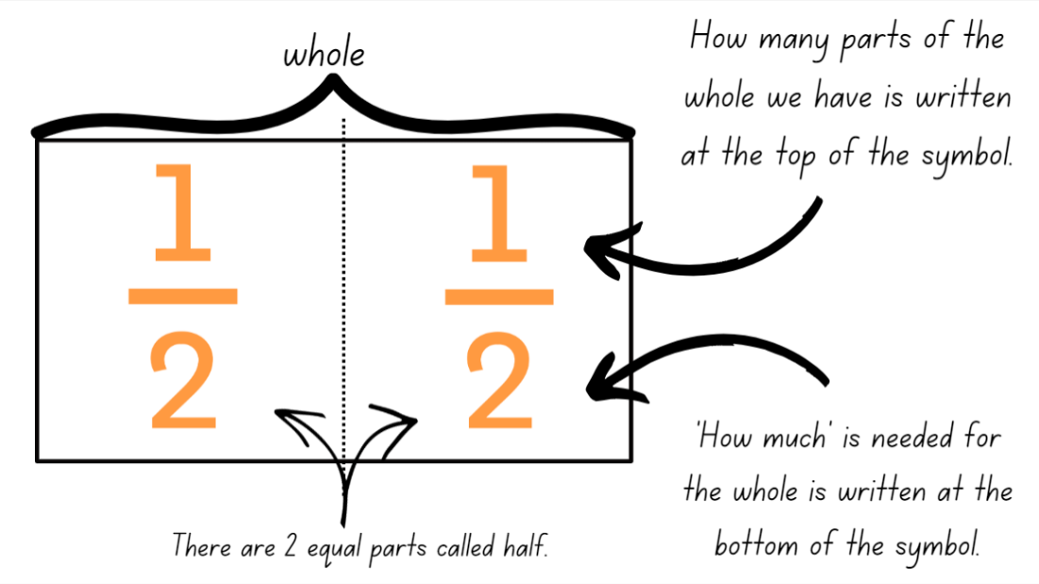
- Draw a strip on the board and partition it into quarters. Label the quarters with the text ‘one-quarter’. Ask:
- What is the whole? How much is that? (4 parts)
- How many of the equal parts is each quarter? (1 part)
- How might you label each of the equal parts using the fraction symbol? ($\frac{1}{4}$)
- Repeat with eighths.
- Students label their fraction strips using fraction notation. Use different coloured strips of paper or colour each strip in a different colour. These will be used in the next lesson to create a fraction wall.
Note: use language that will assist students to develop early fraction ideas. For example, rather than saying ‘one over 2’, ‘one of 2’ or ‘one on 2’ (describing the symbol only), refer to the fractional relationship by saying ‘one-half of the whole strip’. The teaching advice states that the terms ‘numerator’ and ‘denominator’ are used in Stage 3.
This table details opportunities for differentiation.
Too hard? | Too easy?
Stage 2 students cannot model fractions with fraction strips for halves, quarters and eighths.  - Model halves by folding the strip into 2 equal parts to see the relationship between the parts and the whole length.  - Model repeatedly folding a strip to find quarters and eighths. Reinforce 8 parts make eighths, 4 parts make quarters. | Stage 2 students can model fractions with fraction strips for halves, quarters and eighths.  - Students make a poster describing fraction symbols and provide labelled examples.

Stage 3 task – fractions as numbers on a number line
The table below contains suggested learning intentions and success criteria. These are best co-constructed with students.
Core concept learning intentions | Core concept success criteria
Students working towards Stage 3 outcomes are learning to:  - compare and order common unit fractions  - compare common fractions with related denominators. | Students working towards Stage 3 outcomes can:  - compare and order unit fractions with denominators of 2, 3, 4, 5, 6, 8 and 10 by placing them on a number line  - record equivalent fractions using diagrams, words and fraction notation.
- Revise the 2 key ideas in fractional thinking:
- Fractions break up a whole into equal parts. The whole can be a length, a collection or an object, for example, half a set of marbles or half a strip of paper. These are known as partitioned fractions.
- Fractions as a number, for example, $\frac{1}{2}$ represents halfway between zero and one on the number line. These are known as quantity fractions.
- Explain that fractions can be represented as a fraction of a length and as a number on a number line (see Figure 2).
Figure 2 – fractions of a line and fractions on a line
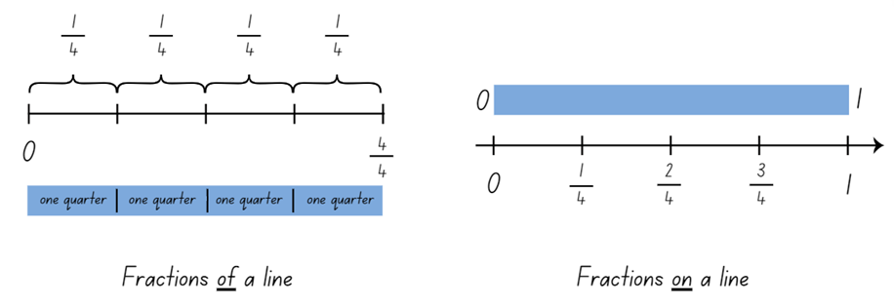
Note: fractions can be represented as a part of a length on a bar model where each segment is labelled as one fractional part of the whole. For example, one-quarter, one-quarter, one-quarter and one-quarter. Fractions can also be represented as numbers on a number line. The distinction between the 2 is that fractions of a length indicate a part of a line or length and fractions as a number that sit at a ‘point’ on a number line (Gojak and Miles 2018). The fraction that names a point on the number line describes the distance of that point from zero.
- Remind students that when writing a fraction in symbolic notation, 2 numerals are separated by a line. The numeral up the top (numerator) tells how many equal parts of the whole are selected. The numeral down the bottom (denominator) tells the total number of parts or the whole. Explain that the line represents a division between the numerator and the denominator (see Figure 3).
Figure 3 – fraction notation
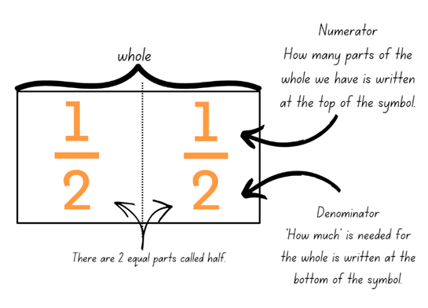
Note: teaching advice states that to develop a quantitative sense of fractions, the emphasis is on dividing a unit whole rather than simply naming denominators or numerators. For example, rather than the fraction $\frac{1}{3}$ being described as having a numerator of 1 and denominator of 3, the understanding of $\frac{1}{3}$ is developed as the number resulting from dividing a unit whole by 3.
- Draw a number line from 0–1 on the board. Make a mark at the one-quarter point on the line and have students identify a fraction that could be placed at that point. The fraction represents how far away from zero the point on the number line is.
- Ask students to suggest other ways to rename that fraction, for example, $\frac{1}{4}$ or $\frac{2}{8}$. Explain that 2 fractions are equivalent (equal) if they are the same size or at the same point on a number line.
- Provide small groups with Resource 2 – domino fractions and an A3 copy of Resource 3 – blank fraction line.
- Students take turns to choose a domino and place the fraction represented by the domino on the number line (see Figure 4).
Figure 4 – domino fractions on number line
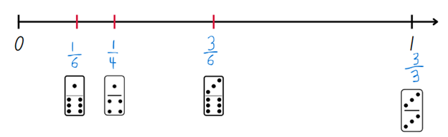
- Regroup and select students to explain the fractions represented on the domino and how they knew where to place them on the number line.
- Ask students if fractions can be represented on a number line that goes beyond one and if anyone can think of an example.
- Draw a blank number line from 0–2 on the board and ask students where the following fractions would be placed on the line:
- one-half
- three-halves
- two-quarters
- six-quarters
- two-thirds
- four-thirds.
- Using the fraction line, discuss how each fraction can be named in more than one way. Circle or highlight the following:
- one-half, two-halves, that makes one whole; three-halves, four-halves, that makes 2.
- one-third, two-thirds, three-thirds, that is equal to one; four-thirds, five-thirds, six-thirds, that makes 2. Six-thirds can be named as 2 wholes.
- one-quarter, two-quarters, three-quarters, four-quarters, that makes one.
- Support students to make connections between fractions and wholes, for example, 7 quarters make one whole and 3 more quarters which can be written symbolically as 1$\frac{3}{4}$.
This table details opportunities for differentiation.
Too hard? | Too easy?
Stage 3 students cannot compare and order unit fractions with denominators of 2, 3, 4, 5, 6, 8 and 10 by placing them on a number line or record equivalent fractions using diagrams, words and fraction notation.  - Students fold the 0–1 fraction line to find halves, thirds and quarters and mark them on the number line.  - Students use the $\frac{1}{1}$, $\frac{1}{2}$, $\frac{1}{4}$ dominoes and place them on the number line. | Stage 3 students can compare and order unit fractions with denominators of 2, 3, 4, 5, 6, 8 and 10 by placing them on a number line and record equivalent fractions using diagrams, words and fraction notation.  - Students extend the fraction line beyond 2 and mark additional fractions, creating their own domino tiles.  - Students use a digital device and access Bigger than and smaller than – Maths Venns to compare fractions.

Discuss and connect the mathematics – 10 minutes
- Display Resource 4 – shaded fraction part. Ask:
- What fraction of the whole is represented by the shaded part?
- Could the shaded part represent a half? Why or why not?
- How many times does the shaded part fit into the whole? How could we be sure of this?
- Provide Stage 2 students with the strip from Resource 4 – shaded fraction part and ask them to investigate by folding and labelling the equal parts with the fraction symbol ($\frac{1}{8}$).
- Stage 3 students use a number line to record the strip and label the partitions as fractions on a number line from zero and one. Ask:
- What other fraction could be placed on the number line at $\frac{6}{8}$?
- What other equivalent fractions can be identified and labelled on the number line?
- Students share and discuss their findings.
This table details opportunities for assessment.
Assessment opportunities | Links
What to look for:  - Can Stage 2 students model fractions with fraction strips for halves, quarters and eighths? [MAO-WM-01, MA2-PF-01]  - Can Stage 3 students compare and order unit fractions with denominators of 2, 3, 4, 5, 6, 8 and 10 by placing them on a number line? [MAO-WM-01, MA3-RQF-01, MA3-RQF-02]  - Can Stage 3 students record equivalent fractions using diagrams, words and fraction notation?  [MAO-WM-01, MA3-RQF-01, MA3-RQF-02] | Links to National Numeracy Learning Progressions (NNLP):  - Stage 2 – InF2, InF3, InF4  - Stage 3 – InF5, InF6.

Lesson 2
Core concept: fractional parts can be made without repeated halving (Stage 2) and the common whole is one (Stage 3).

Daily number sense – partitioning a line – 15 minutes
The table below contains suggested learning intentions and success criteria. These are best co-constructed with students.
Daily number sense learning intentions | Daily number sense success criteria
Students working towards Stage 2 outcomes are learning to:  - model and represent unit fractions and their multiples to a complete whole on a number line.  Students working towards Stage 3 outcomes are learning to:  - compare and order common unit fractions. | Students working towards Stage 2 outcomes can:  - model fractions for halves, quarters and eighths.  Students working towards Stage 3 outcomes can:  - compare and order fractions with denominators of 2, 3, 4, 5, 6, 8 and 10.
- Provide groups of Stage 2 students with masking tape to create a line on the floor. Students discuss ways to partition the line into halves, quarters and eighths using strategies other than repeated halving and label the partitions using sticky notes.
- Provide small groups of Stage 3 students with Resource 5 – finding fractions, pegs and string. Ask:
- Where would you place the fractions $\frac{1}{2}, \frac{1}{3}, \frac{1}{4},\frac{1}{5},\frac{1}{6},\frac{1}{8}$ and $\frac{1}{10}$ on a number line?
- What fractions might you place first on the number line? Explain your thinking.
- Stage 3 students place their fractions on the number line and justify their estimations. Observe student strategies, supporting students to record zero and one on the number line first.
This table details opportunities for assessment.
Assessment opportunities | Links
What to look for:  - Can Stage 2 students model fractions for halves, quarters and eighths? [MAO-WM-01, MA2-PF-01]  - Can Stage 3 students compare and order fractions with denominators of 2, 3, 4, 5, 6, 8 and 10?  [MAO-WM-01, MA3-RQF-01] | Links to National Numeracy Learning Progressions (NNLP):  - Stage 2 – InF2, InF3, InF4  - Stage 3 – InF6.

Core lesson – 25 minutes

Stage 2 task – my fraction wall
The table below contains a suggested learning intention and success criteria. These are best co-constructed with students.
Core concept learning intention | Core concept success criteria
Students working towards Stage 2 outcomes are learning to:  - model and represent unit fractions, and their multiples, to a complete whole on a number line. | Students working towards Stage 2 outcomes can:  - model fractions with fraction strips for thirds, fifths, sixths and tenths  - create fractional parts of a length using techniques other than repeated halving.
- Students review their fraction strips showing halves, quarters and eighths from Lesson 1.
- Provide students with at least 5 more paper strips of different colours (or have students colour them with pencils). Explain they are going to create more fraction strips and use them to build a fraction wall.
- Ask students the name of the fraction that is created when a whole is divided into 3 equal parts. Write ‘one-third’ in words on the board.
- Remind students of the fraction notation they have learned about in the previous lesson: ‘How much’ is needed for the whole is written at the bottom of the fraction symbol. ‘How many’ parts of the whole we have is written on the top of the fraction symbol. Introduce the fraction symbol for one-third and ask students how this relates to what they know about ‘how much’ and ‘how many’. Ask:
- How many thirds make a whole?
- What is the same about a half and a third? What makes them different?
- Do you think it will be more challenging to fold a half or a third? Why?
- Students turn and talk about strategies to fold a paper strip into 3 equal lengths. Share and communicate ideas, for example:
- I could use what I know about a half and estimate that one-third is a little less. I could estimate the length of the parts and fold to check.
- I could make 2 folds by looping my whole paper strip and then keep adjusting them till they were equal (see Figure 5).
Figure 5 – making 3 equal lengths by looping
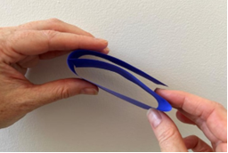
- Students problem solve in pairs or small groups to fold a strip into thirds. Check for accuracy. Reinforce equal lengths and using the full length of the strip to represent the whole.
- Students investigate different sequences of folds to produce different fractional lengths of fifths, sixths and tenths. For example:
- folding a strip into 5 equal parts and naming them as fifths (looping is the easiest strategy).
- folding a strip into 2 equal parts, then folding the halves into 3 equal parts to get sixths.
- folding a strip into 3 equal parts, then folding the thirds in half. Ask why this results in the same number of equal parts as when folding the strip into halves and then folding the halves into 3 equal parts?
- fifth, then halve to produce tenths.
- halve, then fifth to produce tenths.
- some students may third the thirds to produce ninths.
- Students label their fractions and order them by the length of each unit. Glue all strips onto A4 card to build a fraction wall (see Figure 6).
Figure 6 – my fraction wall
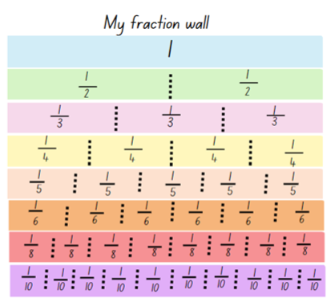
This table details opportunities for differentiation.
Too hard? | Too easy?
Stage 2 students cannot model fractions with fraction strips for thirds, fifths, sixths and tenths or create fractional parts of a length using techniques other than repeated halving.  - Model creating thirds by holding the strip as a loop and estimating where 2 folds can be made to create 3 equal parts. Students check estimation by folding and comparing the 3 parts. Repeat to model fifths.  - Model fractions using concrete materials such as coloured rods.  - Students use their fraction wall to explore thirds, fifths, sixths and tenths. | Stage 2 students can model fractions with fraction strips for thirds, fifths, sixths and tenths using techniques other than repeated halving.  - Students explore equivalence by folding strips of paper. They identify, create and label as many fractions equivalent to one-third as possible.

Stage 3 task – cross-country race
The table below contains a suggested learning intention and success criteria. These are best co-constructed with students.
Core concept learning intention | Core concept success criteria
Students working towards Stage 3 outcomes are learning to:  - compare and order common unit fractions. | Students working towards Stage 3 outcomes can:  - compare unit fractions as numbers to the benchmark value $\frac{1}{2}$  - compare and order unit fractions by placing them on a number line.
- Display Resource 6 – distance travelled (part 1) and explain to students that the number lines show how far each student has run in the cross-country race.
- Explain that the number 1 on each number line represents the common whole, which in this scenario is the entire distance of the race. Ask students to consider how far Amira has run and identify that the mark represents $\frac{1}{2}$, so Amira has completed half of the race.
- Provide students with Resource 6 – distance travelled (part 1) and Resource 7 – distance travelled (part 2). Students label the number lines with the fraction that represents how much of the race each student has completed.
- Students determine what fractions of the distance is left for each student to complete the run (the complementary fractional part).
- Regroup and ask:
- How did the benchmark value of $\frac{1}{2}$ help you identify the other unit fractions?
- Consider Jake and Omar’s distances. In terms of equivalent fractions, what is $\frac{1}{4}$ also known as? (two-eighths)
- Consider Maissa and Niamh’s distances. What is $\frac{1}{3}$also known as? (two-sixths)
This table details opportunities for differentiation.
Too hard? | Too easy?
Stage 3 students cannot compare unit fractions as numbers to the benchmark value $\frac{1}{2}$ or compare and order unit fractions by placing them on a number line.  - Label half on each number line for students to use as a benchmark to locate other unit fractions.  - Reduce the number lines used to those with fractions of half, quarter and eighth. Revise the use of repeated halving. | Stage 3 students can compare unit fractions as numbers to the benchmark value $\frac{1}{2}$ and compare and order unit fractions by placing them on a number line.  - Students label non-unit fractions on the number line; for example, $\frac{2}{3}$, $\frac{3}{5}$, $\frac{6}{8}$ and so on.

Discuss and connect the mathematics – 15 minutes
- Ask Stage 3 students to draw a number line on individual whiteboards from 0–1. Students place a mark on their line to represent these unit fractions: $\frac{1}{8},\frac{1}{6},\frac{1}{5},\frac{1}{4},\frac{1}{3},\frac{1}{2}$ (see Figure 7).
Figure 7 – marked number line
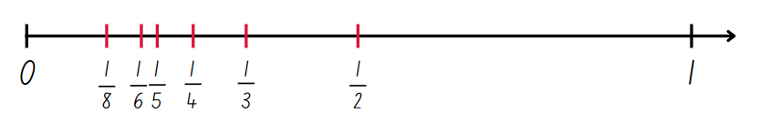
- Explain to Stage 3 students that by placing fractions on a number line, their position and relationship to the common whole, the number one, can be seen. On a number line fractions can be ordered and compared by size.
- Pose the scenario to Stage 3 students: Adrian says this number line is incorrect because the fractional marks are not equally spaced along the line. Is he correct? Students record their answer and reasoning.
- While Stage 3 students are working, draw attention to Stage 2 fraction walls. Ask:
- How many halves make a whole?
- How many fifths make a whole?
- How many tenths make a whole?
- What else do you notice? (Draw students’ attention to see that more partitions produce smaller equal parts and that some fractions are the same size on the wall, for example, 2 quarters, 3 sixths, 4 eighths and 5 tenths.)
This table details opportunities for assessment.
Assessment opportunities | Links
What to look for:  - Can Stage 2 students model fractions with fraction strips for thirds, fifths, sixths and tenths? [MAO-WM-01, MA2-PF-01]  - Can Stage 2 students create fractional parts of a length using techniques other than repeated halving? [MAO-WM-01,  MA2-PF-01]  - Can Stage 3 students compare unit fractions as numbers to the benchmark value $\frac{1}{2}$? [MAO-WM-01, MA3-RQF-01]  - Can Stage 3 students compare and order unit fractions by placing them on a number line? [MAO-WM-01, MA3-RQF-01] | Links to National Numeracy Learning Progressions (NNLP):  - Stage 2 – InF2, InF3, InF4  - Stage 3 – InF5, InF6, InF7.  Links to suggested Interview for Student Reasoning (IfSR) tasks:  - Stage 3 – IfSR-PT: 1A.2, 1A.3  - Stage 3 – IfSR-MT: 3B.3, 3B.4.

Lesson 3
Core concept: fraction strips can be used to represent fractions (Stage 2) and comparing fractional parts of different sized wholes (Stage 3).

Daily number sense – broken fraction wall – 10 minutes
The table below contains suggested learning intentions and success criteria. These are best co-constructed with students.
Daily number sense learning intentions | Daily number sense success criteria
Students working towards Stage 2 outcomes are learning to:  - model and represent unit fractions, and their multiples, to a complete whole on a number line.  Students working towards Stage 3 outcomes are learning to:  - compare and order common unit fractions. | Students working towards Stage 2 outcomes can:  - determine the fractional part needed to make a whole.  Students working towards Stage 3 outcomes can:  - compare and order unit fractions with denominators of 2, 3, 4, 5, 6, 8 and 10 by placing them on a number line.
- Display Resource 8 – broken fraction wall and explain that Maya’s little brother scribbled on her fraction wall. She has forgotten how many fractional parts are missing from each length.
- Students turn and talk and discuss how they could support Maya to understand what is missing. Students share their strategies with the class.
- Ask all students: How does the fraction symbol help you determine how many parts are needed to make the whole?
- Stage 3 students represent $\frac{1}{8},\frac{1}{6},\frac{1}{4},\frac{1}{3}$ on one number line and determine the largest and smallest fraction. Students justify their thinking.
This table details opportunities for assessment.
Assessment opportunities | Links
What to look for:  - Can Stage 2 students determine the fractional part needed to make a whole? [MAO-WM-01, MA2-PF-01]  - Can Stage 3 students compare and order unit fractions with denominators of 2, 3, 4, 5, 6, 8 and 10 by placing them on a number line? [MAO-WM-01, MA3-RQF-01] | Links to National Numeracy Learning Progressions (NNLP):  - InF3, InF4.

Core lesson – 40 minutes

Stage 2 task – representing fractions
The table below contains a suggested learning intention and success criteria. These are best co-constructed with students.
Core concept learning intention | Core concept success criteria
Students working towards Stage 2 outcomes are learning to:  - model and represent unit fractions, and their multiples, to a complete whole on a number line. | Students working towards Stage 2 outcomes can:  - model fractions using fraction strips and number line diagrams  - recreate the whole from a fractional part.
- Draw a line on the board. Divide the line into 4 equal parts to show the fractional parts as quarters of the line (see Figure 8).
Figure 8 – fractions of a line
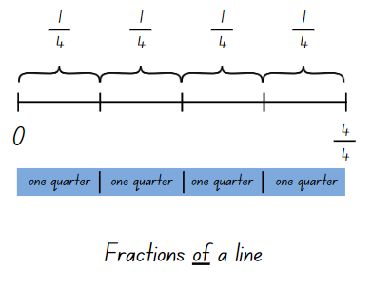
- Explain that each segment shows one-quarter of the whole. Demonstrate how to record the notation for the fractional parts above the line.
- Display Resource 9 – fractions of a length. Select students to record the fractional notation for halves, thirds, quarters and eighths above the line.
Note: when printing Resource 10 – quarters and tenths, ensure that each set makes the same size whole. There are 2 different sized sets of wholes so half of the students will receive one size and the remaining group will receive a different size. This encourages students to think about the size of the parts they combine as they will need 4 equal-sized quarters to form the whole. Cut cards prior to the lesson.
- Provide each student with Resource 10 – quarters and tenths. Tell students they are going to play a fractions game where they need to recreate the whole from a fractional part.
- Students shade one-quarter of their strip and fold it so only the shaded quarter is showing.
- On a signal, students form groups to make exactly one whole or 4 quarters. When they have made a whole, students hold their strips next to each other to show 4 equal-sized quarters which makes a whole.
- Students then choose to keep one-quarter of their strip shaded or change the shaded fraction to represent two-quarters or three-quarters of the whole of the strip.
- On a signal, students combine to make a whole.
- Using Resource 10 – quarters and tenths, repeat the process for the fractions game with tenths. Students can choose to shade two-, three-, four-, five- or six-tenths on their card.
This table details opportunities for differentiation.
Too hard? | Too easy?
Stage 2 students cannot model fractions using fraction strips and number line diagrams or recreate the whole from a fractional part.  - Provide students with 2 strips of different lengths that have been folded into quarters. Students colour $\frac{1}{4}$ in red and $\frac{3}{4}$ in yellow and label the fractional parts that form the whole. | Stage 2 students can model fractions using fraction strips and number line diagrams and recreate the whole from a fractional part.  - Students combine fractional parts other than quarters and tenths to make a whole.

Stage 3 task – pattern block fractions
The table below contains a suggested learning intention and success criteria. These are best co-constructed with students.
Core concept learning intention | Core concept success criteria
Students working towards Stage 3 outcomes are learning to:  - recognise the role of the number 1 as representing the whole. | Students working towards Stage 3 outcomes can:  - compare halves and thirds of different sized wholes.
- Provide pairs with a collection of pattern blocks and have them determine the fractional part of the red, blue and green blocks in relation to the yellow hexagon, one whole (red = $\frac{1}{2}$, blue = $\frac{1}{3}$ and green = $\frac{1}{6}$).
- Ask students to place a blue block on top of a yellow block and a green block on a red block (see Figure 9). Students Think-Pair-Share what they notice and what they wonder about these fractional representations.
Figure 9 – pattern block example
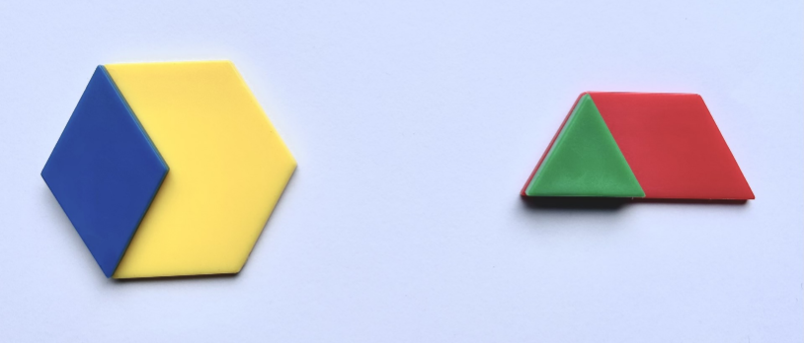
The table below outlines stimulus prompts to generate conversation about the topic, along with anticipated responses from students.
Prompts | Anticipated student responses
- What did you notice? | - Both show one-third of a whole.  - I can see each represents one-third of the whole block because if I had 3 blue rhombuses, I would cover the whole yellow block.  - The third represented by the blue rhombus is larger than the third represented by the green triangle.
- What did you wonder? | - I wonder if these representations show equivalent fractions?  - I wonder if I placed a blue rhombus on the red trapezium, would it still represent one-third of the whole?  - I wonder if I placed the blue rhombus in a different position on the yellow hexagon, or the green triangle in a different position on the red trapezium, would they both still represent a third?
- Display and provide pairs with Resource 11 – fraction mosaics.
- Refer to image A and ask students to turn and talk and identify what the green part would be as a fraction of the whole. ($\frac{1}{10}$)
- Ask students to determine and label the fraction represented by the colour green in each image. Support the use of fractional language such as whole, equivalent, equal to, thirds, one-third, sixths, 2 fifths, partition and so on.
- Repeat the process, determining and labelling the fraction represented by the colour red in each image.
- Refer to images B and F on Resource 11 – fraction mosaics. Highlight that the red fractional part in B is $\frac{1}{3}$ and the red fractional part in F is $\frac{1}{2}$. Ask students to Think-Pair-Share and justify how this is true.
This table details opportunities for differentiation.
Too hard? | Too easy?
Stage 3 students cannot compare halves and quarters of different sized wholes.  - Recreate D from Resource 11 – fraction mosaics using pattern blocks. Make an additional mosaic using 2 red blocks and 6 green blocks. Support students to see that each mosaic is one whole and that each whole consists of half green and half red, despite the increase in block numbers. | Stage 3 students can compare halves and quarters of different sized wholes.  - Challenge students to determine the fractional part of the blue, yellow and red blocks on Resource 11 – fraction mosaics.  - Students create their own pattern block investigation and record it on isometric paper. Students work out the fractions represented by each colour of their own pattern block mosaics.

Discuss and connect the mathematics – 10 minutes
- Pose the following scenario: Emilia ate $\frac{1}{4}$ of a cake and Abdullah ate $\frac{1}{2}$ of a cake. Emilia says that she ate more than Abdullah. How could this be true?
- Students turn and talk and discuss possibilities of how this could be true. Revise that when there are different sized wholes, the size of the fractional parts is dependent on the size of the whole.
This table details opportunities for assessment.
Assessment opportunities | Links
What to look for:  - Can Stage 2 students model fractions using fraction strips and number line diagrams? [MAO-WM-01, MA2-PF-01]  - Can Stage 2 students recreate the whole from a fractional part? [MAO-WM-01, MA2-PF-01]  - Can Stage 3 students compare halves and quarters of different sized wholes? [MAO-WM-01, MA3-RQF-01] | Links to National Numeracy Learning Progressions (NNLP):  - Stage 2 – InF2, InF3, InF4, InF5  - Stage 3 – InF5.

Lesson 4
Core concept: fraction strips and number lines can be used to represent fractions (Stage 2) and unit fractions can be compared and ordered on a number line (Stage 3).

Daily number sense – 10 minutes
- From a class need surfaced through formative assessment data, identify a short, focused activity that targets students’ knowledge, understanding and skills. Example activities may be drawn from the following resources:
- Mathematics K–6 resources
- Universal Resources Hub.

Core lesson – 40 minutes

Stage 2 task 1 – finding the complement
The table below contains a suggested learning intention and success criteria. These are best co-constructed with students.
Core concept learning intention | Core concept success criteria
Students working towards Stage 2 outcomes are learning to:  - model and represent fractions to a complete whole on a number line. | Students working towards Stage 2 outcomes can:  - model fractions with diagrams for halves, quarters, eighths and thirds on a number line  - determine the complementary fractional part needed to complete a whole.
- Review Maya’s broken wall (from Lesson 3) and the strategies that were used to repair Maya’s broken wall. Tell students they will be using the same thinking to complete the following investigation.
- Display Fraction Tiles and Number Line.
- Drag a green whole length and 7 pink eighths onto the screen.
- Model finding the fraction represented by all the pink fractional parts together. Identify the complementary fractional part needed to complete one whole. Record using the pencil tool as shown in Figure 10.
Figure 10 – finding the complement
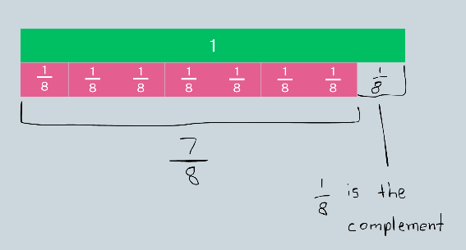
- Repeat, displaying 3 quarters and ask students to determine the complementary fractional part.
- Provide pairs of students with a digital device to use Fraction Tiles and Number Line. Students take turns creating a fractional part for their partner. The partner identifies the complement and records this using the pencil tool. Repeat and swap roles.
This table details opportunities for differentiation.
Too hard? | Too easy?
Stage 2 students cannot determine the complementary fractional part needed to complete a whole.  - Provide students with a strip of paper and ask them to repeatedly halve it into quarters. Students colour 3 quarters and then determine the complementary fractional part by the number of parts left uncoloured. Repeat with eighths.  - Using Fraction Tiles and Number Line, students drag the green bar and 4 orange quarter bars. Remove one quarter bar to demonstrate the complement.  - Students use their fraction wall to identify complementary fractional parts. | Stage 2 students can determine the complementary fractional part needed to complete a whole.  - Students find the complementary fractional part from non-unit fractions. For example, two-eighths.

Stage 2 task 2 – fractions on a number line
- Explain that fractions can also be represented as a number on a number line.
Note: the distinction between the 2 is that fractions of a length indicate a ‘part’ of a line or length and fractions as a number sit at a ‘point’ on a number line. This may be the first time students understand that there are numbers between 0 and 1.
- Draw a line on the board and label 0 and 1 to show where the line starts and finishes. Place 3 equally spaced marks on the line and explain that each mark represents the position of a fraction as a number.
- Students turn and talk and determine the fractions that would be placed on the number line between 0 and 1.
- Select students to name and label the marks using fraction notation (see Figure 11).
Figure 11 – fractions of a line and fractions on a line
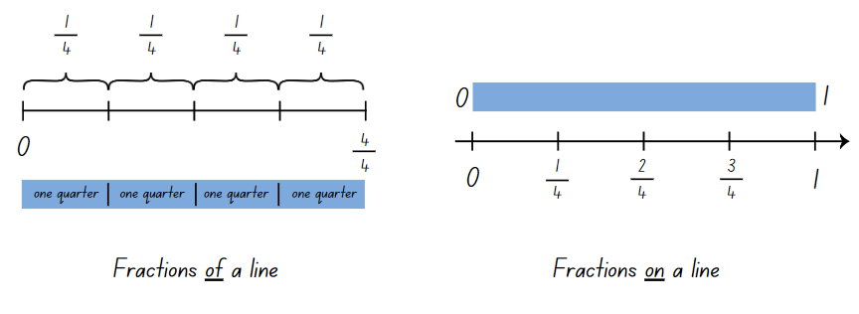
- Ask students to consider the similarities and differences between the 2 fraction representations and situations where each may be useful.
The table below outlines stimulus prompts to generate conversation about the topic, along with anticipated responses from students.
Prompts | Anticipated student responses
- What are some similarities between the 2 fraction representations? | - Both lines start at 0.  - Both represent quarters.  - There are 4 equal partitions on both lines.
- What are some differences between the 2 fraction representations? | - Fractions of a line – the line ends at $\frac{4}{4}$ whereas fractions on a line, the line ends at one but the arrow indicates it keeps going.  - Fractions of a line – the equal parts are labelled as $\frac{1}{4}$, but fractions on a line are labelled with the fraction as a number.  - Fractions on a line – indicate a number as a point on a number line.
- Can you think of any situations where either representation may be useful? | - Fractions of a line – cutting a slab cake lengthways into equal slices.  - Fractions on a line – units of measurement, for example, measuring a $\frac{3}{4}$ cup of milk.
- Repeat the number line demonstration with a line segmented into eighths.
- Provide students with Resource 12 – fractions on a number line. Students record the missing fractions on the number line.
This table details opportunities for differentiation.
Too hard? | Too easy?
Stage 2 students cannot model fractions with diagrams for halves, quarters, eighths and thirds on a number line.  - Provide students with 3 strips of paper and have them repeatedly halve to create halves, quarters and eighths. Glue the strips onto paper and draw a number line directly under each strip. Support students to create marks on the line where the fold lines are and label the fractions on the number line.  - Students can use their fraction wall as a scaffold to help make diagrams for halves, quarters and thirds on the number line. | Stage 2 students can model fractions with diagrams for halves, quarters, eighths and thirds on a number line.  - Students draw a number line from 0–2 and label the fractions for halves, quarters, eighths and thirds.

Stage 3 task – one as the common whole
The table below contains suggested learning intentions and success criteria. These are best co-constructed with students.
Core concept learning intentions | Core concept success criteria
Students working towards Stage 3 outcomes are learning to:  - compare and order common unit fractions  - compare common fractions with related denominators. | Students working towards Stage 3 outcomes can:  - compare unit fractions as numbers to the benchmark value $\frac{1}{2}$  - record equivalent fractions using diagrams, words and fraction notation.
Note: less than (<) and greater than (>) symbols are not specifically referenced in the Mathematics K–10 Syllabus but are important symbols for students to understand. This lesson provides an opportunity for students to use these symbols in context.
- Draw a number line on the board from 0–1. Identify and label some benchmark fractions. Explain that when fractions are represented on a number line, they always refer to the number 1 as the common whole. When the whole equals 1, fractions can be compared, ordered, added and subtracted.
- Students partition and label a number line from 0–1 into tenths.
- Display Resource 13 – fractions wall and have students identify equivalent fractions for $\frac{5}{10}$ ($\frac{1}{2}$, $\frac{2}{4}$, $\frac{3}{6}$, $\frac{4}{8}$)
- Students label their number line with equivalent fractions for quarters and thirds.
- Recreate Figure 12 on the board and have students to use their number line and writing materials to find a solution.
Figure 12 – equivalent fractions
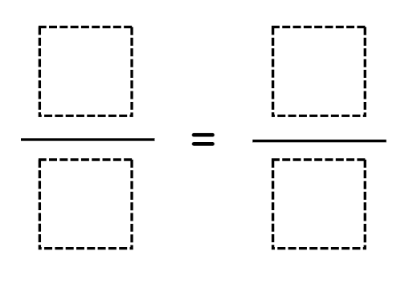
- Ask:
- How do you know that these are equivalent fractions?
- What do you notice about the denominators?
- Is there more than one correct answer for a single fraction?
- Can you think of any other equivalent fractions that are not represented on your number line?
- Using the benchmark value $\frac{1}{2}$, students compare unit fractions by using the greater than and less than symbols to create number sentences. Ask students to record multiple solutions (see Figure 13).
Figure 13 – greater than and less than
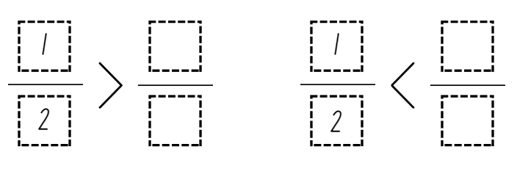
- Regroup and select students to share their solutions by adding the fractions onto a number line labelled 0–1 on the board.
- Discuss the chosen numerators and denominators for each of the missing fractions and ask students to explain why the fraction is greater than or less than half.
This table details opportunities for differentiation.
Too hard? | Too easy?
Students cannot compare unit fractions as numbers to the benchmark value $\frac{1}{2}$.  - Model naming and labelling some benchmark fractions on a number line.  - Model using the fraction wall to identify fractions smaller and larger than $\frac{1}{2}$. | Students can compare unit fractions as numbers to the benchmark value $\frac{1}{2}$.  - Students complete greater than or less than number sentences using a variety of benchmark fractions.  - Students compare non-unit fractions to $\frac{1}{2}$ and identify which is larger or smaller.

Consolidation and meaningful practice – 10 minutes
- For Stage 2 students: display Resource 14 – complementary fraction parts. Students determine the complementary fractional part needed to complete the whole for each length.
Complement: the amount you must add to something to make it ‘whole’ (Math Open Reference 2011).
- Share the definition of ‘complement’. Ask students how this definition supports their understanding of complementary fractional parts.
- For Stage 3 students: reproduce Figure 14 on the board and ask students to copy it into their workbooks.
Figure 14 – greater than
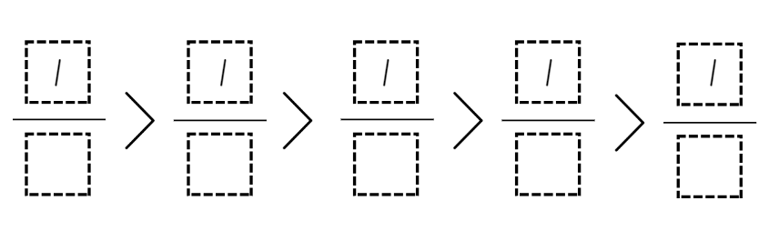
- Students share what they notice about the numerator for each fraction.
- Students select a denominator for each fraction to make the number sentence true. They can use fractions from their number lines or the fraction wall, or they can choose other fractions. For example, student responses may include $\frac{1}{3}$ > $\frac{1}{4}$ > $\frac{1}{5}$ > $\frac{1}{8}$ > $\frac{1}{10}$ or $\frac{1}{1}$ > $\frac{1}{10}$ > $\frac{1}{100}$ > $\frac{1}{1000}$ > $\frac{1}{10 000}$.
- When students have explored this, ask:
- What did you notice about the size of the parts (denominator)? (With unit fractions, the greater the denominator, the smaller the fractional parts.)
- Would it be easier or more challenging to complete this task if you could use choose your own numerators?
- How many unit fractions fall between zero and one on a number line? (An infinite number.)
This table details opportunities for assessment.
Assessment opportunities | Links
What to look for:  - Can Stage 2 students model fractions with diagrams for halves, quarters, eighths and thirds on a number line? [MAO-WM-01, MA2-PF-01]  - Can Stage 2 students determine the complementary fractional part needed to complete a whole? [MAO-WM-01, MA2-PF-01]  - Can students compare unit fractions as numbers to the benchmark value $\frac{1}{2}$? [MAO-WM-01, MA3-RQF-01]  - Can students record equivalent fractions using diagrams, words and fraction notation? [MAO-WM-01, MA3-RQF-01,  MA3-RQF-02] | Links to National Numeracy Learning Progressions (NNLP):  - Stage 2 – InF2, InF3, InF4  - Stage 3 – InF5, InF6, InF7.  Links to suggested Interview for Student Reasoning (IfSR) tasks:  - Stage 3 – IfSR-PT: 1A.2, 1A.3  - Stage 3 – IfSR-MT: 3B.3, 3B.4.

Lesson 5
Core concept: partitioned fractions can have different sized wholes (Stage 2) and adding fractions with the same denominator (Stage 3).

Daily number sense – cover the multiples – 15 minutes
Daily number sense activities for Lessons 5 to 7 ‘loop’ back to concepts and procedures covered in previous units to assist students to build an increasingly connected network of ideas. These concepts may differ from the core concepts being covered by the unit.
The table below contains suggested learning intentions and success criteria. These are best co-constructed with students.
Daily number sense learning intentions | Daily number sense success criteria
Students working towards Stage 2 outcomes are learning to:  - identify multiples of 2, 4, 5 and 10.  Students working towards Stage 3 outcomes are learning to:  - determine products and factors. | Students working towards Stage 2 outcomes can:  - identify multiples of 2, 4, 5 and 10  - relate doubling to multiplication facts for multiples of 2.  Students working towards Stage 3 outcomes can:  - use the term product to describe the result of multiplying 2 or more numbers.
This activity is an adaptation of Common Multiples from NZ Maths by the New Zealand Ministry of Education.
- Display Resource 15 – ‘Multiples’ gameboard (Stage 2) and Resource 16 – ‘Multiples’ gameboard (Stage 3). Model the game by randomly choosing a card from Resource 17 – ‘Multiples’ rule cards and asking which numbers can be covered up with counters. For example, getting the rule card 4 means that the multiples 4, 8, 12, 16, 20, 24, 28 and 32 can be covered on the Stage 2 gameboard. Place the rules card on the bottom of the pile and draw another card. As you model the game, highlight patterns related to multiples such as doubles.
- Repeat twice more. If a number is identified as a multiple of more than one rule card, multiple counters can be placed on that number. For example, 20 will be a multiple of 2, 4, 5 and 10.
- After 3 turns, count how many numbers on the gameboard are covered.
- Provide small groups of Stage 2 students with Resource 15 – ‘Multiples’ gameboard (Stage 2), Stage 3 students with Resource 16 – ‘Multiples’ gameboard (Stage 3), and all groups with Resource 17 – ‘Multiples’ rule cards and counters. Students take turns to draw a rule card. They cover the multiples of that rule card on their gameboard only and justify their thinking. After 3 turns each, students work out who has covered the most multiples.
- Ask students to identify and discuss which numbers have more than one counter on them and why some numbers on their board are uncovered.
Multi-age: students may enjoy the challenge of working with other multiples, such as 3, 7 and 9, and making their own gameboards to play with, or thinking about why some numbers on the gameboard never get covered.
This table details opportunities for assessment.
Assessment opportunities | Links
What to look for:  - Can Stage 2 students identify multiples of 2, 4, 5 and 10?  [MAO-WM-01, MA2-MR-01]  - Can Stage 2 students relate doubling to multiplication facts for multiples of 2? [MAO-WM-01, MA2-MR-01]  - Can Stage 3 students use the term product to describe the result of multiplying 2 or more numbers? [MAO-WM-01, MA3-MR-01] | Links to National Numeracy Learning Progressions (NNLP):  - Stage 2 – MuS6  - Stage 3 – MuS6.

Core lesson – 40 minutes

Stage 2 task – finding the whole
The table below contains a suggested learning intention and success criteria. These are best co-constructed with students.
Core concept learning intention | Core concept success criteria
Students working towards Stage 2 outcomes are learning to:  - model and represent unit fractions to complete a whole on a number line. | Students working towards Stage 2 outcomes can:  - recreate the whole unit from a fractional part.
This activity is an adaptation from Primary and Middle Years Mathematics: Teaching Developmentally by Van de Walle et al.
- Display Cuisenaire Environment and drag one of each rod onto the background. Explain that these rods will help to visualise the fractions in the following questions (see Figure 15).
Figure 15 – Cuisenaire Environment
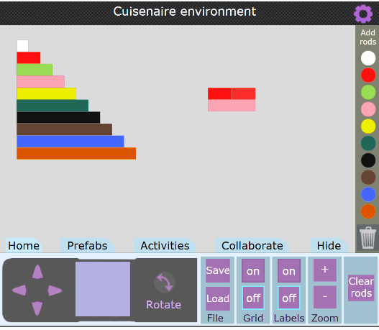
Image created using Cuisenaire Environment by University of Cambridge.
- Drag a red rod onto the background. Explain that this red rod is half the length of the whole. Ask: Which coloured rod is the whole?
- Students turn and talk to determine the length of the whole.
- Prompt students to communicate their reasoning to the class.
- Model dragging an additional red rod onto the background to make two-halves. Explain that two-halves is equivalent to the whole length. Drag the equivalent rod of the same length underneath, showing the pink rod represents the whole.
- Provide pairs with a digital device to access Cuisenaire Environment.
- Display Resource 18 – finding the whole and have students investigate the lengths of each whole when given a fractional part.
- Regroup as a class and select students to share their findings.
- Explain to students that we can use reversible reasoning to find the length of a fractional part if we know the length of the whole. Pose the following question for students to solve: If brown is the whole, find one-quarter. (red)
This table details opportunities for differentiation.
Too hard? | Too easy?
Stage 2 students cannot recreate the whole unit from a fractional part.  - Students complete questions 1, 4, 5, 8, 9 and 10 which recreate the whole from one fractional part.  - Use hands-on materials such as coloured rods or coloured strips of paper to manipulate the fractional parts. | Stage 2 students can recreate the whole unit from a fractional part.  - Students create their own ‘coloured rods’ from coloured paper strips, ensuring equal sized wholes before folding and cutting fractional parts.  - Students solve the following problems:  - If dark green is one whole, which rod is two-thirds? (pink)  - If dark green is one whole, which rod is three-halves? (blue)  - Students create their own problems for their partner to solve.

Stage 3 task – adding fractions
The table below contains a suggested learning intention and success criteria. These are best co-constructed with students.
Core concept learning intention | Core concept success criteria
Students working towards Stage 3 outcomes are learning to:  - solve problems involving addition of fractions with the same denominator. | Students working towards Stage 3 outcomes can:  - represent the sum of fractions with the same denominator, recreating the whole, where the result may exceed one.
- Ask students to relate what they know about using bar models to solve problems. Facilitate the discussion using the following points:
- bar models help to visualise parts of a whole.
- bar models show one whole made up of or divided into 2 or more parts.
- the bar model can be used to identify missing fractional parts of the whole.
- Display Resource 19 – bar model and ask students to Think-Pair-Share what they notice and what they wonder about the bar model image. Explain that the image could represent $\frac{1}{5}$ + $\frac{2}{5}$ = $\frac{3}{5}$ or $\frac{1}{5}$+ $\frac{2}{5}$+ $\frac{2}{5}$ = $\frac{5}{5}$. Record the fraction notation on the board.
- Explain that bar models can be useful when adding and subtracting fractions.
- Model using Amplify Polypad – Fraction Bars to demonstrate adding fractions (with the same denominator) on a bar model. Use an orange $\frac{1}{1}$ bar to provide a visual for the common whole (see Figure 16).
Figure 16 – bar model for addition
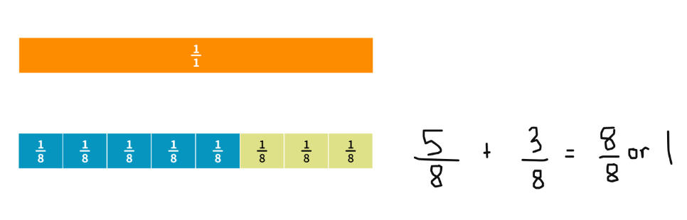
Image created using the free virtual manipulatives at Polypad by Amplify.
- Ask students to turn and talk and share why $\frac{8}{8}$ is equal to 1. (When the numerator and denominator are the same, they represent one whole.)
Note: watch the tutorial Colour Mixing Fraction Bars – Amplify (1:42) to learn how to split the individual fraction parts and change the colours.
- Provide students with a digital device and ask them to represent the following using bar models and fraction notation on Amplify Polypad – Fraction Bars:
- $\frac{1}{4}+\frac{3}{4}$
- $\frac{2}{6}+\frac{4}{6}$
- $\frac{7}{8}+\frac{1}{8}$
- $\frac{2}{5}+\frac{3}{5}$.
- Regroup as a class and model representing the sum of fractions where the result exceeds one (see Figure 17).
Figure 17 – exceeding the whole
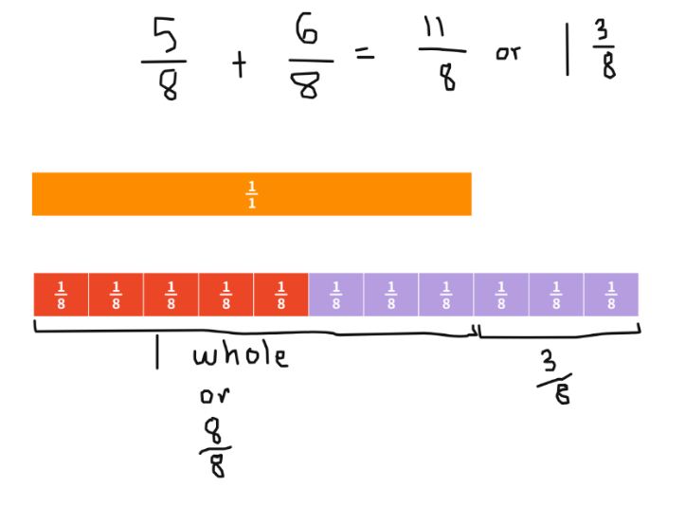
Image created using the free virtual manipulatives at Polypad by Amplify.
Note: in the syllabus, the expression ‘fraction greater than one’ is used instead of the terms ‘improper fraction’ or ‘mixed numeral’.
- Explain that 1 $\frac{3}{8}$ represents one whole and 3 more eighths. This can be written as $\frac{11}{8}$ or 1 $\frac{3}{8}$.
- Students return to their digital device and represent the following questions where the result exceeds one whole.
- $\frac{4}{5}+\frac{3}{5}$
- $\frac{7}{8}+\frac{5}{8}$
- $\frac{5}{6}+\frac{3}{6}$
- $\frac{2}{3}+\frac{2}{3}$.
- Allow students to explore and represent their own fraction sums using the bar model on Amplify Polypad – Fraction Bars.
This table details opportunities for differentiation.
Too hard? | Too easy?
Stage 3 students cannot represent the sum of fractions with the same denominator or recreate the whole where it exceeds one.  - Support students to use a fraction wall or fraction tiles to recreate the sum of fractions.  - Students use fraction strips to cut and colour each of the fractional parts. Discuss the equal parts that exceed the whole and label the fraction, representing the sum where the solution exceeds one. | Stage 3 students can represent the sum of fractions with the same denominator or recreate the whole where it exceeds one.  - Students investigate a fraction sum involving 3 or 4 addends.  - Students add fractions with related denominators.  - Students create a challenging word problem where the solution exceeds 2 wholes for a partner to solve.

Discuss and connect the mathematics – 10 minutes
This activity is an adaption of ‘What's The Split?’ in Exploring the Edges of Mathematical Ideas by Epstein.
- Display Resource 20 – make 2 groups (Stage 2) and Resource 21 – make 2 groups (Stage 3). Ask students to consider the 4 fraction representations and sort them into 2 groups.
- Select students to share their groupings and provide justification for their choices.
Note: the 2 groups do not need to be equal. For example, one group may have one representation and the other group may have 3. Students must be able to reason as to why they have organised the representations into each group. This task is dependent on students’ ability to reason and provide justifications for their choices.
The table below outlines possible solutions, along with anticipated responses from Stage 2 students.
Stage 2 Possible solutions | Stage 2 Anticipated student responses
- Group 1: A. Group 2: B, C and D | - A is the only one that shows a length with unequal partitions.
- Group 1: A and C. Group 2: B and D | - B and D both represent $\frac{1}{2}$ or $\frac{2}{4}$.
- Group 1: A, C and D. Group 2: B | - A, C and D are represented on a straight length. B is not straight.
The table below outlines possible solutions, along with anticipated responses from Stage 3 students.
Stage 3 Possible solutions | Stage 3 Anticipated student responses
- Group 1: B and C. Group 2: A and D | - The sum of B and C both exceed one whole. A and D are less than one whole.
- Group 1: A and D. Group 2: C and D | - A and D have related denominators, sixths and twelfths.
- Group 1: B. Group 2: A, C and D | - B is the only sum that starts with a fractional part larger than one whole (1 $\frac{2}{5}$)
This table details opportunities for assessment.
Assessment opportunities | Links
What to look for:  - Can Stage 2 students recreate the whole unit from a fractional part? [MAO-WM-01, MA2-PF-01]  - Can Stage 3 students represent the sum of fractions with the same denominator, recreating the whole, where the result may exceed one? [MAO-WM-01, MA3-RQF-01] | Links to National Numeracy Learning Progressions (NNLP):  - Stage 2 – InF5  - Stage 3 – InF7, InF8.

Lesson 6
Core concept: complementary fractional parts create a whole (Stage 2) and add and subtract fractions with the same denominator (Stage 3).

Daily number sense – doubling and doubling again – 15 minutes
The table below contains suggested learning intentions and success criteria. These are best co-constructed with students.
Daily number sense learning intentions | Daily number sense success criteria
Students working towards Stage 2 outcomes are learning to:  - use arrays to establish multiplication facts from multiples of 2 and 4.  Students working towards Stage 3 outcomes are learning to:  - determine products and factors. | Students working towards Stage 2 outcomes can:  - use the array structure to coordinate the number of groups with the number in each group  - relate doubling to multiplication facts for multiples of 2.  Students working towards Stage 3 outcomes can:  - model different ways to show a whole number as a product  - determine factors for a given whole number.
- Model placing 2 counters, then another 2 counters to make a 2 × 2 array. Ask students to describe what has happened. For example, doubling the 2 counters or making twice as many counters. Some students may say ‘adding’. Reinforce the multiplicative strategy of doubling.
- Ask students how many counters there will be if the number is doubled. Place 4 more counters to extend the array. Count the total number of counters aloud, emphasising the doubling. For example, 2, double 2 is 4, double 4 is 8.
- Provide pairs of Stage 2 students with a large collection of counters.
- Ask Stage 2 students how many counters there will be if the total number is doubled again. Students use the counters to show doubling 8, using the counters to make an array. Count the total number of counters aloud emphasising the doubling. For example, 2, double 2 is 4, double 4 is 8, and double 8 is 16.
- Stage 2 students repeat the process again, modelling with counters and counting the doubling aloud.
- While Stage 2 students are working, ask Stage 3 students to record the number 3 on an individual whiteboard. Ask students to mentally double 3 (6), double 6 (12), double 12 (24). Explain that by doubling, we have found products where numbers have been multiplied by 2.
- Highlight that they have also found factors of 24. This ability to double can also be utilised to support repeated halving.
- Stage 3 students determine the factors of 48, 54, 72 and 96 using repeated halving. Ask if there are any other factors of these numbers which cannot be determined by repeated halving.
- Regroup and discuss how doubling and doubling again can help to find an answer to a multiplication problem when multiplying by 4.
- Ask students to identify a connection between doubling and halving and how this knowledge can help determine factors of a whole number.
This table details opportunities for assessment.
Assessment opportunities | Links
What to look for:  - Can Stage 2 students use the array structure to coordinate the number of groups with the number in each group? [MAO-WM-01, MA2-MR-01]  - Can Stage 2 students relate doubling to multiplication facts for multiples of 2? [MAO-WM-01, MA2-MR-01]  - Can Stage 3 students model different ways to show a whole number as a product? [MAO-WM-01, MA3-MR-01]  - Can Stage 3 students determine factors for a given whole number? [MAO-WM-01, MA3-MR-01] | Links to National Numeracy Learning Progressions (NNLP):  - Stage 2 – MuS5, MuS6  - Stage 3 – MuS6, MuS7.

Core lesson – 40 minutes

Stage 2 task – complementary fractions
The table below contains a suggested learning intention and success criteria. These are best co-constructed with students.
Core concept learning intention | Core concept success criteria
Students working towards Stage 2 outcomes are learning to:  - model and represent unit fractions, and their multiples, to a complete whole on a number line. | Students working towards Stage 2 outcomes can:  - model fractions with strips and diagrams for halves, quarters, eighths and thirds  - describe complementary fractional parts needed to complete one whole.
The following activities are an adaptation from Open-Ended Maths Activities: Using Good Questions to Enhance Learning Mathematics by Sullivan and Lilburn.
- Provide students with multiple strips of white paper.
- Ask students: If you had $\frac{3}{4}$ of a strip of paper, how many more quarters would you need to make a whole? If you had $\frac{7}{8}$ of a strip of paper, how many more eighths would you need to make one whole? How do you know? Explain that the fractional part needed to make one whole is called the ‘complementary fraction’.
- Pose the question: How many different ways can you colour the length so that $\frac{3}{4}$ is red and $\frac{1}{4}$ is yellow? See Figure 18 for examples of correct solutions.
Figure 18 – correct solutions
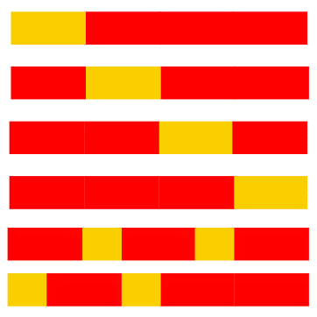
- Ask students to colour their lengths and label the fractional parts of the whole using fraction notation.
- Under each strip, students draw a number line and record the marks for zero and one before adding in the fractions as numbers on the number line.
- Regroup and discuss the different options.
- Provide students with additional strips of paper. State that this time, $\frac{2}{5}$ of the strip is green and the rest is blue. What could the coloured strip look like?
- Students colour and label the fractional parts of their strip using fraction notation.
- Ask students to investigate possible options for what the strip might look like if 3 colours were used to represent fractional parts of the whole length where $\frac{3}{8}$ is green. For example, $\frac{3}{8}$ green, $\frac{1}{8}$ blue and $\frac{4}{8}$ yellow. Students colour and label the fractional parts using fraction notation.
- Students glue their strips onto an A3 piece of paper. Use a gallery walk to explore the various ways whole lengths can be partitioned.
This table details opportunities for differentiation.
Too hard? | Too easy?
Stage 2 students cannot describe complementary fractional parts needed to complete one whole or model fractions with strips and diagrams for halves, quarters, eighths and thirds.  - Provide students with strips of paper that have been pre-folded into quarters and eighths.  - Students refer to their fraction wall to determine the complementary parts. | Stage 2 students can describe complementary fractional parts needed to complete one whole or model fractions with strips and diagrams for halves, quarters, eighths and thirds.  - Students represent complementary fractional parts for fifths and tenths on a labelled number line.

Stage 3 task – the answer is…
The table below contains a suggested learning intention and success criteria. These are best co-constructed with students.
Core concept learning intention | Core concept success criteria
Students working towards Stage 3 outcomes are learning to:  - solve problems that involve addition and subtraction of fractions with the same denominator. | Students working towards Stage 3 outcomes can:  - represent the sum of fractions with the same denominator, recreating the whole, where the result may exceed one  - solve word problems that involve fractions with the same denominator.
- Display Resource 22 – making the whole, only revealing example A. Provide students with individual whiteboards.
- Ask students what they notice about the fractions represented in example A, drawing or writing their responses. Select students to share their findings with the class. Ask:
- Which one of the fraction strips represents one whole? How do you know?
- How many more eighths are needed to make 2 wholes?
- How could we represent the total number of fractional parts in symbolic notation? ($\frac{13}{8}$ or 1 $\frac{5}{8}$)
- Students Think-Pair-Share to determine possible addition sums if $\frac{13}{8}$ or 1 $\frac{5}{8}$ was the answer. For example, $\frac{2}{8}$ + 1 $\frac{1}{8}$ + $\frac{2}{8}$ or $\frac{10}{8}$ + $\frac{3}{8}$.
- Reveal the remaining examples on Resource 22 – making the whole. Explain that in pairs, students will investigate possible addition sums to match each example. Students can show their solutions by writing or drawing fraction strips on their individual whiteboard.
- Select pairs to share their solutions and explanations.
- Provide pairs with a digital device and an individual whiteboard. Explain that they will use the fraction bars or circles in Amplify Polypad – Fraction Bars to develop a fraction challenge for their partner by giving an answer and having their partner develop the question (see Figure 19). Ensure students are exploring a range of fractions, applying the correct vocabulary when discussing and focusing on adding fractional parts that exceed one whole.
Figure 19 – examples of student responses
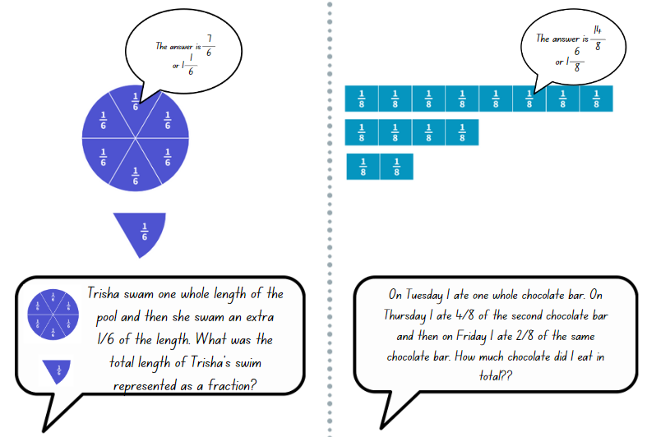
This table details opportunities for differentiation.
Too hard? | Too easy?
- Stage 3 students cannot solve problems that involve addition of fractions with the same denominator.  - Students use paper strips or coloured rods to represent the fractions. Support students to identify the parts and how many more are needed to make one whole.  - Model drawing a fraction strip that has equal parts and colour in the known parts to see what is missing. | - Stage 3 students can solve problems that involve addition of fractions with the same denominator.  - Students investigate fraction sums that exceed 2 wholes.  - Students develop addition sums that add 3 or more fractions. For example, $\frac{2}{5}$+ $\frac{4}{5}$ + 1 $\frac{1}{5}$= 2 $\frac{2}{5}$.

Consolidation and meaningful practice – 10 minutes
- Explain that 2 friends shared a liquorice strap that was cut into eighths. Each friend does not need to have an equal share.
- Ask students to determine the fraction of the liquorice strap that each friend may have eaten. Stage 2 students represent their thinking in a labelled drawing. Stage 3 students represent the 2 fractional amounts as an addition sum using symbolic notation in addition to a labelled drawing.
Multi-age: Stage 2 students repeat the task with 3 or 4 friends sharing the 8 pieces while Stage 3 students repeat the task with 3 friends sharing 2 $\frac{1}{2}$ wholes.
This table details opportunities for assessment.
Assessment opportunities | Links
What to look for:  - Can Stage 2 students model fractions with strips and diagrams for halves, quarters, eighths and thirds? [MAO-WM-01, MA2-PF-01]  - Can Stage 2 students describe complementary fractional parts needed to complete one whole? [MAO-WM-01, MA2-PF-01]  - Can Stage 3 students represent the sum of fractions with the same denominator, recreating the whole, where the result may exceed one? [MAO-WM-01, MA3-RQF-01]  - Can Stage 3 students solve word problems that involve fractions with the same denominator? [MAO-WM-01, MA3-RQF-01] | Links to National Numeracy Learning Progressions (NNLP):  - Stage 2 – InF2, InF3, InF4  - Stage 3 – InF7, InF8.

Lesson 7
Core concept: different sized wholes create different sized parts (Stage 2) and subtracting fractions with the same denominator (Stage 3).

Daily number sense – factors and multiples game – 10 minutes
The table below contains suggested learning intentions and success criteria. These are best co-constructed with students.
Daily number sense learning intentions | Daily number sense success criteria
Students working towards Stage 2 outcomes are learning to:  - use number properties to find related multiplication facts.  Students working towards Stage 3 outcomes are learning to:  - determine products and factors. | Students working towards Stage 2 outcomes can:  - generate and recall multiplication fact families up to 10 × 10.  Students working towards Stage 3 outcomes can:  - use the term product to describe the multiplying of 2 or more numbers  - model different ways to show a whole number as a product.
This activity is an adaptation of Product Game by the National Council of Teachers of Mathematics (NCTM).
- Display Product Game.
- Explain that the aim is to get 4 squares in a row vertically, horizontally or diagonally by multiplying 2 numbers each time to find a product. Explain that the term product is used to describe the answer when multiplying 2 or more numbers.
- Model the game. To begin the game, Player 1 moves a marker (a green square) to a number in the factor list from 1–9 along the bottom of the screen.
- Player 2 then moves the other marker (also a green square) to any number in the factor list. This includes the number marked by Player 1. Students determine the product of the 2 marked numbers and colour them red for Player 2.
- Player 1 moves a marker to another number and colours the new product blue.
- Players take turns moving a marker. Each product is marked red or blue, depending on the player. However, if a product is already coloured, the player does not get a square for that turn.
- Play continues until one player wins by finding 4 products in a vertical, horizontal or diagonal row, or until all squares have been coloured.
Note: if there is no access to the interactive gameboard, play the game using Resource 23 – ‘Product game’ and transparent counters.
- Students play the game in pairs. Some students may enjoy playing a more challenging version of the game using Resource 24 – modified ‘Product game’.
- Display Resource 25 – ‘Product game’ questions, and have students discuss these as they finish their game.
This table details opportunities for assessment.
Assessment opportunities | Links
What to look for:  - Can Stage 2 students generate and recall multiplication fact families up to 10 × 10? [MAO-WM-01, MA2-MR-01]  - Can Stage 3 students use the term product to describe the multiplying of 2 or more numbers? [MAO-WM-01, MA3-MR-01]  - Can Stage 3 students model different ways to show a whole number as a product? [MAO-WM-01, MA3-MR-01] | Links to National Numeracy Learning Progressions (NNLP):  - Stage 2 – MuS6  - Stage 3 – MuS6, MuS7.

Core lesson – 45 minutes

Stage 2 task – What could the whole be?
The table below contains a suggested learning intention and success criteria. These are best co-constructed with students.
Core concept learning intention | Core concept success criteria
Students working towards Stage 2 outcomes are learning to:  - model and represent unit fractions, and their multiples, to complete a whole on a number line. | Students working towards Stage 2 outcomes can:  - recreate the whole unit from a fractional part.
- Explain that when students can only see part of an object, they can use fractions to work out the part they cannot see.
- Display Resource 26 – chocolate bar 1. Explain that the visible chocolate is only a fraction of the whole bar. Ask students to turn and talk about what they can see and what they cannot see.
- Discuss what the whole chocolate bar might look like. For example, students can see $\frac{2}{6}$ and another $\frac{4}{6}$ are hidden inside the wrapper. Select students to draw and label the remaining fraction of the chocolate bar.
- Display Resource 27 – chocolate bar 2. Tell students that Alice is looking at a chocolate bar that has been partially covered by a cloth. Ask:
- What fraction of the chocolate might Alice think is uncovered and why?
- How many equal parts of chocolate would make the whole chocolate bar?
- Students turn and talk to discuss possibilities and record ideas using labelled diagrams (see Figure 20).
Figure 20 – recording fractions: some possibilities
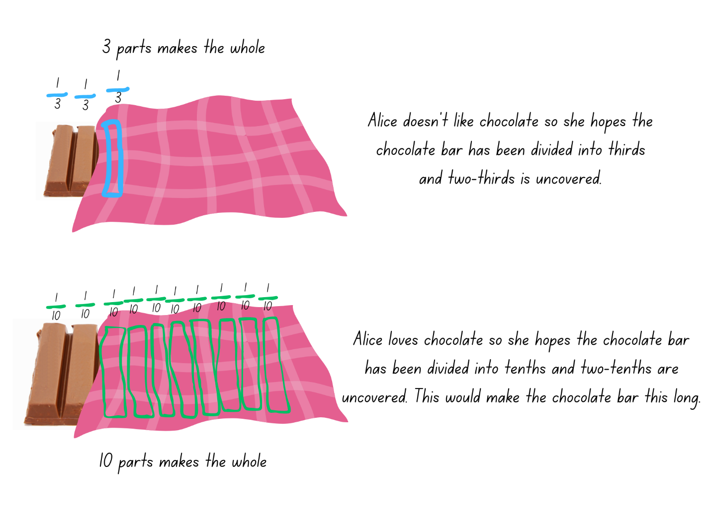
- Display Resource 28 – picture frame problem. Explain that the framer only had time to make one-third of the frame. Ask students how the frame could be finished. Draw the other two-thirds of the frame (see Figure 21) and label the fractions.
Figure 21 – recoding picture frame fractions
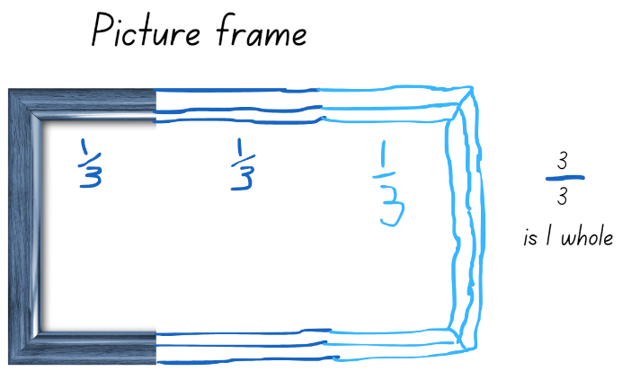
- Ask: What if the framer had only made one-fifth of the length of the frame? Students consider what the whole length of the frame could look like. Provide small groups of students with large paper and Resource 29 – frame beginnings. Students cut and paste the frame beginnings and record different ways that they could be finished (see Figure 22).
Figure 22 – examples of recording picture frame fractions
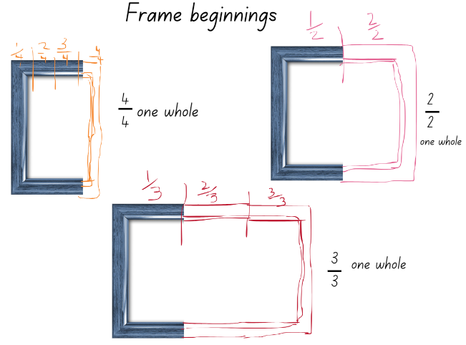
This table details opportunities for differentiation.
Too hard? | Too easy?
Stage 2 students cannot recreate the whole unit from a fractional part.  - Students work with cubes to explore recreating the whole.  - Model further possibilities for students using Resource 29 – frame beginnings. | Stage 2 students can recreate the whole unit from a fractional part.  - Students research artworks that would fit into their frames. For example, portraits, landscapes, panoramas.  - Students choose a classroom object, hide part of it and ask another student what fraction could be unseen.

Stage 3 task – subtracting fractions
The table below contains a suggested learning intention and success criteria. These are best co-constructed with students.
Core concept learning intention | Core concept success criteria
Students working towards Stage 3 outcomes are learning to:  - solve problems involving subtraction of fractions with the same denominator. | Students working towards Stage 3 outcomes can:  - find the difference between fractions with the same denominator and interpret the answer  - solve word problems that involve fractions with the same denominator  - use diagrams, objects and mental strategies to subtract a unit fraction from any whole number including 1.
- Ask: If $\frac{7}{10}$ is the answer:
- What could an addition question be?
- What could a subtraction question be?
- Model using the fraction bars in Amplify Polypad – Fraction Bars to solve the subtraction equation $\frac{7}{8}$ − $\frac{2}{8}$ (see Figure 23).
Figure 23 – subtraction equation
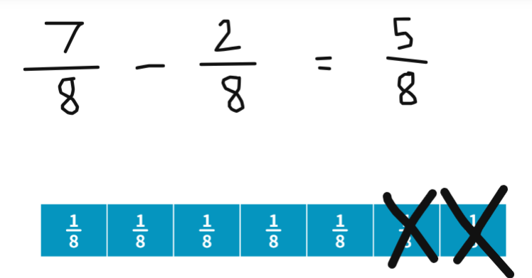
- Provide students with a digital device and ask them to use Amplify Polypad – Fraction Bars to solve the following subtraction problems:
- $\frac{9}{10}$ − $\frac{3}{10}$ = _
- $\frac{10}{12}$ − $\frac{6}{12}$ = _
- $\frac{8}{12}$ − $\frac{3}{12}$ = _
- 1$\frac{3}{4}$ − $\frac{5}{4}$ = _
- 1$\frac{5}{10}$ − $\frac{7}{10}$ = _
- Rehana and Angelina share a baguette that is cut into sixths. Rehana eats four-sixths. How much does Angelina receive? Is Angelina’s share greater than or less than one-half of the baguette?
- Max has one jelly snake. He eats three-eighths of it. How much does he have left?
- Francesca has completed $\frac{4}{5}$ of the swimming race. How much further does she have left to swim?
- Ranjeet had 2 blocks of chocolate. He gave a third of one block to his sister. How much is remaining?
- A pizza was cut into eighths. After Dad ate, there were six-eighths left. My brother ate three-eighths. How much is left for me?
- Students develop their own subtraction word problems that involve fractions with the same denominator.
- Select a few student word problems to share and solve as a class.
This table details opportunities for differentiation.
Too hard? | Too easy?
Stage 3 students cannot find the difference between fractions with the same denominator and interpret the answer, or use diagrams, objects and mental strategies to subtract a unit fraction from any whole number including 1.  - Use interlocking cubes to create the fraction bar length and model subtracting by removing the indicated amount. The individual cubes could be labelled with stickers to show the fractional part, for example, $\frac{1}{4},\frac{1}{4},\frac{1}{4},\frac{1}{4}$.  - Build 2 lengths with interlocking cubes to represent the equation and ask students to find the difference.  Stage 3 students cannot solve word problems that involve fractions with the same denominator.  - Provide students with the numerical equation and interlocking cubes to solve the problems. | Stage 3 students can find the difference between fractions with the same denominator and interpret the answer, and use diagrams, objects and mental strategies to subtract a unit fraction from any whole number including 1.  - Solve word problems involving adding or subtracting fractional quantities with related denominators.  - Use equivalence to add and subtract fractional quantities with related denominators.  Stage 3 students can solve word problems that involve fractions with the same denominator.  - Provide students with word problems that involve fractions with related denominators.

Discuss and connect the mathematics – 10 minutes
- Select Stage 2 students to share a variety of solutions to the framing problem. Prompt students to use appropriate fractional language to communicate their mathematical thinking. Key terminology related to this activity could include: whole, dependent on the whole, fractional parts, thirds, quarters, fifths, tenths.
- Record the following algorithm on the board: 1$\frac{4}{5}$ − $\frac{?}{5}$ = _? for Stage 3 students and encourage them to find multiple solutions, representing their thinking using diagrams, words and symbols.
- Record 2$\frac{3}{5}$ − $\frac{?}{5}$ = 1$\frac{?}{5}$ on the board. Ask:
- How could 2 $\frac{3}{5}$ be renamed?
- What could the missing digits be to complete this equation?
- Can you find multiple ways to solve this problem?
This table details opportunities for assessment.
Assessment opportunities | Links
What to look for:  - Can Stage 2 students explore the different wholes that can be made from a given fractional part? [MAO-WM-01, MA2-PF-01]  - Can Stage 3 students find the difference between fractions with the same denominator and interpret the answer? [MAO-WM-01, MA3-RQF-01]  - Can Stage 3 students solve word problems that involve fractions with the same denominator? [MAO-WM-01, MA3-RQF-01]  - Can Stage 3 students use diagrams, objects and mental strategies to subtract a unit fraction from any whole number including 1? [MAO-WM-01, MA3-RQF-01] | Links to National Numeracy Learning Progressions (NNLP):  - Stage 2 – InF5  - Stage 3 – InF7, InF8.

Lesson 8
Core concept: making and exceeding the whole (Stage 2) and mathematicians solve problems with fractions (Stage 3).

Daily number sense – 10 minutes
- From a class need surfaced through formative assessment data, identify a short, focused activity that targets students’ knowledge, understanding and skills. Example activities may be drawn from the following resources:
- Mathematics K–6 resources
- Universal Resources Hub.

Core lesson – making and exceeding the whole – 45 minutes
The table below contains suggested learning intentions and success criteria. These are best co-constructed with students.
Core concept learning intentions | Core concept success criteria
Students working towards Stage 2 outcomes are learning to:  - model equivalent fractions as lengths  - represent fractional quantities greater than one whole.  Students working towards Stage 3 outcomes are learning to:  - solve problems that involve addition and subtraction of fractions with the same denominator. | Students working towards Stage 2 outcomes can:  - recognise the need to have equal wholes to compare partitioned fractions  - rename 2 halves, 3 thirds, 4 quarters, 5 fifths, 6 sixths, 8 eighths and 10 tenths as wholes  - describe parts left over as fractions, for example, 5 wholes and 2 fifths  - represent totals of halves, quarters and eighths that extend beyond one.  Students working towards Stage 3 outcomes can:  - represent the sum of fractions with the same denominator.
Note: this lesson needs to be delivered in a large space. Ensure each Stage 2 team has copies of Resource 30 – ‘Rob the nest’ score sheet and each Stage 3 team has access to an individual whiteboard and marker.
- Explain that students are going to play a game called ‘Islands’:
- Students slowly move around an open space.
- Teacher calls out ‘fifths make the whole’.
- Students calculate the number of fifths required to make a whole, quickly form groups of 5 and sit down.
- After all possible groups are formed, discuss as a class how many wholes were created and how many students or fifths are left over. For example, 5 wholes and 2 fifths.
- Repeat steps using quarters, eighths, tenths, sixths and halves.
- Explain to the class they will now play a modified version of ‘Rob the nest’ that involves fractions.
- Familiarise students with the game and explain the rules as follows:
- Divide the class into 4 equal teams and line up behind a team hoop.
- Taking turns, one member from each team collects one coloured beanbag from the communal ‘nest’ and places it in their team’s hoop.
- Repeat this process until the communal nest is empty.
- One at a time, players can now collect one beanbag of their choice from an opponent’s hoop, remembering that teams cannot guard or defend their own hoop.
- After 5 minutes, blow a whistle to signify the end of the round.
- After the initial round, explain that the beanbags are worth different points. Teams apply these fraction values to their beanbags to work out a total:
- green = one whole or 1
- red = $\frac{1}{2}$
- blue = $\frac{1}{4}$
- yellow = $\frac{1}{8}$.
- Stage 2 students use Resource 30 – ‘Rob the nest’ score sheet to record their scores. Stage 3 students represent their scores using number lines on individual whiteboards (see Figure 24).
Figure 24 – rob the nest score sheet example
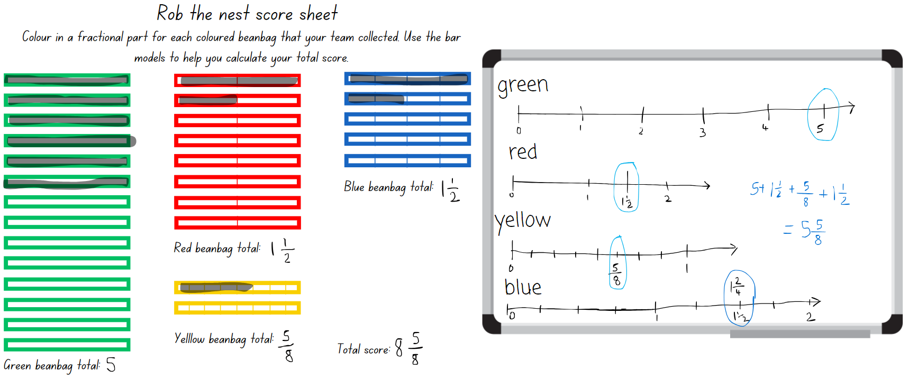
- Ask:
- Did your team collect enough beanbags to represent one or more wholes?
- What is your team total for wholes, halves, quarters and eighths? How could you combine them? This is the team total.
- How could you name leftover beanbags as a fraction?
Note: representing fractional quantities greater than one whole has not yet been explicitly taught to Stage 2 students. This lesson introduces this idea by prompting students to visualise equivalence and fractional lengths beyond one whole when colouring in the fraction bars.
- Play ‘Rob the nest – Round 2’. Students may want to be more strategic with their bean bag choices using the known value of beanbag colours as in Step 6. The aim of this round is to create as many wholes as possible, using any beanbag configuration. Points in this round will only be counted for complete wholes.
This table details opportunities for differentiation.
Too hard? | Too easy?
Stage 2 and Stage 3 students cannot work out the value of the pile using fractions.  - Model task for students.  - Students work with 2 colours of beanbags only, for example, those representing halves and quarters. | Stage 2 and Stage 3 students can use fractions to work out the value of the pile.  - Students assign other fraction values to the 4 colours.

Consolidation and meaningful practice – 10 minutes
- After returning to the classroom, make a pile of beanbags consisting of 3 red, 6 blue, 4 yellow and one green.
- Display Resource 30 – ‘Rob the nest’ score sheet and model colouring the fraction bars to represent the coloured beanbags in the pile.
- Highlight the equivalent fractions of $\frac{4}{8},\frac{2}{4}$ and $\frac{1}{2}$ represented on the score sheet and demonstrate how 2 of these fractional lengths can be combined to make one whole.
- Ask students to calculate the total for each colour as well as the overall total for the pile of beanbags.
- Stage 2 students represent their calculations diagrammatically using bar models or tape diagrams and Stage 3 students represent their calculations using a number line.
This table details opportunities for assessment.
Assessment opportunities | Links
What to look for:  - Can Stage 2 students recognise the need to have equal wholes to compare partitioned fractions? [MAO-WM-01, MA2-PF-01]  - Can Stage 2 students rename 2 halves, 3 thirds, 4 quarters, 5 fifths, 6 sixths, 8 eighths and 10 tenths as wholes? [MAO-WM-01, MA2-PF-01]  - Can Stage 2 students describe parts left over as fractions, for example, 5 wholes and 2 fifths? [MAO-WM-01, MA2-PF-01]  - Can Stage 2 students represent totals of halves, quarters and eighths that extend beyond one? [MAO-WM-01, MA2-PF-01]  - Can Stage 3 students represent the sum of fractions with the same denominator? [MAO-WM-01, MA3-PF-01] | Links to National Numeracy Learning Progressions (NNLP):  - Stage 2 – InF5  - Stage 3 – InF7, InF8.

Resource 1 – Exactly half?
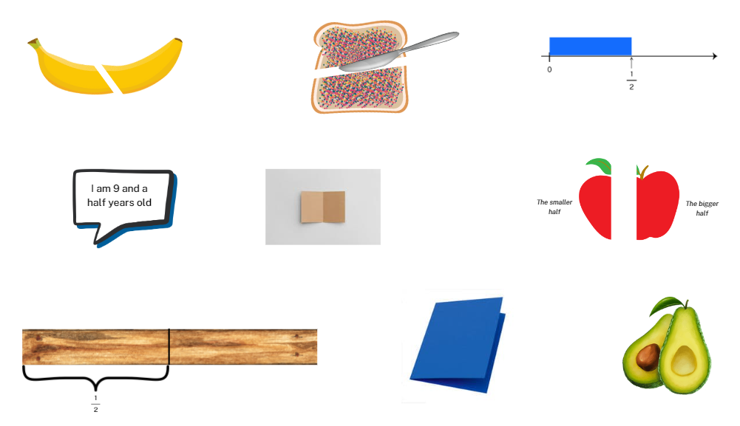

Resource 2 – domino fractions
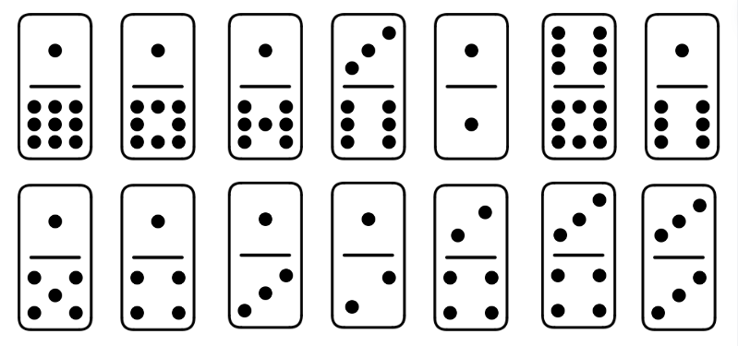

Resource 3 – blank fraction line

Resource 4 – shaded fraction part

Resource 5 – finding fractions
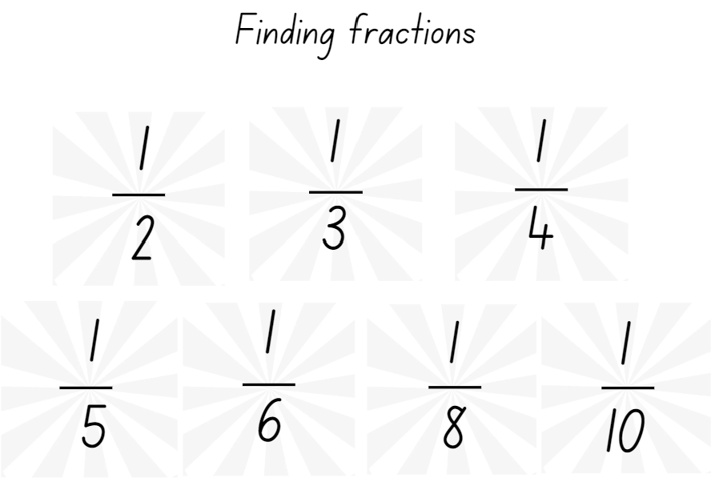

Resource 6 – distance travelled (part 1)
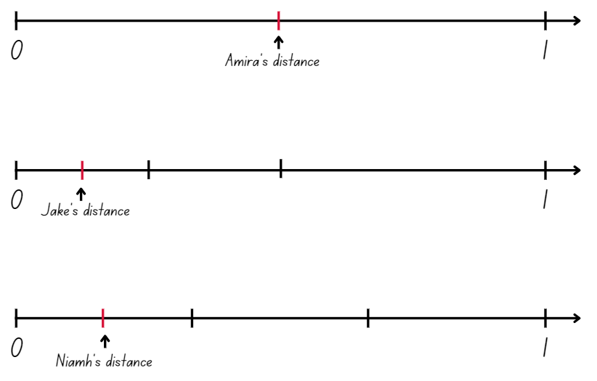

Resource 7 – distance travelled (part 2)
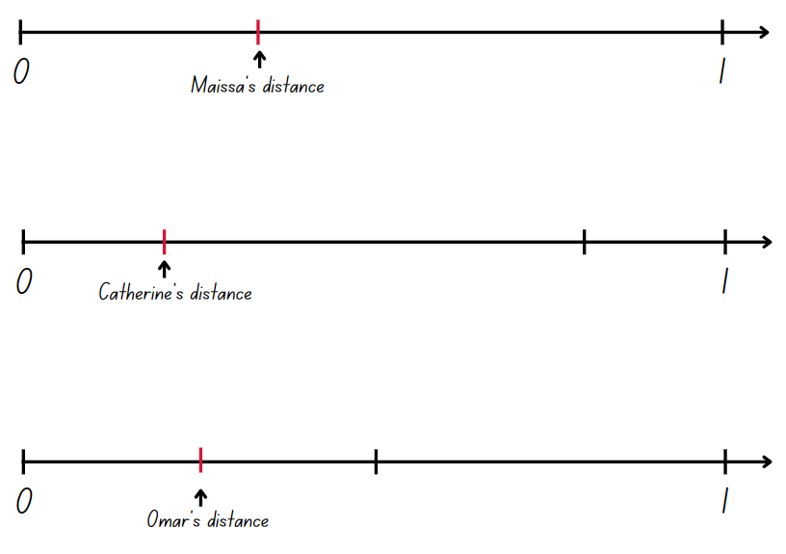

Resource 8 – broken fraction wall
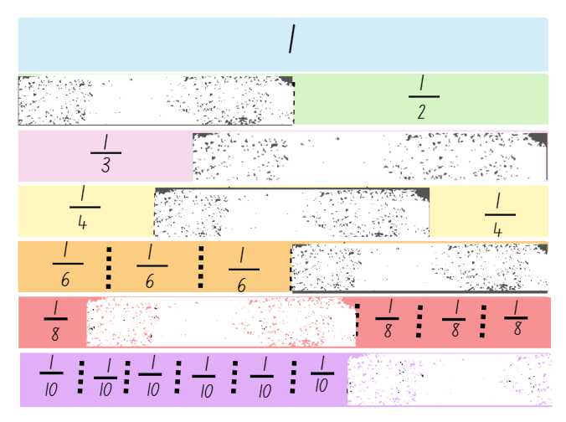

Resource 9 – fractions of a length
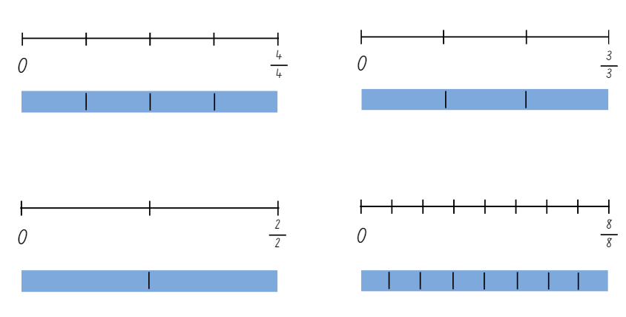

Resource 10 – quarters and tenths
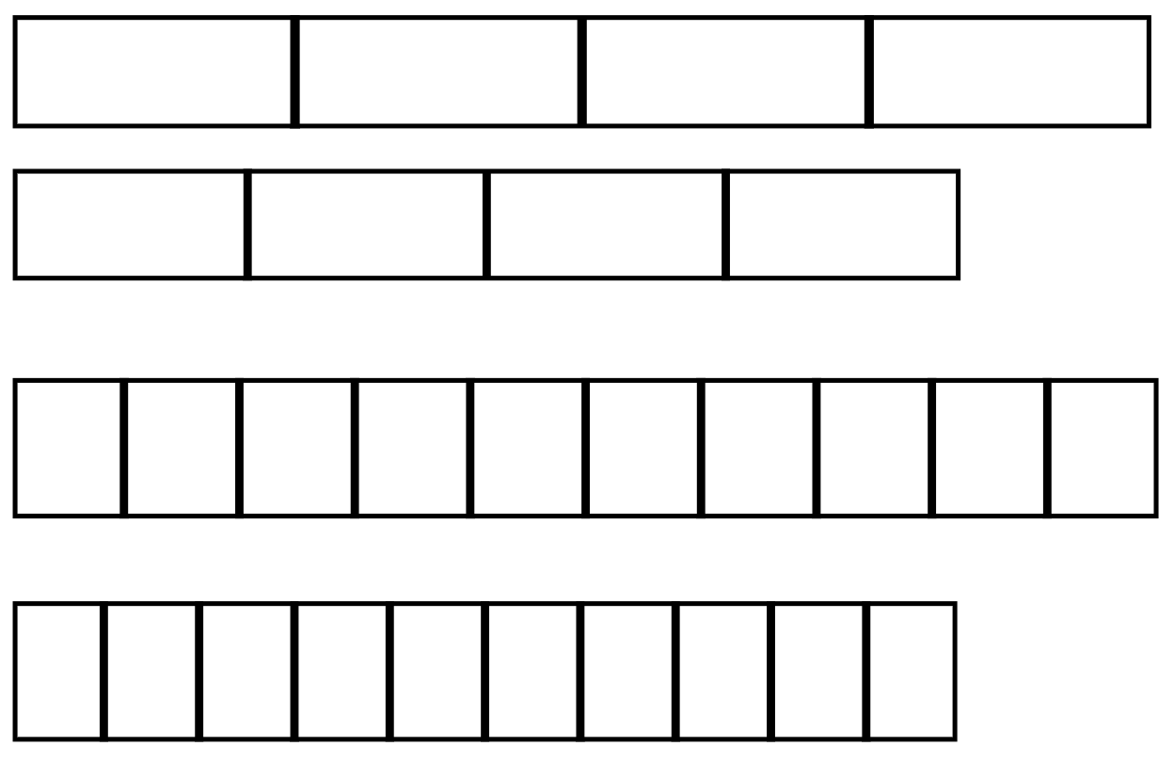

Resource 11 – fraction mosaics
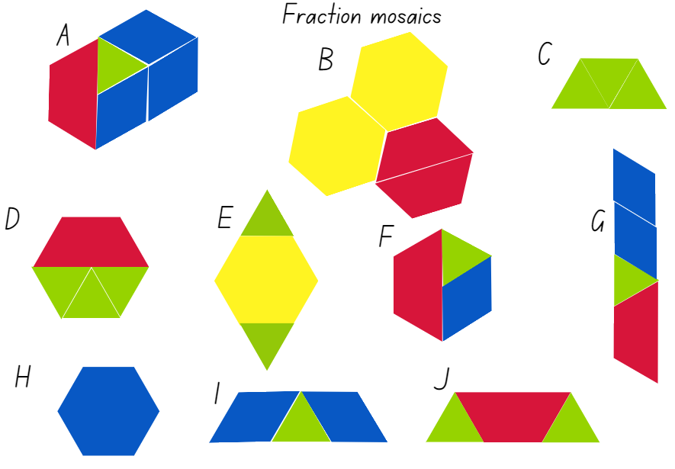

Resource 12 – fractions on a number line
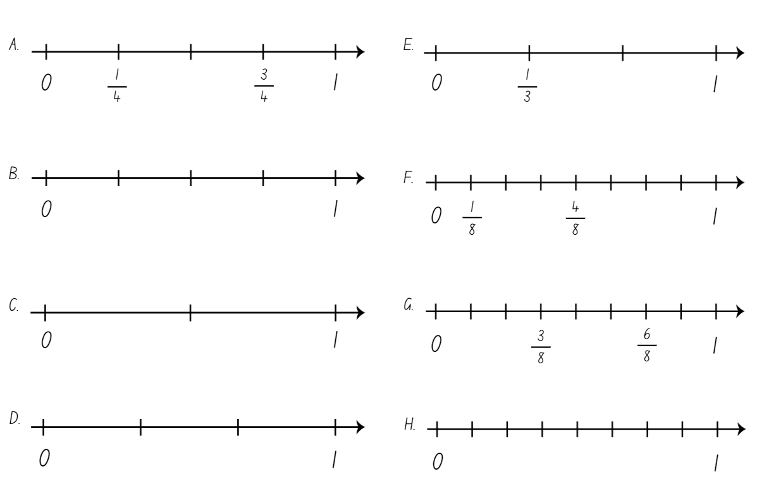

Resource 13 – fractions wall
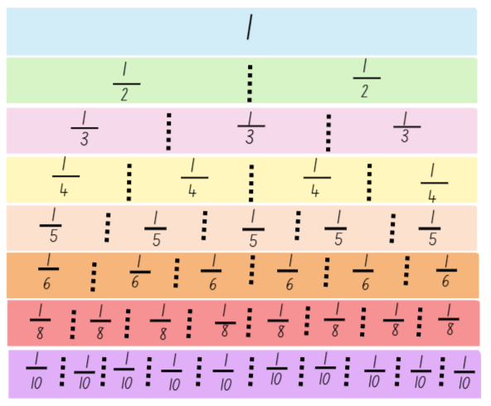

Resource 14 – complementary fraction parts
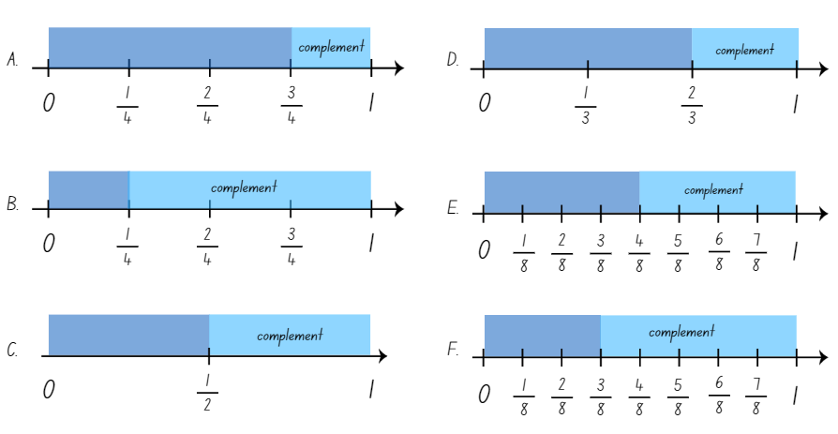

Resource 15 – ‘Multiples’ gameboard (Stage 2)
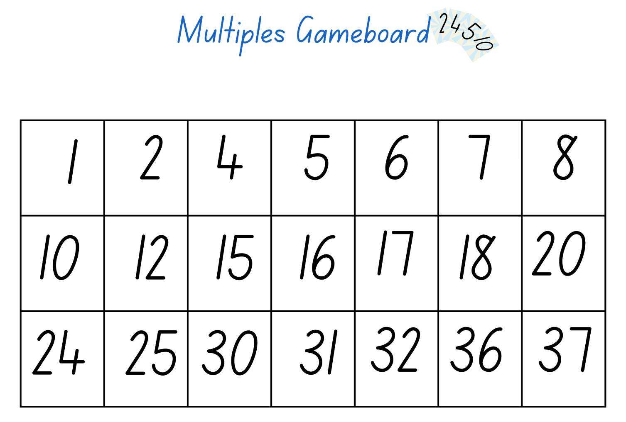

Resource 16 – ‘Multiples’ gameboard (Stage 3)
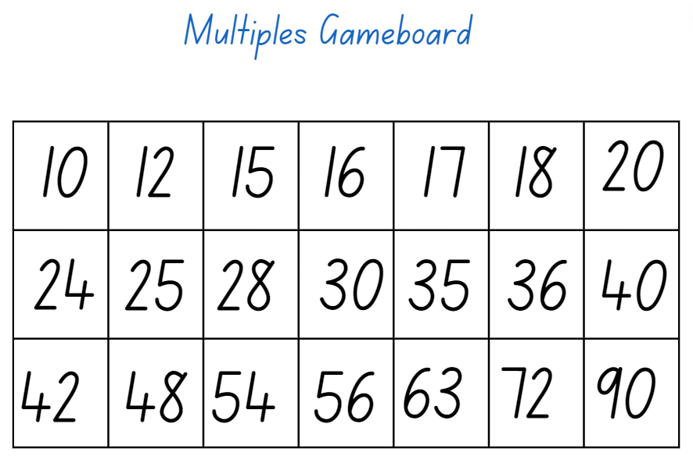

Resource 17 – ‘Multiples’ rule cards
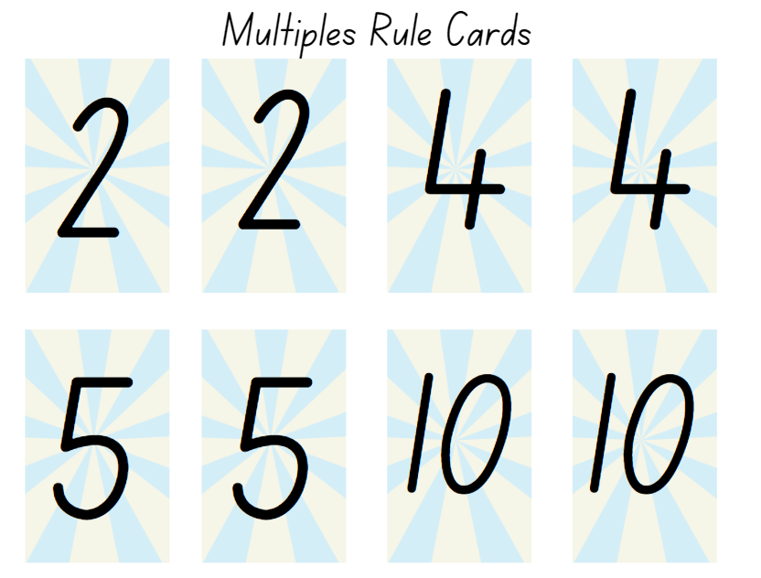

Resource 18 – finding the whole
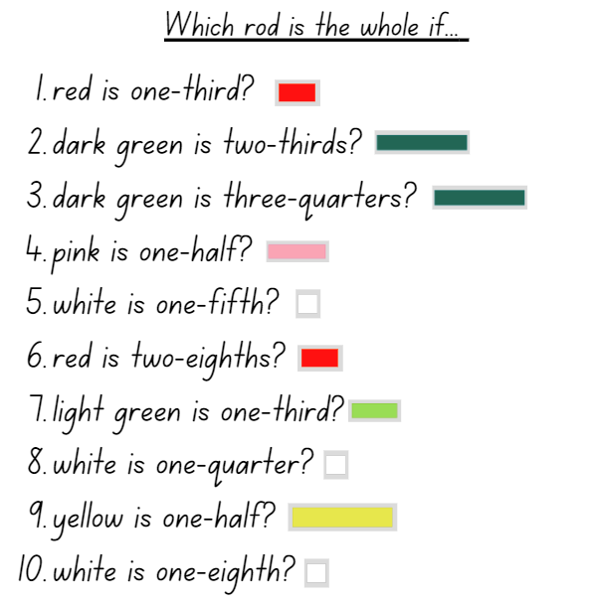

Resource 19 – bar model
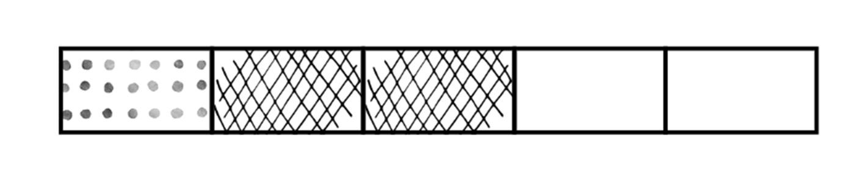

Resource 20 – make 2 groups (Stage 2)
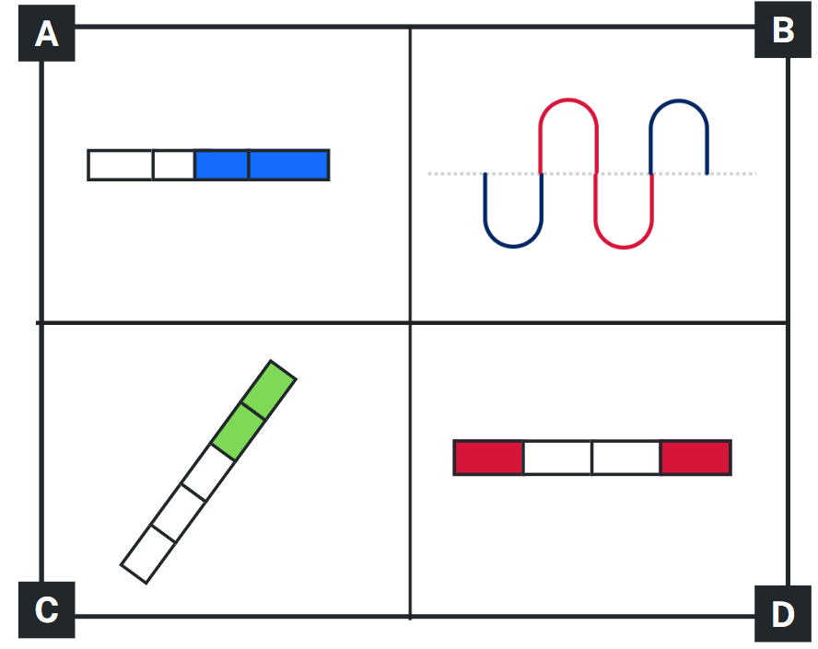

Resource 21 – make 2 groups (Stage 3)
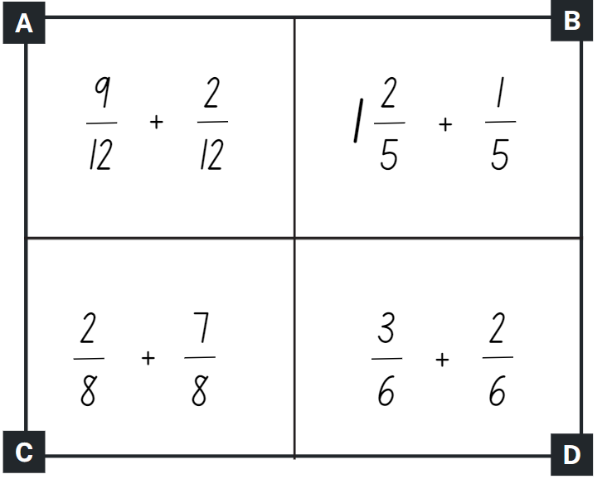

Resource 22 – making the whole
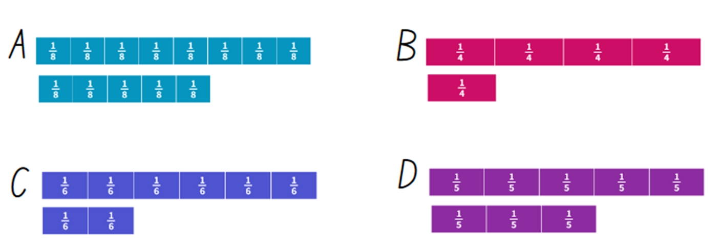

Resource 23 – ‘Product game’
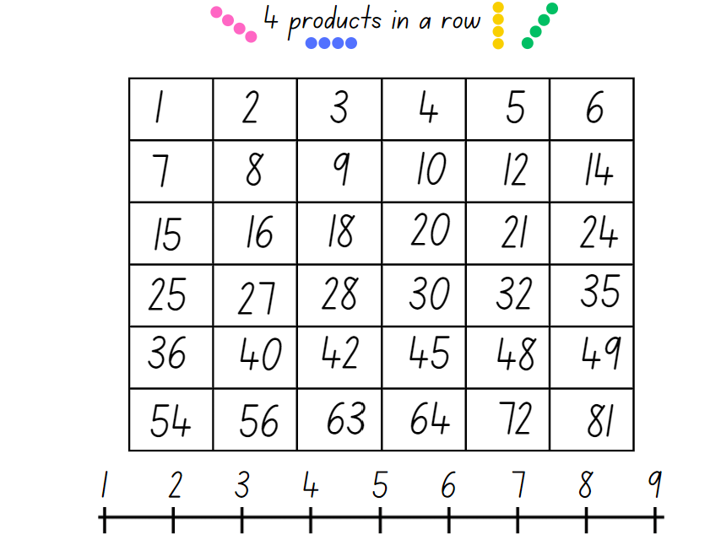

Resource 24 – modified ‘Product game’
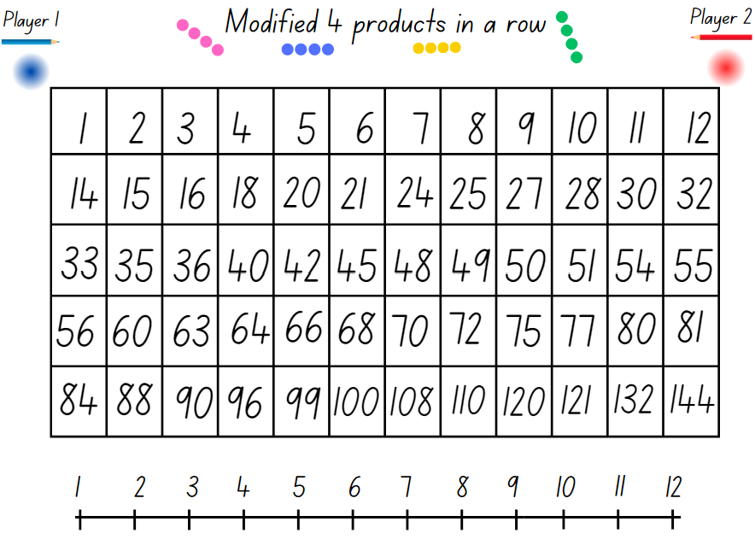

Resource 25 – ‘Product game’ questions
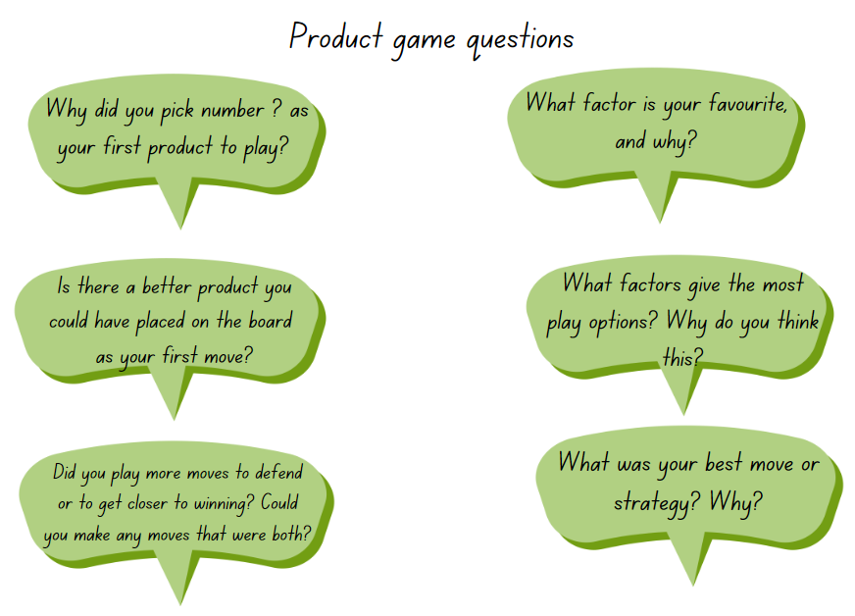

Resource 26 – chocolate bar 1
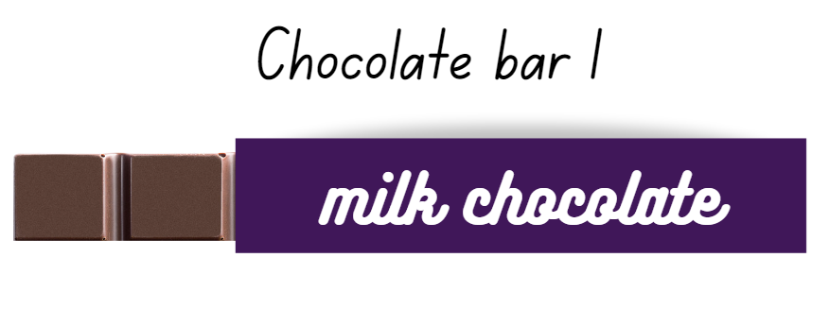

Resource 27 – chocolate bar 2
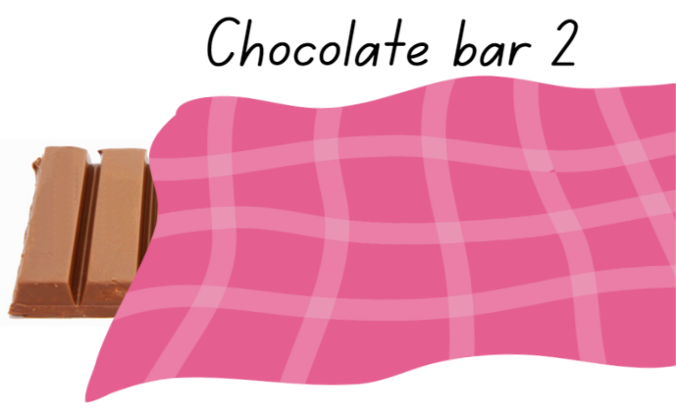

Resource 28 – picture frame problem

Resource 29 – frame beginnings
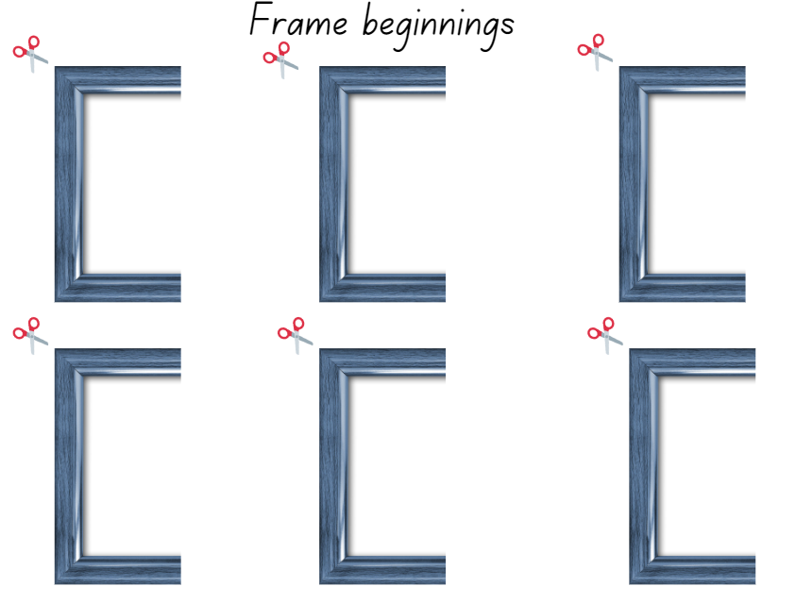

Resource 30 – ‘Rob the nest’ score sheet
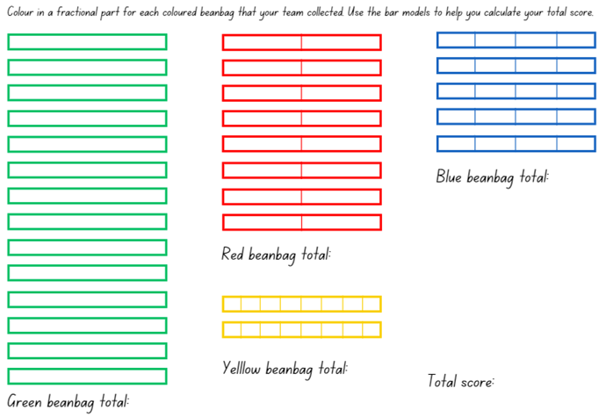

Syllabus outcomes and content

Stage 2
The table below outlines the syllabus outcomes and range of relevant syllabus content covered in this unit. Content is linked to National Numeracy Learning Progression (version 3).
Outcomes and content | 1 | 2 | 3 | 4 | 5 | 6 | 7 | 8
Multiplicative relations A: Use arrays to establish multiplication facts from multiples of 2 and 4, 5 and 10
[MAO-WM-01, MA2-MR-01]
- Use the array structure to coordinate the number of groups with the number in each group |  |  |  |  |  | x
- Relate doubling to multiplication facts for multiples of 2 |  |  |  |  | x | x
- Recognise that doubling is multiplying by 2 and halving is dividing by 2 (Reasons about relations) |  |  |  |  |  |  | x
- Recognise the relationship between one multiple and its double (Reasons about relations) |  |  |  |  |  |  | x
Multiplicative relations A: Recall multiplication facts of 2 and 4, 5 and 10 and related division facts
[MAO-WM-01, MA2-MR-01]
- Generate multiplication fact families for multiples of 2 and 4, 5 and 10 |  |  |  |  | x
Multiplicative relations B: Represent and solve word problems with number sentences involving multiplication or division
[MAO-WM-01, MA2-MR-01]
- Complete number sentences involving multiplication and division by calculating missing numbers (Reasons about relations) |  |  |  |  |  |  | x
Partitioned fractions A: Create fractional parts of a length using techniques other than repeated halving
[MAO-WM-01, MA1-PF-01]
- Make thirds of a length |  | x |  |  |  | x | x
- Create fifths of a length |  | x |  |  |  | x | x
Partitioned fractions A: Model and represent unit fractions, and their multiples, to a complete whole on a number line
[MAO-WM-01, MA2-PF-01]
- Model fractions with fraction strips and diagrams for halves, quarters, eighths, thirds | x | x | x | x |  | x
- Determine the complementary fractional part needed to complete one whole (halves, quarters, eighths, thirds) (Reasons about relations) |  |  | x | x |  | x
- Recreate the whole unit from a fractional part $\frac{1}{2},\frac{1}{4},\frac{1}{3}$ and $\frac{1}{8}$ (Reversible reasoning) |  |  | x |  | x |  | x
Partitioned fractions B: Model equivalent fractions as lengths
[MAO-WM-01, MA2-PF-01]
- Recognise the need to have equal wholes to compare partitioned fractions (Reasoning about relations) |  |  |  |  |  |  |  | x
Partitioned fractions B: Represent fractional quantities equal to and greater than one
[MAO-WM-01, MA2-PF-01]
- Rename 2 halves, 3 thirds, 4 quarters, 5 fifths, 6 sixths, 8 eighths and 10 tenths as one whole |  |  |  |  |  |  |  | x
- Represent totals of halves, thirds, quarters and fifths that extend beyond one |  |  |  |  |  |  |  | x
Mathematics K–10 Syllabus © NSW Education Standards Authority (NESA) for and on behalf of the Crown in right of the State of New South Wales, 2022.

Stage 3
The table below outlines the syllabus outcomes and range of relevant syllabus content covered in this unit. Content is linked to National Numeracy Learning Progression (version 3).
Outcomes and content | 1 | 2 | 3 | 4 | 5 | 6 | 7 | 8
Multiplicative relations A: Determine products and factors
[MAO-WM-01, MA3-MR-01]
- Use the term product to describe the result of multiplying 2 or more numbers |  |  |  |  | x |  | x
- Model different ways to show a whole number as a product (Reasons about structure) |  |  |  |  |  | x | x
- Determine factors for a given whole number |  |  |  |  |  | x
Representing quantity fractions A: Recognise the role of the number 1 as representing the whole
[MAO-WM-01, MA3-RQF-01]
- Compare halves and quarters of different sized wholes |  |  | x
- Justify the need for fractions to refer to the number 1 as the common whole (Reasons about quantity) |  |  | x | x
Representing quantity fractions A: Compare and order common unit fractions
[MAO-WM-01, MA3-RQF-01]
- Compare unit fractions as numbers to the benchmark value $\frac{1}{2}$ | x | x |  | x
- Compare and order unit fractions with denominators of 2, 3, 4, 5, 6, 8 and 10 by placing them on a number line | x | x
Representing quantity fractions A: Solve problems involving addition and subtraction of fractions with the same denominator
[MAO-WM-01, MA3-RQF-01]
- Represent the sum of fractions with the same denominator, recreating the whole, where the result may exceed one |  |  |  |  | x | x |  | x
- Find the difference between fractions with the same denominator and interpret the answer |  |  |  |  |  |  | x
- Solve word problems that involve fractions with the same denominator |  |  |  |  |  | x | x
- Use diagrams, objects and mental strategies to subtract a unit fraction from any whole number including 1 (the complement principle) |  |  |  |  |  |  | x
Representing quantity fractions B: Compare common fractions with related denominators
[MAO-WM-01, MA3-RQF-01]
- Record equivalent fractions using diagrams, words and fraction notation | x |  |  | x
Mathematics K–10 Syllabus © NSW Education Standards Authority (NESA) for and on behalf of the Crown in right of the State of New South Wales, 2022.

References
This resource contains NSW Curriculum and syllabus content. The NSW Curriculum is developed by the NSW Education Standards Authority. This content is prepared by NESA for and on behalf of the Crown in right of the State of New South Wales. The material is protected by Crown copyright.
Please refer to the NESA Copyright Disclaimer for more information https://educationstandards.nsw.edu.au/wps/portal/nesa/mini-footer/copyright.
NESA holds the only official and up-to-date versions of the NSW Curriculum and syllabus documents. Please visit the NSW Education Standards Authority (NESA) website https://educationstandards.nsw.edu.au/wps/portal/nesa/home and the NSW Curriculum website https://curriculum.nsw.edu.au/.
Mathematics K–10 Syllabus © NSW Education Standards Authority (NESA) for and on behalf of the Crown in right of the State of New South Wales, 2022.
National Numeracy Learning Progression © Australian Curriculum, Assessment and Reporting Authority (ACARA) 2010 to present, unless otherwise indicated. This material was downloaded from the Australian Curriculum website (National Numeracy Learning Progression) (accessed 12 February 2024) and was not modified.
Amplify Education (2024) Amplify Polypad – Fraction Bars, Amplify Polypad website, accessed 21 February 2024.
Amplify Education (2024) ‘Colour Mixing Fraction Bars’ [video], Amplify Polypad, Amplify Polypad website, accessed 21 February 2024.
Australian Government Department of Education and Australian Academy of Science (2024) ‘Bar Model Method: Introduction’, Teaching resources, reSolve: Maths by Inquiry website, accessed 12 February 2024.
Barton C (2018) ‘Bigger than and smaller than’, Fractions, Maths Venns website, accessed 12 February 2024.
Didax, Inc (2023) ‘Fraction Tiles and Number Line’, Virtual Manipulatives, Didax website, accessed 19 February 2024.
Epstein M (5 November 2020) ‘Exploring the Edges of Mathematical Ideas’, Michaela Epstein, accessed 12 February 2024.
Gojak LM and Harbin Miles R (2018) Your Mathematics Standards Companion, Grades 3–5: What They Mean and How to Teach Them, Corwin Mathematics and National Council of Teachers of Mathematics, United States of America.
Gould P (2013) ‘Australia's next top fraction model’, Australian Primary Mathematics Classroom, 18(3):5–12.
Math Open Reference (2011) Complement, Math Open Reference website, accessed 19 February 2024.
NCTM (National Council of Teachers of Mathematics) (2024) ‘Product Game’, Classroom Resources, NCTM website, accessed 12 February 2024.
New Zealand Ministry of Education (n.d.) ‘Common multiples’, Resources, NZ Maths website, accessed 12 February 2024.
Sullivan P and Lilburn P (2017) Open-ended Maths Activities: Using ‘Good’ Questions to Enhance Learning in Mathematics, Revised edn, Oxford University Press Australia and New Zealand, Great Britain.
University of Cambridge (n.d.) Cuisenaire Environment, NRICH website, accessed 12 February 2024.
Van de Walle J, Karp K, Bay-Williams JM, Brass A, Bentley B, Ferguson S, Goff W, Livy S, Marshman M, Martin D, Pearn C, Prodromou T, Symons D and Wilkie K (2019) Primary and Middle Years Mathematics: Teaching Developmentally, 1st Australian edn, Pearson Education Australia, Melbourne.

© State of New South Wales (Department of Education), 2023
The copyright material published in this resource is subject to the Copyright Act 1968 (Cth) and is owned by the NSW Department of Education or, where indicated, by a party other than the NSW Department of Education (third-party material).
Copyright material available in this resource and owned by the NSW Department of Education is licensed under a Creative Commons Attribution 4.0 International (CC BY 4.0) license.
This license allows you to share and adapt the material for any purpose, even commercially.
Attribution should be given to © State of New South Wales (Department of Education), 2023.
Material in this resource not available under a Creative Commons license:
- the NSW Department of Education logo, other logos and trademark-protected material
- material owned by a third party that has been reproduced with permission. You will need to obtain permission from the third party to reuse its material.
Links to third-party material and websites
Please note that the provided (reading/viewing material/list/links/texts) are a suggestion only and implies no endorsement, by the New South Wales Department of Education, of any author, publisher, or book title. School principals and teachers are best placed to assess the suitability of resources that would complement the curriculum and reflect the needs and interests of their students.
If you use the links provided in this document to access a third-party's website, you acknowledge that the terms of use, including licence terms set out on the third-party's website apply to the use which may be made of the materials on that third-party website or where permitted by the Copyright Act 1968 (Cth). The department accepts no responsibility for content on third-party websites.

